# Parkin, Macroeconomics: Australia in the Global Environment, 2nd edition

## Chapter 2: The Australian and Global Economies

## Answers to chapter review

### Study plan problems and applications

1. **Explain which of the following items are not consumption goods and services:**

* **A chocolate bar**

**A chocolate bar *is* a consumption good.**

* **A ski lift**

**A ski lift is not a consumption good. It is capital that produces a service for skiers.**

* **A golf ball**

**A golf ball *is* a consumption good.**

1. **Explain which of the following items are *not* capital goods:**

* **A car assembly line**

**A car assembly line *is* a capital good.**

* **A shopping mall**

**A shopping mall *is* a capital good.**

* **A golf ball**

**A golf ball is not a capital good. It is a consumption good.**

1. **Explain which of the following items are *not* factors of production:**

* **Vans used by a baker to deliver bread**

**Vans used to deliver bread are capital, so they are factors of production.**

* **1,000 shares of Amazon.com stock**

**1,000 shares of Amazon.com stock are not a factor of production. The shares represent partial ownership of Amazon.com and therefore are financial capital.**

* **Undiscovered oil in the Southern Ocean**

**Undiscovered oil is not a factor of production because it is not used to produce goods or services. Once it is discovered, it may become a factor of production.**

1. **Which factor of production earns the highest percentage of total Australian income? Define that factor of production. What is the income earned by this factor of production called?**

**Labour earns by far the largest percentage of total Australian income, 53 per cent of total income in 2014. Labour consists of the work time and the work effort that people devote to producing goods and services. The income earned by labour is a wage.**

1. **With more job training and more scholarships to poor Australian students, which special factor of production is likely to grow faster than in the past?**

**As more people go to school and/or receive job training, the nation’s human capital will grow more rapidly. Human capital is the knowledge and skills people obtain from education, on-the-job training and work experience. With more job training and more scholarships, human capital will grow more rapidly.**

1. **Define the factor of production called capital. Give three examples of capital, different from those in the chapter. Distinguish between the factor of production capital and financial capital.**

**Capital is the tools, instruments, machines, buildings and other items that have been produced in the past and that businesses now use to produce goods and services. Capital includes railroad engines and cars, servers, and ATMs. The factor of production “capital” is the actual good itself; “financial capital”, such as stocks and bonds, are the funds that provide businesses with their financial resources, which can be used to acquire capital goods.**

1. **Suppose a new multi-billion dollar government program awards grants to small business owners who are either women, Aborigines or war veterans. Explain how you would expect this program to influence *what*, *how*, and *for whom* goods and services are produced in Australia.**

**The answer to the *what* question would change because more of the goods and services produced by the groups receiving the grants—small business owners who are women, Aborigines and war veterans—would be produced. If these groups of producers produced their goods and services using different technologies than the rest of the producers, then the question of *how* goods and services would change. *For whom* goods and services are produced would change because the producers receiving the subsidies would have larger profits and therefore be able to buy more of the goods and services produced.**

1. **In the circular flow model, explain the real flow and/or money flow in which each item in List 1 (below) belongs. Show your answers on a graph.**

**Figure 2.1 shows the money flows. The real flows go in the opposite direction.**

* **You buy a coffee at Starbucks.**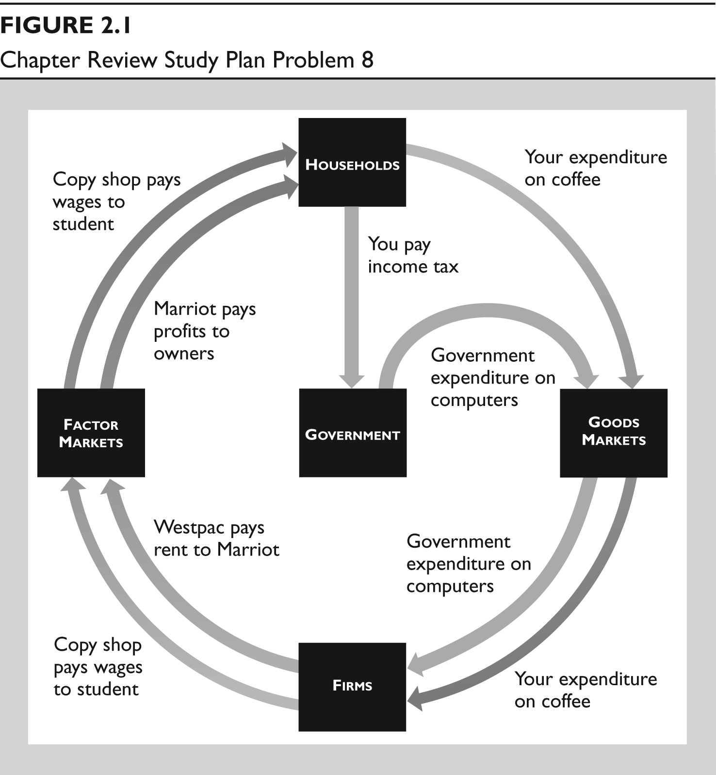

**When you buy a coffee at Starbucks, your expenditure is a money flow from households through the goods market to firms (Starbucks).**

* **The government buys some HP computers.**

**The purchase of computers by the government represents a flow of expenditure from government through the goods market to firms (HP).**

* **A student works at a copy shop.**

**The student working at the copy shop is a factor of production, so the flow of the services of labour is a real flow from households through the factor market to firms. The money flow is the flow of wages from firms through the factor market to households.**

* **Westpac rents a building to Marriot hotels.**

**Westpac’s building is a factor of production, so the flow of rent is the payment for the services from this factor of production. The rent paid is a money flow from Westpac to Marriot and Marriot pays the profit made to households. This money flow goes through factor markets.**

* **You pay your income tax.**

**Your income tax payment is a money flow from households to the government. This flow does not go through a goods market or a factor market.**

1. **Joe Hockey’s Higher Education Reforms**

***We will allow universities to set their own tuition fees, students will still be eligible for concessional higher education loans and one dollar out of every five dollars in additional revenue will be used to fund scholarships to those from disadvantaged backgrounds who want to attend university.***

**Source: Budget Speech, 13 May 2014**

**How do you think the personal distribution of income would change if all Joe Hockey’s proposals had become law?**

**The personal distribution of income would become more equal. The reason is that a university degree leads to a higher income and an increase in tuition fees will decrease the number of students from higher-income families and new scholarships will increase the number of students from lower-income families. So more low-income families will have higher incomes and more high-income families will have lower incomes).**

1. **Compare the scale of agricultural production in the advanced and developing economies. In which is the percentage higher? In which is the total amount produced greater?**

**Agricultural production is a much higher percentage of developing economies than for advanced economies. For example, agriculture contributes only 2.4 per cent to the Australian economy. Despite that, total agricultural production is higher in advanced economies than developing economies. Although advanced economies have only 15 per cent of the population, they produce about one-third of the world’s food. Advanced economies are proportionately much larger than developing economies, and a small share of a large economy can be bigger than a large share of a small economy.**

1. **Read *Eye on the Dreamliner* on p. 41 and then answer the following questions:**

* **How many firms are involved in the production of the Dreamliner and how many are identified in the figure on p. 41?**

**Over 400 firms are involved in the production of the Dreamliner. Only 15 of them are identified in the figure.**

* **Is the Dreamliner a capital good or a consumption good? Explain why?**

**The Dreamliner is a capital good because it will be used to produce services (airline travel) throughout many future years.**

* **State the factors of production that make the Dreamliner and provide an example of each.**

**All the factors of production—land, labour, capital and entrepreneurship—are used to make the Dreamliner. The copper used for wiring is an example of the land used; the engineer who helped design the landing gear is an example of labour; the huge cranes that lift the various pieces of the Dreamliner to assemble them is an example of capital; and the creative and imaginative input of Boeing’s top managers who organise the resources used to produce the Dreamliner exemplify entrepreneurship.**

* **Explain how the production of the Dreamliner influences *what, how* and *for whom*, goods and services are produced.**

**Dreamliner influences “what” goods and services are produced by creating a demand for components manufactured around the world. It influences “how” goods are produced because Boeing and the other 400 firms all determine the best way to produce each particular part of the Dreamliner. It influences “for whom” because factors of production employed to make the Dreamliner receive income from this production, thereby increasing the quantity of goods and services they can purchase.**

* **Use a graph to show where in the circular flow model of the global economy the flows of the components listed on p. 41 appear and where the sales of Dreamliners appear.**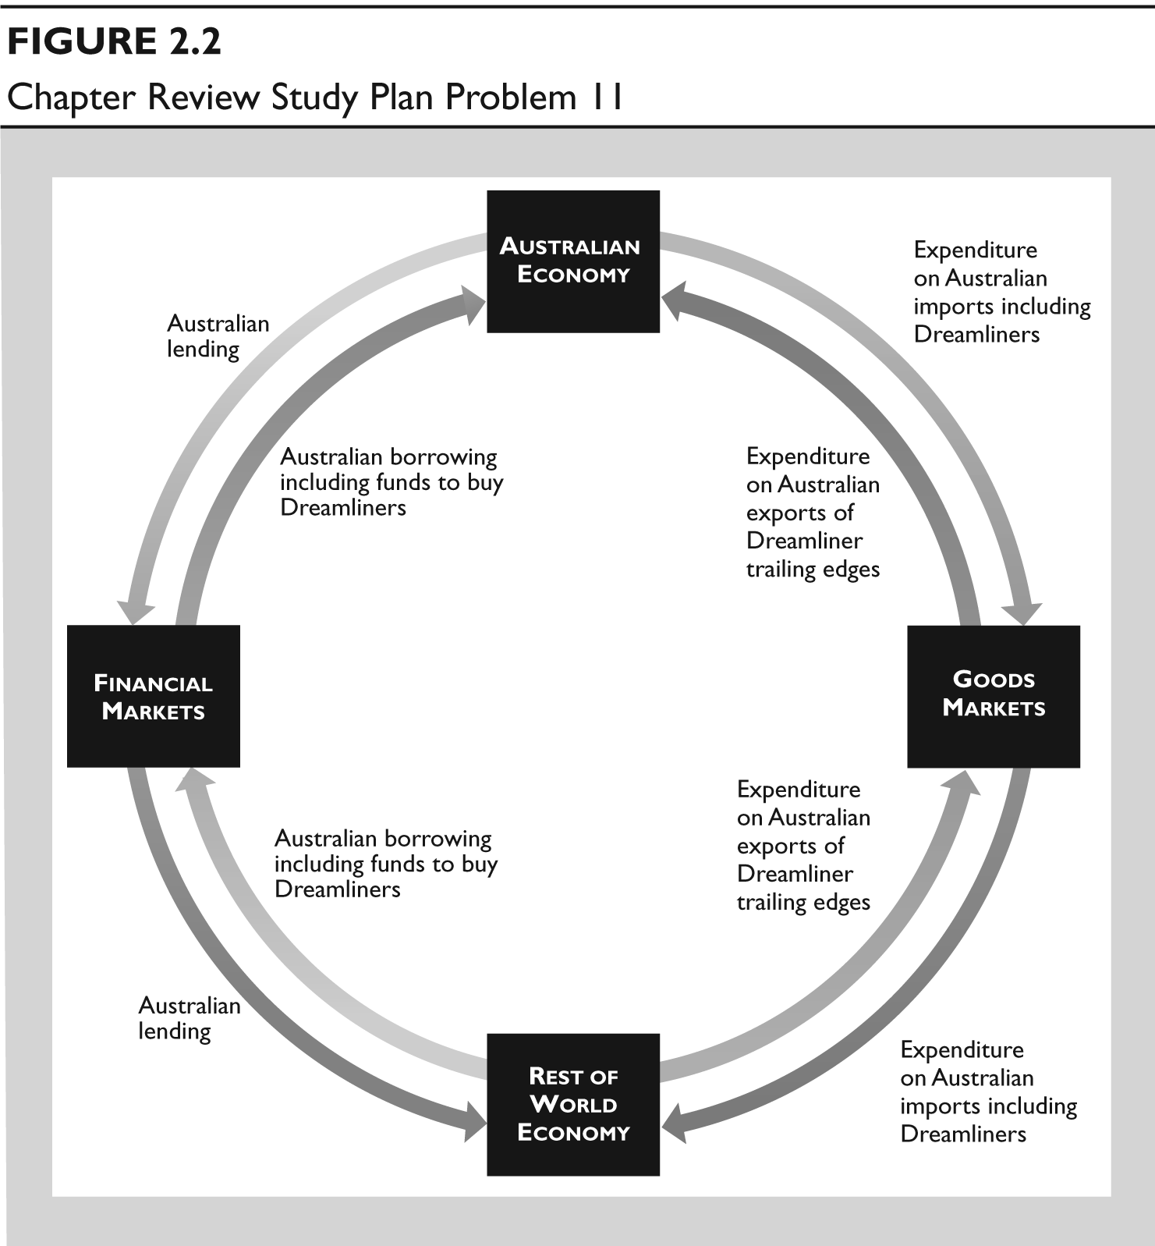

**Australia produces the trailing edge of the Dreamliner and Qantas buys Dreamliners. Trailing edges are an Australian export and expenditure by the rest of the world is a flow from the rest of the world through goods markets to Australia. Qantas’ expenditure on Dreamliners is expenditure on an Australian import, which is a money flow from Australia through goods market to the rest of the world.**

**To buy Dreamliners, Qantas borrows in world financial markets, which is a money flow from the rest of the world to Australian.**

### Additional problems and applications

1. **Boeing’s Dreamliner has had a rocky start.**

* **Why doesn’t Boeing manufacture all the components of the Dreamliner at its own factory in the United States?**

**Boeing wants to manufacture the Dreamliner at the lowest possible cost. It would be more expensive for Boeing to manufacture Dreamliners at its own factory in the United States because Boeing does not have the expertise possessed by its subcontractors and because the wages Boeing pays U.S. workers exceed the wages its subcontractors pays their workers.**

* **Describe some of the changes in *what, how* and *for whom*, that would occur if Boeing manufactured all the components of the Dreamliner at its own factories in the United States.**

**If Boeing manufactured all the components of the Dreamliner at its own factories in the United States, more components would be produced in the United States and more capital would have been used in their production.**

**U.S. workers and investors would have received higher incomes but the Dreamliner would cost more to produce so Boeing would have earned a lower profit.**

* **State some of the tradeoffs that Boeing faces in making the Dreamliner.**

**Boeing faced a huge number of tradeoffs. For example, when designing the plane, Boeing’s engineers had to make decisions about fuel economy and passenger load. Increasing the passenger load decreased fuel economy, so the engineers traded passenger load for fuel economy. Another example revolves around the construction of the Dreamliner. Boeing could have constructed the plane using just a few companies but instead it used over 400. Boeing was trading off the simplicity of dealing with just a handful of companies for the increased specialisation by dealing with many specialised companies.**

* **Why might Boeing’s decisions in making the Dreamliner be in the social interest?**

**Building the Dreamliner itself advances the social interest because it increases the quantity of comfortable, rapid transportation. The amount of high-quality transportation available in the economy increases, which benefits society. The decisions in making the Dreamliner advance the social interest because they were designed to make the Dreamliner at low cost and thereby avoid wasting resources.**

1. **The global economy has three mobile users for every fixed line user. Two in every three mobile phone users lives in a developing nation and the growth rate is fastest in Africa. In 2000, 1 African in 50 had a mobile phone; in 2009, it was 14 in 50. Describe the changes in *what, how*, and *for whom* telecommunication services are produced in the global economy.**

* *What*: As the number of mobile phone users increases, the global economy has been producing more mobile phone telecommunication services. More mobile phones are produced, fewer land phones are produced, and presumably more mobile phone frequencies are used.
* *How*: More telecommunication services are being produced using mobile phones rather than fixed-line phones.
* *For whom:* While the amount of telecommunication services has been rising throughout the world, it definitely has been increasing rapidly in Africa. So more telecommunication services are being produced for residents of Africa as well as for residents in the rest of the world.

|  |
| --- |
| **List 1** |
|
| **A motorway** |
| **An aeroplane** |
| **A school teacher** |
| **A navy submarine** |
| **A garbage truck** |
| **A pack of bubble gum** |
| **The NSW state premier** |
| **A strawberry field** |
| **A movie** |
| **An ATM** |

1. **Which of the entries in List 1 are consumption goods and services and which are government goods? Explain your choice.**

**A pack of bubble gum and a movie are consumption goods. They are purchased by consumers. The motorway and the navy submarine are government goods, but these are capital goods too—they provide services (transportation and defence) that help produce other goods and services.**

1. **Which of the entries in List 1 are capital goods? Explain your choice.**

**An airplane, a garbage truck and an ATM are capital goods. All provide services to produce other goods and services. The motorway and the navy submarine are also capital goods—they provide services (transportation and defence) that help produce other goods and services. They are generally provided by the government.**

1. **Which of the entries in List 1 are factors of production? Explain your choice.**

**A motorway, an aeroplane, a school teacher, a navy submarine, a garbage truck, the NSW state premier, a strawberry field and an ATM are factors of production. A school teacher and the NSW state premier are labour; a motorway, an aeroplane, a navy submarine, a garbage truck and an ATM are capital; and a strawberry field is land.**

1. **In the African nation of Senegal, to enrol in school a child needs a birth certificate that costs $25. This price is several weeks’ income for many families. Explain how this requirement is likely to affect the growth of human capital in Senegal.**

**Human capital growth depends, in part, on the extent of schooling: More schooling means more human capital. Because of Senegal’s hefty fee for a required birth certificate, fewer children will enrol in school, thereby decreasing Senegal’s human capital growth.**

1. **China’s Prosperity Brings Income Gap**

***The Asian Development Bank [ADB] reports that China has the largest gap between the rich and the poor in Asia. Ifzal Ali, the ADB’s chief economist, claims it is not that the rich are getting richer and the poor are getting poorer, but that the rich are getting richer faster than the poor.***

**Source: *Financial Times*, August 9, 2007**

**Explain how the distribution of personal income in China can be getting more unequal even though the poorest 20 per cent are getting richer.**

**The distribution of income in China can be getting more unequal even when the poorest 20 per cent are getting richer because the richest 20 per cent are getting richer even faster. Because the rich are getting richer faster, the fraction of the nation’s total income received by the poorest 20 per cent falls, which makes the personal distribution of income more unequal.**

1. **On a graph of the circular flow model, indicate in which real or money flow each entry in List 2 (below) belongs.**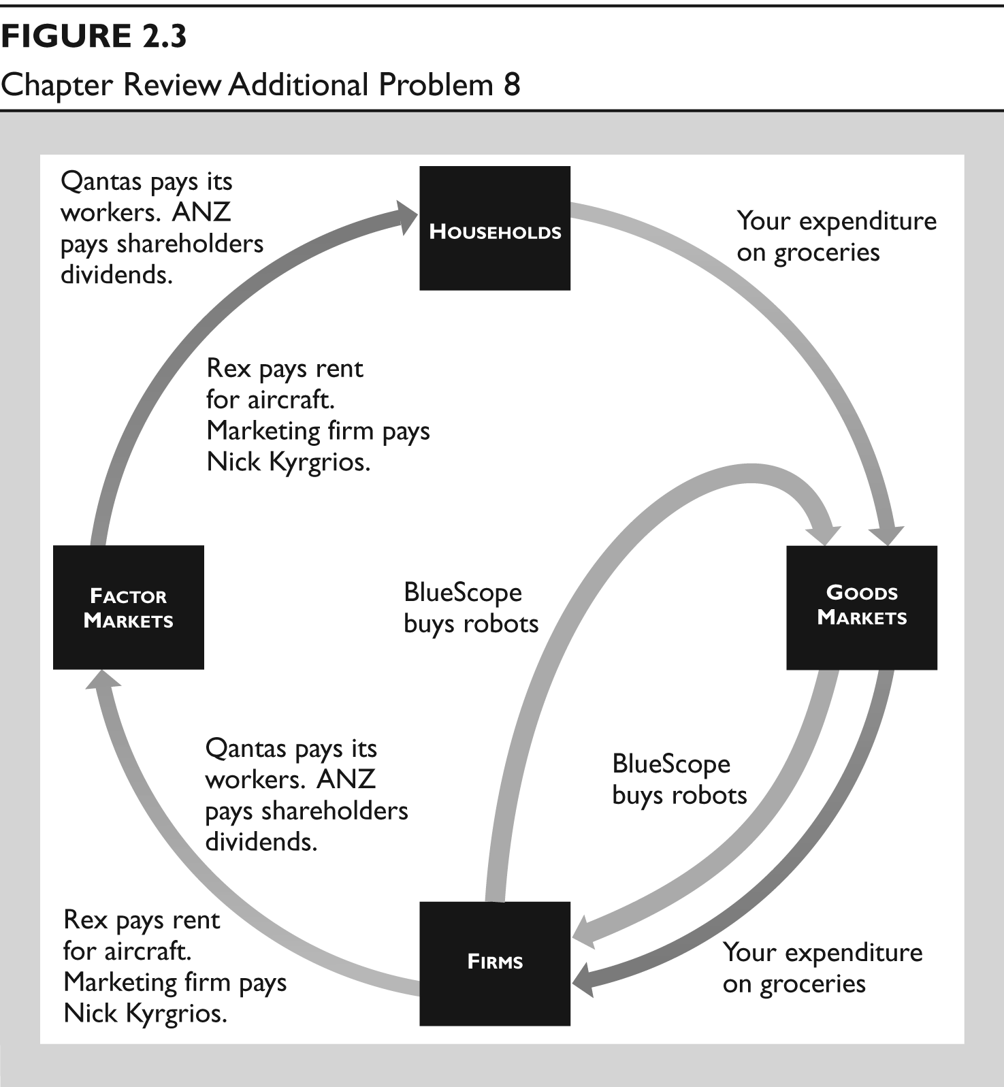

**Figure 2.3 shows the money flow associated with each item in the list. The real flow goes in the opposite direction.**

* **Qantas pays its workers wages.**

**Qantas wage payments is a money flow that is a payment for use of the services of a factor of production and so flows from firms (Qantas) through the factor market to households.**

* **ANZ pays a dividend to its shareholders.**

**ANZ’s dividend payment is a money flow that is a payment for use of the services of a factor of production and so flows from firms (ANZ) through the factor market to households.**

* **You buy your groceries.**

**Your purchase of groceries represents a money flow from households through the goods market to firms.**

* **BlueScope Steel buys robots.**

**BlueScope buy robots, a capital good, from another firm. BlueScope’s expenditure on robots is a money flow from firms (BlueScope) through goods market to firms (robot producer).**

* **Rex Airlines rents some aircraft.**

**The aircraft is a factor of production, so the money flow of rent for the services of the aircraft is a flow from firms (Rex) through the factor market to households (aircraft owners).**

* **Nike pays Nick Kyrgrios for promoting its sports shoes.**

**Nick Kyrgrios is a factor of production, so the flow is a money flow from the firm who markets sports shoes through the factor market to households in exchange for Nick Kyrgrios’ services of promoting the sports shoes.**

***Use the following information to work Problems 9 and 10.***

**Poor India Makes Millionaires at Fastest Pace**

***India, with the world’s largest population of poor people, also paradoxically created millionaires at the fastest pace in the world. Millionaires increased by 22.7 per cent to 123,000. In contrast, the number of Indians living on less than a dollar a day is 350 million and those living on less than $2 a day is 700 million. In other words, there are 7,000 very poor Indians for every millionaire.***

**Source: *The Times of India*, June 25, 2008**

1. **How is the personal distribution of income in India changing?**

**If the number of millionaires is growing more rapidly than the number of other income groups, it will be the case that the personal distribution of income in India is becoming less equally distributed.**

1. **Why might incomes of $1 a day and $2 a day underestimate the value of the goods and services that these households actually consume?**

**The people living on $1 and $2 a day probably grow a lot of their food and produce a lot of their clothing and shelter. If these goods and services are not taken into account, their share of goods and services is understated. Including them raises the value of the goods and services these households actually consume.**

### Multiple choice quiz

1. **Which of the following classifications is correct?**
2. **City streets are consumption goods because they wear out with use.**
3. **Shares of a company stock are capital goods because when people buy and sell them they make a profit.**
4. **The coffee maker in the coffee shop at an airport is a consumption good because people buy the coffee it produces.**
5. **Parliament security is a government service because it is paid for by the government.**

**Answer: D Answer D is correct.**

1. **Which of the following statements about Australian production is correct?**
2. **Construction accounts for a larger percentage of total production than does manufacturing.**
3. **Mining account for 12.6 per cent of the value of total production, larger than any other item of services or goods.**
4. **Consumption goods and services represent 80 per cent of Australian production by value and that percentage doesn’t fluctuate much.**
5. **The manufacture of goods represents more than 50 per cent of total production.**

**Answer: C Answer C is correct as the data on page 32 show.**

1. **Which of the following items is not a factor of production?**
2. **An oil rig**
3. **A ski jump**
4. **A bank loan**
5. **An orange grove**

**Answer: C Answer C is not a factor of production because it is financial capital; see page 35.**

1. **What is human capital?**
2. **Immigrant labour**
3. **Someone who operates heavy equipment**
4. **Your professor’s knowledge of the economy**
5. **A car assembly line robot**

**Answer: C Answer C uses the definition of human capital on page 35.**

1. **Which of the following statements is correct?**
2. **Labour earns wages and entrepreneurship earns bonuses.**
3. **Land earns interest and capital earns rent.**
4. **Entrepreneurship earns interest and capital earns profit.**
5. **Capital earns interest and labour earns wages.**

**Answer: D Page 37 shows that answer D is correct.**

1. **How are goods and services produced in the global economy?**
2. **Developing countries use less human capital but just as much physical capital as advanced economies.**
3. **Emerging economies use more capital-intensive technology than do developing economies.**
4. **Human capital in all economies is similar.**
5. **Advanced economies use less capital than developing economies.**

**Answer: B Developing countries have less capital than emerging economies.**

1. **In the circular flow model, which of the following items is a real flow?**
2. **The flow of government expenditures to firms for the goods bought**
3. **The flow of income from firms to households for the services of the factors of production hired**
4. **The flow of Australian borrowing from the rest of the world**
5. **The flow of labour services from households to firms**

**Answer: D Answer D is a real flow because it is a labour service.**