Chapter 2 – The Research Question: Formulation of the Problem

Poll Question

Using taste tests is a fool-proof method of conducting marketing research.
Strongly Disagree | 1 | 2 | 3 | 4 | 5 | Strongly Agree

The poll question is designed to add a level of interactivity both inside and outside the classroom and between the student and the book.

Interaction Inside the classroom – A show of hands, the use of clickers, having students text or e-mail their answers … All of these, and more, are possible ways of allowing students to make their voices heard on this issue. Poll questions could be a solid class opener.

Interaction Outside the classroom – Have students access www.cengagebrain.com and search for MR (the official name of the book) to answer the poll questions for this and all chapters. Once there, they can also see how their answer compares with other students taking this course at other universities.

Interaction between Student and Book – We would strongly disagree with this statement. As we discuss in the text (starting on page 13), Coke made a classic marketing mistake by introducing New Coke in the 1980s after a series of taste tests. The poll question itself will be addressed, if not outwardly answered, in the text of the chapter. As an instructor, you have the choice of asking students to answer the poll question unaided (before reading the chapter) or aided (after reading the chapter). In fact, an interesting follow-up question might be, “Did you read Chapter 2 before answering the poll question?”

Fast Facts

34% of Young Women (ages 18-34) make Facebook the first thing they do when they wake up.

Fast Facts are designed to enhance the consumption of marketing research. They are spread throughout the book. Also, Tracy Suter provides new Fast Facts daily (except Sundays) on Twitter at @TracySuter. Follow him, encourage your students to follow him, and join the discussion.

The more interesting aspect of these Fast Facts is they can be used multiple ways to spark class discussion from both a marketing and a research perspective.

Marketing Perspective: Facebook, with its wealth of profile data and mass of users (750 million + at this writing), has tremendous marketing potential. Focusing specifically on promotion, the advertising potential is limitless as people provide details about themselves well beyond basic demographics like gender or age and spend a tremendous amount of time on the site (see Chapter 4, Exhibit 4.5). Moreover, the word of mouth communication potential is highlighted in an upcoming Fast Fact (Chapter 7), 68% of Facebook users said they are more likely to buy a product or visit a retailer based on a positive Facebook friend referral.

Research Perspective: How did researchers come to know 34% of young women make Facebook the first thing they do when they wake up? It is unlikely observational research was the method of choice. It is more likely a communication method was used. Is it possible this percentage under-represents start-up Facebook usage as some young women were too embarrassed to admit their top of the day activities? Maybe Facebook usage wasn’t even the focus of the study but rather an interesting by-product of another topic under investigation. A wide variety of research topics could be discussed here.

As a reminder, suggest students find their own Fast Facts. What types of Fast Facts are interesting to them? What topics are of interest? If they bring their own Fast Facts to class on topics of more interest to them, marketing research will be more interesting and more relevant. If they have Twitter accounts, encourage them to send the facts to @TracySuter as they discover them.

Learning Objectives

Upon completing this chapter, students should be able to:

Learning Objective 1 Specify the key steps in problem formulation.
The six key steps are (1) meet with client, (2) clarify the problem/opportunity, (3) state the manager’s decision problem, (4) develop full range of possible research problems, (5) select research problem(s), and (6) prepare and submit a research request agreement.

Learning Objective 2 Distinguish between two types of decision problems.
A decision problem is the basic problem or opportunity facing the manager. Discovery-oriented decision problems typically ask “What?” or “Why?” and generate information that can be used by managers to make important decisions. Strategy-oriented decision problems are usually directed at “how” planned change should be implemented and focus on making decisions.

Learning Objective 3 Distinguish between a decision problem and a research problem.
A decision problem is the problem as seen by managers. Research problems restate the decision problem in research terms, from the researcher’s perspective.

Learning Objective 4 Describe the research request agreement.
The research request agreement summarizes the problem formulation process in written form and is submitted to managers for approval. It includes the following sections: origin, decision problem, research problem(s), use, targets and their subgroups, and logistics.

Learning Objective 5 Outline the various elements of the research proposal.
Most research proposals contain the following elements: problem definition and background, research design and data sources, sampling plan, data collection forms, analysis, time schedule, personnel requirements and cost estimate, and appendices.

Chapter Outline

- Introduction
- Problem Formulation
  - Problems versus Opportunities
- The Problem Formulation Process
(Exhibit 2.1 – Key Steps in Problem Formulation)
- Step 1: Meet with Client
- Planned Change versus Unplanned Change
- Step 2: Clarify the Problem/Opportunity
(Exhibit 2.2 – The Problem with Normal Thinking)
- Step 3: State the Manager’s Decision Problem
- Step 4: Develop Possible Research Problems
(Exhibit 2.3 – The Relationship between Decision Problems and Research Problems)
- Step 5: Select Research Problem(s) to Be Addressed
- Step 6: Prepare Research Request Agreement
(Exhibit 2.4 – Research Request Agreement presented to Stillwater Domestic Violence Services, Inc., by Research Partners, Ltd.)
- The Research Proposal
- Problem Definition and Background
- Research Design and Data Sources
- Sampling Plan
- Data Collection Forms
- Analysis
- Time Schedule
- Personnel Requirements and Cost Estimate
- Appendices

PowerPoint Highlights

Slide 5 – Problems versus Opportunities | 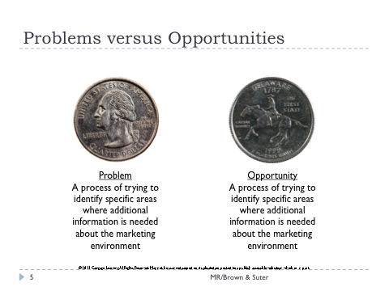
Slide 7 – The Problem Formulation Process | 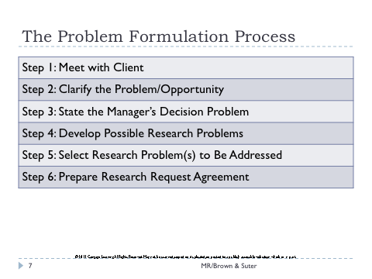
Slide 15 – The Problem Formulation Process (Example of Discovery-Oriented Decision and Research Problems) | 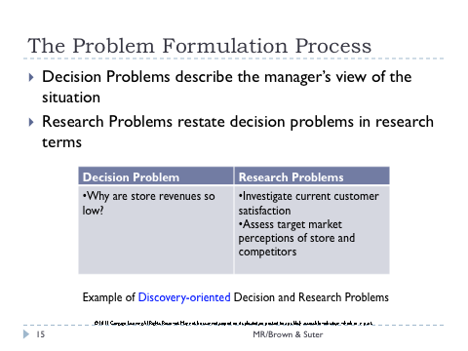
Slide 16 – The Problem Formulation Process (Example of Strategy-Oriented Decision and Research Problems) | 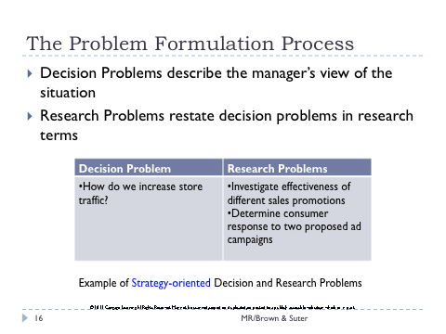
Slide 18 – The Problem Formulation Process (Selection of Research Problems to Be Addressed) | 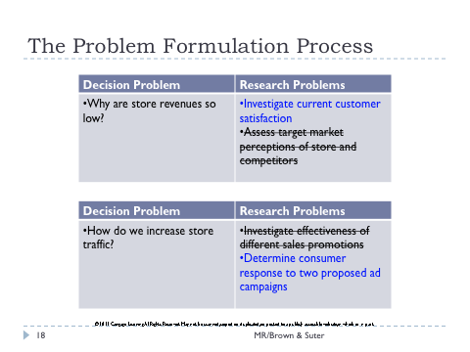

Student Challenges (Possible Answers are bulleted)

1. Are the following decision problems discovery oriented or strategy oriented?

- Why have sales of my brand decreased?

- Discovery-oriented

- What pricing strategy should I choose for my new product?

- Discovery-oriented
(The above answer provided on the Instructor Prep Card focuses on (1) the “what?” type of question and (2) the possibility of seeking information about consumer’s reaction to different pricing approaches. It is plausible to see this as a strategy-oriented decision problem from the perspective of making a choice between two possible pricing strategies, alternative courses of action.)

- How can I increase in-store promotion of existing products?

- Strategy-oriented
(The above answer provided on the Instructor Prep Card focuses on (1) the “how?” type of question and (2) the possibility of choosing one promotional strategy over another. It is plausible to see this as a discovery-oriented decision problem from the perspective of gathering information about different promotional options.)

- Should I change the sales-force compensation package?

- Discovery-oriented
(The above answer provided on the Instructor Prep Card focuses on the possibility of seeking input about acceptable alternative packages. It is plausible to see this as a strategy-oriented decision problem from the perspective of making the actual choice to change or not change the existing compensation package, alternative courses of action.)

2. Identify at least one possible research problem for each of the above-mentioned decision problems.

- Investigate current customer satisfaction with the brand.
- Measure customer’s willingness-to-pay thresholds.
- Investigate effectiveness of different in-store promotions.
- Determine employee response to different compensation packages.

3. Convert Figure 2.1 to series of decision and research problems. Hint: the orange diamond and yellow rectangles can be different types of decision problems.

- See first Teaching Tip below.

Teaching Tips

1. It is our experience that students, especially undergraduates, tend to look at many marketing problems as awareness problems. They use phrases like “they need to get their name out there” or “consumers are not aware of the product or service the firm provides.” The implication is if consumers knew, surely they would buy. Perhaps what they really mean is that they are not aware so others must not be either.

Use Figure 2.1, in conjunction with Student Challenge question number 3, to consider the role of customer awareness as one of many possible issues that might relate a manager’s decision problem to a researcher’s research problems. The overarching issue might be lagging revenue. This could be converted to a discovery-oriented decision problem of, “Why are store revenues so low?” The next layer of Figure 2.1 – number of clients times spend per client” could be converted to strategy-oriented decision problems like, “How can we increase the number of clients we serve?” and “How can we increase client spending on our products or services?” The blue boxes in Figure 2.1 can now be expressed as research problems: “Determine customer awareness,” “Investigate effectiveness of free samples on customer trial,” “Measure customer likelihood of repeat business,” and “Investigate current customer’s spend per visit.” This approach is intended to enhance the understanding of the discovery- versus strategy-oriented decision problems and the relationship between decision and research problems.

2. Begin with a discussion of the task of problem formulation. Note to students, perhaps using the New Coke example, that problem definition is tricky business and involves a great degree of thought and analysis. It can also be pointed out that the situation becomes much more complex when there are multiple decision makers, perhaps with conflicting objectives, multiple alternatives, multiple outcomes, and multiple environmental influences.

3. Students will enjoy a discussion of the problems with “normal thinking,” especially if the instructor can bring in to class some of the many creative thinking exercises available. This will be especially useful for courses with a large project component in the course. Students need to learn to think clearly about the nature of the problem/opportunity confronting project sponsors. They must also learn the importance of quickly developing rapport with the client, so that candid answers are given to their probing questions.

4. Students often seem to struggle with the ambiguity involved in problem formulation. The development of a step-by-step process for defining the problem is helpful, but there are still many subjective aspects of problem definition. Most students will benefit from a discussion of the different goals for discovery- vs. strategy-oriented decision problems. If a manager seems to be asking for information only, the problem is usually discovery-oriented. If an actual decision is to be made, then the problem is strategy-oriented. The instructor should point out to students that while discovery-oriented research is probably the most straightforward and easy to conduct, it is with strategy-oriented research that marketing research can be of greatest managerial use. It is clear, however, that in the earliest stages of most problems/opportunities there is critical need for discovery-oriented research.

5. The relationship between decision problems and research problems can be highlighted by moving from one to the other through examples. The highlighted PowerPoint slides (i.e., 15, 16, and 18) are an attempt at this.

6. The role to be played by marketing research in decision problems can be indicated by discussing how research can help:

(a) in gaining insight into the decision-making environment
(b) in determining the potential courses of action
(c) in determining the consequences of alternative courses of action.

In discussing the role of marketing research, it is useful to discuss the differences between unplanned change and planned change and what that usually implies for research. With unplanned changes, the research typically focuses on determining WHAT exactly is happening and WHY. With planned change, it focuses on HOW to bring about the desired change.

7. Class action can then be directed at the use of a formal research request agreement, a research proposal, and/or a request-for-proposal to ensure that the true decision problem is being addressed. Discussion can focus on what goes into each part of these documents so as to make sure the decision maker and researcher are interpreting the decision situation similarly.

8. Some instructors may find it useful to discuss the research proposal at this point, while others will want to postpone such a discussion until later on in the course when various methodological issues have been addressed. The instructor should probably note that the research proposal is NOT a formal agreement to begin the research, but rather an agreement about the basic nature of the problem or opportunity. The research proposal must be approved before the actual process of data collection begins.

