LABORATORY ONE

**Filling Your Geoscience Toolbox**

**BIG IDEAS:** Geology is the science of Earth. Society needs reliable information about Earth as it confronts challenges related to resources, natural hazards, environmental health, and sustainable development. Geoscientists observe Earth using many technol­ogies, from sophisticated airborne or orbital sensors to laboratory instruments and basic fieldwork. We map Earth’s surface and describe locations using several coordinate systems. Mapping Earth helps us document change over time and identify where useful resources occur. Mathematics is an important language we use to communicate ideas in geoscience.

**THINK ABOUT IT (Key Questions):**

• What do we see when we look at different parts of Earth? (Activities 1.1–1.3)

• How is the elevation of a solid block floating in a more dense fluid related to the relative densities of the two materials? (Activity 1.4)

• How can we convert many observations into useful summary data? (Activity 1.5)

• How can we represent data to help us interpret trends and implications?   
(Activity 1.6)

• How does a variation in density help us understand the broad structure of Earth? (Activity 1.7)

**STUDENT MATERIALS**

Remind students to bring items you check below.

\_\_\_\_\_ laboratory manual with worksheets linked to the assigned activities

\_\_\_\_\_ laboratory notebook

\_\_\_\_\_ pencil with eraser

\_\_\_\_\_ metric ruler (also available on GeoTools sheet 1 or 2)

\_\_\_\_\_ calculator or smartphone with calculator app

\_\_\_\_\_ drafting compass (Activity 1.7)

**INSTRUCTOR MATERIALS**

(Check off items you will need to provide.)

**ACTIVITY 1.1: A View of Earth from Above**

This activity requires a web-enabled device with Google Earth and an Internet connection.

**ACTIVITY 1.2: Finding Latitude and Longitude or UTM Coordinates of a Point**

No instructor-supplied materials are needed for this activity.

**ACTIVITY 1.3: Plotting a Point on a Map Using UTM Coordinates**

No instructor-supplied materials are needed for this activity.

**ACTIVITY 1.4: Floating Blocks and Icebergs**

No instructor-supplied materials are needed for parts A, B, D, and E of this activity.

\_\_\_\_\_ Part C: gram balance

\_\_\_\_\_ Part C: wood blocks about 8 cm × 10 cm × 4 cm. ***Do not use cubes*** because they float diagonally. Refer to the instructor notes. One block per group of students.

\_\_\_\_\_ Part C: small bucket or plastic basin of water to float wood block (one per group of students)

\_\_\_\_\_ Part C: paper towels to clean up spills

**ACTIVITY 1.5: Summarizing Data and Imagining Crustbergs**

**Floating on the Mantle**

\_\_\_\_\_ large (500 mL) graduated cylinders (one per group of students)

\_\_\_\_\_ pieces of basalt and granite that will fit into the large graduated cylinders

(one piece of each per group of students)

\_\_\_\_\_ gram balance

\_\_\_\_\_ washed bottle filled with water or dropper (one per group)

\_\_\_\_\_ paper towels to clean up spills

**ACTIVITY 1.6: Unit Conversions, Notation, Rates, and Interpretations of Data**

\_\_\_\_\_ large (500 mL) graduated cylinders (one per group of students)

\_\_\_\_\_ pieces of basalt and granite that will fit into the large graduated cylinders

(one piece of each per group of students)

\_\_\_\_\_ gram balance

\_\_\_\_\_ washed bottle filled with water or dropper (one per group)

\_\_\_\_\_ paper towels to clean up spills

**ACTIVITY 1.7: Scaling, Density, and Earth’s Deep Interior**

While a drafting compass is listed as a student-supplied material, extra compasses should be available for students who do not have one or who arrive with the kind of magnetic compass used to find directions.

**INSTRUCTOR NOTES**

1. In Activity 1.1, students need access to Google Earth and the Internet. If this is not available in the lab room, perhaps you can assign this activity as homework. Using Google Earth to explore our planet is a very enjoyable pastime. Finding places from coordinates and finding the coordinates of places are important skills that broaden our ability to use Google Earth as a geoscience tool, so Activity 1.1 is recommended whether it is done in lab or at home.

Information that is helpful for identifying features located in Figure A1.1.3 is available in the *Borders and Labels*, *Places*, and *Photos* layers in Google Earth. Making a good map atlas available to students might also be helpful.

2. In Activities 1.2 and 1.3, students use proportions to find map coordinates or to locate a point on a map given the coordinates. It is usually helpful to remind students about how proportions work, and to direct them to pages 8 and 9 for relevant information.

Students should be encouraged to measure lengths and distances as accurately as they can. Sometimes a measurement falls between two millimeter tick marks on a ruler, in which case it is reasonable to record lengths to the nearest half millimeter.

3. Activity 1.4C is an experiment involving floating wooden blocks. This optional (but recommended) experiment can be done in a bucket of water, but using a small aquarium with water tinted by food coloring makes the experimental results easier to see. I recommend that you use a wood sealer to keep water out of the wood grain, and paint the blocks white so that students can mark water levels on them more easily.

You can make this more of a real-world inquiry by providing students with two or more densities of wood. For example, pine and oak or walnut work well because students can easily see that the pine blocks float higher than the hardwood blocks. This makes it easier for students to conceptualize how isostatic differences between granitic and basaltic blocks may explain Earth’s hypsographic curve.

After students have finished with the experiments, *be sure that they remove the blocks from the water and dry them with paper towels*.

4. Information about unit conversions that is useful in Activity 1.6 is available on pages xix and xx of the lab manual.

**LAB 1 ANSWER KEY**

**ACTIVITY 1.1: A View of Earth from Above**

**1.1A** *First Row in Figure A1.1.1* Continent/Island: Asia

Country: Nepal & China

What did you find there? Mount Everest

*Second Row in Figure A1.1.1* Continent/Island: Antarctica

Country: none

What did you find there? McMurdo Station

*Third Row in Figure A1.1.1* Continent/Island: North America

Country: United States

What did you find there? Denali (Mt. McKinley)

*Fourth Row in Figure A1.1.1* Continent/Island: Europe

Country: France

What did you find there? Eiffel Tower

**1.1B** Responses will vary by student.

**1.1C** Students choose to locate “a few” of the sites listed below. There are 6 rows available for responses in Figure A1.1.4.

**Site Continent/Island Country Description**

1 N. America USA, Utah Bingham Canyon copper mine

2 Africa Namibia Brandberg intrusion/structure

3 Hawaii USA, Hawaii Mauna Loa Volcano summit crater

4 Flaherty Island Canada Folded rock controlling shape of Belcher Islands in Hudson Bay

5 Arabian Peninsula Saudi Arabia Sand dunes

6 N. America USA, California Summit of Half Dome in Yosemite National Park

7 N. America USA, Arizona Bottom of Grand Canyon

8 Atlantic Ocean Bahamas Submarine dunes west of Eleuthera Island, Bahamas

9 Asia West Bank, Jordan Jordan River Valley along the Dead Sea transform fault

10 N. America USA, California Wallace Creek along the San Andreas Fault

11 Male Island Maldives Male Island in the Maldives, Indian Ocean

12 Australia Australia Folded rock in the Gammon Range of the Flinders Ranges

13 Europe Italy Mt. Vesuvius

14 N. America USA, Arizona Meteor (or Barringer) Crater

15 N. America USA, Alaska McBride Glacier, Glacier Bay National Park

16 Africa Egypt Desert near Bir Wahed Oasis

17 Africa Tanzania Kilimanjaro Volcano summit crater

18 N. America USA, N. Carolina Cape Hatteras Lighthouse

19 S. America Brazil Amazon River Delta

20 Europe Switzerland, Italy Matterhorn (Mount Cervino) summit

21 N. America USA, California Lake San Andreas along the San Andreas Fault

22 Britain Scotland Loch Ness

23 Africa Mauritania Richat Structure or “Eye of the Sahara”

24 N. America USA, Alaska Yukon River Delta

**1.1D** **1.** There are several reasonable answers. The border might be along the river, or maybe along the NNE-trending road or fence line.

**2.** Northern Ireland and the Republic of Ireland are separated by this border. There are several reasonable answers to the second part of the question. The border is quite irregular and might correspond to old property lines.

**3.** There is native forest south of the river and extensive tree harvesting/ lumbering north of the river.

**4.** Brazil and Bolivia are separated by this border. A river (Rio Negro) marks the border.

**ACTIVITY 1.2: Finding Latitude and Longitude or   
UTM Coordinates of a Point**

**1.2A** The following lengths are measured to the nearest half millimeter. Slight variations in these answers are reasonable.

**1.** *a1* = 2.85 cm

**2.** *b1* = 7.45 cm

**3.** *d1* = 0.10°

**4.** *c1* = 0.04°. This is computed using *c1* = (*a1 $×$* *d1*) ̸ *b1*. Note that the input datum (*d1*) is given to the hundredth of a degree, so the output datum (*c1*) is given to the same number of significant figures.

**5.** latitude of the MLO site is 19.54°N.

**6.** *c* = (*a $×$* *d*)/*b*

**7.** *a2* = 5.35 cm

**8.** *b2* = 7.00 cm

**9.** *d2* = 0.10°

**10.** *c2* = 0.08°

**11.** longitude of the MLO site is 155.58°W

**1.2B 1. a.** The minimum easting is 512000 mE, bounding the left side of the map.

**b.** The minimum northing is 4930000 mN, bounding the bottom of the map.

**c.** The central meridian is to the left/west of this map area. That is because the easting decreases toward 500000 to the left/west.

**2. a.** *a3* is approximately 8.25 cm, measured to the nearest half millimeter. Slight variations in these answers are reasonable.

**b.** *b3* = 100,000 cm

**c.** *e3* = 12121, rounded to the nearest integer because *b3* is an integer. The fractional scales are 1/12121 or 1:12121.

**3. a.** Small variations in the student answers for this set of questions are reasonable because they will have chosen very slightly different points for the center of the Grand Prismatic Spring. My answers are given to provide guidance. *c3* = 7.05 cm

**b.** d3 = 85453 cm

**c.** d3' = 855 m (i.e., 854.53 m rounded to integer meters)

**d.** 512855 mE

**e.** Remember that small variations in the student answers are reasonable because they will have chosen very slightly different points for the center of the Grand Prismatic Spring. My answers are given to provide guidance. *c4* = 1.80 cm

**f.** d4 = 21817.8 cm

**g.** d4' = 218 m (i.e., 218.178 m rounded to integer meters)

**h.** 4,930,218 mN

**i.** 12T 512855 mE 4930218 mN

**ACTIVITY 1.3: Plotting a Point on a Map Using UTM Coordinates**

../AGI_IM_Final_Art_Cropped/AGI11e_IM_CH01/AGI11e_IM_FigA1.3.1A.ai

**1.3A** **1. a.** The minimum easting is 513000 mE on the left edge of the map.

**b.** The minimum northing listed on the map is 4923000 mN near the bottom of the map.

**c.** The central meridian is to the left/west of this map area. That is because the easting decreases toward 500000 to the left/west.

**2. a.** *a5* is approximately 7.95 cm, measured to the nearest half millimeter. Slight variations in this answer are reasonable.

**b.** *b5* = 100,000 cm

**c.** *e5* = 12579, rounded to the nearest integer because *b5* is an integer. The fractional scales are 1/12579 or 1:12579. Slight variations in this answer are reasonable.

**3. a.** The vent is 32 m north of the 4923000 mN line*.*

**b.** Small variations in the student answers for this set of questions are reasonable given the reasonable slight variations in *a5* and hence in *e5*. My answers are given to provide guidance.

32 m/12579 = 0.0025 m, or ~0.25 cm

**c.** See the map on the previous page.

**d.** The vent is 671 m east of the 513000 mE line*.*

**e.** Remember that small variations in the student answers are reasonable given the reasonable slight variations in *a5* and hence in *e5*.

671 m/12579 = 0.0533 m, or ~5.33 cm

**f.** See the map on the previous page.

**g.** See the map on the previous page.

**1.3B** **Reflect & Discuss** Melting of floating icebergs does not contribute to sea-level rise because the total volume of an iceberg's liquid water is already compensated by the water displaced by the solid ice.

**ACTIVITY 1.4: Floating Blocks and Icebergs**

**1.4A** **1.** The volume of the solid equals the lengths of sides *a*, *b*, and *c* multiplied together (*V* = *a $×$* *b $×$* *c*). We can re-arrange this equation to isolate the variable *a* by dividing both sides by (*b $×$* *c*). That yields *a* = *V*/(*b $×$* *c*).

**2. a.** Volume (cm3) equals mass (g) divided by density (g/cm3), or *V* = *m*/**

**b.** Mass (g) equals density (g/cm3) times volume (cm3), or *m* = ** *V*.

**3.** The volume of A is 1.0 cm3 and its mass is 1.0 g. The volume of B is 0.7 cm3 and its mass is 0.7 g. The depth of C is 0.3 cm and its volume is 0.3 cm3.

**4.** The value of *a* is equal to (=) the value of *m*.

**1.4B** **1.** The volume displaced is 0.7 cm3.

**2.** The mass of displaced water is 0.7 g.

**3.** The mass of the block is 0.7 g.

**4.** The density of the block is 0.7 g/cm3.

**5.** Block density divided by water density is 0.70 or 70%.

**6.** The ratio *V*submerged/*V*total is equal to (=) the ratio **block/**water.

**1.4C** The answers for this section depend entirely on your lab setup.

**1.4D** **1.** (**block /*V*total)

Hence, (0.917 g/cm3)/(1.025 g/cm3) = 89% of an iceberg is submerged.

**2.** 100% $-$ 89% = 11% of an iceberg is exposed above water.

**3.** Students will generally find that their grid estimations of the percentages of the iceberg below and above sea level are consistent with their calculations above.

**4.** There are several reasonable answers. As the volume of the exposed part of the iceberg is reduced by melting, the volume of the submerged part must be reduced by rising due to its buoyancy.

**1.4E** **Reflect & Discuss** Melting of floating icebergs does not contribute to sea-level rise because the total volume of an iceberg’s liquid water is already compensated by the water displaced by the solid ice.

**ACTIVITY 1.5: Summarizing Data and Imagining Crustbergs Floating on the Mantle**

**1.5A** Student values for the density of pieces of basalt that they personally analyze might vary from about 2.9 g/cm3 to 3.3 g/cm3. However, the average density of all 10 basalt samples will be about 3.1 g/cm3.

The statistics for the set of 9 specimens of basalt given in the book are as follows: average or mean = 3.1 g/cm3; median = 3.1 g/cm3; mode = 3.1 g/cm3; and standard deviation = 0.1 g/cm3.

**1.5B** Student values for the density of pieces of granite that they personally analyze might vary from about 2.7 g/cm3 to 3.2 g/cm3. However, the average density of all 10 granite samples will be about 2.8 g/cm3.

The statistics for the set of 9 specimens of granite given in the book is as follows: average or mean = 2.8 g/cm3; median = 2.8 g/cm3; mode = 2.8 g/cm3; and standard deviation = 0.1 g/cm3.

**1.5C** **1.** (**basaltic-crust /**mantle) = (*V*submerged /*V*total)

Hence, (3.1 g/cm3)/(3.3 g/cm3) = 93.9% of basaltic oceanic crust would be “submerged” in the upper mantle, and 6.1% would be “exposed”

6.1% $×$ 7 km $≅$ 0.4 km. The upper surface of oceanic crust would be about 0.4 km above the upper surface of the mantle.

**2.** (**granitic-crust /**mantle) = (*V*submerged /*V*total)

Hence, (2.8 g/cm3)/(3.3 g/cm3) = 84.8% of granitic continental crust would be “submerged” in the upper mantle, and 15.2% would be “exposed”

15.2% $×$ 35 km $≅$ 5.3 km. The upper surface of oceanic crust would be about 5.3 km above the upper surface of the mantle.

**3.** The difference is ~4.9 km.

**4.** The comparison is ~4.49 km (observed) versus ~4.9 (modeled).

**1.5D** **Reflect & Discuss** Earth’s bimodal global topography seems to correlate with average crustal density and thickness. Average basaltic oceanic crust is denser, thinner, and lower than average elevation. Average granitic upper crust is less dense, thicker, and higher than average elevation.

**1.5E** **Reflect & Discuss** The higher elevation of mountain ranges requires a greater thickness of continental crust to compensate, and the base of the continental crust under mountain ranges extends deeper into the mantle than average. This is called the “root” of the mountain range, and it is like the bottom of an iceberg. As erosion brings the mountain range back down to the average crustal elevation, the elevation of the “root” adjusts upward to the average depth of the base of the continental crust, just as the bottom of an iceberg rises as the exposed ice melts.

**ACTIVITY 1.6: Unit Conversions, Notation, Rates, and Interpretations of Data**

**1.6A** The mathematical conversions (using the table on laboratory manual pages xix and xx) are:

**1.** 10 mi $×$ 1.609 km/mi = 16.09 km

**2.** 1 ft $×$ 0.3048 m/ft = 0.3048 m

**3.** 16 km $×$ 1000 m/km = 16,000 m

**4.** 25 m $×$ 100 cm/m = 2500 cm

**5.** 25.4 mL $×$ 1.000 cm3/mL = 25.4 cm3

**6.** 1.3 L 1000 cm3/L = 1300 cm3

**1.6B** **1.** 6.555 109

**2.** 1.234 10–6

**1.6C** **1. a.** 1.6 km = 1,600,000 mm, and 6 million years = 6,000,000 yr, so (1,600,000 mm/6,000,000 yr) $≅$ 2.7 mm/yr.

**b.** Answers will vary. For someone who just turned 18 years old, the canyon is (18 yr $×$ 2.7 mm/yr) = 48.6 mm deeper. Students can work in decimal years by counting the number of days since their last birthday. For example, 286 days after someone’s 23rd birthday, they are 23 + (286 days/365.25 days/yr) = 23.78 years old, and the canyon would be about 64.2 mm deeper.

**2. a.** Based on the data provided, the near-surface geothermal gradient is   
[(66° – 15°)/4 km] $≅$ 13°C/km.

**b.** Based on the data provided, the mean geothermal gradient through the lithosphere is [(1300° – 15°)/100 km] $≅$ 13°C/km.

**c.** (6000°C/6371 km) $≅$ 1°C/km (0.94°C by the calculator)   
Because the core temperature is an estimate, there is no reason to subtract the 15°C surface temperature. If we *did* subtract 15°C from the 6000°C estimate, would it change the answer significantly?

**d.** Answers will vary. Beyond the top of the lithosphere at Earth’s surface, the environment is relatively cold. (Think of the frigid temperature outside of an airliner at its cruising elevation, or at the bottom of the ocean where the water might be ~4°C.) At Earth’s center, it is very hot. There is a transfer of thermal energy from the core out to space, and that occurs at a faster rate near Earth’s surface than deeper in Earth’s interior. The lithosphere is sometimes considered to be a thermal boundary layer between the hot interior of Earth and the cold of space.

**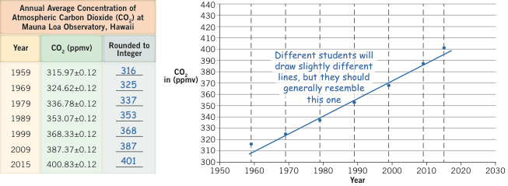**

**1.6D**  **1–3.** See annotated Figure A1.6.1 above.

**4.** The concentration of CO2 in the atmosphere at Mauna Loa Observatory has increased at a steady, or perhaps increasing, rate between 1959 and 2015.

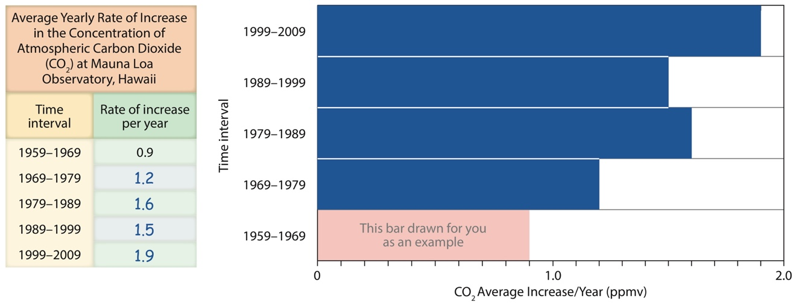

**1.6E** **1–3.** See annotated Figure A1.6.2 above.

**4.** With one exception (1989–99), the average yearly rate of increase of CO2 at Mauna Loa Observatory has increased every decade since 1959.

**1.6F** **1.** Temperature rises generally coincide with CO2 concentration increases, and temperature decreases generally coincide with CO2 concentration decreases. Temperature variations seem to generally track variations in CO2 concentration through several cycles. Carbon dioxide concentrations did not exceed 300 ppm in any of those natural cycles or drop below 180 ppm in any of those natural cycles. According to NOAA’s Earth System Research Laboratory, the current atmospheric CO2 concentration (average for the week of 9–16 April 2017) is 408.85 ppm ([https://www.esrl.noaa.gov/gmd/ccgg/ trends/monthly.html](https://www.esrl.noaa.gov/gmd/ccgg/%20trends/monthly.html)).

**2.** The most obvious type of information that would be useful is the same data from ice cores located elsewhere in the world (for example, Greenland and other continental ice caps) and elsewhere in Antarctica.

**1.6G** **Reflect & Discuss** Based on ice core data reflecting the last 450,000 years of Earth’s climate history, as well as the data from Mauna Loa Observatory since 1959, it is most reasonable to predict a continued rise in atmospheric temperature and CO2 concentration in the future.

**ACTIVITY 1.7: Scaling, Density, and Earth’s Deep Interior**

**1.7A** **1.** The mean radius of Earth (6371 km) is represented by 100 mm in the illustration, and we want a conversion factor that tells us how long 1 km would be in the illustration. So 100 mm is to 6371 as *c* is to 1 km. Isolating the unknown quantity *c*, we have *c* = [(100 mm $×$ 1 km)/6371 km] $≅$ 0.0157 mm. Hence, the conversion factor is 0.0157 mm/km.

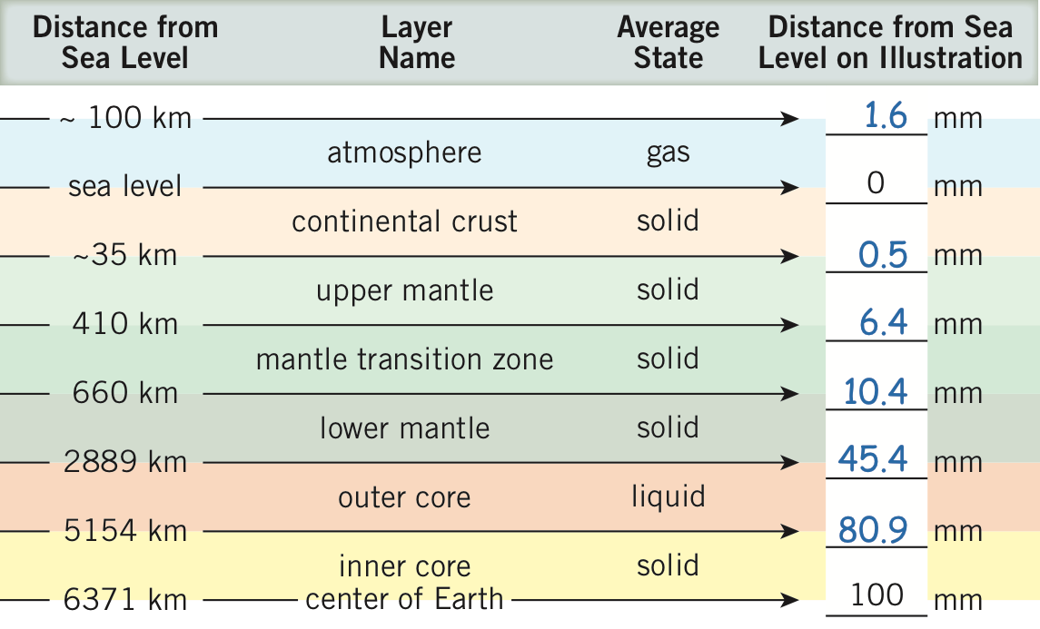

**2.** See annotated Figure A1.7.1 above.

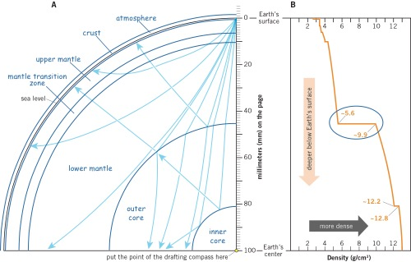

**3–5.** See annotated Figure A1.7.2A above.

**1.7B** **1.** See annotated Figure A1.7.2B above.

**2.** The largest density jump in Earth’s interior occurs at ~2889 km depth.

**3.** The large density jump occurs between the less dense mantle (or lower mantle) and the more dense core (or outer core).

**1.7C** **Reflect & Discuss** The seismic ray paths in the illustration indicate reflections at the boundary between the lower mantle and outer core, and at the boundary between the outer and inner core. Some rays are obviously bent or refracted as they move across the boundary between the lower mantle and outer core.

**1.7D** **Reflect & Discuss** Density of Earth materials increase with decreasing distance to the center of Earth: atmosphere (least dense), ocean, crust, mantle, core (most dense).

**WEB RESOURCES**

Google Earth—<https://www.google.com/earth/>

SI system of units—<http://www.bipm.org/en/publications/si-brochure/>

The Math You Need When You Need It—<http://serc.carleton.edu/mathyouneed/index.html>

**REFERENCES**

2014, The Times Comprehensive Atlas of the World [14th edition]: London, Times Books, 223 pp.

Airy, G.B., 1855, On the computation of the effect of the attraction of mountain-masses, as disturbing the apparent astronomical latitude of stations in geodetic surveys: Philosophical Transactions, Royal Society, London, v. 145, p. 101–104.

Darling, A., and Whipple, K., 2015, Geomorphic constraints on the age of the western Grand Canyon: Geosphere, v. 11, no. 4, p. 958–976, doi: 10.1130/GES01131.1.

Dziewonski, M., and Anderson, D.L., 1981, Preliminary reference Earth model: Physics of the Earth and Planetary Interiors, v. 25, p. 297–356.

Longwell, C.R., 1958, Clarence Edward Dutton, 1841–1912: National Academy of Sciences, Biographical Memoir, p. 130–145.

Neuendorf, K.K.E., Mehl, J.P., Jr., and Jackson, J.A., 2011, Glossary of Geology [5th edition, revised]: Alexandria, Virginia, American Geosciences Institute, 800 pp.

Pratt, J.H., 1855, On the attraction of the Himalaya Mountains, and of the elevated regions beyond them, upon the plumb-line in India: Philosophical Transactions, Royal Society, London, v. 145, p. 53–100.

Pratt, J.H., 1859, On the influence of the ocean on the plumb-line in India: Philosophical Transactions, Royal Society, London, v. 149, p. 779–796.

Yoder, C.F., 1995, Astrometric and geodetic properties of Earth and the Solar System, *in* Ahrens, T.J., editor, Global Earth physics—a handbook of physical constants: Washington, D.C., American Geophysical Union, AGU Reference Shelf 1, 376 pages, ISBN 0-87590-851-9.