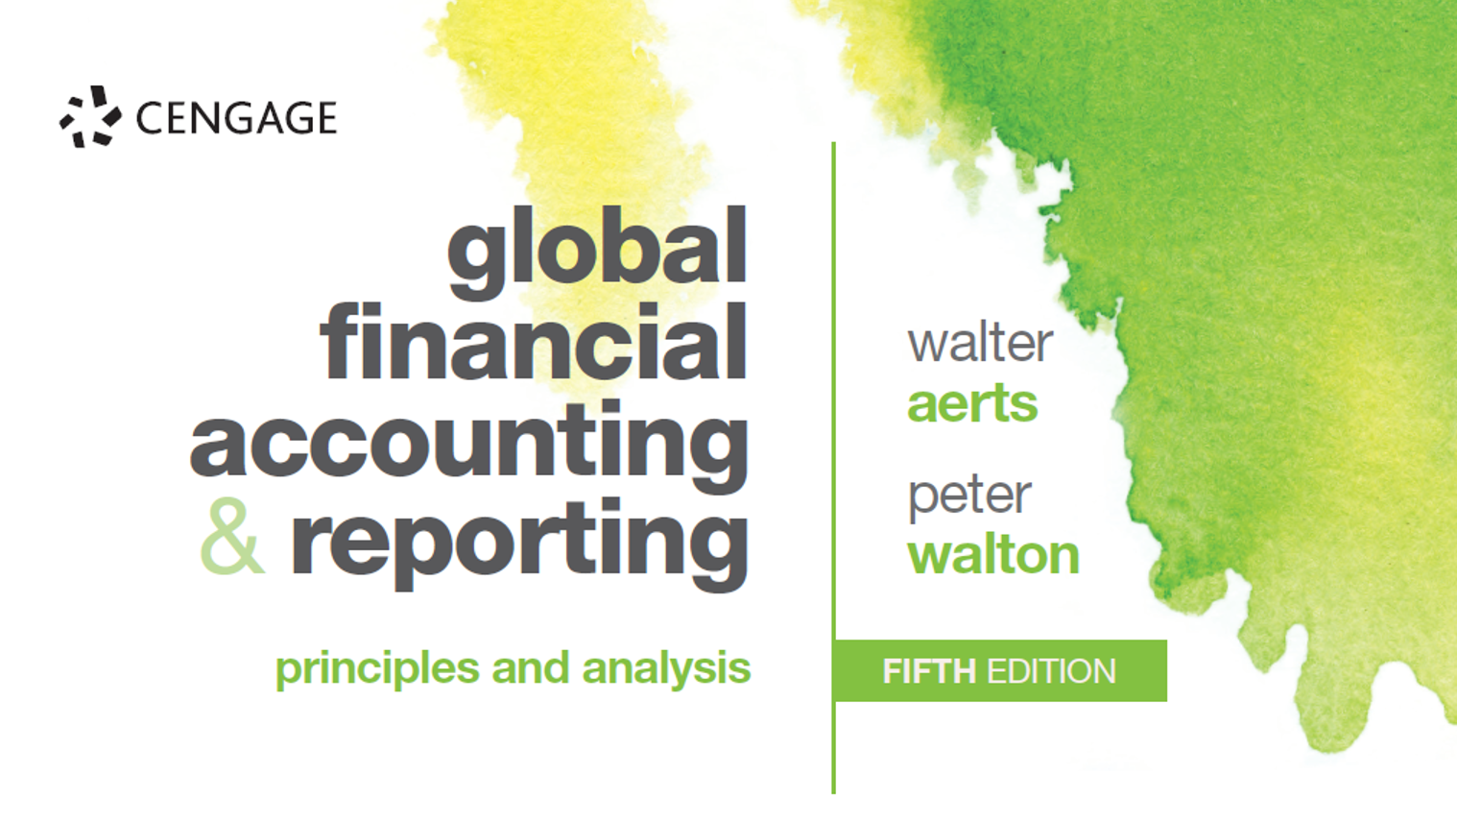

Solutions to end-of-chapter assignments

  - Solution - Jennifer’s canoes

Prerequisites: Chapter 3 + concept of amortisation/depreciation of non-current assets

 | (a) | (b) |  | (c) | (d) | (e) | Year end
Assets
Cash | +60,000 |  | -50,000 | -10,000 | +90,000 | -10,000 | 80,000
Canoes |  |  |  | +30,000 |  | -6,000 | 24,000
Concession |  |  | +50,000 |  |  | -10,000 | 40,000
Total | +60,000 |  | 0 | +20,000 | +90,000 | -26,000 | +144,000
Financing
Liabilities
- Short-term |  |  |  | +20,000 |  |  | 20,000
- Long-term | +40,000 |  |  |  |  |  | 40,000
Equity
Share capital | +20,000 |  |  |  |  |  | 20,000
Profit or loss |  |  |  |  |  |  | 64,000
Sales |  |  |  |  | +90,000
Amortisation concession |  |  |  |  |  | -10,000
Annual rental |  |  |  |  |  | -10,000
Depreciation canoes |  |  |  |  |  | -6,000
Total | +60,000 |  | 0 | +20,000 | +90,000 | -26,000 | +144,000

Statement of profit or loss (Income statement)
Sales |  | 90,000
Expenses
Concession - rental | 10,000
Concession - amortisation | 10,000
Canoe depreciation | 6,000 | -26,000
Profit |  | 64,000

Statement of financial position (Balance sheet)
Intangible fixed assets
Concession | 50,000
Less amortisation | -10,000 | 40,000
Tangible fixed assets
Canoes | 30,000
Less depreciation | -6,000 | 24,000
Cash |  | 80,000
Total |  | 144,000
Equity
Share capital |  | 20,000
Profit for the year |  | 64,000
Liabilities
- Long-term |  | 40,000
- Short-term |  | 20,000
Total |  | 144,000

You may wish to comment on the operating items which are missing in this assignment (e.g., salaries, interest expense, income taxes) and which would significantly affect the current profitability of the business.

3.2 Solution – James / Selling computers

Year 1
Sales |  | 45,000
Cost of computers sold | 30,000
Rent | 6,000
Lease amortisation | 2,500 | -38,500
Profit |  | 6,500
Year 2
Sales |  | 1,000
Cost of computers sold | 20,000
Rent | 6,000
Lease amortisation | 2,500 | -28,500
Loss |  | -27,500
Lifetime result for the business |  | -21,000

3.3 Solution - A&S retail shop (1)
 | Start | April | April | April | April | April | Total
 |  | Rent | Purchase | Advertising | Sales | Salaries
Assets

Motor van |  |  |  |  |  |  | 0
Computer |  |  |  |  |  |  | 0
Shopping carts |  |  |  |  |  |  | 0
Inventory |  |  | 6,300 |  | -3,150 |  | 3,150
Cash | 30,000 | -700 | -6,300 | -1,000 | 4,900 | -1,200 | 25,700
Total | 30,000 | -700 | 0 | -1,000 | 1,750 | -1,200 | 28,850
Financing

Liabilities
Long-term | 4,000 |  |  |  |  |  | 4,000
Short-term | 2,000 |  |  |  |  |  | 2,000
Equity
Share capital | 24,000 |  |  |  |  |  | 24,000
Profit & Loss
Sales |  |  |  |  | 4,900 |  | 4,900
Monthly rent |  | -700 |  |  |  |  | -700
Depreciation |  |  |  |  |  |  | 0
Advertising |  |  |  | -1,000 |  |  | -1,000
Salaries |  |  |  |  |  | -1,200 | -1,200
Interest |  |  |  |  |  |  | 0
Cost of goods sold |  |  |  |  | -3,150 |  | -3,150
Total | 30,000 | -700 | 0 | -1,000 | 1,750 | -1,200 | 28,850

3.3 Solution - A&S retail shop (2)

 | Start | May | May | May | May | Total
 |  | Rent | Purchase | Sales | Salaries
Assets

Motor van | 0 |  |  |  |  | 0
Computer | 0 |  |  |  |  | 0
Shopping carts | 0 |  |  |  |  | 0
Inventory | 3,150 |  | 5,000 | -3,500 |  | 4,650
Cash | 25,700 | -700 | -5,000 | 5,400 | -1,200 | 24,200
Total | 28,850 | -700 | 0 | 1,900 | -1,200 | 28,850
Financing

Liabilities
Long-term | 4,000 |  |  |  |  | 4,000
Short-term | 2,000 |  |  |  |  | 2,000
Equity
Share capital | 24,000 |  |  |  |  | 24,000
Profit & Loss
Sales | 4,900 |  |  | 5,400 |  | 10,300
Monthly rent | -700 | -700 |  |  |  | -1,400
Depreciation | 0 |  |  |  |  | 0
Advertising | -1,000 |  |  |  |  | -1,000
Salaries | -1,200 |  |  |  | -1,200 | -2,400
Interest |  |  |  |  |  | 0
Cost of goods sold | -3,150 |  |  | -3,500 |  | -6,650
Total | 28,850 | -700 | 0 | 1,900 | -1,200 | 28,850

3.3 Solution - A&S retail shop (3)

 | Start | June | June | June | June | June | Total
 |  | Rent | Carts | Sales | Purchase | Salaries
Assets

Motor van | 0 |  |  |  |  |  | 0
Computer | 0 |  |  |  |  |  | 0
Shopping carts | 0 |  | 1,200 |  |  |  | 1,200
Inventory | 4,650 |  |  | -2,900 | 4,650 |  | 6,400
Cash | 24,200 | -700 |  | 4,500 | -4,650 | -1,200 | 22,150
Total | 28,850 | -700 | 1,200 | 1,600 | 0 | -1,200 | 29,750
Financing

Liabilities
Long-term | 4,000 |  |  |  |  |  | 4,000
Short-term | 2,000 |  | 1,200 |  |  |  | 3,200
Equity
Share capital | 24,000 |  |  |  |  |  | 24,000
Profit & Loss
Sales | 10,300 |  |  | 4,500 |  |  | 14,800
Monthly rent | -1,400 | -700 |  |  |  |  | -2,100
Depreciation | 0 |  |  |  |  |  | 0
Advertising | -1,000 |  |  |  |  |  | -1,000
Salaries | -2,400 |  |  |  |  | -1,200 | -3,600
Interest |  |  |  |  |  |  | 0
Cost of goods sold | -6,650 |  |  | -2,900 |  |  | -9,550
Total | 28,850 | -700 | 1,200 | 1,600 | 0 | -1,200 | 29,750
3.3 Solution - A&S retail shop (4)

 | Start | July | July | July | July | Total
 |  | Rent | Sales | Carts | Salaries
Assets

Motor van | 0 |  |  |  |  | 0
Computer | 0 |  |  |  |  | 0
Shopping carts | 1,200 |  |  |  |  | 1,200
Inventory | 6,400 |  | -4,500 |  |  | 1,900
Cash | 22,150 | -700 | 7,200 | -1,200 | -1,200 | 26,250
Total | 29,750 | -700 | 2,700 | -1,200 | -1,200 | 29,350
Financing

Liabilities
Long-term | 4,000 |  |  |  |  | 4,000
Short-term | 3,200 |  |  | -1,200 |  | 2,000
Equity
Share capital | 24,000 |  |  |  |  | 24,000
Profit & Loss
Sales | 14,800 |  | 7,200 |  |  | 22,000
Monthly rent | -2,100 | -700 |  |  |  | -2,800
Depreciation | 0 |  |  |  |  | 0
Advertising | -1,000 |  |  |  |  | -1,000
Salaries | -3,600 |  |  |  | -1,200 | -4,800
Interest |  |  |  |  |  | 0
Cost of goods sold | -9,550 |  | -4,500 |  |  | -14,050
Total | 29,750 | -700 | 2,700 | -1,200 | -1,200 | 29,350

3.3 Solution - A&S retail shop (5)

 | Start | August | August | August | August | August | Total
 |  | Rent | Purchase | Motor van | Sales | Salaries
Assets

Motor van | 0 |  |  | 15,000 |  |  | 15,000
Computer | 0 |  |  |  |  |  | 0
Shopping carts | 1,200 |  |  |  |  |  | 1,200
Inventory | 1,900 |  | 4,800 |  | -3,800 |  | 2,900
Cash | 26,250 | -700 | -4,800 | -12,000 | 5,800 | -1,200 | 13,350
Total | 29,350 | -700 | 0 | 3,000 | 2,000 | -1,200 | 32,450
Financing

Liabilities
Long-term | 4,000 |  |  |  |  |  | 4,000
Short-term | 2,000 |  |  | 3,000 |  |  | 5,000
Equity
Share capital | 24,000 |  |  |  |  |  | 24,000
Profit & Loss
Sales | 22,000 |  |  |  | 5,800 |  | 27,800
Monthly rent | -2,800 | -700 |  |  |  |  | -3,500
Depreciation | 0 |  |  |  |  |  | 0
Advertising | -1,000 |  |  |  |  |  | -1,000
Salaries | -4,800 |  |  |  |  | -1,200 | -6,000
Interest |  |  |  |  |  |  | 0
Cost of goods sold | -14,050 |  |  |  | -3,800 |  | -17,850
Total | 29,350 | -700 | 0 | 3,000 | 2,000 | -1,200 | 32,450

3.3 Solution - A&S retail shop (6)

 | Start | September | September | September | September | September | September | Total
 |  | Rent | Purchase | Sales | Sales | Loan | Salaries
Assets

Motor van | 15000 |  |  |  |  |  |  | 15,000
Computer | 0 |  |  |  |  |  |  | 0
Shopping carts | 1200 |  |  |  |  |  |  | 1,200
Inventory | 2900 |  | 6,500 | -3,500 | -750 |  |  | 5,150
Cash | 13350 | -700 | -6,500 | 5,000 | 1,200 | -1,180 | -1,200 | 9,970
Total | 32450 | -700 | 0 | 1,500 | 450 | -1,180 | -1,200 | 31,320
Financing

Liabilities
Long-term | 4000 |  |  |  |  |  |  | 4,000
Short-term | 5000 |  |  |  |  | -1,000 |  | 4,000
Equity
Share capital | 24000 |  |  |  |  |  |  | 24,000
Profit & Loss
Sales | 27800 |  |  | 5,000 | 1,200 |  |  | 34,000
Monthly rent | -3500 | -700 |  |  |  |  |  | -4,200
Depreciation | 0 |  |  |  |  |  |  | 0
Advertising | -1000 |  |  |  |  |  |  | -1,000
Salaries | -6000 |  |  |  |  |  | -1,200 | -7,200
Interest |  |  |  |  |  | -180 |  | -180
Cost of goods sold | -17850 |  |  | -3,500 | -750 |  |  | -22,100
Total | 32450 | -700 | 0 | 1,500 | 450 | -1,180 | -1,200 | 31,320

3.3 Solution - A&S retail shop (7)

 | Start | October | October | October | October | October | Total
 |  | Rent | Sales | Sales | Purchase | Salaries
Assets

Motor van | 15,000 |  |  |  |  |  | 15,000
Computer | 0 |  |  |  |  |  | 0
Shopping carts | 1,200 |  |  |  |  |  | 1,200
Inventory | 5,150 |  | -2,000 | -750 | 1,250 |  | 3,650
Cash | 9,970 | -700 | 3,400 | 1,200 | -1,250 | -1,200 | 11,420
Total | 31,320 | -700 | 1,400 | 450 | 0 | -1,200 | 31,270
Financing

Liabilities
Long-term | 4,000 |  |  |  |  |  | 4,000
Short-term | 4,000 |  |  |  |  |  | 4,000
Equity
Share capital | 24,000 |  |  |  |  |  | 24,000
Profit & Loss
Sales | 34,000 |  | 3,400 | 1,200 |  |  | 38,600
Monthly rent | -4,200 | -700 |  |  |  |  | -4,900
Depreciation | 0 |  |  |  |  |  | 0
Advertising | -1,000 |  |  |  |  |  | -1,000
Salaries | -7,200 |  |  |  |  | -1,200 | -8,400
Interest | -180 |  |  |  |  |  | -180
Cost of goods sold | -22,100 |  | -2,000 | -750 |  |  | -24,850
Total | 31,320 | -700 | 1,400 | 450 | 0 | -1,200 | 31,270

