Chapter 1: Problem Solving: Strategies and Principles
Section 1.1: Problem Solving

1. Drawings may vary.
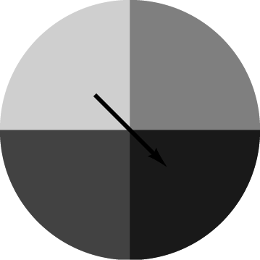
2. Drawings may vary.
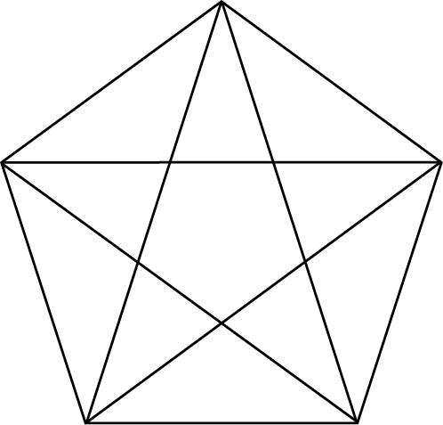
3. Drawings may vary.
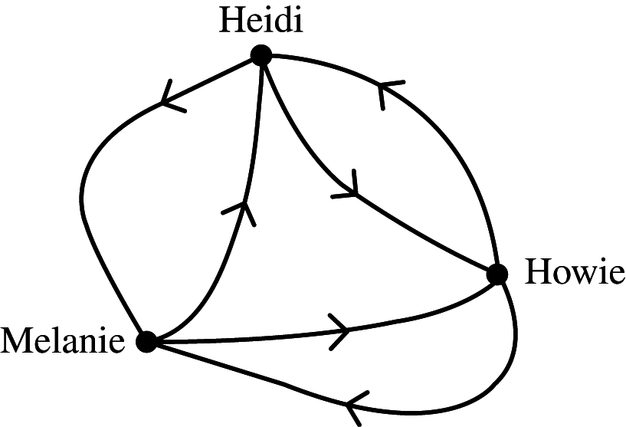
4. Drawings may vary.
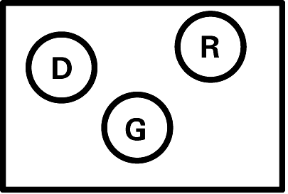

5. Answers may vary. Let be the hybrid automobiles, be the windmill turbines, and be solar energy.
6. Answers may vary. Let be Tyrion, be Jamie, be Cersei, be Daenerys, and be Sansa.
7. Answers may vary. Let be the dollar amount invested in stocks and be the dollar amount invested in bonds.
8. Answers may vary. Let be the amount of calcium and be the amount of protein.
9. Answers (order) may vary. Combinations would be HH, HT, TH, and TT.
Penny | Nickel
Heads | Heads
Heads | Tails
Tails | Heads
Tails | Tails
10. Answers (order) may vary. Pairs would be (1, 1), (1, 2), (1, 3), (2, 1), (2, 2), (2, 3), (3, 1), (3, 2), and (3, 3).
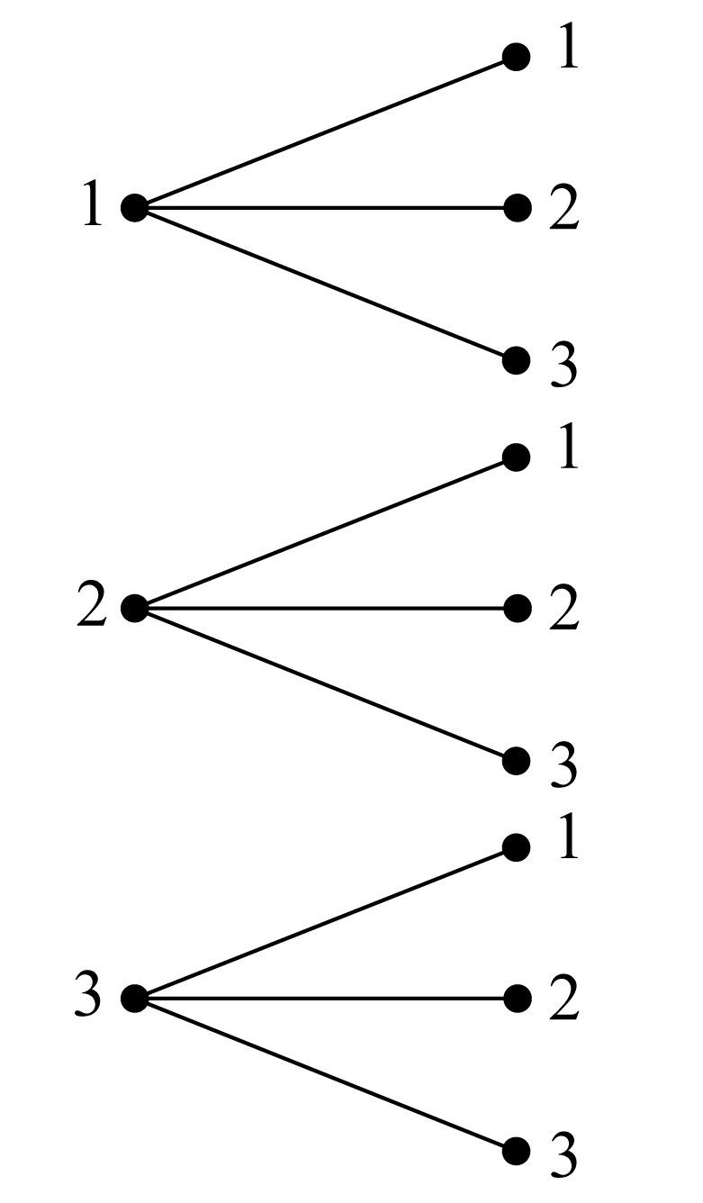

11. Graph not provided.
12.

13. Answers (order) may vary. Using the "Be Systematic" strategy, first list all pairs that begin with L, next all new pairs that begin with S, etc. Pairs would be LS, LB, LE, LD, SB, SE, SD, BE, BD, ED.
14. Answers (order) may vary. Routes you can take are: (Begin, A, D, H, End), (Begin, A, E, H, End), (Begin, A, E, I, End), (Begin, B, E, H, End), (Begin, B, E, I, End), (Begin, B, F, I, End), (Begin, B, F, J, End), (Begin, C, F, I, End), (Begin, C, F, J, End), and (Begin, C, G, J, End).
15. (1, 1), (1, 2), (1, 3), (1, 4), (2, 1), (2, 2), (2, 3), (2, 4), (3, 1), (3, 2), (3, 3), (3, 4), (4, 1), (4, 2), (4, 3),
(4, 4)
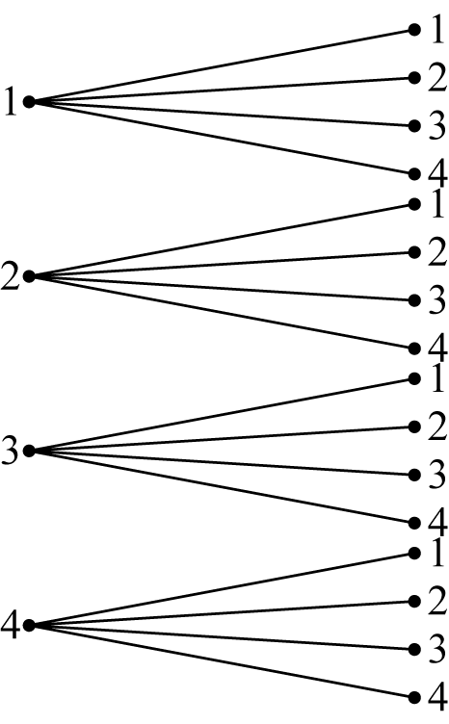
16. (1, 2), (1, 3), (1, 4), (2, 1), (2, 3), (2, 4), (3, 1), (3, 2), (3, 4), (4, 1), (4, 2), (4, 3)
17. is the set of people who are good singers and appeared on “American Idol”. is the set of people who have appeared on “American Idol” and are not good singers.
18. is the set of people who are working to reduce global warming but not striving to reduce world hunger. is the set of people who are striving to reduce world hunger but not working to reduce global warming.
19. 35, 42, 49, 56, 63; multiples of 7
20. 81, 243, 729, 2187, 6561; multiples of 3
21.
22. (2, 4), (2, 5), (2, 6), (3, 1), (3, 2)
23. 21, 34, 55, 89, 144; sum of previous two numbers
24. 19, 23, 29, 31, 37; prime numbers
25. Answers may vary.
In how many ways can we line up three people for a picture? Let the people be labeled A, B, and C.
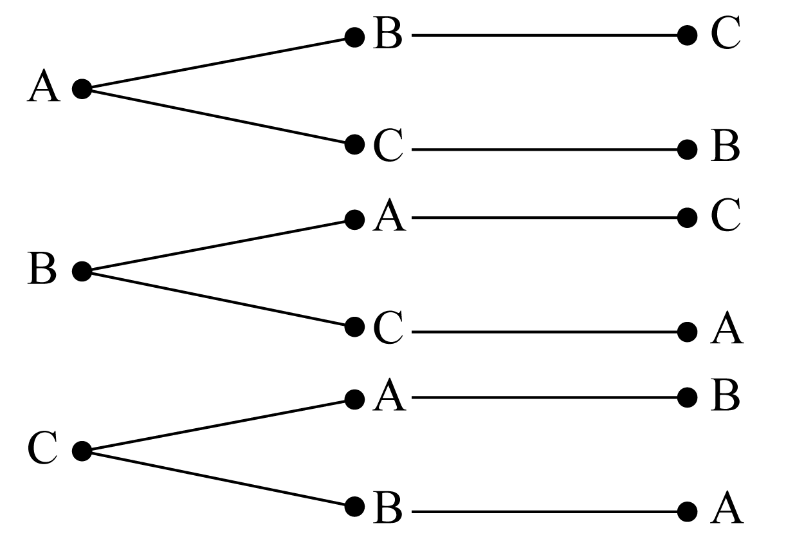
The possible orders are ABC, ACB, BAC, BCA, CAB, and CBA. There are 6 different ways.
In how many ways can we line up four people for a picture? Let the people be labeled A, B, C, and D.
25. (continued)
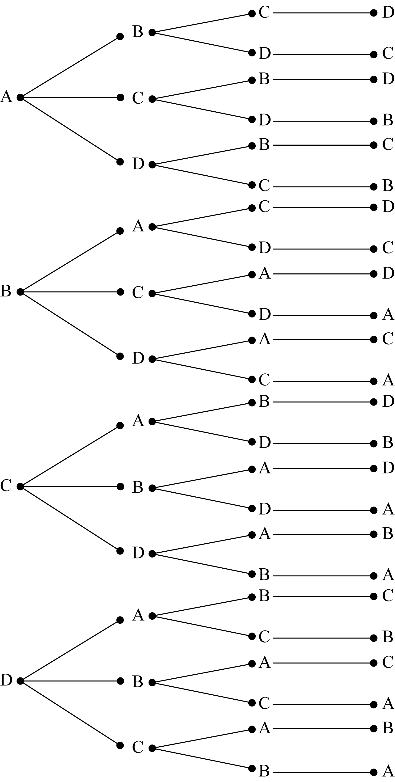
The possible orders are ABCD, ABDC, ACBD, ACDB, ADBC, ADCB, BACD, BADC, BCAD, BCDA, BDAC, BDCA, CABD, CADB, CBAD, CBDA, CDAB, CDBA, DABC, DACB, DBAC, DBCA, DCAB, and DCBA. There are 24 different ways.
26. Answers may vary. If you guess at 2 true-false questions, how many different ways can you fill in the 2 answers?
1 | 2
T | T
T | F
F | T
F | F
There are 4 different ways.
If you guess at 3 true-false questions, how many different ways can you fill in the 3 answers?
1 | 2 | 3
T | T | T
T | T | F
T | F | T
T | F | F
F | T | T
F | T | F
F | F | T
F | F | F
There are 8 different ways.
26. (continued)
If you guess at 4 true-false questions, how many different ways can you fill in the 4 answers?
1 | 2 | 3 | 4
T | T | T | T
T | T | T | F
T | T | F | T
T | T | F | F
T | F | T | T
T | F | T | F
T | F | F | T
T | F | F | F
F | T | T | T
F | T | T | F
F | T | F | T
F | T | F | F
F | F | T | T
F | F | T | F
F | F | F | T
F | F | F | F
There are 16 different ways.
27. Answers may vary. Using the first three letters of the alphabet, how many two-letter codes can we form if we are allowed to use the same letter twice?
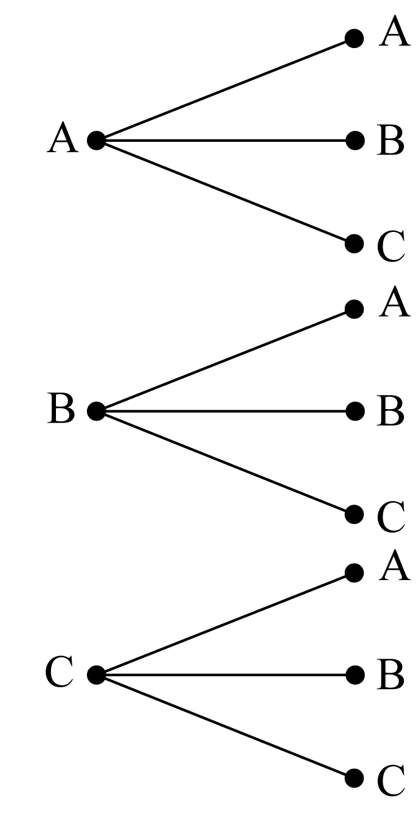
The possible codes are AA, AB, AC, BA, BB, BC, CA, CB, and CC. There are 9 different codes.
27. (continued)
Using the first five letters of the alphabet, how many two-letter codes can we form if we are allowed to use the same letter twice?
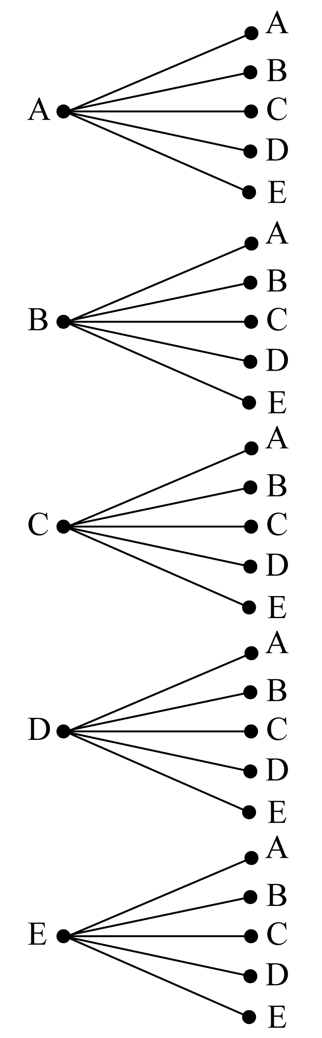
The possible codes are AA, AB, AC, AD, AE, BA, BB, BC, BD, BE, CA, CB, CC, CD, CE, DA, DB, DC, DD, DE, EA, EB, EC, ED, and EE. There are 25 different codes.
28. Answers may vary.
A family has three children. If we list the gender of the children, how many different lists are possible?
1 | 2 | 3
g | g | g
g | g | b
g | b | g
g | b | b
b | g | g
b | g | b
b | b | g
b | b | b
There are 8 different lists.
28. (continued)
A family has four children. If we list the gender of the children, how many different lists are possible?
1 | 2 | 3 | 4
g | g | g | g
g | g | g | b
g | g | b | g
g | g | b | b
g | b | g | g
g | b | g | b
g | b | b | g
g | b | b | b
b | g | g | g
b | g | g | b
b | g | b | g
b | g | b | b
b | b | g | g
b | b | g | b
b | b | b | g
b | b | b | b
There are 16 different lists.
29. Answers may vary.
An electric-blue Ferrari comes with two options: run flat tires and front heated seats. You may buy the car with any combination of the options (including none). How many different choices do you have? Let be run flat tires and be front heated seats. If a feature is not included, it is indicated by a “0”. If it is included, it is indicated by a “1”. There are 4 different choices.
0 | 0
0 | 1
1 | 0
1 | 1
An electric-blue Ferrari comes with three options: run flat tires, front heated seats, and polished rims. You may buy the car with any combination of the options (including none). How many different choices do you have? Let be run flat tires, be front heated seats, and be polished rims. If a feature is not included, it is indicated by a “0”. If it is included, it is indicated by a “1”. There are 8 different choices.
0 | 0 | 0
0 | 0 | 1
0 | 1 | 0
0 | 1 | 1
1 | 0 | 0
1 | 0 | 1
1 | 1 | 0
1 | 1 | 1
30. Answers may vary.
You have 2 different colors of paper to use and 3 different styles of font. How many different ways can you print your resume?
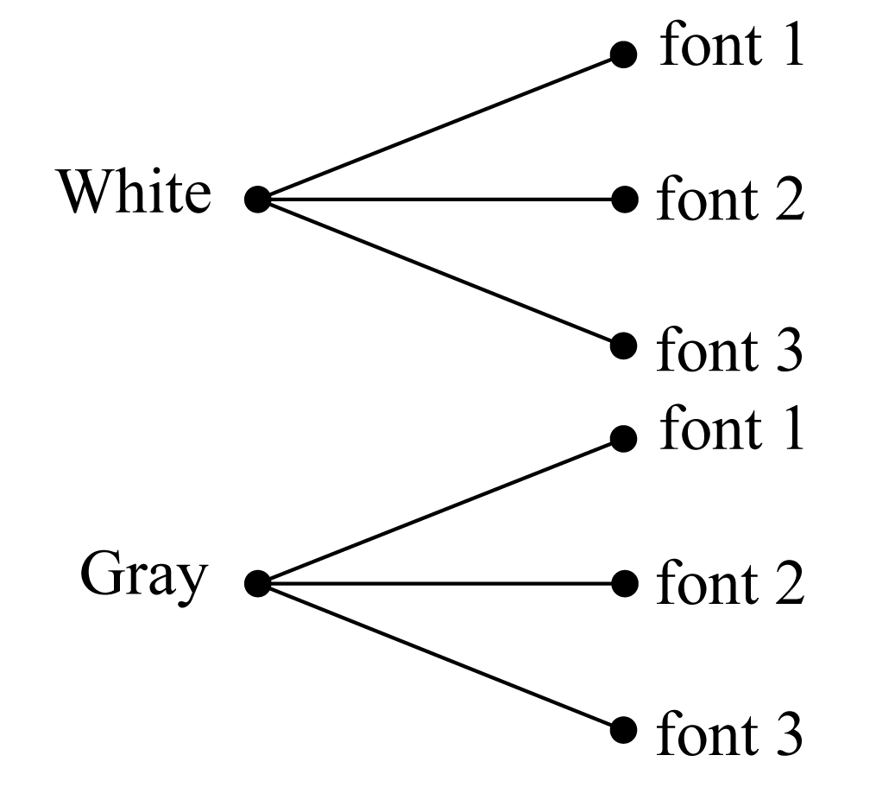
There are 6 different ways .
You have 2 different colors of paper to use and 4 different styles of font. How many different ways can you print your resume?
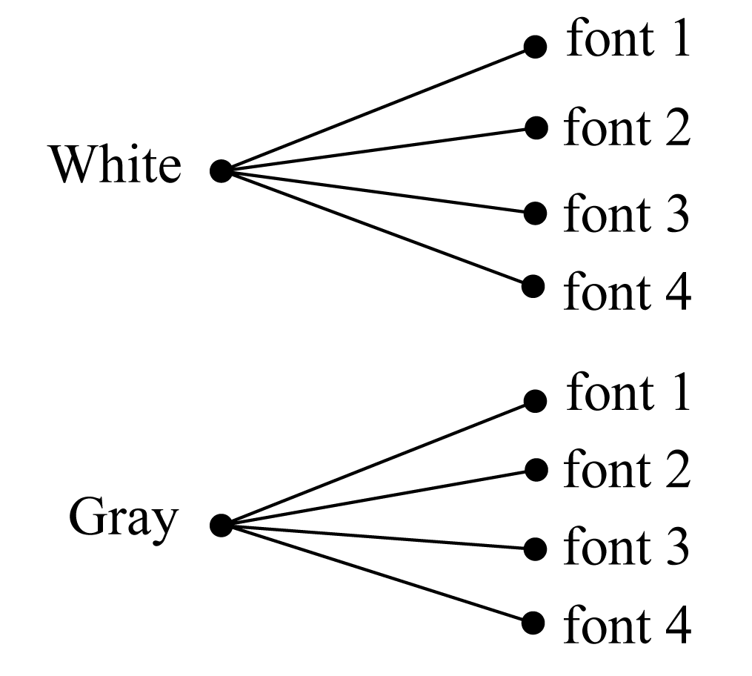
There are 8 different ways.
31. False, counterexamples may vary. June has 30 days.
32. False, counterexamples may vary. At the time this book was written, this was false because Bill Clinton is still alive.
33. False, counterexamples may vary.
34. False, counterexamples may vary.
35. False, A is the grandfather of C.
36. False, counterexamples may vary. You know your instructor and your instructor knows his/her mother, but (most likely) you don’t know your instructor’s mother.
37. False, counterexamples may vary. If the price of a $10.00 item is increased by 10%, its new price is $11.00. If the $11.00 item is then decreased by 10%, the new price would be $9.90, not $10.00.
38. False, counterexamples may vary. If your hourly rate of $10.00 is decreased by 20%, the new rate is $8.00. If the $8.00 rate is then increased by 20%, the new rate would be $9.60, not $10.00.
39. Explanations may vary. These two sequences do not give the same results. The question here is equivalent to asking if the algebraic statement, , is true.
If we let we have a counterexample.
Hence, the statement is false.
40. Explanations may vary. These two sequences do not give the same results. The question here is equivalent to asking if the algebraic statement, , is true.
If we let and we have a counterexample.
Hence, the statement is false.
41. Explanations may vary. These two sequences do give the same results. The question here is equivalent to asking if the algebraic statement, is true. If you think of dividing by 3 as equivalent to multiplying by then you can use the distributive property to prove this statement.
42. Explanations may vary. These two sequences do give the same results. The question here is equivalent to asking if the algebraic statement, is true. The proof of this statement is equivalent to proving the distributive property.
43. Answers may vary. 5 is a number; is a number with braces around it. Moreover, 5 is a singly listed element, while is a set that contains the single element 5.
44. Answers may vary. The second has a prime on it. Moreover, is a set (which is a subset of some universal set and is the complement of set relative to some universal set
45. Answers may vary. One is uppercase and the other is lowercase. Moreover, usually denotes the universal set, and the lower case letters are usually elements that appear in some set.
46. Answers may vary. are different from Moreover, is the set that contains only the elements 1 and 2. is the interval that contains all real numbers between 1 and 2 (not including 1 and 2 themselves). Note: Another interpretation of is being a point in a plane. However, with in this same problem, the interpretation should be relative to sets.
47. Answers may vary. The order of the numbers is different. Moreover, if you interpret and as intervals, they are both expressing the same set of numbers. The standard, however, is to express intervals in such a way that (assuming and are real numbers). Note: Another interpretation of and is as points in the plane, and these two points would be different. They would be points that are reflected over the line The context of this question, however, is relative to intervals.
48. The symbol on the right is the number zero; the symbol on the left is not a number.
49. – 52. No solution provided.
53. Answers may vary. Let be the age of the older building and be the age of the younger building.
Guesses for and | Good Points | Weak Points
100, 221 | Sum is 321. | The older is more than twice the younger.
110, 211 | Sum is 321. | The older is less than twice the older.
107, 214 | All conditions satisfied.  We have the solution.
The buildings are 107 and 214 years old.
54. Answers may vary. Let be the shortest piece, be the middle size piece, and be the longest piece.
Guesses for and | Good Points | Weak Points
3, 8, and 24 | The longest is 3 times the middle size and the shortest is 5 less than the middle size. | Total length is less than 40.
5, 10, and 30 | The longest is 3 times the middle size and the shortest is 5 less than the middle size. | Total length is more than 40.
4, 9, and 27 | All conditions satisfied.  We have the solution
The three pieces should be 4, 9, and 27 inches long.
55. Answers may vary. Let be the number of times Tom Brady threw a touchdown pass, be the number of times Phillip Rivers threw a touchdown pass, and be the number of times Aaron Rodgers threw a touchdown pass.
Guesses for and | Good Points | Weak Points
30, 24, and 22 | is 2 more than and 6 less than | Sum is less than 94.
40, 34, and 32 | is 2 more than and 6 less than | Sum is more than 94.
36, 30, and 28 | All conditions satisfied.  We have the solution.
Brady had 36 touchdowns.
56. Answers may vary. Let be the number of home runs hit by Joc Pederson, be the number of home runs hit by Todd Frazier and be the number of home runs hit by Prince Fielder.
Guesses for and | Good Points | Weak Points
30, 29 and 7 | is 1 more than and is 23 more than | Sum is less than 72.
40, 39 and 17 | is 1 more than and is 23 more than | Sum is more than 72.
32, 31 and 9 | All conditions satisfied.  We have the solution.
Pederson had 32 hits.
57. Answers may vary. Let be the amount invested at 8% and be the amount invested at 6%.
Guesses for and | Good Points | Weak Points
$3,000 and $5,000 | Sum is $8,000. | Return is less than $550.
$4,000 and $4,000 | Sum is $8,000. | Return is more than $550.
$3,500 and $4,500 | All conditions satisfied.  We have the solution
Heather invested $3,500 at 8% and $4,500 at 6%.
58. Answers may vary. Let be the amount invested at 11% and be the amount invested at 8%.
Guesses for and | Good Points | Weak Points
$7,000 and $2,000 | Sum is $9,000. | Return is less than $936.
$7,500 and $1,500 | Sum is $9,000. | Return is more than $936.
$7,200 and $1,800 | All conditions satisfied.  We have the solution.
Carlos invested $7,200 at 11% and $1,800 at 8%.
59. Answers may vary. Let be the number of administrators, be the number of students, and be the number of faculty members.
Guesses for and | Good Points | Weak Points
10, 2, and 7 | is 5 times and is 5 more than S. | There are less than 26 people.
20, 4, and 9 | is 5 times and is 5 more than S. | There are more than 26 people.
15, 3, and 8 | All conditions satisfied.  We have the solution.
There are 3 students.
60. Answers may vary. Let be the number of senior citizens, be the number of young adults, and be the number of middle-aged adults.
Guesses for and | Good Points | Weak Points
18, 6, and 9 | is 3 times and is one-half | There are less than 55 people.
36, 12, and 18 | is 3 times and is one-half | There are more than 55 people.
30, 10, and 15 | All conditions satisfied. We have the solution.
There are 30 senior citizens.
61. LCHPL, LCPHL, LHCPL, LHPCL, LPCHL, LPHCL
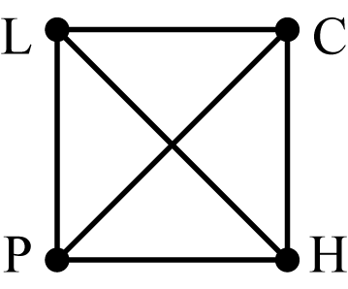

62.
63. PN, PD, PQ, ND, NQ, DQ
64. PND, PNQ, PDQ, NDQ, PNDQ

65. The possible schedules are given in the table below.
Math | English | Sociology | Art History
9 | 11 | 12 | 10
9 | 12 | 10 | 11
10 | 9 | 12 | 11
10 | 11 | 12 | 9
12 | 9 | 10 | 11
12 | 11 | 10 | 9
66. The possible schedules are given in the table below.
Math | English | Sociology | Art History
9 | 11 | 12 | 10
9 | 12 | 10 | 11
12 | 9 | 10 | 11
67. The possible schedules are given in the table below.
Math | English | Art History
9 | 11 | 10
9 | 12 | 10
9 | 12 | 11
10 | 9 | 11
10 | 11 | 9
10 | 12 | 9
10 | 12 | 11
12 | 9 | 10
12 | 9 | 11
12 | 11 | 9
12 | 11 | 10
68. The possible schedules are given in the table below.
Math | English | Sociology | Art History
9 | 11 | 12 | 10
9 | 12 | 11 | 10
10 | 9 | 12 | 11
10 | 11 | 12 | 9
10 | 12 | 11 | 9
12 | 9 | 11 | 10
69. 79; The top and bottom rows will both have 21 tiles, the middle row will have one tile, and the remaining 18 rows will have 2 tiles each.
70. 48; The top and bottom rows will both have 1 tile, and the remaining 23 rows will have 2 tiles each.
71. You will pay more, in total, over the two years if the 8% raise occurs first. As an example, if tuition is $100 and the 8% raise occurs first, you will pay the first year and the second year, for a total of $221.40. If the 5% raise occurs first, you will pay the first year and the second year, for a total of $218.40. Note that in either case, you would pay the same tuition during the second year.
72. The board would not follow its mandate. As an example, if tuition is $100, you will pay after the first increase, after the second increase, and after the third increase, which is an approximately 10.3% increase.

73. – 76. Answers will vary.
77.

78.

79. (41, 43), (59, 61); Pairs of sequential primes that differ by 2.
80. (23, 31), (29, 37); The first numbers are the primes in order, the second numbers come from taking the second prime number after the first.
81. There are a total of 55 squares.

 | 25 |  |  | 4
 | 16 |  |  | 1
 | 9


82. a) 12
b) 6
c) 100


 | 16 |  |  | 12 |  |  | 3 |  |  | 4
 | 9 |  |  | 8 |  |  | 2 |  |  | 6
 | 4 |  |  | 4 |  |  | 12 |  |  | 3
 | 1 |  |  | 6 |  |  | 8 |  |  | 2
83. As you look at the intersections, you’ll see that there is a pattern as to how many routes can be created as you leave the Hard Rock Cafe on the way to The Cheesecake Factory. To choose direct routes, you must always be traveling down and/or to the right. The numbers indicate how many ways there are to get to the intersection below and to the right of the number. For example, the “2” below and to the right of the Hard Rock Cafe indicates there are two ways to arrive at that intersection, one by going right, then down, and another by going down, and then right. There are a total of 252 possible routes.
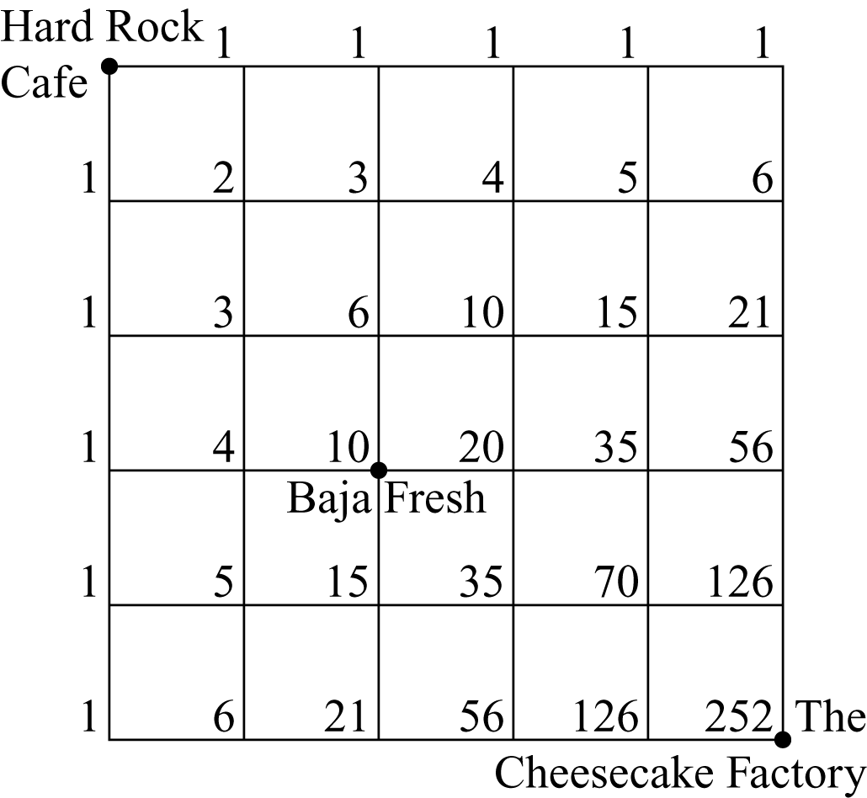

84. As you look at the intersections, you’ll see that there is a pattern as to how many routes can be created as you leave the Hard Rock Cafe on the way to Baja Fresh and as you leave Baja Fresh on the way to The Cheesecake Factory. To choose direct routes, you must always be traveling down and/or to the right. The numbers indicate how many ways there are to get to the intersection below and to the right of the number. Since there are 10 ways to go from the Hard Rock Cafe to Baja Fresh and 10 ways to go from the Baja Fresh to The Cheesecake Factory , there are possible routes.
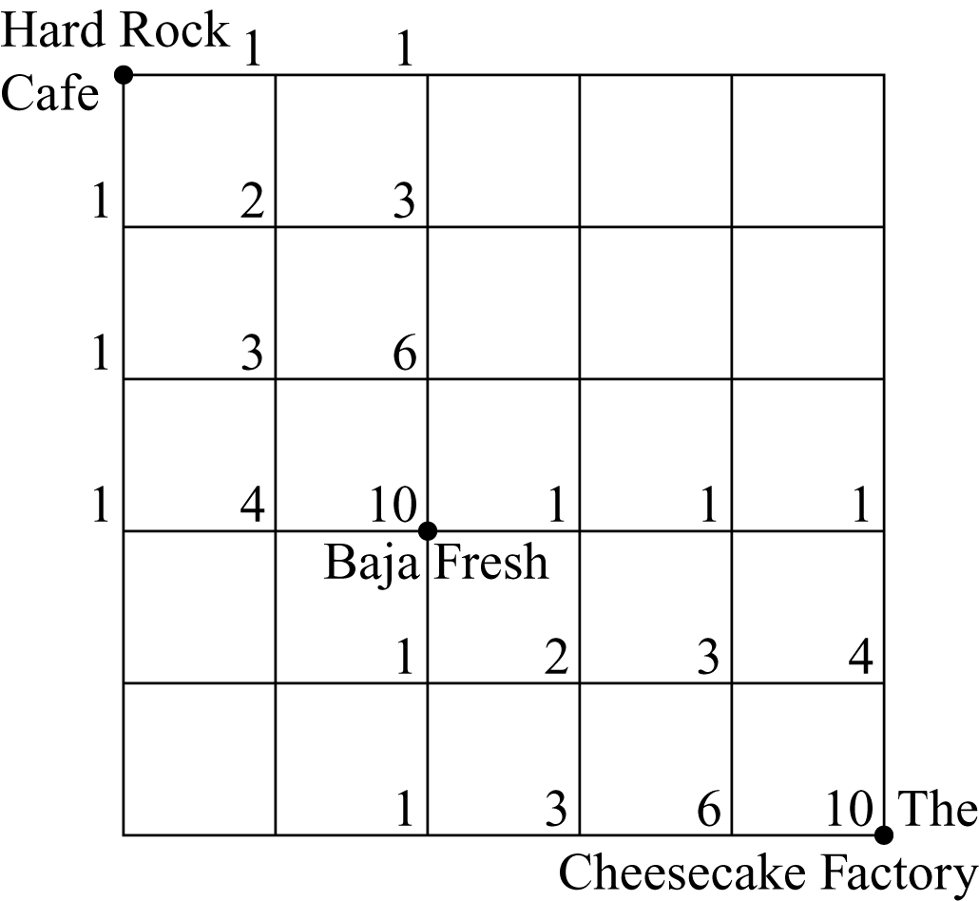
Section 1.2: Inductive and Deductive Reasoning

1. inductive
2. deductive
3. deductive
4. inductive
5. inductive
6. deductive
7. deductive
8. inductive
9. inductive
10. deductive

11. 16
12. 32
13. 96
14. 1,215
15. 21
16. 0.101010

17.

18.
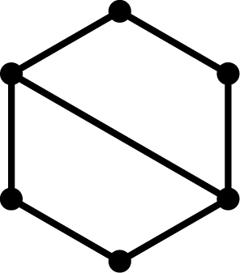

19. A blue face in a green box followed by a red face in a blue box.

20. A red face in a blue box followed by a blue face in a green box.


21. Hint: Think of prime numbers.
2 3 5 7 11 13
22. Hint: Think of the Fibonacci sequence.
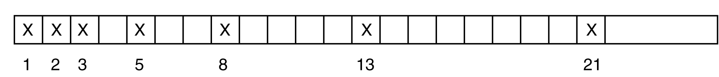

23. or
24. or
25. or
26. or

27.
28.
29.
30.
31.
32.
33. a) The total of all the numbers in the square is
b) The total of the numbers for each row, column, and diagonal would be
c) One can deduce the missing numbers to yield the following.
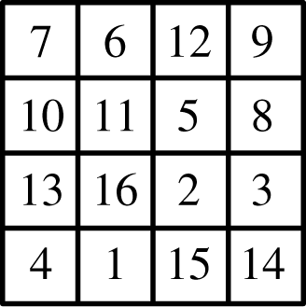
34. a) The total of all the numbers in the square is
b) The total of the numbers for each row, column, and diagonal would be
c) One can deduce the missing numbers to yield the following.
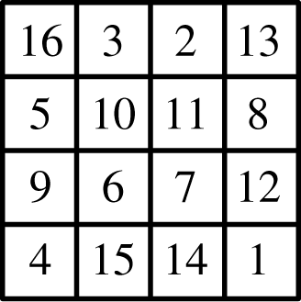

35.
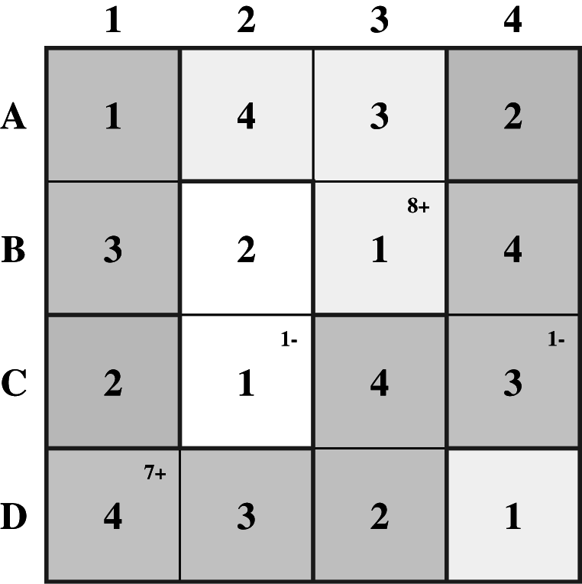
36.
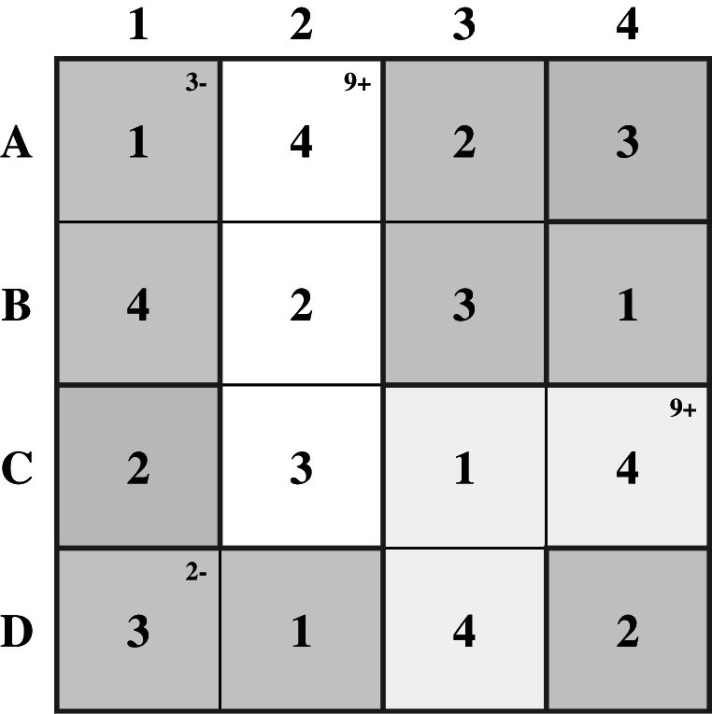

37. Yes; there are many ways to do this. Try to rewrite the puzzle in various ways with some numbers or clues missing to see if you can still solve it.
38. Yes; there are many ways to do this. Try to rewrite the puzzle in various ways with some numbers or clues missing to see if you can still solve it.
39. Adriana (political issues), Caleb (solar power), Ethan (water conservation), and Julia (recycling)
40. Jessica (third), Serena (second), Andre (fourth), and Emily (first)
41. 36644633; Reversing the number in the first pair yields the relationship so G, A, and L correspond to 6, 4, and 3, respectively. Assigning these values to the letters in the second word yields Reversing the order of the resulting number leads to the final value of 36644633.
42. leader; Froofrug Merduc represents “Where is your”
43. 986763; reverse the numbers and delete one number from any pair of numbers.
44. 20; the numbers are found by repeatedly adding 6 then subtracting 2.
45. Answers may vary. Possible responses include that Sharifa would begin by visiting one of the six branches and then visit the five original cities in 120 ways. The total number of ways she could make her visits is ways. The same reasoning would lead to ways for seven cities.
46. Reasons will vary.
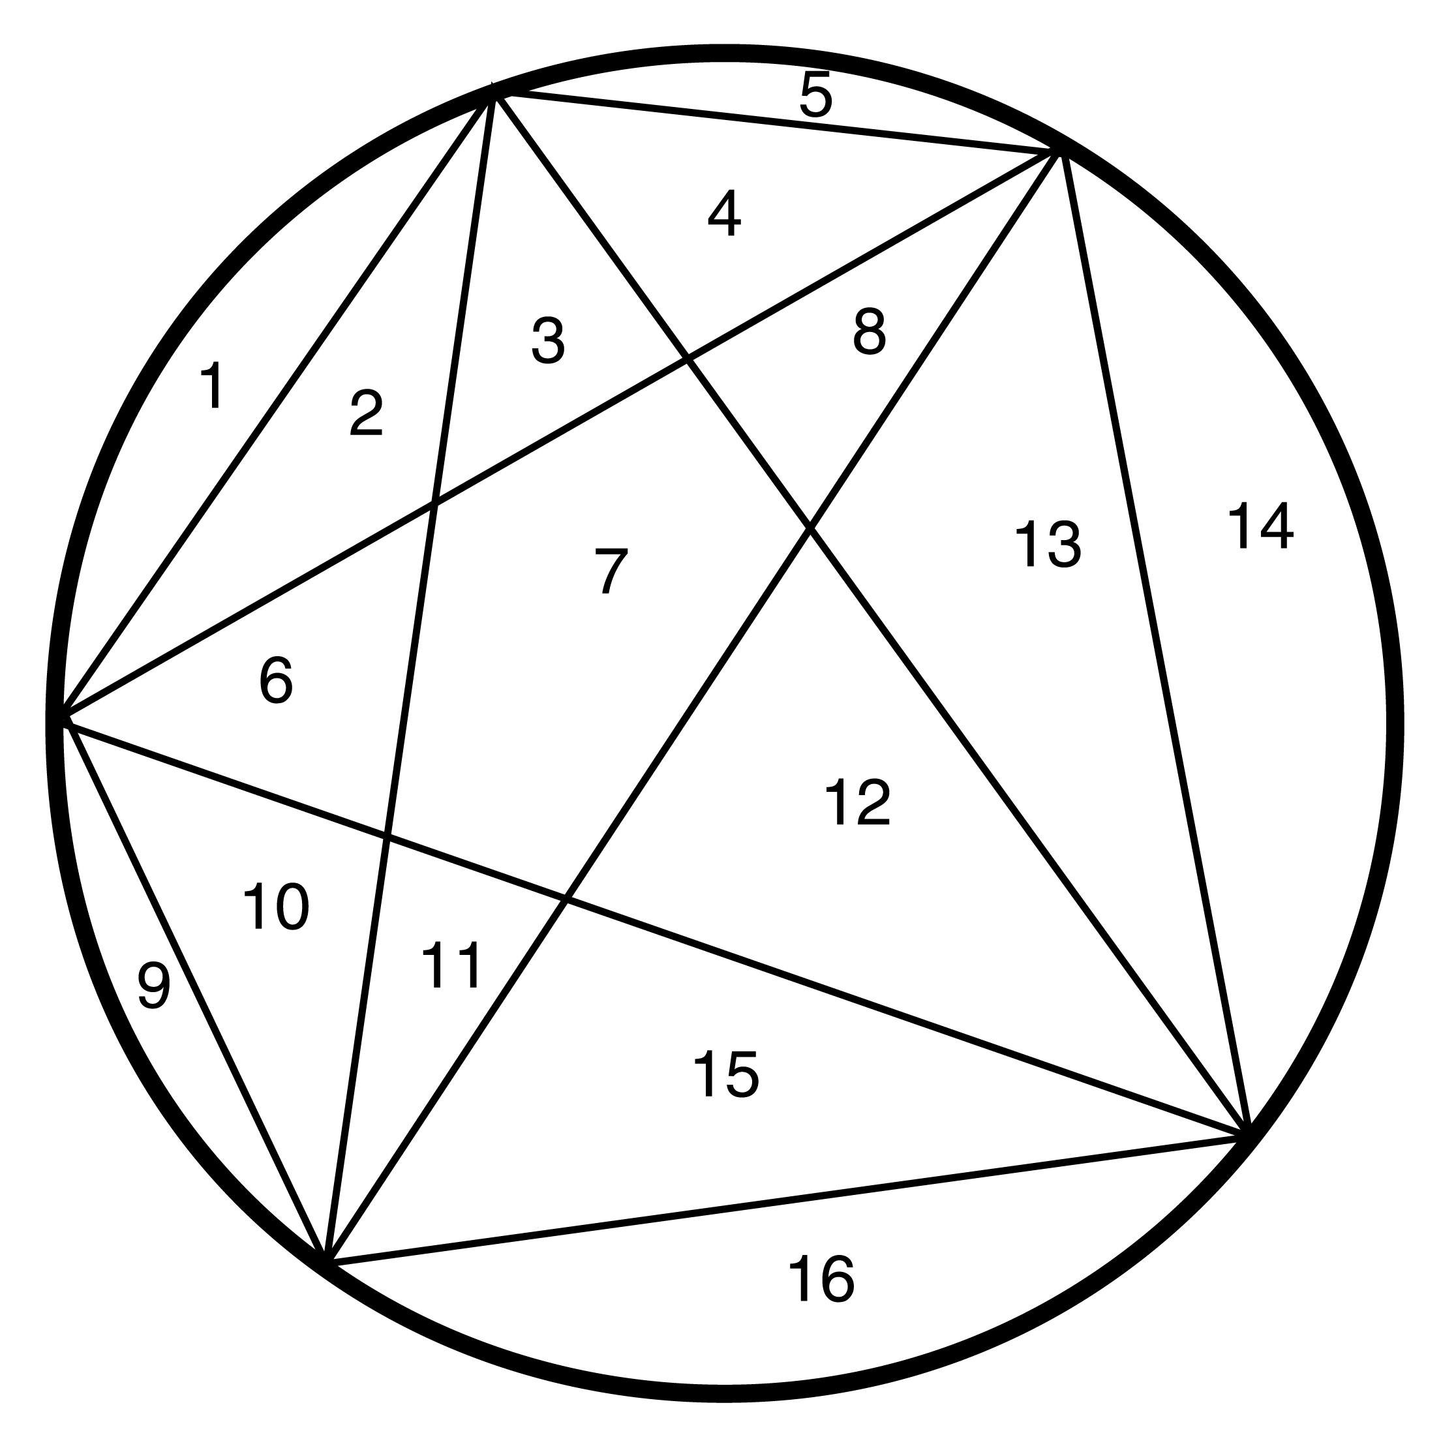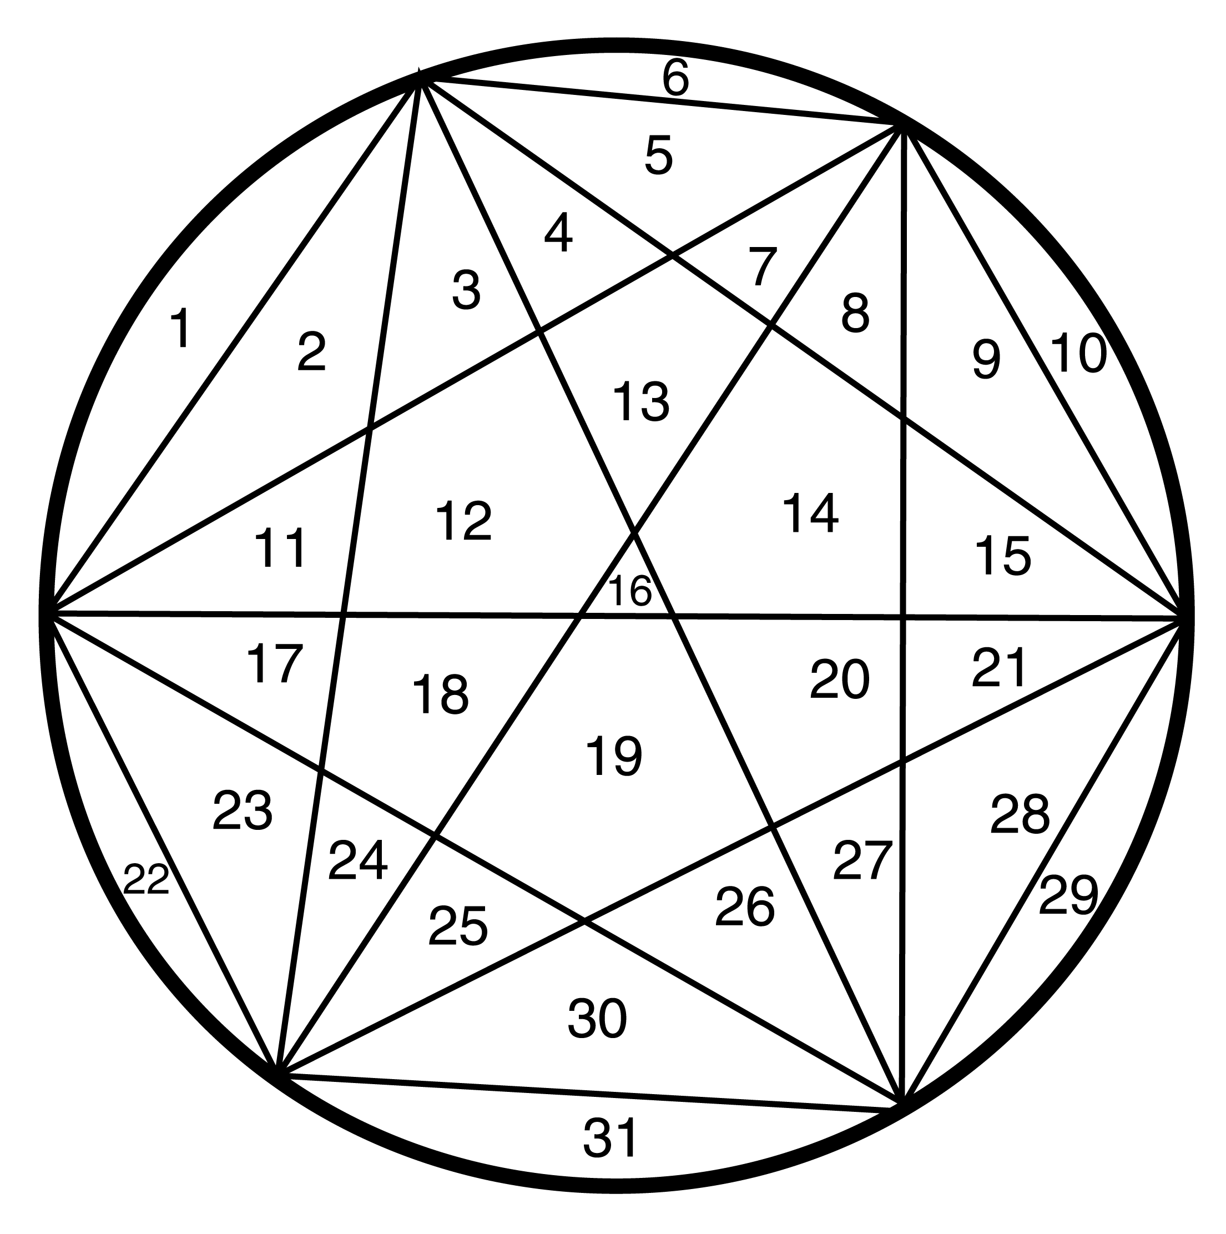

47. (d) step 3
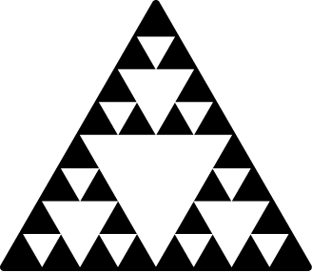
48.


49. By looking at examples, inductive reasoning leads us to make conjectures which we then try to prove.
50. Consider examples; Look for patterns; Make a conjecture; Use deductive reasoning to prove the statement.
51. – 54. Answers will vary.
55. 53, 107, 213; Next term is the previous term plus twice the term before the previous term.
56. 5461, 21845, 87381; Next term is four times the previous term plus one.
57. 47, 76, 123; Next term is sum of two previous terms.
58. 150, 298, 598; Next term is the previous term plus twice the term before the previous term.
59. There are a total of squares.
12
6
2
60. There are a total of squares.


24
15
8
3

61. a) There are a total of 60 rectangles.
12
9
6
3
8
6
4
2
4
3
2
1

b) There are a total of 210 rectangles.
 | 24 |  |  | 12
 | 18 |  |  | 9
 | 12 |  |  | 6
 | 6 |  |  | 3
 | 20 |  |  | 8
 | 15 |  |  | 6
 | 10 |  |  | 4
 | 5 |  |  | 2
 | 16 |  |  | 4
 | 12 |  |  | 3
 | 8 |  |  | 2
 | 4 |  |  | 1


62. Answers may vary. One can count the rectangles in a systematic way like in Exercise 61. One can see that there is a pattern to the counting. Firstly, one needs to realize that the sum of the first natural numbers is In Exercise 61, the first four natural numbers occurred in the last four entries. Looking above these entries, you can see multiples of these numbers. One can view the sum of all the entries as
In general, the number of rectangles of all types would be for an rectangle. For the case of a rectangle, we would have rectangles of all types.
63. The base is a rectangle. If you consider the diagram below as the base, we have baseballs. In order to build the next level, we are looking for the number of places in which four baseballs (squares) meet. There are such places.
For the next level we would have meeting places.

For the last level we would have meeting places.

This yields a total of baseballs.
64. Using the same reasoning as in Exercise 63, we have baseballs.
65. – 66. No solution provided.

67. In this trick, you will always get the result three.
a) Call the number
b)
c)
d)
e)
68. In this trick, you will always get a result that is the number that you started with.
a) Call the number
b)
c)
d)
e)

Section 1.3: Estimation

1.
2.
3.
4.
5.
6.
7.
8.
9.
10.
11.
12.

13. miles; The estimate is larger than the exact answer. The exact answer is 111 miles.
14. The estimate is larger than the exact answer. The exact answer is $16.92.
15. more hours, 7:30 PM; The estimate is earlier than the actual time. The actual answer is 7:50 PM.
16. per gallon; The estimate is less than the actual answer. The actual answer is $3.89 per gallon.
17. The estimate is more than the exact answer. The exact answer is $17.77.
18. The estimate is less than the exact answer. The exact answer is $25.46.
19. The estimate is larger than the exact answer. The exact answer is $17.20.
20. The estimated total is The estimate is less than the exact answer. The exact answer is
21. It seems safe. Alicia probably weighs less than 200 pounds, so that leaves pounds for the 21 students. They probably each weigh less than 100 pounds.
22. NFL linemen usually weigh at least 300 pounds. So the eight linemen would weigh at least pounds, which is above the elevator’s capacity.
23. The estimate is larger than the exact answer. The exact answer is $1324.40.
24. weeks; The estimate is less than the actual answer. The actual answer is 326 weeks.
25. times greater; The estimate is very close to the actual answer. The actual answer is 996.67 times greater.
26. times greater; The estimate is very close to the actual answer. The actual answer is 4.01 times greater.
27 Her total expenses are about $100 per month; The estimate is larger than the actual answer. The actual answer is $163 (you round to nearest dollar on deductions).
28. The estimate is less than the actual answer. The actual answer is $104 (you round to nearest dollar on deductions).
29. Answers will vary. Actual answers are: Male high school graduates; $44,300; Females with associates degrees; $42,000
30. Answers will vary. Actual answer is $17,200.
31. college and professional degrees, high school graduates
32. Answers will vary. Actual answer is $47,300.

33. category 2
34. 500;
35. response 2
36. 139;

37. Estimated answers may vary. Actual value is 69.3%.
38. Slightly decreases.
39. 2014; Estimated answers may vary. Actual value is 84.8%.
40. almost six times
41. Estimated answers may vary. The exact answer is or $874.66 billion.
42. Estimated answers may vary. The exact answer is or $935.28 billion.
43. Estimated answers may vary. The exact answer is or $155.88 billion.
44. Estimated answers may vary. The exact answer is or $1,809.94 billion.
45. Estimated answers may vary. The actual number of immigrants was
46. Estimated answers may vary. The actual number of immigrants was
47. Estimated answers may vary. The actual percentage is or 18.5%.
48. Estimated answers may vary. or 5.8%.
49. – 54. Answers will vary.
55. Answers may vary. The amount of lawn that needs to be fertilized is represented by the size of the lot, less the non-grassy areas such as the garden, driveway and house. If you divide the grassy area into rectangles, you get square feet. They need or slightly over two bags of fertilizer.
56. Answers may vary. For our estimate we will not consider areas such as windows and doors that may not be painted. They need to cover exactly square feet twice for a total of 914.5 square feet. They will need to purchase or 5 gallons of paint (no partial gallons).
57. – 60. No solution provided.
Chapter Review Exercises
1. Understand the problem; devise a plan; carry out your plan; check your answer.
2. An example that shows a conjecture is false.

3. 10; Let A, C, L, R, and T represent Amber, Chris, Lawrence, Remy, and Travis.
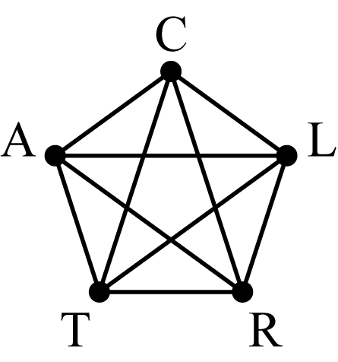
The pairs are AC, AL, AR, AT, CL, CR, CT, LR, LT, and RT.
4. Answers may vary. At a restaurant, you have 2 appetizers, 3 entrees, and 2 desserts. How many different meals can you choose if you select one appetizer, one entrée, and one desert?
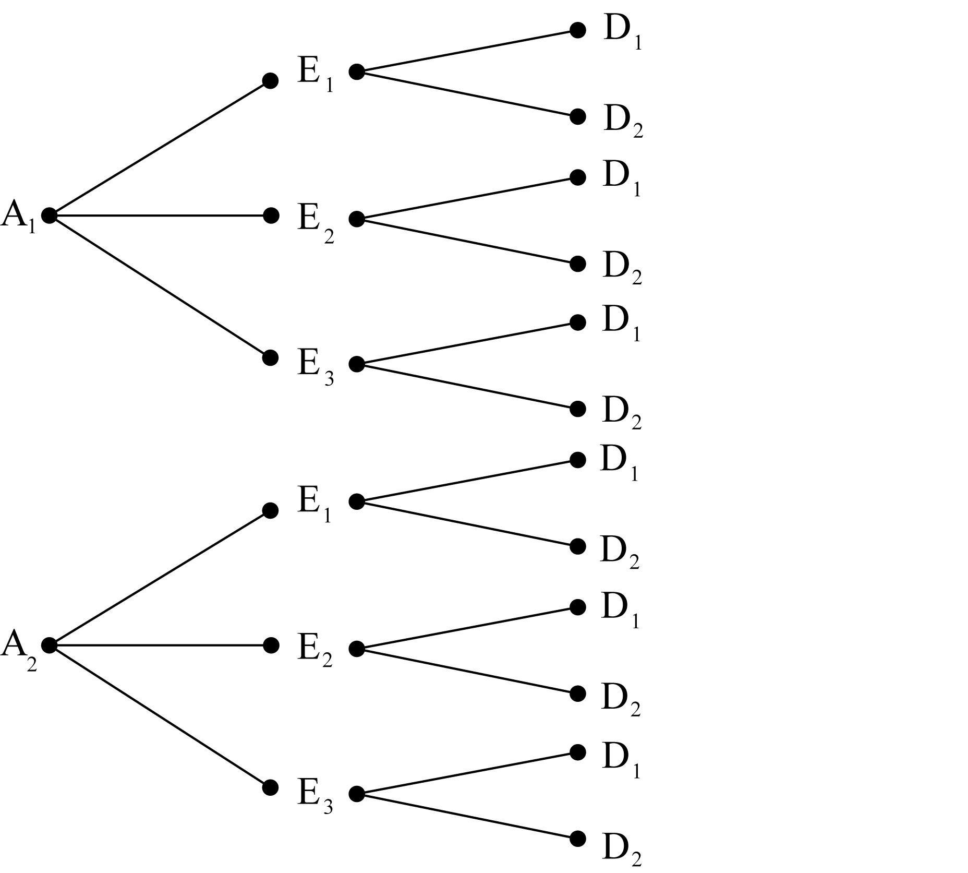
There are twelve different meals possible.
5. Answers may vary. Let be the number of hours Picaboo worked as a stock person and be the number of hours she worked as a ski instructor.
Guesses for  and | Good Points | Weak Points
9 and 11 | Sum is 20. | Amount earned is less than $141.20.
7 and 13 | Sum is 20. | Amount earned is more than $141.20.
8 and 12 | All conditions satisfied. We have the solution.
6. false; Counterexamples may vary.
7. No solution provided.
8. Answers may vary. Possible answers include: Inductive reasoning is the process of drawing a general conclusion by observing a pattern in specific instances. In deductive reasoning, we use accepted facts and general principles to arrive at a specific conclusion.

9. a) deductive
b) inductive
10. a) 27; Add five to the previous number.
b) 47; Add the previous two numbers.
11.
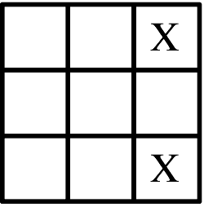
12. or

13. In this trick, you will always get twice the number you started with.
a) Call the number
b)
c)
d)
e)

14. a) 46,000
b) 28,000
15. a)
b)

16. Estimated time left to travel would be hours, arriving at 7:00 PM.
17. a) Estimated answers may vary. The actual difference is 60 milligrams.
b) a little more than twice as much.
c) approximately four
d) the gourmet coffee
Chapter Test
1. Answers will vary.
2. a) true; adding fractions with like denominators
b) false;
3. Answers may vary. Let be the number of Wii Sports sold, be the number of Super Mario Brothers sold, and be the number of Pokémons sold.
Guesses for  and | Good Points | Weak Points
36, 29, and 20 | Super Mario Brothers sold 9 more than Pokémon and 7 less than Wii Sports. | Total number is less than 118.
56, 49, and 40 | Super Mario Brothers sold 9 more than Pokémon and 7 less than Wii Sports. | Total number is more than 118.
47, 40, and 31 | All conditions satisfied.  We have the solution.
47 million Wii Sports, 40 million Super Mario Brothers, and 31 million Pokémons were sold.

4. a) 4,320
b) 2,280
5. a) 36,000
b) 36,500

6. If two terms are similar but sounds slightly different, they usually do not mean exactly the same thing.
7. Answers may vary. Possible answers include: Inductive reasoning is the process of drawing a general conclusion by observing a pattern in specific instances. In deductive reasoning, we use accepted facts and general principles to arrive at a specific conclusion.
8. a) inductive
b) deductive
9. Mathematical ideas can be understood verbally, graphically, and through examples.
10. Answers will vary. One estimate is The true value is $3,220.
11.
12. cde, cdf, cdg
13.
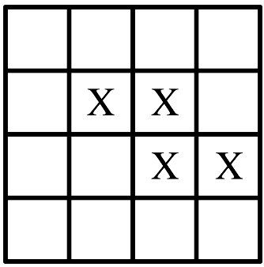
14. or
15. False; suppose the laptop costs $1,000. After the 10% discount, the laptop would cost $900. If that price is increased by 10%, the laptop would cost $990, not $1,000.
16. In this trick, you will always get twice the original number.
a) Call the number
b)
c)
d)
e)

