CHAPTER 2
BUSINESS PROCESSES, MANAGEMENT,
AND DECISION MAKING

CHAPTER OVERVIEW

In the first lecture we worked to convince students that information systems are more than just machines and software. These systems have a large impact on the economy we live in and the career that students will eventually find themselves in. Our next step is to introduce them to business and how information systems support how businesses get things done. As a starter, ask your students about the kind of information they place on their their Facebook page. Having this discussion is a good way to get interaction and discussion about information systems started.

The primary issue to be considered this week is “What is a Business process?” It may be useful to start with a simple example to explain business processes. Our first question “How did this stuff get here” provides an example of how you might bring the subject of business processes to life. You might think about walking through the course registration process as an example of how business processes operate, or filling up the gas tank, or taking money out of an ATM. Another good example is to use the MIS in Use case as an example of a business process. Using examples helps to make the discussion richer. We would suggest spending some time interacting with students and asking them about a process they are familiar with. It is a good use of time when introducing the notion of business process.

We also believe that the Q6 as covered is an important opportunity to quickly reinforce the model of information systems that was introduced in the first week. Students should not be able to escape the class without understanding Figure 2-3.

Another important issue is to recognize that a byproduct of every business process is information about how the process can be improved (Box, 1957). The subject of what information is and how information can influence decision making is the second large issue to address this week. We believe it is important to emphasize the importance of decision making and information early in the course as any business major can relate to using information to make improved decisions.

As a note for instructors working to develop student’s opinions about the importance of information technology, the “What do YOU think?” exercise titled “Your Personal Competitive Advantage” provides a good exercise that can be used effectively in a class discussion about why taking this course might be useful for any business major.

An Example to Use in Class:

The MIS in Use case “EDoc: Software making waves” is an effective case for illustrating business process and how technology supports the process. The most effective thing about this mini-case is that it is simple. The answers to the case are provided at the end of this chapter. Most people think of tugboats as a sunset industry; however, the case shows that a little system can go a long way in making an industry that is over 100 years old more efficient.

CHAPTER OBJECTIVES

- Get students to think about “how stuff gets here.”
- Understand elements of a business process.
- Understand what is meant by information.
- Understand the role information plays in business processes.
- Understand how information systems support decision making.
- Help student to consider their role as part of an information system.

CHAPTER OUTLINE

Q1 “How did this stuff get here?”
Q2 What is a business process?
Q3 What are the components of a business process?
Q4 What is information?
Q5 What is the role of information in business processes?
Q6 How do information systems support business processes?
Q7 How do information systems support decision making?
Q8 What is your role?

ANSWERS TO USING YOUR KNOWLEDGE QUESTIONS

1. Consider the four definitions of information presented in this chapter. The problem with the first definition, “knowledge derived from data,” is that it merely substitutes one word we don't know the meaning of (information) for a second word we don't know the meaning of (knowledge). The problem with the second definition, “data presented in a meaningful context,” is that it is too subjective. Whose context? What makes a context meaningful? The third definition, “data processed by summing, ordering, averaging, etc.,” is too mechanical. It tells us what to do, but it doesn't tell us what information is. The fourth definition, “a difference that makes a difference,” is vague and unhelpful.

As well, none of these definitions helps us to quantify the amount of information we receive. What is the information content of the statement that every human being has a navel? Zero—you already know that. On the other hand, the statement that someone has just deposited $50,000 into your chequing account is chock-full of information. So, good information has an element of surprise.
Considering all of these points, answer the following questions:

- What is information made of?

Information is made of data that has been processed in some way to be meaningful to the recipient.

- If you have more information, do you physically weigh your decisions more? Why or why not?

If you are carrying around a 1,000-page report that contains information, then you might say information causes you to physically weigh more. In most situations, however, having more information does not result in a weight gain. It results in a change in your brain.

- If you give a copy of your transcript to a prospective employer, is that information? If you show that same transcript to your dog, is it still information? Where is the information?

A transcript from a prospective employee is meaningful to an employer trying to fill a position. The content of the transcript (courses taken, grades earned) has value in the hiring context. A dog has no use for the content of the transcript and so it has no value to him. If the piece of paper the transcript is printed on is crumpled up, then it might have value to the dog as an item to chase or tear up (depending on the dog).

- Give your own best definition of information.

Student answers will vary. Despite its subjectivity, I still like “information is
data that is meaningful within a context.” Also, look for the fact that data usually must be transformed in some way to be meaningful; and to provide value, the information must make a difference to the recipient.

- Explain how you think it is possible that we have an industry called the information technology industry, but we have great difficulty defining the word information.

We have many everyday terms that are difficult to define. We speak of the health care industry, but we typically only define “health” in the negative (the absence of disease). This is just another example of a term that is broadly understood but difficult to define precisely.

2. Re-read the “MIS in Use” case to refresh your memory of the Edoc HELM system.

a. Using Figure 2.1 as a guide, draw the paper-based process described in the case.

The actual picture is not important. This is something that students will learn more formally in a systems analysis and design class. What is important is the notion that information is flowing between the various entities in the process.
Figure 1: The Process before Helm

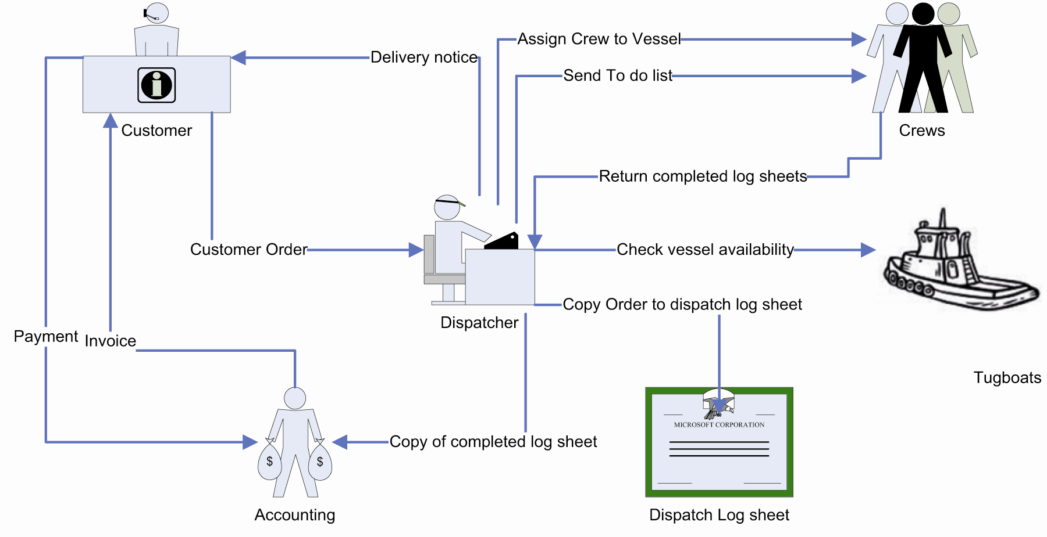

b. Now draw the process after HELM was introduced.

c. What are the major differences between the two processes?

The major differences are the fact that information about a job is recorded once by the dispatcher in HELM. From that point forward, all of the information about the job and its completion is handled through the system. This reduces the amount of manual work to be completed by dispatcher, accountant, and tugboat captain.

Figure 2: The Process after HELM

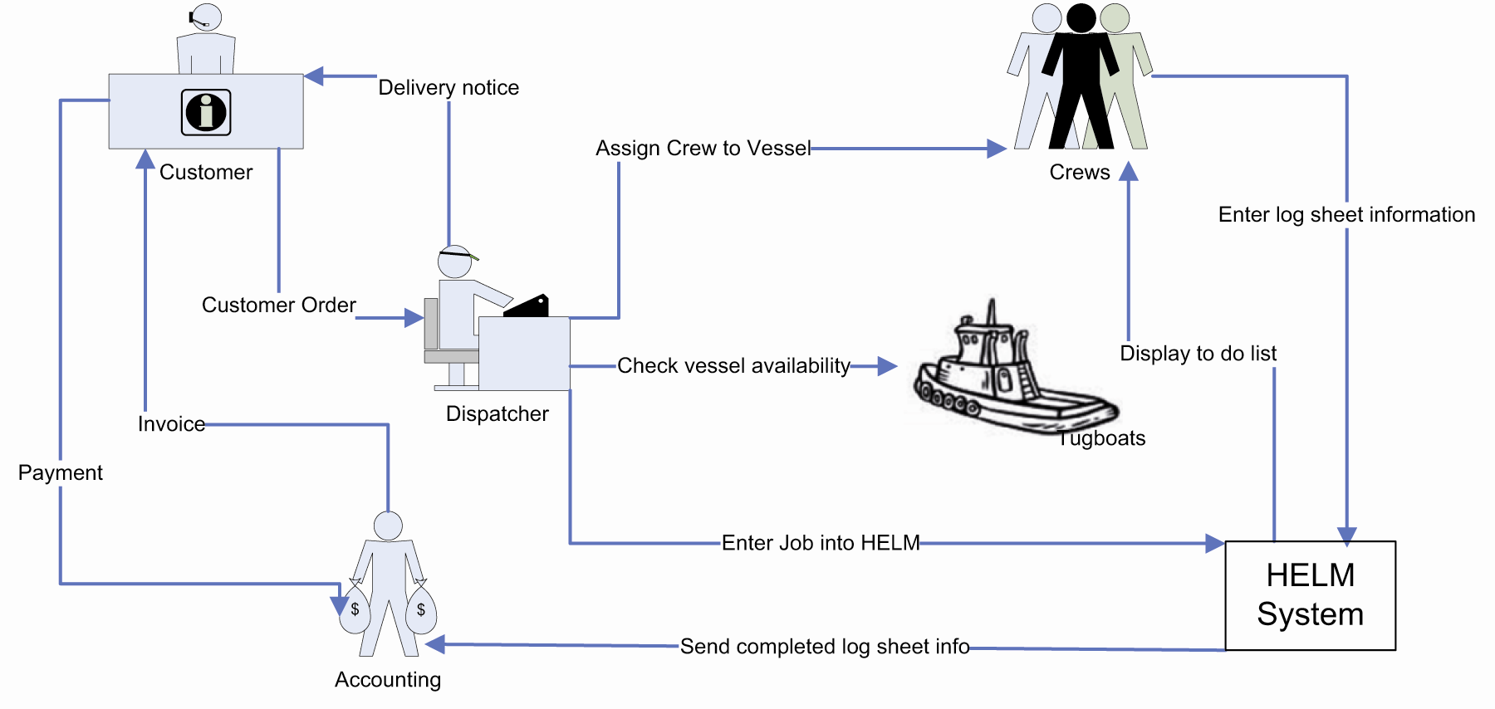
d. What are the improvements that have been made through the introduction of HELM? (Hint: Consider tangible and intangible benefits.)

Tangible: 1) reduced costs, 2) reduced errors, 3) reduced data entry time

Intangible: 1) more accurate information, 2) more timely information, 3) reduced frustration, 4) improved ability to train new dispatchers

3. The text states that information should be worth its cost. Both cost and value can be broken into tangible and intangible factors. Tangible factors can be directly measured; intangible ones arise indirectly and are difficult to measure. For example, a tangible cost is the cost of a computer monitor; an intangible cost is the lost productivity of a poorly trained employee.

Give five important tangible and five important intangible costs of an information system. Give five important tangible and five important intangible measures of the value of an information system. If it helps to focus your thinking, use the example of the class scheduling system at your university or some other university information system. When determining whether an information system is worth its cost, how do you think the tangible and intangible factors should be considered?

Tangible Costs:
- Cost of hardware components
- Cost of software components
- Cost of database components
- Cost of training users
- Cost of hiring users and/or developers

Intangible Costs:
- Cost of searching for information that is difficult to find
- Cost of making a decision when information arrives after the fact
- Cost of frustration when system does not work as expected
- Cost of decision errors when information is inaccurate
- Cost of employees trying to work around or avoid a problematic system

Tangible Value:
- Increased sales to new customers
- Increased sales due to more repeat customers
- Increased employee productivity
- Decreased hiring costs due to lower employee turnover
- Increased quality resulting in fewer defects in output

Intangible Value:
- Increased employee satisfaction
- Increased customer satisfaction
- Improved management decision making
- Decreased employee absenteeism
- Decreased employee turnover

To determine if an information system is worth its cost, the values of all relevant tangible costs and benefits should be estimated as accurately as possible (easier said than done, of course). In addition, the values of intangible costs and benefits can sometimes be estimated with a little effort. If the intangibles cannot be quantified, they should at least be described so that their existence is recognized and appreciated.

4. Singing Valley Resort is a top-end (rooms cost from $400 to $2500 per night), 50-unit resort located high in the mountains of Colorado. Singing Valley prides itself on its beautiful location, its relaxing setting, and its superb service. The resort’s restaurant is highly rated and has an extensive list of exceptional wines. The well-heeled clients are accustomed to the highest levels of service.

a. Give an example of three different operational decisions that Singing Valley personnel make each day. Describe an information system that could be used to facilitate those decisions.

Note that a discussion of the systems will vary depending on the perspective of the person answering the question.

Operational Decisions (system to support decision)
- How much food to buy for restaurant (food service inventory system)
- How much wine to stock this week (food service inventory system)
- How many towels to purchase this month (inventory management system)

b. Give an example of three different managerial decisions that Singing Valley managers make each week. Describe an information system that could be used to facilitate those decisions.

How many servers should be available for dinner? (human resource scheduling system)
What price should we set for our rooms this week? (guest scheduling system that considers time of year and current levels of unused capacity)
How can we incent our guests to spend either more time or more money at the resort? (a system that gathers all of a guest’s activities during a stay for analysis)

c. Give an example of three different strategic decisions that Singing Valley’s owners might make in a year. Describe an information system for each.

Should we expand the number of rooms we have? (this would rely on accurate information from the guest registration system)
Should we offer discounted rates for our guest and at what times for the year?
Should we consider opening a different restaurant that caters more to a family experience?
d. Which of the decisions in your answers to questions a, b, and c are structured? Which, if any, are unstructured?

The decisions in part (a) are primarily structured. The decisions in part (b) are less structured and the decisions in part (c) are largely unstructured.

ANSWERS TO COLLABORATIVE EXERCISES

1. This chapter introduced the concept of Business Process Management (BPM). In the discussion, three methods for improving business processes were listed: Total Quality Management (TQM), Six Sigma, and Lean Production. Do the following with your team:

a. Choose one of the methods listed above. Create a definition of the method, elaborate on how it works, and indicate where and when it was developed. Discuss how this method differs from other BPM methods.

Again, there is no single answer to this question. The question is intended to get students thinking about how an organization might think about how it can change its processes. It is important for students to try to get specific about a particular process so that is why we ask them to choose one and research it.

b. Using the Internet, find an example of at least one company that has used this method.

Examples:
TQM: Ford, Phillips
Six Sigma: Motorola, GE
Lean Production: Toyota

c. Combine what you have discovered in parts a and b and create a two-page (maximum) description of the method, aimed at an audience that has never heard of BPM or your method. Focus on what a manager should know about this method and provide a list of useful web resources where people can go to find out more. Be prepared to present your findings to the class.

Again, there is no single answer to this question. This exercise will work for a smaller class but can become repetitive for a larger class.

2. Business Process Simulation is a method used to simulate a process so that you can explore different ways of managing the business process. IBM’s INNOV8 software provides a “serious game” environment where you can explore Business Process Simulation. Complete the following with your team:

a. Run through the demonstration for INNOV8 2.0. (You can find it at
www-01.ibm.com/software/solutions/soa/innov8/innov8game.jsp)

b. Try at least one of the simulations (supply chain, customer service, or traffic). Record your best score.

c. Describe what your group learned from the simulation. Did you have enough information to make the necessary decisions? What data would you like to have had, to help you get better scores?

Some students find the simulation engaging, while others do not. The idea behind the simulation—that there are different process choices that managers face in developing effective and efficient business processes—is excellent. If you can get students engaged in the exercise it can be rewarding. But many students are used to video games that offer far more interactive environments. Some students might therefore be frustrated The purpose of making it a group exercise is to allow students to talk about business processes and have them start thinking about the value of information in these processes.

ANSWERS TO CASE STUDIES

MIS in Use: Edoc: Software Making Waves

1. What are the primary benefits realized by Edoc’s use of HELM software?

The primary benefits are:

Saves Time in Data Entry
Reduces Errors
Reduces time to process customer orders (improves timeliness of information)

2. Could HELM also result in increased revenue? Explain your answer.

Yes. If the Helm software saves enough time for the people running the tugboat then it may be possible to make additional trips during the day. This would increase revenue. In addition, if more tug boats could be dispatched by the same number of dispatchers then this would allow for the potential for increasing the fleet (therefore increasing revenue).

3. Can you think of other benefits that might arise from the use of the software? For example, experienced dispatchers in the industry are difficult to find. Could the system help with this challenge?

Yes. The HELM system provides relief for the dispatcher job. The paperwork surrounding the job is reduced so that more attention can be placed on optimizing the jobs being allocated. This should make it easier for a company to maintain and train dispatchers. Since experienced dispatchers are difficult to find, this may be a source of advantage for the firm adopting this software.

Case Study 2: High Touch—High Tech

1. What challenges are created when providing anywhere, anytime services? (Hint: How and when did you conduct your last banking transaction?)

A primary challenge with both new and existing customers is the lack of face-to-face contact. Transactional services (deposits and withdrawals) require less personal interaction but more complex or sophisticated services, such as loans or investments and mutual funds, can be difficult to explain and sold if customers do not visit a branch. The Internet and automated banking machines can be viable alternatives for marketing many new products and services but many consumers are also adopting other technologies such as cell phones. These have increased risks and can be both expensive and complex to develop.

2. What business and technology issues would be faced by an organization that wants to have a complete view of its customers? (Hint: What are the benefits and costs of cooperation, and are there any privacy issues?)

Privacy and security are important technological issues to consider. If personal information is being collected, how can this information be secured. Do customers want to have this information available to everyone they deal with at the bank?
(In many cases there are legal limitations on who can have access.) Another consideration is what legal rights the company has to use this information. The additional information will mean additional storage and additional training for CSR’s as they work to sell services. Are the unknown benefits worth the costs?

3. Can you think of any examples where a lack of information or failure to consider the information could affect the profitability of a business?

There are many examples. Financial services are particularly dependent upon information because if credit customers default on loans, the bank loses both the interest (profit) on the transaction, as well as the full loan amount. Conversely, a customer may seem to have little income and not be eligible for a loan, but at the same time could have large amounts of money on deposit. To make the best decisions the bank needs access to the relevant and complete information usually contained in a customer’s full credit report. In retail businesses, a similar example occurs if they do not check the legitimacy of credit card or chequing transactions.

4. If a customer has more than one account at a particular organization, should he or she receive separate mailings or all documentation in the same envelope?

This can be a complex question. From the company’s perspective, if the systems allow this or can be set up this way it may be less expensive (for example in postage) and more convenient. However, not all customers may want to receive their information in a single mailing or at the same location. As a result, understanding what particular customers want or giving them a choice rather than treating them all the same may be the best approach.
5. Does being a credit union rather than a share corporation affect Vancity’s structure?

Yes. In a Credit Union, the customers own shares in the institution. That means clients are not only customers but also owners. Vancity therefore must be especially careful to balance customers’ needs together with the desire to maximize profits.

YOUR PERSONAL COMPETITIVE ADVANTAGE

Goals

- Raise students’ awareness that they should be engaged in job planning/searching right now.
- Show the application of the principles of competitive advantage to career planning.
- Suggest innovative tasks for job searching.

Background and Presentation Strategies

Students seldom understand how their status as students gives them access to business people that they will lose after they graduate. Ask the students if they understand the difference in the response they will receive to the following two statements:

- Hi, my name is XXX, and I’m a student at YYY University. We’re studying information systems and competitive advantage. I see that your company, ZZZ, is using a CRM applications. I’m wondering if you would have a few minutes to talk with me about how your CRM system gives ZZZ a competitive advantage.
- Hi, my name is XXX, and I’m looking for a job. I see that your company, ZZZ, is using a CRM application. I’m wondering if you would have a few minutes to talk with me about how your CRM system gives you a competitive advantage.

What will be the difference in response? Huge. In the first, the person will feel like they’re helping along some bright, ambitious person. Most will say, sure, and maybe offer to buy the student a cup of coffee. In the second, the person will feel like they’re being manipulated to find a job. Most will say, “Contact our HR department.”

Why should students talk with business people, and do it right now? To build their networks.

- Have the conversation. Make a list of great questions to ask; be appreciative that the business person took the time. Then, toward the end of the interview, ask if the person has any advice for finding a job in that industry. Not, do they have a job, but rather, do they have any advice for finding a job. If they have a job, they’ll tell you. If not, they may give you some good advice. Even if you get no good advice, you have another point in your network. Take Figure 2-1 along and ask the person how you can use it to gain a competitive advantage.

See question 3.
Why do students not use their special student status in this way? I don’t know, but I try to ensure that they at least know about these strategies. Some students may be too shy. If this is the case, sometimes I make it an assignment, possibly an extra credit assignment. Similarly, students should be availing themselves of every resource the university provides for outreach to business people.

- If there is a mentor program, get a mentor. If there is a chance to visit a business, go visit the business. If someone from industry speaks on a topic of interest, by all means go. Talk to the speaker afterwards, make one or two positive comments, and ask a good question. Ask for the person’s business card. In a day or two, send them an email thanking them. See if you can get an interview to discuss some topic of mutual interest.

Sometimes I lead them carefully through the disaster scenario. I tell them I had this horrible dream last night. And my dream was that they graduated, couldn’t get a job, took a dead-end job for 2 years, and then couldn’t get out of that track. To avoid this nightmare, they have to start thinking about their jobs, now! (I’m assuming mostly third-year students.)

Suggested Responses for Discussion Questions

- Answer depends on the student. Sometimes I say, “If your list is short, tell me what you plan to do in the next quarter.”

- Again, the answer depends on the student. I also encourage them to realize that they aren’t competing just with the students they see on our campus. They’re competing with students all over the world. (More on this topic in Chapter 3.)

- There are many ways to build networks. Here are two types of answers:

- Read trade magazines, relevant Web sites (e.g., www.cio.com), and other sources. Find an article on a topic of interest and think of ways the ideas in that article apply to you and one or more items in the list in Figure 2-1. Contact the author of the article. Make a few complimentary comments; ask questions that pertain to the article, you, and the list.
- Approach business people working in your major field of study and ask them how you can use knowledge of information systems to gain a competitive advantage in that field. Tell them of your interest in both your major and in IS. Use this situation to generate further introductions, perhaps to specialists in your field.

- Get active. Join clubs. Meet with lots of students. Participate in campus life both in and beyond the business school. You add more connections to your network by meeting students that are outside of your major or even outside of the business school. As you meet people, tell them of your career interests. Ask if they know anyone working in that field. Ask if they know someone you could meet with, as described in question 3. Join a business-specific club, for example, the Accounting Club or the Marketing Club. Get involved, especially with activities that engage local business people. Arrange for speakers and host speakers on campus. As you meet business people on campus, query them about their careers. How did they get where they are?

Use an IS to keep track of the people whom you’ve met. Put contacts in a spreadsheet or database. Keep track of contacts you’ve had, emails you’ve sent, meetings you’ve attended. At an interview, when appropriate, show off your database. Use the Web and email to contact people who are doing interesting things.

Wrap Up

- You don’t want to find just any job. You want to find a great job! You want to find one with appropriate responsibilities, with a growing company, with job growth potential, and where you work with interesting people. You also want one that
pays well.
- Finding that great job may not be easy. Start now! Start thinking about what kind of job you want, and start preparing yourself to find that job. The last semester of your senior year will be too late.
- If you’re not an IS major, combining IS knowledge with your major can make for a great combination. Think about taking some more IS classes.

Box, George E. P. (1957). Evolutionary operation: A method for increasing industrial productivity. Applied Statistics, 6(2), 81-101.

