CHAPTER 2
Step Two: Contract Formation—The Offer, the Events Between Offer and Acceptance, and the Acceptance
Chapter 2 discusses the traditional common law approach to offer and acceptance.
Step Two is divided into three basic PowerPoint templates.
• PowerPoint ch. 2-1 (EXHIBIT 2-1, abbreviated) (The Offer)
• PowerPoint ch. 2-3 (EXHIBIT 2-4, abbreviated) (Post-Offer/Pre-Acceptance)
• PowerPoint ch. 2-8 (EXHIBIT 2-5, abbreviated) (The Acceptance)

The Offer

PowerPoint ch. 2-1 (EXHIBIT 2-1, abbreviated) illustrates the offer.

EXHIBIT 2-1 (abbreviated)
Step Two: Contract Formation—The Offer

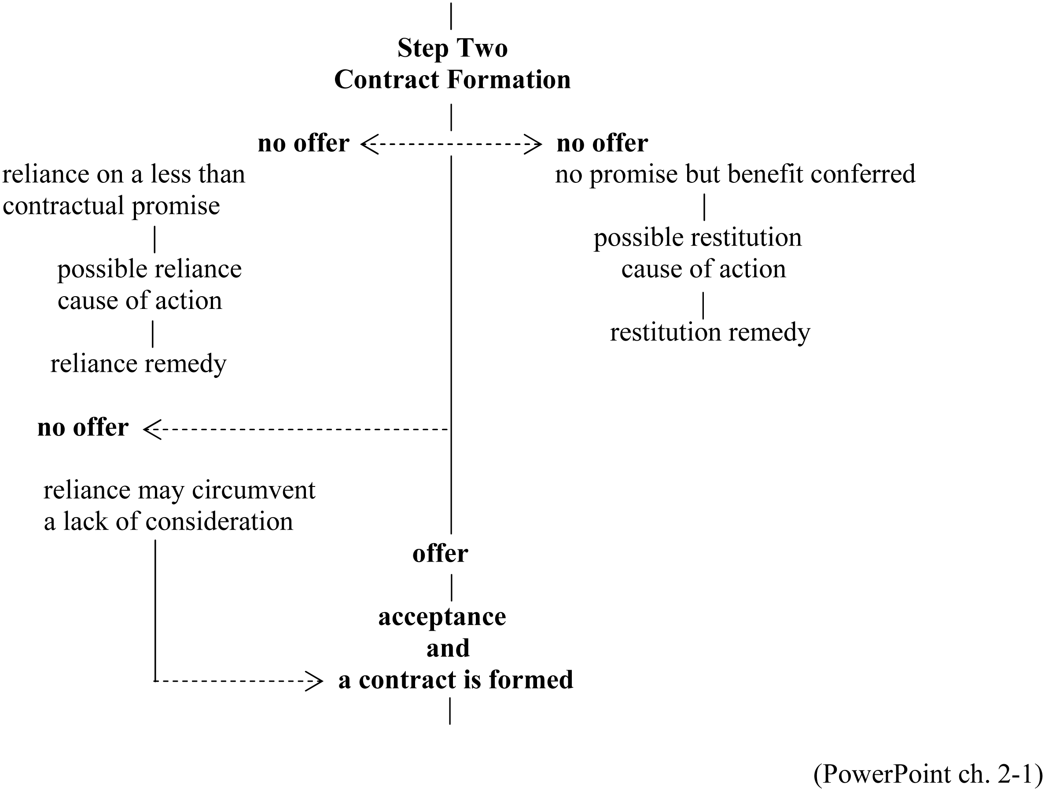
PowerPoint ch. 2-1

• An offer consists of a promisor’s promise and the consideration for that promise.
• A promise is an unequivocal assurance that something will or will not be done.
• When checking for an offer, it is important to look for the promisor’s promise and not the promisor’s performance of this promise. The promisor’s performance will occur after the contract has been formed.
• unequivocal
• to do an act or to forebear from doing an act
• The consideration for the promisor’s promise may be the promisee’s promise or the promisee’s performance. The promisor determines which. Consideration is an element of the offer and is not a stand-alone element of contract formation. A contract consists of an offer and an acceptance; “not” an offer, an acceptance, and consideration.
• Offer for a bilateral contract—promise for a promise (PowerPoint ch. 2-2) (EXHIBIT 2-2).
• Offer for a unilateral contract—promise for a performance (PowerPoint ch. 2-2) (EXHIBIT 2-3).

EXHIBIT 2-2
An Offer for a Bilateral Contract

“I promise to sell you my car for your promise to pay me $15,000.”
promisor promise to sell promisee
(seller) for your promise to pay me $15,000 (buyer)

EXHIBIT 2-3
An Offer for a Unilateral Contract

“ promise to sell you my car for your paying me $15,000.”
promisor promise to sell promisee
(seller) for your paying me $15,000 (buyer)

(PowerPoint ch. 2-2)

• PROBLEMS 2-1 through 2-4 give students an opportunity to distinguish an offer for a bilateral contract from an offer for a unilateral contract.
• PROBLEM 2-1. Offer for a bilateral contract. The promisor is seeking a promise to act.
• PROBLEM 2-2. Offer for a bilateral contract. The promisor is seeking a promise to refrain from acting.
• PROBLEM 2-3. Offer for a unilateral contract. The promisor is seeking an act (swimming).
• PROBLEM 2-4. Offer for a unilateral contract. The promisor is seeking the not doing an act (not swimming).
• The Promisor’s Promise: Is the person making the state making a promise?
• Preliminary negotiation
• Inquiry—Promisor’s promise or preliminary negotiation? Check the language. See the EXAMPLE.
• Advertisement—Promisor’s promise or preliminary negotiation? Does the advertisement rise to the level of promisor’s promise? Check the language? Is the ad specific enough? Is there anything left to be negotiated?
• PROBLEM 2-5. Note the ad on the left says “worth to” while the ad on the right says “worth.” The ad on the left is for three coats. Could they range in price? Which one does the first customer receive? Do you know the coats that are the subject of the ad on the left? Do you know the coat that is the subject of the ad on the right?
• Auction—Are the actions of the auctioneer the promisor’s promise or preliminary negotiation?
Is the auction with or without reservation? As a general rule, an auction is with reservation so the person placing the bid is the offeror and not the auctioneer.
• PROBLEM 2-6 is an auction with reserve so the bidder is the offeror. The auctioneer, as the offeree, could decide not to accept the $100,000 bid.
• PROBLEM 2-7 is an auction without reserve the auctioneer is the offeror. The last bidder ($10,000) accepts the offeror’s offer. The contract is formed so the auctioneer may neither reject the bid nor withdraw Greenacre from the auction.
• PROBLEM 2-8 does not state whether the auction is with or without reserve. Because the general rule is with reserve, the auctioneer, on the owner’s behalf, could withdraw the clock from the auction.
• Indefinite promise—Is the statement a promisor’s promise or does it lack essential terms so it is only preliminary negotiation? The two EXAMPLES lead up to PROBLEM 2-9. The statement lacks how much will be paid and how much work needs to be done.
• Illusory promise—Is the statement a promisor’s promise or not an unequivocal assurance so it is only preliminary negotiation? The EXAMPLE uses “if I feel like it.”
• The consideration for the promisor’s promise.
The following are problems with the existence of consideration for the promisor’s promise.
• The promise to make a future gift is not consideration because a gift is still a gift (EXAMPLE).
• The adequacy of the consideration is irrelevant because the consideration need only be a peppercorn (EXAMPLE).
• Something that purports to be consideration but is a sham is not consideration because it is pretend (EXAMPLE).
• Motive is what causes the promisor to act and is not the “price” the promisor is seeking in return for his or her promise. PROBLEMS 2-10 through 2-12 distinguish motive from consideration.
• PROBLEM 2-10
Motive: wanting the public to see her sculpture.
Consideration: promise to exhibit the sculpture in the foyer.
• PROBLEM 2-11
Motive: wanting her granddaughter to be educated.
Consideration: going to college.
• PROBLEM 2-12
Motive: wanting to get the ring back.
Consideration: finding and returning the ring.
• Moral obligation is a perceived duty based on a person’s code of right and wrong and is not consideration.
• PROBLEM 2-13
Moral obligation: Mills’ good deed should not go uncompensated because Wyman felt grateful.
No consideration: Feelings are intangible and are neither an act nor a preclusion from acting.
• The Quid Pro Quo
The third element of an offer is glue that binds the consideration for the promisor’s promise to the promisor’s promise (i.e., the bargained-for exchange, the quid pro quo).
• Past consideration has already occurred, and therefore there is a timing problem between the promisor’s promise and the consideration for the promisor’s promise (EXAMPLE).
• PROBLEM 2-14. Rendering first aid cannot be consideration because it occurred before the promisor’s promise.
• PROBLEM 2-15. Graduating with honors cannot be consideration because all the work was done before the promisor made his promise.
• A preexisting duty cannot be bargained-for because the duty is already owed (EXAMPLE).
• PROBLEM 2-16
1. Original offer—Promise to pay $3,000 a week for a promise to work for one year.
2. Promisor’s promise—Promise to pay $3,000 a week.
3. Consideration for the promise to pay—Promise to work for one year.
4. New promisor’s promise—Promise to pay $4,500 a week.
5. New consideration for the new promise to pay—Promise to work for the remainder of the year.
6. Compare promisor’s promises—$3,000 to $4,500.
7. Compare the considerations for the promisor’s promises—One year to the remainder of the year for both.
8. Preexisting duty to work for the remainder of the year. Therefore, no new offer.
• A condition cannot be the quid pro quo. The condition as consideration issue only arises if the promisor is seeking a performance rather than a promise.
• PROMISE 2-17
1. The Uncle’s promise—To pay $5,000.
2. What did Uncle require Jake to do? Meet him in front of the bank at noon.
3. Why did Uncle want Jake to meet him? Was this just a convenient time and place?
4. Is Uncle using his promise to induce Jake to refrain? If Uncle probably does not really care about Jake’s health then the conclusion is condition rather than consideration.
[The answers may be different if Uncle and Jake were estranged and by promising to pay was the way Uncle was inducing Jake to thaw their strained relationship and meet him.]
• PROMISE 2-18 is another condition vs. consideration problem.
1. Uncle’s promise—To pay $5,000.
2. What did Uncle require Jake to do? Refrain from smoking for one year.
3. Why did Uncle want Jake to refrain? Was he concerned for Jake’s health?
4. Is Uncle using his promise to induce Jake to stop smoking or does Uncle probably not care whether Jake smokes or not? If Uncle is trying to induce Jake to stop smoking, the conclusion is consideration rather than a condition.
Note that in both PROBLEMS, the promise was for a performance and not for a promise. Therefore, if consideration, the offer would be for a unilateral rather than a bilateral contract.

The Events Between Offer and Acceptance

• The longer the time between offer and acceptance, the more that could happen to preclude an effective acceptance.
• Several events between offer and acceptance could terminate the offeree’s power to accept.
• The offer could lapse.
• The offeror could revoke his or her offer.
• The offeree could reject the offeror’s offer.
• The offeror or offeree could die or become legally incapacitated (PowerPoint ch. 2-3) (EXHIBIT 2-4, abbreviated).

EXHIBIT 2-4 (abbreviated)
Step Two: Contract Formation—Post-Offer/Pre-Acceptance

|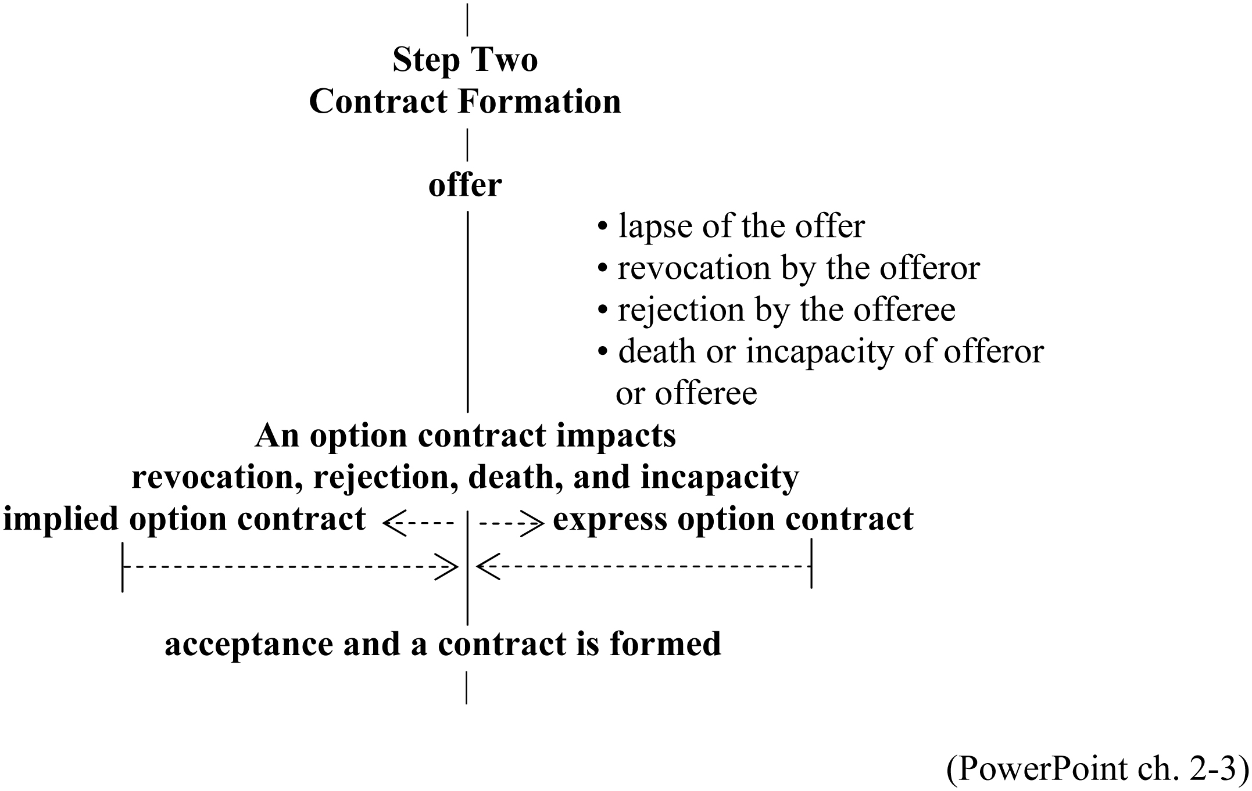
(PowerPoint ch. 2-3)

• The offer may lapse either expressly or impliedly.
• Express lapse—The offeror states in the offer when the offer will expire (EXAMPLE).
• PROBLEM 2-19 asks for situations in which the offeror would find it desirable to have an express termination date in the offer.
• Offeror may want to hurry offeree along.
• Offeror may want to know when it is safe to offer to another if the offeree has not accepted.
• PROBLEM 2-20 turns the tables and asks the same question from the offeree’s point of view.
• Offeree may want some guidelines as to when acceptance must be made so he or she could conclude the investigation whether the offer could be accepted.
• Implied lapse—Occurs when the offer does not state a date when the offer will expire. In this case, the offer will expire within a “reasonable time.”
• PROBLEM 2-21 presents four offers where the “reasonable time” for an implied lapse will differ. Students need to arrange the order and give reasons for their choices. The PROBLEM illustrates that not one size fits all and that the factors differ depending on the subject of the offer.
• The offeror may revoke his or her offer.
• As a general rule, revocation is effective when received by the offeree (and not when the revocation is sent by the offeror).
• PROBLEM 2-22
June 4th—offeree received the offer
June 5th—offeror mailed revocation of the offer
June 8th—offeree received the revocation.
The offer was revoked on June 8th, the date the revocation was received by the offeree.
• The offeree may reject the offeror’s offer.
• As a general rule, revocation is effective when received by the offeror (and not when the rejection is sent by the offeree).
• PROBLEM 2-23
June 4th—offeree received the offer
June 5th—offeree mailed a rejection of the offer
June 8th—offeror received the rejection.
The offer was rejected on June 8th, the date the rejection was received by the offeror.
• If the offeree rejects the offer, the offeree’s rejection may qualify as a counteroffer if it meets the requirements of an offer.
• PROBLEM 2-24
December 5th—preliminary negotiation
December 8th—offer sent by offeror (Seller)
December 16th—rejection and counteroffer sent by offeree (Buyer). No mirror image because the quantities differ.
December 18th—rejection of the counteroffer
December 19th—new offer by Buyer
Conclusion: no contract. The last communication was an offer that was never accepted.
• If the offeree may probe for better terms without rejecting the offer. Whether the probe goes so far as to be a rejection depends on the reasonable person’s perception (EXAMPLE).
• PROBLEM 2-25 presents three situations to test when the offeree’s communication goes so far as to be a rejection.
• The power to accept may end if the offeror or offeree dies or becomes legally incapacitated (EXAMPLE).
• The Option Contract (PowerPoint ch. 2-4)

Main Contract Offer and Option Contract

Main Contract Offer: “I promise to sell you Blackacre for your promise to pay me $500,000”

Offer for an Option Contract: “I promise not to revoke my offer to sell you Blackacre for your
promise to pay me $1,000.”

Acceptance of the Offer for the Option Contract: “I promise to pay you $1,000 for your promise
not to revoke your offer to sell me Blackacre.”

acceptance of the acceptance of
offer for the the main contract
option contract offer. Main contract

main contract offer full
and option contract performance
offer for an of the
option contract main contract

(PowerPoint ch. 2-4)

• An option contract cannot be created before the main contract offer has been created. An option contract can only be created at the same time the main contract offer is created or after that time because the purpose of the option contract is to negate the main contract’s offeror’s power to revoke the main contract offer.
• An offer for an option contract must have an offeror’s promise and consideration for that promise (the offeree’s promise or performance). The acceptance of this offer for an option contract must have the offeree’s promise or performance (depends on what was asked for in the offer) and consideration for that promise or performance (the offeror’s promise).
• The consideration for the offeror’s promise must be different from the consideration stated in the main contract offer.
• The purpose of an option contract is to hold the main contract offer open despite attempts by the offeror to revoke or by the offeree to reject or the death or legal incapacity of either the offeror or offeree.
• An option contract may be express or implied.
• An express option contract is a stated contract with either the offeror’s or offeree’s promise being a promise not to revoke the main contract offer.
• The EXAMPLE presents three situations when an express option contract may be useful.
• PROBLEM 2-26 asks students to go beyond these three situations in the EXAMPLE and create an additional three situations where an offeree would find having time to evaluate the main contract offer without having to be concerned with whether the main contract offer may be revoked.
• An offer for an option contract may be for a bilateral option contract (“I promise not to revoke my main contract offer for your promise to pay me $100” or “I promise to pay you $100 for your promise not to revoke your main contract offer”) or for a unilateral option contract (“I promise not to revoke my main contract offer for your paying me $100.”) (EXAMPLES).
• An implied option contract is based on the offeree from the main contract offer relying on the offer (EXAMPLES and PROBLEMS 2-27 and 2-28).
• Even if an option contract is in place, the main contract offer must be accepted for a main contract to be created.

The Acceptance

PowerPoint ch. 2-5 (EXHIBIT 2-5, abbreviated) illustrates the acceptance.

EXHIBIT 2-5 (abbreviated)
Step Two: Contract Formation—The Acceptance

|
Step Two
Contract Formation
|
offer
|
acceptance no acceptance, no breach
| of contract cause of action,
| and no restitution cause
| of action
a contract is formed
|

(PowerPoint ch. 2-5)

• An offer creates the power in the offeree to accept and form a contract (PowerPoint ch. 2-6) (EXHIBITS 2-6 and 2-7).

EXHIBIT 2-6
Acceptance of an Offer for a Bilateral Contract

Offer: “I promise to sell you my car for your promise to pay
me $15,000.”
Acceptance: “I promise to pay you $15,000 for your promise to
sell me your car.”

offeror promise to pay you $15,000 ---------- offeree
(seller) ------for your promise to sell me your car (buyer)

EXHIBIT 2-7
Acceptance of an Offer for a Unilateral Contract

Offer: “I promise to sell you my car for your paying me
$15,000.”
Acceptance: “Paying you $15,000 for your promise to sell me
your car.”

offeror paying you $15,000 ---------------- offeree
(seller) ------ for your promise to sell me your car (buyer)

(PowerPoint ch. 2-6)

• Under common law, the acceptance must mirror the offer.
• The offeror’s promises becomes the consideration for the offeree’s promise or performance.
• The consideration for the offeror’s promise (i.e., the offeree’s promise or performance) becomes the offeree’s promise or performance.
• The elements of an acceptance are:
• the offeree’s promise or performance;
• the consideration for the offeree’s promise or performance (i.e., the offeror’s promise); and
• the fact that the offeree is making his or her promise or performance to capture the offeror’s promise.
• The textual materials on acceptance discuss six related problem.
• mirror image
• preexisting duty
• offers directed to more than one party
• knowledge of the offer prior to an attempted acceptance
• when acceptance is effective.
• Mirror image—If the attempted acceptance does not mirror the offer, the attempted acceptance is a rejection and may be a counteroffer if it meets the elements of offer.
• The duty emanating from offer’s promise must not be a preexisting duty. This duty may have existed through contract or governmental action (EXAMPLE).
• An offer need not be targeted to just one party. Examples are some advertisements, auctions without reserve, rewards, and lotteries. Naturally, in each, only one party can accept the offer.
• The offeree may only accept an offer for a bilateral contract by having knowledge of it. The acceptance must be in response to the offer. If not responsive, the attempted acceptance my itself be an offer.
• Under classical common law, an offeree may only accept the offer for a unilateral contract by doing all the requested performance after learning of the offer. Restatement [First] of Contracts § 53. The Restatement [Second] of Contracts § 51 eases the performance requirement so the performance needs to be completed after learning of the offer.
• PROBLEM 2-29 illustrates acceptance of a bilateral contract.
• David’s March 1st letter—offer and effective on March 4th when Susan receives it
• Susan’s March 2nd letter—independent of David’s offer and effective as an offer on March 8th
• If David does not revoke his offer, Susan could accept David’s offer even though she has made an independent offer. Because she does not write again, no acceptance, no contract.
• PROBLEM 2-30 illustrates acceptance of a unilateral contract.
• Under Restatement [First] of Contracts, no acceptance because performance has begun before having knowledge of the offer.
• Under Restatement [Second] of Contracts, acceptance because performance was completed after having knowledge of the offer.
• Method and Notification of Acceptance
• An offer for a unilateral contract is accepted by the offeree’s full performance. Full performance is the consideration for the offeror’s promise. A promise to perform is not performance.
• An offer for a bilateral contract is accepted by the offeree’s promise. A promise is the consideration for the offeror’s promise. A promise may be made by an express promise or by a performance that implies the promise. This performance need not be a segment of the performance of the promise. This performance need only be information put into the stream of communication so that it should reach the offeror within a reasonable time.
• The time of contract formation differs depending on whether the offer was for a bilateral or a unilateral contract.
• The offer for a bilateral contract is accepted when the offeree makes the promise.
• The offer for a unilateral contract is accepted when the offeree has fully performed (PowerPoint ch. 2-7) (EXHIBITS 2-8 and 2-9) (EXAMPLES).

EXHIBIT 2-8
When an Offer for a Unilateral Contract Is Accepted

beginning of
offer performance full performance

contract formed

EXHIBIT 2-9
When an Offer for a Bilateral Contract Is Accepted

offeree
offeree’s begins offeree’s
offer promise performance full performance

contract formed
(PowerPoint ch. 2-7)

• The distance between the parties and their method of communication will determine whether notice of acceptance is required.
• If the parties are communicating face to face or voice to voice, the notice will be instantaneous.
• The EXAMPLE illustrates the performance can satisfy the notice requirement for a bilateral contract. In the EXAMPLE, the beginning to work will be facts that will imply acceptance of the offer and will be the notice. This assumes that Oliver will know what is happening to his property.
PROBLEM 2-31 distinguishes when it is reasonable to assume that the offeror will learn of the facts from a situation when it is not so reasonable to draw that assumption. Also, working on the land cannot be misinterpreted as being in response to the offer. Going to a local donut shop may have many implications and is not necessarily responsive to the offer.
• If communication is not voice to voice but over a distance, the notice requirement may depend on whether the offer was for a bilateral or unilateral contract.
• If the offer was for a bilateral contract, receiving the acceptance would be notice. If, however, the acceptance was sent but never received, a question arises whether notice is lack of notice a question for contract formation (has the offer been accepted without actual notice) or is a question of performance and breach.
• If the offer was for a unilateral contract, actual notice is required unless notice of performance would reach the offeror within a reasonable time (EXAMPLE).
• As a general rule and unless the parties specify otherwise, an attempted acceptance is effective when sent. This is known as “the posting rule” or the “mailbox rule” and is followed in Restatement [Second] of Contracts § 63(a) (EXAMPLE).
• Although an acceptance is generally effective when sent by the offeree, if an option contract is in place, the acceptance of the main contract offer is delayed until the offeror receives the acceptance from the offeree.
• PROBLEM 2-32
June 1st—Buyer receives Seller’s main contract offer and an offer for an option contract
June 5th—Buyer sends letter attempting to accept the offer for the option contract (acceptance of an offer for an option contract is not effective until received)
June 7th—Seller dies (due to the option contract, the Seller’s death may not extinguish the offer)
June 9th—Seller’s executor receives Buyer’s attempted acceptance of the offer for the option contract. Because Seller’s death occurred before Buyer’s attempted acceptance of Seller’s offer for the option contract became effective, an option contract was not created.
June 15th—Buyer sends a letter attempting to accept the main contract offer. This attempted acceptance is ineffective because the main contract offer was extinguished when Seller died.
• When is acceptance effective when the offeror attempts to revoke the offer?
• As general rules, an acceptance is effective when sent by the offeree and a revocation is effective when received by the offeree. Therefore, if the offeree sends the acceptance before receiving the attempted revocation, the acceptance is effective and a contract is formed.
• PROBLEM 2-33 (PowerPoint ch. 2-8)
June 1st—Buyer mails purchase order (offer) to Seller
June 5th—Seller receives Buyer’s purchase order
June 8th—Buyer mails an attempted revocation to Seller. Revocation is not effective until received.
June 10th—Seller mails an attempted acceptance to Buyer. Acceptance is effective because acceptance is effective when sent.
June 12th—Seller receives Buyer’s attempted revocation. Attempted revocation ineffective because Buyer’s offer has been accepted.
June 14th—Buyer receives Seller’s attempted acceptance. Offer already accepted when sent.
Contract has been formed on June 10th.

PROBLEM 2-33
June 8th June 10th June 12th June 14th
__|_______________|_______________|______________|_______
revocation acceptance revocation acceptance
sent sent received received
by offeror by offeree by offeree by offeror
(Buyer) (Seller) (Seller) (Buyer)

(PowerPoint ch. 2-8)

• When is acceptance effective when the offeree attempts to reject the offer.
• As general rules, an acceptance is effective when sent by the offeree and a rejection is effective when received by the offeror. Therefore, if the offeree sends the acceptance before the offeror receives the attempted rejection, the acceptance is effective and a contract is formed.
• PROBLEM 2-34 (PowerPoint ch. 2-9)
June 1st—Buyer mails purchase order (offer) to Seller
June 5th—Seller receives Buyer’s purchase order
June 8th—Seller mails an attempted acceptance to Buyer. Acceptance is effective when sent. Therefore, a contract has been formed. Seller knows of the acceptance.
June 10th—Seller mails an attempted rejection to Buyer. Seller knows that it previously sent an acceptance and a contract was formed.
June 12th—Buyer receives Seller’s attempted acceptance. Buyer now believes the offer has been accepted.
June 14th—Buyer receives Seller’s attempted rejection. The receipt of the attempted rejection is irrelevant. Buyer believes Seller accepted.
Contract has been formed on June 8th.

PROBLEM 2-34
June 8th June 10th June 12th June 14th
__|_______________|_______________|______________|______
acceptance rejection acceptance rejection
sent sent received received
by offeree by offeree by offeror by offeror
(Seller) (Seller) (Buyer) (Buyer)
(PowerPoint ch. 2-9)

• Change the facts in PROBLEM 2-34 so the buyer receives the reject before receiving the acceptance (PowerPoint ch. 2-10). On June 12th, Buyer believes there is no contract. Should Seller be estopped from claiming a contract because Seller had all the information as to acceptance and rejection and Buyer did not?

Variation on PROBLEM 2-34

(PowerPoint ch. 2-10)
June 8th June 10th June 12th June 14th
__|_______________|_______________|______________|______
acceptance rejection rejection acceptance
sent sent received received
by offeree by offeree by offeror by offeror
(Seller) (Seller) (Buyer) (Buyer)

• Alternatives to Classical Consideration
• Legislative Tinkering. The EXAMPLES demonstrate how state legislatures could alter the classical common law consideration doctrine.
• In the first EXAMPLE, a written promise substitutes for consideration.
• In the second EXAMPLE, a written promise plus an additional express statement that the signer intends to be legally bound substitutes for consideration.
• In the last two EXAMPLES, change who has the presumption as to consideration.
• Judicial Tinkering. The courts use reliance in lieu of consideration (Restatement [Second] of Contracts § 90). Return to PowerPoint ch. 2-1 (EXHIBIT 2-1, abbreviated) to show the circumvention of consideration for the offer with the elimination of the acceptance step. The elements are:
• a promise by the promisor;
• the promisor should reasonably expect the promisee to rely on this promise thereby inducing the promisee’s action or forbearance;
• the promisee does rely on the promisor’s promise by acting or forbearing as anticipated by the promisor; and
• injustice can be avoided only by the enforcement of the promisor’s promise.
• PROBLEM 2-35
1. Question 1 of PROBLEM 2-35 investigates the classical common law offer. If an offer was made, it would consist of the promisor’s promise (the College’s promise of a scholarship), consideration for the promisor’s promise, and the promise must have been made to induce the promisee’s promise. Here, coming to the college appears to be a condition rather than consideration for the promise to give a scholarship. Therefore, no offer.
2. Question 2 of PROBLEM 2-35 raises reliance to circumvent the lack of consideration. Apply the four requirements for Restatement [Second] of Contracts § 90.
• Promise by the college to give a scholarship
• The reason for making this promise was to have Marylou rely so she would attend the college
• Marylou did rely as evidenced by her attending the college
• Injustice could only be avoided by enforcing the college’s promise because the partial scholarship offers from other colleges and universities no longer exist because Marylou began attending this college.
• Alternative causes of action if there is no offer
• A restitution cause of action may exist if there is no offer. As a general rule, a restitution cause of action cannot be maintained if the benefit has been conferred without an offer. Restatement of Restitution § 112. The exceptions are found in sections 113–117. Each exception requires the conferring of a benefit with intent to charge.
• PROBLEM 2-36 is an application of Restatement of Restitution § 116, the preservation of another’s life or health.
• PROBLEM 2-37 is an application of Restatement of Restitution § 117, the preservation of another’s thing or credit.
• A reliance cause of action might be maintained if there is no promisor’s promise (unequivocal assurance) and therefore no offer. In 1965, the Wisconsin Supreme Court decided Hoffman v. Red Owl Stores, 26 Wis. 2d 683, 133 N.W.2d 267. Hoffman wanted a Red Owl Franchise (EXAMPLE). Representatives from Red Owl led Hoffman on by making small “p” promises that Hoffman would do certain things, he would put himself in the position of receiving a Red Owl franchise. Hoffman bought and sold various businesses and property and changed cities but never received the franchise. The Wisconsin Supreme Court used the elements of Restatement [Second] of Contracts § 90 to create a reliance cause of action.
While the Wisconsin Supreme Court was creating the reliance cause of action, the Texas Supreme Court was also creating a reliance cause of action. Wheeler v. White, 398 S.W.2d 93 (Tex. 1965). Wheeler involved a loan application and the razing of a building.
For a more recent case see Newton Tractor Sales, Inc. v. Kubota Tractor Corp., 233 Ill. 2d 46, 906 N.E.2d 520 (2009) where the Illinois Supreme Court recognized promissory estoppel (reliance) as a cause of action when no contract exists.
Suggested Answers to the Review Questions
Chapter 2

True/False
1. T Modern approach is objective (reasonable person) rather than subjective.
2. F An offer has three elements—the promisor’s promise, the consideration for the promisor’s promise, and the quid pro quo. If the quid pro quo is considered a part of the consideration for the promisor’s promise, then the answer is True.
3. T Offer for a bilateral or unilateral contract.
4. F A continuation of Question 2. Consideration is in the offer and in the acceptance and is not a separate element for contract formation.
5. F Examples of offers extended to the general public are offers to pay a reward, auctions without reserve, and some advertisements.
6. F An illusory promise equivocates.
7. T
8. T Question 8 is an extension of Question 7 in that section 90 can be used to circumvent consideration and a separate cause of action (see Hoffman v. Red Owl Stores, 26 Wis. 2d 683, 133 N.W.2d 267 [1965]).
9. F If motive would be consideration, then all gift promises would be offers.
10. T Question 10 emphasizes the bargained-for exchange (quid pro quo).
11. T Acceptance at a distance is effective when sent. Restatement [Second] of Contracts § 63.
12. T Terminology question.
13. F Not an option contract because the promise not to revoke is made without consideration.
14. F Not necessarily. The attempted rejection sent on Thursday must be received by the offeror before the attempted acceptance is received by the offeror for the offer to have been accepted.
15. T
16. F The signer has a preexisting duty to perform for $100,000, and therefore the casino’s promise to pay $150,000 lacks consideration.
17. T Consideration for the promisor’s promise and consideration for the promisee’s promise or performance (depends on what the promisor asked for).
18. T
19. T
20. T Question 20 illustrates the exceptions to Restatement of Restitution § 112 (i.e., §§ 113–117). Intent to charge is a key element.
21. T Although the concept of implied option contracts was developed in common law, the concept now appears in the Restatement [Second] of Contracts §§ 45 (for an offer for a unilateral contract) and 87(2) (for an offer for either a unilateral or bilateral contract).
22. F The “offer” in the letter is a sham. The promise to give the Corvette was without consideration and therefore not an offer.
23. F The option contract only negates the offeror’s power to revoke the main contract offer. That offer must still be accepted for the main contract to be formed.
24. T The offeror is the master of his or her offer is consistent with mirror image.
25. F An offer for a unilateral contract is a promise for a performance and requires full performance as the acceptance. Performance may imply a promise but a promise cannot imply a performance.

Fill-in the Blank
1. Objective
2. Promise
3. Consideration for the promisor’s promise
4. Quid pro quo
5. A promise
6. Performance
7. Illusory promise
8. Sham
9. Restitution
10. Mirror image
11. Without reserve
12. With reserve
13. Lapse
14. Revocation
15. Rejection
16. Option contract
17. 87(2)
18. Accepted
19. Acceptance
20. Full performance
21. Promise
22. Reliance
23. Sent (dispatched) (mailed)
24. 90
25. Offeror

Multiple Choice
1. (b)
2. (d)
3. (a)
4. (b) The promise not to revoke is not an offer for an option contract because the promise lacks consideration.
5. (c) “When she went to college” is a condition and not consideration for the promise.
6. (b) “If you are nice to me” qualifies “the promise” so the promise to sell is not unequivocal.
7. (c) The promise to pay for the return is an offer for a unilateral contract.
8. (b) The rejection sent on June 7th would be effective when received but because it was never received by the offeror, the attempt rejection never became effective. The acceptance sent on June 10th was effective when sent.
9. (c) The revocation sent on June 7th would be effective when received and would have become effective on June 12th but for the fact that the acceptance was sent on June 10th. Acceptance is effective when sent regardless of the fact that it is never received by the offeror.
10. (c) The advertisement on the left does not identify the three coats. The advertisement on the right identifies the one coat as worth $1,395.
11. (a) The contract to build was formed with the builder’s acceptance.
12. (b) Susan’s letter of June 7th was an inquiry and did not reject Martha’s offer. Therefore, Susan’s letter of June 11th was the acceptance of Martha’s June 1st offer.
13. (a) The visit last week is past and past performance cannot be what the promisor is bargaining-for. No consideration; no offer.
14. (d) Without an affirmative response within a reasonable time, the offer has lapsed.
15. (b) (c) does not state a price and therefore one of the essential terms is missing.
16. (a) Common law does not evaluate “mutuality,” “motive,” or the “adequacy of consideration” but will investigate whether the “offer” was a sham.
17. (c) Ricardo was in no condition to promise and therefore could not accept the doctor’s offer. The doctor did confer a benefit (enrichment) with the intent to charge (doctors charge for their services) and therefore the unjust enrichment. See Restatement of Restitution § 114.
18. (b) The offer lapsed at Sunday, noon.
19. (a) The question is “may not.” The purpose of the option contract is to negate the main contract offer that either is being made or has been made.
20. (b) The Restatement [First] of Contracts requires full performance after learning of the offer. The Restatement [Second] of Contracts only requires the performance to be completed after learning of the offer.
21. (d) See Drennan v. Star Paving Co. This theory has become Restatement [Second] of Contracts § 87(2).
22. (b) Although the statement concerning an option contract is that it negates the offeror’s power to revoke, an option contract is broader and may affect other events occurring between offer an acceptance such as rejection or death of the offeror or offeree.
23. (d) One of the elements of section 90, reliance, is missing under these facts.
24. (a) The requested performance could be either an act or an omission (i.e., not doing something). Therefore, an offer has been extended.
25. (d) The questions asks for the incorrect rather than correct statement. (d) is nonsense. The performance that implies the promise need not be part performance of the promise. The performance only needs to imply the promise.

