Chapter 02
Values, Attitudes, Emotions, and Culture: The Manager as a Person
CHAPTER CONTENTS

Learning Objectives 34

Key Definitions/Terms 34

Chapter Overview 35

Lecture Outline Error: Reference source not found

Lecture Enhancers 42

Management in Action 45

Building Management Skills 47

Managing Ethically 48

Small Group Breakout Exercise 48

Be the Manager 49

Case in the News 50

Supplemental Features 51

Video Case 51

Manager’s Hot Seat 52

Self-Assessment(s) 53

Test Your Knowledge 53

Instructor’s Powerpoint Slides 53

Learning Objectives

LO 2-1. Describe the various personality traits that affect how managers think, feel, and behave.

LO 2-2. Explain what values and attitudes are and describe their impact on managerial action.

LO 2-3. Appreciate how moods and emotions influence all members of an organization.

LO 2-4. Describe the nature of emotional intelligence and its role in management.

LO 2-5. Define organizational culture and explain how mangers both create and are influenced by organizational culture

Key Definitions/Terms

agreeableness: The tendency to get along well with other people

attitude: A collection of feelings and beliefs

attraction-selection-attrition (ASA) framework: A model that explains how personality may influence organizational culture

conscientiousness: The tendency to be careful, scrupulous, and persevering

emotional intelligence: The ability to understand and manage one’s own moods and emotions and the moods and emotions of other people

emotions: Intense, relatively short-lived feelings

external locus of control: The tendency to locate responsibility for one’s fate in outside forces and to believe that one’s own behavior has little impact on outcomes

extraversion: The tendency to experience positive emotions and moods and to feel good about oneself and the rest of the world

instrumental value: A mode of conduct that an individual seeks to follow

internal locus of control: The tendency to locate responsibility for one’s fate within oneself

job satisfaction: The collection of feelings and beliefs that managers have about their current jobs

mood: A feeling or state of mind

need for achievement: The extent to which an individual has a strong desire to perform challenging tasks well and to meet personal standards for excellence

need for affiliation: The extent to which an individual is concerned about establishing and maintaining good interpersonal relations, being liked, and having other people get along

need for power: The extent to which an individual desires to control or influence others

negative affectivity: The tendency to experience negative emotions and moods, to feel distressed, and to be critical of oneself and others

norms: Unwritten, informal codes of conduct that prescribe how people should act in particular situations and are considered important by most members of a group or organization

openness to experience: The tendency to be original, have broad interests, be open to a wide range of stimuli, be daring, and take risks

organizational citizenship behaviors (OCBs): Behaviors that are not required of organizational members but that contribute to and are necessary for organizational efficiency, effectiveness, and competitive advantage

organizational commitment: The collection of feelings and beliefs that managers have about their organization as a whole

organizational culture: The shared set of beliefs, expectations, values, norms, and work routines that influence the ways in which individuals, groups, and teams interact with one another and cooperate to achieve organizational goals

organizational socialization: The process by which newcomers learn an organization’s values and norms and acquire the work behaviors necessary to perform jobs effectively

personality traits: Enduring tendencies to feel, think, and act in certain ways

self-esteem: The degree to which individuals feel good about themselves and their capabilities

terminal value: A lifelong goal or objective that an individual seeks to achieve

value system: The terminal and instrumental values that are guiding principles in an individual’s life

Chapter Overview

This chapter focuses upon the manager as a feeling, thinking human being. We start by describing enduring personality characteristics that influence how managers ‘manage,” as well as how they view other people, their organizations, and the world around them. We discuss as well how managers’ values, attitudes, and moods play out in organizations, shaping organizational culture. This chapter provides a strong appreciation of how the personal characteristics of managers influence the process of management in general, and organizational culture in particular.

Lecture Outline

NOTE ABOUT INSTRUCTOR’S POWERPOINT SLIDES  The Instructor PowerPoint Slides include most Student PowerPoint slides, along with additional material that can be used to expand the lecture. Images of the Instructor PowerPoint slides can be found at the end of this chapter on page 53. | BASIC powerpoint slide 1  (Instructor’s POWERPOINT SLIDE 1)  Chapter Title  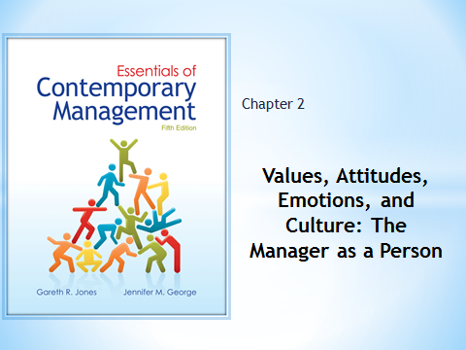
Management Snapshot (pp. 45-46 of text)
PAETEC’s Caring Culture
How Can Managers Sustain A Caring Culture While Promoting Organizational Growth And Effectiveness?

PAETEC Communications is a broadband telecommunications company that provides local and long distance voice, data, and broadband Internet services to businesses in 86 markets across the United States. PAETEC’s growth and ongoing success are a tribute to the values of its five founders and the culture they created. The four core values of PAETEC are “a caring culture, open communication, unmatched service, and personalized solutions. The ways in which these values are enacted daily result in a satisfied, motivated, and loyal workforce whose members have developed a unique and distinct approach to the way they perform their jobs. An overarching principle at PAETEC is that people—employees and customers—come first. Arunas Chesonis, one of the founders and the current chairman and CEO, believes in helping employees attain a well-balanced and prosperous work and family life, providing them with deserved recognition and admiration, and fostering open communication and helping behavior. also believes that all employees should be treated with respect and as equals. Managers at PAETEC do not receive special perks, and pay differentials between managers and nonmanagers are deliberately kept relatively low. In recognition of its commitment to its employees and ethical action, PAETEC received the American Business Ethics Award for midsize companies in 2005. Chesonis takes walks around PAETEC’s headquarters in Fairport, New York, talking with employees, answering questions, and recognizing accomplishments. Accomplishments are also recognized through two kinds of special awards. Chesonis nurtures a culture of care, cooperation, and open communication in which every employee voluntarily offers help when it is needed. Employees are expected to share their knowledge, and Chesonis strives to eliminate boundaries between departments and units. True to this culture, Chesonis has a companywide conference call every two weeks in which he shares up-to-date information with employees and solicits and answers their questions. Chesonis’s values and PAETEC’s culture emphasize putting employees first; this employee-centered approach makes good business sense. Employees at PAETEC really want the company to continue to grow and succeed; they are highly motivated and committed to providing the best service they can to their customers.

I. Enduring Characteristics: Personality Traits  Personality traits are enduring tendencies to feel, think, and act in certain ways. It is important to understand a manager’s personality because it influences his or her behavior and approach to management.  A. The Big Five Personality Traits  The Big Five is a group of five general Traits that contribute to the composition of an individual’s personality. Each should be evaluated along a continuum.  1. Extraversion is the tendency to experience positive emotions and moods expressed by affectionate, outgoing, and friendly demeanor. Being high on this trait can be an asset for managers whose jobs entail an especially high level of social interaction. Those low on this factor can be highly effective if excessive social interaction is not required by their job.  2. Negative Affectivity is the tendency to experience negative emotions and moods, feel distressed, and be critical of others. Managers high on this trait may often feel angry and dissatisfied and complain about their own and others’ lack of progress. Those who are low on negative affectivity do not tend to experience many negative emotions and are less pessimistic and critical of themselves and others. See Figure 2.3 for a measure of Negative Affectivity.  3. Agreeableness is the tendency to get along well with others. Managers high on this continuum are likeable, tend to be affectionate, and care about other people. Those who are low may be somewhat distrustful of others, unsympathetic, uncooperative and even at times antagonistic. See Figure 2.2 for a measure of this.  4. Conscientiousness is the tendency to be careful, scrupulous, and persevering. Managers who are high on this factor are organized and self-disciplined while those who are low may seem to lack self-direction and self-discipline.  5. Openness to experience is the tendency to be original, have broad interests, be open to a wide range of stimuli, be daring, and take risks. Those high on this trait continuum like to take risks and sometimes choose to become an entrepreneur, while those low on this scale tend to be more conservative in their planning and decision-making.  B. Other Personality Traits that Affect Managerial Behavior  1. The locus of control trait captures an individual’s beliefs concerning the amount of control they have over what happens to and around them.  a. People with an internal locus of control believe that they are responsible for their own fate and see their own actions and behaviors as being important and decisive determinants of future outcomes.  b. People with an external locus of control believe that outside forces are responsible for what happens to and around them and that their own actions don’t make much of a difference.  2. Self-esteem is the degree to which feel good about themselves and their capabilities.  3. Needs for achievement, affiliation and power have been extensively researched by psychologist David McClelland.  a. The need for achievement is the extent to which an individual has a strong desire to perform challenging tasks well and to meet personal standards for excellence.  b. The need for affiliation is the extent to which an individual is concerned about establishing and maintaining good interpersonal relations, being liked and getting along with other people.  c. The need for power is the extent to which an individual desires to control or influence others.  II. Values, Attitudes, and Moods and Emotions  A. Values: Terminal and Instrumental  1.A terminal value is a personal conviction about lifelong goals or objectives while an instrumental value is a personal conviction about desired modes of conductor ways of behaving.  2. Terminal values often lead to the formation of norms, which are informal rules of conduct for behaviors considered to be important within an organization.  3. A leading researcher identified 18 terminal values and 18 instrumental values that when placed in rank order, will describe a person’s value system. See Figure 2.4.  B. Attitudes  An attitude is a collection of feelings and beliefs. A manager’s attitude affects how they approach their job. Two of the most important attitudes in this context are:  1. Job Satisfaction is the collection of feelings and beliefs that managers have about their current job. See Figure 2.5 for a sample items from two measures of job satisfaction.  a. Managers who are satisfied with their jobs are more likely to perform organizational citizenship behaviors (OCBs). OCBs are behaviors that are not required but contribute to organizational efficiency, effectiveness, and gaining a competitive advantage .  b. A growing source of dissatisfaction for many lower and middle-level managers and employees is the threat of unemployment and increased workloads from downsizing.  c. The ways in which layoffs are handled is important for both layoff victims and survivors.  2. Organizational commitment is the collection of feelings and beliefs that managers have about their organization as a whole. See Figure 2.6 for a measure of organizational commitment. With organizational commitment, managers:  a. Believe in what their organizations are doing  b. Are proud of what the organization stands for  c. Feel a high degree of loyalty toward their organizations.  C. Moods and Emotions  1. Mood: A mood is a feeling or state of mind. Personality traits and current circumstances often determine a person’s mood. See Figure 2.7 for a measure of positive and negative mood at work  2. Emotions: Emotions are more intense than moods, are more short-lived, and are usually linked to a specific cause.  III. Emotional Intelligence (EI)  Emotional Intelligence is the ability to understand and manage one’s own moods and emotions, as well as the moods and emotions of others.  1. Managers with high levels of EI are able to prevent their emotions from getting in the way of making effective decisions.  2. EI helps managers perform the interpersonal roles of figurehead, leader, and liaison.  3. Emotional intelligence helps managers understand and relate well to other people.  4. See Figure 2.8 for a measure of Emotional Intelligence.  IV. Organizational Culture  Organizational culture describes the set of beliefs, expectations, values, norms, and work routines that influence how members of an organization relate to each other and work together to achieve organizational goals.  1. When members share an intense commitment to goals, a strong organizational culture exists. When the opposite is true, the organization’s culture is weak  2. When an organization’s culture is very strong, it is often referred to as the organization’s ‘personality’ because it influences the way its members behave.  A. Managers and Organizational Culture  1. Managers play a particularly important part in influencing organizational culture. This is most evident in the start-up of new companies  2. Management researcher Benjamin Schneider developed a model called the attraction-selection-attrition (ASA) framework, which posits that entrepreneurs tend to hire employees whose personalities are similar to their own.  B. The Role of Values and Norms in Organizational Culture  Shared values, as well as shared norms, play a particularly important role in organizational culture the types of values and norms that managers promote within an organization determine and shape its culture.  1. Values of the founder: From the ASA model previously discussed, it is clear that founders can have a profound and long-lasting effect on organizational culture.  2. Socialization: This is the process by which newcomers learn an organization’s values and norms and acquire the work behaviors necessary to perform jobs effectively. As a result, organizational values and norms are internalized.  3. Ceremonies and rites: These are formal events that recognize incidents of importance to the organization as a whole and to specific employees. The most common rites that organizations use to transmit cultural norms and values to their members are rites of passage, of integration, and of enhancement. (See Table 2.1 for examples of the rites listed below.)  a. Rites of passage determine how individuals enter, advance within, or leave an organization.  b. Rites of integration build and reinforce common bonds among organizational member  c. Rites of enhancement let organizations publicly recognize and reward employee contributions and thus strengthen their commitment to organizational values.  4. Stories and language: Stories frequently told within an organization, either fact or fiction, provide important clues about values and norms. The slang or jargon that people within an organization use to frame and describe events also provides important clues about norms and values.  C. Culture and Managerial Action  Culture influences the way in which managers perform their four main functions.  1. Planning: In an innovative organizational culture, top managers are likely to develop a flexible approach to planning and to encourage participation by subordinates. In contrast, managers in a conservative organizational culture are likely to emphasize top-down planning.  2. Organizing: Because they value creativity, managers in an innovative culture are likely to create an organic structure that is flat and in which authority is decentralized. In contrast, managers in a conservative culture are likely to create a well-defined hierarchy of authority and establish clear reporting relationships.  3. Leading: In an innovative culture, managers are likely to lead by example, encourage employees to take risks and experiment, and to be supportive regardless of success or failure. In a conservative culture, they are likely to use management by objectives, constantly monitor progress toward goals, and oversee their every move.  4. Controlling: Managers in innovative cultures tend to recognize that there are multiple, potential paths to success and that failure must be accepted in order for creativity to thrive. Therefore, they are more concerned that employees be flexible and take risks and less concerned about their adherence to pre-determined routines and goals in contrast, managers in more conservative cultures emphasize caution and maintenance of the status quo. | LO 2-1: Describe the various personality traits that affect how managers think, feel and behave.  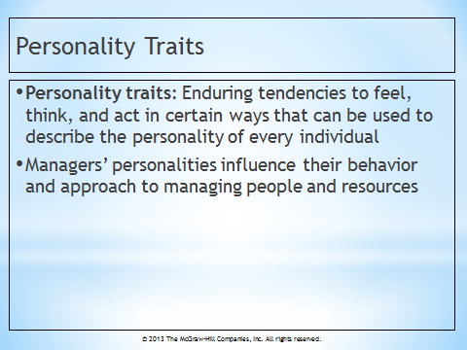  Student powerpoint slide 2  (INSTRUCTOR’S pOWERPOINT SLIDE 3)  Personality Traits  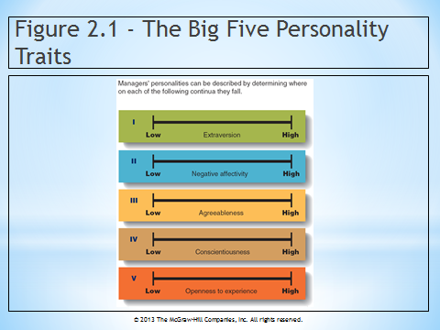  Student powerpoint slide 3  (INSTRUCTOR’S POWERPOINT SLIDE 5)  Figure 2.1 - Big Five Personality Traits  TEXT REFERENCE  Manager as a Person:  Who would have thought Dirty Jobs would be a hit?  Mike Rowe is high on openness to experience, which has helped him as he creates his hit show, Dirty Jobs. By serving as an apprentice to men and women who do all kinds of hard work, Mike encounters things he would have otherwise never had seen. Mike’s openness to experience led him to create the show in the first place, and keeps him experiencing the adventures from week to week. (Box in text on p. 50-51).  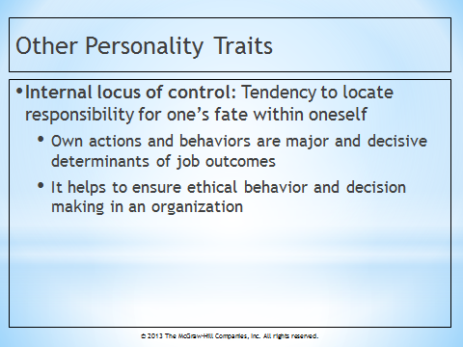  Student powerpoint slide 4  (INSTRUCTOR’S POWERPOINT SLIDE 14)  Internal Locus of Control  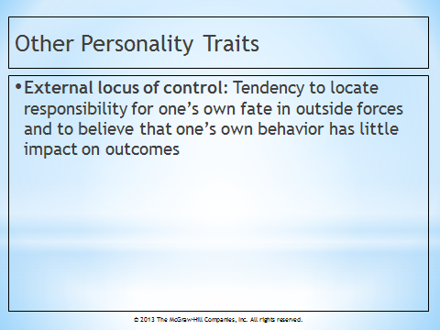  Student powerpoint slide 5  (INSTRUCTOR’S POWERPOINT SLIDE 15)  External Locus of Control  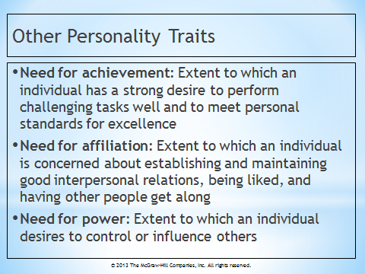  Student powerpoint slide 6  (INSTRUCTOR’S POWERPOINT SLIDE 17)  Need for Achievement…  LO 2-2: Explain what values and attitudes are and describe their impact on managerial action.  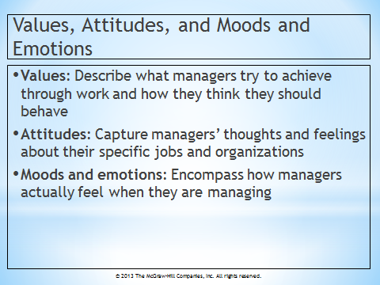  Student powerpoint slide 7  (INSTRUCTOR’S POWERPOINT SLIDE 18)  Values, Attitudes, and Moods and Emotions  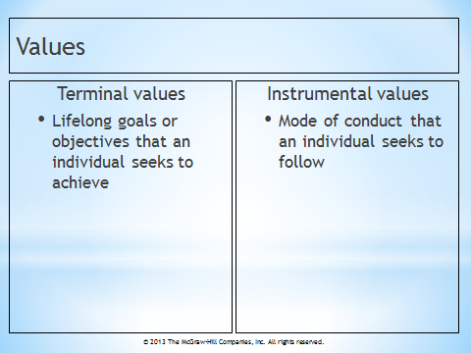  Student powerpoint slide 8  (INSTRUCTOR’S POWERPOINT)  SLIDE 19  Values  TEXT REFERENCE  MANAGEMENT INSIGHT:  Job Satisfaction at Record Low in the United States  In December 2009 the U.S. unemployment rate was 10%, 85,000 jobs were lost from the economy, and the underemployment rate was 17.3%. The Conference Board has been tracking levels of U.S. job satisfaction since 1987. In 2009 only 45% of workers surveyed indicated that they were satisfied with their jobs, an all-time low for the survey. Sources of dissatisfaction include uninteresting work, lack of job security, incomes that have not kept pace with inflation, and health insurance expenditure. Workers under 25 were the most dissatisfied with their jobs. Approximately 64% of workers in this age group were dissatisfied with their jobs, perhaps due to declining opportunities and relatively low earnings. Around 22% of all respondents didn’t think they would still have the same job in a year. (Box in text on pp. 55-56)  LO 2-3: Appreciate how moods and emotions influence all members of an organization  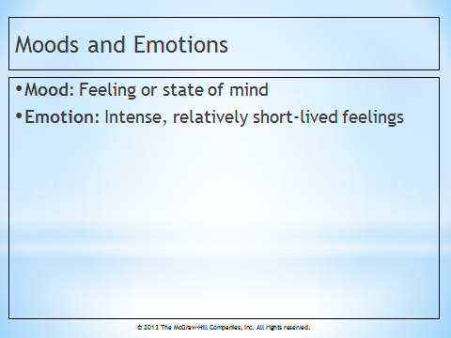  Student powerpoint slide 9  (INSTRUCTOR’S POWERPOINT SLIDE 24)  Moods and Emotions  LO 2-4: Describe the nature of emotional intelligence and its role in management  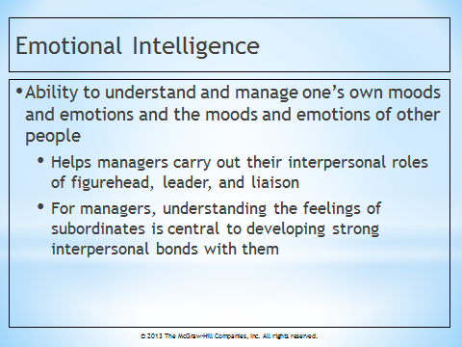  Student powerpoint slide 10  (Instructor’s POWERPOINT  SLIDE 25)  Emotional Intelligence  LO 2-5: Define organizational culture and explain how mangers both create and are influenced by organizational culture  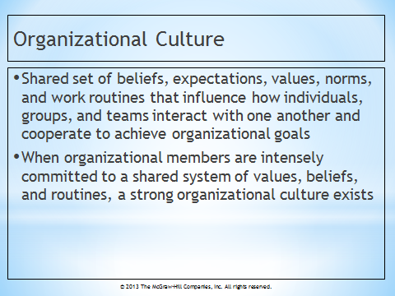  Student powerpoint slide 11  (Instructor’s powerpoint  slide 28)  Organizational Culture  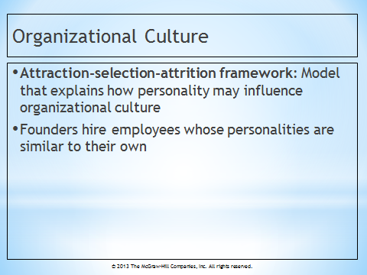  Student powerpoint slide 12  (Instructor’s POWERPOINT SLIDE 29)  Attraction-Selection-Attrition Framework  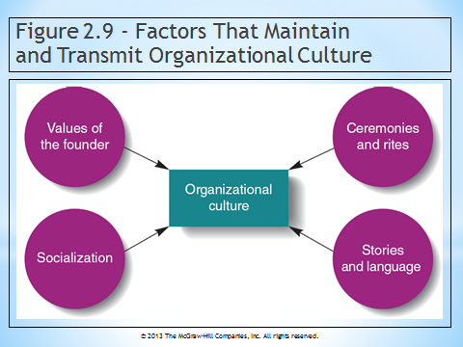  Student powerpoint slide 13  (Instructor’s powerpoint  slide 31)  Figure 2.9 - Factors That Maintain and Transmit Organizational Culture  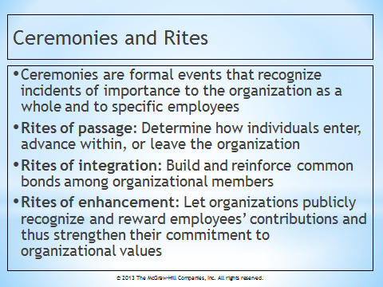  Student powerpoint slide 14  (Instructor’s powerpoint slide 33)  Ceremonies and Rites  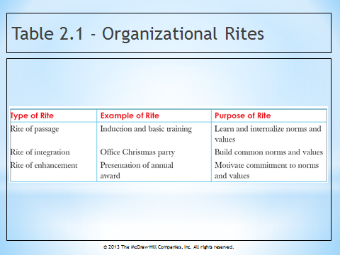  Student powerpoint slide 16  (Instructor’s powerpoint slide 35)  Table 2.1 - Organizational Rites  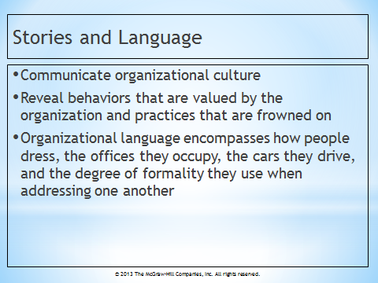  Student powerpoint slide 17  (Instructor’s powerpoint slide 36  Stories and Language)

LECTURE ENHANCERS

Lecture Enhancer 2.1
DANIEL GOLEMAN AND EMOTIONAL INTELLIGENCE

For eight years, Daniel Goleman has argued persuasively that emotionally intelligent managers become the best and most profitable business leaders in the world. Beginning with 1995 bestseller Emotional Intelligence, Goleman has sought to strip away conventional notions of what it means to be intelligent by examining how key personality traits can lead to measurable success. Although his background is in psychology, he has become a powerful voice in the corporate world. It is Goleman’s contention that top leaders will recognize that they cannot function without a clear understanding of their own feelings and those of the people around them. “Emotions have their place, and your emotions have an enormous impact on how well you can do the task as hand,” he says. Below are excerpts from an interview with Dr. Goleman.

Industry observers often complain about the dichotomy in the business world today. Executives are expected to behave as if they have no emotions while they make decisions that will have profound effects on other people’s lives. What do you think has brought us to this state where businesspeople are supposed to ‘check their emotions at the door’?

Goleman: The first analysis of the organizational life was conducted in a sociological tradition by Max Weber and Talcott Parsons, and it pretty much ignored to emotional reality of work. It analyzed the workplace and organizational dynamics as though emotions were not part of the equation. That framework has survived to this day, even though everyone who works knows it’s a lie. We don’t leave emotions at home and we don’t check them at the door. We can either acknowledge this fact or not.

You maintain that companies perform better if top managers have emotional intelligence, but the business world is rife with stories of CEOs and top managers who have been wildly successful even though they are insensitive jerks. If emotional intelligence is so important, how do you account for their successes?

Goleman: The question to ask is not, “Is a specific company successful despite the fact that the head guy is a jerk?” Rather, you should ask, “If all things were equal – if there were two companies with similar markets, similar opportunities, and similar resources, and one boss was a jerk and the other was a dream boss – which company would do better? In fact, the insurance industry did exactly that study. It was commissioned LOMO, an insurance industry organization and carried out by the Hay Group. The researchers looked at moderately successful companies of the same size and evaluated CEOs on their emotional intelligence and leadership abilities. They found that the more these bosses exhibited empathy, initiative, and a drive to achieve, the more profitable the companies were. That’s the better way to answer this question.

Is it there ever a point at which someone is too old to learn these competencies?

Goleman: You are never too old to learn emotional intelligence. In fact, people tend to improve in emotional intelligence over the course of a lifetime, because life lesions often make people wiser in this domain. Thy get more comfortable with themselves and other people. So in a rough way, a slow way, there’s a tendency to earn. But someone who wants to a leader needs to have a relative high level of these abilities. A business school that wants to help its students achieve high leadership levels either has to select people who have already developed these abilities, or it has to help its students to learn them.

Essentially, you are saying that individuals must be able to draw on the so-called ‘soft skills’ or they won’t be good leaders.

Goleman: It’s a paradox. Soft skills have hard consequences.

Taken from Intelligence at Work by Sharon Shinn, published in BizEd Magazine, September/October 2003.

Lecture Enhancer 2.2

BIRTH ORDER AND PERSONALITY

Birth-order guru Kevin Leman, Ph.D. says he can explain how a simple understanding of birth order enhances the chance of success in business. In his book, “The Birth Order Book,” Leman profiles three birth-order positions.

The firstborn tends to be a perfectionist, conscientious, list maker who doesn’t like surprises. The only child has similar, yet often more intense personality traits.

The middle child is a master negotiator who never had his parents to himself, and endured hand-me-downs. The good news is he can compromise, share and negotiate.

Leman describes the baby of the family as manipulative, social, outgoing, and a natural salesperson. She is the child who got her siblings in trouble while she was cute, helpless and got away with murder.

A fourth birth-order position, identified by Michael Maniacci, a clinical psychologist and member of the faculty at the Adler School of Professional Psychology in Chicago, is the second born. The second born tends to be more rebellious, non-conforming and independent than the middle child.

After reading these descriptions, most either buy into the birth-order concept as a perfect description of their family or discount it. Either way, Leman says, there are other birth-order rules that impact children’s development.

Sex of children is an important variable in the birth-order equation. “If there are three daughters and a last-born son, the son may possess the characteristics of the firstborn, rather than the baby,” Leman says.

Maniacci says: “In my practice, I’ve found the greater the sex differentiation between the parents, the less children of the opposite sex compete with each other. That impacts birth-order roles.

“In a family with a firstborn boy and a second born girl, if both parents work, both wear pants, and equally share housework tasks, the girl is more likely to be a rebellious second born. There is not much distinction between being a girl and a boy. Conversely, if Dad has short hair and Mom has long, and Mom stays at home and Dad works, the boy holds the role of the oldest born male and the girl the oldest born female.”

If there is a five-year age gap between the children, you can draw a line and start another family with a whole new set of firstborns and middles, Maniacci says. Physical differences play a role too. If the oldest child is physically or psychologically challenged, the second child usually takes on the role of the firstborn.

Other experts caution that understanding and using birth order is anything but simple, and many variables mold personality. Experts generally agree interpreting birth order can be complicated and only presents part of the picture.

But Leman says, “As a psychologist, I have not found a more practical tool for understanding human dynamics than birth order.”

Lecture Enhancer 2.3

THE BIG THRILL PERSONALITY

Another facet of personality is one’s tolerance for risk taking. Some individuals have a kind of psychological urge to reach beyond the status quo and seek out novelty, change, and excitement. Psychologist Frank Farley, of the University of Wisconsin, has spent twenty years examining what he calls the Type T (thrill-seeking) personality. According to Farley’s theory, Big T types are high-profile individuals who seek excitement and stimulation wherever they can find it or create it. For some the thrills are mostly physical. For others they’re mental.

The degree of risk that individuals are willing to assume spans a broad continuum. Big T personalities, those who continually live on the edge, are at one end of the scale. Little t’s, who cling to certainty and predictability, are at the other. Most people fall somewhere in the middle. But Farley believes it’s the Big T segment, a group that makes up an estimated 10 to 30 percent of the American population, that holds the key to America’s future. “Type T’s are the people who are likely to have enormous impact on society,” he says. “They are the great experimenters in life; they break the rules.”

Whether male or female, risk-taking individuals tend to be what Farley calls “transmutative thinkers,” adept at shifting from one cognitive process to another, and from the abstract to the concrete and vice versa. Thrill seekers are happiest in jobs that provide change, excitement, and an ample outlet for their creativity. They are often drawn to careers in advertising, journalism, or in the brokerage business, where novelty and uncertainty are a given.

Whether individuals seek risks or avoid them affects not only their own job performance but also boss-employee relationships and co-worker production. An organization with too many risk takers can spell trouble. So can one top-heavy with cautious, security-minded individuals. A synergistic mix is best. If it’s the thrill-seeking visionaries who drive a company with their ideas, it’s their more pragmatic peers who help implement those concepts. Finally, says Farley, “people who are the most successful realize that if they’re going to take risks, they’re going to fail once in a while.”

MANAGEMENT IN ACTION

Notes for Topics for Discussion and Action

Discussion
1. Discuss why managers who have different types of personalities can be equally effective and successful.

The chapter notes that there is no single “right” or “wrong” personality trait for being an effective manager; rather, effectiveness is determined by a complex interaction between characteristics of managers (including personality traits) and the nature of the job and organization. Furthermore, personality traits that contribute to the managerial effectiveness in one situation may actually hinder the effectiveness in another situation.

2. Can managers be too satisfied with their job? Can they be too committed to their organizations? Why or why not?

(Note to Instructors: Student answers will vary.)

The text defines job satisfaction as the feelings and beliefs people have about their current jobs and organizational commitment as the collection of feelings and beliefs people have about their organizations as a whole. Students may mention that managers who are too satisfied with their jobs may not look to improve the current state of affairs, preferring to let things go on as they are. This may harm the prospects of the team as a whole. On the personal level, managers who are too satisfied with their jobs or too committed to the organization may harm their own prospects of career improvement or advancement.

3. Assume that you are a manager of a restaurant. Describe what it is like to work for you when you are in a negative mood.

(Note to Instructors: Student answers will vary based on their personalities. The text identifies characteristics of a negative mood as feelings of distress, fearful, scornful, hostile, jittery or nervous.)

This question is very individualized. However, you might turn it into an interesting exercise. You could have the individual student answer the question and then have their classmates react to their self-description as to its accuracy from their perspective.

4. Why might managers be disadvantaged by low levels of emotional intelligence?

Social skills are increasingly important in organizations today. People work more and more in teams. Emotional intelligence enables managers to interact more effectively both internally with co-workers and externally with customers.

Action
5. Interview a manager in a local organization. Ask the manger to describe situations in which he or she is especially likely to act in accordance with his or her values. Ask the manager to describe situations in which he or she is less likely to act in accordance with his or her values.

(Note to Instructor: Student answers will vary based on the manager’s value system and experiences.)

This question to potential strangers is tricky. People are sometimes quite guarded about their values and are not eager to discuss them with others. It is suggested that the class or a team of students, as interviewers, should be more comfortable and aware when asking ethical questions and capturing a response. You may also want to suggest that students interview a manager who is someone they know.

6. Watch a popular television show and as you watch it, try to determine the emotional intelligence levels of the characters each of the actors in the show portrays. Rank the characters from highest to lowest in terms of emotional intelligence. As you watched the show, what factors influenced your assessments of emotional intelligence levels?

(Note to Instructors: Student answers will vary based upon the television show they view. You may want to request that the entire class watch the same episode of a popular television show.)

The ranking of characters by students will probably vary, thereby providing the basis for an interesting discussion. Factors influencing student assessment of emotional intelligence may include awareness of and ability to manage one’s own emotions, the ability to perceive and understand the emotions of others, good listening skills, and the ability to effectively deal with interpersonal conflict.

7. Go to an upscale clothing store in your neighborhood and to a clothing store that is definitely not upscale. Observe the behavior of employees in each store as well as the store’s environment. In what ways are the organizational cultures in each store similar? In what ways are they different?

Often the environment of upscale clothing stores is rather quiet and formal, and salespersons are dressed rather conservatively. On the other hand, less upscale stores often have a much more casual environment in which music that appeals to the younger generation is played. Salespeople sometimes dress in trendy, casual clothing that reflects the store’s product line and the taste of the target audience. Normative behavior for employees in the upscale store is reflected in the reserved and cautious manner required when interacting with customers. In a less upscale environment, however, interaction with customers is less formal and more casual. For example, slang language may be used. However, core values common to both stores would include high levels of customer responsiveness, honesty, and integrity, operational efficiency, and a strong work ethic.

AACSB: Analytic
AACSB: Reflective Thinking

BUILDING MANAGEMENT SKILLS

Diagnosing Culture

1. What values are emphasized in this culture?

Student answers will vary but they should give specific examples of behaviors or policies that reflect specific values such as a sense of accomplishment, self-control, dependability, independence, and honesty.

2. What norms do members of this organization follow?

Again, student answers will vary but they should give specific examples of behaviors or policies that reflect specific norms such as courtesy, informality, and a willingness to take risks.

3. Who seems to have played an important role in creating the culture?

Founders, managers, or even employees often establish or influence the culture.

4. In what ways is the organizational culture communicated to organizational members?

Often founders use their own values to determine and guide organizational culture. Culture can also be communicated to organizational members through formal or informal socialization programs, ceremonies, rites, stories, and language.

AACSB: Analytic
AACSB: Reflective Thinking

MANAGING ETHICALLY

Notes for Managing Ethically

1. Either individually or in a group, think about the ethical implications of using personality and interest inventories to screen potential employees. How might this practice be unfair to potential applicants? How might organizational members who are in charge of hiring misuse it?

It is important that companies make every effort to hire employees whose values, personality, and interests fit with their organizational culture. However, reliance upon personality and inventory tests is an ineffective means of evaluating such factors. Because of their measurement error and validity problems, these tests could mistakenly screen out those candidates who are well suited for the job. Managers in charge of hiring may think these tests are a quick and easy substitute for a thorough interviewing process, but will regret their decision later.

2. Because of measurement error and validity problems, some relatively trustworthy people may “fail” an honesty test given by an employer. What are the ethical implications of trustworthy people “failing” honesty tests, and what obligations do you think employers should have when relying on honesty tests for screening?

(Note to Instructor: Student answers will vary.)

When candidates apply for a job, they generally assume that they will be evaluated and compared to other applicants in a fair, nonbiased manner. The use of such tests violates that trust, thus representing an ethical breach.

AACSB: Analytic
AACSB: Reflective Thinking

SMALL GROUP BREAKOUT EXERCISE

1. Develop a list of options and potential courses of action to address the heightened competition and decline in profitability that your company has been experiencing.

(Note to instructors: student answers will vary based on their experiences.)

Possible options include:
- Employ a consultant to help management determine additional ways to cut costs.
- Implement a hiring freeze and reduce workforce through attrition.
- Build employee motivation to increase performance levels by providing incentives linked to performance, issuing "star-performer" awards, and holding parties or arranging activities for employees.
- Increase marketing and advertising efforts to improve sales.
- Lay off employees.

2. Choose your preferred course of action and justify why you will take this route.

(Note to instructors: Student answers will vary.)

3. Describe how you will communicate your decision to employees.

Since "rumors are rampant", it is important to communicate with everyone in a clear and timely manner. Top management needs to increase the employees' sense of security and confidence about the company's commitment to resolving the situation. Moreover, since the stakes are high and people's jobs are on the line, the decision should be communicated in a face-to-face meeting.

If layoffs are being announced, the meetings should be individualized and terminated employees should be assured that the terminations were based on objective criteria. Specific information regarding severance pay etc. should be clearly communicated as well.

4. If your preferred option involves a layoff, justify why. If it doesn’t involve a layoff, explain why.

Layoffs could be justified if the slowdown of work is so severe that the company cannot keep its workers occupied or is facing a financial crisis, such as bankruptcy. In this case, the only way to save the company and protect the majority of stakeholders could be through downsizing.

Because maintaining the company's no-layoff policy is an important aspect the company's culture, this action should still be considered only as a last resort, as it could be demoralizing to the remaining workers. Other companies, such as Southwest Airlines, have stood by their employees even in the toughest of times, which has resulted in a high level of employee loyalty and commitment.

AACSB: Analytic
AACSB: Reflective Thinking

BE THE MANAGER

In this situation it is best to take a collaborative approach toward conflict resolution. A collaborative approach encourages the disputing parties to solve the problem together. The position of both parties should be treated as equally important (though not necessarily the case), and equal emphasis should be placed on the quality of the outcome and the fairness of the decision making process. The intent is to find solutions that are satisfactory to both parties rather than find fault or assign blame. The first step of the vice president for human resources should be to bring the disputing parties together for the purpose of focusing upon a shared goal, such as improved work climate, improved quality of work, improved work relationships, etc. The establishment of common goals will provide a context for the continuance of discussions between disputants. As the collaborative effort to identify mutually acceptable resolutions continues, it is important that emphasis always rests upon issues, not personalities. In other words, people must remain separated from the problem and that the focus must remain upon interests, not position. Doing so will depersonalize their disagreement and allow all parties to feel less vulnerable about opening up to a different point of view.

After the source of conflict has been identified and resolved, the attitudes and behavior of the disputants should change, gradually eliminating any lingering feelings distress, fear, or hostility in the office environment.

AACSB: Reflective Thinking
AACSB: Communication Skills

CASE IN THE NEWS

Case Synopsis: Merck’s Risky set on Research

Though a safety panel had recently shut down a nearly completed 13,000-patient study of experimental drug vorapaxar, chief executive officer of Merck, Kenneth C. Frazier, announced that the company was doubling down on new-drug development and planned to spend as much as $8.5 billion on research in 2011. Stumbles like vorapaxar are, in Frazier’s view, the price of doing business in the drug industry. “Scientific innovation is hard, it’s complex, it’s risky, it’s uncertain as to timing,” he says. “At the same time, we have huge opportunities. That’s the way a company like Merck needs to exist in the world.” When Frazier announced the $8.5 billion research bet, Merck shares fell 2.7%. That’s because research dollars spent today can take a decade to turn profits. Explains Frazier: “If you’re going to be in the business of breakthrough research, you have to accept that the timing can be uncertain and the risks are large.”

Questions:
1. How would you describe Kenneth Frazier’s personality?

Kenneth Frazier is likely to be high on openness to experience, as he’s willing to take risks when it comes to product research. He would seem to have low negative affectivity, as he takes setbacks in his stride, without becoming pessimistic or critical. He might have an internal locus of control, as he is willing to take responsibility for the failure of his decisions. We might also guess that he has a high need for achievement, based on his academic achievements.

2. Which terminal values do you think might be especially important to him?

His terminal values are likely to be associated with the success of Merck, making a lasting contribution to the world through medical research, and succeeding in breakthrough research.

3. Which instrumental values do you think might be especially important to him?

Frazier’s instrumental values may be to be daring and courageous in seeking out new solutions, and independent and open-minded when considering new research paths.

4. In what ways do you think that Frazier might influence Merck’s culture in his role as CEO?

Frazier would likely allow researchers and employees at Merck to be more accepting of risk and open to unusual ways of solving problems. He might encourage the employees to look beyond safe options and not be restrained by thoughts of failure.

AACSB: Reflective Thinking

SUPPLEMENTAL FEATURES

Please see the following collections in the Asset Gallery on the text website.
VIDEO CASE

Emotional Rescue: Keeping Your Emotions in Check

If you have ever lost control of your emotions or have been on the receiving end of an emotional tirade, you know it isn’t pretty or professional. While everyone experiences intense feelings, keeping them in check can reduce the negative impact they often have. It is important to have emotional intelligence, that is, to understand and manage our emotions and deal with those of other people. For instance, managers are more likely to develop productive working relationships when they can manage their own feelings and understand how a subordinate or co-worker feels in different situations.

Emotions can get in the way of having more in-depth relationships, says psychologist and relationship expert Dr. Michelle Callahan. We can get so caught up in different feelings that we are unable to keep emotions in check and to communicate clearly with others. Instead of communicating effectively, we can let anger or anxiety gets the best of us, get hijacked by emotions, and lose control.

How do you keep your emotions in check and not let them get the best of you? It seems that people who wear their emotions on their sleeves can’t help what they say. Not true, says Josh Freedman, CEO of Six Seconds, a firm specializing in the development of emotional intelligence. He says people can control what they say, and knowing this fact is a critical step to changing. The name of his organization, Six Seconds, reflects the fact that emotions are chemicals lasting in the brain for about six seconds. If a person feels something beyond six seconds, it is technically no longer an emotion; rather it is a feeling a person is choosing. Freedman recalls the advice we probably have all heard at one time or another—count to ten—and suggests a six-second pause to re-engage your thinking brain with your feeling brain to make intelligent decisions.

If the six second pause is not enough and emotions are still running high, Freedman recommends actually naming emotions—anger, frustration, or resentment, for instance. Saying what you feel seems to change something. In fact research has found that when people identify what they are really feeling, the feelings start to subside. Callahan suggests taking some time to get away from the situation if you can’t name the feeling but know you are about to say something you will regret. For example, you might tell a person that you will think it over and get back to him or her later, when you have had time to reflect on the situation and gain control of your emotions.

It isn’t always the situation that stirs a person’s emotions. It may be simply that one person rubs another the wrong way. Over time the feelings build up and one day there is some sort of outburst. In this case one choice is to terminate a relationship with someone who seems to push your hot buttons. Since that isn’t always possible, another choice is to train yourself to not get caught up in the emotion. Be prepared for what the other person is likely to say to set you off. When it happens, laugh it off inside. If the relationship is important, or simply unavoidable, we should care enough to conquer our emotions.

Questions
1. What are emotions and why are they critical to personal relationships?
2. Why do managers need to be concerned with their own emotions and those of their subordinates?
3. What are some strategies a person can use to keep emotions in check?

Chapter 3 Video Case Teaching Note
Emotional Rescue: Keeping Your Emotions in Check

Teaching Objective: To become familiar with emotional intelligence and learn some strategies that can be used to keep emotions in check.

Summary: While everyone experiences emotions, some of them intense, it is important to understand and manage them as well as the emotions of others. Emotional intelligence enables people to keep emotions in check and paves the way to more productive relationships. By understanding that emotions are actually chemicals that last in the brain about six seconds, we can learn to pause before letting our emotions get in the way of clear thinking.
Questions:

1. What are emotions and why are they critical to personal relationships?

Emotions are intense feelings that we all experience from time to time. They are actually chemicals in the brain, and can lead to outbursts we not only regret later but get in the way of productive personal relationships.

2. Why do managers need to be concerned with their emotions and the emotions of their subordinates?

Managers must understand that emotions play an important role in productive relationships. By keeping their own emotions in check and managing the emotions of subordinates, managers pave the way to better communication and greater productivity.

3. What are some of the strategies a person can use to keep emotions in check?

Josh Freedman suggests the six-second pause, training ourselves to wait until our emotions subside before responding. He also recommends identifying the emotion by name, such as anger. If that doesn’t work, Dr. Michelle Callahan recommends simply getting away from the situation until we have had time to gain control of our emotions.

MANAGER’S HOT SEAT (MHS)

- Whistle blowing: Code Red or Red Ink?

SELF-ASSESSMENT(S)

- Assessing Your Emotional Intelligence
- Corporate Culture Preference Scale
- A Profile of Our Personality Based on the Five Factor Scale

TEST YOUR KNOWLEDGE

There are no Test Your Knowledge exercises for this chapter

INSTRUCTOR’S POWERPOINT SLIDES

These Instructor’s PowerPoint slides can be used to supplement the lecture material.
Instructor’s powerpoint  slide 1  Chapter Title | 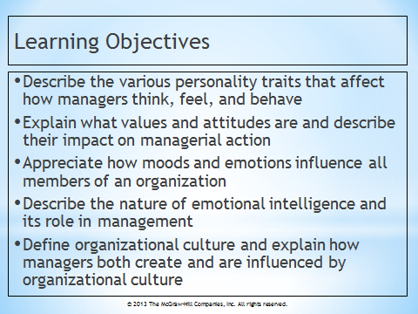  Instructor’s PowerPoint Slide 2  Learning Objectives | INSTRUCTOR’S pOWERPOINT SLIDE 3  Personality Traits
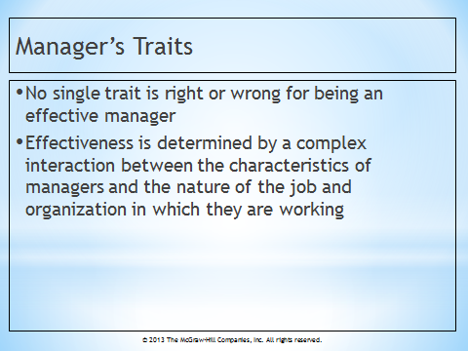  INSTRUCTOR’S POWERPOINT  SLIDE 4  Manager’s Traits | INSTRUCTOR’S POWERPOINT SLIDE 5  Figure 2.1 - Big Five Personality Traits | 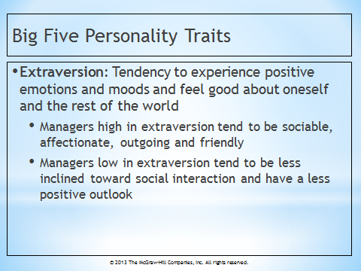  INSTRUCTOR’S POWERPOINT SLIDE 6  Extraversion

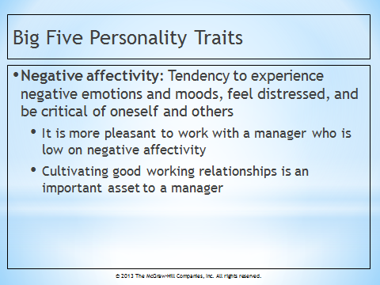  INSTRUCTOR’S POWERPOINT  SLIDE 7  Negative Affectivity | 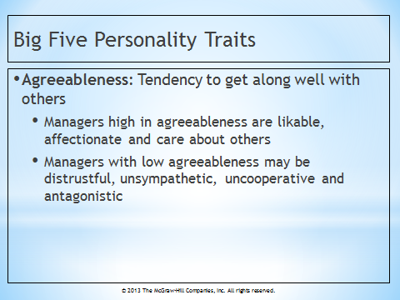  INSTRUCTOR’S POWERPOINT SLIDE 8  Agreeableness | 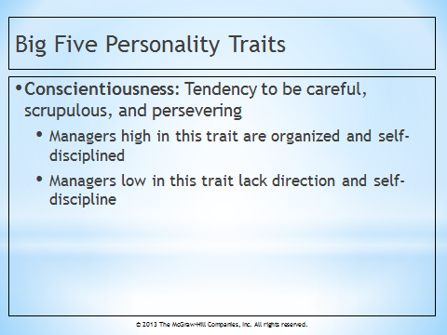  INSTRUCTOR’S POWERPOINT SLIDE 9  Conscientiousness
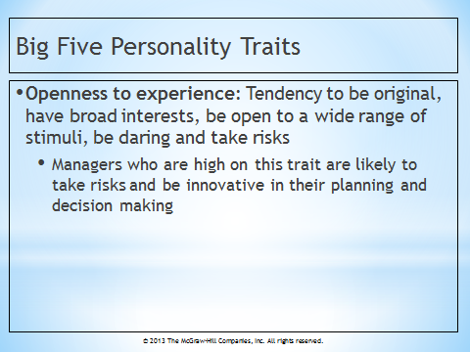  INSTRUCTOR’S POWERPOINT  SLIDE 10  Openness to Experience | 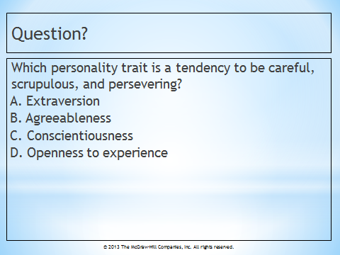  INSTRUCTOR’S POWERPOINT SLIDE 11  Question? | 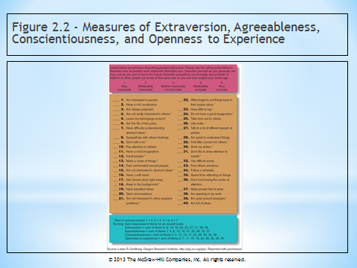  INSTRUCTOR’S POWERPOINT SLIDE 12  Figure 2.2 - Measures of Extraversion, Agreeableness, etc…
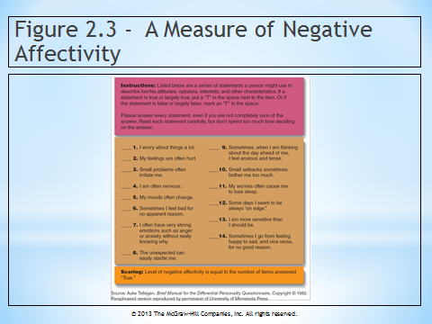  INSTRUCTOR’S POWERPOINT  SLIDE 13  Figure 2.3 - A Measure of Negative Affectivity | INSTRUCTOR’S POWERPOINT SLIDE 14  Internal Locus of Control | INSTRUCTOR’S POWERPOINT SLIDE 15  External Locus of Control

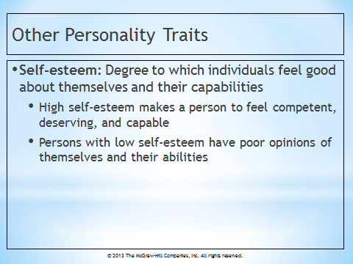  INSTRUCTOR’S POWERPOINT  SLIDE 16  Self-Esteem | INSTRUCTOR’S POWERPOINT SLIDE 17  Need for Achievement… | INSTRUCTOR’S POWERPOINT SLIDE 18  Values, Attitudes, and Moods and Emotions

INSTRUCTOR’S POWERPOINT  SLIDE 19  Values | 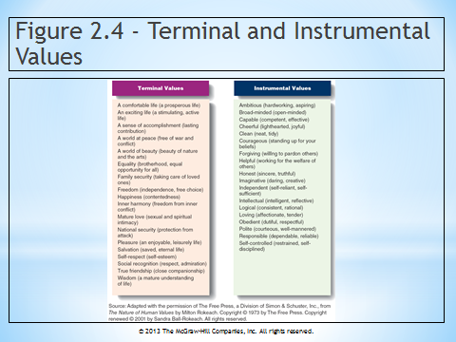  INSTRUCTOR’S POWERPOINT SLIDE 20  Figure 2.4 - Terminal and Instrumental Values | 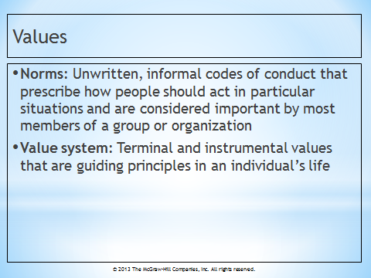  INSTRUCTOR’S POWERPOINT SLIDE 21  Values

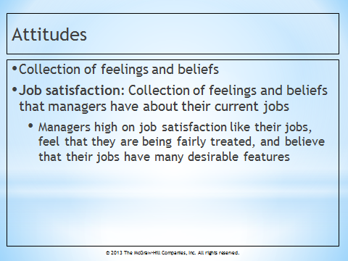  INSTRUCTOR’S POWERPOINT  SLIDE 22  Attitudes | 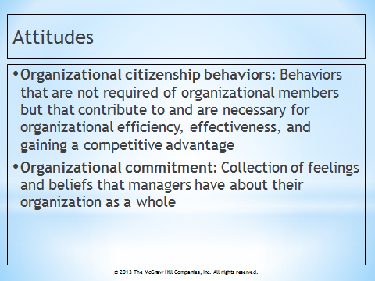  INSTRUCTOR’S POWERPOINT SLIDE 23  Attitudes | INSTRUCTOR’S POWERPOINT SLIDE 24  Moods and Emotions
Instructor’s POWERPOINT  SLIDE 25  Emotional Intelligence | 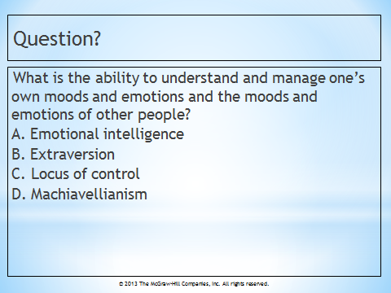  INSTRUCTOR’S POWERPOINT SLIDE 26  Question? | 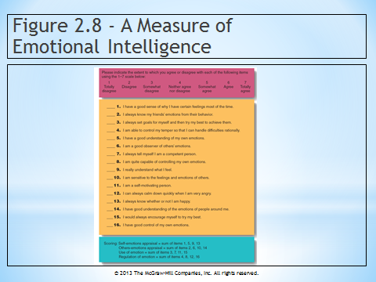  INSTRUCTOR’S POWERPOINT SLIDE 27  Figure 2.8 - A Measure of Emotional Intelligence

Instructor’s powerpoint  slide 28  Organizational Culture | Instructor’s POWERPOINT SLIDE 29  Attraction-Selection-Attrition Framework | 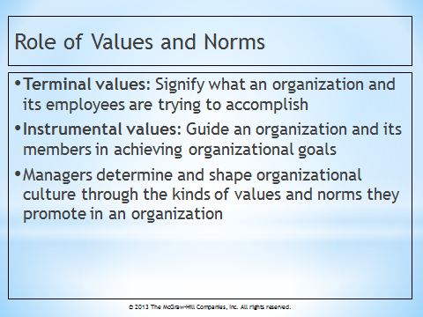  Instructor’s powerpoint slide 30  Role of Values and Norms
Instructor’s powerpoint  slide 31  Figure 2.9 - Factors That Maintain and Transmit Organizational Culture | 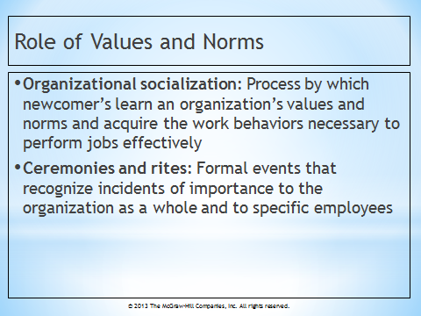  Instructor’s powerpoint slide 32  Role of Values and Norms | Instructor’s powerpoint slide 33  Ceremonies and Rites

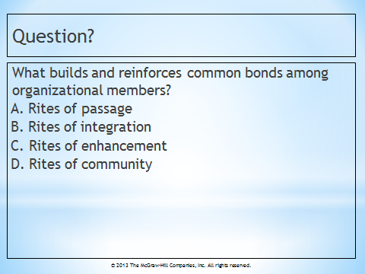  Instructor’s powerpoint  slide 34  Question? | Instructor’s powerpoint slide 35  Table 2.1 - Organizational Rites | Instructor’s powerpoint slide 36  Stories and Language

