# INSTRUCTOR’S MANUAL ENVIRONMENTAL SCIENCE: A GLOBAL CONCERN, 14E

W.P Cunningham, M.A. Cunningham

#### This instructor’s manual emphasizes main points that students should learn in the chapters and provides answers to questions in the text. We also suggest a “key figure” for each chapter. This figure represents an important idea or set of ideas in the chapter, and it can serve as a focal point for lecture or discussion.

Similarly, Further Resources provide general links that can be of use for providing resources in class, for projects, or for discussion.

Chapter names in the list below link to the chapter section in this document. Introduction 1

1 Understanding Our Environment 12

2 Principles of Science and Systems 36

3 Matter, Energy, and Life 51

4 Evolution, Biological Communities, and Species Interactions 74

5 Biomes: Global Patterns of Life 99

6 Population Biology 118

7 Human Populations 133

8 Environmental Health and Toxicology 154

9 Food and Hunger 179

10 Farming: Conventional and Sustainable Practices 197  11 Biodiversity: Preserving Species 225

12 Biodiversity: Preserving Landscapes 249  13 Restoration Ecology 273

14 Geology and Earth Resources 298  15 Climate Change 319

1. Air Pollution 347
2. Water Use and Management 374  18 Water Pollution 398

19 Conventional Energy 424  20 Sustainable Energy 448

21 Solid, Toxic, and Hazardous Waste 474  22 Urbanization and Sustainable Cities 495  23 Ecological Economics 515

24 Environmental Policy, Law, and Planning 539  25 What Then Shall We Do? 560

**INTRODUCTION LEARNING TO LEARN**

(return to Table of Contents)

***MAIN CONCEPTS***

* 1. How Can I Get an A in This Class? 3
  2. Thinking About Thinking 7

This chapter has two purposes. The first is to encourage students to understand learning strategies and learning styles, so that they can identify their own strengths and areas for improvement in studying.

Active reading, which involves pausing to review, question, and connect ideas, is also emphasized. Many students appreciate time spent on developing these basic skills, which are almost universally needed but often go unexamined.

The second purpose is to focus on the nature and practice of critical thinking. Critical thinking is widely noted to be one of the most important practices students should develop. The “What do you think?” reading asks students to think critically about the media they encounter daily. Questions asked here could be asked in all chapters of this book and in daily life. A way to engage students in this material is to present an example of a news report and ask students to provide a comparable set of their own critical questions.

A list of logical errors and fallacies offers students names to identify and categorize different types of arguments, which facilitates critical thinking.

***A KEY FIGURE***

This figure summarizes several aspects of critical thinking and can be useful for slowing down and structuring the process of critical thinking.

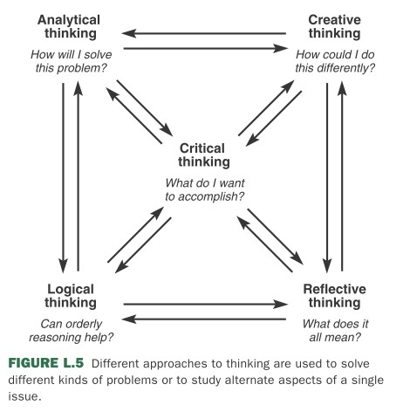

## SECTION REVIEW— QUESTIONS AND ANSWERS

##### Section L.1

1. What is your strongest learning style?

Answers will vary, but students should examine their own behavior patterns and preferences.

1. What are the five techniques of the SQ3R method for studying?

These methods are listed in table L3. They include Survey (the information in the chapter), Qeuestion (yourself about main issues in the readings), Read (in small segments), Recite (ideas you have just read), and Review (main ideas after reading).

##### Section L.2

1. Describe seven attitudes needed for critical thinking.

In the section “What do I need to think critically?” is a list of attitudes and dispositions needed for well- reasoned analysis. These include skepticism and independence, open-mindedness and flexibility, accuracy and orderliness, persistence and relevance, contextual sensitivity and empathy, decisiveness and courage, and humility.

1. List six steps in critical thinking.

Identify and evaluate premises; acknowledge and clarify uncertainties; distinguish between facts and values; recognize and assess assumptions; distinguish the reliability ofa source; recognize and understand conceptual frameworks.

## KEY TERMS

environment environmental science ecological footprint utilitarian conservation biocentric preservation environmentalism sustainable development global environmentalism quality-of-life indicators

throughput ecosystem services

tragedy of the commons managing the commons Millennium Development

Goals ethics moral value

moral extensionism

inherent value instrumental value stewardship environmental justice LULUs

environmental racism toxic colonialism

# CHAPTER 1 UNDERSTANDING OUR ENVIRONMENT

#### (return to Table of Contents)

***MAIN CONCEPTS***

* 1. What Is Environmental Science? 14
  2. Where Do Our Ideas About Our Environment Come From? 20
  3. Sustainable Development 24
  4. Core Concepts in Sustainable Development 27
  5. Environmental Ethics, Faith, and Justice 30

This chapter introduces major themes and concerns in Environmental Science. There are several major themes students should learn. Students should understand some of the ways different disciplines and professions contribute to environmental science. They should be able to recount a number of environmental challenges as well as topics that demonstrate that progress is possible and worth working for. They should also understand the idea of an ecological footprint, which emphasizes that each of us has global impacts, beyond what we often consider.

This chapter also walks through a progression of ideas that have shaped our current understanding of environmental science, including the contributions of thinkers such as Aldo Leopold, Rachel Carson, and Wangari Maathai.

The chapter concludes with a focus on sustainable development and some of the arguments about what makes it both a difficult and an essential aim. The idea of the tragedy of the commons is counterposed against strategies for managing the commons. Finally, the Millenium Development Goals, environmental justice, and moral extensionism are described as approaches to safeguarding people and their environment.

***A KEY FIGURE***

We depend on a great variety of ecosystem services. Identifying them allows us, ideally, to account for their value and for the costs of degrading them

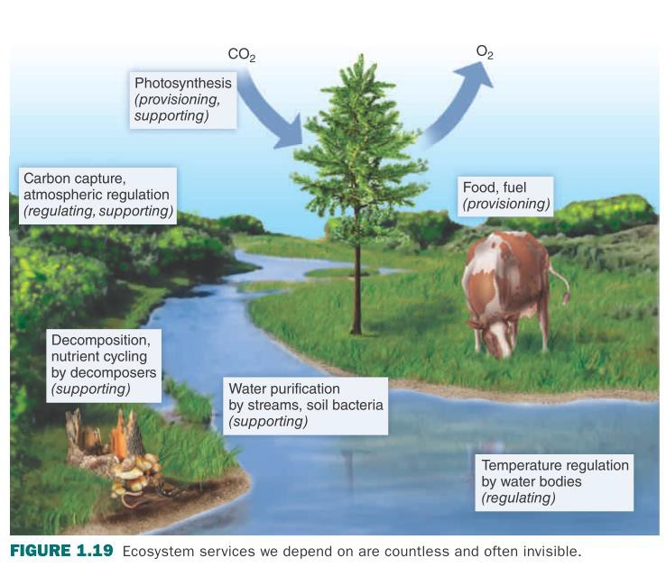

## SECTION REVIEW— QUESTIONS AND ANSWERS

##### Section 1.1

1. Why is population an important question in environmental science? In what ways is population less of a problem than in earlier years?

Both the total population and the rate of consumption per person are of concern in environmental science. More people (and especially more wealthy people) consume more resources, destroy more habitat, and create more pollution. Nevertheless, there are signs that population growth is stabilizing nearly everywhere. If we all convert to more sustainable lifestyles, we could minimize our impacts.

1. In what ways is pollution still a problem? Has it improved? Why?

Although air and water quality have improved dramatically in most developed countries, we still emit more pollution than can be cleaned up by ecological systems. These improvements are due to better public understanding of environmental issues and demands for protective legislation. We’re now particularly about long-lived, highly toxic materials, such as mercury and lead, that have deleterious effects at extremely low levels that may not be manifest for years or decades and act in subtle ways to disrupt endocrine regulation or other fundamental controls on growth and development.

1. What is an “ecological footprint”?

An ecological footprint is a measure of our environmental impacts. It’s generally calculated using a few standard measurements that can be converted (somewhat controversially) into global hectares (of productive land) that would be needed to support each activity we undertake.

##### Section 1.2

1. Differentiate “conservation” and “preservation.” Identify one person associated with each.

Conservation usually means wise use of resources to make them last as long as possible, but still use, nonetheless. Gifford Pinchot was an important proponent of conservation. Preservation emphasizes the protection of organisms and resources for their own sake regardless of their utility to us. John Muir pioneered many of our ideas about preservation.

1. What was Rachel Carson’s *Silent Spring* about? Why?

Silent Spring was concerned with the dangers of chemical pollution and especially its effects on human health. Rachel Carson’s interest in this topic began after the Second World War, when there was a great explosion of synthetic chemical use (most of which hadn’t been sufficiently tested) in every walk of life.

1. In what ways is environmental quality tied to social progress?

Increasingly, environmental activists are linking environmental quality and social progress on a global scale. One of the core concepts of modern environmental thought is sustainable development, the idea that economic improvement for the world’s poorest populations is possible without devastating the environment. A core belief is that as we become wealthier and more technologically advanced, we become more interested in environmental quality, we have the resources and technology to improve our environment.

##### Section 1.3

1. List any three quality of life indicators (table 1.1). How do they differ between wealthy and poor countries?

GDP I at least 35 times higher, the poverty index is about 60% lower, and life expectancy is about 23% higher in most developed countries compared to the least-developed countries.

1. Why is affluence a liability? Give an example.

Affluence makes it possible for us to follow our worst impulses to the detriment of our own health and well-being as well as the quality of our environment.

1. Why are many ecologists skeptical about the idea of sustainable development?

Development generally means more resource consumption. Many ecologists doubt we can do that sustainably.

##### Section 1.4

1. Think of five ecosystem services on which you rely.

Photosynthesis, carbon capture, nutrient recycling, water purification, and temperature regulation (as

well as food and fuel supply).

1. What is the “tragedy of the commons”? List any two of the factors that can help communities manage a commons.

The “tragedy of the commons” is an idea proposed by Garrett Hardin in 1968 claiming that population growth leads inevitably to overuse and then destruction of common resources—such as shared pastures, unregulated fisheries, fresh water, land, and clean air because each of us acts only in our own self-interest motivated primarily by fear and greed. However, there are many cases of successful long- term management of common-property resources, such as sustainable fisheries, common forests, and grazing lands, in communities around the world. Among the requirements for communal resource management are (1) effective and inexpensive monitoring of resource use; (2) an ability to exclude outsiders, who don’t understand rules of use; and (3) frequent face-to-face communications and strong social networks among users.

1. List several concerns of the Millennium Development Goals.

The Millennium Development Goals include ending poverty and hunger, universal education, gender equity, child health, maternal health, combating HIV/AIDS, environmental sustainability, and global cooperation in development efforts. Many of these goals emphasize health and rights for women and children, who traditionally have little access to resources, education, health care, or political rights in many developing areas.

##### Section 1.5

1. Explain the idea of moral extensionism, and give an example.

Moral extensionism expands our concepts of inherent value—that someone or something has value for its own sake-from ourselves to our community, to other groups, and other organisms or even the whole universe. Aldo Leopold’s essay “Thinking like a Mountain” or Christopher *Stone’s Should Trees have Standing?* Have both transformed our understanding of this idea.

1. How does *inherent value* differ from *instrumental value*?

Inherent value implies moral standing and intrinsic rights while instrumental value is based on usefulness to someone else. You have intrinsic rights, but your hammer has only instrumental value.

1. Why is stewardship important in many faiths?

Many faiths believe that God (or Gods) created the earth and entrusted it to our stewardship.

1. What is environmental justice?

Environmental justice combines civil rights with environmental protection to demand a safe, healthy, life-giving environment for everyone.

## QUANTITATIVE REASONING— QUESTIONS AND ANSWERS

**Pg. 18:** In the Ecological Footprint discussion, p. 19, examine figure 1. Which factor shown has the largest effect? The second largest? Which is smallest? Can you explain the idea of a “global hectare”? Finally, which factor has increased the most since 1963? Think of a parent or grandparent who was an adult in 1963. In what ways was his or her energy use different from yours? Why?

**Answers:** Carbon footprint (energy use) has the largest effect, followed by cropland. The smallest factor shown is “built-up land,” that is the footprint of the land we directly occupy for buildings. A “global hectare” (“gha”) of productive capacity is the area that would be needed to support one person. That area could be far from the location of the consumer. One hectare is an area 100 m x 100

m. All factors have increased, but the most dramatic increase has been in carbon footprint. Our energy use has increased in terms of transportation, resources consumed, food processing, air conditioning and lighting and electric appliances, and many other factors.

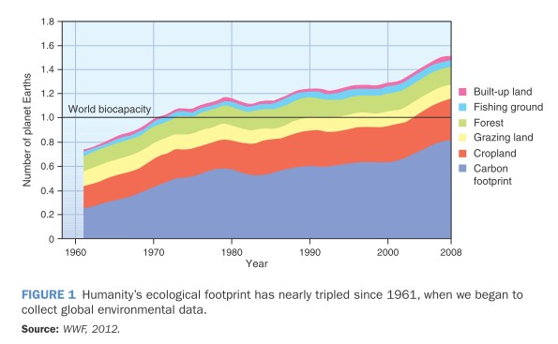

**p.22** Most successful pollution control and conservation efforts have succeeded only when it became possible to gather reliable data, such as the number of illnesses and economic losses resulting from air pollution. Discuss with other students: Are you more convinced of a problem when you see data? Why or why not? Do you, or those around you, feel that environmental data is easy to understand when you see it?

**Answers:** Responses will vary; seeing data makes many people feel more convinced, provided they trust the source of the data. It is useful for students to discuss how easy or hard it is to understand environmental data when they see it.

**p. 27** Examine figure 1.16. Describe in your own words how increasing wealth affects water contamination, air pollution, and greenhouse gas emissions. Why might greenhouse gas emissions rise? Describe and explain the air pollution curve.

**Answers:** Increasing wealth is associated with decreasing water pollution, increasing greenhouse gas emissions, and a rise, then fall in air pollution. Greenhouse gas emissions rise as wealth allows us to drive more, use more electric appliances, and consume more manufactured goods. Water pollution tends to decline with increasing oversight and regulation of pollution. Air pollution tends to rise before it falls, because the pollutants are more diffuse and invisible, so regulation often increases later.

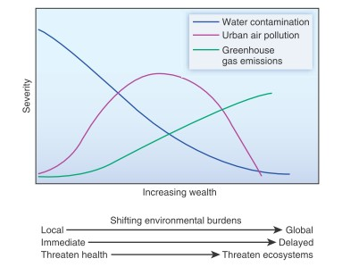

## KEY TERMS

environment environmental science ecological footprint utilitarian conservation biocentric preservation environmentalism sustainable development global environmentalism quality-of-life indicators

throughput ecosystem services

tragedy of the commons managing the commons Millennium Development Goals

ethics moral value

moral extensionism

inherent value instrumental value stewardship environmental justice LULUs

environmental racism toxic colonialism

## FURTHER RESOURCES

<http://www.undp.org/content/undp/en/home/mdgoverview.html>

<http://wwf.panda.org/about_our_earth/all_publications/living_planet_report/>

[http://blogs.discovermagazine.com/collideascape/2014/01/21/demise-easter-islands-eco-collapse-](http://blogs.discovermagazine.com/collideascape/2014/01/21/demise-easter-islands-eco-collapse-parable/#.UuK23bQo69K)  [parable/#.UuK23bQo69K](http://blogs.discovermagazine.com/collideascape/2014/01/21/demise-easter-islands-eco-collapse-parable/#.UuK23bQo69K)

<http://www.thesolutionsjournal.com/features>

<http://grist.org/>

<http://www.hcn.org/>

<http://www.ewg.org/>

# CHAPTER 2

**PRINCIPLES OF SCIENCE AND SYSTEMS**

#### (return to Table of Contents)

***MAIN CONCEPTS***

* 1. What Is Science? 38
  2. Systems Involve Interactions 44
  3. Scientific Consensus and Conflict 46

How do we ask questions and find answers in science? Understanding how to carefully frame a question, gather information, evaluate information, find a reliable conclusion, and understand aspects of uncertainty in that conclusion are all critical skills for students and citizens. This chapter closely examines each of these aspects of the process of science. The chapter opens with a case study showing how we can understand invisible but powerful processes such as impacts of climate change on forests and forest soils. Basic principles of science are then emphasized (Table 2.1). This study focuses on multiple aspects of a forest *system*—one of the ideas that is emphasized in this chapter.

An important idea for students to practice in this chapter is how to form a hypothesis—a testable statement, which allows us to find out whether our expectations are supported by evidence. Students can practice forming and testing hypotheses in many ways, and this topic is a good one for discussion, small group work, or writing.

Students should also finish this chapter understanding that measurement of uncertainty is a good thing because gives us *confidence* in what we know and don’t yet know. Students should also leave this chapter with a basic understanding of how and why statistics are used to answer questions.

***A KEY FIGURE***

The idea of a system, such as this one, provides an approach to understanding interactions, cumulative processes, and general patterns such as feedbacks. The orderly structure of the scientific method is necessary for finding answers in complex, interacting systems such as this.

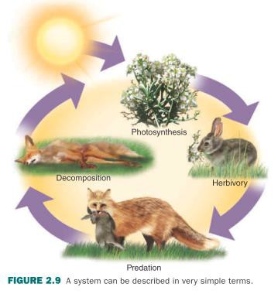

## SECTION REVIEW— QUESTIONS AND ANSWERS

##### Exploring science questions/ Test your comprehension

1. What is a mean? How would you use one?

A mean is an average for a group of samples, that is, the sum of all values divided by the number of values in the group. We use mean values to describe and compare groups, as in the case of national income or educational attainment.

1. What is a Gaussian or normal distribution? What shape does it create in a graph?

A normal or Gaussian frequency distribution is a symmetrical, bell-shaped distribution, with the mean is near the center of the range of values and most values are fairly close to the mean.

1. What do statisticians mean by confidence limits?

When you calculate a mean or other statistical measure, you are often estimating what that value would be for any sample of the population. Confidence limits (or levels, or intervals) indicate where that value probably falls for a different sample of the same population.

##### Section 2.1

1. What is science? What are some of its basic principles?

Science is a process for producing knowledge methodically and logically. Some of the basic principles of science are empiricism, uniformitarianism, parsimony, uncertainty, repeatability, an assumption that proof is elusive, and a demand for testable questions.

1. Why are widely accepted, well-defended scientific explanations called “theories”?

Ideas and explanations in science are always open to revision and correction as further evidence emerges. Scientists try to be cautious about proof, so they use the term “theory” to describe many explanations that are supported by the overwhelming weight of available data and experience, and are generally accepted as fact by the scientific community.

1. Draw a diagram showing the steps of the scientific method, and explain why each is important. A diagram of the scientific process should look very much like figure 2.3.

##### Section 2.2

1. Why are systems important in our environment?

Systems are important in environmental science because they help explain relationships.

1. What are feedback mechanisms?

A feedback mechanism is a process that either leads to enhanced or suppressed change in a system. A positive feedback is self-enhancing: plant growth produces more leaves which leads to more plant growth, and the process continues. A negative feedback suppresses change in a system: plant growth demands light and moisture, which reduces available light and moisture, which slows plant growth.

1. Describe some emergent properties of ecosystems.

Emergent properties are characteristics that belong only to the entire system and not to any of the component parts. That is, the properties arise from the organization of the system.

##### Section 2.3

1. Why do we say that proof is elusive in science?

There’s always a chance that some unknown factor will change our assessment. Therefore we almost never claim to have proven anything conclusively in science. We normally say that the evidence supports or disproves a hypothesis or theory.

1. How can we evaluate the validity of claims about science?

We can evaluate the validity of claims by asking the questions in Table 2.2.

1. What is the role of consensus in science?

Consensus is important in science because it represents a process in which ideas and information are exchanged, debated, and tested to create a general agreement among informed scholars.

## KEY TERMS

science reproducibility replication significant number deductive reasoning inductive reasoning hypothesis

scientific theory natural experiment

manipulative experiment

controlled study blind experiment

double-blind experiment dependent variable independent variable models

systems open systems

closed system throughput

positive feedback negative feedback homeostasis disturbances resilience

state shift

emergent properties scientific consensus paradigm shifts

## FURTHER RESOURCES

<http://www.usgs.gov/ecosystems/> <http://www.esa.org/esa/?page_id=6399> <http://gapanalysis.usgs.gov/gaplandcover/viewer/>