CHAPTER 2 │ DESCRIPTIVE STATISTICS 17

2.1 EXERCISE SOLUTIONS

1. Organizing the data into a frequency distribution may make patterns within the data more evident.   
 Sometimes it is easier to identify patterns of a data set by looking at a graph of the frequency   
 distribution.

2. If there are too few or too many classes, it may be difficult to detect patterns because the data are too   
 condensed or too spread out.

3. Class limits determine which numbers can belong to that class.

Class boundaries are the numbers that separate classes without forming gaps between them.

4. Relative frequency of a class is the portion, or percentage, of the data that falls in that class.

Cumulative frequency of a class is the sum of the frequencies of that class and all previous classes.

5. The sum of the relative frequencies must be 1 or 100% because it is the sum of all portions or   
 percentages of the data.

6. A frequency polygon displays frequencies or relative frequencies whereas an ogive displays   
 cumulative frequencies.

7. False. Class width is the difference between the lower (or upper limits) of consecutive classes.

8. True

9. False. An ogive is a graph that displays cumulative frequencies.

10. True

11.

Range 649

Class width   7.98

Number of classes 7

Lower class limits: 9, 17, 25, 33, 41, 49, 57   
Upper class limits: 16, 24, 32, 40, 48, 56, 64

Range 8812

12. Class width   12.713

Number of classes 6

Lower class limits: 12, 25, 38, 51, 64, 77

Upper class limits: 24, 37, 50, 63, 76, 89

Range 13517

13. Class width   14.7515

Number of classes 8

Lower class limits: 17, 32, 47, 62, 77, 92, 107, 122

Upper class limits: 31, 46, 61, 76, 91, 106, 121, 136

14.

Range 24754

Class width   19.320

Number of classes 10

Lower class limits: 54, 74, 94, 114, 134, 154, 174, 194, 214, 234   
Upper class limits: 73, 93, 113, 133, 153, 173, 193, 213, 233, 253

Copyright © 2019 Pearson Education, Inc.

18 CHAPTER 2 │ DESCRIPTIVE STATISTICS

15. (a) Class width 110 11

(b) and (c)

Midpoint 

(Lower class limit) + (Upper class limit)   
 2

Find the class boundaries. Because the data entries are integers, subtract 0.5 from each lower limit to   
find the lower class boundaries and add 0.5 to each upper limit to find the upper class boundaries.

|  |  |  |
| --- | --- | --- |
| Class | Midpoint | Class  boundaries |
| 0 - 10 | 5 | −0.5 - 10.5 |
| 11 - 21 | 16 | 10.5 - 21.5 |
| 22 - 32 | 27 | 21.5 - 32.5 |
| 33 - 43 | 38 | 32.5 - 43.5 |
| 44 - 54 | 49 | 43.5 - 54.5 |
| 55 - 65 | 60 | 54.5 - 65.5 |
| 66 - 76 | 71 | 65.5 - 76.5 |

16. (a) Class width  3325 8

(b) and (c)

Midpoint 

(Lower class limit) + (Upper class limit)   
 2

Find the class boundaries. Because the data entries are integers, subtract 0.5 from each lower limit to   
find the lower class boundaries and add 0.5 to each upper limit to find the upper class boundaries.

|  |  |  |
| --- | --- | --- |
| Class | Midpoint | Class  boundaries |
| 25 - 32 | 28.5 | 24.5- 32.5 |
| 33 - 40 | 36.5 | 32.5- 40.5 |
| 41 - 48 | 44.5 | 40.5- 48.5 |
| 49 - 56 | 52.5 | 48.5- 56.5 |
| 57 - 64 | 60.5 | 56.5- 64.5 |
| 65 - 72 | 68.5 | 64.5- 72.5 |
| 73 - 80 | 76.5 | 72.5- 80.5 |

Copyright © 2019 Pearson Education, Inc.

17. Relative frequency

Class frequency   
 Sample size

CHAPTER 2 │ DESCRIPTIVE STATISTICS 19

*f*



*n*

The cumulative frequency of a class is the sum of the frequencies of that class and all previous

classes.

|  |  |  |  |  |
| --- | --- | --- | --- | --- |
| Class | Frequency  *f* | Midpoint | Relative  frequency | Cumulative  frequency |
| 0 - 10 | 188 | 5 | 0.15 | 188 |
| 11 - 21 | 372 | 16 | 0.30 | 560 |
| 22 - 32 | 264 | 27 | 0.22 | 824 |
| 33 - 43 | 205 | 38 | 0.17 | 1029 |
| 44 - 54 | 83 | 49 | 0.07 | 1112 |
| 55 - 65 | 76 | 60 | 0.06 | 1188 |
| 66 - 76 | 32 | 71 | 0.03 | 1220 |
|  | ∑*f* = 1220 |  | ∑~~௙~~ ൌ ͳ  ௡ |  |

18. Relative frequency

Class frequency   
 Sample size

*f*



*n*

The cumulative frequency of a class is the sum of the frequencies of that class and all previous

classes.

|  |  |  |  |  |
| --- | --- | --- | --- | --- |
| Class | Frequency,  *f* | Midpoint | Relative  frequency | Cumulative  frequency |
| 25 - 32 | 86 | 28.5 | 0.24 | 86 |
| 33 - 40 | 39 | 36.5 | 0.11 | 125 |
| 41 - 48 | 41 | 44.5 | 0.11 | 166 |
| 49 - 56 | 48 | 52.5 | 0.13 | 214 |
| 57 - 64 | 43 | 60.5 | 0.12 | 257 |
| 65 - 72 | 68 | 68.5 | 0.19 | 325 |
| 73 - 80 | 40 | 76.5 | 0.11 | 365 |
|  | ∑*f* = 365 |  | ∑~~௙~~ ൎ ͳ  ௡ |  |

19. (a) Number of classes: 7

(b) Greatest frequency: about 300   
 Least frequency: about 10

(c) Class width: 10

(d) *Sample answer:* About half of the employee salaries are between $50,000 and $69,000.

20. (a) Number of classes: 6

(b) Greatest frequency: 37   
 Least frequency: 1

(c) Class width: 53

Copyright © 2019 Pearson Education, Inc.

20 CHAPTER 2 │ DESCRIPTIVE STATISTICS

(d) *Sample answer:* The heights of most roller coasters are less than 231 feet.

21. Identify the highest point and its respective class. Class with greatest frequency: 506 - 510

Identify the lowest point (not including the points on the horizontal axis) and its respective class. Class with least frequency: 474 - 478

22. Identify the highest point and its respective class. Class with greatest frequency: 3.5 - 4.5 miles   
 Identify the lowest point (not including the points on the horizontal axis) and its respective class.   
 Class with least frequency: 0.5 - 1.5 miles

23. (a) Identify the tallest bar and its respective class. Class with greatest relative frequency: 35 - 36   
 centimeters

Identify the shortest bar and its respective class. Class with least relative frequency: 39 - 40 centimeters

(b) Greatest relative frequency ≈ 0.25   
 Least relative frequency ≈ 0.01

(c) *Sample answer*: From the graph, 0.25 or 25% of females have a fibula length between 35 and 36   
 centimeters.

24. (a) Identify the tallest bar and its respective class. Class with greatest relative frequency: 11 - 12   
 minutes

Identify the shortest bar and its respective class. Class with least relative frequency: 14 - 15   
minutes

(b) Greatest relative frequency ≈ 38%   
 Least relative frequency ≈ 4%

(c) *Sample answer*: From the graph, about 0.75 or 75% of campus security response times are   
 between 11 and 13 minutes.

25. (a) Locate the cumulative frequency of the highest (right-most) point. The number in the sample is

75.

(b) Locate the neighboring points where the pitch between them is the steepest. The greatest increase   
 in frequency is from 158.5 - 201.5 pounds.

26. (a) Locate the cumulative frequency of the highest (right-most) point. The number in the sample is

77.

(b) Locate the neighboring points where the pitch between them is the steepest. The greatest increase   
 in frequency is from 68 - 70 inches.

27. (a) Locate 201.5 on the horizontal axis and find the corresponding cumulative frequency at the point   
 on the ogive: 47

(b) Locate 68 on the vertical axis and find the corresponding weight at the point on the ogive: 287.5   
 pounds

(c) Subtract the cumulative frequency for each weight: 62 - 22 = 40

Copyright © 2019 Pearson Education, Inc.

CHAPTER 2 │ DESCRIPTIVE STATISTICS 21

(d) Subtract the cumulative frequency for bears weighing 330.5 pounds from the number in the   
 sample: 75 - 69 = 6

28. (a) Locate 72 on the horizontal axis and find the corresponding cumulative frequency at the point on   
 the ogive: 71

(b) Locate 15 on the vertical axis and find the corresponding height at the point on the ogive: 68   
 inches

(c) Subtract the cumulative frequency for each height: 71 - 15 = 56

(d) Subtract the cumulative frequency for adult males that are 70 inches tall from the number in the   
 sample: 77 - 47 = 30

29. Class width 

Range 390

 7.88

Number of classes 5

|  |  |  |  |  |
| --- | --- | --- | --- | --- |
| Class | Frequency,  *f* | Midpoint | Relative  frequency | Cumulative  frequency |
| 0 - 7 | 8 | 3.5 | 0.33 | 8 |
| 8 - 15 | 7 | 11.5 | 0.29 | 15 |
| 16 - 23 | 3 | 19.5 | 0.13 | 18 |
| 24 - 31 | 3 | 27.5 | 0.13 | 21 |
| 32 - 39 | 3 | 35.5 | 0.13 | 24 |
|  | ∑*f* = 24 |  | *f*   1  *n* |  |

Class with greatest frequency: 0 - 7

Classes with least frequency: 16 - 23, 24 - 31, 32 - 39

30. Class width 

Range 53030

 83.384

Number of classes 6

|  |  |  |  |  |
| --- | --- | --- | --- | --- |
| Class | Frequency,  *f* | Midpoint | Relative  frequency | Cumulative  frequency |
| 30 - 113 | 5 | 71.5 | 0.17 | 5 |
| 114 - 197 | 7 | 155.5 | 0.23 | 12 |
| 198 - 281 | 8 | 239.5 | 0.27 | 20 |
| 282 - 365 | 3 | 323.5 | 0.10 | 23 |
| 366 - 449 | 3 | 407.5 | 0.10 | 26 |
| 450 - 533 | 4 | 491.5 | 0.13 | 30 |
|  | ∑*f* = 30 |  | *f*   1  *n* |  |

Copyright © 2019 Pearson Education, Inc.

22 CHAPTER 2 │ DESCRIPTIVE STATISTICS

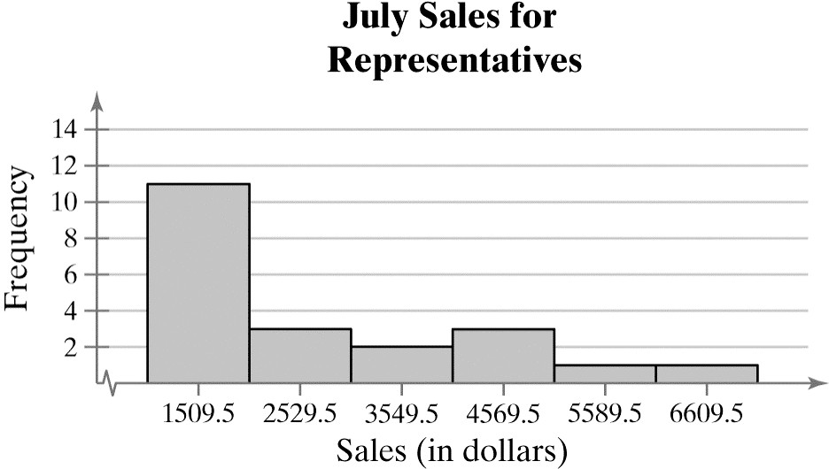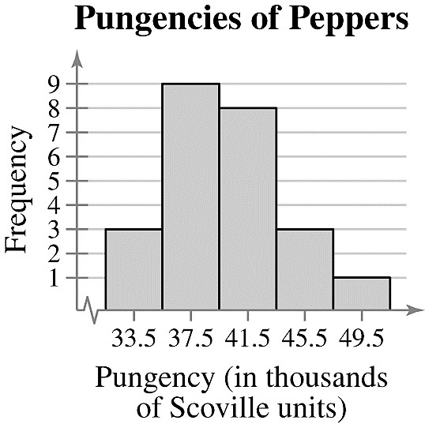

31. Class width 

Range 71191000

 1019.81020

Number of classes 6

|  |  |  |  |  |
| --- | --- | --- | --- | --- |
| Class | Frequency,  *f* | Mid-point | Relative  frequency | Cumulative  frequency |
| 1000 - 2019 | 11 | 1509.5 | 0.52 | 11 |
| 2020 - 3039 | 3 | 2529.5 | 0.14 | 14 |
| 3040 - 4059 | 2 | 3549.5 | 0.10 | 16 |
| 4060 - 5079 | 3 | 4569.5 | 0.14 | 19 |
| 5080 - 6099 | 1 | 5589.5 | 0.05 | 20 |
| 6100 - 7119 | 1 | 6609.5 | 0.05 | 21 |
|  | ∑*f* = 21 |  | *f*   1  *n* |  |

*Sample answer*: The graph shows that most of the sales representatives at the company sold from $1000 to $2019.

32. Class width 

Range 5132

 3.84

Number of classes 5

|  |  |  |  |  |
| --- | --- | --- | --- | --- |
| Class | Frequency, *f* | Midpoint | Relative  frequency | Cumulative  frequency |
| 32-35  36-39  40-43  44-47  48-51 | 3  9  8  3  1 | 33.5  37.5  41.5  45.5  49.5 | 0.1250  0.3750  0.3333  0.1250  0.0417 | 3  12  20  23  24 |
|  |  *f*  24 |  | *f*   1  *n* |  |

*Sample answer*: The graph shows that most of the pungencies of the peppers were between 36,000

and 43,000 Scoville units.

33. Class width 

Range 514291

 27.87528

Number of classes 8

Copyright © 2019 Pearson Education, Inc.

CHAPTER 2 │ DESCRIPTIVE STATISTICS 23

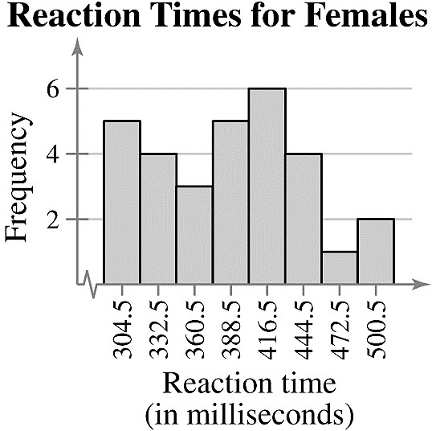

|  |  |  |  |  |
| --- | --- | --- | --- | --- |
| Class | Frequency, *f* | Midpoint | Relative  frequency | Cumulative  frequency |
| 291-318  319-346  347-374  375-402  403-430  431-458  459-486  487-514 | 5  4  3  5  6  4  1  2 | 304.5  332.5  360.5  388.5  416.5  444.5  472.5  500.5 | 0.1667  0.1333  0.1000  0.1667  0.2000  0.1333  0.0333  0.0667 | 5  9  12  17  23  27  28  30 |
|  |  *f*  30 |  | *f*   1  *n* |  |

*Sample answer*: The graph shows that the most frequent reaction times were between 403 and 430 milliseconds.