|  |
| --- |
| 2.1 FREQUENCY DISTRIBUTIONS AND THEIR GRAPHS |

2.1 Try It Yourself Solutions

**1a.** The number of classes is 7.

**b.** Min = 26, Max = 86, 

**c.**

|  |  |
| --- | --- |
| **Lower limit** | **Upper limit** |
| 26 | 34 |
| 35 | 43 |
| 44 | 52 |
| 53 | 61 |
| 62 | 70 |
| 71 | 79 |
| 80 | 88 |

**de.**

|  |  |
| --- | --- |
| **Class** | **Frequency, *f*** |
| 26-34 | 2 |
| 35-43 | 5 |
| 44-52 | 12 |
| 53-61 | 18 |
| 62-70 | 11 |
| 71-79 | 1 |
| 80-88 | 1 |

**2a.** See part (b).

**b.**

|  |  |  |  |  |
| --- | --- | --- | --- | --- |
| **Class** | **Frequency, *f*** | **Midpoint** | **Relative frequency** | **Cumulative frequency** |
| 26-34 | 2 | 30 | 0.04 | 2 |
| 35-43 | 5 | 39 | 0.10 | 7 |
| 44-52 | 12 | 48 | 0.24 | 19 |
| 53-61 | 18 | 57 | 0.36 | 37 |
| 62-70 | 11 | 66 | 0.22 | 48 |
| 71-79 | 1 | 75 | 0.02 | 49 |
| 80-88 | 1 | 84 | 0.02 | 50 |
|  |  |  |  |  |

**c.** *Sample answer*: The most common age bracket for the 50 most powerful women is 53-61. Eighty-six percent of the 50 most powerful women are older than 43. Four percent of the 50 most powerful women are younger than 35.

**3a.**

|  |
| --- |
| **Class Boundaries** |
| 25.5-34.5 |
| 34.5-43.5 |
| 43.5-52.5 |
| 52.5-61.5 |
| 61.5-70.5 |
| 70.5-79.5 |
| 79.5-88.5 |

**b.** Use class midpoints for the horizontal scale and frequency for the vertical scale. (Class boundaries can also be used for the horizontal scale.)

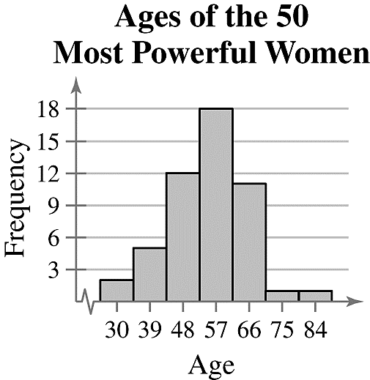**c.**

**d.** Same as 2(c).

**4a.** Same as 3(b).

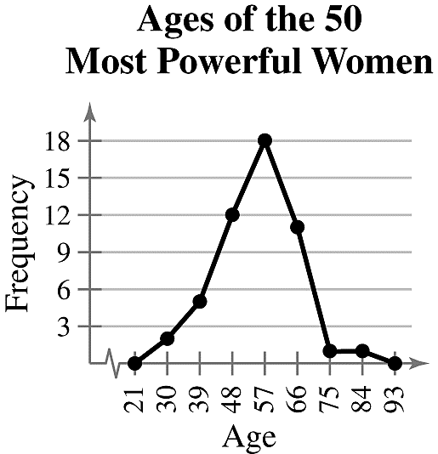**bc.**

**d.** The frequency of ages increases up to 57 years old and then decreases.

**5abc.**

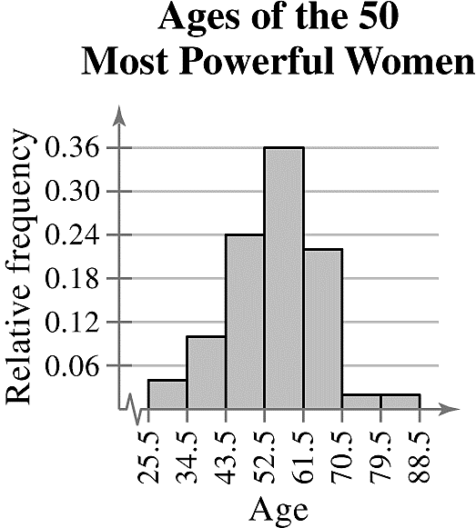

**6a.** Use upper class boundaries for the horizontal scale and cumulative frequency for the vertical scale.

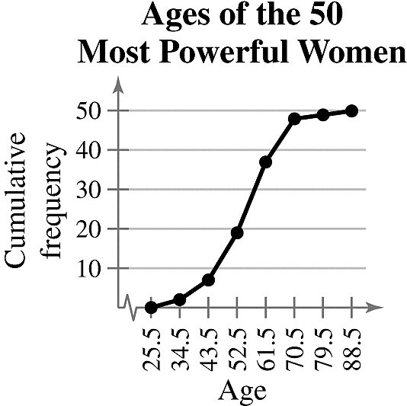**bc.**

*Sample answer*: The greatest increase in cumulative frequency occurs between 52.5 and 61.5

**7a.** Enter data.

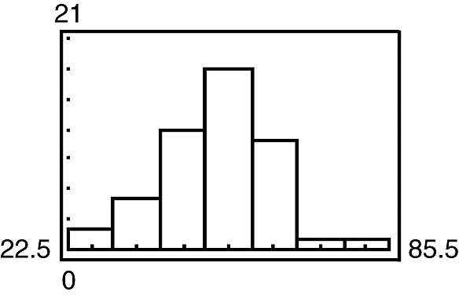**b.**

2.1 EXERCISE SOLUTIONS

**1.** Organizing the data into a frequency distribution may make patterns within the data more evident. Sometimes it is easier to identify patterns of a data set by looking at a graph of the frequency distribution.

**2.** If there are too few or too many classes, it may be difficult to detect patterns because the data are too condensed or too spread out.

**3.** Class limits determine which numbers can belong to that class.

Class boundaries are the numbers that separate classes without forming gaps between them.

**4.** Relative frequency of a class is the portion, or percentage, of the data that falls in that class.

Cumulative frequency of a class is the sum of the frequencies of that class and all previous classes.

**5.** The sum of the relative frequencies must be 1 or 100% because it is the sum of all portions or percentages of the data.

**6.** A frequency polygon displays frequencies or relative frequencies whereas an ogive displays cumulative frequencies.

**7.** False. Class width is the difference between the lower (or upper limits) of consecutive classes.

**8.** True

**9.** False. An ogive is a graph that displays cumulative frequencies.

**10.** True

**11. **

Lower class limits: 9, 17, 25, 33, 41, 49, 57

Upper class limits: 16, 24, 32, 40, 48, 56, 64

**12. **

Lower class limits: 12, 25, 38, 51, 64, 77

Upper class limits: 24, 37, 50, 63, 76, 89

**13.** 

Lower class limits: 17, 32, 47, 62, 77, 92, 107, 122

Upper class limits: 31, 46, 61, 76, 91, 106, 121, 136

**14. **

Lower class limits: 54, 74, 94, 114, 134, 154, 174, 194, 214, 234

Upper class limits: 73, 93, 113, 133, 153, 173, 193, 213, 233, 253

**15.** (a) 

(b)and (c)

|  |  |  |
| --- | --- | --- |
| **Class** | **Midpoint** | **Class boundaries** |
| 20-30 | 25 | 19.5-30.5 |
| 31-41 | 36 | 30.5-41.5 |
| 42-52 | 47 | 41.5-52.5 |
| 53-63 | 58 | 52.5-63.5 |
| 64-74 | 69 | 63.5-74.5 |
| 75-85 | 80 | 74.5-85.5 |
| 86-96 | 91 | 85.5-96.5 |

**16.** (a) 

(b) and (c)

|  |  |  |
| --- | --- | --- |
| **Class** | **Midpoint** | **Class boundaries** |
| 0-9 | 4.5 | -9.5 |
| 10-19 | 14.5 | 9.5-19.5 |
| 20-29 | 24.5 | 19.5-29.5 |
| 30-39 | 34.5 | 29.5-39.5 |
| 40-49 | 44.5 | 39.5-49.5 |
| 50-59 | 54.5 | 49.5-59.5 |
| 60-69 | 64.5 | 59.5-69.5 |

**17.**

|  |  |  |  |  |
| --- | --- | --- | --- | --- |
| **Class** | **Frequency, *f*** | **Midpoint** | **Relative frequency** | **Cumulative frequency** |
| 20-30 | 19 | 25 | 0.05 | 19 |
| 31-41 | 43 | 36 | 0.12 | 62 |
| 42-52 | 68 | 47 | 0.19 | 130 |
| 53-63 | 69 | 58 | 0.19 | 199 |
| 64-74 | 74 | 69 | 0.20 | 273 |
| 75-85 | 68 | 80 | 0.19 | 341 |
| 86-96 | 24 | 91 | 0.07 | 365 |
|  |  |  |  |  |

**18.**

|  |  |  |  |  |
| --- | --- | --- | --- | --- |
| **Class** | **Frequency, *f*** | **Midpoint** | **Relative frequency** | **Cumulative frequency** |
| 0-9 | 188 | 4.5 | 0.15 | 188 |
| 10-19 | 372 | 14.5 | 0.30 | 560 |
| 20-29 | 264 | 24.5 | 0.22 | 824 |
| 30-39 | 205 | 34.5 | 0.17 | 1029 |
| 40-49 | 83 | 44.5 | 0.07 | 1112 |
| 50-59 | 76 | 54.5 | 0.06 | 1188 |
| 60-69 | 32 | 64.5 | 0.03 | 1220 |
|  |  |  |  |  |

**19.** (a)Number of classes = 7 (b)Least frequency ≈ 10

(c) Greatest frequency ≈ 300 (d)Class width = 10

**20.** (a)Number of classes = 7 (b)Least frequency = 1

(c) Greatest frequency =23 (d)Class width = 53

**21.** (a)50 (b) 345.5-365.5 pounds

**22.** (a)50 (b) 64-66 inches

**23.** (a)15 (b) 385.5 pounds

(c)31 – 6 = 25 (d) 50 – 42 = 8

**24.** (a)48 (b) 66 inches

(c)25 – 5 = 20 (d) 50 – 44 = 6

**25.** (a)Class with greatest relative frequency: 39-40centimeters

Class with least relative frequency: 34-35centimeters

(b)Greatest relative frequency ≈ 0.25

Least relative frequency ≈ 0.02

(c) Approximately 0.08

**26.** (a)Class with greatest relative frequency: 19-20 minutes

Class with least relative frequency: 21-22 minutes

(b)Greatest relative frequency ≈ 40%

Least relative frequency ≈ 2%

(c) Approximately 33%

**27.** Class with greatest frequency: 29.5-32.5

Classeswith least frequency: 11.5-14.5 and 38.5-41.5

**28.** Class with greatest frequency: 7.75-8.25

Class with least frequency: 6.25-6.75

**29. **

|  |  |  |  |  |
| --- | --- | --- | --- | --- |
| **Class** | **Frequency, *f*** | **Midpoint** | **Relative frequency** | **Cumulative frequency** |
| 0-7 | 8 | 3.5 | 0.32 | 8 |
| 8-15 | 8 | 11.5 | 0.32 | 16 |
| 16-23 | 3 | 19.5 | 0.12 | 19 |
| 24-31 | 3 | 27.5 | 0.12 | 22 |
| 32-39 | 3 | 35.5 | 0.12 | 25 |
|  |  |  |  |  |

Classes with greatest frequency: 0-7, 8-15

Classeswith least frequency: 16-23, 24-31, 32-39

**30. **

|  |  |  |  |  |
| --- | --- | --- | --- | --- |
| **Class** | **Frequency, *f*** | **Midpoint** | **Relative frequency** | **Cumulative frequency** |
| 30-113 | 5 | 71.5 | 0.1724 | 5 |
| 114-197 | 7 | 155.5 | 0.2414 | 12 |
| 198-281 | 8 | 239.5 | 0.2759 | 20 |
| 282-365 | 2 | 323.5 | 0.0690 | 22 |
| 366-449 | 3 | 407.5 | 0.1034 | 25 |
| 450-533 | 4 | 491.5 | 0.1379 | 29 |
|  |  |  |  |  |

Class with greatest frequency: 198-281

Class with least frequency: 282-365

**31.** 

|  |  |  |  |  |
| --- | --- | --- | --- | --- |
| **Class** | **Frequency, *f*** | **Midpoint** | **Relative frequency** | **Cumulative frequency** |
| 1000-2019 | 12 | 1509.5 | 0.5455 | 12 |
| 2020-3039 | 3 | 2529.5 | 0.1364 | 15 |
| 3040-4059 | 2 | 3549.5 | 0.0909 | 17 |
| 4060-5079 | 3 | 4569.5 | 0.1364 | 20 |
| 5080-6099 | 1 | 5589.5 | 0.0455 | 21 |
| 6100-7119 | 1 | 6609.5 | 0.0455 | 22 |
|  |  |  |  |  |

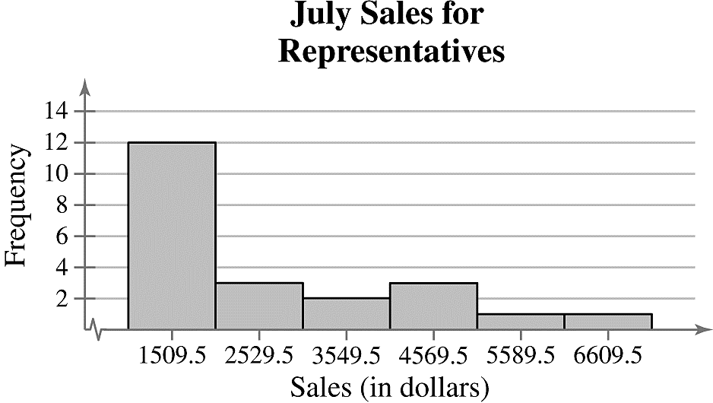

*Sample answer*: The graph shows that most of the sales representatives at the company sold between $1000 and $2019.

**32. **

|  |  |  |  |  |
| --- | --- | --- | --- | --- |
| **Class** | **Frequency, *f*** | **Midpoint** | **Relative frequency** | **Cumulative frequency** |
| 32-35 | 3 | 33.5 | 0.1250 | 3 |
| 36-39 | 9 | 37.5 | 0.3750 | 12 |
| 40-43 | 8 | 41.5 | 0.3333 | 20 |
| 44-47 | 3 | 45.5 | 0.1250 | 23 |
| 48-51 | 1 | 49.5 | 0.0417 | 24 |
|  |  |  |  |  |

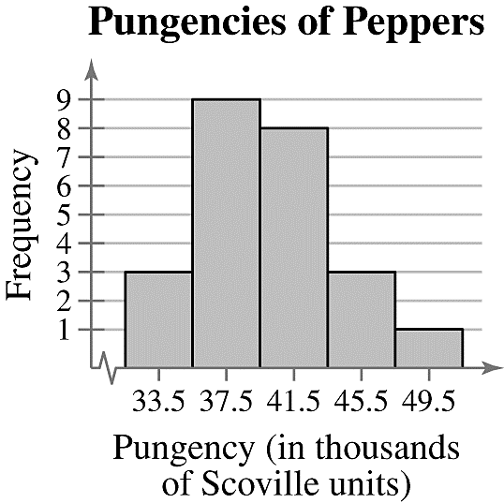

*Sample answer*: The graph shows that most of the pungencies of the peppers were between 36,000 and 43,000 Scoville units.

**33. **

|  |  |  |  |  |
| --- | --- | --- | --- | --- |
| **Class** | **Frequency, *f*** | **Midpoint** | **Relative frequency** | **Cumulative frequency** |
| 291-318 | 5 | 304.5 | 0.1667 | 5 |
| 319-346 | 4 | 332.5 | 0.1333 | 9 |
| 347-374 | 3 | 360.5 | 0.1000 | 12 |
| 375-402 | 5 | 388.5 | 0.1667 | 17 |
| 403-430 | 6 | 416.5 | 0.2000 | 23 |
| 431-458 | 4 | 444.5 | 0.1333 | 27 |
| 459-486 | 1 | 472.5 | 0.0333 | 28 |
| 487-514 | 2 | 500.5 | 0.0667 | 30 |
|  |  |  |  |  |

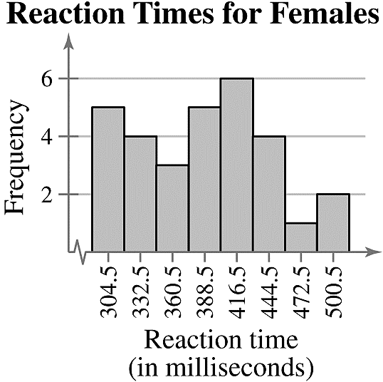

*Sample answer*: The graph shows that the most frequent reaction times were between 403 and 430 milliseconds.

**34. **

|  |  |  |  |  |
| --- | --- | --- | --- | --- |
| **Class** | **Frequency, *f*** | **Midpoint** | **Relative frequency** | **Cumulative frequency** |
| 1250-1380 | 2 | 1315 | 0.10 | 2 |
| 1381-1511 | 3 | 1446 | 0.15 | 5 |
| 1512-1642 | 6 | 1577 | 0.30 | 11 |
| 1643-1773 | 1 | 1708 | 0.05 | 12 |
| 1774-1904 | 4 | 1839 | 0.20 | 16 |
| 1905-2035 | 2 | 1970 | 0.10 | 18 |
| 2036-2166 | 1 | 2101 | 0.05 | 19 |
| 2167-2297 | 1 | 2232 | 0.05 | 20 |
|  |  |  |  |  |

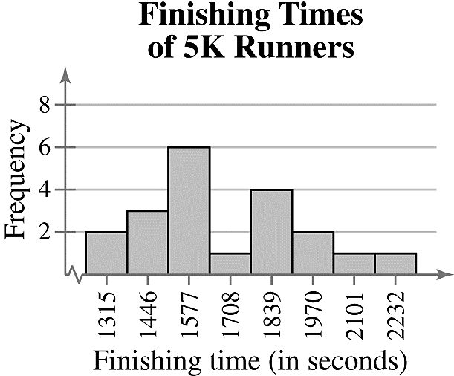

*Sample answer:* The graph shows that the most frequent finishing times were from 1381 to 1642 seconds and from 1774 to 2035 seconds.

**35. **

|  |  |  |  |  |
| --- | --- | --- | --- | --- |
| **Class** | **Frequency, *f*** | **Midpoint** | **Relative frequency** | **Cumulative frequency** |
| 1-2 | 2 | 1.5 | 0.0833 | 2 |
| 3-4 | 2 | 3.5 | 0.0833 | 4 |
| 5-6 | 5 | 5.5 | 0.2083 | 9 |
| 7-8 | 10 | 7.5 | 0.4167 | 19 |
| 9-10 | 5 | 9.5 | 0.2083 | 24 |
|  |  |  |  |  |

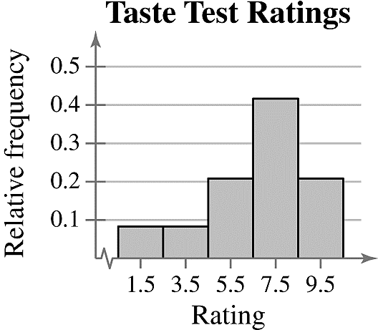

Class with greatest relative frequency: 7-8

Class with least relative frequency: 1-2 and 3-4

**36. **

|  |  |  |  |  |
| --- | --- | --- | --- | --- |
| **Class** | **Frequency, *f*** | **Midpoint** | **Relative frequency** | **Cumulative frequency** |
| 6-7 | 3 | 6.5 | 0.12 | 3 |
| 8-9 | 10 | 8.5 | 0.38 | 13 |
| 10-11 | 6 | 10.5 | 0.23 | 19 |
| 12-13 | 6 | 12.5 | 0.23 | 25 |
| 14-15 | 1 | 14.5 | 0.04 | 26 |
|  |  |  |  |  |

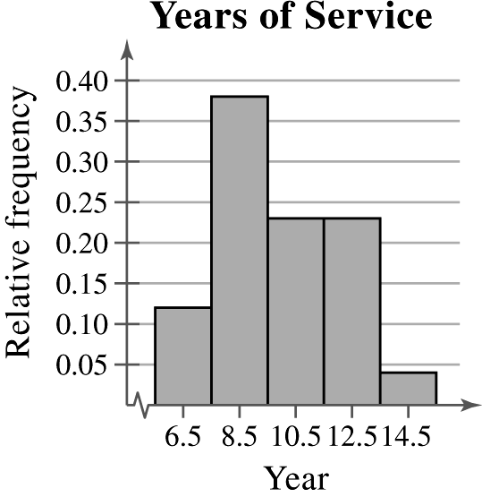

Class with greatest relative frequency: 8-9

Class with least relative frequency: 14-15

**37. **

|  |  |  |  |  |
| --- | --- | --- | --- | --- |
| **Class** | **Frequency, *f*** | **Midpoint** | **Relative frequency** | **Cumulative frequency** |
| 417-443 | 5 | 430 | 0.20 | 5 |
| 444-470 | 5 | 457 | 0.20 | 10 |
| 471-497 | 6 | 484 | 0.24 | 16 |
| 498-524 | 4 | 511 | 0.16 | 20 |
| 525-551 | 5 | 538 | 0.20 | 25 |
|  |  |  |  |  |

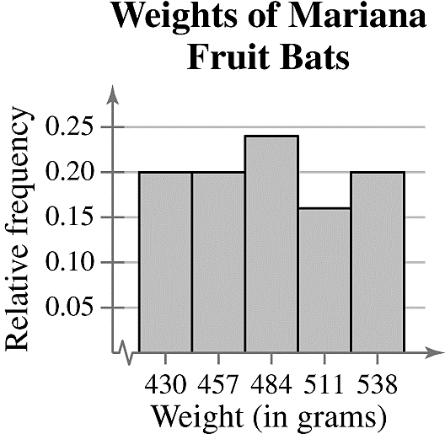

Class with greatest relative frequency: 471-497

Class with least relative frequency: 498-524

**38. **

|  |  |  |  |  |
| --- | --- | --- | --- | --- |
| **Class** | **Frequency, *f*** | **Midpoint** | **Relative frequency** | **Cumulative frequency** |
| 138-202 | 12 | 170 | 0.46 | 12 |
| 203-267 | 6 | 235 | 0.23 | 18 |
| 268-332 | 4 | 300 | 0.15 | 22 |
| 333-397 | 1 | 365 | 0.04 | 23 |
| 398-462 | 3 | 430 | 0.12 | 26 |
|  |  |  |  |  |

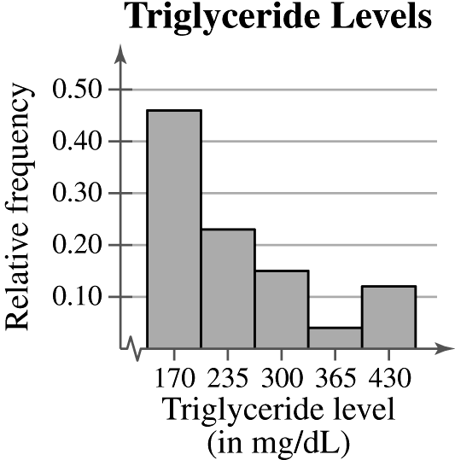

Class with greatest relative frequency: 138-202

Class with least relative frequency: 333-397

**39. **

|  |  |  |  |
| --- | --- | --- | --- |
| **Class** | **Frequency, *f*** | **Relative frequency** | **Cumulative frequency** |
| 52-55 | 3 | 0.125 | 3 |
| 56-59 | 3 | 0.125 | 6 |
| 60-63 | 9 | 0.375 | 15 |
| 64-67 | 4 | 0.167 | 19 |
| 68-71 | 4 | 0.167 | 23 |
| 72-75 | 1 | 0.042 | 24 |
|  |  |  |  |

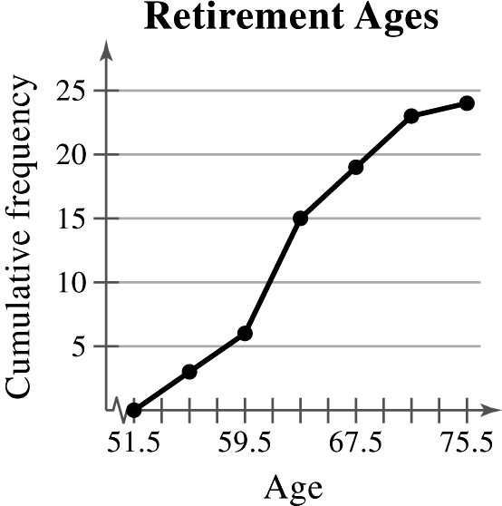

Location of the greatest increase in frequency: 60-63

**40. **

|  |  |  |  |
| --- | --- | --- | --- |
| **Class** | **Frequency, *f*** | **Relative frequency** | **Cumulative frequency** |
| 16-22 | 2 | 0.10 | 2 |
| 23-29 | 3 | 0.15 | 5 |
| 30-36 | 8 | 0.40 | 13 |
| 37-43 | 5 | 0.25 | 18 |
| 44-50 | 0 | 0.00 | 18 |
| 51-57 | 2 | 0.10 | 20 |
|  |  |  |  |

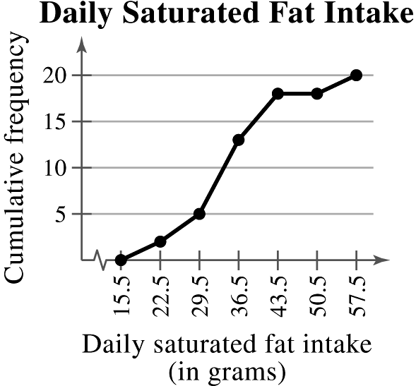

Location of the greatest increase in frequency: 30-36

**41. **

|  |  |  |  |  |
| --- | --- | --- | --- | --- |
| **Class** | **Frequency, *f*** | **Midpoint** | **Relative frequency** | **Cumulative frequency** |
| 0-2 | 17 | 1 | 0.3953 | 17 |
| 3-5 | 17 | 4 | 0.3953 | 34 |
| 6-8 | 7 | 7 | 0.1628 | 41 |
| 9-11 | 1 | 10 | 0.0233 | 42 |
| 12-14 | 0 | 13 | 0.0000 | 42 |
| 15-17 | 1 | 16 | 0.0233 | 43 |
|  |  |  |  |  |

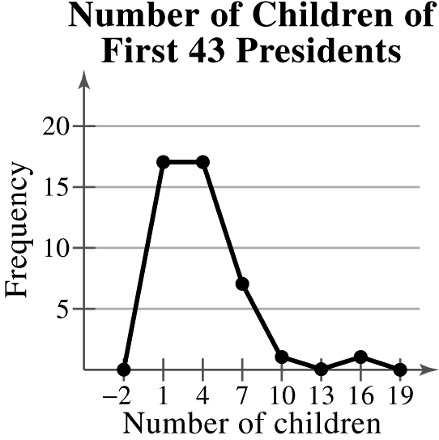

*Sample answer:* The graph shows that most of the first 43 presidents had fewer than 6 children.

**42. **

|  |  |  |  |  |
| --- | --- | --- | --- | --- |
| **Class** | **Frequency, *f*** | **Midpoint** | **Relative frequency** | **Cumulative frequency** |
| 26-34 | 10 | 30 | 0.1786 | 11 |
| 35-43 | 17 | 39 | 0.3036 | 27 |
| 44-52 | 18 | 48 | 0.3214 | 45 |
| 53-61 | 6 | 57 | 0.1071 | 51 |
| 62-70 | 5 | 66 | 0.0893 | 56 |
|  |  |  |  |  |

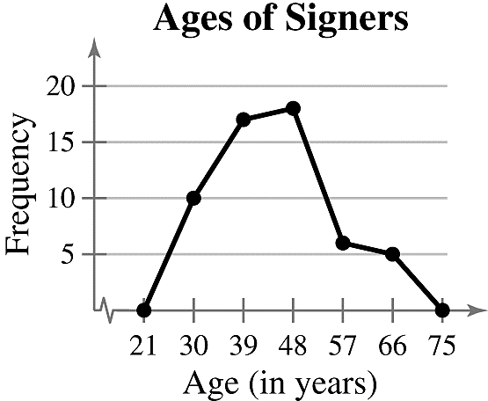

*Sample answer:* The graph shows that majority of signers were from 35 to 52 years old.

**43.** (a) 

|  |  |  |  |  |
| --- | --- | --- | --- | --- |
| **Class** | **Frequency, *f*** | **Midpoint** | **Relative frequency** | **Cumulative frequency** |
| 65-74 | 4 | 69.5 | 0.1667 | 4 |
| 75-84 | 7 | 79.5 | 0.2917 | 11 |
| 85-94 | 4 | 89.5 | 0.1667 | 15 |
| 95-104 | 5 | 99.5 | 0.2083 | 20 |
| 105-114 | 3 | 109.5 | 0.1250 | 23 |
| 115-124 | 1 | 119.5 | 0.0417 | 24 |
|  |  |  |  |  |

(b)(c)

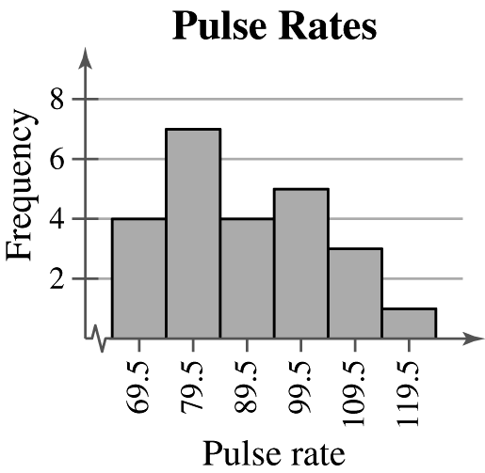 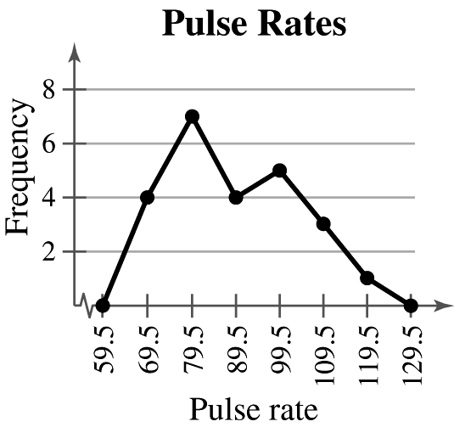

(d)(e)

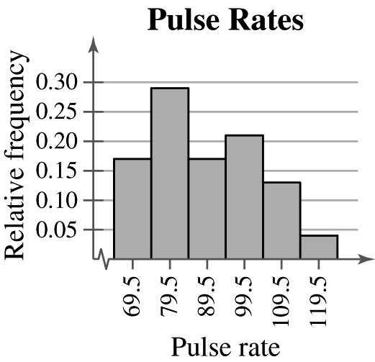 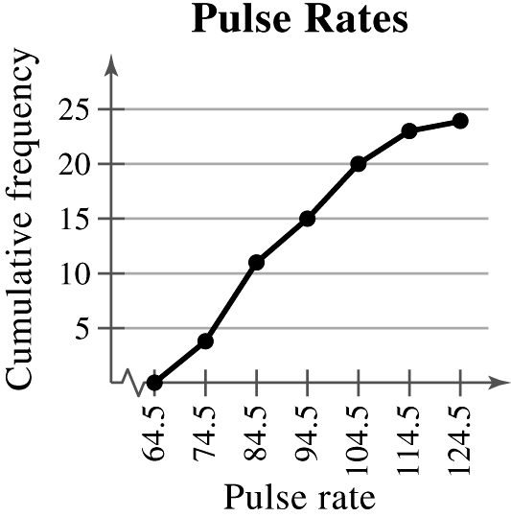

**44.** (a)****

|  |  |  |  |  |
| --- | --- | --- | --- | --- |
| **Class** | **Frequency, *f*** | **Midpoint** | **Relative frequency** | **Cumulative frequency** |
| 7-53 | 23 | 30 | 0.46 | 23 |
| 54-100 | 14 | 77 | 0.28 | 37 |
| 101-147 | 7 | 124 | 0.14 | 44 |
| 148-194 | 2 | 171 | 0.04 | 46 |
| 195-241 | 2 | 218 | 0.04 | 48 |
| 242-288 | 0 | 265 | 0.00 | 48 |
| 289-335 | 0 | 312 | 0.00 | 48 |
| 336-382 | 2 | 359 | 0.04 | 50 |
|  |  |  |  |  |

(b)(c)

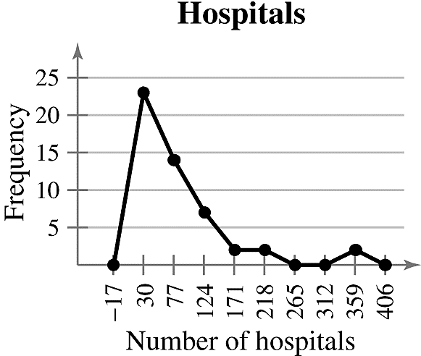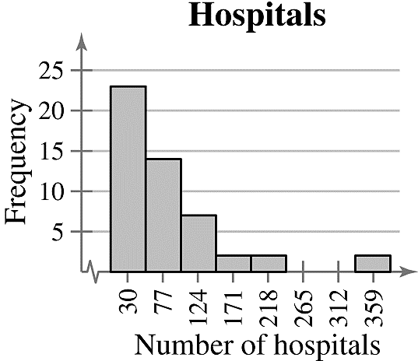

(d)(e)

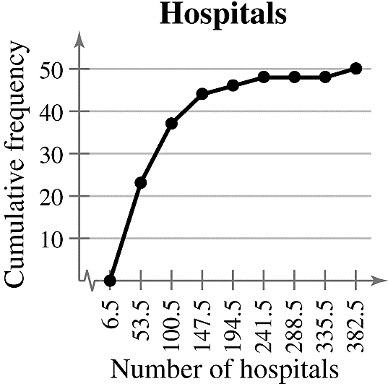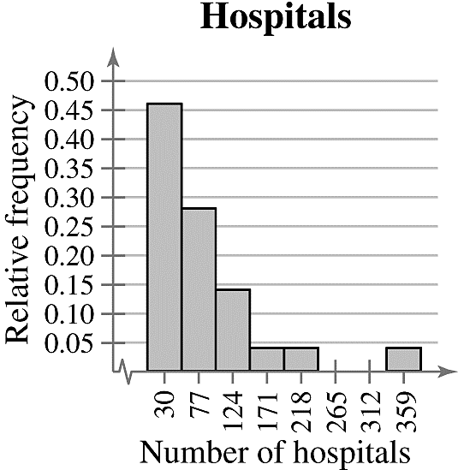

**45.** (a) 

|  |  |  |  |
| --- | --- | --- | --- |
| **Class** | **Frequency, *f*** | **Midpoint** | **Relative frequency** |
| 61-66 | 1 | 63.5 | 0.033 |
| 67-72 | 3 | 69.5 | 0.100 |
| 73-78 | 6 | 75.5 | 0.200 |
| 79-84 | 10 | 81.5 | 0.333 |
| 85-90 | 5 | 87.5 | 0.167 |
| 91-96 | 2 | 93.5 | 0.067 |
| 97-102 | 2 | 99.5 | 0.067 |
| 103-108 | 1 | 105.5 | 0.033 |
|  |  |  |  |

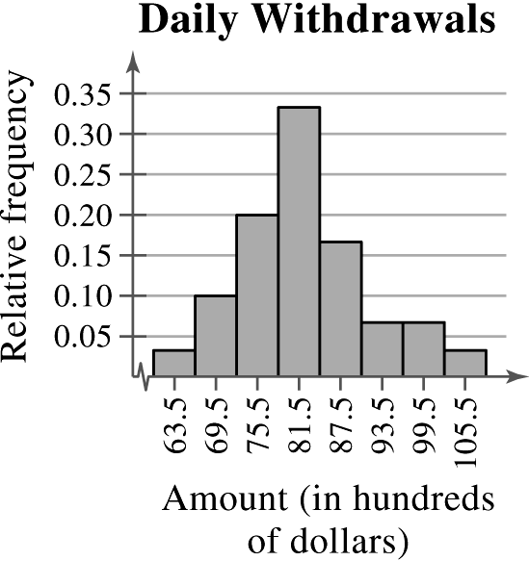

(b)16.7%, because the sum of the relative frequencies for the last three classes is 0.167.

(c)$9700, because the sum of the relative frequencies for the last two classes is 0.10.

**46.** (a)****

|  |  |  |  |
| --- | --- | --- | --- |
| **Class** | **Frequency, *f*** | **Midpoint** | **Relative frequency** |
| 970-1098 | 1 | 1034 | 0.02 |
| 1099-1227 | 1 | 1163 | 0.02 |
| 1228-1356 | 4 | 1292 | 0.08 |
| 1357-1485 | 6 | 1421 | 0.12 |
| 1486-1614 | 8 | 1550 | 0.16 |
| 1615-1743 | 8 | 1679 | 0.16 |
| 1744-1872 | 6 | 1808 | 0.12 |
| 1873-2001 | 9 | 1937 | 0.18 |
| 2002-2130 | 4 | 2066 | 0.08 |
| 2131-2259 | 3 | 2195 | 0.06 |
|  |  |  |  |

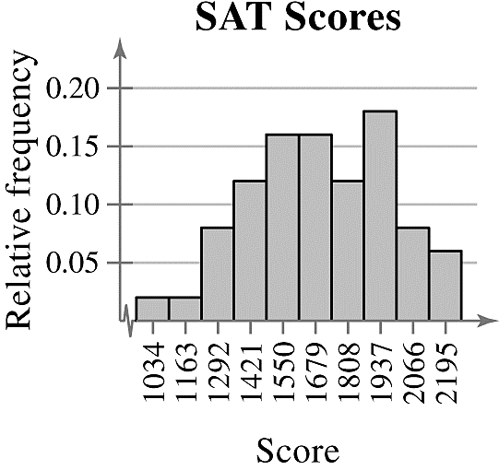

(b)62%; The proportionof scores greater than or equal to 1610 is 0.62.

(c) A score of 1357 or above, because the sum of the relative frequencies of the class starting with 1357 and all classes with higher scores is 0.88.

**47.**

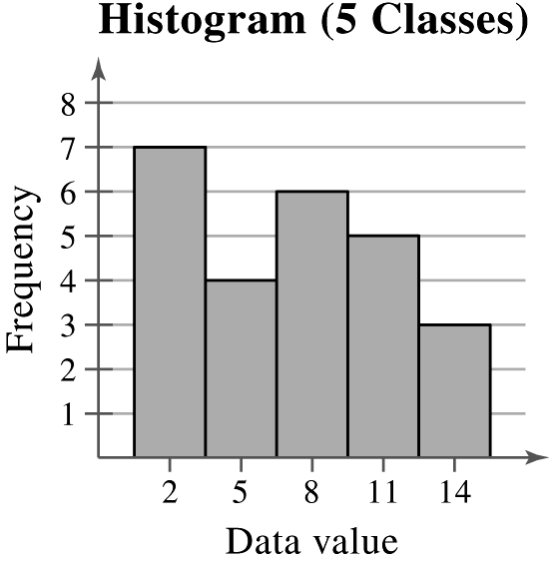 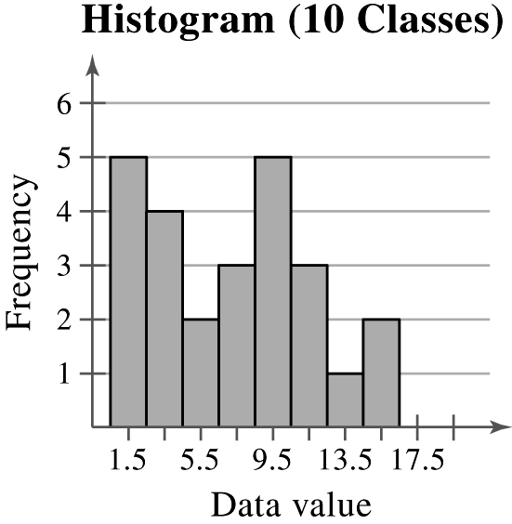 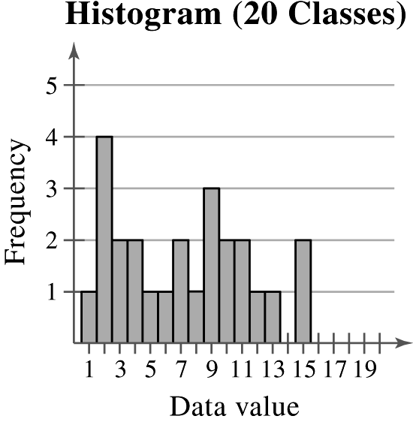

In general, a greater number of classes better preserves the actual values of the data set but is not as helpful for observing general trends and making conclusions. In choosing the number of classes, an important consideration is the size of the data set. For instance, you would not want to use 20 classes if your data set contained 20 entries. In this particular example, as the number of classes increases, the histogram shows more fluctuation. The histograms with 10 and 20 classes have classes with zero frequencies. Not much is gained by using more than five classes. Therefore, it appears that five classes would be best.

|  |
| --- |
| 2.2 MORE GRAPHS AND DISPLAYS |

2.2 Try It Yourself Solutions

**1a. ** **b.**

Key  = 36

**c.** *Sample answer:*Most of the most powerful women are between 40 and 70 years old.

**2a, b.**



**c.** *Sample answer:* Most of the 50 most powerful women are older than 50.

**3a.** Use the age for the horizontal axis.

**b.**

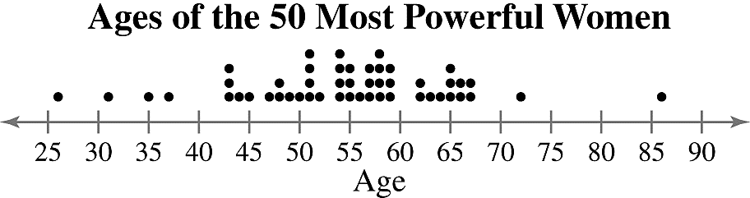

**c.** *Sample answer:*Most of the ages cluster between 43 and 67 years old. The age of 86 years old is an unusual data entry.

**4a.**

|  |  |  |  |
| --- | --- | --- | --- |
| **Type of Degree** | ***f*** | **Relative Frequency** | **Angle** |
| Associate’s | 455 | 0.235 |  |
| Bachelor’s | 1051 | 0.542 |  |
| Master’s | 330 | 0.170 |  |
| Doctoral | 104 | 0.054 |  |
|  |  |  |  |

**b.**

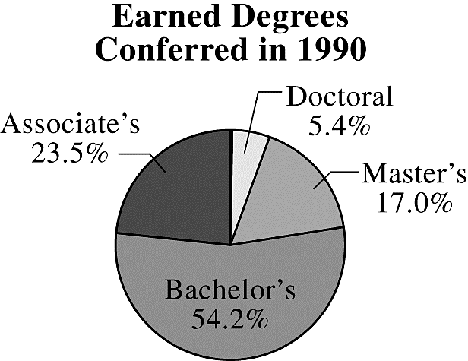

**c.** From 1990 to 2011, as percentages of total degrees conferred, associate’s degrees increased by 3%, bachelor’s degrees decreased by 5.9%, master’s degrees increased by 3.6%, and doctoral degrees decreased by 0.8%.

**5a.**

|  |  |
| --- | --- |
| **Cause** | **Frequency, *f*** |
| Auto repair and service | 14,156 |
| Insurance companies | 8,568 |
| Mortgage brokers | 6,712 |
| Telephone companies | 15,394 |
| Travel agencies | 5,841 |

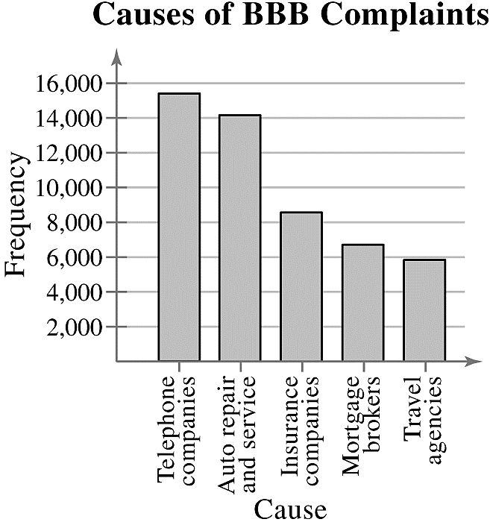**b.**

**c.** *Sample answer:* Telephone companies and auto repair and service account for over half of all complaints received by the BBB.

**6a, b.**

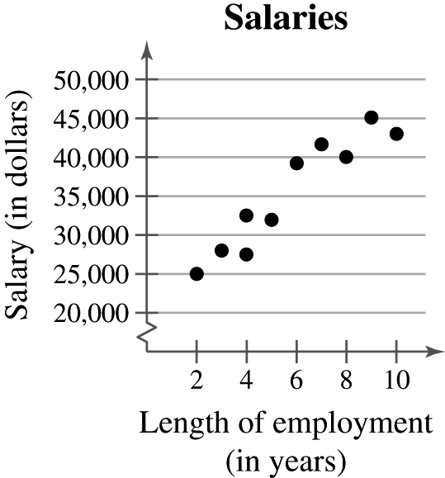

**c.** It appears that the longer an employee is with the company, the larger the employee’s salary will be.

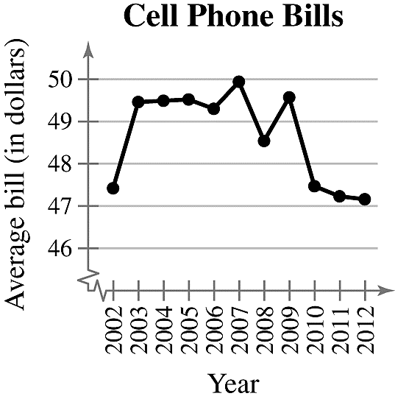**7ab.**

**c.** The average bill increased from 2002 to 2003, then it hovered from 2003 to 2009, and decreased from 2009 to 2012.

2.2 EXERCISE SOLUTIONS

**1.** Quantitative: stem-and-leaf plot, dot plot, histogram, time series chart, scatter plot.

Qualitative: pie chart, Pareto chart

**2.** Unlike the histogram, the stem-and-leaf plot still contains the original data values. However, some data are difficult to organize in a stem-and-leaf plot.

**3.** Both the stem-and-leaf plot and the dot plot allow you to see how data are distributed, determine specific data entries, and identify unusual data values.

**4.** In a Pareto chart, the height of each bar represents frequency or relative frequency and the bars are positioned in order of decreasing height with the tallest bar positioned at the left.

**5.** b **6.** d **7.** a **8.** c

**9.** 27, 32, 41, 43, 43, 44, 47, 47, 48, 50, 51, 51, 52, 53, 53, 53, 54, 54, 54, 54, 55, 56, 56, 58, 59, 68, 68, 68, 73, 78, 78, 85

Max: 85 Min: 27

**10.** 12.9, 13.3, 13.6, 13.7, 13.7, 14.1, 14.1, 14.1, 14.1, 14.3, 14.4, 14.4, 14.6, 14.9, 14.9, 15.0, 15.0, 15.0, 15.1, 15.2, 15.4, 15.6, 15.7, 15.8, 15.8, 15.8, 15.9, 16.1, 16.6, 16.7

Max: 16.7 Min: 12.9

**11.** 13, 13, 14, 14, 14, 15, 15, 15, 15, 15, 16, 17, 17, 18, 19

Max: 19 Min: 13

**12.** 214, 214, 214, 216, 216, 217, 218, 218, 220, 221, 223, 224, 225, 225, 227, 228, 228, 228, 228, 230, 230, 231, 235, 237, 239

Max: 239 Min: 214

**13.** *Sample answer*: Users spend the most amount of time on Facebook and the least amount of time on LinkedIn.

**14.** *Sample answer*: Motor vehicle thefts decreased from 2006 and 2011.

**15.** *Sample answer*: Tailgaters irk drivers the most, while too-cautious drivers irk drivers the least.

**16.** *Sample answer*: Food is the most costly aspect of pet care. The actual price of the pet is the least costly aspect of pet care.

**17. Exam Scores **



*Sample answer*: Most grades for the biology midterm were in the 80s and 90s.

**18. Hours Worked by Nurses** Key: 



*Sample answer:* Most nurses work between 30 and 40 hours per week.

**19. Ice Thickness (in centimeters)** Key: 



*Sample answer:* Most of the ice had a thickness of 5.8 centimeters to 7.2 centimeters.

**20. Apple Prices (in cents per pound)** Key: 



*Sample answer:* Most farmers charge 26 to 28 cents per pound of apples.

**21. Ages of Highest-Paid CEOs** Key: 



*Sample answer:* Most of the highest-paid CEOs have ages that range from 55 and 64 years old.

**22. Super Bowl Winning Scores** Key: 



**23.**

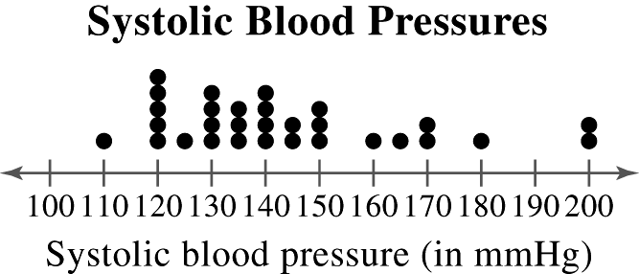

*Sample answer:* Systolic blood pressure tends to be between 120 and 150 millimeters of mercury.

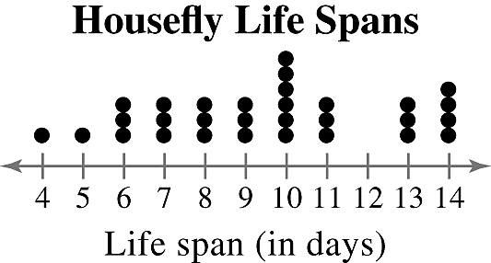**24.**

*Sample answer:* The lifespan of a housefly tends to be from6to14 days.

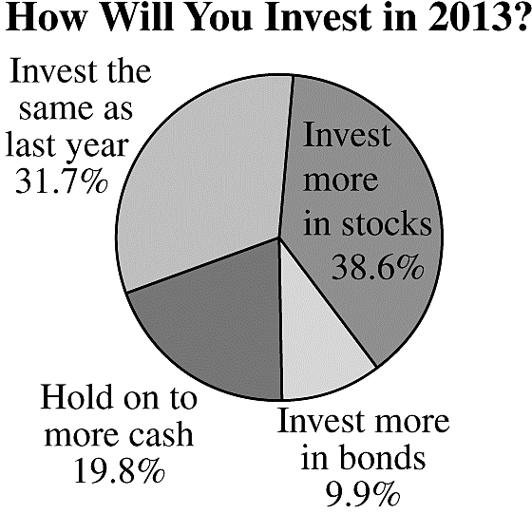**25.**

*Sample answer:* The majority of people will either invest more in stocks or invest the same as last year.

**26.**

|  |  |  |  |
| --- | --- | --- | --- |
| **Category** | **Frequency, *f*** | **Relative Frequency** | **Angle** |
| United States | 15 | 0.357 |  |
| Italy | 4 | 0.095 |  |
| Ethiopia | 2 | 0.048 |  |
| South Africa | 2 | 0.048 |  |
| Tanzania | 1 | 0.024 |  |
| Kenya | 9 | 0.214 |  |
| Mexico | 4 | 0.095 |  |
| Morocco | 1 | 0.024 |  |
| Great Britain | 1 | 0.024 |  |
| Brazil | 2 | 0.048 |  |
| New Zealand | 1 | 0.024 |  |
|  |  |  |  |

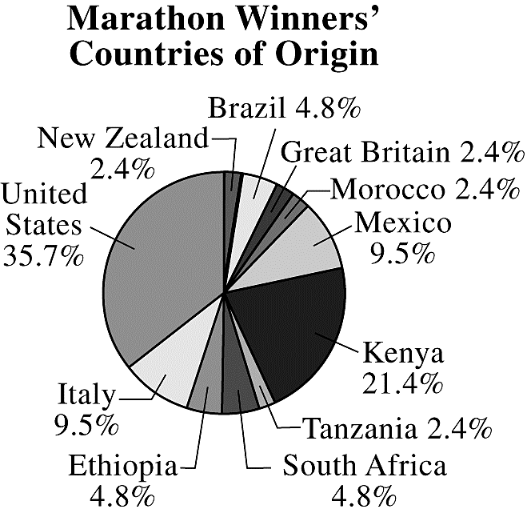

*Sample answer:* Most of the New York City Marathon winners are from the United States and Kenya.

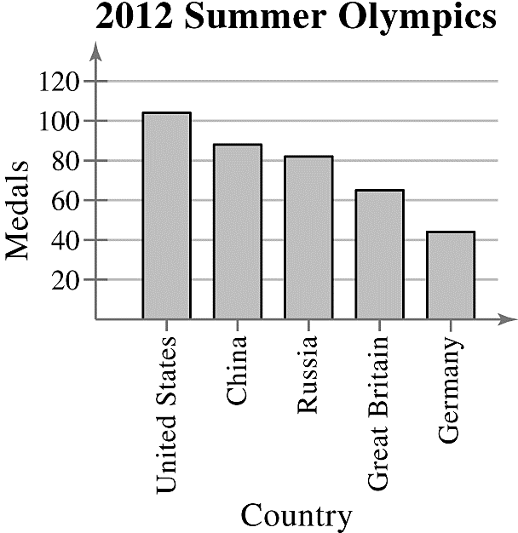**27.**

*Sample answer:* The United States won the most medals out of the five countries and Germany won the least.

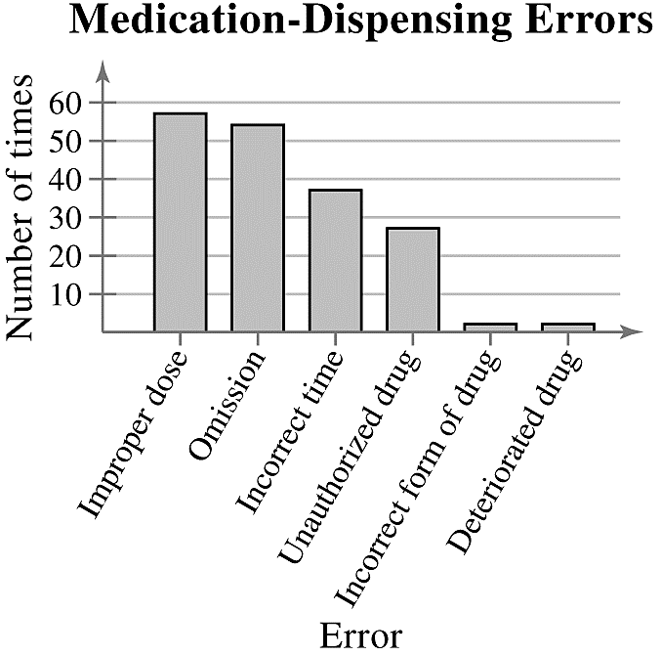**28.**

*Sample answer:* The greatest types of medication-dispensing errors are improper doses and omissions.

**29.**

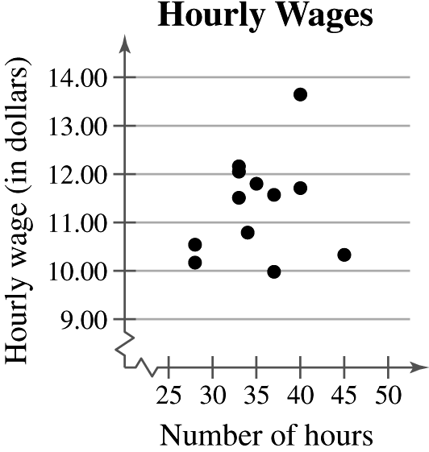

*Sample answer:* It appears that there is no relation between wages and hours worked.

**30.**

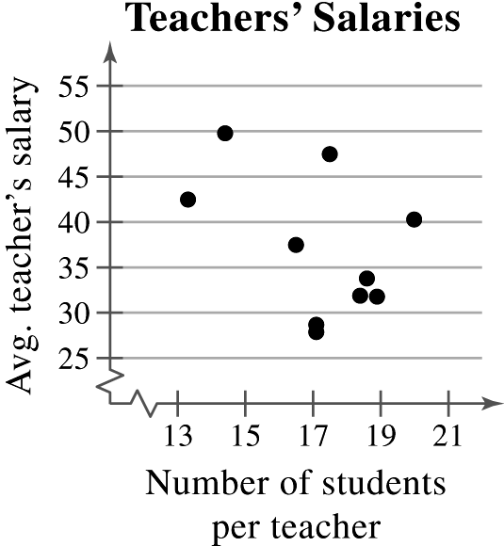

*Sample answer:* It appears that there is no relation between a teacher’s average salary and the number of students per teacher.

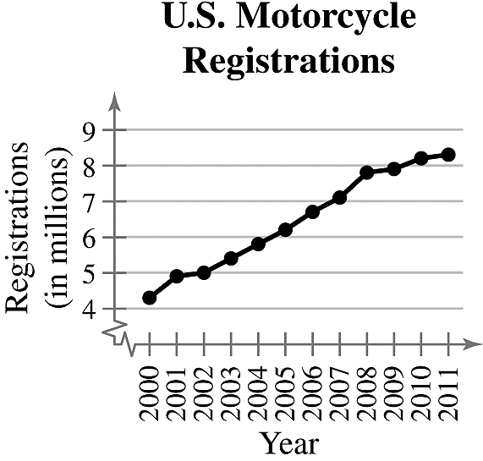**31.**

*Sample answer:* The number of motorcycle registrations has increased from 2000 to 2011.

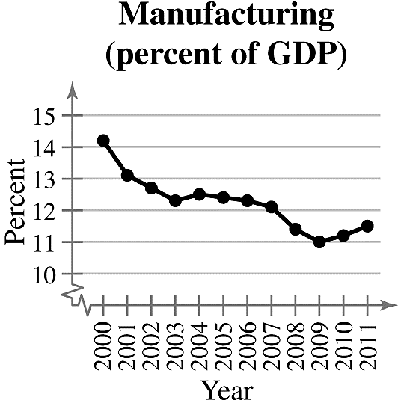**32.**

*Sample answer:* The percentage of the U.S. gross domestic product that comes from the manufacturing sector has decreased from 2000 to 2009.

**33.**

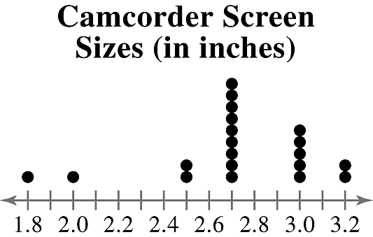

The stem-and-leaf plot helps you see that most values are from 2.5 to 3.2. The dot plot helps you see that the values 2.7 and 3.0 occur most frequently, with 2.7 occurring most frequently.

**34. Heights (in inches) **



The dot plot helps you see that the data are clustered from 78 to 83 with 78 being the most frequent value. The stem-and-leaf plot helps you see that most values are in the 70s and 80s.

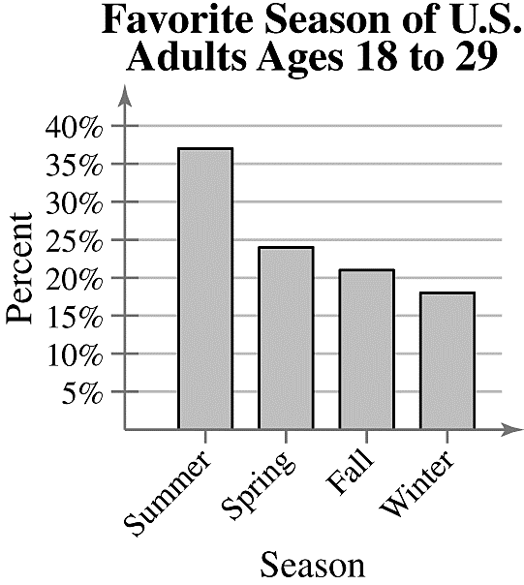**35.**

The pie chart helps you to see the percentages as parts of a whole, with summer being the largest. It is also shows that while summer is the largest percentage, it only makes up about one-third of the pie chart. That means that about two-thirds of U.S. adults ages 18 to 29 prefer a season other than summer. This means it would not be a fair statement to say that most U.S. adults ages 18 to 29 prefer summer. The Pareto chart helps you to see the rankings of the seasons. It helps you to see that the favorite seasons in order from greatest to least percentage are summer, spring, fall, and winter.

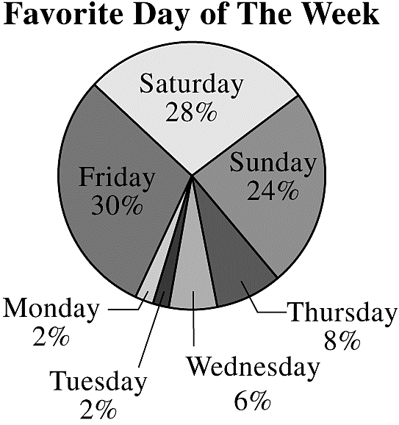**36.**

The Pareto chart helps you see the order from the most favorite to least favorite day. The pie chart helps you visualize the data as parts of a whole and see that about 80% of people say their favorite day is Friday, Saturday, or Sunday.

**37.** (a)The graph is misleading because the large gap from 0 to 90 makes it appear that the sales for the 3rd quarter are disproportionately larger than the other quarters.

(b)

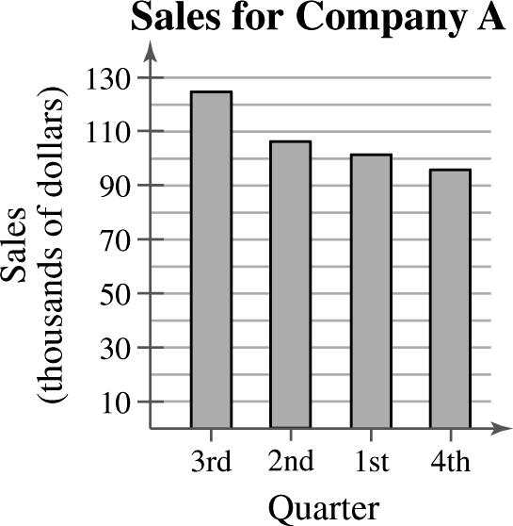

**38.** (a)The graph is misleading because the vertical axis has no break. The percent of middle schoolers that responded “yes” appears three times larger than either of the others when the difference is only 10%.

(b)

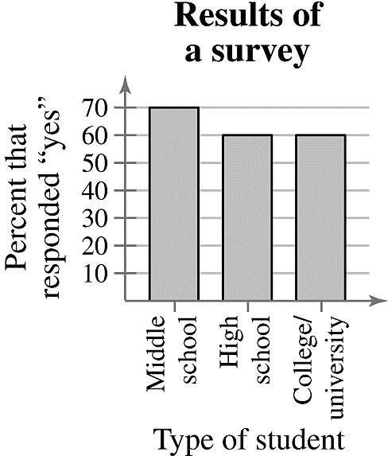

**39.** (a)The graph is misleading because the angle makes it appear as though the 3rd quarter had a larger percent of sales than the others, when the 1st and 3rd quarters have the same percent.

(b)

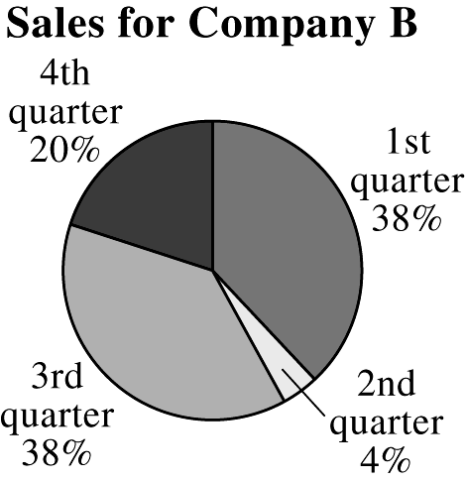

**40.** (a) The graph is misleading because the “non-OPEC countries” bar is wider than the “OPEC countries” bar.

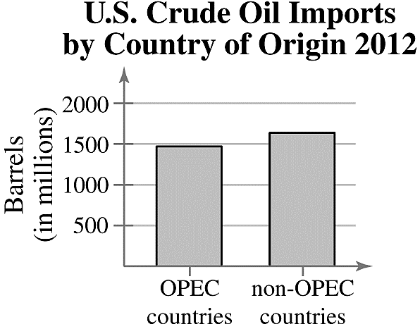(b)

**41.** (a)At Law Firm A, the lowest salary was $90,000 and the highest salary was $203,000. At Law Firm B, the lowest salary was $90,000 and the highest salary was $190,000.

(b) There are 30 lawyers at Law Firm A and 32 lawyers at Law Firm B.

(c)At Law Firm A, the salaries tend to be clustered at the far ends of the distribution range. At Law Firm B, the salaries are spread out.

**42.** (a) Key: 35-year-old in 3:00 p.m. class and 31-year old in 8:00 p.m. class.

**3:00 P.M. Class 8:00 P.M. Class**



(b)In the 3:00 p.m. class, the lowest age is 35 years old and the highest age is 85 years old. In the 8:00 p.m. class, the lowest age is 18 years old and the highest age is 71 years old.

(c) There are 26 participantsin the 3:00 p.m. class and there are 30 participants in the 8:00 p.m. class.

(d)*Sample answer:* The participants in each class are clustered at one of the ends of their distribution range. The 3:00 p.m. class mostly has participants over 50 years old and the 8:00 p.m. class mostly has participants under 50 years old.

|  |
| --- |
| 2.3 MEASURES OF CENTRAL TENDENCY |

2.3 Try It Yourself Solutions

**1a.** 

**b. **

**c.** The mean height of the player is about 79.5 inches.

**2a.** 18, 18, 19, 19, 19, 20, 21, 21, 21,21, 23, 24, 24, 26, 27, 27, 29, 30, 30, 30, 33, 33, 34, 35, 38

**b.** median = 24

**c.** The median age of the sample of fans at the concert is 24.

**3a.** 10, 50, 50, 70, 70, 80, 100, 100, 120, 130

**b.** median

**c.** The median price of the sample of digital photo frames is $75.

**4a.** 324, 385, 450, 450, 462, 475, 540, 540, 564, 618, 624, 638, 670, 670, 670, 705, 720, 723, 750, 750, 825, 830, 912, 975, 980, 980, 1100, 1260, 1420, 1650

**b.** The price that occurs with the greatest frequency is $670 per square foot.

**c.** The mode of the prices for the sample of South Beach, FL condominiums is $670 per square foot.

**5a.** “Better prices” occurs with the greatest frequency (399).

**b.** In this sample, there were more people who shop online for better prices than for any other reason.

**6a. **

median = 21

mode = 20

**b.** The mean in Example 6 () was heavily influenced by the entry 65. Neither the median nor the mode was affected as much by the entry 65.

**7a, b.**

|  |  |  |  |
| --- | --- | --- | --- |
| **Source** | **Score, *x*** | **Weight, *w*** | ***x · w*** |
| Test mean | 86 | 0.50 | 43.0 |
| Midterm | 96 | 0.15 | 14.4 |
| Final exam | 98 | 0.20 | 19.6 |
| Computer lab | 98 | 0.10 | 9.8 |
| Homework | 100 | 0.05 | 5.0 |
|  |  |  |  |

**c. **

**d.** The weighted mean for the course is 91.8. So, you did get an A.

**8a, b, c.**

|  |  |  |  |
| --- | --- | --- | --- |
| **Class** | **Midpoint, *x*** | **Frequency, *f*** | ***x · f*** |
| 26-34 | 30 | 2 | 60 |
| 35-43 | 39 | 5 | 195 |
| 44-52 | 48 | 12 | 576 |
| 53-61 | 57 | 18 | 1026 |
| 62-70 | 66 | 11 | 726 |
| 71-79 | 75 | 1 | 75 |
| 80-88 | 84 | 1 | 84 |
|  |  |  |  |

**d. **

2.3 EXERCISE SOLUTIONS

**1.** True

**2.** False. All quantitative data sets have a median.

**3.** True

**4.** True

**5.** *Sample answer:* 1, 2, 2, 2, 3

**6.** *Sample answer:* 2, 4, 5, 5, 6, 8

**7.** *Sample answer:* 2, 5, 7, 9, 35

**8.** *Sample answer:* 1, 2, 3, 3, 3, 4, 5

**9.** The shape of the distribution is skewed right because the bars have a “tail” to the right.

**10.** The shape of the distribution is symmetric because a vertical line can be drawn down the middle, creating two halves that are approximately the same.

**11.** The shape of the distribution is uniform because the bars are approximately the same height.

**12.** The shape of the distribution is skewed left because the bars have a “tail” to the left.

**13.** (11), because the distribution values range from 1 to 12 and has (approximately) equal frequencies.

**14.** (9), because the distribution has values in the thousands of dollars and is skewed right due to the few executives that make a much higher salary than the majority of the employees.

**15.** (12), because the distribution has a maximum value of 90 and is skewed left due to a few students scoring much lower than the majority of the students.

**16.** (10), because the distribution is approximately symmetric and the weights range from 80 to 160 pounds.

**17. **

12 12 13 14 14 15 **15** 15 16 16 16 16 18

median = 15

mode = 16 (occurs 4 times)

**18. **

169 169 170 **172** 174 175 176

median = 172

mode = 169 (occurs 2 times)

The mode does not represent the center of the data because 169 is the smallest number in the data set.

**19. **

818 1125 1155 **1229** 1275 1277 1370

median = 1229

mode = none

The mode cannot be found because no data entry is repeated.

**20. **

36 38 40 43 **43** 49 50 52 63

median = 43

mode = 43(occurs 2 times)

**21. **



mode = 44 (occurs 5 times)

**22. **



mode = none; The mode cannot be found because no data entryis repeated.

**23. **



mode = 31 and 34 (both occur 3 times)

**24. **



mode = 80, 125

The modes do not represent the center of the data set because they are large values compared to the rest of the data.

**25. **

1.0 10.0 **15.0** 25.5 31.5

median = 43

mode = none

The mode cannot be found because no data entry is repeated.

**26. **



mode = 2.5 (occurs 2 times)

The mode does not represent the center of the data set because 2.5 is much smaller than most of the data in the set.

**27. **is not possible (nominal data)

median = not possible (nominal data)

mode = “Eyeglasses”

The mean and median cannot be found because the data are at the nominal level of measurement.

**28. **is not possible (nominal data)

median is not possible (nominal data)

mode = “Money needed”

The mean and median cannot be found because the data are at the nominal level of measurement.

**29. **is not possible (nominal data)

median is not possible (nominal data)

mode = “Junior”

The mean and median cannot be found because the data are at the nominal level of measurement.

**30. **is not possible (nominal data)

median is not possible (nominal data)

mode = “on Facebook, find it valuable”

The mean and median cannot be found because the data are at the nominal level of measurement.

**31. **



mode = 24, 35 (both occur 3 times each)

**32. **



mode = 4.0 (occurs 2 times)

The mode does not represent the center of the data set because it is the largest value in the data set.

**33. **

581015 15 15 17 **20** 21 22 22 25 28 32 37

median = 20

mode = 15 (occurs 3 times)

**34. **

170 180 190 200 200 210 210 **210** 210 210 220 220 220 220 240

median = 210

mode = 210 (occurs 5 times)

**35.** The data are skewed right.

A = mode, because it is the data entry that occurred most often.

B = median, because the median is to the left of the mean in a skewed right distribution.

C = mean, because the mean is to the right of the median in a skewed right distribution.

**36.** The data are skewed left.

A = mean, because the mean is to the left of the median in a skewed left distribution.

B = median, because the median is to the right of the mean in a skewed left distribution.

C = mode, because it is the data entry that occurred most often.

**37.** Mode, because the data are at the nominal level of measurement.

**38.** Mean, because the data are symmetric.

**39.** Mean, because the distribution is symmetric and there are no outliers.

**40.** Median, because there is an outlier.

**41.**

|  |  |  |  |
| --- | --- | --- | --- |
| **Source** | **Score, *x*** | **Weight, *w*** | ***x · w*** |
| Homework | 85 | 0.05 | 4.25 |
| Quiz | 80 | 0.35 | 28 |
| Project | 100 | 0.20 | 20 |
| Speech | 90 | 0.15 | 13.5 |
| Final exam | 93 | 0.25 | 23.25 |
|  |  |  |  |



**42.**

|  |  |  |  |
| --- | --- | --- | --- |
| **Source** | **Score, *x*** | **Weight, *w*** | ***x · w*** |
| Article reviews | 95 | 10% | 9.5 |
| Quizzes | 100 | 10% | 10 |
| Midterm exam | 89 | 30% | 26.7 |
| Student lecture | 100 | 10% | 10 |
| Final exam | 92 | 40% | 36.8 |
|  |  |  |  |



**43.**

|  |  |  |
| --- | --- | --- |
| **Balance, *x*** | **Days, *w*** | ***x · w*** |
| $523 | 24 | 12,552 |
| $2415 | 2 | 4830 |
| $250 | 4 | 1000 |
|  |  |  |



**44.**

|  |  |  |
| --- | --- | --- |
| **Balance, *x*** | **Days, *w*** | ***x · w*** |
| $759 | 15 | 11,385 |
| $1985 | 5 | 9925 |
| $1410 | 5 | 7050 |
| $348 | 6 | 2088 |
|  |  |  |



**45.**

|  |  |  |  |
| --- | --- | --- | --- |
| **Grade** | **Points, *x*** | **Credits, *w*** | ***x · w*** |
| A | 4 | 4 | 16 |
| B | 3 | 3 | 9 |
| B | 3 | 3 | 9 |
| C | 2 | 3 | 6 |
| D | 1 | 2 | 2 |
|  |  |  |  |



**46.**

|  |  |  |  |
| --- | --- | --- | --- |
| **Source** | **Score, *x*** | **Weight, *w*** | ***x · w*** |
| Engineering | 85 | 9 | 765 |
| Business | 81 | 13 | 1053 |
| Math | 90 | 5 | 450 |
|  |  |  |  |



**47.**

|  |  |  |  |
| --- | --- | --- | --- |
| **Source** | **Score, *x*** | **Weight, *w*** | ***x · w*** |
| Homework | 85 | 0.05 | 4.25 |
| Quiz | 80 | 0.35 | 28 |
| Project | 100 | 0.20 | 20 |
| Speech | 90 | 0.15 | 13.5 |
| Final exam | 85 | 0.25 | 21.25 |
|  |  |  |  |



**48.**

|  |  |  |  |
| --- | --- | --- | --- |
| **Grade** | **Points, *x*** | **Credits, *w*** | ***x · w*** |
| A | 4 | 4 | 16 |
| A | 4 | 3 | 12 |
| B | 3 | 3 | 9 |
| C | 2 | 3 | 6 |
| D | 1 | 2 | 2 |
|  |  |  |  |



**49.**

|  |  |  |  |
| --- | --- | --- | --- |
| **Class** | **Midpoint, *x*** | **Frequency, *f*** | ***x · f*** |
| 29-33 | 31 | 11 | 341 |
| 34-38 | 36 | 12 | 432 |
| 39-43 | 41 | 2 | 82 |
| 44-48 | 46 | 5 | 230 |
|  |  |  |  |

****miles per gallon

**50.**

|  |  |  |  |
| --- | --- | --- | --- |
| **Class** | **Midpoint, *x*** | **Frequency, *f*** | ***x · f*** |
| 22-27 | 24.5 | 16 | 392 |
| 28-33 | 30.5 | 2 | 61 |
| 34-39 | 36.5 | 2 | 73 |
| 40-45 | 42.5 | 3 | 127.5 |
| 46-51 | 48.5 | 1 | 48.5 |
|  |  |  |  |

****miles per gallon

**51.**

|  |  |  |  |
| --- | --- | --- | --- |
| **Class** | **Midpoint, *x*** | **Frequency, *f*** | ***x · f*** |
| 0-9 | 4.5 | 44 | 198.0 |
| 10-19 | 14.5 | 66 | 957.0 |
| 20-29 | 24.5 | 32 | 784.0 |
| 30-39 | 34.5 | 53 | 1828.5 |
| 40-49 | 44.5 | 35 | 1557.5 |
| 50-59 | 54.5 | 31 | 1689.5 |
| 60-69 | 64.5 | 23 | 1483.5 |
| 70-79 | 74.5 | 13 | 968.5 |
| 80-89 | 84.5 | 2 | 169.0 |
|  |  |  |  |

****yearsold

**52.**

|  |  |  |  |
| --- | --- | --- | --- |
| **Class** | **Midpoint, *x*** | **Frequency, *f*** | ***x · f*** |
| 0-9 | 4.5 | 30 | 135.0 |
| 10-19 | 14.5 | 28 | 406.0 |
| 20-29 | 24.5 | 17 | 416.5 |
| 30-39 | 34.5 | 22 | 759.0 |
| 40-49 | 44.5 | 23 | 1023.5 |
| 50-59 | 54.5 | 46 | 2507.0 |
| 60-69 | 64.5 | 37 | 2386.5 |
| 70-79 | 74.5 | 18 | 1341.0 |
| 80-89 | 84.5 | 4 | 338.0 |
|  |  |  |  |

****years old

**53. **

|  |  |  |
| --- | --- | --- |
| **Class** | **Midpoint** | **Frequency, *f*** |
| 127-161 | 144 | 9 |
| 162-196 | 179 | 8 |
| 197-231 | 214 | 3 |
| 232-266 | 249 | 3 |
| 267-301 | 284 | 1 |
|  |  |  |

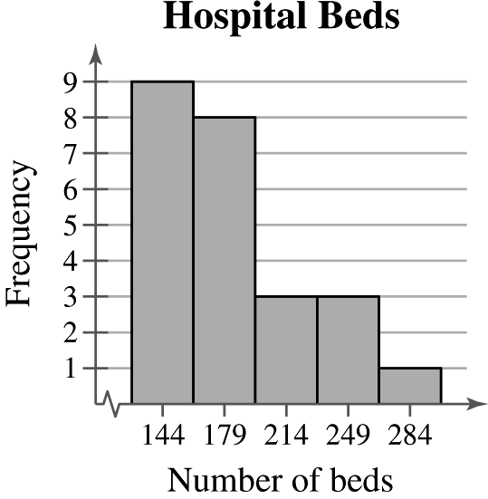

Shape: Positively skewed

**54. **

|  |  |  |
| --- | --- | --- |
| **Class** | **Midpoint** | **Frequency, *f*** |
| 3-4 | 3.5 | 3 |
| 5-6 | 5.5 | 8 |
| 7-8 | 7.5 | 4 |
| 9-10 | 9.5 | 2 |
| 11-12 | 11.5 | 2 |
| 13-14 | 13.5 | 1 |
|  |  |  |

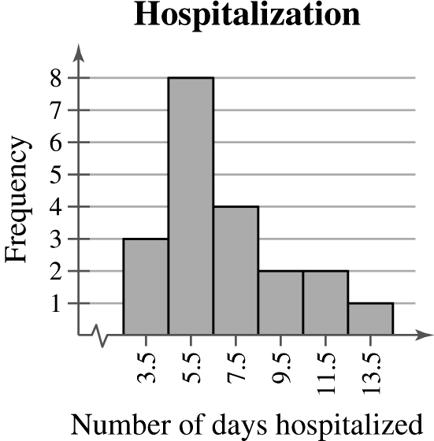

Shape: Positively skewed

**55. **

|  |  |  |
| --- | --- | --- |
| **Class** | **Midpoint** | **Frequency, *f*** |
| 62-64 | 63 | 3 |
| 65-67 | 66 | 7 |
| 68-70 | 69 | 9 |
| 71-73 | 72 | 8 |
| 74-76 | 75 | 3 |
|  |  |  |

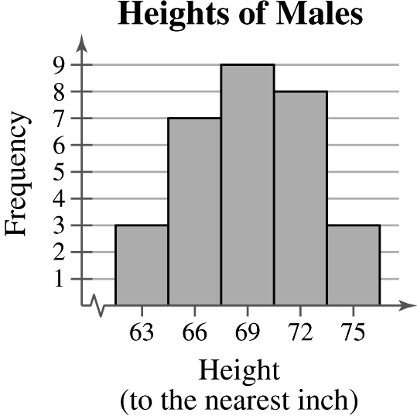

Shape: Symmetric

**56. **

|  |  |
| --- | --- |
| **Class** | **Frequency, *f*** |
| 1 | 6 |
| 2 | 5 |
| 3 | 4 |
| 4 | 6 |
| 5 | 4 |
| 6 | 5 |
|  |  |

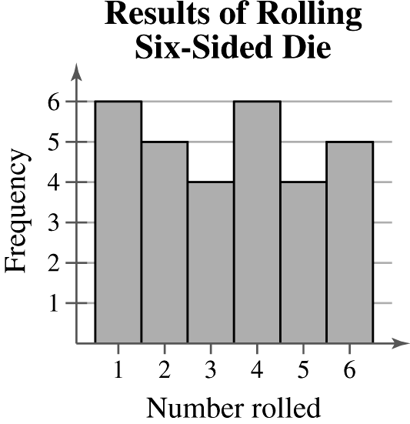

Shape: Uniform

**57.** (a) 



(b) 



(c)The mean was affected more.

**58.** (a) 

10.9 13.8 14.2 16.0 24.4 25.9 27.5 27.8 29.9 **31.2** 42.4 42.9 43.4 49.2 55.9 65.7 103.9 198.4 280.9

median = 31.2

(b) 



The mean was affected more.

(c) 

****The mean was affected more.

**59.** Clusters around 16-21 and around 36

**60.** Cluster around 18-27, gap between 27 and 72, outlier at 72

**61.** *Sample answer:* Option 2; The two clusters represent different types of vehicles which can be more meaningfully analyzed separately. For instance, suppose the mean gas mileage for cars is very far from the mean gas mileage for trucks, vans, and SUVs. Then, the mean gas mileage for all of the vehicles would be somewhere in the middle and would not accurately represent the gas mileages of either group of vehicles.

**62.** (a) 

147 177 336 360 **375** 393 408 504 522

median = 375

(b) 

441 531 1008 1080 **1125**  1179 1224 1512 1566

median = 1125

(c)The mean and median in part (b) are three times the mean and median in part (a).

(d) If you multiply the mean and median of the original data set by 36, you will get the mean and median of the data set in inches.

**63.** Car A



28 28 **30** 32 34

median = 30

mode = 28 (occurs 2 times)

Car B



29 29**31** 31 31

median = 31

mode = 31 (occurs 3 times)

Car C



28 29**30** 32 32

median = 30

mode = 32 (occurs 2 times)

(a)Mean should be used because Car A has the highest mean of the three.

(b) Median should be used because Car B has the highest median of the three.

(c) Mode should be used because Car C has the highest mode of the three.

**64.** Car A: Midrange = 

Car B: Midrange = 

Car C: Midrange = 

Car A because the midrange is the largest.

**65.** (a) 



(b)Key: 



mean

median

(c)The distribution is positively skewed.

**66.** (a)Order the data values.

11 13 22 28 36 36 36 37 37 37 38 41 43 44 46

47 51 51 51 53 61 62 63 64 72 72 74 76 85 90

Delete the lowest 10%, smallest 3 observations (11, 13, 22).

Delete the highest 10%, largest 3 observations (76, 85, 90).

Find the 10% trimmed mean using the remaining 24 observations.



10% trimmed mean

(b) 

median = 46.5

mode = 36, 37, 51



(c) Using a trimmed mean eliminates potential outliers that may affect the mean of all the observations.

|  |
| --- |
| 2.4 MEASURES OF VARIATION |

2.4 Try It Yourself Solutions

**1a.** Min = 23, or $23,000 and Max = 58, or $58,000

**b.** Range = Max – Min = 58 – 23 = 35, or $35,000

**c.** The range of the starting salaries for Corporation B is 35, or $35,000. This is much larger than the range for Corporation A.

**2ab. **, or $41,500

|  |  |  |
| --- | --- | --- |
| **Salary, *x*** | ***x* – *μ*** | **(*x* – *μ*)2** |
| 23 | –18.5 | 342.25 |
| 29 | –12.5 | 156.25 |
| 32 | –9.5 | 90.25 |
| 40 | –1.5 | 2.25 |
| 41 | –0.5 | 0.25 |
| 41 | –0.5 | 0.25 |
| 49 | 7.5 | 56.25 |
| 50 | 8.5 | 72.25 |
| 52 | 10.5 | 110.25 |
| 58 | 16.5 | 272.25 |
|  |  |  |

**c. **

**d. ** or $10,500

**e.** The population variance is about 110.3 and the population standard deviation is 10.5, or $10,500.

**3ab. **

|  |  |  |
| --- | --- | --- |
| **Time, *x*** |  |  |
| 43 | 3.5 | 12.25 |
| 57 | 17.5 | 306.25 |
| 18 | -21.5 | 462.25 |
| 45 | 5.5 | 30.25 |
| 47 | 7.5 | 56.25 |
| 33 | -6.5 | 42.25 |
| 49 | 9.5 | 90.25 |
| 24 | -15.5 | 240.25 |
|  |  |  |



**b.** 

**c.** 

**4a.** Enter the data in a computer or a calculator.

**b. **

**5a.** *Sample answer:* 7, 7, 7, 7, 7, 13, 13, 13, 13, 13

**b.**

|  |  |  |
| --- | --- | --- |
| **Salary, *x*** | ***x* – *μ*** | **(*x* – *μ*)2** |
| 7 | –3 | 9 |
| 7 | –3 | 9 |
| 7 | –3 | 9 |
| 7 | –3 | 9 |
| 7 | –3 | 9 |
| 13 | 3 | 9 |
| 13 | 3 | 9 |
| 13 | 3 | 9 |
| 13 | 3 | 9 |
| 13 | 3 | 9 |
|  |  |  |





**6a.** 67.1 – 64.2 = 2.9 = 1 standard deviation

**b.** 34%

**c.** Approximately 34% of women ages 20-29 are between 64.2 and 67.1 inches tall.

**7a.** 35.3 – 2(21.1) = -6.9

Because –6.9 does not make sense for an age, use 0.

**b.** 35.3 + 2(21.1) = 77.5

**c.** 

At least 75% of the data lie within 2 standard deviations of the mean. At least 75% of the population of Alaska is between 0 and 77.5 years old.

**8a.**

|  |  |  |
| --- | --- | --- |
| ***x*** | ***f*** | ***xf*** |
| 0 | 10 | 0 |
| 1 | 19 | 19 |
| 2 | 7 | 14 |
| 3 | 7 | 21 |
| 4 | 5 | 20 |
| 5 | 1 | 5 |
| 6 | 1 | 6 |
|  | *n* = 50 |  |

**b. **

**c.**

|  |  |  |
| --- | --- | --- |
|  |  |  |
| –1.7 | 2.89 | 28.90 |
| –0.7 | 0.49 | 9.31 |
| 0.3 | 0.09 | 0.63 |
| 1.3 | 1.69 | 11.83 |
| 2.3 | 5.29 | 26.45 |
| 3.3 | 10.89 | 10.89 |
| 4.3 | 18.49 | 18.49 |
|  |  |  |

**d. **

**9a.**

|  |  |  |  |
| --- | --- | --- | --- |
| **Class** | ***x*** | ***f*** | ***xf*** |
| 1-99 | 49.5 | 380 | 18,810 |
| 100-199 | 149.5 | 230 | 34,385 |
| 200-299 | 249.5 | 210 | 52,395 |
| 300-399 | 349.5 | 50 | 17,475 |
| 400-499 | 449.5 | 60 | 26,970 |
| 500+ | 650 | 70 | 45,500 |
|  |  | *n* = 1000 |  |

**b. **

**c.**

|  |  |  |
| --- | --- | --- |
|  |  |  |
| –146.0 | 21,316 | 8,100,080 |
| –46.0 | 2116 | 486,680 |
| 54.0 | 2916 | 612,360 |
| 154.0 | 23,716 | 1,185,800 |
| 254.0 | 64,516 | 3,870,960 |
| 454.5 | 206,570.25 | 14,459,917.5 |
|  |  |  |

**d. **

**10a.** Los Angeles:, 

Dallas/Fort Worth:, 

**b.** Los Angeles:

Dallas/Fort Worth:

**c.** The office rental rates are more variable in Los Angeles than in Dallas/Fort Worth.

2.4 EXERCISE SOLUTIONS

**1.** The range is the difference between the maximum and minimum values of a data set. The advantage of the range is that it is easy to calculate. The disadvantage is that it uses only two entries from the data set.

**2.** A deviation  is the difference between an entry *x* and the mean of the data *μ*. The sum of the deviations is always zero.

**3.** The units of variance are squared. Its units are meaningless (example: dollars2). The units of standard deviation are the same as the data.

**4.** The standard deviation is the positive square root of the variance. The standard deviation and variance can never be negative because squared deviations can never be negative.

**5.** When calculating the population standard deviation, you divide the sum of the squared deviations by *N*, then take the square root of that value. When calculating the sample standard deviation, you divide the sum of the squared deviations by , then take the square root of that value.

**6.** When given a data set,you would have to determine if it represented the population or if it was a sample taken from the population. If the data are a population, then  is calculated. If the data are a sample, then *s* is calculated.

**7.** Similarity: Both estimate proportions of the data contained within *k* standard deviations of the mean.

Difference: The Empirical Rule assumes the distribution is approximately symmetric and bell-shaped. Chebychev’s Theorem makes no such assumption.

**8.** You must know that the distribution is approximately symmetric and bell-shaped.

**9.** Range = Max – Min = 34 – 24 = 10

**10.** Range = Max – Min = 98 – 74 = 24

**11.** (a)Range = Max – Min = 38.5 – 20.7 = 17.8

(b) Range = Max – Min = 60.5 – 20.7 = 39.8

**12.** Changing the maximum value of the data set greatly affects the range.

**13.** Range = Max – Min = 13 – 2 = 11



|  |  |  |
| --- | --- | --- |
|  |  |  |
| 13 | 5.4 | 29.16 |
| 10 | 2.4 | 5.76 |
| 12 | 4.4 | 19.36 |
| 11 | 3.4 | 11.56 |
| 7 | -0.6 | 0.36 |
| 8 | 0.4 | 0.16 |
| 6 | -1.6 | 2.56 |
| 6 | -1.6 | 2.56 |
| 10 | 2.4 | 5.76 |
| 7 | -0.6 | 0.36 |
| 12 | 4.4 | 19.36 |
| 4 | -3.6 | 12.96 |
| 6 | -1.6 | 2.56 |
| 5 | -2.6 | 6.76 |
| 2 | -5.6 | 31.36 |
| 2 | -5.6 | 31.36 |
|  |  |  |





**14.** Range = Max – Min = 230 – 160 = 70



|  |  |  |
| --- | --- | --- |
|  |  |  |
| 173 | -13.1 | 171.61 |
| 175 | -11.1 | 123.21 |
| 200 | 13.9 | 193.21 |
| 173 | -13.1 | 171.61 |
| 160 | -26.1 | 681.21 |
| 185 | -1.1 | 1.21 |
| 195 | 8.9 | 79.21 |
| 230 | 43.9 | 1927.21 |
| 190 | 3.9 | 15.21 |
| 180 | -6.1 | 37.21 |
|  |  |  |





**15.** Range = Max – Min = 24 – 14 = 10



|  |  |  |
| --- | --- | --- |
|  |  |  |
| 16 | -1 | 1 |
| 18 | 1 | 1 |
| 19 | 2 | 4 |
| 17 | 0 | 0 |
| 14 | -3 | 9 |
| 15 | -2 | 4 |
| 17 | 0 | 0 |
| 17 | 0 | 0 |
| 17 | 0 | 0 |
| 16 | -1 | 1 |
| 19 | 2 | 4 |
| 22 | 5 | 25 |
| 24 | 7 | 49 |
| 14 | -3 | 9 |
| 16 | -1 | 1 |
| 14 | -3 | 9 |
| 17 | 0 | 0 |
| 16 | -1 | 1 |
| 14 | -3 | 9 |
| 18 | 1 | 1 |
|  |  |  |





**16.** Range = Max – Min = 299 – 264 = 35



|  |  |  |
| --- | --- | --- |
|  |  |  |
| 277 | -4.4 | 19.36 |
| 277 | -4.4 | 19.36 |
| 267 | -14.4 | 207.36 |
| 291 | 9.6 | 92.16 |
| 282 | 0.6 | 0.36 |
| 281 | -0.4 | 0.16 |
| 295 | 13.6 | 184.96 |
| 279 | -2.4 | 5.76 |
| 286 | 4.6 | 21.16 |
| 280 | -1.4 | 1.96 |
| 296 | 14.6 | 213.16 |
| 269 | -12.4 | 153.76 |
| 268 | -13.4 | 179.56 |
| 285 | 3.6 | 12.96 |
| 264 | -17.4 | 302.76 |
| 278 | -3.4 | 11.56 |
| 269 | -12.4 | 153.76 |
| 299 | 17.6 | 309.76 |
| 291 | 9.6 | 92.16 |
| 293 | 11.6 | 134.56 |
|  |  |  |





**17.** The data set in (a) has a standard deviation of 24 and the data set in (b) has a standard deviation of 16 because the data in (a) have more variability.

**18.** The data set in (a) has a standard deviation of 2.4 and the data set in (b) has a standard deviation of 5 because the data in (b) have more variability.

**19.** Company B. An offer of $33,000 is two standard deviations from the mean of Company A’s starting salaries, which makes it unlikely. The same offer is within one standard deviation of the mean of Company B’s starting salaries, which makes the offer likely.

**20.** Company C. An offer of $42,000 is two standard deviations from the mean of Company D’s starting salaries, which makes it unlikely. The same offer is within one standard deviation of the mean of Company C’s starting salaries, which makes the offer likely.

**21.** (a)Greatest sample standard deviation: (ii)

Data set (ii) has more entries that are farther away from the mean.

Least sample standard deviation: (iii)

Data set (iii) has more entries that are close to the mean.

(b)The three data sets have the same mean but have different standard deviations.

**22.** (a)Greatest sample standard deviation: (i)

Data set (i) has more entries that are farther away from the mean.

Least sample standard deviation: (iii)

Data set (iii) has more entries that are close to the mean.

(b)The three data sets have the same mean, median, and mode, but have different standard deviations.

**23.** (a)Greatest sample standard deviation: (ii)

Data set (ii) has more entries that are farther away from the mean.

Least sample standard deviation: (iii)

Data set (iii) has more entries that are close to the mean.

(b)The three data sets have the same mean, median, and mode, but have different standard deviations.

**24.** (a)Greatest sample standard deviation: (iii)

Data set (iii) has more entries that are farther away from the mean.

Least sample standard deviation: (i)

Data set (i) has more entries that are close to the mean.

(b)The three data sets have the same mean and median but have different modes and standard deviations.

**25.** *Sample answer:* 3,3,3,7,7,7

**26.** *Sample answer:* 3,3,3,3,9,9,9,9

**27.** *Sample answer:* 9,9,9,9,9,9,9

**28.** *Sample answer:* 5,5,5,9,9,9

**29. **

68% of the vehicles have speeds between 63 and 71 mph.

**30.** 95% of the data falls between  and .





95% of the households have monthlyutility bills between $54 and $86.

**31.** (a) ****; 68%(75) = (0.68)(75) ≈ 51 vehicles have speeds between 63 and 71 mph.

(b) ****; 68%(25) = (0.68)(25) ≈ 17 vehicles have speeds between 63 and 71 mph.

**32.** (a) ****; 95%(40) = (0.95)(40) ≈ 38 households have monthly utility bills between $54 and $86.

(b) ****; 95%(20) = (0.95)(20) ≈ 19 households have monthly utility bills between $54 and $86.

**33.** 78, 76, and 82 are unusual; 82 is very unusual because it is more than 3 standard deviations from the mean.

**34.** $52 and $98 are unusual; $98 is very unusual because it is more than 3 standard deviations from the mean.

**35. ** are 2 standard deviations from the mean.

****At least 75% of the eruption times lie between 0 and 4.

If *n* = 40, at least (0.75)(40) = 30 households have between 0 and 4 pets.

**36. ** are 2 standard deviations from the mean.

****At least 75% of the eruption times lie between 1.14 and 5.5 minutes.

If *n* = 32, at least (0.75)(32) = 24 eruptions will lie between 1.14 and 5.5 minutes.

**37. ** are 2 standard deviations from the mean.

At least 75% of the test scores are from 80 to 96.

**38. **

At least 75% of the 800-meter freestyle times lie within 2 standard deviations of the mean.



At least 75% of the 800-meter freestyle times lie between 493.48 and 512.20 seconds.

**39.**

|  |  |  |  |  |  |
| --- | --- | --- | --- | --- | --- |
| ***x*** | ***f*** | ***xf*** |  |  |  |
| 0 | 3 | 0 | –1.74 | 3.0276 | 9.0828 |
| 1 | 15 | 15 | –0.74 | 0.5476 | 8.2140 |
| 2 | 24 | 48 | 0.26 | 0.0676 | 1.6224 |
| 3 | 8 | 24 | 1.26 | 1.5876 | 12.7008 |
|  | *n* = 50 |  |  |  |  |





**40.**

|  |  |  |
| --- | --- | --- |
| **Midpoint, *x*** | ***f*** | ***xf*** |
| 70.5 | 1 | 70.5 |
| 92.5 | 12 | 1110.0 |
| 114.5 | 25 | 2862.5 |
| 136.5 | 10 | 1365.0 |
| 158.5 | 2 | 317.0 |
|  |  |  |



|  |  |  |
| --- | --- | --- |
|  |  |  |
| –44 | 1936 | 1936 |
| –22 | 484 | 5808 |
| 0 | 0 | 0 |
| 22 | 484 | 4840 |
| 44 | 1936 | 3872 |
|  |  |  |



**41.**

|  |  |  |  |
| --- | --- | --- | --- |
| **Class** | **Midpoint, *x*** | ***f*** | ***xf*** |
| 0-4 | 2 | 5 | 10 |
| 5-9 | 7 | 12 | 84 |
| 10-14 | 12 | 24 | 288 |
| 15-19 | 17 | 17 | 289 |
| 20-24 | 22 | 16 | 352 |
| 25-29 | 27 | 11 | 297 |
| 30+ | 32 | 5 | 160 |
|  |  |  |  |



|  |  |  |
| --- | --- | --- |
|  |  |  |
| -14.44 | 208.5136 | 1042.5680 |
| -9.44 | 89.1136 | 1069.3632 |
| -4.44 | 19.7136 | 473.1264 |
| 0.56 | 0.3136 | 5.3312 |
| 5.56 | 30.9136 | 494.6176 |
| 10.56 | 111.5136 | 1226.6496 |
| 15.56 | 242.1136 | 1210.5680 |
|  |  |  |



**42.**

|  |  |  |  |
| --- | --- | --- | --- |
| **Class** | **Midpoint, *x*** | ***f*** | ***xf*** |
| 0-1999 | 999.5 | 11 | 10,994.5 |
| 2000-3999 | 2999.5 | 12 | 35,994.0 |
| 4000-5999 | 4999.5 | 20 | 99,990.0 |
| 6000-7999 | 6999.5 | 10 | 69,995.0 |
| 8000-9999 | 8999.5 | 13 | 116,993.5 |
| 10,000+ | 10,999.5 | 10 | 109,995.0 |
|  |  |  |  |



|  |  |  |
| --- | --- | --- |
|  |  |  |
| -4842.11 | 23,446,029.2521 | 257,906,321.7731 |
| -2842.11 | 8,077,589.2521 | 96,931,071.0252 |
| -842.11 | 709,149.2521 | 14,182,985.0420 |
| 1157.89 | 1,340,709.2521 | 13,407,092.5210 |
| 3157.89 | 9,972,269.2521 | 129,639,500.2773 |
| 5157.89 | 26,603,829.2521 | 266,038,292.5210 |
|  |  |  |



**43.**Dallas:

|  |  |  |
| --- | --- | --- |
|  |  |  |
| 38.7 | –5.58 | 31.1364 |
| 39.9 | –4.38 | 19.1844 |
| 40.5 | –3.78 | 14.2884 |
| 41.6 | –2.68 | 7.1824 |
| 44.3 | 0.02 | 0.0004 |
| 44.7 | 0.42 | 0.1764 |
| 45.8 | 1.52 | 2.3104 |
| 47.8 | 3.52 | 12.3904 |
| 49.5 | 5.22 | 27.2484 |
| 50.0 | 5.72 | 32.7184 |
|  |  |  |

; 



New York City:

|  |  |  |
| --- | --- | --- |
|  |  |  |
| 41.5 | –9.42 | 88.7364 |
| 42.3 | –8.62 | 74.3044 |
| 45.6 | –5.32 | 28.3024 |
| 47.2 | –3.72 | 13.8384 |
| 50.6 | –0.32 | 0.1024 |
| 51.0 | 0.08 | 0.0064 |
| 55.1 | 4.18 | 17.4724 |
| 57.6 | 6.68 | 44.6224 |
| 59.0 | 8.08 | 65.2864 |
| 59.3 | 8.38 | 70.2244 |
|  |  |  |

; 



Salaries for entry level accountants are more variable in New York City than in Dallas.

**44.** Boston: 

|  |  |  |
| --- | --- | --- |
|  |  |  |
| 58.5 | –15.66 | 245.2356 |
| 64.5 | –9.66 | 93.3156 |
| 69.9 | –4.26 | 18.1476 |
| 70.4 | –3.76 | 14.1376 |
| 71.6 | –2.56 | 6.5536 |
| 79.9 | 5.74 | 32.9476 |
| 80.1 | 5.94 | 35.2836 |
| 84.2 | 10.04 | 100.8016 |
| 88.3 | 14.14 | 199.9396 |
|  |  |  |

; 



Chicago:

|  |  |  |
| --- | --- | --- |
|  |  |  |
| 59.9 | –6.71 | 45.0241 |
| 60.9 | –5.71 | 32.6041 |
| 62.9 | –3.71 | 13.7641 |
| 65.4 | –1.21 | 1.4641 |
| 68.5 | 1.89 | 3.5721 |
| 69.4 | 2.79 | 7.7841 |
| 70.1 | 3.49 | 12.1801 |
| 70.9 | 4.29 | 18.4041 |
| 71.5 | 4.89 | 23.9121 |
|  |  |  |

; 



Salaries for entry level electrical engineers are more variable in Boston than in Chicago.

**45.** Ages:

|  |  |  |
| --- | --- | --- |
|  |  |  |
| 24 | -3.17 | 10.0489 |
| 29 | 1.83 | 3.3489 |
| 37 | 9.83 | 96.6289 |
| 24 | -3.17 | 10.0489 |
| 26 | -1.17 | 1.3689 |
| 25 | -2.17 | 4.7089 |
| 24 | -3.17 | 10.0489 |
| 32 | 4.83 | 23.3289 |
| 22 | -5.17 | 26.7289 |
| 29 | 1.83 | 3.3489 |
| 23 | -4.17 | 17.3889 |
| 31 | 3.83 | 14.6689 |
|  |  |  |

; 



Heights: 

|  |  |  |
| --- | --- | --- |
|  |  |  |
| 72 | -2.67 | 7.1289 |
| 76 | 1.33 | 1.7689 |
| 73 | -1.67 | 2.7889 |
| 73 | -1.67 | 2.7889 |
| 77 | 2.33 | 5.4289 |
| 76 | 1.33 | 1.7689 |
| 72 | -2.67 | 7.1289 |
| 74 | -0.67 | 0.4489 |
| 75 | 0.33 | 0.1089 |
| 75 | 0.33 | 0.1089 |
| 74 | -0.67 | 0.4489 |
| 79 | 4.33 | 18.7489 |
|  |  |  |

; 



Ages are more variable than heights for all pitchers on the St. Louis Cardinals.

**46.** Male:

|  |  |  |
| --- | --- | --- |
|  |  |  |
| 1520 | -122.5 | 15,006.25 |
| 1750 | 107.5 | 11,556.25 |
| 2120 | 477.5 | 228,006.25 |
| 1380 | -262.5 | 68,906.25 |
| 1980 | 337.5 | 113,906.25 |
| 1650 | 7.5 | 56.25 |
| 1030 | -612.5 | 375,156.25 |
| 1710 | 67.5 | 4,556.25 |
|  |  |  |

; 



Female:

|  |  |  |
| --- | --- | --- |
|  |  |  |
| 1790 | 80 | 6,400 |
| 1510 | -200 | 40,000 |
| 1500 | -210 | 44,100 |
| 1950 | 240 | 57,600 |
| 2210 | 500 | 250,000 |
| 1870 | 160 | 25,600 |
| 1260 | -450 | 202,500 |
| 1590 | -120 | 14,400 |
|  |  |  |

; 



SAT scores are more variable for males than for females.

**47.** Team A: 

|  |  |  |
| --- | --- | --- |
|  |  |  |
| 0.235 | –0.0641 | 0.00410881 |
| 0.256 | –0.0431 | 0.00185761 |
| 0.272 | –0.0271 | 0.00073441 |
| 0.295 | –0.0041 | 0.00001681 |
| 0.297 | –0.0021 | 0.00000441 |
| 0.297 | –0.0021 | 0.00000441 |
| 0.310 | 0.0109 | 0.00011881 |
| 0.320 | 0.0209 | 0.00043681 |
| 0.325 | 0.0259 | 0.00067081 |
| 0.384 | 0.0849 | 0.00720801 |
|  |  |  |

; 



Team B: 

|  |  |  |
| --- | --- | --- |
|  |  |  |
| .204 | -0.057 | 0.003249 |
| .223 | -0.038 | 0.001444 |
| .226 | -0.035 | 0.001225 |
| .238 | -0.023 | 0.000529 |
| .256 | -0.005 | 0.000025 |
| .260 | -0.001 | 0.000001 |
| .292 | 0.031 | 0.000961 |
| .299 | 0.038 | 0.001444 |
| .300 | 0.039 | 0.001521 |
| .312 | 0.051 | 0.002601 |
|  |  |  |

; 



Batting averages are slightly more variable on Team B than on Team A.

**48.**  Ages:

|  |  |  |
| --- | --- | --- |
|  |  |  |
| 25 | -1.11 | 1.2321 |
| 24 | -2.11 | 4.4521 |
| 24 | -2.11 | 4.4521 |
| 31 | 4.89 | 23.9121 |
| 25 | -1.11 | 1.2321 |
| 28 | 1.89 | 3.5721 |
| 26 | -0.11 | 0.0121 |
| 30 | 3.89 | 15.1321 |
| 22 | -4.11 | 16.8921 |
|  |  |  |

; 



Heights: 

|  |  |  |
| --- | --- | --- |
|  |  |  |
| 215 | 7.33 | 53.7289 |
| 217 | 9.33 | 87.0489 |
| 190 | -17.67 | 312.2289 |
| 225 | 17.33 | 300.3289 |
| 192 | -15.67 | 245.5489 |
| 215 | 7.33 | 53.7289 |
| 185 | -22.67 | 513.9289 |
| 210 | 2.33 | 5.4289 |
| 220 | 12.33 | 152.0289 |
|  |  |  |

; 



Ages are more variable than heights for all wide receivers on the San Diego Chargers.

**49.** Ages**:**

|  |  |
| --- | --- |
|  |  |
| 16 | 256 |
| 18 | 324 |
| 19 | 361 |
| 17 | 289 |
| 14 | 196 |
| 15 | 225 |
| 17 | 289 |
| 17 | 289 |
| 17 | 289 |
| 16 | 256 |
| 19 | 361 |
| 22 | 484 |
| 24 | 576 |
| 14 | 196 |
| 16 | 256 |
| 14 | 196 |
| 17 | 289 |
| 16 | 256 |
| 14 | 196 |
| 18 | 324 |
|  |  |



(b)The answer is the same as from Exercise 15.

**50.** (a) 

(b) ** **

(c) ** **

(d)By multiplying each entry by a constant *k*, the new sample mean is  and the new sample standard deviation is .

**51.** (a)  

(b) ** **

(c) ** **

(d)By adding a constant *k* to, or subtracting it from, each entry, the new sample mean will be , or , with the sample standard being unaffected.

**52.** (a) Ages****

|  |  |
| --- | --- |
|  |  |
| 16 | 1 |
| 18 | 1 |
| 19 | 2 |
| 17 | 0 |
| 14 | 3 |
| 15 | 2 |
| 17 | 0 |
| 17 | 0 |
| 17 | 0 |
| 16 | 1 |
| 19 | 2 |
| 22 | 5 |
| 24 | 7 |
| 14 | 3 |
| 16 | 1 |
| 14 | 3 |
| 17 | 0 |
| 16 | 1 |
| 14 | 3 |
| 18 | 1 |
|  |  |





The mean absolute deviation is less than the sample standard deviation.

(b)Days:****

|  |  |
| --- | --- |
|  |  |
| 277 | 4.4 |
| 277 | 4.4 |
| 267 | 14.4 |
| 291 | 9.6 |
| 282 | 0.6 |
| 281 | 0.4 |
| 295 | 13.6 |
| 279 | 2.4 |
| 286 | 4.6 |
| 280 | 1.4 |
| 296 | 14.6 |
| 269 | 12.4 |
| 268 | 13.4 |
| 285 | 3.6 |
| 264 | 17.4 |
| 278 | 3.4 |
| 269 | 12.4 |
| 299 | 17.6 |
| 291 | 9.6 |
| 293 | 11.6 |
|  |  |





The mean absolute deviation is less than the sample standard deviation.

**53. **

At least 99% of the data in any data set lie within 10 standard deviations of the mean.

**54.** (a) ****The data are skewed left.

(b) ****The data areskewed right.

(c) ****The data are symmetric.

(d) ****The data are skewed right.

|  |
| --- |
| 2.5 MEASURES OF POSITION |

2.5 Try It Yourself Solutions

**1a.** 26, 31, 35, 37, 43, 43, 43, 44, 45, 47, 48, 48, 49, 50, 51, 51, 51, 51, 52, 54, 54, 54, 54, 55, 55, 55, 56, 57, 57, 57, 58, 58, 58, 58, 59, 59, 59, 62, 62, 63, 64, 65, 65, 65, 66, 66, 67, 67, 72, 86

**b.** 

**c.** 

**d.** About one fourth of the 50 most powerful women are 49 years old or younger; about one half are 55 years old or younger; and about three fourths of the 50 most powerful womenare 62 years old or younger.

**2a.** Enter data

**b.** 

**c.** About one-quarter of these universities charge tuition of $23,500 or less;about one-half charge $30,000 or less; and about three-quarters charge $45,000 or less.

**3a. **

**b. **

**c. **; The age 26 is less than and the age 86is greater than .

**d.** The ages of the 50 most powerful women in the middle portion of the data set vary by at most 13 years. The ages 62 and 86 are outliers.

**4a.** Min = 26,  Max = 86

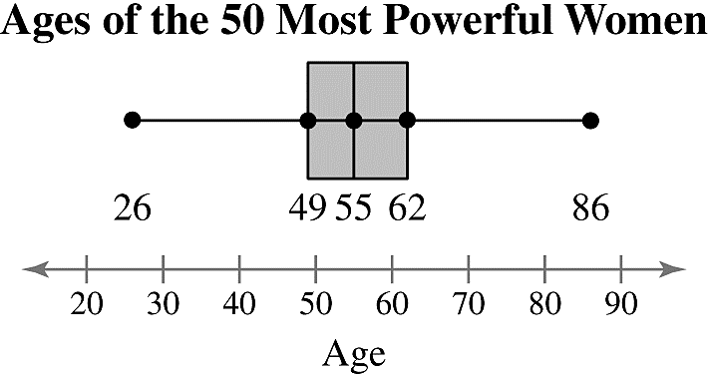 **bc.**

**d.** About 50% of the ages are between 49 and 62 years old. About 25% of the ages are less than 49 years old. About 25% of the ages are older than 62 years old.

**5a.** about 62

**b.** About 75% of the most powerful women are 62 years old or younger.

**6a.** 17,18,19,20,20,23,24,26,29,29,29,30,30,34,35,36,38,39,39,43,44,44,44,45,45

**b.** 7 data entries are less than 26

**c.** Percentile of 26

**d.** The tuition cost of $26,000 is greater than 28% of the other tuition costs.

**7a. **







**b.** From the *z*-scores, the utility bill of $60 is 1.25 standard deviations below the mean, the bill of $71 is 0.125 standard deviation above the mean, and the bill of $92 is 2.75 standard deviations above the mean.

**8a.** 5 feet = 5(12) = 60 inches

**b.** Man: ; Woman: 

**c.** The *z*-score for the 5-foot-tall man is 3.3 standard deviations below the mean. This is an unusual height for a man. The *z*-score for the 5-foot-tall woman is 1.7 standard deviations below the mean. This is among the typical heights for a woman.

2.5 EXERCISE SOLUTIONS

**1.** The movie is shorter in length than 75% of the movies in the theater.

**2.** The car’s fuel efficiency is higher than 90% of the other cars in its class.

**3.** The student scored higher than 83% of the students who took the actuarial exam.

**4.** The child’s IQ is higher than 93% of the other children in the same age group.

**5.** The interquartile range of a data set can be used to identify outliers because data values that are greater than  or less than  are considered outliers.

**6.** Quartiles are special cases of percentiles.  is the 25th percentile,  is the 50th percentile, and  is the 75th percentile.

**7.** True

**8.** False. The second quartile is the median of an ordered data set.

**9.** False. An outlier is any number above  or below .

**10.** False. It is possible to have a*z*-score of zero when the *x*-value equals the mean.

**11.** (a)51 54 56 **57** 59 60 60 **60** 60 62 63 **63** 63 65 80



(b)****

(c) ****; . The date entry 80 is an outlier.

**12.** (a)15 18 19 **25** 27 28 28 **34** 36 39 41 **47** 48 50 53



(b)****

(c) ****; . There are no outliers.

**13.** (a)19 26 28 34 **3636** 37 38 38 **40 41** 42 43 43 **45 48** 50 52 53 56



(b)****

(c) ****; . The data entry 19 is an outlier.

**14.** (a)19 20 20 21 **2121** 22 22 22 **22 23** 23 23 23 **24 24** 25 25 25 29



(b) 

(c) ****; . The data entry 29 is an outlier.

**15.** Min = 10, , , , Max = 20

**16.** Min = 100, , , , Max = 320

**17.** (a)24 26 27 **28** 30 32 35 **35** 36 39 39 **41** 50 51 60



Min = 24, , , , Max = 60

(b)

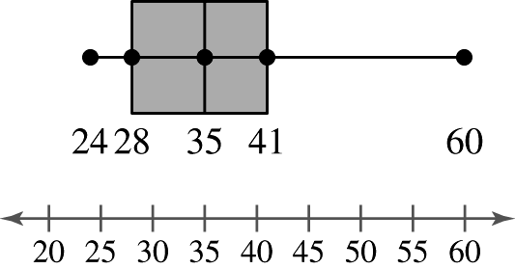

**18.** (a)

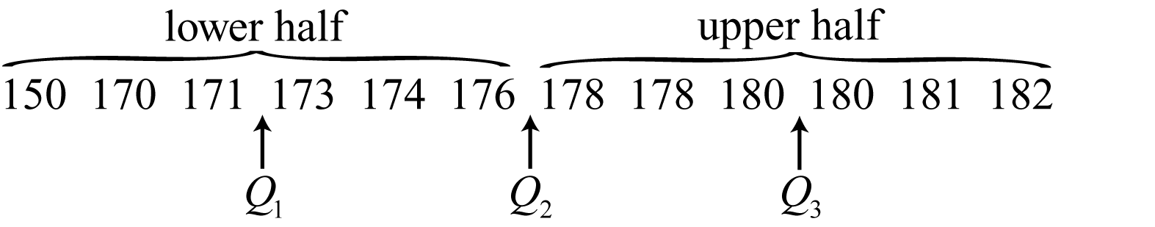

Min = 150, , , , Max = 182

(b)

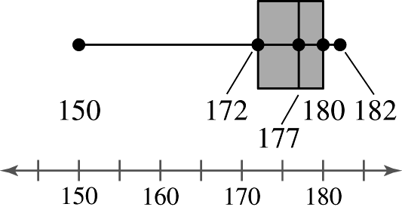

**19.** (a)

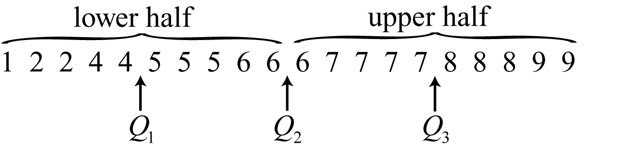

Min = 1, , , , Max = 9

(b)

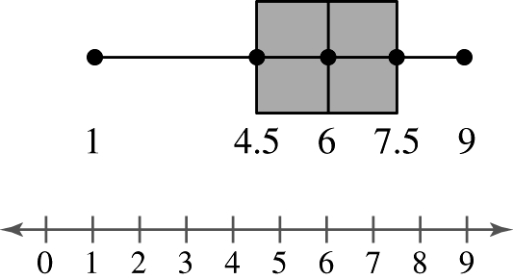

**20.** (a)

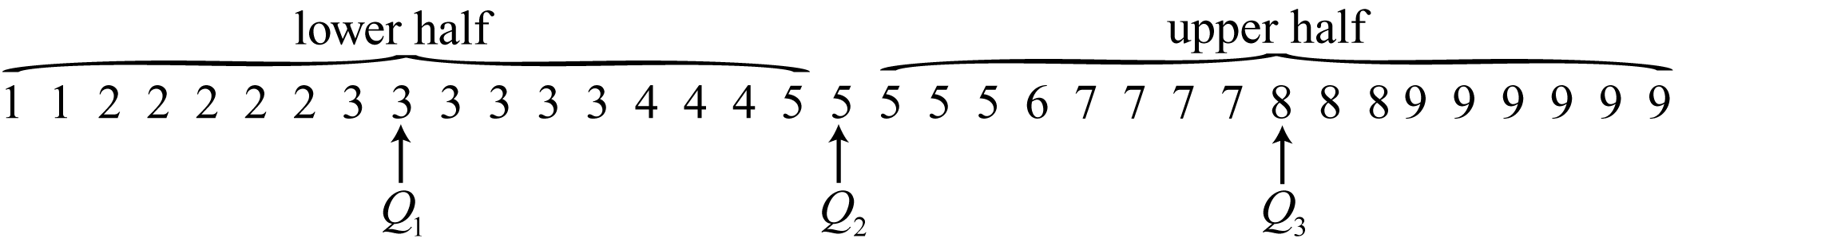

Min = 1, , , , Max = 9

(b)

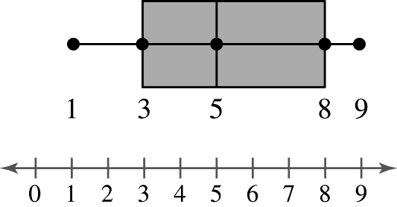

**21.** None. The Data are not skewed or symmetric.

**22.** Skewed right. Most of the data lie to the left in the box-and-whisker plot.

**23.** Skewed left. Most of the data lie to the right in the box-and-whisker plot.

**24.** Symmetric. The data are evenly spaced to the left and to the right of the median.

**25.** (a) ****, , 

(b)

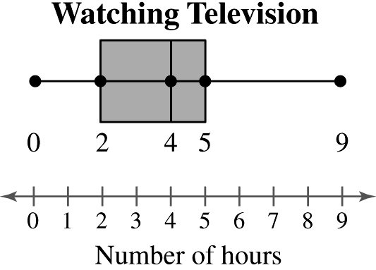

**26.** (a) ****, , 

(b)

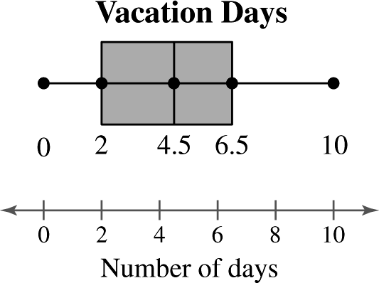

**27.** (a) ****, , 

(b)

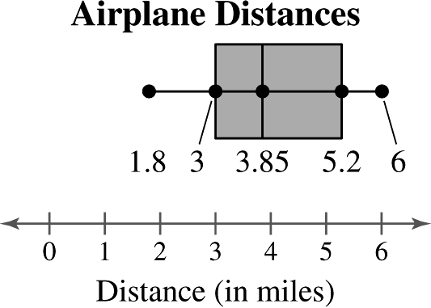

**28.** (a) ****, , 

(b)

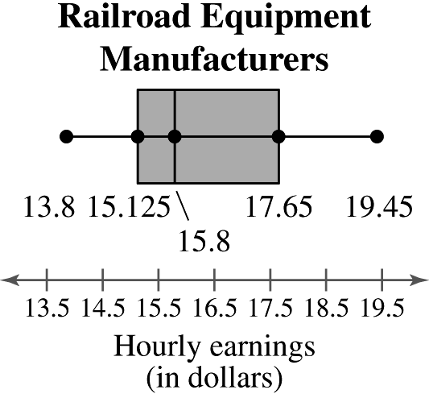

**29.** (a)5 (b)50% (c)25%

**30.** (a)$17.65 (b)50% (c)50%

**31.** about70 inches; About 60% of U.S. males ages 20-29 are shorter than 70 inches.

**32.** about72 inches; About 80% of U.S. males ages 20-29 are shorter than 72 inches.

**33.** about 90th percentile; About 90% of U.S. males ages 20-29 are shorter than 73 inches.

**34.** about 20th percentile; About 20% of U.S. males ages 20-29 are shorter than 67 inches.

**35.** Percentile of 40

**36.** Percentile of 56

**37.** 75th percentile **=**; Ages over 56 are 57,57,61,61,65,66

**38.** 25th percentile **=**; Ages below 43 are 28,35,38,40,41,41,42

**39.** A

B

C

The *z*-score 2.14 is unusual because it is so large.

**40.** A

B

C

None of the *z*-scores are unusual.

**41.** (a)Bradley Wiggins:

(b)An age of 32 is about 1.15 standard deviations above the mean.

(c) Not unusual.

**42.** (a)Jan Ullrich:

(b)An age of 24 is about 1.21 standard deviations below the mean.

(c) Not unusual.

**43.** (a)Cadel Evans:

(b)An age of 34 is about 1.74 standard deviations above the mean.

(c) Not unusual.

**44.** (a)Henri Cornet:

(b)An age of 20 is about 2.38 standard deviations below the mean.

(c) Unusual.

**45.** (a)Firmin Lambot:

(b)An age of 36 is about 2.32 standard deviations above the mean.

(c) Unusual.

**46.** (a)Philippe Thys:

(b)An age of 23 is 1.5 standard deviations below the mean.

(c) Not unusual.

**47.** (a) 





The tire with a life span of 30,000 miles has an unusually short life span.

(b) ****about 2.5th percentile

****about 84th percentile

about 50th percentile

**48.** (a) 





The fruit fly with a life span of 42 days has an unusually long life span.

(b) ****about 16th percentile

about 97.5th percentile

about 2.5th percentile

**49.** Robert Duvall: 

Jack Nicholson: 

The age of Robert Duvall was about a standard deviation above the mean age of Best Actor winners, and the age of Jack Nicholson was less than 1 standard deviation below the mean age of Best Supporting Actor winners. Neither actor’s age is unusual.

**50.** Jamie Foxx: 

Morgan Freeman: 

The age of Jamie Foxx was less than 1standard deviation below the mean age of Best Actor winners, and the age of Morgan Freeman was between 1and 2 standard deviationsabove the mean age of Best Supporting Actor winners. Neither actor’s age is unusual.

**51.** John Wayne: 

Gig Young: 

The age of John Wayne was more than 2 standard deviations above the mean age of Best Actor winners, which is unusual. The age of Gig Young was less than 1 standard deviation above the mean age of Best Supporting Actor winners, which is not unusual.

**52.** Henry Fonda: 

John Gielgud: 

The age of Henry Fonda was more than 3 standard deviations above the mean age of Best Actor winners, which is very unusual. The age of John Gielgud was less than 2 standard deviations above the mean age of Best Supporting Actor winners, which is not unusual.

**53.**

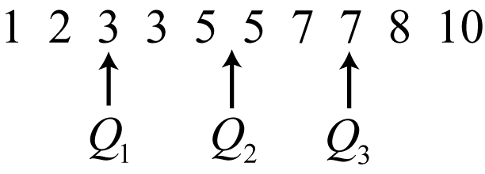

Midquartile

**54.**

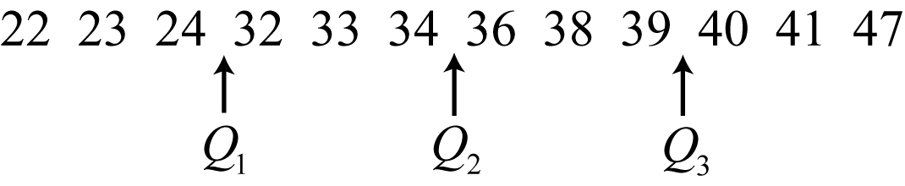

Midquartile

**55.** (a)The distribution of Concert 1 is symmetric. The distribution of Concert 2 isskewed right. Concert 1 has less variation.

(b) Concert 2 is more likely to have outliers because it has more variation.

(c)Concert 1, because 68% of the data should be between  of the mean.

(d) No, you do not know the number of songs played at either concert or the actual lengths of the songs.

**56.**

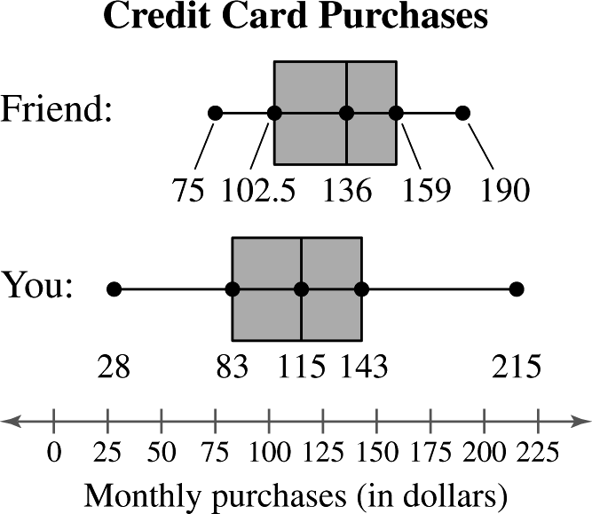

Your distribution is symmetric and your friend’s distribution slightly skewed to the right.

**57.** (a)

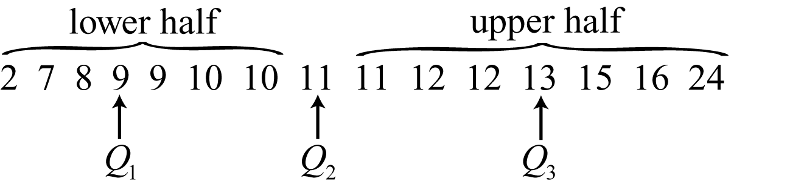

****, , 







Any values less than 6 or greater than 19 are outliers. So, 2 and 24 are outliers.

(b)

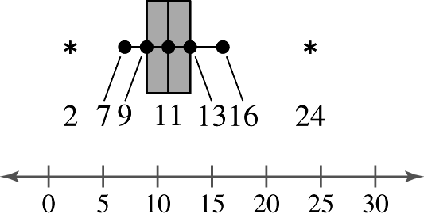

**58.** (a)

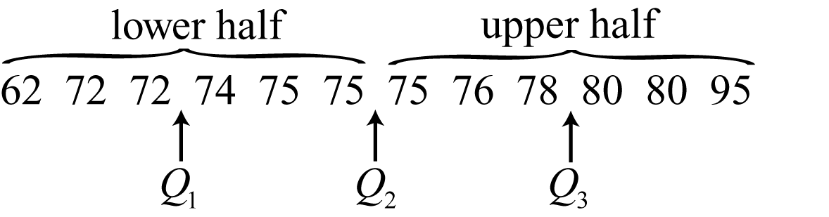

****, , 







Any values less than 64 or greater than 88 are outliers. So, 62 and 95 are outliers.

(b)

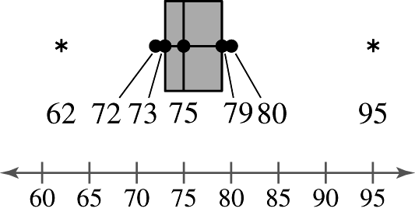

**59.** Answers will vary.

CHAPTER 2 REVIEW EXERCISE SOLUTIONS

**1. **

|  |  |  |  |  |  |
| --- | --- | --- | --- | --- | --- |
| **Class** | **Midpoint, *x*** | **Boundaries** | **Frequency, *f*** | **Relative frequency** | **Cumulative frequency** |
| 8-12 | 10 | 7.5-12.5 | 2 | 0.10 | 2 |
| 13-17 | 15 | 12.5-17.5 | 10 | 0.50 | 12 |
| 18-22 | 20 | 17.5-22.5 | 5 | 0.25 | 17 |
| 23-27 | 25 | 22.5-27.5 | 1 | 0.05 | 18 |
| 28-32 | 30 | 27.5-32.5 | 2 | 0.10 | 20 |
|  |  |  |  |  |  |

**2.**

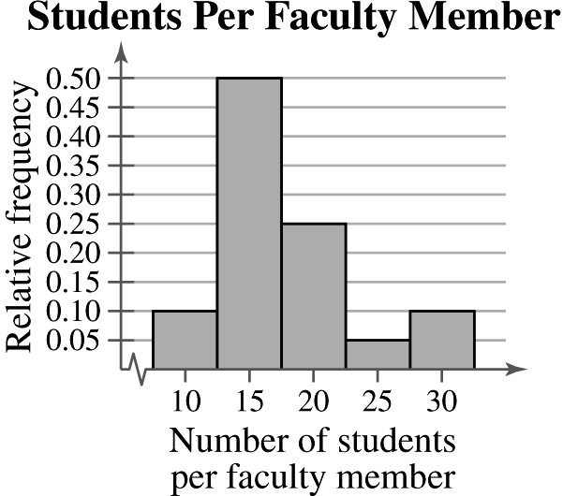

Class with greatest relative frequency: 13-17

Class with least relative frequency: 23-27

**3. **

|  |  |  |  |
| --- | --- | --- | --- |
| **Class** | **Midpoint** | **Frequency, *f*** | **Relative frequency** |
| 11.86-11.89 | 11.875 | 3 | 0.125 |
| 11.90-11.93 | 11.915 | 5 | 0.208 |
| 11.94-11.97 | 11.955 | 8 | 0.333 |
| 11.98-12.01 | 11.995 | 7 | 0.292 |
| 12.02-12.05 | 12.035 | 0 | 0.000 |
| 12.06-12.09 | 12.075 | 0 | 0.000 |
| 12.10-12.13 | 12.115 | 1 | 0.042 |
|  |  |  |  |

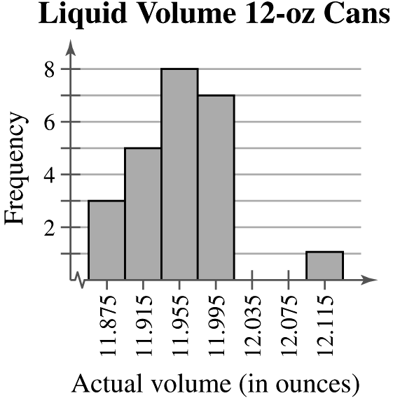

**4. **

|  |  |  |  |
| --- | --- | --- | --- |
| **Class** | **Midpoint** | **Frequency, *f*** | **Relative frequency** |
| 11.86-11.89 | 11.875 | 3 | 0.125 |
| 11.90-11.93 | 11.915 | 5 | 0.208 |
| 11.94-11.97 | 11.955 | 8 | 0.333 |
| 11.98-12.01 | 11.995 | 7 | 0.292 |
| 12.02-12.05 | 12.035 | 0 | 0.000 |
| 12.06-12.09 | 12.075 | 0 | 0.000 |
| 12.10-12.13 | 12.115 | 1 | 0.042 |
|  |  |  |  |

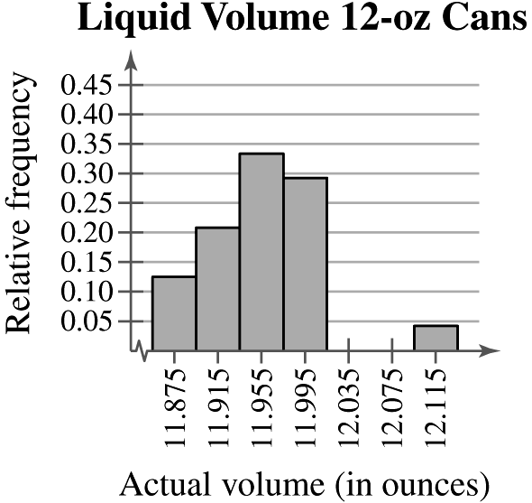

**5. **

|  |  |  |  |
| --- | --- | --- | --- |
| **Class** | **Midpoint** | **Frequency, *f*** | **Cumulative frequency** |
| 79-93 | 86 | 9 | 9 |
| 94-108 | 101 | 12 | 21 |
| 109-123 | 116 | 5 | 26 |
| 124-138 | 131 | 3 | 29 |
| 139-153 | 146 | 2 | 31 |
| 154-168 | 161 | 1 | 32 |
|  |  |  |  |

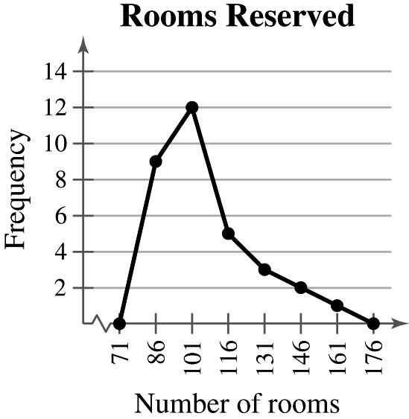

**6.**

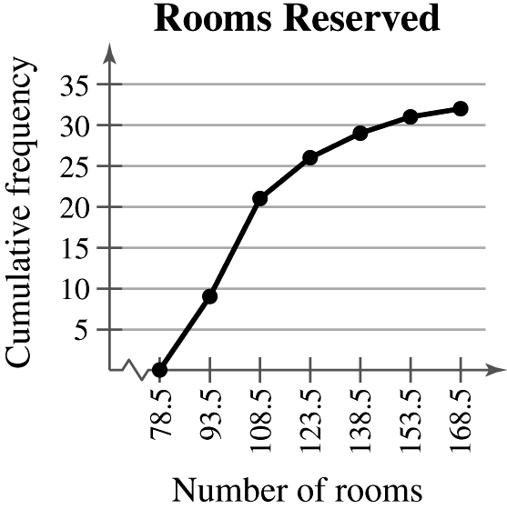

**7. **Key: 

*Sample answer:* Most cities have an air quality index from 20 to 59.

**8.**

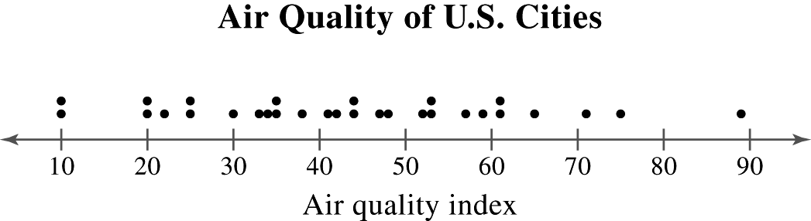

*Sample answer:* Most cities have an air quality index from 20 to 59.

**9.**

|  |  |  |  |
| --- | --- | --- | --- |
| **Location** | **Frequency** | **Relative frequency** | **Degrees** |
| At home | 620 | 0.6139 |  |
| At friend’s home | 110 | 0.1089 |  |
| At restaurant or bar | 50 | 0.0495 |  |
| Somewhere else | 100 | 0.0990 |  |
| Not sure | 130 | 0.1287 |  |
|  |  |  |  |

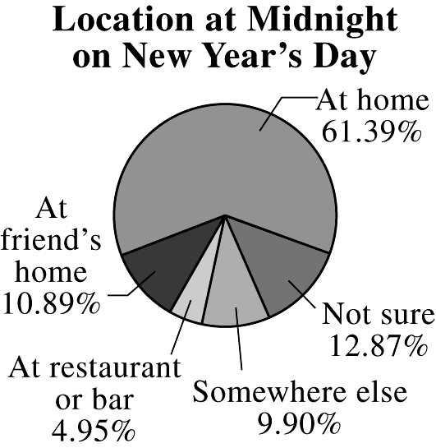

*Sample answer:* Over half of the people surveyed will be at home on New Year’s Day at midnight.

**10.**

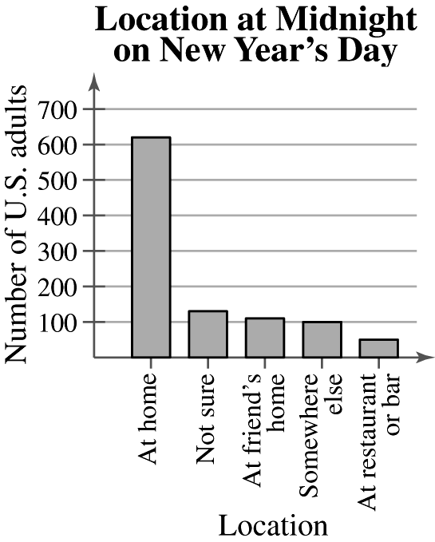

*Sample answer:* Most of the people surveyed will be at home on New Year’s Day at midnight.

**11.**

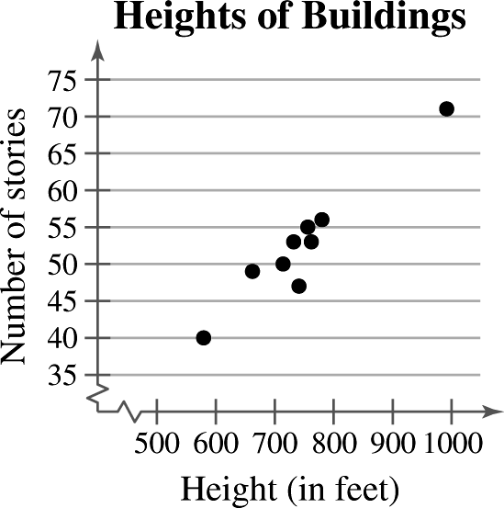

*Sample answer:*The number of stories appears to increase with height.

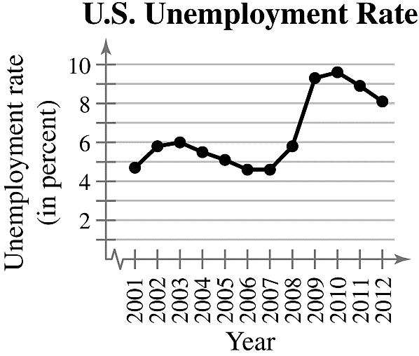**12.**

*Sample answer:*The unemployment rate varied by a couple of percentage points from 2001 to 2008 and then increased dramatically from 2008 to 2009.

**13. **

24.5 24.5 25.5 28.0 **28.5 29.5** 30.0 31.0 32.5 34.0

median = 29

Mode = 24.5 (occurs 2 times)

The mode does not represent the center of the data because 24.5 is the smallest number in the data set.

**14. **isnot possible

median is not possible

mode = “Vote for”

The mean and median cannot be found because the data are at the nominal level of measurement.

**15.**

|  |  |  |  |
| --- | --- | --- | --- |
| **Source** | **Score, *x*** | **Weight, *w*** | ***x · w*** |
| Test 1 | 78 | 0.15 | 11.7 |
| Test 2 | 72 | 0.15 | 10.8 |
| Test 3 | 86 | 0.15 | 12.9 |
| Test 4 | 91 | 0.15 | 13.65 |
| Test 5 | 87 | 0.15 | 13.05 |
| Test 6 | 80 | 0.25 | 20 |
|  |  |  |  |



**16.**

|  |  |  |  |
| --- | --- | --- | --- |
| **Source** | **Score, *x*** | **Weight, *w*** | ***x · w*** |
| Test 1 | 96 | 0.2 | 19.2 |
| Test 2 | 85 | 0.2 | 17 |
| Test 3 | 91 | 0.2 | 18.2 |
| Test 4 | 86 | 0.4 | 34.4 |
|  |  |  |  |



**17.**

|  |  |  |
| --- | --- | --- |
| **Midpoint, *x*** | **Frequency, *f*** | ***x · f*** |
| 10 | 2 | 20 |
| 15 | 10 | 150 |
| 20 | 5 | 100 |
| 25 | 1 | 25 |
| 30 | 2 | 60 |
|  |  |  |



**18.**

|  |  |  |
| --- | --- | --- |
| ***x*** | ***f*** | ***x · f*** |
| 0 | 13 | 0 |
| 1 | 9 | 9 |
| 2 | 19 | 38 |
| 3 | 8 | 24 |
| 4 | 5 | 20 |
| 5 | 2 | 10 |
| 6 | 4 | 24 |
|  |  |  |



**19.** Skewed right **20.** Skewed right **21.** Skewed left **22.** Skewed right

**23.** Median, because the mean is to the left of the median in a skewed left distribution.

**24.** Mean, because the mean is to the right of the median in a skewed right distribution.

**25.** ange = Max – Min = 12 – 4 = 8

$$μ= \frac{\sum{x}}{N}=\frac{113}{14}≈8.1$$

|  |  |  |
| --- | --- | --- |
| $$x$$ | $$x-μ$$ | $${\left(x-μ\right)}^{2}$$ |
| 7 | -1.1 | 1.21 |
| 5 | -3.1 | 9.61 |
| 12 | 3.9 | 15.21 |
| 12 | 3.9 | 15.21 |
| 6 | -2.1 | 4.41 |
| 9 | 0.9 | 0.81 |
| 11 | 2.9 | 8.41 |
| 4 | -4.1 | 16.81 |
| 7 | -1.1 | 1.21 |
| 6 | -2.1 | 4.41 |
| 8 | -0.1 | 0.01 |
| 7 | -1.1 | 1.21 |
| 10 | 1.9 | 3.61 |
| 9 | 0.9 | 0.81 |
| $$\sum{x}=113$$ | $$\sum{\left(x-μ\right)≈0}$$ | $$\sum{{\left(x-μ\right)}^{2}=82.94}$$ |

$$σ^{2}= \frac{\sum{{\left(x-μ\right)}^{2}}}{N}=\frac{82.94}{14}≈5.92$$

$$σ=\sqrt{\frac{\sum{{\left(x-μ\right)}^{2}}}{N}}= \sqrt{\frac{82.94}{14}}=≈2.43$$

**26.** Range = Max – Min = 79 – 52 = 27



|  |  |  |
| --- | --- | --- |
| ***x*** |  |  |
| 58 | -8.56 | 73.2736 |
| 52 | -14.56 | 211.9936 |
| 76 | 9.44 | 89.1136 |
| 76 | 9.44 | 89.1136 |
| 64 | -2.56 | 6.5536 |
| 79 | 12.44 | 154.7536 |
| 74 | 7.44 | 55.3536 |
| 62 | -4.56 | 20.7936 |
| 58 | -8.56 | 73.2736 |
|  |  |  |





**27.** Range = Max – Min = $1847 – $585 = $1262

$$\overline{x}=\frac{\sum{x}}{n}=\frac{16594}{15}≈\$1106.27$$

|  |  |  |
| --- | --- | --- |
| $$x$$ | $$x-\overline{x}$$ | $${\left(x-\overline{x}\right)}^{2}$$ |
| 1514 | 407.73 | 166243.7529 |
| 1473 | 366.73 | 134490.8929 |
| 1847 | 740.73 | 548680.9329 |
| 1746 | 639.73 | 409254.4729 |
| 1545 | 438.73 | 192484.0129 |
| 994 | -112.27 | 12604.5529 |
| 883 | -223.27 | 49849.4929 |
| 705 | -401.27 | 161017.6129 |
| 612 | -494.27 | 244302.8329 |
| 1204 | 97.73 | 9551.1529 |
| 612 | -494.27 | 244302.8329 |
| 585 | -521.27 | 271722.4129 |
| 936 | -170.27 | 28991.8729 |
| 1122 | 15.73 | 247.4329 |
| 816 | -290.27 | 84256.6729 |
| $$∑x=16594$$ | $$∑(x-\overline{x})≈0$$ | $$∑{\left(x-\overline{x}\right)}^{2}≈2558000.934$$ |

$$s^{2}= \frac{\sum{{\left(x-\overline{x}\right)}^{2}}}{n-1}= \frac{2558000.934}{14}≈ 182714.35$$

$$s=\sqrt{\frac{\sum{{\left(x-\overline{x}\right)}^{2}}}{n-1}}= \sqrt{\frac{2558000.934}{14}} ≈\$427.45$$

**28.** Range = Max – Min = 58,298 – 48,250 = $10,048

$$\overline{x}=\frac{\sum{x}}{n}=\frac{3,12,496}{8}=\$39,062$$

|  |  |  |
| --- | --- | --- |
| $$x$$ | $$x-\overline{x}$$ | $${\left(x-\overline{x}\right)}^{2}$$ |
| 37,224 | -1,838 | 33,78,244 |
| 40,964 | 1,902 | 3617604 |
| 43,724 | 4,662 | 21734244 |
| 36,188 | -2,874 | 8259876 |
| 38,882 | -180 | 32400 |
| 38,157 | -905 | 819025 |
| 39,914 | 852 | 725904 |
| $$37,443$$ | $$-1,619$$ | $$2621161$$ |
| $$∑x=3,12,496$$ | $$∑\left(x-\overline{x}\right)=0$$ | $$∑{\left(x-\overline{x}\right)}^{2}=41188458$$ |

$$s^{2}= \frac{\sum{{\left(x-\overline{x}\right)}^{2}}}{n-1}= \frac{41188458}{7}≈5884065.43$$

$$s=\sqrt{\frac{\sum{{\left(x-\overline{x}\right)}^{2}}}{n-1}}= \sqrt{\frac{41188458}{7}} ≈\$2425.71$$

**29.** 95% of the distribution lies within 2 standard deviations of the mean.

$$\overline{x}-2s=18-(2)(2.5)=13$$

$$\overline{x}+2s=18+(2)(2.5)=23$$

$95\%$ of the distribution lies between $\$13$ and $\$23.$

**30. ($12.00, 21.00)→→\left(16.50-3\left(1.50\right), 16.50+3\left(1.50\right)\right)→→(\overline{x}-3s, \overline{x}+3s)$**

$99.7\%$ of the wages lie between $12.00 and $21.00 per day.

**31. $\left(\overline{x}-2s, \overline{x}+2s\right)→(58, 92)$**  are 2 standard deviations from the mean.

$$1-\frac{1}{k^{2}}=1-\frac{1}{{\left(2\right)}^{2}}=0.75.$$

At least (20)(0.75) = 15 students scored between 58 and 92.

**32. ** are 2 standard deviations from the mean.



At least (20)(0.75) = 15 shuttle flights lasted between 3 days and 11 days.

**33. **

|  |  |  |  |  |  |
| --- | --- | --- | --- | --- | --- |
| ***x*** | ***f*** | ***xf*** |  |  |  |
| 0 | 1 | 0 | –2.5 | 6.25 | 6.25 |
| 1 | 8 | 8 | –1.5 | 2.25 | 18.00 |
| 2 | 13 | 26 | –0.5 | 0.25 | 3.25 |
| 3 | 10 | 30 | 0.5 | 0.25 | 2.50 |
| 4 | 5 | 20 | 1.5 | 2.25 | 11.25 |
| 5 | 3 | 15 | 2.5 | 6.25 | 18.75 |
|  |  |  |  |  |  |



**34. **

|  |  |  |  |  |  |
| --- | --- | --- | --- | --- | --- |
| ***x*** | ***f*** | ***xf*** |  |  |  |
| 0 | 4 | 0 | –2.4 | 5.76 | 23.04 |
| 1 | 5 | 5 | –1.4 | 1.96 | 9.80 |
| 2 | 2 | 4 | –0.4 | 0.16 | 0.32 |
| 3 | 9 | 27 | 0.6 | 0.36 | 3.24 |
| 4 | 1 | 4 | 1.6 | 2.56 | 2.56 |
| 5 | 3 | 15 | 2.6 | 6.76 | 20.28 |
| 6 | 1 | 6 | 3.6 | 12.96 | 12.96 |
|  |  |  |  |  |  |



**35.** Company A: $\overline{x}=\frac{\sum{x}}{n}=\frac{22.6}{9}≈2.511$

|  |  |  |
| --- | --- | --- |
| $$x$$ | $$x-\overline{x}$$ | $${\left(x-\overline{x}\right)}^{2}$$ |
| 2.3 | -0.211 | 0.0445 |
| 2.9 | 0.389 | 0.1513 |
| 3.9 | 1.389 | 1.9293 |
| 3.1 | 0.589 | 0.3469 |
| 2.2 | -0.311 | 0.0967 |
| 1.5 | -1.011 | 1.0221 |
| 2.2 | -0.311 | 0.0967 |
| 2.7 | 0.189 | 0.0357 |
| 1.8 | -0.711 | 0.5055 |
| $$∑x=22.6$$ | $$∑(x-\overline{x})≈0$$ | $$∑{\left(x-\overline{x}\right)}^{2}=4.2287$$ |

$$s=\sqrt{\frac{\sum{{\left(x-\overline{x}\right)}^{2}}}{n-1}}= \sqrt{\frac{4.2287}{8}} ≈ 0.7271$$

$$CV=\frac{s}{\overline{x}}= \frac{0.7271}{2.511}.100\%≈28.96\%$$

Company B: $\overline{x}=\frac{\sum{x}}{n}=\frac{25.7}{9}≈2.856$

|  |  |  |
| --- | --- | --- |
| $$x$$ | $$x-\overline{x}$$ | $${\left(x-\overline{x}\right)}^{2}$$ |
| 2.8 | -0.056 | 0.003136 |
| 2.5 | -0.356 | 0.126736 |
| 2.9 | 0.044 | 0.001936 |
| 3.6 | 0.744 | 0.553536 |
| 2.9 | 0.044 | 0.001936 |
| 3.3 | 0.444 | 0.197136 |
| 3.3 | 0.444 | 0.197136 |
| 2.8 | -0.056 | 0.003136 |
| 1.6 | -1.256 | 1.577536 |
| $$∑x=25.7$$ | $$∑(x-\overline{x})≈0$$ | $$∑{\left(x-\overline{x}\right)}^{2}=2.6622$$ |

$$s=\sqrt{\frac{\sum{{\left(x-\overline{x}\right)}^{2}}}{n-1}}= \sqrt{\frac{2.6622}{8}} ≈ 0.5769$$

$$CV=\frac{s}{\overline{x}}= \frac{0.5769}{2.856}.100\%≈20.2\%$$

Dividends are more variable for Company A than Company B.

**36.** Heights: $μ=\frac{\sum{x}}{N}=\frac{516}{8}=64.5 inches$

|  |  |  |
| --- | --- | --- |
| $$x$$ | $$x-μ$$ | $${\left(x-μ\right)}^{2}$$ |
| 62 | -2.5 | 6.25 |
| 58 | -6.5 | 42.25 |
| 60 | -4.5 | 20.25 |
| 64 | -0.5 | 0.25 |
| 70 | 5.5 | 30.25 |
| 62 | -2.5 | 6.25 |
| 72 | 7.5 | 56.25 |
| 68 | 3.5 | 12.25 |
| $$∑x=516$$ | $$∑\left(x-μ\right)=u) f experiets (in lbs) of 9hts (in lbs) of 9 students in a secondary school are listed. 0$$ | $$∑{\left(x-μ\right)}^{2}=174$$ |

$σ=\sqrt{\frac{\sum{{\left(x-μ\right)}^{2}}}{N}}= \sqrt{\frac{174}{8}} ≈ 4.664$ inches

$$CV=\frac{σ}{μ}= \frac{4.664}{64.15}.100\%≈7.2\%$$

Weights: $μ=\frac{\sum{x}}{N}=\frac{876}{8}=109.5$ lbs

|  |  |  |
| --- | --- | --- |
| $$x$$ | $$x-μ$$ | $${\left(x-μ\right)}^{2}$$ |
| 92 | -17.5 | 306.25 |
| 80 | -29.5 | 870.25 |
| 82 | -27.5 | 756.25 |
| 106 | -3.5 | 12.25 |
| 136 | 26.5 | 702.25 |
| 96 | -13.5 | 182.25 |
| 146 | 36.5 | 1332.25 |
| 138 | 28.5 | 812.25 |
| $$∑x=876$$ | $$∑\left(x-μ\right)=0$$ | $$∑{\left(x-μ\right)}^{2}=4974$$ |

$σ=\sqrt{\frac{\sum{{\left(x-μ\right)}^{2}}}{N}}= \sqrt{\frac{4974}{8}} ≈ 24.935$ lbs

$$CV=\frac{σ}{μ}= \frac{24.935}{109.5}.100\%≈22.8\%$$

Weights are more variable than heights for all students of the secondary school.

**37.**

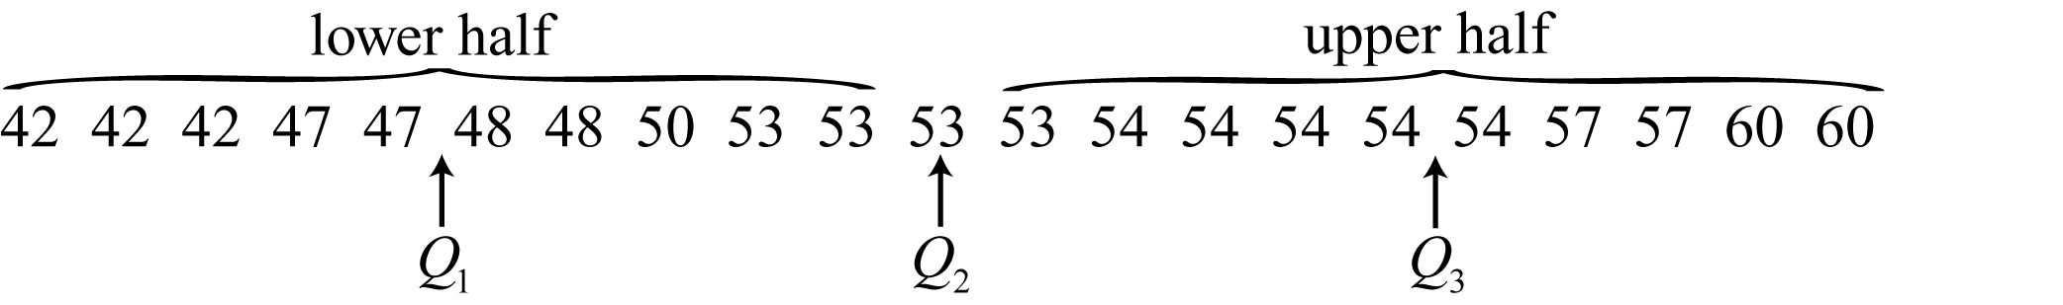

Min = 42, , , , Max = 60

**38. **highway miles per gallon

**39.**

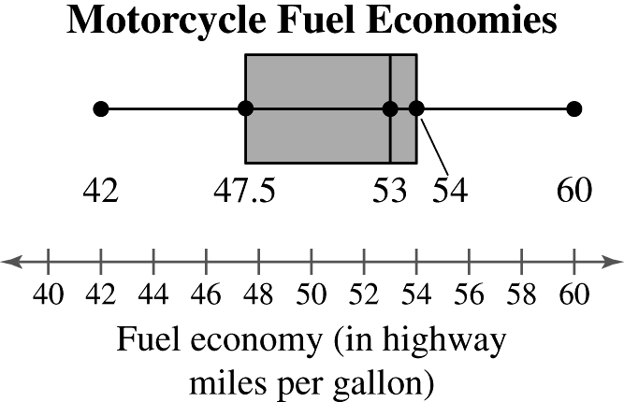

**40.** 17

**41.**

24.5 24.5**25.5** 28.0 **28.5 29.5** 30.0 **31.0** 32.5 34.0

********

****inches

**42.**

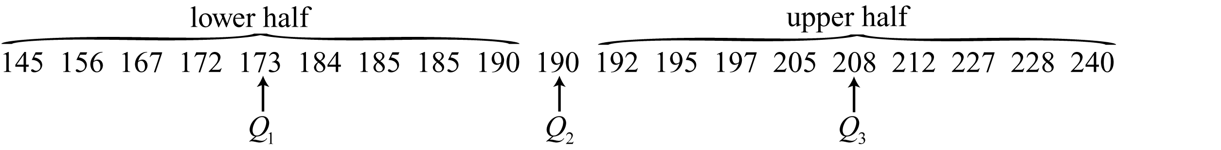

Min = 145, , , , Max = 240

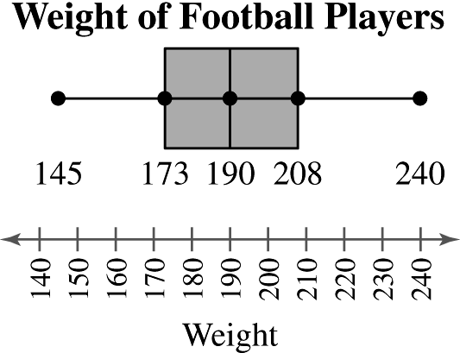

The distribution of weights is symmetric.

**43.** The 15th percentile means that 15% had an income of $32 or less. So, 85% earned more than $32.

**44.** If there are 106 stations with a larger daily audience, then this station has the 665 – 106 = 559th largest audience. The percentile of 559

**45. (**a) $z=\frac{16.396-13,140}{2628}≈1.24$

(b) A lifetime of 16,396 hours is about 1.24 standard deviations above the mean.

(c) Not unusual

**46. (**a) $z=\frac{6570-13,140}{2628}≈-2.5$

(b) A lifetime of 6570 hours is about 2.5 standard deviations below the mean.

(c) Unusual

**47. (**a) $z=\frac{20,024-13,140}{2628}≈2.62$

(b) A lifetime of 20,024 hours is about 2.62 standard deviations above the mean.

(c) Unusual

**48.** (a) $z=\frac{12.483-13,140}{2628}≈-0.25$

(b) A lifetime of 12,483 hours is about 0.25 standard deviations below the mean.

(c) Not unusual

CHAPTER 2 QUIZ SOLUTIONS

1. (a) 

|  |  |  |  |  |  |
| --- | --- | --- | --- | --- | --- |
| **Class** | **Midpoint** | **Class**  **boundaries** | **Frequency, *f*** | **Relative frequency** | **Cumulative frequency** |
| 101-112 | 106.5 | 100.5-112.5 | 3 | 0.12 | 3 |
| 113-124 | 118.5 | 112.5-124.5 | 11 | 0.44 | 14 |
| 125-136 | 130.5 | 124.5-136.5 | 7 | 0.28 | 21 |
| 137-148 | 142.5 | 136.5-148.5 | 2 | 0.08 | 23 |
| 149-160 | 154.5 | 148.5-160.5 | 2 | 0.08 | 25 |
|  |  |  |  |  |  |

(b)Frequency histogram and polygon (c) Relative frequency histogram

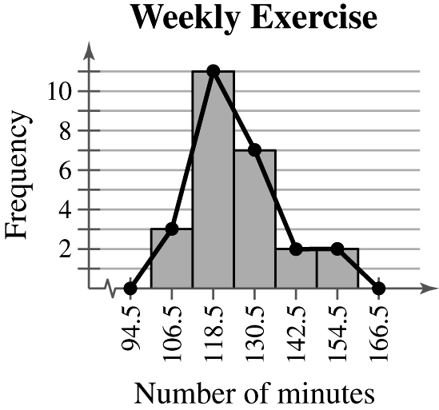 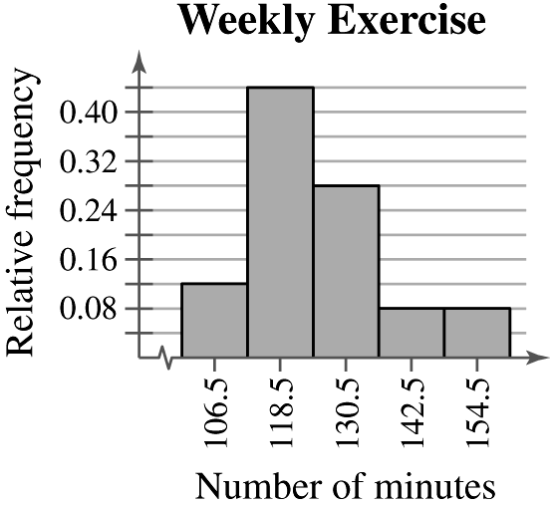

(d)Skewed right

(e) ****Key: 

(f)



Min = 101, , , , Max = 157

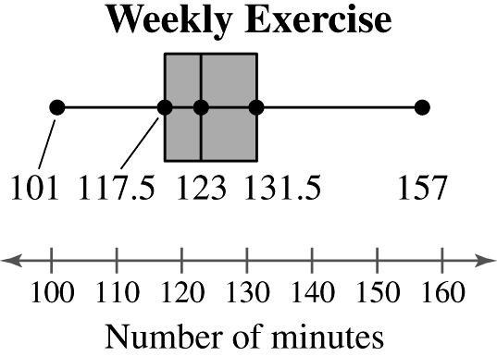

(g)

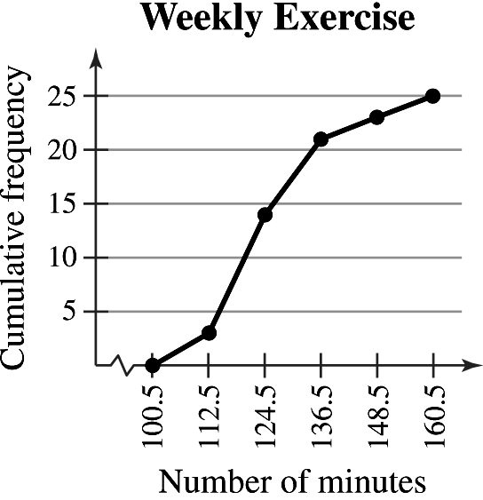

**2. **

|  |  |  |  |  |  |
| --- | --- | --- | --- | --- | --- |
| **Midpoint, *x*** | **Frequency, *f*** | ***xf*** |  |  |  |
| 106.5 | 3 | 319.5 | –18.7 | 349.69 | 1049.07 |
| 118.5 | 11 | 1303.5 | –6.7 | 44.89 | 493.79 |
| 130.5 | 7 | 913.5 | 5.3 | 28.09 | 196.63 |
| 142.5 | 2 | 285.0 | 17.3 | 299.29 | 598.58 |
| 154.5 | 2 | 309.0 | 29.3 | 858.49 | 1716.98 |
|  |  |  |  |  |  |



1. (a)

|  |  |  |  |
| --- | --- | --- | --- |
| **Category** | **Frequency** | **Relative frequency** | **Degrees** |
| Clothing | 9.7 | 0.1187 |  |
| Footwear | 18.4 | 0.2252 |  |
| Equipment | 27.5 | 0.3366 |  |
| Rec. Transport | 26.1 | 0.3195 |  |
|  |  |  |  |

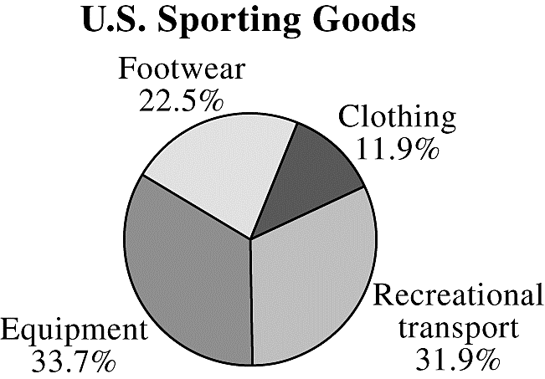

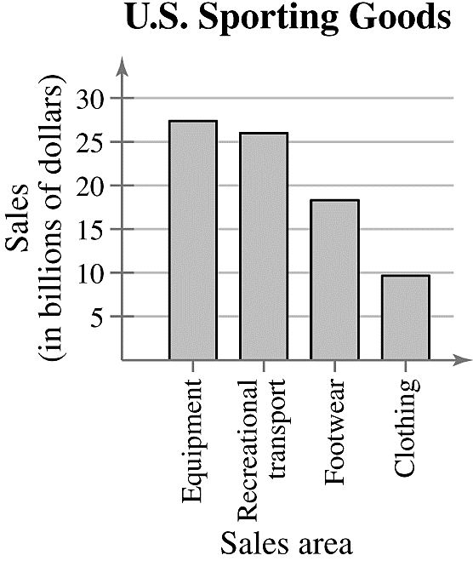(b)

1. (a) 

619 621 842 **949 970** 1083 1135 1194



mode = none

The mean best describes a typical salary because there are no outliers.

(b)Range = Max – Min = 1194 – 619 = 575

|  |  |  |
| --- | --- | --- |
| ***x*** |  |  |
| 949 | 22.4 | 501.76 |
| 621 | –305.6 | 93,391.36 |
| 1194 | 267.4 | 71,502.76 |
| 970 | 43.4 | 1883.56 |
| 1083 | 156.4 | 24,460.96 |
| 842 | –84.6 | 7157.16 |
| 619 | –307.6 | 94,617.76 |
| 1135 | 208.4 | 43,430.56 |
|  |  |  |





(c) 

**5. **



95% of the new home prices fall between $125,000 and $185,000.

**6.** (a) ****unusual price

(b) ****very unusual price

(c)  not unusual price

(d) ****unusual price

**7.** (a)

55 61 64 66 68 69 69 **72** 73 74 75 76 79 81 **81 83** 85 86 88 88 89 90 **93** 93 94 94 94 95 97 98



Min = 55, , , , Max = 98

(b) 

(c)

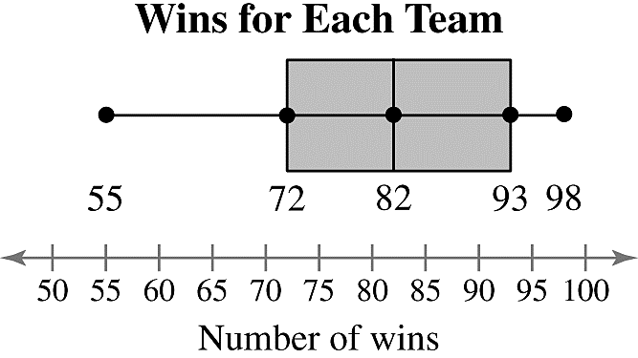

|  |
| --- |
| CUMULATIVE REVIEW FOR CHAPTERS 1 AND 2 |

**1.** Systematic sampling is used because every fortieth toothbrush from each assembly line is tested. It is possible for bias to enter into the sample if, for some reason, an assembly line makes a consistent error.

**2.** Simple random sampling is used because each telephone number has an equal chance of being dialed, and all samples of 1200 phone numbers have an equal chance of being selected. The sample may be biased because telephone samplingonly samples those individuals who have telephones, who are available, and who are willing to respond.

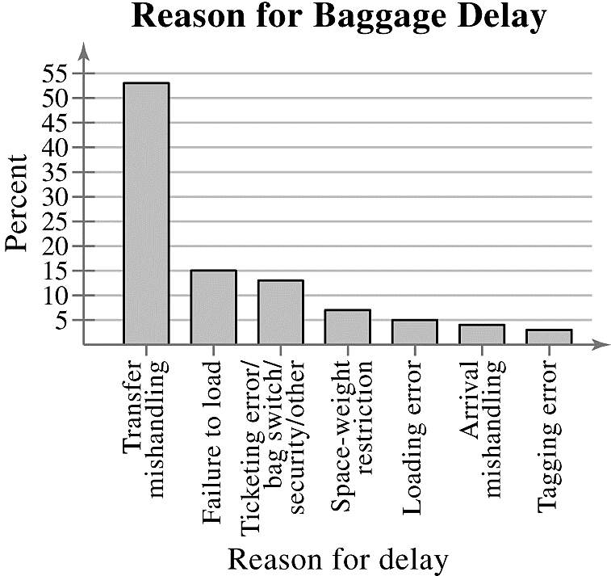**3.**

**4.** $3,213,479 is a parameter because it is describing the average salary of all Major League Baseball players.

**5.** 10% is a statistic because it is describing a proportion within a sample of 1000 likely voters.

1. (a) 

****2 standard deviations away form the mean.

Approximately 95% of the electrical engineers will have salaries between $80,500 and$86,500.

(b)40(0.95) = 38

(c) 





The salaries of $90,500 and $79,750 are unusual.

**7.** Population: Collection of opinions of all adults in the United States

Sample: Collection of opinions of the 1009U.S. adults surveyed

**8.** Population: Prescription refilling persistency of all prescription drug patients

Sample: Prescription refilling persistency of the 61,522 prescription drug patients studied

**9.** Experiment. The study applies a treatment (stroke prevention devise) to the subjects.

**10.** Observational study. The study does not attempt to influence the responses of the subjects.

**11.** Quantitative: The data are at the ratio level.

**12.** Qualitative: The data are at the nominal level.

**13.** (a)****

0 0 0 0 0 0 0 0 0 1 1 1 **1** 1 1 2 2 3 3 4 6 7 8 8 **10 10** 15 16 17 17

18 19 20 25 26 29 32 **33** 37 39 39 40 41 48 53 65 75 87 114 145



Min = 0, , , , Max = 145

(b)

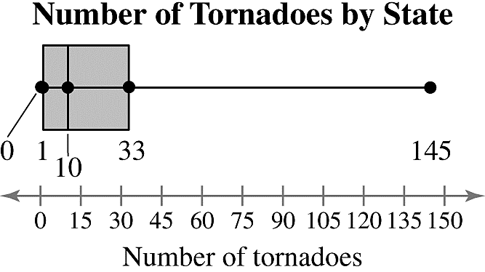

(c)The distribution of the number of tornadoes is skewed right.

**14.**

|  |  |  |  |
| --- | --- | --- | --- |
| **Source** | **Score, *x*** | **Weight, *w*** | ***x · w*** |
| Test 1 | 85 | 0.15 | 12.75 |
| Test 2 | 92 | 0.15 | 13.80 |
| Test 3 | 84 | 0.15 | 12.60 |
| Test 4 | 89 | 0.15 | 13.35 |
| Test 5 | 91 | 0.40 | 36.40 |
|  |  |  |  |



**15.** (a) 

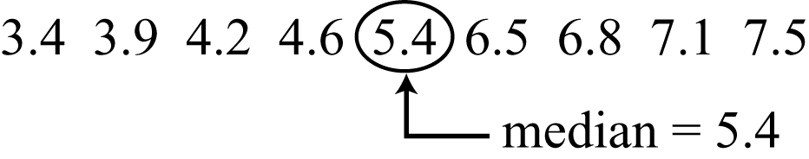

mode = none

Both the mean and median accurately describe a typical American alligator tail length. (Answers will vary.)

(b)Range – Max – Min – 7.5 – 3.4 = 4.1

|  |  |  |
| --- | --- | --- |
| ***x*** |  |  |
| 3.4 | –2.09 | 4.3681 |
| 3.9 | –1.59 | 2.5281 |
| 4.2 | –1.29 | 1.6641 |
| 4.6 | –0.89 | 0.7921 |
| 5.4 | –0.09 | 0.0081 |
| 6.5 | 1.01 | 1.0201 |
| 6.8 | 1.31 | 1.7161 |
| 7.1 | 1.61 | 2.5921 |
| 7.5 | 2.01 | 4.0401 |
|  |  |  |





**16.** (a)An inference drawn from the sample is that the number of deaths due to heart disease for women will continue to decrease.

(b) This inference may incorrectly imply that women will have less of a chance of dying of heart disease in the future. The study was only conducted over the past 5 years and deaths may not decrease in the next year.

**17. **

|  |  |  |  |  |  |
| --- | --- | --- | --- | --- | --- |
| **Class limits** | **Midpoint** | **Class boundaries** | **Frequency** | **Relative frequency** | **Cumulative frequency** |
| 0-8 | 4 | –0.5-8.5 | 14 | 0.47 | 14 |
| 9-17 | 13 | 8.5-17.5 | 8 | 0.27 | 22 |
| 18-26 | 22 | 17.5-26.5 | 4 | 0.13 | 26 |
| 27-35 | 31 | 26.5-35.5 | 1 | 0.03 | 27 |
| 36-44 | 40 | 35.5-44.5 | 1 | 0.03 | 28 |
| 45-53 | 49 | 44.5-53.5 | 1 | 0.03 | 29 |
| 54-62 | 58 | 53.5-62.5 | 2 | 0.07 | 31 |
| 63-71 | 67 | 62.5-71.5 | 1 | 0.03 | 32 |
|  |  |  |  |  |  |

**18.** The distribution is skewed right.

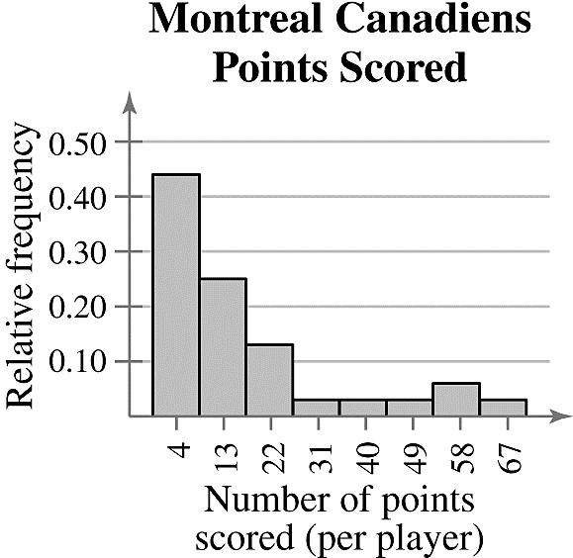**19.**

Class with greatest frequency: 0-8

Classes with least frequency: 27-35, 36-44, 45-53, and 63-71

CHAPTER 2 TEST SOLUTIONS

1. (a) 



median = 19

mode = 19, 22

The mean and median both represent the center of the data well.

(b)Range = Max – Min = 34 – 6 = 28

|  |  |  |
| --- | --- | --- |
| ***x*** |  |  |
| 29 | 9.5 | 90.25 |
| 15 | -4.5 | 20.25 |
| 14 | -5.5 | 30.25 |
| 22 | 2.5 | 6.25 |
| 22 | 2.5 | 6.25 |
| 8 | -11.5 | 132.25 |
| 19 | -0.5 | 0.25 |
| 6 | -13.5 | 182.25 |
| 28 | 8.5 | 72.25 |
| 18 | -1.5 | 2.25 |
| 19 | -0.5 | 0.25 |
| 34 | 14.5 | 210.25 |
|  |  |  |





(c) 

(d) **Points scored** 



**2.** (a) Class width = 

|  |  |  |  |  |  |
| --- | --- | --- | --- | --- | --- |
| **Class** | **Midpoint** | **Class**  **boundaries** | **Frequency, *f*** | **Relative frequency** | **Cumulative frequency** |
| 18-51 | 34.5 | 17.5-51.5 | 2 | 0.08 | 2 |
| 52-85 | 68.5 | 51.5-85.5 | 5 | 0.21 | 7 |
| 86-119 | 102.5 | 85.5-119.5 | 6 | 0.25 | 13 |
| 120-153 | 136.5 | 119.5-153.5 | 6 | 0.25 | 19 |
| 154-187 | 170.5 | 153.5-187.5 | 4 | 0.17 | 23 |
| 188-221 | 204.5 | 187.5-221.5 | 1 | 0.04 | 24 |
|  |  |  |  |  |  |

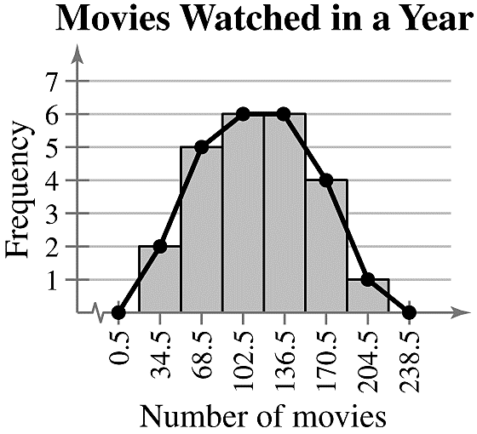 (b)

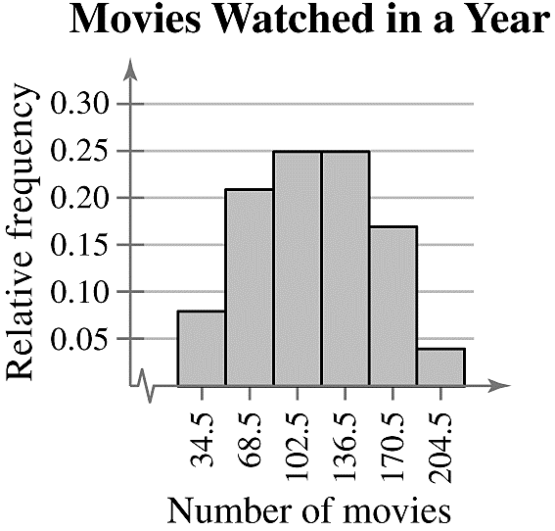 (c)

(d)Symmetric

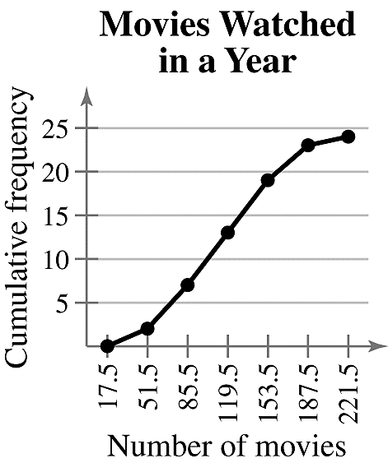 (e)

**3. **

|  |  |  |  |  |  |
| --- | --- | --- | --- | --- | --- |
| **Midpoint, *x*** | **Frequency, *f*** | ***xf*** |  |  |  |
| 34.5 | 2 | 69.0 | -79.33 | 6293.2489 | 12,586.4978 |
| 68.5 | 5 | 342.5 | -45.33 | 2054.8089 | 10,274.0445 |
| 102.5 | 6 | 615.0 | -11.33 | 128.3689 | 770.2134 |
| 136.5 | 6 | 819.0 | 22.67 | 513.9289 | 3,083.5734 |
| 170.5 | 4 | 682.0 | 56.67 | 3211.4889 | 12,845.9556 |
| 204.5 | 1 | 204.5 | 90.67 | 8221.0489 | 8,221.0489 |
|  |  |  |  |  |  |



**4.** 149 is the 19th observation when the data are ordered. The percentile for 149 

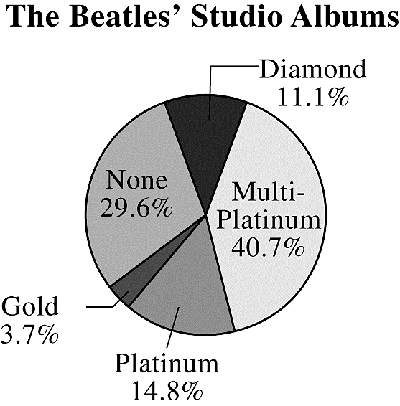**5.** (a)

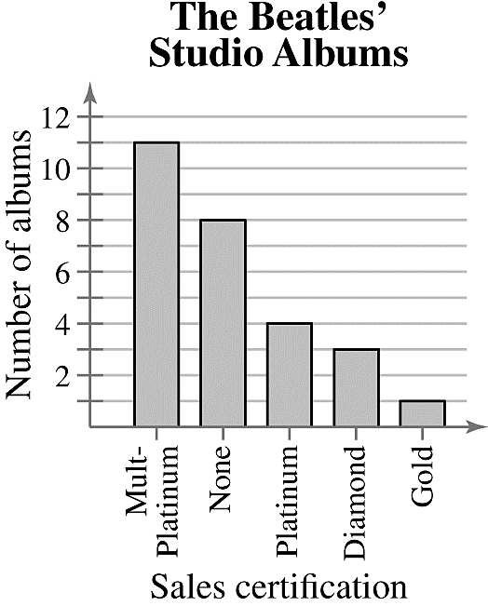 (b)

**6.**

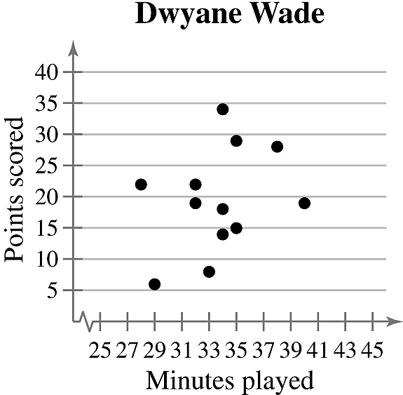

*Sample answer:* It appears that there is no relation between points scored and minutes played.

**7.** (a) 



Min = 28, , , , Max = 68

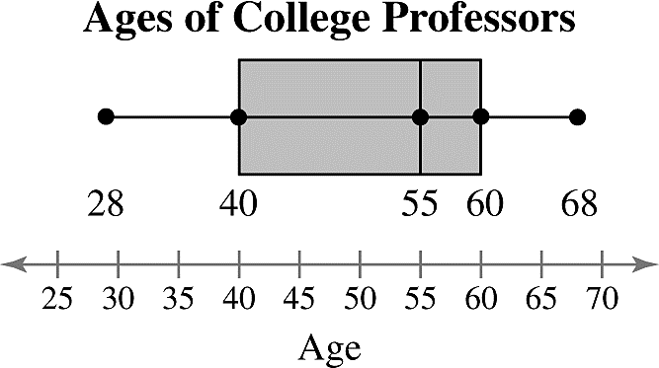 (b)

(c)About 75%

**8.** (a)

About 68% of the iguanas are between 4.1 and 5.5 feet long. Thus, about .68(125) = 85 iguanas are between 4.1 and 5.5 feet long.

(b) ****; unusual