Chapter 2
Innovation

n Chapter Overview

Innovation is the transformation of something new, such as an invention, into a practical application that creates value for human beings. Innovations can either reduce the cost of producing what we already have or provide new goods and services (or improve their quality). Innovations raise the wealth of both innovators and consumers. This does not mean that everyone benefits from every innovation—indeed, innovations often increase the competitive pressure felt by some firms, and thus make them worse off. For this reason, innovations are sometimes met by efforts to prevent or limit their introduction.

n Descriptive Analysis

A simple depiction of the wealth-enhancing effects of innovation is shown in Figure 2-1, on the next page. Panel (a) illustrates the impact of an innovation that increases the use-value of a good to consumers. The pre-innovation demand and supply curves are given by D₀ and S₀. The initial equilibrium is at point A, with equilibrium price and quantity shown by (P₀, Q₀). The innovation—perhaps superior performance or longevity of the good—raises the marginal value to consumers by an amount equal to the vertical distance from point A to point V. As shown, this increase in marginal value raises the demand for the good to D₁. Consumers bid the equilibrium price up to P₁>P₀ and consume the new equilibrium quantity of Q₁>Q₀.

Because the equilibrium price of the good rises, we can be confident that the innovators—the firms selling the new, improved good—gain from their actions. These gains can be thought of as having two elements. First, firms receive a higher price per unit (P₁) on all of the Q₀ units that they had previously been willing to sell at P₀. This increment to profit is simply (P₁ – P₀)•Q₀. The higher price also induces firms to sell (Q₁ – Q₀) additional units, on which new profits are also earned. With a linear supply curve, for example, this increment to profits is given by 0.5•(Q₁ – Q₀)•(P₁ – P₀).

Despite the higher price of the good, consumers also benefit from the innovation. This is because the marginal value of the good rises by more than the price of the good rises: the increase in marginal value, shown by the distance from A to V, exceeds the price rise, P₁ – P₀. As with suppliers, we can think of the gain to consumers consisting of two parts. First, they enjoy more consumer surplus on the Q₀ units they were consuming prior to the innovation. Second, the rise in quality induces buyers to purchase more, and they enjoy new gains from trade on these (Q₁ – Q₀) units.

Panel (b) shows the effect of a different type of innovation, one that reduces the marginal (and thus average and total) cost of producing the good. Again we have pre-innovation demand and supply curves D₀ and S₀, with the initial equilibrium at point A. Prior to the innovation, price and quantity are shown by P₀ and Q₀. The innovation causes marginal costs to fall by an amount equal to the vertical distance between A and C. This cost reduction causes the industry supply curve to shift to S₁. Competition among suppliers hoping to take advantage of their lower costs drives equilibrium price down to P₁, which in turn induces consumers to raise purchases to Q₁, the new equilibrium quantity.

The gain to consumers is immediately apparent, and is brought about by the fall in the equilibrium price of the good. Consumers enjoy higher gains from trade (consumer surplus) of (P₀ – P₁) on each of the original Q₀ units consumed, plus they enjoy added consumer surplus on the extra units (Q₁ – Q₀) they buy at the new, lower price. Suppliers also gain from the innovation, despite the fall in equilibrium price. This occurs because the per-unit cost reduction (the vertical distance from A to C) exceeds the price reduction (the vertical distance from P₀ to P₁). Again, we can think of these new profits (or producer surplus) conceptually as stemming from two sources: the firms earn more on the Q₀ units they had been willing to sell before at the old price and costs, and they also profit from selling more units.
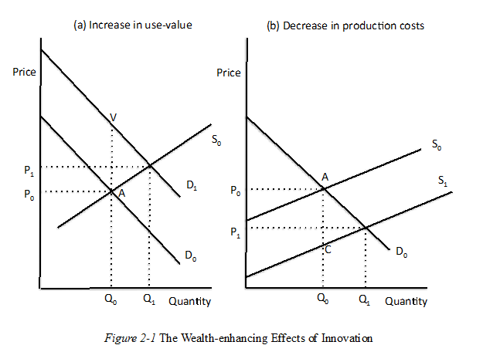
Even though both types of innovation raise the total wealth of society, some people in society may be made worse off because of a specific innovation. The superior products resulting from the innovations shown in panel (a), and the lower prices accompanying those highlighted in panel (b) will both draw customers away from other firms, lowering the wealth of their owners. This may induce the non-innovating, competing firms to enlist the government in suppressing the innovations. The ride-sharing services Uber and Lyft, for example, create wealth by raising output quality and lowering production costs. But their competition also lowers the wealth of conventional taxi companies, whose owners have had success many places in getting governments to limit or even prohibit Uber and Lyft. Although such restrictions on competition have been presented as “consumer protection,” in fact they reduce the wealth of consumers.

Sometimes an innovation produces great economic benefits, but does so in a way that the casual observer might not recognize. This is often the case for innovation in the health industry. Consider, for example, drugs to treat hepatitis C, a viral infection of the liver that, in 70 to 85 percent of the people infected, will produce long-term chronic health problems, often death, if the disease is not successfully treated. Approximately 3.2 million people in the United States are infected with hepatitis C. Until recently, the only “treatment” for the disease rarely worked and generally produced severe adverse side effects. People with the chronic version of hepatitis C thus faced a life of great uncertainty, and could expect mounting medical bills as the disease progressed. For about 15,000 of these people each year, the culmination was a painful, premature death. In 2013, however, a new drug was introduced that cures about 90 percent of the patients who take it, generally with no significant side effects. The problem, in the eyes of some people, is that the pharmaceutical company that created the drug set the price of a full 12-week course of treatment at approximately $84,000.

For the 3.2 million people with hepatitis C, the price of a health-preserving and life-saving treatment was reduced from infinity to $84,000. Yet many people have argued that the company who developed the drug should not be allowed to charge this much for it—that such a sum is “unreasonably high.” Given that the drug exists, it is true that $84,000 is far in excess of the manufacturing costs of producing the drug. But it was only the prospect of being able to charge a price far above manufacturing costs that induced the company to undertake the highly risky R&D that led to the drug. Limiting the price the firm can charge will, in the short run, save money in treating the people who have hepatitis C. But it will also serve as a lesson to this company and all others in all industries, that the rewards from R&D are lower than they had previously believed. This will reduce firms’ R&D investment on a wide scale, and thus produce lower rates of innovation and lower economic growth and economic wellbeing. (For more details on the consequences of limiting the prices firms can charge for their products, see Chapter 11, “Bankrupt Landlords, from Sea to Shining Sea.”)

n Chapter Answers

- Innovation has made the world today far more prosperous than 100 years ago, and helped people live much longer lives. Both seem good reasons to prefer today rather than then. Continuing innovation in the future is likely to make the citizens of the 22nd century even richer, healthier, and longer-lived.

- Most inventions yield no commercially viable products—although there are probably no readily available data that would tell us whether it takes exactly a dozen to generate a dime’s worth of profits.

- All research and development is a venture into the unknown. After the fact some R&D will yield profitable innovations, while most will not. But before the fact no one knows which of the R&D efforts will turn out to be profitable and which will not. Because it is not possible to know ahead of time which R&D will succeed, the decision to invest in R&D can only be made by comparing all of the R&D costs will all of the net revenue thereby generated.

- When the growth rate is 0.9 percent per year it takes approximately 78 years (about a human life span) for income to double. Over that same time span, if the growth rate is 2.1 percent per year, income will rise by a factor of five.

- After-tax income in the high tax state will be $83,000 per year, but it will be $90,000 in the low-tax state. Ceteris paribus, the low tax state is the preferred location for the business.

- The answer to this question must be left to the interested reader.

