CHAPTER 2: DEMAND, SUPPLY AND EQUILIBRIUM PRICES

OVERVIEW

This chapter introduces students to the important concepts of demand and supply. The chapter uses examples to illustrate how changes in non-price factors impact demand, supply, and the resulting market equilibrium. Demand is the relationship between price and the quantity demanded of a good by consumers in a given period of time, all other factors held constant. Supply is the relationship between price and the quantity supplied of a good by producers in a given period of time, all other factors held constant. The discussion uses graphical and algebraic methods. The chapter begins with a case of analysis (Demand and Supply in The Copper Industry) which demonstrates how demand and supply factors influenced the copper supply and demand and how changes in these functions impact the market price of copper.

OUTLINE OF TEXT MATERIAL

- Introduction (outlines the chapter content and defines the main concepts: Demand and Supply)

  - Demand: Functional relationship between the price and quantity demanded of goods and services by consumers in a given period of time, all else equal.
  - Supply: Functional relationship between the price and quantity supplied of goods and services by producers in a given period of time, all else equal.

  - Managers need to understand demand and supply to develop competitive strategies and respond to the actions of competitors.

  - The chapter covers verbal, graphical and mathematical analyses of demand and supply.

- Case for Analysis: Demand and Supply in the Copper Industry

  - The case uses the global copper market during 1997 – 2011 as an illustration of how various factors influence the copper demand, supply, and equilibrium. The objective of the case is to illustrate how the non-price factors can cause demand and/or supply to changes. Two important points are being emphasized. One, identifying whether the factor is on the demand side or the supply side of the market. Two, whether the factor causes the relevant function to increase or decrease. The discussion also contrasts changes in demand/supply with changes in quantity demanded/supplied.
(Teaching Tip: after the chapter is covered, the students can be asked to find examples in the case that cause changes in quantity demanded [any factors changing the supply]).

  - Changes in quantity demanded - a response in consumer behavior to a change in the price. The case shows (page 17, paragraph 3) that a higher price of copper encourages copper consumers to switch to other substitutes (such as plastic and aluminum)

  - Changes in quantity supplied – a producer’s response to a change in the price. The case demonstrates (page 18, first full paragraph) that higher copper prices encourage suppliers of copper to mine lower grade copper.

  - Demand for copper factors discussed in the case include (changes in demand):
    - The impact of the macroeconomic conditions in China
    - The impact of a global economic slowdown
    - The impact of the expectations about the future
      - Changes in initial unemployment claims in the US
      - Expectations of stabilization policy in the EU

  - Supply for copper factors discussed in the case include (changes in supply)
    - Labor issues and labor strikes at important mining facilities
    - Natural disasters affecting production centers (a massive earthquake hitting Chile in 2010).

  - Copper is widely used in manufacturing and construction. As a result, the copper market is an indicator of the state of the global economy (a coincident indicator).

- Demand

  - Demand: Functional relationship between the price and quantity demanded of goods and services by consumers in a given period of time, all else held constant.

  - Non-price factors influence demand, causing either an increase or a decrease in demand. These factors are the following.

    - Tastes and Preferences

      - A favorable change in the taste for good X increases its demand.

Teaching Tip: The text has concrete examples of tastes and preferences. For instance, after September 11, 2001, airlines have used different marketing strategies to encourage more people to fly. The advertising message shifted to safety of flying because it was the safety concern that was responsible for the decline in the demand.

    - Income

      - Normal Good: A product whose demand will increase with an increase in income.
      - Inferior Good: A product whose demand will decrease with an increase in income.

Teaching Tip: Make sure the students understand the difference between normal and inferior goods. Normal and inferior goods are differently impacted by recessions. Use examples like new cars versus fast food as illustrations. The textbook examples include jewelry, gourmet pet food, dollar general stores. Ask the students to come up with other examples of inferior goods as they have better and interesting examples. Ask them how revenues of inferior goods producers are expected to be affected by economic recessions and expansions.

    - Prices of Related Goods

      - Substitute Goods: Products that can be used in place of one another. An increase in the price of a substitute good, Y, causes an increase in the demand for good X.
      - Complementary Goods: Products that are used together. A decrease in the price of a complementary good, Y, causes an increase in the demand for good X.

Teaching Tip: Make sure the students understand the difference between substitute goods and complementary goods. The examples used in the text are iPods and laptops that serve as substitutes for wristwatches, palladium as a cheap substitute for platinum and personal computers being complementary to printers and printer cartridges. Ask the students to come up with other examples of substitute goods and complementary goods.

    - Future Expectations

      - An expected increase in the future price of good X will increase its current demand.
      - This was demonstrated in the world grain prices in 2007 and in steel prices in 2011.

    - Number of Consumers

      - An increase in the number of buyers of good X will increase the market demand for X. The illustration provided is that of the US timber industry during 2007-2011. During this time the entry by Chinese buyers of timber into the US market helped the US timber industry compensate for the decline in the domestic demand (due to a drop in housing construction).

  - Demand Function: Function represented by Q_{XD}= f (P_{X}, T, I, P_{Y}, P_{Z}, EXC, NC, ...) where:

Q_{XD}= quantity demanded of X
P_{X}= price of X
T= variables representing an individual’s tastes and preferences
I= income
P_{Y}, P_{Z}= prices of goods Y and Z, which are related in consumption to good X
EXC= consumer expectations about future prices
NC= number of consumers

    - Individual Demand Function: Function that shows the variables that affect an individual consumer’s quantity demanded of a particular product.

    - Market Demand Function: Function that shows the variables that affect all consumers’ quantity demanded of a particular product in the market.

  - Demand Curve: The graphical relationship between the price of a good (P) and the quantity demanded by consumers (Q), with all other factors influencing demand held constant.

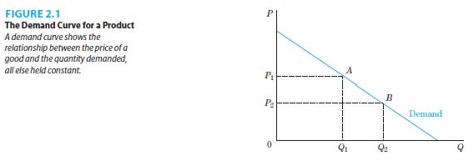

    - Demand Shifters: The variables in a demand function that are held constant when defining a given demand curve. If their values change, the demand curve would shift.

    - Price is on the vertical axis and quantity demanded is on the horizontal axis.

    - Demand curves are generally downward sloping.

    - Price and quantity demanded have a negative relationship.

  - Change in Quantity Demanded and Change in Demand

    - Change in Quantity Demanded: Movement along a demand curve when consumers react to a change in the price of the product, all other factors held constant. This is illustrated in Figure 2.1.

    - Change in Demand: Movement of the entire demand curve when consumers react to a change in factors other than the price of the product changing. This is illustrated in Figure 2.2.

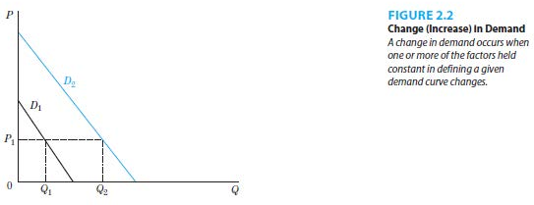

Teaching Tip: Make sure the students understand the distinction between a change in quantity demanded versus a change in demand. Although the difference in the wording seems trivial, these two concepts are quite different. The price of the product itself is the only determinant of a change in quantity demanded. All other factors are determinants of a change in demand.

  - The market demand curve can be derived by horizontal summation of the individual demand curves.

    - Horizontal Summation: For every price, add the quantity that each individual in a market demands.
    - A simple example is when there are two individuals in a market. This is illustrated in Figure 2.3.

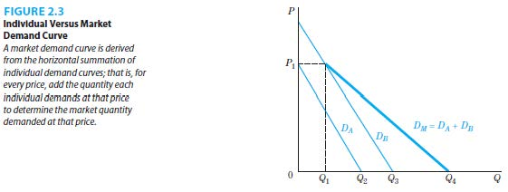

  - Linear Demand Function and Curves

    - Linear Demand Function: Mathematical relationship in which all terms are added or subtracted.

    - The graph of a linear demand curve is a straight line.

  - Math Example of a Demand Function (for copper at the beginning of 2010)

    - Equation 2.2: Q_{D}=3-2P_{C}+0.2I+1.6TC+0.4E
where:

Q_{D}= quantity demanded of copper (millions of pounds)
P_{C}= price of copper ($ per pound)
I= consumer income index
TC= telecom index showing uses or tastes for copper in the telecommunications industry
E=expectation index representing purchaser’s expectations of a lower price over the following six months

    - The negative coefficient on P_{C} shows an inverse relationship between price and quantity demanded for copper.

    - The positive coefficient on I shows that copper is a normal good.

    - The positive coefficient on TC shows that improved technology and greater demand for telecom services lead to higher demand.

    - The negative coefficient on E shows that expectations of lower price leads to an increased demand for copper in the future but a decreased demand for copper for the current period.

    - Equation 2.3: Q_{D}=15-2P_{C} is the alternative demand equation that is derived after substituting values for I, TC and E. It illustrates the meaning of the expression, “all else equal.”

- Supply

  - Supply: Functional relationship between the price and quantity supplied of goods and services by producers in a given period of time, all else equal.

  - Non-price factors influence the cost of production, causing either an increase or a decrease in supply. These factors are the following.

    - State of Technology

      - Better technology allows for a more efficient use of resources, increasing supply.

    - Input Prices

      - Lower prices of inputs (labor, capital, land and raw materials) lead to a reduction in the production cost and an increase in supply.

    - Prices of Goods Related in Production

      - Substitute Goods: The same inputs can be used to produce one good over another. An increase in the price of a substitute good, Y, causes an increase in the production of good X.
      - Complementary Goods: Products that are produced together. A decrease in the price of a complementary good, Y, causes an increase in the production of good X.

Teaching Tip: Students sometimes get confused between prices of related goods that affect demand and the prices of goods related in production that affect supply. Make sure that they understand the distinctions that come from the demand or supply side of the market.

    - Future Expectations

      - An expected decrease in the future price of good X will increase its current supply.

    - Number of Producers

      - An increase in the number of sellers of good X will increase its supply.
      - Changes in laws or regulations including trade barriers (quotas and tariffs) can also achieve the same result.

  - Supply Function: Function represented by Q_{XS}= f (P_{X}, TX, P_{I}, P_{A}, P_{B}, EXP, NP, ...) where:

Q_{XS}= quantity supplied of X
P_{X}= price of X
TX=state of technology
P_{I}= prices of inputs of production
P_{A}, P_{B}= prices of goods A and B, which are related in production of good X
EXP= producer expectations about future prices
NP= number of producers

  - Supply Curve: The graphical relationship between the price of a good (P) and the quantity supplied by producers (Q), with all other factors influencing supply held constant.

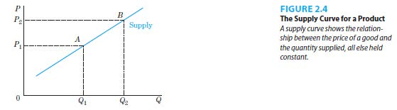

    - Supply Shifters: The variables in a supply function that are held constant when defining a given supply curve. If their values change, the supply curve would shift.

    - Price is on the vertical axis and quantity supplied is on the horizontal axis.

    - Supply curves are generally upward sloping.

    - Price and quantity supplied have a positive relationship.

  - Change in Quantity Supplied and Change in Supply

    - Change in Quantity Supplied: Movement along a supply curve when producers react to a change in the price of the product, all other factors held constant. This is illustrated in Figure 2.4.

    - Change in Supply: Movement of the entire supply curve when producers react to a change in factors other than the price of the product changing. This is illustrated in Figure 2.5. Factors capable of shifting a supply curve (changes in supply) include technological changes that increase input productivity, changes in input costs, changes in the prices of related in production goods, changes in producer’s expectations.

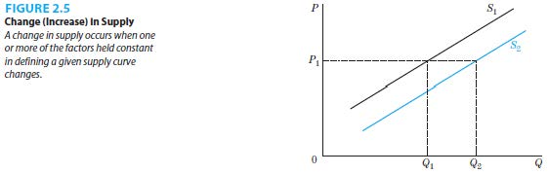

  - Math Example of a Supply Function

    - Equation 2.5: Q_{S}= -5+8P_{C}-0.5W+0.4T+0.5N
where:

Q_{S}= quantity supplied of copper (millions of pounds)
P_{C}= price of copper ($ per pound)
W= an index of wage rates in the copper industry
T= technology index
N= number of active mines in the copper industry.

    - The positive coefficient on P_{C} shows a positive relationship between price and quantity supplied of copper.

    - The negative coefficient on W shows that as the input price increases, supply decreases due to costly production.

    - The positive coefficient on T shows that an increase in technology increases the supply of copper.

    - The positive coefficient on N shows that an increase in the number of active mines increases the supply of copper.

    - Equation 2.6: Q_{S}= -25+8P_{C} is the alternative supply equation that is derived after substituting values for W, T and N. It illustrates the meaning of the expression, “all else equal.”

  - Summary of Demand and Supply Factors
    - Table 2.1 provides a summary of the discussion
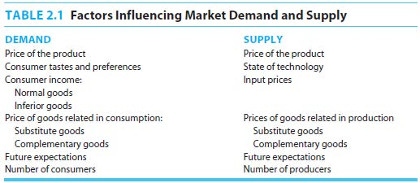

- Demand, Supply and Equilibrium

  - When the market is in equilibrium, there is an equilibrium price and quantity. This is illustrated in Figure 2.6.

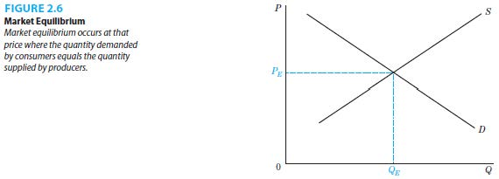
    - Equilibrium Price (P_{E}): The price that actually exists in the market (or toward which the market is moving) where the quantity demanded by consumers equals the quantity supplied by producers.

    - Equilibrium Quantity (Q_{E}): The quantity of a good, determined by the equilibrium price, where the amount of output that consumers demand is equal to the amount that producers want to supply.

  - Lower-than-equilibrium prices would result in a shortage of the good, as the quantity demanded exceeds the quantity supplied. This is illustrated in Figure 2.7.

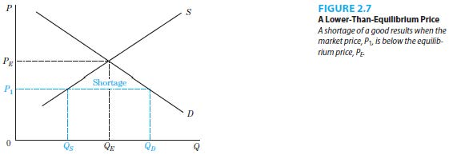
  - Higher-than-equilibrium prices would result in a surplus of the good, as the quantity supplied exceeds the quantity demanded. This is illustrated in Figure 2.8.

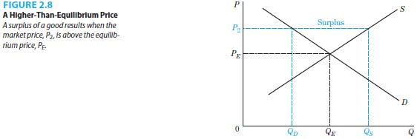
  - Math Example of Equilibrium

    - Equation 2.3: Q_{D}= 15-2P_{C}

    - Equation 2.6: Q_{S}= -25+8P_{C}

    - In equilibrium, there is only one quantity where Q_{D}=Q_{S}. Equating the two equations lead to an equilibrium price of $4.00 and an equilibrium quantity of 7 million pounds.

  - Changes in Equilibrium Prices and Quantities

    - A change in demand results from a change in tastes and preferences, income, prices of related goods, expectations or the number of consumers. This alters the market equilibrium in the following ways.

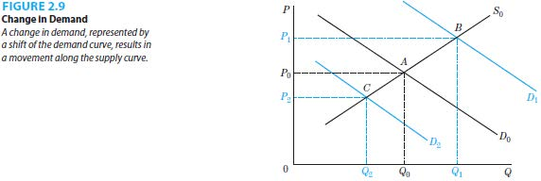
      - An increase in demand (D₀ to D₁) raises the equilibrium price and raises the equilibrium quantity. This is illustrated in Figure 2.9.
      - A decrease in demand (D₀ to D₂) lowers the equilibrium price and lowers the equilibrium quantity. This is illustrated in Figure 2.9.

    - A change in supply results from a change in technology, input prices, prices of goods related in production, expectations, or the number of suppliers. This alters the market equilibrium in the following ways.

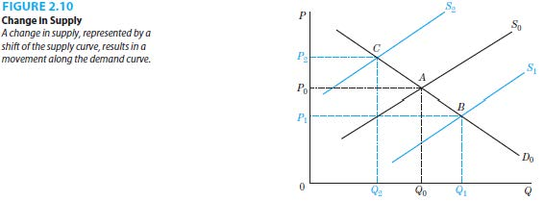
      - An increase in supply (S₀ to S₁) lowers the equilibrium price and raises the equilibrium quantity. This is illustrated in Figure 2.10.
      - A decrease in supply (S₀ to S₂) raises the equilibrium price and lowers the equilibrium quantity. This is illustrated in Figure 2.10.

    - The effects of changes in both sides of the market on the equilibrium price and quantity depend on the sizes of the shifts of the demand and supply curves.

    - An increase in demand and a decrease in supply raise the equilibrium price but the effect on the equilibrium quantity is indeterminate. This is illustrated in Figures 2.11 and 2.12.

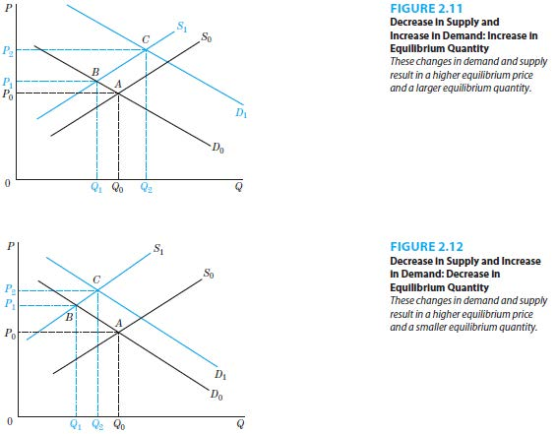
    - An increase in demand and an increase in supply raise the equilibrium quantity but the effect on the equilibrium price is indeterminate. This is illustrated in Figures 2.13 and 2.14.

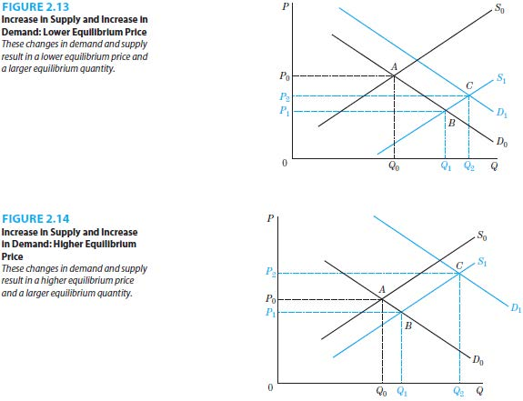
  - Math Example of an Equilibrium Change (continuation of the prior setup of the copper market in 2010

    - Start with an initial equilibrium price of $4.00 and an initial equilibrium quantity of 7 million pounds at the beginning of 2010.

    - Assume that the US and European economic weaknesses cause cancellation of copper orders during 2010 - 2011. Assume that a decrease in the demand for copper that resulted from the weaknesses in the US and Europe was not offset by an increase in the demand for copper from China. This causes several of the relevant to the market demand factors to change: the income index (I) to decrease from 20 to 14, the telecom index (TC) decreases from 2.5 to 1.875, the expectations index (E) decreases from 100 to 80.

    - Supply side factors are also allowed to change. Assume that the wage index (W) decreases from 100 to 98, the technology index increases from 50 to 55, NP increases from 20 to 28 (due to a release of copper stockpile in China).

    - Substituting for new values of for the above listed factors into the demand and supply equations results in the new equilibrium price is $3.00 and the new equilibrium quantity is 6 million pounds. This is also illustrated graphically in Figure 2.15.

