Chapter 2
Scarcity and the World of Trade-Offs

■ Overview
This chapter introduces the central concept of economics, scarcity. It is the existence of scarcity that requires people to make choices, both individually and collectively. Along with the concept of scarcity, the chapter introduces the tools that economists use to analyze choice. These are the concepts of opportunity costs, trade-offs, and the production possibilities model. The production possibilities model is used not only to analyze trade-offs but also to illustrate economic growth and the implications of an inefficient use of resources. Specialization is introduced along with a discussion of the basis for trade, comparative advantage.

■ Learning Objectives
After studying this chapter students should be able to:
• 2.1 Evaluate why everyone, whether poor or affluent, faces the problem of scarcity
• 2.2 Explain why the scarcity problem causes people to consider opportunity costs and trade-offs among choices
• 2.3 Discuss why obtaining increasing increments of any particular good typically entails giving up more and more units of other goods
• 2.4 Explain why the economy faces a trade-off between consumption goods and capital goods
• 2.5 Distinguish between absolute and comparative advantage

■ Outline
I. Scarcity: Scarcity is a situation in which the ingredients for producing the things that people desire are insufficient to satisfy all wants at a zero price. It exists in all societies and at all income levels because human wants exceed what can be produced with the limited resources and time that nature makes available.
A. What Scarcity Is Not: Scarcity is not a shortage. It is also not poverty. High incomes do not reduce scarcity.
B. Scarcity and Resources: Resources or factors of production are inputs used in the production of things that people want. Production is any activity that results in the conversion of resources into products that can be used in consumption.
1. Land: Land is often called the natural resource and consists of all the gifts of nature.
2. Labor: Labor is the human resource that includes all productive contributions made by individuals who work and involves both mental and physical activities.
3. Physical Capital: Capital is all manufactured resources that are used for production. It also includes improvements to natural resources, such as irrigation ditches.
4. Human Capital: The accumulated training and education workers receive that increases their productivity.
5. Entrepreneurship: Human resources that perform the functions of organizing, managing, and assembling the other factors of production to create and operate business ventures and that take the risks associated with introducing new methods and other types of new thinking that could lead to more monetary income.
C. Goods versus Economic Goods: All things from which individuals derive satisfaction or happiness.
1. Economic Goods: Goods that are scarce. The quantity of such goods desired exceeds the quantity that is available at a zero price.
2. Services: Mental or physical labor or help purchased by consumers. They can be viewed as intangible goods.
D. Wants and Needs: Needs are not objectively definable. Perhaps the best way to view a need is as an absolute necessity to stay alive. Wants refer to desired goods and are unlimited.
II. Opportunity Cost, Trade-Offs, and Choices: Scarcity requires choices be made. When one choice is made, then another is given up.
A. Valuing Forgone Alternatives: Only the individual can determine the value of each choice that is available.
B. Opportunity Cost: The highest valued, next-best alternative that must be sacrificed for the choice that was made. In economics, cost is always a forgone opportunity.
C. The World of Trade-Offs: Whenever you engage in any activity using any resource you are trading off the use of that resource for one or more alternative uses. For example, the more time that is devoted to studying economics, the less time that can be devoted to studying mathematics. Thus, a higher grade in economics has a “cost” of a lower mathematics grade. (See Figure 2-1.)
D. Graphical Analysis: How Figure 2-1 is set up is explained.
E. The Production Possibilities Curve (PPC): A curve representing the maximum possible combinations of total output that could be produced assuming a fixed amount of resources of a given quality.
1. Production Possibilities for Course Grades: A straight-line production possibilities curve can show the opportunity cost of studying one more hour in one subject in terms of a change in the grade of another subject. (See Figure 2-1.)
2. Measuring Trade-Offs Along a Production Possibilities Curve: A movement from one point to another on the PPC shows that some of one good must be given up to have more of another. (See Figure 2-1.)
III. The Economic Choices a Nation’s People Face: The production possibilities curve does not in practice have constant trade-offs of one good for another and is typically a curve that is bowed outward. (See Figure 2-2.)
A. A Two-Good Example
B. Production Trade-Offs (See Figure 2-2.)
C. Assumptions Underlying the Production Possibilities Curve:
1. Resources are fully employed.
2. Production takes place over a specific time period—for example, one year.
3. Resources are fixed in both quantity and quality.
4. Technology does not change over this period of time.
a. Technology is defined as society’s pool of applied knowledge concerning how goods and services can be produced.
D. Being off the Production Possibilities Curve: Any point outside the PPC cannot be reached for the time period assumed. Any point inside the PPC is attainable, but resources are not being fully utilized. (See Figure 2-2.)
E. Efficiency: The case in which a given level of inputs is used to produce the maximum output possible. It is also a situation in which a given output is produced at a minimum cost. An economy is efficient when it is on its PPC. An inefficient point is any point below the production possibilities curve.
F. The Law of Increasing Additional Cost: The fact that the opportunity cost of additional units of a good generally increases as society attempts to produce more of that good. This accounts for the bowed-out shape of the production possibilities curve. (See Figure 2-3.)
1. Increasing Additional Costs: As society takes more and more resources and applies them to the production of any one item, the opportunity cost increases for each additional unit produced. This law is illustrated by the PPC being bowed outward.
2. Explaining the Law of Increasing Additional Cost: The more highly specialized resources are, the more bowed outward the PPC will be.
IV. Economic Growth, Production Possibilities, and the Trade-Off between Present and Future
- Economic Growth and the Production Possibilities Curve: Economic growth is illustrated by an outward shift of the production possibilities curve. (See Figure 2-4.)
- The Trade-Off between the Present and the Future
1. Why We Make Capital Goods: Capital goods are one of society’s resources. Producing more of them allows a society to produce more of all types of goods.
2. Forgoing Current Consumption: When existing resources are used to produce capital goods, we are forgoing current consumption. When we forgo consumption to invest in capital goods, we are waiting to consume what will be produced from the use of those capital goods then.
3. The Trade-Off between Consumption Goods and Capital Goods: To have more consumer goods in the future, we must produce capital goods today. The more capital goods that are produced today, the less consumer goods that are produced today. In the future there will be more consumption goods as the economy grows. (See Figure 2-5.)
V. Specialization, Comparative Advantage, and Trade: Specialization means working at a relatively well-defined, limited activity. It means the organization of economic activity so that what each person or region consumes is not identical to what each person or region produces.
A. Comparative Advantage: The ability to produce a good or service at a lower opportunity cost compared to other producers. This is the basis for specialization.
B. Absolute Advantage: The ability to produce more units of a good or service using a given quantity of labor or resource inputs. This is the ability to produce the same quantity of a good
or service using fewer units of labor or resource inputs. This is not the basis for specialization.
1. Absolute Advantage versus Comparative Advantage: Only comparative advantage, not absolute advantage, matters in determining how people will allocate time and make other choices.
2. Comparative Advantage in Sports: Babe Ruth had an absolute advantage in both hitting and pitching baseball, but he had a comparative advantage in hitting home runs than pitching.
C. Scarcity, Self-Interest, and Specialization: Persons who are making decisions that further
their self-interest will make choices that maximize the benefits net of opportunity cost. The result is that they choose their comparative advantage and end up specializing.
D. The Division of Labor: The segregation of a resource into different specific tasks.
E. Comparative Advantage and Trade among Nations: The analysis of absolute advantage, comparative advantage, and specialization applies equally to nations.
1. Trade among Regions: Specialization along lines of comparative advantage in agricultural products in the plains states and industrial products in the northeastern states and resulting trade between them allows each region to have higher incomes and living standards. The result would be the same if the plains states and the northeastern states were separate countries.
2. International Aspects of Trade: A producer in one part of the United States must adapt
to improvements in production along lines of comparative advantage by those in another part. Producers in the United States will try to raise political barriers to trade with foreign producers by arguing about “unfair” competition and loss of U.S. jobs.

■ Points to Emphasize

Graphing
Graphs are usually difficult for students to grasp. It is worthwhile spending some time going over basic graphing techniques and terminology from the Appendix to Chapter 1 before getting into this chapter. These pictures of relationships between variables may simply create confusion rather than clarify the issue being presented. This confusion results when students are trying to figure out where the graph comes from and what it means to refer to an inverse or positive relationship, while at the same time trying to make sense of the actual economic analysis.

Scarcity
This is the central concept in economics. All economic analysis derives from this condition. Stress that scarcity arises because at any given time people want more than their resources will allow them to consume. The classic way to define scarcity is that wants are unlimited while resources are limited. Resources or inputs are anything that can be used to produce things people want. It is important to stress that scarcity is a relative concept. Even though not everyone has “unlimited” wants, they usually want more than they can have at the moment. As income rises, so do wants. Studies by Simon Kuznets and Milton Friedman provide evidence of this fact. Kuznets found that between 1869 and 1929, real national income rose by a factor of 4, but the APC remained constant. Friedman reported in The Theory of the Consumption Function that the APC remains constant even cross-sectionally as income goes from lower levels to higher levels out of permanent income. Also, poverty in the United States is defined at levels that would be considered affluent by people in most countries.

Resources
Resources or inputs are things that produce goods and services. At any given time, resources are fixed. Generally, students will agree that this is so. Thus, at any given time, the amount of goods and services that can be produced is limited. Over time, resources have increased. Indeed, 150 years ago petroleum
was not even a resource. Today, it is one of the most important resources. Advances in technology allow society to use things that were previously not resources. Over time, an increase in resources does not allow society to eliminate scarcity because, at any given time, resources are fixed while wants are not.

Choice
After the scarcity problem is analyzed, the problem of choice should be presented. Because of scarcity, that is wants are greater than the means to satisfy these wants (resources), people are forced to choose means
of satisfying these wants. The concepts of opportunity cost, trade-offs, and the production possibilities curve are introduced. These concepts are often difficult for students to grasp. The production possibilities curve can be especially troublesome if actual numbers are not presented along with the graph. A successful method of presenting this model is to use a table of combinations of two goods and fully develop the model before introducing the graph.

Specialization and Comparative Advantage
After the tools for analyzing choice are developed, the chapter discusses specialization based on comparative advantage. The relationship between these two is essential to develop because it is the basis for exchange. A convincing case can be made on an intuitive level that if each person, region, and country specializes in producing those things that they can produce relatively most efficiently, then it is possible to increase output without increasing the total amount of resources. Then a more formal demonstration can be given. A result of specialization is that trade occurs because each economic unit ends up producing more of something than they want. In some cases, they produce something that they do not consume at all. Higher incomes and living standards result from specialization and trade based on comparative advantage.

■ For Those Who Wish to Stress Theory

Production Possibilities Curve
An in-depth analysis of the production possibilities curve (PPC) can be especially valuable. In particular, consider the following:

1. Rigorously define the PPC: The PPC shows the maximum possible combinations of output of two goods that can be produced by given resources and technology in a given time period.

2. Consider the PPC when inputs are equally suited to producing both of the goods. The x and y intercepts define the maximum quantities of each good that can be had. By connecting these two points, a linear PPC is derived.

3. Note that when some resources are better suited to either output, there are two important differences in the PPC.

a. It is no longer linear. Instead, it is now concave to the origin due to increasing resource cost.
As we move from producing all x to all y, we initially produce units of y by releasing greater percentages of resources more suited to production of y and smaller percentages of resources more suited to the production of x. Since only 100 percent of resources exist, we must eventually release greater percentages of y-suited resources and smaller percentages of x-suited resources
to produce additional units of x.

b. The new PPC lies above the linear PPC except at the x and y intercepts because the new curve accounts for the fact that inputs are more suitable to producing x or y.

■ Further Questions for Class Discussion

1. In recent years, online news sites such as the ones at MSNBC and Yahoo! have designed a business model in which they collect stories from the online pages of newspapers and wire services, such as the Associated Press (AP), and allow free access to the articles for visitors to their Web sites. The effect has been to decrease newspaper and wire service revenues and profits. As a result, newspapers and organizations such as the AP have begun to charge or discuss plans to charge visitors to access to their Web sites or to download their stories. Most users of the news sites of both the newspapers and sites such as Yahoo! and MSN argue that they should not be charged for access to these companies’ Web sites. An interesting question for students is why they believe that access to news should be free. Then ask them if, in fact, any given news story is a free good or an economic good in the sense that economists use those terms. Obviously, news stories are economic goods because scarce resources are used to produce them. Because those resources have alternative uses, there is an opportunity cost for using them to research and produce news stories.

2. Does the federal government face a scarcity constraint? In discussions of the federal government,
each interest group wants more spent on its programs and speaks as if the government has virtually unlimited funds for its program that has some supposed beneficial social impact. The problem is that the government has fewer funds to allocate than are desired by all of the interest groups. Thus, wants exceed the ability of the federal government to finance all of these wants—a clear case of scarcity. The government does indeed face a scarcity constraint in the form of a limited budget with which to accomplish its goals. The way this constraint is manifested is in wrangling about budget priorities. The opportunity cost of more for one program means less for others.

3. Students will usually agree that specialization along lines of comparative advantage and then trade
is beneficial. Point out Adam Smith’s statement in The Wealth of Nations that no “prudent master [will] make at home what it will cost him more to make than to buy.” Consider outsourcing where American firms have foreign firms produce certain goods or services for them instead of producing them in the United States. Ask why this is a problem if the foreign firms in fact have comparative advantage. If trade along lines of comparative advantage allows U.S. companies to buy these goods and services more cheaply than they can produce them, then why should we want to restrict trade in them? There will be a reallocation of jobs in the United States as those displaced by outsourcing, find jobs in activities in which the United States has a comparative advantage. This will usually generate controversy.

4. A major political issue revolves around tax policy and its effect on investment and economic growth. How might increases in taxes on business profits affect economic growth? (Hint: Investment is inversely related to expected after-tax profits on new investment.) Use the production possibilities model to explain your answer. Other things being equal, an increase in taxes on profits will reduce investment spending by decreasing expected after-tax profits. Investment represents new capital formation, and thus less capital will be produced. The rate of economic growth will be reduced by higher business taxes, other things being equal.

■ Adam Smith (1723–1790): Scottish Economist
“I have never known much good done by those who affected to trade for the public good,” Adam Smith once remarked. If he put little stock in good intentions, Smith did invest heavily in demonstrating that selfish intentions could lead to public good. In The Theory of Moral Sentiments (1759), his first book, Smith tried to show how altruism could come out of self-interest. In his second, more famous book, he attempted to reveal how the self-interest of private individuals could be transformed by the sleight of an invisible hand (the unfettered market) into social harmony and public benefit, producing the wealth of the nation in the best of all possible ways. The result of this effort was An Inquiry into the Nature and Causes of the Wealth of Nations (1776), perhaps the most influential economics treatise ever written, one that has set the tone for capitalist ideology for more than two centuries.
As the title indicates, Smith attempted to examine the sources of the wealth of nations. He proposed that first on the list of sources was the division of labor. Smith’s pin factory example of dramatic increases in productivity possible through the division of labor has made its mark on virtually every textbook written on the subject since. He went on to point out that the division of labor does not occur because individuals possess an overall perception of its ultimate benefit to society. Rather, the division of labor occurs simply because it is in each individual’s self-interest to specialize and to exchange: “The natural effort of every individual to better his own condition, when suffered to exert itself with freedom and security, is so powerful a principle, that it is alone, and without any assistance . . . capable of carrying on the society
to wealth and prosperity.”

In addition to Smith’s famous “invisible hand” theme, the theme of individual economic freedom was quite strong in The Wealth of Nations. He believed that any governmental attempt to guide or to regulate actions of individuals in the economic marketplace would end up doing more harm than good. Smith was especially harsh on legally protected monopolies. Smith’s critics contend that his model may have fit England at the time he wrote his treatise, but it does not fit industrialized Western countries today—where the state plays a large role and large corporations have replaced shopkeepers. Nonetheless, for many, The Wealth of Nations remains a laissez-faire bible, and Smith remains a central figure in the development of economic thought.

■ Answers to Questions for Critical Analysis

Why the “Free File” Tax Services Is Not Really “Free” (p. 30)
Why might a person pay a firm at a mall to prepare her tax forms while she shops instead of allocating the same amount of time to finding a qualifying Free-File tax preparation service?
For some people, the opportunity cost of spending time in finding a qualifying Free-File tax-preparation service might be higher than their opportunity cost of spending the same amount of time shopping.

An Economic Explanation for Monogamy (p. 32)
What must be true of the trade-off perceived by people who have multiple sex partners?
For people who have multiple sex partners, their opportunity cost of the time required to maintain involvement with multiple sex partners must be smaller than the opportunity cost of devoting that amount of time to earning income or the next highest-valued activity.

The Substantial Trade-off of Satisfying U.N. Development Goals (p. 34)
If the U.N. follows through on a proposal to add production targets for 148 more items to its Sustainable Development Goals, why might we expect that the opportunity cost in terms of other goods and services that must be forgone could be even greater? Explain briefly.
Because of the law of increasing additional cost, which means a bowed curve for the a nation’s production possibilities curve, the opportunity cost of adding production targets for more items to the Sustainable Development Goals must be even greater.

The Airline Industry Confronts the Law of Increasing Additional Cost (p. 36)
Why might the production possibilities curve relating the number of electronic-gadget-accessory boxes at passenger seats to the quantity of seats on a plane be bowed? Explain your reasoning.
The bowed shape of the production possibilities curve reflects the fact that existing seats on a plane are specialized resources.

■ You Are There

Reducing the Opportunity Cost of Waiting in Gridlocked Traffic, at a Price (p. 42)

1. How must the dollar values of the opportunity costs of time compare for a typical purchaser of a vehicle converted by Becker Automotive, Inc., versus commuters who do not purchase them? Explain briefly.

Because the prices of those converted vehicles are at least $150,000, which is higher than the price of a typical vehicle, the opportunity cost of time for Becker’s customer must be higher than that for other commuters.

2. Why do you suppose that economists have estimated the dollar value of the combined opportunity costs of time that U.S. commuters spend in gridlocked traffic to be in excess of $150 billion per year? Explain our reasoning.

U.S. commuters spend a total of 7 billion hours per year in gridlocked traffic. The opportunity
cost of that total amount of time can be measured by the amount of income earnings forgone. Economists can use the average wage rate per hour to arrive at the total dollar value in excess
of $150 billion per year.

■ Issues & Applications

The U.S. Navy Expands Production Possibilities via a New Technology (pp. 42–43)

1. In spite of the lower opportunity cost of rail-gun projectiles instead of missiles, does the U.S. Navy continue to face an increasing additional cost, in terms of forgone ship production, to obtain additional weapons? Explain briefly.

Despite the lower opportunity cost of rail-gun projectiles, the U.S. Navy’s production possibilities curve still bows outward, meaning an increasing additional cost for obtaining more weapons.

2. Could the U.S. Navy expand its production of both ships and weapons after switching from missiles to rail-gun weapons? Explain your reasoning. (Hint: Are there points along PPC₂ involving combinations of both more ships and more weapons than is feasible at point A
on PPC₁?)

Yes, the switch from the production of missiles to rail-gun weapons leaves the U.S. Navy with resources that can be used for the production of ships and weapons. The U.S. Navy’s production possibilities curve shifts outward as a result, meaning more production of both ships and weapons.

■ Research Project

1. Learn more about the U.S. Navy’s rail-gun technology in the Web Links in MyEconLab.

2. Read about how other divisions of the U.S. military also are working on developing rail-gun technologies in the Web Links in MyEconLab.

■ Answers to Problems

2-1. Define opportunity cost. What is your opportunity cost of attending a class at 11:00 a.m.? How does it differ from your opportunity cost of attending a class at 8:00 a.m.?

The opportunity cost of attending a class at 11:00 a.m. is the next-highest-valued use of that hour of the day. Likewise, the opportunity cost of attending an 8:00 a.m. class is the next-highest-valued use of that particular hour of the day. If you are an early riser, it is arguable that the opportunity cost of the 8:00 a.m. hour is lower because you will already be up at that time, but have fewer choices compared with the 11:00 a.m. hour when shops, recreation centers, and the like are open. If you are a late riser, it may be that the opportunity cost of the 8:00 a.m. hour is higher, because you place a relatively high value on an additional hour of sleep in the morning.

2-2. If you receive a ticket to a concert at no charge, what, if anything, is your opportunity cost of attending the concert? How does your opportunity cost change if miserable weather on the night of the concert requires you to leave much earlier for the concert hall and greatly extends the time it takes to get home afterward?

The opportunity cost of attending the concert is the next-highest-value use of the time spent at the concert. If bad weather extends the amount of time spent on an evening at the concert, then there is an additional opportunity cost in the form of the next-best uses of that additional time.

2-3. You and a friend decide to spend $100 each on concert tickets. Each of you alternatively could have spent the $100 to purchase a textbook, a meal at a highly rated local restaurant, or several Internet movie downloads. As you are on the way to the concert, your friend tells you that if she had not bought the concert ticket, she would have opted for a restaurant meal, and you reply that you otherwise would have downloaded several movies. Identify the relevant opportunity costs for you and your friend of the concert tickets that you purchased. Explain briefly.

The opportunity cost is the cost of the single, next-highest-valued foregone alternative to the $100 spent on the concert ticket, which for your friend was a restaurant meal she otherwise could have purchased and which for you was movie downloads that you otherwise could have bought.

2-4. After the concert discussed in Problem 2-3 is over and you and your friend are traveling home, you discuss how each of you might otherwise have used the four hours devoted to attending the concert. The four hours could have been used to study, to watch a sporting event on TV, or to get some extra sleep. Your friend decides that if she had not spent four hours attending the concert, she would have chosen to study, and you reply that you otherwise would have watched the televised sporting event. Identify the relevant opportunity costs for you and your friend for allocating your four hours to attending the concert. Explain briefly.

The opportunity cost is the cost of the single, next-highest-value forgone alternative to the four hours spent attending the concert, which for your friend was time that she otherwise could have devoted to study and for you was time that you otherwise could have spent watching the sporting event on television.

2-5. Recently, a woman named Mary Krawiec attended an auction in Troy, New York. At the auction, a bank was seeking to sell a foreclosed property: a large Victorian house suffering from years of neglect in a neighborhood in which many properties had been on the market for years yet remained unsold. Her $10 offer was the highest bid in the auction, and she handed over a $10 bill for a title to ownership. Once she acquired the house, however, she became responsible for all taxes on the property and for an overdue water bill of $2,000. In addition, to make the house habitable, she and her husband devoted months of time and unpaid labor to renovating the property. In the process, they incurred explicit expenses totaling $65,000. Why do you suppose that the bank was willing to sell the house to Ms. Krawiec for only $10? (Hint: Contemplate the bank’s expected gain, net of all explicit and opportunity costs, if it had attempted to make the house habitable.)

The bank apparently determined that the net gain that it anticipated receiving from trying to sell the house to someone else, taking into account the opportunity cost of resources that the bank would have had to devote to renovating the house, was less than $10.

2-6. The following table illustrates the points a student can earn on examinations in economics
and biology if the student uses all available hours for study. Plot this student’s production possibilities curve. Does the PPC illustrate the law of increasing additional cost?

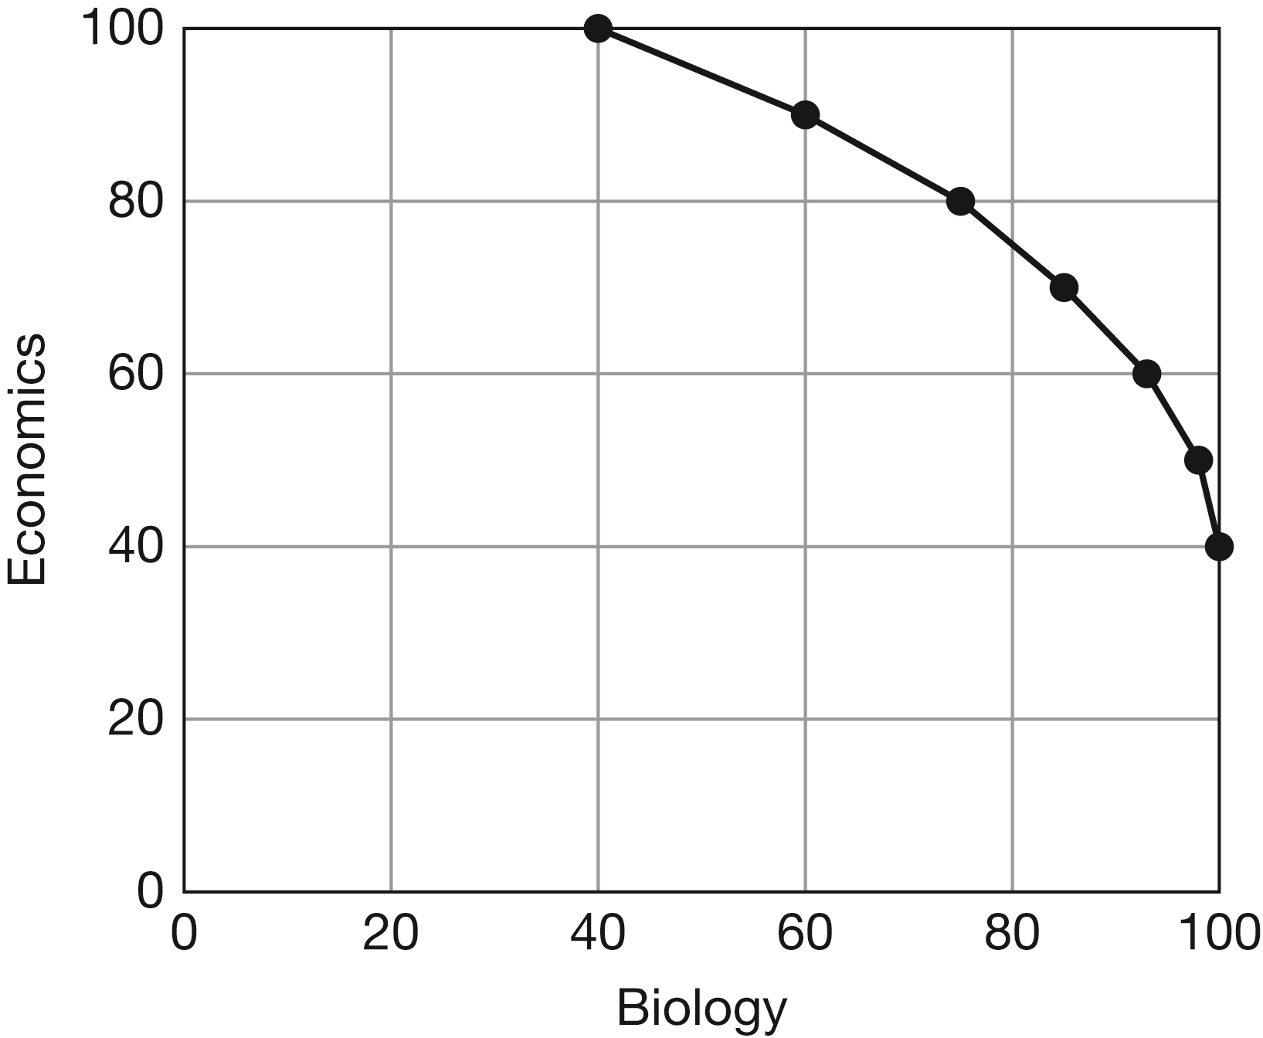

Economics | Biology
100 | 40
90 | 60
80 | 75
70 | 85
60 | 93
50 | 98
40 | 100

Each additional 10 points earned in economics costs 10 additional points in biology, so this PPC illustrates constant additional opportunity costs. It does not satisfy the law of increasing relative cost.

2-7. Based on the information provided in Problem 2-6, what is the opportunity cost to this student of allocating enough additional study time on economics to move her grade up from a 90 to a 100?
If the student allocates additional study time to economics in order to increase her score from 90 to 100, her biology score declines from 50 to 40, so the opportunity cost of earning 10 additional points in economics is 10 fewer points in biology.

2-8. Consider a change in the table in Problem 2-6. The student’s set of opportunities is now as follows: Does the PPC illustrate the law of increasing additional cost? What is the opportunity cost to this student for the additional amount of study time on economics required to move her grade from 60 to 70? From 90 to 100?

Economics | Biology
100 | 40
90 | 50
80 | 60
70 | 70
60 | 80
50 | 90
40 | 100

Each additional 10 points earned in economics costs a greater number of biology points. For instance, the opportunity cost to the student of increasing points earned in economics from 60 to 70 is 8 points forgone in biology, but the opportunity cost of increasing economics points from 90 to 100 rises to 20 points forgone in biology. Thus, the new PPC illustrates the law of increasing relative cost.

2-9. Construct a production possibilities curve for a nation facing increasing opportunity costs for producing food and video games. Show how the PPC changes given the following events.

a. A new and better fertilizer is invented.

b. Immigration occurs, and immigrants’ labor can be employed in both the agricultural sector and the video game sector.

c. People invent a new programming language that is much less costly to code and is more memory-efficient.

d. A heat wave and drought result in a 10 percent decrease in usable farmland.
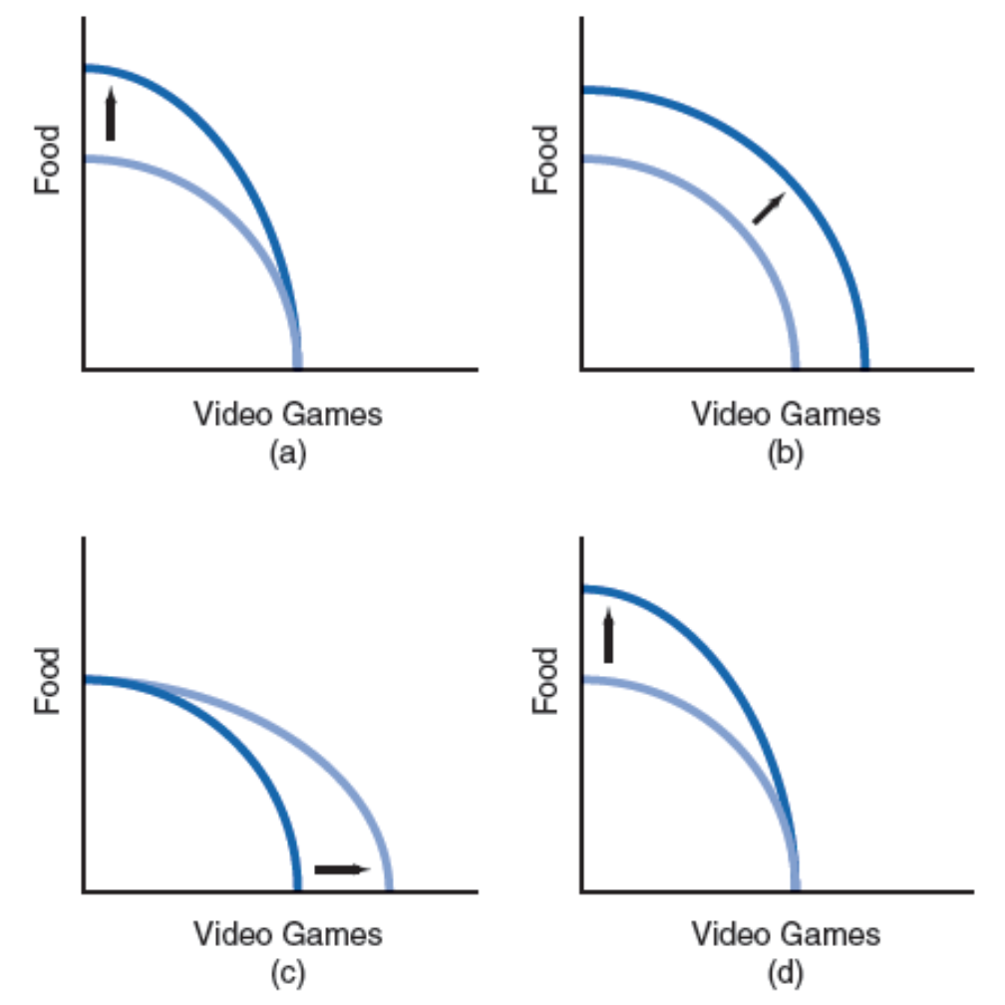

2-10. During a debate on the floor of the U.S. Senate, Senator Creighton states, “Our nation should not devote so many of its fully employed resources to producing capital goods because we already are not producing enough consumption goods for our citizens.” Compared with the other labeled points on the diagram, which one could be consistent
with the current production combination choice that Senator Creighton believes the nation has made?

Point C

2-11. In response to Senator Creighton’s statement reported in Problem 2-10, Senator Long replies, “We must remain at our current production combination if we want to be able to produce more consumption goods in the future.” Of the labeled points on the diagram, which one could depict the future production combination Senator Long has in mind?

Point D

2-12. Senator Borman interjects the following comment after the statements by Senators Creighton and Long reported in Problems 2-10 and 2-11: “In fact, both of my esteemed colleagues are wrong, because an unacceptably large portion of our nation’s resources is currently unemployed.” Of the labeled points on the diagram, which one is consistent with Senator Borman’s position?

Point A

2-13. A nation’s residents can allocate their scarce resources either to producing consumption goods or to producing human capital—that is, providing themselves with training and education. The table at the top of next column displays the production possibilities for this nation:

a. Suppose that the nation’s residents currently produce combination A. What is the opportunity cost of increasing production of consumption goods by 10 units? By 60 units?

b. Does the law of increasing additional cost hold true for this nation? Why or why not?

 | Units of
Production | Consumption | Units of
Combination | Goods | Human Capital
A | 0 | 100
B | 10 | 97
C | 20 | 90
D | 30 | 75
E | 40 | 55
F | 50 | 30
G | 60 | 0

a. If the nation’s residents increase production of consumption goods from 0 units to 10 units, the opportunity cost is 3 units of human capital forgone. If the nation’s residents increase production of consumption goods from 0 units to 60 units, the opportunity cost is 100 units of human capital.

b. Yes, because successive 10-unit increases in production of consumption goods generate larger sacrifices of human capital, equal to 3, 7, 15, 20, 25, and 30.

2-14. Like physical capital, human capital produced in the present can be applied to the production of future goods and services. Consider the table in Problem 2-13, and suppose that the nation’s residents are trying to choose between combination C and combination F. Other things being equal, will the future production possibilities curve for this nation be located farther outward if the nation chooses combination F instead of combination C? Explain.

No, because combination F entails production of less human capital than combination C, so choosing combination F today would result in a smaller output shift in the production possibilities curve than would be experienced if combination C were chosen instead.

2-15. You can wash, fold, and iron a basket of laundry in two hours and prepare a meal in one hour. Your roommate can wash, fold, and iron a basket of laundry in three hours and prepare a meal in one hour. Who has the absolute advantage in laundry, and who has an absolute advantage in meal preparation? Who has the comparative advantage in laundry, and who has a comparative advantage in meal preparation?

Because it takes you less time to do laundry, you have an absolute advantage in laundry. Neither
you nor your roommate has an absolute advantage in meal preparation. You require 2 hours to
fold a basket of laundry, so your opportunity cost of folding a basket of laundry is 2 meals. Your roommate’s opportunity cost of folding a basket of laundry is 3 meals. Hence, you have a comparative advantage in laundry, and your roommate has a comparative advantage in meal preparation.

2-16. Based on the information in Problem 2-15, should you and your roommate specialize in a particular task? Why? If so, who should specialize in which task? Show how much labor time you save if you choose to “trade” an appropriate task with your roommate as opposed to doing it yourself.

Yes, you and your roommate should specialize in the task in which each of you has a comparative advantage. You should specialize in folding laundry and your roommate in preparing meals. If you
fold a basket of laundry, you must forgo the time that it would take to prepare two meals. For your roommate to fold a basket of laundry, the time that it takes to prepare three meals must be given up. Suppose that you “trade” folding a basket of laundry for preparing 2.5 meals. You gain 0.5 meals, which is equivalent to one-half hour of meal preparation time. Hence, you save one-half hour for
every basket of laundry you fold for your roommate in exchange for an hour of meal preparation time.

2-17. Using only the concept of comparative advantage, evaluate this statement: “A professor with a Ph.D. in physics should never mow his or her own lawn, because this would fail to take into account the professor’s comparative advantage.”

It may be that the professor is very proficient at doing yard work relative to teaching and research activities, so in fact the professor may have a comparative advantage in doing yard work.

2-18. Country A and country B produce the same consumption goods and capital goods and currently have identical production possibilities curves. They also have the same resources at present, and they have access to the same technology.

a. At present, does either country have a comparative advantage in producing capital goods? Consumption goods?

b. Currently, country A has chosen to produce more consumption goods, compared with country B. Other things being equal, which country will experience the larger outward shift of its PPC during the next year?

a. If the two nations have the same production possibilities, then they face the same opportunity costs of producing consumption goods and capital goods. Thus, at present neither has a comparative advantage in producing either good.

b. Because country B produces more capital goods today, it will be able to produce more of both goods in the future. Consequently, country B’s PPC will shift outward by a greater amount next year.

2-19. Suppose that in Figure 2-1, a student currently is allocating her study time in such a way that she is earning a C in mathematics and a C in economics. What is the opportunity cost, measured in terms of the resulting grade change, if this student wishes to reallocate her study time in order to raise her mathematics grade by one letter, from a C to a B?

According to the figure, if the student makes the required reallocation of study time to earn a B in mathematics, then she will earn a D in economics. Thus, the student’s opportunity cost of raising her grade by one letter grade, from a C to a B, is a one-letter grade drop in her economics grade, from a
C to a D.

2-20. Suppose that in Figure 2-1, a student currently is allocating her study time in such a way that she is earning a C in mathematics and a C in economics. If the student desires to boost her economics grade to an A, how must she alter the number of hours per week that she studies economics? How must she alter the number of hours per week that she studies mathematics?

The student currently is allocating 3 hours per week of study time to mathematics and 3 hours per week of study time to economics. To boost her grade in economics from a C to an A, she must devote all
6 hours of available study time to economics, so she must increase the amount of time she spends studying economics by 3 hours per week. To attain a grade of A in economics, she can devote none of her weekly study hours to mathematics, so she must decrease the amount of time she devotes to studying mathematics by 3 hours per week.

2-21. Suppose that in Figure 2-2, the nation currently is producing combination D in the table and on the graph of the production possibilities curve. What is the opportunity cost of producing
5 million more smartphones and moving to production combination C?

To move from combination D to combination C and produce 5 million more smartphones, instead
of producing 30 million tablet devices at point D, at point C the nation is capable of producing only
20 million tablets. Thus, in order to move to point C, the nation must give up production of 10 million tablets (30 million tablets – 20 million tablets = 10 million tablets). The opportunity cost of the additional 5 million smartphones, therefore, is 10 million tablets.

2-22. Suppose that in Figure 2-2, the nation currently is producing combination D in the table and on the graph of the production possibilities curve. What is the opportunity cost of producing 20 million more tablet devices and moving to production combination F?

To move from combination D to combination F and produce 20 million more tablet devices at point F, instead of producing 45 million smartphones at point C, at point F the nation is capable of producing only 22.5 million smartphones. Thus, in order to move to point F, the nation must give up production of 17.5 million smartphones (45 million smartphones – 22.5 million smartphones = 17.5 million smartphones). The opportunity cost of the additional 20 million tablets, therefore, is 17.5 million smartphones.

2-23. Suppose that in Figure 2-4, the nation currently has sufficient resources to produce combinations located along only the innermost production possibilities curve. In addition, suppose that the nation’s residents have determined that smartphones function mainly as consumption goods while tablet devices function primarily as capital goods. If the nation produces no additional tablets this year, will the intermediate-shifted PPC resulting from minimal economic growth or the farthest-shifted PPC caused by more significant economic growth be more likely to apply next year?

The nation is said to have determined that tablet devices are capital goods that can be used to produce more items in the future, whereas smartphones are consumption goods that cannot. Consequently, by producing no additional tablets this year, the nation has chosen to produce no new capital goods. Its economic growth will be minimal, so the intermediate-shifted PPC will result.

2-24. Suppose that in Figure 2-4, the nation with otherwise the same background conditions as
in Problem 2-23 currently has sufficient resources to produce combinations located along
only the innermost production possibilities curve. If the nation produce s no additional smartphones this year, will the intermediate-shifted PPC resulting from minimal economic growth or the farthest-shifted PPC caused by more significant economic growth be more likely to apply next year?

The nation is said to have determined that tablet devices are capital goods that can be used to produce more items in the future, whereas smartphones are consumption goods that cannot. Consequently, by producing no additional smartphones this year, the nation has chosen to produce as many tablets—that is, capital goods—as feasibly can produce. Its economic growth will be substantial, so the farthest-shifted PPC will result.

■ Selected References
Fellner, William, The Emergence and Content of Modern Economics, New York: McGraw-Hill, 1970.
Friedman, Milton, Free to Choose, New York: Harcourt, Brace, Jovanovich, 1980.
Friedman, Milton, Capitalism and Freedom, Chicago: University of Chicago Press, 1962.
Schotter, Andrew, Free Market Economics: A Critical Appraisal, New York: St. Martin’s Press, 1985.

