Chapter 1

What Is Economics?

Discussion Questions
1. This question is designed to make students construct their own version of the map example. A good answer is one in which (i) the people who are principally involved in the decision are identified, (ii) the flow of information and persuasion between those people is outlined and (iii) extraneous detail is eliminated. The “model” is likely to be quite different for part (a) and part (b). Thus decisions on financial aid may depend upon the trustees, who set overall policy and attempt to raise funds; the president, who allocates the college budget; the admissions office, which determines what portion of each class is financially needy; and the counselors in the financial aid office, who make decisions about individual cases. Information about policy flows from the top of the bureaucratic hierarchy, and information about need from the bottom. In part (b), faculty quality may be determined by the trustees, who may be responsible for setting salary levels; the president or dean, who must agree to each faculty appointment and promotion; and the faculty committees in each department and division, that search for potential appointees. Instructors who assign this question may be amazed at the image of their institution’s structure held by the students.
2. Most students are familiar with the need to abstract from detail, and take notes only about the essential points. The student will want enough detail to be able to reconstruct the instructor’s argument, but not so much detail as to obscure the main point. It is unlikely that simply writing down the title of the lecture will enable the student to recall the main arguments at a later date. The choices of how much detail, and what particular detail, are similar to the choices an economist makes in thinking about a problem, that is to say, in constructing a model. [This is a good opportunity to discuss note-taking with the students. While most understand the basic idea, few are skilled at it. Take a look at a few students’ lecture notes, and ask whether you would be comfortable learning economics from those notes.]
3. Without theory, an economist (or anyone else) can only assemble facts, but she cannot understand the relationship between those facts, in particular the cause-and-effect relationships. for example, a person who ignores theory can notice that average prices sometimes rise a short time after the country’s money supply increases, but has no way of knowing whether there is a causal relationship between those two phenomena, or whether they are just coincidences. A government policy maker who wants to change something in the country only has a few policy “tools” to use, and so she must have a theory to indicate to her whether changing one of those tools is likely to have the desired result in the country.

Appendix—Using Graphs: A Review
1.
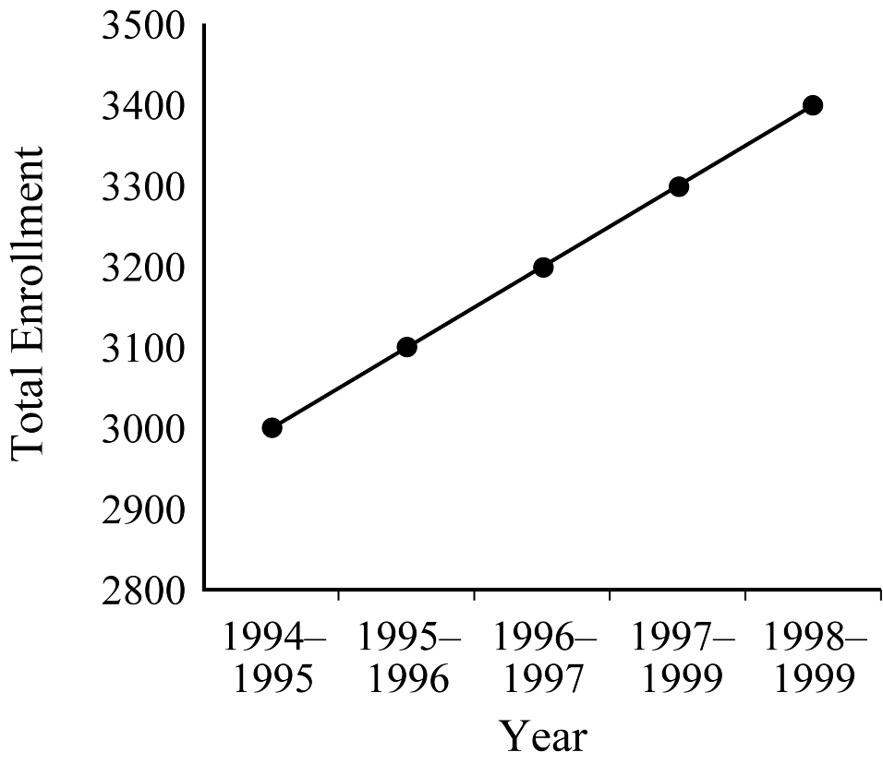
Slope is 100 interpreted as 100 new students each academic year.
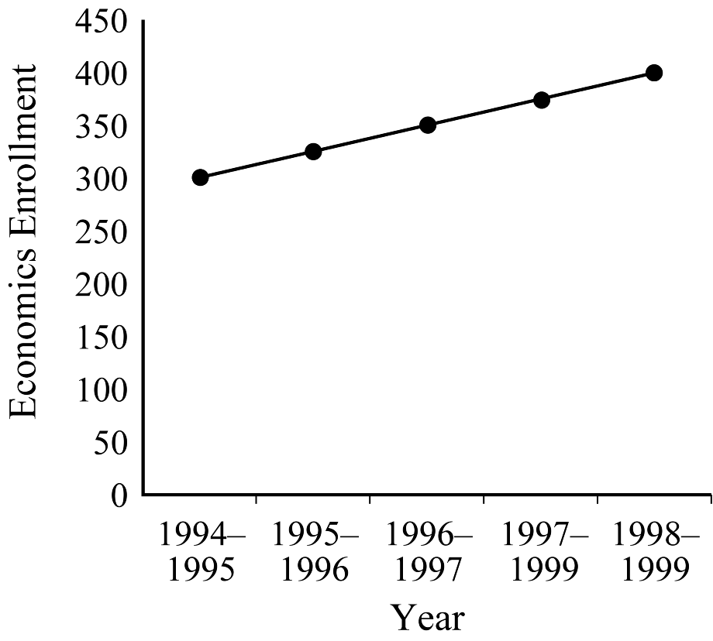
Slope is 25 interpreted as 25 new economics students each academic year.
2. Slope is 0.
3.
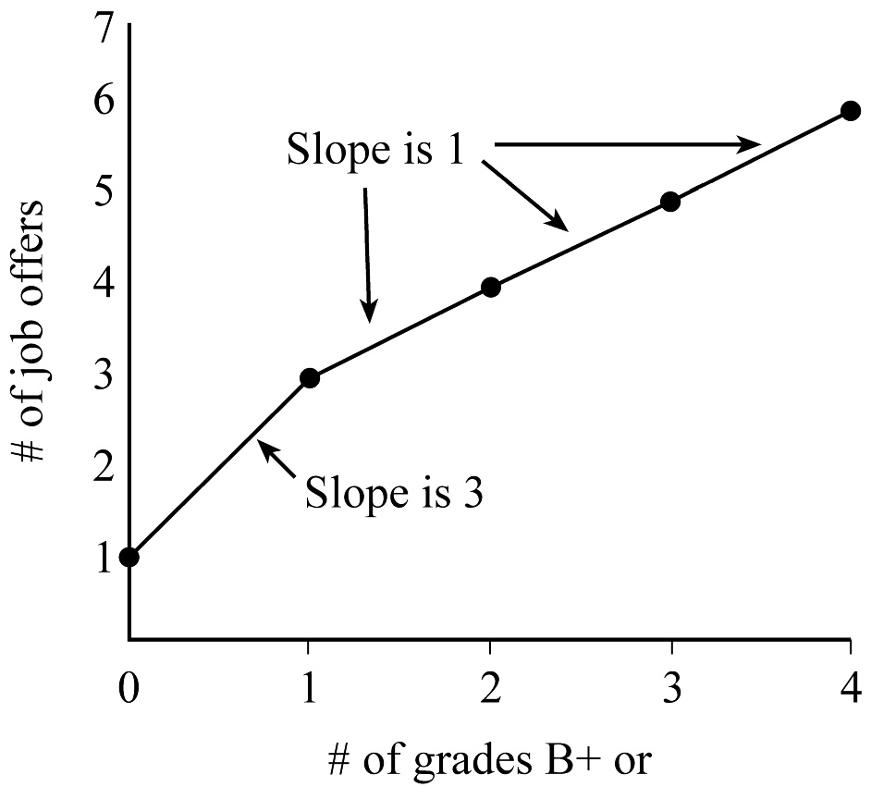
A marginal increase in the number of job offers is relatively larger with the first good grade compared to additional good grades.
4. K = (2,2); E = (2,1)
The “What do you conclude?” question is very vague. Maybe ask “What do you conclude about the slopes of the lines on which K and E are located?”
5. A => 30 hours labor and 40 yds. cloth = 20 units of output.
B => 40 hours labor and 28 yds. cloth = 20 units of output.
Common: 20 units of output; Difference: Amount of labor and cloth charge—more labor, less cloth.

