CHAPTER 2

SCARCITY, CHOICE, AND ECONOMIC SYSTEMS



The objectives of this chapter are to:

1. Construct a production possibilities frontier and use it to explain the concepts of productive inefficiency, recessions, the law of increasing opportunity cost, and economic growth.

2. Explain the sources of the gains from specialization.

3. Define comparative advantage and absolute advantage and explain why specialization according to comparative advantage should be used to maximize production.

4. Apply the concept of comparative advantage to countries to explain trade among nations.

5. Describe the three problems that all economies face in allocating scarce resources.

6. Describe the three methods of resource allocation and give examples of how each method is used in the United States.



Production possibilities frontiers (PPFs) are used to apply the principle of opportunity cost to society’s choices and to demonstrate the law of increasing opportunity cost, productive inefficiency, recessions, and economic growth.

Every economic system over the past 10,000 years has been characterized by specialization and exchange. Specialization and exchange enable us to enjoy greater production and higher living standards than would otherwise be possible. The chapter explains why there are gains from specialization, and discusses some of the problems that may arise from specializing. This is also applied to countries and trade among nations.

*Resource allocation* means deciding how to use our scarce resources; that is, deciding what to produce, how to produce, and for whom to produce. The three methods of resource allocation are tradition, command, and market. While all three methods are used in the United States, the dominant method of resource allocation is the market.

One of the key advantages of a market system is that, in most cases, it forces us to face the opportunity cost of our actions. The chapter ends with an example of what happens when we do *not* face the costs of our actions: the possible overuse of some life-saving techniques and underuse of others.



*In order presented in chapter.*

Production possibilities frontier (PPF): A curve showing all combinations of two goods that can be produced with the resources and technology currently available.

Productively inefficient: A situation in which more of at least one good can be produced without sacrificing the production of any other good.

Specialization: A method of production in which each person concentrates on a limited number of activities.

Exchange: The act of trading with others to obtain what we desire.

Absolute Advantage: The ability to produce a good or service using fewer resources than other producers use.

Comparative Advantage: The ability to produce a good or service at a lower opportunity cost than other producers.

Traditional Economy: An economy in which resources are allocated according to long-lived practices from the past.

Command or centrally planned economy: An economic system in which resources are allocated according to explicit instructions from a central authority.

Market economy: An economic system in which resources are allocated through individual decision making.

Market: A group of buyers and sellers with the potential to trade with each other.

Price: The amount of money that must be paid to a seller to obtain a good or service.



1. An insightful article that describes the strengths and weaknesses of market capitalism is: Robert J. Samuelson, “Capitalism Under Siege,” *Newsweek,* May 6, 1996, p. 51.

2. *PPF*s are concave because the law of increasing opportunity cost holds. To see why, imagine a situation in which the law does not hold. For example, imagine an economy that produces two products: left moccasins and right moccasins.

a. What would its *PPF* look like? (A negatively sloped, 45-degree straight line)

b. Explain *why* the *PPF* has this shape. (Because the resources used to produce left and right moccasins are perfectly adaptable, so the law of increasing opportunity cost does not hold.)

c. What would the PPF look like if the economy produced ankle-high moccasins and knee-high moccasins? (The PPF would still be a negatively sloped straight line, although, since the knee-high moccasins use more material, it would not be a 45‑degree line.)

3. How does an economy’s present choices affect its future possibilities? Construct a production possibilities frontier showing capital goods on one axis and consumption goods on the other axis. Use this *PPF* to demonstrate the following:

a. What will happen to our *PPF* over time if we employ our current resources to produce only consumption goods?

b. How would our *PPF* change over time if we concentrated, instead, on producing just capital goods? What if we only produced enough capital goods to replace the ones that wear out in the current production period? What if we produced more than enough capital goods to replace the ones that wear out in the current period?



1. Labor economists use the concept of opportunity cost to explain how small wage differences between men and women can lead to larger wage differences. The ratio of women’s to men’s median weekly earnings of full-time wage and salary workers in the United States in second quarter of 2011 was 83.5%, according to the Bureau of Labor Statistics (<http://www.bls.gov/news.release/wkyeng.nr0.htm>).

a. Which spouse, generally, has the higher opportunity cost of staying home to take care of children?

b. How might higher market wages for men influence husbands’ and wives’ decisions to enter the job market?

c. How might these decisions to enter the job market influence young men and women’s decisions to pursue higher education? Would higher market wages for men influence men and women’s choices of fields of study?

d. How would these education decisions further effect the ratio of women’s to men’s earnings?

2. Have students test their understanding of the concept of opportunity cost by completing the following exercise.

a. Ask students to estimate the opportunity cost of taking this class. They should include direct expenditures such as tuition, books, and supplies, as well as indirect expenditures such as the value of the time spent in class. Did they forget to include the opportunity cost of time spent preparing for class and studying for exams?

b. Ask the students to compare their opportunity cost calculation with those of a classmate. What factors cause the opportunity costs to vary? Possible answers might include different foregone wages, different backgrounds in economics, and differences in expected effort.



**PROBLEM SET**

1. As society moves from point F to point H to point J and so forth, the opportunity cost of 200,000 additional bushels of wheat rises. Looking at the horizontal axis we see that as we go from point F to H to J and so forth, producing 200,000 additional bushels of wheat requires us to sacrifice more and more tanks. Therefore, the law of increasing opportunity cost does apply to the production of wheat.



2. A technological innovation in life-saving would rotate the PPF out along the horizontal axis, since the maximum number of lives saved would increase while the maximum quantity of all other goods would not change.

3. A technological innovation in the production of other goods would rotate the PPF out along the vertical axis.

4 .

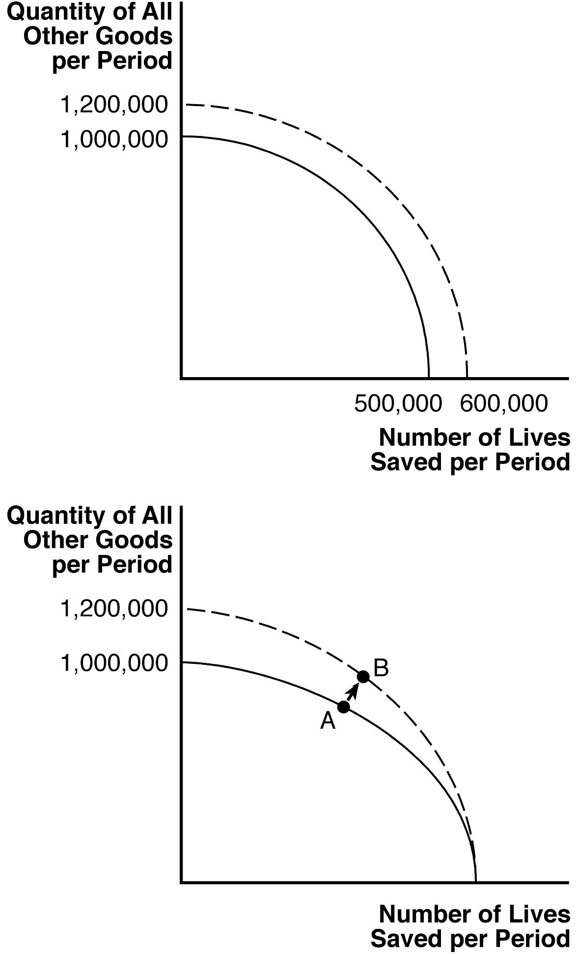

5. a.

|  |  |  |
| --- | --- | --- |
| Labor Requirements for Berries and Fish | | |
|  | **1 Cup of Berries** | **1 Fish** |
| Maryanne | 1 hour | 1 hour |
| Gilligan | ½ hour | ¼ hour |

1. Maryanne has a competitive advantage in picking berries, since her opportunity cost of picking berries is lower than Gilligan’s. Her opportunity cost of picking 1 cup of berries is 1 of a fish, while his opportunity cost of picking 1 cup of berries is 2 fish. Gilligan has a competitive advantage in fishing, since his opportunity cost of fishing is lower than Maryanne’s. His opportunity cost of catching 1 fish is ½ cup of berries, while her opportunity cost of catching 1 fish is 1 cup of berries. When the castaways discover each other, Maryanne should specialize in picking berries, and Gilligan should specialize in fishing.
2. Both castaways can benefit from Gilligan’s new abilities if they specialize in producing the good in which they have the comparative advantage. If Maryanne catches two less fish, she can use the two hours saved to produce two more cups of berries. Similarly, if Gilligan produces one less cup of berries, he saves half an hour, which he can instead use to catch two more fish. The final outcome on the island is no change in fish production and one more cup of berries caught. Thus, if the castaways begin to specialize and exchange goods, they can both benefit.

|  |  |  |
| --- | --- | --- |
|  | Change in Berry Production | Change in Fish Production |
| Maryanne | +2 | −2 |
| Gilligan | −1 | +2 |
| Total Island | +1 | 0 |

6. a.

|  |  |  |
| --- | --- | --- |
| Labor Requirements for Pineapples and Coconuts | | |
|  | **1 Pineapple** | **1 Coconut** |
| Mr. Howell | 1 hour | 1 hour |
| Mrs. Howell | ½ hour | 2 hours |

b. Mrs. Howell has a competitive advantage in picking pineapples, since her opportunity cost of picking pineapples is lower than Mr. Howell’s. Her opportunity cost of picking 1 pineapple is ¼ coconut, while his opportunity cost of picking 1 pineapple is 1 coconut. Mr. Howell has a competitive advantage in picking coconuts, since his opportunity picking coconuts is lower than Mrs. Howell’s. His opportunity cost of picking 1 coconut is 1 pineapple, while her opportunity cost of picking 1 coconut is 4 pineapples. Mrs. Howell should specialize in picking pineapples, and Mr. Howell should specialize in picking coconuts.

1. Before finding each other, Mr. and Mrs. Howell’s total production would be:

|  |  |  |
| --- | --- | --- |
|  | Pineapples | Coconuts |
| Mr. Howell | 6 | 6 |
| Mrs. Howell | 12 | 3 |
| Total | 18 | 9 |

After specializing, their total production would be:

|  |  |  |
| --- | --- | --- |
|  | Pineapples | Coconuts |
| Mr. Howell | 0 | 12 |
| Mrs. Howell | 24 | 0 |
| Total | 24 | 12 |

Specifically, there are 6 more pineapples and 3 more coconuts available to be divided between them.

7. a. You have an absolute advantage in outlining since you can produce four more outlines each day than your friend. You also have an absolute advantage in typing since you can type ten more pages per day than your friend.

b. If you spend a full day doing research, you can produce 6 outlines, but must give up 20 pages of typing; the opportunity cost of each outline is 20/6 = 3 1/3 typed pages. On the other hand, your friend could produce 2 outlines, and would have to give up 10 typed pages; for him, the opportunity cost of each outline is 10/2 = 5 typed pages. Thus, your opportunity cost of research is lower than your friend’s—you have the *comparative advantage* in research. (By similarly calculating the opportunity cost in terms of “outlines foregone” of one typed page for both you and your friend, you find that your friend has a comparative advantage in typing.)

c. According to the principle of comparative advantage, you should specialize in research, leaving all the typing to your friend.

8. If the PPF is a downward-sloping straight line, then the law of increasing opportunity cost does not hold. Instead, the opportunity cost of producing an additional unit of good 1 or good 2 remains constant as more of either is produced (i.e., there are constant opportunity costs in production).



**MORE CHALLENGING**

9. a. Because each bushel of soybean is exchanged for 3 T-shirts, and the U.S. exports 90 bushels of soybean, we know that the U.S. will receive 3*90 = 270 T-shirts.

1. After trade with China, Americans will have 10 more bushels of soybean, and 70 more T-shits to consume.

Changes in the U.S. due to partial specialization and trade with China

|  |  |  |
| --- | --- | --- |
|  | Soybeans (Bushels) | T-Shirts |
| United States production | +100 | −200 |
| From trade with China | −90 | +270 |
| Available in U.S. after trade | +10 | +70 |

1. After trade with the U.S., the Chinese will have 10 more bushels of soybean, and 130 more T-shits to consume.

Changes in the China due to partial specialization and trade with the U.S.

|  |  |  |
| --- | --- | --- |
|  | Soybeans (Bushels) | T-Shirts |
| Chinese production | −80 | +400 |
| From trade with U.S. | +90 | −270 |
| Available in China after trade | +10 | +130 |

1. This statement is false. We can see that trade benefits both the U.S. and China as both countries have more of both goods available after trade.

10. The statement is false. Just because one method is cheaper *per life-year saved* does not mean that fully implementing that method is cheaper in *total*. The cost per life-year saved is a fraction: total cost in the numerator divided by life-years saved in the denominator. We cannot draw conclusions about the size of the numerator (total cost) from the size of the entire fraction (cost per life-year saved). For example, vaccinating all adolescents might cost more in total, but still have a lower cost per life-year saved (as in the table) because it saves so many more life years than would seat belts on all school buses.

**EXPERIENTIAL EXERCISES**

The ability to measure the true cost of a choice is a skill that will pay you great dividends. Using a recent issue of the *Wall Street Journal*, try to find an article that discusses a decision some firm has made. Then review this chapter’s section on “The Concept of Opportunity Cost.” Finally, make a list of the kinds of cost involved in the firm’s decision. Identify each item in your list as an explicit cost or an implicit cost.