Chapter 2
A Framework for Analysis

n Solutions to Problems

1. Proximate causes are causes that directly affect the variable of interest. Low levels of physical and human capital, technology, and efficiency are all examples of a proximate cause of low GDP per capita.

2. Fundamental causes are causes that indirectly affect the variable of interest by systematically affecting one or many other causes that in turn affect the variable of interest. Possible fundamental causes may be government, culture, ethnic composition, rule of law, geography, climate, resources, and so forth. These causes affect GDP per capita by affecting the proximate causes of low GDP per capita.

3. To show different levels of factors of production, the figures must not intersect at the same level of output. To show different levels of productivity, the figures must have different slopes. In the figure below, Country 1 and Country 2 have the same level of output per worker. However, Country 1
has a higher level of factors of production than does Country 2, and Country 1 has a lower level of productivity than does Country 2.

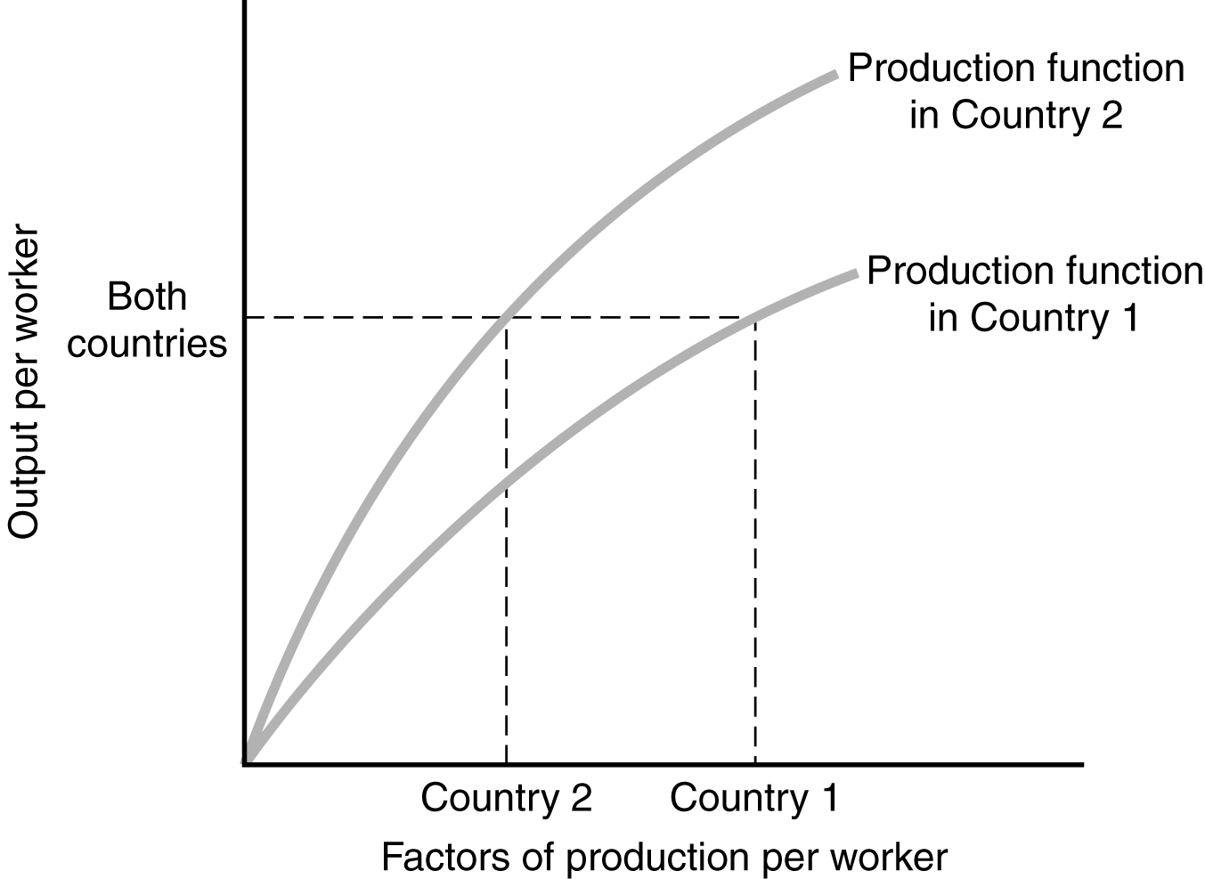

4. In the long run, the two countries would be expected to have the same levels (and thus growth rates) of income, because they have the same fundamentals. In the short run Country B would be expected to have faster growth because the two countries are moving toward having similar income levels, but Country B is starting out with a lower level.

5. A correct solution is a variable that systematically rises or falls only because of a rise or fall in
GDP per capita. Take for instance expenditures on unproductive luxury items. It is reasonable to conclude that as GDP per capita rises, individuals allocate a larger amount of money to purchasing unproductive luxury items. Hence, with a rise in GDP per capita, we should see an increase in expenditures on unproductive luxury items because of increased income. However, it is unreasonable to assume that a rise in expenditures on unproductive luxury items raises GDP per capita.

An example of an incorrect solution would be health. While it is reasonable to assume that a rise in GDP per capita will raise the health level of a country, it is also reasonable to say that a rise in health will result in a rise in GDP per capita. As income increases, there will be a larger amount of money to increase the health of the population. However, a healthier population is also able to work harder and increase income levels as well. In this situation, we have both direct and reverse causation.

6. Simply finding a correlation between being overweight and having a heart attack does not imply causation. The correlation could be due to a missing variable like genetics which may be a factor in
a person’s weight as well as put him or her at risk for a heart attack. Also, reverse causation may be the reason for the correlation if heart disease has incapacitated a person, thus making him or her unable to exercise which leads to obesity.

7. a. Although the majority of right-wing voters may live longer, the inference that being a political conservative is good for you is incorrect because correlation does not imply causation. A likely omitted variable is wealth. Right wing voters may live longer because they are wealthier, and thus able to afford healthier lifestyles and better medical care. Being wealthier may also lead them to embrace right-wing politics.

b. The statistical problem is reverse causation: the people are in the hospital because they are sick and not sick because they are in the hospital.

8. a. Positive Correlation. It is reasonable to assume that higher (lower) GDP per capita increases (decreases) available expenditure for printing books. Moreover, it is also reasonable to assume that a greater (smaller) number of books printed per capita increases (decreases) the level of education within a country, translating into higher (lower) levels of GDP per capita.

b. Negative Correlation. The higher GDP is per capita, the more likely it is that basic nutrition needs of the population will be met, and the smaller the number of people suffering from malnutrition, the more likely it is that there will be a healthier labor force to produce higher levels of GDP per capita. Hence, higher GDP per capita should be correlated with lower fractions of people suffering from malnutrition and vice versa.

c. No Correlation or Positive Correlation. There are two things to consider. First, does eyesight progressively deteriorate with age? Second, does the level of GDP positively affect both one’s ability to diagnose and correct vision problems and one’s life expectancy through access to better nutrition, health care, and so on? If one does not assume the above to be true, then there should be no correlation between life expectancy and the population that wears eyeglasses. On the other hand, if one does assume the above to be true, then one should see high life expectancy figures when one sees a high fraction of people wearing eyeglasses, for the simple reason that there is a large elderly population with poor vision able to afford glasses.

d. No Correlation. There is no obvious relationship between the number of letters in a country’s name and the number of automobiles per capita.

9. To construct a randomized controlled trial, one would advertise the study on the campus, and once a certain number of subjects (enough to give the RCT statistical power) has signed up, subjects would be randomized into two groups: treatment and control. The treatment group would receive the drug, while the control group would not. To assess the outcomes, first randomization has to be checked, by showing that there is no statistically significant difference between the treatment and control groups and then the outcome variable (GPA or something like it) would be compared between treatment and control. From a logistical point of view, it is crucial to insure that students who have been assigned to the control group do not have access to the drug and the students who have been assigned to the treatment group do actually take the drug. (Note that if this does not work properly, one can still use intent-to-treat to come up with meaningful econometric estimates for the effects of the drug.) When it comes to ethical considerations, it is essential to inform subjects about possible side-effects and it would be considered unethical to keep running the trial if some of them turn out to be very harmful, for example, if there is a systematic decrease in student achievement in the treatment group. There might be several problems when trying to draw a general conclusion. For example, the external validity of such an RCT might be limited by the particular setting it was conducted in or the particular students who chose to take part in the study.

