Chapter 2

ECONOMIC TOOLS AND eCONOMIC sYSTEMS

## SOLUTIONS TO END OF CHAPTER PROBLEMS

1. This question highlights the importance of ignoring sunk costs in marginal decision making. Once you have purchased the meal, you cannot get your money back whether or not you finish the meal. There is no benefit to overeating.

2. The opportunity cost is the total cost of going to Florida and includes dollar costs incurred as well as the forgone opportunity of working. Assuming you would work for 5 days if you stayed home, the opportunity cost of going to Florida would total $1,000: the $700 cost of going to Florida plus the net value of what you could have earned—$300 ($400 in earnings less expenses of $100)—if you stayed home.

3.

a. In the United Kingdom, the opportunity cost of one unit of wheat is 1/3 unit of cloth (producing one unit of wheat uses 2 labor hours, the amount of resource that would allow you to produce only 1/3 unit of cloth). In the United States, the opportunity cost of one unit of wheat is 1/5 unit of cloth (producing one unit of wheat uses 1 labor hour, the amount of resource that would allow you to produce only 1/5 unit of cloth).

b. The United States has an absolute advantage in both goods; it is able to produce both products with fewer resources than the United Kingdom requires.

c. The United States has a comparative advantage in wheat because it has the lowest opportunity cost of producing (1/5 unit of cloth versus 1/3 unit of cloth for the United Kingdom), while the United Kingdom has the comparative advantage in cloth. (The opportunity cost of cloth in the United States is 5 units of wheat. The opportunity cost of cloth in the United Kingdom is 3 units of wheat.)

d. The United States should specialize in wheat, and the United Kingdom should specialize in cloth. The country with the lower opportunity cost of producing a good should specialize in producing that output.

4. Students’ answers will vary according to their experiences. One specialized market is that for military weapons. The stock exchange provides a specialized market for buying and selling company shares, and there are specialized markets for selling government bonds and foreign currencies. Specialized retail outlets could include movie theaters specializing in “art” films, wine shops, cheese shops, language schools, and so forth. Media such as the Web allow firms in specialized markets to advertise their products at relatively low costs and also permit customers to conduct interactive online searches for relatively specialized goods and services.

5.

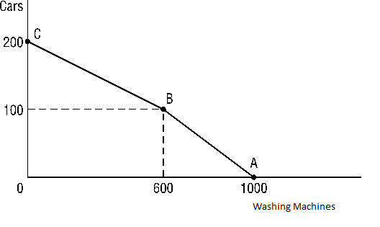

a. The PPF drawn above is composed of two straight-line segments: *AB* and *BC*.

b. The cost of a car when 50 cars are produced is 4 washing machines. In segment *AB*, as you move from 0 to 100 cars, you must give up 1,000 − 600 = 400 washing machines. Thus, each additional car costs 400/100 = 4 washing machines along segment *AB* of this PPF.

c. The cost of a car when 150 cars are produced is 6 washing machines. In segment *BC* of this PPF, as you move from 100 to 200 cars, you must forgo 600 washing machines. Thus, each additional car costs 600/100 = 6 washing machines along segment *BC* of this PPF. 150 cars cost you 6 washing machines.

d. The cost of a washing machine when 50 cars are produced is one-fourth of a car. In segment *AB*, as you move from 600 to 1,000 washing machines, you must forgo 100 cars. {[100/(1000 − 600)]} = 1/4, the slope of segment *AB* of the PPF. Note: The PPF would indicate that when 50 cars are produced, 800 washing machines can be produced.

The cost of an additional washing machine when 150 cars are produced is one-sixth of a car. In segment *BC*, as you move from 0 to 600 washing machines, you must forgo 100 cars. (100/600) = 1/6, the slope of segment *BC* of the PPF. Note: The PPF indicates that when 150 cars are produced, only 300 washing machines are produced. Also note that the answers to this question are the inverse of the answers to questions (b) and (c).

e. As you increase the production level of either good, its opportunity cost eventually increases. When you go from 50 cars produced to 150 cars produced, the cost in terms of washing machines forgone rises from 4 washing machines to 6 washing machines. When you go from 300 washing machines produced to 800 washing machines produced, the opportunity cost in terms of cars forgone rises from 1/6 of a car to 1/4 of a car.

6. The PPF will shift inward along the axis measuring cloth production and outward along the axis measuring wheat production. This is represented by a shift from *CD* to *AB* on the following graph:

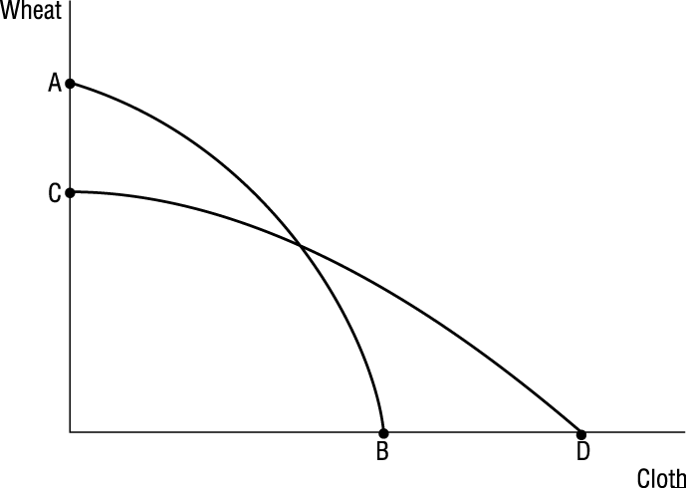

7.

a. 0203

b. Moving upward and to the left along the PPF could be represented by a move from point *C* to point *B*. You would be giving up some partying to engage in more studying. You would have to adjust your schedule so that you would frequent places where there were inducements to study rather than to party. The library, a quiet spot in the cafeteria, or a café playing classical music and offering quiet solitude would be your quest for at least a few more hours of the week.

c. The PPF drawn assumes that you have a fixed amount of time as well as some capital. The time you have available can’t change; there are only 24 hours in a day. However, your study skills could be enhanced by training or by acquiring a new computer. This increase in skills and capital in the production of studying would shift the PPF outward along the vertical axis indicating that you are able to accomplish more studying with the same time constraint. A parallel shift in the PPF could occur if that new computer also allowed you greater satisfaction partying, if, for example, the Internet opened you to new opportunities for parties.

8. Items a, c, and d all decrease the amount of labor available; thus, the PPF would shift inward. Item b increases the available labor, and thus the PPF would shift outward.

9. The government represents an element of command in the U.S. economy. Government accounts for about one-third of all economic activity. In addition, government regulates the private economy in a number of areas including antitrust laws, workplace safety, zoning, food safety, illegal activities, and so on. Elements of tradition or custom would include style of dress, similarity in choice of children’s occupations to that of their parents, and fierce adherence to the English system of measurement rather than the metric system used by the rest of the world.