Chapter 2

An Introduction to Forwards and Options

Question 2.1
The payoff diagram of the stock is just a graph of the stock price as a function of the stock price:
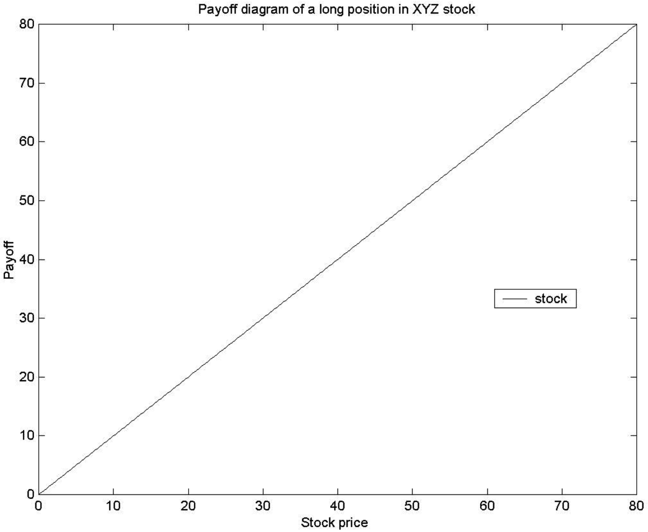
In order to obtain the profit diagram at expiration, we have to finance the initial investment. We do so by selling a bond for $50. After one year, we have to pay back: $50 × (1 + 0.1) = $55. The second figure (on the next page) shows the graph of the stock, of the bond to be repaid, and of the sum of the two positions, which is the profit graph. The arrows show that at a stock price of $55, the profit at expiration is indeed zero.
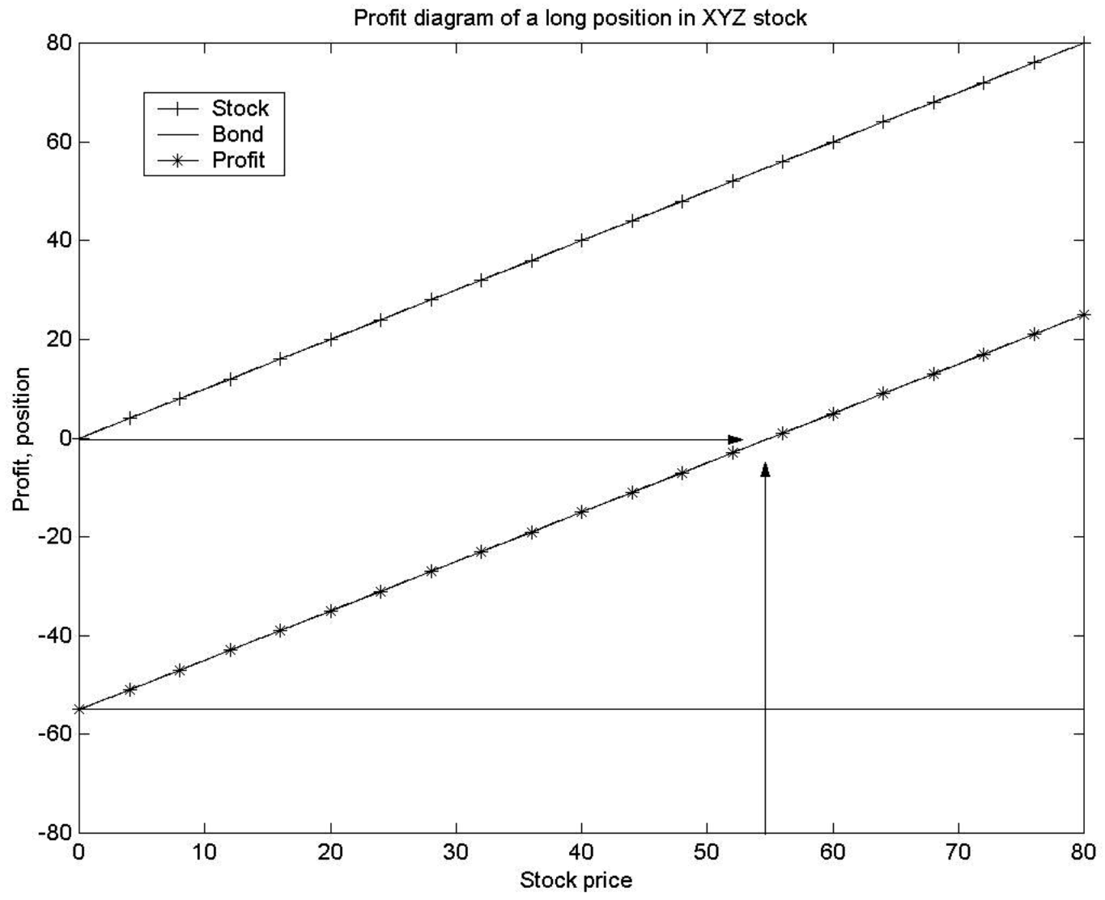

Question 2.2
Since we sold the stock initially, our payoff at expiration from being short the stock is negative.
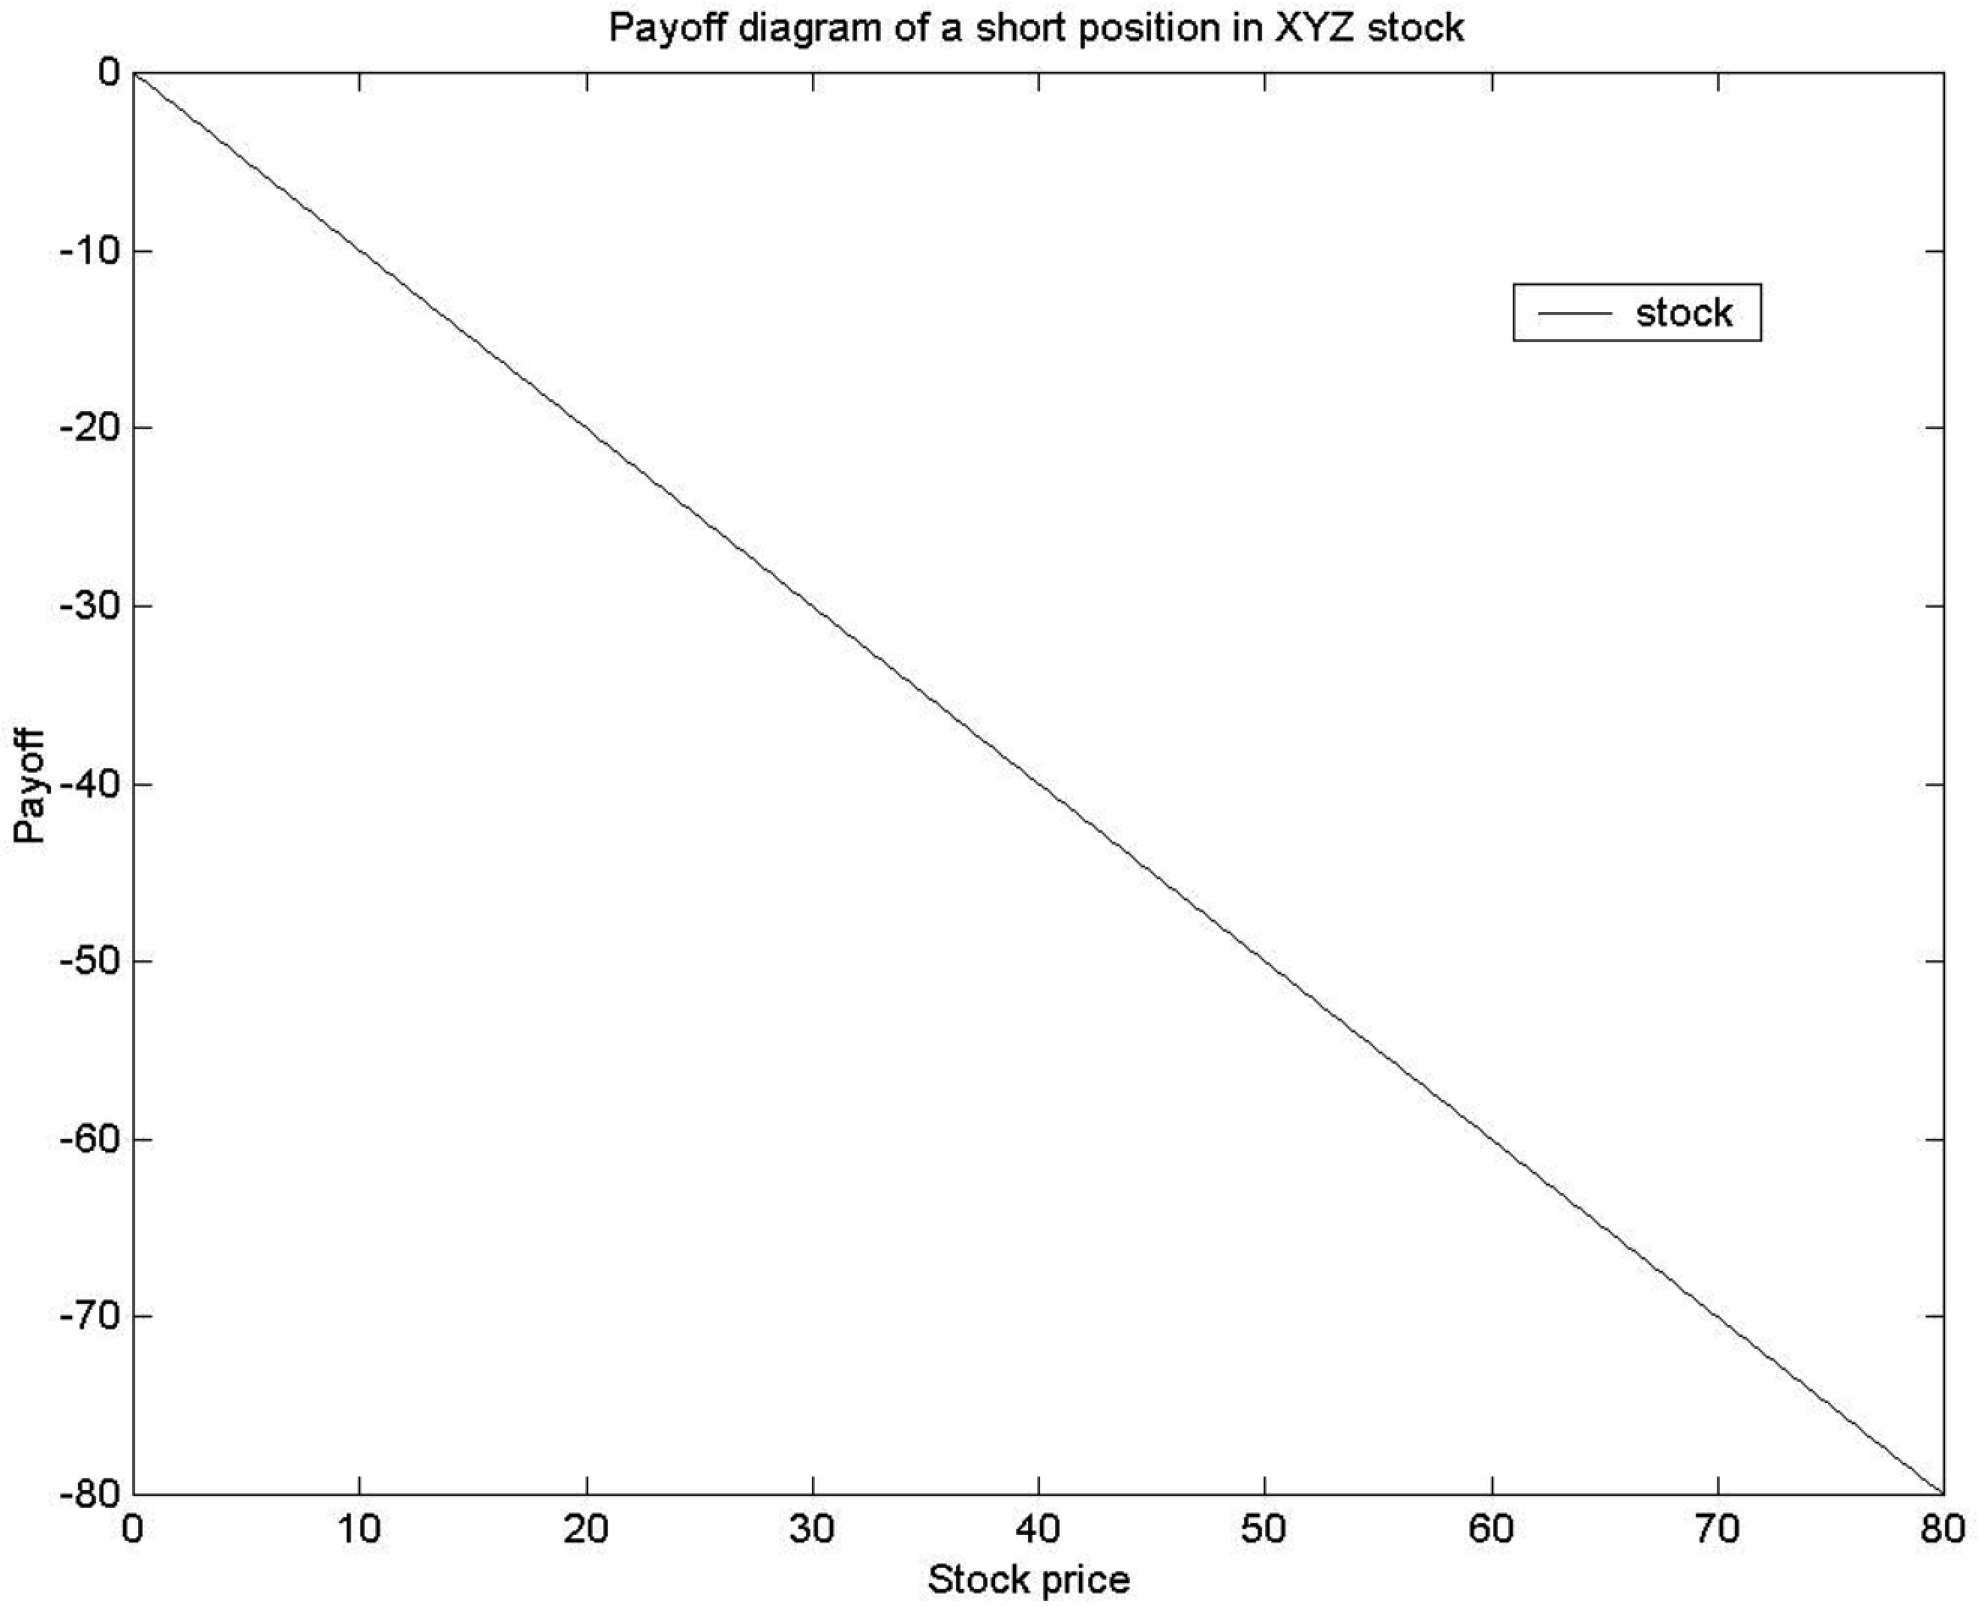
In order to obtain the profit diagram at expiration, we have to lend out the money we received from the short sale of the stock. We do so by buying a bond for $50. After one year, we receive from the investment in the bond: $50 × (1 + 0.1) = $55. The second figure shows the graph of the sold stock, of the money we receive from the investment in the bond, and of the sum of the two positions, which is the profit graph. The arrows show that at a stock price of $55, the profit at expiration is indeed zero.
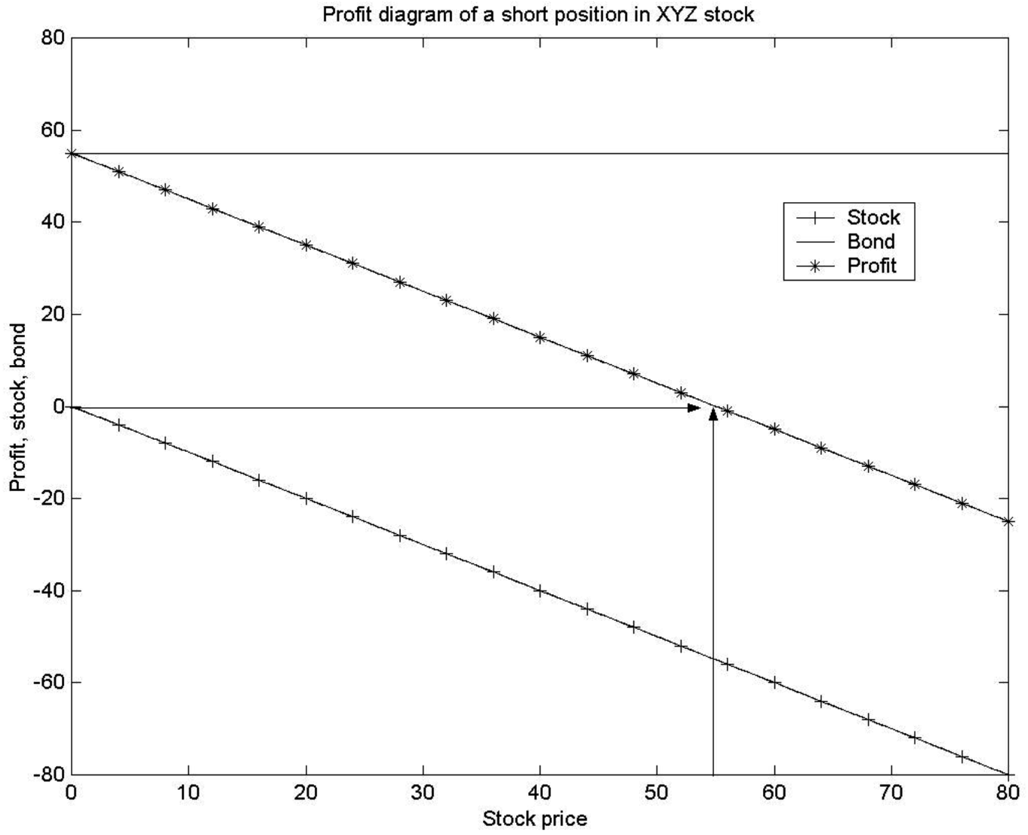

Question 2.3
The position that is the opposite of a purchased call is a written call. A seller of a call option is said to be the option writer or to have a short position. The call option writer is the counterparty to the option buyer, and his payoffs and profits are just the opposite of those of the call option buyer.
Similarly, the position that is the opposite of a purchased put option is a written put option. Again, the payoff and profit for a written put are just the opposite of those of the purchased put.
It is important to note that the opposite of a purchased call is NOT the purchased put. If you do not see why, please draw a payoff diagram with a purchased call and a purchased put.

Question 2.4
a) The payoff to a long forward at expiration is equal to:
Payoff to long forward = Spot price at expiration – forward price
Therefore, we can construct the following table:
Price of asset in six months | Agreed forward price | Payoff to the long forward
40 | 50 | −10
45 | 50 | −5
50 | 50 | 0
55 | 50 | 5
60 | 50 | 10

b) The payoff to a purchased call option at expiration is:
Payoff to call option = max[0, spot price at expiration – strike price]
The strike is given: It is $50. Therefore, we can construct the following table:
Price of asset in six months | Strike price | Payoff to the call option
40 | 50 | 0
45 | 50 | 0
50 | 50 | 0
55 | 50 | 5
60 | 50 | 10

c) If we compare the two contracts, we immediately see that the call option has a protection for adverse movements in the price of the asset: If the spot price is below $50, the buyer of the call option can walk away and need not incur a loss. The buyer of the long forward incurs a loss, but he has the same payoff as the buyer of the call option if the spot price is above $50. Therefore, the call option should be more expensive. It is this attractive option to walk away that we have to pay for.

Question 2.5
a) The payoff to a short forward at expiration is equal to:
Payoff to short forward = forward price – spot price at expiration
Therefore, we can construct the following table:
Price of asset in six months | Agreed forward price | Payoff to the short forward
40 | 50 | 10
45 | 50 | 5
50 | 50 | 0
55 | 50 | −5
60 | 50 | −10
b) The payoff to a purchased put option at expiration is:
Payoff to put option = max[0, strike price – spot price at expiration]
The strike is given: It is $50. Therefore, we can construct the following table:
Price of asset in six months | Strike price | Payoff to the call option
40 | 50 | 10
45 | 50 | 5
50 | 50 | 0
55 | 50 | 0
60 | 50 | 0
c) The same logic as in question 2.4 (c) applies. If we compare the two contracts, we see that the put option has a protection for increases in the price of the asset: If the spot price is above $50, the buyer of the put option can walk away and need not incur a loss. The buyer of the short forward incurs a loss and must meet her obligations. However, she has the same payoff as the buyer of the put option if the spot price is below $50. Therefore, the put option should be more expensive. It is this attractive option to walk away if things are not as we want that we have to pay for.

Question 2.6
We need to solve the following equation to determine the effective annual interest rate: $91 × (1 + r) = $100. We obtain r = 0.0989, which means that the effective annual interest rate is approximately 9.9 percent.
Remember that when we drew profit diagrams for the forward or call option, we drew the payoff on the vertical axis, and the index price at the expiration of the contract on the horizontal axis. In this case, the particularity is that the default-free, zero-coupon bond will pay exactly $100, no matter what the stock price is. Therefore, the payoff diagram is just a horizontal line, intersecting the y-axis at $100.
The textbook provides the answer to the question concerning the profit diagram in the section “Zero-Coupon Bonds in Payoff and Profit Diagrams.” When we were calculating profits, we saw that we had to find the future value of the initial investment. In this case, our initial investment is $91. How do we find the future value? We use the current risk-free interest rate and multiply the initial investment by it. However, as our bond is default-free and does not bear coupons, the effective annual interest rate is exactly the 9.9 percent we have calculated before. Therefore, the future value of $91 is $91 × (1 + 0.0989) = $100, and our profit in six months is zero!

Question 2.7
a) It does not cost anything to enter into a forward contract—we do not pay a premium. Therefore, the payoff diagram of a forward contract coincides with the profit diagram. The graphs have the following shape:
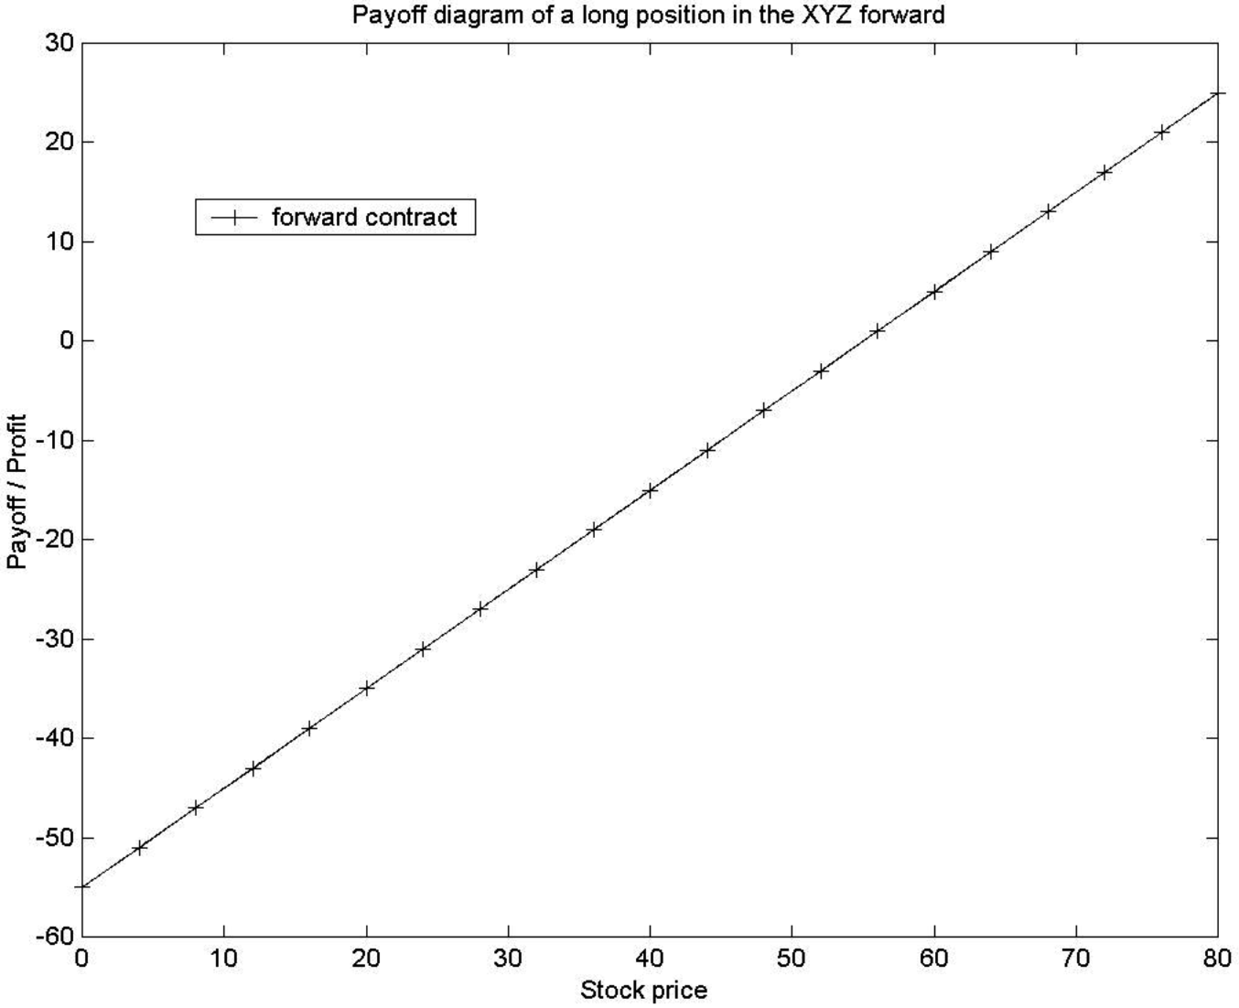
b) We have seen in question 2.1 that in order to obtain the profit diagram at expiration of a purchase of XYZ stock, we have to finance the initial investment. We did so by selling a bond for $50. After one year, we had to pay back: $50 × (1 + 0.1) = $55. Therefore, our total profit at expiration from the purchase of a stock that was financed by a loan was: $S_{T} − $55, where S_{T} is the value of one share of XYZ at expiration. But this profit from buying the stock, and financing it is the same as the profit from our long forward contract, and both positions do not require any initial cash—but then, there is no advantage in investing in either instrument.
c) The dividend is only paid to the owner of the stock. The owner of the long forward contract is not entitled to receive the dividend because she only has a claim to buy the stock in the future for a given price, but she does not own it yet. Therefore, it does matter now whether we own the stock or the long forward contract. Because everything else is the same as in part a) and b), it is now beneficial to own the share: We can receive an additional payment in the form of the dividend if we own the stock at the ex-dividend date. This question hints at the very important fact that we have to be careful to take into account all the benefits and costs of an asset when we try to compare prices. We will encounter similar problems in later chapters.

Question 2.8
We saw in question 2.7 (b) that there is no advantage in buying either the stock or the forward contract if we can borrow to buy a stock today (so both strategies do not require any initial cash) and if the profit from this strategy is the same as the profit of a long forward contract. The profit of a long forward contract with a price for delivery of $53 is equal to: $S_{T} − $53, where S_{T} is the (unknown) value of one share of XYZ at expiration of the forward contract in one year. If we borrow $50 today to buy one share of XYZ stock (that costs $50), we have to repay in one year: $50 × (1 + r). Our total profit in one year from borrowing to buy one share of XYZ is therefore: $S_{T} − $50 × (1 + r). Now we can equate the two profit equations and solve for the interest rate r:
$S_{T} − $53 = $S_{T} − $50 × (1 + r)
⇔ $53 = $50 × (1 + r)
⇔ = r
⇔ r = 0.06
Therefore, the one-year effective interest rate that is consistent with no advantage to either buying the stock or forward contract is 6 percent.

Question 2.9
a) If the forward price is $1,100, then the buyer of the one-year forward contract receives at expiration after one year a profit of: $S_{T} − $1,100, where S_{T} is the (unknown) value of the S&R index at expiration of the forward contract in one year. Remember that it costs nothing to enter the forward contract.
Let us again follow our strategy of borrowing money to finance the purchase of the index today, so that we do not need any initial cash. If we borrow $1,000 today to buy the S&R index (that costs $1,000), we have to repay in one year: $1,000 × (1 + 0.10) = $1,100. Our total profit in one year from borrowing to buy the S&R index is therefore: $S_{T} − $1,100. The profits from the two strategies are identical.
b) The forward price of $1,200 is worse for us if we want to buy a forward contract. To understand this, suppose the index after one year is $1,150. While we have already made money in part a) with a forward price of $1,100, we are still losing $50 with the new price of $1,200. As there was no advantage in buying either the stock or forward at a price of $1,100, we now need to be “bribed” to enter into the forward contract. We somehow need to find an equation that makes the two strategies comparable again. Suppose that we lend some money initially together with entering into the forward contract so that we will receive $100 after one year. Then, the payoff from our modified forward strategy is: $S_{T} − $1,200 + $100 = $S_{T} − $1,100, which equals the payoff of the “borrow to buy index” strategy. We have found the future value of the premium somebody needs us to pay. We still need to find out what the premium we will receive in one year is worth today.
We need to discount it: $100/(1 + 0.10) = $90.91.
c) Similarly, the forward price of $1,000 is advantageous for us. As there was no advantage in buying either stock or forward at a price of $1,100, we now need to “bribe” someone to sell this advantageous forward contract to us. We somehow need to find an equation that makes the two strategies comparable again. Suppose that we borrow some money initially together with entering into the forward contract so that we will have to pay back $100 after one year. Then, the payoff from our modified forward strategy is: $S_{T} − $1,000 − $100 = $S_{T} − $1,100, which equals the payoff of the “borrow to buy index” strategy. We have found the future value of the premium we need to pay. We still need to find out what this premium we have to pay in one year is worth today. We simply need to discount it: $100/(1 + 0.10) = $90.91. We should be willing to pay $90.91 to enter into the one-year forward contract with a forward price of $1,000.

Question 2.10
a) Figure 2.6 depicts the profit from a long call option on the S&R index with six months to expiration and a strike price of $1,000 if the future price of the option premium is $95.68. The profit of the long call option is:
max[0, S_{T} − $1,000] − $95.68
⇔ max[−$95.68, S_{T} − $1,095.68]
where S_{T} is the (unknown) value of the S&R index at expiration of the call option in six months. In order to find the S&R index price at which the call option diagram intersects the x-axis, we have to set the above equation equal to zero. We get: S_{T} − $1,095.68 = 0 ⇔ S_{T} = $1,095.68. This is the only solution, as the other part of the maximum function, −$95.68, is always less than zero.
b) The profit of the six month forward contract with a forward price of $1,020 is: $S_{T} − $1,020. In order to find the S&R index price at which the call option and the forward contract have the same profit, we need to set both parts of the maximum function of the profit of the call option equal to the profit of the forward contract and see which part permits a solution. First, we see immediately that $S_{T} − $1,020 = $S_{T} − $1,095.68 does not have a solution. But we can solve the other leg: $S_{T} − $1,020 = −$95.68 ⇔ S_{T} = $924.32, which is the value given in the exercise.

Question 2.11
a) Figure 2.8 depicts the profit from a long put option on the S&R index with six months to expiration and a strike price of $1,000 if the future value of the put premium is $75.68. The profit of the long put option is:
max[0, $1, 000 − S_{T} ] − $75.68
⇔ max[−$75.68, $924.32 − S_{T} ]
where S_{T} is the (unknown) value of the S&R index at expiration of the put option in six months. In order to find the S&R index price at which the put option diagram intersects the x-axis, we have to set the above equation equal to zero. We get: $924.32 − S_{T} = 0 ⇔ S_{T} = $924.32. This is the only solution, as the other part of the maximum function, −$75.68, is always less than zero.
b) The profit of the short six-month forward contract with a forward price of $1,020 is: $1,020 − $S_{T}. In order to find the S&R index price at which the put option and the sold forward contract have the same profit, we need to set both parts of the maximum function of the profit of the put option equal to the profit of the forward contract and see which part permits a solution. First, we see immediately that $1,020 − $S_{T} = $924.32 − $S_{T} does not have a solution. But we can solve the other leg: $1,020 − S_{T} = −$75.68 ⇔ S_{T} = $1,095.68, which is the value given in the exercise.

Question 2.12
a) Long Forward
The maximum loss occurs if the stock price at expiration is zero (the stock price cannot be less than zero because companies have limited liability). The forward then pays 0 – Forward price. The maximum gain is unlimited. The stock price at expiration could theoretically grow to infinity; there is no bound. We make a lot of money if the stock price grows to infinity (or to a very large amount).
b) Short Forward
The profit for a short forward contract is forward price – stock price at expiration. The maximum loss occurs if the stock price rises sharply; there is no bound to it, so it could grow to infinity. The maximum gain occurs if the stock price is zero.
c) Long Call
We will not exercise the call option if the stock price at expiration is less than the strike price. Consequently, the only thing we lose is the future value of the premium we paid initially to buy the option. As the stock price can grow very large (and without bound), and our payoff grows linearly in the terminal stock price once it is higher than the strike, there is no limit to our gain.
d) Short Call
We have no control over the exercise decision when we write a call. The buyer of the call option decides whether to exercise it or not, and he will only exercise the call if he makes a profit. As we have the opposite side, we will never make any money at the expiration of the call option. Our profit is restricted to the future value of the premium, and we make this maximum profit whenever the stock price at expiration is smaller than the strike price. However, the stock price at expiration can be very large and has no bound, and as our loss grows linearly in the terminal stock price, there is no limit to our loss.
e) Long Put
We will not exercise the put option if the stock price at expiration is larger than the strike price. Consequently, the only thing we lose whenever the terminal stock price is larger than the strike is the future value of the premium we paid initially to buy the option. We will profit from a decline in the stock prices. However, stock prices cannot be smaller than zero, so our maximum gain is restricted to strike price less the future value of the premium, and it occurs at a terminal stock price of zero.
f) Short Put
We have no control over the exercise decision when we write a put. The buyer of the put option decides whether to exercise or not, and he will only exercise if he makes a profit. As we have the opposite side, we will never make any money at the expiration of the put option. Our profit is restricted to the future value of the premium, and we make this maximum profit whenever the stock price at expiration is greater than the strike price. However, we lose money whenever the stock price is smaller than the strike; hence, the largest loss occurs when the stock price attains its smallest possible value, zero. We lose the strike price because somebody sells us an asset for the strike that is worth nothing. We are only compensated by the future value of the premium we received.

Question 2.13
a) In order to be able to draw profit diagrams, we need to find the future values of the call premia. They are:
i) 35-strike call: $9.12 × (1 + 0.08) = $9.8496
ii) 40-strike call: $6.22 × (1 + 0.08) = $6.7176
iii) 45-strike call: $4.08 × (1 + 0.08) = $4.4064
We can now graph the payoff and profit diagrams for the call options. The payoff diagram looks as follows:
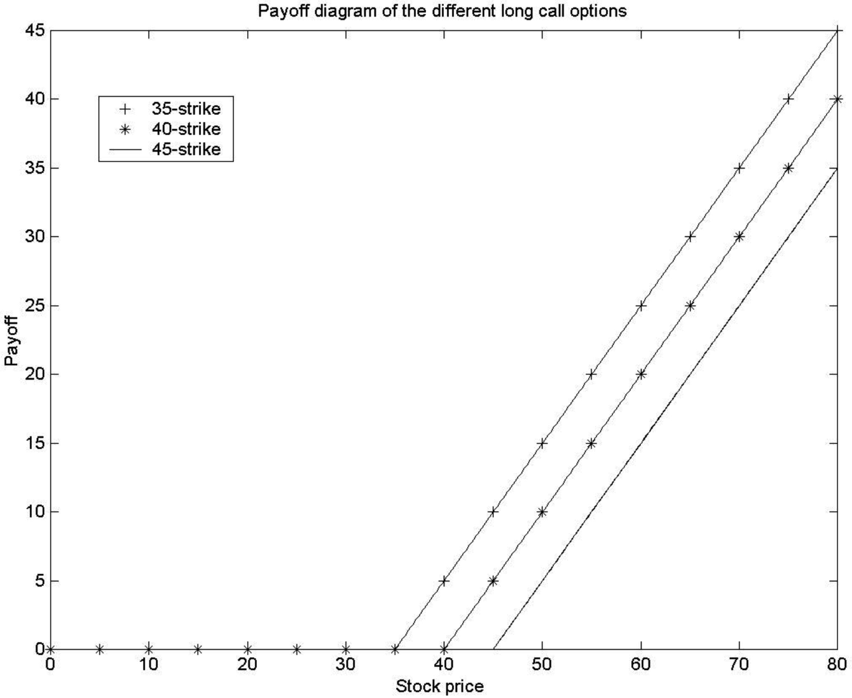
We get the profit diagram by deducting the option premia from the payoff graphs. The profit diagram looks as follows:
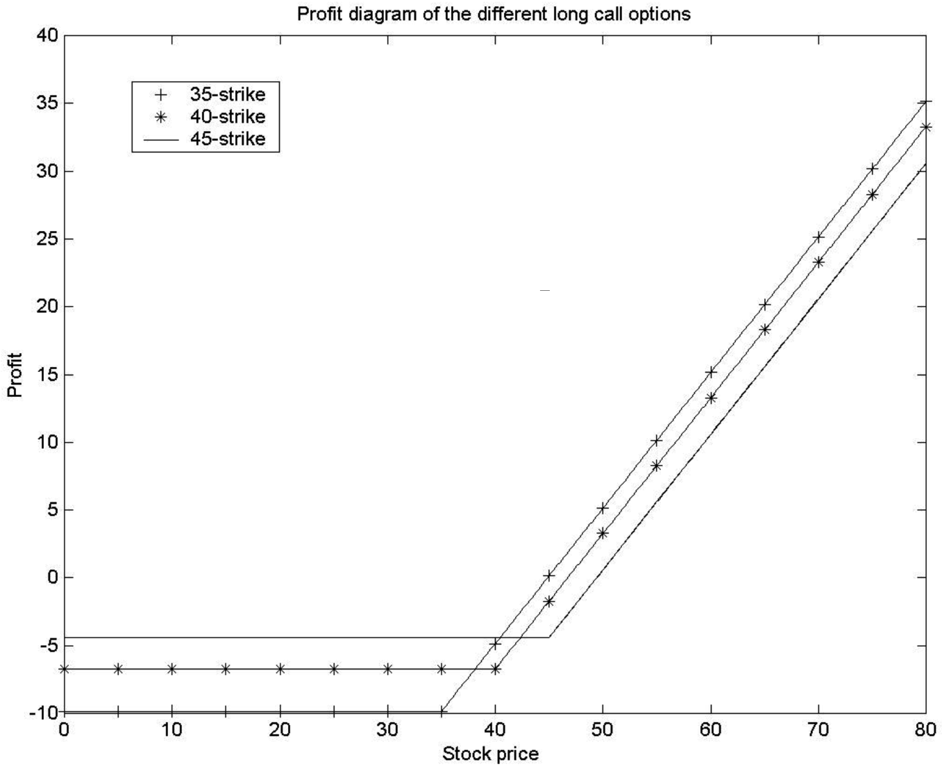
b) Intuitively, whenever the 45-strike option pays off (i.e., has a payoff bigger than zero), the 40-strike and the 35-strike options pay off. However, there are some instances in which the 40-strike option pays off and the 45-strike option does not. Similarly, there are some instances in which the 35-strike option pays off but neither the 40-strike nor the 45-strike pay off. Therefore, the 35-strike offers more potential than the 40- and 45-strike, and the 40-strike offers more potential than the 45-strike. We pay for these additional payoff possibilities by initially paying a higher premium.

Question 2.14
In order to be able to draw profit diagrams, we need to find the future values of the put premia. They are:
a) 35-strike put: $1.53 × (1 + 0.08) = $1.6524
b) 40-strike put: $3.26 × (1 + 0.08) = $3.5208
c) 45-strike put: $5.75 × (1 + 0.08) = $6.21
We get the following payoff diagrams:
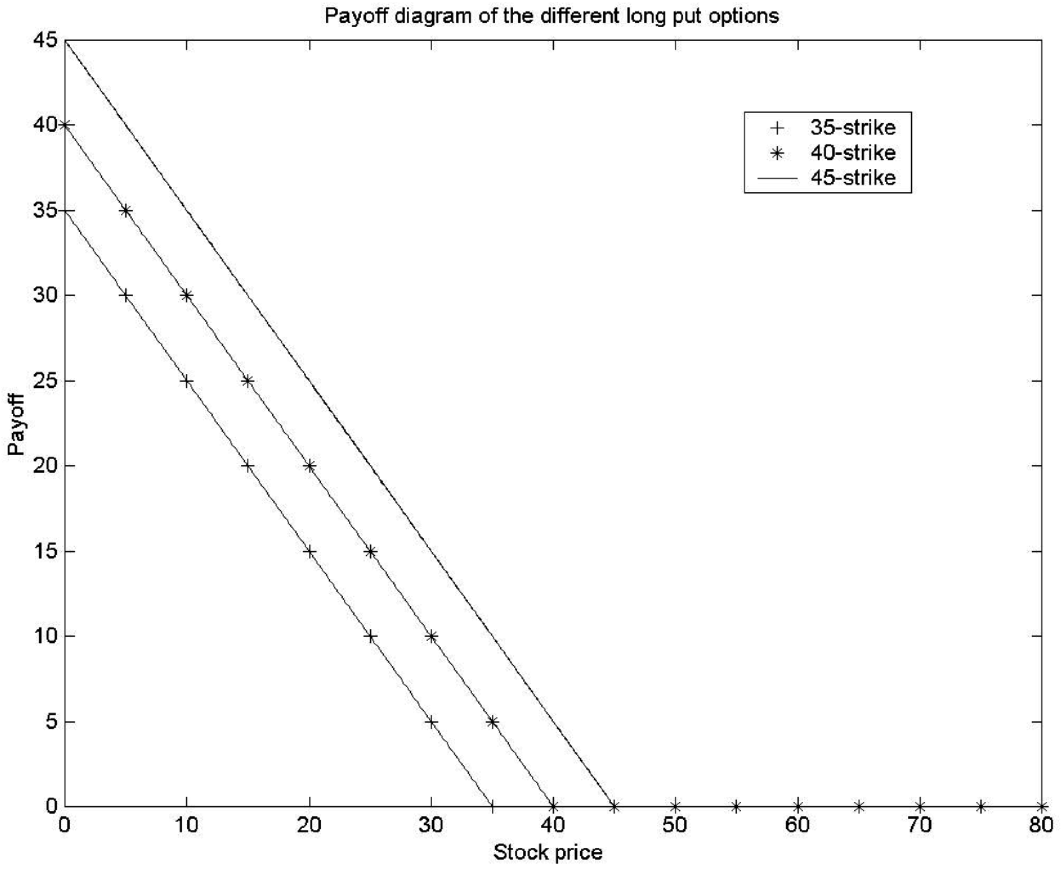
We get the profit diagram by deducting the option premia from the payoff graphs. The profit diagram looks as follows:
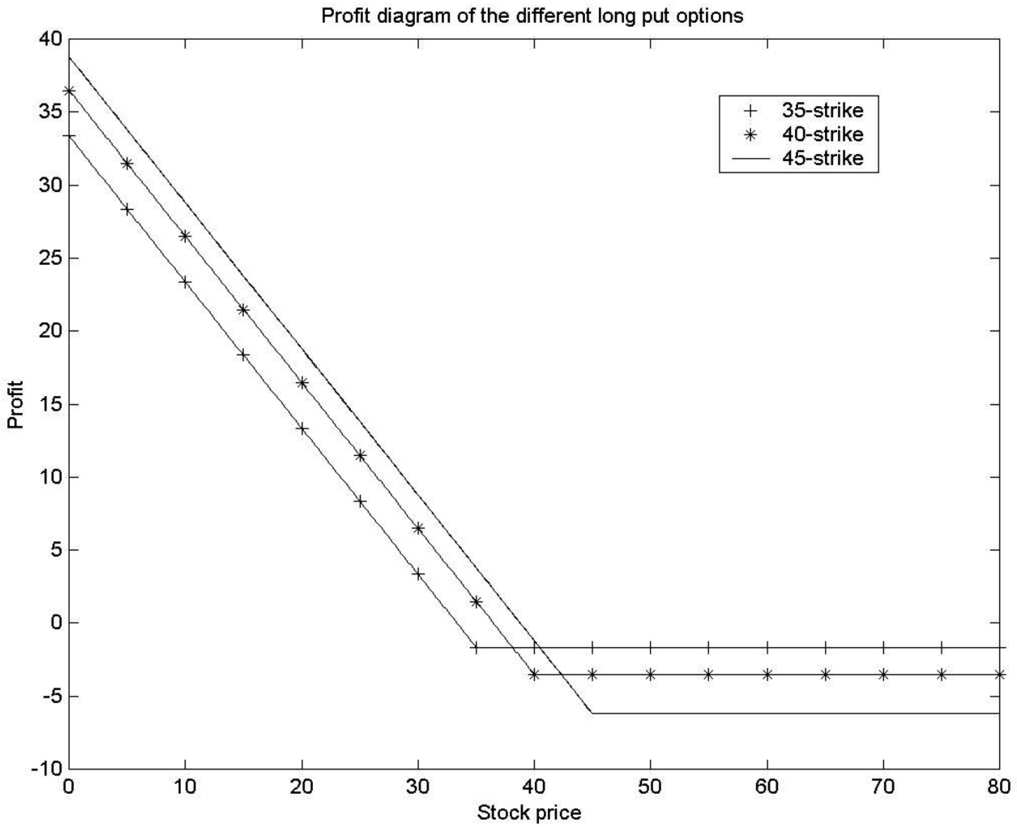
Intuitively, whenever the 35-strike put option pays off (i.e., has a payoff bigger than zero), the 40-strike and the 35-strike options also pay off. However, there are some instances in which the 40-strike option pays off and the 35-strike option does not. Similarly, there are some instances in which the 45-strike option pays off but neither the 40-strike nor the 35-strike pay off. Therefore, the 45-strike offers more potential than the 40- and 35-strike, and the 40-strike offers more potential than the 35-strike. We pay for these additional payoff possibilities by initially paying a higher premium. It makes sense that the premium is increasing in the strike price.

Question 2.15
The nice thing that lead us to the notion of indifference between a forward contract and a loan- financed stock index purchase whenever the forward price equaled the future price of the loan was that we could already tell today what we had to pay back in the future. In other words, the return on the loan, the risk-free interest rate r, was known today, and we removed uncertainty about the payment to be made. If we were to finance the purchase of the index by short selling IBM stock, we would introduce additional uncertainty because the future value of the IBM stock is unknown. Therefore, we could not calculate today the amount to be repaid, and it would be impossible to establish an equivalence between the forward and loan-financed index purchase today. The calculation of a profit diagram would only be possible if we assumed an arbitrary value for IBM at expiration of the futures, and we would have to draw many profit diagrams with different values for IBM to get an idea of the many possible profits we could make.

Question 2.16
The following is a copy of a spreadsheet that solves the problem:

