INSTRUCTOR’S MANUAL

TO ACCOMPANY

**DAVID M. KROENKE AND DAVID J. AUER**

Database Processing

*Fundamentals, Design, and Implementation*

13th Edition

CHAPTER TWO

INTRODUCTION TO STRUCTURE QUERY LANGUAGE



Prepared By

David J. Auer

Western Washington University

Copyright © 2014 Pearson Education, Inc.

* CHAPTER OBJECTIVES

To understand the use of extracted data sets

To understand the use of ad-hoc queries

To understand the history and significance of Structured Query Language (SQL)

To understand the basic SQL SELECT/FROM/WHERE framework as the basis for database queries

To be able to write queries in SQL to retrieve data from a single table

To be able to write queries in SQL to use the SQL SELECT, FROM, WHERE, ORDER BY, GROUP BY, and HAVING clauses

To be able to write queries in SQL to use SQL DISTINCT, AND, OR, NOT, BETWEEN, LIKE, and IN keywords

To be able to use the SQL built-in functions of SUM, COUNT, MIN, MAX, and AVG with and without the use of a GROUP BY clause

To be able to write queries in SQL to retrieve data from a single table but restricting the data based upon data in another table (subquery)

To create SQL queries that retrieve data from multiple tables using the SQL join and JOIN ON operations

To create SQL queries that retrieve data from multiple tables using the SQL OUTER JOIN operation

* ERRATA

There are no known errors at this time. Any errors that are discovered in the future will be reported and corrected in the Online DBP e13 Errata document, which will be available at [http://www.pearsonhighered.com/kroenke](http://www.pearsonhighered.com/kroenke/).

* TEACHING SUGGESTIONS

Database files to illustrate the examples in the chapter and solution database files for your use are available in the Instructor’s Resource Center on the text’s Web site ([www.pearsonhighered.com/kroenke](http://www.pearsonhighered.com/kroenke/)).

The best way for students to understand SQL is by using it. Have your students work through the Review Questions, Project Questions and the Marcia’s Dry Cleaning and Morgan Importing Project Questions in an actual database. Students can create databases in Microsoft Access with basic tables, relationships and data from the material in the book. SQL scripts for Microsoft SQL Server, Oracle Database and MySQL versions of Cape Codd, WPC, MDC and MI are available in the Instructor’s Resource Center on the text’s Web site ([www.pearsonhighered.com/kroenke](http://www.pearsonhighered.com/kroenke/)).

Microsoft Access database files for Cape Codd and the NASDAQ data (NDX.accdb), together with SQL scripts for Microsoft SQL Server, Oracle Database and MySQL versions of Cape Codd, MDC and MI are available for student use in the Student Resources on the text’s Web site ([www.pearsonhighered.com/kroenke](http://www.pearsonhighered.com/kroenke/)).

The SQL processors in the various DBMSs are very fussy about character sets used for SQL statements. They want to see plain ASCII text, not fancy fonts. This is particularly true of the single quotation ( ' ) used to designate character strings, but I’ve also had problems with the minus sign. If your students are having problems getting a “properly structured SQL statement” to run, look closely for this type of problem.

There is a useful teaching technique which will allow you to demonstrate the SQL queries in the text using Microsoft SQL Server if you have it available.

Open the Microsoft SQL Server Management Studio, and create a new SQL Server database named Cape-Codd.

In the Microsoft SQL Server Management Studio, use the SQL statements in the *.sql text file *DBP-e13-MSSQL-Cape-Codd-Create-Tables.sql* to create the RETAIL_ORDER, ORDER_ITEM and SKU_DATA tables [the WAREHOUSE and INVENTORY tables, used in the Review Questions, are also created].

In the Microsoft SQL Server Management Studio, use the SQL statements *.sql text file *DBP-e13-MSSQL-Cape-Dodd-Insert-Data.sql* to populate the RETAIL_ORDER, ORDER_ITEM and SKU_DATA tables [the WAREHOUSE and INVENTORY tables, used in the Review Questions, are also populated].

In the Microsoft SQL Server Management Studio, open the *.sql text file *DBP-e13-MSSQL-Cape-Codd-Query-Set-CH02.sql*. This file contains all the queries shown in the Chapter 2 text.

Highlight the query you want to run and click the Execute Query button to display the results of the query. An example of this is shown in the following screenshot.

All of the *.sql text files needed to do this are available in the Instructor’s Resource Center on the text’s Web site ([www.pearsonhighered.com/kroenke](http://www.pearsonhighered.com/kroenke/)).

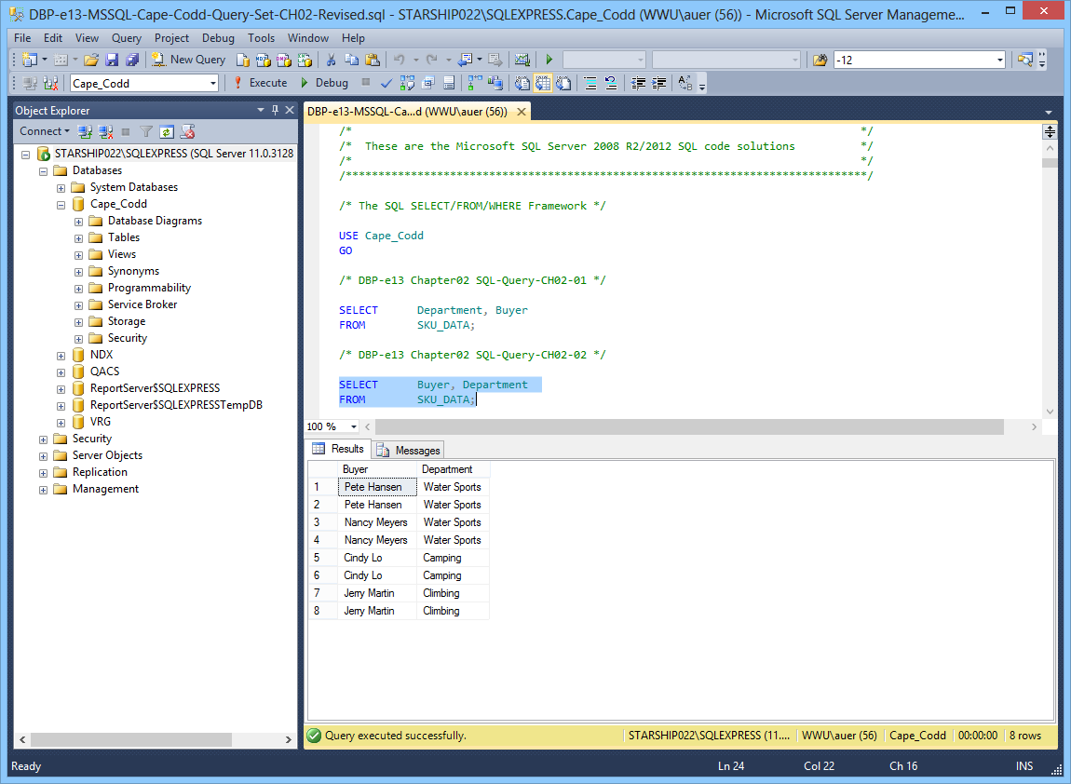

Microsoft Access 2013 does not support all SQL-92 (and newer) constructs. While this chapter still considers Microsoft Access as the DBMS most likely to be used by students at this point in the course, there are some Review Questions and Project Questions that use the ORDER BY clause with aliased computed columns that will not run in Access (see Review Questions 2.42 – 2.44 and Project Questions 2.63.e – 2.63.g). The correct solutions for these questions were obtained using Microsoft SQL Server 2012. The Microsoft Access results without the ORDER BY clause are also shown, so you can assign these problems without the ORDER BY part of the questions.

Microsoft Access 2013 does not support SQL wildcard characters (see Review Questions 2.36 – 2.38), although it does have equivalent wildcard characters as described in the chapter. The correct solutions for these questions were obtained using Microsoft SQL Server 2012.

For those students who are used to procedural languages, they may have some initial difficulty with a language that does set processing like SQL. These students are accustomed to processing rows (records) rather than sets. It is time well spent to make sure they understand that SQL processes tables at a time, not rows at a time.

Students may have some trouble understanding the GROUP BY clause. If you can explain it in terms of traditional control break logic (sort rows on a key then process the rows until the value of the key changes), they will have less trouble. This also explains why the Group By clause will present the rows sorted even though you do not use an order by clause.

At this point, students familiar with Microsoft Access will wonder why they are learning SQL. They have made queries in Microsoft Access using Microsoft Access's version of Query-By-Example (QBE), and therefore never had to understand the SQL. In many cases, they will not know that Microsoft Access generates SQL code when you create a query in design view. It is worth letting them know this is done and even showing them the SQL created for and underlying a Microsoft Access query.

It is also important for students to understand that, in many cases, the Query-By-Example forms such as Microsoft Access’ design view can be very inefficient. Also, the QBE forms are not available from within an application program such as Java or C, and so SQL must be written.

It has been our experience that a review of a Cartesian Product from an algebra class is time well spent. Show students what will happen if a WHERE statement is left off of a join. The following example will work. Assume you create four tables with five columns each and 100 rows each. How many columns and rows will be displayed by the statement:

SELECT * FROM TABLE1, TABLE2, TABLE3, TABLE4;

The result is 20 columns (not bad) but 100,000,000 rows (100 * 100 = 10,000, 10,000 * 100 = 1,000,000, 1,000,000 * 100 = 100,000,000). This happens because the JOIN is not qualified. If they understand Cartesian products then they will understand how to fix a JOIN where the results are much too large.

Note that in the Marcia's Dry Cleaning project, where in some previous editions we have used tables named ORDER and ORDER_ITEM, we have changed these table names to INVOICE and INVOICE_ITEM. We did this because ORDER is an SQL reserved word (part of ORDER BY). Therefore, when the table name ORDER is used as part of a query, it may need to be ("must be" in Access 2013) enclosed in delimiters as [ORDER] if the query is going to run correctly. The topic of reserved words and delimiters is discussed in more detail in Chapters 6 and 7. However, now is a good time to introduce it to your students.

Note that Microsoft Access SQL requires the INNER JOIN syntax instead of the standard SQL syntax JOIN used by Microsoft SQL Server, Oracle Database and MySQL

* ANSWERS TO REVIEW QUESTIONS

1. What is a business intelligence (BI) system?

A business intelligence (BI) system, is a system used to support management decisions by producing information for assessment, analysis, planning and control.

1. What is an ad-hoc query?

An ad-hoc query is a query created by the user as needed, rather than a query programmed into an application.

1. What does SQL stand for, and what is SQL?

SQL stands for *Structured Query Language*. SQL is the universal query language for relational DBMS products.

1. What does SKU stand for, and what is an SKU?

SKU stands for stock keeping unit. An SKU is a an identifier used to label and distinguish each item sold by a business.

1. Summarize how data were altered and filtered in creating the Cape Codd data extraction.

Data from the Cape Codd operational retail sales database were used to create a retail sales extraction database with three tables: RETAIL_ORDER, ORDER_ITEM and SKU_DATA.

The **RETAIL_ORDER** table uses only a few of the columns in the operational database. The structure of the table is:

RETAIL_ORDER (OrderNumber, StoreNumber, StoreZip, OrderMonth, OrderYear,

OrderTotal)

For this table, the original column OrderDate (in the data format MM/DD/YYYY [04/26/2013]) was converted into the columns OrderMonth (in a Character(12) format so that each month is spelled out [April]) and OrderYear (in an Integer format with each year appearing as a four-digit year [2013]).

We also note that the OrderTotal column includes tax, shipping and other charges that do not appear in the data extract. Thus, it does not equal the sum of the related ExtendedPrice column in the ORDER_ITEM table discussed below.

The **ORDER_ITEM** table uses an extract of the items purchased for each order. The structure of the table is:

ORDER_ITEM (OrderNumber, SKU, Quantity, Price, ExtendedPrice)

For this table, there is one row for each SKU associated with a given OrderNumber, representing one row for each type of item purchased in a specific order.

The **SKU_DATA** table uses an extract of the item identifying and describing data in the complete operational table. The structure of the table is:

SKU_DATA (SKU, SKU_Description, Department, Buyer)

For this table, there is one row to describe each SKU, representing one particular item that is sold by Cape Codd.

1. Explain, in general terms, the relationships of the RETAIL_ORDER, ORDER_ITEM, and SKU_DATA tables.

In general, each sale in RETAIL_ORDER relates to one or more rows in ORDER_ITEM that detail the items sold in the specific order. Each row in ORDER_ITEM is associated with a specific SKU in the SKU_DATA table. Thus one SKU may be associated once with each specific order number, but may also be associated with many different order numbers (as long as it appears only once in each order).

Using the Microsoft Access Relationship window, the relationships (including the additional relationships with the INVENTORY and WAREHOUSE tables described after Review Question 2.15) are shown in Figure 2-24 and look like this:

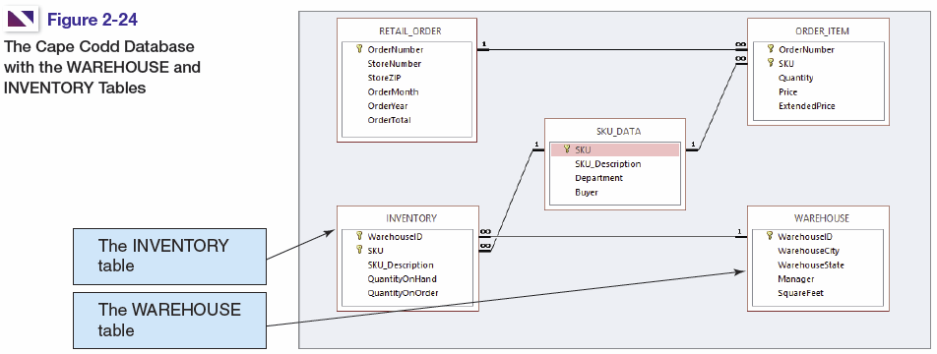

*Figure 2-23 – The Cape Codd Database with the WAREHOUSE and INVENTORY tables*

In traditional database terms (which will be discussed in Chapter 6) OrderNumber and SKU in ORDER_ITEM are foreign keys that provide the links to the RETAIL_ORDER and SKU_DATA tables respectively. Using an underline to show primary keys and italics to show foreign keys, the tables and their relationships are shown as:

RETAIL_ORDER (OrderNumber, StoreNumber, StoreZip, OrderMonth, OrderYear,

OrderTotal)

ORDER_ITEM (*OrderNumber*, *SKU*, Quantity, Price, ExtendedPrice)

SKU_DATA (SKU, SKU_Description, Department, Buyer)

1. Summarize the background of SQL.

SQL was developed by IBM in the late 1970s, and in 1992 it was endorsed as a national standard by the American National Standards Institute (ANSI). That version is called SQL-92. There is a later version called SQL3 that has some object-oriented concepts, but SQL3 has not received much commercial attention.

1. What is SQL-92? How does it relate to the SQL statements in this chapter?

SQL-92 is the version of SQL endorsed as a national standard by the American National Standards Institute (ANSI) in 1992. It is the version of SQL supported by most commonly used database management systems. The SQL statements in the chapter are based on SQL-92 and the SQL standards that followed and modified it.

1. What features have been added to SQL in versions subsequent to the SQL-92?

Versions of SQL subsequent to SQL-92 have extended features or added new features to SQL, the most important of which, for our purposes, is support for Extensible Markup Language (XML).

1. Why is SQL described as a data sublanguage?

A data sublanguage consists only of language statements for defining and processing a database. To obtain a full programming language, SQL statements must be embedded in scripting languages such as VBScript or in programming languages such as Java or C#.

1. What does DML stand for? What are DML statements?

DML stands for *data manipulation language*. DML statements are used for querying and modifying data.

1. What does DDL stand for? What are DDL statements?

DDL stands for *data definition language*. DDL statements are used for creating tables, relationships and other database querying and modifying data.

1. What is the SQL SELECT/FROM/WHERE framework?

The SQL SELECT/FROM/WHERE framework is the basis for queries in SQL. In this framework:

* The SQL SELECT clause specifies which columns are to be listed in the query results.
* The SQL FROM clause specifies which tables are to be used in the query.
* The SQL WHERE clause specifies which rows are to be listed in the query results.

1. Explain how Microsoft Access uses SQL.

Microsoft Access uses SQL, but generally hides the SQL from the user. For example, Microsoft Access automatically generates SQL and sends it to the Microsoft Access’s internal Access Database Engine (ADE, which is a variant of the Microsoft Jet engine) every time you run a query, process a form or create a report. To go beyond elementary database processing, you need to know how to use SQL in Microsoft Access.

1. Explain how enterprise-class DBMS products use SQL.

Enterprise-class DBMS products, which include Microsoft SQL Server, Oracle Corporation’s Oracle Database and MySQL, and IBM’s DB2, require you to know and use SQL. All data manipulation is expressed in SQL in these products.

*The Cape Codd Outdoor Sports sale extraction database has been modified to include two additional tables, the INVENTORY table and the WAREHOUSE table. The table schemas for these tables, together with the SKU table, are as follows:*

RETAIL_ORDER (OrderNumber, StoreNumber, StoreZip, OrderMonth, OrderYear, OrderTotal)

ORDER_ITEM (*OrderNumber*, *SKU*, Quantity, Price, ExtendedPrice)

SKU_DATA (SKU, SKU_Description, Department, Buyer)

WAREHOUSE (WarehouseID, WarehouseCity, WarehouseState, Manager, Squarefeet)

INVENTORY (*WarehouseID*, *SKU*, SKU_Description, QuantityOnHand, QuantityOnOrder)

*The five tables in the revised Cape Codd database schema are shown in Figure 2-24. The column characteristics for the WAREHOUSE table are shown in Figure 2-25, and the column characteristics for the INVENTORY table are shown in Figure 2-26. The data for the WAREHOUSE table are shown in Figure 2-27, and the data for the INVENTORY table are shown in Figure 2-28.*



*Figure 2-24 – The Cape Codd Database with the WAREHOUSE and INVENTORY tables*

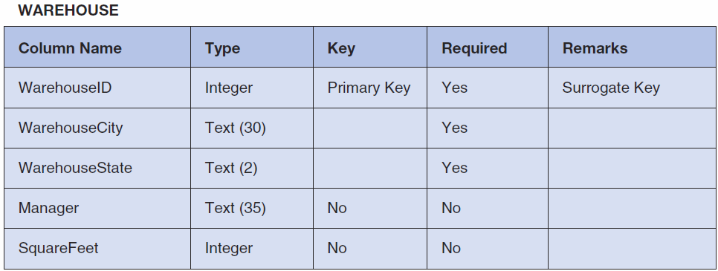

*Figure 2-25 - Column Characteristics for the WAREHOUSE Table*

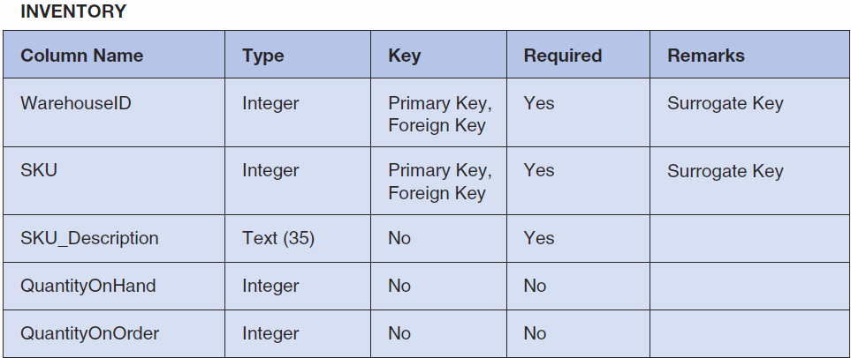

*Figure 2-26 - Column Characteristics for the INVENTORY Table*

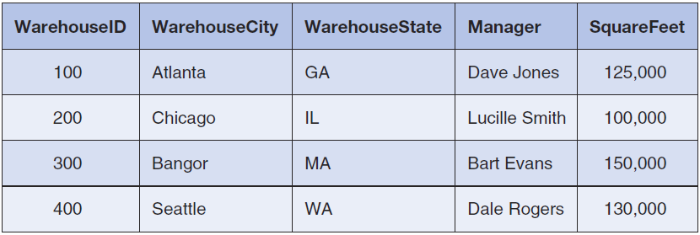

*Figure 2-27 - Cape Codd Outdoor Sports WAREHOUSE Data*

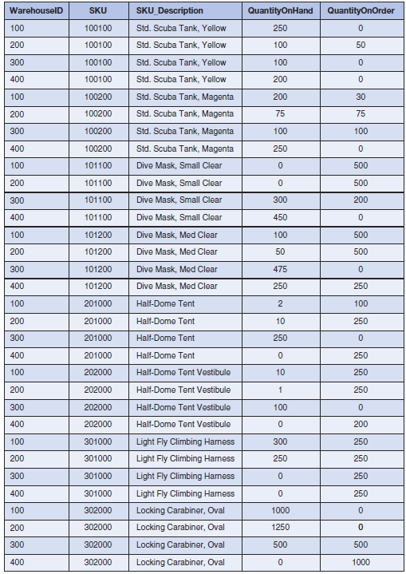

*Figure 2-28 - Cape Codd Outdoor Sports INVENTORY Data*

*If at all possible, you should run your SQL solutions to the following questions against an actual database. A Microsoft Access database named Cape-Codd.accdb is available on our Web site (*[*www.pearsonhighered.com/kroenke*](http://www.pearsonhighered.com/kroenke)*) that contains all the tables and data for the Cape Codd Outdoor Sports sales data extract database. Also available on our Web site are SQL scripts for creating and populating the tables for the Cape Codd database in Microsoft SQL Server, Oracle Database, and MySQL.*

NOTE: All answers below show the correct SQL statement, as well as SQL statements modified for Microsoft Access 2013 when needed. Whenever possible, all results were obtained by running the SQL statements in Microsoft Access 2013, and the corresponding screen shots of the results are shown below. As explained in the text, some queries cannot be run in Microsoft Access 2013, and for those queries the correct result was obtained using Microsoft SQL Server 2012. The SQL statements shown should run with little, if any, modification needed for Oracle Database 11*g* Release 2 and MySQL 5.6.

Solutions to Project Questions 2.17 – 2.55 are contained in the Microsoft Access database *DBP-e13-IM-CH02-Cape-Codd.accdb* which is available on the text’s Web site ([www.pearsonhighered.com/kroenke](http://www.pearsonhighered.com/kroenke/)).

If your students are using a DBMS other than Microsoft Access, the SQL code to create and populate the Cape Codd database is available in the *.sql script files for SQL Server 2012, Oracle Database 11*g*, and MySQL 5.5 in the Instructor’s Resource Center on the text’s Web site ([www.pearsonhighered.com/kroenke](http://www.pearsonhighered.com/kroenke/)).

1. There is an intentional flaw in the design of the INVENTORY table used in these exercises. This flaw was purposely included in the INVENTORY tables so that you can answer some of the following questions using only that table. Compare the SKU and INVENTORY tables, and determine what design flaw is included in INVENTORY. Specifically, why did we include it?

The flaw is the inclusion of the SKU_Description attribute in the INVENTORY table. This attribute duplicates the SKU_Description attribute and data in the SKU_DATA table, where the attribute rightfully belongs. By duplicating SKU_Description in the INVENTORY table, we can ask you to list the SKU and its associated description in a single table query against the INVENTORY table. Otherwise, a two table query would be required. If these tables were in a production database, we would eliminate the INVENTORY.SKU_Description column.

*Use only the INVENTORY table to answer Review Questions 2.17 through 2.39:*

1. Write an SQL statement to display SKU and SKU_Description.

SQL Solutions to Project Questions 2.17 – 2.52 are contained in the Microsoft Access database *DBP-e13-IM-CH02-Cape-Codd-RQ.accdb* which is available on the text’s Web site ([www.pearsonhighered.com/kroenke](http://www.pearsonhighered.com/kroenke/)).

SELECT SKU, SKU_Description

FROM INVENTORY;

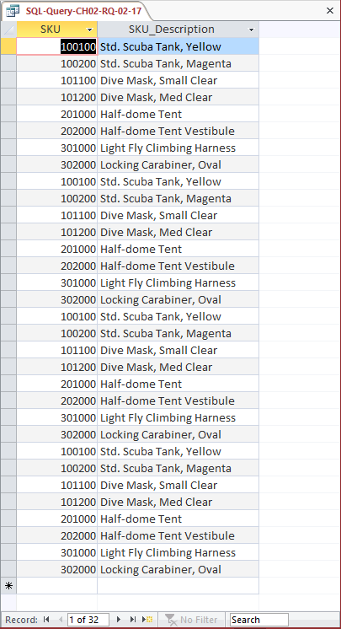

The question does not ask for unique SKU and SKU_Description data, but could be obtained by using:

SELECT UNIQUE SKU, SKU_Description

FROM INVENTORY;

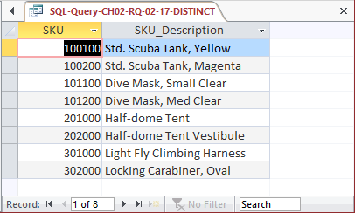

1. Write an SQL statement to display SKU_Description and SKU.

SQL Solutions to Project Questions 2.17 – 2.52 are contained in the Microsoft Access database *DBP-e13-IM-CH02-Cape-Codd-RQ.accdb* which is available on the text’s Web site ([www.pearsonhighered.com/kroenke](http://www.pearsonhighered.com/kroenke/)).

SELECT SKU_Description, SKU

FROM INVENTORY;

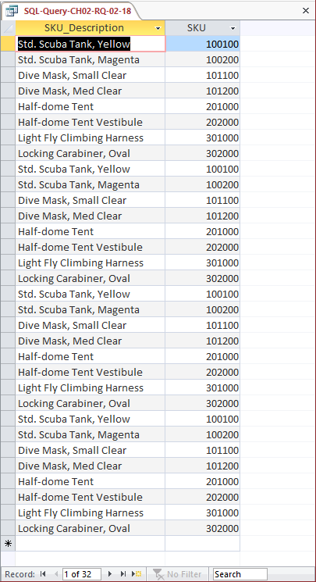

The question does not ask for unique SKU and SKU_Description data, but could be obtained by using:

SELECT UNIQUE SKU_Description, SKU

FROM INVENTORY;

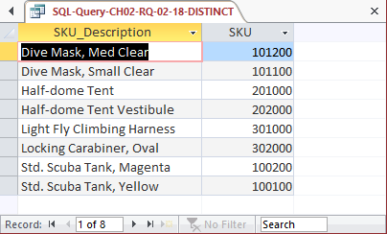

1. Write an SQL statement to display WarehouseID.

SQL Solutions to Project Questions 2.17 – 2.52 are contained in the Microsoft Access database *DBP-e13-IM-CH02-Cape-Codd-RQ.accdb* which is available on the text’s Web site ([www.pearsonhighered.com/kroenke](http://www.pearsonhighered.com/kroenke/)).

SELECT WarehouseID

FROM INVENTORY;

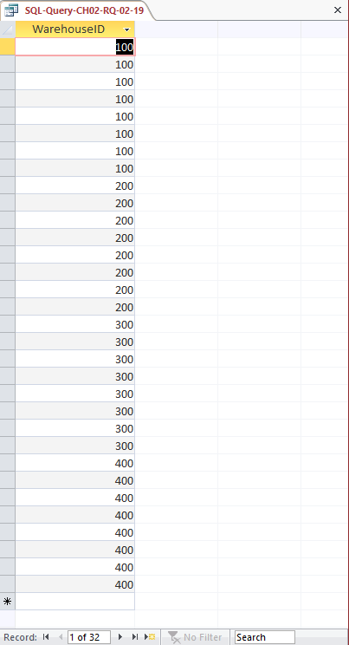

1. Write an SQL statement to display unique WarehouseIDs.

SQL Solutions to Project Questions 2.17 – 2.52 are contained in the Microsoft Access database *DBP-e13-IM-CH02-Cape-Codd-RQ.accdb* which is available on the text’s Web site ([www.pearsonhighered.com/kroenke](http://www.pearsonhighered.com/kroenke/)).

SELECT DISTINCT WarehouseID

FROM INVENTORY;

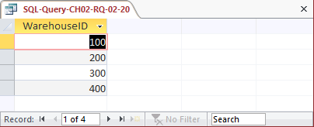

1. Write an SQL statement to display all of the columns without using the SQL asterisk (*) wildcard character.

SQL Solutions to Project Questions 2.17 – 2.52 are contained in the Microsoft Access database *DBP-e13-IM-CH02-Cape-Codd-RQ.accdb* which is available on the text’s Web site ([www.pearsonhighered.com/kroenke](http://www.pearsonhighered.com/kroenke/)).

SELECT WarehouseID, SKU, SKU_Description,

QuantityOnHand, QuantityOnOrder

FROM INVENTORY;

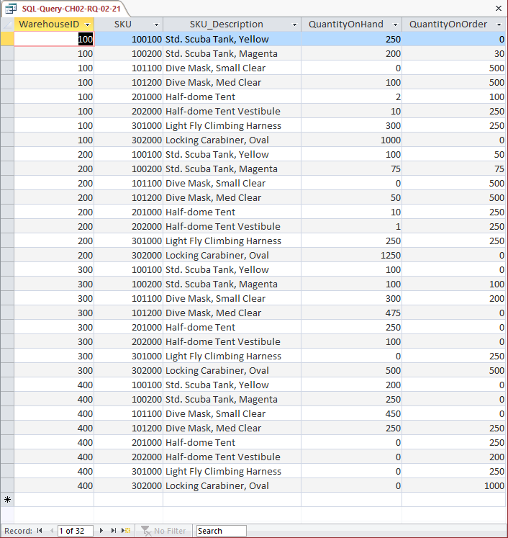

1. Write an SQL statement to display all of the columns using the SQL asterisk (*) wildcard character.

SQL Solutions to Project Questions 2.17 – 2.52 are contained in the Microsoft Access database *DBP-e13-IM-CH02-Cape-Codd-RQ.accdb* which is available on the text’s Web site ([www.pearsonhighered.com/kroenke](http://www.pearsonhighered.com/kroenke/)).

SELECT *

FROM INVENTORY;

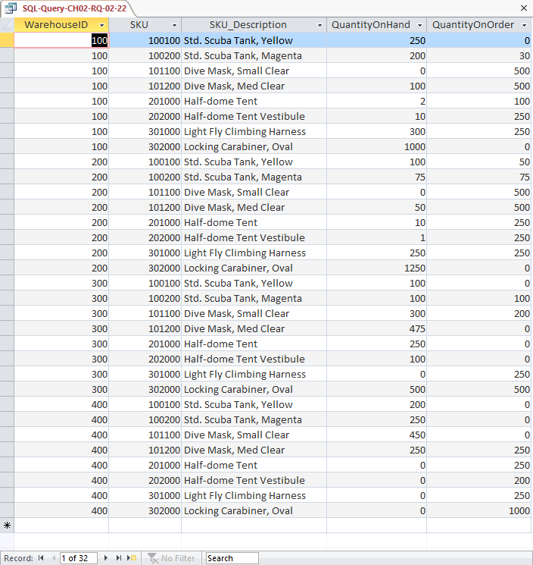

1. Write an SQL statement to display all data on products having a QuantityOnHand greater than 0.

SQL Solutions to Project Questions 2.17 – 2.52 are contained in the Microsoft Access database *DBP-e13-IM-CH02-Cape-Codd-RQ.accdb* which is available on the text’s Web site ([www.pearsonhighered.com/kroenke](http://www.pearsonhighered.com/kroenke/)).

SELECT *

FROM INVENTORY

WHERE QuantityOnHand >0;

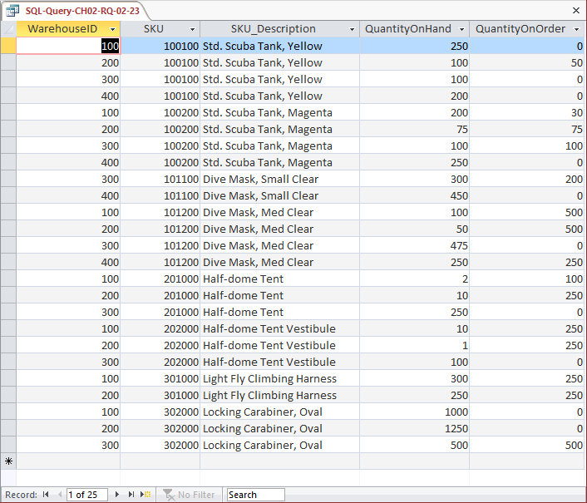

1. Write an SQL statement to display the SKU and SKU_Description for products having QuantityOnHand equal to 0.

SQL Solutions to Project Questions 2.17 – 2.52 are contained in the Microsoft Access database *DBP-e13-IM-CH02-Cape-Codd-RQ.accdb* which is available on the text’s Web site ([www.pearsonhighered.com/kroenke](http://www.pearsonhighered.com/kroenke/)).

SELECT SKU, SKU_Description

FROM INVENTORY

WHERE QuantityOnHand =0;

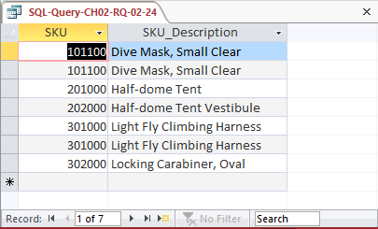

1. Write an SQL statement to display the SKU, SKU_Description, and Warehouse for products having QuantityOnHand equal to 0. Sort the results in ascending order by WarehouseID.

SQL Solutions to Project Questions 2.17 – 2.52 are contained in the Microsoft Access database *DBP-e13-IM-CH02-Cape-Codd-RQ.accdb* which is available on the text’s Web site ([www.pearsonhighered.com/kroenke](http://www.pearsonhighered.com/kroenke/)).

SELECT SKU, SKU_Description, WarehouseID

FROM INVENTORY

WHERE QuantityOnHand =0

ORDER BY WarehouseID;

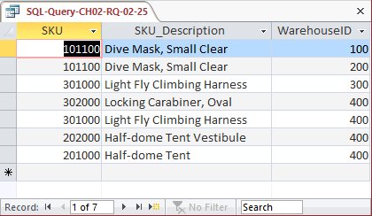

1. Write an SQL statement to display the SKU, SKU_Description, and WarehouseID for products having QuantityOnHand greater than 0. Sort the results in descending order by WarehouseID and ascending order by SKU.

SQL Solutions to Project Questions 2.17 – 2.52 are contained in the Microsoft Access database *DBP-e13-IM-CH02-Cape-Codd-RQ.accdb* which is available on the text’s Web site ([www.pearsonhighered.com/kroenke](http://www.pearsonhighered.com/kroenke/)).

SELECT SKU, SKU_Description, WarehouseID

FROM INVENTORY

WHERE QuantityOnHand > 0

ORDER BY WarehouseID DESC, SKU;

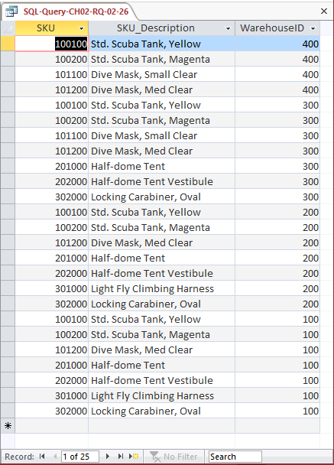

1. Write an SQL statement to display SKU, SKU_Description, and WarehouseID for all products that have a QuantityOnHand equal to 0 and a QuantityOnOrder greater than 0. Sort the results in descending order by WarehouseID and in ascending order by SKU.

SQL Solutions to Project Questions 2.17 – 2.52 are contained in the Microsoft Access database *DBP-e13-IM-CH02-Cape-Codd-RQ.accdb* which is available on the text’s Web site ([www.pearsonhighered.com/kroenke](http://www.pearsonhighered.com/kroenke/)).

SELECT SKU, SKU_Description, WarehouseID

FROM INVENTORY

WHERE QuantityOnHand = 0

AND QuantityOnOrder > 0

ORDER BY WarehouseID DESC, SKU;

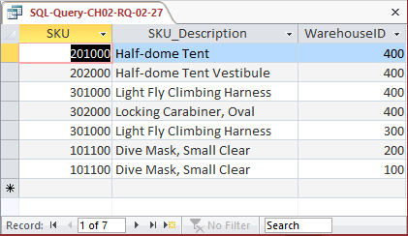

1. Write an SQL statement to display SKU, SKU_Description, and WarehouseID for all products that have a QuantityOnHand equal to 0 or a QuantityOnOrder equal to 0. Sort the results in descending order by WarehouseID and in ascending order by SKU.

SQL Solutions to Project Questions 2.17 – 2.52 are contained in the Microsoft Access database *DBP-e13-IM-CH02-Cape-Codd-RQ.accdb* which is available on the text’s Web site ([www.pearsonhighered.com/kroenke](http://www.pearsonhighered.com/kroenke/)).

SELECT SKU, SKU_Description, WarehouseID

FROM INVENTORY

WHERE QuantityOnHand = 0

OR QuantityOnOrder = 0

ORDER BY WarehouseID DESC, SKU;

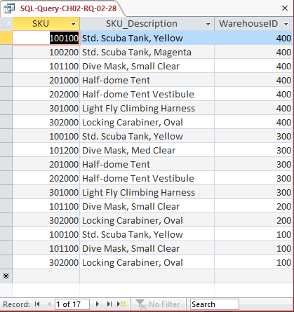

1. Write an SQL statement to display the SKU, SKU_Description, WarehouseID, and QuantityOnHand for all products having a QuantityOnHand greater than 1 and less than 10. Do not use the BETWEEN keyword.

SQL Solutions to Project Questions 2.17 – 2.52 are contained in the Microsoft Access database *DBP-e13-IM-CH02-Cape-Codd-RQ.accdb* which is available on the text’s Web site ([www.pearsonhighered.com/kroenke](http://www.pearsonhighered.com/kroenke/)).

SELECT SKU, SKU_Description, WarehouseID, QuantityOnHand

FROM INVENTORY

WHERE QuantityOnHand > 1

AND QuantityOnhand < 10;

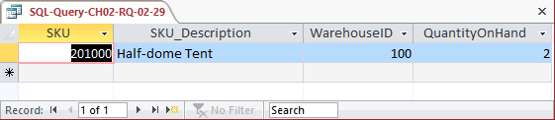

1. Write an SQL statement to display the SKU, SKU_Description, WarehouseID, and QuantityOnHand for all products having a QuantityOnHand greater than 1 and less than 10. Use the BETWEEN keyword.

SQL Solutions to Project Questions 2.17 – 2.52 are contained in the Microsoft Access database *DBP-e13-IM-CH02-Cape-Codd-RQ.accdb* which is available on the text’s Web site ([www.pearsonhighered.com/kroenke](http://www.pearsonhighered.com/kroenke/)).

SELECT SKU, SKU_Description, WarehouseID, QuantityOnHand

FROM INVENTORY

WHERE QuantityOnHand BETWEEN 2 AND 9;

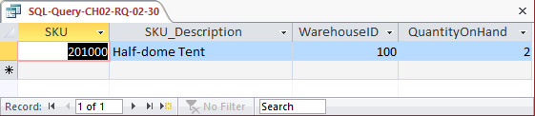

1. Write an SQL statement to show a unique SKU and SKU_Description for all products having an SKU description starting with ‘Half-dome’.

SQL Solutions to Project Questions 2.17 – 2.52 are contained in the Microsoft Access database *DBP-e13-IM-CH02-Cape-Codd-RQ.accdb* which is available on the text’s Web site ([www.pearsonhighered.com/kroenke](http://www.pearsonhighered.com/kroenke/)).

Note that, as discussed in Chapter 2, Microsoft Access 2013 uses wildcard characters that differ from the SQL standard.

For Microsoft SQL Server, Oracle Database and MySQL:

SELECT DISTINCT SKU, SKU_Description

FROM INVENTORY

WHERE SKU_Description LIKE 'Half-dome%';

For Microsoft Access:

SELECT DISTINCT SKU, SKU_Description

FROM INVENTORY

WHERE SKU_Description LIKE 'Half-dome*';

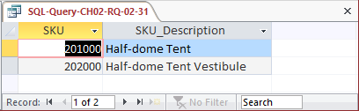

1. Write an SQL statement to show a unique SKU and SKU_Description for all products having a description that includes the word 'Climb'.

SQL Solutions to Project Questions 2.17 – 2.52 are contained in the Microsoft Access database *DBP-e13-IM-CH02-Cape-Codd-RQ.accdb* which is available on the text’s Web site ([www.pearsonhighered.com/kroenke](http://www.pearsonhighered.com/kroenke/)).

Note that, as discussed in Chapter 2, Microsoft Access 2013 uses wildcard characters that differ from the SQL standard.

For Microsoft SQL Server, Oracle Database and MySQL:

SELECT DISTINCT SKU, SKU_Description

FROM INVENTORY

WHERE SKU_Description LIKE '%Climb%';

For Microsoft Access:

SELECT DISTINCT SKU, SKU_Description

FROM INVENTORY

WHERE SKU_Description LIKE '*Climb*';

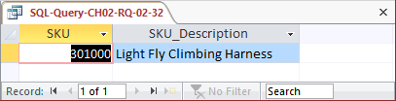

1. Write an SQL statement to show a unique SKU and SKU_Description for all products having a ‘d’ in the third position from the left in SKU_Description.

SQL Solutions to Project Questions 2.17 – 2.52 are contained in the Microsoft Access database *DBP-e13-IM-CH02-Cape-Codd-RQ.accdb* which is available on the text’s Web site ([www.pearsonhighered.com/kroenke](http://www.pearsonhighered.com/kroenke/)).

Note that, as discussed in Chapter 2, Microsoft Access 2013 uses wildcard characters that differ from the SQL standard.

For Microsoft SQL Server, Oracle Database and MySQL:

SELECT DISTINCT SKU, SKU_Description

FROM INVENTORY

WHERE SKU_Description LIKE '__d%';

For Microsoft Access:

SELECT DISTINCT SKU, SKU_Description

FROM INVENTORY

WHERE SKU_Description LIKE '??d*';

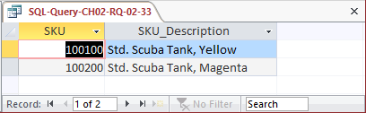

1. Write an SQL statement that uses all of the SQL built-in functions on the QuantityOn-Hand column. Include meaningful column names in the result.

SQL Solutions to Project Questions 2.17 – 2.52 are contained in the Microsoft Access database *DBP-e13-IM-CH02-Cape-Codd-RQ.accdb* which is available on the text’s Web site ([www.pearsonhighered.com/kroenke](http://www.pearsonhighered.com/kroenke/)).

SELECT COUNT(QuantityOnHand) AS NumberOfRows,

SUM(QuantityOnHand) AS TotalQuantityOnHand,

AVG(QuantityOnHand) AS AverageQuantityOnHand,

MAX(QuantityOnHand) AS MaximumQuantityOnHand,

MIN(QuantityOnHand) AS MinimumQuantityOnHand

FROM INVENTORY;

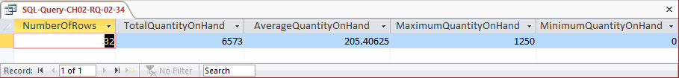

1. Explain the difference between the SQL built-in functions COUNT and SUM.

COUNT counts the number of rows or records in a table, while SUM adds up the data values in the specified column.

1. Write an SQL statement to display the WarehouseID and the sum of QuantityOnHand, grouped by WarehouseID. Name the sum TotalItemsOnHand and display the results in descending order of TotalItemsOnHand.

SQL Solutions to Project Questions 2.17 – 2.52 are contained in the Microsoft Access database *DBP-e13-IM-CH02-Cape-Codd-RQ.accdb* which is available on the text’s Web site ([www.pearsonhighered.com/kroenke](http://www.pearsonhighered.com/kroenke/)).

For Microsoft SQL Server, Oracle Database and MySQL:

SELECT WarehouseID, SUM(QuantityOnHand) AS TotalItemsOnHand

FROM INVENTORY

GROUP BY WarehouseID

ORDER BY TotalItemsOnHand DESC;

The correct results, obtained from SQL Server 2008 R2 / 2012, are:

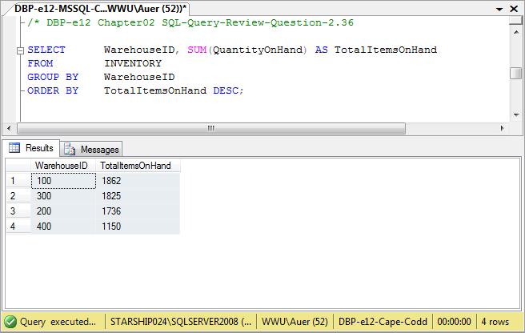

For Microsoft Access:

Unfortunately, Microsoft Access cannot process the ORDER BY clause because it contains an aliased computed result. To correct this, we use an SQL statement with the un-aliased computation:

SELECT WarehouseID, SUM(QuantityOnHand) AS TotalItemsOnHand

FROM INVENTORY

GROUP BY WarehouseID

ORDER BY SUM(QuantityOnHand) DESC;

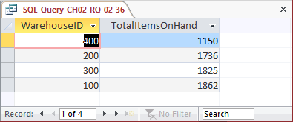

1. Write an SQL statement to display the WarehouseID and the sum of QuantityOnHand, grouped by WarehouseID. Omit all SKU items that have 3 or more items on hand from the sum, and name the sum TotalItemsOnHandLT3. Display the results in descending order of TotalItemsOnHandLT3.

SQL Solutions to Project Questions 2.17 – 2.52 are contained in the Microsoft Access database *DBP-e13-IM-CH02-Cape-Codd-RQ.accdb* which is available on the text’s Web site ([www.pearsonhighered.com/kroenke](http://www.pearsonhighered.com/kroenke/)).

For Microsoft SQL Server, Oracle Database and MySQL:

SELECT WarehouseID, SUM(QuantityOnHand) AS TotalItemsOnHandLT3

FROM INVENTORY

WHERE QuantityOnHand < 3

GROUP BY WarehouseID

ORDER BY TotalItemsOnHandLT3 DESC;

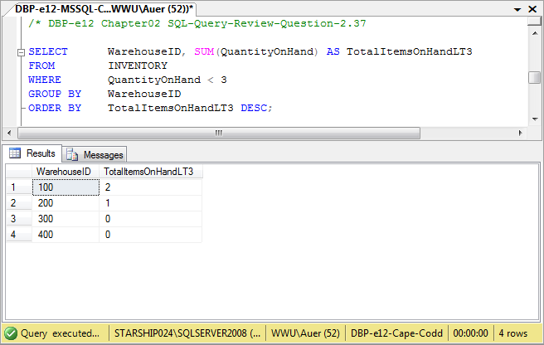

For Microsoft Access:

Unfortunately, Microsoft Access cannot process the ORDER BY clause because it contains an aliased computed result. To correct this, we use an SQL statement with the un-aliased computation:

SELECT WarehouseID, SUM(QuantityOnHand) AS TotalItemsOnHandLT3

FROM INVENTORY

WHERE QuantityOnHand < 3

GROUP BY WarehouseID

ORDER BY SUM(QuantityOnHand) DESC;

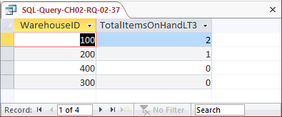

1. Write an SQL statement to display the WarehouseID and the sum of QuantityOnHand grouped by WarehouseID. Omit all SKU items that have 3 or more items on hand from the sum, and name the sum TotalItemsOnHandLT3. Show Warehouse ID only for warehouses having fewer than 2 SKUs in their TotalItemsOnHandLT3. Display the results in descending order of TotalItemsOnHandLT3.

SQL Solutions to Project Questions 2.17 – 2.52 are contained in the Microsoft Access database *DBP-e13-IM-CH02-Cape-Codd-RQ.accdb* which is available on the text’s Web site ([www.pearsonhighered.com/kroenke](http://www.pearsonhighered.com/kroenke/)).

For Microsoft SQL Server, Oracle Database and MySQL:

SELECT WarehouseID, SUM(QuantityOnHand) AS TotalItemsOnHandLT3

FROM INVENTORY

WHERE QuantityOnHand < 3

GROUP BY WarehouseID

HAVING COUNT(*) < 2

ORDER BY TotalItemsOnHandLT3 DESC;

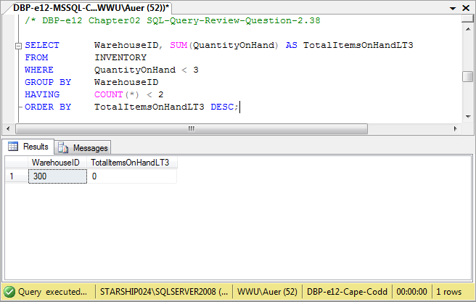

For Microsoft Access:

Unfortunately, Microsoft Access cannot process the ORDER BY clause because it contains an aliased computed result. To correct this, we use an SQL statement with the un-aliased computation:

SELECT WarehouseID, SUM(QuantityOnHand) AS TotalItemsOnHandLT3

FROM INVENTORY

WHERE QuantityOnHand < 3

GROUP BY WarehouseID

HAVING COUNT(*) < 2

ORDER BY SUM(QuantityOnHand) DESC;

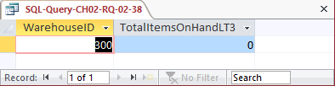

1. In your answer to Review Question 2.38, was the WHERE or HAVING applied first? Why?

The WHERE clause is always applied before the HAVING clause. Otherwise there would be ambiguity in the SQL statement and the results would differ according to which clause was applied first.

*Use both the INVENTORY and WAREHOUSE tables to answer Review Questions 2.40  
through 2.55:*

1. Write an SQL statement to display the SKU, SKU_Description, and WarehouseID, WarehouseCity, and WarehouseState for all items stored in the Atlanta, Bangor, or Chicago warehouse. Do not use the IN keyword.

SQL Solutions to Project Questions 2.17 – 2.52 are contained in the Microsoft Access database *DBP-e13-IM-CH02-Cape-Codd-RQ.accdb* which is available on the text’s Web site ([www.pearsonhighered.com/kroenke](http://www.pearsonhighered.com/kroenke/)).

SELECT SKU, SKU_Description,

WAREHOUSE.WarehouseID, WarehouseCity, WarehouseState

FROM INVENTORY, WAREHOUSE

WHERE INVENTORY.WarehouseID=WAREHOUSE.WarehouseID

AND (WarehouseCity = 'Atlanta'

OR WarehouseCity = 'Bangor'

OR WarehouseCity = 'Chicago')

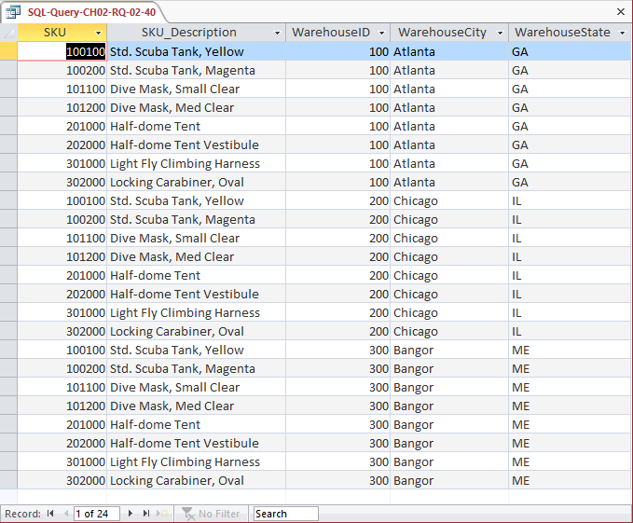

1. Write an SQL statement to display the SKU, SKU_Description, and WarehouseID, WarehouseCity, and WarehouseState for all items stored in the Atlanta, Bangor, or Chicago warehouse. Use the IN keyword.

SQL Solutions to Project Questions 2.17 – 2.52 are contained in the Microsoft Access database *DBP-e13-IM-CH02-Cape-Codd-RQ.accdb* which is available on the text’s Web site ([www.pearsonhighered.com/kroenke](http://www.pearsonhighered.com/kroenke/)).

SELECT SKU, SKU_Description,

WAREHOUSE.WarehouseID, WarehouseCity, WarehouseState

FROM INVENTORY, WAREHOUSE

WHERE INVENTORY.WarehouseID=WAREHOUSE.WarehouseID

AND WarehouseCity IN ('Atlanta', 'Bangor' ,'Chicago');

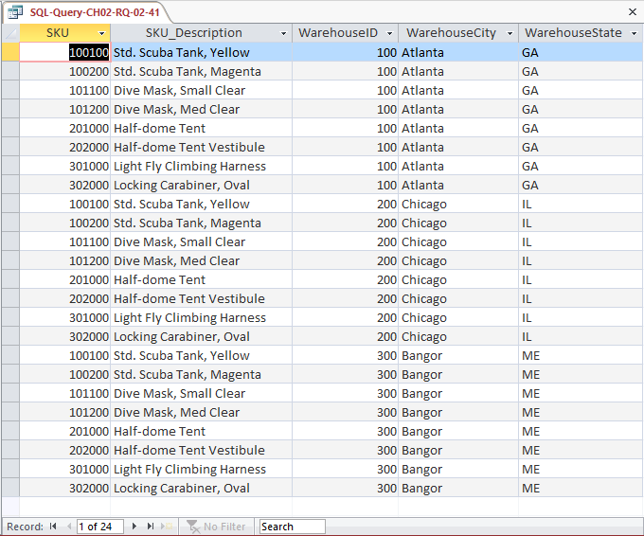

1. Write an SQL statement to display the SKU, SKU_Description, WarehouseID, WarehouseCity, and WarehouseState of all items not stored in the Atlanta, Bangor, or Chicago warehouse. Do not use the NOT IN keyword.

SQL Solutions to Project Questions 2.17 – 2.52 are contained in the Microsoft Access database *DBP-e13-IM-CH02-Cape-Codd-RQ.accdb* which is available on the text’s Web site ([www.pearsonhighered.com/kroenke](http://www.pearsonhighered.com/kroenke/)).

NOTE: The symbol for “not equal to” is < >. Since we want the query output for warehouses that are not Atlanta or Bangor or Chicago as a set, we must ask for warehouses that are not in the group (Atlanta **and** Bangor **and** Chicago). This means we use AND in the WHERE clause – if we used OR in the WHERE clause, we would end up with ALL warehouses being in the query output. This happens because each OR eliminates only one warehouse, but that warehouse still qualifies for inclusion in the other OR statements. To demonstrate this, substitute OR for each AND in the SQL statement below.

SELECT SKU, SKU_Description,

WAREHOUSE.WarehouseID, WarehouseCity, WarehouseState

FROM INVENTORY, WAREHOUSE

WHERE INVENTORY.WarehouseID=WAREHOUSE.WarehouseID

AND WarehouseCity <> 'Atlanta'

AND WarehouseCity <> 'Bangor'

AND WarehouseCity <> 'Chicago';

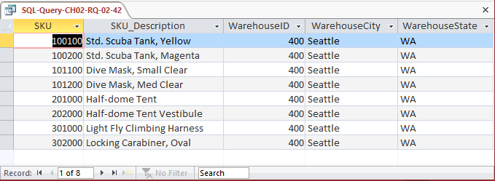

1. Write an SQL statement to display the SKU, SKU_Description, WarehouseID, WarehouseCity, and WarehouseState of all items not stored in the Atlanta, Bangor, or Chicago warehouse. Use the NOT IN keyword.

SQL Solutions to Project Questions 2.17 – 2.52 are contained in the Microsoft Access database *DBP-e13-IM-CH02-Cape-Codd-RQ.accdb* which is available on the text’s Web site ([www.pearsonhighered.com/kroenke](http://www.pearsonhighered.com/kroenke/)).

SELECT SKU, SKU_Description,

WAREHOUSE.WarehouseID, WarehouseCity, WarehouseState

FROM INVENTORY, WAREHOUSE

WHERE INVENTORY.WarehouseID=WAREHOUSE.WarehouseID

AND WarehouseCity NOT IN ('Atlanta', 'Bangor' ,'Chicago');

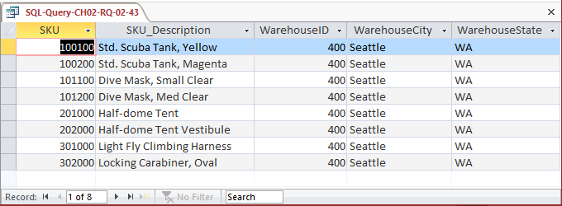

1. Write an SQL statement to produce a single column called ItemLocation that combines the SKU_Description, the phrase “is in a warehouse in”, and WarehouseCity. Do not be concerned with removing leading or trailing blanks.

SQL Solutions to Project Questions 2.17 – 2.52 are contained in the Microsoft Access database *DBP-e13-IM-CH02-Cape-Codd-RQ.accdb* which is available on the text’s Web site ([www.pearsonhighered.com/kroenke](http://www.pearsonhighered.com/kroenke/)).

Note that the SQL syntax will vary depending upon the DBMS—see the discussion in Chapter 2.

SELECT SKU_Description+' is in a warehouse in '

+WarehouseCity AS ITEM_Location

FROM INVENTORY, WAREHOUSE

WHERE INVENTORY.WarehouseID=WAREHOUSE.WarehouseID;

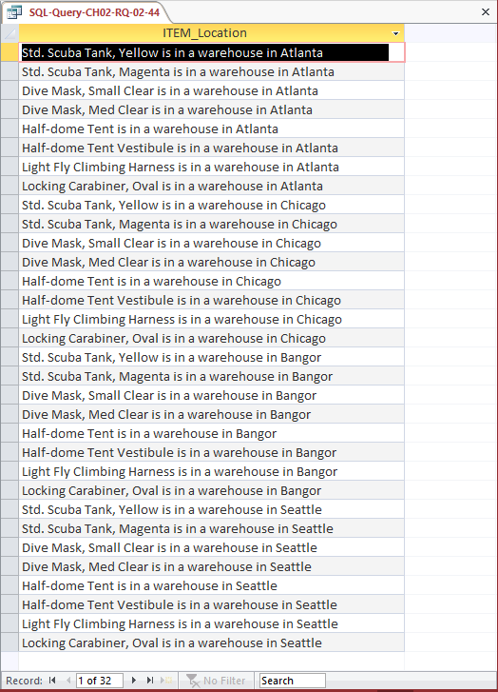

1. Write an SQL statement to show the SKU, SKU_Description, WarehouseID for all items stored in a warehouse managed by ‘Lucille Smith’. Use a subquery.

SQL Solutions to Project Questions 2.17 – 2.52 are contained in the Microsoft Access database *DBP-e13-IM-CH02-Cape-Codd-RQ.accdb* which is available on the text’s Web site ([www.pearsonhighered.com/kroenke](http://www.pearsonhighered.com/kroenke/)).

SELECT SKU, SKU_Description, WarehouseID

FROM INVENTORY

WHERE WarehouseID IN

(SELECT WarehouseID

FROM WAREHOUSE

WHERE Manager = 'Lucille Smith');

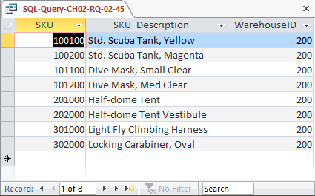

1. Write an SQL statement to show the SKU, SKU_Description, WarehouseID for all items stored in a warehouse managed by ‘Lucille Smith’. Use a join, but do not use JOIN ON syntax.

SQL Solutions to Project Questions 2.17 – 2.52 are contained in the Microsoft Access database *DBP-e13-IM-CH02-Cape-Codd-RQ.accdb* which is available on the text’s Web site ([www.pearsonhighered.com/kroenke](http://www.pearsonhighered.com/kroenke/)).

SELECT SKU, SKU_Description, WAREHOUSE.WarehouseID

FROM INVENTORY, WAREHOUSE

WHERE INVENTORY.WarehouseID=WAREHOUSE.WarehouseID

AND Manager = 'Lucille Smith';

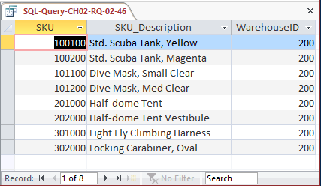

1. Write an SQL statement to show the SKU, SKU_Description, WarehouseID for all items stored in a warehouse managed by ‘Lucille Smith’. Use a join using JOIN ON syntax.

SQL Solutions to Project Questions 2.17 – 2.52 are contained in the Microsoft Access database *DBP-e13-IM-CH02-Cape-Codd-RQ.accdb* which is available on the text’s Web site ([www.pearsonhighered.com/kroenke](http://www.pearsonhighered.com/kroenke/)).

For Microsoft SQL Server, Oracle Database and MySQL:

SELECT SKU, SKU_Description, WAREHOUSE.WarehouseID

FROM INVENTORY JOIN WAREHOUSE

ON INVENTORY.WarehouseID=WAREHOUSE.WarehouseID

WHERE Manager = 'Lucille Smith';

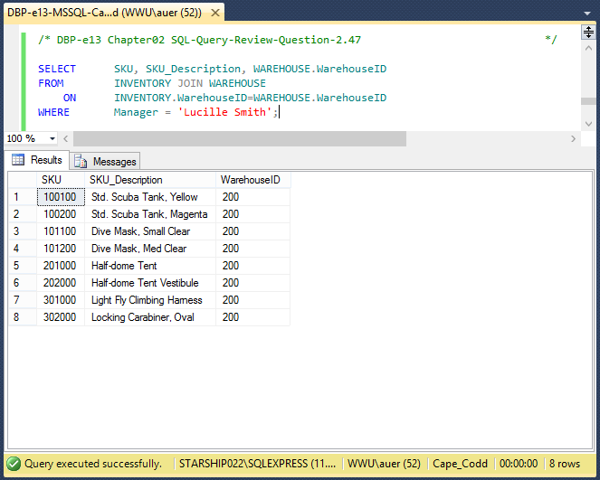

For Microsoft Access:

Microsoft Access requires the SQL JOIN ON syntax INNER JOIN instead of just JOIN:

For Microsoft SQL Server, Oracle Database and MySQL:

SELECT SKU, SKU_Description, WAREHOUSE.WarehouseID

FROM INVENTORY INNER JOIN WAREHOUSE

ON INVENTORY.WarehouseID=WAREHOUSE.WarehouseID

WHERE Manager = 'Lucille Smith';

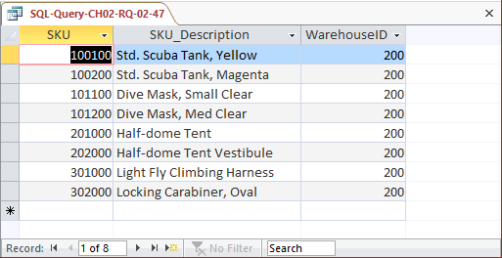

1. Write an SQL statement to show the WarehouseID and average QuantityOnHand of all items stored in a warehouse managed by ‘Lucille Smith’. Use a subquery.

SQL Solutions to Project Questions 2.17 – 2.52 are contained in the Microsoft Access database *DBP-e13-IM-CH02-Cape-Codd-RQ.accdb* which is available on the text’s Web site ([www.pearsonhighered.com/kroenke](http://www.pearsonhighered.com/kroenke/)).

SELECT WarehouseID,

AVG(QuantityOnHand) AS AverageQuantityOnHand

FROM INVENTORY

WHERE WarehouseID IN

(SELECT WarehouseID

FROM WAREHOUSE

WHERE Manager = 'Lucille Smith')

GROUP BY WarehouseID;

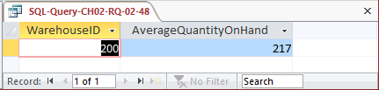

1. Write an SQL statement to show the WarehouseID and average QuantityOnHand of all items stored in a warehouse managed by ‘Lucille Smith’. Use a join, but do not use JOIN ON syntax.

SQL Solutions to Project Questions 2.17 – 2.52 are contained in the Microsoft Access database *DBP-e13-IM-CH02-Cape-Codd-RQ.accdb* which is available on the text’s Web site ([www.pearsonhighered.com/kroenke](http://www.pearsonhighered.com/kroenke/)).

SELECT INVENTORY.WarehouseID,

AVG(QuantityOnHand) AS AverageQuantityOnHand

FROM INVENTORY, WAREHOUSE

WHERE INVENTORY.WarehouseID = WAREHOUSE.WarehouseID

AND Manager = 'Lucille Smith'

GROUP BY INVENTORY.Warehouse.ID;

Note the use of the complete references to **INVENTORY.Warehouse**—the query will NOT work without them.

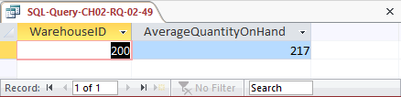

1. Write an SQL statement to show the WarehouseID and average QuantityOnHand of all items stored in a warehouse managed by ‘Lucille Smith’. Use a join using JOIN ON syntax.

SQL Solutions to Project Questions 2.17 – 2.52 are contained in the Microsoft Access database *DBP-e13-IM-CH02-Cape-Codd-RQ.accdb* which is available on the text’s Web site ([www.pearsonhighered.com/kroenke](http://www.pearsonhighered.com/kroenke/)).

For Microsoft SQL Server, Oracle Database and MySQL:

SELECT INVENTORY.WarehouseID,

AVG(QuantityOnHand) AS AverageQuantityOnHand

FROM INVENTORY JOIN WAREHOUSE

ON INVENTORY.WarehouseID=WAREHOUSE.WarehouseID

WHERE Manager = 'Lucille Smith'

GROUP BY INVENTORY.WarehouseID;

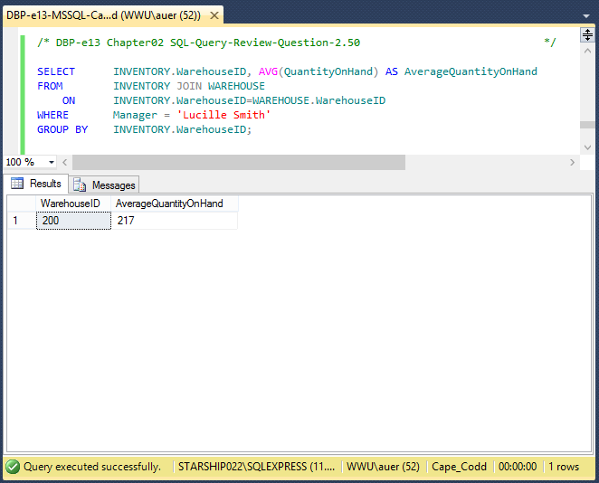

For Microsoft Access:

Microsoft Access requires the SQL JOIN ON syntax INNER JOIN instead of just JOIN:

SELECT INVENTORY.WarehouseID,

AVG(QuantityOnHand) AS AverageQuantityOnHand

FROM INVENTORY INNER JOIN WAREHOUSE

ON INVENTORY.WarehouseID=WAREHOUSE.WarehouseID

WHERE Manager = 'Lucille Smith'

GROUP BY INVENTORY.WarehouseID;

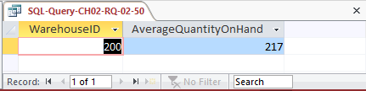

1. Write an SQL statement to display the WarehouseID, the sum of QuantityOnOrder and sum of QuantityOnHand, grouped by WarehouseID and QuantityOnOrder. Name the sum of QuantityOnOrder as TotalItemsOnOrder and the sum of QuantityOnHand as TotalItemsOnHand.

SQL Solutions to Project Questions 2.17 – 2.52 are contained in the Microsoft Access database *DBP-e13-IM-CH02-Cape-Codd-RQ.accdb* which is available on the text’s Web site ([www.pearsonhighered.com/kroenke](http://www.pearsonhighered.com/kroenke/)).

SELECT WarehouseID,

SUM(QuantityOnOrder) AS TotalItemsOnOrder,

SUM(QuantityOnHand) AS TotalItemsOnHand

FROM INVENTORY

GROUP BY WarehouseID, QuantityOnHand;

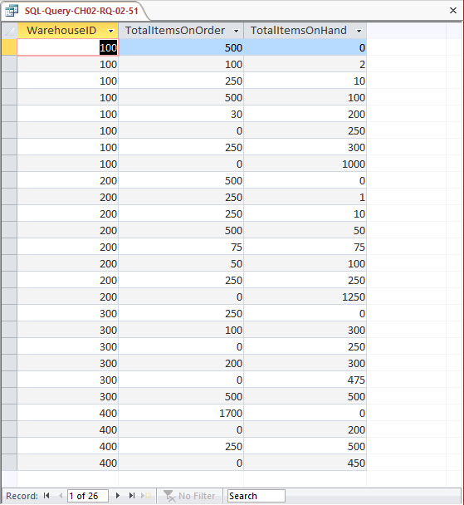

1. Write an SQL statement to show the WarehouseID, WarehouseCity, WarehouseState, Manager, SKU, SKU_Description, and QuantityOnHand of all items with a Manager of ‘Lucille Smith’. Use a join.

SQL Solutions to Project Questions 2.17 – 2.52 are contained in the Microsoft Access database *DBP-e13-IM-CH02-Cape-Codd-RQ.accdb* which is available on the text’s Web site ([www.pearsonhighered.com/kroenke](http://www.pearsonhighered.com/kroenke/)).

SELECT W.WarehouseID, WarehouseCity,

WarehouseState, Manager,

SKU, SKU_Description, QuantityOnHand

FROM INVENTORY AS I, WAREHOUSE AS W

WHERE I.WarehouseID=W.WarehouseID

AND Manager = 'Lucille Smith';

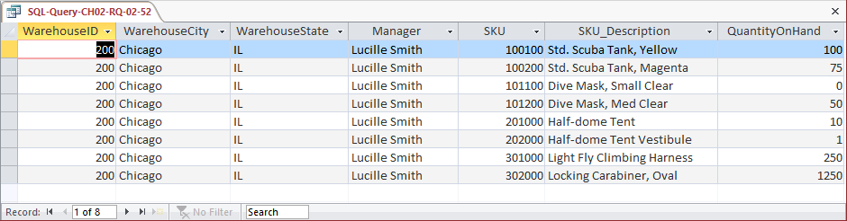

Note the use of the complete references to **INVENTORY.WarehouseID (aliased as I.Warehouse) and WAREHOUSE.WarehouseID (aliased as W.WarehouseID)**—the query will NOT work without them.

1. Explain why you cannot use a subquery in your answer to question 2.50.

In a query that contains a subquery, only data from fields in the table used in the top-level query can be included in the SELECT statement. If data from fields from other tables are also needed, a join must be used. In question 2.50 we needed to display WAREHOUSE.Manager but INVENTORY would have been the table in the top-level query. Therefore, we had to use a join.

1. Explain how subqueries and joins differ.

(1) In a query that contains a subquery, only data from fields in the table used in the top-level query can be included in the SELECT statement. If data from fields from other tables are also needed, a join must be used. See the answer to question 2.53.

(2) The subqueries in this chapter are **non-correlated subqueries**, which have an equivalent join structure. In Chapter 8, **correlated subqueries** will be discussed, and correlated subqueries do not have an equivalent join structure—you must use subqueries.

1. Write an SQL statement to show the WAREHOUSE and INVENTORY and include all rows of WAREHOUSE in your answer, regardless of whether they have any INVENTORY. Run this statement.

SELECT W.WarehouseID, WarehouseCity, WarehouseState, Manager,

SKU, SKU_Description, QuantityOnHand, QuantityOnOrder

FROM WAREHOUSE AS W LEFT JOIN INVENTORY AS I

ON W.WarehouseID = I.WarehouseID;

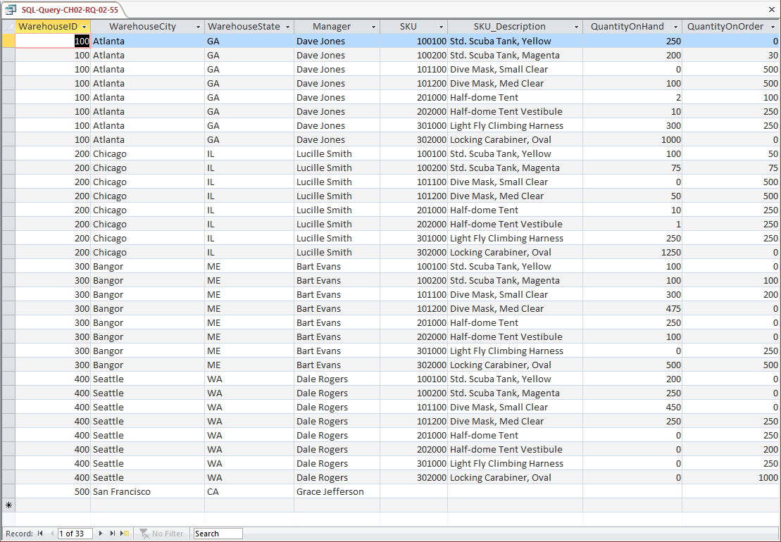

* ANSWERS TO PROJECT QUESTIONS

For this set of project questions, we will continue creating a Microsoft Access database for the Wedgewood Pacific Corporation (WPC) that we created in Chapter 1. Founded in 1957 in Seattle, Washington, WPC has grown into an internationally recognized organization. The company is located in two buildings. One building houses the Administration, Accounting, Finance, and Human Resources departments, and the second houses the Production, Marketing, and Information Systems departments. The company database contains data about company employees, departments, company projects, company assets such as computer equipment, and other aspects of company operations.

In the following project questions, we have already created the WPC.accdb database with the following two tables (see Chapter 1 Project Questions):

DEPARTMENT (DepartmentName, BudgetCode, OfficeNumber, Phone)

EMPLOYEE (EmployeeNumber, FirstName, LastName, *Department*, Phone, Email)

Now we will add in the following two tables:

PROJECT (ProjectID, Name, *Department*, MaxHours, StartDate, EndDate)

ASSIGNMENT (*ProjectID*, *EmployeeNumber*, HoursWorked)

The four tables in the revised WPC database schema are shown in Figure 2-28. The column characteristics for the PROJECT table are shown in Figure 2-29, and the column characteristics for the ASSIGNMENT table are shown in Figure 2-31. Data for the PROJECT table are shown in Figure 2-30, and the data for the ASSIGNMENT table are shown in Figure 2-32.

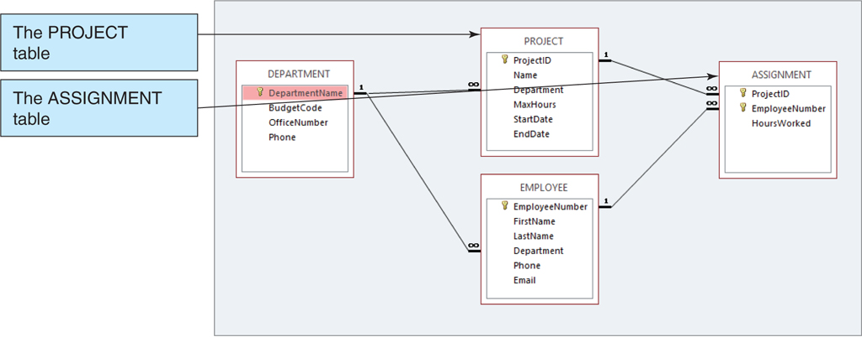

*Figure 2-29 – The WPC Database with the PROJECT and ASSIGNMENT Tables*

1. Figure 2-29 shows the column characteristics for the WPC PROJECT table. Using the column characteristics, create the PROJECT table in the WPC.accdb database.

SQL Solutions to Project Questions 2.56 – 2.65 are contained in the Microsoft Access database *DBP-e13-IM-CH02-WPC.accdb* which is available on the text’s Web site ([www.pearsonhighered.com/kroenke](http://www.pearsonhighered.com/kroenke/)).

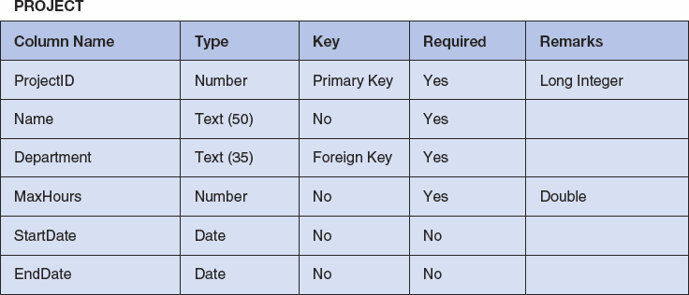

*Figure 2-30 - Column Characteristics for the PROJECT Table*

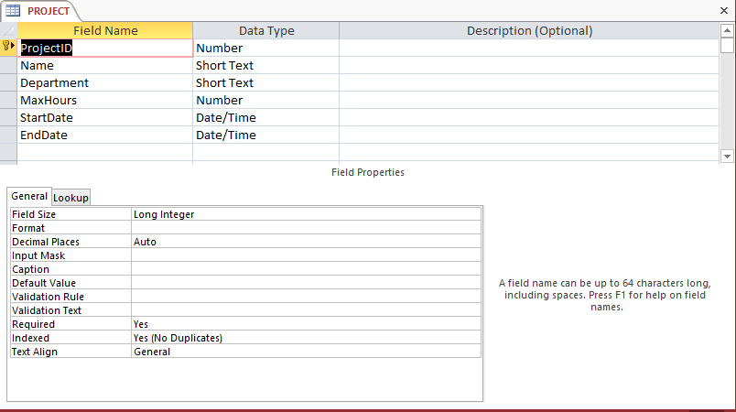

1. Create the relationship and referential integrity constraint between PROJECT and DEPARTMENT. Enable enforcing of referential integrity and cascading of data updates, but do not enable cascading of data from deleted records.

SQL Solutions to Project Questions 2.56 – 2.65 are contained in the Microsoft Access database *DBP-e13-IM-CH02-WPC.accdb* which is available on the text’s Web site ([www.pearsonhighered.com/kroenke](http://www.pearsonhighered.com/kroenke/)).

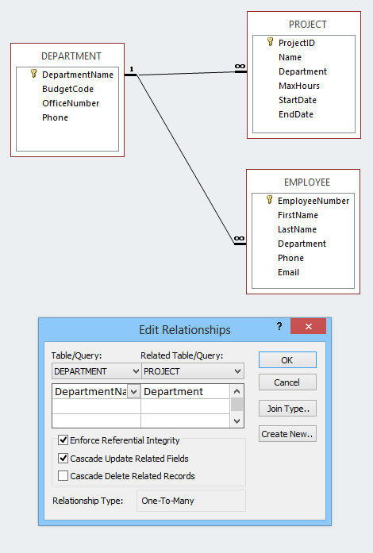

1. Figure 2-31 shows the data for the WPC PROJECT table. Using the Datasheet view, enter the data shown in Figure 2-27 into your PROJECT table.

Solutions to Project Questions 2.56 – 2.65 are contained in the Microsoft Access database *DBP-e13-IM-CH02-WPC.accdb* which is available on the text’s Web site ([www.pearsonhighered.com/kroenke](http://www.pearsonhighered.com/kroenke/)).

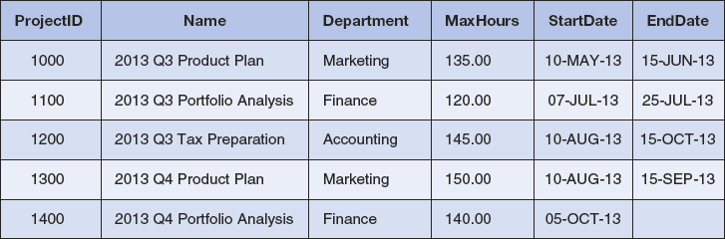

*Figure 2-31 - Sample Data for the PROJECT Table*

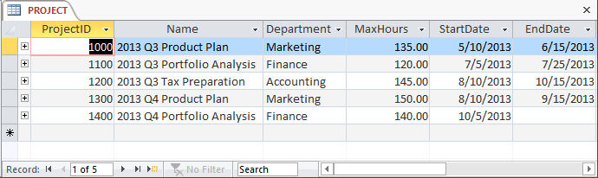

1. Figure 2-32 shows the column characteristics for the WPC ASSIGNMENT table. Using the column characteristics, create the ASSIGNMENT table in the WPC.accdb database.

Solutions to Project Questions 2.56 – 2.65 are contained in the Microsoft Access database *DBP-e13-IM-CH02-WPC.accdb* which is available on the text’s Web site ([www.pearsonhighered.com/kroenke](http://www.pearsonhighered.com/kroenke/)).

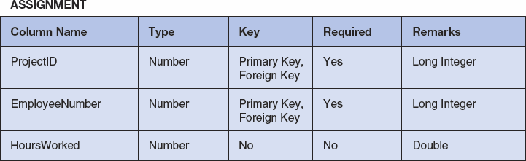

*Figure 2-32 - Column Characteristics for the ASSIGNMENT Table*

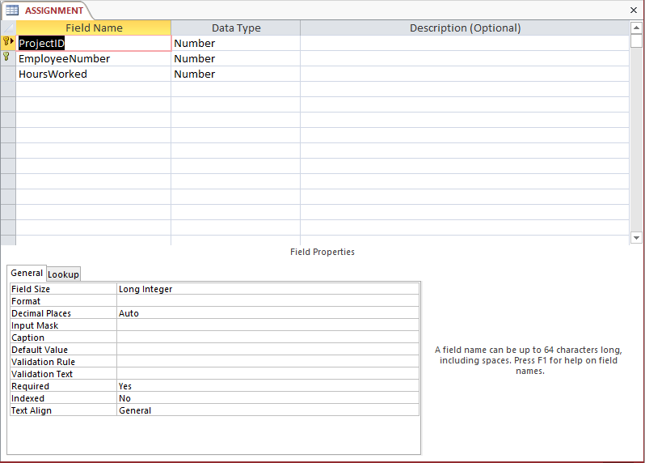

1. Create the relationship and referential integrity constraint between ASSIGNMENT and EMPLOYEE. Enable enforcing of referential integrity, but do not enable either cascading updates or the cascading of data from deleted records.

Solutions to Project Questions 2.56 – 2.65 are contained in the Microsoft Access database *DBP-e13-IM-CH02-WPC.accdb* which is available on the text’s Web site ([www.pearsonhighered.com/kroenke](http://www.pearsonhighered.com/kroenke/)).

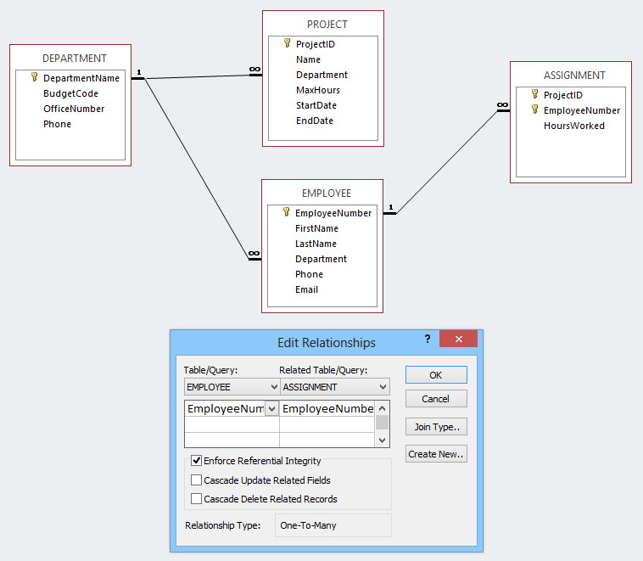

1. Create the relationship and referential integrity constraint between ASSIGNMENT and PROJECT. Enable enforcing of referential integrity and cascading of deletes, but do not enable cascading updates.

Solutions to Project Questions 2.56 – 2.65 are contained in the Microsoft Access database *DBP-e13-IM-CH02-WPC.accdb* which is available on the text’s Web site ([www.pearsonhighered.com/kroenke](http://www.pearsonhighered.com/kroenke/)).

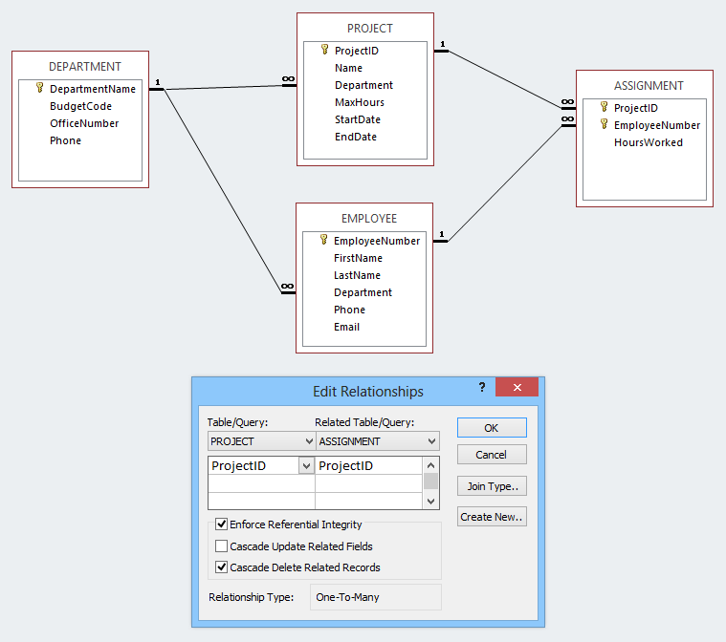

1. Figure 2-33 shows the data for the WPC ASSIGNMENT table. Using the Datasheet view, enter the data shown in Figure 2-33 into your ASSIGNMENT table.

Solutions to Project Questions 2.56 – 2.65 are contained in the Microsoft Access database *DBP-e13-IM-CH02-WPC.accdb* which is available on the text’s Web site ([www.pearsonhighered.com/kroenke](http://www.pearsonhighered.com/kroenke/)).

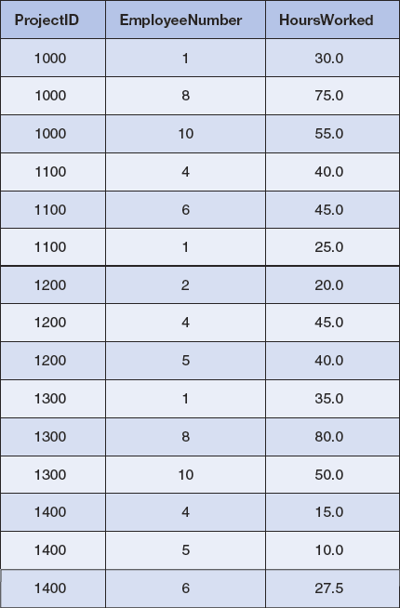

*Figure 2-33 - Sample Data for the ASSIGNEMENT Table*

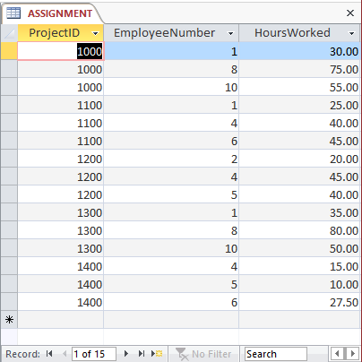

1. In Project Question 2.58, the table data was entered after referential integrity constraints were created in Project Question 2.57. In Project Question 2.62, the table data was entered after referential integrity constraints were created in Project Questions 2.59 and 2.60. Why was the data entered after the referential integrity constraints were created instead of before the constraints were created?

Both the PROJECT and ASSIGNMENT tables have foreign keys. PROJECT.Department is the foreign key in PROJECT, and both ASSIGNMENT.ProjectID and ASSIGNMENT.EmployeeNumber are foreign keys in ASSIGNMENT, If data was entered into these columns before the referential integrity constraints were established, it would be possible to enter foreign key data that had no corresponding primary key data. Thus, we establish the referential integrity constraints so that the DBMS will not allow inconsistent data to be entered into the foreign key columns.

1. Using Access SQL, create and run queries to answer the following questions. Save each query using the query name format SQL-Query-02-##, where the ## sign is replaced by the letter designator of the question. For example, the first query will be saved as SQL-Query-02-A.Write SQL queries to produce the following results:

Solutions to Project Questions 2.64 A–N are contained in the Microsoft Access database *DBP-e13-IM-CH02-WPC.accdb* which is available on the text’s Web site ([www.pearsonhighered.com/kroenke](http://www.pearsonhighered.com/kroenke/)).

1. What projects are in the PROJECT table? Show all information for each project.

/***** Question A - SQL-Query-02-A ************************/

SELECT * FROM PROJECT;

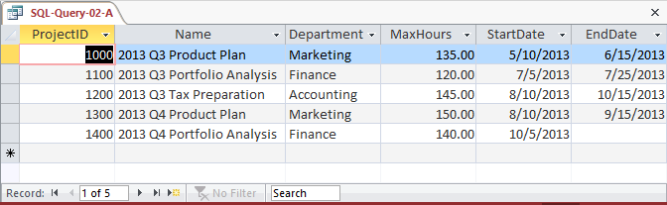

1. What are the ProjectID, Name, StartDate, and EndDate values of projects in the PROJECT table?

/***** Question B - SQL-Query-02-B ************************/

SELECT ProjectID, Name, StartDate, EndDate

FROM PROJECT;

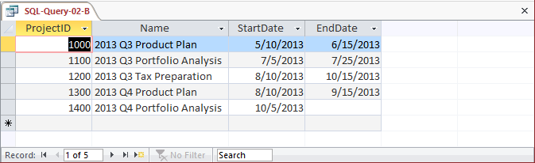

1. What projects in the PROJECT table started before August 1, 2013? Show all the information for each project.

Note that the answer is an **empty set**—there are **no** PROJECTs that were started before **August 1, 2013**. This answer may surprise students, but it is the correct and intended answer. Point out in class that sometimes the results of a query will be an empty set. Then ask your class to rerun the query with the dates **August 1, 2012** and **August 1, 2014** and compare the results of the three queries.

/***** Question C - SQL-Query-02-C ************************/

SELECT *

FROM PROJECT

WHERE StartDate < #01-AUG-13#;

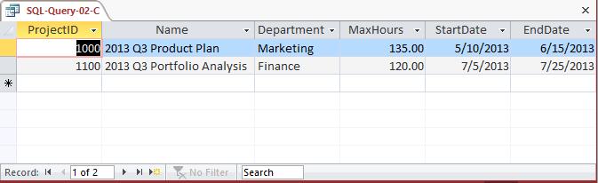

1. What projects in the PROJECT table have not been completed? Show all the information for each project.

/***** Question D - SQL-Query-02-D ************************/

SELECT *

FROM PROJECT

WHERE EndDate IS NULL;

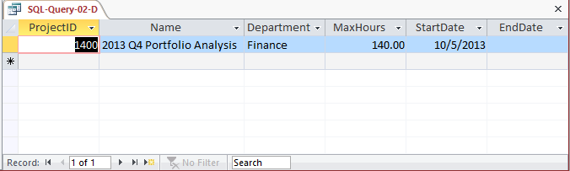

1. Who are the employees assigned to each project? Show ProjectID, Employee-Number, LastName, FirstName, and Phone.

/***** Question E - SQL-Query-02-E ************************/

SELECT ProjectID, E.EmployeeNumber, LastName, FirstName, Phone

FROM ASSIGNMENT AS A INNER JOIN EMPLOYEE AS E

ON A.EmployeeNumber=E.EmployeeNumber;

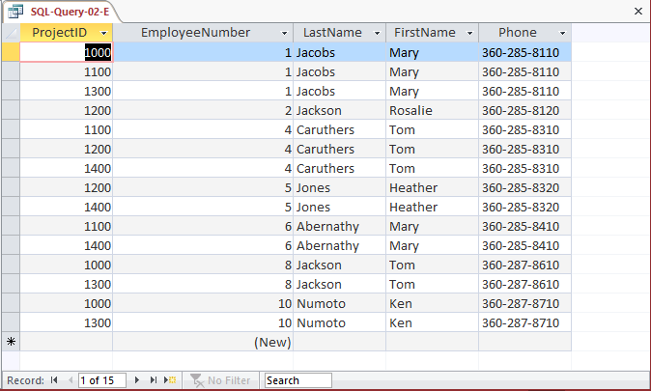

1. Who are the employees assigned to each project? Show the ProjectID, Name, and Department. Show EmployeeNumber, LastName, FirstName, and Phone.

Note the use of the aliases **ProjectName**, **ProjectDepartment**, **DepartmentPhone** and **EmployeePhone**)

/***** Question F - SQL-Query-02-F ************************/

SELECT P.ProjectID, Name AS ProjectName,

P.Department AS ProjectDepartment,

E.EmployeeNumber, LastName, FirstName,

Phone AS EmployeePhone

FROM (ASSIGNMENT AS A INNER JOIN EMPLOYEE AS E

ON A.EmployeeNumber=E.EmployeeNumber)

INNER JOIN PROJECT AS P

ON A.ProjectID=P.ProjectID;

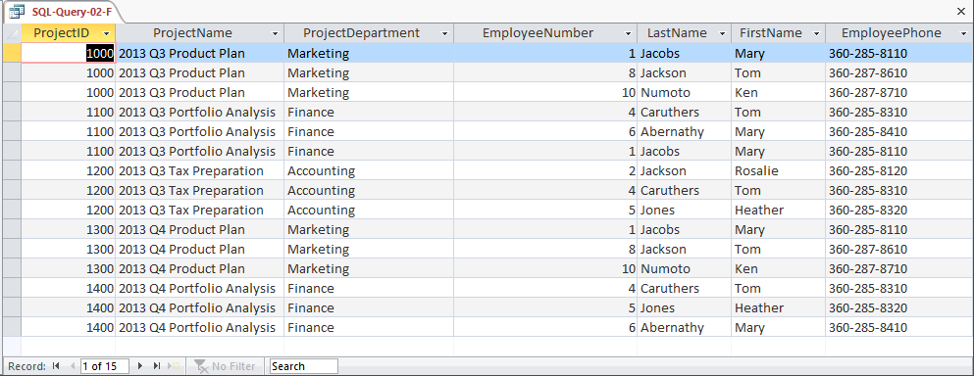

1. Who are the employees assigned to each project? Show ProjectID, Name, Department, and Department Phone. Show EmployeeNumber, LastName, FirstName, and Employee Phone. Sort by ProjectID in ascending order.

Note the use of the aliases **ProjectName**, **ProjectDepartment**, **DepartmentPhone** and **EmployeePhone**.

/***** Question G - SQL-Query-02-G ************************/

SELECT P.ProjectID, Name AS ProjectName,

D.DepartmentName AS ProjectDepartment,

D.Phone AS DepartmentPhone,

E.EmployeeNumber, LastName, FirstName,

E.Phone AS EmployeePhone

FROM ((ASSIGNMENT AS A INNER JOIN EMPLOYEE AS E

ON A.EmployeeNumber=E.EmployeeNumber)

INNER JOIN PROJECT AS P

ON A.ProjectID=P.ProjectID)

INNER JOIN DEPARTMENT AS D

ON P.Department=D.DepartmentName

ORDER BY P.ProjectID;

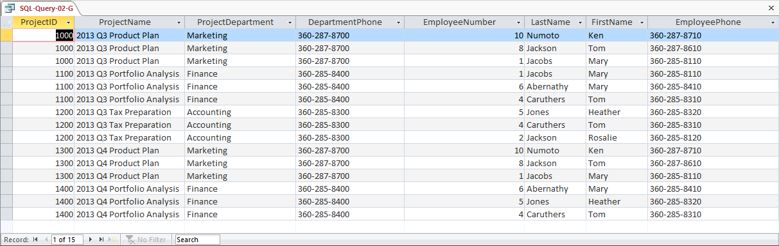

1. Who are the employees assigned to projects run by the marketing department? Show ProjectID, Name, Department, and Department Phone. Show EmployeeNumber, LastName, FirstName, and Employee Phone. Sort by ProjectID in ascending order.

Note the use of the aliases **ProjectName**, **ProjectDepartment**, **DepartmentPhone** and **EmployeePhone**.

/***** Question H - SQL-Query-02-H ************************/

SELECT P.ProjectID, Name AS ProjectName,

D.DepartmentName AS ProjectDepartment,

D.Phone AS DepartmentPhone,

E.EmployeeNumber, LastName, FirstName,

E.Phone AS EmployeePhone

FROM ((ASSIGNMENT AS A INNER JOIN EMPLOYEE AS E

ON A.EmployeeNumber=E.EmployeeNumber)

INNER JOIN PROJECT AS P

ON A.ProjectID=P.ProjectID)

INNER JOIN DEPARTMENT AS D

ON P.Department=D.DepartmentName

WHERE DepartmentName='Marketing'

ORDER BY P.ProjectID;

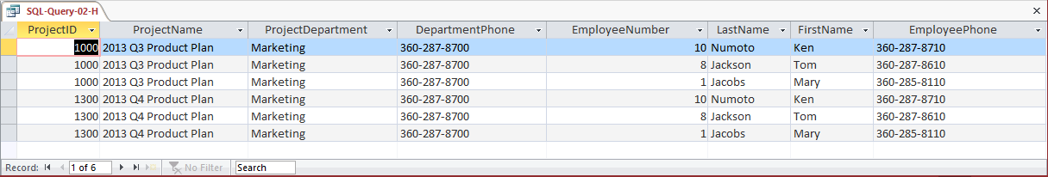

1. How many projects are being run by the marketing department? Be sure to assign an appropriate column name to the computed results.

Note the use of the alias **NumberOfMarketingProjects**.

/***** Question I - SQL-Query-02-I ************************/

SELECT COUNT(*) AS NumberOfMarketingProjects

FROM PROJECT

WHERE Department='Marketing';

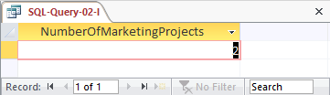

1. What is the total MaxHours of projects being run by the marketing department? Be sure to assign an appropriate column name to the computed results.

Note the use of the alias **TotalMaxHoursForMarketingProjects**.

/***** Question J - SQL-Query-02-J ************************/

SELECT SUM(MaxHours) AS TotalMaxHoursForMarketingProjects

FROM PROJECT

WHERE Department='Marketing';

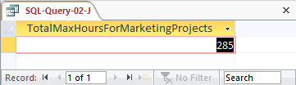

1. What is the average MaxHours of projects being run by the marketing department? Be sure to assign an appropriate column name to the computed results.

Note the use of the alias **AverageMaxHoursForMarketingProjects**.

/***** Question K - SQL-Query-02-K ************************/

SELECT AVG(MaxHours) AS AverageMaxHoursForMarketingProjects

FROM PROJECT

WHERE Department='Marketing';

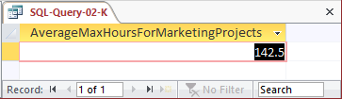

1. How many projects are being run by each department? Be sure to display each DepartmentName and to assign an appropriate column name to the computed results.

Note the use of the alias **NumberOfDepartmentProjects**.

/***** Question L - SQL-Query-02-L ************************/

SELECT Department, COUNT(*) AS NumberOfDepartmentProjects

FROM PROJECT

GROUP BY Department;

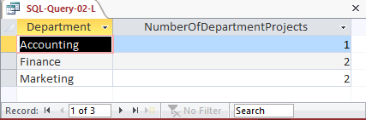

1. Write an SQL statement to join EMPLOYEE, ASSIGNMENT, and PROJECT using the JOIN ON syntax. Run this statement.

For Microsoft SQL Server, Oracle Database and MySQL:

/***** Review Question 2.55 M ******************************************/

SELECT E.*, A.*, P.*

FROM EMPLOYEE AS E JOIN ASSIGNMENT AS A

ON E.EmployeeNumber = A.EmployeeNumber

JOIN PROJECT AS P

ON A.ProjectID = P.ProjectID;

For Microsoft Access:

Microsoft Access requires the SQL JOIN ON syntax INNER JOIN instead of just JOIN:

SELECT E.*, A.*, P.*

FROM (EMPLOYEE AS E INNER JOIN ASSIGNMENT AS A

ON E.EmployeeNumber = A.EmployeeNumber)

INNER JOIN PROJECT AS P

ON A.ProjectID = P.ProjectID;

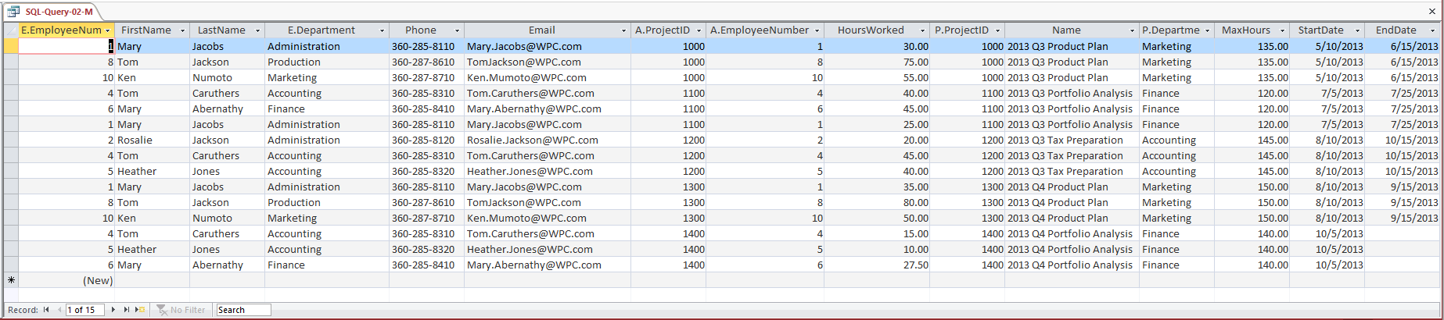

1. Write an SQL statement to join EMPLOYEE and ASSIGNMENT and include all rows of EMPLOYEE in your answer, regardless of whether they have an ASSIGNMENT. Run this statement.

/***** Review Question 2.55 N *******************************************/

SELECT E.*, A.*

FROM EMPLOYEE AS E LEFT JOIN ASSIGNMENT AS A

ON E.EmployeeNumber = A.EmployeeNumber;

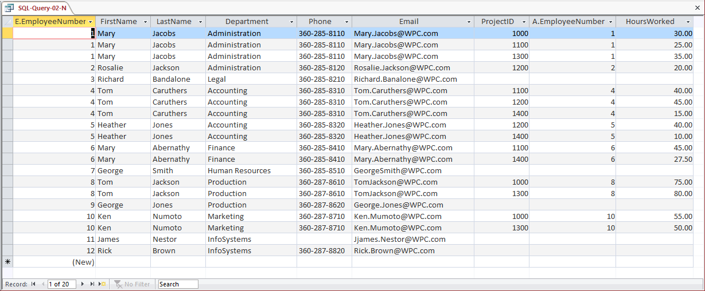

1. Using Access QBE, create and run new queries to answer the questions in exercise 2.64. Save each query using the query name format QBE-Query-02-##, where the ## sign is replaced by the letter designator of the question. For example, the first query will be saved as QBE-Query-02-A.

Solutions to Project Questions 2.65 A–N are contained in the Microsoft Access database *DBP-e13-IM-CH02-WPC.accdb* which is available on the text’s Web site ([www.pearsonhighered.com/kroenke](http://www.pearsonhighered.com/kroenke/)).

The results of each query will be identical to the corresponding SQL query in the previous Project Question. Here we will show the QBE design of the query.

1. What projects are in the PROJECT table? Show all information for each project.

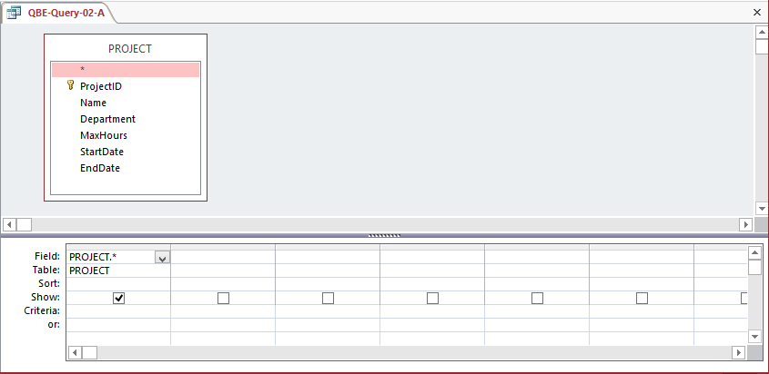

1. What are the ProjectID, Name, StartDate, and EndDate values of projects in the PROJECT table?

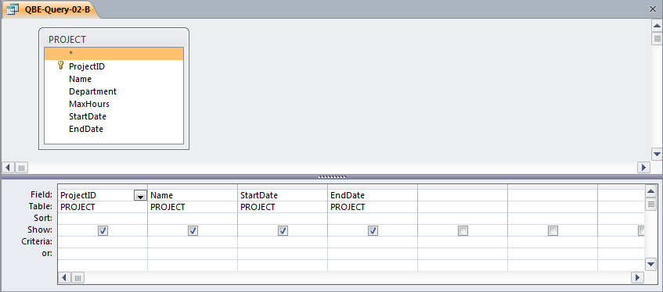

1. What projects in the PROJECT table started before August 1, 2013? Show all the information for each project.

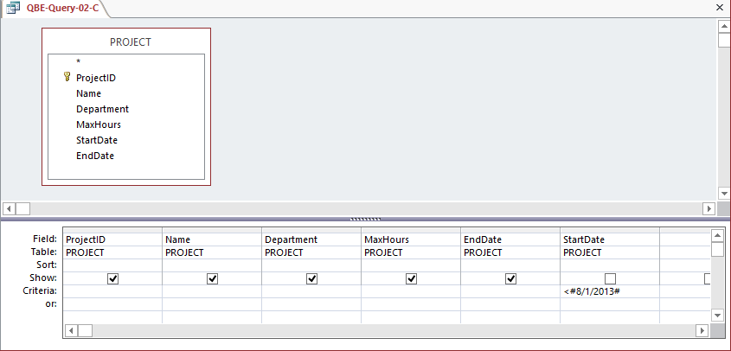

1. What projects in the PROJECT table have not been completed? Show all the information for each project.

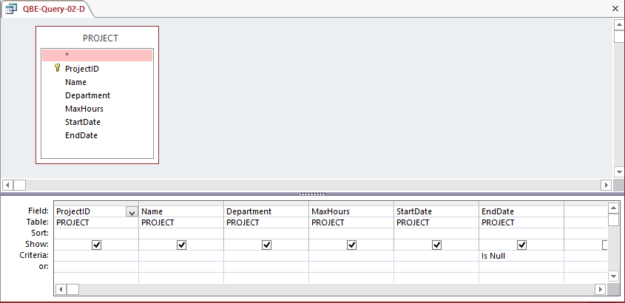

1. Who are the employees assigned to each project? Show ProjectID, Employee-Number, LastName, FirstName, and Phone.

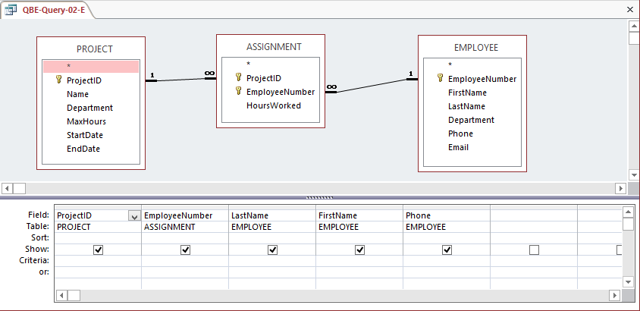

1. Who are the employees assigned to each project? Show the ProjectID, Name, and Department. Show EmployeeNumber, LastName, FirstName, and Phone.

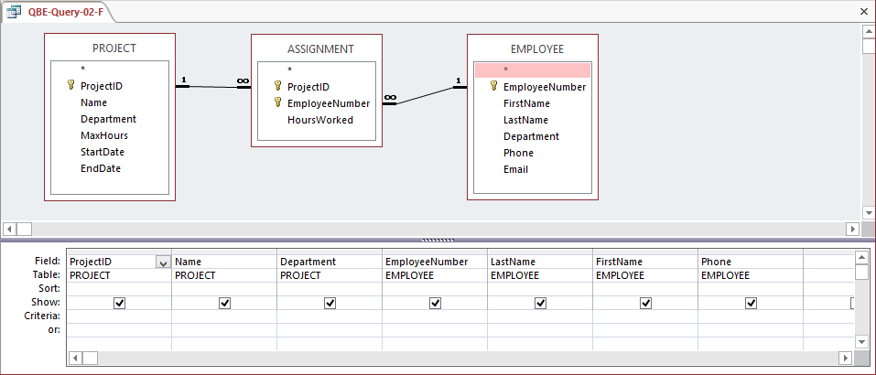

1. Who are the employees assigned to each project? Show ProjectID, Name, Department, and Department Phone. Show EmployeeNumber, LastName, FirstName, and Employee Phone. Sort by ProjectID in ascending order.

This question is more complicated than it seems. It also raises the important question of why students need to know SQL, and provides one answer: QBE equivalents may not always work, or at least they don’t work as intended. You should use this question as the basis for a discussion of this issue.

We have already run this query as an SQL query, and gotten the correct results. That SQL Query (from RQ 2.61-G) is

/***** Question G - SQL-Query-02-G ************************/

SELECT P.ProjectID, Name AS ProjectName,

D.DepartmentName AS ProjectDepartment,

D.Phone AS DepartmentPhone,

E.EmployeeNumber, LastName, FirstName,

E.Phone AS EmployeePhone

FROM ((ASSIGNMENT AS A INNER JOIN EMPLOYEE AS E

ON A.EmployeeNumber=E.EmployeeNumber)

INNER JOIN PROJECT AS P

ON A.ProjectID=P.ProjectID)

INNER JOIN DEPARTMENT AS D

ON P.Department=D.DepartmentName

ORDER BY P.ProjectID;

The results, which are correct, of this query are:



If we build the obvious corresponding QBE query we get (note the use of the aliases **ProjectName**, **ProjectDepartment**, **DepartmentPhone** and **EmployeePhone**):

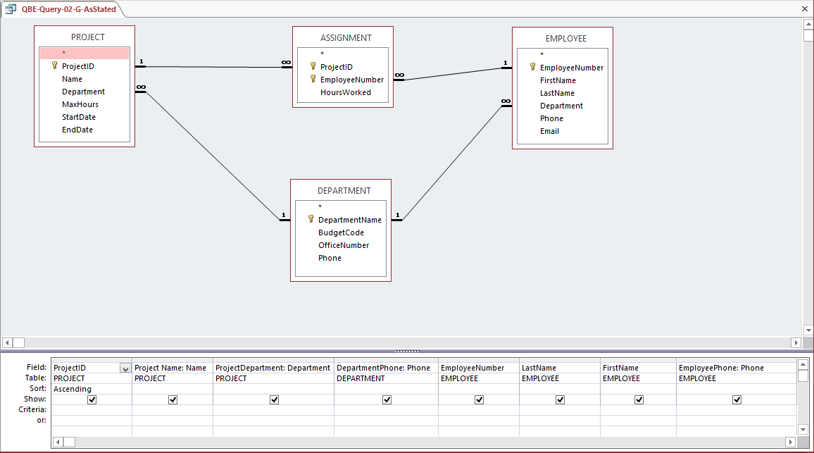

This QBE query shows the solution to the question as stated, but it will not run correctly due to how Microsoft Access interprets the JOIN...ON commands in the QBE query it itself created! The QBE query results are:

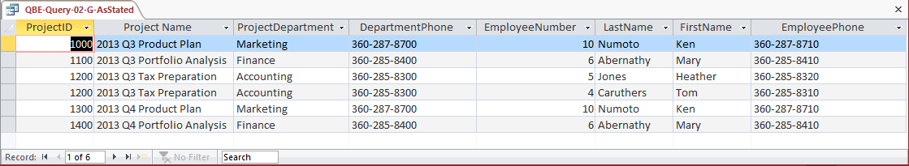

Compare these results with those shown for SQL-Query-2-G above, and you will see the difference and these results are clearly wrong. Looking at the data itself and thinking about what the query results *should* be also makes it obvious that there is a problem here.

For reference, here is the SQL code that Microsoft Access created from the QBE query:

SELECT PROJECT.ProjectID, PROJECT.Name AS [Project Name],

PROJECT.Department, DEPARTMENT.Phone AS DepartmentPhone, EMPLOYEE.EmployeeNumber, EMPLOYEE.LastName, EMPLOYEE.FirstName, EMPLOYEE.Phone AS EmployeePhone

FROM ((DEPARTMENT INNER JOIN PROJECT ON

DEPARTMENT.DepartmentName = PROJECT.Department)

INNER JOIN EMPLOYEE ON

DEPARTMENT.DepartmentName = EMPLOYEE.Department)

INNER JOIN ASSIGNMENT ON

(PROJECT.ProjectID = ASSIGNMENT.ProjectID)

AND

(EMPLOYEE.EmployeeNumber = ASSIGNMENT.EmployeeNumber)

ORDER BY PROJECT.ProjectID;

What can we do? There are two work arounds.

First, create the query *without* Department Phone. This is the only column needed from the DEPARTMENT table, which can thus be eliminated from the query. The QBE query is (note the use of the aliases **ProjectName**, **ProjectDepartment** and **EmployeePhone**):

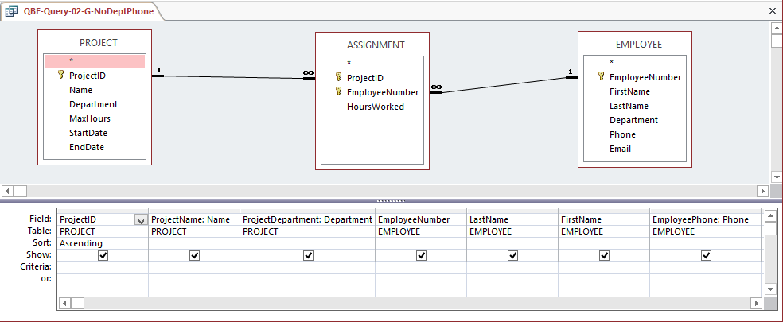

The results will be correct, but without the DepartmentPhone column. The results are:

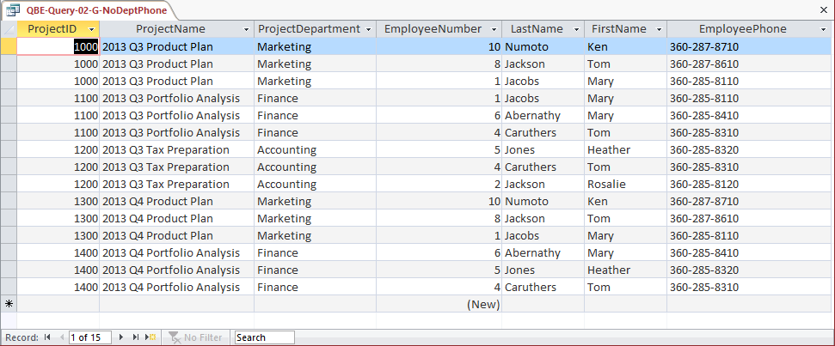

Alternatively, as devised by Professor John Schauf of Edgewood College, Madison, WI, you can illustrate building a set of queries, where each one uses the previous query and adds one additional table. This is possible because Microsoft Access allows saved queries to be used as the equivalent of a table in a query. By adding in one table at a time, you can control the JOIN...ON statement sequence, and obtain the correct answer.

This is a much better solution, because the end result is exactly what we want, rather than a truncated version of it.

You should use this solution in class to illustrate how to use Microsoft Access query objects as pseudo tables in queries, and point out that they can also be used in forms and reports.

The steps below show how to create the needed sequence of QBE queries:

(1) Create a query that joins PROJECT and ASSIGNMENT, and name it QBE-Query-02-G-PA. Note that you must include ASSIGNMENT.EmployeeNumber in this query. Also note the use of the two aliases **ProjectName** and **ProjectDepartment**:

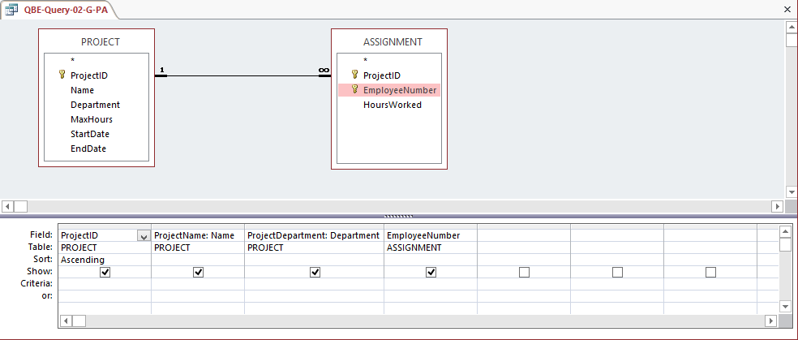

(2) Create a query that joins QBE-Query-02-G-PA and DEPARTMENT, and name it QBE-Query-02-G-PAD. Note that you will have to **manually link** the DEPARTMENT primary key to the foreign key in QBE-Query-02-G-PA. Also note the use of the alias **DepartmentPhone**:

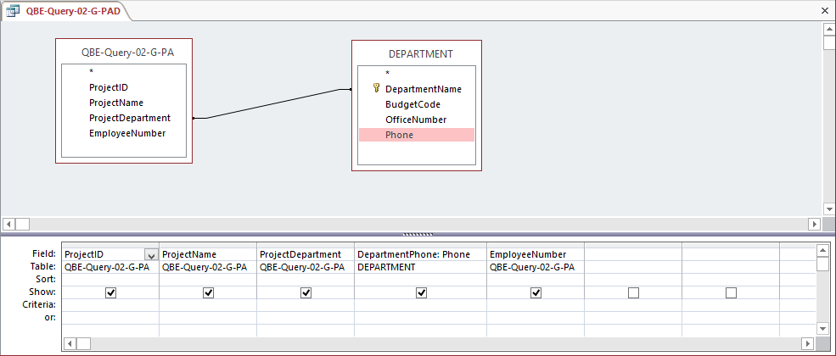

(3) Create a query that joins QBE-Query-02-G-PAD and EMPLOYEE, and name it QBE-Query-02-G-PADE. Note that you will have to **manually link** the DEPARTMENT primary key to the foreign key in QBE-Query-02-G-PAD. Also note the use of the alias **EmployeePhone**:

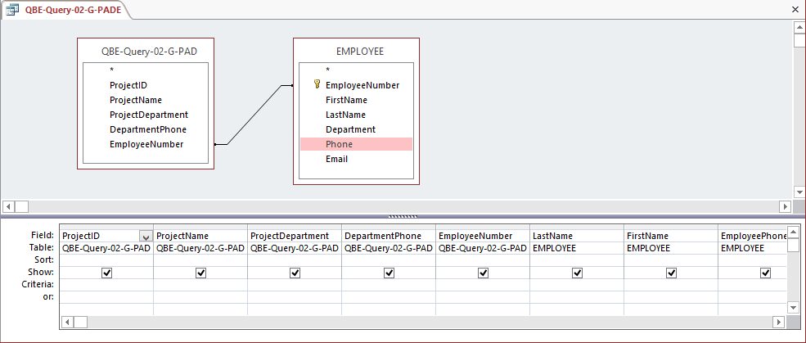

The query results are now correct:

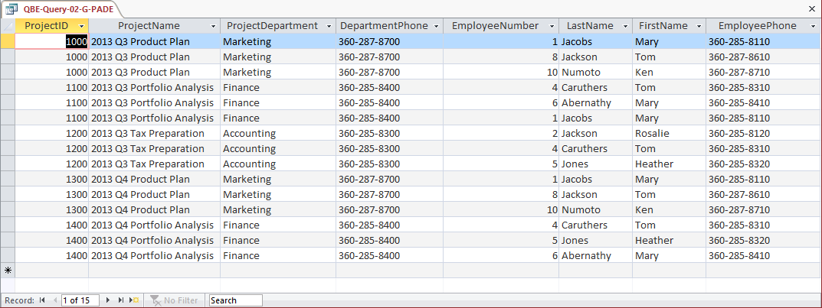

1. Who are the employees assigned to projects run by the marketing department? Show ProjectID, Name, Department, and Department Phone. Show EmployeeNumber, LastName, FirstName, and Employee Phone. Sort by ProjectID in ascending order.

This question is identical to question G except for the restriction to marketing department projects. And, again, this question is more complicated than it seems. It also raises the important question of why students need to know SQL, and provides one answer: QBE equivalents may not always work, or at least they don’t work as intended. You should use this question as the basis for a discussion of this issue.

We have already run this query as an SQL query, and gotten the correct results. That SQL Query (from RQ 2.61-H) is

/***** Question H - SQL-Query-02-H ************************/

SELECT P.ProjectID, Name AS ProjectName,

D.DepartmentName AS ProjectDepartment,

D.Phone AS DepartmentPhone,

E.EmployeeNumber, LastName, FirstName,

E.Phone AS EmployeePhone

FROM ((ASSIGNMENT AS A INNER JOIN EMPLOYEE AS E

ON A.EmployeeNumber=E.EmployeeNumber)

INNER JOIN PROJECT AS P

ON A.ProjectID=P.ProjectID)

INNER JOIN DEPARTMENT AS D

ON P.Department=D.DepartmentName

WHERE DepartmentName='Marketing'

ORDER BY P.ProjectID;

The results, which are correct, of this query are:



If we build the obvious corresponding QBE query we get (note the use of the aliases **ProjectName**, **ProjectDepartment**, **DepartmentPhone** and **EmployeePhone**):

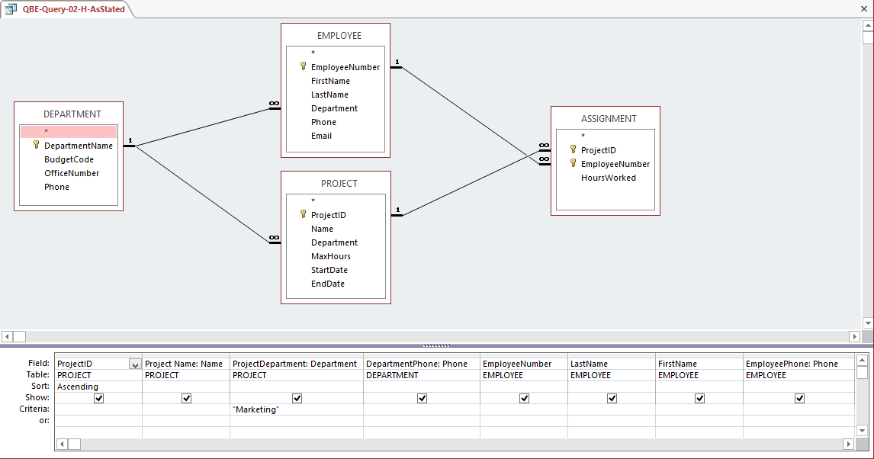

The results are:

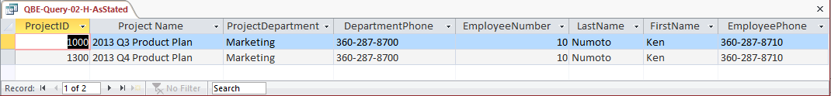

Compare these results with those shown for SQL-Query-02-H above, and you will see the difference.

For reference, here is the SQL code that Microsoft Access created from the QBE query:

SELECT PROJECT.ProjectID, PROJECT.Name AS [Project Name],

PROJECT.Department AS ProjectDepartment,

DEPARTMENT.Phone AS DepartmentPhone, EMPLOYEE.EmployeeNumber,

EMPLOYEE.LastName, EMPLOYEE.FirstName,

EMPLOYEE.Phone AS EmployeePhone

FROM ((DEPARTMENT INNER JOIN PROJECT ON

DEPARTMENT.DepartmentName = PROJECT.Department)

INNER JOIN EMPLOYEE ON

DEPARTMENT.DepartmentName = EMPLOYEE.Department)

INNER JOIN ASSIGNMENT ON

(PROJECT.ProjectID = ASSIGNMENT.ProjectID)

AND

(EMPLOYEE.EmployeeNumber = ASSIGNMENT.EmployeeNumber)

WHERE (((PROJECT.Department)="Marketing"))

ORDER BY PROJECT.ProjectID;

The problem we are encountering here is the same as described above in 2.64 G. Again, there are two work arounds. First, create the query *without* Department Phone. This is the only column needed from the DEPARTMENT table, which can thus be eliminated from the query. The QBE Query is (note the use of the aliases **ProjectName**, **ProjectDepartment** and **EmployeePhone**):

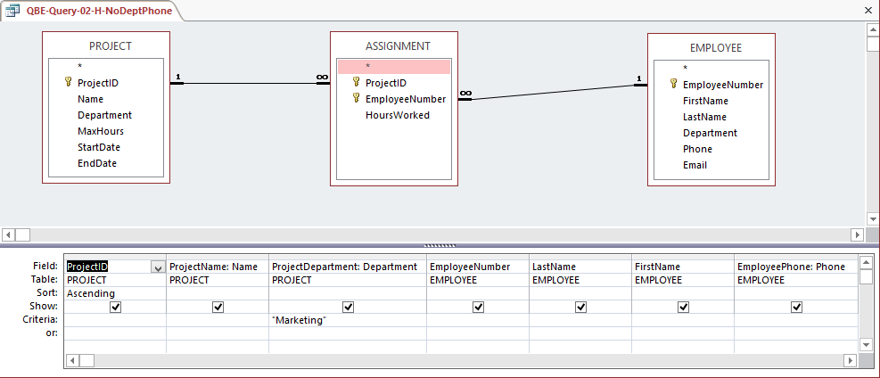

The results will be correct, but without the DepartmentPhone column:

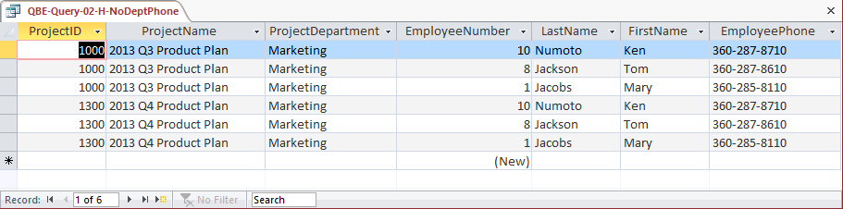

Alternatively, as devised by Professor John Schauf of Edgewood College, Madison, WI, you can illustrate building a set of queries, where each one uses the previous query and adds one additional table. This is possible because Microsoft Access allows saved queries to be used as the equivalent of a table in a query. By adding in one table at a time, you can control the JOIN...ON statement sequence, and obtain the correct answer.

This is a much better solution, because the end result is exactly what we want, rather than a truncated version of it.

You should use this solution in class to illustrate how to use Microsoft Access query objects as pseudo tables in queries, and point out that they can also be used in forms and reports.

The steps below show how to create the needed sequence of QBE queries:

(1) Create a query that joins PROJECT and ASSIGNMENT, and name it QBE-Query-0H-G-PA. Note that you must include ASSIGNMENT.EmployeeNumber in this query, and note the use of the aliases **ProjectName** and **ProjectDepartment**:

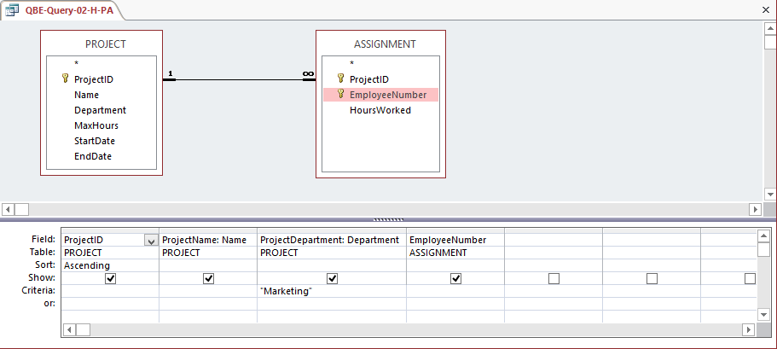

(2) Create a query that joins QBE-Query-02-H-PA and DEPARTMENT, and name it QBE-Query-02-H-PAD. Note that you will have to **manually link** the DEPARTMENT primary key to the foreign key in QBE-Query-02-H-PA, and note the use of the alias **DepartmentPhone**:

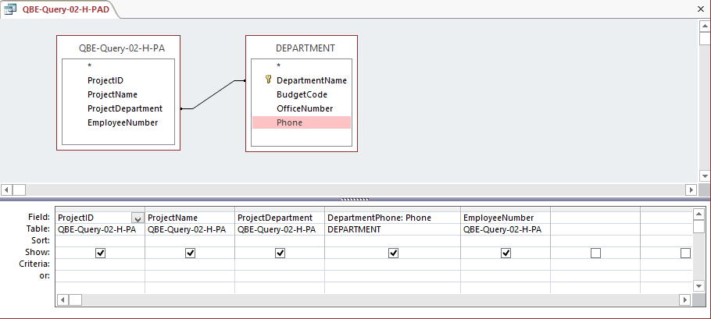

(3) Create a query that joins QBE-Query-02-H-PAD and EMPLOYEE, and name it QBE-Query-02-H-PADE. Note that you will have to **manually link** the DEPARTMENT primary key to the foreign key in QBE-Query-02-H-PAD, and note the use of the alias **EmployeePhone**:

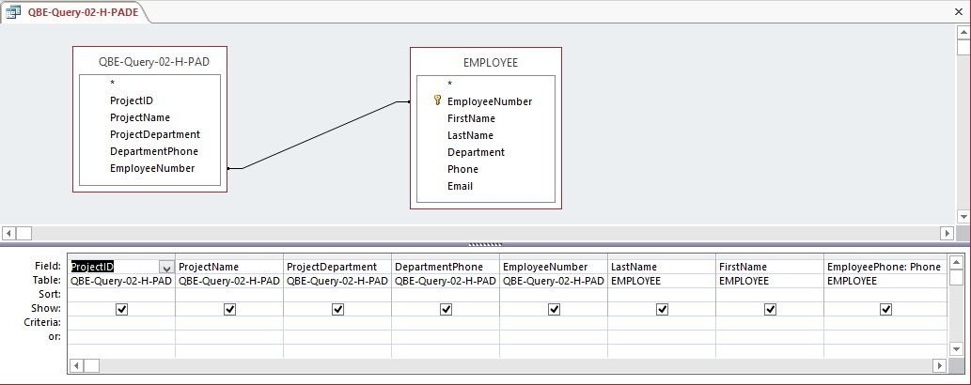

The query results are now correct:

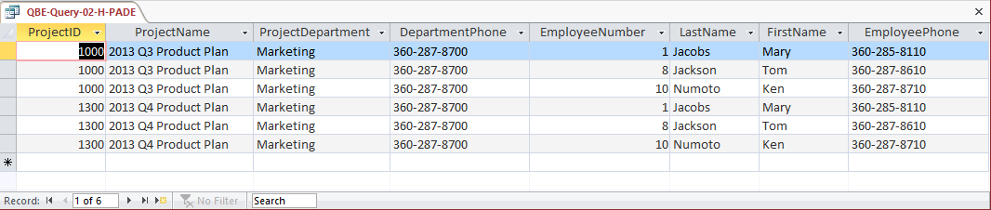

1. How many projects are being run by the marketing department? Be sure to assign an appropriate column name to the computed results.

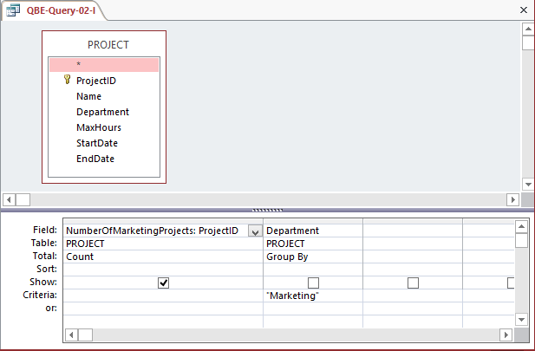

1. What is the total MaxHours of projects being run by the marketing department? Be sure to assign an appropriate column name to the computed results.

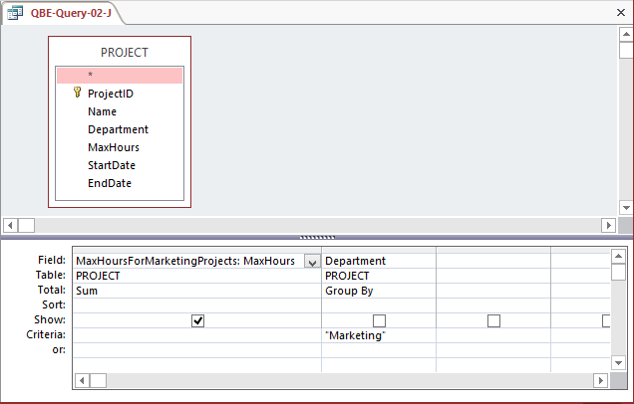

1. What is the average MaxHours of projects being run by the marketing department? Be sure to assign an appropriate column name to the computed results.

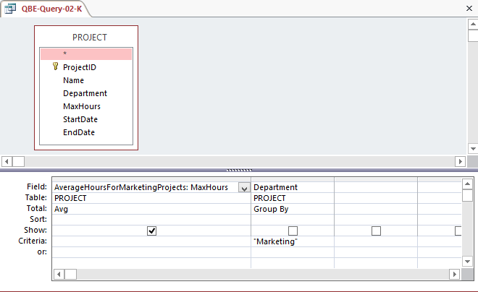

1. How many projects are being run by each department? Be sure to display each DepartmentName and to assign an appropriate column name to the computed results.

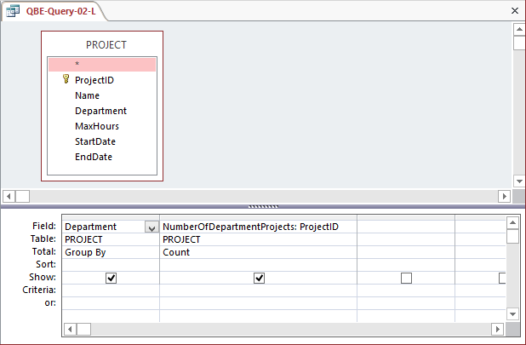

1. Write an SQL statement to join EMPLOYEE, ASSIGNMENT, and PROJECT using the JOIN ON syntax. Run this statement.

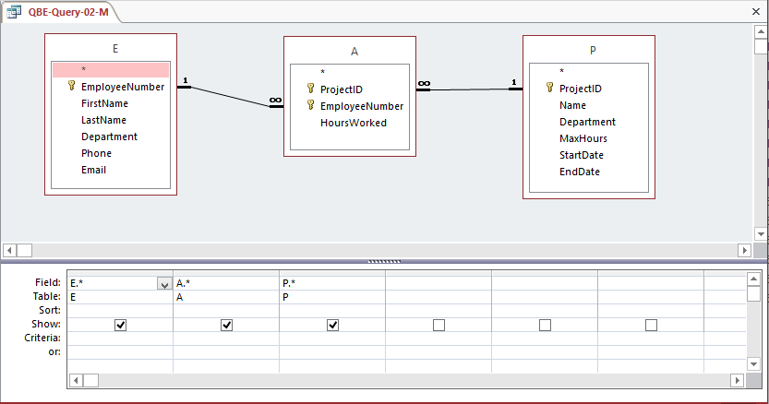

1. Write an SQL statement to join EMPLOYEE and ASSIGNMENT and include all rows of EMPLOYEE in your answer, regardless of whether they have an ASSIGNMENT. Run this statement.

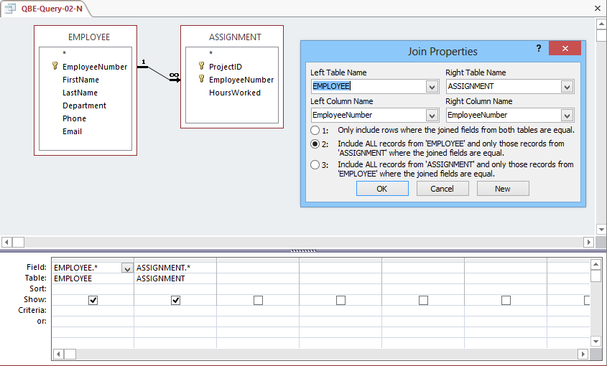

The following questions refer to the NDX table of data as described starting on page 72. You can obtain a copy of this data in the Access database, DBPe11-NDX.accdb located on this text's Web site at [www.pearsonhighered.com/kroenke](http://www.pearsonhighered.com/kroenke/).

1. Write SQL queries to produce the following results:
2. The ChangeClose on Fridays.

Solutions to Project Questions 2.66.A – 2.66.H are contained in the Microsoft Access database *DBP e13-IM-CH02-NDX.accdb* which is available on the text’s Web site ([www.pearsonhighered.com/kroenke](http://www.pearsonhighered.com/kroenke/)).

/* *** SQL-Query-2-63-A *** */

SELECT ChangeClose

FROM NDX

WHERE TDayOfWeeK = 'Friday';

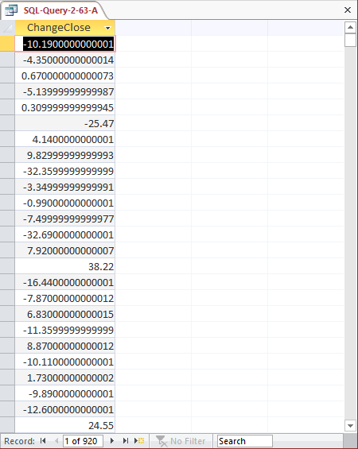

1. The minimum, maximum, and average ChangeClose on Fridays.

Solutions to Project Questions 2.63.A – 2.63.H are contained in the Microsoft Access database *DBP-e13-IM-CH02-NDX.accdb* which is available on the text’s Web site ([www.pearsonhighered.com/kroenke](http://www.pearsonhighered.com/kroenke/)).

/* *** SQL-Query-2-63-B *** */

SELECT MIN (ChangeClose) AS MinFridayChangeClose,

MAX (ChangeClose) AS MaxFridayChangeClose,

AVG (ChangeClose) AS AverageFridayChangeClose

FROM NDX

WHERE TDayOfWeeK = 'Friday';

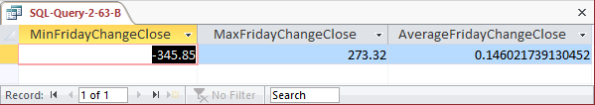

1. The average ChangeClose grouped by TYear. Show TYear.

Since TYear is being displayed, it makes sense to sort the results by TYear although this is not explicitly stated in the question.

Solutions to Project Questions 2.66.A – 2.66.H are contained in the Microsoft Access database *DBP-e13-IM-CH02-NDX.accdb* which is available on the text’s Web site ([www.pearsonhighered.com/kroenke](http://www.pearsonhighered.com/kroenke/)).

/* *** SQL-Query-2-63-C *** */

SELECT TYear, AVG (ChangeClose) AS AverageChangeClose

FROM NDX

GROUP BY TYear

ORDER BY TYear;

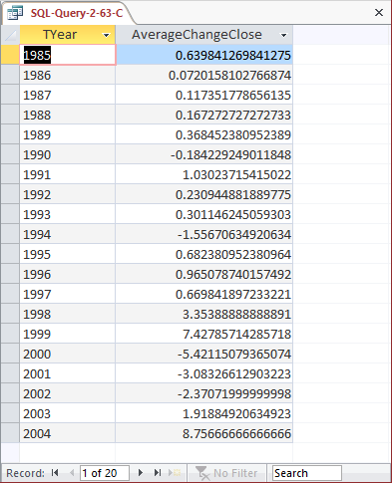

1. The average ChangeClose grouped by TYear and TMonth. Show TYear and TMonth.

Since TYear and TMonth are being displayed, it makes sense to sort the results by TYear and TMonth although this is not explicitly stated in the question.

Solutions to Project Questions 2.66.A – 2.66.H are contained in the Microsoft Access database *DBP-e13-IM-CH02-NDX.accdb* which is available on the text’s Web site ([www.pearsonhighered.com/kroenke](http://www.pearsonhighered.com/kroenke/)).

/* *** SQL-Query-2-63-D-A *** */

SELECT TYear, TMonth,

AVG (ChangeClose) AS AverageChangeClose

FROM NDX

GROUP BY TYear, TMonth

ORDER BY TYear, TMonth;

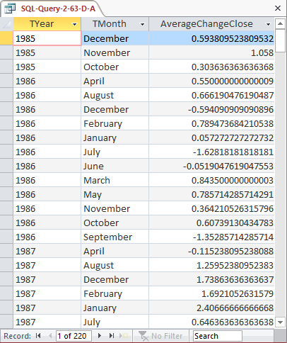

Unfortunately, the table NDX does not contain a numeric value of the month, so in order to sort the months correctly, we need a TMonthNumber which has a column containing a representative number for each month (January = 1, February = 2, etc.)

Although the SQL DDL and DML for doing this is not covered until Chapter 7, this is a good exercise in adding a column to an existing table, and you may want to show this to your students at this time.

We can create this column as follows (note that Microsoft Access can only run one SQL command at a time!):

/* *** SQL-ALTER-TABLE-2-63-D *** */

ALTER TABLE NDX

ADD COLUMN TMonthNumber Int NULL;

/* *** SQL-UPDATES-2-63-D *** */

UPDATE NDX

SET TMonthNumber = 1

WHERE TMonth = 'January';

UPDATE NDX

SET TMonthNumber = 2

WHERE TMonth = 'February';

UPDATE NDX

SET TMonthNumber = 3

WHERE TMonth = 'March';

UPDATE NDX

SET TMonthNumber = 4

WHERE TMonth = 'April';

UPDATE NDX

SET TMonthNumber = 5

WHERE TMonth = 'May';

UPDATE NDX

SET TMonthNumber = 6

WHERE TMonth = 'June';

UPDATE NDX

SET TMonthNumber = 7

WHERE TMonth = 'July';

UPDATE NDX

SET TMonthNumber = 8

WHERE TMonth = 'August';

UPDATE NDX

SET TMonthNumber = 9

WHERE TMonth = 'September';

UPDATE NDX

SET TMonthNumber = 10

WHERE TMonth = 'October';

UPDATE NDX

SET TMonthNumber = 11

WHERE TMonth = 'November';

UPDATE NDX

SET TMonthNumber = 12

WHERE TMonth = 'December';

=================================================================

An SQL or QBE Query can be used to show the data in the table (use GROUP BY):

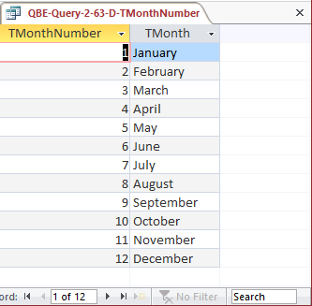

Now that the NDX table includes this column, we can use it as follows to sort the data correctly:

/* *** SQL-Query-2-63-D-B *** */

SELECT TYear, TMonth,

AVG (ChangeClose) AS AverageFridayChangeClose

FROM NDX

GROUP BY TYear, TMonth, TMonthNumber

ORDER BY TYear, TMonthNumber;

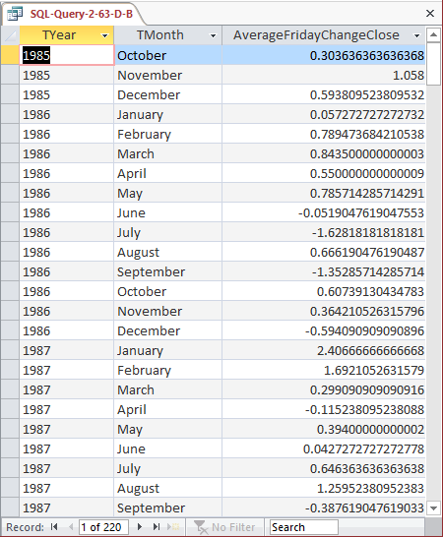

1. The average ChangeClose grouped by TYear, TQuarter, TMonth shown in descending order of the average (you will have to give a name to the average in order to sort by it). Show TYear, TQuarter, and TMonth. Note that months appear in alphabetical and not calendar order. Explain what you need to do to obtain months in calendar order.

Solutions to Project Questions 2.66.A – 2.66.H are contained in the Microsoft Access database *DBP-e13-IM—CH02-NDX.accdb* which is available on the text’s Web site ([www.pearsonhighered.com/kroenke](http://www.pearsonhighered.com/kroenke/)).

**For Microsoft SQL Server, Oracle Database and MySQL:**

/* *** SQL-Query-2-63-E *** */

SELECT TYear, TQuarter, TMonth,

AVG(ChangeClose) AS AverageChangeClose

FROM NDX

GROUP BY TYear, TQuarter, TMonth

ORDER BY AverageChangeClose DESC;

**For Microsoft Access:**

Unfortunately, as discussed above, Microsoft Access cannot process the ORDER BY clause correctly when an SQL built-in function is used in it. Therefore we rewrite the query as:

/* *** SQL-Query-2-63-E-Access *** */

SELECT TYear, TQuarter, TMonth,

AVG(ChangeClose) AS AverageChangeClose

FROM NDX

GROUP BY TYear, TQuarter, TMonth

ORDER BY AVG(ChangeClose) DESC;

The result is:

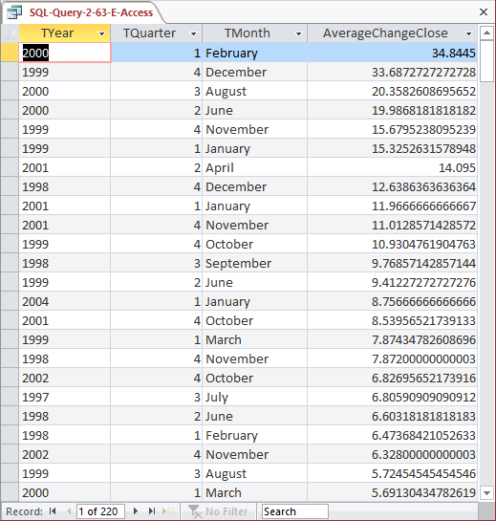

In order to obtain the months in calendar order, we would have to use the TMonthNumber column we created in PQ 2.63-D with a numerical value for each month (1, 2, 3, …, 12) and sort by those values.

1. The difference between the maximum ChangeClose and the minimum ChangeClose grouped by TYear, TQuarter, TMonth shown in descending order of the difference (you will have to give a name to the difference in order to sort by it). Show TYear, TQuarter, and TMonth.

Solutions to Project Questions 2.66.A – 2.66.H are contained in the Microsoft Access database *DBP-e13-IM—CH02-NDX.accdb* which is available on the text’s Web site ([www.pearsonhighered.com/kroenke](http://www.pearsonhighered.com/kroenke/)).

**For Microsoft SQL Server, Oracle Database and MySQL:**

/* *** SQL-Query-2-63-F *** */

SELECT TYear, TQuarter, TMonth,

(MAX(ChangeClose) – MIN(ChangeClose)) AS DifChangeClose

FROM NDX

GROUP BY TYear, TQuarter, TMonth

ORDER BY DifChangeClose DESC;

**For Microsoft Access:**

Unfortunately, as discussed above, Microsoft Access cannot process the ORDER BY clause correctly when an SQL built-in function is used in it. Therefore we rewrite the query as:

/* *** SQL-Query-2-63-F-Access *** */

SELECT TYear, TQuarter, TMonth,

(MAX(ChangeClose) – MIN(ChangeClose)) AS DifChangeClose

FROM NDX

GROUP BY TYear, TQuarter, TMonth

ORDER BY (MAX(ChangeClose) – MIN(ChangeClose)) DESC;

The query result is:

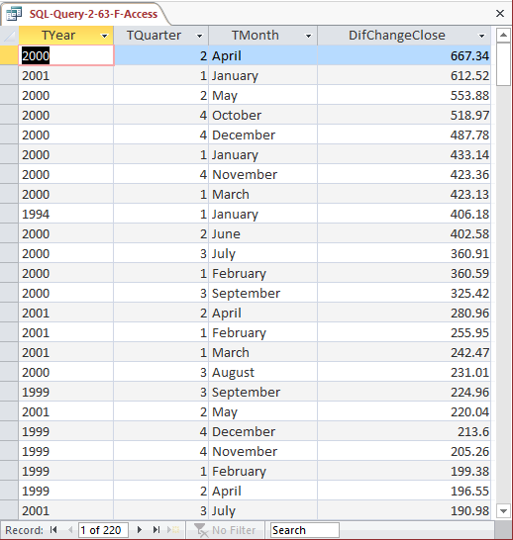

1. The average ChangeClose grouped by TYear shown in descending order of the average (you will have to give a name to the average in order to sort by it). Show only groups for which the average is positive.

Solutions to Project Questions 2.66.A – 2.66.H are contained in the Microsoft Access database *DBP-e13-IM—CH02-NDX.accdb* which is available on the text’s Web site ([www.pearsonhighered.com/kroenke](http://www.pearsonhighered.com/kroenke/)).

**For Microsoft SQL Server, Oracle Database and MySQL:**

/* *** SQL-Query-2-63-G *** */

SELECT TYear,

AVG(ChangeClose) AS AverageChangeClose

FROM NDX

GROUP BY TYear

HAVING AVG(ChangeClose) > 0

ORDER BY AverageChangeClose DESC;

**For Microsoft Access:**

Unfortunately, as discussed above, Microsoft Access cannot process the ORDER BY clause correctly when an SQL built-in function is used in it. Therefore we rewrite the query as:

/* *** SQL-Query-2-63-G-Access *** */

SELECT TYear,

AVG(ChangeClose) AS AverageChangeClose

FROM NDX

GROUP BY TYear

HAVING AVG(ChangeClose) > 0

ORDER BY AVG(ChangeClose) DESC;

The result is:

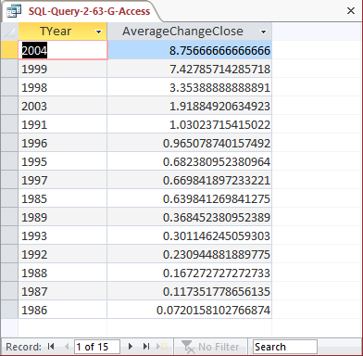

1. Display a single field with the date in the form: day/month/year. Do not be concerned with trailing blanks.

Solutions to Project Questions 2.66.A – 2.66.H are contained in the Microsoft Access database *DBP-e13-IM—CH02-NDX.accdb* which is available on the text’s Web site ([www.pearsonhighered.com/kroenke](http://www.pearsonhighered.com/kroenke/)).

The solution to this question requires the student to use the DBMS help function or other references to figure out a conversion function to convert the numerical day of the month to a character string that can be combined with other data already in character format. The original table NDX does not have a numeric value for month, so the names of the months will appear in the solution. If we want the numeric value of the month, we could use the modified NDX table, which has a numeric value TMonthNumber column. We would need to use the data type conversion on this field as well.

The SQL Statement using SQL Server 2012 character string functions is:

/* *** SQL-Query-2-63-H *** */

SELECT CAST (TDayOfMonth AS Char (2)) + ' / ' +

TMonth + ' / ' + TYear AS DisplayDate

FROM NDX;

The SQL Statement (as created with Expression Builder) for Microsoft Access 2013 is:

/* *** SQL-Query-2-63-H-Access *** */

SELECT [NDX]![TDayOfMonth]

&'/'&[NDX]![TMonth]

&'/'&[NDX]![TYear] AS DisplayDate

FROM NDX;

The Microsoft Access 2013 result is:

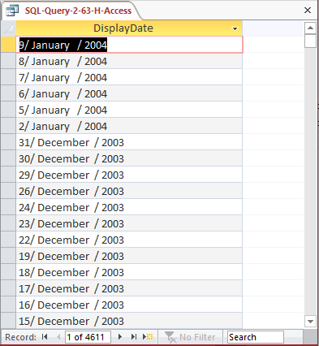

1. It is possible that volume (the number of shares traded) has some correlation with the direction of the stock market. Use the SQL you have learned in this chapter to investigate that possibility. Develop at least five different SQL statements in your investigation.

If volume is correlated with the direction of the stock market, this means that there should be either:

(1) POSITIVE CORRELATION: Higher volume when the market closes higher, or

(2) NEGATIVE CORRELATION: Higher volume when the market closes lower.

When does the market close higher? When NDX.ChangeClose is positive.

/* *** SQL-Query-2-64-A *** */

SELECT TMonth, TDayOfMonth, TYear, ChangeClose

FROM NDX

WHERE ChangeClose > 0;

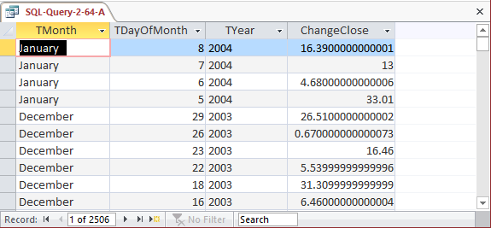

When does the market close lower? When NDX.ChangeClose is negative.

/* *** SQL-Query-2-64-B *** */

SELECT TMonth, TDayOfMonth, TYear, ChangeClose

FROM NDX

WHERE ChangeClose < 0;

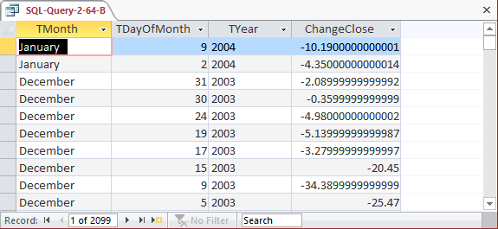

Now, what are the average positive and negative changes?

/* *** SQL-Query-2-64-C *** */

SELECT AVG (ChangeClose) AS AvgPositiveChange

FROM NDX

WHERE ChangeClose > 0;

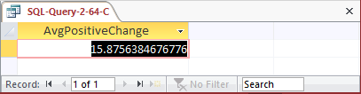

/* *** SQL-Query-2-64-D *** */

SELECT AVG (ChangeClose) AS AvgNegativeChange

FROM NDX

WHERE ChangeClose < 0;

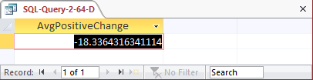

Now, what are the average volumes associated with the positive and negative changes?

/* *** SQL-Query-2-64-E *** */

SELECT AVG (ChangeClose) AS AvgPositiveChange,

AVG (Volume) AS AvgVolumeOnPositiveChange

FROM NDX

WHERE ChangeClose > 0;

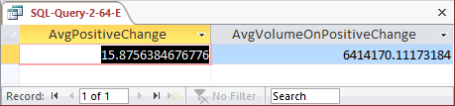

/* *** SQL-Query-2-64-F *** */

SELECT AVG (ChangeClose) AS AvgNegativeChange,

AVG (Volume) AS AvgVolumeOnNegativeChange

FROM NDX

WHERE ChangeClose < 0;

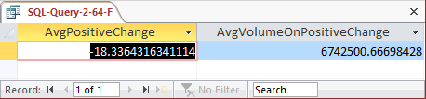

So, when there is a positive, or upward, change in the market we have an average volume of 641417.1117318 shares traded, and when we have a negative, or downward, change in the market we have an average volume of 6742500.66698428 shares. These numbers do not look significantly different, we will conclude that there is no correlation between the direction of the market movement and the volume of shares traded (if we wanted to be more formal, we could use a statistical procedure and do a hypothesis test as to whether or not there is really a statistically significant difference between these two numbers).

* MARCIA’S DRY CLEANING CASE QUESTIONS

Marcia Wilson owns and operates Marcia’s Dry Cleaning, which is an upscale dry cleaner in a well-to-do suburban neighborhood. Marcia makes her business stand out from the competition by providing superior customer service. She wants to keep track of each of her customers and their orders. Ultimately, she wants to notify them that their clothes are ready via e-mail. To provide this service, she has developed an initial database with several tables. Three of those tables are the following:

CUSTOMER (CustomerID, FirstName, LastName, Phone, Email)

INVOICE (InvoiceNumber, *CustomerNumber*, DateIn, DateOut, TotalAmount)

INVOICE_ITEM (*InvoiceNumber*, ItemNumber, Item, Quantity, UnitPrice)

In the database schema above, the primary keys are underlined and the foreign keys are shown in italics. The database that Marcia has created is named MDC, and the three tables in the MDC database schema are shown in Figure 2-34.

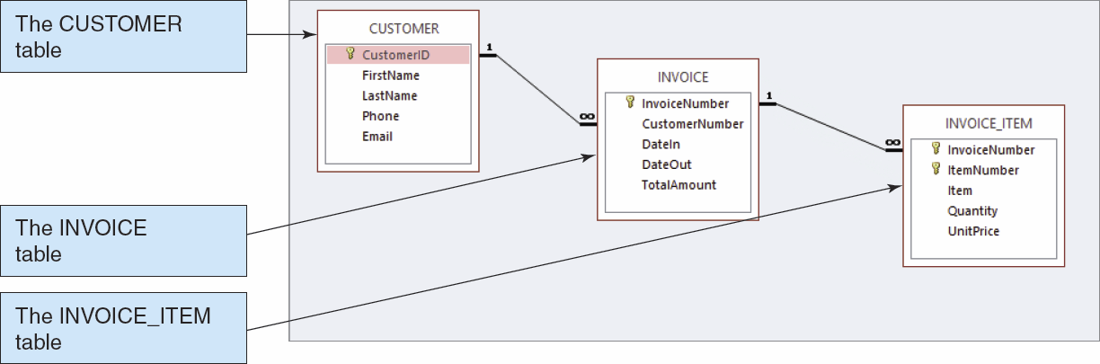

FIGURE 2-34 – The MDC Database

The column characteristics for the tables are shown in Figures 2-34, 2-35, and 2-36. The relationship between CUSTOMER and INVOICE should enforce referential integrity, but not cascade updates or deletions, while the relationship between INVOICE and INVOICE_ITEM should enforce referential integrity and cascade both updates and deletions. The data for these tables are shown in Figures 2-38, 2-39, and 2-40.

We recommend that you create a Microsoft Access 2013 database named MDC-CH02.accdb using the database schema, column characteristics, and data shown above, and then use this database to test your solutions to the questions in this section. Alternatively, SQL scripts for creating the MDC-CH02 database in SQL Server, Oracle Database, and MySQL are available on our Web site at [www.pearsonhighered.com/kroenke](http://www.pearsonhighered.com/kroenke) .

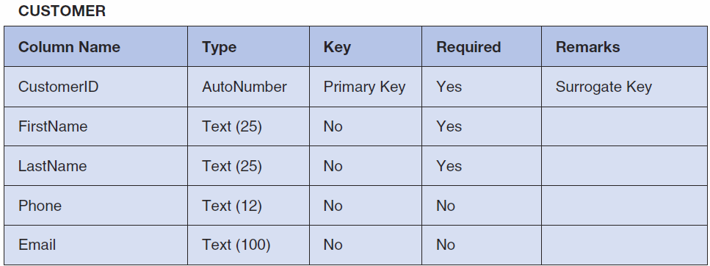

*Figure 2-35 - Column Characteristics for the CUSTOMER Table*

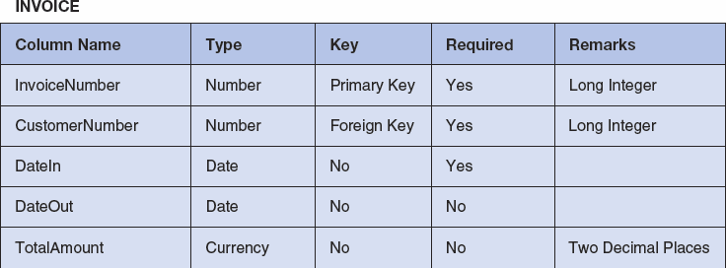

*Figure 2-36 - Column Characteristics for the INVOICE Table*

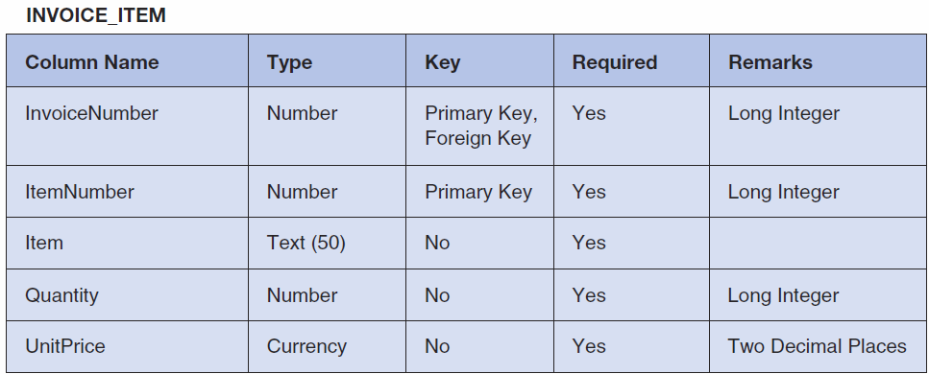

*Figure 2-37 - Column Characteristics for the INVOICE_ITEM Table*

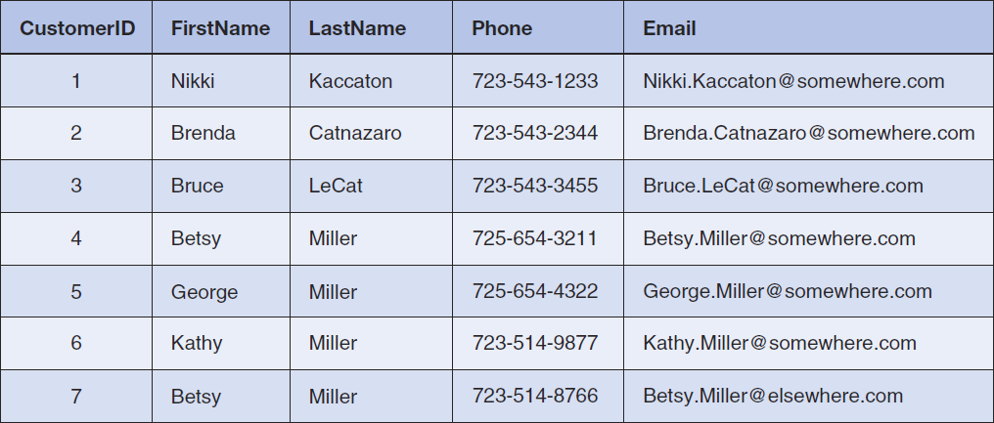

*Figure 2-38 - Sample Data for the MDC Database CUSTOMER table*

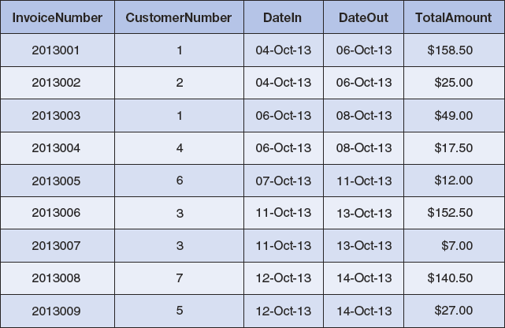

*Figure 2-38 - Sample Data for the MDC Database INVOICE table*

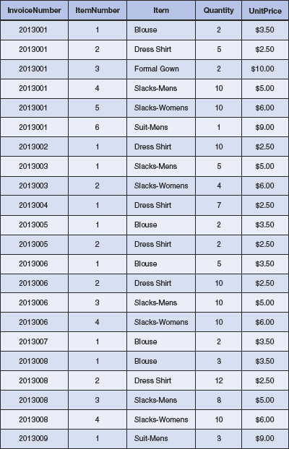

*Figure 2-39 - Sample Data for the MDC Database INVOICE_ITEM table*

Write SQL statements and show the results based on the MDC data for each of the following:

1. Show all data in each of the tables.

Solutions to Marcia’s Dry Cleaning questions are contained in the Microsoft Access database *DBP-e13-IM-CH02-MDC.accdb* which is available at the Instructor’s Resource Center on the text’s Web site ([www.pearsonhighered.com/kroenke](http://www.pearsonhighered.com/kroenke/)).

/* *** SQL-Query-MDC-A-CUSTOMER *** */

SELECT *

FROM CUSTOMER;

Note there are two customers both named Betsy Miller.

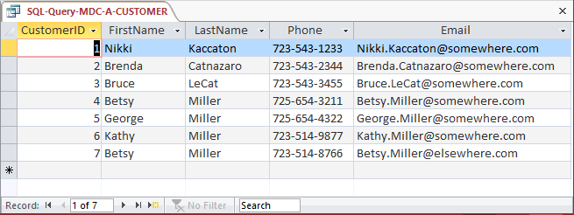

/* *** SQL-Query-MDC-A-INVOICE *** */

SELECT *

FROM INVOICE;

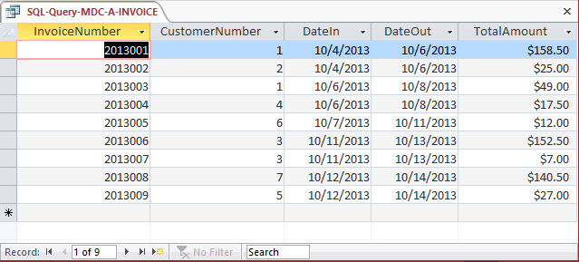

/* *** SQL-Query-MDC-A-INVOICE-ITEM *** */

SELECT *

FROM INVOICE_ITEM;

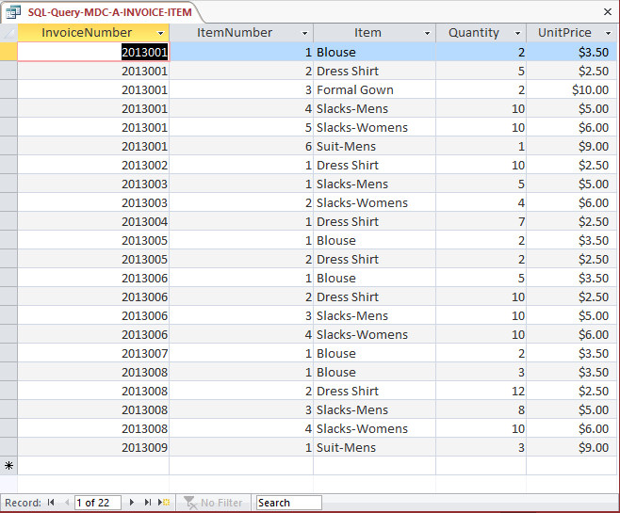

1. List the LastName, FirstName, and Phone of all customers.

Solutions to Marcia’s Dry Cleaning questions are contained in the Microsoft Access database *DBP-e13-IM-CH02-MDC.accdb* which is available at the Instructor’s Resource Center on the text’s Web site ([www.pearsonhighered.com/kroenke](http://www.pearsonhighered.com/kroenke/)).

/* *** SQL-Query-MDC-B *** */

SELECT Phone, LastName

FROM CUSTOMER;

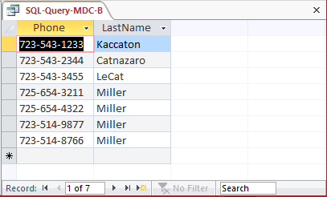

1. List the LastName, FirstName, and Phone for all customers with a FirstName of “Nikki”.

Solutions to Marcia’s Dry Cleaning questions are contained in the Microsoft Access database *DBP-e13-IM-CH02-MDC.accdb* which is available at the Instructor’s Resource Center on the text’s Web site ([www.pearsonhighered.com/kroenke](http://www.pearsonhighered.com/kroenke/)).

/* *** SQL-Query-MDC-C *** */

SELECT Phone, LastName

FROM CUSTOMER

WHERE FirstName = 'Nikki';

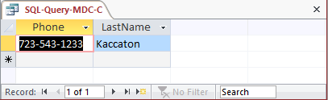

1. List the LastName, FirstName, Phone, DateIn, and DateOut of all orders in excess of 100.

Solutions to Marcia’s Dry Cleaning questions are contained in the Microsoft Access database *DBP-e13-IM-CH02-MDC.accdb* which is available at the Instructor’s Resource Center on the text’s Web site ([www.pearsonhighered.com/kroenke](http://www.pearsonhighered.com/kroenke/)).

/* *** SQL-Query-MDC-D *** */

SELECT Phone, DateIn, DateOut

FROM CUSTOMER, INVOICE

WHERE TotalAmount >100

AND CUSTOMER.CustomerID = INVOICE.CustomerNumber;

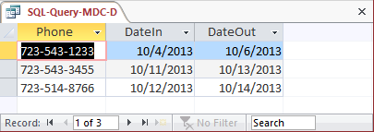

1. List the LastName, FirstName, and Phone of all customers whose first name starts with 'B'.

Solutions to Marcia’s Dry Cleaning questions are contained in the Microsoft Access database *DBP-e13-IM-CH02-MDC.accdb* which is available at the Instructor’s Resource Center on the text’s Web site ([www.pearsonhighered.com/kroenke](http://www.pearsonhighered.com/kroenke/)).

The correct SQL-92 statement, which uses the wildcard %, is:

/* *** SQL-Query-MDC-E *** */

SELECT Phone, FirstName

FROM CUSTOMER

WHERE FirstName LIKE 'B%';

/* *** SQL-Query-MDC-E-Access *** */

However, Microsoft Access uses the wildcard *, which gives the following SQL statement:

/* *** SQL-Query-MDC-E-Access *** */

SELECT Phone, FirstName

FROM CUSTOMER

WHERE FirstName LIKE 'B*';

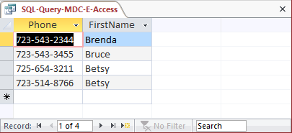

1. List the LastName, FirstName, and Phone of all customers whose last name includes the characters, 'cat'.

Solutions to Marcia’s Dry Cleaning questions are contained in the Microsoft Access database *DBP-e13-IM-CH02-MDC.accdb* which is available at the Instructor’s Resource Center on the text’s Web site ([www.pearsonhighered.com/kroenke](http://www.pearsonhighered.com/kroenke/)).

The correct SQL-92 statement, which uses the wildcard %, is:

/* *** SQL-Query-MDC-F *** */

SELECT Phone, FirstName

FROM CUSTOMER

WHERE LastName LIKE '%cat%';

However, Microsoft Access uses the wildcard *, which give the following SQL statement:

/* *** SQL-Query-MDC-F-Access *** */

SELECT Phone, FirstName

FROM CUSTOMER

WHERE LastName LIKE '*cat*';

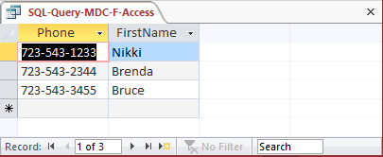

1. List the LastName, FirstName, and Phone for all customers whose second and third characters of phone number is 23.

Solutions to Marcia’s Dry Cleaning questions are contained in the Microsoft Access database *DBP-e13-IM-CH02-MDC.accdb* which is available at the Instructor’s Resource Center on the text’s Web site ([www.pearsonhighered.com/kroenke](http://www.pearsonhighered.com/kroenke/)).

Note that since the phone numbers in this database include the area code, we are really finding phone numbers with ‘23’ as the second and third numbers in the area code. We could, off course, write statements to find ‘23’ in the prefix or in the 4-digit sequence portion of the phone number.

The correct SQL-92 statement, which uses the wildcards % and _, is:

/* *** SQL-Query-MDC-G *** */

SELECT Phone, FirstName, LastName

FROM CUSTOMER

WHERE Phone LIKE '_23%';

However, Microsoft Access uses the wildcards * and ?, which give the following SQL statement:

/* *** SQL-Query-MDC-G-Access *** */

SELECT Phone, FirstName, LastName

FROM CUSTOMER

WHERE Phone LIKE '?23*';

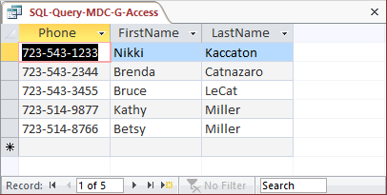

1. Determine the maximum and minimum TotalAmounts.

Solutions to Marcia’s Dry Cleaning questions are contained in the Microsoft Access database *DBP-e13-IM-CH02-MDC.accdb* which is available at the Instructor’s Resource Center on the text’s Web site ([www.pearsonhighered.com/kroenke](http://www.pearsonhighered.com/kroenke/)).

/* *** SQL-Query-MDC-H *** */

SELECT MAX (TotalAmt) AS MaxTotalAmount,

MIN (TotalAmt) AS MinTotalAmount

FROM INVOICE;

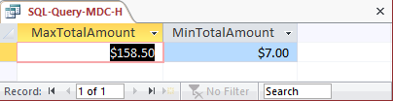

1. Determine the average TotalAmount.

Solutions to Marcia’s Dry Cleaning questions are contained in the Microsoft Access database *DBP-e13-IM-CH02-MDC.accdb* which is available at the Instructor’s Resource Center on the text’s Web site ([www.pearsonhighered.com/kroenke](http://www.pearsonhighered.com/kroenke/)).

Note that since ORDER is an SQL reserved word, it must be enclosed in delimiters (square brackets [ ] ).

/* *** SQL-Query-MDC-I *** */

SELECT AVG (TotalAmt) AS AvgTotalAmount

FROM [ORDER];

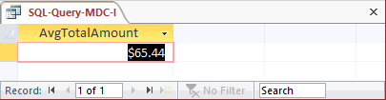

1. Count the number of customers.

Solutions to Marcia’s Dry Cleaning questions are contained in the Microsoft Access database *DBP-e13-IM-CH02-MDC.accdb* which is available at the Instructor’s Resource Center on the text’s Web site ([www.pearsonhighered.com/kroenke](http://www.pearsonhighered.com/kroenke/)).

/* *** SQL-Query-MDC-J *** */

SELECT Count (*)AS NumberOfCustomers

FROM CUSTOMER;

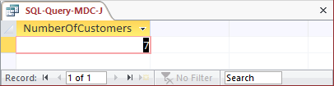

1. Group customers by LastName and then by FirstName.

Solutions to Marcia’s Dry Cleaning questions are contained in the Microsoft Access database *DBP-e13-IM-CH02-MDC.accdb* which is available at the Instructor’s Resource Center on the text’s Web site ([www.pearsonhighered.com/kroenke](http://www.pearsonhighered.com/kroenke/)).

/* *** SQL-Query-MDC-K *** */

SELECT LastName, FirstName

FROM CUSTOMER

GROUP BY LastName, FirstName;

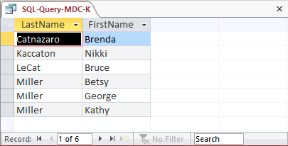

1. Count the number of customers having each combination of LastName and FirstName.

Solutions to Marcia’s Dry Cleaning questions are contained in the Microsoft Access database *DBP-e13-IM-CH02-MDC.accdb* which is available at the Instructor’s Resource Center on the text’s Web site ([www.pearsonhighered.com/kroenke](http://www.pearsonhighered.com/kroenke/)).

/* *** SQL-Query-MDC-L *** */

SELECT LastName, FirstName,

COUNT (*) AS Last_First_Combination_Count

FROM CUSTOMER

GROUP BY LastName, FirstName;

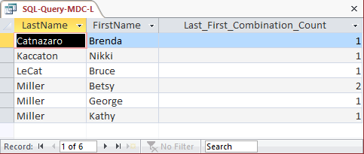

1. Show the FirstName and LastName of all customers who have had an order with TotalAmount greater than $100.00. Use a subquery. Present the results sorted by LastName in ascending order and then FirstName in descending order.

Solutions to Marcia’s Dry Cleaning questions are contained in the Microsoft Access database *DBP-e13-IM-CH02-MDC.accdb* which is available at the Instructor’s Resource Center on the text’s Web site ([www.pearsonhighered.com/kroenke](http://www.pearsonhighered.com/kroenke/)).

/* *** SQL-Query-MDC-M *** */

SELECT FirstName, LastName

FROM CUSTOMER

WHERE CustomerID IN

(SELECT CustomerNumber

FROM INVOICE

WHERE TotalAmount > 100)

ORDER BY LastName, FirstName DESC;

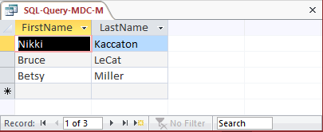

1. Show the LastName, FirstName and Phone of all customers who have had an order with TotalAmount greater than 100. Use a join, but do not use JOIN ON syntax. Present the results sorted by LastName in ascending order and then FirstName in descending order.

Solutions to Marcia’s Dry Cleaning questions are contained in the Microsoft Access database *DBP-e13-IM-CH02-MDC.accdb* which is available at the Instructor’s Resource Center on the text’s Web site ([www.pearsonhighered.com/kroenke](http://www.pearsonhighered.com/kroenke/)).

/* *** SQL-Query-MDC-N *** */

SELECT FirstName, LastName

FROM CUSTOMER, INVOICE

WHERE CUSTOMER.CustomerID = INVOICE.CustomerNumber

AND TotalAmount > 100

ORDER BY LastName, FirstName DESC;

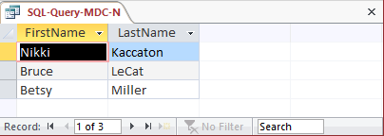

1. Show the LastName, FirstName and Phone of all customers who have had an order with TotalAmount greater than 100. Use a join using JOIN ON syntax. Present the results sorted by LastName in ascending order and then FirstName in descending order.

/* *** SQL-Query-MDC-O *** */

SELECT CUSTOMER.LastName, CUSTOMER.FirstName, CUSTOMER.Phone,

INVOICE.TotalAmount

FROM CUSTOMER JOIN INVOICE

ON CUSTOMER.CustomerID = INVOICE.CustomerNumber

WHERE INVOICE.TotalAmount>100;

Note that for Microsoft Access, we must use the INNER JOIN syntax:

/* *** SQL-Query-MDC-O *** */

SELECT CUSTOMER.LastName, CUSTOMER.FirstName, CUSTOMER.Phone,

INVOICE.TotalAmount

FROM CUSTOMER INNER JOIN INVOICE

ON CUSTOMER.CustomerID = INVOICE.CustomerNumber

WHERE INVOICE.TotalAmount>100;

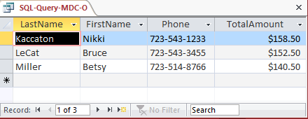

1. Show the LastName, FirstName and Phone of all customers who have had an order with an Item named “Dress Shirt”. Use a subquery. Present the results sorted by LastName in ascending order and then FirstName in descending order.

Solutions to Marcia’s Dry Cleaning questions are contained in the Microsoft Access database *DBP-e13-IM-CH02-MDC.accdb* which is available at the Instructor’s Resource Center on the text’s Web site ([www.pearsonhighered.com/kroenke](http://www.pearsonhighered.com/kroenke/)).

/* *** SQL-Query-MDC-P *** */

SELECT FirstName, LastName

FROM CUSTOMER

WHERE CustomerID IN

(SELECT CustomerNumber

FROM INVOICE

WHERE InvoiceNumber IN

(SELECT InvoiceNumber

FROM INVOICE_ITEM

WHERE Item = 'Dress Shirt'))

ORDER BY LastName, FirstName DESC;

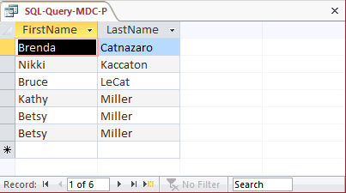

1. Show the LastName, FirstName and Phone of all customers who have had an order with an Item named “Dress Shirt”. Use a join, but do not use JOIN ON syntax. Present the results sorted by LastName in ascending order and then FirstName in descending order.

Solutions to Marcia’s Dry Cleaning questions are contained in the Microsoft Access database *DBP-e13-IM-CH02-MDC.accdb* which is available at the Instructor’s Resource Center on the text’s Web site ([www.pearsonhighered.com/kroenke](http://www.pearsonhighered.com/kroenke/)).

/* *** SQL-Query-MDC-Q-Access *** */

SELECT FirstName, LastName

FROM CUSTOMER, INVOICE, INVOICE_ITEM

WHERE CUSTOMER.CustomerID = INVOICE.CustomerNumber

AND INVOICE.InvoiceNumber = INVOICE_ITEM.InvoiceNumber

AND INVOICE_ITEM.Item = 'Dress Shirt'

ORDER BY LastName, FirstName DESC;

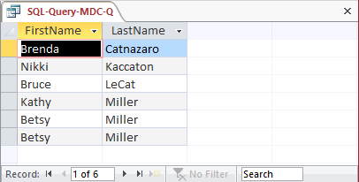

1. Show the LastName, FirstName and Phone of all customers who have had an order with an Item named “Dress Shirt”. Use a join using JOIN ON syntax. Present the results sorted by LastName in ascending order and then FirstName in descending order.

/* *** SQL-Query-MDC-R *** */

SELECT CUSTOMER.LastName, CUSTOMER.FirstName,

CUSTOMER.Phone

FROM CUSTOMER JOIN INVOICE

ON CUSTOMER.CustomerID = INVOICE.CustomerNumber)

JOIN INVOICE_ITEM

ON INVOICE.InvoiceNumber = INVOICE_ITEM.InvoiceNumber

WHERE INVOICE_ITEM.Item='Dress Shirt';

Note that for Microsoft Access, we must use the INNER JOIN syntax:

/* *** SQL-Query-MDC-R-Access *** */

SELECT CUSTOMER.LastName, CUSTOMER.FirstName,

CUSTOMER.Phone

FROM (CUSTOMER INNER JOIN INVOICE

ON CUSTOMER.CustomerID = INVOICE.CustomerNumber)

INNER JOIN INVOICE_ITEM

ON INVOICE.InvoiceNumber = INVOICE_ITEM.InvoiceNumber

WHERE (((INVOICE_ITEM.Item)='Dress Shirt'));

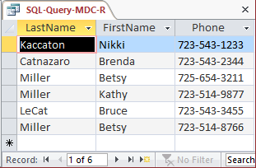

1. Show the LastName, FirstName, Phone and Total Amount of all customers who have had an order with an Item named “Dress Shirt”. Use a combination of a join with a subquery. Present results sorted by LastName in ascending order and then FirstName in descending order.

Solutions to Marcia’s Dry Cleaning questions are contained in the Microsoft Access database *DBP-e13-IM-CH02-MDC.accdb* which is available at the Instructor’s Resource Center on the text’s Web site ([www.pearsonhighered.com/kroenke](http://www.pearsonhighered.com/kroenke/)).

Since we want to display data in fields from two tables, these tables must be combined with a join. Data in a table without displayed fields can still be brought into the query with a subquery. Therefore, we will join CUSTOMER and INVOICE, while using a subquery with INVOICE_ITEM.

/* *** SQL-Query-MDC-s *** */

SELECT FirstName, LastName, TotalAmount

FROM CUSTOMER, INVOICE

WHERE CUSTOMER.CustomerID = INVOICE.CustomerNumber

AND INVOICE.InvoiceNumber IN

(SELECT InvoiceNumber

FROM INVOICE_ITEM

WHERE Item = 'Dress Shirt')

ORDER BY LastName, FirstName DESC;

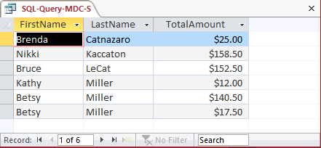

1. Show the LastName, FirstName, Phone and Total Amount of all customers who have had an order with an Item named “Dress Shirt”. Also show the LastName, FirstName and Phone of all other customers. Present results sorted by LastName in ascending order and then FirstName in descending order.

/* *** SQL-Query-MDC- *** */

SELECT CUSTOMER.LastName, CUSTOMER.FirstName, CUSTOMER.Phone

FROM CUSTOMER LEFT JOIN INVOICE

ON CUSTOMER.CustomerID = INVOICE.CustomerNumber

LEFT JOIN INVOICE_ITEM

ON INVOICE.InvoiceNumber = INVOICE_ITEM.InvoiceNumber

WHERE INVOICE_ITEM.Item='Dress Shirt';

Note that for Microsoft Access, we must use the OUTER JOIN syntax:

/* *** SQL-Query-MDC-T-Access *** */

SELECT CUSTOMER.LastName, CUSTOMER.FirstName, CUSTOMER.Phone

FROM (CUSTOMER LEFT OUTER JOIN INVOICE

ON CUSTOMER.CustomerID = INVOICE.CustomerNumber)

LEFT OUTER JOIN INVOICE_ITEM

ON INVOICE.InvoiceNumber = INVOICE_ITEM.InvoiceNumber

WHERE (((INVOICE_ITEM.Item)='Dress Shirt'));

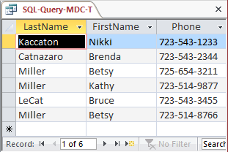

* ANSWERS TO THE QUEEN ANNE CURIOSITY SHOP PROJECT QUESTIONS

The Queen Anne Curiosity Shop is an upscale home furnishings store in a well-to-do urban neighborhood. It sells both antiques and current-production household items that complement or are useful with the antiques. For example, the store sells antique dining room tables and new tablecloths. The antiques are purchased from both individuals and wholesalers, and the new items are purchased from distributors. The store’s customers include individuals, owners of bed-and-breakfast operations, and local interior designers who work with both individuals and small businesses. The antiques are unique, though some multiple items, such as dining room chairs, may be available as a set (sets are never broken). The new items are not unique, and an item may be reordered if it is out of stock. New items are also available in various sizes and colors (for example, a particular style of tablecloth may be available in several sizes and in a variety of colors).

Assume that The Queen Anne Curiosity Shop designs a database with the following tables:

CUSTOMER (CustomerID, LastName, FirstName, Address, City, State, ZIP, Phone,

Email)

ITEM (ItemID, ItemDescription, CompanyName, PurchaseDate, ItemCost,

ItemPrice)

SALE (SaleID, *CustomerID*, SaleDate, SubTotal, Tax, Total)

SALE_ITEM (*SaleID*, SaleItemID, *ItemID*, ItemPrice)

The referential integrity constraints are:

CustomerID in SALE must exist in CustomerID in CUSTOMER

SaleID in SALE_ITEM must exist in SaleID in SALE

ItemID in SALE_ITEM must exist in ItemID in ITEM

Assume that CustomerID of CUSTOMER, ItemID of ITEM, SaleID of SALE, and SaleItemID of SALE_ITEM are all surrogate keys with values as follows:

CustomerID Start at 1 Increment by 1

ItemID Start at 1 Increment by 1

SaleID Start at 1 Increment by 1

The database that The Queen Anne Curiosity Shop has created is named QACS, and the four tables in the QACS database schema are shown in Figure 2-41.

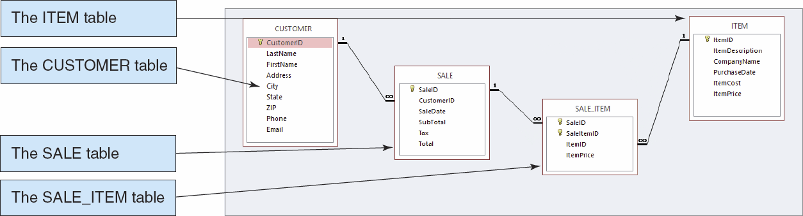

*Figure 2-41 – The QACS Database*

The column characteristics for the tables are shown in Figures 2-42, 2-43, 2-44, and 2-45. The relationships CUSTOMER-to-SALE and ITEM-to-SALE_ITEM should enforce referential integrity, but not cascade updates nor deletions, while the relationship between SALE and SALE_ITEM should enforce referential integrity and cascade both updates and deletions. The data for these tables are shown in Figures 2-46, 2-47, 2-48, and 2-49.

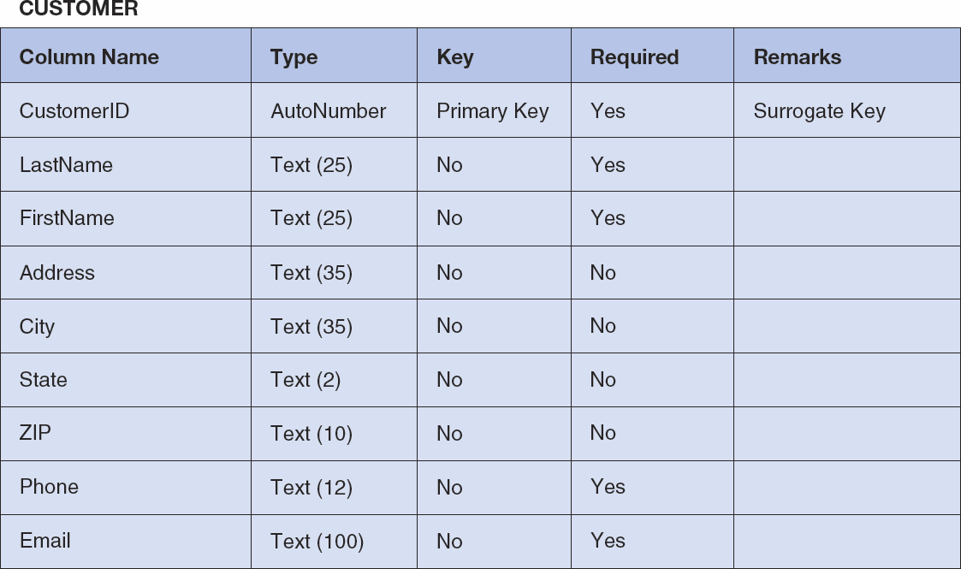

*Figure 2-42 - Column Characteristics for the QACS Database CUSTOMER Table*

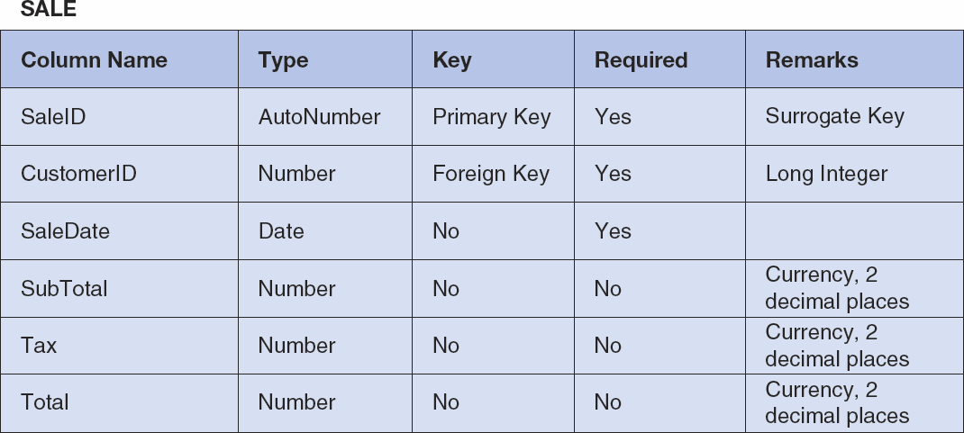

*Figure 2-43 - Column Characteristics for the QACS Database SALE Table*

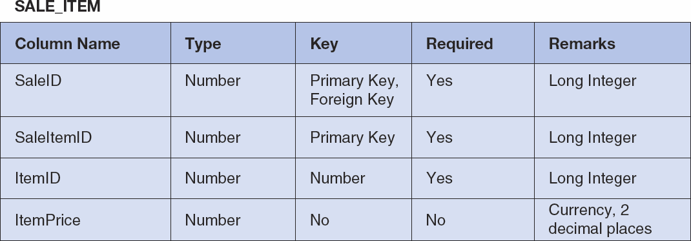

*Figure 2-44 - Column Characteristics for the QACS Database SALE_ITEM Table*

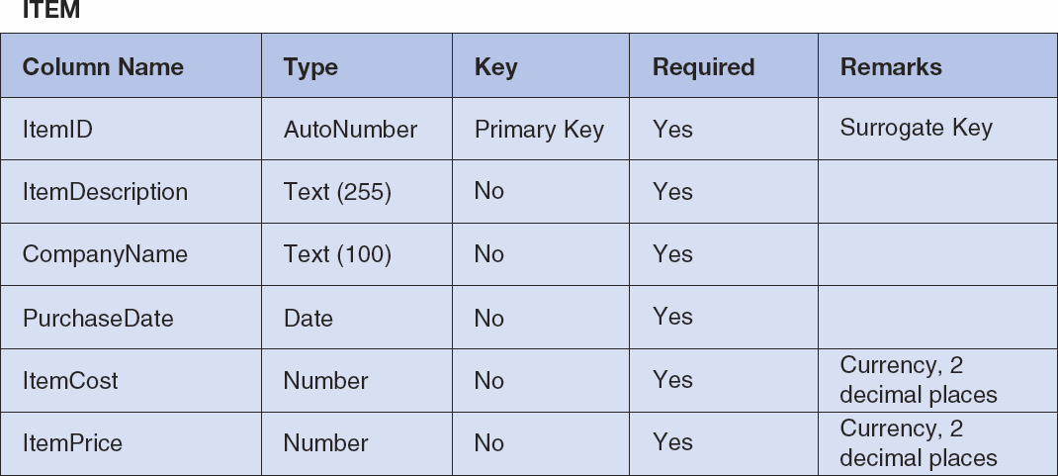

*Figure 2-45 - Column Characteristics for the QACS Database ITEM Table*

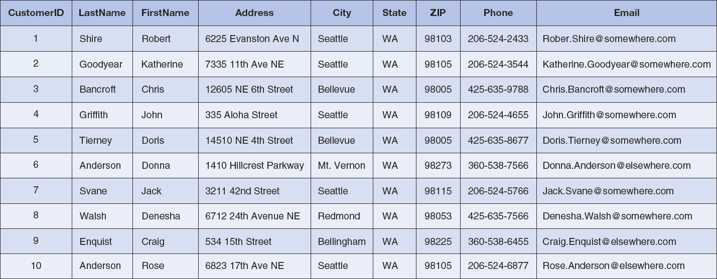

*Figure 2-46 – Sample Data for the QACS Database CUSTOMER Table*

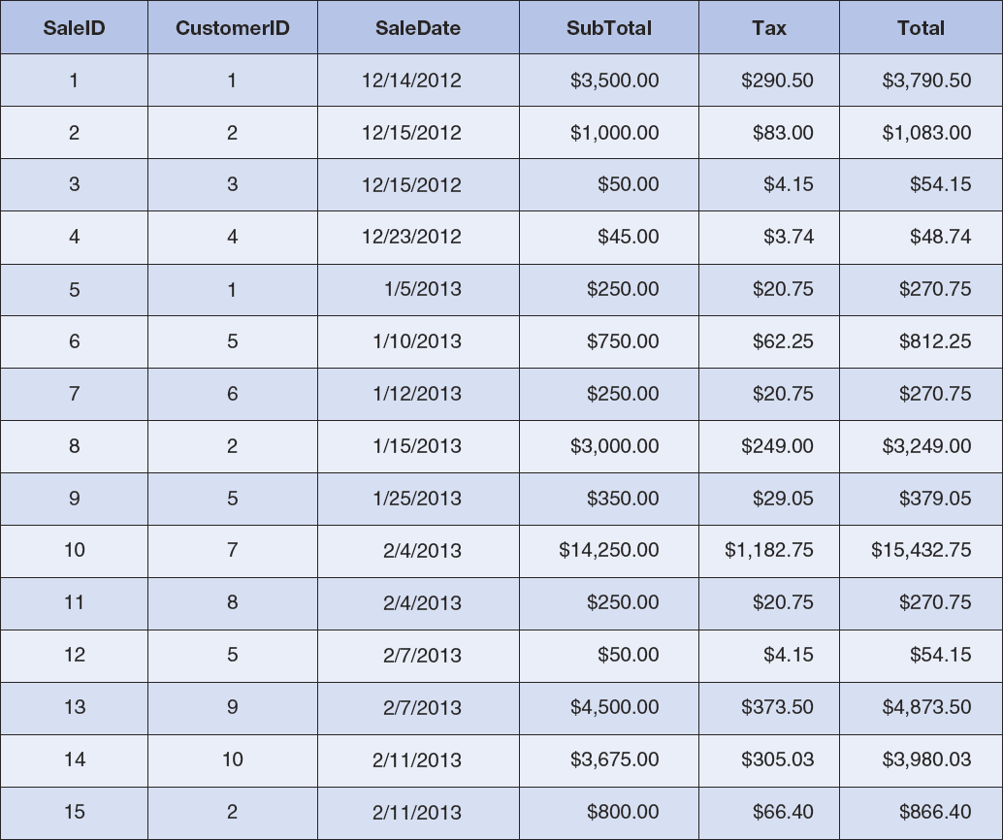

*Figure 2-47 - Sample Data for the QACS Database SALE Table*

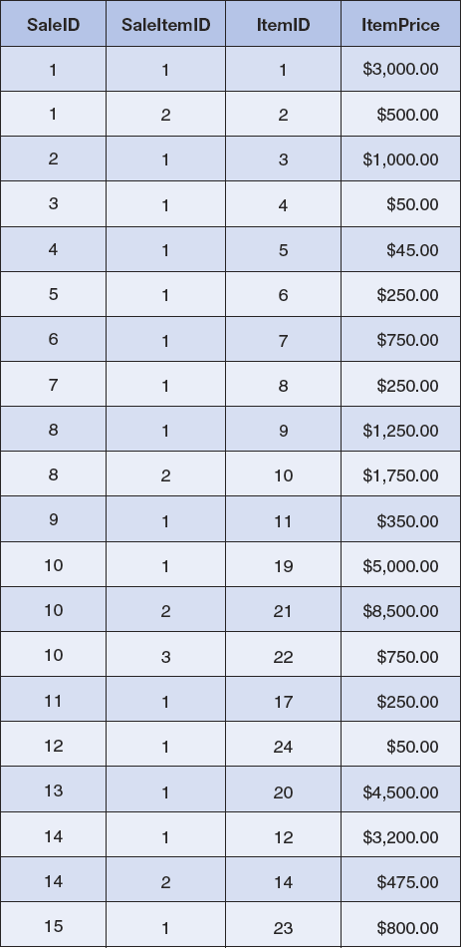

*Figure 2-48 - Sample Data for the QACS Database SALE_ITEM Table*

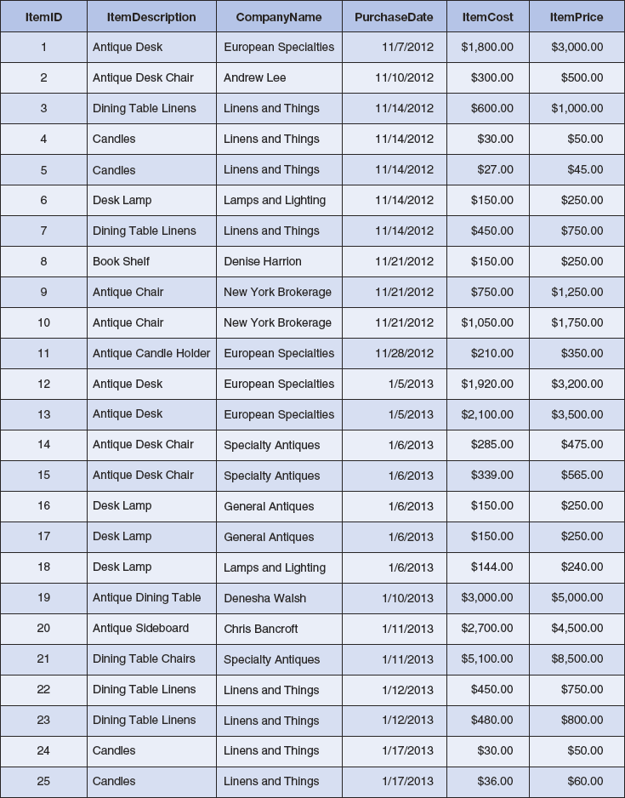

*Figure 2-49 - Sample Data for the QACS Database ITEM Table*

We recommend that you create a Microsoft Access 2013 database named QACS-CH02.accdb using the database schema, column characteristics, and data shown above and then use this database to test your solutions to the questions in this section. Alternatively, SQL scripts for creating the QACS-CH02 database in Microsoft SQL Server, Oracle Database, and MySQL are available on our Web site at [www.pearsonhighered.com/kroenke](http://www.pearsonhighered.com/kroenke).

Write SQL statements and show the results based on the QACS data for each of the following:

1. Show all data in each of the tables.

Solutions to The Queen Anne Curiosity Shop questions are contained in the Microsoft Access database *DBP-e13-IM-CH02-QACS.accdb* which is available in the Instructor’s Resource Center on the text’s Web site ([www.pearsonhighered.com/kroenke](http://www.pearsonhighered.com/kroenke/)).

/* *** SQL-Query-QACS-A-CUSTOMER *** */

SELECT *

FROM CUSTOMER;

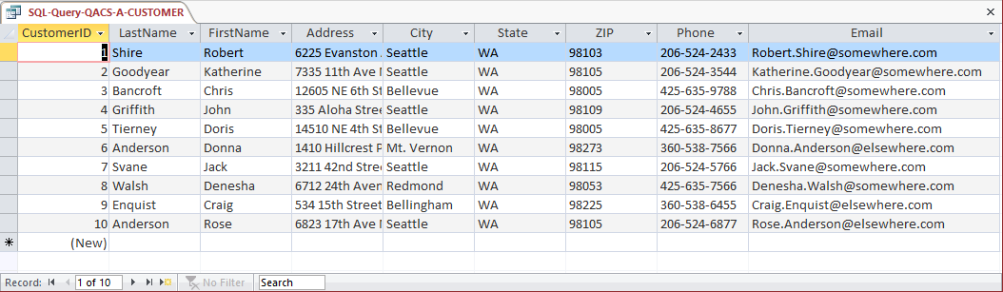

/* *** SQL-Query-QACS-A-SALE *** */

SELECT *

FROM SALE;

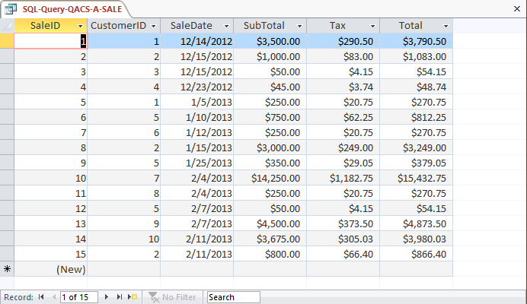

/* *** SQL-Query-QACS-A-SALE-ITEM *** */

SELECT *

FROM SALE_ITEM;

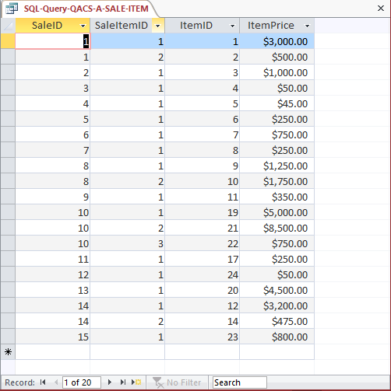

/* *** SQL-Query-QACS-A-ITEM *** */

SELECT *

FROM ITEM;

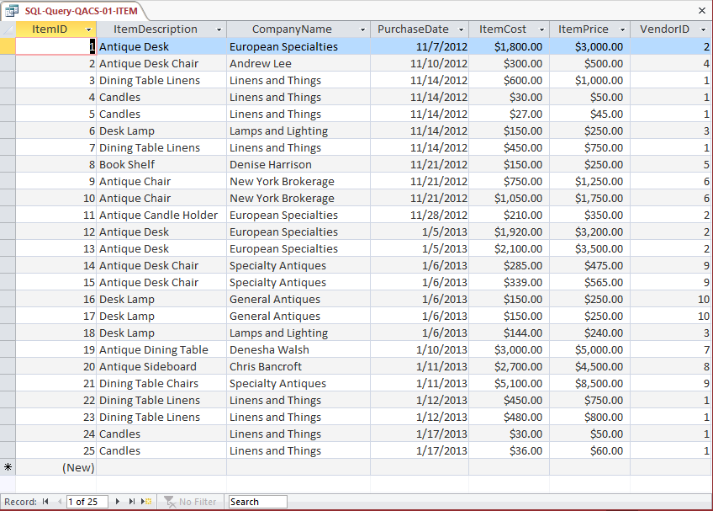

1. List the LastName, FirstName, and Phone of all customers.

Solutions to The Queen Anne Curiosity Shop questions are contained in the Microsoft Access database *DBP-e13-IM-CH02-QACS.accdb* which is available in the Instructor’s Resource Center on the text’s Web site ([www.pearsonhighered.com/kroenke](http://www.pearsonhighered.com/kroenke/)).

/* *** SQL-Query-QACS-B *** */

SELECT LastName, FirstName, Phone

FROM CUSTOMER;

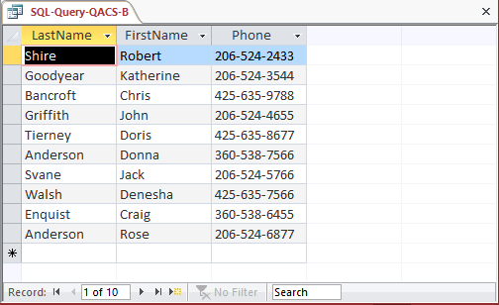

1. List the LastName, FirstName, and Phone for all customers with a FirstName of 'John'.

Solutions to The Queen Anne Curiosity Shop questions are contained in the Microsoft Access database *DBP-e13-IM-CH02-QACS.accdb* which is available in the Instructor’s Resource Center on the text’s Web site ([www.pearsonhighered.com/kroenke](http://www.pearsonhighered.com/kroenke/)).

/* *** SQL-Query-QACS-C *** */

SELECT LastName, FirstName, Phone

FROM CUSTOMER

WHERE FirstName = 'John';

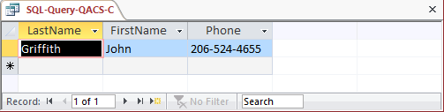

1. List the LastName, FirstName, and Phone of all customers with a last name of 'Anderson'.

Solutions to The Queen Anne Curiosity Shop questions are contained in the Microsoft Access database *DBP-e13-IM-CH02-QACS.accdb* which is available in the Instructor’s Resource Center on the text’s Web site ([www.pearsonhighered.com/kroenke](http://www.pearsonhighered.com/kroenke/)).

/* *** SQL-Query-QACS-D *** */

SELECT LastName, FirstName, Phone

FROM CUSTOMER

WHERE LastName = 'Anderson';

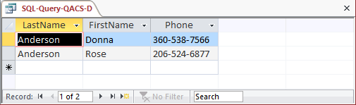

1. List the LastName, FirstName, and Phone of all customers whose first name starts  
   with 'D'.

Solutions to The Queen Anne Curiosity Shop questions are contained in the Microsoft Access database *DBP-e13-IM-CH02-QACS.accdb* which is available in the Instructor’s Resource Center on the text’s Web site ([www.pearsonhighered.com/kroenke](http://www.pearsonhighered.com/kroenke/)).

For SQL Server, Oracle Database and MySQL:

/* *** SQL-Query-QACS-E *** */

SELECT LastName, FirstName, Phone

FROM CUSTOMER

WHERE FirstName LIKE 'D%';

For Microsoft Access:

/* *** SQL-Query-QACS-E *** */

SELECT LastName, FirstName, Phone

FROM CUSTOMER

WHERE FirstName LIKE 'D*';

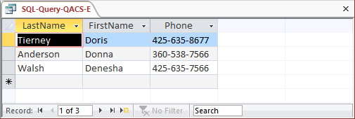

1. List the LastName, FirstName, and Phone of all customers whose last name includes the characters 'ne'.

Solutions to The Queen Anne Curiosity Shop questions are contained in the Microsoft Access database *DBP-e13-IM-CH02-QACS.accdb* which is available in the Instructor’s Resource Center on the text’s Web site ([www.pearsonhighered.com/kroenke](http://www.pearsonhighered.com/kroenke/)).

For SQL Server, Oracle Database and MySQL:

/* *** SQL-Query-QACS-F *** */

SELECT LastName, FirstName, Phone

FROM CUSTOMER

WHERE LastName LIKE '%ne%';

For Microsoft Access:

/* *** SQL-Query-QACS-F *** */

SELECT LastName, FirstName, Phone

FROM CUSTOMER

WHERE LastName LIKE '*ne*';

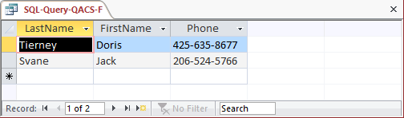

1. List the LastName, FirstName, and Phone for all customers whose second and third numbers (from the right) of their phone number are 56.

Solutions to The Queen Anne Curiosity Shop questions are contained in the Microsoft Access database *DBP-e13-IM-CH02-QACS.accdb* which is available in the Instructor’s Resource Center on the text’s Web site ([www.pearsonhighered.com/kroenke](http://www.pearsonhighered.com/kroenke/)).

For SQL Server, Oracle Database and MySQL:

/* *** SQL-Query-QACS-G *** */

SELECT LastName, FirstName, Phone

FROM CUSTOMER

WHERE Phone LIKE '%56_';

For Microsoft Access:

/* *** SQL-Query-QACS-G *** */

SELECT LastName, FirstName, Phone

FROM CUSTOMER

WHERE Phone LIKE '*56?';

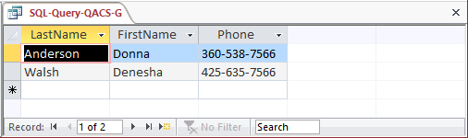

1. Determine the maximum and minimum sales Total.

Solutions to The Queen Anne Curiosity Shop questions are contained in the Microsoft Access database *DBP-e13-IM-CH02-QACS.accdb* which is available in the Instructor’s Resource Center on the text’s Web site ([www.pearsonhighered.com/kroenke](http://www.pearsonhighered.com/kroenke/)).

/* *** SQL-Query-QACS-H *** */

SELECT MAX (Total) as MaximumTotalSales,

MIN (Total) as MinimumTotalSales

FROM SALE;

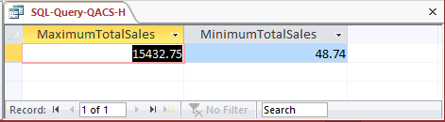

1. Determine the average sales Total.

Solutions to The Queen Anne Curiosity Shop questions are contained in the Microsoft Access database *DBP-e13-IM-CH02-QACS.accdb* which is available in the Instructor’s Resource Center on the text’s Web site ([www.pearsonhighered.com/kroenke](http://www.pearsonhighered.com/kroenke/)).

/* *** SQL-Query-QACS-I *** */

SELECT AVG (Total) as AverageTotalSales

FROM SALE;

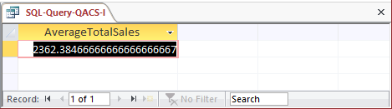

1. Count the number of customers.

Solutions to The Queen Anne Curiosity Shop questions are contained in the Microsoft Access database *DBP-e13-IM-CH02-QACS.accdb* which is available in the Instructor’s Resource Center on the text’s Web site ([www.pearsonhighered.com/kroenke](http://www.pearsonhighered.com/kroenke/)).

/* *** SQL-Query-QACS-J *** */

SELECT COUNT (*) AS NumberOfCustomers

FROM CUSTOMER;

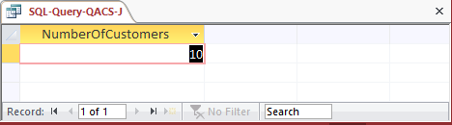

1. Group customers by LastName and then by FirstName.

Solutions to The Queen Anne Curiosity Shop questions are contained in the Microsoft Access database *DBP-e13-IM-CH02-QACS.accdb* which is available in the Instructor’s Resource Center on the text’s Web site ([www.pearsonhighered.com/kroenke](http://www.pearsonhighered.com/kroenke/)).

/* *** SQL-Query-QACS-K *** */

SELECT LastName, FirstName

FROM CUSTOMER

GROUP BY LastName, FirstName;

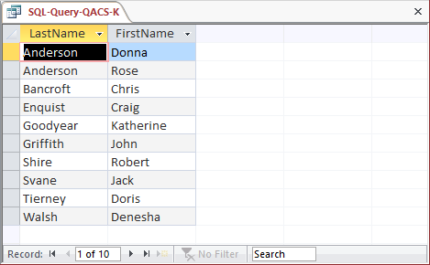

1. Count the number of customers having each combination of LastName and FirstName.

Solutions to The Queen Anne Curiosity Shop questions are contained in the Microsoft Access database *DBP-e13-IM-CH02-QACS.accdb* which is available in the Instructor’s Resource Center on the text’s Web site ([www.pearsonhighered.com/kroenke](http://www.pearsonhighered.com/kroenke/)).

/* *** SQL-Query-QACS-L *** */

SELECT LastName, FirstName, COUNT (*) AS NumberOfCustomers

FROM CUSTOMER

GROUP BY LastName, FirstName;

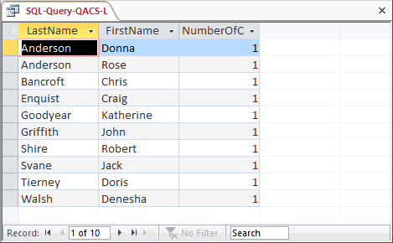

1. Show the LastName, FirstName, and Phone of all customers who have had an order with Total greater than $100.00. Use a subquery. Present the results sorted by LastName in ascending order and then FirstName in descending order.

Solutions to The Queen Anne Curiosity Shop questions are contained in the Microsoft Access database *DBP-e13-IM-CH02-QACS.accdb* which is available in the Instructor’s Resource Center on the text’s Web site ([www.pearsonhighered.com/kroenke](http://www.pearsonhighered.com/kroenke/)).

/* *** SQL-Query-QACS-M *** */

SELECT LastName, FirstName, Phone

FROM CUSTOMER

WHERE CustomerID IN

(SELECT CustomerID

FROM SALE

WHERE Total > 100)

ORDER BY LastName, FirstName DESC;

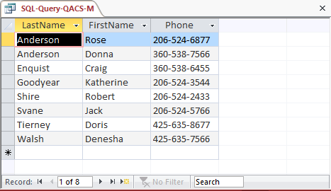

1. Show the LastName, FirstName, and Phone of all customers who have had an order with Total greater than $100.00. Use a join, but do not use JOIN ON syntax. Present results sorted by LastName in ascending order and then FirstName in descending order.

Solutions to The Queen Anne Curiosity Shop questions are contained in the Microsoft Access database *DBP-e13-IM-CH02-QACS.accdb* which is available in the Instructor’s Resource Center on the text’s Web site ([www.pearsonhighered.com/kroenke](http://www.pearsonhighered.com/kroenke/)).

/* *** SQL-Query-QACS-E *** */

SELECT LastName, FirstName, Phone

FROM CUSTOMER, SALE

WHERE CUSTOMER.CustomerID = SALE.CustomerID

AND Total > 100;

/* For each CUSTOMER only once: */

SELECT DISTINCT LastName, FirstName, Phone

FROM CUSTOMER, SALE

WHERE CUSTOMER.CustomerID = SALE.CustomerID

AND Total > 100;

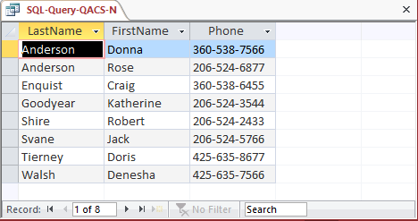

1. Show the LastName, FirstName, and Phone of all customers who have had an order with Total greater than $100.00. Use a join using JOIN ON syntax. Present results sorted by LastName in ascending order and then FirstName in descending order.

Solutions to The Queen Anne Curiosity Shop questions are contained in the Microsoft Access database *DBP-e13-IM-CH02-QACS.accdb* which is available in the Instructor’s Resource Center on the text’s Web site ([www.pearsonhighered.com/kroenke](http://www.pearsonhighered.com/kroenke/)).

/* *** SQL-Query-QACS-O *** */

SELECT LastName, FirstName, Phone

FROM CUSTOMER JOIN SALE

ON CUSTOMER.CustomerID = SALE.CustomerID

WHERE Total > 100;

/* For each CUSTOMER only once: */

SELECT DISTINCT LastName, FirstName, Phone

FROM CUSTOMER JOIN SALE

ON CUSTOMER.CustomerID = SALE.CustomerID

WHERE Total > 100;

Note that for Microsoft Access, we must use the INNER JOIN syntax:

SELECT DISTINCT LastName, FirstName, Phone

FROM CUSTOMER INNER JOIN SALE

ON CUSTOMER.CustomerID = SALE.CustomerID

WHERE Total > 100;

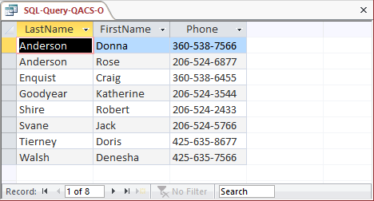

1. Show the LastName, FirstName, and Phone of all customers who who have bought an Item named 'Desk Lamp'. Use a subquery. Present results sorted by LastName in ascending order and then FirstName in descending order.

Solutions to The Queen Anne Curiosity Shop questions are contained in the Microsoft Access database *DBP-e13-IM-CH02-QACS.accdb* which is available in the Instructor’s Resource Center on the text’s Web site ([www.pearsonhighered.com/kroenke](http://www.pearsonhighered.com/kroenke/)).

/* *** SQL-Query-QACS-E *** */

SELECT LastName, FirstName, Phone

FROM CUSTOMER

WHERE CustomerID IN

(SELECT CustomerID

FROM SALE

WHERE SaleID IN

(SELECT SaleID

FROM SALE_ITEM

WHERE ItemID IN

(SELECT ItemID

FROM ITEM

WHERE ItemDescription = 'Desk Lamp')));

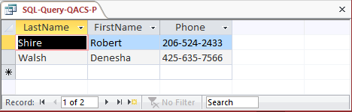

1. Show the LastName, FirstName, and Phone of all customers who have bought an Item named 'Desk Lamp'. Use a join, but do not use JOIN ON syntax. Present results sorted by LastName in ascending order and then FirstName in descending order.

Solutions to The Queen Anne Curiosity Shop questions are contained in the Microsoft Access database *DBP-e13-IM-CH02-QACS.accdb* which is available in the Instructor’s Resource Center on the text’s Web site ([www.pearsonhighered.com/kroenke](http://www.pearsonhighered.com/kroenke/)).

/* *** SQL-Query-QACS-E *** */

SELECT LastName, FirstName, Phone

FROM CUSTOMER AS C,

SALE AS S,

SALE_ITEM AS SI,

ITEM AS I

WHERE C.CustomerID = S.CustomerID

AND S.SaleID = SI.SaleID

AND SI.ItemID = I.ItemID

AND ItemDescription = 'Desk Lamp';

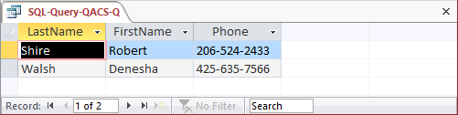

1. Show the LastName, FirstName, and Phone of all customers who have bought an Item named 'Desk Lamp'. Use a join using JOIN ON syntax. Present results sorted by LastName in ascending order and then FirstName in descending order.

Solutions to The Queen Anne Curiosity Shop questions are contained in the Microsoft Access database *DBP-e13-IM-CH02-QACS.accdb* which is available in the Instructor’s Resource Center on the text’s Web site ([www.pearsonhighered.com/kroenke](http://www.pearsonhighered.com/kroenke/)).

/* *** SQL-Query-QACS-R *** */

SELECT LastName, FirstName, Phone

FROM CUSTOMER AS C JOIN SALE AS S

ON C.CustomerID = S.CustomerID

JOIN SALE_ITEM AS SI

ON S.SaleID = SI.SaleID

JOIN ITEM AS I

ON SI.ItemID = I.ItemID

WHERE ItemDescription = 'Desk Lamp';

Note that for Microsoft Access, we must use the INNER JOIN syntax with grouping of the INNER JOINS:

SELECT LastName, FirstName, Phone

FROM CUSTOMER AS C INNER JOIN SALE AS S

ON ((C.CustomerID = S.CustomerID

INNER JOIN SALE_ITEM AS SI)

ON S.SaleID = SI.SaleID)

INNER JOIN ITEM AS I

ON SI.ItemID = I.ItemID

WHERE ItemDescription = 'Desk Lamp';

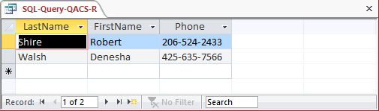

1. Show the LastName, FirstName, and Phone of all customers who have bought an Item named 'Desk Lamp'. Use a combination of a join and a subquery. Present results sorted by LastName in ascending order and then FirstName in descending order.

Solutions to The Queen Anne Curiosity Shop questions are contained in the Microsoft Access database *DBP-e13-IM-CH02-QACS.accdb* which is available in the Instructor’s Resource Center on the text’s Web site ([www.pearsonhighered.com/kroenke](http://www.pearsonhighered.com/kroenke/)).

/* *** SQL-Query-QACS-S *** */

SELECT LastName, FirstName, Phone

FROM CUSTOMER AS C,

SALE AS S

WHERE C.CustomerID = S.CustomerID

AND SaleID IN

(SELECT SaleID

FROM SALE_ITEM

WHERE ItemID IN

(SELECT ItemID

FROM ITEM

WHERE ItemDescription = 'Desk Lamp'));

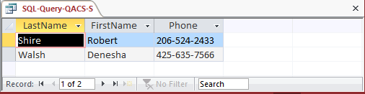

1. Show the LastName, FirstName, and Phone of all customers who have bought an Item named 'Desk Lamp'. Use a combination of a join and a subquery that is different from the combination used for question S. Present results sorted by LastName in ascending order and then FirstName in descending order.

Solutions to The Queen Anne Curiosity Shop questions are contained in the Microsoft Access database *DBP-e13-IM-CH02-QACS.accdb* which is available in the Instructor’s Resource Center on the text’s Web site ([www.pearsonhighered.com/kroenke](http://www.pearsonhighered.com/kroenke/)).

/* *** SQL-Query-QACS-S *** */

SELECT LastName, FirstName, Phone

FROM CUSTOMER AS C,

SALE AS S,

SALE_ITEM AS SI

WHERE C.CustomerID = S.CustomerID

AND S.SaleID = SI.SaleID

AND ItemID IN

(SELECT ItemID

FROM ITEM AS I

WHERE ItemDescription = 'Desk Lamp');

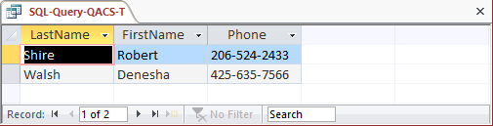

* ANSWERS TO MORGAN IMPORTING PROJECT QUESTIONS

James Morgan owns and operates Morgan Importing, which purchases antiques and home furnishings in Asia, ships those items to a warehouse facility in Los Angeles, and then sells these items in the United States. James tracks the Asian purchases and subsequent shipments of these items to Los Angeles by using a database to keep a list of items purchased, shipments of the purchased items, and the items in each shipment. His database includes the following tables:

ITEM (ItemID, Description, PurchaseDate, Store, City, Quantity, LocalCurrencyAmount, ExchangeRate)

SHIPMENT (ShipmentID, ShipperName, ShipperInvoiceNumber, DepartureDate, ArrivalDate, InsuredValue)

SHIPMENT_ITEM (*ShipmentID*, ShipmentItemID, *ItemID*, Value)

In the database schema above, the primary keys are underlined and the foreign keys are shown in italics. The database that James has created is named MI, and the three tables in the MI database schema are shown in Figure 2-50.

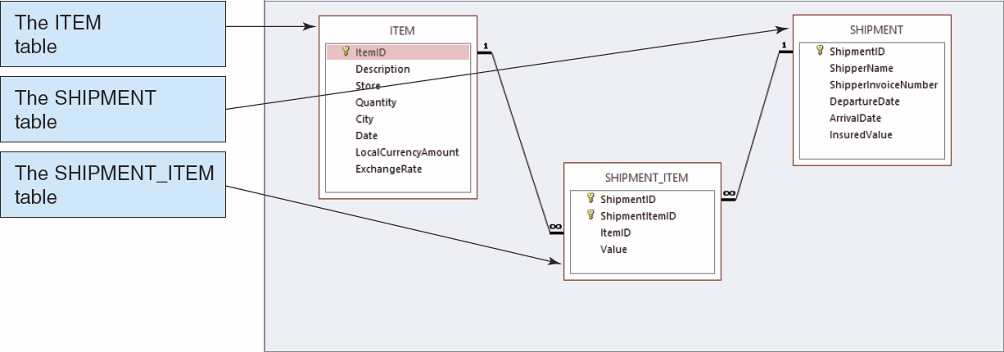

*Figure 2-50 – The MI Database*

The column characteristics for the tables are shown in Figures 2-51, 2-52, and 2-53. The data for the tables are shown in Figures 2-44, 2-45, and 2-46. The relationship between ITEM and SHIPMENT_ITEM should enforce referential integrity, and although it should cascade updates, it should not cascade deletions. The relationship between SHIPMENT and SHIPMENT_ITEM should enforce referential integrity and cascade both updates and deletions.

We recommend that you create a Microsoft Access 2013 database named MI-Ch02.accdb using the database schema, column characteristics, and data shown above, and then use this database to test your solutions to the questions in this section. Alternatively, SQL scripts for creating the MI-CH02 database in SQL Server, Oracle Database, and MySQL are available on our Web site at [www.pearsonhighered.com/kroenke](http://www.pearsonhighered.com/kroenke).

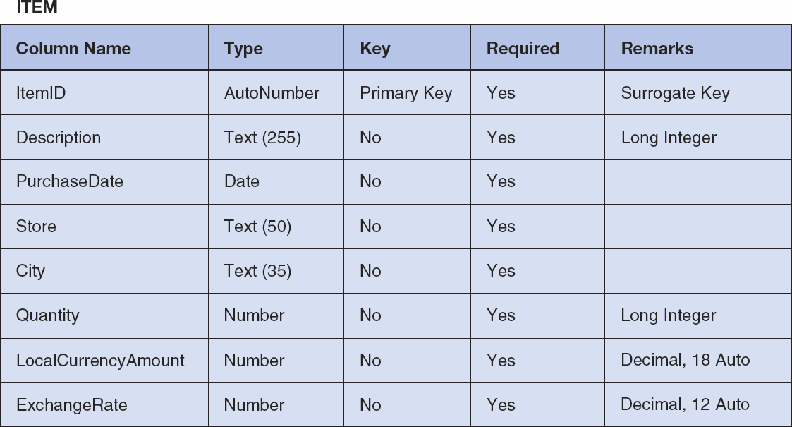

*Figure 2-51 - Column Characteristics for the MI Database ITEM Table*

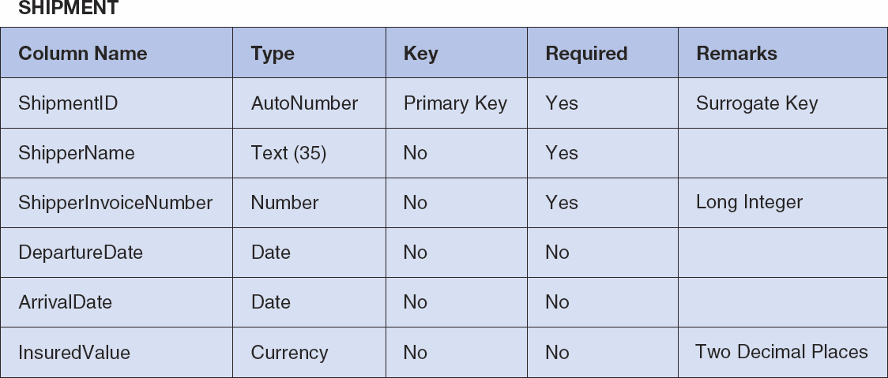

*Figure 2-52 - Column Characteristics for the MI Database SHIPMENT Table*

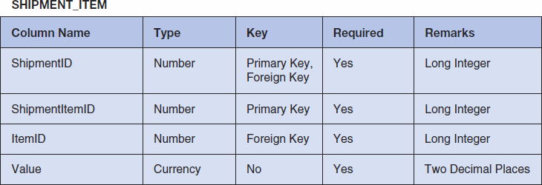

*Figure 2-53 - Column Characteristics for the MI Database SHIPMENT_ITEM Table*

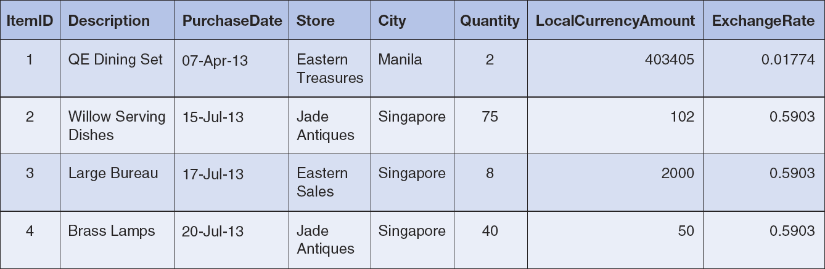

*Figure 2-54 - Sample Data for the MI Database ITEM Table*

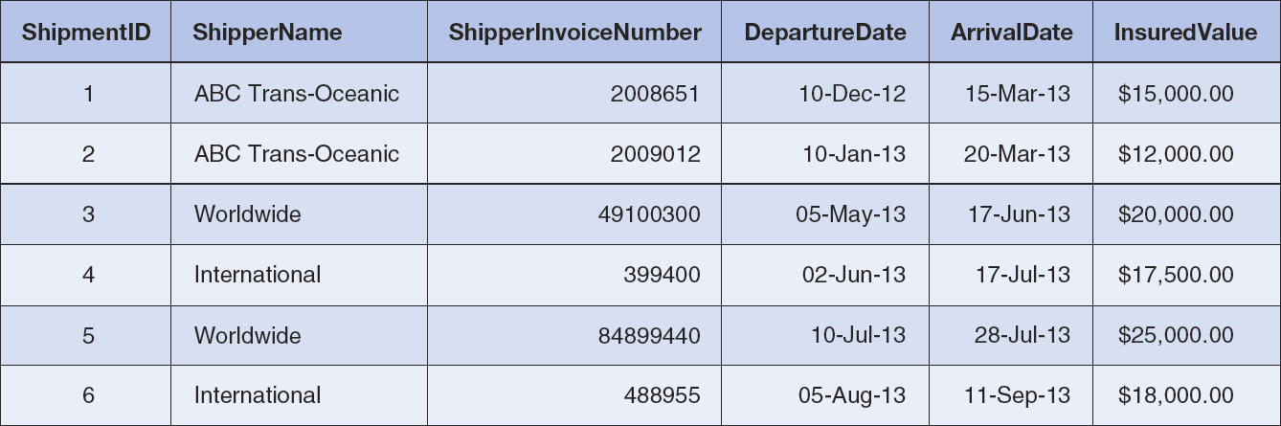

*Figure 2-55 - Sample Data for the MI Database SHIPMENT Table*

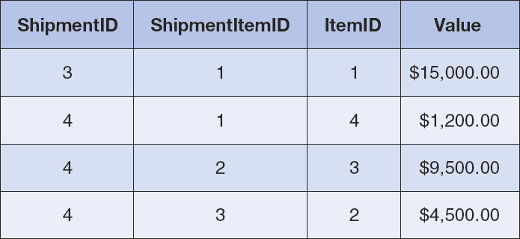

*Figure 2-56 - Sample Data for the MI Database SHIPMENT_ITEM Table*

Write SQL statements and show the results based on the MI data for each of the following:

1. Show all data in each of the tables.

Solutions to Morgan Importing questions are contained in the Microsoft Access database *DBP-e13-IM-CH02-MI.accdb* which is available in the Instructor’s Resource Center on the text’s Web site ([www.pearsonhighered.com/kroenke](http://www.pearsonhighered.com/kroenke/)).

/* *** SQL-Query-MI-A-ITEM *** */

SELECT *

FROM ITEM;

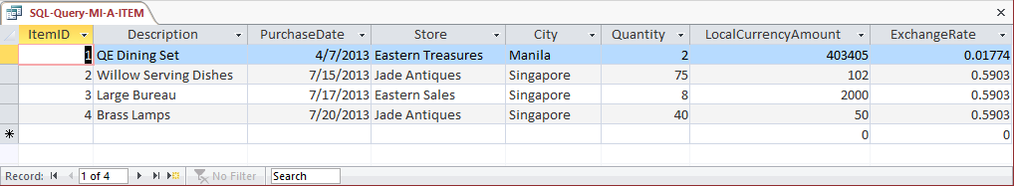

/* *** SQL-Query-MI-A-SHIPMENT *** */

SELECT *

FROM SHIPMENT;

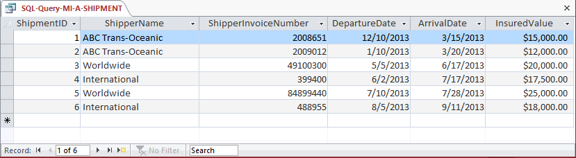

/* *** SQL-Query-MI-A-SHIPMENT-ITEM *** */

SELECT *

FROM SHIPMENT_ITEM;

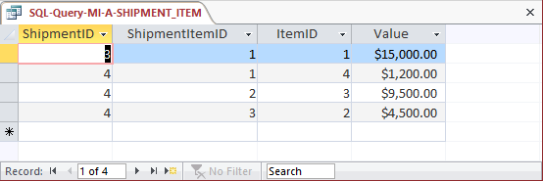

1. List the ShipmentID, ShipperName, and ShipperInvoiceNumber of all shipments.

Solutions to Morgan Importing questions are contained in the Microsoft Access database *DBP-e13-IM-CH02-MI.accdb* which is available in the Instructor’s Resource Center on the text’s Web site ([www.pearsonhighered.com/kroenke](http://www.pearsonhighered.com/kroenke/)).

/* *** SQL-Query-MI-B *** */

SELECT ShipmentID, ShipperName, ShipperInvoiceNumber

FROM SHIPMENT;

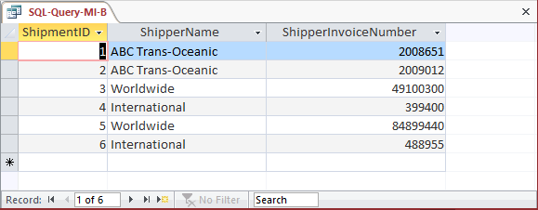

1. List the ShipmentID, ShipperName, and ShipperInvoiceNumber for all shipments with an insured value greater than $10,000.00.

Solutions to Morgan Importing questions are contained in the Microsoft Access database *DBP-e13-IM-CH02-MI.accdb* which is available in the Instructor’s Resource Center on the text’s Web site ([www.pearsonhighered.com/kroenke](http://www.pearsonhighered.com/kroenke/)).

/* *** SQL-Query-MI-C *** */

SELECT ShipmentID, ShipperName, ShipperInvoiceNumber

FROM SHIPMENT

WHERE InsuredValue > 10000;

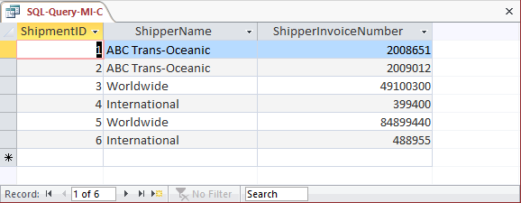

1. List the ShipmentID, ShipperName, and ShipperInvoiceNumber of all shippers whose name starts with “AB”.

Solutions to Morgan Importing questions are contained in the Microsoft Access database *DBP-e13-IM-CH02-MI.accdb* which is available in the Instructor’s Resource Center on the text’s Web site ([www.pearsonhighered.com/kroenke](http://www.pearsonhighered.com/kroenke/)).

The correct SQL-92 statement, which uses the wildcard %, is:

/* *** SQL-Query-MI-D *** */

SELECT ShipmentID, ShipperName, ShipperInvoiceNumber

FROM SHIPMENT

WHERE Shipper LIKE 'AB%';

However, Microsoft Access uses the wildcard *, which give the following SQL statement:

/* *** SQL-Query-MI-D-Access *** */

SELECT ShipmentID, ShipperName, ShipperInvoiceNumber

FROM SHIPMENT

WHERE Shipper LIKE 'AB*';

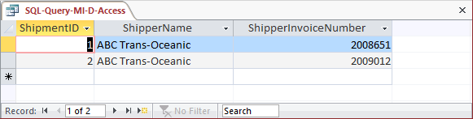

1. Assume DepartureDate and ArrivalDate are in the format MM/DD/YY. List the ShipmentID, ShipperName, and ShipperInvoiceNumber and ArrivalDate of all shipments that departed in December.

Solutions to Morgan Importing questions are contained in the Microsoft Access database *DBP-e13-IM-CH02-MI.accdb* which is available in the Instructor’s Resource Center on the text’s Web site ([www.pearsonhighered.com/kroenke](http://www.pearsonhighered.com/kroenke/)).

The correct SQL-92 statement, which uses the wildcard %, is:

/* *** SQL-Query-MI-E *** */

SELECT ShipmentID, ShipperName, ShipperInvoiceNumber, ArrivalDate

FROM SHIPMENT

WHERE DepartureDate LIKE '12%';

However, Microsoft Access uses the wildcard *, which gives the following SQL statement:

/* *** SQL-Query-MI-E-Access *** */

SELECT ShipmentID, ShipperName, ShipperInvoiceNumber, ArrivalDate

FROM SHIPMENT

WHERE DepartureDate LIKE '12*';

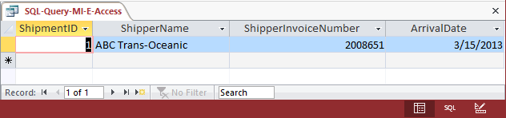

1. Assume DepartureDate and ArrivalDate are in the format MM/DD/YY. List the ShipmentID, ShipperName, and ShipperInvoiceNumber and ArrivalDate of all shipments that departed on the tenth day of any month.

Solutions to Morgan Importing questions are contained in the Microsoft Access database *DBP-e13-IM-CH02-MI.accdb* which is available in the Instructor’s Resource Center on the text’s Web site ([www.pearsonhighered.com/kroenke](http://www.pearsonhighered.com/kroenke/)).

The correct SQL-92 statement, which uses the wildcards % and _, is:

/* *** SQL-Query-MI-F *** */

SELECT ShipmentID, ShipperName, ShipperInvoiceNumber, ArrivalDate

FROM SHIPMENT

WHERE DepartureDate LIKE '___10%';

However, Microsoft Access uses the wildcards * and ?, which give the following SQL statement:

/* *** SQL-Query-MI-F-Access-A *** */

SELECT ShipmentID, ShipperName, ShipperInvoiceNumber, ArrivalDate

FROM SHIPMENT

WHERE DepartureDate LIKE '???10*';

Further, Microsoft Access does NOT show the leading zero in MM, so we must add a compound WHERE clause to get months without the leading zeros:

/* *** SQL-Query-MI-F-Access-B *** */

SELECT ShipmentID, ShipperName, ShipperInvoiceNumber, ArrivalDate

FROM SHIPMENT

WHERE DepartureDate LIKE '???10*'

OR DepartureDate LIKE '??10*';

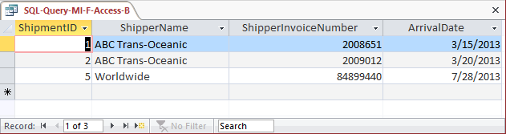

1. Determine the maximum and minimum InsuredValue.

Solutions to Morgan Importing questions are contained in the Microsoft Access database *DBP-e13-IM-CH02-MI.accdb* which is available in the Instructor’s Resource Center on the text’s Web site ([www.pearsonhighered.com/kroenke](http://www.pearsonhighered.com/kroenke/)).

/* *** SQL-Query-MI-G *** */

SELECT MAX (InsuredValue) AS MaxInsuredValue,

MIN (InsuredValue) AS MinInsuredValue,

FROM SHIPMENT;

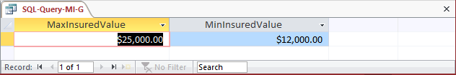

1. Determine the average InsuredValue.

Solutions to Morgan Importing questions are contained in the Microsoft Access database *DBP-e13-IM-CH02-MI.accdb* which is available in the Instructor’s Resource Center on the text’s Web site ([www.pearsonhighered.com/kroenke](http://www.pearsonhighered.com/kroenke/)).

/* *** SQL-Query-MI-H *** */

SELECT AVG (InsuredValue) AS AvgInsuredValue

FROM SHIPMENT;

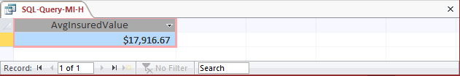

1. Count the number of shipments.

Solutions to Morgan Importing questions are contained in the Microsoft Access database *DBP-e13-IM-CH02-MI.accdb* which is available in the Instructor’s Resource Center on the text’s Web site ([www.pearsonhighered.com/kroenke](http://www.pearsonhighered.com/kroenke/)).

/* *** SQL-Query-MI-I *** */

SELECT COUNT (*) AS NumberOfShipments

FROM SHIPMENT;

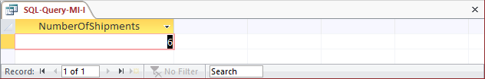

1. Show ItemID, Description, Store, and a calculated column named StdCurrencyAmount that is equal to LocalCurrencyAmt times the ExchangeRate for all rows of ITEM.

Solutions to Morgan Importing questions are contained in the Microsoft Access database *DBP-e13-IM-CH02-MI.accdb* which is available in the Instructor’s Resource Center on the text’s Web site ([www.pearsonhighered.com/kroenke](http://www.pearsonhighered.com/kroenke/)).

/* *** SQL-Query-MI-J *** */

SELECT Item, Store,

LocalCurrencyAmt * ExchangeRate AS StdCurrencyAmount

FROM ITEM;

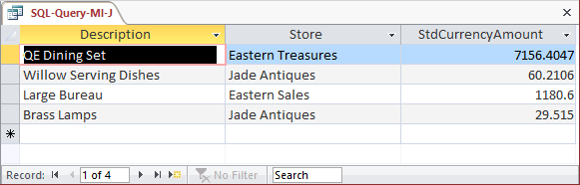

1. Group item purchases by City and Store.

Solutions to Morgan Importing questions are contained in the Microsoft Access database *DBP-e13-IM-CH02-MI.accdb* which is available in the Instructor’s Resource Center on the text’s Web site ([www.pearsonhighered.com/kroenke](http://www.pearsonhighered.com/kroenke/)).

/* *** SQL-Query-MI-K *** */

SELECT City, Store

FROM ITEM

GROUP BY City, Store;

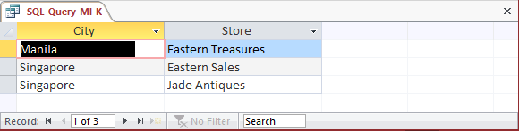

1. Count the number of purchases having each combination of City and Store.

Solutions to Morgan Importing questions are contained in the Microsoft Access database *DBP-e13-IM-CH02-MI.accdb* which is available in the Instructor’s Resource Center on the text’s Web site ([www.pearsonhighered.com/kroenke](http://www.pearsonhighered.com/kroenke/)).

/* *** SQL-Query-MI-L *** */

SELECT City, Store

COUNT (*) AS City_Store_Combination_Count

FROM ITEM

GROUP BY City, Store;

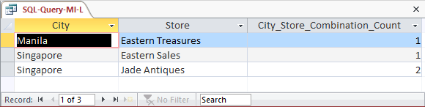

1. Show the ShipperName, ShipmentID and DepartureDate of all shipments that have an item with a value of 1000 or more. Use a subquery. Present results sorted by ShipperName in ascending order and then DepartureDate in descending order.

Solutions to Morgan Importing questions are contained in the Microsoft Access database *DBP-e13-IM-CH02-MI.accdb* which is available in the Instructor’s Resource Center on the text’s Web site ([www.pearsonhighered.com/kroenke](http://www.pearsonhighered.com/kroenke/)).

/* *** SQL-Query-MI-M *** */

SELECT ShipperName, DepartureDate

FROM SHIPMENT

WHERE ShipmentID IN

(SELECT ShipmentID

FROM SHIPMENT_ITEM

WHERE Value = 1000

OR Value > 1000)

ORDER BY ShipperName, DepartureDate DESC;

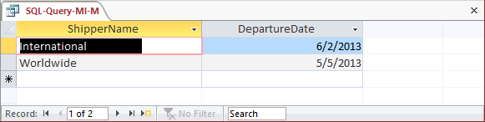

1. Show the ShipperName, ShipmentID and DepartureDate of all shipments that have an item with a value of 1000 or more. Use a join. Present results sorted by ShipperName in ascending order and then DepartureDate in descending order.

Solutions to Morgan Importing questions are contained in the Microsoft Access database *DBP-e13-IM-CH02-MI.accdb* which is available in the Instructor’s Resource Center on the text’s Web site ([www.pearsonhighered.com/kroenke](http://www.pearsonhighered.com/kroenke/)).

This question is a little more complicated than it appears. Note how the following three queries determine that there are actually only two shipments that meet the criteria.

/* *** SQL-Query-MI-N-A *** */

SELECT ShipperName, DepartureDate

FROM SHIPMENT, SHIPMENT_ITEM

WHERE SHIPMENT.ShipmentID = SHIPMENT_ITEM.ShipmentID

AND (Value = 1000 OR Value > 1000)

ORDER BY ShipperName, DepartureDate DESC;

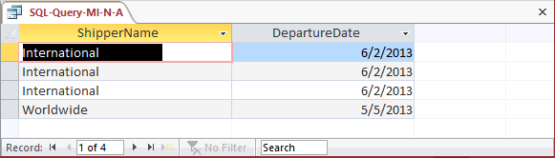

We’ll add some more details to confirm the fact that the three lines for International are actually only one shipment. Note that we can use the *greater than or equal to* operator >= to simplify the WHERE clause:

/* *** SQL-Query-MI-N-B *** */

SELECT SHIPMENT.ShipmentID, ShipmentItemID, Description,

ShipperName, DepartureDate

FROM SHIPMENT, SHIPMENT_ITEM, ITEM

WHERE SHIPMENT.ShipmentID = SHIPMENT_ITEM.ShipmentID

AND SHIPMENT_ITEM.ItemID = ITEM.ItemID

AND Value >= 1000

ORDER BY ShipperName, DepartureDate DESC;

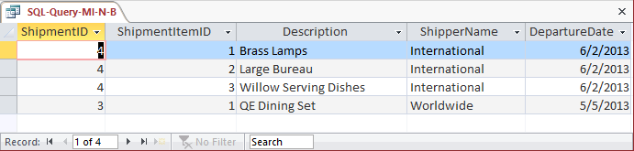

Now that we can see that all three lines for International are for ShipmentID 4, we’ll get the proper results from the revised query by adding the DISTINCT keyword:

/* *** SQL-Query-MI-N-C *** */

SELECT DISTINCT ShipperName, DepartureDate

FROM SHIPMENT, SHIPMENT_ITEM

WHERE SHIPMENT.ShipmentID = SHIPMENT_ITEM.ShipmentID

AND Value >= 1000

ORDER BY ShipperName, DepartureDate DESC;

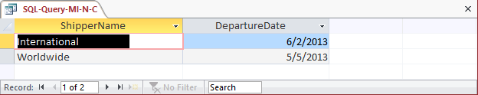

1. Show the ShipperName, ShipmentID and DepartureDate of all shipments that have an item that was purchased in Singapore. Use a subquery. Present results sorted by ShipperName in ascending order and then DepartureDate in descending order.

Solutions to Morgan Importing questions are contained in the Microsoft Access database *DBP-e13-IM-CH02-MI.accdb* which is available in the Instructor’s Resource Center on the text’s Web site ([www.pearsonhighered.com/kroenke](http://www.pearsonhighered.com/kroenke/)).

/* *** SQL-Query-MI-O *** */

SELECT ShipperName, DepartureDate

FROM SHIPMENT

WHERE ShipmentID IN

(SELECT ShipmentID

FROM SHIPMENT_ITEM

WHERE ItemID IN

(SELECT ItemID

FROM ITEM

WHERE City = 'Singapore'))

ORDER BY ShipperName, DepartureDate DESC;

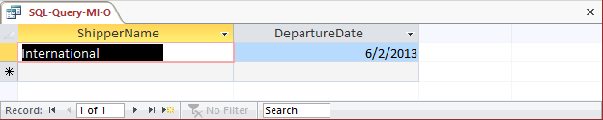

1. Show the ShipperName, ShipmentID and DepartureDate of all shipments that have an item that was purchased in Singapore. Use a join, but do not use JOIN ON syntax. Present results sorted by ShipperName in ascending order and then DepartureDate in descending order.

Solutions to Morgan Importing questions are contained in the Microsoft Access database *DBP-e13-IM-CH02-MI.accdb* which is available in the Instructor’s Resource Center on the text’s Web site ([www.pearsonhighered.com/kroenke](http://www.pearsonhighered.com/kroenke/)).

As in question N, we will have to use a DISTINCT keyword to get the appropriate answer.

/* *** SQL-Query-MI-P *** */

SELECT DISTINCT ShipperName, DepartureDate

FROM SHIPMENT, SHIPMENT_ITEM, ITEM

WHERE SHIPMENT.ShipmentID = SHIPMENT_ITEM.ShipmentID

AND SHIPMENT_ITEM.ItemID = ITEM.ItemID

AND City = 'Singapore'

ORDER BY ShipperName, DepartureDate DESC;

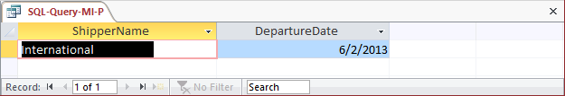

1. Show the ShipperName, ShipmentID and DepartureDate of all shipments that have an item that was purchased in Singapore. Use a join using JOIN ON syntax. Present results sorted by ShipperName in ascending order and then DepartureDate in descending order.

Solutions to Morgan Importing questions are contained in the Microsoft Access database *DBP-e13-IM-CH02-MI.accdb* which is available in the Instructor’s Resource Center on the text’s Web site ([www.pearsonhighered.com/kroenke](http://www.pearsonhighered.com/kroenke/)).

/* *** SQL-Query-MI-Q *** */

SELECT SHIPMENT.ShipperName, SHIPMENT_ITEM.ShipmentID, SHIPMENT.DepartureDate

FROM ITEM JOIN SHIPMENT INNER

ON ITEM.ItemID = SHIPMENT_ITEM.ItemID

JOIN SHIPMENT_ITEM

ON SHIPMENT.ShipmentID = SHIPMENT_ITEM.ShipmentID)

GROUP BY SHIPMENT.ShipperName, SHIPMENT_ITEM.ShipmentID,

SHIPMENT.DepartureDate, ITEM.City

HAVING ITEM.City='Singapore';

Note that for Microsoft Access, we must use the INNER JOIN syntax:

/* *** SQL-Query-MI-Q *** */

SELECT SHIPMENT.ShipperName, SHIPMENT_ITEM.ShipmentID, SHIPMENT.DepartureDate

FROM ITEM INNER JOIN (SHIPMENT INNER JOIN SHIPMENT_ITEM

ON SHIPMENT.ShipmentID = SHIPMENT_ITEM.ShipmentID)

ON ITEM.ItemID = SHIPMENT_ITEM.ItemID

GROUP BY SHIPMENT.ShipperName, SHIPMENT_ITEM.ShipmentID,

SHIPMENT.DepartureDate, ITEM.City

HAVING (((ITEM.City)='Singapore'));

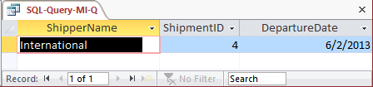

1. Show the ShipperName, ShipmentID, DepartureDate of shipment, and Value for items that were purchased in Singapore. Use a combination of a join and a subquery. Present results sorted by ShipperName in ascending order and then DepartureDate in descending order.

Solutions to Morgan Importing questions are contained in the Microsoft Access database *DBP-e13-IM-CH02-MI.accdb* which is available in the Instructor’s Resource Center on the text’s Web site ([www.pearsonhighered.com/kroenke](http://www.pearsonhighered.com/kroenke/)).

/* *** SQL-Query-MI-R *** */

SELECT ShipperName, DepartureDate, Value

FROM SHIPMENT, SHIPMENT_ITEM

WHERE SHIPMENT.ShipmentID = SHIPMENT_ITEM.ShipmentID

AND ItemID IN

(SELECT ItemID

FROM ITEM

WHERE City = 'Singapore')

ORDER BY ShipperName, DepartureDate DESC;

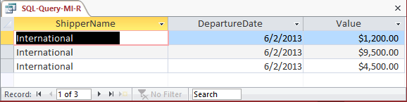

1. Show the ShipperName, ShipmentID, DepartureDate of shipment, and Value for items that were purchased in Singapore. Also show ShipperName, ShipmentID, DepartureDate for all other shipments. Use a combination of a join and a subquery. Present results sorted by ShipperName in ascending order and then DepartureDate in descending order.

Solutions to Morgan Importing questions are contained in the Microsoft Access database *DBP-e13-IM-CH02-MI.accdb* which is available in the Instructor’s Resource Center on the text’s Web site ([www.pearsonhighered.com/kroenke](http://www.pearsonhighered.com/kroenke/)).

/* *** SQL-Query-MI-S *** */

SELECT SHIPMENT.ShipperName, SHIPMENT_ITEM.ShipmentID,

SHIPMENT.DepartureDate, SHIPMENT_ITEM.Value

FROM (ITEM RIGHT JOIN SHIPMENT_ITEM

ON ITEM.ItemID = SHIPMENT_ITEM.ItemID)

RIGHT JOIN SHIPMENT

ON SHIPMENT_ITEM.ShipmentID = SHIPMENT.ShipmentID

WHERE (((ITEM.City)='Singapore')

AND ((SHIPMENT.ShipmentID)=[SHIPMENT_ITEM].[ShipmentID])

AND ((SHIPMENT_ITEM.[ItemID]) IN

(SELECT ItemID

FROM ITEM

WHERE City = 'Singapore')))

ORDER BY SHIPMENT.ShipperName, SHIPMENT.DepartureDate DESC;

