Chapter 2 Exercises

Name Date____________

1. Create a new data set by polling 5 other people and asking the following questions:   
 RESPOND. What are the last four digits of your phone number?   
 EXER1. Do you exercise regularly? (Yes or No)   
 EXER2. How many hours a week would you say you exercise?   
 EXER3. Do you participate in team sports? (Yes or No)   
 EXER4. What is your favorite sport to play?

Create a new data set using these data and incorporating the following labels.

Variable Name Type Label Value Labels Measure

RESPOND String20   
EXER1 Numeric

EXER2 Numeric

EXER3 Numeric

EXER4 String 20

Respondent Name None Nominal

Exercise Regularly? 0=no 1=yes Nominal

Hours/Week of Exercise None Scale

Participate in Team Sports? 0=no 1=yes Nominal

Favorite Sport None Nominal

Enter the responses and save the data as “EXERCISE.SAV”. Be sure to save it to a location that you have access to. Show that you have set up the file with the following command and follow your instructor’s request, such as print the output:

*File*

*Display Data File Information   
 Working File*

Copyright © 2012 Pearson Education, Inc. All rights reserved.

11

Instructor’s Manual for Sweet & Grace-Martin, *Data Analysis with SPSS*, 4/e

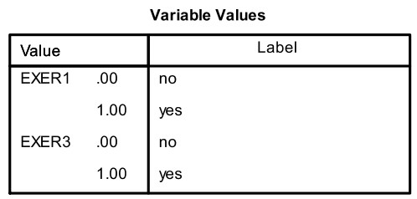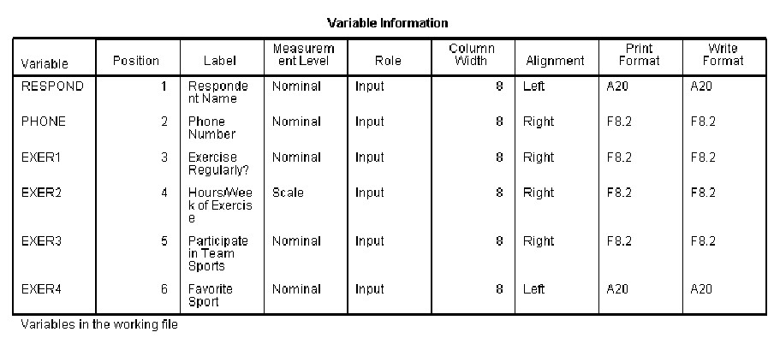

Copyright © 2012 Pearson Education, Inc. All rights reserved.

12

Chapter 2 - Getting Started: Accessing, Examining, and Saving Data

2. Open the data STATES10.SAV. Examine the data set in the *Variable View Window* and locate some variables that measure the following concepts. Recall that the variable names begin with a 2-letter code for the general topic of the variable. (Double click within the box of variables and scroll up or down to view all of the variables.)

A. Economic Prosperity

*ECS96 Per Capita Gross Domestic Product: 2008*

*ECS100 Per Capita Personal Income: 2008*

*ECS103 Median Household Income: 2008*

*ECS103 Median Household Income: 2008*

*ECS105 Personal Bankruptcy Rate per 100,000: 2009 ECS445 Homeownership Rate: 2008*

B. Substance Abuse

*HTC254 Percent of High School Students Who Drink Alcohol: 2007 HTC255 Percent of High School Students Who Use Marijuana: 2007 HTH180 Death Rate per 100,000 by Alcohol-Induced Deaths: 2006 HTH503 Adult Per Capita Beer Consumption: 2007   
HTH505 Adult Per Capita Wine Consumption: 2007   
HTH507 Adult Per Capita Distilled Spirits Consumption: 2007   
HTH508 Percent of Adults Who Do Not Drink Alcohol: 2008   
HTH510 Percent of Adults Who Smoke: 2008*

*HTH515 Percent of Population Who are Illicit Drug Users: 2007 HTS420 Adult Per Capita Alcohol Consumption: 2007*

C. Educational Attainment

*EDS127 Percent of Public School 4th Graders Proficient or Better in Reading: 2007 EDS128 Percent of Public School 8th Graders Proficient or Better in Reading: 2007 EDS129 Percent of Public School 4th Graders Proficient or Better in Math: 2009 EDS130 Percent of Public School 8th Graders Proficient or Better in Math: 2009 EDS131 Percent of Population Graduated from High School: 2008   
EDS134 Public High School Drop Out Rate: 2007*

*EDS135 ACT Average Composite Score: 2009*

*EDS151 Enrollment Rate per 1,000 Aged 18-24 in Institutions of Higher Education:   
2006*

*EDS154 Percent of Population With a Bachelors Degree or More: 2008*

Copyright © 2012 Pearson Education, Inc. All rights reserved.

13

Instructor’s Manual for Sweet & Grace-Martin, *Data Analysis with SPSS*, 4/e

3. Your state’s Department of Education hires you as a statistical consultant to help design a   
data set. They have already sent a survey to school superintendents, and need you to design their   
data set so they can begin entering information. Below is an example of a survey returned from   
one school district. Using the survey, answer the questions below, showing how you would   
design the data set.

1. Number of elementary schools: 8

2. Number of middle schools: 4

3. Number of high schools: 2

4. Average spending per pupil: $7500

5. Student/Teacher ratio: 19/1

6. High School drop-out rate: 10%

7. Does the High School offer AP classes? Yes

8.Type of district: (circle one) Rural Suburban Urban

In this data set, what will be a case? *School district or Superintendent*

Design variable names, labels, and measurement types for each of the variables in the study.

Variable Variable Value Measurement

Name Label Labels Type

1. *Answers will vary.*

*All variables should have names 8 digits or fewer.   
All variables should have variable labels.   
Variables 7 and 8 should have value labels.   
Variables 1,2,3,4,5,and 6 are scale variables.   
Variables 7 and 8 are categorical variables,*

Copyright © 2012 Pearson Education, Inc. All rights reserved.

14

Chapter 2 - Getting Started: Accessing, Examining, and Saving Data

4. Open the GSS08 data and examine the variable SATFIN (Satisfaction with Financial Situation). Can you identify the values and the value labels?

Value *____1_____*_   
Value *____2_____*_   
Value *____3_____*_   
Value *____8_____*_   
Value *____9_____*_

Value label *___Satisfied _____*______________   
Value label *___More or Less* _______________   
Value label *___Not at All Sat_*_______________   
Value label *___DK__________*______________   
Value label *___NA__________*______________

Note, in the GSS08 Data, IAP means “Inapplicable,” DK means “Don’t Know” and NA means “No Answer”.

5. A novice researcher begins an analysis of the GSS08 data and wants to understand the   
distribution of income in the United States. She looks at the data in the *Data View* and sees   
values that range mostly from 1 to 25, but occasionally also sees the number 98 (you can do this   
by finding the variable INCOME06 in the GSS08 data). She explains to her instructor that the   
data must be wrong because almost no one has an income of “10.” Her instructor tells her the   
data are fine, and asks her to come back when she can tell him how much a family income is for   
an observation that is listed as “10”.

What does “10” in the INCOME06 variable indicate? __ *$12,500-$14,999_____________*

What is the reason for the novice researcher’s confusion?

*The confusion stems from thinking of the data value as being equivalent to the dollar income. In this case, the 10 indicates a value assigned to an income range. In the GSS08 data, “10” is the value assigned to identify individuals with incomes that range from $12,500-$14,999 in the variable INCOME98.*

Copyright © 2012 Pearson Education, Inc. All rights reserved.

15

Instructor’s Manual for Sweet & Grace-Martin, *Data Analysis with SPSS*, 4/e

6. Open the file FAMILY.SAV that you saved earlier and design 4 new variables to put into the data set and enter in the values. Try to vary the structure of the variables so that you include at least one scale variable, one ordinal variable, and one nominal variable. For example (don’t use this one!), we could add the variable “FISH” with the label “Likes to Fish”, the value labels   
“0=NO, 1-YES”, and the measurement type “Nominal”. Enter the responses and save the data as “FAMILY2.SAV”. Show that you have set up the file with the following command and follow your instructor’s directions, such as print the output:

*File*

*Display Data File Information   
 Working File*

*Answers will vary.*