Chapter 2

The Evolution of Management Thought
CHAPTER CONTENTS

Learning Objectives 2-2

Key Definitions/Terms 2-2

Chapter Overview 2-4

Lecture Outline 2-5

Lecture Enhancers 2-24

Management in Action 2-26

Building Management Skills 2-33

Managing Ethically 2-34

Small Group Breakout Exercise 2-35

Exploring the World Wide Web 2-36

Be the Manager 2-37

Case in the News 2-38

Supplemental Features 2-40

Manager’s Hot Seat 2-42

Instructor PowerPoint Slides 2-43

LEARNING OBJECTIVES

LO2-1. Describe how the need to increase organizational efficiency and effectiveness has guided the evolution of management theory.

LO2-2. Explain the principle of job specialization and division of labor, and tell why the study of person-task relationships is central to the pursuit of increased efficiency.

LO2-3. Identify the principles of administration and organization that underlie effective organizations.

LO2-4. Trace the changes in theories about how managers should behave to motivate and control employees.

LO2-5. Explain the contribution of management science to the efficient use of organizational resources.

LO2-6. Explain why the study of the external environment and its impact on an organization has become a central issue in management thought.

Key Definitions/Terms

Administrative management: The study of how to create an organizational structure and control system that leads to high efficiency and effectiveness.
Authority: The power to hold people accountable for their actions and to make decisions concerning the use of organizational resources.
Behavioral management: The study of how managers should behave to motivate employees and encourage them to perform at high levels and be committed to the achievement of organizational goals.
Bureaucracy: A formal system of organization and administration designed to ensure efficiency and effectiveness.
Centralization: The concentration of authority at the top of the managerial hierarchy.
Closed system: A system that is self-contained and thus not affected by changes occurring in its external environment.
Contingency theory: The idea that the organizational structures and control systems managers choose depend on (are contingent on) characteristics of the external environment in which the organization operates.
Discipline: Obedience, energy, application, and other outward marks of respect for a superior’s authority.
Entropy: The tendency of a closed system to lose its ability to control itself and thus to dissolve and disintegrate.
Equity: The justice, impartiality, and fairness to which all organizational members are entitled.
Esprit de corps: Shared feelings of comradeship, enthusiasm, or devotion to a common cause among members of a group.
Hawthorne effect: The finding that a manager’s behavior or leadership approach can affect workers’ level of performance.
Human relations movement: A management approach that advocates the idea that supervisors should receive behavioral training to manage subordinates in ways that elicit their cooperation and increase their productivity.
Informal organization: The system of behavioral rules and norms that emerge in a group.
Initiative: The ability to act on one’s own without direction from a superior.
Job specialization: The process by which a division of labor occurs as different workers specialize in different tasks over time.
Line of authority: The chain of command extending from the top to the bottom of an organization.
Management science theory: An approach to management that uses rigorous quantitative techniques to help managers make maximum use of organizational resources.
Mechanistic structure: An organizational structure in which authority is centralized, tasks and rules are clearly specified, and employees are closely supervised.
Norms: Unwritten, informal codes of conduct that prescribe how people should act in particular situations and are considered important by most members of a group or organization.
Open system: A system that takes in resources from its external environment and converts them into goods and services that are then sent back to that environment for purchase by customers.
Order: The methodical arrangement of positions to provide the organization with the greatest benefit and to provide employees with career opportunities.
Organic structure: An organizational structure in which authority is decentralized to middle and first-line managers and tasks and roles are left ambiguous to encourage employees to cooperate and respond quickly to the unexpected.
Organizational behavior: The study of the factors that have an impact on how individuals and groups respond to and act in organizations.
Organizational environment: The set of forces and conditions that operate beyond an organization’s boundaries but affect a manager’s ability to acquire and utilize resources.
Rules: Formal written instructions that specify actions to be taken under different circumstances to achieve specific goals.
Scientific management: The systematic study of relationships between people and tasks for the purpose of redesigning the work process to increase efficiency.
Standard operating procedures (SOPs): Specific sets of written instructions about how to perform a certain aspect of a task.
Synergy: Performance gains that result when individuals and departments coordinate their actions.
Theory X: A set of negative assumptions about workers that leads to the conclusion that a manager’s task is to supervise workers closely and control their behavior.
Theory Y: A set of positive assumptions about workers that leads to the conclusion that a manager’s task is to create a work setting that encourages commitment to organizational goals and provides opportunities for workers to be imaginative and to exercise initiative and self-direction.
Unity of command: A reporting relationship in which an employee receives orders from, and reports to, only one superior.
Unity of direction: The singleness of purpose that makes possible the creation of one plan of action to guide managers and workers as they use organizational resources.
Chapter Overview

In this chapter, how management thought has evolved in modern times and the central concerns that have guided ongoing advances in management theory are explored. First, the classical management theories that emerged around the turn of the twentieth century are examined. Next, behavioral management theories developed before and after World War II are examined, and then management science theory, which developed during the second World War. Finally, the theories developed to help explain how the external environment affects the way organizations and managers operate are examined.

Lecture Outline

NOTE ABOUT INSTRUCTOR POWERPOINT SLIDES  The Instructor PowerPoint Slides include most Student PowerPoint Slides, along with additional material that can be used to expand the lecture. Images of the Instructor PowerPoint slides can be found at the end of this chapter on Page 2-43. | 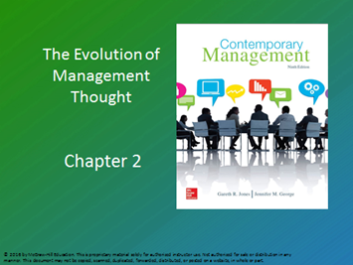  BASIC powerpoint slide 1  (Instructor’s POWERPOINT SLIDE 1)  Chapter 2: The Evolution of Management Thought

Manager’s Challenge (pages 35-37 of text)
Simplification and Excellence at General Electric

More than ever before, companies must learn how to adapt and remain competitive in a changing global marketplace. General Electric is one example. It is a highly diversified global company that makes everything from lightbulbs and refrigerators to locomotives and aircraft engines. It also has finance businesses, and it runs power plants.

The company was created in 1892 from the merger of two companies: the Edison General Electric Company and the Thomas-Houston Company. Thomas Edison and Charles Coffin pioneered the development of the incandescent lightbulb, which heats a filament wire, using electricity, until it emits light. The filament is protected from oxidation by a glass
bulb that contained inert gas or a vacuum. General Electric was not the first company to produce and sell such bulbs and related electrical equipment. However, Edison and Coffin used their combined expertise and patents to produce practical, affordable lightbulbs relatively easily, which gave them a competitive advantage.

Originally General Electric produced lightbulbs and related electrical equipment at its headquarters in Schenectady, New York. Over the years it has expanded to serve
customers in more than 160 nations with a lineup of multiple businesses and several
hundred products. To do this, General Electric draws on the talents of more than 300,000 employees.

General Electric’s birth as a merger established a pattern for quick growth by diversifying its businesses through merger and acquisition of other firms, as well as developing new business portfolios. In 1911 GE bought the National Electric Lamp Association, which strengthened its distribution and product portfolio. A few short years later, in 1919, GE formed the Radio Corporation of America (RCA). RCA was intended to operate as a retailer for General Electric’s
radios, but grew into a large business of its own. Since then General Electric has diversified into aircraft engines, computers, medical technology, entertainment, wind power, appliances, and even petroleum extraction products. It also maintains financial stakes in banking and finance.

One challenge inherent in this growth is the incredible complexity of managing multiple businesses in different industries across the globe. As businesses like General Electric grow in size and scope, they often become cumbersome to manage. To be consistent across its operations, these businesses can become highly formalized and bureaucratic. This management style enables the company to maintain control over its operations. However, it can also impede the company’s ability to respond to changing market dynamics and competitive realities. Because General Electric competes in multiple industries, it must work hard to stay flexible in the face of multiple competitors.

Large companies also struggle to maintain a competitive edge with innovation because new products or offerings must be approved by layers of formal bureaucracy, which slows down the process. Since companies often compete to bring products to market first, the size and formal bureaucracy of an organization can be a stumbling block. For example, even though a General Electric engineer, Edward Hammer, developed the spiral compact fluorescent light (CFL) in the 1970s, General Electric’s management decided to shelve the project due to cost concerns. Today incandescent bulbs are being phased out in favor of CFLs, and GE has lost ground to competitors like Philips.

One effort to simplify General Electric involves reducing the firm’s exposure to risk in economic markets. GE Capital is the financial arm of the corporation, and it took on risky bets that hurt its parent company during the recent economic downturn. Immelt and General Electric’s managers are working to divest its financial assets so that the firm has less exposure to economic risk. For example, GE Capital recently sold a Swiss subsidiary that had a successful initial public offering. Normally, companies like General Electric would be pursuing these start-up firms, but managers like Immelt realize that such acquisitions can distract the company from its core businesses.

General Electric has also divested other businesses, including insurance and media. In 2013 Comcast purchased General Electric’s remaining stake in NBCUniversal, an entertainment production company. Although NBCUniversal is profitable, Immelt and General Electric’s management believed that the business did not reflect the manufacturing core GE wanted to spend its energies and resources on. These divestitures have changed General Electric’s focus to businesses such as aircraft engines and refining equipment, and have helped the company simplify its management processes.

Time will tell whether these actions change General Electric’s competitive position, but GE is betting on changes in management to help move the company forward in the next century.

I. Scientific Management Theory  - In the 19th century’s new economic climate, managers of all types of organizations—political, educational, and economic—were trying to find better ways to satisfy customers’ needs.  - Many major economic, technical, and cultural changes were taking place at this time.  - The introduction of steam power and the development of sophisticated machinery and equipment changed how goods were produced.  - Small workshops run by skilled workers who produced hand-manufactured products (a system called crafts production) were being replaced by large factories in which sophisticated machines controlled by hundreds or even thousands of unskilled or semiskilled workers made products.  - Owners and managers of the new factories found themselves unprepared for the challenges accompanying the change from small-scale crafts production to large-scale mechanized manufacturing.  - Moreover, many managers and supervisors in these workshops and factories were engineers who had only a technical orientation.  - They were unprepared for the social problems that occur when people work together in large groups in a factory or shop system.  - Managers began to search for new techniques to manage their organizations’ resources, and soon they began to focus on ways to increase the efficiency of the worker–task mix.  A. Job Specialization and the Division of Labor  - In a study of factories that produced various pins or nails, famous economist Adam Smith identified two different types of manufacturing:  - The first was similar to crafts-style production, in which each worker was responsible for all the 18 tasks involved in producing a pin.  - The other had each worker performing only one or a few of the 18 tasks.  - Smith found that the performance of the factories in which workers specialized in only one or a few tasks was much greater than the performance of the factory in which each worker performed all 18 pin-making tasks.  - Smith concluded that increasing the level of job specialization—the process by which a division of labor occurs as different workers specialize in tasks—improves efficiency and leads to higher organizational performance.  B. Frederick. W. Taylor and Scientific Management  - Frederick W. Taylor is best known for defining the techniques of scientific management, the systematic study of relationships between people and tasks for the purpose of redesigning the work process to increase efficiency.  - Taylor believed that if the amount of time and effort that each worker expends to produce a unit of output (a finished good or service) can be reduced by increasing specialization and the division of labor, the production process will become more efficient.  - Based on his experiments and observations as a manufacturing manager in a variety of settings, he developed four principles to increase efficiency in the workplace:  - Principle 1: Study the way workers perform their tasks, gather all the informal job knowledge that workers possess, and experiment with ways of improving how tasks are performed.  - Principle 2: Codify the new methods of performing tasks into written rules and standard operating procedures.  - Principle 3: Carefully select workers who possess skills and abilities that match the needs of the task, and train them to perform the task according to the established rules and procedures.  - Principle 4: Establish a fair or acceptable level of performance for a task, and then develop a pay system that rewards performance above the acceptable level.  - Managers in many organizations chose to implement the new principles of scientific management selectively. This decision ultimately resulted in problems:  - For example, some managers using scientific management obtained increases in performance, but rather than sharing performance gains with workers through bonuses as Taylor had advocated, they simply increased the amount of work that each worker was expected to do.  - Workers also learned that performance increases often meant fewer jobs and a greater threat of layoffs because fewer workers were needed.  - The specialized, simplified jobs were often monotonous and repetitive, and many workers became dissatisfied with their jobs.  - Scientific management brought many workers more hardship than gain and a distrust of managers who did not seem to care about workers’ well-being.  - These dissatisfied workers resisted attempts to use the new scientific management techniques and at times even withheld their job knowledge from managers to protect their jobs and pay.  - Unable to inspire workers to accept the new scientific management techniques for performing tasks, some organizations increased the mechanization of the work process.  - From a performance perspective, the combination of the two management practices—(1) achieving the right worker–task specialization and (2) linking people and tasks by the speed of the production line—produces the huge cost savings and dramatic output increases that occur in large organized work settings.  C. The Gilbreths  - Frank Gilbreth and Lillian Gilbreth refined Taylor’s analysis of work movements and made many contributions to time-and-motion study.  - Their aims were to:  - Analyze every individual action necessary to perform a particular task and break it into each of its component actions.  - Find better ways to perform each component action.  - Reorganize each of the component actions so that the action as a whole could be performed more efficiently—at less cost in time and effort.  - The Gilbreths became increasingly interested in the study of fatigue.  - They studied how physical characteristics of the workplace contribute to job stress that often leads to fatigue and thus poor performance.  - They isolated factors that result in worker fatigue, such as lighting, heating, the color of walls, and the design of tools and machines.  - In workshops and factories, the work of the Gilbreths, Taylor, and many others had a major effect on the practice of management.  - In comparison with the old crafts system, jobs in the new system were more repetitive, boring, and monotonous as a result of the application of scientific management principles, and workers became increasingly dissatisfied.  - Frequently the management of work settings became a game between workers and managers: Managers tried to initiate work practices to increase performance, and workers tried to hide the true potential efficiency of the work setting to protect their own well-being.  II. ADMINISTRATIVE MANAGEMENT THEORY  - Administrative management is the study of how to create an organizational structure and control system that leads to high efficiency and effectiveness.  - Organizational structure is the system of task and authority relationships that controls how employees use resources to achieve the organization’s goals.  A. The Theory of Bureaucracy  - Max Weber developed the principles of bureaucracy—a formal system of organization and administration designed to ensure efficiency and effectiveness. A bureaucratic system of administration is based on the five principles summarized in Figure 2.2.  - Principle 1: In a bureaucracy, a manager’s formal authority derives from the position he or she holds in the organization.  - Authority is the power to hold people accountable for their actions and to make decisions concerning the use of organizational resources. Authority gives managers the right to direct and control their subordinates’ behavior to achieve organizational goals.  - Principle 2: In a bureaucracy, people should occupy positions because of their performance, not because of their social standing or personal contacts.  - Principle 3: The extent of each position’s formal authority and task responsibilities, and its relationship to other positions in an organization, should be clearly specified.  - Principle 4: Authority can be exercised effectively in an organization when positions are arranged hierarchically, so employees know whom to report to and who reports to them.  - Principle 5: Managers must create a well-defined system of rules, standard operating procedures, and norms so they can effectively control behavior within an organization.  - Rules are formal written instructions that specify actions to be taken under different circumstances to achieve specific goals.  - Standard operating procedures (SOPs) are specific sets of written instructions about how to perform a certain aspect of a task.  - Norms are unwritten, informal codes of conduct that prescribe how people should act in particular situations and are considered important by most members of a group or organization.  - Weber believed organizations that implement all five principles establish a bureaucratic system that improves organizational performance. However, if bureaucracies are not managed well many problems can result.  - Sometimes managers allow rules and SOPs, “bureaucratic red tape,” to become so cumbersome that decision making is slow and inefficient and organizations cannot change.  - When managers rely too much on rules to solve problems and not enough on their own skills and judgment, their behavior becomes inflexible.  B. Fayol’s Principles of Management  - Henri Fayol identified 14 principles (summarized in Table 2.1) that he believed essential to increase the efficiency of the management process.  Division of Labor  - Fayol advocated that workers be given more job duties to perform or be encouraged to assume more responsibility for work outcomes.  Authority and Responsibility  - Fayol, went beyond Weber’s formal authority, which derives from a manager’s position in the hierarchy, to recognize the informal authority that derives from personal expertise, technical knowledge, moral worth, and the ability to lead and to generate commitment from subordinates.  Unity of Command  - The principle of unity of command specifies that an employee should receive orders from, and report to, only one superior.  Line of Authority  - The line of authority is the chain of command extending from the top to the bottom of an organization.  - Fayol pointed out that when organizations are split into different departments or functions, each with its own hierarchy, it is important to allow middle and first-line managers in each department to interact with managers at similar levels in other departments. This interaction helps speed decision making.  Centralization  - Centralization is the concentration of authority at the top of the managerial hierarchy.  Unity of Direction  - Unity of direction is the singleness of purpose that makes possible the creation of one plan of action to guide managers and workers as they use organizational resources.  - An organization without a single guiding plan becomes inefficient and ineffective.  Equity  - Equity—the justice, impartiality, and fairness to which all organizational members are entitled—is receiving much attention today; the desire to treat employees fairly is a primary concern of managers.  Order  - To Fayol, order meant the methodical arrangement of positions to provide the organization with the greatest benefit and to provide employees with career opportunities that satisfy their needs.  Initiative  - Fayol believed managers must also encourage employees to exercise initiative, the ability to act on their own without direction from a superior. Used properly, initiative can be a major source of strength for an organization because it leads to creativity and innovation.  Discipline  - Discipline is the obedience, energy, application, and other outward marks of respect for a superior’s authority.  Remuneration of Personnel  - Fayol proposed reward systems including bonuses and profit sharing plans.  Stability of Tenure of Personnel  - When employees stay with an organization for extended periods, they develop skills that improve the organization’s ability to utilize its resources.  Subordination of Individual Interest to General Interest  - The interests of the organization as a whole must take precedence over the interests of any individual or group if the organization is to survive.  Esprit de Corps  - A key element in a successful organization is the development of esprit de corps, a French expression that refers to shared feelings of comradeship, enthusiasm, or devotion to a common cause among members of a group.  III. BEHAVIORAL MANAGEMENT THEORY  - Behavioral Management is the study of how managers should behave to motivate employees and encourage them to perform at high levels, and be committed to the achievement of organizational goals.  A. The Work of Mary Parker Follett  - Much of Mary Parker Follet’s writing about management and about the way managers should behave toward workers was a response to her concern that Taylor was ignoring the human side of the organization. She pointed out that management often overlooks the multitude of ways in which employees can contribute to the organization.  - She argued that because workers know the most about their jobs, they should be involved in job analysis and managers should allow them to participate in the work development process.  - Follet anticipated the current interest in self-managed teams and empowerment. She advocated what she called “cross-functioning”: members of different departments working together in cross-departmental teams to accomplish tasks.  - Follett proposed that knowledge and expertise, and not managers’ formal authority, should decide who will lead at any particular moment. She took a horizontal view of power and authority.  B. The Hawthorne Studies and Human Relations  - Probably because of its radical nature, Follett’s work was unappreciated by managers and researchers until quite recently. Most continued to follow in the footsteps of Taylor and the Gilbreths.  - To increase efficiency, they studied ways to improve various characteristics of the work setting, such as job specialization or the kinds of tools workers used. One series of studies was conducted from 1924 to 1932 at the Hawthorne Works of the Western Electric Company.  - This research, now known as the Hawthorne studies, began as an attempt to investigate how characteristics of the work setting—specifically the level of lighting or illumination—affect worker fatigue and performance.  - The study produced some unexpected results. The researchers found that regardless of whether they raised or lowered the level of illumination, productivity increased.  - The researchers found these results puzzling and invited a noted Harvard psychologist, Elton Mayo, to help them. Mayo proposed another series of experiments to solve the mystery.  - These experiments, known as the relay assembly test experiments, were designed to investigate the effects of other aspects of the work context on job performance, such as the effect of the number and length of rest periods and hours of work on fatigue and monotony. During a two-year study of a small group of female workers, the researchers again observed that productivity increased over time, but the increases could not be solely attributed to the effects of changes in the work setting.  - The researchers discovered that their presence was affecting the results because the workers enjoyed receiving attention and being the subject of study and were willing to cooperate with the researchers to produce the results they believed the researchers desired. This particular effect became known as the Hawthorne effect.  - The significant finding was that each manager’s personal behavior or leadership approach can affect performance. From this view emerged the human relations movement, which advocates that supervisors be behaviorally trained to manage subordinates in ways that elicit their cooperation and increase their productivity.  - The importance of behavioral or human relations training became even clearer to its supporters after the bank wiring room experiments.  - Managers must understand the workings of the informal organization, the system of behavioral rules and norms that emerge in a group, when they try to manage or change behavior in organizations.  - The increasing interest in the area of management known as organizational behavior, the study of the factors that have an impact on how individuals and groups respond to and act in organizations, dates from these early studies.  C. Theory X and Theory Y  - Douglas McGregor proposed two sets of assumptions about how work attitudes and behaviors not only dominate the way managers think but also affect how they behave in organizations. McGregor named these two contrasting sets of assumptions Theory X and Theory Y (Figure 2.3).  Theory X  - According to the assumptions of Theory X, the average worker is lazy, dislikes work, and will try to do as little as possible. To keep worker’s performance at a high level, the manager must supervise workers closely and control their behavior by means of “the carrot and stick”—rewards and punishments.  - Managers who accept the assumptions of Theory X design and shape the work setting to maximize their control over workers’ behaviors and minimize workers’ control over the pace of work.  Theory Y  - Theory Y assumes that workers are not inherently lazy, do not naturally dislike work, and if given the opportunity, will do what is good for the organization. The characteristics of the work setting determine whether workers consider work to be a source of satisfaction or punishment, and managers do not need to closely control workers’ behavior to make them perform at a high level because workers exercise self-control when they are committed to organizational goals.  - Managers who believe workers are motivated to help the organization reach its goals can decentralize authority and give more control over the job to workers.  IV. MANAGEMENT SCIENCE THEORY  - Management science theory is a contemporary approach to management that focuses on the use of rigorous quantitative techniques to help managers make maximum use of organizational resources to produce goods and services.  - There are many branches of management science; and information technology (IT), which is having a significant impact on all kinds of management practices, is affecting the tools managers use to make decisions. Each branch of management science deals with a specific set of concerns:  - Quantitative management uses mathematical techniques—such as linear and nonlinear programming, modeling, simulation, queuing theory, and chaos theory—to help managers decide, for example, how much inventory to hold at different times of the year, where to locate a new factory, and how best to invest an organization’s financial capital.  - Operations management gives managers a set of techniques they can use to analyze any aspect of an organization’s production system to increase efficiency.  - Total quality management (TQM) focuses on analyzing an organization’s input, conversion, and output activities to increase product quality.  - Management information systems (MISs) give managers information about events occurring inside the organization as well as in its external environment—information that is vital for effective decision making.  V. ORGANIZATIONAL ENVIRONMENT THEORY  - The organizational environment is the set of forces and conditions that operate beyond an organization’s boundaries but affect a manager’s ability to acquire and utilize resources.  A. The Open-Systems View  - Theorists like Daniel Katz, Robert Kahn, and James Thompson viewed the organization as an open system—a system that takes in resources from its external environment and converts or transforms them into goods and services that are then sent back to the environment, where they are bought by customers (Figure 2.4).  - At the input stage an organization acquires resources such as raw materials, money, and skilled workers to produce goods and services.  - Once the organization has gathered the necessary resources, conversion begins.  - At the conversion stage the organization’s workforce, using appropriate tools, techniques, and machinery, transforms the inputs into outputs of finished goods and services.  - At the output stage the organization releases finished goods and services to its external environment, where customers purchase and use them to satisfy their needs.  - A closed system, in contrast, is a self-contained system that is not affected by changes in its external environment. Organizations that operate as closed systems, that ignore the external environment, and that fail to acquire inputs are likely to experience entropy, which is the tendency of a closed system to lose its ability to control itself and thus to dissolve and disintegrate.  - Systems theorists like to argue that the whole is greater than the sum of its parts; they mean that an organization performs at a higher level when its departments work together rather than separately.  - Synergy, the performance gains that result from the combined actions of individuals and departments, is possible only in an organized system.  B. Contingency Theory  - The contingency theory is an idea that organizational structures and control systems managers choose are contingent on the characteristics of the external environment in which the organization operates (Figure 2.5).  - An important characteristic of the external environment that affects an organization’s ability to obtain resources is the degree to which the environment is changing.  - Changes in the organizational environment include changes in technology, which can lead to the creation of new products and result in the obsolescence of existing products; the entry of new competitors; and unstable economic conditions.  Mechanistic and Organic Structures  - Burns and Stalker proposed two basic ways in which managers can organize and control an organization’s activities to respond to characteristics of its external environment:  - Mechanistic structure—authority is centralized at the top of the managerial hierarchy, and the vertical hierarchy of authority is the main means used to control subordinates’ behavior. This structure provides the most efficient way to operate in a stable environment.  - Organic structure—authority is decentralized to middle and first-line managers to encourage them to take responsibility and act quickly to pursue scarce resources. This structure provides the most efficient way to operate in a rapidly changing environment. | LO2-1: Describe how the need to increase organizational efficiency and effectiveness has guided the evolution of management theory.  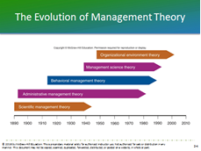  Student powerpoint slide 4 (Instructor’s POWERPOINT SLIDE 4)  The Evolution of Management Theory: Figure 2.1  LO2-2: Explain the principle of job specialization and division of labor, and tell why the study of person-task relationships is central to the pursuit of increased efficiency  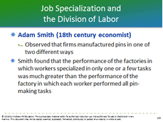  (Instructor’s POWERPOINT SLIDE 5)  Job Specialization and the Division of Labor  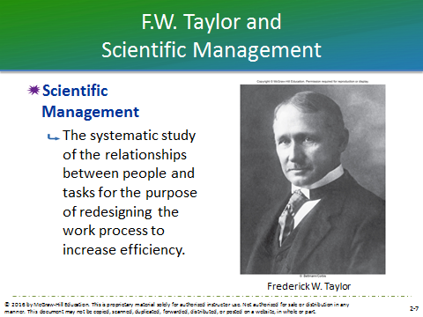  Student powerpoint slide 6 (Instructor’s POWERPOINT SLIDE 7)  Scientific Management  TEXT REFERENCE  Ethics in Action  McDonald’s and Human Rights  McDonald’s, like other global companies, has faced increased scrutiny  about the way its employees are treated. In response to the increased scrutiny, the McDonald’s corporation recently issued  a report on the sustainability and corporate responsibility of its businesses. Because 80 percent of McDonald’s restaurants are independently owned, the corporation has only indirect control over the majority of its restaurants. Yet the  company has put in place a number of managerial controls designed to help ensure that all McDonald’s employees are treated humanely and fairly. McDonald’s hopes that these policies and controls will ensure that its employees are treated well, and that any human rights violations will be quickly reported.  (Box in text on pages 40-41)  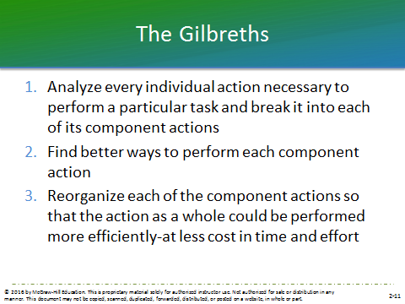  (Instructor’s POWERPOINT SLIDE 11)  The Gilbreths  TEXT REFERENCE  Manager as a Person  John D. Rockefeller  John D. Rockefeller was born in 1839 and showed an aptitude for finance from an early age. He took a job as an assistant bookkeeper with a company in Cleveland Ohio. Before long, Rockefeller’s mathematical ability and conscientiousness gained him additional responsibilities in the company.  At the age of 19, Rockefeller created a commodities partnership with Maurice  Clark. The American Civil War began in 1861, and causing prices and demand for commodities to soar. Then in 1862, Rockefeller entered the industry for which he would become famous: oil refining.  Rockefeller devoted a significant amount of energy to increasing the efficiency of his refineries. He soon bought out his partners and hired his brother William to help manage the operation. He set up his business so that the refinery increased the scope and efficiency of production to develop and maintain economies of scale.  In 1870, Rockefeller and his associates found the Standard Oil Company of Ohio. That same year, Rockefeller began implementing his vision to unite the area’s oil producers and consolidate the industry.  By 1879, just eight years after its creation, Standard Oil had grown to managing almost 90 percent of the oil refining business. The business would make Rockefeller among the wealthiest men of his day. He gave most of his fortune to charitable groups before his death.  (Box in text on page 42).  LO2-3: Identify the principles of administration and organization that underlie effective organizations.  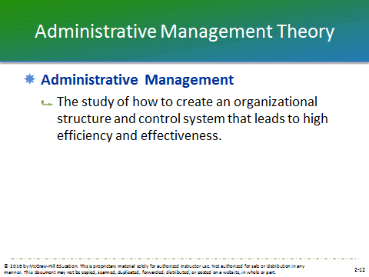  Student powerpoint slide 7 (Instructor’s POWERPOINT SLIDE 12)  Administrative Management Theory  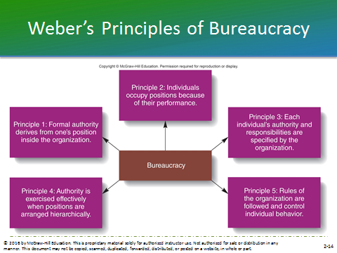  Student powerpoint slide 8 (Instructor’s POWERPOINT SLIDE 14)  Weber’s Principles of Bureaucracy: Figure 2.2  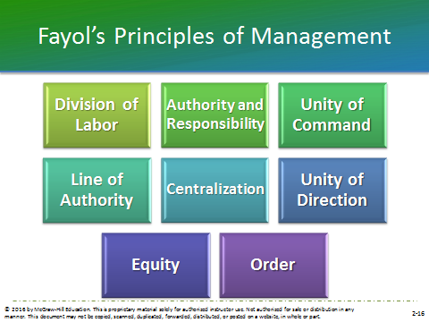  (Instructor’s POWERPOINT SLIDE 16)  Fayol’s Principles of Management  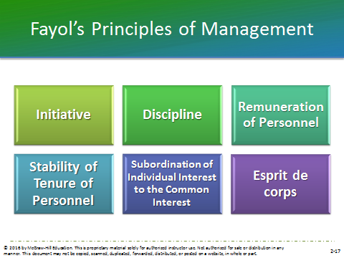  (Instructor’s POWERPOINT SLIDE 17)  Fayol’s Principles of Management  TEXT REFERENCE  Management INsight  Jim Collins: Good to Great  Jim Collings, noted consultant and business coach says that several principles predict a firm’s success. 1) Level 5 Leadership. 2) Having the right people in place is more important than establishing the values and strategy of the firm. 3) Confrontation and conflict and important drivers of decision success. 4) The Hedgehog Principle: companies should stick to what they know. 5) Discipline. 6) Rather than chase technological fads, seek incremental improvements in technology that complement core businesses.  (Box in text on page 48.)  LO2-4 Trace the changes in theories about how managers should behave to motivate and control employees  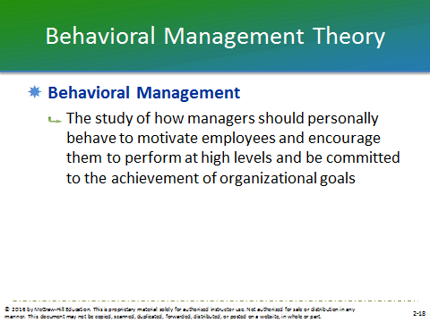  (Instructor’s POWERPOINT SLIDE 18)  Behavioral Management Theory  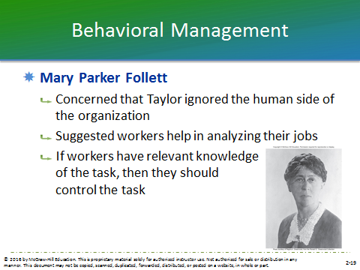  Student powerpoint slide 10 (Instructor’s POWERPOINT SLIDE 19)  Mary Parker Follett  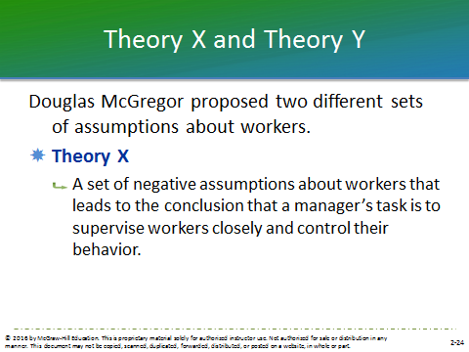  (Instructor’s POWERPOINT SLIDE 24)  Theory X  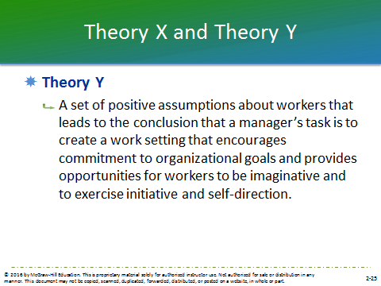  (Instructor’s POWERPOINT SLIDE 25  Theory Y  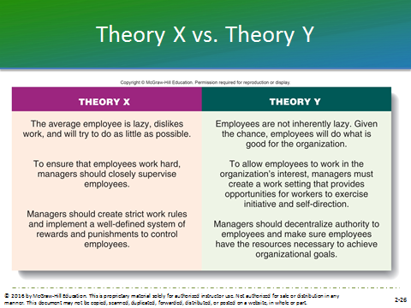  Student powerpoint slide 12 (Instructor’s POWERPOINT SLIDE 26)  Theory X vs. Theory Y: Figure 2.3  LO2-5: Explain the contributions of management science to the efficient use of organizational resources  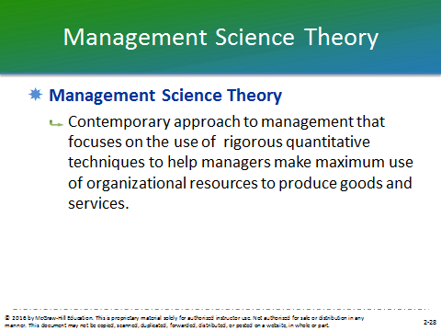  Student powerpoint slide 13 (Instructor’s POWERPOINT SLIDE 28)  Management Science Theory  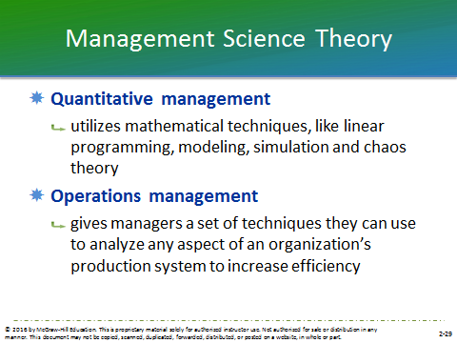  (Instructor’s POWERPOINT SLIDE 29)  Quantitative and Operations management  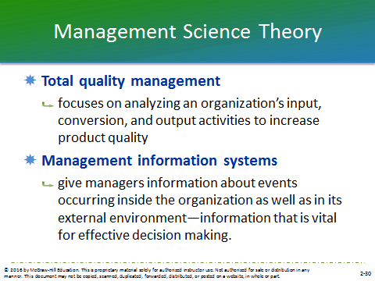  (Instructor’s POWERPOINT SLIDE 30)  Total quality management & Management information systems  LO2-6: Explain why the study of the external environment and its impact on an organization has become a central issue in management thought.  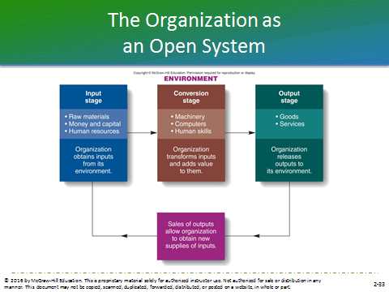  Student powerpoint slide 14 (Instructor’s POWERPOINT SLIDE 33)  The Organization as an Open System: Figure 2.4  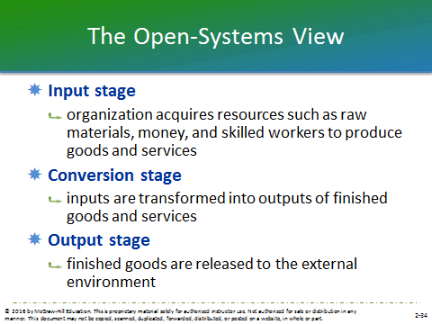  (Instructor’s POWERPOINT SLIDE 34)  Input, Conversion & Output stages  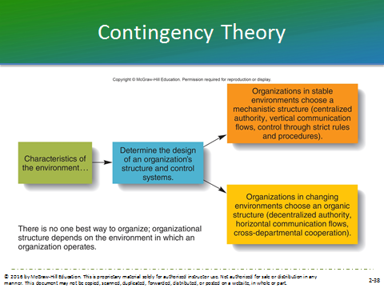  Student powerpoint slide 15 (Instructor’s POWERPOINT SLIDE 38)  Contingency Theory: Figure 2.5

LECTURE ENHANCERS

Lecture Enhancer 2.1

Management in Early Civilizations

Although text discussion concentrates on the evolution of management since the nineteenth century, many management practices were developed much earlier. The great civilizations of Sumeria, Babylon, Egypt, Assyria, and Persia had expert managers, as seen by achievements such as the Great Pyramids of Egypt and the Hanging Gardens of Babylon. Sumerian builders relied on the use of merit wages to build the walled cities and canals of Sumer. The highway and library systems of Assyria and the great cities of Persia required organization and managerial genius to achieve. The Code of Hammurabi included incentive and minimum wages as early as 1800 B.C.

Greek achievements in architecture, literature, and civil government required the application of complex management knowledge. The citizens of Greek city states worked under the piecework system on government contracts.

Rome once controlled the world from England to Asia and is still known for its systems of roads, construction of public buildings, and civil government. These were developed and maintained by a military system that is still a model for modern armies. These accomplishments required the application of highly developed management knowledge. As early as 300 B.C., Rome used minimum wage laws to try to compensate for a shortage of labor.

China’s Great Wall, complex road system, and silk trade required extensive management expertise. The principle of specialization was used as early as 1650 B.C., and labor turnover was understood as early as 400 B.C.

More than 400 years ago, a diplomat and civil servant in the city-state of Florence named Niccolo Machiavelli wrote a book called The Prince. Machiavelli was an experienced observer of the intrigues of state. His book was a how-to-do-it manual for a ruler. The Prince focused on how to rule: not how to be good or wise, but how to rule successfully. Machiavelli’s beliefs about the nature of people were illustrated by his famous statement, “Whoever desires to found a state and give it laws, must start with the assumption that all men are bad and ever ready to display their vicious nature whenever they may find occasion for it.” He believed that a leader is justified in using any leadership style or tactic to cope with these types of people. That is, the end justifies the means. If a leader had to choose between being feared and loved, she or he should choose fear, since he can control fear but not love.

The Roman Catholic Church has contributed greatly to the evolution of management thought. As Christianity spread and different sects emerged, the church needed to define more clearly its mission, purpose, objectives, policies, rules, and organizational hierarchy. It developed a strong centralized authority-responsibility relationship. This centralization and the Church’s extensive enforcement of doctrines and rules was one of the major factors leading to the Reformation.

Lecture Enhancer 2.2

Gilbreth’s Motion Studies

Frank Gilbreth began his career as an apprentice bricklayer. He watched other bricklayers and saw that some were slow and inefficient while some were very productive. He discovered that each used a different set of motions to lay bricks. From his observations, he isolated the basic movements necessary to do the job and eliminated wasted ones. His revised method reduced unnecessary motions by 70 percent and tripled bricklayers’ productivity.

This was the first “motion study,” designed to isolate the best possible method of performing a given job. Later Gilbreth and his wife, Lillian, studied job motions using a motion picture camera and split-second clock. The isolated individual motions they called “therbligs,” which is “Gilbreth” spelled backwards with the “th” reversed.

One of Gilbreth’s clients in the 1920s was James E. Casey, the founder of UPS. Mr. Casey turned to Gilbreth to develop techniques to measure the time consumed each day by each UPS driver. Later, UPS engineers cut away the sides of a UPS delivery truck and used Gilbreth’s techniques to study a driver at work. The resulting changes in package loading increased efficiency by 30 percent.

Lecture Enhancer 2.3

Attributes of Excellent Companies

In their book In Search of Excellence, Thomas J. Peters and Robert Waterman identified the characteristics that distinguish the excellent and innovative companies in America. These are:
- A bias for action: These companies “got on with it.” They didn’t let bureaucracy keep them from making decisions.
- Closeness to the customer: They listened to their customers and learned from the people they served.
- Autonomy and entrepreneurship: They had “product champions” who generated new products or services. They encouraged these people to make sure they generated “a reasonable number of mistakes.”
- Productivity through people: They treated the rank and file as the source of quality and productivity gains. They valued their people and respected the individual.
- Hands-on, value-driven: Company values and philosophy were more important than organizational structure.
- “Stick to the knitting”: They never acquired a business they didn’t know how to run.
- Lean staff, simple form: They had simple organizational structures and lean top-level staffs.
- Simultaneous loose-tight properties: They were both centralized (about the few core values) and decentralized (product development and “product champions”).

MANAGEMENT IN ACTION

Notes for Topics for Discussion and Action

Discussion
1. Choose a fast-food restaurant, a department store, or some other organization with which you are familiar, and describe the division of labor and job specialization it uses to produce goods and services. How might this division of labor be improved?

Students should cite instances in which employees specialize in only one or a few tasks of a process, rather than one in which employees perform all tasks. McDonald’s managers decided on a basic division of labor among chefs and food servers. Managers allocated all the tasks involved in actually cooking the food to the job of the chef, and allocated all of tasks related to giving food to customers to food servers. In addition, the company created other kinds of specialized jobs, such as dealing with drive-through customers and keeping the restaurant clean. This kind of job specialization increases efficiency and worker productivity.

Managers must continually analyze the range of tasks to be performed and then create jobs that allow the organization to give customers the quality of goods and level of service that they want. In doing so, however, they must certain not to oversimplify tasks, since too much specialization can lead to worker boredom and monotony. This can have an adverse impact on productivity and efficiency.

2. Apply Taylor’s principles of scientific management to improve the performance of the organization you chose in topic 1.

McDonald’s has in place an efficient system for filling orders, though some benefit may be gained from gathering more information on task performance and experimenting with ways of improving the way tasks are performed to increase efficiency (Taylor’s Principle #1.)

A record of procedures is kept that codifies methods of performing tasks into written work rules and standard operating procedures. New employees are given this record when they begin training, and these rules are used to further standardize and simplify jobs (Taylor’s Principle #2.)

Employees are carefully selected so that they possess the skills and abilities that match the needs of the task and are trained to perform the task according to the rules and procedures established in Principle 2 (Taylor’s Principle #3.) Employees receive a training manual and begin with simplified jobs, earning advancement to more complex positions as they increase their performance.

Employees are given an acceptable level of performance that they must meet, though their pay system does not seem to provide higher rewards for performance above the acceptable level (Taylor’s Principle #4.) A pay system that ties performance to bonuses or time off might provide workers with incentive to sell more food and improve their customer service.

3. In what ways are Weber’s and Fayol’s ideas about bureaucracy and administration similar? How do they differ?

Weber developed a system of bureaucracy—a formal system of organization and administration designed to ensure efficiency and effectiveness. It is a system based on five principles. Fayol identified 14 principles that he believed to be essential to increasing the efficiency of the management process.

Both management theorists emphasized the following principles for successful management:
- Authority: This is the power to hold people accountable for their actions and to make decisions concerning the use of organizational resources. According to Weber, formal authority derives from the position a manager holds in the organization. Fayol went beyond formal authority to include the informal authority derived from personal expertise, technical knowledge, moral worth, and ability to lead and to generate commitment from subordinates.
- Line and unity of command: Weber argued that the extent of each position’s formal authority and task responsibilities, and its relationship to other positions in an organization, should be clearly specified. Fayol echoes this idea when he speaks of unity of command—an employee should receive orders from only one superior. Both ideas emphasize specification of responsibility and seek to avoid confusion and overlap of authority that may decrease efficiency and/or effectiveness.
- Authority organization: Both Weber and Fayol suggest a chain of managers in an organization be arranged from top to bottom. While Weber was more adherent to a hierarchical strategy, Fayol emphasized also the importance of cross-departmental integration and teams, and communication at the lower levels of management in an organization. Fayol also stressed the importance of limiting the number of levels in the hierarchy to reduce communication problems.
- Centralization: Weber and Fayol argue for a strong concentration of authority at the top of the organizational hierarchy. Fayol was more flexible, though, in allowing for initiative and innovation at lower levels in an organization.
- Established rules: Weber argued for a well-defined system of rules, standard operating procedures, and norms so that behavior within an organization could be effectively controlled. These standards provide guidelines that increase performance because they specify the best ways to accomplish organizational tasks. Fayol also stressed order and discipline, which echo the tenets of Weber’s principle, but Fayol also stressed equity and esprit de corps, principles that emphasize the need to treat employees fairly and to create a positive work environment.

4. Which of Weber’s and Fayol’s principles seem most relevant to the creation of an ethical organization?

Ethical behavior in organizations is crucial for organizational success and employee well being. Weber’s focus on performance and ability rather than social status or wealth as determinants of authority, are relevant to ethical considerations. Weber also emphasizes specificity in authority hierarchy, task requirements, and chains of command. By communicating to employees the organization’s expectations for responsible behavior, management acts ethically and fairly. The fairness and equity of the selection and promotion systems that Weber advocates encourages organizational members to act ethically and further promote the interests of the organization as well.

Fayol’s principles also exemplify ethical considerations. By recognizing the downside of specialization and focusing upon expanded employee duties and responsibilities, Fayol avoids unethical treatment of employees. The need to treat employees in a just and respectful manner is central to Fayol’s principle of equity. Also emphasized is the respect for employees’ sense of integrity, which is crucial for creating an ethical organization. A fair and well-designed pay system is also necessary, as discussed in the principle of “Remuneration of Personnel.” Good performance should be rewarded, and the system needs to be uniformly applied to employees to ensure equitable and ethical treatment.

5. How are companies using management science theory to improve their processes? Is this theory equally applicable for manufacturing and service companies? If so, how?

The management science theory focuses on the use of rigorous quantitative techniques to help managers make maximum use of organizational resources to produce goods and services. The branches of management science include: quantitative management, operations management, total quality management (TQM), and management information systems (MISs).

These approaches, combined with sophisticated IT, provide tools for managers to improve the quality of their decision making and increase efficiency and effectiveness. Management science theory is equally applicable for manufacturing and service companies, because both industries can benefit from reduction of waste, improvement in quality, and effective work processes, even if the intended outputs are different. For example, manufacturing companies can use management science techniques to schedule operations, choose plant locations, control production, or to implement quality control. Service organizations such as banks, airlines, and hospitals can rely on these techniques to ensure their operations effectively meet customer's needs while maintaining efficiency. The data driven and forecasting techniques associated with the management science perspective enable managers to solve complex problems more objectively and effectively.

6. What is contingency theory? What kinds of organizations familiar to you have been successful or unsuccessful in dealing with contingencies from the external environment?

The important message of contingency theory is that there is no one best way to manage. If an organization is to succeed, managers must look to the environment in which the organization operates to determine the kind of strategy, structure, and control systems to implement. Since the ability of an organization to obtain resources depends on the nature and characteristics of the environment, managers cannot afford to adhere to an inflexible management strategy. The strategy will need to adapt to changing characteristics of the environment. Managers must recognize the opportunities and limitations sometimes imposed by the environment, and then. organize and control activities accordingly. The ultimate goal is to be able to respond to a changing environment quickly and effectively.

Examples of organizations that were unable to deal with contingencies from the environment include those that have become obsolete due to changes in technology, the entry of new competitors in the environment, and changes in economic conditions. Intel is successful because it developed new computer technology that surpassed existing technology. McDonald’s has expanded their customer base by developing new products to appeal to health conscious adults, an increasingly popular trend in the fast-food industry. Donna Karan, a high-end clothing manufacturer, has been unsuccessful in controlling costs that its sales cannot support. People are now spending less money on clothing than during previous decades and Donna Karan was slow to respond to this environmental shift. America Online was unprepared for the shift to broadband internet access and has been slow to formulate a new strategy for success in an environment in which functioning solely as an internet portal no longer provides a competitive advantage.

7. Why are mechanistic and organic structures suited to different organizational environments?

There are two basic ways that managers can organize and control an organization’s activities to respond to the nature of its environment. A mechanistic structure is chosen when the environment surrounding an organization is stable. This would be the case for an organization that has steady supply and demand and is somewhat immune to the fluctuations of the economy. A mechanistic structure is characterized by a “top-down” hierarchy and that vertical hierarchy of authority is the main means used to control subordinates’ behavior. Management closely supervises subordinates and the emphasis is on strict discipline and order. A mechanistic structure allows inputs to be obtained at the lowest cost, giving an organization the most control over its conversion processes and enabling the most efficient production of goods and services. In a stable environment lower level employees do not need to make management decisions in response to changing environment characteristics.

An organic structure is chosen when the environment surrounding an organization is changing rapidly, making it is more difficult to obtain access to resources. In this kind of environment, managers need to be able to respond quickly to seize resources, so it must be free from the difficulties associated with a vertical hierarchy that exists in a mechanistic structure. Instead of vertical authority, authority is more decentralized to people lower in the organization. Departments are encouraged to take a cross-departmental or functional perspective, which makes authority more horizontal than vertical. An organic structure allows managers to react more quickly to a changing environment than a mechanistic structure. There is looser control than in a mechanistic structure, and the reliance is on shared norms, rather than rules and SOP’s, to guide organizational activities. An advantage is that authority rests with the people who are in the best positions to control and address the current problems the organization is facing.

Action
8. Question a manager about his or her views of the relative importance of Fayol’s 14 principles of management.

The following is a brief overview of Fayol’s 14 principles of management.

- Division of Labor: Workers should be specialized, but should also be given more job duties to perform or should assume more responsibility for work outcomes.
- Authority and Responsibility: Beyond formal authority, this includes informal authority derived from personal expertise, knowledge, and morals.
- Unity of Command: An employee should receive orders from only one superior, rather than from two or more, which safeguards against inefficiency and overlap.
- Line of Authority: The line of authority is the chain of managers in an organization from the top to the bottom. The number of levels should be limited to help ensure timely and flexible reactions to problems, and to facilitate communication.
- Centralization: This is the degree to which authority is located at the top of the organizational hierarchy.
- Unity of direction: Management should have one plan of action to guide managers and workers as they use organizational resources—a single overall guiding plan and organizational strategy.
- Equity: Equity is a combination of justice and respect toward employees. This is a primary concern for many managers who work with diverse workforces.
- Order: Managers achieve order by ensuring that every employee finds a position in the organization that provides the organization with the greatest benefit while providing employees with the greatest career opportunities to satisfy their own needs. Order also addresses the need for organizational charts to clarify employee position and promotion opportunities, and career planning
- Initiative: This principle involves encouraging employees to be creative and innovative in their work, which leads to progress and innovation.
- Discipline: This is the need for obedience, energy, application, and outward marks of respect for a superior’s authority from employees. Discipline results in respectful relations between organizational members and reflects the quality of an organization’s leadership.
- Remuneration of Personnel: This refers to the reward systems, which should be equitable for employees and the organization. The system should encourage productivity by rewarding well-directed effort, and it should be resistant to abuse. It should be uniformly applied to all employees.
- Stability of tenure of personnel: This is the concept of long-term, but not necessarily lifetime, employment.
- Subordination of individual interest to general interest: The interests of the organization as a whole must take precedence over the interests of any one individual or group.
- Esprit de corps: A shared feeling of comradeship, enthusiasm, or devotion to a common cause, such as the organization, is important for a successful management effort.

9. Visit at least two organizations in your community, and identify those that seem to operate with a Theory X or a Theory Y approach to management.

(Note to the instructor: Student answers will vary. The following is a brief overview of the Theory X and Theory Y approach to management.)

Theory X approach to management: According to this theory, managers believe the average worker is lazy, dislikes work, and will try to do as little as possible. These managers believe that it is their job to counteract the natural tendencies of workers to avoid work by closely supervising and controlling them. Control is exercised through a system of rewards and punishments. This theory asserts that managers need to maximize control and minimize employee autonomy over their work and work pace. Cooperation is neither expected nor desired by the workforce. Managers see their role as to closely monitor workers to ensure they contribute to the production process and follow the rules and standard operating procedures of the organization, and do not threaten product quality.

Typical examples of Theory X organizations include fast food restaurants and retail stores. Employee turnover tends to be very high and employees are motivated mostly by the money and many will quit as soon as a short term financial objective is achieved (pay off a traffic ticket, buy books for the semester, buy car insurance). Rules, procedures and strict managerial oversight are often effective in these organizations.

Theory Y Approach to Management: According to Theory Y, workers do not naturally dislike work; the work setting itself determines whether or not work is seen as a source of satisfaction or punishment. Given the chance or opportunity, workers will do what is good for the organization. It is the manager’s task to create a work setting that encourages commitment to organizational objectives. If managers believe that workers are motivated, they can decentralize authority and give more control over the job to workers. A manager’s role is not to control employees, but to provide support and advice.

Typical examples of Theory Y organizations include law offices, hospitals, and schools. These are organizations that employee highly skilled, highly educated employees who are often experts at what they do. They are motivated by their enjoyment of their work, ambition, and the desire to be perceived as excellent at what they do. Managers mostly just need to point the way and the employees will take care of the rest.

AACSB standards: Analytic, Reflective Thinking

BUILDING MANAGEMENT SKILLS

Managing Your Own Business

1. Use the principles of Weber and Fayol to decide on the system of organization and management that you think will be most effective for your growing organization. How many levels will the managerial hierarchy of your organization have? How much authority will you decentralize to your subordinates? How will you establish the division of labor between subordinates? Will your subordinates work alone and report to you or work in teams?

(Note to the instructor: Due to the nature of the question, individual answers will vary. The following points should be addressed in each answer)

Weber developed his five principles of bureaucracy that utilize a formal system of organization and administration to ensure efficiency and effectiveness. The clear specification of positions within the organization’s hierarchy and the use of rules and standard operating procedures (SOP’s) to regulate how tasks are performed make it easier for managers to organize and control the work of subordinates. Bureaucracies tend to have more levels of hierarchy than do other systems. Authority derives from position in the hierarchy and decisions are made at the top and “trickle down” to lower levels in the organization. Subordinates tend to work independently and are typically not given much authority. Labor tends to be very specialized and divided among many subordinates. Problems can arise within a bureaucratic system when the number of rules and SOP’s make decision making slow and inefficient, and restrict the flexibility of the managers to solve problems efficiently and effectively.

Fayol identified fourteen principles of management that he believed to be essential to increasing the efficiency of the management process. Several of these are relevant when deciding which system of organization and management should be implemented. Division of labor was suggested, but Fayol also advocated that workers should be given more responsibility and authority. Fayol went beyond formal authority to include informal authority, such as expertise or knowledge, as well. He also stressed the importance of limiting the number of levels of management, suggesting that subordinates report to one manager only. This reduces communication problems so that an organization can act quickly and flexibly. Fayol also advocated teams and cross-departmental integration, as opposed to individuals working alone. Decentralization of authority is also part of Fayol’s principles, allowing authority to be diffused throughout an organization, rather than centralized at the top of the hierarchy.

2. Which management approach (for example, Theory X or Y) do you propose to use to run your organization? In 50 or fewer words write a statement describing the management approach you believe will motivate and coordinate your subordinates, and tell why you think this style will be best.

(Note to the instructor: Student answers will vary. The following is an overview of Theory X and Y.)

Management approaches are typically developed from either Theory X or Y. Theory X managers closely supervise and control workers’ behavior by a system of rewards and punishments. They maximize management control and minimize control workers have over the pace of work. Management sees its task as counteracting worker’s natural tendencies to avoid work. Theory Y managers do not need to closely control workers’ behaviors because they believe that workers, when given the chance, will do what is good for the organization. Management views its task as creating a work setting that encourages commitment to organizational goals, with the assumption that workers will exercise self-control when they are committed to these goals. Commitment also provides opportunities for workers to be imaginative, and to exercise initiative and self-direction.

While some students may argue persuasively for a Theory X type of approach, the nature of the company suggests a Theory Y approach. Computer gaming is a highly competitive industry and the successful games are creative, complex, intricate and immerse the player in the imaginary world. This suggests that employees, particularly the software developers, graphic artists and computer technicians will be highly educated, highly creative and largely self-motivated. High levels of bureaucracy will seriously impede the chaotic process of game creation. This is something that the founder should understand well, so it is likely that the founder will be looking for good people who identify with his/her vision and then he or she will let them go to develop the best game they can. There will be natural tendency for coordination, so the owner’s best strategy is to prevent the creation of barriers to collaboration.

AACSB standards: Analytic, Reflective Thinking

MANAGING ETHICALLY

Notes for Topics for Discussion and Action

1. Use the theories discussed in the chapter to debate the ethical issues involved in the way the Westland/ Hallmark Meat Co. business operated.

(Note to the instructor: Student answers will vary.)

Westland/ Hallmark Meat Co. flagrantly disregarded established health procedures and also treated animals inhumanely. By slaughtering sick cows and allowing them to enter the food chain, dragging sick cows using metal chains and forklifts, shocking them with electric prods, and shooting water in their noses and faces, the company has resorted to unacceptable and unethical practices.

According to the Scientific Management Theory, Westland/Hallmark should have codified the method for performing tasks involved in meatpacking into written rules and standard operating procedures. Management then should have closely watched how employees were carrying out their jobs and if non-compliance was observed, those employees should have been reprimanded and corrected. This would have eliminated unacceptable employee practices, thereby avoiding the untoward situation the developed. Similarly, the fifth principle of Max Weber’s Theory of Bureaucracy states that managers must create a well-defined system of rules, stands, operating systems, and norms so that they can effectively control behavior within the organization.

2. Also use the theories to discuss the ethical issues involved in the way the meat-packing business is being conducted today.

(Note to the instructor: Student answers will vary.)

Factors such as proper hygiene by employees, the torture of animals to get the work done quickly, and allowing sick cows to enter the food chain persist in the meatpacking industry today. Because managers must rely upon their personal and organizational ethics to guide their decision making regarding each of these issues, ethics training and reinforcement of high ethical standards in this industry is critical.

According to the Hawthorne studies, managers can be trained to behave in ways that will elicit cooperative behavior from their subordinates, so that productivity is positively impacted. If this is the case, managers whose behavior reflect high levels of integrity and make highly ethical decisions can influence their employees to do the same. Also, according to Theory Y, employees will make decisions that are in the best interest of the organization, provided that management creates a highly ethical corporate culture and workers are allowed to exercise self-initiative and self-direction. They must also be provided with adequate resources to achieve organizational goals.

3. Search the web for changes occurring in the meatpacking business.

(Note to the instructor: Student answers will vary.)
Meat-packing businesses today are largely automated. Examples include hog jaw and snout pullers, boning tables, cutting floor and harvest floor equipment and conveyors, and pack-off conveyors. These machines provide “start to finish” processing, reduce incidences of disease transmission, torture of animals, and wastage, while at the same time increases efficiency and the quality of the products.

AACSB standards: Analytic, Reflective Thinking

SMALL GROUP BREAKOUT EXERCISE

Modeling an Open System

Think of an organization with which you are all familiar, such as a local restaurant, store, or bank. After choosing an organization, model it from an open-systems perspective. Identify its input, conversion, and output processes; and identify forces in the external environment that help or hurt the organization’s ability to obtain resources and dispose of its goods and services.

An open system is one that takes in resources from the environment, changes or transforms them into goods and services, and sends them back into the environment where they are bought by customers. Students should identify all three parts of the open system process. The term “open system” is used because the organization must draw from and interact with the environment to survive; therefore, it must be open to its environment.

Input stage: An organization acquires resources from the environment that it needs to produce goods and services. Typically this includes capital, employees, raw materials, and supplies (such as paper or computers).

Conversion stage: An organization’s workforce, using appropriate tools, techniques, and machinery, transforms the inputs into outputs of finished goods and services. In the case of a restaurant, the conversion stage takes food and turns it into a meal, a bank takes in money and earns more money, and a retail store displays goods in an attractive, inviting way so that customers want to buy the goods.

Output stage: An organization releases its output of finished goods and services to its environment where they are purchased and used by the organization’s customers to satisfy their needs. In a restaurant, the output is the delivery of the meal to the customer (and the subsequent cleaning of the used dishes), in a bank the output is money loaned or interest paid to customers, and in a retail environment the output stage is when the customer walks out the door with their purchase in a bag.

Forces in the external environment that can affect the ability of an organization to obtain resources or dispose of its goods and services may include such factors as natural disasters, lack of available labor, instability of the economy, fluctuations in consumer demand, and advances in technology.

AACSB standards: Analytic, Reflective Thinking

EXPLORING THE WORLD WIDE WEB

General Electric’s growth strategy based on merger and acquisition is likely to have precipitated for several of the following reasons: to drive growth, to reduce costs, to diversify into new businesses, to acquire customers, to improve profit margins, to capitalize on company strengths, to eliminate competitors, to buy lower cost suppliers, to improve existing products, to expand into new markets, and to maintain their innovative focus.

In the early days of the Edison General Electric Company, acquired Sprague Electric Railway & Motor the same year it was incorporated, 1889. A competitor emerged—the Thomson-Houston Company. In 1892, the two companies combined into the General Electric Company. By combining their experience and expertise, the new GE was able to do what neither of the previous companies could do on their own—produce complete electrical installations, using only their own patents and technologies. GE has diversified the business through acquisitions. For example, to enter the broadcasting business GE purchased RCA (parent of NBC). Following the Enron scandals, in 2002 GE formed GE Wind Energy after acquiring Enron Wind. Recently, to expand their Energy & Power industries, summer 2014 GE bid to acquire Alstom (expected completion in 2015).
- Some of the challenges that GE’s current leadership faces include: effectively managing multiple businesses in different industries around the world, implementing ways to be consistent across operations, staying competitive in multiple markets, integrating corporate cultures, and keeping up-to-date with technological advancements.

AACSB standards: Analytic

BE THE MANAGER

1. How do the various management theories discussed in this chapter offer clues for organizing and controlling hotel employees?

Mary Parker Follett’s theories give much insight concerning the empowerment of employees. In this elite hotel, employees must be allowed to service customer needs without always checking with a supervisor first.

2. Which parts would be the most important for an effective system to organize and control employees?

Mary Parker Follett pointed out that management often overlooks the many contributions that employees can make to organizations when managers allow them to participate and exercise initiative. She calls for employee involvement in analyzing their responsibilities and participating in the work development process. She also advocates self-managed teams and empowerment, in which workers manage many of their own activities. Her ideas concerning “cross-functioning,” in which different departments work together in cross-departmental teams to ensure that a goal, such as exemplary customer service, is achieved seems relevant here.

AACSB standards: Analytic

CASE IN THE NEWS

Case Synopsis: Deutsche Bank Found Inappropriate Communication between Staffer, Central Bank Salesperson Was Placed on Leave in March

Foreign exchange rates, often referred to as fixes, are used to price trillions of dollars a day worth of investments and deals between companies, investors and central banks. Investigation into the potential manipulation of the foreign currency has received attention during much of 2013-2014. It is suggested that information has been passed between traders and banks to artificially raise the value of one currency against another. Worldwide investigation into the alleged manipulation of the foreign exchange market involves many of biggest banks including Deutsche Bank, JP Morgan Chase, UBS, and Citigroup. A director of sales at Deutsche Bank in London was placed on leave after Deutsche Bank concluded that she had communicated inappropriately with the Monetary Authority of Singapore (MAS). The MAS itself is among a growing list of central banks and regulators that has said it is investigating potential manipulation of the foreign exchange markets.

Communication between bank employees and officials at central banks is common. But with the expansion of global regulatory investigation into currency trading and focusing in part on inappropriate sharing of information, some banks have started monitoring and even discouraging this type of communication.

Questions:

1. Under what conditions is it acceptable for a company to monitor its employees’ communications?
(Note to the instructor: Student answers will vary. The following is a sample response.)

Companies may choose to closely monitor employees when they deal with sensitive information. In industries where sharing information can have a negative impact, companies may choose to monitor employee communications. A company that monitors its employees’ communications should disclose to employees what types of communications are considered unacceptable, and should disclose that communications may be monitored at random.

2. How would you feel if your employer monitored your communications?

(Note to the instructor: Student answers will vary.)

Some students may not feel their privacy is impacted because they view it within the rights of the organization to monitor organizational resources (work email, computers, etc.). Other students may feel their privacy rights are violated through the monitoring. Some students may bring up issues related to blogs, internet use at work, and social media.

(The following is a sample response.)

If I knew that the company might monitor my communications to protect itself, I would be certain to communicate ethically and professionally at all times. If a company randomly monitored my personal communications, I would feel that my privacy had been violated.

3. Are there alternatives to keeping such a close eye on employees? If so, what?

(Note to the instructor: Student answers will vary. The following is a sample response.)

Some students may say there is no other option than monitoring closely. Rather than keeping a close eye, some students may bring up issues related to trust. Monitoring shows a lack of trust which may reduce morale. Instead, expectations should be made clear and accessible to employees. Employees should be trained on appropriate policies, procedures, and expectations.

AACSB standards: Analytic, Reflective Thinking

Source: http://online.wsj.com/news/articles/SB10001424052702303873604579491562249087486?mg=reno64wsj&url=http%3A%2F%2Fonline.wsj.com%2Farticle%2FSB10001424052702303873604579491562249087486.html
SUPPLEMENTAL FEATURES

The following material is available as Interactives through Connect.
MANAGER’S HOT SEAT (MHS)

- Cultural Differences: Let’s Break a Deal
(Note: Also recommended with chapter 6)

INSTRUCTOR’S POWERPOINT SLIDES

These Instructor’s PowerPoint slides can be used to supplement the lecture material.

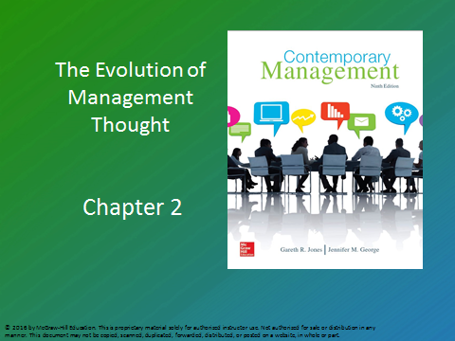  Instructor’s powerpoint slide 1  Chapter Title | 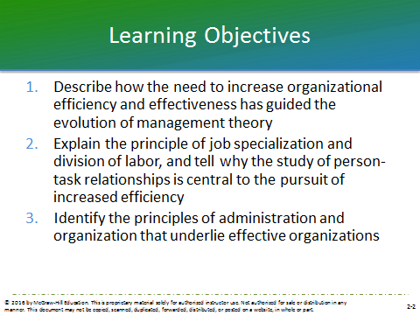  Instructor’s PowerPoint Slide 2  Learning Objectives | 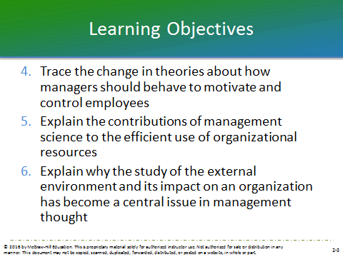  INSTRUCTOR’S pOWERPOINT SLIDE 3  Learning Objectives cont.
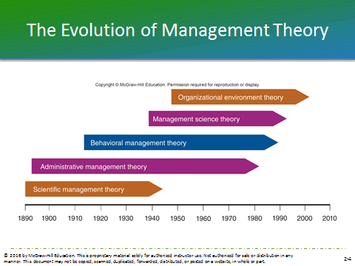  INSTRUCTOR’S POWERPOINT SLIDE 4  The Evolution of Management Theory: Figure 2.1 | 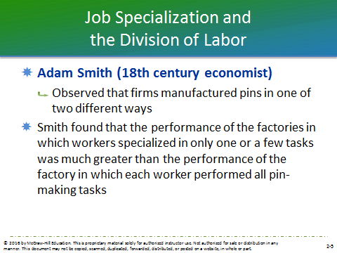  INSTRUCTOR’S POWERPOINT SLIDE 5  Adam Smith | 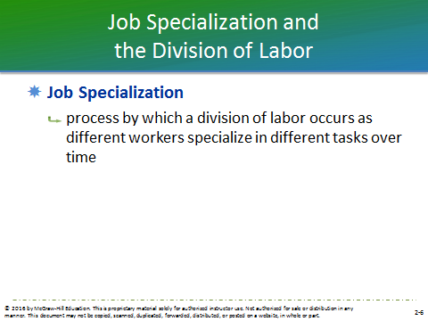  INSTRUCTOR’S POWERPOINT SLIDE 6  Job Specialization
INSTRUCTOR’S POWERPOINT SLIDE 7  Scientific Management  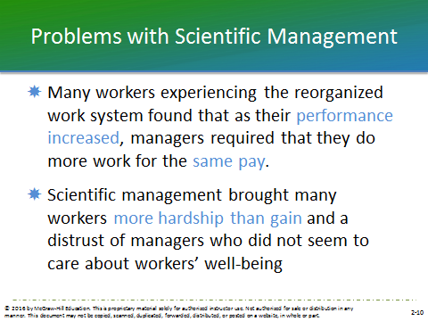  INSTRUCTOR’S  POWERPOINT SLIDE 10  Problems with Scientific Management | 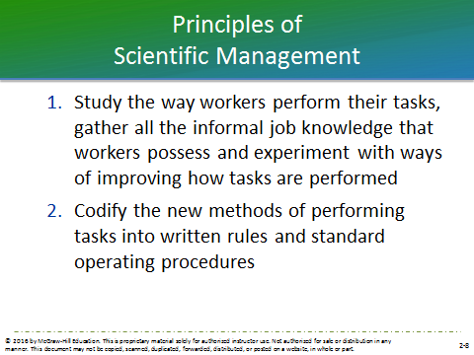  INSTRUCTOR’S POWERPOINT SLIDE 8  Principles of Scientific Management  INSTRUCTOR’S POWERPOINT SLIDE 11  The Gilbreths | 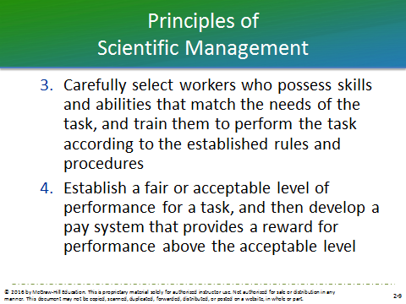  INSTRUCTOR’S POWERPOINT SLIDE 9  Principles of Scientific Management

INSTRUCTOR’S POWERPOINT SLIDE 12  Administrative Management Theory | 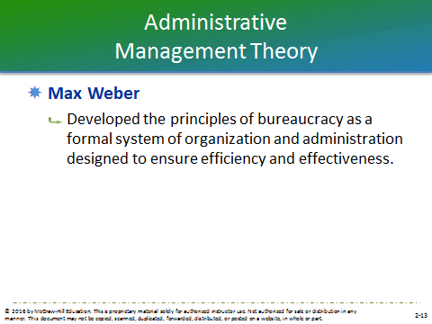  INSTRUCTOR’S POWERPOINT SLIDE 13  Max Weber | INSTRUCTOR’S POWERPOINT SLIDE 14  Weber’s Principles of Bureaucracy: Figure 2.2
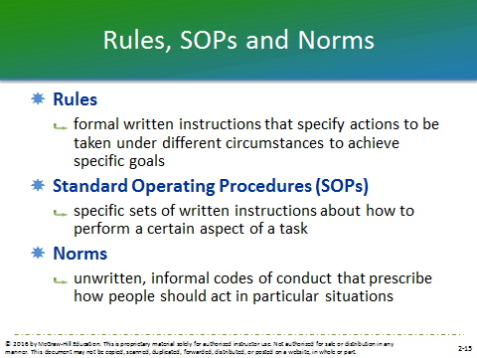  INSTRUCTOR’S POWERPOINT SLIDE 15  Rules, SOPs and Norms | INSTRUCTOR’S POWERPOINT SLIDE 16  Fayol’s Principles of Management: Division of Labor etc. | INSTRUCTOR’S POWERPOINT SLIDE 17  Fayol’s Principles of Management: Initiative etc.
INSTRUCTOR’S POWERPOINT SLIDE 18  Behavioral Management | INSTRUCTOR’S POWERPOINT SLIDE 19  Mary Parker Follett | 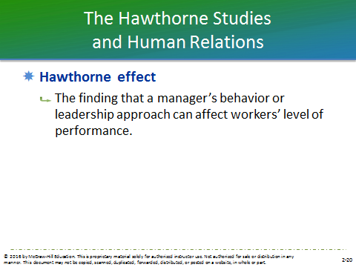  INSTRUCTOR’S POWERPOINT SLIDE 20  Hawthorne effect
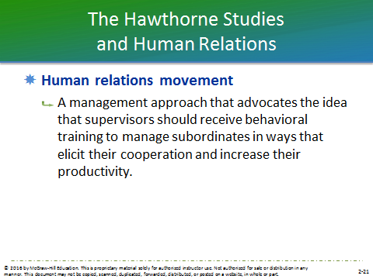  INSTRUCTOR’S POWERPOINT SLIDE 21  Human relations movement: definition | 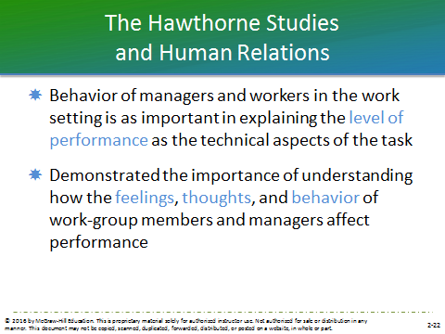  INSTRUCTOR’S POWERPOINT SLIDE 22  Behavior of managers | 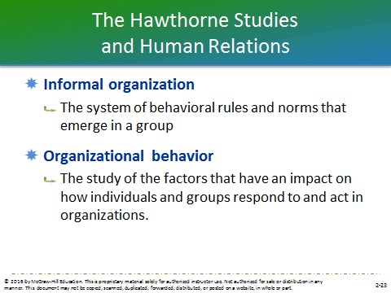  INSTRUCTOR’S POWERPOINT SLIDE 23  Informal organization and Organizational behavior
INSTRUCTOR’S POWERPOINT SLIDE 24  Theory X | INSTRUCTOR’S POWERPOINT SLIDE 25  Theory Y | INSTRUCTOR’S POWERPOINT SLIDE 26  Theory X vs. Theory Y: Figure 2.3
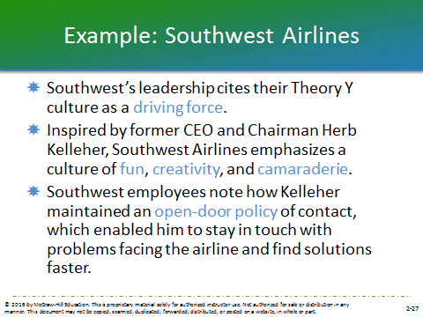  Instructor’s POWERPOINT SLIDE 27  Example—Southwest Airlines | INSTRUCTOR’S POWERPOINT SLIDE 28  Management Science Theory | INSTRUCTOR’S POWERPOINT SLIDE 29  Quantitative and Operations management
Instructor’s powerpoint slide 30  Total quality management and Management information systems | 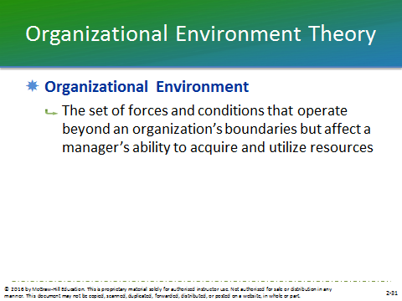  Instructor’s POWERPOINT SLIDE 31  Organizational Environment | 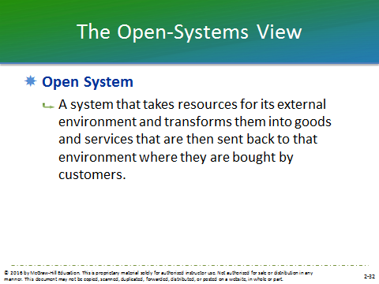  Instructor’s powerpoint slide 32  Open System: definition
Instructor’s powerpoint slide 33  The Organization as an Open System: Figure 2.4 | Instructor’s powerpoint slide 34  Input, Conversion & Output stages | 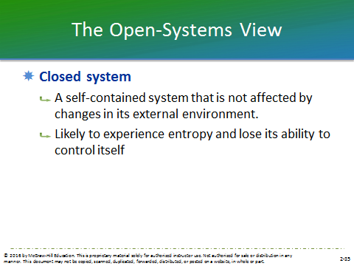  Instructor’s powerpoint slide 35  Closed system: definition
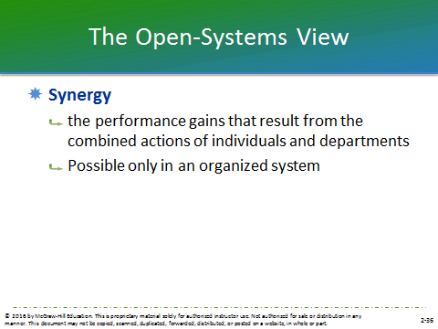  Instructor’s powerpoint slide 36  Synergy | 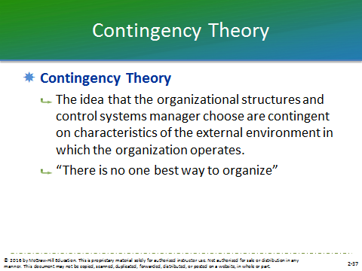  Instructor’s powerpoint slide 37  Contingency Theory | Instructor’s powerpoint slide 38  Contingency Theory: Figure 2.5
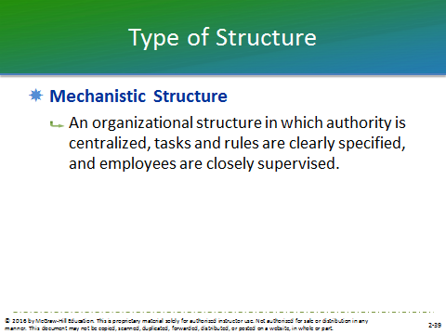  Instructor’s powerpoint slide 39  Mechanistic Structure | 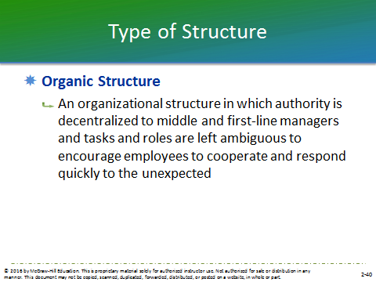  Instructor’s powerpoint slide 40  Organic Structure | 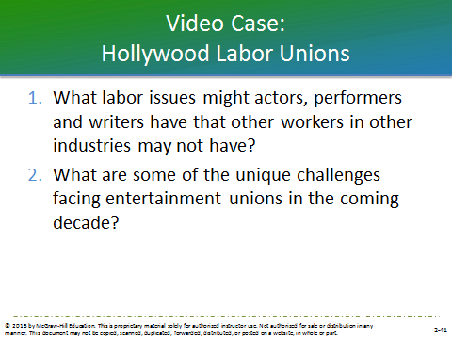  instructor’s powerpoint slide 41  Video Case: Hollywood Labor Unions

