# 

# CHAPTER 2. THE JUDICIAL SYSTEM AND ALTERNATIVE DISPUTE RESOLUTION

**Chapter** **Topics**

Introduction

Development of the Law Courts

The Structure of the Judicial System

The Judicial System in Action

Administrative Tribunals

Alternative Dispute Resolution (ADR)

The Legal Profession

The Role of the Legal Profession

Summary

Key Terms

Review Questions

Mini-Case Problems

**Chapter Objectives**

Knowing where and how to enforce rights and obligations is a key business

survival skill. After study of this chapter, students should be able to:

• Describe the development, content and structure of the judicial system.

• Explain the sequence of steps in court procedure, particularly civil court

procedure.

• Identify how and why alternative dispute resolution may be the best

option for the settlement of business disputes.

• Explain the role of barristers and solicitors, the range of services provided

by the legal profession, and the concept and limitations of court costs.

CHAPTER COMMENTARY

Chapter 2 represents a continuation of the material contained in the previous chapter, but focuses upon the administration of the law. The text material includes the structure of the courts in Canada, and as a class exercise, it might be useful to carry simple criminal and civil actions (based upon easily understood incidents) through the various steps and appeals to their final resolution at the highest appeal levels. In this fashion, the text material may be re‑enforced, and the various limitations on appeal, etc., noted in the process.

The distinction between criminal and civil proceedings should be emphasized, as experience has indicated that students frequently fail to realize that an incident which gives rise to both civil and criminal proceedings (such as a "criminal negligence" incident) would follow two separate legal paths, one dealing with the criminal act, and the second, dealing with the civil aspect.

Some time should be given to the procedure by which judgments of lower courts may be appealed. The conditions under which a judgment may be appealed should be stressed (error of law, rejection of important evidence in reaching a decision, etc.) and the appeal routes examined for both civil and criminal cases. These are depicted on the charts which follow.

Since alternate dispute resolution (ADR) is considered by many business firms as a more efficient system of resolving disputes, the topic should be opened for class discussion as an alternative to the court system. Discussion should note the particular advantages of ADR over the court system (speed of resolution, lower costs, etc.) but it should also be noted that certain kinds of disputes still lend themselves to court resolution.

## Review Questions

1. Why is arbitration sometimes a more attractive means of settling contract disputes between business persons?

**Answer:** Arbitration is a confidential process as well as a relatively low cost and efficient process for resolving disputes. Often business people do not wish to destroy a business relationship if a dispute arises, and arbitration will often allow them to obtain an answer or solution to their problem that will allow them to continue to do business with each other.

1. Discuss the importance of an independent judiciary.

**Answer**: Important because:

(a) not open to manipulation by political action.

(b) free to resolve differences between individuals without fear of the consequences.

(c) able to determine differences between governments without concern that the powers of the court will be attacked.

1. permanent body to administer the law is vital in order to maintain continuity and confidence in the system.
2. "independence" generally equated to "fairness".
3. If a provincial government should pass a law which prohibits any person from expressing any criticism of any elected government official on penalty of imprisonment, how might the law itself be challenged?

**Answer**: A person accused may ask the court to review the law in the light of the Charter of Rights and Freedoms or the jurisdiction of the province to make such a law. The court will then determine if the law is enforceable.

1. Explain the differences between a Small Claims Court and a Magistrate's Court.

**Answer:** A Small Claims Court deals with civil disputes between individuals where the monetary amount is small (limit varies from province to province, $3,000 - $10,000, and in some, up to $25,000). Magistrate's Court is a court which enforces by-laws, provincial statutes and the Criminal Code (except for the more serious offences). It does not deal with civil disputes.

1. On what basis is it possible to justify the right of the court to declare unconstitutional legislation enacted by a legislature?

**Answer**: The right may be justified because the court represents an independent, permanent body that is made up of persons with the expertise to interpret the constitution and to oversee its application. No political body is able to do so in an unbiased or fair manner.

1. How does a criminal case differ from a civil action?

**Answer**:

**Criminal**:

‑ Crown brings the charge against the accused. A two‑step process in many cases: (1) preliminary hearing, (2) full hearing.

‑ Crown obliged to prove the particular offence was committed by the accused, and that the offence is one which is set out in the criminal code.

‑ Crown must prove act, identity, and intent to commit the offence (subject to certain exceptions).

‑ must prove its case beyond any reasonable doubt in order to obtain a conviction.

**Civil**:

‑ the party who alleges a violation of his or her rights brings the action.

‑ onus of proof of facts alleged rests on the plaintiff.

‑ case is outlined through "pleadings".

‑ plaintiff not subject to the higher standard of proof of criminal courts.

1. In criminal proceedings, what obligation rests on the Crown in order to obtain a conviction?

**Answer**: Crown must normally prove beyond any reasonable doubt that the accused committed the particular offence, intended to commit it, and was the person who committed it.

1. What is the purpose of "pleadings" in a civil case?

**Answer**: The purpose of pleadings in a civil action is to set out the facts of the case and the issues in dispute in sufficient detail to enable each party to know the matters in dispute and prepare their respective cases for the trial. They avoid surprise at trial, and minimize the time required by the courts to dispose of the case.

1. How does "direct" evidence differ from "opinion" evidence? How do these types of evidence differ from "hearsay" evidence?

**Answer**: "Direct" evidence is given by ordinary witnesses who testify as to what they heard, saw, or did. "Opinion" evidence is evidence given by experts who have special knowledge about the subject matter of the evidence, and who express an opinion about the matter based upon their specialized knowledge or expertise.

Hearsay evidence is neither direct nor expert evidence, but evidence given by a third party who was informed by someone else (usually a person who would normally be an ordinary witness) of the facts. Hearsay evidence is usually not admissible in a court of law.

1. Describe the role performed by legal counsel in the administration of justice.

**Answer**: Legal Counsel are learned in the law and advise others of their legal rights and duties. They also carry out on behalf of their clients the job of processing an action through the courts or negotiating legal matters on their behalf.

1. Distinguish between a "barrister" and a "solicitor".

**Answer**: A barrister is a lawyer who handles litigation matters on behalf of clients. A

“court‑room” lawyer. A solicitor advises clients of their legal rights and duties, and normally prepares

contracts, deeds, wills, and other legal documents for clients.

1. On what basis might an appeal be allowed from a judgment of a court of original jurisdiction?

**Answer**: An appeal may be allowed where the judge improperly applied the law, (improperly instructed the jury as to the law) or made an error in rendering a decision.

1. Where a judgment is reviewed by a Court of Appeal, what type of decision might the court make?

**Answer**: A Court of Appeal may:

(1) reverse the decision, if the trial judge erred.

(2) affirm the decision of the trial judge, or

(3) send the matter back to the lower court for a new trial.

1. What is a court of original jurisdiction? How does it differ from a court of appeal?

**Answer**: A court of original jurisdiction (sometimes referred to a court of first instance) is a court where a case is heard for the first time. A court of appeal is a court which reviews the decision of the court of original jurisdiction to make certain that the judgment was fairly and properly made.

1. How does arbitration differ from a court action?

**Answer:** Arbitration is conducted much like a court action, but in a much less formal setting. While the rules of evidence and procedure are usually followed, the process generally does not require pleadings or discovery. The parties are usually responsible for the selection of the arbitrator, and the arbitrator’s fees. The hearing does not involve ‘court costs’.

1. Explain the nature of mediation, and how it is used in the resolution of disputes.

**Answer:** Mediation is an attempt to resolve a dispute between parties prior to formal court or arbitration proceedings by a third party through a discussion process. A mediator has no authority to impose a dispute by suggesting ways in which the parties may reach agreement on a solution to their problem.

1. "In a free and democratic society, the courts perform the important role of guardians of the rights and freedoms of the individual. While important, this is far from being the only part they play in society." How do the courts perform this important role? What other functions do they have in society?

**Answer:** Courts guard the rights and freedoms of the individual by acting as the medium through which rights and duties are determined and enforced. They also act as a "check" on government action which might improperly encroach on the rights and freedoms of individuals protected by the Charter. Finally, they preserve peace and order by providing an obligatory process for dispute resolution (replacing vengeance).

## Mini-Case Problems

1. Michael, an otherwise well-behaved boy of 11, fell in with Gavin, 13, a repeat offender as a delinquent. The boys were arrested by police while spray painting a school and breaking into a portable outside classroom. Under the provisions of the *Youth Criminal Justice Act*, there was no public disclosure of their names, and the Youth Court proceedings were sealed from public scrutiny now and future.

Are the provisions of the law appropriate for both boys?

Whether yes or no, explain why.

**Answer:**

The fact situation calls for a reasoned opinion, rather than a yes or no answer. In most

instances students will provide an answer that in some measure provides a reflection of their

personal values, as well as their perception of the criminal justice system.

2. Anne is unsuccessful in her suit at trial and on appeal to the provincial appeal court. If she wishes to proceed, where must she go, and what burden will she face before her case will be heard again? What factors may prevent her case from being heard again?

**Answer:**

The only remaining route of appeal for Anne is to the Supreme Court of Canada,

however this appeal is not a matter of right. She faces the burden of being successful in

seeking “leave to appeal” before she can have her case presented. The Supreme Court of

Canada could give leave to hear any case it wishes, however it is doubtful that it will do

so unless it is in the public interest, and/or commonly, any of the following: errors at

appeal are evident such that a denial of fundamental justice would otherwise take place,

a significant Charter or other constitutional determination is at stake, or the lower ruling

employs outdated Common Law in need of reform.

3. Carlson invented a new valve for natural gas pipelines, and sold his drawings to Pipeco, a manufacturer of such items. A dispute arose before production began, and both parties immediately agreed to ADR. What would lie behind this mutual aversion to court proceedings?

**Answer:**

The most likely reasons behind the selection of ADR in this case are (in order of importance):

(a) **Secrecy** – the invention is new, which may have great value from a competitive standpoint.

(b) **Speed** – production is likely set up already and any delay is expensive.

(c) **Cost** – a cheaper proceeding producing a better result is in the interest of both parties.

## Case Problems for Discussion

Case 1

A backhoe owned by Digger Ltd. was involved in the trenching for a water pipeline located along a city sidewalk. In moving a bucketful of rock into a waiting truck, the backhoe operator accidentally struck and cut an overhead power line. The cut power line fell to the sidewalk, injuring and electrocuting a pedestrian who had been observing the trenching. The pedestrian required extensive hospitalization and reconstructive surgery, and later commenced legal proceedings against Digger for the injuries suffered, including six month’s lost wages while hospitalized.

Outline the various steps the parties to the action would take to bring the case to trial, and briefly describe the trial process.

**Answer:**

The case is quite straightforward, and students should not be thrown off by the causal chain of backhoe, power line and passer-by. Although students have not yet been exposed to the principles of negligence law, most will recognize the duty, breach, damage elements of this incident and as something more than a simple and blameless accident. As to the substance of the question, the stages by which the case will be brought to trial, and the trial process itself, are described the sections entitled “Civil Courts” and “Civil Court Procedure”.

Case 2

As the Head of Information Systems at Equity Brokerage, you maintain the computer systems which support all aspects of stock trading accounts at Equity, including access for trading purposes. Your firm is being sued by a customer who alleges trading irregularities occurred on her account. When you testify at trial as to the identity of the person who conducted the transactions and the actions that affected the status of the account, what kind of witness are you, and what kind of evidence are you providing?

**Answer:**

Despite having some particular expertise, the witness would be considered to be only an “ordinary witness”. As an employee of the defendant firm, the witness lacks the independence of opinion that is usually one of the hallmarks of most “expert witnesses”. As the witness has direct knowledge of the events (regarding the computer system itself), the witness is giving “direct” evidence rather than “hearsay”.

Case 3

Farhan is personally injured and his home is badly burned by a toaster oven that, on first use, burst into flame. With Farhan successful in an action for damages, what factors should a judge take into consideration in determining the issue of costs?

**Answer:**

The issue of an award of costs is covered in the section entitled “Court Costs”. The judge would take into account the behaviour of the parties, especially the defendant, in forcing the case to a judicial hearing. While there may be genuine issues for trial, including the amount of damages claimed, the judge will be concerned as to whether the defendant manufacturer was simply attempting to stall or bankrupt Farhan, thus perverting justice rather than seeking it. Such efforts will be penalized in costs, in addition to disposing the court toward generosity in the award in the first place.

CHAPTER CHARTS

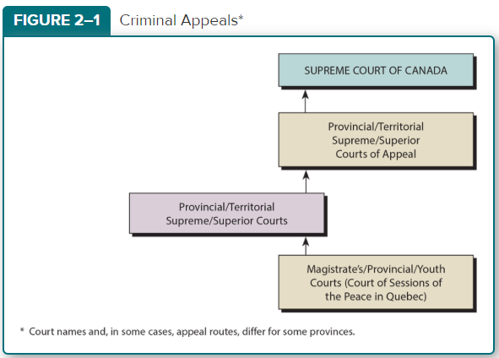

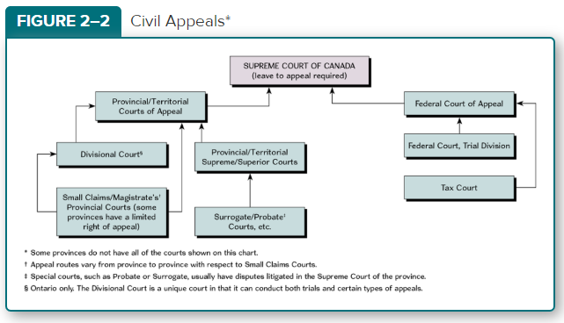

**Table 2–1**

**Trial Level**

|  |
| --- |
|  |
| **Jurisdiction** | **Designation of Court** |
| Alberta | Court of Queen’s Bench of Alberta |
| British Columbia | Supreme Court of British Columbia |
| Manitoba | Court of Queen’s Bench of Manitoba |
| New Brunswick | Court of Queen’s Bench of New Brunswick |
| Newfoundland & Labrador | Supreme Court of Newfoundland & Labrador (Trial Division) |
| Northwest Territories | Supreme Court of the Northwest Territories |
| Nova Scotia | Supreme Court of Nova Scotia |
| Nunavut | Nunavut Court of Justice |
| Ontario | Superior Court of Justice |
| Prince Edward Island | Supreme Court of Prince Edward Island |
| Quebec | Superior Court of Quebec |
| Saskatchewan | Court of Queen’s Bench for Saskatchewan |
| Yukon Territory | Supreme Court of Yukon |
| **Appeal Level** | **Designation of Court** |
| Alberta | Court of Appeal of Alberta |
| British Columbia | British Columbia Court of Appeal |
| Manitoba | Manitoba Court of Appeal |
| New Brunswick | Court of Appeal of New Brunswick |
| Newfoundland & Labrador | Supreme Court of Newfoundland & Labrador (Court of Appeal) |
| Northwest Territories | Court of Appeal for the Northwest Territories |
| Nova Scotia | Court of Appeal for Nova Scotia |
| Nunavut | Nunavut Court of Appeal |
| Ontario | Court of Appeal for Ontario |
| Prince Edward Island | Court of Appeal of Prince Edward Island |
| Quebec | Court of Appeal of Quebec |
| Saskatchewan | Court of Appeal for Saskatchewan |
| Yukon Territory | Court of Appeal of Yukon |