CHAPTER
2

Newton’s Laws of Motion

2.1 Newton’s First Law of Motion
The Moving Earth
2.2 Newton’s Second Law of Motion
When Acceleration Is g—Free Fall
When Acceleration Is Less than g—Non-Free Fall
2.3 Forces and Interactions
2.4 Newton’s Third Law of Motion
Action and Reaction on Different Masses
Defining Your System
2.5 Summary of Newton’s Three Laws
Isaac Newton Biography
Demonstration Equipment
- Spring balance and wood block (that you’ll pull across the table at constant speed)
- Iron ball, about 1 kilogram, with hooks for attached strings (mass versus weight demo)
- Hammer and heavy weight (or sledge hammer and blacksmith anvil) for inertia demo

This is a central chapter—the backbone of classical mechanics. The concept of inertia has already been introduced, so you begin here with more illustrations of the same concept under the banner of Newton’s first law. The second and third follow, and the chapter concludes with a treatment of vectors. This is a heavy chapter that needs time and care.
As a matter of interest and class discussion, note the wingsuit flyer in Figure 2.11. This new form of recreation follows hang gliding, which in turn followed the NASA Moon landings. Wouldn’t one expect a reversed sequence: people first emulating flying squirrels, then advancing to hang gliding, and then a giant step later, to rocketing to the Moon and back?

In the Practice Book:
- Newton’s First Law and Friction
- Non-Accelerated and Accelerated Motion
- A Day at the Races with Newton’s Second Law: a = F/m
- Dropping Masses and Accelerating Cart
- Bronco and the Second Law
- Newton’s Third Law
- Nellie and Newton’s Third Law

Next-Time Questions on the IRDVD:
- Balanced Scale
- Apple on a Table
- Tug-of-War
- Leaning Tower of Pisa Drop
- Atwood Pulley
- Nellie Suspended by Ropes
- Acceleration on the Way Up;
- Reaction Forces
- Scale Reading
- Tug-of-War 2
- Apple on Table
- Airplane in the Wind
- Ball Swing
- Falling Elephant and Feather
- Spool Pull
- Skydiver
- Block Pull
- Against Wall
- Pellet in the Spiral
- Skidding Truck
- Falling Balls
- Truck and Car Collision
- Book Push
- Acceleration at the Top
- Net Force Half-Way Up

In the Lab Manual:
- Pushing Things Around
- Putting the Force Before the Cart
- The Newtonian Shot
- Force Mirror
- Blowout!

Screencasts:
- Newton’s First Law of Motion
- Mass/Weight
- Acceleration Units
- Newton’s Second Law
- Skydiver Problem
- Newton’s Third Law
- Newton’s Laws Problem
- Nellie in an Elevator
SUGGESTED PRESENTATION
Newton’s First Law of Motion—The Law of Inertia
Begin with a demonstration, such as the tablecloth pull.
DEMONSTRATION: Show that inertia refers also to objects at rest with the classic tablecloth-and-dishes demonstration. [Be sure to pull the tablecloth slightly downward so there is no upward component of force on the dishes!] I precede this demo with a simpler version, a simple block of wood on a piece of cloth—but with a twist. I ask what the block will do when I suddenly whip the cloth toward me. After a neighbor check, I surprise the class when they see that the block has been stapled to the cloth! This illustrates Newton’s zeroth law—be skeptical. Then I follow up with the classic tablecloth demo. Don’t think the classic demo is too corny, for your students will really love it. Or take a shortcut and show the YouTube video (Paul G. Hewitt).
Of course when we show a demonstration to illustrate a particular concept, there is almost always more than one concept involved. The tablecloth demo is no exception, which also illustrates impulse and momentum (Chapter 3). The plates experience two impulses: friction between the cloth and the dishes, and friction between the sliding dishes and the table. The first impulse moves the dishes slightly toward you. It is brief and very little momentum builds up. Once the dishes are no longer on the cloth, the second impulse acts in a direction away from you and prevents continued sliding toward you, bringing the dishes to rest. Done quickly, the brief displacement of the dishes is hardly noticed. Is inertia really at work here? Yes, for if there were no friction in the demo, the dishes would strictly remain at rest.
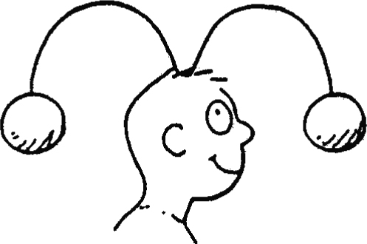
DEMONSTRATION: Continuing with inertia, do as Jim Szeszol does and fashion a wire coat hanger into an “m” shape as shown. Two globs of clay are stuck to each end. Balance it on your head, with one glob in front of your face. State you wish to view the other blob and ask how you can do so without touching the apparatus. Then simply turn around and look at it. It’s like rotating the bowl of soup only to find the soup remains put. Inertia in action! (Of course, like the tablecloth demo, there is more physics here than inertia; this demo can also be used to illustrate rotational inertia and the conservation of angular momentum.)
A useful way to impart the idea of mass and inertia is to place two objects, say a pencil and a piece of chalk, in the hands of a student and ask for a judgment of which is heavier. The student will likely respond by shaking them, one in each hand. Point out that in so doing the student is really comparing their inertias, and is making use of the intuitive knowledge that weight and inertia are directly proportional to each other.
CHECK YOUR NEIGHBOR: How does the law of inertia account for removing dirt from your shoes by stamping on the porch before entering a house, or snow from your shoes by doing the same? Or removing dust from a coat by shaking it?
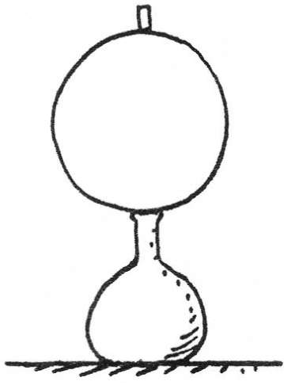
DEMONSTRATION: Do as Marshall Ellenstein does and place a metal hoop atop a narrow jar. On top of the hoop balance a piece of chalk. Then whisk the hoop away and the chalk falls neatly into the narrow opening. The key here is grabbing the hoop on the inside, on the side farthest from your sweep. This elongates the hoop horizontally and the part that supports the chalk drops from beneath the chalk. (If you grab the hoop on the nearer side, the elongation will be vertical and pop the chalk up into the air!)
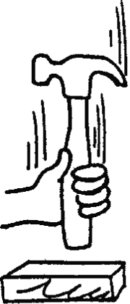
DEMONSTRATION: Lie on your back and have an assistant place a blacksmith’s anvil on your stomach. Have the assistant strike the anvil rather hard with a sledge hammer. The principles here are the same as the ball and string demo. Both the inertia of the ball and the inertia of the anvil resist the changes in motion they would otherwise undergo. So the string doesn’t break, and your body is not squashed. (Be sure that your assistant is skillful with the hammer. When I began teaching I used to trust students to the task. In my fourth year the student who volunteered was extra nervous in front of the class and missed the anvil entirely—but not me. The hammer smashed into my hand breaking two fingers. I was lucky I was not seriously injured.)
Relate the idea of tightening a hammerhead by slamming the opposite end of the handle on a firm surface to the bones of the human spine after jogging or even walking around. Interestingly, we are similarly a bit shorter at night. Ask your students to find a place in their homes that they can’t quite reach before going to bed—a place that is one or two centimeters higher than their reach. Then tell them to try again when they awake the next morning. Unforgettable, for you are likely instructing them to discover something about themselves they were not aware of!
The Moving Earth
Stand facing a wall and jump up. Then ask why the wall does not smash into you as the Earth rotates under you while you’re airborne. Relate this to the idea of a helicopter ascending over San Francisco, waiting motionless for 3 hours and waiting until Washington, D.C. appears below, then descending. Hooray, this would be a neat way to fly cross-country! Except, of course, for the fact that the “stationary” helicopter remains in motion with the ground below. “Stationary” relative to the stars means it would have to fly as fast as the Earth turns (what jets attempt to do!).
Acceleration Relates to Force
Acceleration was introduced in the previous chapter, and polished a bit with the falling speedometers, al la the Practice Book. Now we move on to the cause of acceleration—force. State that acceleration is produced by an imposed force. Write this as a ~ F and give examples of doubling the force and the resulting doubling of the acceleration, etc. Introduce the idea of net force, with appropriate examples—like applying twice the force to a stalled car gives it twice as much acceleration—three times the force, three times the acceleration.
Newton’s Second Law Links Force, Acceleration, and Mass
Point out that although Galileo introduced the idea of inertia, discussed the role of forces, and defined acceleration, he never made the connections to these ideas as Newton did with his second law. Although Galileo is credited as the first to demonstrate that in the absence of air resistance, falling objects fall with equal accelerations, he was unable to say why this is so. The answer is given by Newton’s 2nd law.
Newton’s Second Law Links Force, Acceleration, and Mass
Point out that although Galileo introduced the idea of inertia and defined acceleration, he never made the connections of these ideas to the concept of force as Newton did with his second law. Although Galileo is credited as the first to demonstrate that in the absence of air resistance, falling objects fall with equal accelerations, he was unable to say why this is so. The answer is given by Newton’s 2nd law.
SKIT: Hold a heavy object like a kilogram weight and a piece of chalk with outstretched hands, ready to drop them. Ask your class which will strike the ground first if you drop them simultaneously. They know. Ask them to imagine you ask the same of a bright child, who responds by asking to handle the two objects before giving an answer. Pretend you are the child judging the lifting of the two objects. “The metal object is heavier than the chalk, which means there is more gravity force acting on it, which means it will accelerate to the ground before the chalk does.” Write the child’s argument in symbol notation on the board, a ~ F. Then go through the motions of asking the same of another child, who responds with a good argument that takes inertia rather than weight into account. This child says, after shaking the metal and chalk back-and-forth in his or her hands, “The piece of metal is more massive than the chalk, which means it has more inertia than the chalk, which means it will be harder to get moving than the chalk. So the chalk will race to the ground first, while the inertia of the metal causes it to lag behind.” Write this kid’s argument with, a ~1/m. State that the beauty of science is that such speculations can be ascertained by experiment. Drop the weight and the chalk to show that however sound each child’s argument seemed to be, the results do not support either. Then bring both arguments together with a ~F/m, Newton’s 2nd law.
CHECK YOUR NEIGHBOR: (similar to one in the text): Suppose in a high-flying airplane the captain announces over the cabin public address system that the plane is flying at a constant 900 km/h and the thrust of the engines is a constant 80,000 newtons. What is the acceleration of the airplane? [Answer: Zero, because velocity is constant.] What is the combined force of air resistance that acts all over the plane’s outside surface? [Answer: 80,000 N. If it were less, the plane would speed up; if it were more, the plane would slow down.]
Page 5 in the Practice Book Conceptual Physical Science, nicely treats friction in some detail.
Objects in Free Fall Have Equal Acceleration
The falling speedometers of Figure 1.23 of the previous chapter show that acceleration of free fall is constant. Speed picks up, and distance of fall increases, but acceleration remains a constant
10 m/s². Newton’s 2nd law provides the explanation. This is importantly illustrated in the falling bricks and feathers of Figures 2.9 and 2.10. Emphasize these!
Acceleration of Fall Is Less When Air Resistance Acts
DEMONSTRATION: After you have made clear the cases with no friction, then make a transition to practical examples that involve friction—leading off with the dropping of sheets of paper, one crumpled and one flat. Point out that the masses and weights are the same, and the only variable is air resistance. Bring in the idea of net force again, asking what the net force is when the paper falls at constant speed. (Consider doing Activity 34 at the end of the chapter as a follow-up demo here.)
CHECK YOUR NEIGHBOR: What is the acceleration of a feather that “floats” slowly to the ground? The net force acting on the feather? If the feather weighs 0.01 N, how much air resistance acts upward against it?
These questions lead into a discussion of the parachutists, as treated in the Practice Book, page 11. It also leads to a discussion of wingsuit flying, as shown in Figure 2.11.
For your information, the terminal velocity of a falling baseball is about 150 km/h (95 mi/h), and for a falling Ping-Pong ball about 32 km/h (20 mi/h).
So far we have regarded a force as a push or a pull. We will now consider a broader definition of force.
A Force Is Part of an Interaction
Hold a piece of tissue paper at arm’s length and ask if the heavyweight champion of the world could hit the paper with 50 pounds of force. Ask your class to check their answer with their neighbors. Then don’t give your answer. Instead, continue with your lecture.
Reach out to your class and state, “I can’t touch you, without you touching me in return—I can’t nudge this chair without the chair in turn nudging me—I can’t exert a force on a body without that body in turn exerting a force on me.” In all these cases of contact there is a single interaction between two things—contact requires a pair of forces, whether they be slight nudges or great impacts, between two things. This is Newton’s 3rd law of motion. Call attention to the examples of Figure 2.19.
Newton’s Third Law—Action and Reaction
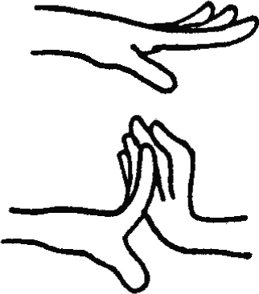
Extend your arm horizontally and show the class that you can bend your fingers upward only very little. Show that if you push with your other hand, and thereby apply a force to them, or have a student do the same, they will bend appreciably more. Then walk over to the wall and show that the inanimate wall does the same (as you push against the wall). State that everybody will acknowledge that you are pushing on the wall, but only a few realize the fundamental fact that the wall is simultaneously pushing on you also—as evidenced by your bent fingers!
CHECK YOUR NEIGHBOR: Identify the action and reaction forces for the case of a bat striking the ball. [Ball strikes bat.]
Simple Rule Distinguishes Action and Reaction
When body A acts on body B, body B reacts on body A. It makes no difference which is called action and which is called reaction. Figure 2.19 captures the essence.
Discuss walking on the floor in terms of the single interaction between you and the floor, and the pair of action and reaction forces that comprise this interaction. Contrast this to walking on frictionless ice, where no interaction occurs. Ask how one could leave a pond of frictionless ice. Make the answer easy by saying one has a massive brick in hand. By throwing the brick there is an interaction between the thrower and the brick. The reaction to the force on the brick, the recoiling force, sends one to shore. Or without such a convenient brick, one has clothing. Or if no clothing, one has air in the lungs. One could blow air in jet fashion. Exhale with the mouth facing away from shore, but be sure to inhale with the mouth facing toward shore.
CHECK YOUR NEIGHBOR: Identify the force that pushes a car along the road. [Interestingly enough, the force that pushes cars is provided by the road. Why? The tires push on the road (action) and the road pushes on the tires (reaction). So roads push cars along. A somewhat different viewpoint! A photo of road bricks displaced by auto traffic is in Exercise 117.]
Action and Reaction on Objects of Different Masses
Most people say that the Moon is attracted to the Earth by gravity. Ask most people if the Earth is also attracted to the Moon, and if so, which pulls harder, the Earth or the Moon? You’ll get mixed answers. Physicists think differently than most people on this topic: Rather than saying the Moon is attracted to the Earth by gravity, a physicist would say there is an attractive force between the Earth and the Moon. There is an important difference here.
Asking if the Moon pulls as hard on the Earth as the Earth pulls on the Moon is similar to asking if the distance between New York and Los Angeles is the same as the distance between Los Angeles and New York. Rather than thinking in terms of two distances, we think of a single distance between New York and Los Angeles. Likewise there is a single gravitational interaction between the Earth and the Moon.
Action and Reaction Forces Act on Different Objects
Show your outstretched hand where you have a stretched rubber band between your thumb and forefinger. Ask which is pulling with the greater force, the thumb or the finger. Or, as you increase the stretch, which is being pulled with more force toward the other—the thumb toward the finger or the finger toward the thumb. After neighbor discussion, stress the single interaction between things that pull on each other. The Earth and the Moon are each pulling on each other. Their pulls on each other comprise a single interaction. This point of view makes a moot point of deciding which exerts the greater force, the Moon on the Earth or the Earth on the Moon, or the ball on the bat or the bat on the ball, et cetera. Pass a box of rubber bands to your class and have them do it.
DEMONSTRATION: Tug-of-war in class. Have a team of women engage in a tug-of-war with a team of men. If you do this on a smooth floor, with men wearing socks and women wearing rubber-soled shoes, the women will win. The team who wins in this game is the team who pushes harder on the floor.
Discuss the firing of a cannonball from a cannon, as treated in the chapter. Illustrate Newton’s 3rd law with a skit about a man who is given one last wish before being shot, who states that his crime demands more punishment than being struck by a tiny bullet, who wishes instead that the mass of the bullet match the magnitude of his crime (being rational in a rigid totalitarian society), that the mass of the bullet be much much more massive than the gun from which it is fired—and that his antagonist pull the trigger!
Action and reaction are nicely illustrated with airplane flight. When a plane’s propeller or jet engine pushes air backward, that air pushes the plane forward just as a rocket’s exhaust does. Likewise for the forward thrust given to a swimmer by the water she pushes backward. A plane’s lift is mostly due to its wings’ tilt (angle of attack), which deflects air downward, so that air’s reaction force pushes the wing upward. Spinning helicopter blades provide lift in the same way.
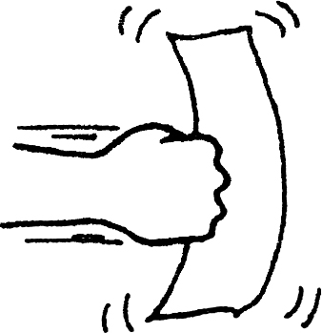
Return to your question about whether a heavyweight boxer could hit a piece of tissue paper with a force of 50 pounds or so. Now your class understands (hopefully) that the fist can’t produce any more force on the paper than the paper exerts on the fist. The paper doesn’t have enough mass to do this, so the answer is no. The fighter can’t hit the paper any harder than the paper can hit in return. Consider solving Problem 12 in the end matter here.
Importance of Identifying Systems
Much of the confusion of Newton’s 3rd law has to do with failure to define a system. This is covered at length in Figures 2.24–2.27 in the text (the apple and orange). In the system of only the cart, there is a net force—the one provided by the pull of the apple minus the small friction of the wheels on the ground.
In the system of only the apple, the net force is the ground pushing on it minus the reaction pull by the cart. In the system of the orange-apple, the net force is that of the ground pushing on the apple. This point is worth developing.
Consider the three systems below: pool ball A, pool ball B, and balls A + B. Only in the two-ball system, A + B, is the net force zero.
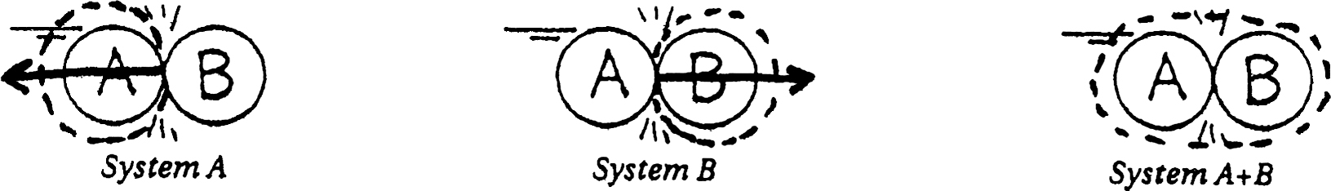
Forces at an Angle
Again, the Practice Book nicely develops force vectors. As a demonstration, support a heavy weight with a pair of scales as shown. Show that as the angles between supporting strings are wider, the tensions increase. This explains why one can safely hang from a couple of strands of vertical clothesline, but can’t when the clothesline is horizontally strung. Interesting stuff, which in the interest of “Information Overload” is not covered in the chapter.
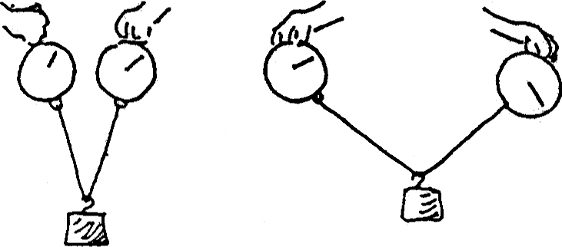
Tell your students that humankind struggled for nearly 2000 years in developing the ideas of this chapter. With this in mind, remind them that they should be patient with themselves if it takes a few days or weeks to achieve as much.
