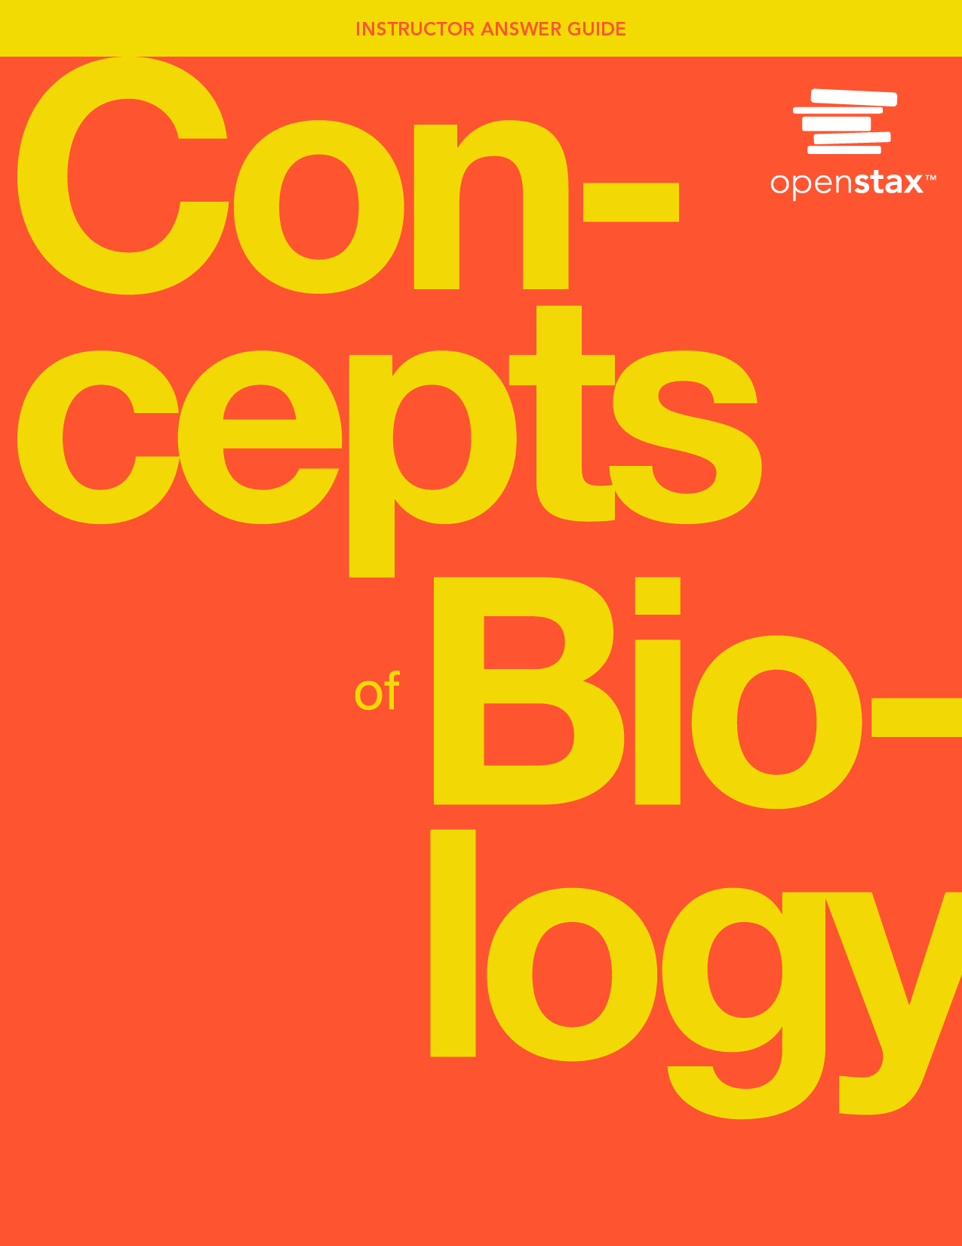

***Concepts of Biology***

**Unit 1. The Cellular Foundation of Life**

**Chapter 1: Introduction to Biology**

**Art Connection Questions**

1. Figure 1.8

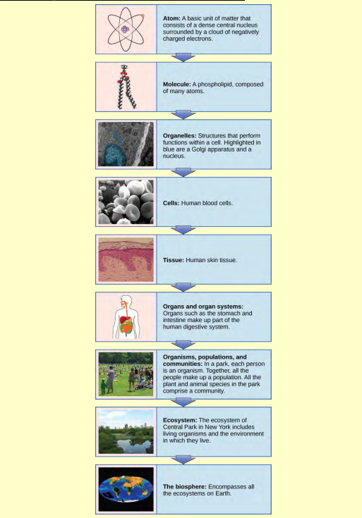

Which of the following statements is false?

A. Tissues exist within organs which exist within organ systems.

B. Communities exist within populations which exist within ecosystems.

C. Organelles exist within cells which exist within tissues.

D. Communities exist within ecosystems which exist in the biosphere.

Answer

B. Communities exist within populations which exist within ecosystems.

2. Figure 1.18

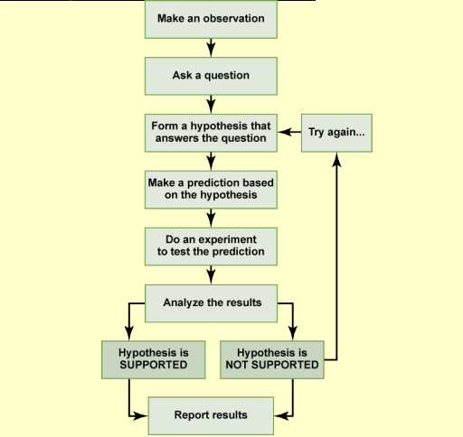

In the example below, the scientific method is used to solve an everyday problem. Which part in the example below is the hypothesis? Which is the prediction? Based on the results of the experiment, is the hypothesis supported? If it is not supported, propose some alternative hypotheses.

1. My toaster doesn’t toast my bread.

2. Why doesn’t my toaster work?

3. There is something wrong with the electrical outlet.

4. If something is wrong with the outlet, my coffeemaker also won’t work when plugged into it. 5. I plug my coffeemaker into the outlet.

6. My coffeemaker works.

Answer

The hypothesis is #3 (there is something wrong with the electrical outlet), and the prediction is #4 (if something is wrong with the outlet, then the coffeemaker also won’t work when plugged into the outlet). The original hypothesis is not supported, as the coffee maker works when plugged into the outlet. Alternative hypotheses may include (1) the toaster might be broken or (2) the toaster wasn’t turned on

**Review Questions**

3. The smallest unit of biological structure that meets the functional requirements of “living” is the ________.

Answer

C. cell

4. Which of the following sequences represents the hierarchy of biological organization from the most complex to the least complex level?

Answer

D. biosphere, ecosystem, community, population, organism

5. A suggested and testable explanation for an event is called a ________.

Answer

A. hypothesis

6. The type of logical thinking that uses related observations to arrive at a general conclusion is called ________.

Answer

D. inductive reasoning

**Critical Thinking Questions**

7. Using examples, explain how biology can be studied from a microscopic approach to a global approach.

Answer

Researchers can approach biology from the smallest to the largest, and everything in between. For instance, an ecologist may study a population of individuals, the population’s community, the community’s ecosystem, and the ecosystem’s part in the biosphere. When studying an individual organism, a biologist could examine the cell and its organelles, the tissues that the cells make up, the organs and their respective organ systems, and the sum total—the organism itself.

8. Give an example of how applied science has had a direct effect on your daily life.

Answer

Answers will vary. One example of how applied science has had a direct effect on daily life is the presence of vaccines. Vaccines to prevent diseases such polio, measles, tetanus, and even the influenza affect daily life by contributing to individual and societal health.