**CHAPTER 1**

**QUICKBOOKS ONLINE TEST-DRIVE**

**INSTRUCTOR’S MANUAL**

**OBJECTIVES**

1. Start the sample company, Craig’s Design and Landscaping Services.
2. Tour QuickBooks Online (QBO).
3. Explore the User Interface.
4. Export the Chart of Accounts to Excel.
5. View recent transactions and reports.
6. Create an invoice, sales receipt, bill, and write check.
7. Complete Check Your Progress.
8. Review and complete the QuickBooks Resources and Activities.
9. Complete Exercises 1-1, 1-2, 1-3, and 1-4.

[**SYSTEM REQUIREMENTS**](https://quickbooks.intuit.com/learn-support/en-us/install-or-update-products/system-requirements-for-quickbooks-online-quickbooks-online/01/188943)

To use QuickBooks Online (QBO), you need to sign in with a web browser. [The URL is <https://quickbooks.intuit.com/learn-support/en-us/install-or-update-products/system-requirements-for-quickbooks-online-quickbooks-online/01/188943>.]

**Recommended specs**

* **Windows PC:** Windows 7 or newer, Intel Core i5 or comparable processor (2015 or newer) with at least 4 GB of RAM. **Note:** You need [Adobe Reader 11.0](https://acrobat.adobe.com/us/en/acrobat/pdf-reader.html) or higher to print forms. [URL for Adobe Reader <https://acrobat.adobe.com/us/en/acrobat/pdf-reader.html>.]
* **Mac:** OS X "Panther" 10.13 or newer.
* **Internet connection:** 3 Mbps or higher.

**Note:** QuickBooks Online, QuickBooks Online Accountant, and QuickBooks Self-Employed are not compatible with Linux operating systems like Ubuntu or Fedora.

**Minimum requirements**

* **Windows PC:** Windows 7 or newer, Intel Core i3 or a comparable processor (2013 or newer) with at least 2 GB of RAM.
* **Mac:** OS X "El Capitan" 10.11 or newer.
* **Internet connection:** 1.5 Mbps.

**Supported Browsers and Mobile Browsers**

* Google Chrome, Mozilla Firefox (to preview and print forms on Mac OS, you need the Firefox PDF plugin), Microsoft Edge, Safari 11 or newer (Mac only)
* iPhone/iPad: OS 11.1 or newer, Safari browser (make sure Private Mode is off to allow cookies).
* Android smartphones and tablets: Nougat 7.1.1 or newer, Chrome browser. Also accessible via Chrome on Android and Safari on iOS.
* Microsoft Surface: Microsoft Edge.

**QBO Tips**

* Start an Internet browser. Go online to <https://qbo.intuit.com/redir/testdrive>.
* Each time your students start the sample company, Craig’s Design and Landscaping Services, security verification is required.
* Each time the sample company is started, a new session begins. Data is not saved.
* In Chapter 1, students complete Check Your Progress assignments and compare their results with the answers shown. In subsequent chapters, students provide Check Your Progress answers.
* Before students start Exercise 1-1, the authors suggest they sign out of QBO. Then, students log into a new session of QBO *before* starting Exercise 1-1. Students complete Exercise 1-1’s transactions and continue with Exercise 1-2. Students should not log out until Exercises 1-1, 1-2 are completed.

**QUICKBOOKS RESOURCES AND ACTIVITIES**

All students and professors have access to the **Online Learning Center (OLC)\*** at [www.mhhe.com/qbo3e](http://www.mhhe.com/qbo3e) which include the following.

1. Access QBO Sign Up.
2. Narrated PowerPoints.
3. Going to the Net:
4. [Move to QuickBooks Online](http://quickbooks.intuit.com/move-to-quickbooks-online/). List four similarities between QuickBooks Online and QuickBooks Desktop.

Create professional invoices, automatically schedule and send invoices, one-click sales, and tax reports, track sales and expenses. As of this writing, this comparison is shown. (Student answers may vary.)

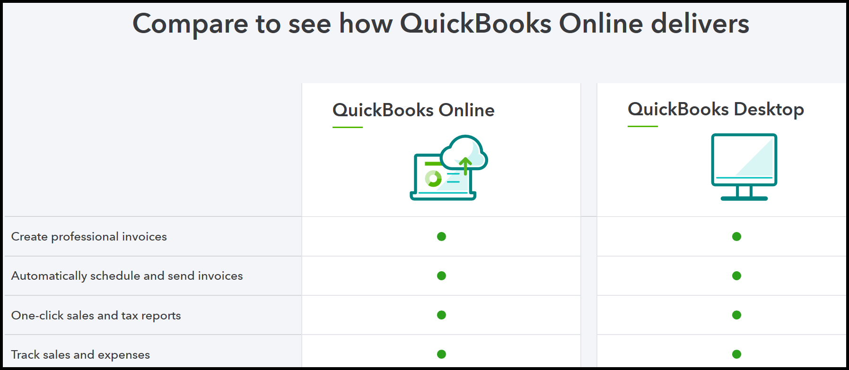

1. [Empower students with Free QuickBooks](https://www.intuit.com/partners/education-program/products/quickbooks/). Answer these questions:

How many small businesses use cloud accounting software? (As of this writing, this is the answer.)

ANSWER: 7 million (as of this writing)

1. [Top Intuit Education questions](https://www.intuit.com/partners/education-program/support/). Scroll down the page to **QuickBooks** select Expand All. Read General questions, Educator questions, and Student questions.

1. [QuickBooks Support](https://quickbooks.intuit.com/learn-support/). Type a search word, and explore the page’s topics. Describe the “Topics for” QuickBooks Online.

The Topics for QuickBooks Online are organized into these sections: Account management, Advanced accounting, Banking, Expenses and vendors, Get started, Inventory, Payroll and workers, Reports, Sales and customers, and Taxes.

1. QBO Videos: Watch these videos.
2. [QuickBooks Online for iPad](http://www.youtube.com/watch?v=6Mw5iIV53C4)
3. [How to use the QuickBooks Mobile App](https://www.youtube.com/watch?v=yAUIq-k4OdA&feature=emb_logo)
4. [Additional videos](https://quickbooks.intuit.com/learn-support/tutorials?product=QuickBooks%20Online&tutorial=get-started) – watch step-by-step videos to learn your way around QuickBooks.
5. Text Updates.

*Additional helpful resources may be added periodically.

**Connect:** If using Connect, the QuickBooks Resources and Activities can be found under Additional Student Resources (ASR) within Connect. The professor may also assign one or more of the following resources for grading within Connect.

1. Multiple-choice and true or false questions.
2. Analysis question(s).
3. Check Your Progress.
4. Chapter work and end-of-chapter exercises.
5. Problem Solving.
6. Certification Q&A.
7. OLC activities.

**INSTRUCTOR RESOURCES AND ADDITIONAL STUDENT RESOURCES**

* Instructor’s Manual for Chapters 1-12.
* Excel Reports and PDF Reports. Excel and PDF files are saved in each chapter. Refer to the **Files Saved in Chapter 1** chart on pages 12 and 13.
* Certification Information
* Instructor PowerPoints
* QBO Access, System Requirements, Technical Support, and Resources
* Syllabi
* Test Bank for Chapters 1-12
* Using Accountant Version and Certification for Professors
* Instructor preview for Connect assignments—Multiple-choice and True False quizzes, Analysis Questions, Check Your Progress, Chapter work and End-of-Chapter Exercises, Problem Solving, Certification Q&A quiz. Connect assignments are auto-graded.
* Additional Student Resources online at [www.mhhe.com/qbo3e](http://www.mhhe.com/qbo3e): Access QBO Sign Up, Narrated PowerPoints, QBO Videos, Going to the Net, Text Updates.

To access the Instructor’s Resources, contact the school’s McGraw-Hill Learning Technology Representative at <https://shop.mheducation.com/store/paris/user/findltr.html>.

**ANSWERS ANALYSIS QUESTIONS**

The Analysis questions and answers are shown below, and are included within Connect’s Instructor login. Within Connect, students’ responses are auto-graded.

1. Define the chart of accounts and its categories. How do accounting textbooks define the chart of accounts?

ANSWER:

The Chart of Accounts is a complete list of a business’s accounts and their balances. QBO includes the Account name, Type (for financial statement classification), the Detail Type (account subcategory), and Balance.

The chart of accounts includes two categories of accounts:

* ***Balance Sheet*** accounts: In QBO, these types of accounts reflect what you own and what you owe, like Bank, Credit Card, Assets, Liabilities, Accounts Receivable, Accounts Payable and Equity.
* ***Income and expense accounts***: These are categories for tracking how money flows in and out of your company.

In accounting textbooks, the term Chart of Accountsis defined as a list of all the accounts used in the General Ledger. Accounts are used to classify transaction information for reporting purposes.

1. What do you select to add account numbers to the Chart of Accounts?

ANSWER:

Adding account numbers is a two-step process.

1. Go to  > Account and Settings (*or* Company Settings) > Advanced > in the Chart of accounts area, click on the pencil icon to Enable account numbers and Show account numbers > Save > Done.

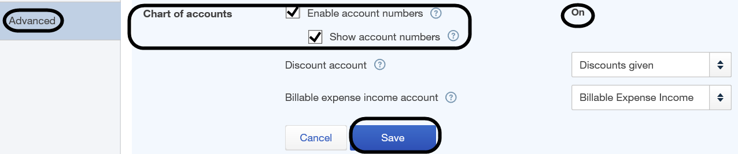

1. After saving, then selecting <Done> on the Advanced Settings page, click  > Chart of Accounts > View Register > Edit > type the account number in the Number field.
2. What numbering system is used for the Chart of Accounts? Complete the following chart.

|  |  |
| --- | --- |
| **Numbers** | **Type** |
| 1000s | Assets |
| 2000s | Liabilities |
| 3000s | Equity |
| 4000s | Income |
| 5000s | Cost of Sales |
| 6000s | Expenses |

**ANSWERS MULTIPLE-CHOICE AND TRUE FALSE QUESTIONS**

The multiple-choice and true false quizzes are within Connect. The answers are shown below and within Connect’s Instructor login. Within Connect, students’ responses are auto-graded.

1. The following Internet browsers can be used with QB Online:

a. Internet Explorer and Microsoft Edge.

b. Firefox.

c. Google Chrome.

d. Safari.

**e. All of these**.

2. To start QuickBooks Online, you need to:

a. Insert a software DVD into the drive.

b. Go to your hard drive to install software.

c. Insert a USB flash drive.

**d. Start your Internet browser.**

e. None of these.

3. When you start QBO, you need to:

**a. Complete security verification.**

b. Select the back button.

c. Select Start to access the software.

d. Install the desktop software.

e. All of these.

4. The central place for getting an overview of the company is called the:

a. Taskbar.

b. Tabs.

**c**. **Dashboard.**

d. Vendors page.

e. All of these.

5. From the plus (+) sign, you can:

a. Create an invoice.

b. Create a sales receipt.

c. Enter a bill.

d. Write a check.

**e. All of these.**

6. Use this icon to search transactions.

a. Gear.

**b. Magnifying-glass.**

c. Question mark.

d. Plus sign.

e. None of these.

7. To navigate the QBO interface, select:

a. Customers.

b. Vendors.

c. Employees.

d. Reports.

**e. All of these.**

8. A list of all the accounts used in the General Ledger is called a:

a. Balance Sheet.

b. Journal.

**c. Chart of Accounts.**

d. Trial Balance.

e. Profit and Loss Statement.

9. QBO’s Dashboard displays one or more of the following:

a. Bar and pie charts.

b. Line graphs.

c. Data metrics and visualization.

d. Current bank accounts.

**e. All of these**.

10. In which of the following areas, is the Chart of Accounts located?

**a. Settings.**

b. Customers.

c. Vendors.

d. Banking.

e. Apps.

**True or False:** The True or False questions are within Connect.

1. The QuickBooks Online (QBO) sample company is Bellflower Landscaping.

**False. Craig’s Design and Landscaping Services.**

1. QBO can be used on Windows and Mac operating systems.

**True.**

1. Since QBO is web-delivered, you need an internet connection.

**True.**

1. Each time you log into the sample company, the same security verification is used.

**False. Security verification changes.**

1. A chart of accounts is a list of all the accounts used by a company showing identifying numbers assigned to each account.

**True**.

1. The user interface is the link between a user and the software.

**True**.

1. In the business snapshot, the general ledger is shown.

**False. Income and expense graphs are shown.**

1. One of the ways to add an invoice, click on the gear icon.

**False. Click on the plus sign.**

1. Each time you start QBO’s sample company, a new session of the company starts.

**True**

1. The Journal report shows every transaction during a period of time and includes debits and credits.

**True**

**Exercise 1-1**

Students complete 12 transactions. They should continue with Exercises 1-2. 1-3, and 1-4 before signing out.

**Exercise 1-2**

In Exercise 1-2, students export the Journal, Transaction Detail by Account, and Trial Balance to Excel.

**Journal Report:** The Excel report shows the 12 transactions recorded in Exercise 1-1. Go to Instructor Resources > Excel Reports. The Journal shows the date that students entered the transactions. The default date is This Month-to-date.

**Transaction Detail by Account**: The Excel report lists transactions subtotaled by each account on the chart of accounts. It is like the General Ledger without opening balances.

**Trial Balance:** The Excel report shows the Trial Balance after students record the 12 transactions in Exercise 1-1. The Instructor Resources include the Excel Reports saved. Display the trial balance for the dates you used for the Exercise 1-1 transactions.

Exercise 1-2 includes the following Check Your Figures amounts:

**Check Your Figures:**

Checking 2,189.58

Accounts Receivable 6,215.72

Accounts Payable 2,895.61

Design Income 3,225.00

Advertising 324.86

These account balances are based on starting the sample company with Exercise 1-1. Depending on when you signed into the test-drive, your balances may differ. All Dates was selected for the Trial Balance.

**Exercise 1-3: Problem Solving**

Exercise 1-3 Problem Solving is available within Connect. Student responses are auto-graded within Connect.

1. Display Craig’s Design and Landscaping Services Chart of Accounts.

Display the test drive’s chart of accounts: <https://qbo.intuit.com/redir/testdrive> > Gear > Chart of Accounts.

1. How do the View register accounts differ from the Run report accounts? Include information about financial statements in your answer.

The View register accounts show their Chart of Accounts balances. The View register accounts are also called permanent accounts and appear on the Balance Sheet. The Run report accounts do not show balances and are called temporary accounts. Temporary accounts appear on QBO’s Profit & Loss (also called the Income Statement). The Run report accounts are closed at the end of the year.

1. When through, sign out.

**Exercise 1-4: Certification Q&A**

Exercise 1-4’s Certification Q&A multiple-choice questions are available within Connect.

For Chapters 1 through 12, the Certification practice test includes 120 Multiple-Choice questions (10 multiple-choice questions for each chapter). The Certification Q&A are aligned with the Objective Domains shown on this file, QBU_Online Exam Objectives.pdf.

**FILES SAVED IN CHAPTER 1**

In Chapter 1, these files are exported to Excel and saved as PDFs. Instructors may want students to add their names to file names shown below.

|  |  |  |
| --- | --- | --- |
| Chapter/Exercise | Excel and PDF | Page No. |
| 1 | Chapter 1_CofA_sample company_Student Name.xlsx | 21-22 |
|  | Chapter 1_CofA_sample company_Student Name.pdf | 22-23 |
| 1-2 | Exercise 1-2_Journal.xlsx | 49 |
|  | Exercise 1-2_Journal.pdf | 49 |
|  | Exercise 1-2_Transaction Detail by Account.xlsx | 49 |

|  |  |  |
| --- | --- | --- |
| Chapter/Exercise | Excel and PDF | Page No. |
| 1-2 | Exercise 1-2_Transaction Detail by Acocunt.pdf | 49 |
|  | Exercise 1-2_Trial Balance.xlsx | 49 |
|  | Exercise 1-2_Trial Balance.pdf | 49 |

Links to both the Chapter files and Exercise files are listed. For access to the Instructor Resources, professors should contact their McGraw-Hill Learning Technology Representative at <https://shop.mheducation.com/store/paris/user/findltr.html>.