Units, Physical Quantities and Vectors | 1
1.1. Identify: Convert units from mi to km and from km to ft.
Set Up:
Execute: (a)
(b)
Evaluate: A mile is a greater distance than a kilometer. There are 5280 ft in a mile but only 3280 ft in
a km.
1.2. Identify: Convert volume units from L to
Set Up:
Execute:
Evaluate: is greater than so the volume in is a smaller number than the volume in which is
1.3. Identify: We know the speed of light in m/s. Convert 1.00 ft to m and t from s to ns.
Set Up: The speed of light is
Execute:
Evaluate: In 1.00 s light travels
1.4. Identify: Convert the units from g to kg and from to
Set Up:
Execute:
Evaluate: The ratio that converts cm to m is cubed, because we need to convert to
1.5. Identify: Convert volume units from to L.
Set Up:
Execute:
Evaluate: The volume is is less than so the volume in is a larger number than the volume in
1.6. Identify: Convert to and then to hectares.
Set Up:
Execute: The area is
Evaluate: Since
1.7. Identify: Convert seconds to years.
Set Up:
Execute:
Evaluate: The conversion assumes which is the average for one extra day every four years, in leap years. The problem says instead to assume a 365-day year.
1.8. Identify: Apply the given conversion factors.
Set Up:
Execute:
Evaluate: A furlong is less than a mile and a fortnight is many hours, so the speed limit in mph is a much smaller number.
1.9. Identify: Convert miles/gallon to km/L.
Set Up:
Execute: (a)
(b) The volume of gas required is
Evaluate: A km is very roughly half a mile and there are roughly 4 liters in a gallon, so which is roughly our result.
1.10. Identify: Convert units.
Set Up: Use the unit conversions given in the problem. Also, and
Execute: (a)
(b)
(c)
Evaluate: The relations and are exact. The relation is accurate to only two significant figures.
1.11. Identify: We know the density and mass; thus we can find the volume using the relation The radius is then found from the volume equation for a sphere and the result for the volume.
Set Up: and For a sphere
Execute:
Evaluate: The density is very large, so the 130-pound sphere is small in size.
1.12. Identify: Convert units.
Set Up: We know the equalities 1 µg and
Execute: (a)
(b)
(c) The mass of each tablet is The number of tablets required each day is the number of grams recommended per day divided by the number of grams per tablet: Take 2 tablets each day.
(d)
Evaluate: Quantities in medicine and nutrition are frequently expressed in a wide variety of units.
1.13. Identify: The percent error is the error divided by the quantity.
Set Up: The distance from Berlin to Paris is given to the nearest 10 km.
Execute: (a)
(b) Since the distance was given as 890 km, the total distance should be 890,000 meters. We know the total distance to only three significant figures.
Evaluate: In this case a very small percentage error has disastrous consequences.
1.14. Identify: When numbers are multiplied or divided, the number of significant figures in the result can be no greater than in the factor with the fewest significant figures. When we add or subtract numbers it is the location of the decimal that matters.
Set Up: 12 mm has two significant figures and 5.98 mm has three significant figures.
Execute: (a) (two significant figures)
(b) (also two significant figures)
(c) 36 mm (to the nearest millimeter)
(d) 6 mm
(e) 2.0 (two significant figures)
Evaluate: The length of the rectangle is known only to the nearest mm, so the answers in parts (c) and (d) are known only to the nearest mm.
1.15. Identify: Use your calculator to displayCompare that number to the number of seconds in a year.
Set Up: and
Execute:
The approximate expression is accurate to two significant figures. The percent error is 0.45%.
Evaluate: The close agreement is a numerical accident.
1.16. Identify: Estimate the number of people and then use the estimates given in the problem to calculate the number of gallons.
Set Up: Estimate people, so cars.
Execute:
Evaluate: The number of gallons of gas used each day approximately equals the population of the U.S.
1.17. Identify: Express 200 kg in pounds. Express each of 200 m, 200 cm and 200 mm in inches. Express 200 months in years.
Set Up: A mass of 1 kg is equivalent to a weight of about 2.2 lbs.
Execute: (a) 200 kg is a weight of 440 lb. This is much larger than the typical weight of a man.
(b) This is much greater than the height of a person.
(c) Some people are this tall, but not an ordinary man.
(d) This is much too short.
(e) This is the age of a teenager; a middle-aged man is much older than this.
Evaluate: None are plausible. When specifying the value of a measured quantity it is essential to give the units in which it is being expressed.
1.18. Identify: The number of kernels can be calculated as
Set Up: Based on an Internet search, Iowa corn farmers use a sieve having a hole size of 0.3125 in. ≅
8 mm to remove kernel fragments. Therefore estimate the average kernel length as 10 mm, the width as
6 mm and the depth as 3 mm. We must also apply the conversion factors
Execute: The volume of the kernel is: The bottle’s volume is: The number of kernels is then
Evaluate: This estimate is highly dependent upon your estimate of the kernel dimensions. And since these dimensions vary amongst the different available types of corn, acceptable answers could range from 6,500 to 20,000.
1.19. Identify: Estimate the number of pages and the number of words per page.
Set Up: Assuming the two-volume edition, there are approximately a thousand pages, and each page has between 500 and a thousand words (counting captions and the smaller print, such as the end-of-chapter exercises and problems).
Execute: An estimate for the number of words is about
Evaluate: We can expect that this estimate is accurate to within a factor of 10.
1.20. Identify: Approximate the number of breaths per minute. Convert minutes to years and to to find the volume in breathed in a year.
Set Up: Assume so The volume of a sphere is where r is the radius and d is the diameter. Don’t forget to account for four astronauts.
Execute: (a) The volume is
(b)
Evaluate: Our estimate assumes that each of air is breathed in only once, where in reality not all the oxygen is absorbed from the air in each breath. Therefore, a somewhat smaller volume would actually be required.
1.21. Identify: Estimate the number of blinks per minute. Convert minutes to years. Estimate the typical lifetime in years.
Set Up: Estimate that we blink 10 times per minute.Use 80 years for the lifetime.
Execute: The number of blinks is
Evaluate: Our estimate of the number of blinks per minute can be off by a factor of two but our calculation is surely accurate to a power of 10.
1.22. Identify: Estimate the number of beats per minute and the duration of a lifetime. The volume of blood pumped during this interval is then the volume per beat multiplied by the total beats.
Set Up: An average middle-aged (40 year-old) adult at rest has a heart rate of roughly 75 beats per minute. To calculate the number of beats in a lifetime, use the current average lifespan of 80 years.
Execute:
Evaluate: This is a very large volume.
1.23. Identify: Estimation problem
Set Up: Estimate that the pile is Use the density of gold to calculate the mass of gold in the pile and from this calculate the dollar value.
Execute: The volume of gold in the pile is Convert to
The density of gold is so the mass of this volume of gold is
The monetary value of one gram is $10, so the gold has a value of or about (one hundred million dollars).
Evaluate: This is quite a large pile of gold, so such a large monetary value is reasonable.
1.24. Identify: Estimate the diameter of a drop and from that calculate the volume of a drop, in Convert to L.
Set Up: Estimate the diameter of a drop to be The volume of a spherical drop is
Execute: The number of drops in 1.0 L is
Evaluate: Since if our estimate of the diameter of a drop is off by a factor of 2 then our estimate of the number of drops is off by a factor of 8.
1.25. Identify: Estimate the number of students and the average number of pizzas eaten by each student in a school year.
Set Up: Assume a school of a thousand students, each of whom averages ten pizzas a year (perhaps an underestimate)
Execute: They eat a total of pizzas.
Evaluate: The same answer applies to a school of 250 students averaging 40 pizzas a year each.
1.26. Identify: The displacements must be added as vectors and the magnitude of the sum depends on the relative orientation of the two displacements.
Set Up: The sum with the largest magnitude is when the two displacements are parallel and the sum with the smallest magnitude is when the two displacements are antiparallel.
Execute: The orientations of the displacements that give the desired sum are shown in Figure 1.26.
Evaluate: The orientations of the two displacements can be chosen such that the sum has any value between 0.6 m and 4.2 m.

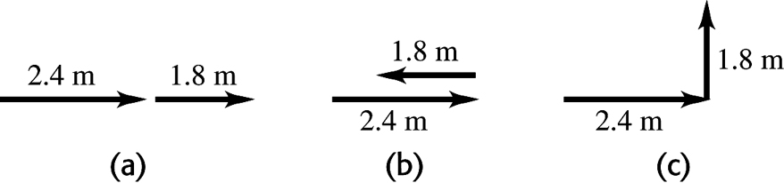
Figure 1.26

1.27. Identify: Draw each subsequent displacement tail to head with the previous displacement. The resultant displacement is the single vector that points from the starting point to the stopping point.
Set Up: Call the three displacements and The resultant displacement is given by
Execute: The vector addition diagram is given in Figure 1.27. Careful measurement gives that is
Evaluate: The magnitude of the resultant displacement, 7.8 km, is less than the sum of the magnitudes of the individual displacements,

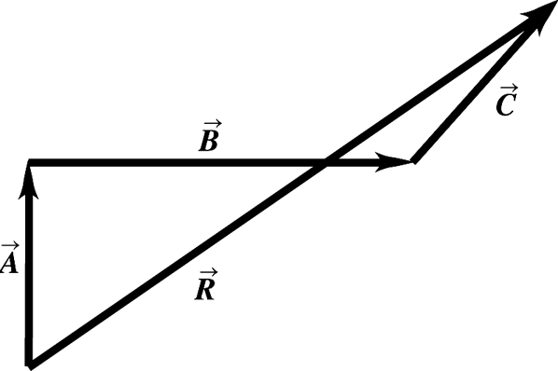
Figure 1.27

1.28. Identify: Draw the vector addition diagram to scale.
Set Up: The two vectors and are specified in the figure that accompanies the problem.
Execute: (a) The diagram for is given in Figure 1.28a. Measuring the length and angle of gives and an angle of
(b) The diagram for is given in Figure 1.28b. Measuring the length and angle of gives and an angle of
(c) so has a magnitude of 9.0 m (the same as ) and an angle with the axis of (opposite to the direction of
(d) so has a magnitude of 22 m and an angle with the axis of (opposite to the direction of ).
Evaluate: The vector is equal in magnitude and opposite in direction to the vector

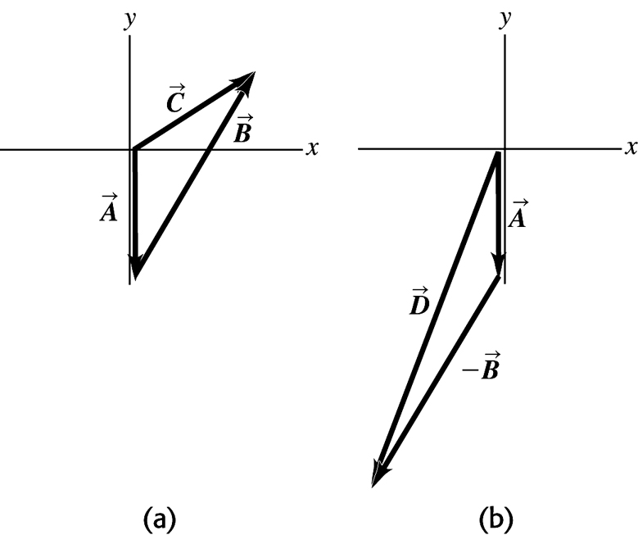
Figure 1.28
1.29. Identify: Since she returns to the starting point, the vector sum of the four displacements must be zero.
Set Up: Call the three given displacements and and call the fourth displacement
Execute: The vector addition diagram is sketched in Figure 1.29. Careful measurement gives that is
Evaluate: is equal in magnitude and opposite in direction to the sum

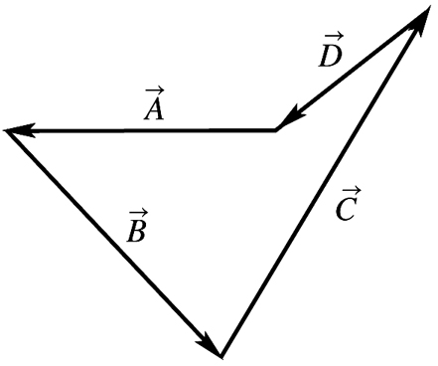
Figure 1.29
1.30. Identify: for measured counterclockwise from the -axis.
Set Up: A sketch of and tells us the quadrant in which lies.
Execute:
(a)
(b)
(c)
(d)
Evaluate: The anglesand have the same tangent. Our sketch tells us which is the correct value of
1.31. Identify: For each vector use that and when is the angle makes with the axis, measured counterclockwise from the axis.
Set Up: For For For For
Execute:
Evaluate: The signs of the components correspond to the quadrant in which the vector lies.
1.32. Identify: Given the direction and one component of a vector, find the other component and the magnitude.
Set Up: Use the tangent of the given angle and the definition of vector magnitude.
Execute: (a)
(b)
Evaluate: The magnitude is greater than either of the components.
1.33. Identify: Given the direction and one component of a vector, find the other component and the magnitude.
Set Up: Use the tangent of the given angle and the definition of vector magnitude.
Execute: (a)
(b)
Evaluate: The magnitude is greater than either of the components.
1.34. Identify: Find the vector sum of the three given displacements.
Set Up: Use coordinates for which is east and is north. The driver’s vector displacements are:
Execute: This result is confirmed by the sketch in Figure 1.34.
Evaluate: Both and are positive and is in the first quadrant.
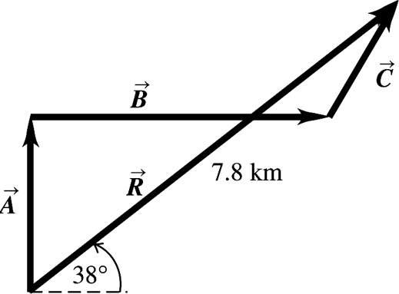
Figure 1.34
1.35. Identify: If then and Use and to find the magnitude and direction of
Set Up: From Figure E1.28 in the textbook, and
Execute: (a) so and and
(b) so has magnitude 9.01 m and direction specified by
(c) so and and is in the quadrant and the angle counterclockwise from the axis is
(d) so has magnitude 22.3 m and direction specified by
Evaluate: These results agree with those calculated from a scale drawing in Problem 1.28.
1.36. Identify: Use Equations (1.7) and (1.8) to calculate the magnitude and direction of each of the given vectors.
Set Up: A sketch of and tells us the quadrant in which lies.
Execute: (a) (which is ).
(b)
(c) (which is ).
Evaluate: In each case the angle is measured counterclockwise from the axis. Our results for agree with our sketches.
1.37. Identify: Vector addition problem. We are given the magnitude and direction of three vectors and are asked to find their sum.
Set Up:

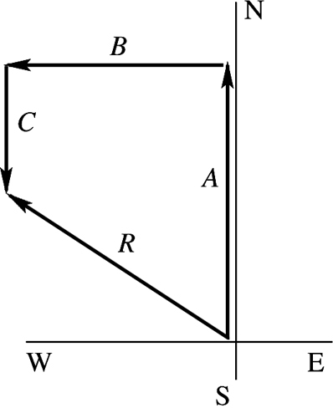
Figure 1.37a

Select a coordinate system where is east and is north. Let and be the three displacements of the professor. Then the resultant displacement is given by By the method of components, and Find the x and y components of each vector; add them to find the components of the resultant. Then the magnitude and direction of the resultant can be found from its x and y components that we have calculated. As always it is essential to draw a sketch.

Execute:

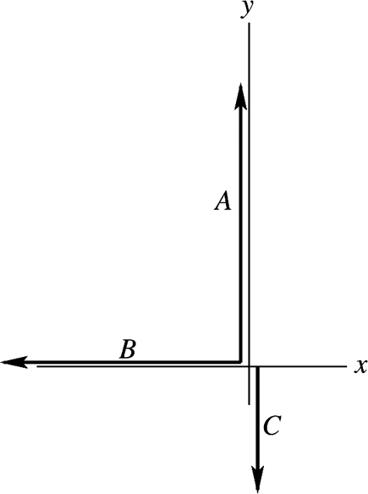
Figure 1.37b

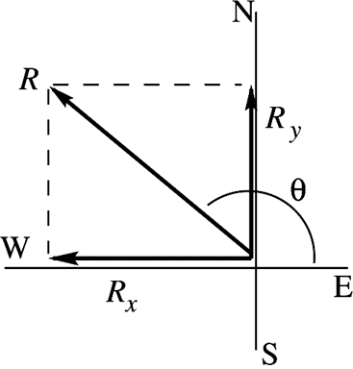
Figure 1.37c

The angle measured counterclockwise from the In terms of compass directions, the resultant displacement is of W.
Evaluate: and so is in 2nd quadrant. This agrees with the vector addition diagram.
1.38. Identify: We know the vector sum and want to find the magnitude of the vectors. Use the method of components.
Set Up: The two vectors and and their resultant are shown in Figure 1.38. Let be in the direction of the resultant.
Execute: and
Evaluate: The sum of the magnitudes of the two forces exceeds the magnitude of the resultant force because only a component of each force is upward.

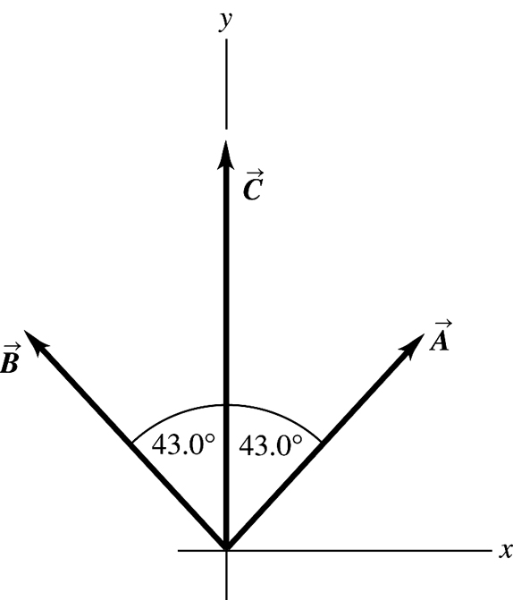
Figure 1.38
1.39. Identify: Vector addition problem.
Set Up: Find the x- and y-components of and Then the x- and y-components of the vector sum are calculated from the x- and y-components of and
Execute:

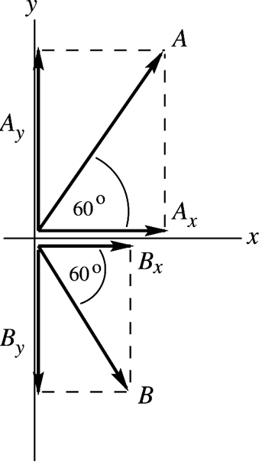 |  | Note that the signs of the components correspond  to the directions of the component vectors.
Figure 1.39a

(a) Now let

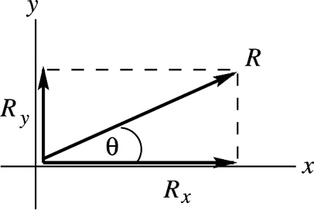
Figure 1.39b

Evaluate: The vector addition diagram for is

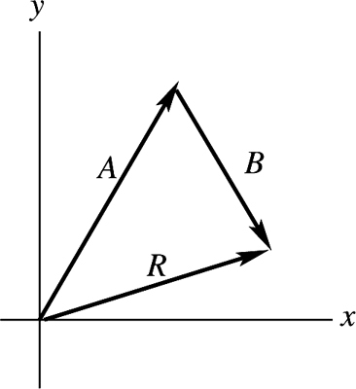 |  | is in the 1st quadrant, with  in agreement with our calculation.
Figure 1.39c

(b) Execute: Now let

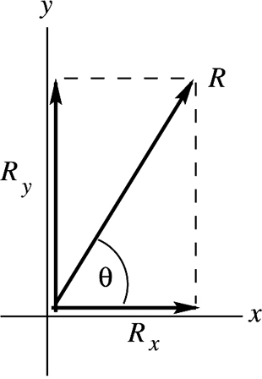
Figure 1.39d

Evaluate: The vector addition diagram for is

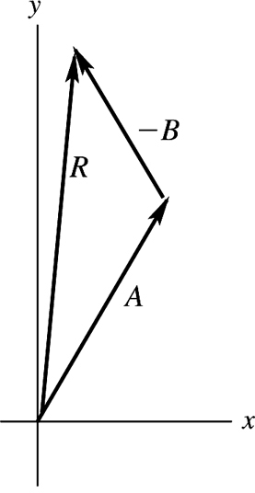 |  | is in the 1st quadrant, with  in agreement with our calculation.
Figure 1.39e

(c) Execute:

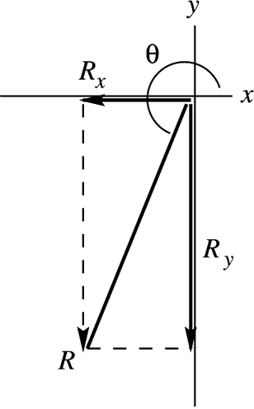 |  | and are equal in magnitude and  opposite in direction.  and
Figure 1.39f

Evaluate: The vector addition diagram for is

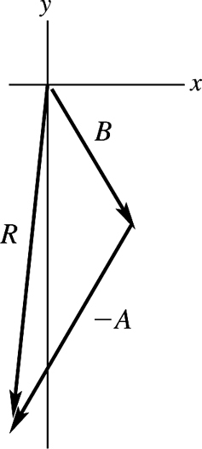 |  | is in the 3rd quadrant, with  in agreement with our calculation.
Figure 1.39g
1.40. Identify: The general expression for a vector written in terms of components and unit vectors is
Set Up:
Execute: (a) (b) (c)
(d)
Evaluate: The components are signed scalars.
1.41. Identify: Find the components of each vector and then use Eq. (1.14).
Set Up:
Execute:
Evaluate: All these vectors lie in the xy-plane and have no z-component.
1.42. Identify: Find A and B. Find the vector difference using components.
Set Up: Deduce the x- and y-components and use Eq. (1.8).
Execute: (a)
Evaluate: Note that the magnitudes of and are each larger than either of their components.
Execute: (b)
(c) Let Then

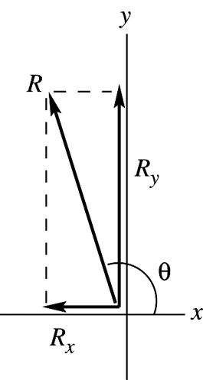
Figure 1.42

Evaluate: and so is in the 2nd quadrant.
1.43. Identify: Use trig to find the components of each vector. Use Eq. (1.11) to find the components of the vector sum. Eq. (1.14) expresses a vector in terms of its components.
Set Up: Use the coordinates in the figure that accompanies the problem.
Execute: (a)
(c) From Equations (1.7) and (1.8),
Evaluate: and are both positive, so is in the first quadrant.
1.44. Identify: A unit vector has magnitude equal to 1.
Set Up: The magnitude of a vector is given in terms of its components by Eq. (1.12).
Execute: (a) so it is not a unit vector.
(b) If any component is greater than or less than so it cannot be a unit vector. can have negative components since the minus sign goes away when the component is squared.
(c) gives and
Evaluate: The magnitude of a vector is greater than the magnitude of any of its components.
1.45. Identify:
Set Up: For and For and For and
Execute: (a)
(b)
(c)
Evaluate: When the scalar product is positive and when the scalar product is negative.
1.46. Identify: Target variables are and the angle between the two vectors.
Set Up: We are given and in unit vector form and can take the scalar product using Eq. (1.19). The angle can then be found from Eq. (1.18).
Execute: (a)
(b)
Evaluate: The component of along is in the same direction as so the scalar product is positive and the angle is less than
1.47. Identify: For all of these pairs of vectors, the angle is found from combining Eqs. (1.18) and (1.21),
to give the angle as
Set Up: Eq. (1.14) shows how to obtain the components for a vector written in terms of unit vectors.
Execute: (a) and so
(b)
(c) and
Evaluate: If If If and the two vectors are perpendicular.
1.48. Identify: Target variable is the vector expressed in terms of unit vectors.
Set Up: We are given and in unit vector form and can take the vector product using Eq. (1.24).
Execute:
But and so The magnitude of is 43.0.
Evaluate: Sketch the vectors and in a coordinate system where the xy-plane is in the plane of the paper and the z-axis is directed out toward you. By the right-hand rule is directed into the plane of the paper, in the This agrees with the above calculation that used unit vectors.

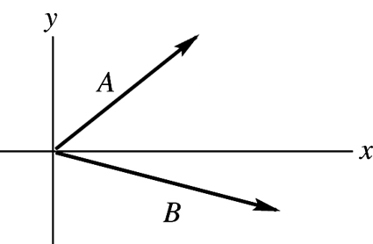
Figure 1.48

1.49. Identify: has magnitude Its direction is given by the right-hand rule.
Set Up:
Execute: (a) The right-hand rule says is in the (into the page).
has the same magnitude as and is in the opposite direction.
Evaluate: The component of perpendicular to is which agrees with our previous result.
1.50. Identify: The right-hand rule gives the direction and Eq. (1.22) gives the magnitude.
Set Up:
Execute: (a) The direction of is into the page (the ). The magnitude of the vector product is
(b) Rather than repeat the calculations, Eq. (1.23) may be used to see that has magnitude and is in the (out of the page).
Evaluate: For part (a) we could use Eq. (1.27) and note that the only non-vanishing component is
This gives the same result.
1.51. Identify: Apply Eqs. (1.18) and (1.22).
Set Up: The angle between the vectors is
Execute: (a) Eq. (1.18) gives
(b) From Eq. (1.22), the magnitude of the cross product is and the direction, from the right-hand rule, is out of the page (the ).
Evaluate: We could also use Eqs. (1.21) and (1.27), with the components of and
1.52. Identify: Use Eq. (1.27) for the components of the vector product.
Set Up: Use coordinates with the to the right, toward the top of the page, and out of the page. and The page is 20 cm by 35 cm, so and
Execute:
Evaluate: From the components we calculated the magnitude of the vector product is and so which agrees.
1.53. Identify: and are given in unit vector form. Find A, B and the vector difference
Set Up:
Use Eq. (1.8) to find the magnitudes of the vectors.
Execute: (a)
(b)
(c) Let so
so and have the same magnitude but opposite directions.
Evaluate: A, B and C are each larger than any of their components.
1.54. Identify: Area is length times width. Do unit conversions.
Set Up:
Execute: (a) The area of one acre is so there are 640 acres to a square mile.
(b)
(all of the above conversions are exact).
(c) (1 acre-foot)which is rounded to three significant figures.
Evaluate: An acre is much larger than a square foot but less than a square mile. A volume of 1 acre-foot is much larger than a gallon.
1.55. Identify: The density relates mass and volume. Use the given mass and density to find the volume and from this the radius.
Set Up: The earth has mass and radius The volume of a sphere is
Execute: (a) The planet has mass
(b)
Evaluate: Volume V is proportional to mass and radius r is proportional to so r is proportional to If the planet and earth had the same density its radius would be The radius of the planet is greater than this, so its density must be less than that of the earth.
1.56. Identify and Set Up: Unit conversion.
Execute: (a) so for one cycle.
(b)
(c) Calculate the number of seconds in 4600 million and divide by the time for 1 cycle:
(d) The clock is off by 1 s in so in it is off by (about 13 h).
Evaluate: In each case the units in the calculation combine algebraically to give the correct units for the answer.
1.57. Identify: Using the density of the oxygen and volume of a breath, we want the mass of oxygen (the target variable in part (a)) breathed in per day and the dimensions of the tank in which it is stored.
Set Up: The mass is the density times the volume. Estimate 12 breaths per minute. We know 1 day = 24 h, 1 h = 60 min and 1000 L = 1 m³. The volume of a cube having faces of length l is
Execute: (a) The volume of air breathed in one day is The mass of air breathed in one day is the density of air times the volume of air breathed: As 20% of this quantity is oxygen, the mass of oxygen breathed in 1 day is
(b) V = and so
Evaluate: A person could not survive one day in a closed tank of this size because the exhaled air is breathed back into the tank and thus reduces the percent of oxygen in the air in the tank. That is, a person cannot extract all of the oxygen from the air in an enclosed space.
1.58. Identify: Use the extreme values in the piece’s length and width to find the uncertainty in the area.
Set Up: The length could be as large as 7.61 cm and the width could be as large as 1.91 cm.
Execute: The area is 14.44 ± 0.095 cm². The fractional uncertainty in the area is and the fractional uncertainties in the length and width are and The sum of these fractional uncertainties is in agreement with the fractional uncertainty in the area.
Evaluate: The fractional uncertainty in a product of numbers is greater than the fractional uncertainty in any of the individual numbers.
1.59. Identify: Calculate the average volume and diameter and the uncertainty in these quantities.
Set Up: Using the extreme values of the input data gives us the largest and smallest values of the target variables and from these we get the uncertainty.
Execute: (a) The volume of a disk of diameter d and thickness t is
The average volume is But t is given to only two significant figures so the answer should be expressed to two significant figures:
We can find the uncertainty in the volume as follows. The volume could be as large as which is larger than the average value. The volume could be as small as which is smaller than the average value. The uncertainty is and we express the volume as
(b) The ratio of the average diameter to the average thickness is By taking the largest possible value of the diameter and the smallest possible thickness we get the largest possible value for this ratio: The smallest possible value of the ratio is Thus the uncertainty is and we write the ratio as
Evaluate: The thickness is uncertain by 10% and the percentage uncertainty in the diameter is much less, so the percentage uncertainty in the volume and in the ratio should be about 10%.
1.60. Identify: Estimate the volume of each object. The mass m is the density times the volume.
Set Up: The volume of a sphere of radius r is The volume of a cylinder of radius r and length l is The density of water is
Execute: (a) Estimate the volume as that of a sphere of diameter 10 cm:
(b) Approximate as a sphere of radius (probably an overestimate):
(c) Estimate the volume as that of a cylinder of length 1 cm and radius 3 mm:
Evaluate: The mass is directly proportional to the volume.
1.61. Identify: The number of atoms is your mass divided by the mass of one atom.
Set Up: Assume a 70-kg person and that the human body is mostly water. Use Appendix D to find the mass of one molecule:
Execute: molecules. Each molecule has
3 atoms, so there are about atoms.
Evaluate: Assuming carbon to be the most common atom gives molecules, which is a result of the same order of magnitude.
1.62. Identify: The number of bills is the distance to the moon divided by the thickness of one bill.
Set Up: Estimate the thickness of a dollar bill by measuring a short stack, say ten, and dividing the measurement by the total number of bills. I obtain a thickness of roughly 1 mm. From Appendix F, the distance from the earth to the moon is
Execute:
Evaluate: This answer represents 4 trillion dollars! The cost of a single space shuttle mission in 2005 is significantly less—roughly 1 billion dollars.
1.63. Identify: The cost would equal the number of dollar bills required; the surface area of the U.S. divided by the surface area of a single dollar bill.
Set Up: By drawing a rectangle on a map of the U.S., the approximate area is 2600 mi by 1300 mi or 3,380,000 This estimate is within 10 percent of the actual area, 3,794,083 The population is roughly while the area of a dollar bill, as measured with a ruler, is approximately in. by
in.
Execute:
Evaluate: The actual cost would be somewhat larger, because the land isn’t flat.
1.64. Identify: Estimate the volume of sand in all the beaches on the earth. The diameter of a grain of sand determines its volume. From the volume of one grain and the total volume of sand we can calculate the number of grains.
Set Up: The volume of a sphere of diameter d is Consulting an atlas, we estimate that the continents have about of coastline. Add another 25% of this for rivers and lakes, giving of coastline. Assume that a beach extends 50 m beyond the water and that the sand is 2 m deep.
Execute: (a) The volume of sand is The volume of a grain is The number of grains is The number of grains of sand is about
(b) The number of stars is The two estimates result in comparable numbers for these two quantities.
Evaluate: Both numbers are crude estimates but are probably accurate to a few powers of 10.
1.65. Identify: We know the magnitude and direction of the sum of the two vector pulls and the direction of one pull. We also know that one pull has twice the magnitude of the other. There are two unknowns, the magnitude of the smaller pull and its direction.and give two equations for these two unknowns.
Set Up: Let the smaller pull be and the larger pull be has magnitude 460.0 N and is northward. Let be east and be north.and must have an eastward component to cancel the westward component of There are then two possibilities, as sketched in Figures 1.65 a and b. can have a northward component or can have a southward component.
Execute: In either Figure 1.65 a or b, and gives and In Figure 1.65a, gives and In Figure 1.65b, and One solution is for the smaller pull to be east of north. In this case, the smaller pull is 196 N and the larger pull is 392 N. The other solution is for the smaller pull to be east of south. In this case the smaller pull is 360 N and the larger pull is 720 N.
Evaluate: For the first solution, with east of north, each worker has to exert less force to produce the given resultant force and this is the sensible direction for the worker to pull.

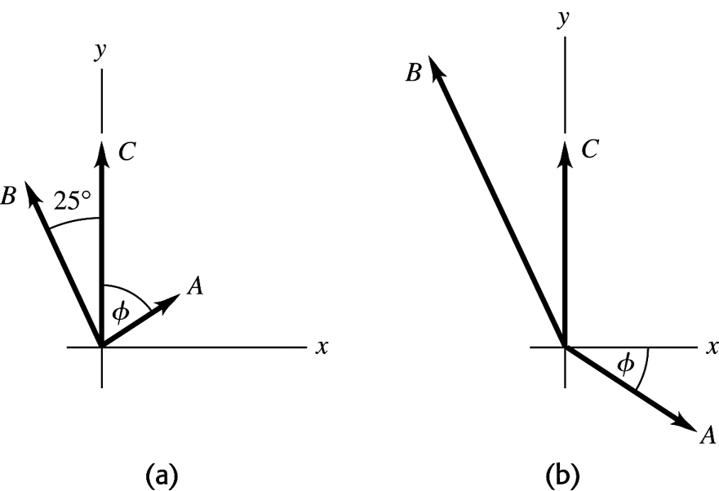
Figure 1.65

1.66. Identify: Let be the fourth force. Find such that so
Set Up: Use components and solve for the components and of
Execute:
Then and counterclockwise from the
Evaluate: As shown in Figure 1.66, since and are both negative, must lie in the third quadrant.

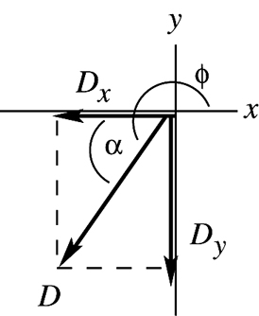
Figure 1.66

1.67. Identify: (or ). The target variable is vector
Set Up: Use components and Eq. (1.10) to solve for the components of Find the magnitude and direction of from its components.
Execute: (a)

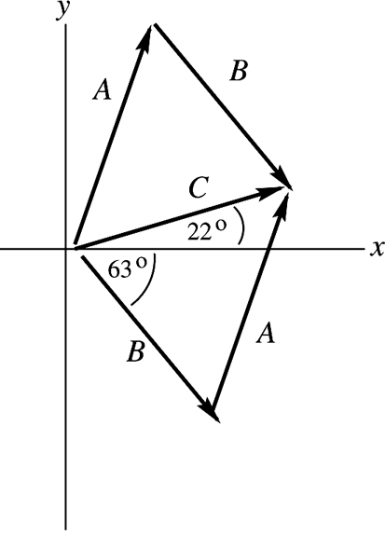 |  | so  so
Figure 1.67a

(b)

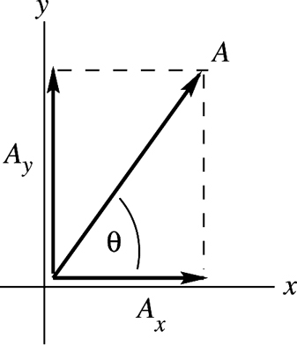
Figure 1.67b

Evaluate: The we calculated agrees qualitatively with vector in the vector addition diagram in part (a).
1.68. Identify: Find the vector sum of the two displacements.
Set Up: Call the two displacements and where and and are as shown in Figure 1.68.
Execute:
Evaluate: Our calculation using components agrees with shown in the vector addition diagram, Figure 1.68.

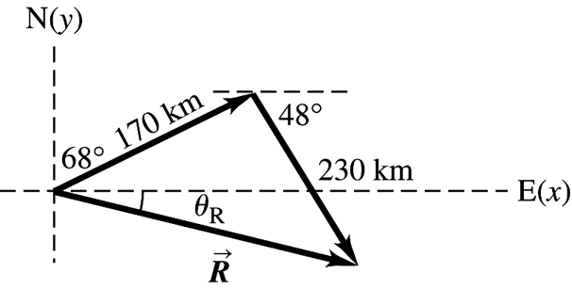
Figure 1.68

1.69. Identify: Vector addition. Target variable is the 4th displacement.
Set Up: Use a coordinate system where east is in the and north is in the
Let and be the three displacements that are given and let be the fourth unmeasured displacement. Then the resultant displacement is And since she ends up back where she started,
so
and
Execute:

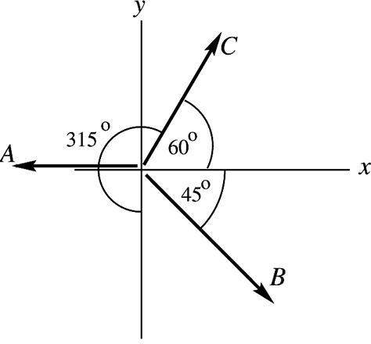
Figure 1.69a

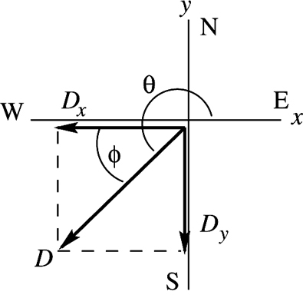 |  | ( is in the third quadrant since both  and are negative.)
Figure 1.69b
The direction of can also be specified in terms of is south of west.
Evaluate: The vector addition diagram, approximately to scale, is

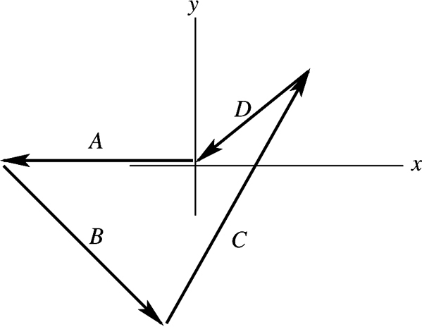 |  | Vector in this diagram agrees qualitatively  with our calculation using components.
Figure 1.69c

1.70. Identify: Add the vectors using the method of components.
Set Up:
Execute: (a) below the
(b) below the
Evaluate: The magnitude and direction we calculated for and agree with our vector diagrams.

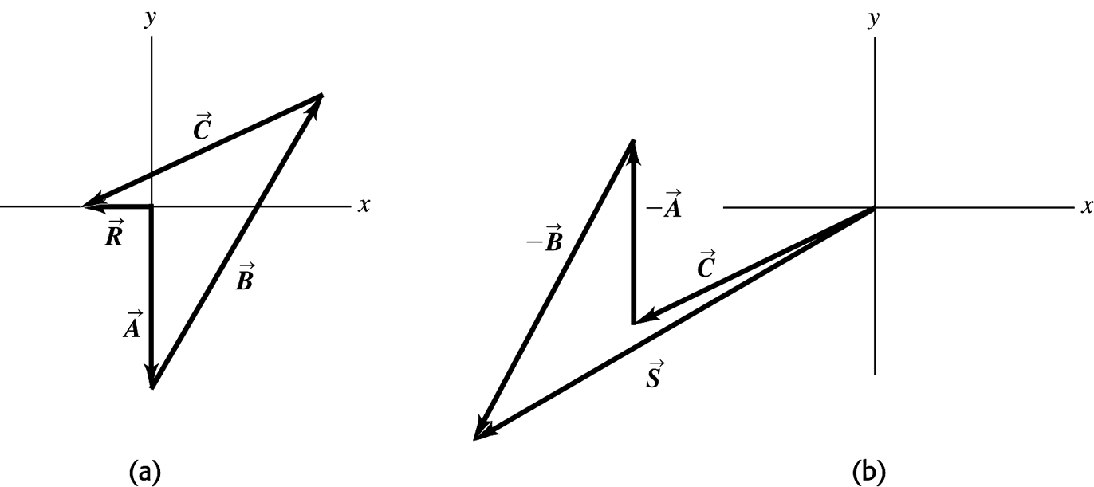
Figure 1.70

1.71. Identify: Find the vector sum of the two forces.
Set Up: Use components to add the two forces. Take the to be forward and the to be upward.
Execute: The second force has components and The first force has components and and The resultant force is 954 N in the direction 16.8° above the forward direction.
Evaluate: Since the two forces are not in the same direction the magnitude of their vector sum is less than the sum of their magnitudes.
1.72. Identify: Solve for one of the vectors in the vector sum. Use components.
Set Up: Use coordinates for which is east and is north. The vector displacements are: and
Execute:
The vector addition diagram in Figure 1.72 shows good qualitative agreement with these values.
Evaluate: The third leg lies in the first quadrant since its x and y components are both positive.

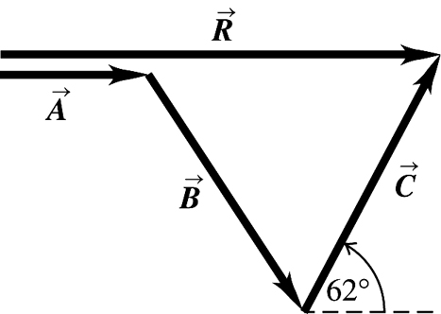
Figure 1.72

1.73. Identify: We know the resultant of two forces of known equal magnitudes and want to find that magnitude (the target variable).
Set Up: Use coordinates having a horizontal axis and an upward axis. Then and
Solve: and Since
so
Evaluate: The magnitude of the x component of each pull is 2.80 N, so the magnitude of each pull
(3.30 N) is greater than its x component, as it should be.
1.74. Identify: The four displacements return her to her starting point, so where and are in the three given displacements and is the displacement for her return.
Start Up: Let be east and be north.
Execute: (a)
(b) The direction relative to north is Since and the direction of is west of north.
Evaluate: The four displacements add to zero.
1.75. Identify: The sum of the vector forces on the beam sum to zero, so their x components and their y components sum to zero. Solve for the components of
Set Up: The forces on the beam are sketched in Figure 1.75a. Choose coordinates as shown in the sketch. The 100-N pull makes an angle of with the horizontal. and the 100-N pull have been replaced by their x and y components.
Execute: (a) The sum of the x-components is equal to zero gives and The sum of the y-components is equal to zero gives and and its components are sketched in Figure 1.75b. and is directed at above the -axis in Figure 1.75a.
(b) The vector addition diagram is given in Figure 1.75c. determined from the diagram agrees with calculated in part (a) using components.
Evaluate: The vertical component of the 100 N pull is less than the 124 N weight so must have an upward component if all three forces balance.

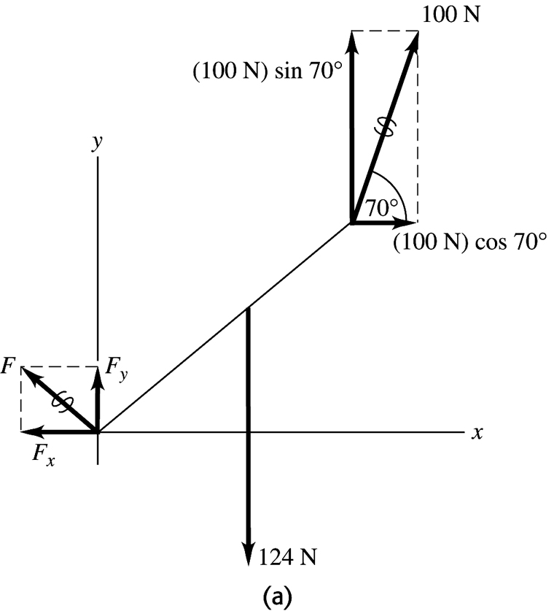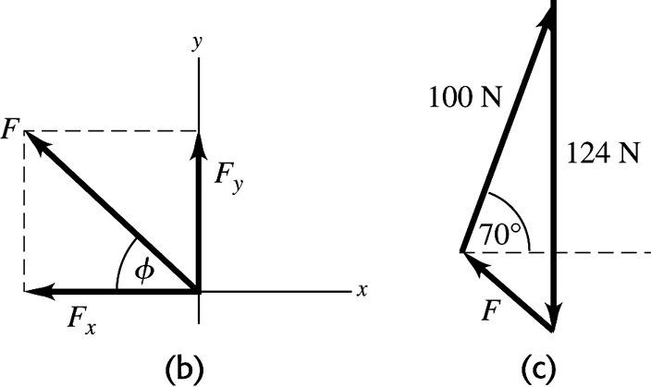
Figure 1.75

1.76. Identify: Let the three given displacements be and where and The displacement that will return him to his hut is
Set Up: Let the east direction be the and the north direction be the
Execute: (a) The three displacements and their resultant are sketched in Figure 1.76.
(b) and
The magnitude and direction of the resultant are north of west. We know that is in the second quadrant because To return to the hut, the explorer must take 49 steps in a direction south of east, which is east of south.
Evaluate: It is useful to show and on a sketch, so we can specify what angle we are computing.

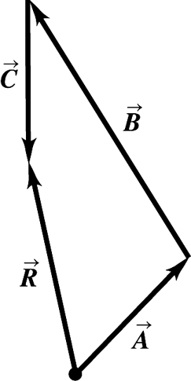
Figure 1.76

1.77. Identify and Set Up: The vectorthat connects points and has components and
Execute: (a) Angle of first line is Angle of second line is Thereforefor a final point of (87,258).
(b) The computer screen now looks something like Figure 1.77. The length of the bottom line is and its direction is below straight left.
Evaluate: Figure 1.77 is a vector addition diagram. The vector first line plus the vector arrow gives the vector for the second line.

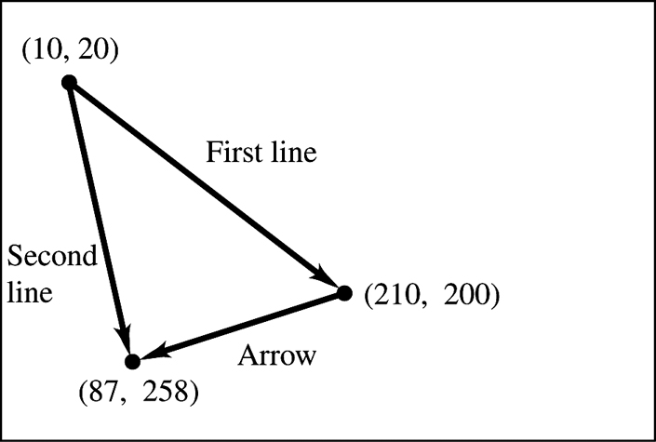
Figure 1.77

1.78. Identify: Vector addition. One vector and the sum are given; find the second vector (magnitude and direction).
Set Up: Let be east and be north. Let be the displacement 285 km at north of west and let be the unknown displacement.
where east
Execute:
Then

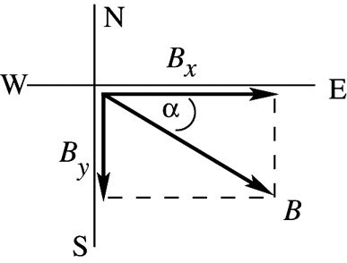 |  | south of east
Figure 1.78

Evaluate: The southward component of cancels the northward component of The eastward component of must be 115 km larger than the magnitude of the westward component of
1.79. Identify: Vector addition. One force and the vector sum are given; find the second force.
Set Up: Use components. Let be upward.
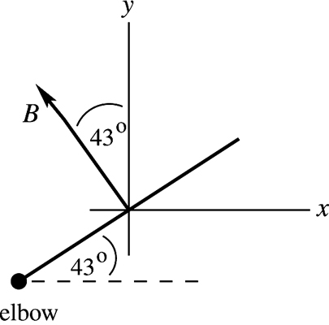 |  | is the force the biceps exerts.
Figure 1.79a

is the force the elbow exerts. where and is upward.
Execute:
Then

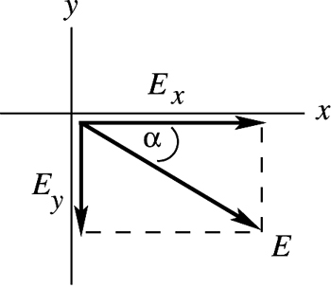 |  | below horizontal
Figure 1.79b

Evaluate: The x-component of cancels the x-component of The resultant upward force is less than the upward component of so must be downward.
1.80. Identify: Find the vector sum of the four displacements.
Set Up: Take the beginning of the journey as the origin, with north being the y-direction, east the
x-direction, and the z-axis vertical. The first displacement is then the second is the third is and the fourth is
Execute: (a) Adding the four displacements gives
(b) The total distance traveled is the sum of the distances of the individual segments: The magnitude of the total displacement is:
Evaluate: The magnitude of the displacement is much less than the distance traveled along the path.
1.81. Identify: The sum of the force displacements must be zero. Use components.
Set Up: Call the displacements and where is the final unknown displacement for the return from the treasure to the oak tree. Vectors andare sketched in Figure 1.81a. says and and Let be eastward and be north.
Execute: (a) gives gives The fourth displacement and its components are sketched in Figure 1.81b. and You should head west of south and must walk 911 m.
(b) The vector diagram is sketched in Figure 1.81c. The final displacement from this diagram agrees with the vector calculated in part (a) using components.
Evaluate: Note that is the negative of the sum of and

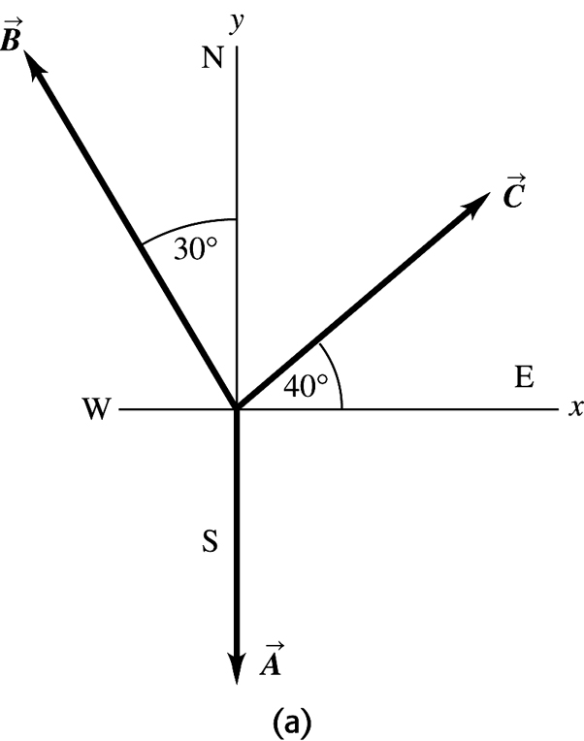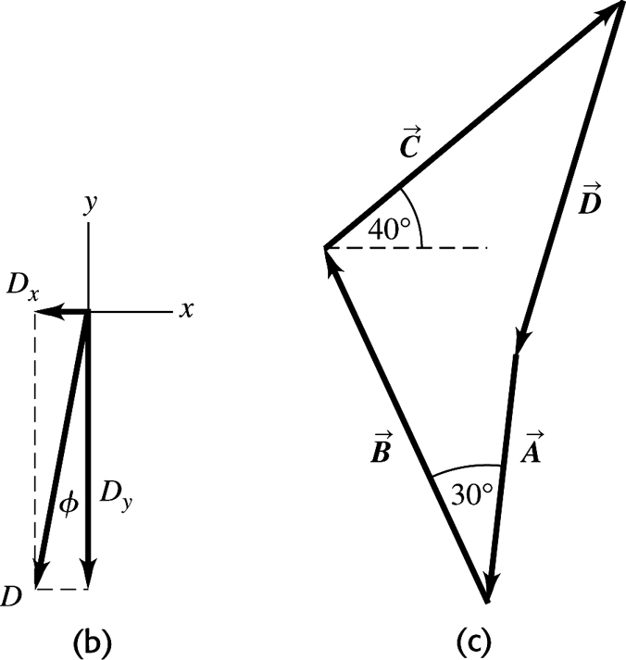
Figure 1.81

1.82. Identify: The displacements are vectors in which we know the magnitude of the resultant and want to find the magnitude of one of the other vectors.
Set Up: Calling the vector from you to the first post, the vector from you to the second post, and the vector from the first to the second post, we have Solving using components and the magnitude of gives and
Execute: and
so
The post is 37.1 m from you.
Evaluate: (negative) since post is south of you (in the negative y direction).
1.83. Identify: We are given the resultant of three vectors, two of which we know, and want to find the magnitude and direction of the third vector.
Set Up: Calling the unknown vector and and the known vectors, we have The components are and
Execute: The components of the known vectors are and Therefore the components of are and
Using these components to find the magnitude and direction of gives and and east of south
Evaluate: A graphical sketch shows that this answer is reasonable.
1.84. Identify: The displacements are vectors in which we know the magnitude of the resultant and want to find the magnitude of one of the other vectors.
Set Up: Calling the vector of Ricardo’s displacement from the tree, the vector of Jane’s displacement from the tree, and the vector from Ricardo to Jane, we have Solving using components we have and
Execute: (a) The components of and are
Finding the magnitude from the components gives
(b) Finding the direction from the components gives and east of south.
Evaluate: A graphical sketch confirms that this answer is reasonable.
1.85. Identify: Think of the displacements of the three people as vectors. We know two of them and want to find their resultant.
Set Up: Calling the vector from John to Paul, the vector from Paul to George, and the vector from John to George, we have which gives and
Execute: The known components are and Therefore These components give and which gives east of south.
Evaluate: A graphical sketch confirms that this answer is reasonable.
1.86. Identify: If the vector from your tent to Joe’s is and from your tent to Karl’s is then the vector from Joe’s tent to Karl’s is
Set Up: Take your tent’s position as the origin. Let be east and be north.
Execute: The position vector for Joe’s tent is
The position vector for Karl’s tent is
The difference between the two positions is The magnitude of this vector is the distance between the two tents:
Evaluate: If both tents were due east of yours, the distance between them would be If Joe’s was due north of yours and Karl’s was due south of yours, then the distance between them would be The actual distance between them lies between these limiting values.
1.87. Identify: We know the scalar product and the magnitude of the vector product of two vectors and want to know the angle between them.
Set Up: The scalar product is and the vector product is
Execute: and Taking the ratio gives so
Evaluate: Since the scalar product is negative, the angle must be between 90° and 180°.
1.88. Identify: Calculate the scalar product and use Eq. (1.18) to determine
Set Up: The unit vectors are perpendicular to each other.
Execute: The direction vectors each have magnitude and their scalar product is so from Eq. (1.18) the angle between the bonds is
Evaluate: The angle between the two vectors in the bond directions is greater than
1.89. Identify: We know the magnitude of two vectors and their scalar product and want to find the magnitude of their vector product.
Set Up: The scalar product is and the vector product is
Execute: = 90.0 m², which gives so Therefore
Evaluate: The magnitude of the vector product is greater than the scalar product because the angle between the vectors is greater than 45º.
1.90. Identify: Let and calculate the scalar product
Set Up: For any vector
Execute: (a) Use the linearity of the dot product to show that the square of the magnitude of the sum is
(b) Using the result of part (a), with the condition is that which solves for and
Evaluate: The expression is called the law of cosines.
1.91. Identify: Find the angle between specified pairs of vectors.
Set Up: Use
Execute: (a) (along line ab)
(along line ad)
So
(b) (along line ad)
(along line ac)
So
Evaluate: Each angle is computed to be less than in agreement with what is deduced from
Figure P1.91 in the textbook.
1.92. Identify: We know the magnitude of two vectors and the magnitude of their vector product, and we want to find the possible values of their scalar product.
Set Up: The vector product is and the scalar product is
Execute: = 12.0 m², so which gives two possible values: or Therefore the two possible values of the scalar product are
Evaluate: The two possibilities have equal magnitude but opposite sign because the two possible angles are supplementary to each other. The sines of these angles are the same but the cosines differ by a factor
of −1. See Figure 1.92.

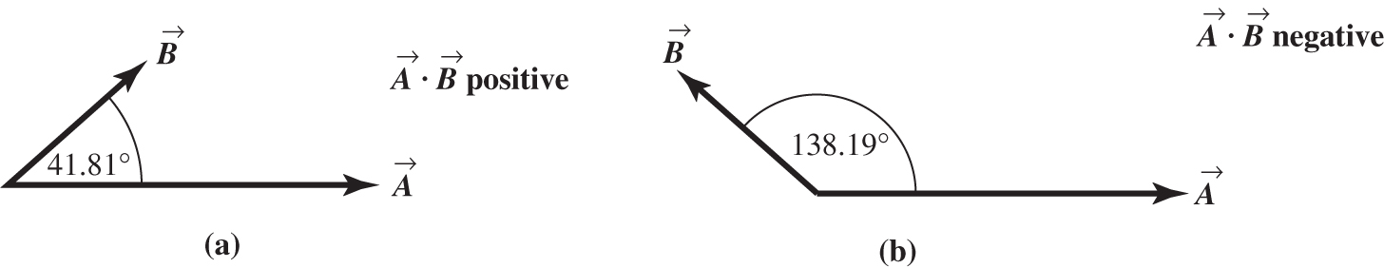
Figure 1.92

1.93. Identify: We know the scalar product of two vectors, both their directions, and the magnitude of one of them, and we want to find the magnitude of the other vector.
Set Up: Since we know the direction of each vector, we can find the angle between them.
Execute: The angle between the vectors is Since we have
Evaluate: Vector has the same units as vector
1.94. Identify: The cross product is perpendicular to both and
Set Up: Use Eq. (1.27) to calculate the components of
Execute: The cross product is
The magnitude of the vector in square brackets is and so a unit vector in this direction is
The negative of this vector,
is also a unit vector perpendicular to and
Evaluate: Any two vectors that are not parallel or antiparallel form a plane and a vector perpendicular to both vectors is perpendicular to this plane.
1.95. Identify and Set Up: The target variables are the components of We are given and We also know and and this gives us two equations in the two unknowns and
Execute: and are perpendicular, so which gives
so
We have two equations in two unknowns and Solving gives and
Evaluate: We can check that our result does give us a vector that satisfies the two equations and
1.96. Identify: Calculate the magnitude of the vector product and then use Eq. (1.22).
Set Up: The magnitude of a vector is related to its components by Eq. (1.12).
Execute: and
Evaluate: We haven’t found and just the angle between them.
1.97. (a) Identify: Prove that
Set Up: Express the scalar and vector products in terms of components.
Execute:
Comparison of the expressions for and shows they contain the same terms, so
(b) Identify: Calculate given the magnitude and direction of and
Set Up: Use Eq. (1.22) to find the magnitude and direction of Then we know the components of and of and can use an expression like Eq. (1.21) to find the scalar product in terms of components.
Execute:
The angle between and is equal to So and by the right hand-rule is in the Thus
Evaluate: is a vector, so taking its scalar product with is a legitimate vector operation. is a scalar product between two vectors so the result is a scalar.
1.98. Identify: Use the maximum and minimum values of the dimensions to find the maximum and minimum areas and volumes.
Set Up: For a rectangle of width W and length L the area is LW. For a rectangular solid with dimensions L, W and H the volume is LWH.
Execute: (a) The maximum and minimum areas are where the common terms wl have been omitted. The area and its uncertainty are then so the uncertainty in the area is
(b) The fractional uncertainty in the area is the sum of the fractional uncertainties in the length and width.
(c) The similar calculation to find the uncertainty v in the volume will involve neglecting the terms lwH, lWh and Lwh as well as lwh; the uncertainty in the volume is and the fractional
uncertainty in the volume is the sum of the fractional uncertainties in the length, width and height.
Evaluate: The calculation assumes the uncertainties are small, so that terms involving products of two or more uncertainties can be neglected.
1.99. Identify: Add the vector displacements of the receiver and then find the vector from the quarterback to the receiver.
Set Up: Add the x-components and the y-components.
Execute: The receiver’s position is
The vector from the quarterback to the receiver is the receiver’s position minus the quarterback’s position, or a vector with magnitude The angle is to the right of downfield.
Evaluate: The vector from the quarterback to receiver has positive x-component and positive
y-component.
1.100. Identify: Use the x and y coordinates for each object to find the vector from one object to the other; the distance between two objects is the magnitude of this vector. Use the scalar product to find the angle between two vectors.
Set Up: If object A has coordinatesand object B has coordinatesthe vector from A to B has x-componentand y-component
Execute: (a) The diagram is sketched in Figure 1.100.
(b) (i) In AU,
(ii) In AU,
(iii) In AU
(c) The angle between the directions from the Earth to the Sun and to Mars is obtained from the dot product. Combining Eqs. (1.18) and (1.21),
(d) Mars could not have been visible at midnight, because the Sun-Mars angle is less than
Evaluate: Our calculations correctly give that Mars is farther from the Sun than the earth is. Note that on this date Mars was farther from the earth than it is from the Sun.

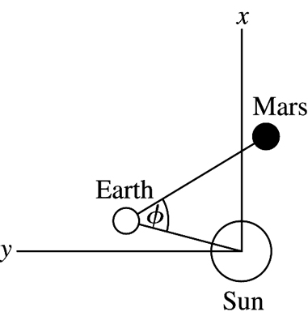
Figure 1.100

1.101. Identify: Draw the vector addition diagram for the position vectors.
Set Up: Use coordinates in which the Sun to Merak line lies along the x-axis. Let be the position vector of Alkaid relative to the Sun, is the position vector of Merak relative to the Sun, and is the position vector for Alkaid relative to Merak. and
Execute: The relative positions are shown in Figure 1.101. so is the distance between Alkaid and Merak.
(b) The angle is angle in Figure 1.101. and Then
Evaluate: The concepts of vector addition and components make these calculations very simple.

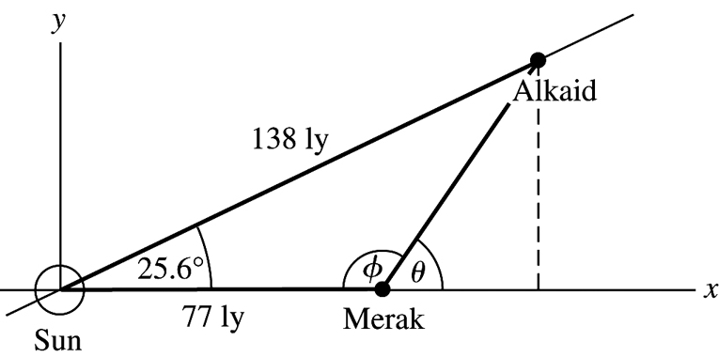
Figure 1.101

1.102. Identify: Define Show that if
Set Up: Use Eq. (1.21) to calculate the scalar product.
Execute:
If the points satisfy then and all points are perpendicular to The vector and plane are sketched in Figure 1.102.
Evaluate: If two vectors are perpendicular their scalar product is zero.

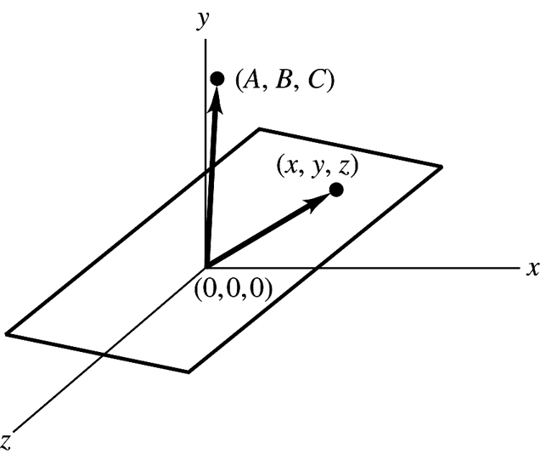
Figure 1.102

