**CHAPTER 2—Descriptive Statistics: Tabular and Graphical Methods and Descriptive Analytics**

# §2.1 Concepts

**2.1** Constructing either a frequency or a relative frequency distribution helps identify and quantify patterns that are not apparent in the raw data.

LO02-01

**2.2** Relative frequency of any category is calculated by dividing its frequency by the total number of observations. Percent frequency is calculated by multiplying relative frequency by 100.

LO02-01

**2.3** Answers and examples will vary.

LO02-01

# §2.1 Methods and Applications

|  |  |  |  |  |  |
| --- | --- | --- | --- | --- | --- |
| **2.4** | **a.** | Test |  | Relative | Percent |
|  |  | Response | Frequency | Frequency | Frequency |
|  |  | A | 100 | 0.4 | 40% |
|  |  | B | 25 | 0.1 | 10% |
|  |  | C | 75 | 0.3 | 30% |
|  |  | D | 50 | 0.2 | 20% |

**b.**

LO02-01

**2.5** **a.** (100/250) • 360 degrees = 144 degrees for response (a)

**b.** (25/250) • 360 degrees = 36 degreesfor response (b)

**c**.

LO02-01

**2.6** **a.** Relative frequency for product *x* is 1 – (0.15 + 0.36 + 0.28) = 0.21

**b.** Frequency= relative frequency • N. For W, this is 0.15 • 500 **=** 75

|  |  |  |  |  |
| --- | --- | --- | --- | --- |
| product | W | X | Y | Z |
| frequency | 75 | 105 | 180 | 140 |

So we have

**c.**

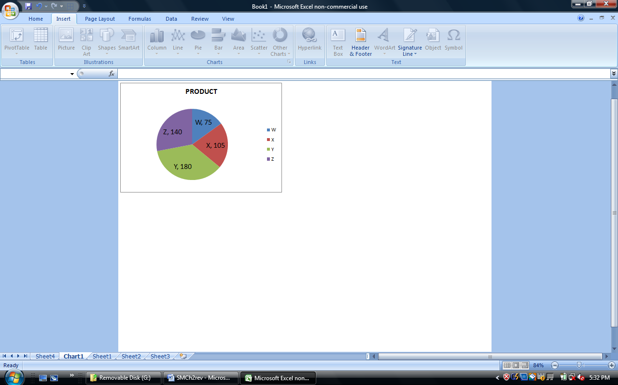 **d.** Degrees for W would be 0.15 • 360 = 54; for X: 75.6; for Y: 129.6;   
for Z: 100.8.

LO02-01

**2.7 a.** Rating Frequency Relative Frequency

Outstanding 14 14/30 = 0.467

Very Good 10 10/30 = 0.333

Good 5 5/30 = 0.167

Average 1 1/30 = 0.033

Poor 0 0/30 = 0.000

∑ = 30

**b.**

**c.**

LO02-01

**2.8 a.** Frequency Distribution for ***Sports League Preference***

|  |  |  |  |
| --- | --- | --- | --- |
| *Sports League* | *Frequency* | *Percent Frequency* | *Percent* |
| MLB | 11 | 0.22 | 22% |
| MLS | 3 | 0.06 | 6% |
| NBA | 8 | 0.16 | 16% |
| NFL | 23 | 0.46 | 46% |
| NHL | 5 | 0.10 | 10% |
|  | 50 |  |  |

**b.**

**c.**

**d.** The most popular league is NFL and the least popular is MLS.

LO02-011

**2.9**

LO02-01

**2.10** Comparing the pie chart above with chart for 2014 in the textbook shows that between 2005 and 2014, the three U.S. manufacturers, Chrysler, Ford and GM have all lost market share, while Japanese and other imported models have increased market share.

LO02-01

**2.11** Comparing Types of Health Insurance Coverage Based on Income Level

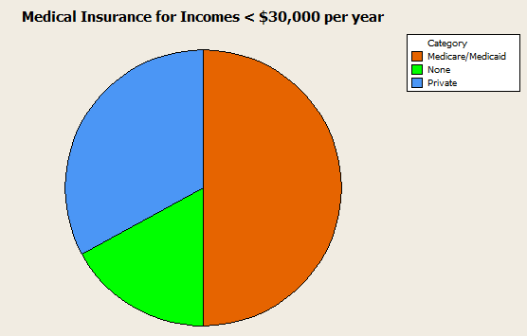

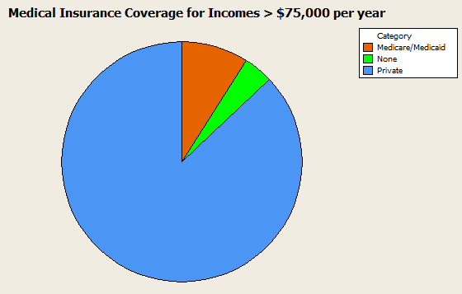

LO02-01

**2.12 a.** Percent of calls that are require investigation or help = 28.12% + 4.17% =32.29%

**b.** Percent of calls that represent a new problem = 4.17%

**c.** Only 4% of the calls represent a new problem to all of technical support, but one-third of the problems require the technician to determine which of several previously known problems this is and which solutions to apply. It appears that increasing training or improving the documentation of known problems and solutions will help.

LO02-02

# §2.2Concepts

**2.13 a.** We construct a frequency distribution and a histogram for a data set so we can gain some insight into the shape, center, and spread of the data along with whether outliers exist.

**b.** A frequency histogram represents the frequencies for the classes using bars while in a frequency polygon the frequencies are represented by plotted points connected by line segments.

**c.** A frequency ogive represents a cumulative frequency distribution while the frequency polygon represents a frequency distribution. Also, in a frequency ogive, the points are plotted at the upper class boundaries; in a frequency polygon, the points are plotted at the class midpoints.

LO02-03

**2.14 a.** To find the frequency for a class, you simply count how many of the observations have values that are greater than or equal to the lower boundary and less than the upper boundary.

**b.** Once you determine the frequency for a class, the relative frequency is obtained by dividing the class frequency by the total number of observations (data points).

**c.** The percent frequency for a class is calculated by multiplying the relative frequency by 100.

LO02-03

**2.15 a.** Symmetrical and mound shaped:   
One hump in the middle; left side is a mirror image of the right side.

**b.** Double peaked:   
Two humps, the left of which may or may not look like the right one, nor is each hump required to be symmetrical

**c.** Skewed to the right:  
Long tail to the right

**d.** Skewed to the left:  
 Long tail to the left

LO02-03

# §2.2 Methods and Applications

**2.16 a.** Since there are 28 points we use 5 classes (from Table 2.5).

**b.** Class Length (CL) = (largest measurement – smallest measurement) / #classes   
 = (46 – 17) / 5 = 6 (we have rounded up to the integer level since the data are recorded to the nearest integer.)

**c.** The first class’s lower boundary is the smallest measurement, 17.

The first class’s upper boundary is the lower boundary plus the Class Length, 17 + 6 = 23

The second class’s lower boundary is the first class’s upper boundary, 23

Continue adding the Class Length (width) to lower boundaries to obtain the 5 classes:

17 ≤ *x*<23 | 23 ≤ *x*< 29 | 29 ≤ *x*< 35 | 35 ≤ *x*< 41 | 41 ≤ x ≤ 47

**d.** Frequency Distribution for ***Values***

|  |  |  |  |  |  |  |  |  |
| --- | --- | --- | --- | --- | --- | --- | --- | --- |
|  |  |  |  |  |  |  | cumulative | cumulative |
| lower |  | upper | midpoint | width | frequency | percent | frequency | percent |
| 17 | < | 23 | 20 | 6 | 4 | 14.3 | 4 | 14.3 |
| 23 | < | 29 | 26 | 6 | 2 | 7.1 | 6 | 21.4 |
| 29 | < | 35 | 32 | 6 | 4 | 14.3 | 10 | 35.7 |
| 35 | < | 41 | 38 | 6 | 14 | 50.0 | 24 | 85.7 |
| 41 | < | 47 | 44 | 6 | 4 | 14.3 | 28 | 100.0 |
|  |  |  |  |  | 28 | 100.0 |  |  |

**e.**



**f.** See output in answer to **d**.

LO02-03

**2.17** **a.** and **b.***Frequency Distribution for* ***Exam Scores***

|  |  |  |  |  |  |  |  |  |  |
| --- | --- | --- | --- | --- | --- | --- | --- | --- | --- |
|  |  |  |  |  |  |  | *relative* | *cumulative* | *cumulative* |
| *lower* |  | *upper* | *midpoint* | *width* | *frequency* | *percent* | *frequency* | *frequency* | *percent* |
| 50 | < | 60 | 55 | 10 | 2 | 4.0 | 0.04 | 2 | 4.0 |
| 60 | < | 70 | 65 | 10 | 5 | 10.0 | 0.10 | 7 | 14.0 |
| 70 | < | 80 | 75 | 10 | 14 | 28.0 | 0.28 | 21 | 42.0 |
| 80 | < | 90 | 85 | 10 | 17 | 34.0 | 0.34 | 38 | 76.0 |
| 90 | < | 100 | 95 | 10 | 12 | 24.0 | 0.24 | 50 | 100.0 |
|  |  |  |  |  | 50 | 100.0 |  |  |  |

**c.**



**d.**



LO02-03

**2.18 a.** Because there are 60 data points of design ratings, we use six classes (from Table 2.5).

**b.** Class Length (CL) = (Max – Min)/#Classes = (35 – 20) / 6 = 2.5 and we round up to 3, since the data are recorded to the nearest integer.

**c.** The first class’s lower boundary is the smallest measurement, 20.

The first class’s upper boundary is the lower boundary plus the Class Length, 20 + 3 = 23

The second class’s lower boundary is the first class’s upper boundary, 23

Continue adding the Class Length (width) to lower boundaries to obtain the 6 classes:

| 20 < 23 | 23 < 26 | 26 < 29 | 29 < 32 | 32 < 35 | 35 < 38 |

**d.** Frequency Distribution for ***Bottle Design Ratings***

|  |  |  |  |  |  |  |  |  |
| --- | --- | --- | --- | --- | --- | --- | --- | --- |
|  |  |  |  |  |  |  | *cumulative* | *cumulative* |
| *lower* |  | *upper* | *midpoint* | *width* | *frequency* | *percent* | *frequency* | *percent* |
| 20 | < | 23 | 21.5 | 3 | 2 | 3.3 | 2 | 3.3 |
| 23 | < | 26 | 24.5 | 3 | 3 | 5 | 5 | 8.3 |
| 26 | < | 29 | 27.5 | 3 | 9 | 15 | 14 | 23.3 |
| 29 | < | 32 | 30.5 | 3 | 19 | 31.7 | 33 | 55 |
| 32 | < | 35 | 33.5 | 3 | 26 | 43.3 | 59 | 98.3 |
| 35 | < | 38 | 36.5 | 3 | 1 | 1.7 | 60 | 100 |
|  |  |  |  |  | 60 | 100 |  |  |

**e.** Distribution shape is skewed left.



LO02-03

**2.19 a& b.** Frequency Distribution for ***Ratings***

|  |  |  |  |  |  |  |  |  |
| --- | --- | --- | --- | --- | --- | --- | --- | --- |
|  |  |  |  |  | *relative* |  | *cumulative relative* | *cumulative* |
| *lower* |  | *upper* | *midpoint* | *width* | *frequency* | *percent* | *frequency* | *percent* |
| 20 | < | 23 | 21.5 | 3 | 0.033 | 3.3 | 0.033 | 3.3 |
| 23 | < | 26 | 24.5 | 3 | 0.050 | 5.0 | 0.083 | 8.3 |
| 26 | < | 29 | 27.5 | 3 | 0.150 | 15.0 | 0.233 | 23.3 |
| 29 | < | 32 | 30.5 | 3 | 0.317 | 31.7 | 0.550 | 55.0 |
| 32 | < | 35 | 33.5 | 3 | 0.433 | 43.3 | 0.983 | 98.3 |
| 35 | < | 38 | 36.5 | 3 | 0.017 | 1.7 | 1.000 | 100.0 |
|  |  |  |  |  | 1.000 | 100 |  |  |

**c.**



LO02-03

**2.20 a.** Omitting Dr. Dre leaves us with the annual earnings of 24 celebrities, ranging from 30 to 115 million. We will use five classes (from Table 2.5).

The first class’s lower boundary is the smallest measurement, 30.

Using class length = 18, as prescribed in the problem, the first class’s upper boundary is the lower boundary plus the class length, 30 + 18 = 48

The second class’s lower boundary is the first class’s upper boundary, 48.

Continue adding the Class Length (width) to lower boundaries to obtain the 5 classes:

| 30<48 | 48<66 | 66<84 |84<102 | 102<120 |

Frequency Distribution for ***Earnings (omitting Dr. Dre)***

|  |  |  |  |  |  |  |  |  |
| --- | --- | --- | --- | --- | --- | --- | --- | --- |
|  |  |  |  |  |  |  | *cumulative* | *cumulative* |
| *lower* |  | *upper* | *midpoint* | *width* | *frequency* | *percent* | *frequency* | *percent* |
| 30 | < | 48 | 39 | 18 | 6 | 25 | 6 | 25 |
| 48 | < | 66 | 57 | 18 | 8 | 33.3 | 14 | 58.3 |
| 66 | < | 84 | 75 | 18 | 7 | 29.2 | 21 | 87.5 |
| 84 | < | 102 | 93 | 18 | 1 | 4.2 | 22 | 91.7 |
| 102 | < | 120 | 111 | 18 | 2 | 8.3 | 24 | 100 |
|  |  |  |  |  | 24 | 100 |  |  |

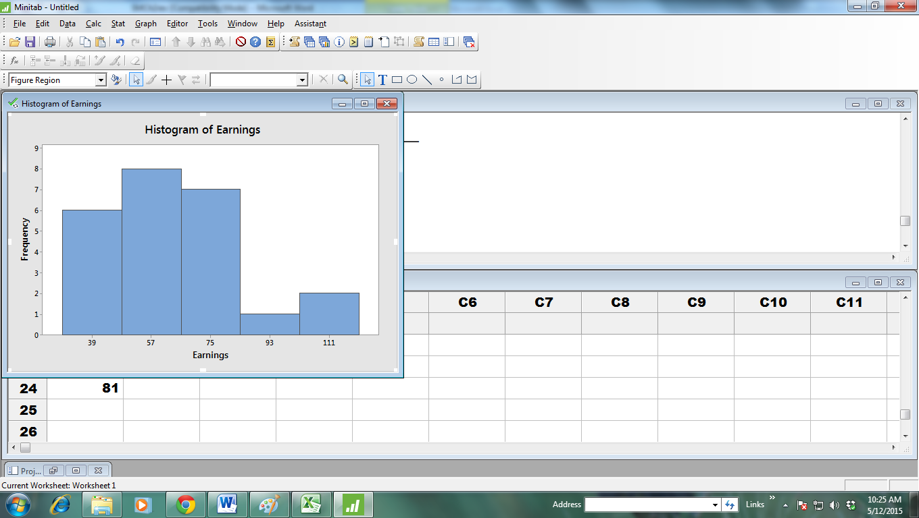

b. See table in part (a) for cumulative distributions.

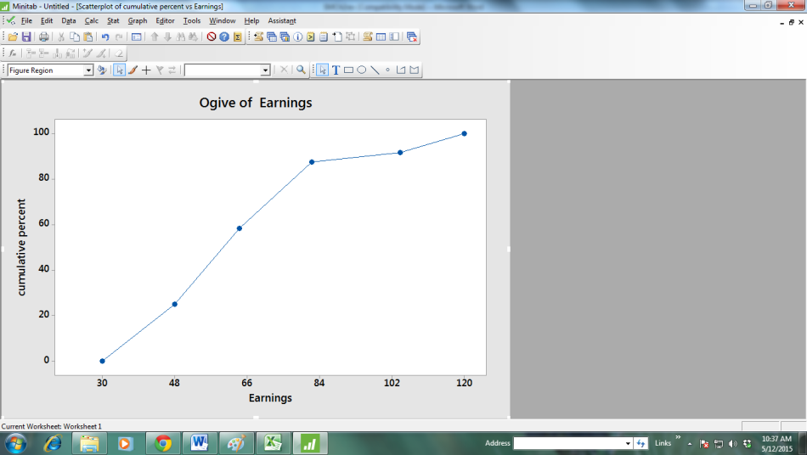

c.

d.The first class’s lower boundary is the smallest measurement, 30. Using the suggested class length of 120, the first class’s upper boundary is the lower boundary plus the class length, 30 + 120 = 150

The second class’s lower boundary is the first class’s upper boundary, 150

Continue adding the Class Length (width) to lower boundaries to obtain the 5 classes:

| 30 < 150 | 150 < 270 | 270 < 390 | 390 < 510 | 510 < 630 |

Frequency Distribution for ***Earnings (including Dr. Dre)***

|  |  |  |  |  |  |  |  |  |
| --- | --- | --- | --- | --- | --- | --- | --- | --- |
|  |  |  |  |  |  |  | *cumulative* | *cumulative* |
| *lower* |  | *upper* | *midpoint* | *width* | *frequency* | *percent* | *frequency* | *percent* |
| 30 | < | 150 | 90 | 120 | 24 | 96 | 24 | 96 |
| 150 | < | 270 | 210 | 120 | 0 | 0 | 24 | 96 |
| 270 | < | 390 | 330 | 120 | 0 | 0 | 24 | 96 |
| 390 | < | 510 | 450 | 120 | 0 | 0 | 24 | 96 |
| 510 | ≤ | 630 | 570 | 120 | 1 | 4 | 25 | 100 |
|  |  |  |  |  | 25 | 100 |  |  |

LO02-03

**2.21 a.** The video game satisfaction ratings are concentrated between 40 and 46.

**b.** Shape of distribution is slightly skewed left. Recall that these ratings have a minimum value of 7 and a maximum value of 49. This shows that the responses from this survey are reaching near to the upper limit but significantly diminishing on the low side.

|  |  |  |  |  |  |  |  |  |
| --- | --- | --- | --- | --- | --- | --- | --- | --- |
| **c.** | Class: | 1 | 2 | 3 | 4 | 5 | 6 | 7 |
|  | Ratings: | 34<x≤36 | 36<x≤38 | 38<x≤40 | 40<x≤42 | 42<x≤44 | 44<x≤46 | 46<x≤48 |
| **d.** | CumFreq: | 1 | 4 | 13 | 25 | 45 | 61 | 65 |

LO02-03

**2.22 a.** The bank wait times are concentrated between 4 and 9 minutes. (You might make a slightly different choice.)

**b.** The shape of distribution is slightly skewed right. Waiting time has a lower limit of 0 and stretches out to the high side where there are a few people who have to wait longer.

**c.** The class length is 1 minute.

**d.** Frequency Distribution for ***Bank Wait Times***

|  |  |  |  |  |  |  |  |  |
| --- | --- | --- | --- | --- | --- | --- | --- | --- |
|  |  |  |  |  |  |  | *cumulative* | *cumulative* |
| *lower* | < | *upper* | *midpoint* | *width* | *frequency* | *percent* | *frequency* | *percent* |
| -0.5 | < | 0.5 | 0 | 1 | 1 | 1% | 1 | 1% |
| 0.5 | < | 1.5 | 1 | 1 | 4 | 4% | 5 | 5% |
| 1.5 | < | 2.5 | 2 | 1 | 7 | 7% | 12 | 12% |
| 2.5 | < | 3.5 | 3 | 1 | 8 | 8% | 20 | 20% |
| 3.5 | < | 4.5 | 4 | 1 | 17 | 17% | 37 | 37% |
| 4.5 | < | 5.5 | 5 | 1 | 16 | 16% | 53 | 53% |
| 5.5 | < | 6.5 | 6 | 1 | 14 | 14% | 67 | 67% |
| 6.5 | < | 7.5 | 7 | 1 | 12 | 12% | 79 | 79% |
| 7.5 | < | 8.5 | 8 | 1 | 8 | 8% | 87 | 87% |
| 8.5 | < | 9.5 | 9 | 1 | 6 | 6% | 93 | 93% |
| 9.5 | < | 10.5 | 10 | 1 | 4 | 4% | 97 | 97% |
| 10.5 | < | 11.5 | 11 | 1 | 2 | 2% | 99 | 99% |
| 11.5 | < | 12.5 | 12 | 1 | 1 | 1% | 100 | 100% |
|  |  |  |  |  | 100 |  |  |  |

LO02-03

**2.23 a.** The trash bag breaking strengths areconcentrated between 48 and 53 pounds.

**b.** The shape of distribution is symmetric and bell shaped.

**c.** The class length is 1 pound.

**d.** Class: 46<47 47<48 48<49 49<50 50<51 51<52 52<53 53<54 54<55  
Cum Freq. 2.5% 5.0% 15.0% 35.0% 60.0% 80.0% 90.0% 97.5% 100.0%



LO02-03

**2.24 a.** With 30 values, we will use 5 classes**.** Note that(Max – Min)/#Classes = (2500 – 485) / 5 = 403. For convenience, we will use classes of length 500 and begin the first class at 250. We obtain the 5 classes:

| 250 < 750 | 750 < 1250 | 1250 < 1750 | 1750 < 2250 | 2250< 2750 |

Frequency Distribution for MLB Team Values

|  |  |  |  |  |  |  |
| --- | --- | --- | --- | --- | --- | --- |
|  |  |  |  |  |  |  |
| *lower* |  | *upper* | *midpoint* | *width* | *frequency* | *percent* |
| 250 | < | 750 | 500 | 500 | 20 | 66.7 |
| 750 | < | 1250 | 1000 | 500 | 7 | 23.3 |
| 1250 | < | 1750 | 1500 | 500 | 1 | 3.3 |
| 1750 | < | 2250 | 2000 | 500 | 1 | 3.3 |
| 2250 | < | 2750 | 2500 | 500 | 1 | 3.3 |
|  |  |  |  |  | 30 | 99.9 |

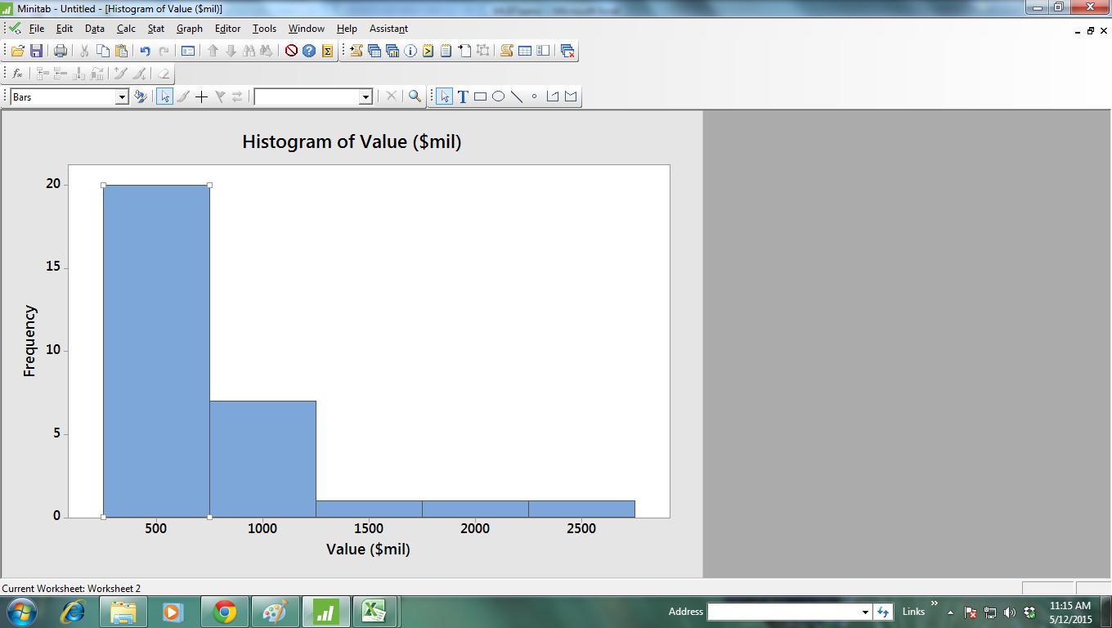The distribution is skewed right. While the majority of teams have valuations under $750 million, a few franchises have much higher valuations.

**b.** Again,we will use 5 classes**.** Note that (Max – Min)/#Classes = (461 – 159) / 5 = 60.4. For convenience, we will use classes of length 75 and begin the first class at 150. We obtain the 5 classes:

| 150 < 225 | 225 < 300 | 300 < 375 | 375 < 450 | 450 < 525 |

Frequency Distribution for MLB Team Revenues

|  |  |  |  |  |  |  |
| --- | --- | --- | --- | --- | --- | --- |
|  |  |  |  |  |  |  |
| *lower* |  | *upper* | *midpoint* | *width* | *frequency* | *percent* |
| 150 | < | 225 | 187.5 | 75 | 17 | 56.7 |
| 225 | < | 300 | 262.5 | 75 | 10 | 33.3 |
| 300 | < | 375 | 337.5 | 75 | 2 | 6.7 |
| 375 | < | 450 | 412.5 | 75 | 0 | 0 |
| 450 | < | 525 | 487.5 | 75 | 1 | 3.3 |
|  |  |  |  |  | 30 | 100 |

**c**.

LO02-03

**2.25 a.** We will use 6 classes since n = 40. Note that (Max – Min)/#Classes = (958 – 57) / 6 = 150.2. For convenience, we will use classes of length 175 and begin the first class at 0. We obtain the 6 classes:

| 0 < 175 | 175 < 350 | 350 < 525 | 525 < 700 | 700 < 875 | 875 < 1050

Frequency Distribution for ***Best Small Company Sales***

|  |  |  |  |  |  |
| --- | --- | --- | --- | --- | --- |
|  |  |  |  |  |  |
| *lower* |  | *upper* | *midpoint* | *width* | *frequency* |
| 0 | < | 175 | 87.5 | 175 | 9 |
| 175 | < | 350 | 262.5 | 175 | 7 |
| 350 | < | 525 | 437.5 | 175 | 3 |
| 525 | < | 700 | 612.5 | 175 | 6 |
| 700 | < | 875 | 787.5 | 175 | 12 |
| 875 | < | 1050 | 962.5 | 175 | 3 |
|  |  |  |  |  |  |

40

**b.** We will again use 6 classes. Note that (Max – Min)/#Classes = (75 – 4) / 6 = 11.8. For convenience, we will use classes of length 15 and begin the first class at 0. We obtain the 6 classes:

| 0 < 15 | 15 < 30 | 30 < 45 | 45 < 60 | 60 < 75 | 75 < 90

Frequency Distribution for ***Best Small Company Sales Growth***

|  |  |  |  |  |  |
| --- | --- | --- | --- | --- | --- |
|  |  |  |  |  |  |
| *lower* |  | *upper* | *midpoint* | *width* | *frequency* |
| 0 | < | 15 | 7.5 | 175 | 16 |
| 15 | < | 30 | 22.5 | 175 | 17 |
| 30 | < | 45 | 37.5 | 175 | 5 |
| 45 | < | 60 | 52.5 | 175 | 1 |
| 60 | < | 75 | 67.5 | 175 | 0 |
| 75 | < | 90 | 82.5 | 175 | 1 |
|  |  |  |  |  |  |

40

LO02-03

**2.26 a.** Frequency Distribution for ***Annual Savings in $000***

|  |  |  |  |  |  |  |  |  |  |
| --- | --- | --- | --- | --- | --- | --- | --- | --- | --- |
|  |  |  |  |  |  | *width =* | *factor* | *frequency =* | *height* |
| *lower* |  | *upper* | *midpoint* | *width* | *frequency* | *base* |  | *factor* |  |
| 0 | < | 10 | 5.0 | 10 | 162 | 10 / 10 = | 1.0 | 162 / 1.0 = | 162.0 |
| 10 | < | 25 | 17.5 | 15 | 62 | 15 / 10 = | 1.5 | 62 / 1.5 = | 41.3 |
| 25 | < | 50 | 37.5 | 25 | 53 | 25 / 10 = | 2.5 | 53 / 2.5 = | 21.2 |
| 50 | < | 100 | 75.0 | 50 | 60 | 50 / 10 = | 5.0 | 60 / 5.0 = | 12 |
| 100 | < | 150 | 125.0 | 50 | 24 | 50 / 10 = | 5.0 | 24 / 5.0 = | 4.8 |
| 150 | < | 200 | 175.0 | 50 | 19 | 50 / 10 = | 5.0 | 19 / 5.0 = | 3.8 |
| 200 | < | 250 | 225.0 | 50 | 22 | 50 / 10 = | 5.0 | 22 / 5.0 = | 4.4 |
| 250 | < | 500 | 375.0 | 250 | 21 | 250 / 10 = | 25.0 | 21 / 25.0 = | 0.8 |
| 500 |  |  |  |  | 37 |  |  |  |  |
|  |  |  |  |  | 460 |  |  |  |  |

**2.26 b.** and **2.27**

|  |  |  |  |  |  |  |  |  |  |  |  |  |  |  |  |  |  |  |  |
| --- | --- | --- | --- | --- | --- | --- | --- | --- | --- | --- | --- | --- | --- | --- | --- | --- | --- | --- | --- |
| **Histogram of Annual Savings in $000** | | | | | | | | | | | | | | | | | | | |
| 160 |  |  | 162 | |  | |  | |  | |  | |  | |  | |  | |  |
| 150 |  |  |  | |  | |  | |  | |  | |  | |  | |  | |  |
| 140 |  |  |  | |  | |  | |  | |  | |  | |  | |  | |  |
| 130 |  |  |  | |  | |  | |  | |  | |  | |  | |  | |  |
| 120 |  |  |  | |  | |  | |  | |  | |  | |  | |  | |  |
| 110 |  |  |  | |  | |  | |  | |  | |  | |  | |  | |  |
| 100 |  |  |  | |  | |  | |  | |  | |  | |  | |  | |  |
| 90 |  |  |  | |  | |  | |  | |  | |  | |  | |  | |  |
| 80 |  |  |  | |  | |  | |  | |  | |  | |  | |  | |  |
| 70 |  |  |  | |  | |  | |  | |  | |  | |  | |  | |  |
| 60 |  |  |  | |  | |  | |  | |  | |  | |  | |  | |  |
| 50 |  |  |  | |  | |  | |  | |  | |  | |  | |  | |  |
| 40 |  |  | 41.3 | |  | |  | |  | |  | |  | |  | |  | |  |
| 30 |  |  |  | |  | |  | |  | |  | |  | |  | |  | |  |
| 20 |  |  |  | | 21.2 | |  | |  | |  | |  | |  | |  | |  |
| 10 |  |  |  | |  | | 12.0 | |  | |  | |  | |  | |  | |  |
|  |  |  |  | |  | |  | | 4.8 | | 3.8 | | 4.4 | |  | |  | |  |
|  |  |  |  | |  | |  | |  | |  | |  | | 0.8 | |  | |  |
|  | 0 | 10 | | 25 | | 50 | | 100 | | 150 | | 200 | | 250 | | 500 | | * 37 |  |
| **Annual Savings ($000)** | | | | | | | | | | | | | | | | | | | |

LO02-03

# §2.3Concepts

**2.28** The horizontal axis spans the range of measurements, and the dots represent the measurements.

LO02-04

**2.29** A dot plot with 1,000 points is not practical. Group the data and use a histogram.

LO02-03, LO02-04

# §2.3 Methods and Applications

**2.30**



The distribution is concentrated between 0 and 2 and is skewed to the right. Eight and ten are probably high outliers.

LO02-04

**2.31**



Most growth rates are no more than 71%, but 4 companies had growth rates of 87% or more.

LO02-04

**2.32**



The distribution is slightly skewed to the left and centered near 45 home runs.

LO02-04

# §2.4 Concepts

**2.33** Both the histogram and the stem-and-leaf show the shape of the distribution, but only the stem-and-leaf shows the values of the individual measurements.

LO02-03, LO02-05

**2.34** Several advantages of the stem-and-leaf display include that it:  
-Displays all the individual measurements.   
-Puts data in numerical order  
-Is simple to construct

LO02-05

**2.35** With a large data set (e.g., 1,000 measurements) it does not make sense to use a stem-and-leaf because it is impractical to write out 1,000 data points. Group the data and use a histogram.

LO02-03, LO02-05

# §2.4 Methods and Applications

**2.36** Stem Unit = 10, Leaf Unit = 1 ***Revenue Growth in Percent***

|  |  |  |
| --- | --- | --- |
| *Frequency* | *Stem* | *Leaf* |
| 1 | 2 | 8 |
| 4 | 3 | 0 2 3 6 |
| 5 | 4 | 2 2 3 4 9 |
| 5 | 5 | 1 3 5 6 9 |
| 2 | 6 | 3 5 |
| 1 | 7 | 0 |
| 1 | 8 | 3 |
| 1 | 9 | 1 |
| 20 |  |  |

LO02-05

**2.37** Stem Unit = 1, Leaf Unit =.1 ***Profit Margins (%)***

|  |  |  |
| --- | --- | --- |
| *Frequency* | *Stem* | *Leaf* |
| 2 | 10 | 4 4 |
| 0 | 11 |  |
| 1 | 12 | 6 |
| 3 | 13 | 2 8 9 |
| 4 | 14 | 0 1 4 9 |
| 4 | 15 | 2 2 8 9 |
| 4 | 16 | 1 1 4 8 |
| 0 | 17 |  |
| 0 | 18 |  |
| 0 | 19 |  |
| 0 | 20 |  |
| 0 | 21 |  |
| 1 | 22 | 2 |
| 0 | 23 |  |
| 0 | 24 |  |
| 1 | 25 | 2 |
| 20 |  |  |

LO02-05

**2.38** Stem Unit = 1000, Leaf Unit = 100 ***Sales($mil)***

|  |  |  |
| --- | --- | --- |
| *Frequency* | *Stem* | *Leaf* |
| 5 | 1 | 2 4 4 5 7 |
| 5 | 2 | 0 4 7 7 8 |
| 4 | 3 | 3 3 5 7 |
| 2 | 4 | 2 6 |
| 1 | 5 | 4 |
| 2 | 6 | 0 8 |
| 1 | 7 | 9 |

LO02-05

**2.39 a.** The Payment Times distribution is skewed to the right.

**b.** The Bottle Design Ratings distribution is skewed to the left.

LO02-05

**2.40 a.** The distribution is symmetric and centered near 50.7 pounds.

**b.** 46.8, 47.5, 48.2, 48.3, 48.5, 48.8, 49.0, 49.2, 49.3, 49.4

LO02-05

**2.41** Stem unit = 10, Leaf Unit = 1 ***Home Runs***

|  |  |  |
| --- | --- | --- |
| *Leaf* | *Stem* | *Leaf* |
| Roger Maris |  | Babe Ruth |
| 8 | 0 |  |
| 6 4 3 | 1 |  |
| 8 6 3 | 2 | 2 5 |
| 9 3 | 3 | 4 5 |
|  | 4 | 1 1 6 6 6 7 9 |
|  | 5 | 4 4 9 |
| 1 | 6 | 0 |

The 61 home runs hit by Maris would be considered an outlier for him, although an exceptional individual achievement.

LO02-05

**2.42 a.** Stem unit = 1, Leaf Unit = 0.1 ***Bank Customer Wait Time***

|  |  |  |
| --- | --- | --- |
| *Frequency* | *Stem* | *Leaf* |
| 2 | 0 | 4 8 |
| 6 | 1 | 1 3 4 6 8 8 |
| 9 | 2 | 0 2 3 4 5 7 8 9 9 |
| 11 | 3 | 1 2 4 5 6 7 7 8 8 9 9 |
| 17 | 4 | 0 0 1 2 3 3 3 4 4 5 5 5 6 7 7 8 9 |
| 15 | 5 | 0 1 1 2 2 3 4 4 5 6 6 7 8 8 8 |
| 13 | 6 | 1 1 2 3 3 3 4 5 5 6 7 7 8 |
| 10 | 7 | 0 2 2 3 4 4 5 7 8 9 |
| 7 | 8 | 0 1 3 4 6 6 7 |
| 6 | 9 | 1 2 3 5 8 9 |
| 3 | 10 | 2 7 9 |
| 1 | 11 | 6 |
| 100 |  |  |

**b.** The distribution of wait times is fairly symmetrical, maybe with a slight skew to the right.

LO02-05

**2.43 a.** Stem unit = 1, Leaf Unit = 0.1 ***Video Game Satisfaction Ratings***

|  |  |  |
| --- | --- | --- |
| *Frequency* | *Stem* | *Leaf* |
| *1* | 36 | 0 |
| 0 | 37 |  |
| 3 | 38 | 0 0 0 |
| 4 | 39 | 0 0 0 0 |
| 5 | 40 | 0 0 0 0 0 |
| 6 | 41 | 0 0 0 0 0 0 |
| 6 | 42 | 0 0 0 0 0 0 |
| 8 | 43 | 0 0 0 0 0 0 0 0 |
| 12 | 44 | 0 0 0 0 0 0 0 0 0 0 0 0 |
| 9 | 45 | 0 0 0 0 0 0 0 0 0 |
| 7 | 46 | 0 0 0 0 0 0 0 |
| 3 | 47 | 0 0 0 |
| 1 | 48 | 0 |
| 65 |  |  |

**b.** The video game satisfaction ratings distribution is slightly skewed to the left.

**c.** Since 19 of the 65 ratings (29%) are below the “very satisfied” level of 42, it would *not* be accurate to say that almost all purchasers are very satisfied.

LO02-05

# §2.5Concepts

**2.44** Contingency tables are used to study the association between two variables.

LO02-06

**2.45** We fill each cell of the contingency table by counting the number of observations that have both of the specific values of the categorical variables associated with that cell.

LO02-06

**2.46** A row percentage is calculated by dividing the cell frequency by the total frequency for that particular row and by expressing the resulting fraction as a percentage.

A column percentage is calculated by dividing the cell frequency by the total frequency for that particular column and by expressing the resulting fraction as a percentage.

Row percentages show the distribution of the column categorical variable for a given value of the row categorical variable.

Column percentages show the distribution of the row categorical variable for a given value of the column categorical variable.

LO02-06

# §2.5 Methods and Applications

**2.47** Cross tabulation of Brand Preference vs. Rola Purchase History

**Brand Purchased Rola?**

|  |  |  |  |  |
| --- | --- | --- | --- | --- |
| **Preference** |  | **No** | **Yes** | ***Total*** |
| **Koka** | **Observed** | **14** | **2** | ***16*** |
|  | % of row | 87.5% | 12.5% | 100% |
|  | % of column | 66.7% | 10.5% | 40% |
|  | % of total | 35.0% | 5.0% | 40% |
| **Rola** | **Observed** | **7** | **17** | ***24*** |
|  | % of row | 29.2% | 70.8% | 100% |
|  | % of column | 33.3% | 89.5% | 60% |
|  | % of total | 17.5% | 42.5% | 60% |
| ***Total*** | ***Observed*** | ***21*** | ***19*** | ***40*** |
|  | % of row | 52.5% | 47.5% | 100% |
|  | % of column | 100.0% | 100.0% | 100% |
|  | % of total | 52.5% | 47.5% | 100% |

**a.** 17 shoppers who preferred Rola-Cola had purchased it before.

**b.** 14 shoppers who preferred Koka-Cola had not purchased Rola before.

**c.** If you have purchased Rola previously you are more likely to prefer Rola.   
If you have not purchased Rola previously you are more likely to prefer Koka.

LO02-06

**2.48** Cross tabulation of Brand Preference vs. Sweetness Preference

**Brand Sweetness Preference**

|  |  |  |  |  |  |
| --- | --- | --- | --- | --- | --- |
| **Preference** |  | **Very Sweet** | **Sweet** | **Not So Sweet** | ***Total*** |
| **Koka** | **Observed** | **6** | **4** | **6** | ***16*** |
|  | % of row | 37.5% | 25.0% | 37.5% | 100% |
|  | % of column | 42.9% | 30.8% | 46.2% | 40% |
|  | % of total | 15.0% | 10.0% | 15.0% | 40% |
| **Rola** | **Observed** | **8** | **9** | **7** | ***24*** |
|  | % of row | 33.3% | 37.5% | 29.2% | 100% |
|  | % of column | 57.1% | 69.2% | 53.8% | 60% |
|  | % of total | 20.0% | 22.5% | 17.5% | 60% |
| ***Total*** | ***Observed*** | ***14*** | ***13*** | ***13*** | ***40*** |
|  | % of row | 35.0% | 32.5% | 32.5% | 100% |
|  | % of column | 100.0% | 100.0% | 100.0% | 100% |
|  | % of total | 35.0% | 32.5% | 32.5% | 100% |

**a.** 8 + 9 = 17 shoppers who preferred Rola-Cola also preferred their drinks Sweet or Very Sweet.

**b.** 6 shoppers who preferred Koka-Cola also preferred their drinks not so sweet.

**c.** Rola drinkers may prefer slightly sweeter drinks than Koka drinkers.

LO02-06

**2.49** Cross tabulation of Brand Preference vs. Number of 12-PacksConsumed Monthly

**Brand Consumption**

|  |  |  |  |  |  |
| --- | --- | --- | --- | --- | --- |
| **Preference** |  | **0 to 5** | **6 to 10** | **>10** | **Total** |
| **Koka** | **Observed** | **12** | **3** | **1** | ***16*** |
|  | % of row | 75.0% | 18.8% | 6.3% | 100% |
|  | % of column | 60.0% | 17.6% | 33.3% | 40% |
|  | % of total | 30.0% | 7.5% | 2.5% | 40% |
| **Rola** | **Observed** | **8** | **14** | **2** | ***24*** |
|  | % of row | 33.3% | 58.3% | 8.3% | 100% |
|  | % of column | 40.0% | 82.4% | 66.7% | 60% |
|  | % of total | 20.0% | 35.0% | 5.0% | 60% |
| ***Total*** | ***Observed*** | ***20*** | ***17*** | ***3*** | ***40*** |
|  | % of row | 50.0% | 42.5% | 7.5% | 100% |
|  | % of column | 100.0% | 100.0% | 100.0% | 100% |
|  | % of total | 50.0% | 42.5% | 7.5% | 100% |

**a.** 8 + 14 = 22 shoppers who preferred Rola-Cola purchase 10 or fewer 12-packs.

**b.** 3 + 1 = 4 shoppers who preferred Koka-Cola purchase 6 or more 12-packs.

**c.** People who drink more cola seem more likely to prefer Rola.

LO02-06

**2.50 a.** 16%, 56%

|  |  |  |  |  |
| --- | --- | --- | --- | --- |
| **b.** | Row Percentage Table | **Watch Tennis** | **Do Not Watch Tennis** | **Total** |
|  | **Drink Wine** | 40% | 60% | 100% |
|  | **Do Not Drink Wine** | 6.7% | 93.3% | 100% |

|  |  |  |  |
| --- | --- | --- | --- |
| **c.** | Column Percentage Table | **Watch Tennis** | **Do Not Watch Tennis** |
|  | **Drink Wine** | 80% | 30% |
|  | **Do Not Drink Wine** | 20% | 70% |
|  | **Total** | 100% | 100% |

**d.** People who watch tennis are more likely to drink wine than those who do not watch tennis.

**e.**

|  |  |
| --- | --- |
|  |  |

LO02-01, LO02-06

**2.51 a.** TV Violence

|  |  |  |  |
| --- | --- | --- | --- |
| TV Quality | Increased | Not Increased | Total |
| Worse | 362 | 92 | 454 |
| Not Worse | 359 | 187 | 546 |
| Total | 721 | 279 | 1000 |

**b.** Row percentages TV Violence

|  |  |  |  |
| --- | --- | --- | --- |
| TV Quality | Increased | Not Increased | Total |
| Worse | 79.7% | 20.3% | 100% |
| Not Worse | 65.8% | 34.2% | 100% |

**c.** Column percentagesTV Violence

|  |  |  |
| --- | --- | --- |
| TV Quality | Increased | Not Increased |
| Worse | 50.2% | 33.0% |
| Not Worse | 49.8% | 67.0% |
| Total | 100.0% | 100.0% |

**d.** Those people who think TV violence has increased are more likely to think TV quality has gotten worse.

**e.**

LO02-01, LO02-06

**2.52 a.** As income rises the percent of people seeing larger tips as appropriate also rises.

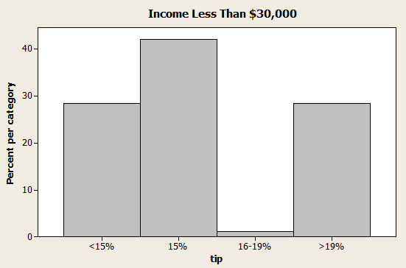

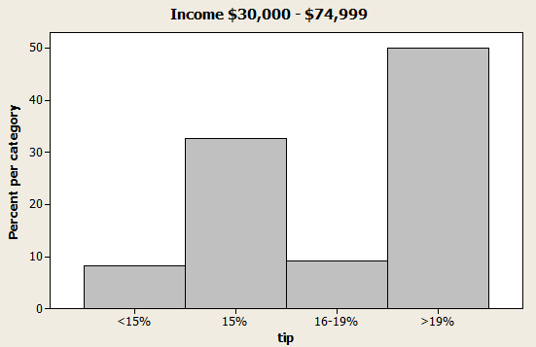

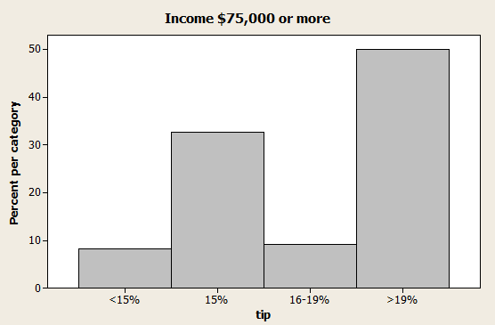

**b.** People who have left at least once without leaving a tip are more likely to think a smaller tip is appropriate.



LO02-01, LO02-06

# §2.6 Concepts

**2.53** A scatterplot is used to look at the relationship between two quantitative variables.

LO02-07

**2.54** On a scatter plot, each value of *y* is plotted against its corresponding value of *x*.  
On a times series plot, each individual process measurement is plotted against its corresponding time of occurrence.

LO02-07

# §2.6 Methods and Applications

**2.55** As the number of copiers increases, so does the service time.



LO02-07

**2.56** The scatterplot shows that the average rating for taste is related to the average rating for preference in a positive linear fashion. This relationship is fairly strong.



**2.56** (*cont*.) The scatterplots below show that average convenience, familiarity, and price are all approximately linearly related to average preference in a positive, positive, and negative fashion (respectively). These relationships are not as strong as the one between taste and preference.







LO02-07

# §2.7 Concepts

**2.58** When the vertical axis does not start at zero, the bars themselves will not be as tall as if the bars had started at zero. Hence, the relative differences in the heights of the bars will be more pronounced.

LO02-08

**2.59** Examples and reports will vary.

LO02-08

# §2.7 Methods and Applications

**2.60** The administration’s compressed plot indicates a steep increase of nurses’ salaries over the four years, while the union organizer’s stretched plot shows a more gradual increase of the same salaries over the same time period.

LO02-08

**2.61 a.** No. The graph of the number of private elementary schools is showing only a very slight (if any) increasing trend when scaled with public schools.

**b.** Yes. The graph of the number of private elementary schools is showing strong increasing trend, particularly after 1950.

**c.** The line graph is more appropriate because it shows growth.

**d.** Neither graph gives an accurate understanding of the changes spanning a half century. Because of the very large difference in scale between private and public schools, a comparison of growth might be better described using percent increase.

LO02-08

# §2.8Concepts

**2.62** (1) A gauge allows us to visualize an organization’s key performance indicators in way that is similar to an automobile speedometer.

(2) A bullet graph displays a measure of performance as a horizontal (or vertical) bar that extends into ranges representing qualitative measures of performance. Many bullet graphs compare the measure of performance (bar) to a target or objective.

(3) A treemap displays information in a series of clustered rectangles. The sizes of the rectangles represent values of a first variable, and the colors of the rectangles represent a second variable.

(4) A sparkline is a line chart that shows the pattern of variation of variable (usually over time).

LO02-09

**2.63** Data drill down is a version of data discovery which reveals more detailed data that underlie a higher level data summary.

LO02-09

# §2.8 Methods and Applications

**2.64** The company has met the targets for revenue and customer satisfaction, but has not met the targets for profit, average order size, and new customers.

LO02-09

**2.65** The ozone level is higher in Chicago because the corresponding rectangle is more nearly red.

LO02-089

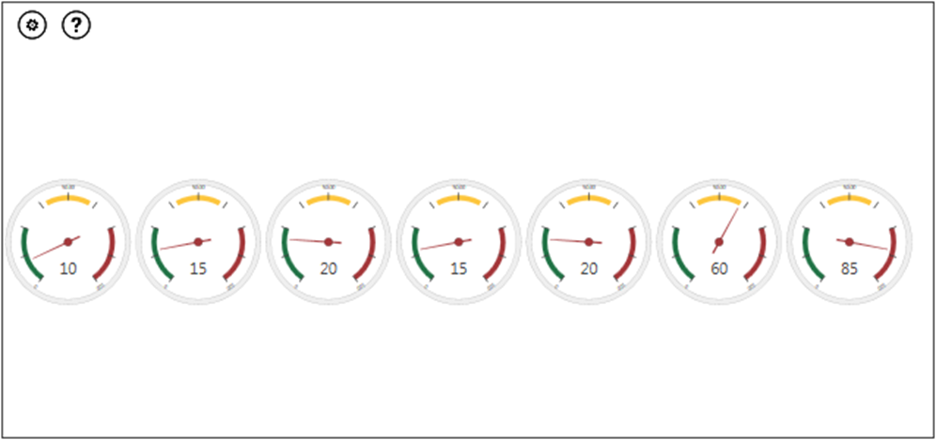**2.66**

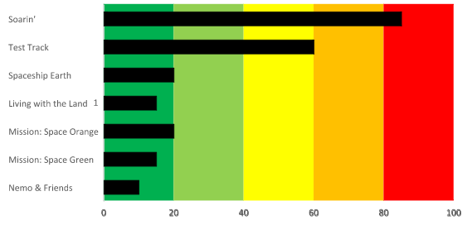

LO02-09

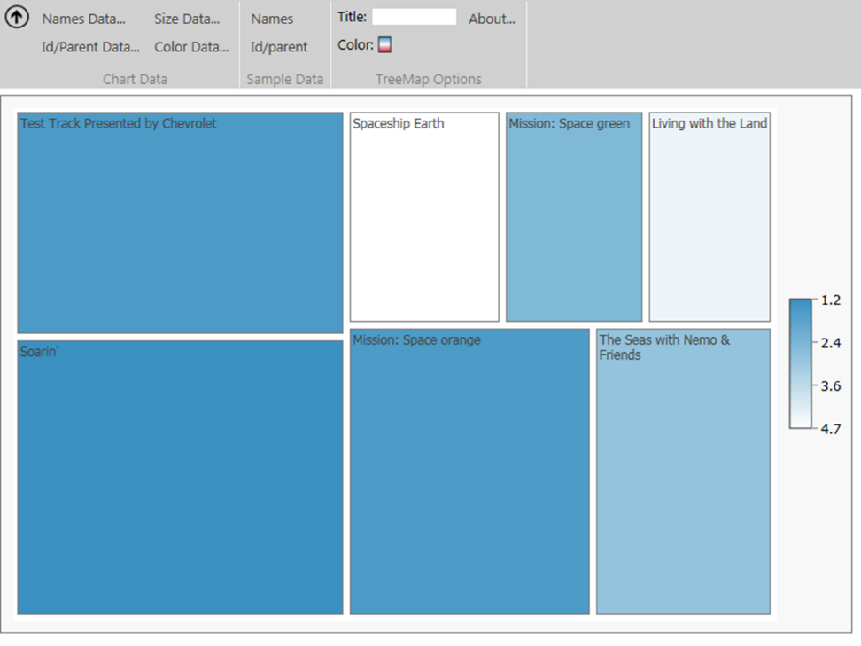**2.67**

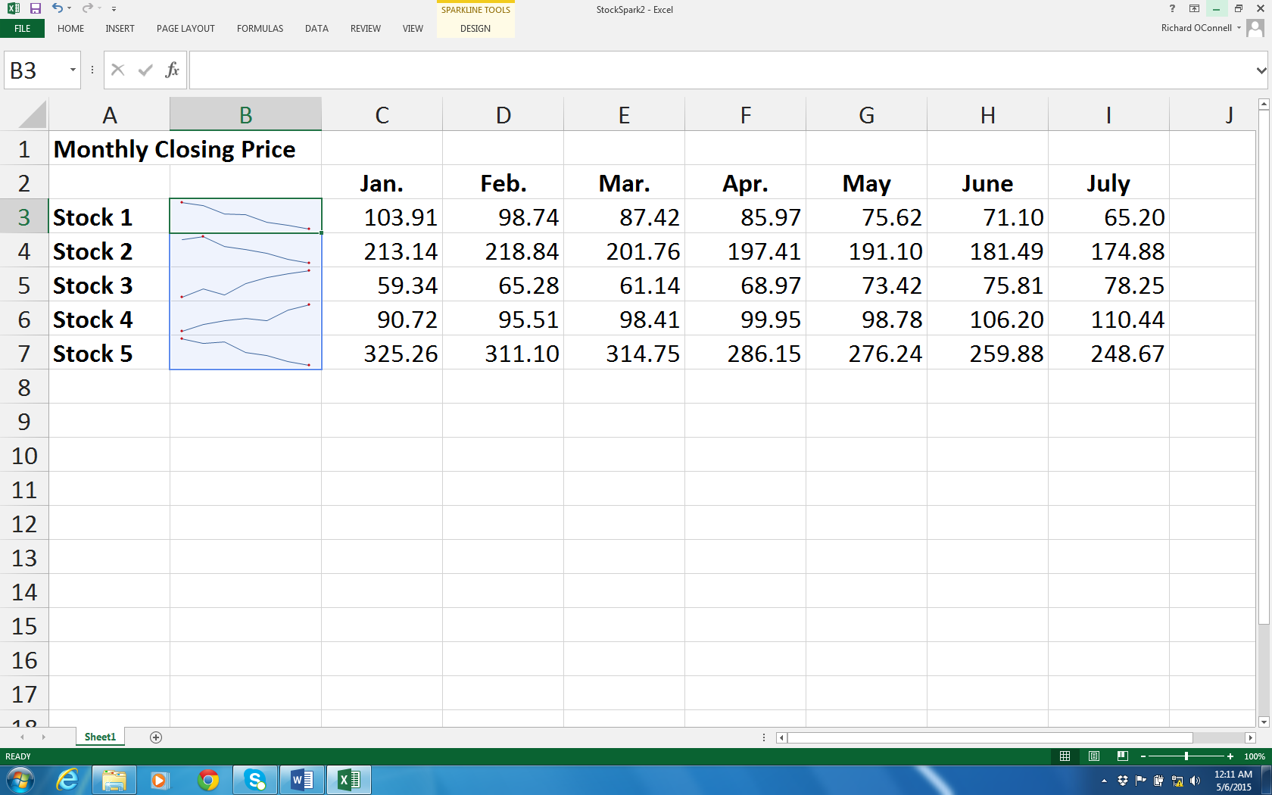 **2.68**

LO02-089

Supplementary Exercises

**2.69**





Reports will vary but should mention that although Liberty sales declined, this is not surprising since Liberty was one of 4 models in 2006 but one of 6 in 2011. As the dealer’s second most popular model in 2011, it is still an important part of his sales.

LO02-01

**2.70**

|  |  |  |
| --- | --- | --- |
|  | **Mechanical Quality** |  |
| **class** | **midpoint** | **frequency** |
| **1.5 < 2.5** | **2** | **6** |
| **2.5 < 3.5** | **3** | **16** |
| **3.5 < 4.5** | **4** | **9** |
| **4.5 < 5.5** | **5** | **1** |
|  |  | **32** |

The most common mechanical quality rating is 3 while only one, the Lexus, got a 5.

**2.71**

|  |  |  |  |
| --- | --- | --- | --- |
| **Design Quality** | | | |
| **class** | **midpoint** | **frequency** | **rel freq** |
| **1.5 < 2.5** | **2** | **4** | **.125** |
| **2.5 < 3.5** | **3** | **23** | **.71875** |
| **3.5 < 4.5** | **4** | **3** | **.09375** |
| **4.5 < 5.5** | **5** | **2** | **.0625** |
|  |  | **32** | **1.0000** |

The majority of the cars (23 of 32) received a design rating of 3.

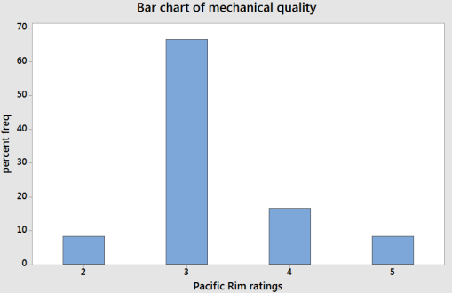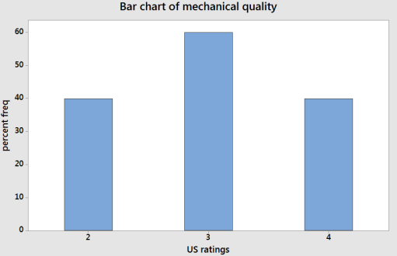**2.72**

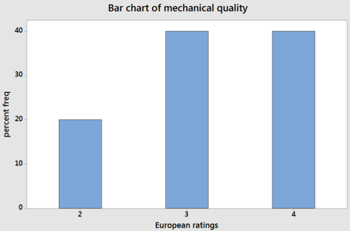

The US and Europe have very similar mechanical quality ratings although the US ratings are slightly lower than the European ones. The Pacific Rim cars overwhelmingly receive ratings of 3.

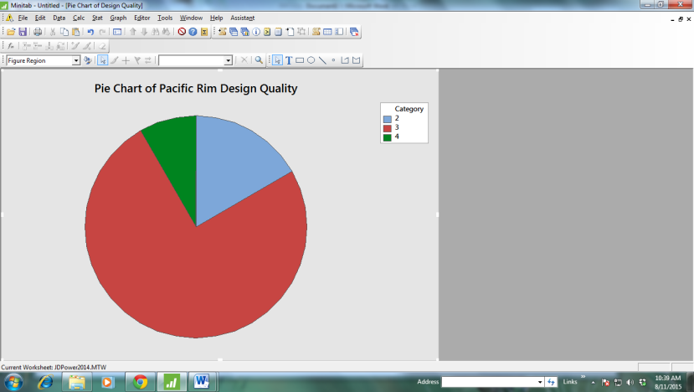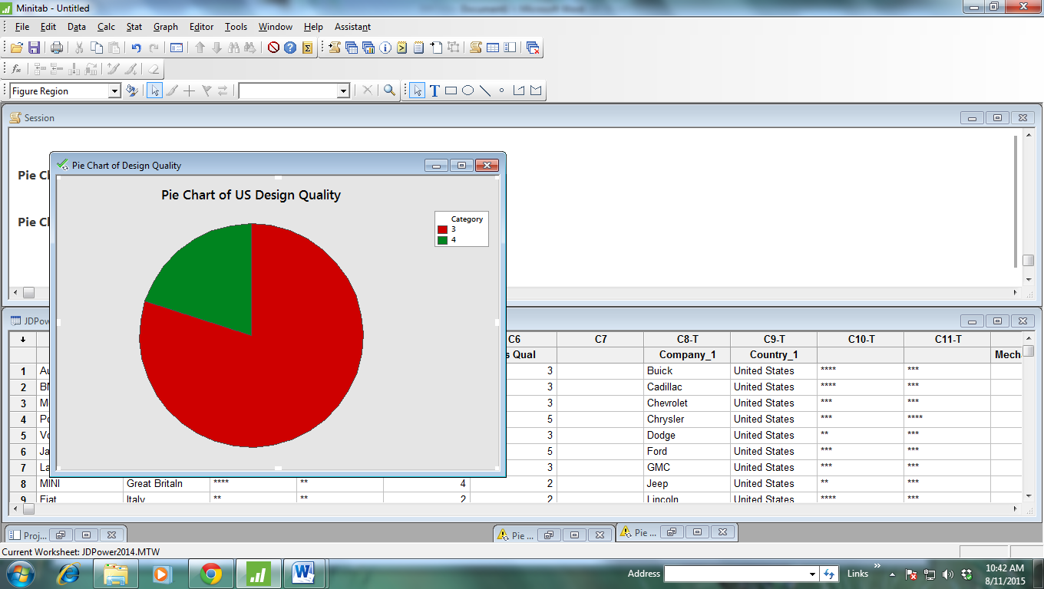**2.73**

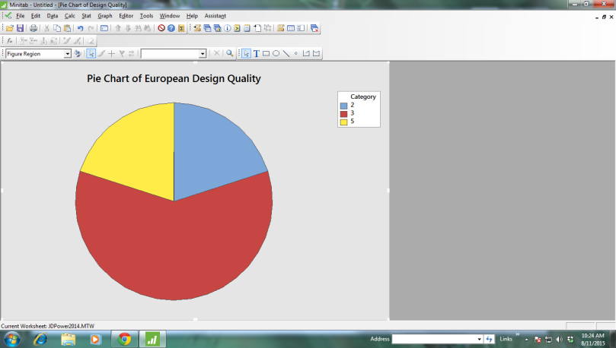All three regions have a majority of models rated 3 in design. Europe has the only models with ratings of 5, but like the Pacific Rim, it also has models rated 2, unlike the US.

**2.74** Rows: Region Columns: Mech quality

Among Better About

the best than most average The rest All

United States 0 3 4 3 10

0.00 30.00 40.00 30.00 100.00

Pacific Rim 1 2 8 1 12

8.33 16.67 66.67 8.33 100.00

Europe 0 4 4 2 10

0.00 40.00 40.00 20.00 100.00

All 1 9 16 6 32

3.13 28.13 50.00 18.75 100.00

Pacific Rim cars are likely to be about average in mechanical quality. European cars are the most likely to be above average (40% vs 30% for US and 25% for Pacific Rim).

**2.75** See table in 2.74 and the bar charts in 2.72

**2.76** Rows: Region Columns: Design quality

Among Better About

the best than most average The rest All

United States 0 2 8 0 10

0.00 20.00 80.00 0.00 100.00

Pacific Rim 0 1 9 2 12

0.00 8.33 75.00 16.67 100.00

Europe 2 0 6 2 10

20.00 0.00 60.00 20.00 100.00

All 2 3 23 4 32

6.25 9.38 71.88 12.50 100.00

All three regions tend to receive average design ratings, but the Pacific Rim region seems weakest in design. Only one model (8%) received a rating above average. In the US, 2 models (20%) received above average ratings and in Europe, 2 (20%) received “among the best” ratings.

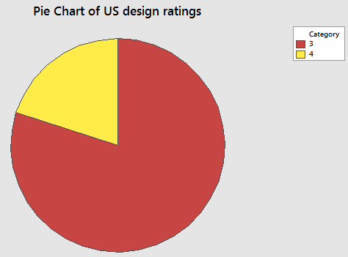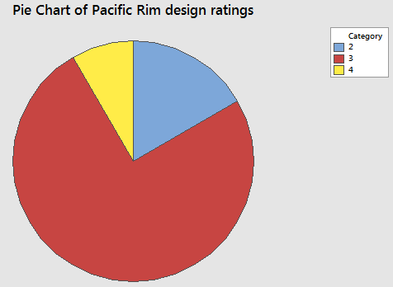**2.77** See the table in 2.76**.**

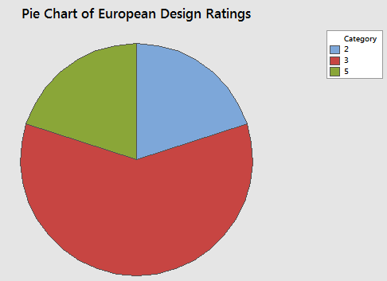

Same observations as in 2.76.

**2.78 a.** Frequency Distribution for ***Model Age***

|  |  |  |  |  |  |  |  |  |
| --- | --- | --- | --- | --- | --- | --- | --- | --- |
|  |  |  |  |  |  |  | *Cumulative* | *Cumulative* |
| *Lower* |  | *Upper* | *Midpoint* | *Width* | *Frequency* | *Percent* | *Frequency* | *Percent* |
| 17 | < | 19 | 18 | 2 | 3 | 6 | 3 | 6 |
| 19 | < | 21 | 20 | 2 | 2 | 4 | 5 | 10 |
| 21 | < | 23 | 22 | 2 | 3 | 6 | 8 | 16 |
| 23 | < | 25 | 24 | 2 | 5 | 10 | 13 | 26 |
| 25 | < | 27 | 26 | 2 | 8 | 16 | 21 | 42 |
| 27 | < | 29 | 28 | 2 | 15 | 30 | 36 | 72 |
| 29 | < | 31 | 30 | 2 | 10 | 20 | 46 | 92 |
| 31 | < | 33 | 32 | 2 | 4 | 8 | 50 | 100 |
|  |  |  |  |  | 50 | 100 |  |  |

While the 2K rule suggests using 6 classes, we are using 8 as suggested in the problem.

 **b.**

**c.** This distribution is skewed to the left.

LO02-03

**2.79**



LO02-03

**2.80** 26% of the perceived ages are below 25. This is probably too high.



LO02-04

**2.81 a & b & c.** See table in 2.78

 **d.**

**e.** 36 out of 50 = 72%

**f.** 8 out of 50 = 16%

LO02-03

**2.82 a. (1)** There are 50 charities in the list, so we will use 6 classes. The maximum private support is 3870 while the minimum is 235. Class length: (3870 – 235)/6 = 605.8. For convenience, we will use a length of 650 and make the first class have lower limit 200. We get:

|  |  |  |  |
| --- | --- | --- | --- |
| **classes** | **Midpoint** | **Frequency** | **Percent frequency** |
| **200 < 850** | **525** | **40** | **80** |
| **850 < 1500** | **1175** | **6** | **12** |
| **1500 < 2150** | **1825** | **3** | **6** |
| **2150 < 2800** | **2475** | **0** | **0** |
| **2800 < 3450** | **3125** | **0** | **0** |
| **3450 < 4100** | **3775** | **1** | **2** |

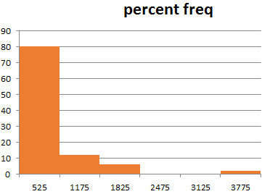

**2.82 a. (2)**

|  |  |  |  |
| --- | --- | --- | --- |
| **classes** | **Midpoint** | **Frequency** | **Percent frequency** |
| **200 < 3700** | **1950** | **43** | **86** |
| **3700 < 7200** | **5450** | **6** | **12** |
| **7200 < 10,700** | **8950** | **0** | **0** |
| **10,700 < 14,200** | **12,450** | **0** | **0** |
| **14,200 < 17,700** | **15,950** | **0** | **0** |
| **17,700 < 21,200** | **19,450** | **1** | **2** |

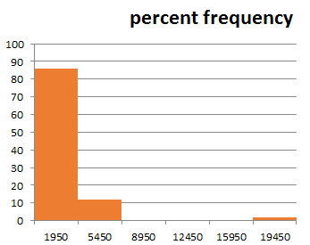

**2.82 a. (3)**

|  |  |  |  |
| --- | --- | --- | --- |
| **classes** | **Midpoint** | **Frequency** | **Percent frequency** |
| **77 < 81** | **79** | **1** | **2** |
| **81 < 85** | **83** | **8** | **16** |
| **85 < 89** | **87** | **8** | **16** |
| **89 < 93** | **91** | **9** | **18** |
| **93 < 97** | **95** | **6** | **12** |
| **97 < 101** | **99** | **18** | **36** |

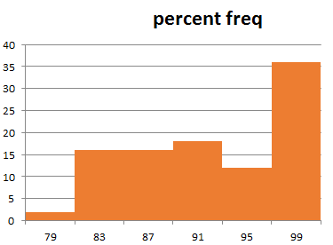

**2.82 b.** The histograms depicting private support and total revenues are quite skewed to the right while the histogram depicting fundraising efficiencies is skewed to the left.

**2.83** Distribution has one high outlier and with or without the outlier is skewed right.

**2.84** Stem Unit = 1, Leaf Unit = 0.1 ***Shots Missed***.

|  |  |  |
| --- | --- | --- |
| Frequency | Stem | Leaf |
| 1 | 5 | 0 |
| 2 | 6 | 0 |
| 4 | 7 | 0 0 |
| 9 | 8 | 0 0 0 0 0 |
| 15 | 9 | 0 0 0 0 0 0 |
| 15 | 10 | 0 0 0 0 0 |
| 10 | 11 | 0 0 |
| 8 | 12 | 0 |
| 7 | 13 | 0 |
| 6 | 14 | 0 |
| 5 | 15 | 0 0 |
| 3 | 16 | 0 |
| 2 | 17 | 0 |
| 1 | 18 | 0 |
| 30 |  |  |

•

•

•

•

•

•

0 10 20 30

15

10

5

Day

Number of Misses

•

•

•

•

•

•

•

•

•

•

•

•

•

•

•

•

•

•

•

•

•

•

•

•

The time series plot shows that the player is improving over time. Therefore the stem-and-leaf display does not predict how well the player will shoot in the future.

LO02-05

**2.85** **a.** Stock funds: $60,000; bond funds: $30,000; govt. securities: $10,000

**b.** Stock funds: $78,000 (63.36%); Bond funds: $34,500 (28.03%);   
Govt. securities: $10,600 (8.61%)

**c.** Stock funds: $73,860; Bond funds: $36,930; Govt. securities: $12,310

LO02-01

**2.86** The graph indicates that Chevy trucks far exceed Ford and Dodge in terms of resale value, but the y-axis scale is misleading.

LO02-08

# Internet Exercises

**2.87** Answers will vary depending on which poll(s) the student refers to.

LO02-01 – LO02-08