**CHAPTER 2—Descriptive Statistics: Tabular and Graphical Methods**

**2.1** Constructing either a frequency or a relative frequency distribution helps identify and quantify patterns in how often various categories occur.

L02-01

**2.2** Relative frequency of any category is calculated by counting the number of occurrences of the category divided by the total number of observations. Percent frequency is calculated by multiplying relative frequency by 100.

L02-01

**2.3** Answers and examples will vary.

L02-01

**2.4 a.**  Relative Percent

Category / ClassFrequencyFrequency Frequency

A 100 0.40 40%

B 25 0.10 10%

C 75 0.30 30%

D 50 0.20 20%

**b.**



L02-01

**2.5** **a.** (100 / 250) * 360 degrees = 144 degrees

**b.** (25 / 250) * 360 degrees = 36 degrees

**c.**



L02-01

**2.6** **a.** Relative frequency for product x is 1 – (0.15 + 0.36 + 0.28) = 0.21

**b.** Product: W X Y Z

75 105 180 140

**c.**



**d.** Degrees for W would be 54, for X degrees would be 75.6, for Y 129.6, and for Z 100.8.

L02-01

**2.7 a.** Rating Frequency Relative Frequency

Outstanding 14 0.467

Very Good 10 0.333

Good 5 0.167

Average 1 0.033

Poor 0 0.000

**b.**

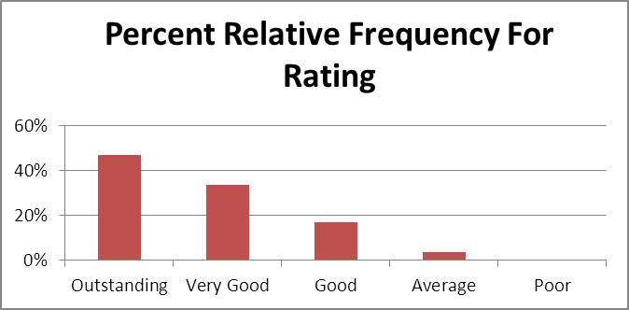

**c.**

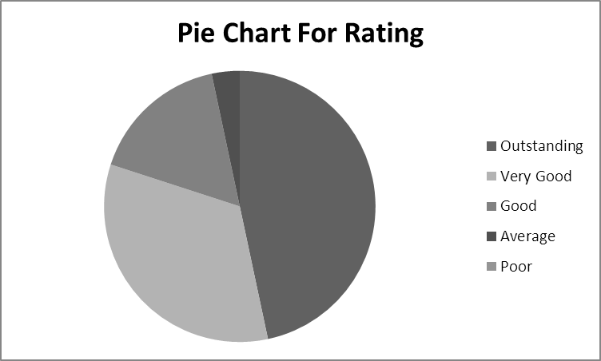

L02-01

**2.8 a. Tally for Discrete Variables: Sports League**

Sports Rel.

League Count Freq. Percent

MLB 11 0.22 22.00

MLS 3 0.06 6.00

NBA 8 0.16 16.00

NFL 23 0.46 46.00

NHL 5 0.10 10.00

N= 50

**b.**



**c.**



**d.** Most popular league is NFL and least popular is MLS.

L02-01

**2.9**

Chrysler

Dodge

Jeep



Chrysler Dodge Jeep



L02-01

**2.10** Comparing the two pie charts they show that since 2005 Ford & GM, have lost market share, while Chrysler and Japanese models have increased market share.

L02-01

**2.11**

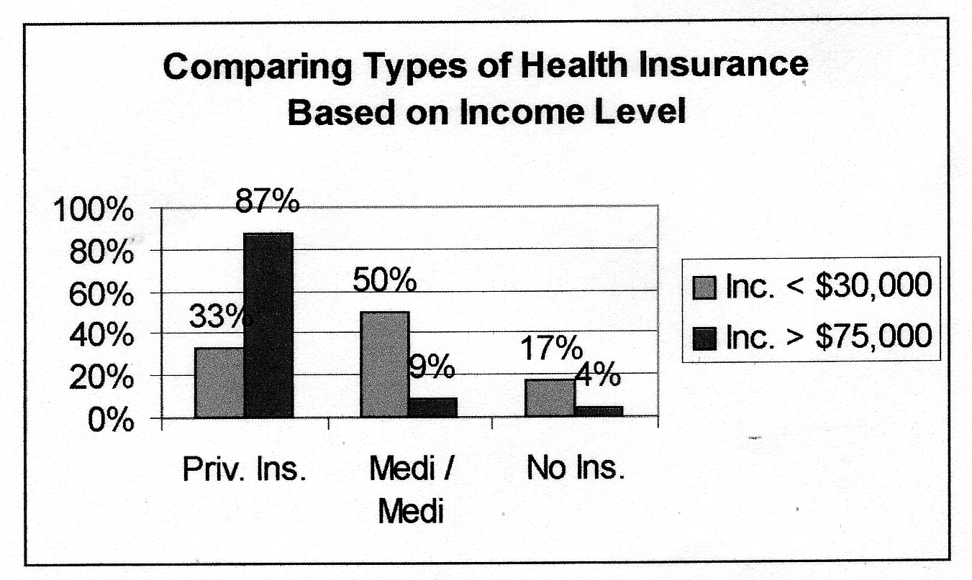

L02-01

**2.12 a.** 32.29%

**b.** 4.17%

**c.** Explanations will vary

L02-02

**2.13 a.** We construct a frequency distribution and a histogram for a data set so we can gain some insight into the shape, center, and spread of the data along with whether or not outliers exist.

**b.** A frequency histogram represents the frequency in a class using bars while in a frequency polygon the frequencies in consecutive classes are connected by a line.

**c.** A frequency ogive represents a cumulative distribution while the frequency polygon is not a cumulative distribution. Also, in a frequency polygon the lines connect the class midpoints while in a frequency ogive the lines connect the upper boundaries of the classes.

L02-03

**2.14 a.** To find the frequency for a class you simply count how many of the observations are greater than or equal to the lower boundary and less than the upper boundary.

**b.** Once you get the frequency for a class the relative frequency is obtained by dividing the class frequency by the total number of observations (data points).

**c.** Percent frequency for a class is calculated by multiplying the relative frequency by 100.

L02-03

**2.15 a.** One hump in the middle; left side looks like right side.

1. Two humps, left side may or may not look like right side.

1. Long tail to the right

**d.** Long tail to the left

L02-03

**2.16 a.** Since there are 28 points you should use 5 classes (from Table 2.5).

**b.** Class Length (CL) = (46 – 17) / 5 = 6

**c.** 17 ≤ x < 23, 23 ≤ x < 29, 29 ≤ x < 35, 35 ≤ x < 41, 41 ≤ x < 47

**d.**

|  |  |  |  |  |  |  |  |  |  |
| --- | --- | --- | --- | --- | --- | --- | --- | --- | --- |
| Frequency Distribution - Quantitative | | | | | |  |  |  |  |
|  |  |  |  |  |  |  |  |  |  |
|  |  | ***Data*** |  |  |  |  |  | *cumulative* | |
|  | *lower* |  | *upper* | *midpoint* | *width* | *frequency* | *percent* | *frequency* | *percent* |
|  | 12 | < | 18 | 15 | 6 | 1 | 3.6 | 1 | 3.6 |
|  | 18 | < | 24 | 21 | 6 | 3 | 10.7 | 4 | 14.3 |
|  | 24 | < | 30 | 27 | 6 | 2 | 7.1 | 6 | 21.4 |
|  | 30 | < | 36 | 33 | 6 | 5 | 17.9 | 11 | 39.3 |
|  | 36 | < | 42 | 39 | 6 | 14 | 50.0 | 25 | 89.3 |
|  | 42 | < | 48 | 45 | 6 | 3 | 10.7 | 28 | 100.0 |
|  |  |  |  |  |  |  |  |  |  |
|  |  |  |  |  |  | 28 | 100.0 |  |  |

**e.**

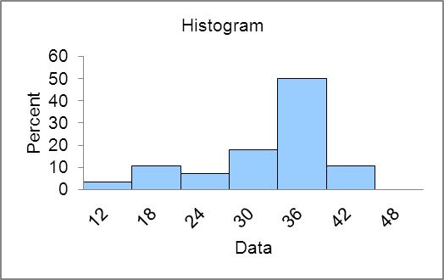

**f.** See output in answer to d.

L02-03

**2.17 a & b.**

|  |  |  |  |  |
| --- | --- | --- | --- | --- |
|  |  | Cum | Percent | Cum % |
| Class | Frequency | Frequency | Frequency | Frequency |
| 50 < 60 | 2 | 2 | 4% | 4% |
| 60 < 70 | 5 | 7 | 10% | 14% |
| 70 < 80 | 14 | 21 | 28% | 42% |
| 80 < 90 | 17 | 38 | 34% | 76% |
| 90 < 100 | 12 | 50 | 24% | 100% |
| Total | 50 | 50 | 100% |  |

**c.**



**d.**



L02-03

**2.18 a.** 6 classes because there are 60 data points (from Table 2.5).

**b.** Class Length (CL) = (35 – 20) / 6 = 2.5 and we round up to 3.

**c.** 20 ≤ x < 23, 23 ≤ x < 26, 26 ≤ x < 29, 29 ≤ x < 32, 32 ≤ x < 35, 35 ≤ x < 38

**d.**

|  |  |  |  |  |  |  |  |  |
| --- | --- | --- | --- | --- | --- | --- | --- | --- |
|  | ***Rating*** |  |  |  |  |  | *cumulative* | |
| *lower* |  | *upper* | *midpoint* | *width* | *frequency* | *Percent* | *frequency* | *percent* |
| 20 | < | 23 | 21.5 | 3 | 2 | 3.3 | 2 | 3.3 |
| 23 | < | 26 | 24.5 | 3 | 3 | 5.0 | 5 | 8.3 |
| 26 | < | 29 | 27.5 | 3 | 9 | 15.0 | 14 | 23.3 |
| 29 | < | 32 | 30.5 | 3 | 19 | 31.7 | 33 | 55.0 |
| 32 | < | 35 | 33.5 | 3 | 26 | 43.3 | 59 | 98.3 |
| 35 | < | 38 | 36.5 | 3 | 1 | 1.7 | 60 | 100.0 |
|  |  |  |  |  |  |  |  |  |
|  |  |  |  |  | 60 | 100.0 |  |  |

**e.**



Distribution shape is skewed left.

L02-03

**2.19 a & b.**

|  |  |  |  |  |  |  |  |  |
| --- | --- | --- | --- | --- | --- | --- | --- | --- |
|  | ***Rating*** |  |  |  |  |  | *cumulative* | |
| *lower* |  | *upper* | *midpoint* | *width* | *frequency* | *Percent* | *frequency* | *percent* |
| 20 | < | 23 | 21.5 | 3 | 2 | 3.3 | 2 | 3.3 |
| 23 | < | 26 | 24.5 | 3 | 3 | 5.0 | 5 | 8.3 |
| 26 | < | 29 | 27.5 | 3 | 9 | 15.0 | 14 | 23.3 |
| 29 | < | 32 | 30.5 | 3 | 19 | 31.7 | 33 | 55.0 |
| 32 | < | 35 | 33.5 | 3 | 26 | 43.3 | 59 | 98.3 |
| 35 | < | 38 | 36.5 | 3 | 1 | 1.7 | 60 | 100.0 |
|  |  |  |  |  |  |  |  |  |
|  |  |  |  |  | 60 | 100.0 |  |  |

**c.**



L02-03

**2.20 a & b & c.**

|  |  |  |  |  |  |  |  |  |  |
| --- | --- | --- | --- | --- | --- | --- | --- | --- | --- |
| Frequency Distribution | | | | |  |  |  |  |  |
|  |  |  |  |  |  |  |  |  |  |
|  |  | ***Pay ($mil)*** |  |  |  |  |  | *cumulative* | |
|  | *lower* |  | *upper* | *midpoint* | *width* | *frequency* | *percent* | *frequency* | *percent* |
|  |  |  |  |  |  |  |  |  |  |
|  | 20 | < | 40 | 30 | 20 | 2 | 8.0 | 2 | 8.0 |
|  | 40 | < | 60 | 50 | 20 | 7 | 28.0 | 9 | 36.0 |
|  | 60 | < | 80 | 70 | 20 | 7 | 28.0 | 16 | 64.0 |
|  | 80 | < | 100 | 90 | 20 | 3 | 12.0 | 19 | 76.0 |
|  | 100 | < | 120 | 110 | 20 | 2 | 8.0 | 21 | 84.0 |
|  | 120 | < | 140 | 130 | 20 | 2 | 8.0 | 23 | 92.0 |
|  | 140 | < | 160 | 150 | 20 | 0 | 0.0 | 23 | 92.0 |
|  | 160 | < | 180 | 170 | 20 | 0 | 0.0 | 23 | 92.0 |
|  | 180 | < | 200 | 190 | 20 | 1 | 4.0 | 24 | 96.0 |
|  | 200 | < | 220 | 210 | 20 | 0 | 0.0 | 24 | 96.0 |
|  | 220 | < | 240 | 230 | 20 | 0 | 0.0 | 24 | 96.0 |
|  | 240 | < | 260 | 250 | 20 | 0 | 0.0 | 24 | 96.0 |
|  | 260 | < | 280 | 270 | 20 | 0 | 0.0 | 24 | 96.0 |
|  | 280 | < | 300 | 290 | 20 | 1 | 4.0 | 25 | 100.0 |
|  |  |  |  |  |  |  |  |  |  |
|  |  |  |  |  |  | 25 | 100.0 |  |  |

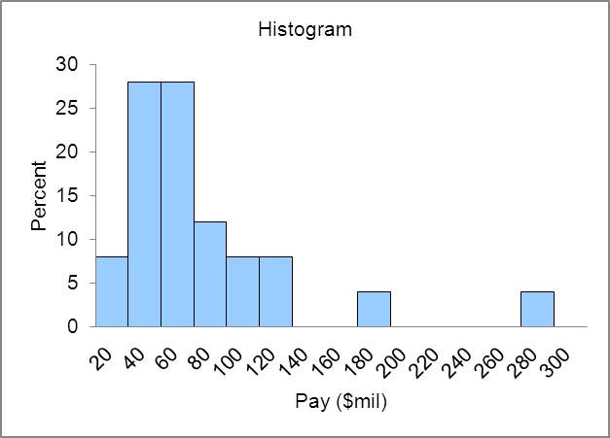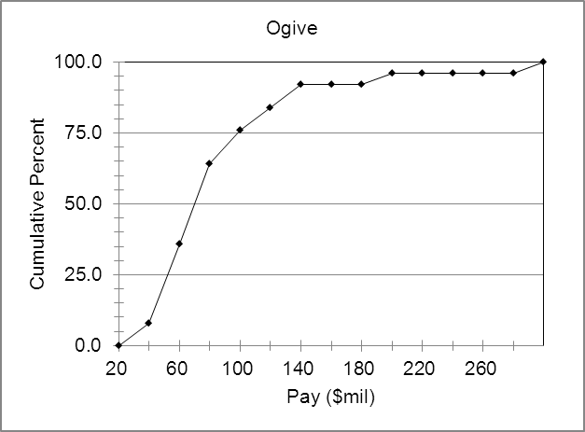

L02-03

**2.21 a.** Concentrated between 42 and 46.

**b.** Shape of distribution is slightly skewed left. Ratings have an upper limit but stretch out to the low side.

**c.** Class 1 2 3 4 5 6 7 8

34 < x ≤ 36, 36 < x ≤ 38, 38 < x ≤ 40, 40 < x ≤ 42, 42 < x ≤ 44, 44 < x ≤ 46, 46 < x ≤ 48, more

**d.** Class 1 2 3 4 5 6 7 8

Cum Freq 1 4 13 25 45 61 65 65

L02-03

**2.22 a.** Concentrated between 3.5 and 5.5.

**b.** Shape of distribution is slightly skewed right. Waiting time has a lower limit of 0 and stretches out to the high side where there are a few people who have to wait longer.

**c.** The class length is 1.

**d.** Class Cum Frequency

**-**0.5< 0 .5 1

0.5< 1.5 5

1.5< 2.5 12

2.5< 3.5 20

3.5< 4.5 37

4.5< 5.5 53

5.5< 6.5 67

6.5< 7.5 79

7.5< 8.5 87

8.5< 9.5 93

9.5<10.5 97

10.5<11.5 99

11.5<12.5 100

L02-03

**2.23 a.** Concentrated between 48 and 53.

**b.** Shape of distribution is symmetric and bell shaped.

**c.** Class length is 1.

**d.** Class: 46<47 47<48 48<49 49<50 50<51 51<52 52<53 53<54 54<55

Cum Freq. 2.5% 5.0% 15.0% 35.0% 60.0% 80.0% 90.0% 97.5% 100.0%



L02-03

**2.24 a.**

|  |  |  |  |  |  |
| --- | --- | --- | --- | --- | --- |
|  | ***Value*** |  |  |  |  |
| *lower* |  | *upper* | *midpoint* | *width* | *frequency* |
| 300 | < | 400 | 350 | 100 | 11 |
| 400 | < | 500 | 450 | 100 | 8 |
| 500 | < | 600 | 550 | 100 | 5 |
| 600 | < | 700 | 650 | 100 | 1 |
| 700 | < | 800 | 750 | 100 | 2 |
| 800 | < | 900 | 850 | 100 | 1 |
| 900 | < | 1,000 | 950 | 100 | 1 |
| 1,000 | < | 1,100 | 1,050 | 100 | 0 |
| 1,100 | < | 1,200 | 1,150 | 100 | 0 |
| 1,200 | < | 1,300 | 1,250 | 100 | 0 |
| 1,300 | < | 1,400 | 1,350 | 100 | 0 |
| 1,400 | < | 1,500 | 1,450 | 100 | 0 |
| 1,500 | < | 1,600 | 1,550 | 100 | 0 |
| 1,600 | < | 1,700 | 1,650 | 100 | 0 |
| 1,700 | < | 1,800 | 1,750 | 100 | 1 |
|  |  |  |  |  |  |
|  |  |  |  |  | 30 |

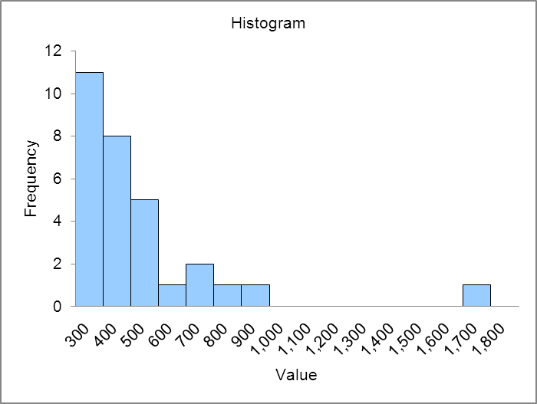

Distribution is skewed right and has a distinct outlier, The NY Yankees.

**b.**

|  |  |  |  |  |  |  |  |  |  |
| --- | --- | --- | --- | --- | --- | --- | --- | --- | --- |
| Frequency Distribution - Quantitative | | | | | |  |  |  |  |
|  |  |  |  |  |  |  |  |  |  |
|  |  | ***Revenue*** |  |  |  |  |  | *cumulative* | |
|  | *lower* |  | *upper* | *midpoint* | *width* | *frequency* | *percent* | *frequency* | *percent* |
|  | 140 | < | 160 | 150 | 20 | 2 | 6.7 | 2 | 6.7 |
|  | 160 | < | 180 | 170 | 20 | 9 | 30.0 | 11 | 36.7 |
|  | 180 | < | 200 | 190 | 20 | 5 | 16.7 | 16 | 53.3 |
|  | 200 | < | 220 | 210 | 20 | 6 | 20.0 | 22 | 73.3 |
|  | 220 | < | 240 | 230 | 20 | 4 | 13.3 | 26 | 86.7 |
|  | 240 | < | 260 | 250 | 20 | 2 | 6.7 | 28 | 93.3 |
|  | 260 | < | 280 | 270 | 20 | 1 | 3.3 | 29 | 96.7 |
|  | 280 | < | 300 | 290 | 20 | 0 | 0.0 | 29 | 96.7 |
|  | 300 | < | 320 | 310 | 20 | 0 | 0.0 | 29 | 96.7 |
|  | 320 | < | 340 | 330 | 20 | 0 | 0.0 | 29 | 96.7 |
|  | 340 | < | 360 | 350 | 20 | 0 | 0.0 | 29 | 96.7 |
|  | 360 | < | 380 | 370 | 20 | 0 | 0.0 | 29 | 96.7 |
|  | 380 | < | 400 | 390 | 20 | 0 | 0.0 | 29 | 96.7 |
|  | 400 | < | 420 | 410 | 20 | 0 | 0.0 | 29 | 96.7 |
|  | 420 | < | 440 | 430 | 20 | 1 | 3.3 | 30 | 100.0 |
|  |  |  |  |  |  |  |  |  |  |
|  |  |  |  |  |  | 30 | 100.0 |  |  |

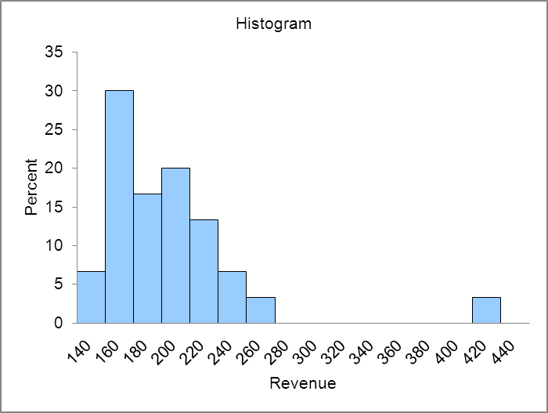

Distribution is skewed right.

**c.**

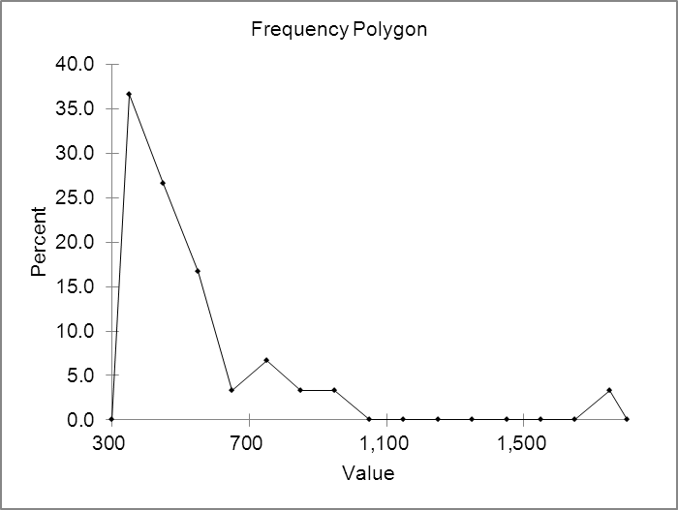

L02-03

**2.25 a.**

|  |  |  |  |  |  |  |  |  |  |
| --- | --- | --- | --- | --- | --- | --- | --- | --- | --- |
| Frequency Distribution - Quantitative | | | | | |  |  |  |  |
|  |  |  |  |  |  |  |  |  |  |
|  |  | ***Sales ($mil)*** |  |  |  |  |  | *cumulative* | |
|  | *lower* |  | *upper* | *midpoint* | *width* | *frequency* | *percent* | *frequency* | *percent* |
|  | 0 | < | 100 | 50 | 100 | 3 | 7.5 | 3 | 7.5 |
|  | 100 | < | 200 | 150 | 100 | 4 | 10.0 | 7 | 17.5 |
|  | 200 | < | 300 | 250 | 100 | 6 | 15.0 | 13 | 32.5 |
|  | 300 | < | 400 | 350 | 100 | 5 | 12.5 | 18 | 45.0 |
|  | 400 | < | 500 | 450 | 100 | 4 | 10.0 | 22 | 55.0 |
|  | 500 | < | 600 | 550 | 100 | 4 | 10.0 | 26 | 65.0 |
|  | 600 | < | 700 | 650 | 100 | 4 | 10.0 | 30 | 75.0 |
|  | 700 | < | 800 | 750 | 100 | 1 | 2.5 | 31 | 77.5 |
|  | 800 | < | 900 | 850 | 100 | 4 | 10.0 | 35 | 87.5 |
|  | 900 | < | 1,000 | 950 | 100 | 5 | 12.5 | 40 | 100.0 |
|  |  |  |  |  |  |  |  |  |  |
|  |  |  |  |  |  | 40 | 100.0 |  |  |

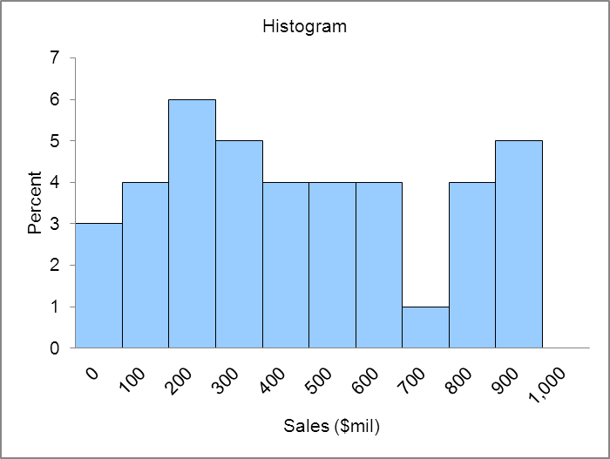

Distribution is relatively flat, perhaps two humped.

**b.**

|  |  |  |  |  |  |  |  |  |  |
| --- | --- | --- | --- | --- | --- | --- | --- | --- | --- |
| Frequency Distribution - Quantitative | | | | | |  |  |  |  |
|  |  |  |  |  |  |  |  |  |  |
|  |  | ***Sales Growth (%)*** |  |  |  |  |  | *cumulative* | |
|  | *lower* |  | *upper* | *midpoint* | *width* | *frequency* | *percent* | *frequency* | *percent* |
|  | 0 | < | 10 | 5 | 10 | 4 | 10.0 | 4 | 10.0 |
|  | 10 | < | 20 | 15 | 10 | 3 | 7.5 | 7 | 17.5 |
|  | 20 | < | 30 | 25 | 10 | 13 | 32.5 | 20 | 50.0 |
|  | 30 | < | 40 | 35 | 10 | 11 | 27.5 | 31 | 77.5 |
|  | 40 | < | 50 | 45 | 10 | 4 | 10.0 | 35 | 87.5 |
|  | 50 | < | 60 | 55 | 10 | 2 | 5.0 | 37 | 92.5 |
|  | 60 | < | 70 | 65 | 10 | 2 | 5.0 | 39 | 97.5 |
|  | 70 | < | 80 | 75 | 10 | 0 | 0.0 | 39 | 97.5 |
|  | 80 | < | 90 | 85 | 10 | 1 | 2.5 | 40 | 100.0 |
|  |  |  |  |  |  |  |  |  |  |
|  |  |  |  |  |  | 40 | 100.0 |  |  |

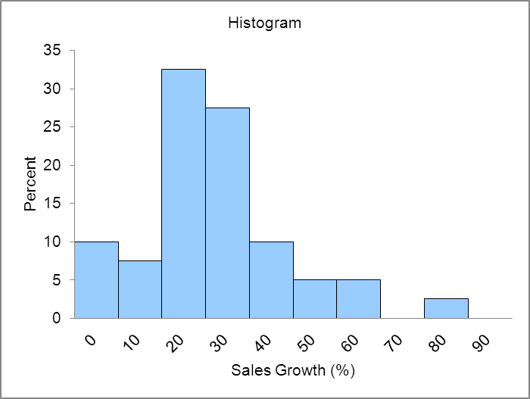

Distribution is skewed right.

L02-03

**2.26** The horizontal axis spans the range of measurements and the dots represent the measurements.

L02-04

**2.27** A dot plot with a 1000 points is not practical. Use a histogram.

L02-03, L02-04

**2.28**



Distribution is concentrated between 0 and 2 and is skewed to the right. 10 and 8 are probably high outliers.

L02-04

**2.29**



High outliers greater than 80%. Eliminating the high outliers the distribution is reasonably symmetric.

L02-04

**2.30**



Low outliers 22 and 25. Without outliers distribution is reasonably symmetric.

L02-04

**2.31** A stem & leaf enables one to see the shape of the distribution and still see all the measurements where in a histogram you cannot see the values of the individual measurements.

L02-03, L02-05

**2.32 --**Displays all the individual measurements.

--Puts data in numerical order

--Simple to construct

L02-05

**2.33** With a large data set (eg 1000 measurements) it does not make sense to do a stem & leaf because it is impractical to write out 1000 leafs. Should use a histogram.

L02-03, L02-05

**2.34**

Stem Unit = 10, Leaf Unit = 1

|  |  |  |  |
| --- | --- | --- | --- |
| Frequency | Stem | Leaf |  |
| *1* | *2* | 8 |  |
| 4 | 3 | 0 2 3 6 | |
| 5 | 4 | 2 2 3 4 9 | |
| 5 | 5 | 1 3 5 6 9 | |
| 2 | 6 | 3 5 |  |
| 1 | 7 | 0 |  |
| 1 | 8 | 3 |  |
| 1 | 9 | 1 |  |
| 20 |  |  |  |

L02-05

**2.35**

Stem Unit = 1, Leaf Unit = .1

|  |  |  |  |
| --- | --- | --- | --- |
| Frequency | Stem | Leaf |  |
| *2* | *10* | 4 4 |  |
| 0 | 11 |  |  |
| 1 | 12 | 6 |  |
| 3 | 13 | 2 8 9 | |
| 4 | 14 | 0 1 4 9 | |
| 4 | 15 | 2 2 8 9 | |
| 4 | 16 | 1 1 4 8 | |
| 0 | 17 |  |  |
| 0 | 18 |  |  |
| 0 | 19 |  |  |
| 0 | 20 |  |  |
| 0 | 21 |  |  |
| 1 | 22 | 2 |  |
| 0 | 23 |  |  |
| 0 | 24 |  |  |
| 1 | 25 | 2 |  |
| 20 |  |  |  |
|  |  |  |  |

L02-05

**2.36** Rounding each measurement to the nearest hundred yields the following stem & leaf

Stem unit = 1000, Leaf Unit = 100

|  |  |  |  |
| --- | --- | --- | --- |
| Frequency | Stem | Leaf |  |
| *5* | *1* | 2 4 4 5 7 | |
| 5 | 2 | 0 4 7 7 8 | |
| 4 | 3 | 3 3 5 7 | |
| 2 | 4 | 2 6 |  |
| 1 | 5 | 4 |  |
| 2 | 6 | 0 8 |  |
| 1 | 7 | 9 |  |
| 20 |  |  |  |

L02-05

**2.37 a.** Payment times distribution is skewed to the right.

**b.** Bottle design ratings distribution is skewed to the left.

L02-05

**2.38 a.** Distribution is symmetric

**b.** 46.8, 47.5, 48.2, 48.3, 48.5, 48.8, 49.0, 49.2, 49.3, 49.4

L02-05

**2.39**

|  |  |  |  |
| --- | --- | --- | --- |
|  | Roger Maris | 0 | Babe Ruth |
|  | 8 | 0 |  |
|  | 4 3 | 1 |  |
|  | 6 | 1 |  |
|  | 3 | 2 | 2 |
|  | 8 6 | 2 | 5 |
|  | 3 | 3 | 4 |
|  | 9 | 3 | 5 |
|  |  | 4 | 1 1 |
|  |  | 4 | 6 6 6 7 9 |
|  |  | 5 | 4 4 |
|  |  | 5 | 9 |
|  | 1 | 6 | 0 |

The 61 home runs hit by Maris would be considered an outlier, although an exceptional individual achievement.

L02-05

**2.40 a.**

|  |  |  |  |  |  |  |  |
| --- | --- | --- | --- | --- | --- | --- | --- |
|  |  |  | *WaitTime* |  |  |  |  |
|  |  | count | 100 |  |  |  |  |
|  |  |  |  |  |  |  |  |
|  |  |  |  |  |  |  |  |
|  |  | Stem and Leaf plot for | WaitTime |  |  |  |  |
|  |  | stem unit = | 1 |  |  |  |  |
|  |  | leaf unit = | 0.1 |  |  |  |  |
|  |  |  |  |  |  |  |  |
|  |  | Frequency | Stem | Leaf |  |  |  |
|  |  | 2 | 0 | 4 8 |  |  |  |
|  |  | 6 | 1 | 1 3 4 6 8 8 | |  |  |
|  |  | 9 | 2 | 0 2 3 4 5 7 8 9 9 | |  |  |
|  |  | 11 | 3 | 1 2 4 5 6 7 7 8 8 9 9 | | |  |
|  |  | 17 | 4 | 0 0 1 2 3 3 3 4 4 5 5 5 6 7 7 8 9 | | | |
|  |  | 15 | 5 | 0 1 1 2 2 3 4 4 5 6 6 7 8 8 8 | | |  |
|  |  | 13 | 6 | 1 1 2 3 3 3 4 5 5 6 7 7 8 | | |  |
|  |  | 10 | 7 | 0 2 2 3 4 4 5 7 8 9 | |  |  |
|  |  | 7 | 8 | 0 1 3 4 6 6 7 | |  |  |
|  |  | 6 | 9 | 1 2 3 5 8 9 | |  |  |
|  |  | 3 | 10 | 2 7 9 |  |  |  |
|  |  | 1 | 11 | 6 |  |  |  |
|  |  | 100 |  |  |  |  |  |

**b.** Distribution of wait times is fairly symmetrical, may be slightly skewed to the right.

L02-05

**2.41 a.**

|  |  |  |  |  |  |
| --- | --- | --- | --- | --- | --- |
| Stem and Leaf plot for | Ratings |  |  |  |  |
| stem unit = | 1 |  |  |  |  |
| leaf unit = | 0.1 |  |  |  |  |
| Descriptive statistics |  |  |  |  |  |
| Frequency | Stem | Leaf |  |  |  |
| *1* | *36* | 0 |  |  |  |
| 0 | 37 |  |  |  |  |
| 3 | 38 | 0 0 0 | |  |  |
| 4 | 39 | 0 0 0 0 | |  |  |
| 5 | 40 | 0 0 0 0 0 | |  |  |
| 6 | 41 | 0 0 0 0 0 0 | |  |  |
| 6 | 42 | 0 0 0 0 0 0 | |  |  |
| 8 | 43 | 0 0 0 0 0 0 0 0 | | |  |
| 12 | 44 | 0 0 0 0 0 0 0 0 0 0 0 0 | | | |
| 9 | 45 | 0 0 0 0 0 0 0 0 0 | | |  |
| 7 | 46 | 0 0 0 0 0 0 0 | | |  |
| 3 | 47 | 0 0 0 | |  |  |
| 1 | 48 | 0 |  |  |  |
| 65 |  |  |  |  |  |

**b.** Distribution is slightly skewed to the left.

**c.** Since 19 of the ratings are below 42 it would not be accurate to say that almost all purchasers are very satisfied.

L02-05

**2.42** Cross tabulation tables are used to study association between categorical variables.

L02-06

**2.43** Each cell is filled with the number of observations that have the specific values of the categorical variables associated with that cell.

L02-06

**2.44** Row percentages are calculated by dividing the cell frequency by the total frequency for that particular row. Column percentages are calculated by dividing the cell frequency by the total frequency for that particular column. Row percentages show the distribution of the column categorical variable for a given value of the row categorical variable. Column percentages show the distribution of the row categorical variable for a given value of the column categorical variable.

L02-06

**2.45**

|  |  |  |  |  |  |
| --- | --- | --- | --- | --- | --- |
| Crosstabulation | | |  |  |  |
|  |  |  |  |  |  |
|  |  |  | Purchased? | |  |
|  |  |  | No | Yes | Total |
|  | Koka | Observed | **14** | **2** | 16 |
|  |  | % of row | 87.5% | 12.5% | 100.0% |
|  |  | % of column | 66.7% | 10.5% | 40.0% |
| Preference |  | % of total | 35.0% | 5.0% | 40.0% |
|  | Rola | Observed | **7** | **17** | 24 |
|  |  | % of row | 29.2% | 70.8% | 100.0% |
|  |  | % of column | 33.3% | 89.5% | 60.0% |
|  |  | % of total | 17.5% | 42.5% | 60.0% |
|  | Total | Observed | 21 | 19 | 40 |
|  |  | % of row | 52.5% | 47.5% | 100.0% |
|  |  | % of column | 100.0% | 100.0% | 100.0% |
|  |  | % of total | 52.5% | 47.5% | 100.0% |

**a.** 17 **b.** 14

**c.** If you have purchased Rola previously you are more likely to prefer Rola. If you have not purchased Rola previously you are more likely to prefer Koka.

L02-06

**2.46**

|  |  |  |  |  |  |  |
| --- | --- | --- | --- | --- | --- | --- |
| Crosstabulation | | |  |  |  |  |
|  |  |  |  |  |  |  |
|  |  |  | Preference | | |  |
|  |  |  | Very Sweet | Sweet | Not So Sweet | Total |
|  | Koka | Observed | **6** | **4** | **6** | 16 |
|  |  | % of row | 37.5% | 25.0% | 37.5% | 100.0% |
|  |  | % of column | 42.9% | 30.8% | 46.2% | 40.0% |
| Preference |  | % of total | 15.0% | 10.0% | 15.0% | 40.0% |
|  | Rola | Observed | **8** | **9** | **7** | 24 |
|  |  | % of row | 33.3% | 37.5% | 29.2% | 100.0% |
|  |  | % of column | 57.1% | 69.2% | 53.8% | 60.0% |
|  |  | % of total | 20.0% | 22.5% | 17.5% | 60.0% |
|  | Total | Observed | 14 | 13 | 13 | 40 |
|  |  | % of row | 35.0% | 32.5% | 32.5% | 100.0% |
|  |  | % of column | 100.0% | 100.0% | 100.0% | 100.0% |
|  |  | % of total | 35.0% | 32.5% | 32.5% | 100.0% |

**a.** 17 **b.** 6

**c.** No relationship.

L02-06

**2.47**

|  |  |  |  |  |  |  |
| --- | --- | --- | --- | --- | --- | --- |
|  |  |  | Consumption | | |  |
|  |  |  | 0 to 5 | 6 to 10 | More Than 10 | Total |
|  | Koka | Observed | **12** | **3** | **1** | 16 |
|  |  | % of row | 75.0% | 18.8% | 6.3% | 100.0% |
|  |  | % of column | 60.0% | 17.6% | 33.3% | 40.0% |
| Preference |  | % of total | 30.0% | 7.5% | 2.5% | 40.0% |
|  | Rola | Observed | **8** | **14** | **2** | 24 |
|  |  | % of row | 33.3% | 58.3% | 8.3% | 100.0% |
|  |  | % of column | 40.0% | 82.4% | 66.7% | 60.0% |
|  |  | % of total | 20.0% | 35.0% | 5.0% | 60.0% |
|  | Total | Observed | 20 | 17 | 3 | 40 |
|  |  | % of row | 50.0% | 42.5% | 7.5% | 100.0% |
|  |  | % of column | 100.0% | 100.0% | 100.0% | 100.0% |
|  |  | % of total | 50.0% | 42.5% | 7.5% | 100.0% |

**a.** 22 **b.** 4

**c.** People who drink more cola are more likely to prefer Rola.

L02-06

**2.48 a.** 16%, 56%

**b.** Row Percentage Table

Watch Tennis Do Not Watch Tennis Total

Drink Wine 40% 60% 100%

Do Not Drink Wine 6.7% 93.3% 100%

**c.** Column Percentage Table

Watch Tennis Do Not Watch Tennis

Drink Wine 80% 30%

Do Not Drink Wine 20% 70%

Total 100% 100%

**d.** People who watch tennis are more likely to drink wine.

**e.**



L02-01, L02-06

**2.49**

**a.**

|  |  |  |  |
| --- | --- | --- | --- |
|  | **TV Violence Inc.** | **TV Violence No Inc.** | **Total** |
| **TV Quality Worse** | **362** | **92** | **454** |
| **TV Quality Not Worse** | **359** | **187** | **546** |
| **Total** | **721** | **279** | **1000** |

**b.**

|  |  |  |  |
| --- | --- | --- | --- |
|  | **TV Violence Inc.** | **TV Violence No Inc.** | **Total** |
| **TV Quality Worse** | **79.7%** | **20.3%** | **100%** |
| **TV Quality Not Worse** | **65.8%** | **34.2%** | **100%** |

**c.**

|  |  |  |
| --- | --- | --- |
|  | **TV Violence Inc.** | **TV Violence No Inc.** |
| **TV Quality Worse** | **50.2%** | **33.0%** |
| **TV Quality Not Worse** | **49.8%** | **67.0%** |
| **Total** | **100%** | **100%** |

**d.** Those people who think TV violence has increased are more likely to think TV quality has gotten worse.

**e.**



L02-01, L02-06

**2.50 a.**



**b.** As income rises the percent of people seeing larger tips as appropriate also rises.

L02-01, L02-06

**2.51 a.**



**b.** People who have left at least once without leaving a tip are more likely to think a smaller tip is appropriate.

L02-01, L02-06

**2.52** A scatterplot is used to look at the relationship between two quantitative variables.

L02-07

**2.53** Data are scattered around a straight line with positive slope.

L02-07

**2.54** Data are scattered around a straight line with negative slope.

L02-07

**2.55** Data are scattered on the plot with the best line to draw through the data being horizontal.

L02-07

**2.56** Scatter plot: each value of *y* is plotted against its corresponding value of *x*.  
Runs plot: a graph of individual process measurements versus time

L02-07

**2.57** As home size increases, sales price increases in a linear fashion. A fairly strong relationship



L02-07

**2.58** As temperature increases, fuel consumption decreases in a linear fashion. A strong relationship.

L02-07

**2.59** Cable rates decreased in the early 1990’s in an attempt to compete with the newly emerging satellite business. As the satellite business was increasing its rates from 1995 to 2005, cable was able to do the same.

L02-07

**2.60** Clearly there is a positive linear relationship here. As a brand gets more sales, retailers want to give more shelf space. Also as shelf space increases sales will tend to increase. Its difficult to determine cause and effect here.

L02-07

**2.61** The scatterplot shows that the average rating for taste is related to the average rating for preference in a positive linear fashion. This relationship is fairly strong.

The scatterplots below show that average convenience, familiarity, and price are all related in a linear fashion to average preference in a positive, positive, and negative fashion (respectively). These relationships are not as strong as the one between taste and preference.







L02-07

**2.62** The differences in the heights of the bars are more pronounced.

L02-08

**2.63** Examples and reports will vary.

L02-08

**2.64** The administration’s plot indicates a steep increase over the four years while the union organizer’s plot shows a gradual increase.

L02-08

**2.65 a.** No, very slight (if any).

**b.** Yes, strong trend.

**c.** The line graph is more appropriate because it shows growth.

**d.** Probably not. Both distort the data.

L02-08

**2.66**

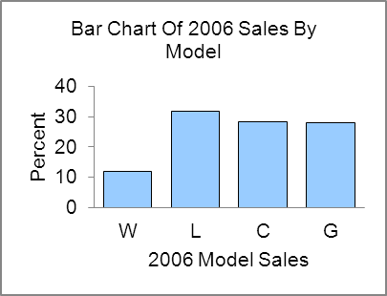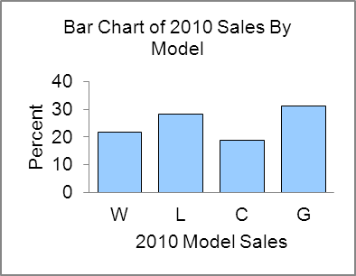

Reports will vary but should focus on the Liberty model sales staying around 30% of total sales.

L02-01

**2.67** Large portion of manufacturers are rated 3.

|  |  |
| --- | --- |
| ***Overall Mechanical*** |  |
| ***Quality*** | *frequency* |
| 1 | 0 |
| 2 | 6 |
| 3 | 23 |
| 4 | 2 |
| 5 | 2 |
|  | 33 |

L02-01

**2.68** Categories 3 & 4 cover large portion of companies.

|  |  |  |
| --- | --- | --- |
| ***Overall***  ***Design*** |  |  |
| ***Quality*** | *frequency* | *percent* |
| 1 | 0 | 0.0 |
| 2 | 4 | 12.1 |
| 3 | 22 | 66.7 |
| 4 | 6 | 18.2 |
| 5 | 1 | 3.0 |
|  | 33 | 100.0 |

L02-01

**2.69**  Written analysis will vary.







L02-01

**2.70** Written analysis will vary



L02-01

**2.71** Europe and the Pacific Rim both have a couple of outliers with ratings of 4 & 5, otherwise there does not seem to be much of a relationship.

**Tabulated statistics: Area of Origin, Overall Quality Mechanical**

Rows: Area of Origin Columns: Overall Quality Mechanical

The Rest About Better Than Among The All

Average Most Best

Europe 3 4 1 1 9

33.33 44.44 11.11 11.11 100.00

Pacific Rim 2 9 1 1 13

15.38 69.23 7.69 7.69 100.00

United States 1 10 0 0 11

9.09 90.91 0.00 0.00 100.00

All 6 23 2 2 33

18.18 69.70 6.06 6.06 100.00

Cell Contents: Count

% of Row

L02-06

**2.72** Written reports will vary. See 2.69 for percentage bar charts. See 2.71 for row percentages.

L02-06

**2.73** Pacific Rim has a much higher percentage rated 4 or higher than either Europe or United States.

**Tabulated statistics: Area of Origin, Overall Quality Design**

Rows: Area of Origin Columns: Overall Quality Design

2 3 4 5 All

Europe 1 7 0 1 9

11.11 77.78 0.00 11.11 100.00

Pacific Rim 0 9 4 0 13

0.00 69.23 30.77 0.00 100.00

United States 3 6 2 0 11

27.27 54.55 18.18 0.00 100.00

All 4 22 6 1 33

12.12 66.67 18.18 3.03 100.00

Cell Contents: Count

% of Row

L02-06

**2.74** Written reports will vary. See 2.70 for pie charts. See 2.73 for row percentages

L02-06

**2.75 a.** Since there are 50 data points you should use 6 classes.

**b.**

|  |  |  |  |  |  |  |  |  |  |
| --- | --- | --- | --- | --- | --- | --- | --- | --- | --- |
| Frequency Distribution - Quantitative | | | | | |  |  |  |  |
|  |  |  |  |  |  |  |  |  |  |
|  |  | ***ModelAge*** |  |  |  |  |  | *cumulative* | |
|  | *lower* |  | *upper* | *midpoint* | *width* | *frequency* | *percent* | *frequency* | *percent* |
|  |  |  |  |  |  |  |  |  |  |
|  | 17 | < | 19 | 18 | 2 | 3 | 6.0 | 3 | 6.0 |
|  | 19 | < | 21 | 20 | 2 | 2 | 4.0 | 5 | 10.0 |
|  | 21 | < | 23 | 22 | 2 | 3 | 6.0 | 8 | 16.0 |
|  | 23 | < | 25 | 24 | 2 | 5 | 10.0 | 13 | 26.0 |
|  | 25 | < | 27 | 26 | 2 | 8 | 16.0 | 21 | 42.0 |
|  | 27 | < | 29 | 28 | 2 | 15 | 30.0 | 36 | 72.0 |
|  | 29 | < | 31 | 30 | 2 | 10 | 20.0 | 46 | 92.0 |
|  | 31 | < | 33 | 32 | 2 | 4 | 8.0 | 50 | 100.0 |
|  |  |  |  |  |  |  |  |  |  |
|  |  |  |  |  |  | 50 | 100.0 |  |  |

**c.**



**d.** This distribution is skewed to the left.

L02-03

**2.76**



L02-03

**2.77** 26% of the perceived ages are below 25. Much too high.



L02-04

**2.78 a & b & c.** See table in 2.75

**d.**



**e.** 36 out of 50 = 72%

**f.** 8 out of 50 = 16%

L02-03

**2.79**

Distribution is skewed to the right

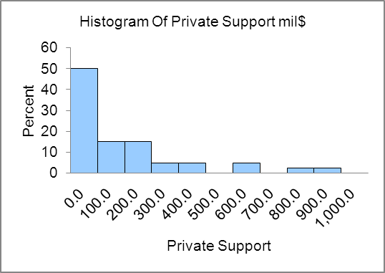

Distribution is skewed to the right

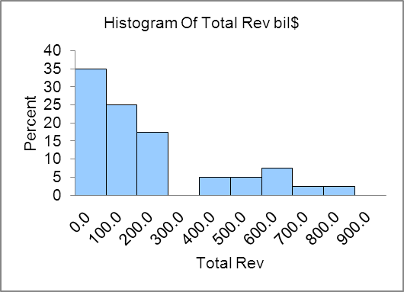

Distribution is skewed to the left

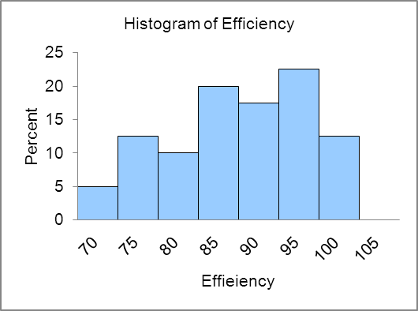

L02-03

**2.80** Distribution has one high outlier and with or without the outlier is skewed right.

L02-04

|  |  |  |  |
| --- | --- | --- | --- |
| **2.81 a.** | Class | Factor | Height |
|  | $25K to 50K |  |  |
|  | $50K to 100K |  |  |
|  | $100K to 150K |  |  |
|  | $150K to 200K |  |  |
|  | $200K to 250K |  |  |
|  | $250K to 500K |  |  |

**b,** **c.**

175

150

125

100

50

25

0

0 100 200 300 400 500 *37

L02-03

**2.82** Since the runs plot is not in control, the stem & leaf is not representative of the number of missed shots.

Stem-and-leaf of Shots Missed N = 30

Leaf Unit = 0.10

1 5 0

2 6 0

4 7 00

9 8 00000

15 9 000000

15 10 00000

10 11 00

8 12 0

7 13 0

6 14 0

5 15 00

3 16 0

2 17 0

1 18 0

•

•

•

•

•

•

0 10 20 30

15

10

5

Day

Number of Misses

•

•

•

•

•

•

•

•

•

•

•

•

•

•

•

•

•

•

•

•

•

•

•

•

L02-05

**2.83** The graph indicates that Chevy trucks far exceed Ford and Dodge in terms of resale value, but the y-axis scale is misleading.

L02-08

**2.84** **a.** Stock funds: $60,000; bond funds: $30,000; govt. securities: $10,000

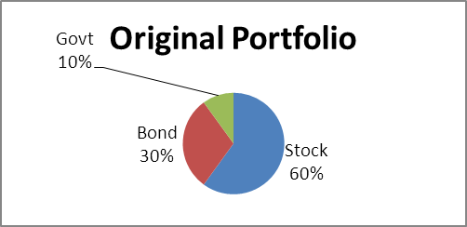

**b.** Stock funds: $78,000 (63.36%); bond funds: $34,500 (28.03%);   
govt. securities: $10,600 (8.61%)

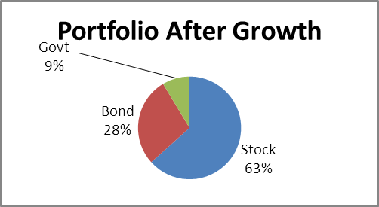

**c.** Stock funds: $73,860; bond funds: $36,930; govt. securities: $12,310

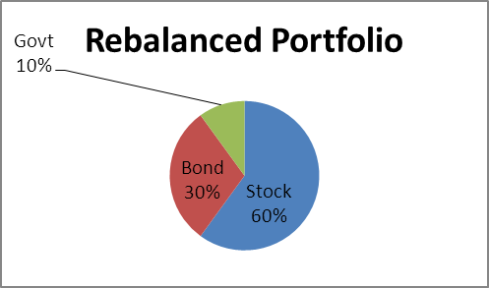

L02-01

**Internet Exercises**

**2.85** Answers will vary depending on which poll(s) the student refers to.

L02-01 – L02-08