Module 2
Adapting Your Message to Your Audience

LO 2-1 Understand expectations from your organization.
LO 2-2 Define audiences for messages.
LO 2-3 Apply strategies for audience analysis with PAIBOC.
LO 2-4 Apply strategies for individual and group audience analyses.
LO 2-5 Apply strategies for audience needs analysis.
LO 2-6 Adapt messages for audiences.
LO 2-7 Choose channels for audiences.

Module Overview

Module 2 discusses ways for students to adapt messages to audiences. It identifies the five types of audiences and strategies to shape messages to meet different audience needs. It also discusses the tools writers can use, such as demographics and psychographics.

Because it discusses seminal concepts in business communication, Kitty and Steve recommend Module 2 be covered early in your course. Students should return to it as they analyze audiences for the messages they write and the presentations they give.

As with all modules, Kitty and Steve recommend that you read Module 2 thoroughly before reviewing the discussion that follows.

☺ Teaching Tip: Students often believe that regardless of the class, audience expectations on writing assignments remain the same. Have them discuss situations where they found themselves following the writing guidelines and expectations of previous instructors only to discover that guidelines and expectations had changed with their audience. What steps did the students take to analyze the new audience? What “clues” did the new instructor reveal as to his or her expectations? How did the instructor reveal them? What did they learn about the importance of audience analysis from the experience?

 In-Class Exercise: Individually or in groups, have the students spend 15-20 minutes discussing who they believe are the audiences for movies—the latest romantic comedy, action thriller, and literary drama. What are the characteristics of each audience? How do the students know?

What’s in This Supplement

This supplement is organized around the major questions posed in Module 2. It covers

Part 1: Key Lecture Points, Teaching Tips, and In-Class Exercises Page 19
Part 2: Answers to Textbook Assignments Page 33
Part 3: Appendixes of Handouts/Transparency Masters Page 37

PowerPoint presentations can be found at our Web page at www.mhhe.com/bcs6e.

Questions (with answers) suitable for quizzes are in the Instructor’s Test Bank. For student practice quizzes with answers, see our Web page.

Part 1: Key Lecture Points, Teaching Tips, and In-Class Exercises

Understanding what your organization wants LO 2-1

Just as every sport has rules about scoring, so, too, do workplaces have rules about what “counts.” But often these rules are not spelled out nor communicated directly to employees. For every expectation discussed in an employee handbook, there are probably several others that never get spoken of overtly or that require employees to observe and listen carefully to determine what organizations seek.

This concept may be obvious to some of your students but quite novel to others. If we are to believe the anecdotal information about challenges many companies face today, a sizable number of incoming workers could use greater awareness of how (and why) to adapt.

☺ Teaching Tip: Think back to your own experiences adapting to an organization’s culture. For instance, how did you figure out what spaces were okay for socializing versus which were strictly for quiet and work? How did you know what to wear, and more importantly, what clothing, colors, and styles to avoid? How did you identify leaders? Heroes? Role models? Share some of your observations with your class, and ask students already in the workforce what strategies and experiences they rely on to make choices.

As PP 2-4 and PP 2-5 suggest, several strategies to help employees adapt exist:

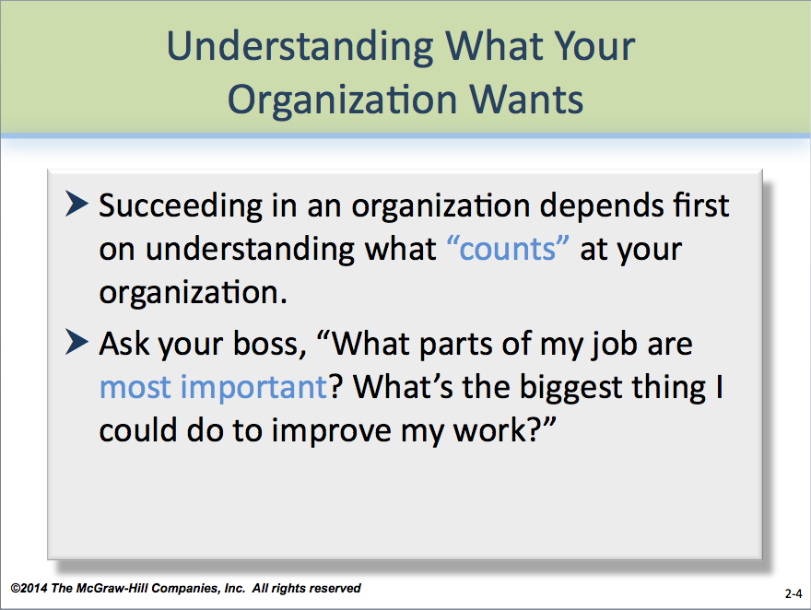
- Ask your boss, “What parts of my job are most important? What’s the biggest thing I could do to improve my work?”
- Listen to the stories colleagues tell about people who have succeeded and those who have failed.
- Observe.

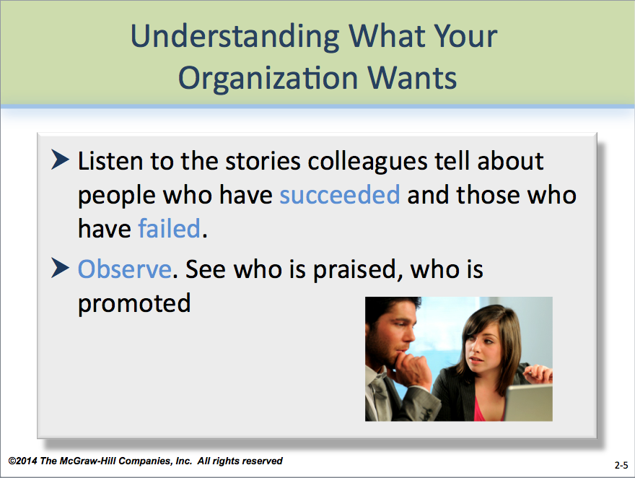
☺ Teaching Tip: Remind students that they likely will make mistakes—adaptation in any circumstance is governed by trial and error—and one of the hardest realities to accept is how much isn’t explained to employees when the arrive for that first day on the job. But we survive!

Who is my audience? LO 2-2
More people than you might think!

Students often are surprised to learn that audiences for their messages may be complex and more than one person. Understanding these concepts takes time—but it’s time well spent!

Kitty and Steve support the audience-centered approach to communication. By keeping the audiences in mind, writers and speakers are more likely to create effective messages for those audiences.

Key to understanding the importance of audience is defining the five types of audiences (p. 20), as described in PP 2-6.

The five kinds of audiences:
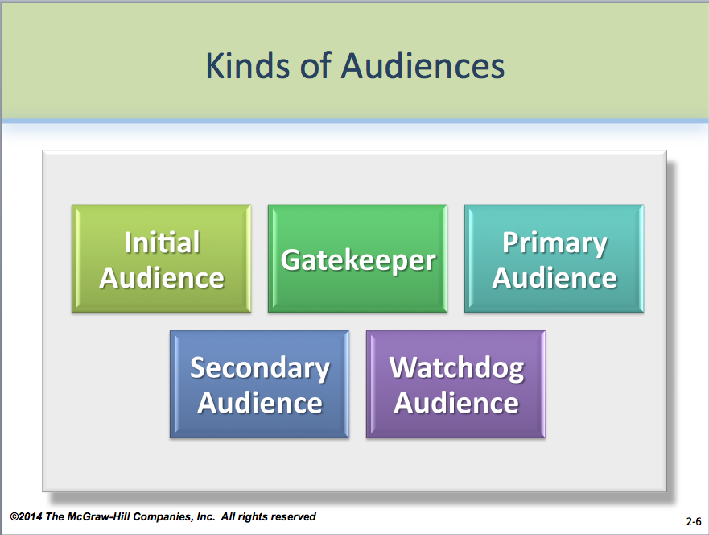
- Initial audience
- Gatekeeper
- Primary audience
- Secondary audience
- Watchdog audience

For messages going to multiple audiences, writers should use the primary audience and the gatekeeper to decide on message detail, organization, level of formality, and technical terms and theory.

☺ Teaching Tip: Students often confuse gatekeepers with initial audiences. Emphasize that while gatekeepers can also be the initial audience, the initial audience does not have to be a gatekeeper. Initial audiences simply are the first to receive the message. Students also should understand the importance of secondary audiences. For instance, a letter to an employee announcing a benefits change may not only affect the employee but also his or her spouse or domestic partner.

Figures 2.1 and 2.2 (p. 21) help students to visualize how audiences work. A key concept illustrated in both figures is the multiple roles that audiences can take. For instance, in Figure 2.1, the boss is both the initial audience and the gatekeeper. The figures also help students understand the “real world” application of audience—both figures suggest the multitude of audiences possible for a business message.

(Students must remember, however, that the primary audience will most affect how the writer approaches creating the message.)

 In-Class Exercise: Individually or in groups, have students spend 10-15 minutes identifying key audiences for common messages. Good general examples are applying for a job where several levels of executives will review the application or a familiar advertisement for a product or service. Have the students brainstorm how the message intended for the primary audience would be affected by additional audiences (which they also must identify) and their needs or concerns. For more specific scenarios, consider assigning Exercise 2.8 (p. 33).

Why is my audience so important? LO 2-3
To be successful, messages must meet the audiences’ needs.

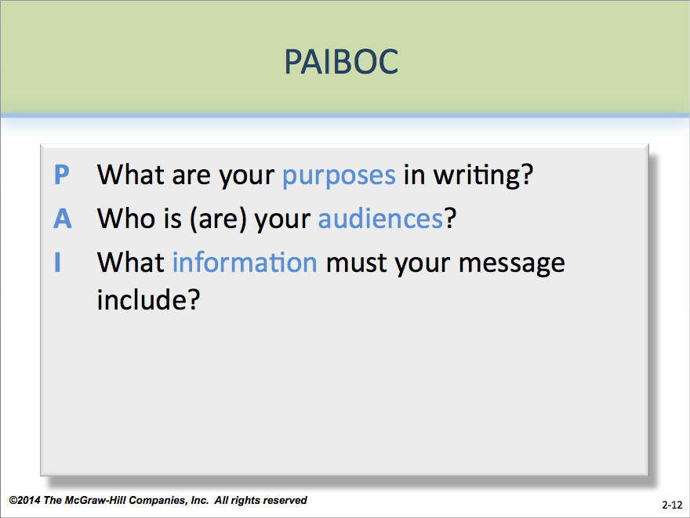
Some students resist the notion that audience plays so important a role in communication, assuming instead that the writer or speaker should be privileged.
But successful messages always meet the audiences’ needs. To help students better understand the effect of audience on a message, have them consider audience and PAIBOC (introduced in Module 1). PP 2-12 and PP 2-13 discuss PAIBOC and audience analysis.
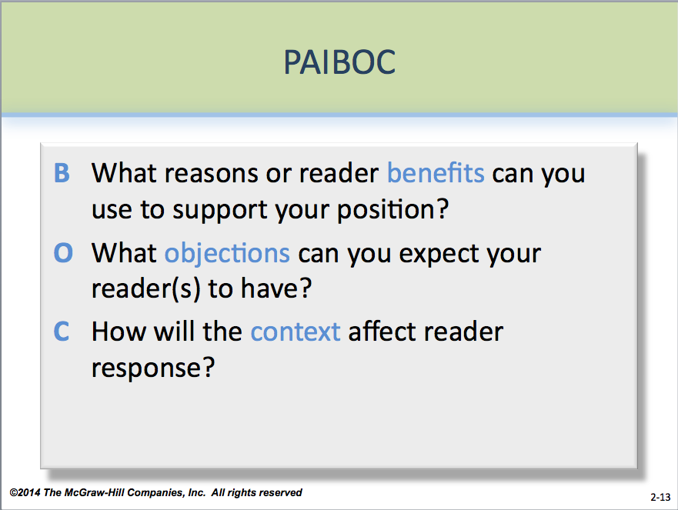
PAIBOC (pp. 22-24) refers to six areas writers should consider when composing messages. Five of those areas relate to audience:

P What are your purposes in writing or speaking?

A Who is (are) your audiences? How do members of your audience differ?

I What information must your message include?

B What reasons or reader benefits can you use to support your position?

O What objections can you expect your reader(s) to have? What negative elements of your message must you de-emphasize or overcome?

C How will the context affect reader response? Think about your relationship to the reader, morale in the organization, the economy, the time of year, and any special circumstance.

PAIBOC allows students to quickly identify the six key areas in planning messages and designing messages. Make sure students understand what each component of PAIBOC represents.

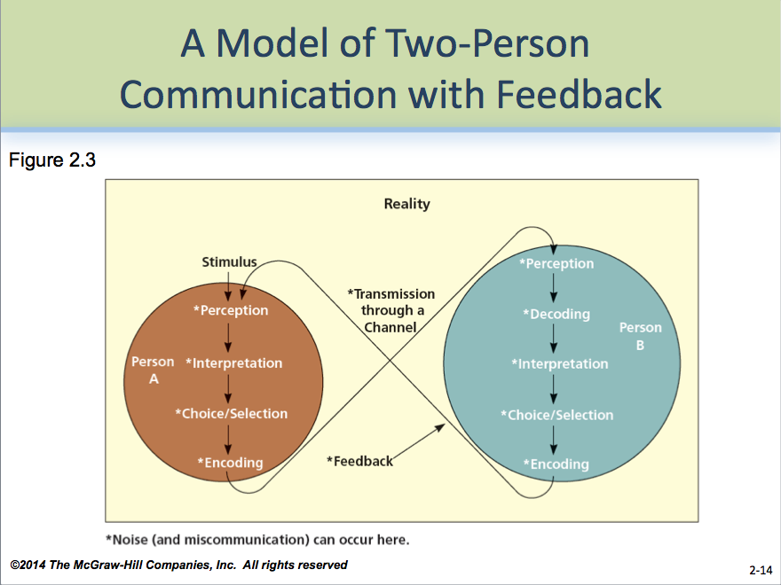
A simplified model of two-person communication with feedback, stressing the importance of audience, is the focus of Figure 2.3 (p. 23). Its principal parts are described on PP 2-14 and PP 2-15. Students should understand from this figure the principal actions that take place in both sending and receiving a message:

- Perception
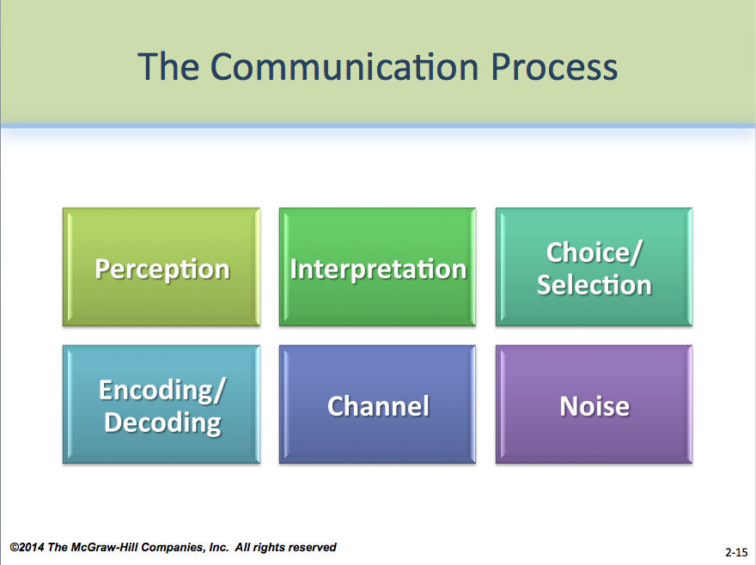
- Interpretation
- Choice/Selection
- Encoding/Decoding

☺ Teaching Tip: Most students are aware of the concept of codes and codebooks. Use this to help explain the encoding/decoding process. For instance, once a message is put into secret code, the receiver must have the codebook in order to decipher, or decode, the message. Similarly, business messages sent in the wrong code make no sense to the receiver. They are just as secret.

- Channel
- Noise

☺ Teaching Tip: Emphasize to students that noise can occur at any point during the message transmission, such as when the sender uses jargon that the receiver will not understand or telephones a business after hours. While senders cannot control all noise factors, students should keep in mind those under the sender’s control—language, how and when the message will be sent, and the form the message will take.
 In-Class Exercise: Individually or in groups, have the students spend 15-20 minutes recounting frustrations they’ve had sending or receiving messages. These could be at work, at school, or in their personal lives. Have them identify what they believe were noise factors. Ask the students to list what steps could have been taken to minimize the noise.

To better understand channels, have students in groups analyze some or all of the channel possibilities in Exercise 2.9 (p. 34).

What do I need to know about my audience(s)? LO 2-4
Everything that’s relevant to what you’re writing or talking about.

Kitty and Steve believe the more a writer knows about the audience when composing, the more likely the message will succeed. Many students, however, are uncertain what steps can be taken to assess audience.

A key to understanding audience is empathy, or putting oneself in the audiences’ shoes. Empathy requires students to imagine themselves as the audience and to anticipate and understand the audiences’ emotional, psychological, and physical needs. Therefore, writers must avoid being self-centered.

 In-Class Exercise: Form groups of two students each. Have Student A share a (non-traumatic) story with Student B about a significant interaction with another person in which Student A was displeased or misunderstood. Then, have Student B assume the role of Student A in the situation, while Student A assumes the other role. Role play, re-creating the event as best possible. Afterward, have each student discuss what they thought and felt during the role play. How do Student B’s thoughts and feelings compare to what Student A actually thought and felt in the original situation? What did Student A learn about the other person? Repeat with Student B’s story.

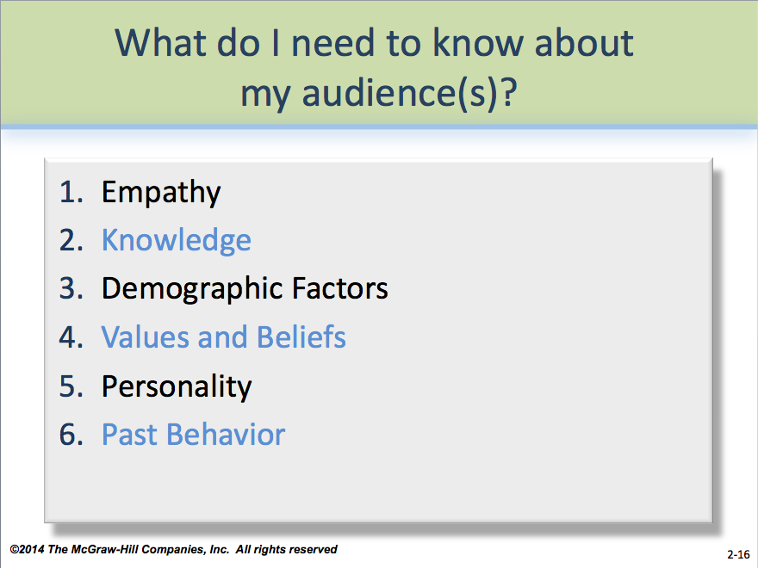
Beyond empathy, five additional concepts about audience can help, all of which are illustrated on PP 2-16 and discussed in detail on PP 2-17 through 2-20:

- Knowledge
- Demographic Factors

☺ Teaching Tip: Such “objective” information may be attractive to students, particularly those who come from fields of study that privilege it. Emphasize that making hasty generalizations about audience from demographics is dangerous. For instance, belonging to one ethnicity or another does not guarantee loyalty to a particular product or service, even if it is more likely to be used by members of that group. Students must understand that demographics are just one of many tools at their disposal.

- Values and Beliefs

 In-Class Exercise: Have students form groups of 3-5 and spend 15-20 minutes completing Exercise 2.9 (p. 34), which offers insight into the dimensions of demographics and psychographics. Afterward, consider challenging the assumptions students have made—what do they base their conclusions on? Are there any groups left out of their analysis? Why? What might these issues suggest about the limitations of demographics and psychographics?

- Personality—Different personality types may require different strategies for working with them. For instance, an introvert may prefer to read information while an extravert may prefer to have a phone or a face-to-face conversation.

 In-Class Exercise: Take 15-20 minutes to have students individually or in groups recount experiences with supervisors who preferred to have information in writing versus those who wanted the information orally. Which wanted more detail? Which might have delayed making decisions? Which might be introverted? Extraverted? What other dimensions might be represented? Why do the students think so? Have them consider the values applied to these terms. All have strengths and weaknesses, but do the students privilege some personality dimensions more than others? Should they?

- Past Behavior

☺ Teaching Tip: The world seems to be changing at ever-increasing speeds. To illustrate this concept, have students spend 10-15 minutes comparing fads popular this year to those two years ago. Five years ago. Ten years ago. Are there any constants? What is different? What might the actions of the past suggest about the future? Ask the students what they think the “shelf life” is for information in a constantly changing world.

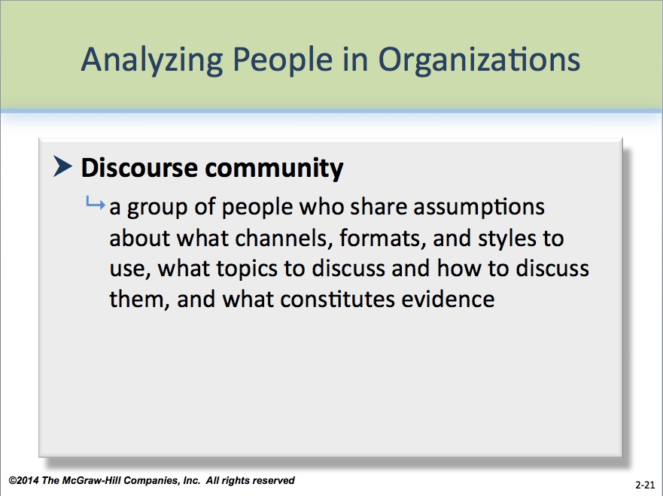
Additional concepts students should remember are discourse community and organizational (or corporate) culture. Use PP 2-21 through PP 2-23 to illustrate these concepts.

- Discourse Community
- Organizational or Corporate Culture
- Norms of Behavior in an Organization
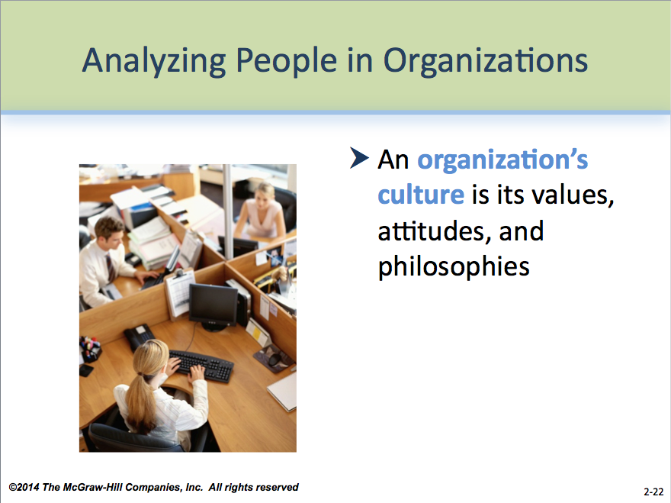
While there may be similarities, each discourse community and organizational culture can be quite different from the next. Differences can even exist among (and within) departments and subsidiaries within the same organization. Students must use a combination of observation, research through asking colleagues questions, and trial-and-error to learn these differences.
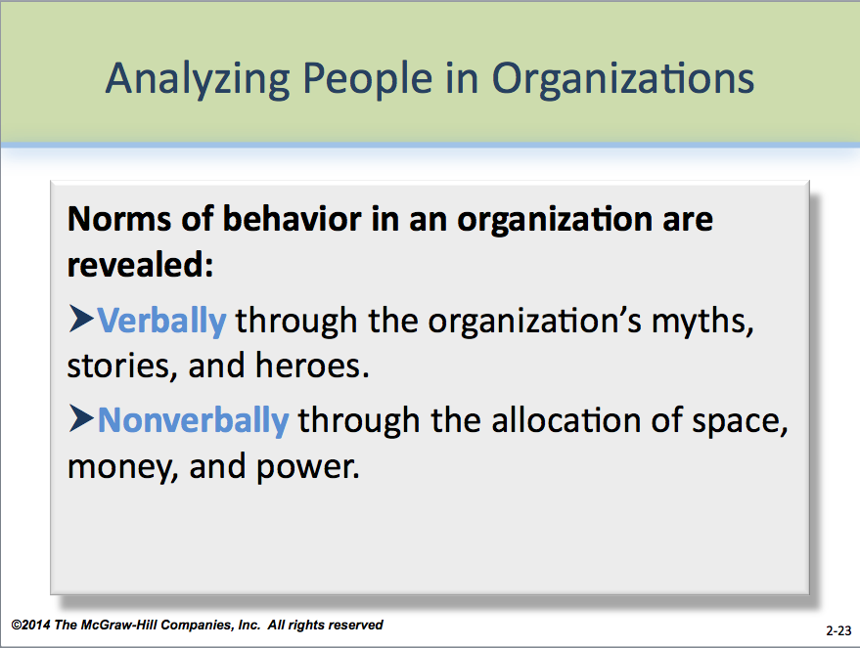
Spend at least 10 minutes defining and explaining organizational culture and discourse communities and how they affect both spoken and written messages. Use this terminology throughout your discussion of audience and throughout the course as you discuss assignments students will write.
☺ Teaching Tip: A common reaction from students to some business communication concepts is “That’s not how we do it in my company.” Take this opportunity to discuss discourse community and organizational culture. What might the practice in question reveal about either? Ask the class if they believe such a practice would work in a different discourse community or organizational culture. Why or why not?

The concept of discourse communities is crucial: it explains in part why some documents “succeed” on a particular job even though they would not get high grades in your course.

☺ Teaching Tip: Make your course expectations and standards of grading for assignments clear to your students. In effect, your classroom is one discourse community, and students certainly will have to adapt to your standards throughout the course. Invite them to ask questions and practice skills to assess its boundaries.

 In-Class Exercise: Choose 3-4 different organizations and list them on the board. Microsoft, the Walt Disney Corporation, Wendy’s International, etc., are good places to start; a good source for this information would be the company Web sites, such as www.microsoft.com; http://disney.com; www.wendys.com. For 15 minutes, have students list what similar and dissimilar qualities each might have with regard to organizational culture. For instance, who might the heroes be? Where might casual dress be acceptable? How might success be determined? At the conclusion, take a quick poll of how many students might want to work for each. Take another five minutes to discuss with students why some organizations might seem more or less appealing. Let students share why.

Now that I have my analysis, what do I do with it? LO 2-5
Use it to plan strategy, organization, style, document design, and visuals.

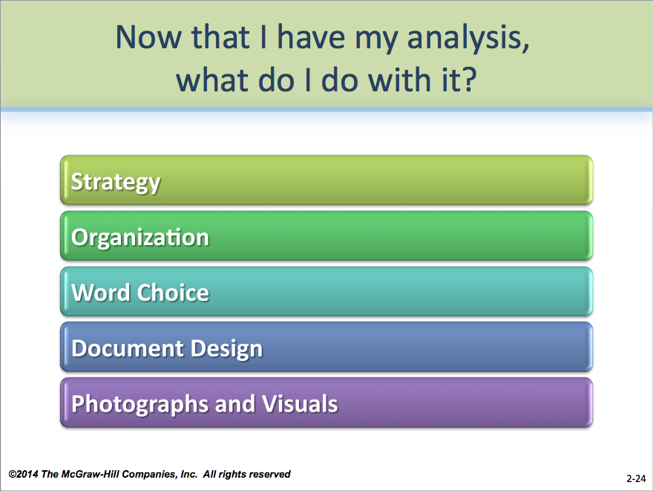
If writers know their audience well, many of their audience analysis decisions will be unconscious or “instinctive.” More commonly, though, writers will need to consider five areas during audience analysis. These are illustrated in PP 2-24 for use in a 15- to 20-minute discussion.

- Strategy
- Organization
- Word Choice

☺ Teaching Tip: What students perceive as “academic” language may be different from that of their instructors. Ask the students to share what kind of words the term brings to mind. What specific examples are problematic? What language would they substitute? Would the change accurately convey the same information?

- Document Design
- Photographs and Visuals

☺ Teaching Tip: Though most students inundate themselves daily with such visual images as movies, magazines, music videos, and Web pages, few consider the power and content of the images they see. Help them by using a common advertisement featuring images of people. From those images, have the students share their perceptions. Who is the ad aimed at? What assumptions has the advertiser made about that audience? Its needs and lifestyle? Who is excluded from the ad? If the image is non-inclusive, what might the effect be on overlooked individuals?

 In-Class Exercise: Locate two different messages from your college or university. A good example might be a letter explaining to students a policy or procedure, such as applying for financial aid, registering for classes, or moving into the dormitory. Contrast that with a letter to alumni requesting donations or a memo to staff and faculty explaining a contractual or human resources issue. For 15-20 minutes, have students as a class review each message to decide how strategy, organization, style, and if applicable, document design and visuals are used by the writer to communicate the message. What other audiences might these messages be addressed to? What assumptions have the writers made about the audiences? If time permits, ask students if they see opportunities for revision that might better communicate the message to the audiences.

What if my audiences have different needs? LO 2-6
Focus on gatekeepers and decision makers.

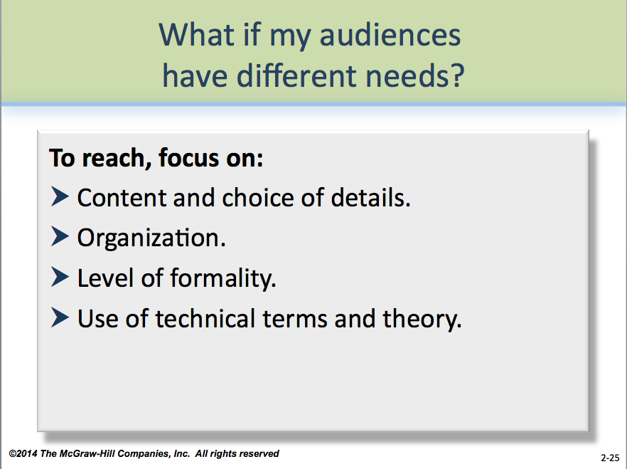
When it’s not possible to meet all audience members’ needs, writers should focus on gatekeepers and decision makers first, shown in PP 2-25.

Writers should look to these factors when composing:

- Content and choice of details.
- Organization.
- Level of formality.
- Use of technical terms and theory.

☺ Teaching Tip: Use Appendix 2-A through Appendix 2-D to show students two examples of how different audiences may have different expectations concerning an issue. In these examples—one aimed at workers and the other at the boss—the same general issue about work efficiency during a holiday is addressed. Let students see that different audiences will have different expectations and that the writer will choose content and expression accordingly.

How do I reach my audience(s)? LO 2-7

Important messages may require multiple channels.

The communication channel a writer or speaker chooses can affect the success of the message. The advantages of each kind of message and considerations for communication channels include (illustrated on PP 2-26 through PP 2-30):

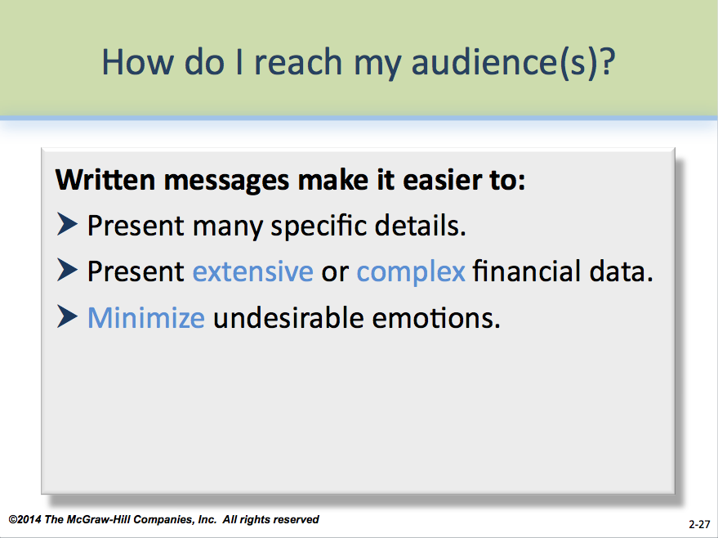
A written message (PP 2-27) makes it easier to

- Present many specific details of a law, policy, or procedure
- Present extensive or complex financial data.
- Minimize undesirable emotions.

(Because paper messages are more formal, email should be used primarily for routine messages to people writers know.)

Writers should choose carefully the channel they use to communicate a message. Channels can vary according to

- Speed.
- Accuracy of transmission.
- Cost.

- Number of messages carried.
- Number of people reached.
- Efficiency.
- Ability to provide goodwill.

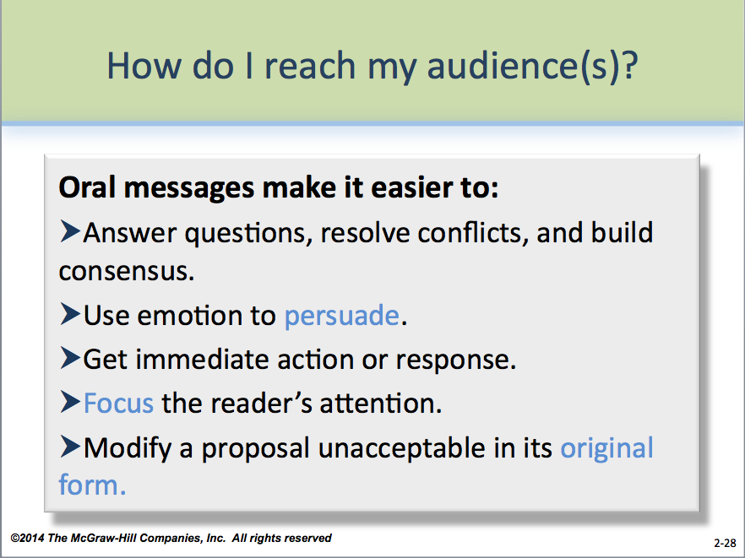
An oral message (PP 2-28) makes it easier to

- Answer questions, resolve conflicts, and build consensus
- Use emotion to help persuade the audience.
- Get immediate action or response.
- Focus the audience’s attention on specific points.
- Modify a proposal that may not be acceptable in its original form.

As PP 2-29 shows, channels have a variety of properties. For both oral and written messages

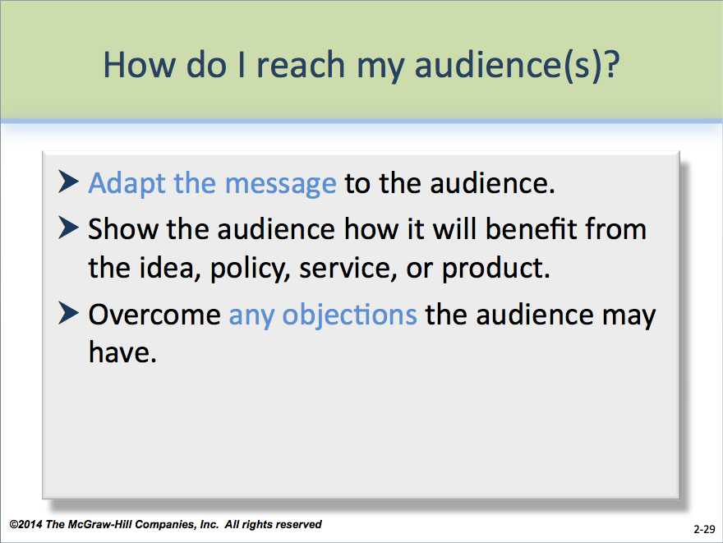
- Adapt the message to the specific audience.
- Show the audience members how they benefit from the idea, policy, service, or product.
- Overcome any objections the audience may have.
- Use you-attitude and positive emphasis.
- Use visuals to clarify or emphasize material
- Specify exactly what the audience should do.

Last Word: Emphasize to students that while it’s unrealistic to expect to know everything about their audiences, using what they know—and taking steps to learn what they don’t—often is a winning combination. They should also be prepared to make mistakes, as even in the best of situations, there is always room for error. The goal is to minimize the potential for errors and to maximize the learning from them for the future.

Part 2: Answers to Textbook Assignments

Questions for Comprehension

2.1 What are the five kinds of audiences? (LO 2-2)

Primary, secondary, initial, gatekeeper, and watchdog

2.2 What are ways to analyze your audience? (LO 2-3, LO 2-4)

Choose empathy first. Then identify the audience’s knowledge, demographics, personality, values and beliefs (psychographics), and past history. Knowledge of discourse communities and

organizational or corporate culture is also important. Students should use PAIBOC to help them throughout the audience analysis process.

2.3 What are three ways to adapt your message to your audience? (LO 2-5, LO 2-6)

Use strategy, organization, and style for any message; and document design and visuals for paper or electronic documents.

2.4 Emphasizing the importance of audience, marketers frequently say, “The customer is in control.” To what extent do you feel in control as a customer, a student, a citizen? What actions could you take to increase your control? (LO 2-1 to LO 2-3)

Student answers will vary. Though teens and 20-somethings drive most consumer purchases of clothing and entertainment, younger consumers often complain of feeling alienated because of limited buying power (which is changing!). Savvy consumers know their voices can be heard through letters and emails, participation in focus groups and surveys, boycotts and product protests, and simply passing up on purchases. That last point is important: no one has to buy anything, literally or figuratively, expressed in a message.

2.5 If you are employed, which aspects of your organization’s culture match your own values? What kind of culture would you like to join when you are next on the job market? (LO 2-1 to LO 2-3)

Students’ answers will vary. Look for threads of explanation that use terms and concepts from this module. Challenge students to give detailed, complete answers.

2.6 Why do internal audiences, especially your boss, sometimes feel more important than primary audiences outside your organization? (LO 2-1 to LO 2-3)

Of course, students may answer this question in any number of ways. A common answer would be that a boss exercises authority over the employee, making the employee more likely to privilege the boss’s needs over that of the external audience. Because external audiences are distanced from the organization, writers also may find internal audiences more familiar and, therefore, comfortable to write to. Internal audiences typically provide more immediate feedback, too. The employee finds out quickly what works and does not.

2.7 What are your options if your boss’s criteria for a document are different than those of the primary audience? (LO 2-1 to LO 2-3)

When it’s not possible to meet all audience members’ needs, writers should focus on gatekeepers and decision makers first. If the boss falls into these categories, shape the message to fit his or her needs in addition to those of the primary audience. If not, you have two options: focus on the primary audience or try to educate the boss. Writers should use tact to explain their decision to the boss, focusing on how the needs of the organization will be met by meeting the primary audience’s needs. Show the boss how the style of message meets the needs of the audience, even if the style differs from that of the boss.

2.8 Identifying Audiences (LO 2-1 to LO 2-4)

- Andrea’s initial and gatekeeper audiences would be the investment services company she represents as well as the organization that provides her financial planning credentials. The potential clients are the primary audience. Secondary audiences include the local vendors who donated prizes to be awarded at the seminar.
- Carmale’s primary audience is the corporation that can approve her application for the franchise. However, before she can reach that audience, she must first get her loan secured through a bank, which acts as both the initial and gatekeeper audience for the application. Secondary audiences will include any vendors, contractors, inspectors, or suppliers that will ultimately help her to build her restaurant.
- The council members are the primary audience, while citizens, mayors, union representatives, department heads, blue-ribbon panelists, and affected city workers are the secondary audience. The watchdog audience includes anyone who has economic, social, or political power over the council; in this case, the voters, lobbying groups, and any group that has watchdog influence (e.g., Citizens for Fair Government).

2.9 Choosing a Channel to Reach a Specific Audience (LO 2-1 to LO 2-4)

Students’ answers will vary, depending on how they define each audience (in terms of size or location, for instance). Ask the students to supply reasonable reasons why they’ve chosen their channels to meet audience needs, using the terms discussed throughout the text.

Acceptable answers are:

- Direct mail, on-site posters; print ads in general newspapers; radio or television ads.
- E-mail solicitations; Facebook promotions; ads on bulletin board sites.
- Print ads in trade or union newsletters or magazines; direct mail; promotions in AARP publications.
- Ads in both general and ethnic newspapers or magazines (e.g., Ebony); direct mail; promotions and personal appeals through civic, neighborhood, or religious organizations; radio or television ads.
- Ads in trade or union newsletters or magazines; radio or television ads; e-mail solicitations.
- Print ads in ethnic newspapers or magazines (e.g., AsianWeek); personal appeals through civic, neighborhood, or religious organizations; appeals through language acquisition organizations (for recent immigrants for whom English is a second language) or ethnic grocery stores and restaurants.
- Letters; ads at campgrounds or sporting goods stores; Facebook promotions.
- Personalized letters; ads in trade newsletters or magazines; promotions at conventions.
- Personalized letters; e-mail solicitations; Facebook promotions.
- Ads in college publications; LinkedIn promotions; ads on job Web sites.

No single channel is likely to reach all members of an audience. Usually, a combination of channels is the best approach. When budgets or time constraints prevent this, writers should choose one channel most likely to reach the audience.

2.10 through 2.13 (LO 2-1 to LO 2-4)
Analyzing a Discourse Community
Analyzing an Organization’s Culture
Analyzing the Audiences for Noncommercial Web Pages
Analyzing People in Your Organization

Students’ answers will vary. Whatever their response, expect a detailed, reasoned answer. For Exercise 2.10 and Exercise 2.11, make sure the student uses discretion—few people enjoy being scrutinized without their knowledge. Where possible, the student should rely on experiences with managers and co-workers and report information using anonymous names. When an interview is required, the student should disclose the purpose.

A possible solution for Exercise 2.10 is included on Appendix 2-E through Appendix 2-H. Discuss this solution with students, sharing the following points:

- The background about the team in the introductory paragraph allows the writer to focus on discourse-related issues under the main headings of the memo.
- Under each heading of the memo, information is organized clearly. For example, under the first heading, the writer uses classification to organize the material, and in the paragraph following the second heading the comparison-contrast mode is used.
- All the writer’s statements are well-supported with examples. Under “Topics Discussed by the Team,” for instance, the writer effectively uses dialogue to show different types of possible conversations, rather than just naming topics that the team would consider appropriate.
- Overall, this memo is very thorough. However, there are a few places where the writer might expand. The section where the writer discusses how authority is distributed on the playing field might also consider other kinds of authority or power on the team in addition to that officially assigned to the coach and umpire. Did some players have especially great influence over the coach and/or other players? What kinds of power and authority might only players on that specific team be aware of? Is there a hierarchy of some kind among players.

A possible solution for Exercise 2.11 is included on Appendix 2-I through Appendix 2-K. Discuss this solution with students, sharing the following points:

- The introductory paragraph provides a summary of Weight Watchers and defines it as a culture.
- In the third paragraph, there could be some confusion about whether the leader gives 40-minute talks at every meeting.
- Throughout the memo, the writer includes good specifics about possible meeting topics (dealing with holidays, handling stress) and about booklets (on exercise, dining out).
- The list on page 2 creates good visual impact.
- The success section is nicely introduced by framing the issue as a question often asked by newcomers.
- The last two headings follow the problem in the book fairly closely. That’s OK, but it's also OK for students to use original headings that cover the material in a section.
- Since this isn’t a persuasive message, the writer doesn’t do a “hard sell”; instead, she just presents her reasons in the final paragraph.

Note also that these examples can be used to show students the style and format for memos.

Students should focus on both the content and the expression of information on the Web pages for Exercise 2.12. For guidelines, they can consult pp. 79 and 226–227, which discuss the format and writing style for Web pages, respectively. Will audiences find the pages well organized and written? Have students consider the full range of potential audiences, including people who use dial-up rather than high speed lines, may be sight or hearing impaired, or may be visiting the pages from another country.

Should students choose to analyze the college as their organization for Exercise 2.13, encourage them to start by seeking answers from the campus admissions or student affairs office, which may keep relevant statistics on hand.

Make sure the student uses discretion—few people enjoy being scrutinized without their knowledge. Where possible, the student should rely on past experiences with managers and co-workers and report information using anonymous names. When an interview is required, the student should disclose the purpose.

2.14 Persuading a Lender to Defer Paying a Student Loan (LO 2-2)

This is a topical problem to assign given issues with repayment of student loans. Consider asking students to bring in copies of correspondence they have received from lenders as well as research some of the issues surrounding student loan deferments that may be making headlines.

Any message directed to students as the primary audience also likely has a secondary audience of parents or guardians. Therefore, information on the cost of deferring student loans will likely appeal to both audiences.

In addition, some students may pile up substantial student loan debt assuming that a high-paying job awaits them upon graduation, so they will be able to start paying back the loans rather than defer them. A good solution will stress that fiscal responsibility should start early and that repaying loans on time will only help an individual learn how to manage money in the future. It will also make the point to read the “fine print” so that borrowers have a complete understanding of their responsibilities when it comes to repaying any type of loan. To prepare them, you might have them review the information in Module 5, pp. 74-78.

  - Sending a Question to a Web Site (LO 2-2, LO 2-3)

Students’ answers will vary. Make sure that students accurately complete all information required to submit information to a Web page—some Web sites simply have an e-mail link while others require a form that includes a space for return email addresses. Students should print out a copy of the form and submit it to you with a printout of the original e-mail message. Some Web sites will also list a specific person to address questions to.

You might consider having students read Module 13, pp. 226-227, prior to working on this exercise. There, information is given discussing the style for writing for the Web. In addition, Module 5, p. 79, has information on designing screens for Web pages.

2.16 Convincing Your Organization to Allow Flex-Time for Students (LO 2-2, LO 2-3)

Students’ answers will vary. Students should identify benefits to both the organization and the employee.

Organization benefits include having happier and more productive employees, better educated employees, employees better able to juggle school-related and work-related tasks (thereby using less personal leave time or missing fewer work-related events), and an additional benefit to attract and retain the best employees.

Employee benefits include having less stress, more incentive for personal development, more control over weekly schedules, and increased self-esteem. Some organizational cultures are rigid about time, and some managers may doubt that employees will make up work for the same amount of time taken for school—these kinds of objections must be overcome in the message, especially for distance-learning courses, where students are not required to physically attend class.

2.17 Announcing Holiday Diversity (LO 2-2, LO 2-3)

As the workforce becomes more diverse in many countries, especially the United States, a policy that allows employees equal access to holiday time off is important. However, to some individuals, any policy that gives special treatment to some holidays at what is perceived as the expense of others is a problem. In government organizations, some people may object to the notion of religion being endorsed by employers, if the holiday is a religious one.

Successful answers will stress that all employees are being given equal access to ten holidays but that some latitude must be granted to managers to recognize what holidays exist—for instance, a holiday that is verifiable in a reference text certainly would apply; one that is only celebrated by a single family would not. Writers may also stress the benefits to the organization, such as being perceived as a good “corporate citizen” by matching policies to the surrounding community.

A potential follow-up assignment could be to ask students to write a memo to the boss advocating which holidays should be recognized by the organization. Any such communication would require that the writer carefully analyze the organizational culture, as well as be sensitive to differences in the workplace.

Polishing Your Prose: Comma Splices (Odd-numbered answers are in the back of the textbook.)
Several answers are possible—here are likely ones.

2. Wednesday was the last time we did anything on our Facebook page. Please ask Sandy to post an update on our news feed.

4. Suri decided to hold the meeting online, which will save a considerable amount of money in our travel budget.

6. The Purchasing Department needs copies of receipts from your Kyoto trip. If you submit them by Friday, you will be reimbursed.

8. After the executive council meeting, we got a call that our proposal had been accepted, which was great news for the team!

10. Lani Kapur, who is an Oxford graduate and spent several years in Geneva, is fluent in French and German. She would be an excellent candidate to lead the consulting team in Western Europe.
Part 3:
Appendix 2-A: A Memo to Workers

February 5, 2008

To: Loading Dock Workers
From: Doug Wilkins 0

Subject: Double-Checking the Invoices

With Valentine’s Day just around the corner, we’re loading about nine extra trucks a week to keep up with our customers’ demands for Cupid’s Chocolate Hearts, Sweetie Pies, and all our other products.

To keep the trucks rolling out on schedule, please be sure to double-check each invoice to make sure that the entire order is ready before loading any truck. By checking the invoices and loading only complete orders, we can keep things running smoothly on the docks--and do each job just once. Thanks!

Appendix 2-B: A Memo to Workers

Addresses the
appropriate audience

Subject line
describes
memo content

Shows the background information important to the audience
Makes request in positive terms.

Gives reader benefit and ends with courteous close

Appendix 2-C: A Memo to the Boss

February 5, 2008

To: Marcy D’Agostino
From: Doug Wilkins 0

Subject: Improved Loading Dock Efficiency

Thanks to the new Just-in-Time order-pulling and loading schedule, the loading dock crews have been able to keep up with the increased volume on the docks due to the seasonal rush. We’ve been loading about nine extra trucks a week without having to pay overtime wages.

The loading dock crews have done remarkably well in adjusting to the new system. We’ve had only one situation in which three workers did not check the invoice against the order, and the truck had to be reloaded. Attached is a copy of a memo reminding employees to always check the invoice against the order.

Appendix 2-D: A Memo to the Boss

Addresses the
appropriate audience

Subject line
describes
memo content and updates the reader using positive emphasis
Introduces minor problem but shows solution

Indicates an attachment important to the audience
Appendix 2-E: Discourse Community Analysis

August 21, 2006

To: Kitty O. Locker
From: Gary Griffith 

Subject: The Pickerington Church of the Nazarene Softball Team as a Discourse Community

This past softball season was very successful for the softball team sponsored by the Pickerington Church of the Nazarene. With a record of twelve wins and three loses, we finished third in our league. The team consists of fourteen male players between the ages of 14 and 48 who all attend the Pickerington Church of the Nazarene (a requirement for membership on the team).

Kinds of Communication on the Team

Communication on the team serves three functions: administrative, practical, and social. Administrative discourse organizes the team to play and includes announcements of the dates and times of games and practice sessions, who the opponent is, what positions people will play, and the order in which players will bat. Practical discourse directly relates to techniques and strategy. It includes communication between players on the field or comments from the coach to players on how to play. Social communication is any communication that doesn’t serve an administrative or practical function. Social communication is the most common kind.

Specialized Terms Used by the Team

Baseball terms can be used in softball since the rules and games are so similar. Many of the terms used by sportscasters and writers refer to statistical information about a game, an individual’s performance, or a team’s performance, such as batting average, slugging percentage, and perfect game. Fans use less technical terms such as KO, hit, and strike. Our team uses more technical terms than our fans do.

Fans use the term double play. Our team uses turn two to describe a particular kind of double play. The turn in turn two denotes the act of getting the lead runner (the base runner furthest along the bases). To make double play you don't have to get the lead runner out, but to turn two you do. Sports writers are more specific. They might refer to a 4-6-3 double play, which describes who fielded the ball, whom the ball was thrown to for the first out, and whom the ball was thrown to for the second out.
Appendix 2-F: Discourse Community Analysis

Kitty O. Locker 2 August 21, 2006

Another difference in terminology pertains to a type of base hit (hitting the ball and safely making it to base). The current buzz word among sports writers for this is fleer, denoting a softly hit ball that falls between the infield and the outfield where neither player can reach the ball. I recently saw a stat on the number of fleers that a team gave up during a season. Our coach uses the term hitting the seam when he wants us to hit a ball between the infield and the outfield. Our fans just call that a hit.

Topics Discussed by the Team

In games, topics focus on the team and how we are doing. Even here, detail is spared:
Coach: “Come on guys; we need some hits.”
Shortstop: “Hey, what am I doing wrong when I'm up there swinging?”
Me: “You're not extending your arms over the plate.”

I could tell him about the mechanics of swinging the bat, discuss the strategy of moving back from the plate, and explain why people don't extend their arms and why they need to. However, there isn’t time in a game to go into this sort of detail.

Some topics come up in practice but not in games. Loses are never discussed during games. Most social communication occurs during practices. For example, the Reds’ successes and failures were discussed at almost every practice:
“Did you see the Reds’ game last night? It was great.”
“I thought the crowd would go crazy when the game went into double overtime.”

Other comments deal with current events:
“What do you think about the situation in Yugoslavia? Should the U.S. send in troops?”
“No. What's happening there is awful, but it's not our job to fix it.”

Sometimes we even talk about softball:
“All right, let's take some infield. We had a hard time with turning two the other night.

Some topics would be inappropriate both in games and in practices. Cursing is another form of language that doesn't occur on this team. Most Christians believe that curse words are inappropriate if not immoral. This team doesn’t gossip. The Church of the Nazarene feels that gossiping is inappropriate, but this team adheres more closely to church doctrine than other teams I’ve played for in the same denomination. The following conversation occurred on another Church of the Nazarene softball team in town; it wouldn’t have occurred on the Pickerington team.

Appendix 2-G: Discourse Community Analysis

Kitty O. Locker 3 August 21, 2006

Larry: “Did you hear about Larry W.?”
John: “About him checking himself into a mental institution?”
Someone else: “He did what? I thought he was having some problems after getting laid
off, but I never realized he was having that sort of problem.”

My current team would see this conversation as offensive; Larry W.’s action is nobody’s business but his own.

Even when a topic is not seen as immoral or offensive, it may be inappropriate if few players would be interested in it or if not everyone is educated enough to discuss it. For example, I had an Astronomy class last quarter which taught the Pauli theory. This theory would be inappropriate to discuss since not everyone is interested in or understands nuclear physics and chemistry.

Communication Channels and Messages

Face-to-face oral communication is the most widely used channel. In practices, one person (usually the coach) often speaks to many people at a time, telling the team what to do in certain situations or instructing the team in the best way to swing a bat. During games, many people may simultaneously tell a player where to throw the ball. Both these channels carry authoritarian messages, with no expectation of verbal feedback. Those doing the telling aren't giving suggestions or emotional support; they are giving the person with the ball an order. Cheering may be designed to elicit nonverbal, not verbal, feedback, but its messages are supportive and motivational, not informational or directive. Social communication usually has more people speaking. People are expected to respond in words to what other people say; everyone has the opportunity to speak.

Nonverbal communication is common. In administrative and social communication, nonverbal usually augments verbal channels, but it can substitute for verbal cues during practical communication during a game or practice. For example, when the coach at third base wants to signal a base runner to keep going, he waves his arms in a circle. When he wants the runner to stop, he puts both hands out in front of him.

These channels differ from other discourse communities of which the same people are a part. For example, the church finance committee uses written reports and letters, and many members of the softball team are on the finance committee. Perhaps the difference is that the softball team is less formal. From the church’s point of view, it is less important to keep a record of the discourse. Even team documents that are written--such as the roster, the batting

Appendix 2-H: Discourse Community Analysis

Kitty O. Locker 4 August 21, 2006

lineup for a game, the schedule, or even the won-loss record--may not be saved when the season is over.

Authority, Facts, and Credibility in This Community

Authority during games is divided between the coach and the umpire. The coach assigns positions, determines the batting order, and tells a base runner whether to keep running. The umpire has the final say on whether a pitch is a ball or strike and whether a runner is safe or out. Team members rarely challenge a decision openly during a game.

Semanticists believe that only observations are facts. However, on our team, a Afact@ can be anything the majority of players believe to be true, even though this belief is based on what someone says. If someone who knows a great deal about the game says that a base runner was safe when the umpire called him out, most of the teammates would agree that the runner was indeed safe but that the umpire made the wrong call. Semantics would say that the team's theory that the runner was safe was an inference, not a fact.

In semantics, inferences are things that individuals can prove to be true. An inference for this softball team is a belief or theory about something based on observations. For example, if a player pops up every time he bats, he is probably dropping his back shoulder. However, the person inferring the cause hasn't consciously observed the dropped shoulder; instead, the inference could be based on knowledge of the game and reading. Making valid inferences is one way to gain credibility.

The Role of the Team for the Church and the Players

Pickerington Church of the Nazarene sees softball as recreation. It's not surprising that most of the team’s communication serves a social function. Baseball is America's pastime, and softball is our church's pastime. It's fun for the whole family. People don’t get beer spilled on them, nor do they have to sit far away from the field. All they do is come and watch grown men relive their youth. For the men on the team, it's like playing on the majors. Well, almost. The season is over now; the softball bats need to be stored away for next year. Winter will soon be here. Then one warm spring day, the team will decide to have practice. That's when the fun begins.

Appendix 2-I: Organizational Culture Analysis

September 23, 2006

To: Kitty Locker
From: Theresa Davis 

Subject: The Organizational Culture of My Wednesday Night Weight Watchers Group

Weight Watchers is an international organization of people who have weight problems. Anyone who is overweight can join the program by paying an initial service fee and then a weekly membership fee. The main purpose of Weight Watchers is to help people lose weight safely. To a certain extent, each class is a subculture, since different leaders have different styles. I will analyze the culture of the Wednesday night group in Bexley.

What Happens at a Typical Meeting

The first half hour is taken up with paying the weekly fee and getting “weighed in.” The scales are arranged so no one but the member and the leader can see the weight. Members sometimes talk about their problems with the leader at the scales, but since there is usually a line, the leader asks people who have time-consuming concerns to stay after the meeting. After they've weighed in, members sit in chairs arranged in rows. Some people talk to each other; some people read the materials.

After everyone is weighed, the leader gives an inspiring 40-minute talk on our struggle to lose weight. She opens by telling her name and the story of her own weight loss. My leader lost 164 pounds three years ago as a Weight Watchers member. Next, the leader usually asks how the past week went, what went well, and whether people used the strategies from the previous week. Each meeting has a topic: dealing with holidays, handling stress, finding ways to overcome setbacks. Sometimes the lecturer does most of the talking; sometimes members ask a lot of questions and share concerns and strategies with each other.

Learning about the Organization

New members receive a booklet that talks not only about losing weight but also about the Weight Watchers philosophy. Later on, the member will get other booklets--on exercise, dining out, and dealing with eating challenges. Sometimes the leader distributes handouts, either official Weight Watchers information or things she has brought. A free newsletter is distributed once a month. Members can buy cookbooks and subscribe to the Weight Watchers magazine.

Appendix 2-J: Organizational Culture Analysis

Kitty O. Locker 2 September 23, 2006

Oral and interpersonal channels are even more important. Members are encouraged to get to know each other. Although the leader often lectures, questions and discussion are encouraged. There's lots of informal discussion at the scales and after meetings.

Visual channels are also used. Each leader brings a picture of her “before” self. Sometimes leaders bring food to be weighed or measured to discuss portion size.

Success in Weight Watchers

New members often ask, “What does it take to be successful on the Weight Watchers program?” Basically, there are four steps.
Admit to yourself that you have a weight problem.
Establish the desire to lose weight.
Establish the dedication to stick with the program by following the diet and attending the meetings.
Learn to like yourself.

People who expect immediate success or who have not come to terms with their feelings and their bodies are less likely to be successful, even if they initially lose weight.

Someone who failed the program is a woman who lost 30 pounds in four months and then gained it all back plus 20 additional pounds. She allowed a personal crisis to throw her off course, and she never got back on the program. Now she hates the way she looks. She complains about her weight but does nothing about it. She could have continued to come to meetings and turned to the group for the support she needed to get through a stressful situation. She feels that Weight Watchers failed her, but really she failed Weight Watchers.

If people follow the plan closely, it works. Cheating on the diet defeats the purpose. A woman who joined six weeks ago has only lost half a pound. She is frustrated, but she is not successful because she does not follow the program. She has not established the dedication needed for success.

In contrast, another woman is a good example of overcoming challenges and being in control. This woman obviously loves to eat because she easily weighs over 230 pounds. But a few weeks ago she went to the state fair and instead of eating all the fattening food sold there, she packed her own lunch and stayed on program.

Appendix 2-K: Organizational Culture Analysis

Kitty O. Locker 3 September 23, 2006

My group leader is a “hero” to group members. She takes a great interest in our group and her dedication is sincere. She wants to see everyone succeed. Also she is not ashamed of who she was before she lost weight. She passes around photographs of herself when she was fat and inspires others to lose weight.

Rituals and Rewards of Weight Watchers

Weighing in at every meeting is the most obvious ritual. Another ritual is announcing the total weight lost by the group that week.

Rewards are so common they are almost rituals, too. Members who have lost 10 pounds get red ribbons; they get gold stars to put on the ribbon for each additional 10-pound loss. People who are in “new numbers” (down into a lower number in the tens column) get silver stars to put by the weight in the membership book. People also get stickers or coupons for exercising or drinking the full eight glasses of water a day. Often the group claps for people who share specific weight losses with the group--even small ones.

A member who reaches goal weight gets a certificate and a silver pin. When he or she maintains goal weight for six weeks, the member gets a gold pin which together with the silver pin is a stylized “WW” and becomes a lifetime member. Lifetime members attend meetings free as long as they check in once a month and don’t go over two pounds over goal weight. Someone who is more than two pounds over pays the weekly fee (not the initial fee) until he or she is back to goal.

Why Choose the Weight Watchers Program?

I joined the program because I know several people who lost weight on it. I did not know of any other weight loss program that has the success that Weight Watchers does. The people in my group and my leader are very supportive. Also, Weight Watchers is affordable. There is a small registration fee and a weekly membership fee. I don’t have to buy special food, so the program is economical as well as effective.

