Chapter 2
Focusing on Interpersonal
and Group Communication

Learning Objectives
- Explain how behavioral theories about human needs, trust and disclosure, and motivation relate to business communication.
- Describe the role of nonverbal messages in communication.
- Identify aspects of effective listening.
- Identify factors affecting group and team communication.
- Discuss aspects of effective meeting management.

Chapter Overview
Behavioral theories form the conceptual basis for business communication. Nonverbal communication, listening, and group communication are essential interpersonal skills for success in today’s organizations. A team is a group with a clear identity and a high level of member commitment. Groups and teams communicate via both traditional and electronic meetings, which must be managed successfully to insure that organizational goals are met.
Organizational ShowCASE
Part 1 highlights Wellpoint, a company that provides insurance to nearly 35 million members, and its emphasis on diversity and service as part of corporate culture. Part 2 highlights CEO Angela Braly and her emphasis on straightforward, honest, and transparent communication at every organizational level. Part 3 uses classroom discussion and further research to help students consider and apply concepts that have led to the company’s success.
Strategic Forces Features
The two Strategic Forces boxes focus on cultural differences in nonverbal messages and on communication differences in men and women working in a team environment.
Your Turn Features
Your Turn is designed to draw the student into reflection, reaction, and assessment. The five Your Turn features focus on communicating with office staff in a new employment situation, using listening to overcome communication breakdowns, assessing listening skills, determining a dominant communication style, and providing email security.
Cases
Two real-world cases focus on how data storage company NetApp boosts employee morale and how technology is promoting team collaboration. The Office video case requires students to assess nonverbal communication in the workplace by watching a humorous video clip. With the Holistic Assessment Case, students explore the vital importance of listening in the workplace and identify and implement a plan for improving their listening skills.
Web Enrichment
The enrichment topic available at the companion website allows students to explore ways to maximize the effectiveness of virtual teams. You may use this resource to provide students with a more in-depth look into the everyday realities of this topic.
Technology Features
A variety of electronic teaching and student resources aid you in achieving instructional goals at the companion website and with the WebTutor or Aplia product available with the 16th edition. The text companion website provides a variety of electronic study aids that can be customized to fit your course design. Included are narrated PowerPoint slides, electronically-graded quizzes, threaded discussion ideas, enrichment content, assignment drop boxes, and video clips for each part of the text.
PowerPoint Slides
Lecture Slides — Key chapter concepts are presented to instructors and students in the following formats:
- Instructor’s CD and Companion website (Instructor’s Resources): File downloads for displaying in the classroom.
- Companion website (Student’s Resources): Slide downloads for convenient printing of handouts for taking class notes.
- E-lectures — Slides with engaging narration of key concepts useful as reinforcement of lectures and exam reviews are available through the WebTutor product.
Resource Slides — Class enrichment and solutions to end-of-chapter activities and applications are available at the Companion website (Instructor’s Resources) and on the Instructor’s CD.

Chapter Outline
ShowCASE Part 1: WellPoint Embraces a Service Culture

BEHAVIORAL THEORIES THAT IMPACT COMMUNICATION
Recognizing Human Needs
Stroking
Exploring the Johari Window
Contrasting Management Styles
Your Turn 2-1: You’re the Professional

NONVERBAL COMMUNICATION
Metacommunication
Kinesic Messages
Understanding Nonverbal Messages
Strategic Forces: Diversity Challenges: Cultural Differences in Nonverbal Messages

LISTENING AS A COMMUNICATION SKILL
Your Turn 2-2: Miscue
Listening for a Specific Purpose
Bad Listening Habits
Suggestions for Effective Listening
Your Turn 2-3: Assessment

GROUP COMMUNICATION
Increasing Focus on Groups
ShowCASE Part 2: Spotlight Communicator: Angela Braly, CEO, WellPoint: Making the Complex Simple
Characteristics of Effective Groups
Group Roles
From Groups to Teams
Your Turn 2-4: Career Portfolio

MEETING MANAGEMENT
Face-to-Face Meetings
Strategic Forces: Team Environment: Communication Styles of Men and Women
Electronic Meetings
Your Turn 2-5: Electronic Café: Secure Email Protects Corporate Information
Suggestions for Effective Meetings

ShowCASE Part 3: WellPoint Gives Back

SUMMARY/CHAPTER REVIEW
ACTIVITIES/APPLICATIONS
CASES
Boosting Employee Morale in Uncertain Economic Times
Using High-Tech and High-Touch Methods to Enhance Colloboration
Video Case: The Office: Gestures: Do They Say What You Mean?
Holistic Assessment Case: Is Anyone Listening?

Teaching Suggestions
Organizational Showcase
The following suggestions will provide insights for incorporating the organizational showcase. Chapter 2 highlights how Wellpoint is emphasizing diversity and service as part of corporate culture, providing straightforward, honest, and transparent communication at every organizational level, and giving back to the community it serves.
Part 1: WellPoint Embraces a Service Culture
Proving health benefits to nearly 35 million members, WellPoint is the nation’s largest health benefits company, covering one in nine Americans. WellPoint’s focus is on promoting core values that guide strategy and operations. This Fortune 50 company puts the customer first and emphasizes integrity and personal accountability, along with promoting a service culture that gives back to its community.
Part 2: Spotlight Communicator: Angela Braly, CEO, WellPoint: Making the Complex Simple
WellPoint CEO Angela Braly is the only woman leading a Fortune 50 company. Her philosophy of straightforward, honest, and transparent communication at every level has made her one of the Wall
Street Journal’s “Women to Watch.” Her tough job focuses on health care reform that she says must come from the private sector in measured steps.

Part 2 (web content): Angela Braly, CEO, WellPoint: Making the Complex Simple
1 | What unique challenges do women CEOs face?  Women in these senior positions face some of the same challenges as other women in the workplace, including gender discrimination and lower pay. A 2008 study by The Corporate Library revealed that female CEOs still earn only 85 percent of what male CEOs earn. Women also often face pressures from home life, including caring for children and/or aging parents, which male CEOs often don’t face.
2 | How does a corporate leader “fix what is broken, without breaking what works”?  With this philosophy, Braly focuses in communicating with employees and customers to identify what is broken and what is working. By focusing on these areas, WellPoint can participate in health care reform in a way that supports its customers.
3 | How do honesty and transparency affect manager/subordinate relationships?  With honest and transparency, manager/subordinate relationships are strengthened, which leads to stronger relationships with investors, customers, and other constituents.
Part 3 WellPoint Gives Back
In these activties, students are asked to research the charitable activities and vision of WellPoint as compared to other companies. WellPoint specifically emphasizes contributing manpower and funds to noin-profit oraganizations. In April 2008, 3,000 WellPoint employees volunteered time to more than 220 projects in 140 cities around the nation. According to the company website, “WellPoint's mission is to improve the lives of the people we serve and the health of our communities.” The company focuses on five core values:
- Customer First
- Personal Accountability for Excellence
- Lead Through Innovation
- One Company, One Team
Learning Objective 1
Explain how behavioral theories about human needs, trust and disclosure, and motivation relate to business communication.
1  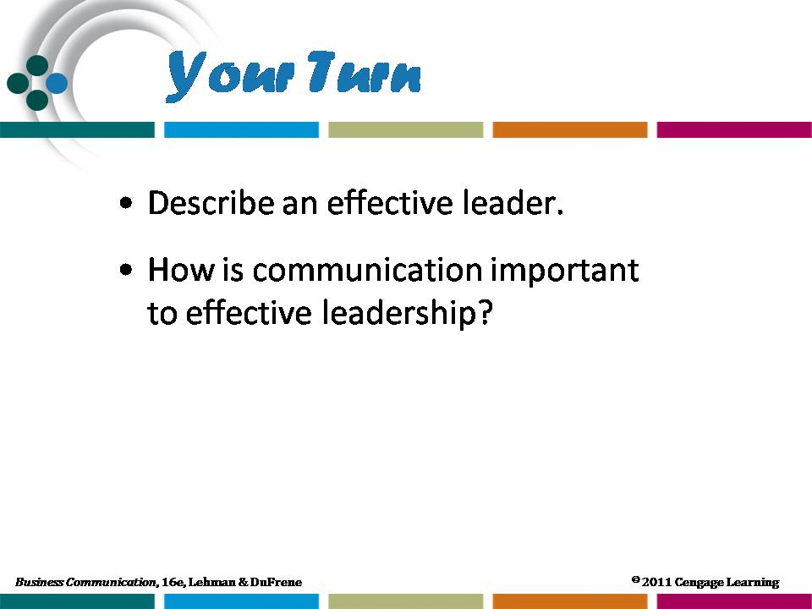 | Behavioral Theories That Impact Communication  An effective way to show the importance of each of the behavioral theories discussed is to relate them to modern organizations.  - Refer students to the photo essay on page 46 that highlights the Ritz-Carlton hotel chain and its emphasis on employee decision-making without supervisor approval or interference. As part of the chain’s emphasis on customer satisfaction, employees are | 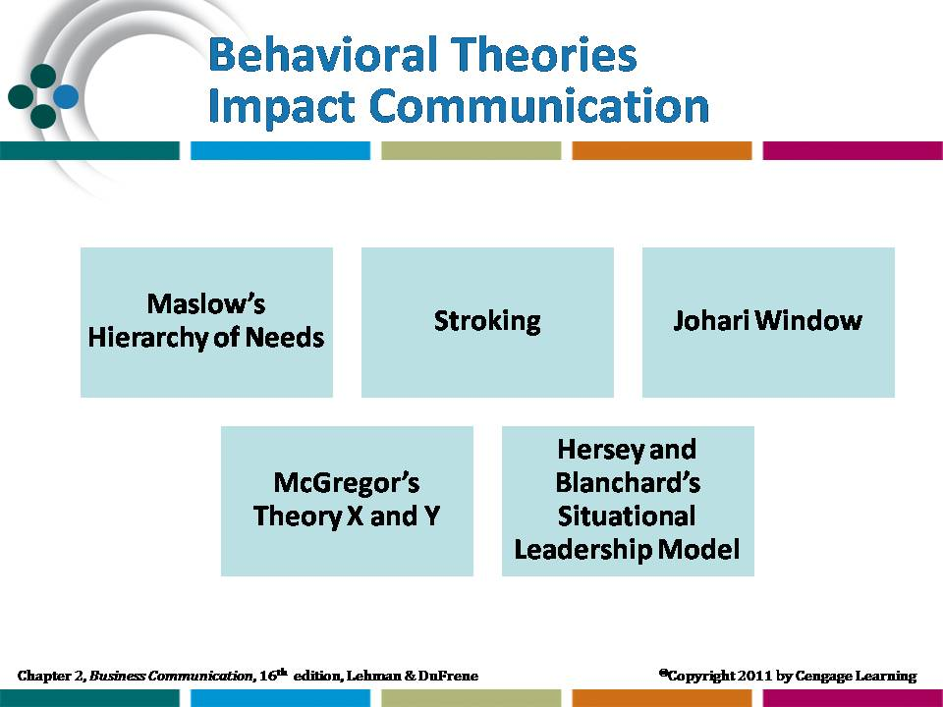  Lecture slide
assigned a dollar amount available to settle customer problems without supervisor approval. Discuss how Theory Y management style provides employees with value and independence.
- Have students visit the Ritz-Carlton corporate website at http://corporate.ritzcarlton.com/en/About/GoldStandards.htm and learn about the company’s Gold Standards. Discuss how these standards make for a superior customer experience.
 | According to essayist, philosopher, and poet Ralph Waldo Emerson, “Our chief want is someone who will inspire us to be what we know we could be.” Leaders must encourage and guide employees without quashing their desires and ideas. For effective leadership, communica-tion is key. When U.S. President Barak Obama accepted the Nobel Peace Prize in December 2009, his speech to committee members had to show his push for peace while defending the U.S.’ increase of troops in Afghanistan.” |  | Lecture slide
The humble note he struck is one hallmark of his leadership style. According to Obama campaign strategist David Axelrod, Obama asks a series of questions before he makes decisions. By doing this, his openness style comes through because he allows his supporters and advisers to have input into decisions. His campaign leadership was focused on hiring trusted workers and giving them power to make decisions.
To read more about Obama’s acceptance speech, visit the National Public Radio website at http://www.npr.org/templates/story/story.php?storyId=121276209
For more information about Obama’s leadership and communication style, visit the Public Broadcasting website at http://www.pbs.org/newshour/bb/politics/july-dec08/obamacloseup_09-23.html
Other organizations and their practices can be used as examples in describing this and other theories. Ask students for input about companies with which they are familiar.
2 | Recognizing Human Needs  Display visuals as you discuss Maslow’s needs hierarchy and relate it to McGregor’s management styles.  - Managers who practice Theory Y help satisfy workers’ social and ego needs. By satisfying these needs, people gain in personal maturity, which helps lead to trust in management.  - In contrasting, managers who practice Theory X tend to assume that workers are concerned only with satisfying lower-level physiological and security safety | 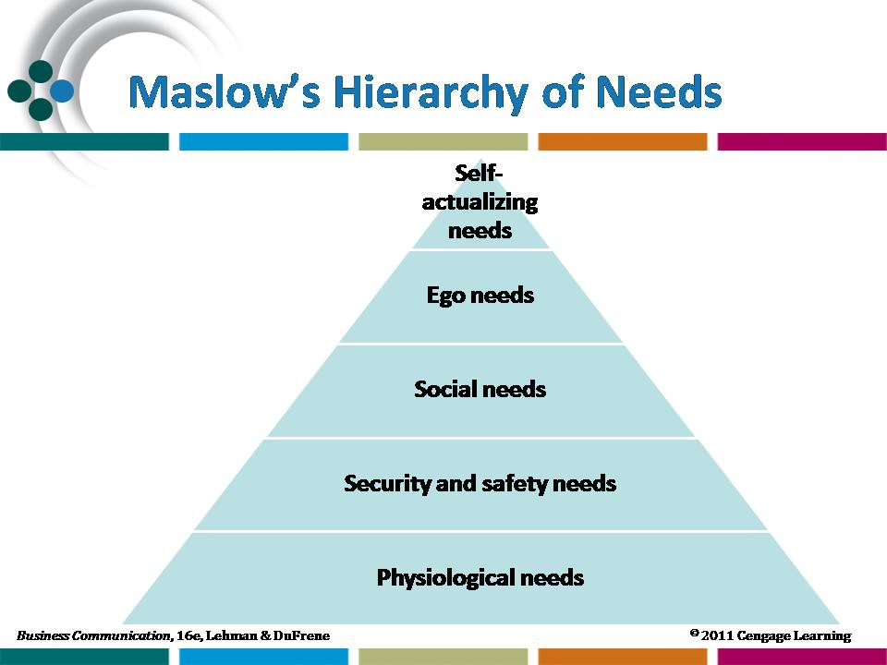  Resource slide
 | needs so these managers fail to assist in people’s efforts to satisfy higher-level needs.
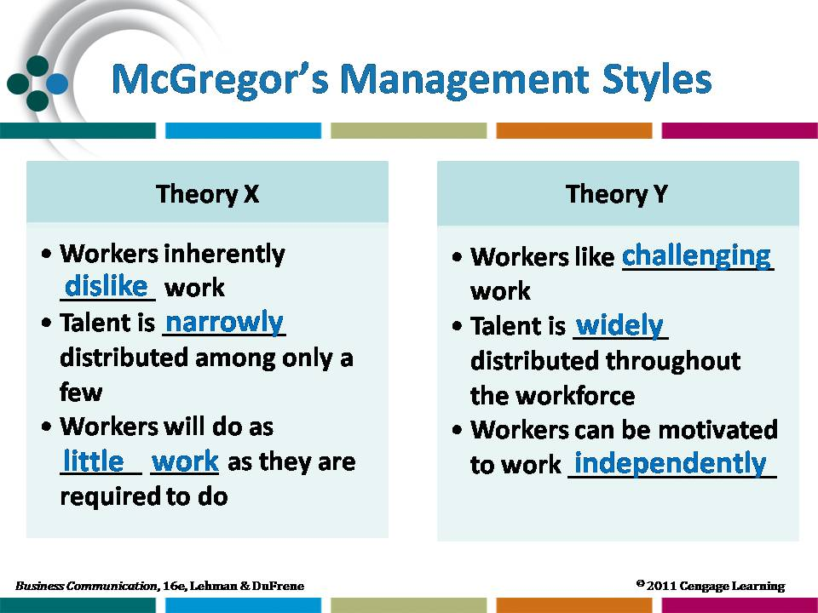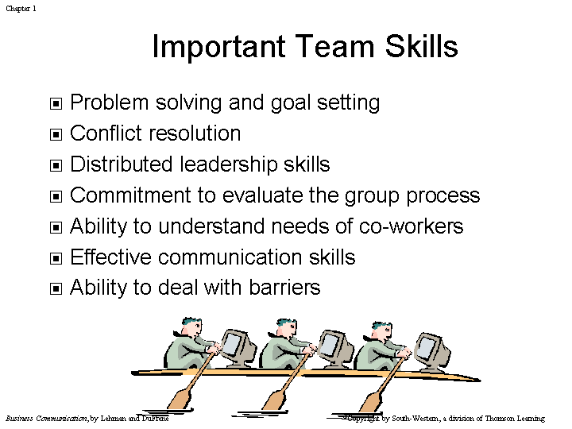 | Resource slide | 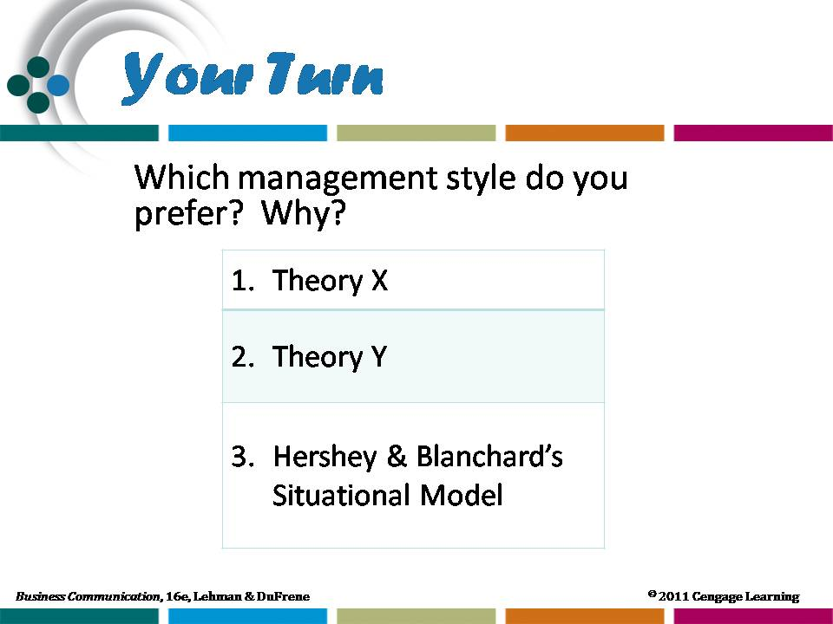  Resource slide
Stroking and the Johari Window
Display the Johari Window or direct students’ attention to Figure 2-1.
- Trust in another leads to a person’s willingness to disclose personal feelings, beliefs, and problems. Trust in others results from need satisfaction and from mature treatment at work.
- The Johari Window visual provides a means to show how trust leading to self-disclosure helps enlarge the free or open area and, in turn, decreases the size of the blind and hidden areas. Self-disclosure leads to further trust and to a higher level of interpersonal “sharing.”
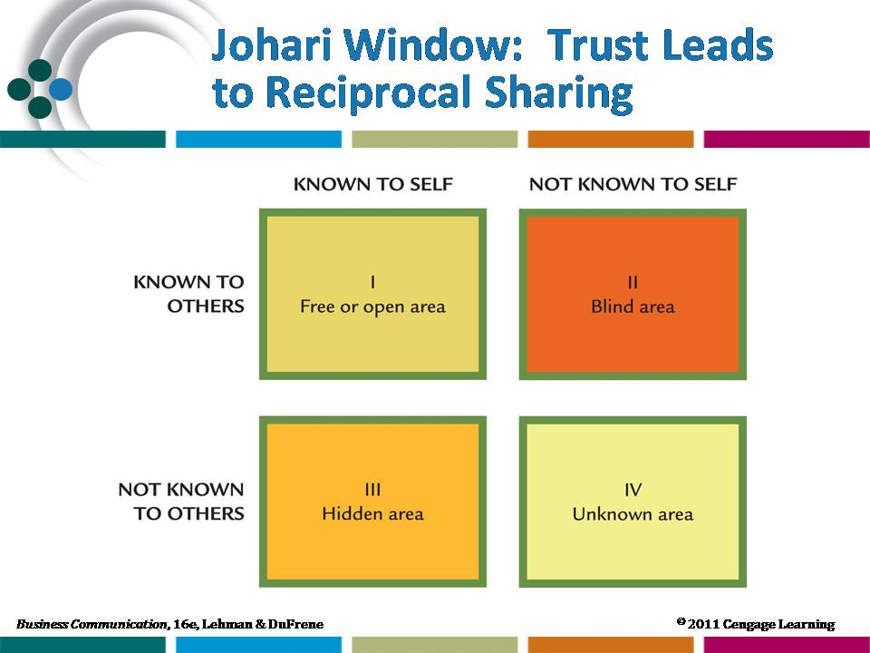 | Resource slide  Refer to Figure 2-1, p. 45. | 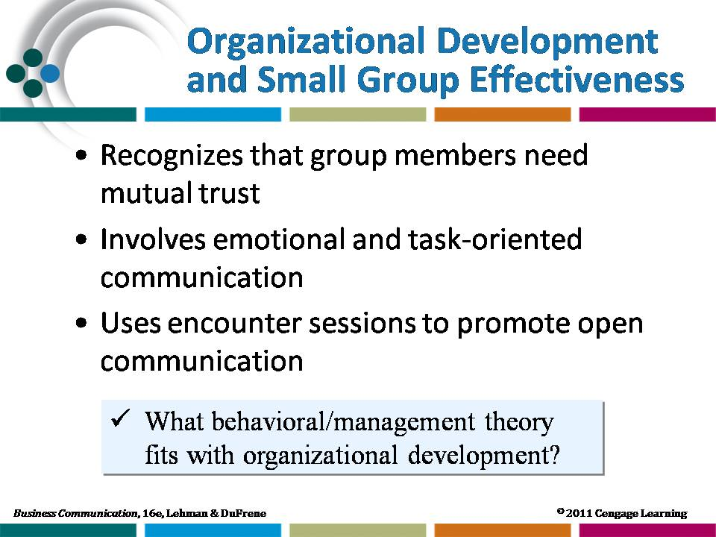  Resource slide
 | Contrasting Management Styles  Show the visual (right) and point out that Hersey and Blanchard’s Situational Leadership Model emphasizes using different management styles based on the situation and who the participants are. The directive behavior they describe occurs when a supervisor gives detailed rules and instructions to an employee and then monitors him or her closely. The supportive behavior they describe occurs when leaders listen, communicate, recognize, and encourage rather than dictating. | 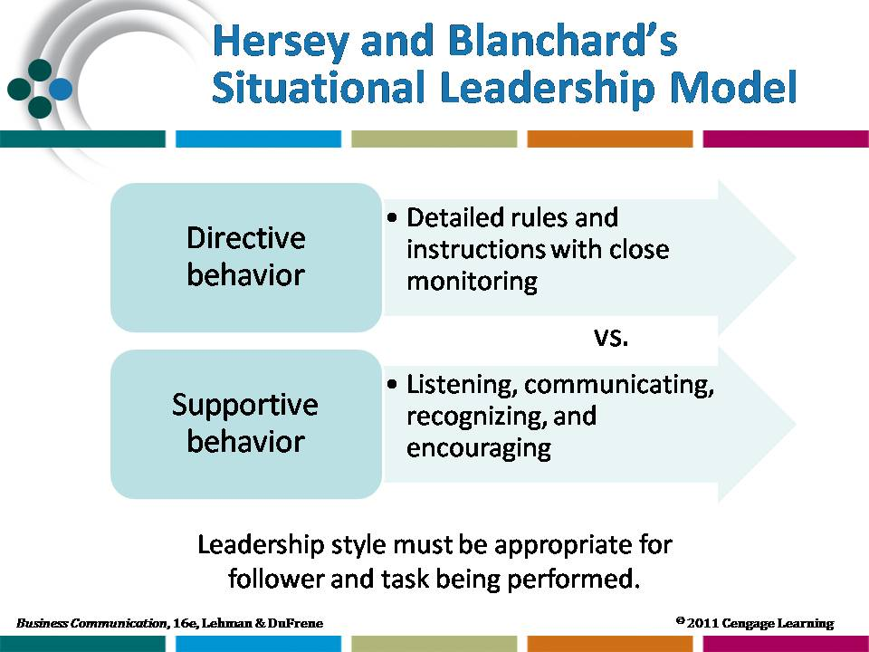  Resource slide
Your Turn 2-1: You’re the Professional  Have students consider this exercise in four groups. Assign each group one theme to use as the basis of increasing productivity in this new workplace. Group answers should focus on making a positive impact on the staff and not on demeaning or degrading past employees. Ask to think about other issues they might include in the presentations, e.g. incentives/rewards for increased productivity. | In addition to focusing on McGregor’s Theory X, you might discuss William Ouchi’s Theory Z.  - Theory Z, also known as Japanese style management, is marked by a strong bilateral commitment of employer and employee, life-long employment, and slow decision making based on consensus.  - Total Quality Management (TQM) is consistent with Theory Y and Theory Z since the contribution of the individual is emphasized.  - Assign Activity 1 and ask students to relate their personal communication experience to the class.  - Assign Question 1 of “Digging Deeper” and ask students to focus on one theory and list specific actions managers can take, based on that theory, to improve communication with employees.
Learning Objective 2
Describe the role of nonverbal messages in communication.
1 | Nonverbal Communication  Show the visuals (right and below) to illustrate the different components of nonverbal communication. Remind students that nonverbal includes everything except the actual words that occur in an interaction.  - Ask students to watch an interaction from a distance, involving people they do not know. Have them analyze the kind of interaction they viewed, based only on what they could see from a distance (they | 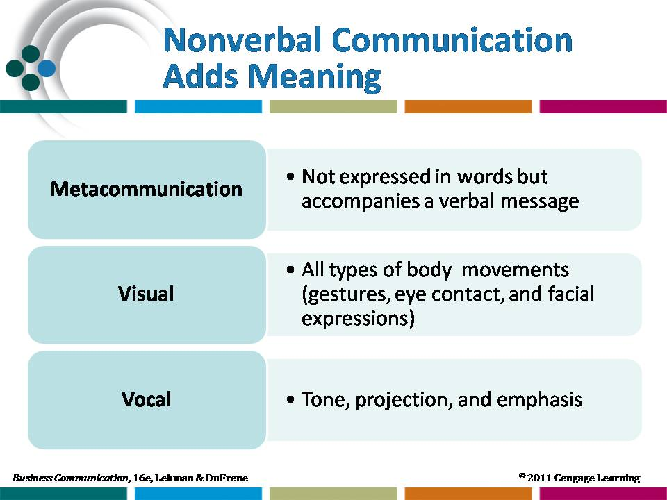  Lecture slide
could not hear the words). How much could they decipher? Emphasize that what they learn about the people and the situation is based only on nonverbal behaviors.
- Refer students to the photo essay on page 49. What can you tell about these people, simply from the way they dress and how they are standing?
- Ask students about what they plan to wear when they begin their professional careers after college. Consider showing photos of casual dress, business casual dress, and business professional dress. (Some images may be found at
http://humanresources.about.com/od/workrelationships/tp/dress_code_collect.htm
Remind students that they should “dress for the job they want, not the job they have.”
- Assign Application 2 and discuss in class.
 | 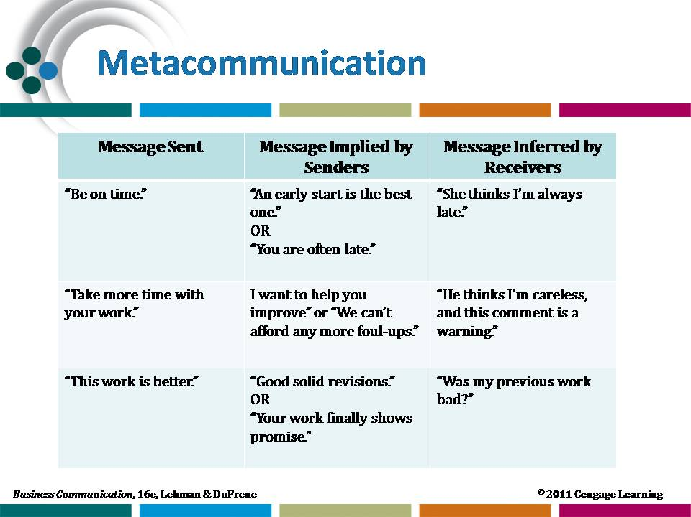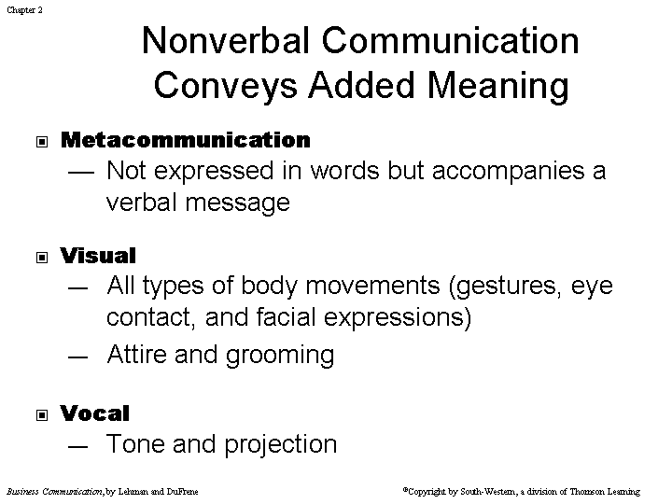  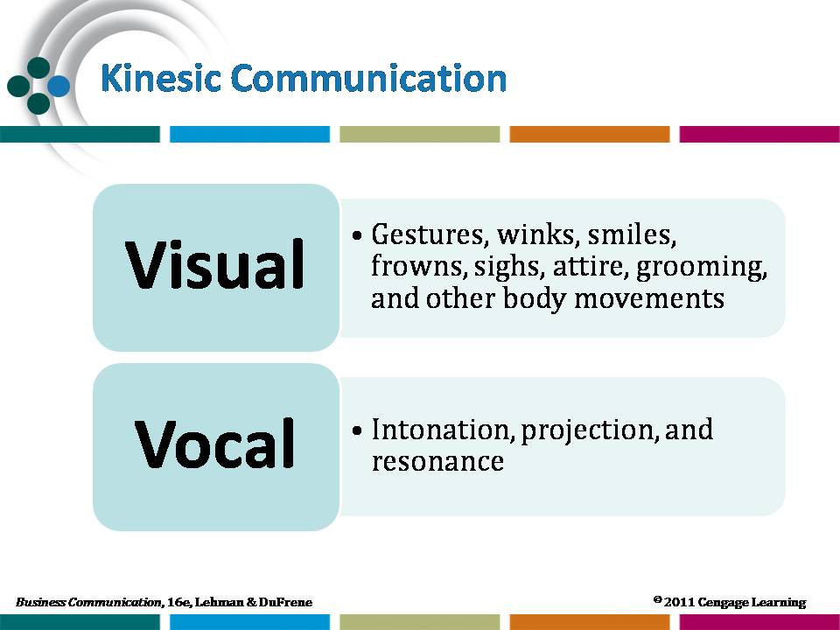  Resource slide | Resource slide
 | - Show the slide at right and discuss how different kinesics messages can have different meanings to different people, based on culture, background, gender, age, etc. Ask students for examples of situations where they have misread body language or where their body language has been misunderstood. | 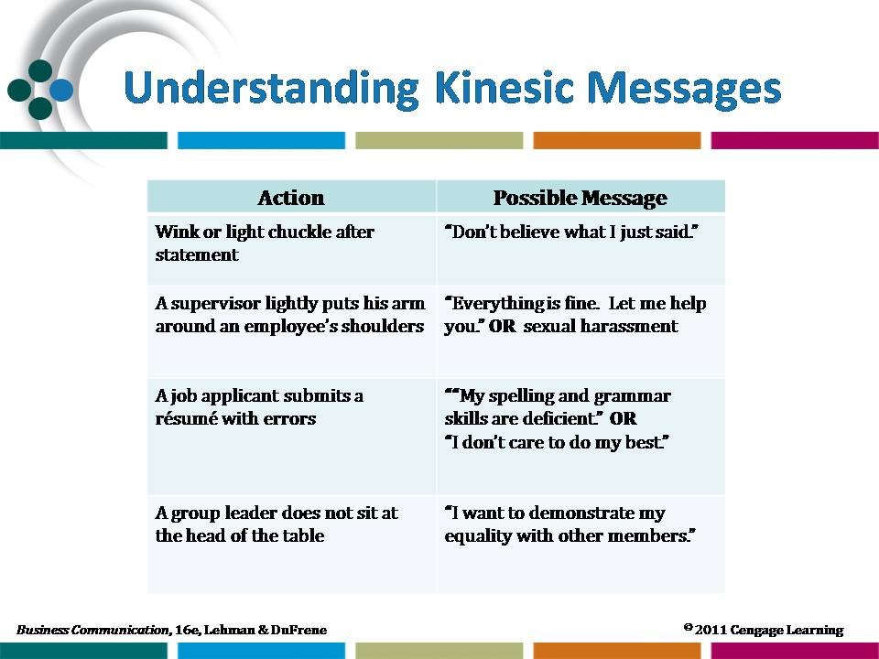  Resource slide
2 | Overcoming Barriers Created by Nonverbal Messages  Demonstrate several nonverbal signals and have students write down what they perceive to be their meanings.  - You might include some of the following: folded arms, raised eyebrows, scratching the head, hands on hips, shrug of shoulders, etc.  - Have students share their perceptions. Were there differences in what students perceived? Explain. How might those signals be interpreted differently when accompanied with various word messages? | 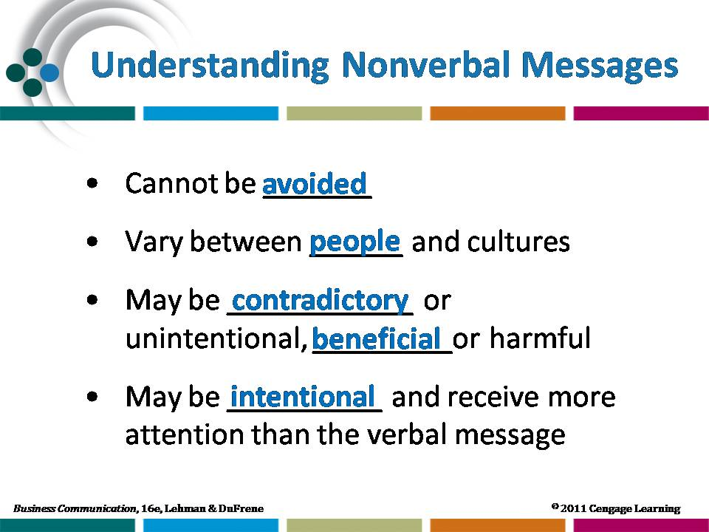  Lecture slide
3 | Cultural Differences in Nonverbal Communication  - Project the visual that asks students to consider how other cultures might react to nonverbal messages. Discuss the possible reactions and encourage students to share other examples.  - Assign Application 7 and discuss in class. | 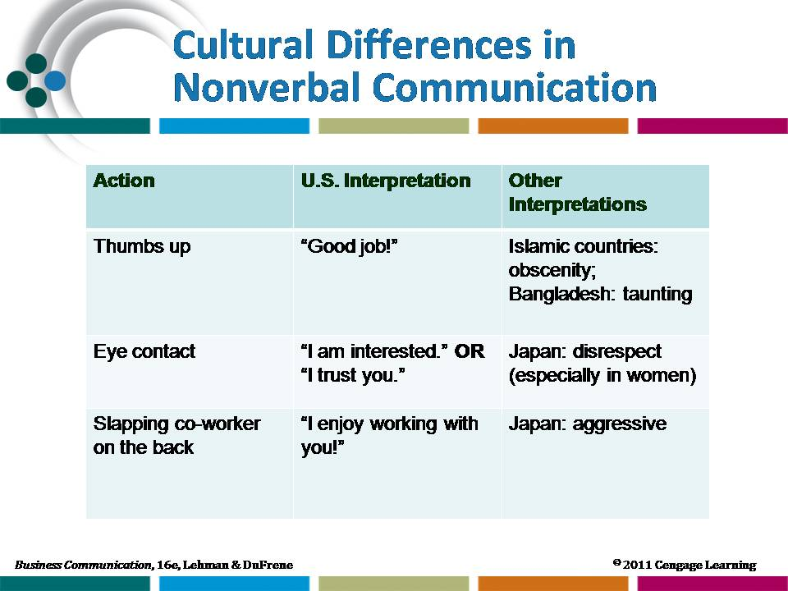  Resource slide
Strategic Forces Feature: Diversity Challenges: Cultural Differences in Nonverbal Messages
Assign the application to be completed prior to the class discussion of nonverbal communication. Students should be able to contribute meaningfully to the class session based on their interviews.
Learning Objective 3
Identify aspects of effective listening.
1 | Aspects of Effective Listening  Because of its pervasive nature, listening should be a concern of other disciplines in addition to business communication. In the business communication course, listening instruction should be related to interpersonal and group communication and interviewing practices.  Your Turn 2-2: Miscue  Discuss the special importance of communication and listening in the health-care field, on the part of nurse, doctors, and patients. Remind students about problems with miscommunication using cell phones because of dropped calls, poor signals, etc. Consider revisiting this exercise when discussing cell phone communication in Chapter 5.
2 | Listening for a Purpose  - Display the visual and discuss the different types of listening. |  |  | 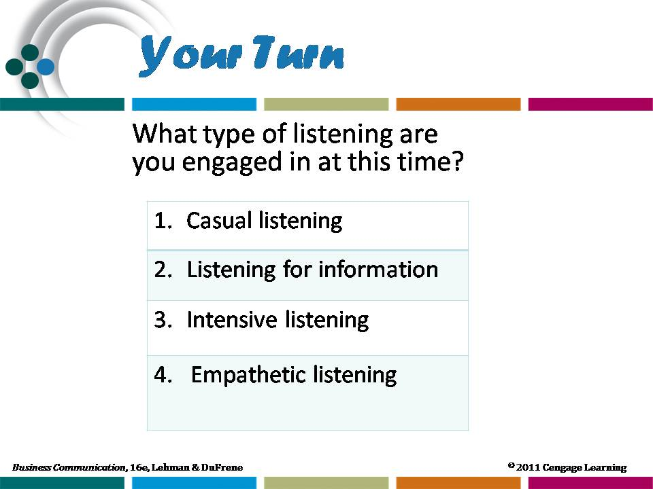  Lecture slide  Lecture slide
- Discuss and give examples of the different reasons for listening:
- To interact socially, such as talking with your colleagues about weekend plans.
- To receive information, such as calling a vendor to obtain a price for an item.
- To solve problems, such as discussing with your team members why work must be completed earlier than you had planned.
- To share feelings with others, such as hearing how a co-worker is tired of the two-hour commute to work everyday.
- Assign Activity 3 and discuss in class.
3 | Bad Listening Habits  - Display the visual listing bad listening habits.  - Ask students to work in small groups to discuss a situation they have faced that provides evidence of bad listening habits. Ask each group what specific suggestions they could provide that would improve listening in this situation.  - Ask a member of each group to share listening suggestions with the class. Use these class presentations to lead into a discussion of speaker and listener responsibilities. | Resource slide  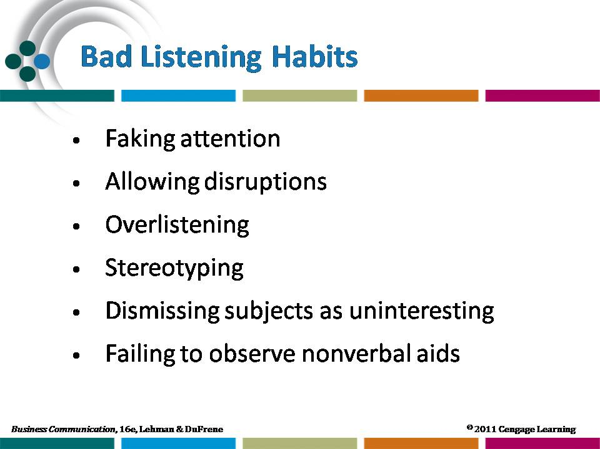
 | - Lead students in a discussion of how to overcome bad listening habits.
4 | Suggestions for Effective Listening  - Discuss effective listening guidelines. To help students identify listening weaknesses and develop a plan for improvement:  - Have students answer Chapter Review Question 5, noting their listening weaknesses.  - Assign the Holistic Assessment Case: Is Anyone Listening? The related activities focus on a self-diagnosis of listening habits and the development of a plan for improvement.
 | 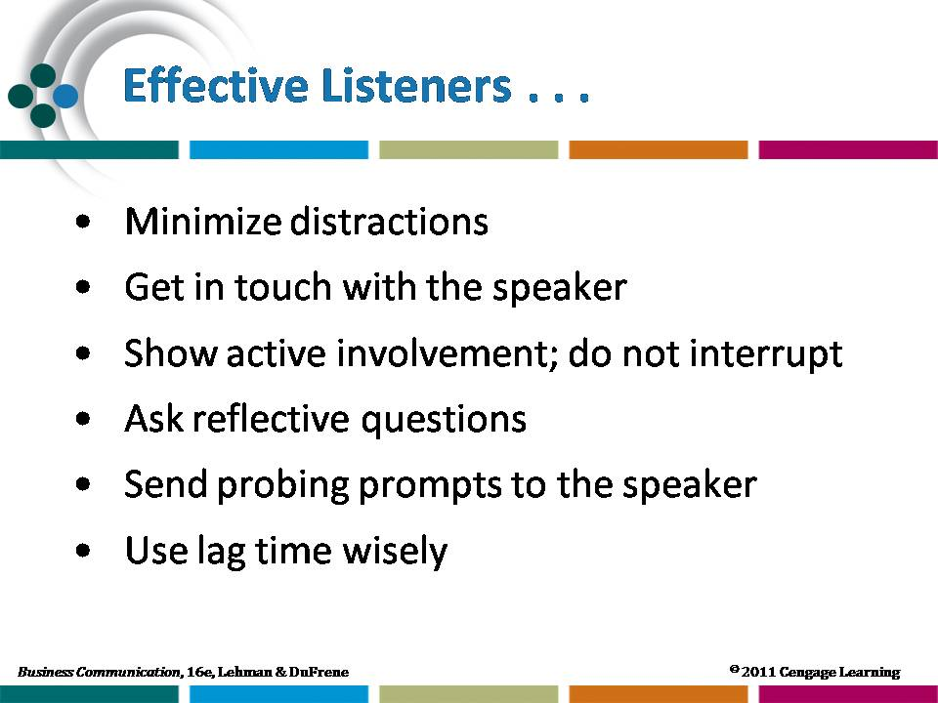  Lecture slide | 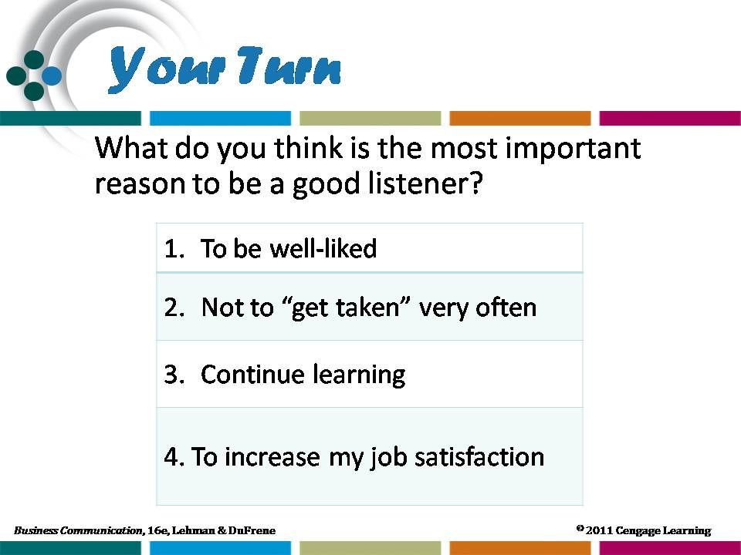  Resource slide
- Require students to keep a listening log for 21 days, the time needed to break a habit. They should record what they did each day to break the bad listening habits which were identified (daydreaming, interrupting the speaker, prejudging the subject, etc.). Have students give a short report at the end of the three-week period, summarizing their outcomes.
- Assign students to read a current article about a topic of your choice and give a short (two- or three-minute) presentation. Instruct the class to listen attentively but not to take notes. You might direct the speaker to incorporate one or more of the listening distractions in his/her presentation. Prepare three to five questions to ask the class about the material (either multiple choice, true/false, or short answer) to assess their listening effectiveness.

Your Turn 2-3: Assessment
Have students complete the online listening assessment. Once they have completed the assessment, ask each student to write a short paragraph outlining the scores and describing what the scores mean. Class discussion should focus on adopting the effective listening habits discussed in the chapter to improve listening. You might ask students to pay attention to their listening for 21 days, a timeframe recommended for changing a habit, and then have them take the assessment twice, once before the 21 days, and once after, to assess whether scores improve.

Learning Objective 4
Identify factors affecting group and team communication.
1 | Increasing Focus on Groups  - Lead students in a discussion of how communication in flat organizations differs from that in traditional organizations. Emphasize the need for more lateral (horizontal) communication and how that can be accomplished.
 | - Display the visuals as you discuss the following:  - Discuss the barriers that include role vs. status, excessive competition, flat organizational structures that pose new requirements for communication flow.  - When mid-level positions are eliminated, communication must be redirected.  - Assign Application 8 and have students report in class on the flat organizations they researched. | 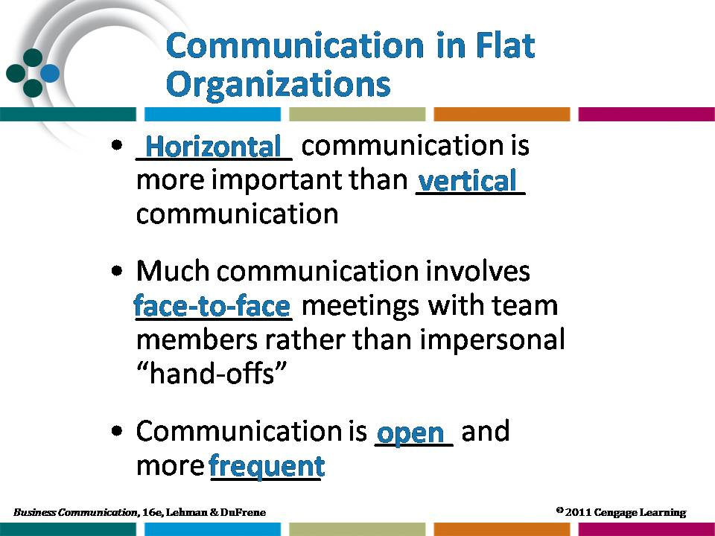  Resource slide
2 | Characteristics of Effective Groups  - Show the visual while discussing characteristics of effective teams. To illustrate the importance of common goals, ask students what happens in a team project in which two members want to make an “A” and the other two members are satisfied with a “C.”  - Ask students what size team they prefer for completing school projects, giving reasons for their preference. | 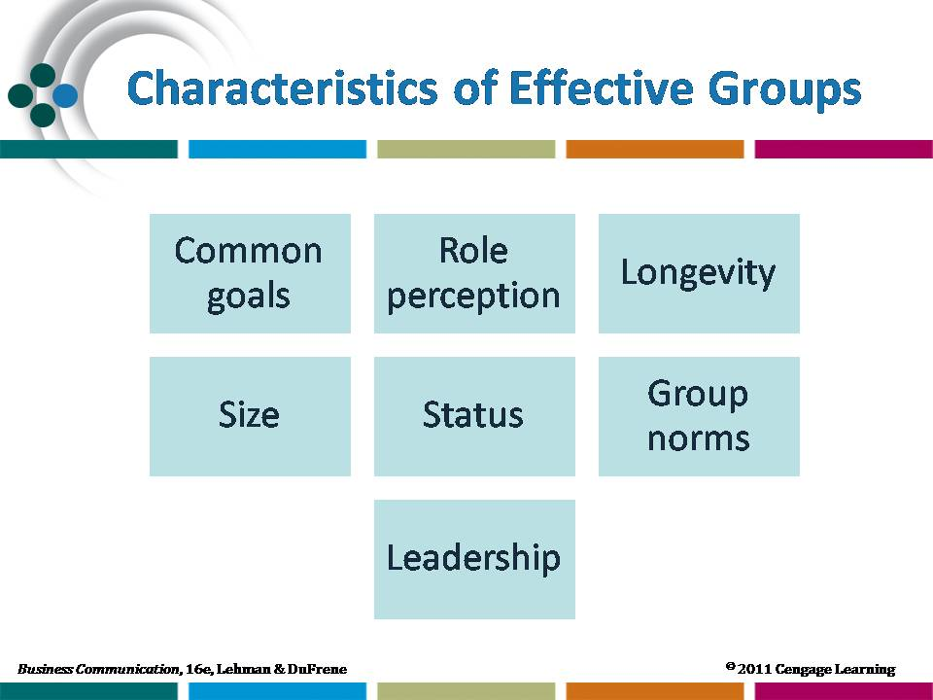  Lecture slide
 | - Ask students to recall a negative team experience they may have had at school or work. Which of the characteristics were lacking in that situation?
3 | Group Roles  - Project the visual as you discuss team roles. Which roles are positive? Which are negative? Can an individual group member play more than one role?  - Ask students to think of a group of which they are members (family, club, church, etc.) and to identify persons in that group who play each of the discussed roles. Ask students about which negative group roles are the most difficult to control or manage? Which ones are tolerable?
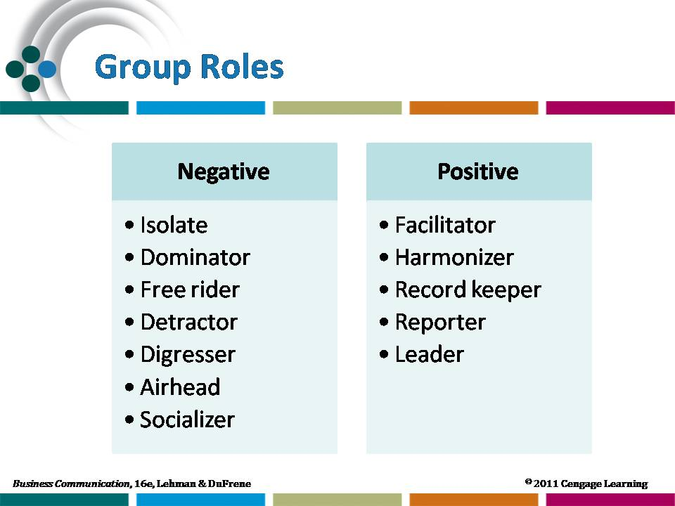 | Resource slide |  | 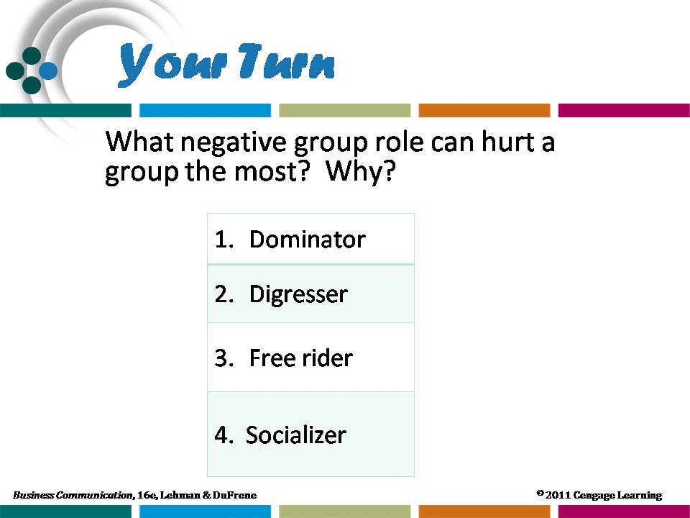  Resource slide
4 | From Groups to Teams  - Project the visuals and lead a discussion of different types of teams. Remind students that becoming a team is a process that does not occur simply because a group is put together by a manager or supervisor. For a group to become a team, it must go through a development process with four distinct phases—forming, storming, norming, and performing. All teams will not reach their optimum performance level but will settle for the acceptable performance that comes in the norming stage.  - Assign Application 1. Discuss how corporate team-building has changed and how companies are using off-site physical and mental activities to make on-site teamwork more effective.
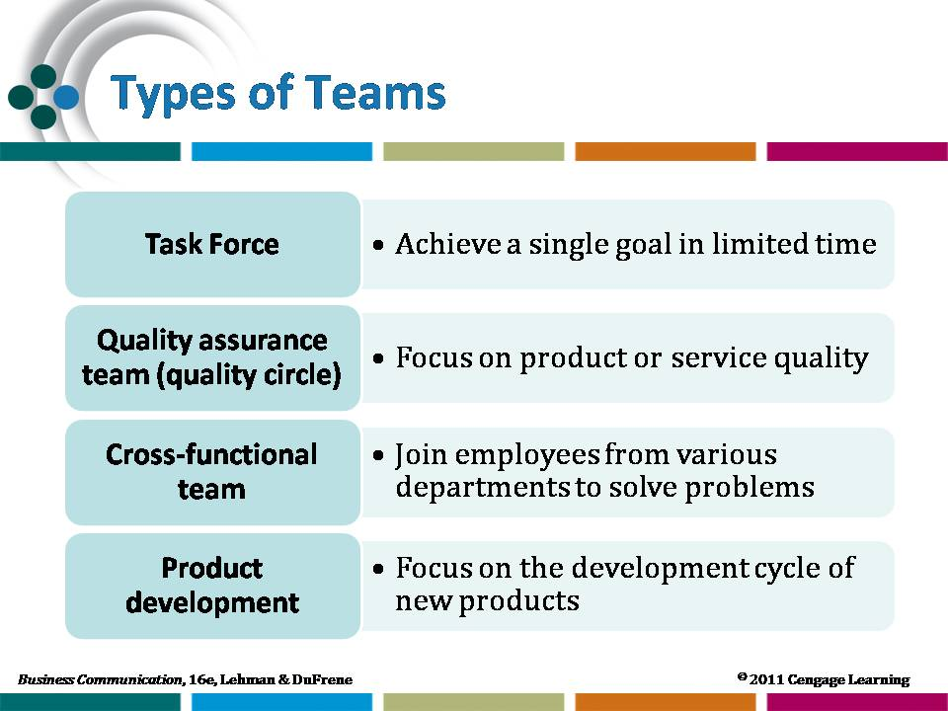
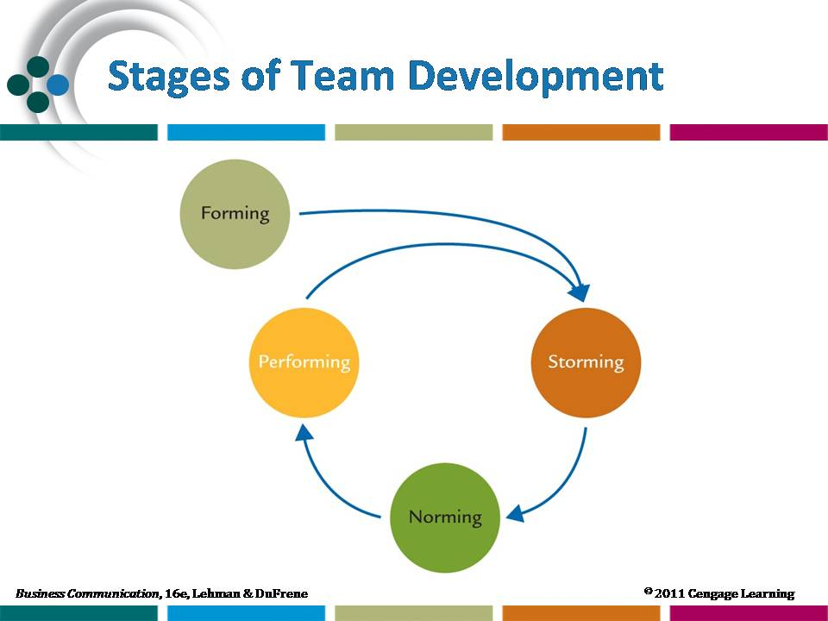
 | Resource slide |  | Lecture slide
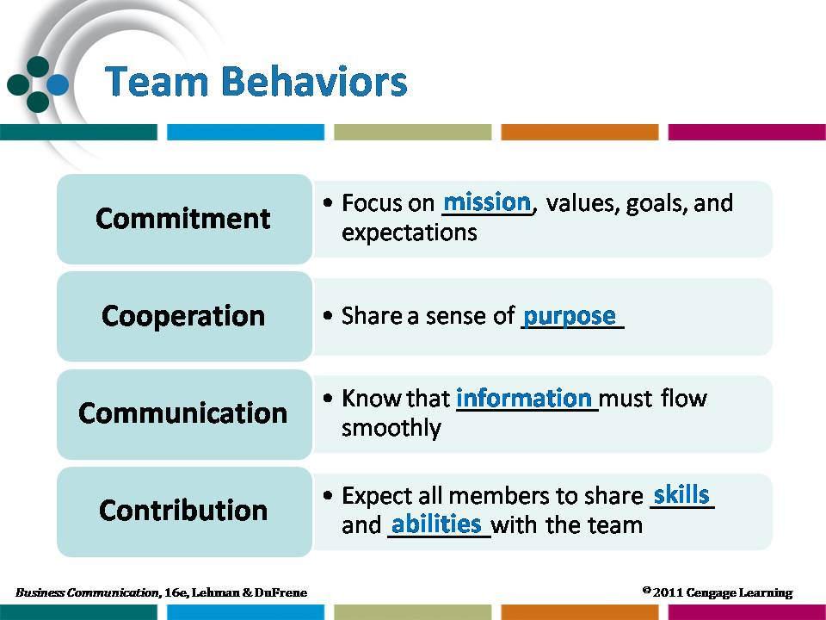 | - In small groups, have students brainstorm a list of recommendations for using teams effectively. As each team reports its list, record the recommendations on the chalkboard or overhead.  - Show the visuals as you discuss team behaviors. Newly formed groups often find it helpful to set aside time to define their purpose, expectations, and roles. | Resource slide
5 | Overcoming Groupthink  To supplement the text’s discussion of teams, project these visuals as you lead a discussion of the value of conflict in the group process. Stress the following:  - Groupthink is a destructive phenomenon that results when a group develops a single mindset rather than exploring alternative solutions.  - Groupthink can result because of pressure to conform and to present a unified front. | 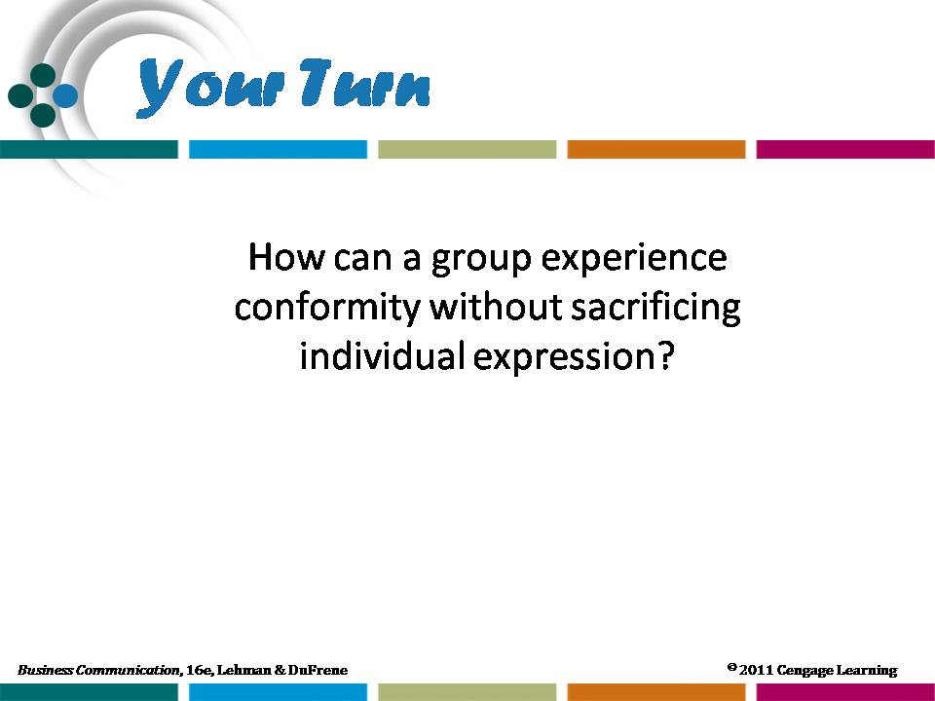  Resource slide
- Conflict is a healthy process that counteracts groupthink.
The space shuttle Challenger disaster was a prime example of groupthink at work. After the tragedy, numerous persons involved with the project indicated that they had indeed had reservations about the launch, yet the pressure to not further delay the mission influenced them to say nothing to the contrary.
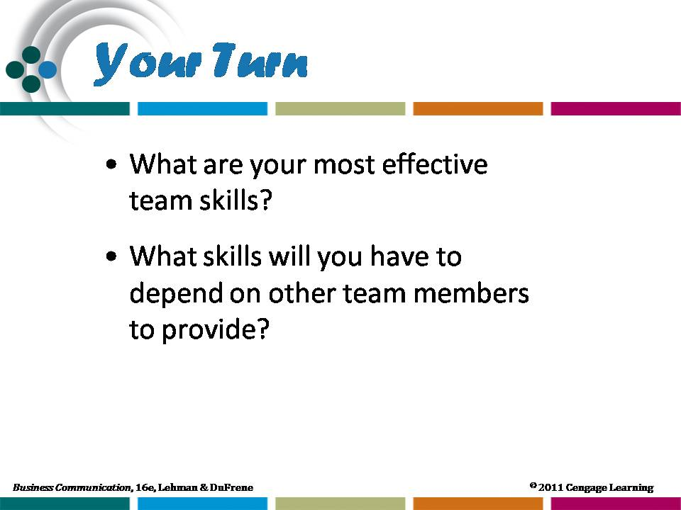 | - Remind students that teamwork is not about each member contributing to a project separately. Teamwork should focus on the concept of synergy, that the whole is bigger than the sum of the parts, or 1+1=3. When becoming part of a team, students should consider what skills they can offer and what skills they need to improve.  - Student work on group projects often becomes each student working on his/her part and then group coming together to try and combine the | Lecture slide
 | more easily with outlined goals and each group member working with the others.

Your Turn 2-4: Career Portfolio
Have students complete the online communications style survey. Once they have completed the assessment, ask each student to write a short paragraph outlining what their styles are and how their styles as scored might affect their interactions with others. Lead a class discussion of the different styles (found on the survey website) and how those styles can help and hinder interactions in groups.

Learning Objective 5
Discuss aspects of effective meeting management.
1 | Meeting Management  - Have you ever heard someone say “I have been in meetings all week, and we haven’t accomplished anything!”?Managers often spend up to 60 percent of their time in meetings that can sometimes turn into a free-for-all. Effective meetings don’t just happen; they occur because the organizer engages in careful planning and attention to specific guidelines.  - Show the following visuals while discussing the relative advantages and limitations of face-to-face and electronic meetings.  - Refer students to the photo essay on 63. Discuss collaborative and videoconferencing technology that allows meetings to happen electronically, without the financial and logistical issues that can come with trying to schedule meetings when people are separated geographically.  - If your school has a distance learning or extension area, see if you can schedule time in the unit’s videoconferencing classrooms to allow your students to experience the technology. Place two groups of students in different classrooms and let them communicate with each other. Discuss the issues of microphone and camera placement and the need to look at the camera, not necessarily the projection screen.
 | 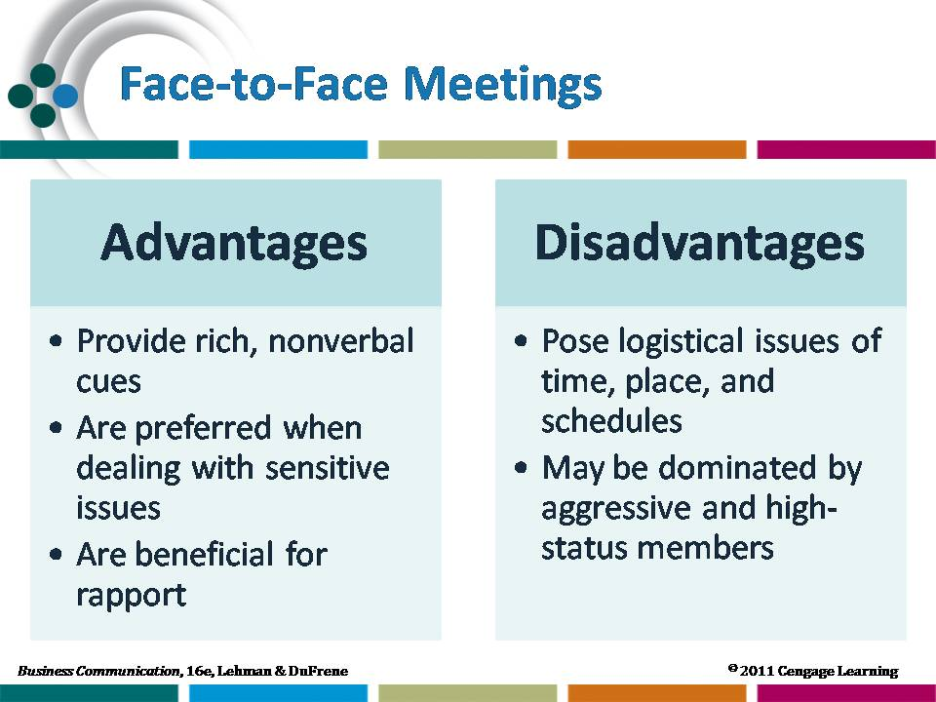  Resource slide | 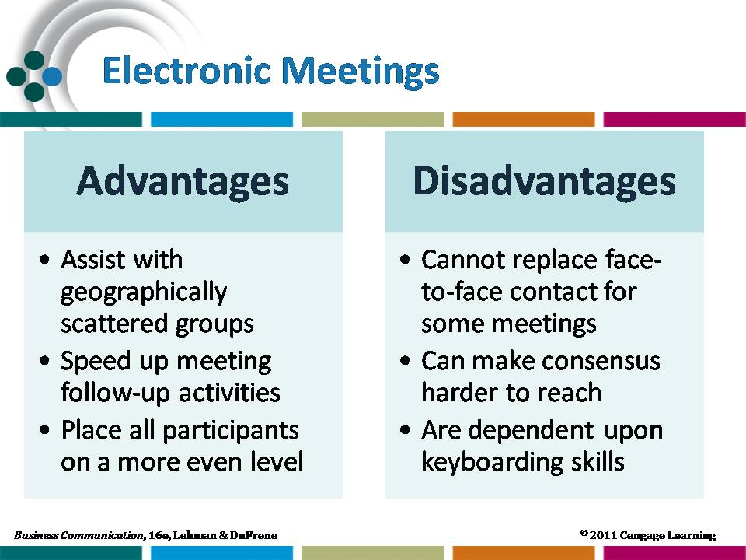  Resource slide
 | Strategic Forces Feature: Diversity Challenges: Communication Styles of Men and Women  - Ask students to share their lists of suggestions. The list will be varied; however, you might add the following to enrich the discussion:  - Gender differences may be viewed as strengths or weaknesses. Men and women should consider how or whether to tailor their communication approaches to better appeal to the opposite gender. | 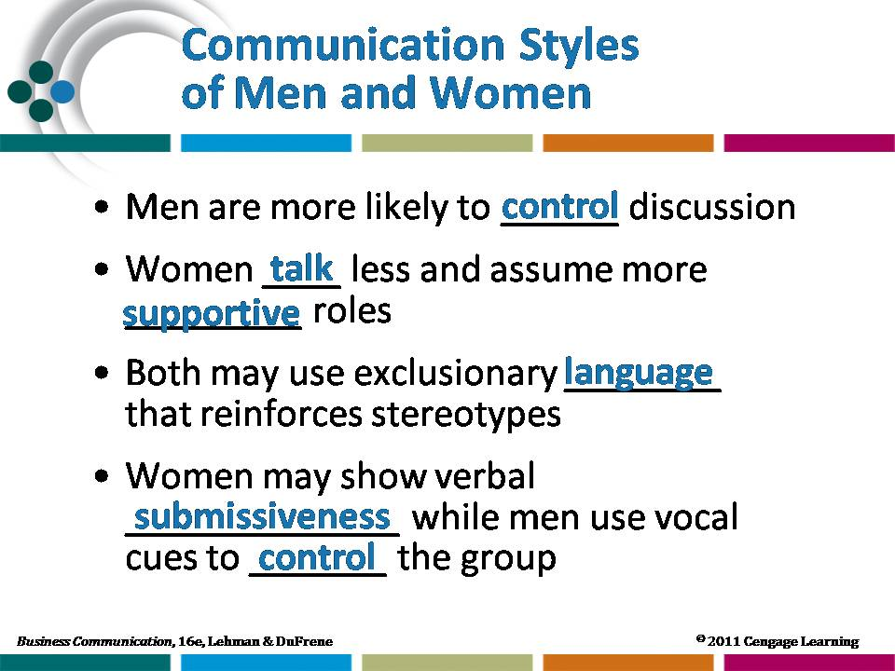  Resource slide
- “Fix” communication breakdowns by modifying your words/tonality/gestures, etc., to re-communicate the message.
- Give a small group of students a topic for a meeting. Have the men in the group be stereotypical “male” communicators (as defined in the Strategic Forces feature) and have the women be stereotypical “female” communicators. Have them act out a meeting on the topic you choose. Ask the remaining students to analyze where the breakdowns occur in the meeting process and discuss how to remedy those breakdowns.
2 | Suggestions for Effective Meetings  - Show the visuals and ask students for other suggestions for making a meeting productive.  Web Enrichment Content: Maximizing the Effectiveness of Virtual Teams  - Ask students to read the Web Enrichment: Maximizing the Effectiveness of Virtual Teams.  - Assign Application 5 and discuss student responses in class.  Assign students to research current software available for managing virtual teams. Ask them to find articles discussing the advantages and disadvantages of different types of software. |  | 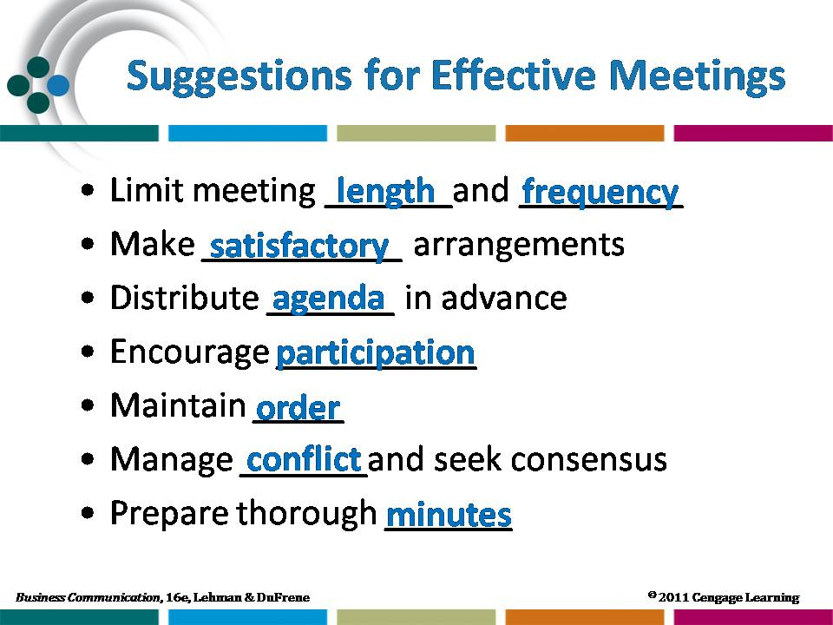  Figure 1  Lecture slide

Your Turn 2-5: Electronic Café

SECURE EMAIL PROTECTS CORPORATE INFORMATION
Business organizations need secure control over incoming and outgoing email. Financial services institutions are particularly aware of the need to keep email communication private. These exercises will allow students to explore the topic of secure email in more depth.
Learn more about secure email systems
After visiting the email policy website, students will have a better understanding of the threats that companies face, the need for an email policy, and procedures for creating, publishing, and enforcing an email policy. Students will also gain an understanding of legal issues concerning email monitoring.
Before assigning students the task of interviewing a business manager concerning company email policy, divide the class into teams to develop questions to be posed during the interview. Have the students use the information found on the http://humanresources.about.com/od/policiesandsamples1/a/email_policy.htm website as a guideline for developing the questions. Then, form a team of one representative from each team to develop one list of questions to be used by all students during the interviews.

Suggested Solution
Results of the interviews will vary. However, using a list of standard questions will generate data that can be analyzed to produce an accurate view of the status of email policies in local businesses.
Read about email security products
After reading the Bradley article, students will recognize the importance of securing email, even personal and email that may seem innocuous. Bradley compares securing email messages to using opaque envelopes to send checks or important messages via postal mail. He also outlines the reason for encrypting all email messages, not only the ones with sensitive or private information.
Learn more about email security.
Refer students to the five lessons on email security so that they may use the information as a professional resource in the future. Suggest that they take the five lessons and make a list of tips for ensuring email security that they can carry with them into the corporate world.
Suggested Solution
Students can write a more thorough email message by searching the Internet for issues concerning “email security.” The content of the email messages will vary. However, business situations that would require a secure email transaction include sending email containing sensitive financial data; personnel issues—especially related to hiring and firing; industrial designs or blueprints; or management/senior level “planning stage” communication.

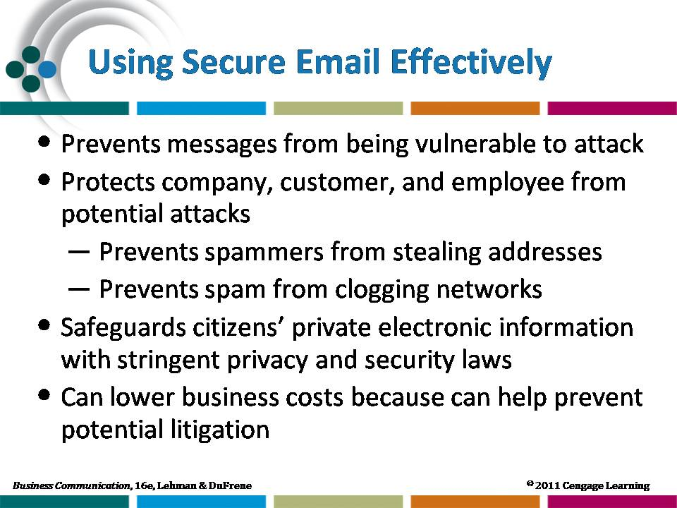
Figure 2

Chapter Review
1 | What is meant by stroking? How does it affect interpersonal communication in the workplace?  (Obj. 1)  Stroking is a transactional analysis term for identifying the way others give recognition to a person. It can be in the form of a pat on the back from the supervisor, a congratulatory message, or being listened to. Receiving strokes is essential to a person’s mental and emotional well-being. By staying aware of this fact, managers can greatly improve communication and people’s attitudes toward their work.
2 | When a manager says to an employee, “May I see you in my office,” what are some of the possible metacommunications? (Obj. 2)  Some possible metacommunications (both positive and negative) are as follows: “You have not been performing up to our company’s standards so we are letting you go. “You had the best sales presentation of the entire staff, so you will receive a 10 percent bonus this month, if the client selects our firm.” Your workplace dress is inappropriate, and you must begin adhering to our company dress policy.” What an employee expects and the metacommunication inferred depend completely on the past interactions with the manager and on what has happened most recently.
3 | What roles do culture and gender play in nonverbal communication? (Obj. 2)  Nonverbal messages have different meanings from culture to culture, and men and women from the same culture typically exhibit different body language. Such nonverbal behaviors are learned through the example of others.
4 | How is the activity of listening impacted by the particular situation? (Obj. 3)  People satisfy a variety of purposes through listening, including social interaction, receiving of information, problem solving, and sharing of feelings. Each activity calls for a different style of listening.
5 | Discuss six bad listening habits. Which do you think is the biggest challenge for you personally? (Obj. 3)  Bad listening habits include faking attention, allowing disruptions, overlistening, stereotyping, dismissing subjects as uninteresting, and failing to observe nonverbal aids. Personal responses of students will vary.
6 | What is a possible cause of most conflict between or among groups? (Obj. 4)  Lack of understanding about the nature and roles of other persons or groups is a possible cause of most conflict between or among groups. This shortcoming is a communication problem that leads to conflict.
7 | How are a group and a team different? (Obj. 4)  The main difference between groups and teams are in member attitudes and the levels of commitment.
8 | Discuss how a flat organizational structure affects communication. (Obj. 4)  In a flat organization, communicating across the organizational chart becomes more important than communicating up and down in a top-heavy hierarchy. Communication is enhanced because the message must travel shorter distances. Much of the communication is face to face.
9 | What are some factors to consider in deciding whether to hold a face-to-face meeting or an electronic meeting? (Obj. 5)  Geographic dispersion, familiarity of participants with one another, and technical capabilities of participants should all be considered in deciding whether to hold a face-to-face or an electronic meeting.
10 | Why are records such as agendas and minutes important to group success? (Obj. 5)  An agenda provides a plan for the meeting to keep everyone informed and to provide for orderly activity. Minutes provide a written record of meeting actions to assure that necessary tracking, follow-up, and implementation occur.

Digging Deeper
1 | How can managers use Maslow’s need levels, the Johari Window, and the management theories of McGregor and Hersey and Blanchard to improve communication with employees?  Knowledge of these theories will aid managers in supervising their employees more effectively.  A manager can help employees meet needs in Maslow’s order and therefore motivate them to perform better. For example, employees can better reach their fullest potential [self-actualization] with confidence that the manager supports/understands them. By using the theories of the Johari Window, a manager can help increase what is in the free and open area by maintaining open communication with an employee. A manager can analyze employees to see which ones work better with more supervision and less control (Theory X or directive behavior) and which ones work better under less supervision and more control (Theory Y or supportive behavior).
2 | How do effective conversation and listening impact a business’ overall success?  Businesses are impacted by effective conversation and listening skills because employees who listen are more likely to be well-liked and to work more effectively than employees who are not. Conversation skills are important because conversation means communication, and effective communication is essential to a business’ long-term success.
3 | Why do some teams never reach the highest stage of team development? What can be done to overcome the obstacles to peak team performance  Teams fail to reach the highest performance stage because of lack in one or more of the 4 C’s: Commitment, Cooperation, Communication, and Contribution. For instance, a team could fall short of the performing stage because of a lack of commitment to common goals. Or a team could stall because the personality styles of each team member have not been explored and their roles have not been well defined. Poor communication can result in low team performance, as can the lack of quality contribution by one or more members.
Activities
Teaching Suggestions and Possible Solutions
1 | Applying Behavioral Theories to Communication Situations (Obj. 1)  In analyzing student responses, focus on the creative application of the behavioral theories to practical situations.
2 | Understanding the Importance of Nonverbal Messages (Obj. 2)
2 | Nonverbal | Possible Meaning | Misinterpretation
2 | Steepling hands.  Covering mouth with hand when talking. | I am propping my arms on the table because I am tired.  I think I have bad breath. | I am better than you.  I am lying; I have no confidence in what I am saying.
 | Not making eye contact.  Standing while everyone else is sitting. | The sun is in my eyes.  My back hurts, and I need to stretch. | I am lying; I am not confident in what I am saying.  I have authority over you.
3 | Identifying Appropriate Listening Styles (Obj. 3)  After reading student responses, summarize their suggestions for maximizing their own listening. Challenge each student to target several of the suggestions for personal implementation.
4 | Identifying Deterrents to Group Success (Obj. 4)  Responses will vary. Students should focus on a lack of common goals, misunderstood role perceptions, group size, or lack of leadership as reasons for groups not succeeding.
5 | Analyzing a Meeting for Effective Behaviors (Obj. 5)  Responses will vary. Students should focus on how well the meeting manager (a) limits the running time of the meeting, (b) sets the agenda and distributes in advance, (c) encourages participation, (d) maintains order, (e) manages conflict, (f) seeks consensus, and (g) aids in preparing thorough minutes.
6 | Assessing the Professional Value of Interpersonal and Group Communication Skills (Objs. 1-5)  Responses will vary. This activity is most effective when teaching students who are close enough to graduation to be considering specific positions for which they might apply. Consider pairing this assignment with Chapter 1, Activity 1 where student shadow a business manager for a day and log communication activities. Students also could assess his/her use of interpersonal and group communication skills.

Applications
Teaching Suggestions and Possible Solutions
READ |  | THINK | WRITE | SPEAK | COLLABORATE
1 | Boosting Team Effectiveness: Trend in Corporate America (Objs. 1, 4)  Responses will vary. Consider using the activities listed in your class with teams you organize for class projects. Divide the students into different teams for each activity you choose. Have students complete the activity and then complete a team debriefing to analyze strengths and weaknesses.
2 | Gaining Insights from Nonverbally Communication (Obj. 2)  Presentation formats will vary. Encourage students to be creative by setting up a mock job interview and having both the interviewer and interviewee exhibit positive and negative nonverbal behaviors. Or ask one group to model negative behaviors and the other to model positive behaviors. Additions to the list in the article might include talking with a hand over the mouth, which can be interpreted as lying or lack of confidence; standing while everyone else is sitting, which can be interpreted as a sign of implied superiority; and sitting away from everyone else in the room, perhaps with an extra chair between, which can be interpreted an purposeful isolation.
READ |  | THINK | WRITE | SPEAK | COLLABORATE
3 | Analyzing Limitations of Electronic Communications (Objs. 2, 3, 5)  Have students discuss their impressions about the distance interaction and identify the relative advantages and disadvantages.
READ |  | THINK | WRITE | SPEAK | COLLABORATE
4 | Recognizing Events that Involve Metacommunication (Obj. 2) Downloadable file available at companion website  Encourage students to share with the class or small groups their organizational chart depicting the external communication system of an organization. Good examples may be drawn from workplace peer groups, student organizations, social groups, athletic teams, academic departments, and religious groups. Discuss the formal hierarchies as they compare to informal power structures.
5 | Maximizing the Effectiveness of Virtual Teams (Objs. 4, 5) Web enrichment content available at companion website  Personality attributes listed might include discipline, detail orientation, and timeliness; these are complimented with strong written communication skills, problem-solving ability, and a comfort with technology. The links provided in the text enrichment provide a wealth of information about effective virtual team membership.
6 | Documenting Meeting Activities (Obj. 5) Web enrichment content available at companion website  Evaluate the minutes for completeness. Follow up with a class discussion of the importance and purposes of meetings.

READ |  | THINK | WRITE | SPEAK | COLLABORATE
7 | Locating Information on Nonverbal Communication in Other Cultures (Obj. 2)  Encourage students to share their findings in small groups and compile a list of gestures that have different meanings. Have each group share one or two gestures with the class and discuss the various meanings.
8 | Discussing the Impact of Flat Organizational Structure on Communication (Obj. 4)  Discussion of the readings should focus on the common effects on communication that have been reported. Did some organizations deal more effectively with communication issues than did others? What communication advice would you offer to an organization that is about to undergo “flattening”?
READ |  | THINK | WRITE | SPEAK | COLLABORATE
9 | Analyzing Group and Team Experiences (Obj. 4)  When student teams take this survey, ask them to click the “Next” tab at the end of the survey. Students should consider the five types of groupings outlined on the website. Email messages about this activity should focus on what the teams learned about themselves as individuals and about how they work together as a team. They should also outline some strategies for improving themselves as a team.
10 | Using Instant Messaging to Communicate (Objs. 3, 4)  Grading of this assignment should focus on content, rather than format. Completeness of the message and attention to what the assignment requested in the way of information should be the key criterion for evaluation.
Cases
Teaching Suggestions and Possible Solutions
1 | Boosting Employee Morale in Uncertain Economic Times  In this real world case, student explore NetApp, named Fortune magazine’s best company to work for in February 2009 because of its focus on equality among employees, salary, unique benefits, and solid management style.  - Have students visit the website indicated and learn about the criteria used to determine a “great place to work.” The website focuses on trust and relationships. Specific criteria for these include:  - Credibility—communicating with employees and solicitating their ideas.  - Respect— providing employees with the equipment, resources, and training they need to do their job.  - Fairness—allowing all employees to share equally in the company’s success or failure.  - Pride and camaraderie—promoting strong and open relationships among employees and between each employee and his/her job.  Also have students look at these criteria and compare them to their experience in any previous positions they have held. Discuss student experiences in class.  - NetApp made the list for its egalitarian culture and its management style that enourcages employees to “use your common sense.” Have students look at the CNNMoney site for the other 99 companies on the list and pick three to compare and contrast with NetApp. Students should choose companies that interest them, because of reputation, specific industry, or geographic location. Have students make a short presentation to the class about the three companies they choose and have them pick one they would like to work for. Encourage them to investigate employement opportunities with that company.  - Student responses will vary. A list of full benefits for NetApp employees is available at http://www.netapp.com/us/careers/your-career/benefits-new.html. Student checklists should focus on  - HealthCare Programs, including health insurance  - Dental, Vision, Wellness, and Family Programs, including dental and vision coverage, autism coverage, and adoption and fertility benefits  - Insurance and Income Protection Programs, including short- and long-term disability, life insurance, and supplemental insurance  - Financial and Savings Programs, including flexible spending accounts for transit costs,  out-of-pocket health care costs, and child care costs; 401K plans; and stock options  - Work-Life Programs, including paid vacation days, Family and Medical Leave, volunteer time off, employee counseling, and tuition reimbursement.  Consider having a Human Resources Specialist from a local company come to your class to discuss the benefits available at his/her company. Ask the speaker to bring copies of the company’s specific benefits and to be prepared to answer questions. Have students use the information from the speaker to compare that company’s benefits to NetApp.
2 | Video Case: The Office: Gestures: Do They Say What You Mean?  Students should view the video segment and complete the following activities:  - In small groups, discuss what meanings could be attributed to Gareth’s body language. What should Gareth do to be a more effective communicator in this situation?  For example, Gareth’s initial body language could mean that he has to send the email immediately. However, the way he points his finger and then slows down his typing could indicate a lack of patience with his co-worker. His tone of voice in his eventual answer to the question also indicates a lack of patience as well as condescension. Gareth should have used words to ask his co-worker to wait a moment. He also could have used a more patient tone of voice in his answer or offered to help with filing the invoices.  - As Gareth, compose a short email to your co-worker apologizing for your earlier impatience and explaining the need to continue working for a moment.  Messages will vary but should begin with an apology specific to the situation, followed with a brief explanation for the need to complete the current work. The message should close with a short statement offering help in the future.
3 | Using High-Tech and High-Touch Methods to Enhance Collaboration  - The Alter article states that 80 percent of technology executives believe collaboration software can boost productivity and aid in decision-making. However, executives tend to emphasize the use of email and the telephone for collaboration while lower-level workers may emphasize blogs and chat and avoid emails. The article also emphasizes corporate culture and insufficient support as being the most difficult barriers to high-tech collaboration.  Have students contribute to a classroom blog or chat/discussion feature about their experiences at a campus-wide event, e.g., a football game. Encourage them to add to and edit each other’s posts to provide a description of the event that captures the most information from the most participants.  - The Sutherland article focuses on collaboration between employees and managers through face-to-face communication rather than technology. Enerplus as a company values employees’ goals, plans, concerns and ideas, and managers encourage employees to communicate these aspects in regular face-to-face communication with supervisors.  - Student reports with vary. Consider placing students in groups and having them complete a  5-10 minute presentation outlining a company that successfully uses collaboration, either high-tech or low-tech. An interesting analogy comparing successful collaboration to a chocolate truffle is available at http://www.fullcirc.com/weblog/2006/11/chocolate-and-collaboration.htm. Another interesting site that talks about business teams as compared to ant hills and other “swarms” in nature is The Bumble Bee found at http://www.bioteam.com/2010/09/02/gartner_research_discovers.html#more This article discusses telecommuting as contributing to work teams spreading from cities into rural areas: http://www.bioteams.com/2006/09/16/virtual_professional_communities.html
4 | Holistic Assessment Case: Is Anyone Listening  This case allows students to explore the vital importance of listening in the workplace and identify and implement a plan for improving their listening skills.  - Tell why you are either a good or poor listener. Support your conclusion with reasons and/or evidence.  Students should include information about poor listening and/or inappropriate listening styles.  - One of the sites you visited identified a plan for improving the listening skills of a negotiator. Prepare a similar plan for a position in your chosen career field (human resources manager, auditor, salesperson, etc.), adapting the points to fit the activities and expectations of the position. Students should incorporate guidelines for effective listening with adaptations that are appropriate for the selected career field.  - Outline and implement a plan for improving your own listening skills. Your plan should include the following: (1) identification of your major listening weaknesses; (2) one or more strategies for overcoming each of the stated weaknesses; (3) activities or occasions in which you applied the corrective strategies, with dates and times; and (4) outcomes of your corrective strategies. Implement your plan for one week, or some other time period as specified by your instructor. Summarize in writing the results of your self-improvement project.  Students’ solutions will vary.

