**Biology 2e**

Unit 1: The Chemistry of Life

Chapter 2: The Chemical Foundation of Life

**Visual Connection Questions**

**1**. How many neutrons do carbon-12 and carbon-13 have, respectively?

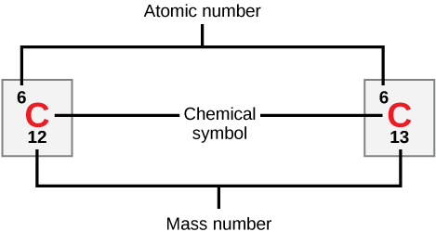

Carbon-12 has six neutrons. Carbon-13 has seven neutrons.

**2**. Figure 2.7 An atom may give, take, or share electrons with another atom to achieve a full valence shell, the most stable electron configuration. Looking at this figure, how many electrons do elements in group 1 need to lose in order to achieve a stable electron configuration? How many electrons do elements in groups 14 and 17 need to gain to achieve a stable configuration?

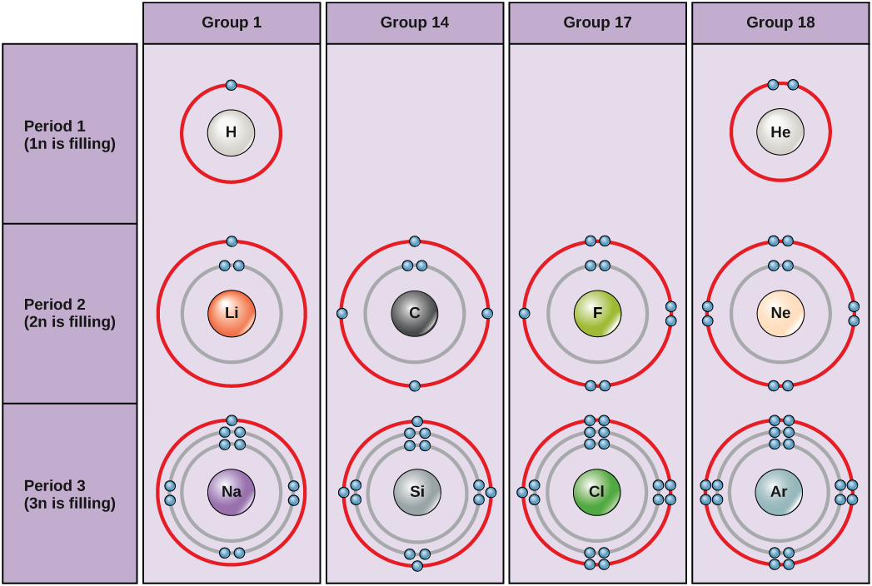

Elements in group 1 need to lose one electron to achieve a stable electron configuration. Elements in groups 14 and 17 need to gain four and one electrons, respectively, to achieve a stable configuration.

**3**. Which of the following statements is false?

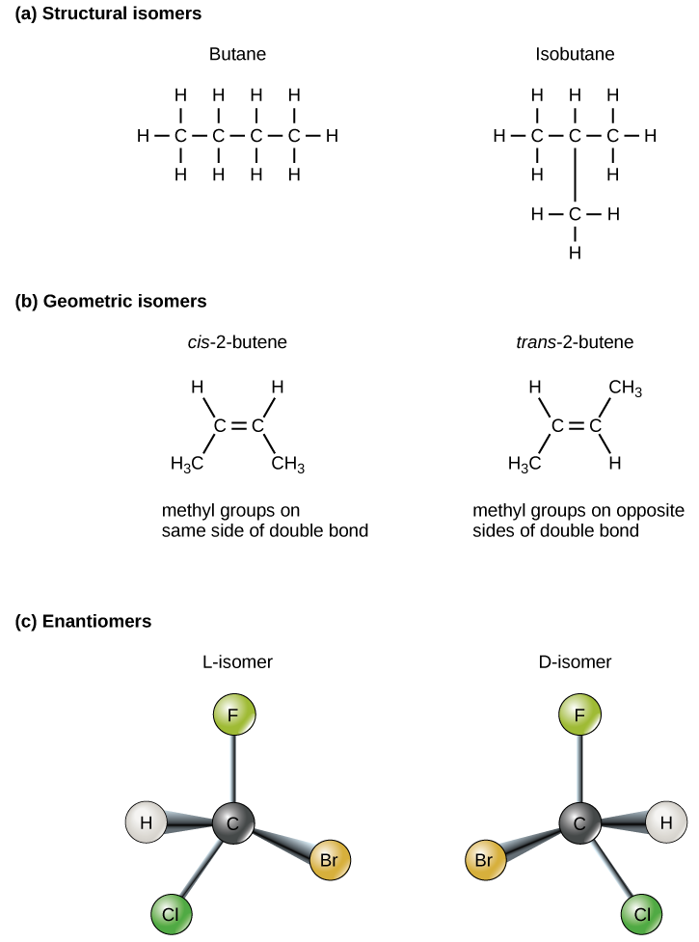

c. To be enantiomers, a molecule must have at least three different atoms or groups connected to a central carbon.

**Review Questions**

**4**. If xenon has an atomic number of 54 and a mass number of 108, how many neutrons does it have?

a. 54

**5**. Atoms that vary in the number of neutrons found in their nuclei are called ________.

d. isotopes

**6**. Potassium has an atomic number of 19. What is its electron configuration?

c. shells 1, 2 and 3 are full and shell 4 has one electron

**7**. Which type of bond represents a weak chemical bond?

a. hydrogen bond

**8**. Which of the following statements is not true?

d. Water is the most abundant molecule in the Earth’s atmosphere.

**9**. When acids are added to a solution, the pH should ________.

a. decrease

**10**. We call a molecule that binds up excess hydrogen ions in a solution a(n) ________.

c. base

**11**. Which of the following statements is true?

b. Acids and bases will neutralize each other

**12**. Each carbon molecule can bond with as many as________ other atom(s) or molecule(s).

d. four

**13**. Which of the following is not a functional group that can bond with carbon?

a. sodium

**Critical Thinking Questions**

**14**. What makes ionic bonds different from covalent bonds?

Ionic bonds are created between ions. The electrons are not shared between the atoms, but rather are associated more with one ion than the other. Ionic bonds are strong bonds, but are weaker than covalent bonds, meaning it takes less energy to break an ionic bond compared with a covalent one.

**15**. Why are hydrogen bonds and van der Waals interactions necessary for cells?

Hydrogen bonds and van der Waals interactions form weak associations between different molecules or within different regions of the same molecule. They provide the structure and shape necessary for proteins and DNA within cells so that they function properly

**16**. Discuss how buffers help prevent drastic swings in pH.

Buffers absorb the free hydrogen ions and hydroxide ions that result from chemical reactions. Because they can bond these ions, they prevent increases or decreases in pH. An example of a buffer system is the bicarbonate system in the human body. This system is able to absorb hydrogen and hydroxide ions to prevent changes in pH and keep cells functioning properly.

**17**. Why can some insects walk on water?

Some insects can walk on water, although they are heavier (denser) than water, because of the surface tension of water. Surface tension results from cohesion, or the attraction between water molecules at the surface of the body of water (the liquid-air/gas interface).

**18**. What property of carbon makes it essential for organic life?

Carbon is unique and found in all living things because it can form up to four covalent bonds between atoms or molecules. These can be nonpolar or polar covalent bonds, and they allow for the formation of long chains of carbon molecules that combine to form proteins and DNA.

**19**. Compare and contrast saturated and unsaturated triglycerides.

Saturated triglycerides contain no double bonds between carbon atoms; they are usually solid at room temperature. Unsaturated triglycerides contain at least one double bond between carbon atoms and are usually liquid at room temperature.

This file is copyright 2018, Rice University. All Rights Reserved.