Chapter 2
Describing Data: Frequency Tables, Frequency Distributions, and Graphic Presentation

1. Pepsi-Cola has a 25% market share, found by 90/360. (LO2-2)

2. Three classes are needed, one for each player. (LO2-1)

3.
Season | Frequency | Relative Frequency
Winter | 100 | 0.1
Spring | 300 | 0.3
Summer | 400 | 0.4
Fall | 200 | 0.2
Total | 1000 | 1.0
(LO2-1)

4.
City | Frequency | Relative Frequency
Indianapolis | 100 | 0.05
St. Louis | 450 | 0.225
Chicago | 1300 | 0.65
Milwaukee | 150 | 0.075
(LO2-1)

5. a. A frequency table.
Color Frequency Relative Frequency
Bright White 130 0.10
Metallic Black 104 0.08
Magnetic lime 325 0.25
Tangerine Orange 455 0.35
Fusion Red 286 0.22
Total 1300 1.00

b.
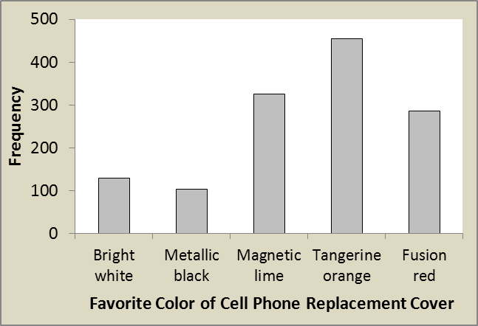

c.

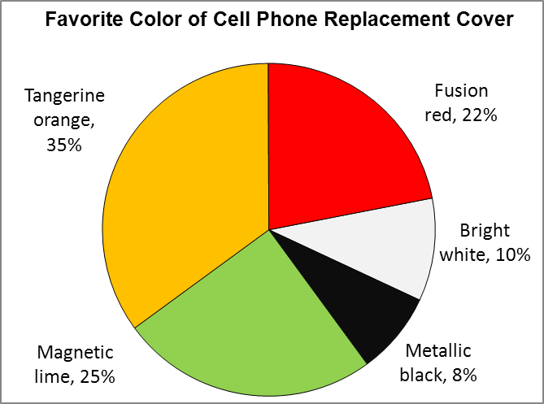

d. Wellstone Inc. should produce 350,000 orange; 250,000 lime; 220,000 red; 100,000 white, and 80,000 black. These numbers are found by multiplying the relative frequency of each color by the 1,000,000 production level. (LO2-2)

6. Maxwell Heating & Air Conditioning far exceeds the other corporations in sales. Mancell electric & Plumbing and Mizelle Roofing & Sheet Metal are the two corporations with the least amount of fourth quarter sales. (LO2-2)

7. 2⁵ = 32 < 38 < 64 = 2⁶ therefore 6 classes (LO2-3)

8. 2⁵ = 32< 45 < 64 = 2⁶ suggests 6 classes. Use interval of 5. (LO2-3)

9. 2⁷ = 128< 230 < 256 = 2⁸ suggests 8 classes Use interval of 45. (LO2-3)

10. a. 2⁵ = 32< 53 < 64 = 2⁶ suggests 6 classes.
- Use interval of 15 and start first class at 40. (LO2-3)

11. a. 2⁴ =16 suggests 5 classes
- Use interval of 1.5
- 24
d. f Relative frequency
24 up to 25.5 2 0.125
25.5 up to 27 4 0.250
27 up to 28.5 8 0.500
28.5 up to 30 0 0.000
30 up to 31.5 2 0.125
Total 16 1.000
e. The number of units produced in the past 16 days range between 24 and 31 units.
The largest concentration is in the 27 up to 28.5 class (8). (LO2-3)

12. a. 2⁴ = 16 < 20 < 32 = 2⁵ suggest 5 classes
b. Use interval of 10.
c. 50
d. f Relative frequency
50 up to 60 4 0.20
60 up to 70 5 0.25
70 up to 80 6 0.30
80 up to 90 2 0.10
90 up to 100 3 0.15
Total 20 1.00
e. The fewest number is about 50, the highest about 100. The greatest concentration is in classes 60 up to 70 and 70 up to 80. (LO2-3)

Visits f
13. a. 0 up to 3 9
3 up to 6 21
6 up to 9 13
9 up to 12 4
12 up to 15 3
15 up to 18 1
Total 51
- The largest group of shoppers (21) shop at BiLo 3, 4 or 5 times during a month period. Some customers visit the store only 1 time during the month, but others shop as many as 15 times.
c. Number of Percent of
Visits Total
0 up to 3 17.65
3 up to 6 41.18
6 up to 9 25.49
9 up to 12 7.84
12 up to 15 5.88
15 up to 18 1.96
Total 100.00 (LO2-3)

14. a. The 2^{k} rule would suggest 6 classes as 2⁵ = 32 < 40 < 64 = 2⁶. With six classes the interval would be larger than (84 – 18) / 6 = 11, but as we are summarizing money observations a class interval of 10 is more convenient to work with.
The frequency distribution using 10 is:
f
15 up to 25 1
25 up to 35 2
35 up to 45 5
45 up to 55 10
55 up to 65 15
65 up to 75 4
75 up to 85 3
Total 40
- Data tends to cluster in classes 45 up to 55 and 55 up to 65.
- Based on the distribution, the youngest person taking the Caribbean cruise is 15 years (actually 18 from the raw data). The oldest person was less than 85 years (actually 84 from the raw data). The largest concentration of ages is between 45 up to 65 years.
d. Ages Percent of
Total
15 up to 25 2.5
25 up to 35 5.0
35 up to 45 12.5
45 up to 55 25.0
55 up to 65 37.5
65 up to 75 10.0
75 up to 85 7.5
Total 100.0 (LO2-3)

15. a. Histogram
- 100
- 5
- 28
- 0.28
- 12.5
- 13 (LO2-4)

16. a. 3
- about 26
- 2
- frequency polygon (LO2-4)

17. a. 50
- 1.5 thousand frequent flier miles
c.

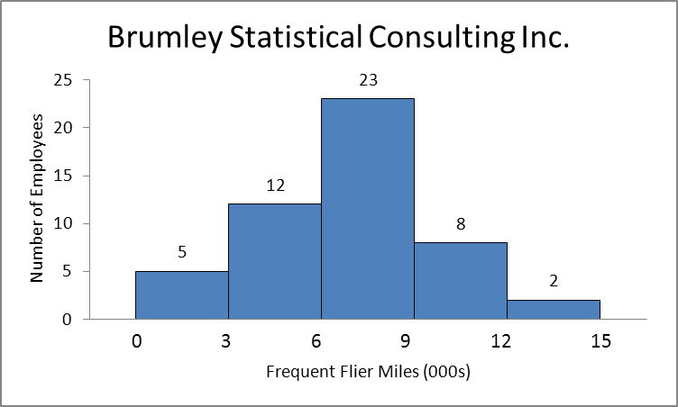

d. X = 1.5, Y = 5
e.

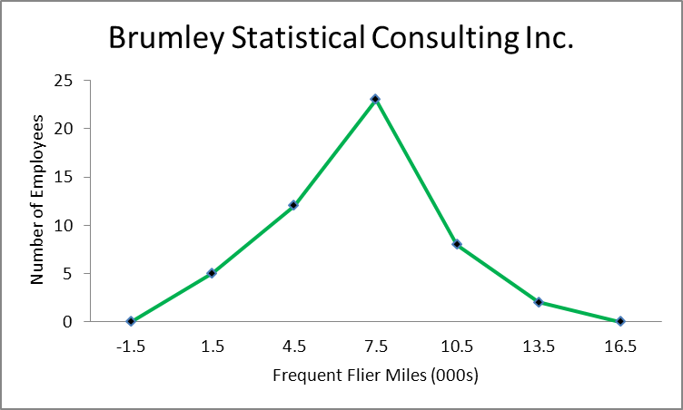

f. For the 50 employees about half earn between 6 and 9 thousand frequent flier miles. Five earn less than 3 thousand frequent flier miles, and two earn more than 12 thousand frequent flier miles. (LO2-4)

18. a. 40
- 2.5 days
- 2.5,6
d.
- 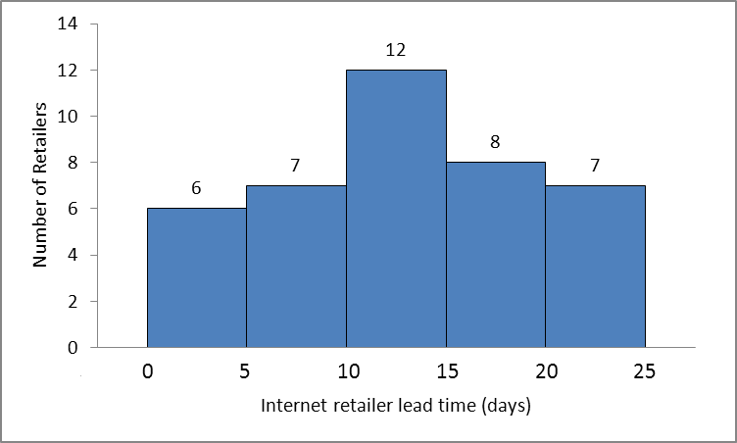

e.

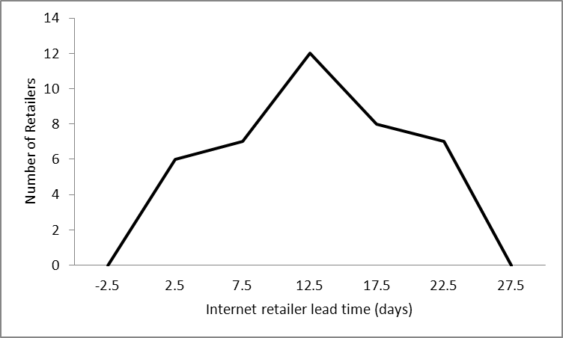e.

f. Based on the charts, the shortest lead time is 0 days, the longest 25 days.
The concentration of lead times is 10-15 days. (LO2-4)

19. a. 40
- 5
- 11 or 12
- about $18 per hour
- about $9 per hour
- about 78% (LO2-4)

20. a. 200
- b. 50 or $50,000
- c. about $180,000
- d. about $240,000
- about 60 homes
- about 145 homes (LO2-4)

21. a. 5
b. Miles CF
Less than 3 5
Less than 6 17
Less than 9 40
Less than 12 48
Less than 15 50
c.

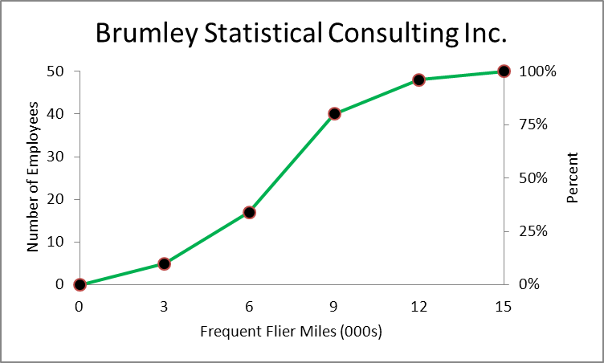

d. about 8.7 thousand frequent flier miles (LO2-4)
22. a. 13, 25
b. Lead Time Cum. Freq Cumulative Relative Frequency
Less than 5 6 .15 or 15%
Less than 10 13 .325 or 32.5%
Less than 15 25 .625 or 62.5%
Less than 20 33 .825 or 82.5%
Less than 25 40 1.00 or 100%
c.

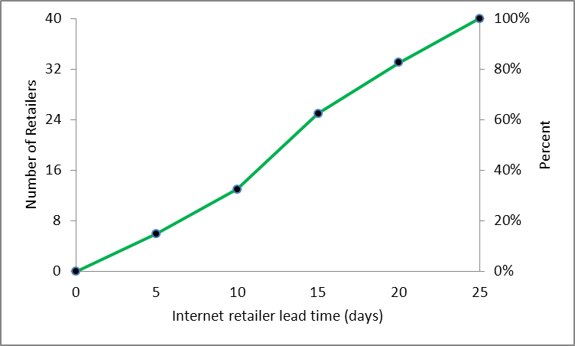

d. 14 (LO2-4)

23. a. Qualitative variables are ordinarily nominal level of measurement, but some are ordinal. Quantitative variables are commonly of interval or ratio level of measurement. (LO1-5)
b. Yes, both types depict samples and populations. (LO1-3)

24. A frequency table calls for qualitative data. On the other hand, a frequency distribution involves quantitative data. (LO2-1 and 2-3)

25. a. A frequency table.
b.
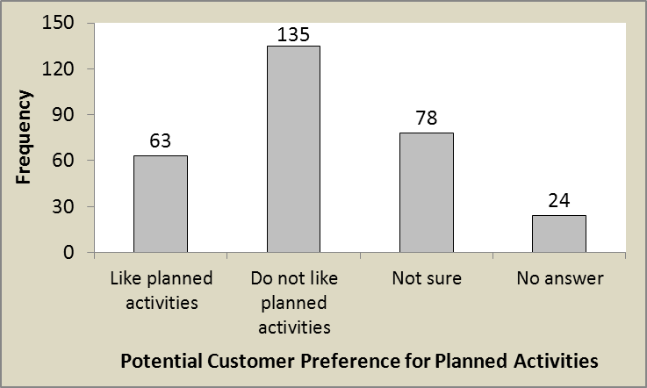

c.
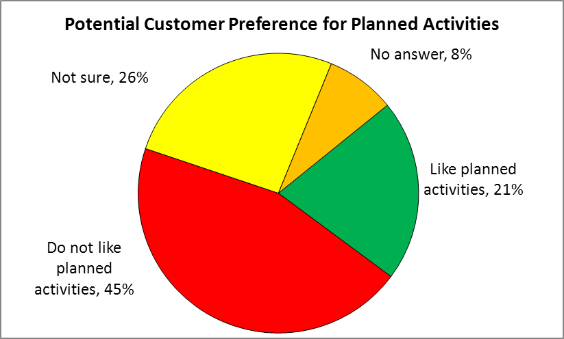

d. The pie chart may be easier to comprehend as the percentages of potential customers are likely more important than the number of potential customers. (LO2-2)

26. a. The scale is ordinal and the variable is qualitative.
b.
Performance | Frequency
Early | 22
On-time | 67
Late | 9
Lost | 2

c.
Performance | Relative Frequency
Early | .22
On-time | .67
Late | .09
Lost | .02

d.
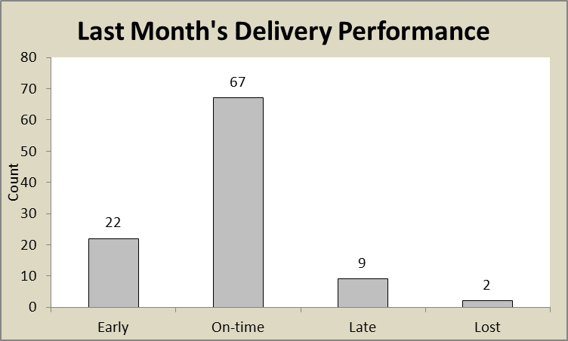

e.

f. 89% of the packages are either early or on-time and 2% of the packages are lost. So they are missing both of their objectives. They must eliminate all lost packages and reduce the late percentage to below 1%. (LO2-2)

27. The 2^{k} rule would suggest using 7 classes as 2⁶ = 64 < 83 < 128 = 2⁷ . (LO2-3)
28. 2⁷ = 128 < 145 < 256 = 2⁸ suggests 8 classes. Use interval of 60. (LO2-3)
29. a. 5 because 2⁴ = 16 < 25 < 32 = 2⁵
b. suggests an interval of 7.
c. 15
d. Class Frequency
15 up to 22 3
22 up to 29 8
29 up to 36 7
36 up to 43 5
43 up to 50 2
Total 25
e. Based on the frequency distribution we see the data are fairly symmetric with most of the values between 22 and 36 and a minimum of 15 and a maximum of 50. (LO2-3)

30. a. 6 because 2⁵ = 32 < 45 < 64 = 2⁶
- 100, suggested as the interval must be larger than i ≥
- 0
d. Class Frequency
0 up to 100 3
100 up to 200 12
200 up to 300 16
300 up to 400 10
400 up to 500 3
500 up to 600 1
Total 45 (LO2-3)

31. a. 6 because 2⁵ = 32 < 45 < 64 = 2⁶ .
b. The interval width should be at least 1.5 as i ≥ (10-1) /6. Use 2 for convenience.
c. 0
d.
Class | Frequency
0 up to 2 | 1
2 up to 4 | 5
4 up to 6 | 12
6 up to 8 | 17
8 up to 10 | 8
10 up to 12 | 2
Total | 45

e. The distribution is fairly symmetric or “bell-shaped” with most of the observations occurring in the middle two classes of 4 up to 8. (LO2-3)

32. a. 6 because 2⁵ = 32 < 36 < 64 = 2⁶ .
b. The interval width should be at least 2 as i ≥ (15-3) /6. Use 2.2 for convenience and to ensure there are only 6 classes
c. 2.2
d.
Class | Frequency
2.2 up to 4.4 | 2
4.4 up to 6.6 | 7
6.6 up to 8.8 | 11
8.8 up to 11.0 | 7
11.0 up to 13.2 | 7
13.2 up to 15.4 | 2
Total | 36
e. The distribution is fairly symmetric or “bell-shaped” with a peak in the middle class of 6.6 up to 8.8. (LO2-3)

33.
Class | Frequency
0 up to 200 | 19
200 up to 400 | 1
400 up to 600 | 4
600 up to 800 | 1
800 up to 1000 | 2
Total | 27
This distribution is positively skewed with a large “tail” to the right or positive values. Notice that the top 7 tunes account for 4342 plays out of a total of 5968 or about 73 percent of all plays. (LO2-3)

34. a. 2⁵ = 32 < 33 < 64 = 2⁶. Thus 6 classes are recommended.
b. The interval width should be at least 1253 as i ≥ (7829-312) /6. Use 1500 for convenience.
c. 0
d.
Class | Frequency
0 up to 1500 | 1
1500 up to 3000 | 2
3000 up to 4500 | 0
4500 up to 6000 | 7
6000 up to 7500 | 20
7500 up to 9000 | 3
Total | 33
e. This distribution is negatively skewed with a few very small values which likely correspond to the “start up” phase of this publication. The crest of the distribution is in the 6000 up to 7500 class which contains the greater part or 20 of the 33 months. (LO2-3)

35. a. 56
b. 10 (found by 60 – 50)
c. 55
d. 17 (LO2-4)

36. a. Cumulative frequency polygon
- 250
- 50 (found by 100 – 50)
- $240,000
- $230,000 (LO2-4)

37. a. 2⁵ = 32 < 33 < 64 = 2⁶. Thus 6 classes are recommended.
The minimum class interval size would be $30.50 as i ≥ (265 – 82)/6 thus an interval of 35 would work.
b.
Class | Frequency
$70 up to $105 | 4
105 up to 140 | 17
140 up to 175 | 14
175 up to 210 | 2
210 up to 245 | 6
245 up to 280 | 1
Total | 44
d. Based on the frequency distribution the purchases ranged from a low of about $70 to a high of about $280. The concentration is in the $105 up to $175 classes. (LO2-3)

38. a. 2⁴ = 16 < 24 < 32 = 2⁵. Thus 5 classes are recommended. Class interval is at least 387 as i ≥ (1957 – 22)/5. A suggest interval size would be 400.

Outstanding Shares(millions) | Number of Companies
0 up to 400 | 10
400 up to 800 | 8
800 up to 1200 | 4
1200 up to 1600 | 1
1600 up to 2000 | 1
Total | 24
`

b.

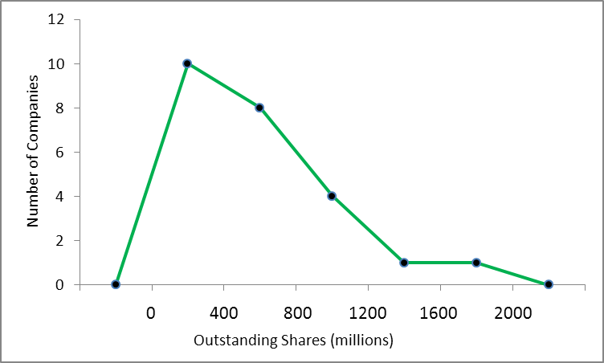

c.
Outstanding Shares(millions) | Number of Companies
Less than 400 | 10
Less than 800 | 18
Less than 1200 | 22
Less than 1600 | 23
Less than 2000 | 24

d.
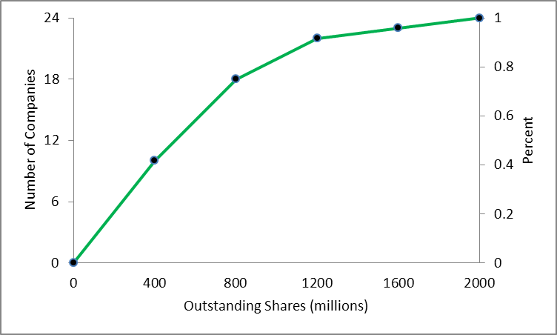

e. About 800 million shares are outstanding for the lowest 75% of the companies. This is found by drawing a line to the curve from 75% and reading off the value on the X-axis.
f. The number of outstanding shares range from 0 to 2 billion, with the largest number of companies (10 of 24) having less than 400 million outstanding shares. Only 2 companies have more than 1200 million shares. (LO2-4)

39. This data is qualitative and can be represented with either a bar chart or a pie chart. Bar charts are preferred when the goal is to compare the actual amount in each category. (LO2-2)

40. a. Balance f CF
0 up to 100 9 9
100 up to 200 6 15
200 up to 300 6 21
300 up to 400 6 27
400 up to 500 5 32
500 up to 600 2 34
600 up to 700 1 35
700 up to 800 3 38
800 up to 900 1 39
900 up to 1000 1 40
Total 40
Probably a class interval of $200 would be better.

b.

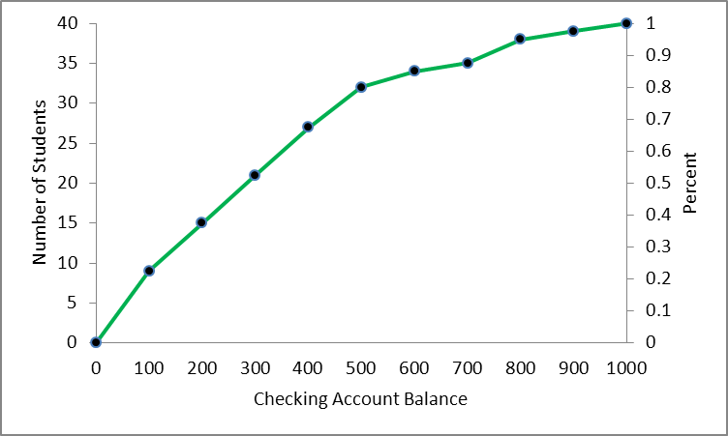
c. Based on the cumulative frequency polygon it appears that about 67% have less than a $400 balance. Therefore, about 33% would be considered “preferred.”
d. Less than $100 would be a convenient cutoff point. (LO2-3)

41.

By far the largest part, nearly three-fourths of adjustable gross income in South Carolina is from wages and salaries. Dividends and IRAs each contribute roughly another ten percent to AGI with eight percent coming from business income pensions, social security, and other sources. (LO2-2)

42. a. Since , 6 classes are recommended. The interval should be at least as i ≥ (10.1 − 0.4)/6 = 1.6, with 2 being a convenient value.
Hours Spent on Personal Computer (per week) | Number of Individuals
0 up to 2 | 7
2 up to 4 | 11
4 up to 6 | 19
6 up to 8 | 12
8 up to 10 | 10
10 up to 12 | 1
Total | 60

b.
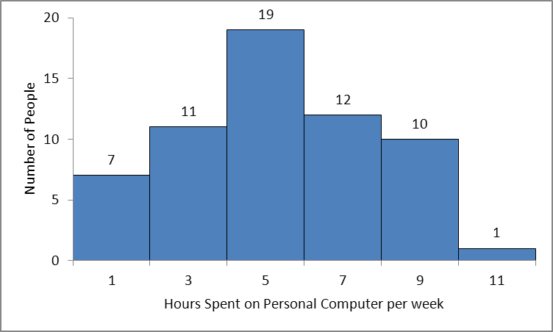
The “typical” person used the computer about 5 hours per week and everyone is within about five hours of that amount. (LO2-4)

43. a. Since , 7 classes are recommended. The interval should be at least (1002.2 − 3.3)/7 = 142.7 use 150 as a convenient value. (LO2-4)

b. Based on the histogram, the majority of people has less than $500,000 in their investment portfolio and may not have enough money for retirement. Merrill Lynch financial advisors need to promote the importance of investing for retirement in this age group.
b.

44. (LO2-2)

45. a. pie chart
b. 700, found by 0.70(1000)
c. Yes, ninety percent are either through networking and connections (70%) or job posting websites (20%). (LO2-2)

46. a. 87.88%, found by 44.54% + 43.34%
b. Corporate taxes (8.31%) are more than license fees (2.9%)
c. 2.81 billion, found by (0.4454)(6.3), in sales taxes and
2.73 billion, found by (0.4334)(6.3), in individual taxes (LO2-2)

47. a.

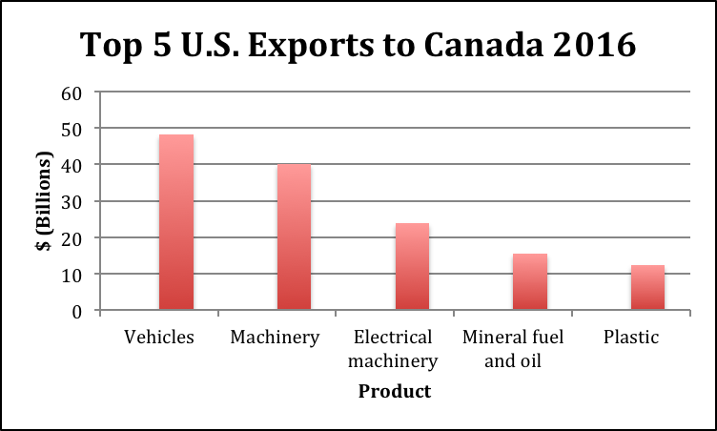

b. 24.0%, found by (40.0+23.9)/266
c. 45.7%, found by (40.0+23.9)/(48.1+40.0+23.9+15.5+12.3) (LO2-2)

48. There are 50 observations so the recommended number of classes is 6. However, there are several states that have many more farms than the others, so it may be useful to have an open ended class.
One possible frequency distribution is.
Farms in USA Frequency
0 up to 20 14
20 up to 40 14
40 up to 60 10
60 up to 80 8
80 up to 100 3
100 or more 1
Total 50
Twenty-six of the 50 states, or 56 percent, have fewer than 40,000 farms. There is one state that has more than 100,000 farms. (LO2-3)

49.
Brown, yellow, and red make up almost 75 percent of the candies. The other 25 percent is composed of blue, orange, and green. (LO2-2)

50. a.

Class | Cumulative Frequency
Less than 15 | 1
Less than 30 | 6
Less than 45 | 15
Less than 60 | 26
Less than 75 | 30

b.

c. 6 days saw fewer than 30.
d. The highest 80 percent of the days had at least 30 families. (LO2-3)

51. There are many choices and possibilities here. For example you could choose to start the first class at 160,000 rather than 120,000. The choice is yours!

i>= (919,480-167,962)/7 = 107,360. Use intervals of 120,000

Selling Price (000) Frequency Cumulative Frequency
120 up to 240 26 26
240 up to 360 36 62
360 up to 480 27 89
480 up to 600 7 96
600 up to 720 4 100
720 up to 840 2 102
840 up to 960 1 105

a. Most homes (60%) sell between $240,000 and $480,000.
b. The typical price in the first class is $180,000 and in the last class it is $900,000
c.

Fifty percent (about 52) of the homes sold for about $320,000 or less.
The top ten percent (about 90) of homes sold for at least $520,000
About 41 (about 41) percent of the homes sold for less than $300,000.

d.

2,3 and 4 bedroom houses are most common with about 25 houses each. 7 and 8 bedroom houses are rather rare. (LO2-3)

52.

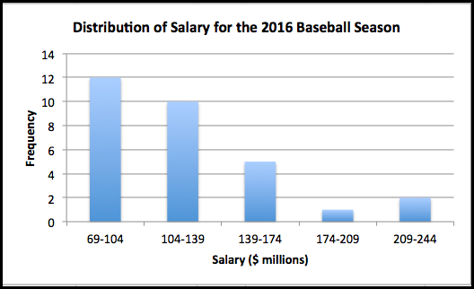

- The mean salary is $121 million. The overall range of salaries is based on the minimum of $69.06 million and a maximum of $223.35. The range of salaries would be $154.29 million.
- The distribution of salaries is skewed to the right. There are three teams that are much higher than the 27 teams that make up most of the distribution of salary.
c.
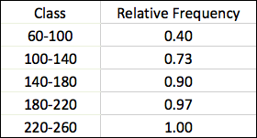

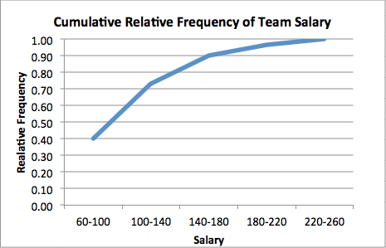

Based on the cumulative frequency distribution, we can estimate that 40% of the teams have a salary of about $100 million or less. Using the table and the distribution, about 3% of the 30 teams have a salary of $220 million or more. 3% of 30 teams rounds to 1 team. (LO2-3)

53. Since 2⁶ ⁼ 64 < 80 < 128 = 2⁷, use 7 classes. The interval should be at least (11973 − 10000)/7 = 281 miles. Use 300. The resulting frequency distribution is:
Class f
9900 up to 10200 8
10200 up to 10500 8
10500 up to 10800 11
10800 up to 11100 8
11110 up to 11400 13
11400 up to 11700 12
11700 up to 12000 20
a. The typical amount driven, or the middle of the distribution is about 11100 miles. Based on the frequency distribution, the range is from 9900 up to 12000 miles. (LO2-3)
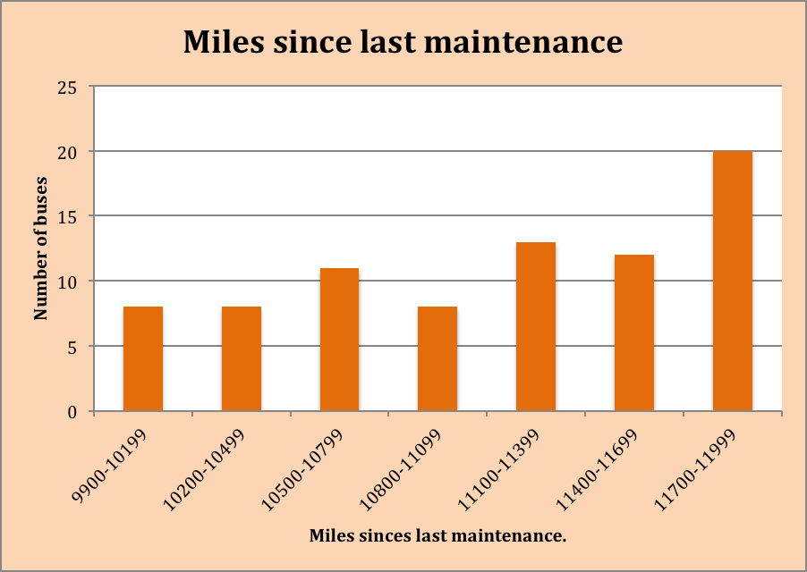

b. The distribution is somewhat “skewed” with a longer “tail” to the left and no outliers. (LO2-3)

c.

Forty percent of the buses were driven fewer than 11000 miles.
Sixteen (16) busses were driven less than 10500 miles. (LO2-3)

d.

The first diagram shows that nearly three fourths of the buses have 55 seats. The second chart shows that Bluebird makes about 60 percent of the busses and Thompson only about 10 percent. (LO2-2)

