Chapter 2—Organizing and Visualizing Data

2.1 The answer depends on the chosen data set.

2.2 The answer depends on the specific story.

2.3 The supermarket chain should use primary data collected through an observation study of the shopping behavior of their customers.

2.4 The information presented there is based on surveys.

2.5 (a) Category Frequency Percentage
A 13 26%
B 28 56
C 9 18
(b) Category “B” is the majority.

2.6 (a) Table frequencies for all student responses
Student Major Categories
Gender A C M Totals
Male 14 9 2 25
Female 6 6 3 15
Totals 20 15 5 40
(b) Table percentages based on overall student responses
Student Major Categories
Gender A C M Totals
Male 35.0% 22.5% 5.0% 62.5%
Female 15.0% 15.0% 7.5% 37.5%
Totals 50.0% 37.5% 12.5% 100.0%
Table based on row percentages
Student Major Categories
Gender A C M Totals
Male 56.0% 36.0% 8.0% 100.0%
Female 40.0% 40.0% 20.0% 100.0%
Totals 50.0% 37.5% 12.5% 100.0%
Table based on column percentages
Student Major Categories
Gender A C M Totals
Male 70.0% 60.0% 40.0% 62.5%
Female 30.0% 40.0% 60.0% 37.5%
Totals 100.0% 100.0% 100.0% 100.0%

2.7 (a)
Category | Frequency | Percentage
Flammables/Irritants | 8,350 | 59.26%
Knives and blades | 4,134 | 29.34%
Prohibited tools | 753 | 5.34%
Sharp objects | 497 | 3.53%
Other | 357 | 2.53%
Total | 14,091 | 100.00%
(b) Flammables, irritants, knives and blades made up almost 90% of the banned items.

2.8 (a)
Source of Electricity | Net Electricity Generation in millions of megawatt hours | Percentage
Coal | 1,994.40 | 48.52%
Hydroelectric | 248.1 | 6.04%
Natural gas | 876.9 | 21.33%
Nuclear | 806.2 | 19.61%
Other | 184.7 | 4.49%
Total | 4,110.3 | 100.00%
(b) Three sources of electricity dominate the U.S. electricity generation with coal being the major source at 48.52% followed by natural gas at 21.33% and nuclear at 19.61%.

2.9 (a)
Category | Cost per Household | Percentage
Civil servant retirement | 15,851 | 2.90%
Federal debt | 54,537 | 9.97%
Medicare | 284,288 | 52.00%
Military retirement | 29,694 | 5.43%
Social Security | 160,216 | 29.30%
Other | 2,172 | 0.40%
Total | 546,758 | 100.00%
(b) Medicare at 52% and Social Security at 29.3% together made up more than 80% of the debt.

2.10 (a) Table of total percentages
 | Gender
Enjoy Shopping for Clothing | Male | Female | Total
Yes | 27% | 45% | 72%
No | 21% | 7% | 28%
Total | 48% | 52% | 100%

Table of row percentages
 | Gender
Enjoy Shopping for Clothing | Male | Female | Total
Yes | 38% | 62% | 100%
No | 74% | 26% | 100%
Total | 48% | 52% | 100%

Table of column percentages
 | Gender
Enjoy Shopping for Clothing | Male | Female | Total
Yes | 57% | 86% | 72%
No | 43% | 14% | 28%
Total | 100% | 100% | 100%

(b) The percentage of shoppers who enjoy shopping for clothing is higher among females than males.

2.11 (a)
Table of total percentages

Table of row percentages

Table of column percentages

2.11 (b) The row percentages allow us to block the effect of disproportionate group size and
cont. show us that the pattern for day and evening tests among the nonconforming group is very different from the pattern for day and evening tests among the conforming group. Where 40% of the nonconforming group was tested during the day, 68% of the conforming group was tested during the day.
(c) The director of the lab may be able to cut the number of nonconforming tests by reducing the number of tests run in the evening, when there is a higher percent of tests run improperly.

2.12 Table of row percentages
According to the row percentages table, 32% more online retailers were requiring three or more clicks in 2009 than in 2008.

2.13 Ordered array: 63 64 68 71 75 88 94

2.14 Ordered array: 73 78 78 78 85 88 91

2.15 (a) 4% (b) 32% (c) 36% (d) 100%

2.16 (a) The class boundaries of the 9 classes can be "10 to less than 20", "20 to less than 30", "30 to less than 40", "40 to less than 50", "50 to less than 60", "60 to less than 70", "70 to less than 80", "80 to less than 90", and "90 to less than 100".
(b) The class-interval width is .
(c) The nine class midpoints are: 15, 25, 35, 45, 55, 65, 75, 85, and 95.

2.17 (a) Ordered array: Cost($)114, 135, 141, 145, 146, 151, 158, 161, 162, 164, 165, 166, 170, 170, 172, 180, 185, 187, 205, 210, 215, 216, 220, 222, 223, 224, 259, 305, 326, 411
(b) PHStat output:
Bin Cell | Frequency | Percentage
110 but less than 150 | 5 | 16.67%
150 but less than 190 | 13 | 43.33%
190 but less than 230 | 8 | 26.67%
230 but less than 270 | 1 | 3.33%
270 but less than 310 | 1 | 3.33%
310 but less than 350 | 1 | 3.33%
350 but less than 390 | 0 | 0.00%
390 but less than 430 | 1 | 3.33%
(c) The costs of attending a baseball game is concentrating around $170 for thirteen of the teams have costs in between $150 and $190.

2.18 (a) Electricity Costs Frequency Percentage
$80 to $99 4 8%
$100 to $119 7 14
$120 to $139 9 18
$140 to $159 13 26
$160 to $179 9 18
$180 to $199 5 10
$200 to $219 3 6
(b)
Electricity Costs | Frequency | Percentage | Cumulative %
$99 | 4 | 8% | 8%
$119 | 7 | 14% | 22%
$139 | 9 | 18% | 40%
$159 | 13 | 26% | 66%
$179 | 9 | 18% | 84%
$199 | 5 | 10% | 94%
$219 | 3 | 6% | 100%

(c) The majority of utility charges are clustered between $120 and $180.

2.19 (a), (b)
Bin | Frequency | Percentage | Cumulative %
-0.00350 but less than -0.00201 | 13 | 13.00% | 13.00%
-0.00200 but less than -0.00051 | 26 | 26.00% | 39.00%
-0.00050 but less than 0.00099 | 32 | 32.00% | 71.00%
0.00100 but less than 0.00249 | 20 | 20.00% | 91.00%
0.00250 but less than 0.00399 | 8 | 8.00% | 99.00%
0.004 but less than 0.00549 | 1 | 1.00% | 100.00%

(c) Yes, the steel mill is doing a good job at meeting the requirement as there is only one steel part out of a sample of 100 that is as much as 0.005 inches longer than the specified requirement.

2.20 (a), (b)
Bin | Frequency | Percentage | Cumulative %
8.310 -- 8.329 | 3 | 6.12% | 6.12%
8.330 -- 8.349 | 2 | 4.08% | 10.20%
8.350 -- 8.369 | 1 | 2.04% | 12.24%
8.370 -- 8.389 | 4 | 8.16% | 20.41%
8.390 -- 8.409 | 4 | 8.16% | 28.57%
8.410 -- 8.429 | 15 | 30.61% | 59.18%
8.430 -- 8.449 | 7 | 14.29% | 73.47%
8.450 -- 8.469 | 5 | 10.20% | 83.67%
8.470 -- 8.489 | 5 | 10.20% | 93.88%
8.490 -- 8.509 | 3 | 6.12% | 100.00%
(c) All the troughs will meet the company’s requirements of between 8.31 and 8.61 inches wide.

2.21 (a),(b)
Strength | Frequency | Percentage | Cumulative Percentage
1500 -- 1549 | 1 | 3.33% | 3.33%
1550 -- 1599 | 2 | 6.67% | 10.00%
1600 -- 1649 | 2 | 6.67% | 16.67%
1650 -- 1699 | 7 | 23.33% | 40.00%
1700 -- 1749 | 5 | 16.67% | 56.67%
1750 -- 1799 | 7 | 23.33% | 80.00%
1800 -- 1849 | 3 | 10.00% | 90.00%
1850 -- 1899 | 3 | 10.00% | 100.00%

(c) The strength of all the insulators meets the company’s requirement of at least 1500 lbs.

2.22 (a)
Bulb Life (hrs) | Frequency  Manufacturer A |  | Bulb Life (hrs) | Frequency  Manufacturer B
650 -- 749 | 3 |  | 750 -- 849 | 2
750 -- 849 | 5 |  | 850 -- 949 | 8
850 -- 949 | 20 |  | 950 -- 1049 | 16
950 -- 1049 | 9 |  | 1050 -- 1149 | 9
1050 -- 1149 | 3 |  | 1150 -- 1249 | 5

(a), (b)

Bulb Life (hrs) | A |  | B
 | Percentage | Cumulative % | Percentage | Cumulative %
650 – 749 | 7.50% | 7.50% | .00% | 0.00%
750 – 849 | 12.50% | 20.00% | 5.00% | 5.00%
850 – 949 | 50.00% | 70.00% | 20.00% | 25.00%
950 – 1049 | 22.50% | 92.50% | 40.00% | 65.00%
1050 – 1149 | 7.50% | 100.00% | 22.50% | 87.50%
1150 – 1249 | 0.00% | 100.00% | 12.50% | 100.00%

(c) Manufacturer B produces bulbs with longer lives than Manufacturer A. The cumulative percentage for Manufacturer B shows 65% of its bulbs lasted less than 1,050 hours, contrasted with 70% of Manufacturer A’s bulbs, which lasted less than 950 hours. None of Manufacturer A’s bulbs lasted more than 1,149 hours, but 12.5% of Manufacturer B’s bulbs lasted between 1,150 and 1,249 hours. At the same time, 7.5% of Manufacturer A’s bulbs lasted less than 750 hours, whereas all of Manufacturer B’s bulbs lasted at least 750 hours
2.23 (a) Amount of
Soft Drink Frequency Percentage
1.850 – 1.899 1 2%
1.900 – 1.949 5 10
1.950 – 1.999 18 36
2.000 – 2.049 19 38
2.050 – 2.099 6 12
2.100 – 2.149 1 2
Amount of Frequency Percentage
Soft Drink Less Than Less Than
1.899 1 2%
1.949 6 12
1.999 24 48
2.049 43 86
2.099 49 98
2.149 50 100
(b) The amount of soft drink filled in the two liter bottles is most concentrated in two intervals on either side of the two-liter mark, from 1.950 to 1.999 and from 2.000 to 2.049 liters. Almost three-fourths of the 50 bottles sampled contained between 1.950 liters and 2.049 liters.

2.24 (a) Note: %s converted to counts. n = 1264
2.24 (a)
cont.

(b) The Pareto diagram is better than the pie chart to portray these data because it not only sorts the frequencies in descending order, it also provides the cumulative polygon on the same scale.
(c) You can conclude that friends/family account for the largest percentage of 45%. When other, news media, and online user reviews are added to friends/family, this accounts for 83%.

2.25 (a)
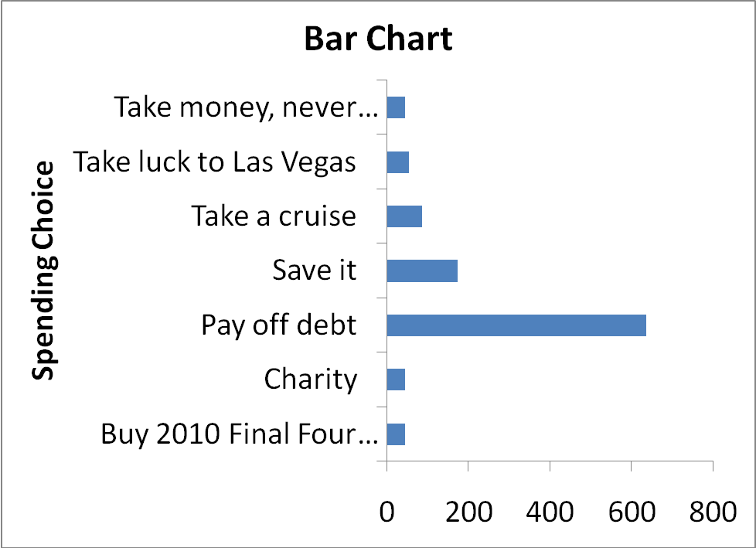
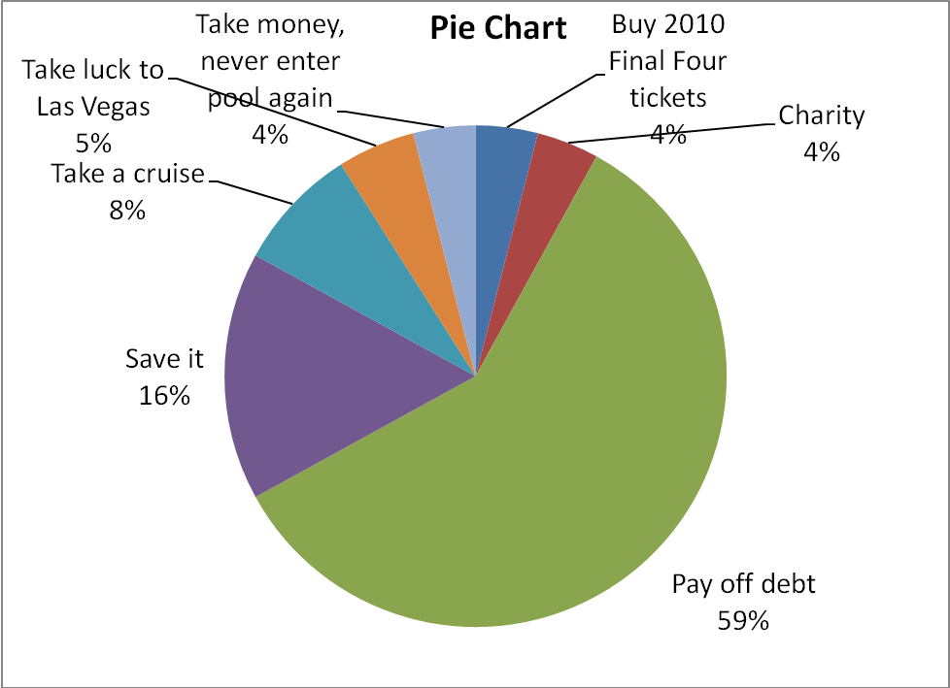
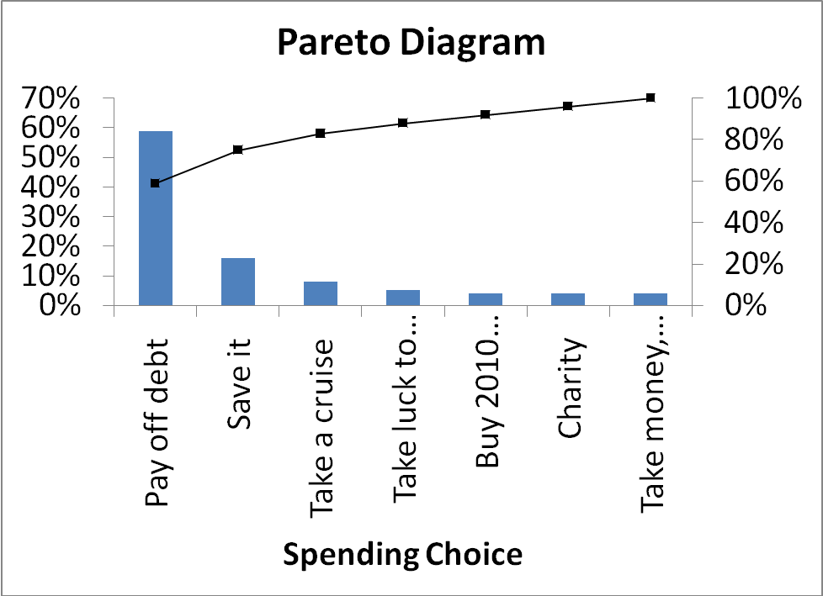
(b) The Pareto diagram is better than the pie chart or the bar chart because it not only sorts the frequencies in descending order, it also provides the cumulative polygon on the same scale.
(c) From the Pareto diagram, it is obvious that more than 50% would pay off their debt with $1 million.

2.26 (a)
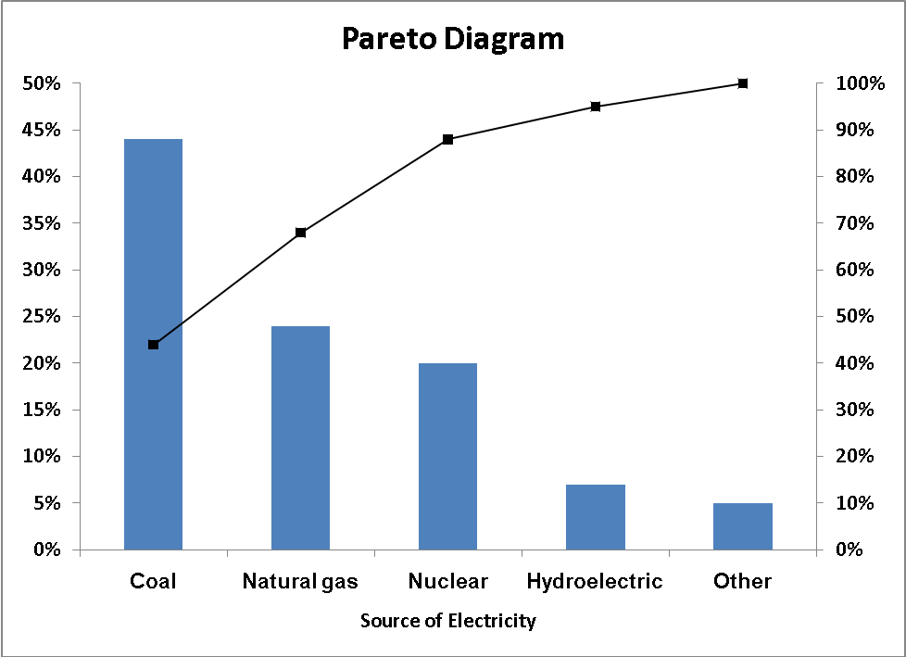
(b) According to the Pareto chart, slightly less than 90% of the power is derived from coal, nuclear, or natural gas.
(c)
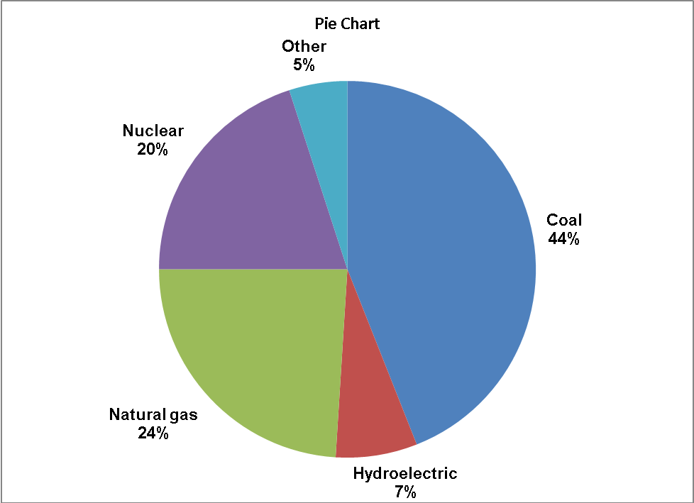
(d) You will prefer using the Pareto chart over the pie chart because the Pareto chart not only sorts the frequencies in descending order, it also provides the cumulative polygon on the same scale.

2.27 (a)
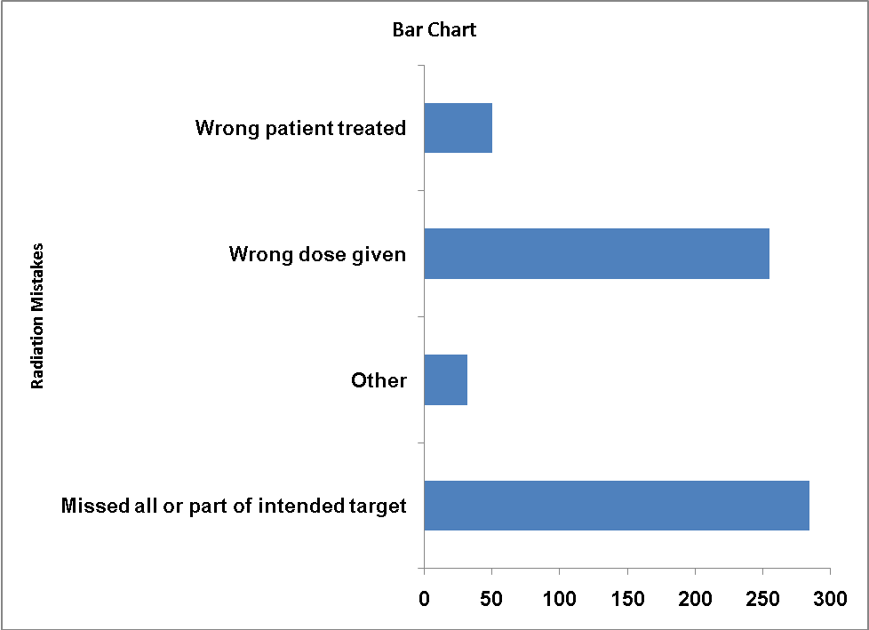
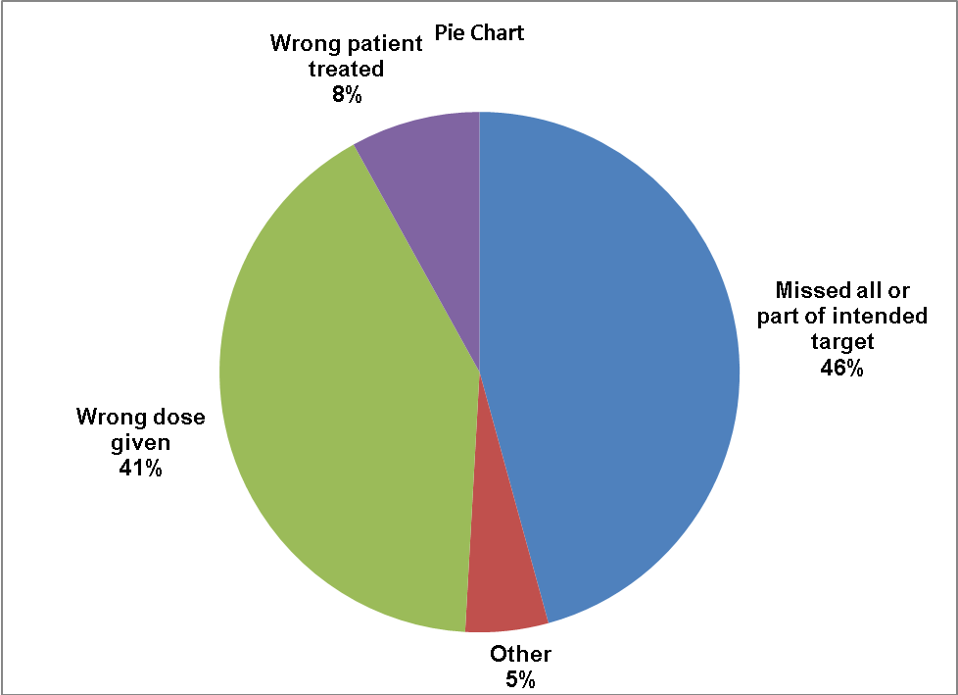
(b) The bar chart is more suitable if the purpose is to compare the categories. The pie chart is more suitable if the main objective is to investigate the portion of the whole that is in a particular category. *
* Note: This is one of the many possible solutions for the question.
2.27 (c)
cont.
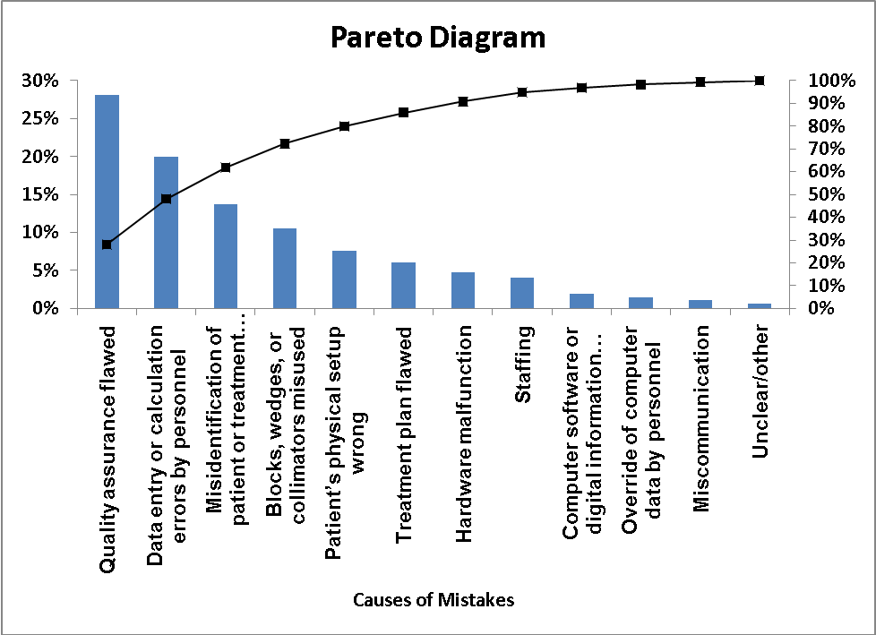
(d) The “vital few” reasons for the causes of mistakes are “Quality assurance flawed”, “Data entry or calculation errors by personnel”, and “Misidentification of patient or treatment location” which account for more than 60% of the mistakes. The remaining causes are the “trivial many” which make up less than 40% of the mistakes.

2.28 (a)
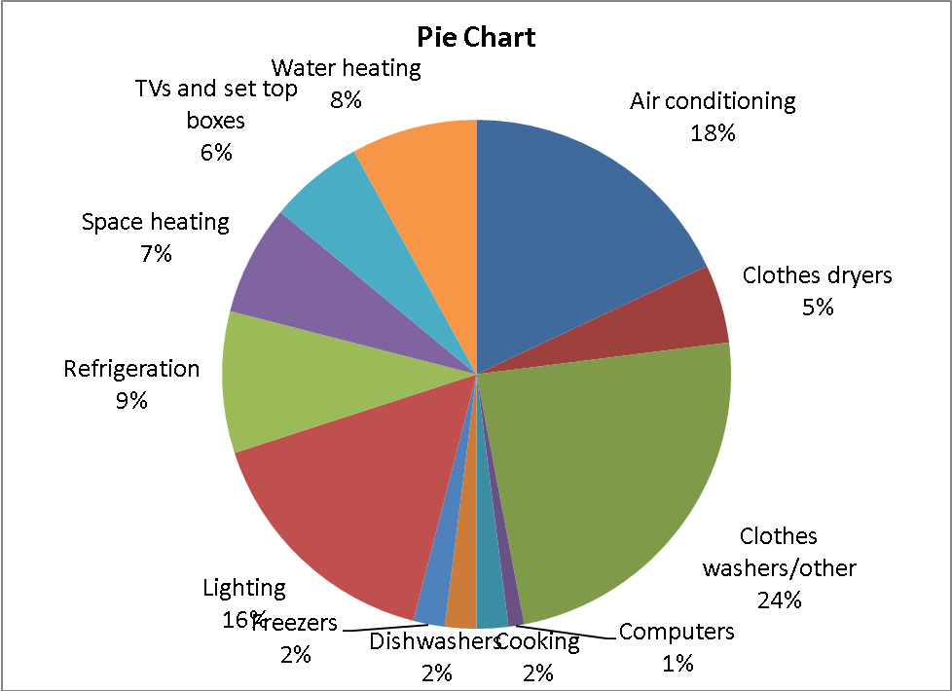
2.28 (a)
cont.
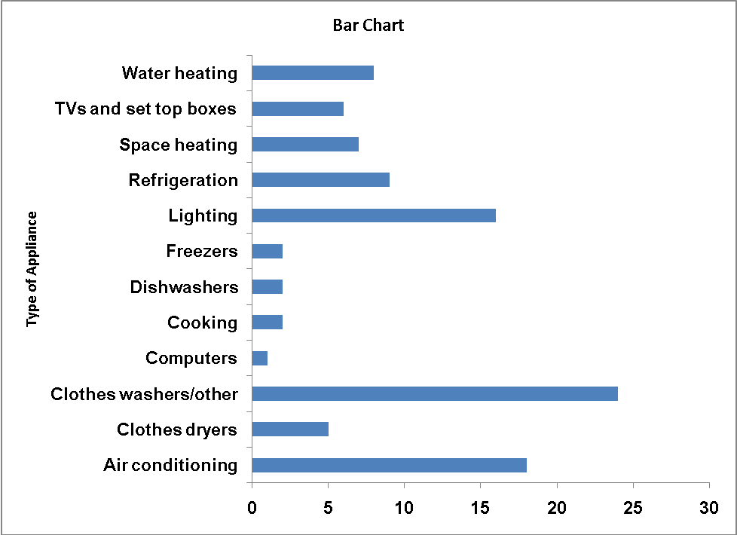
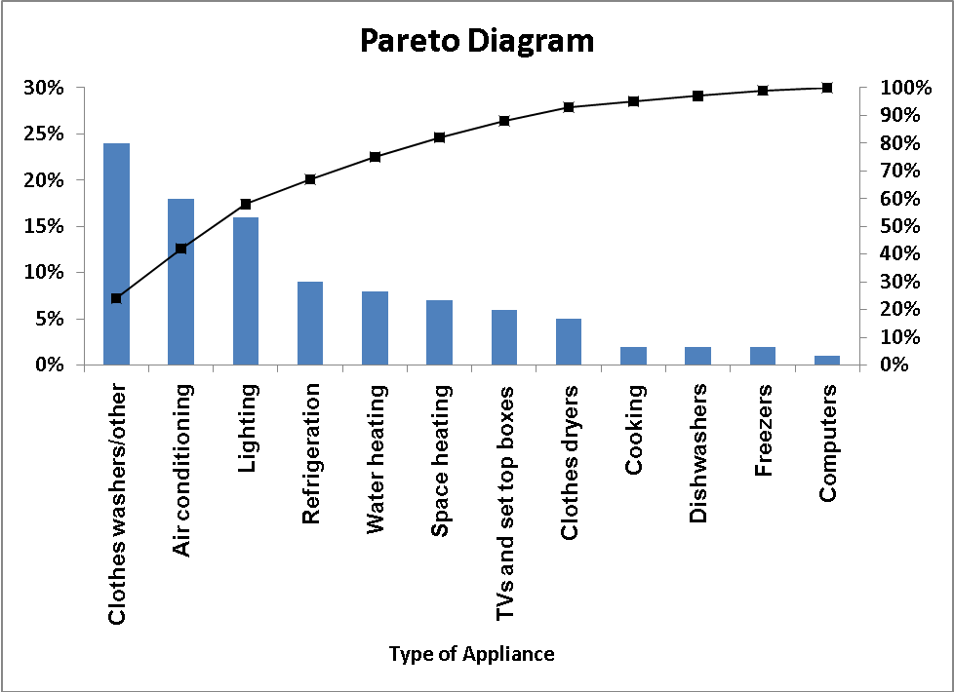

(b) The Pareto diagram is better than the pie chart and bar chart because it not only sorts the frequencies in descending order, it also provides the cumulative polygon on the same scale.
(c) Almost 60% of the residential electricity consumption in the United States is on “Clothes washers/other”, “Air conditioning”, and “Lighting”.

2.29 (a)
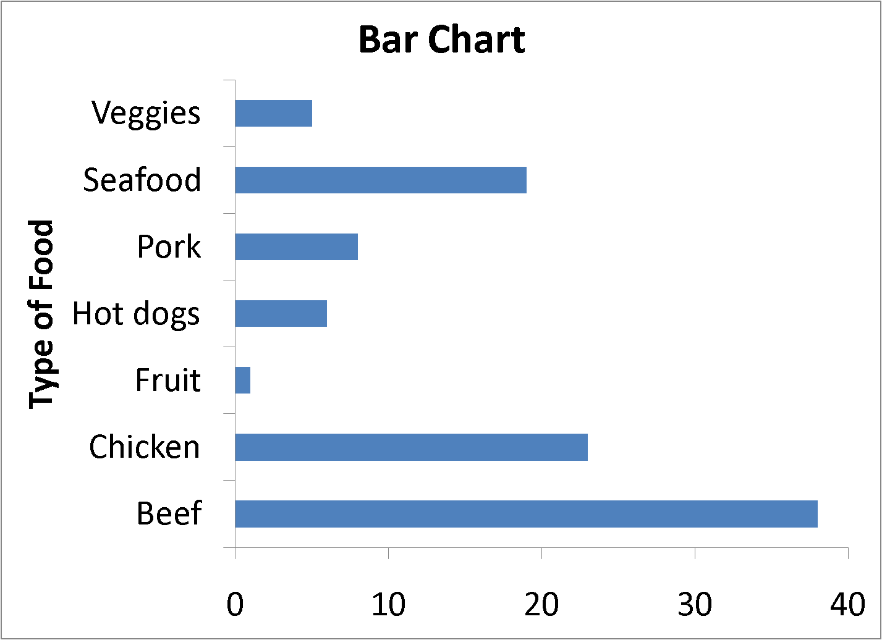
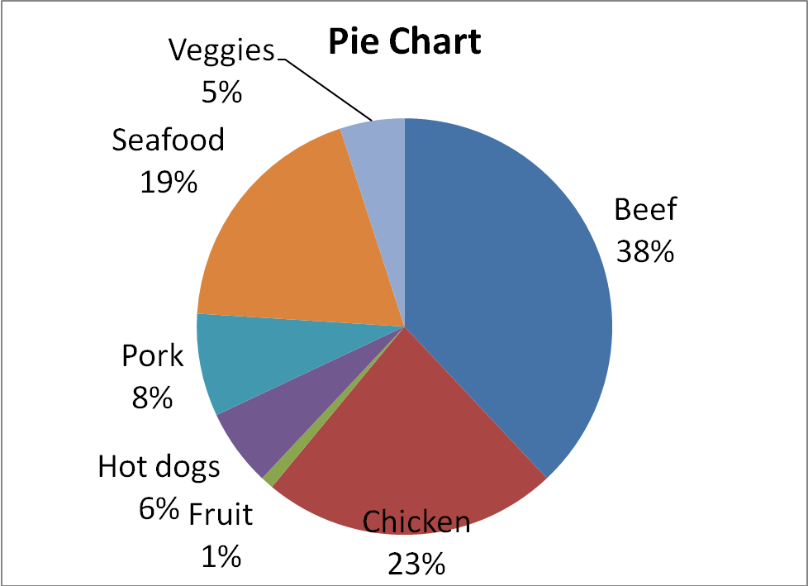
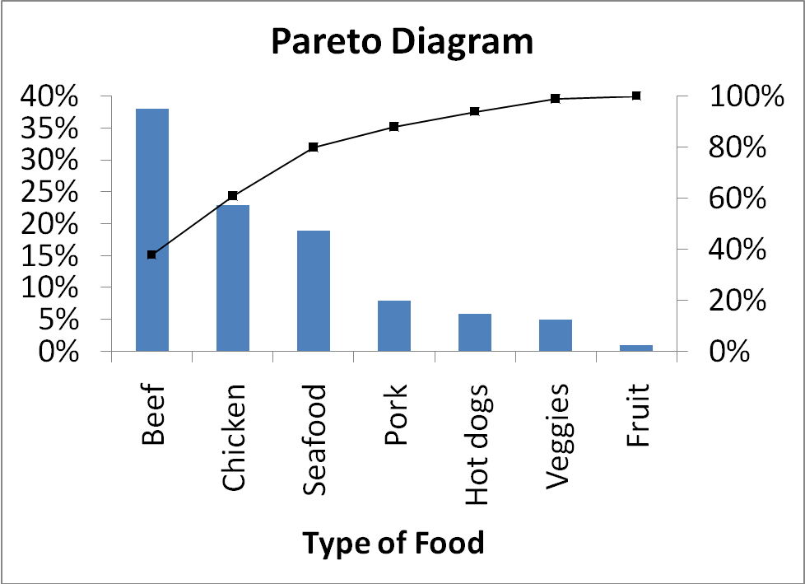
(b) The Pareto diagram is better than the pie chart because it not only sorts the frequencies in descending order, it also provides the cumulative polygon on the same scale.
(c) From the Pareto chart, beef, chicken and seafood make up 80% of what folks want sizzling on the grill during barbecue season.

2.30 (a)
(b) A higher percentage of females enjoy shopping for clothing.

2.31 (a)
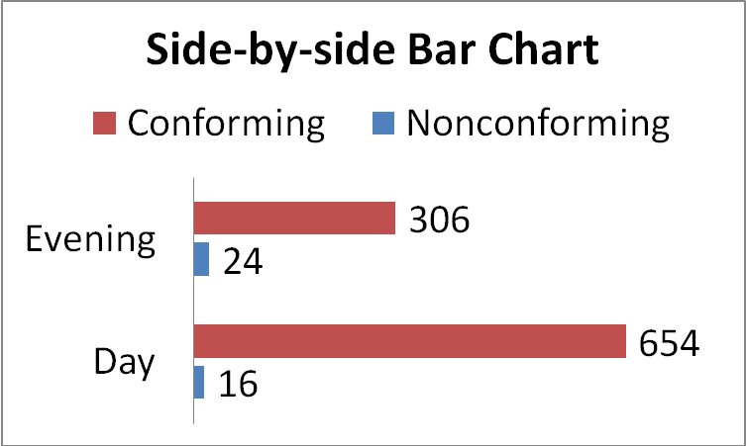
(b) The director of the lab may be able to cut the number of nonconforming tests by reducing the number of tests run in the evening, when there is a higher percent of tests run improperly.

2.32 (a)
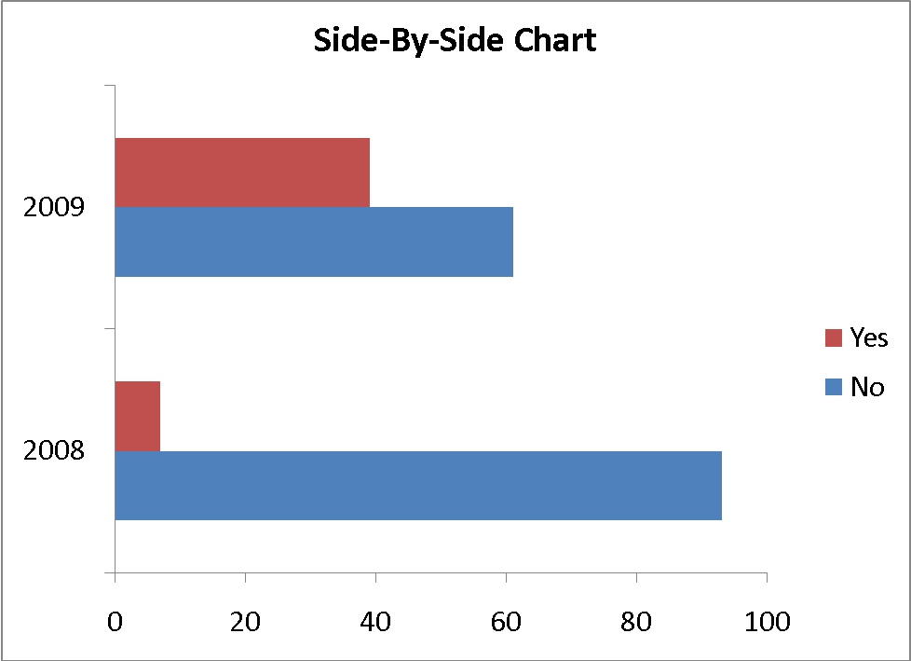
(b) 32% more online retailers were requiring three or more clicks in 2009 than in 2008.

2.33 Stem-and-leaf of Finance Scores
5 34
6 9
7 4
9 38

2.34 Ordered array: 50 74 74 76 81 89 92

2.35 (a) Ordered array: 9.1 9.4 9.7 10.0 10.2 10.2 10.3 10.8 11.1 11.2
11.5 11.5 11.6 11.6 11.7 11.7 11.7 12.2 12.2 12.3
12.4 12.8 12.9 13.0 13.2
(b) The stem-and-leaf display conveys more information than the ordered array. We can more readily determine the arrangement of the data from the stem-and-leaf display than we can from the ordered array. We can also obtain a sense of the distribution of the data from the stem-and-leaf display.
(c) The most likely gasoline purchase is between 11 and 11.7 gallons.
(d) Yes, the third row is the most frequently occurring stem in the display and it is located in the center of the distribution.

2.36 (a) Stem-and-Leaf Display
 |  |  | Stem unit: | 10
Statistics |  |  | 11 | 4
Sample Size | 30 |  | 12
Mean | 196.9333 |  | 13 | 5
Median | 176 |  | 14 | 1 5 6
Std. Deviation | 62.26857 |  | 15 | 1 8
Minimum | 114 |  | 16 | 1 2 4 5 6
Maximum | 411 |  | 17 | 0 0 2
 |  |  | 18 | 0 5 7
 |  |  | 19
 |  |  | 20 | 5
 |  |  | 21 | 0 5 6
 |  |  | 22 | 0 2 3 4
 |  |  | 23
 |  |  | 24
 |  |  | 25 | 9
 |  |  | 26
 |  |  | 27
 |  |  | 28
 |  |  | 29
 |  |  | 30 | 5
 |  |  | 31
 |  |  | 32 | 6
 |  |  | 33
 |  |  | 34
 |  |  | 35
 |  |  | 36
 |  |  | 37
 |  |  | 38
 |  |  | 39
 |  |  | 40
 |  |  | 41 | 1
 | (b)
(b) The results are concentrated between $160 and $225.

2.37 (a) Ordered array: Cost($) 0.55, 0.57, 0.57, 0.68, 0.72, 0.77, 0.86, 0.90, 0.92, 0.94, 1.14, 1.41, 1.42, 1.51
(b)
Stem-and-Leaf Display
Stem unit: | 0.1
5 | 5 7 7
6 | 8
7 | 2 7
8 | 6
9 | 0 2 4
10
11 | 4
12
13
14 | 1 2
15 | 1
(c) The stem-and-leaf display conveys more information than the ordered array. We can more readily determine the arrangement of the data from the stem-and-leaf display than we can from the ordered array. We can also obtain a sense of the distribution of the data from the stem-and-leaf display.
(d) The cost does not appear to be concentrated around any value.

2.38 (a)
2.38 (b)
cont.
(c) The majority of utility charges are clustered between $120 and $180.

2.39 The costs of attending a baseball game is concentrating around $160 for nine of the teams. Six teams have costs centered around $220. There are a few outliers in the right tail with one team having a cost higher than $410.

2.40 The property taxes per capita appear to be right-skewed with approximately 90% falling between $399 and $1,700, and the remaining 10% fall between $1,700 and $2,100. The center is at about $1,000.

2.41 (a)
(b) Yes, the steel mill is doing a good job at meeting the requirement as there is only one steel part out of a sample of 100 that is as much as 0.005 inches longer than the specified requirement.

2.42 (a)

(b)
(c) All the troughs will meet the company’s requirements of between 8.31 and 8.61 inches wide.

2.43 (a)
(b)
(c) The strength of all the insulators meets the company’s requirement of at least 1500 lbs.

2.44 (a)
(b)
2.44 (c) Manufacturer B produces bulbs with longer lives than Manufacturer A. The
cont. cumulative percentage for Manufacturer B shows 65% of their bulbs lasted 1049 hours or less contrasted with 70% of Manufacturer A’s bulbs which lasted 949 hours or less. None of Manufacturer A’s bulbs lasted more than 1149 hours, but 12.5% of Manufacturer B’s bulbs lasted between 1150 and 1249 hours. At the same time, 7.5% of Manufacturer A’s bulbs lasted less than 750 hours, while all of Manufacturer B’s bulbs lasted at least 750 hours.

2.45 (a)
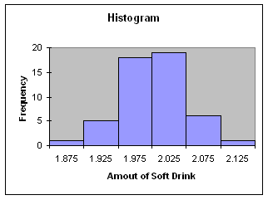
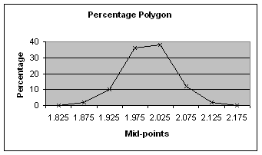
(b) Amount of Frequency Percentage
Soft Drink Less Than Less Than
1.899 1 2%
1.949 6 12
1.999 24 48
2.049 43 86
2.099 49 98
2.149 50 100
2.45 (b)
cont.
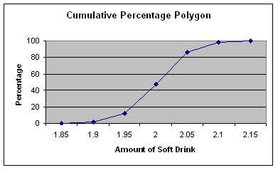
(c) The amount of soft drink filled in the two liter bottles is most concentrated in two intervals on either side of the two-liter mark, from 1.950 to 1.999 and from 2.000 to 2.049 liters. Almost three-fourths of the 50 bottles sampled contained between 1.950 liters and 2.049 liters.

2.46 (a)
(b) There is no relationship between X and Y.

2.47 (a)
(b) Annual sales appear to be increasing in the earlier years before 2002 but start to decline after 2006.

2.48 (a)
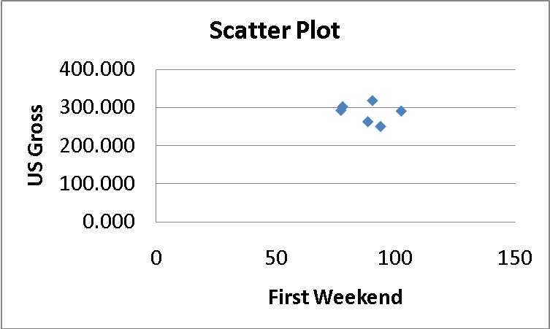
(b)
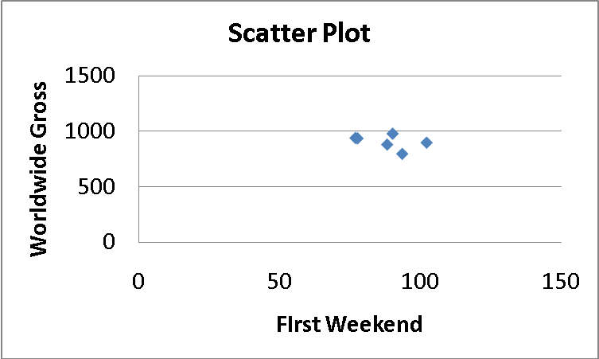
(c) There appears to be a rather weak negative relationship between first weekend gross and U. S. gross and between first weekend gross and worldwide gross. However, due to the small sample size, the relationships should not be taken as conclusive.

2.49 (a)
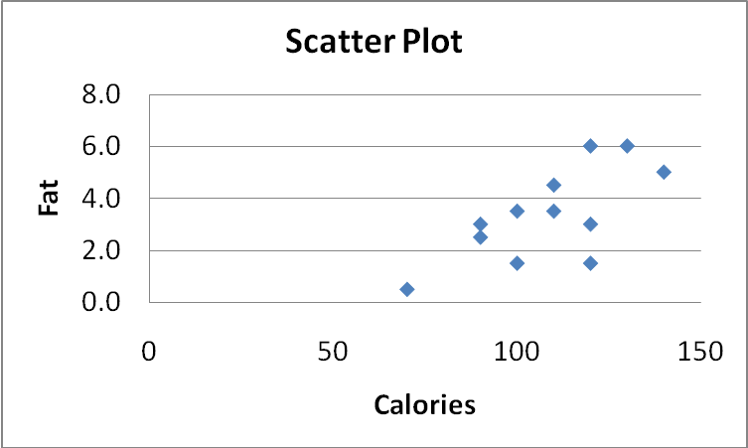
(b) There appears to be a positive relationship between the calories and total fat in veggie burgers.

2.50 (a) Yes, schools with higher revenues will also have higher coaches’ salaries.
(b)
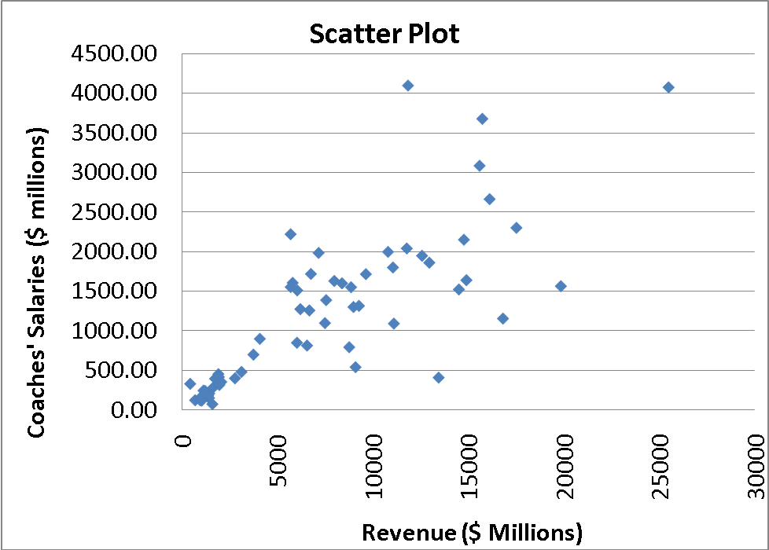
(c) There appears to be a positive relationship between coaches’ salary and revenue.
Yes, this is borne out by the data.

2.51 (a)
(b) There is a positive relationship between Wonderlic score and graduation rate.

2.52 (a) Excel output:
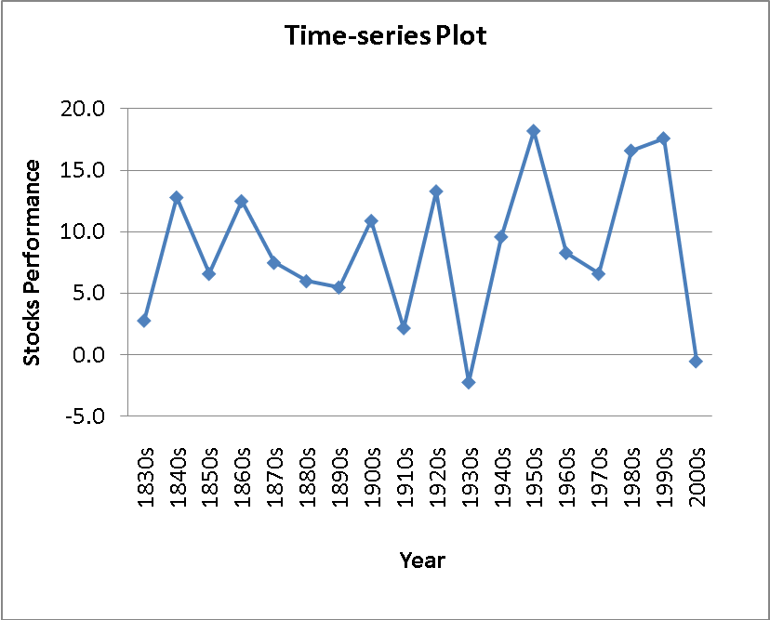
(b) There is no obvious pattern in the data.

2.53 (a)
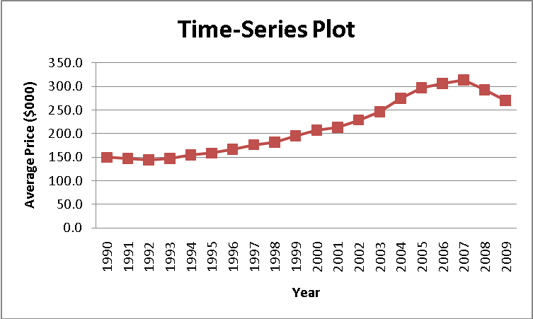
(b) There is an upward trend on the average price till 2007 and the average price started a downward trend from then on.

2.54 (a)
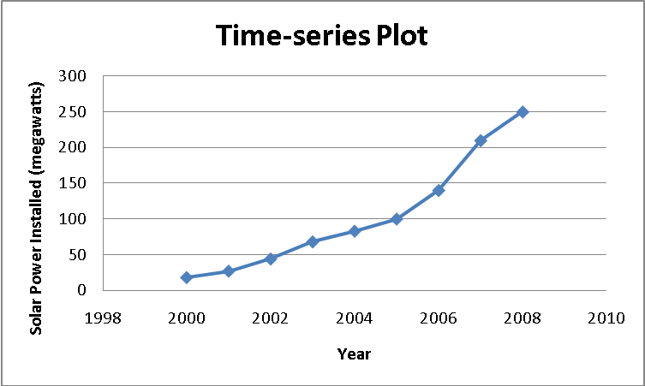
(b) There was a steady increase in the amount of solar power installed in the United States between 2000 and 2008

2.55 (a)
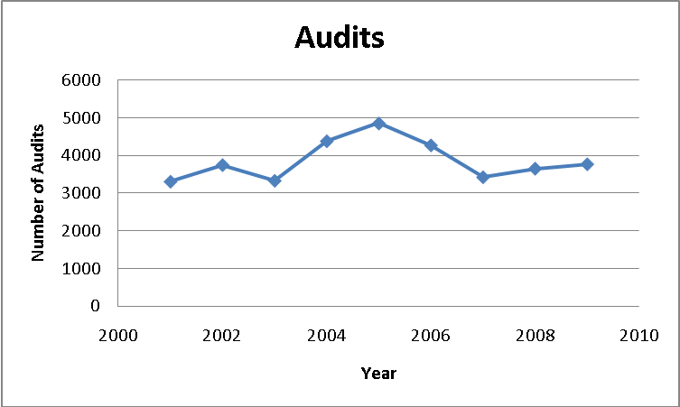
(b) There is no obvious pattern in the data.

2.56 (a)
Count of Risk |  | Fees
Risk | Type | No | Yes | Grand Total
Above Average | Intermediate Government | 9.44% | 8.89% | 18.33%
 | Short Term Corporate | 11.11% | 2.78% | 13.89%
Above Average Total |  | 20.56% | 11.67% | 32.22%
Average | Intermediate Government | 10.56% | 5.56% | 16.11%
 | Short Term Corporate | 12.78% | 4.44% | 17.22%
Average Total |  | 23.33% | 10.00% | 33.33%
Below Average | Intermediate Government | 10.56% | 5.00% | 15.56%
 | Short Term Corporate | 16.67% | 2.22% | 18.89%
Below Average Total |  | 27.22% | 7.22% | 34.44%
Grand Total |  | 71.11% | 28.89% | 100.00%
(b) Although the ratio of fee-yes to fee-no bond funds for intermediate government category seems to be about 2-to-3 (19% to 31%), the ratio for above average risk intermediate government bond funds is closer to 1-to-1 (8.9% to 9.4%). While the group “intermediate government funds that do not charge a fee” has nearly equal numbers of above average risk, average risk, and below risk funds, the group “short term corporate bond funds that do not charge a fee” contains about fifty percent more below average risk funds than above average ones. The pattern of risk percentages differs between the fee-yes and fee-no funds in each bond fund category.
(c) The results for type, fee, and risk, in the two years are similar.

2.57 (a)
(b) The large cap constitutes the largest percentage among all combinations of objective and fees.

2.58 (a)
(b) Large cap funds without fees are fairly evenly spread in risk while large cap funds with fees are more likely to have average or low risk. Mid cap and small cap funds regardless of fees are more likely to have average or high risk.

2.59 (a)
(b) The large cap constitute the largest percentage among the various combinations of fees, risk factor, and objective except the high risk, growth and fee; average risk, value and no fee; high risk, value and no fee; high risk, value and fee combinations that are dominated by the small cap.

2.67 (a)
2.67 (a)
cont.
(b) The bar chart and the pie chart should be preferred over the exploded pie chart, doughnut chart, the cone chart and the pyramid chart since the former set is simpler and easier to interpret.

2.68 (a)
2.68 (a)
cont.
(b) The bar chart and the pie chart should be preferred over the exploded pie chart, doughnut chart, the cone chart and the pyramid chart since the former set is simpler and easier to interpret.

2.69 A histogram uses bars to represent each class while a polygon uses a single point. The histogram should be used for only one group, while several polygons can be plotted on a single graph.

2.70 A summary table allows one to determine the frequency or percentage of occurrences in each category.

2.71 A bar chart is useful for comparing categories. A pie chart is useful when examining the portion of the whole that is in each category. A Pareto diagram is useful in focusing on the categories that make up most of the frequencies or percentages.

2.72 The bar chart for categorical data is plotted with the categories on the vertical axis and the frequencies or percentages on the horizontal axis. In addition, there is a separation between categories. The histogram is plotted with the class grouping on the horizontal axis and the frequencies or percentages on the vertical axis. This allows one to more easily determine the distribution of the data. In addition, there are no gaps between classes in the histogram.

2.73 A time-series plot is a type of scatter diagram with time on the x-axis.

2.74 Because the categories are arranged according to frequency or importance, it allows the user to focus attention on the categories that have the greatest frequency or importance.

2.75 Percentage breakdowns according to the total percentage, the row percentage, and/or the column percentage allow the interpretation of data in a two-way contingency table from several different perspectives.

2.76 A contingency table contains information on two categorical variables whereas a multidimensional table can display information on more than two categorical variables.

2.77 The multidimensional PivotTable can reveal additional patterns that cannot be seen in the a contingency table. One can also change the statistic displayed and compute descriptive statistics which can add insight into the data.

2.78 (a)
2.78 (a)
cont.

(b)

(c) The publisher gets the largest portion (64.8%) of the revenue. About half (32.3%) of the revenue received by the publisher covers manufacturing costs. The publisher’s marketing and promotion account for the next largest share of the revenue, at 15.4%. Author, bookstore employee salaries and benefits, and publisher administrative costs and taxes each account for around 10% of the revenue, whereas the publisher after-tax profit, bookstore operations, bookstore pretax profit, and freight constitute the “trivial few” allocations of the revenue. Yes, the bookstore gets twice the revenue of the authors.

2.79 (a) Number of Movies:
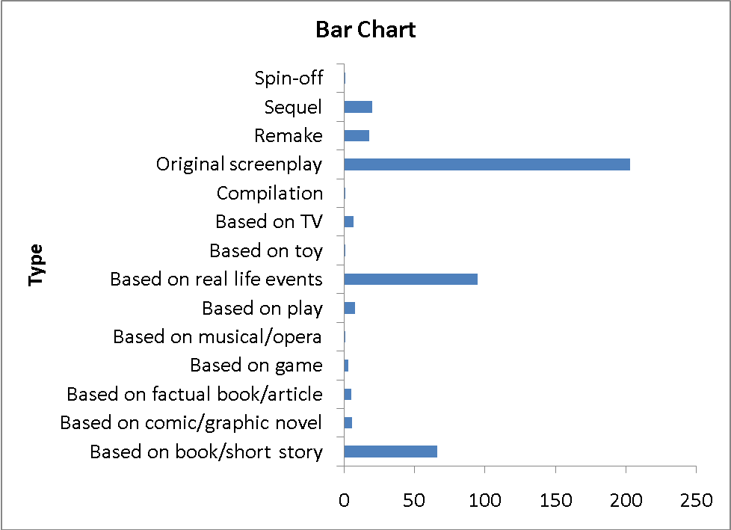
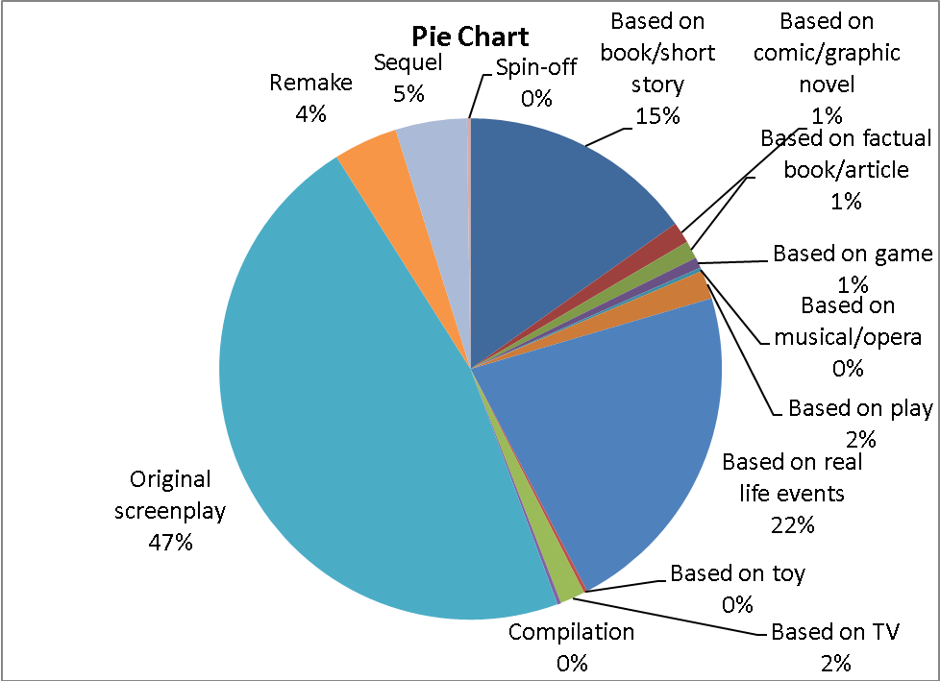
2.79 (a)
cont.
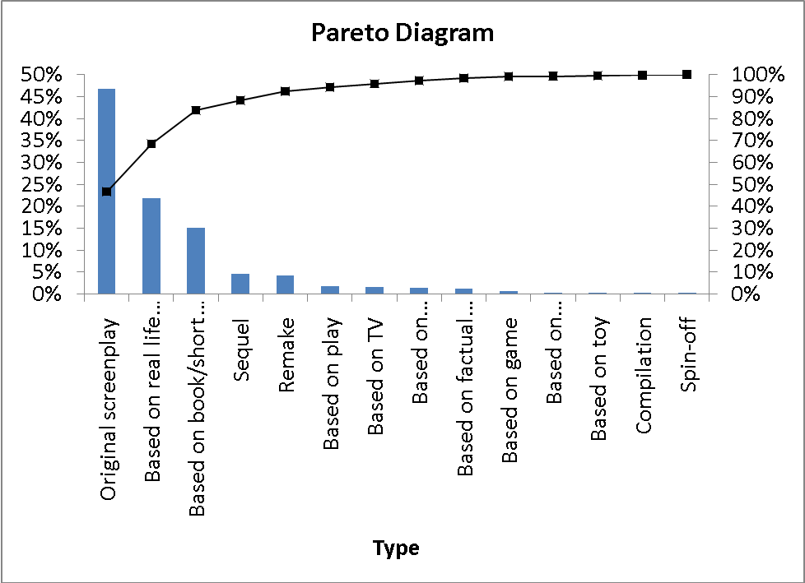

Gross (in $millions):
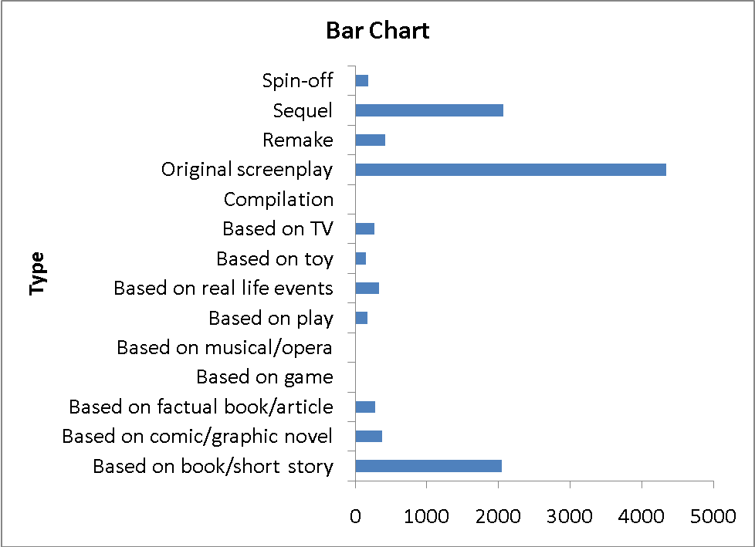
2.79 (a)
cont.
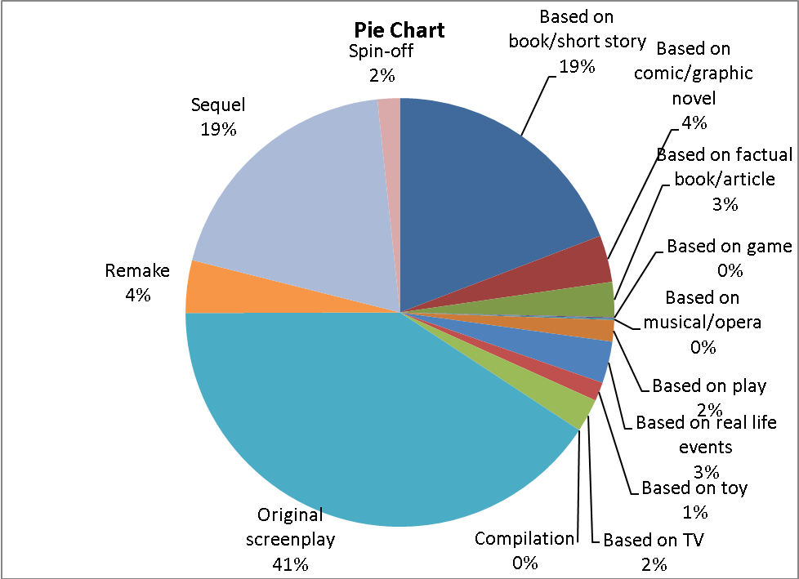
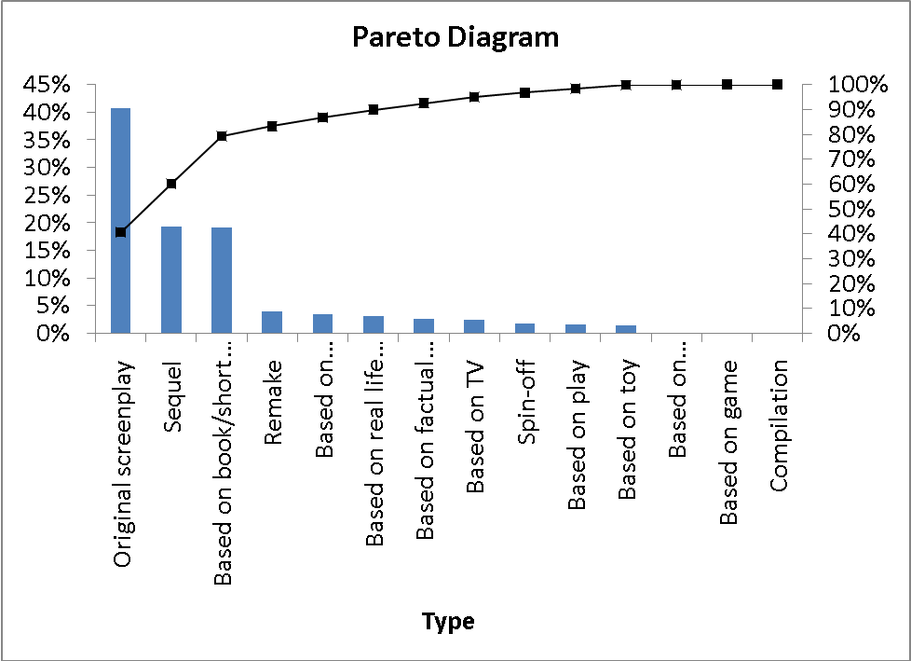
2.79 (a) Number of Tickets Sold (millions):
cont.
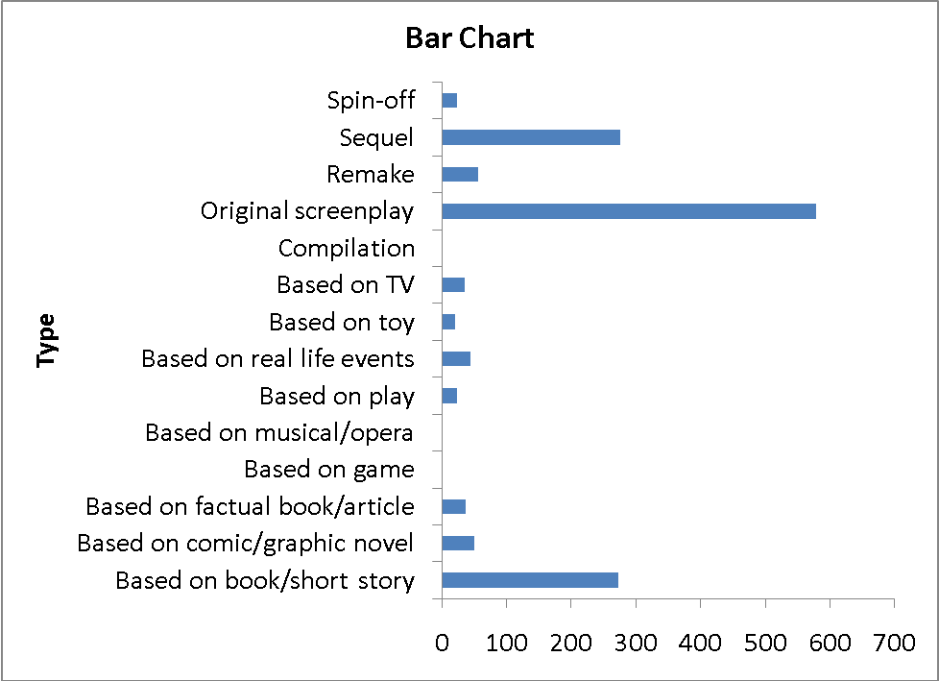
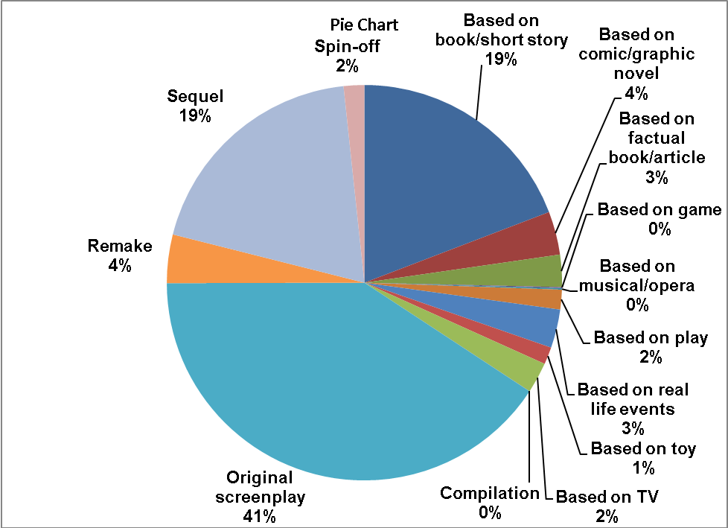
2.79 (a)
cont.
(b) Based on the Pareto chart for the number of movies, “Original screenplay”, “Based on real life events” and “Based on book/short story” are the “vital few” and capture more than 80% of the market share. According to the Pareto chart for gross (in $millions) and number of ticket sold in millions, “Original screenplay”, “Sequel” and “Based on book/short story” are the “vital few” and capture about 80% of the market share.

2.80 (a)
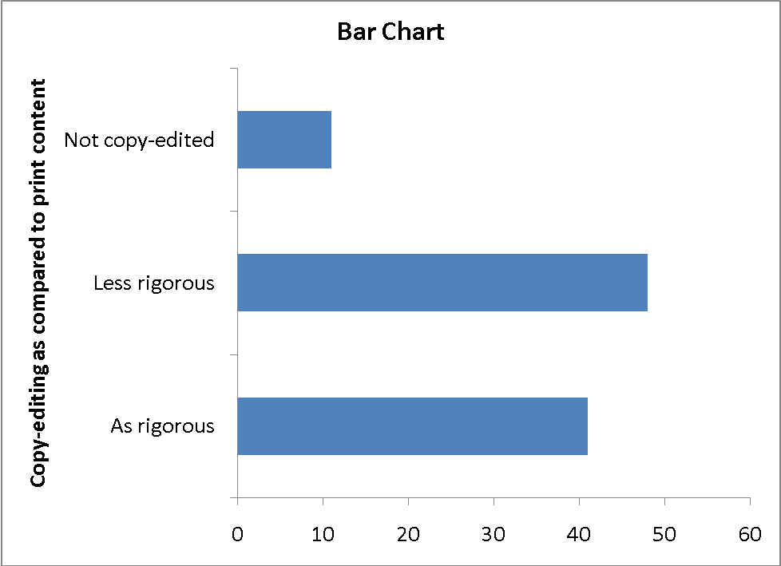
2.80 (a)
cont.
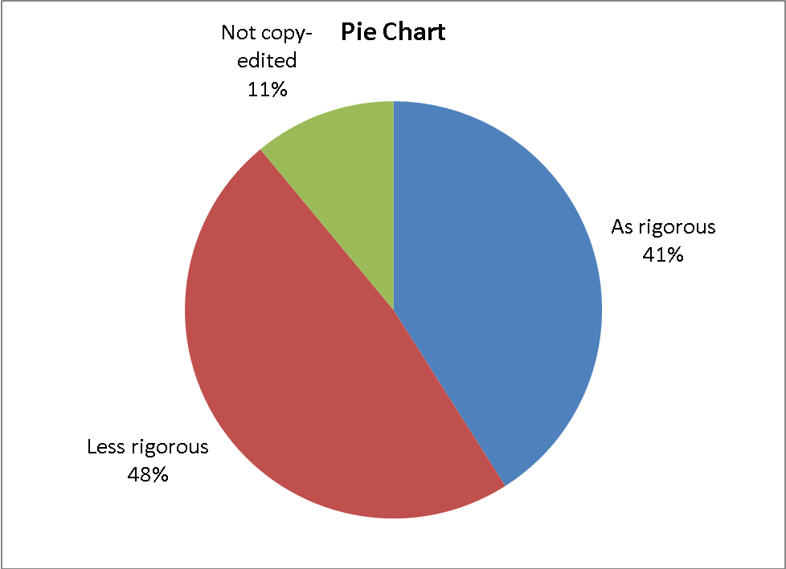
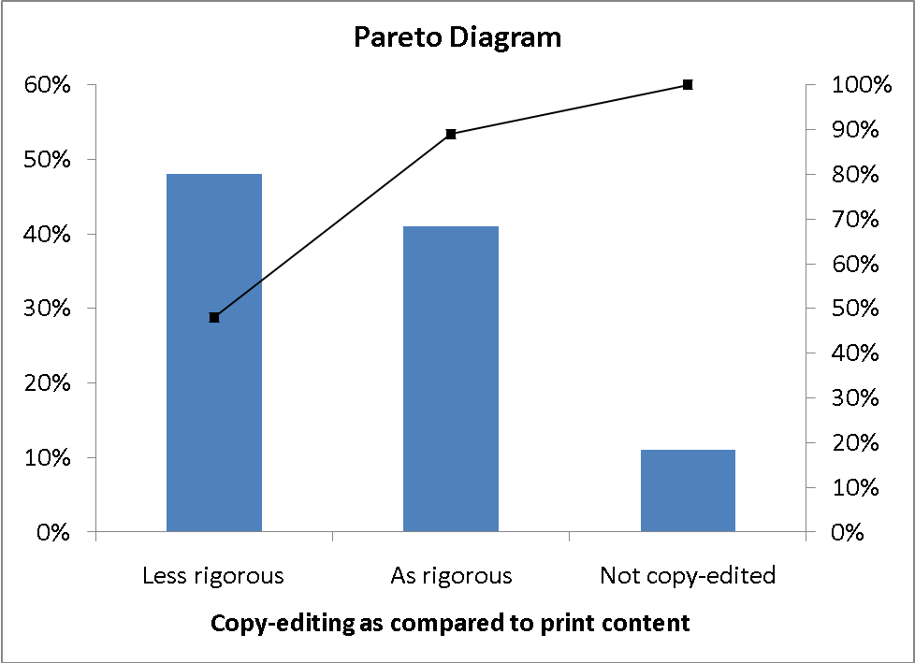
(b) Since there are only three categories, all the three graphical methods are capable of portraying these data well. The Pareto diagram, however, is better than the pie chart and bar chart because it not only sorts the frequencies in descending order, it also provides the cumulative polygon on the same scale.
2.80 (c)
cont.
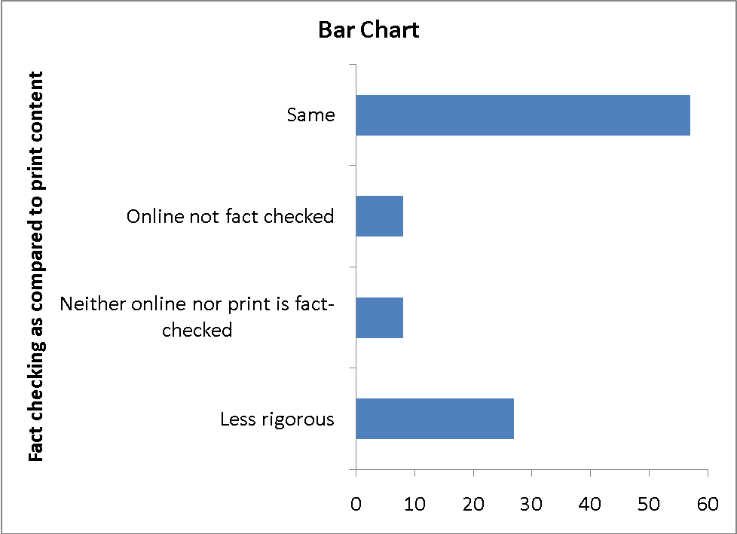
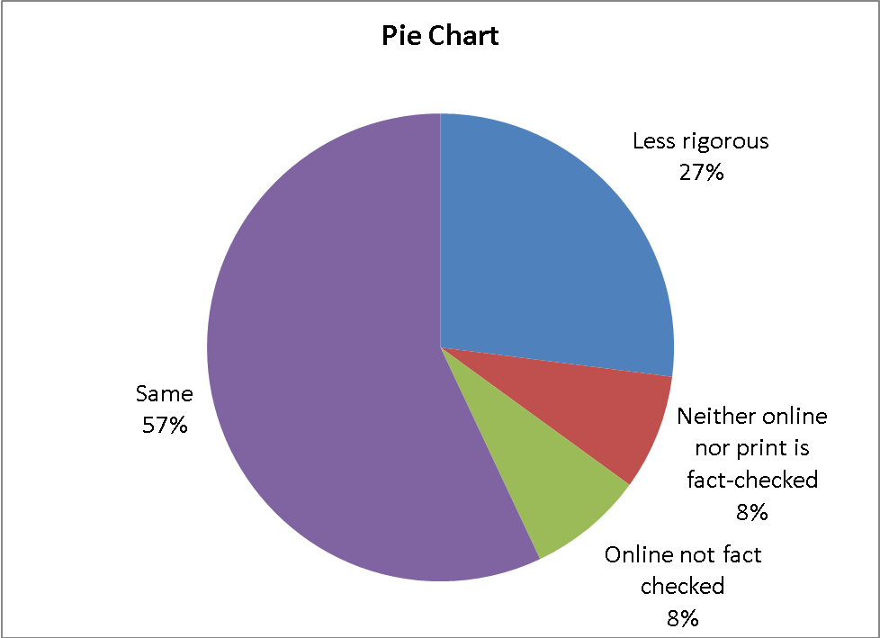
2.80 (c)
cont.
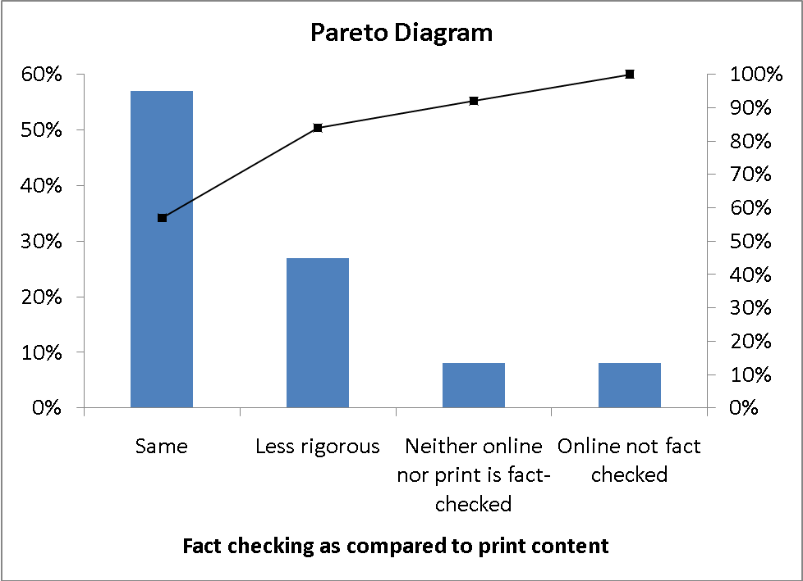
(d) Since there are only four categories, all the three graphical methods are capable of portraying these data well. The Pareto diagram, however, is better than the pie chart and bar chart because it not only sorts the frequencies in descending order, it also provides the cumulative polygon on the same scale.
(e) Based on the Pareto chart for copy-editing, about 50% of the contents in online consumer magazines receive less rigorous copy-editing. Based on the Pareto chart for fact-checking, more than 50% of the contents in online consumer magazines receive the same amount of fact-checking.

2.81 (a)
2.81 (b)
cont.
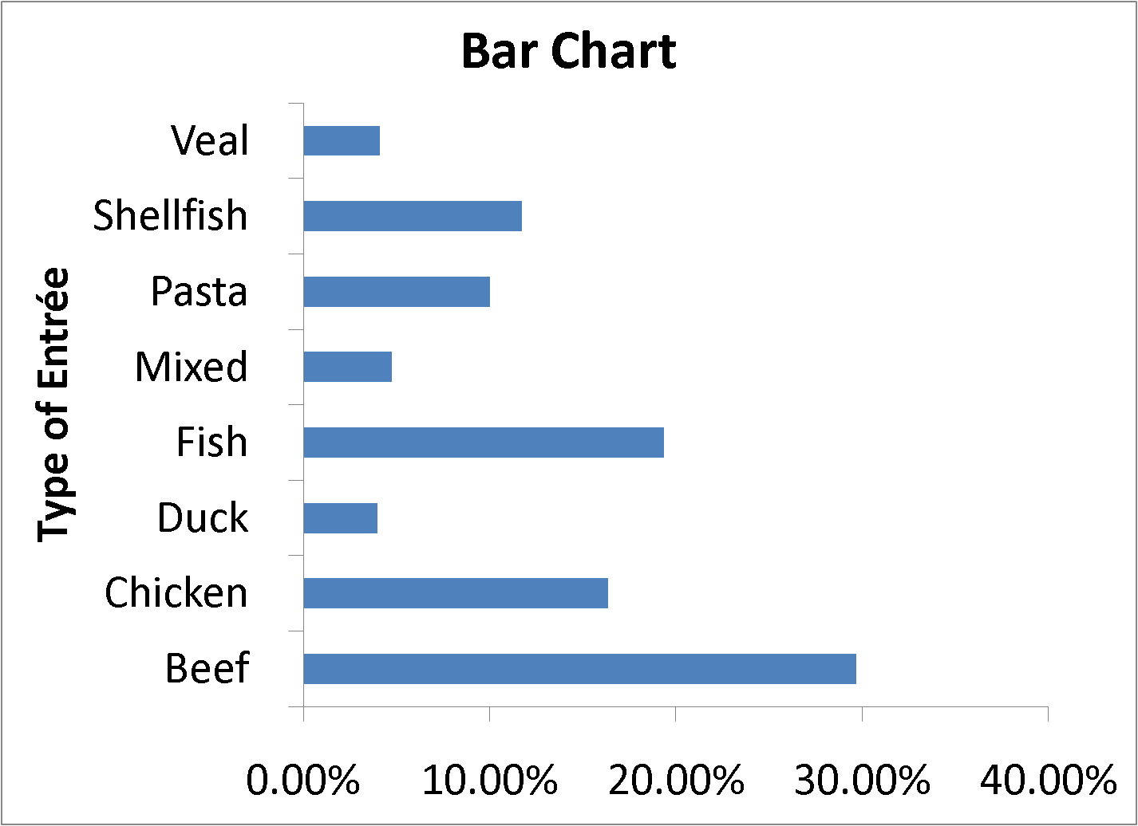
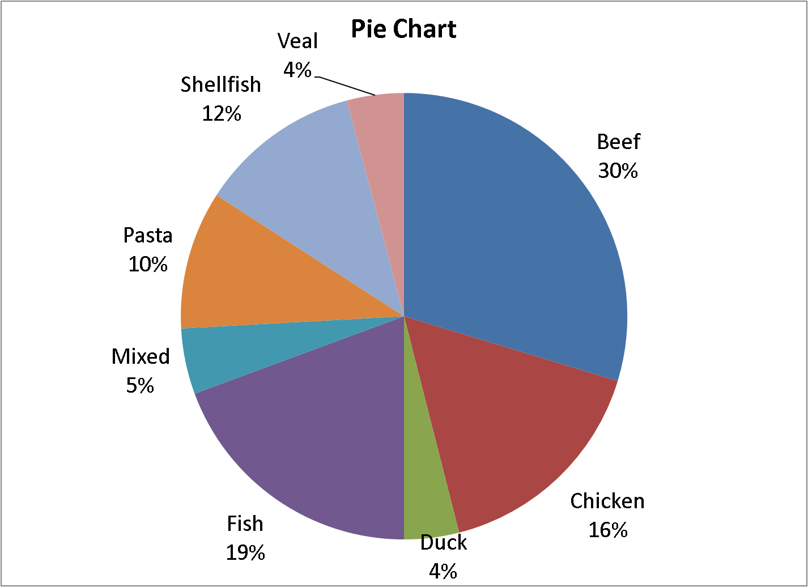

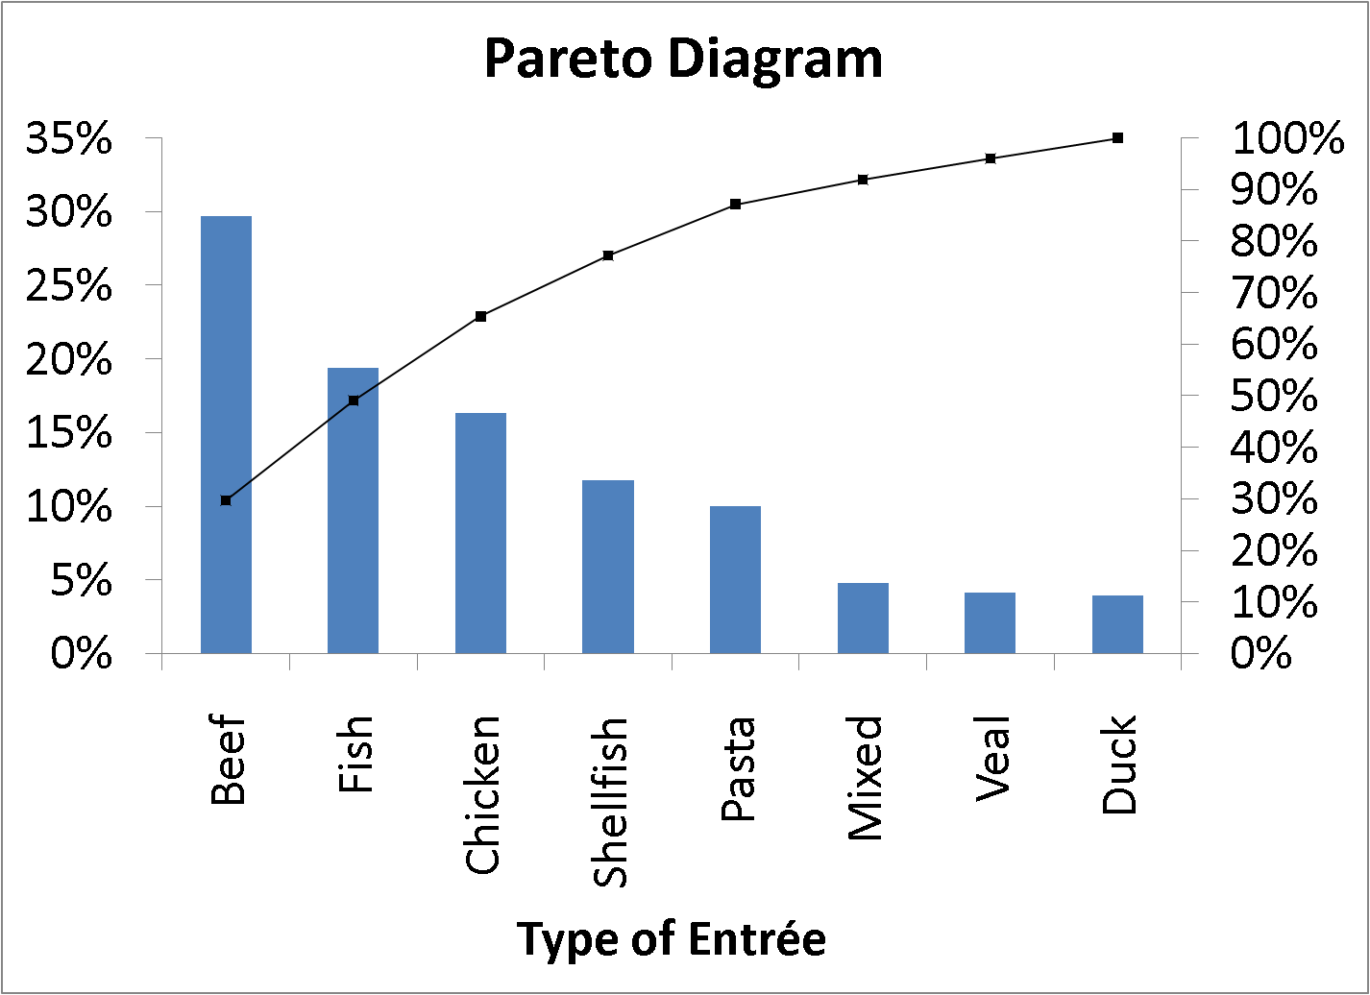
2.81 (c) The Pareto diagram has the advantage of offering the cumulative percentage view of
cont. the categories and, hence, enables the viewer to separate the "vital few" from the "trivial many".
(d) Beef and fish account for nearly 50% of all entrees ordered by weekend patrons
of a continental restaurant. When chicken is included, nearly two-thirds of the entrees are accounted for.

2.82 (a)
 | Gender |  |  |  |  | Beef Entrée
Dessert Ordered | Male | Female | Total |  | Dessert Ordered | Yes | No | Total
Yes | 71% | 29% | 100% |  | Yes | 52% | 48% | 100%
No | 48% | 52% | 100% |  | No | 25% | 75% | 100%
Total | 53% | 47% | 100% |  | Total | 31% | 69% | 100%

 | Gender |  |  |  |  | Beef Entrée
Dessert Ordered | Male | Female | Total |  | Dessert Ordered | Yes | No | Total
Yes | 30% | 14% | 23% |  | Yes | 38% | 16% | 23%
No | 70% | 86% | 77% |  | No | 62% | 84% | 77%
Total | 100% | 100% | 100% |  | Total | 100% | 100% | 100%

 | Gender |  |  |  |  | Beef Entrée
Dessert Ordered | Male | Female | Total |  | Dessert Ordered | Yes | No | Total
Yes | 16% | 7% | 23% |  | Yes | 12% | 11% | 23%
No | 37% | 40% | 77% |  | No | 19% | 58% | 77%
Total | 53% | 47% | 100% |  | Total | 31% | 69% | 100%

(b) If the owner is interested in finding out the percentage of joint occurrence of gender
and ordering of dessert or the percentage of joint occurrence of ordering a beef entrée and a dessert among all patrons, the table of total percentages is most informative. If the owner is interested in the effect of gender on ordering of dessert or the effect of ordering a beef entrée on the ordering of dessert, the table of column percentages will be most informative. Since dessert will usually be ordered after the main entree and the owner has no direct control over the gender of patrons, the table of row percentages is not very useful here.
(c) 30% of the men sampled ordered desserts compared to 14% of the women. Men are more than twice as likely to order desserts as women. Almost 38% of the patrons ordering a beef entree ordered dessert compared to less than 16% of patrons ordering all other entrees. Patrons ordering beef are better than 2.3 times as likely to order dessert as patrons ordering any other entree.

2.83 (a) United States Fresh Food Consumed:
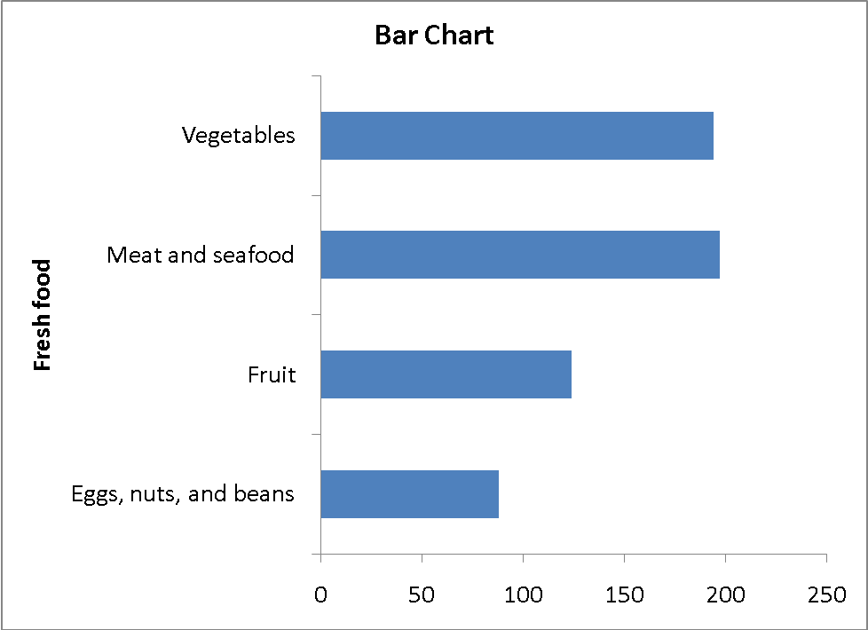
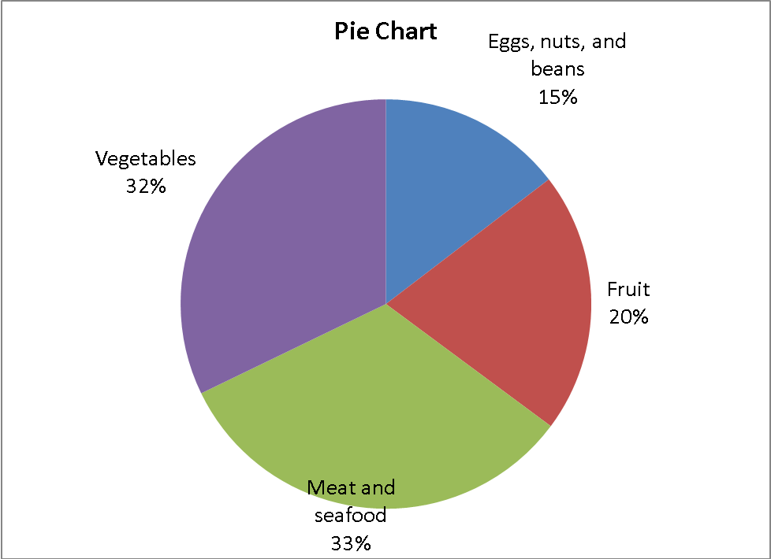
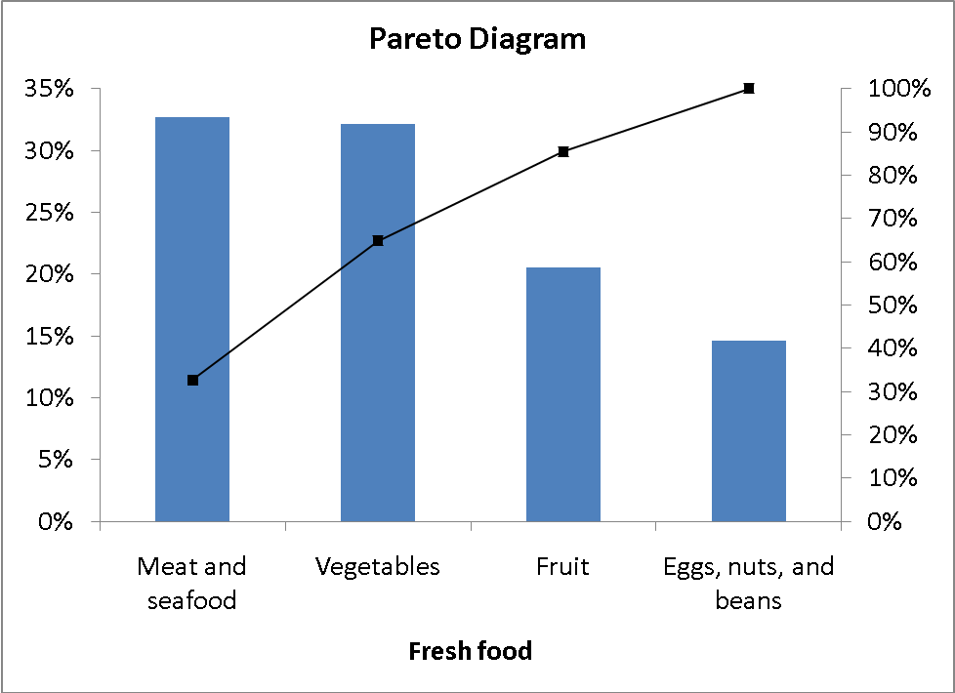
2.83 (a) Japan Fresh Food Consumed:
cont.
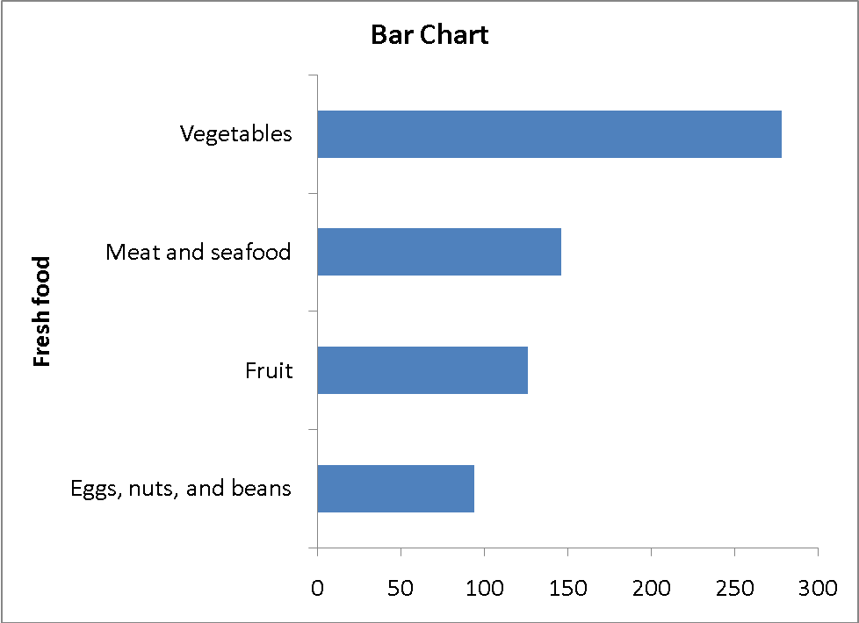
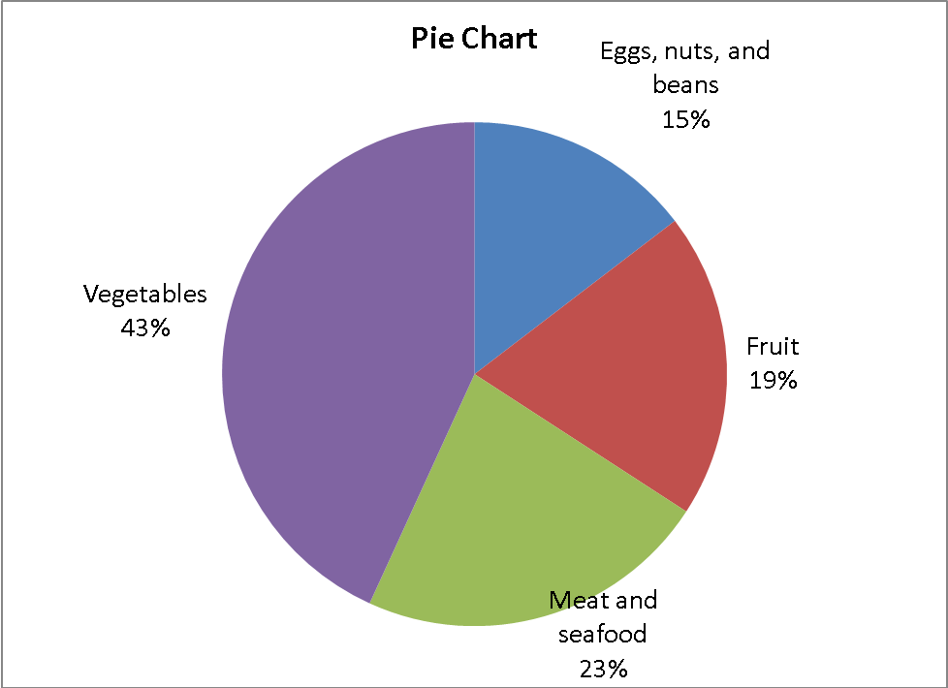
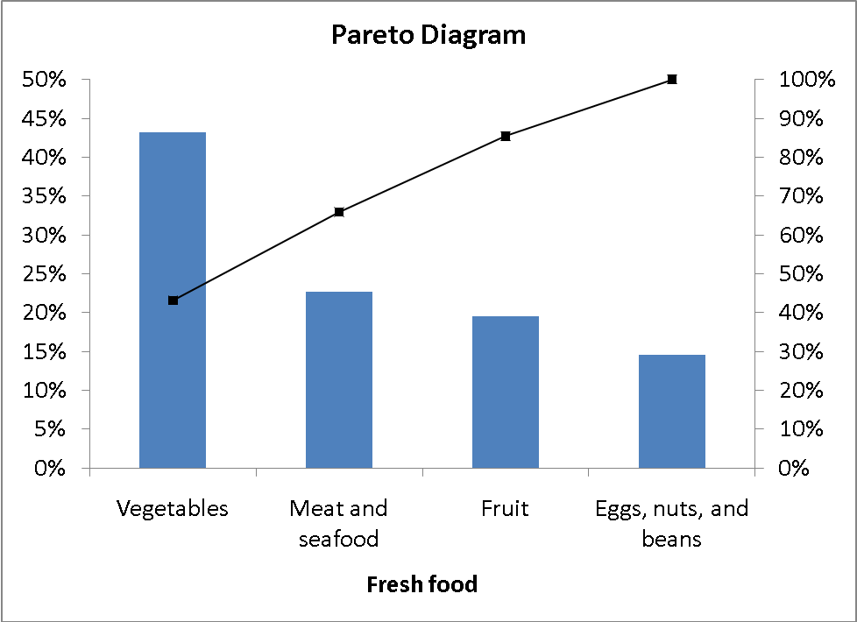
2.83 (a) Russia Fresh Food Consumed:
cont.
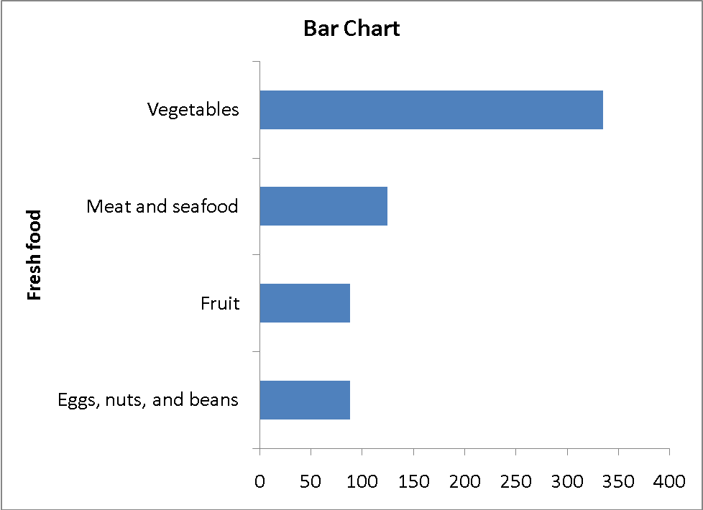
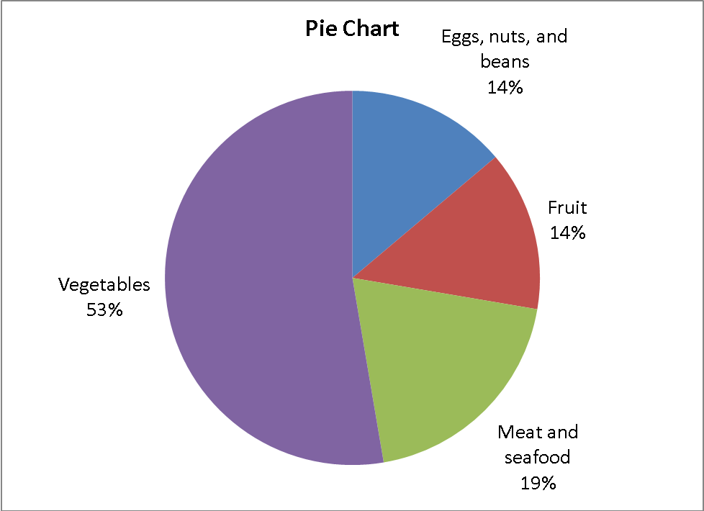
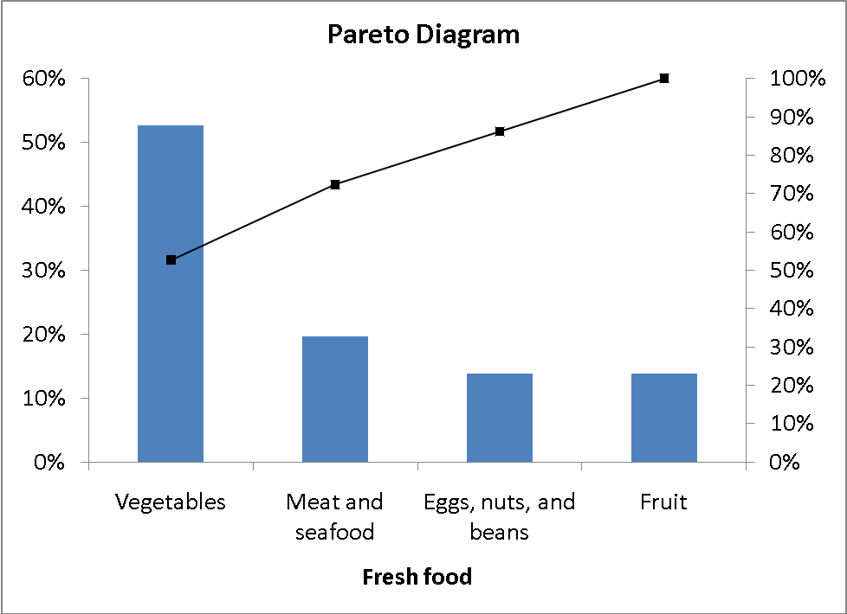
2.83 (b) United States Packaged Food Consumed:
cont.
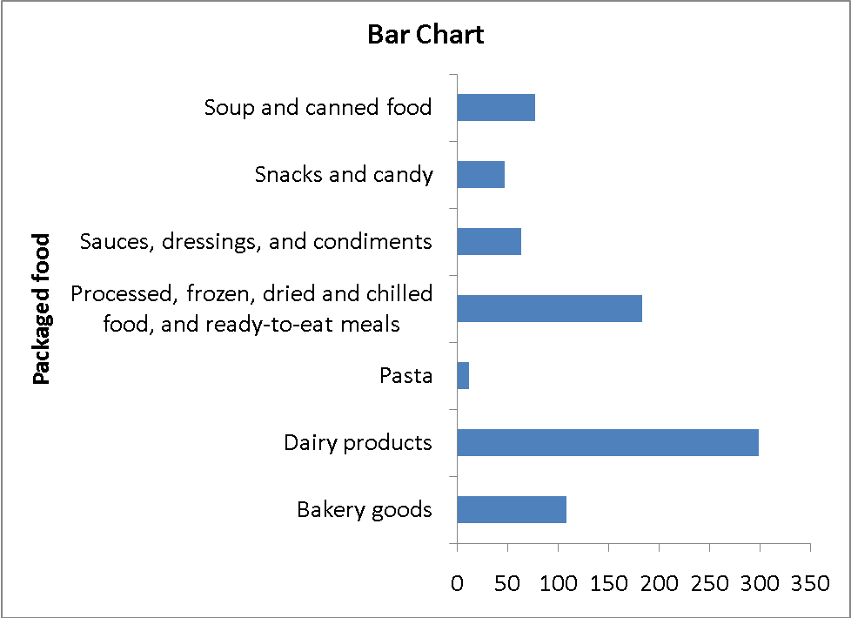
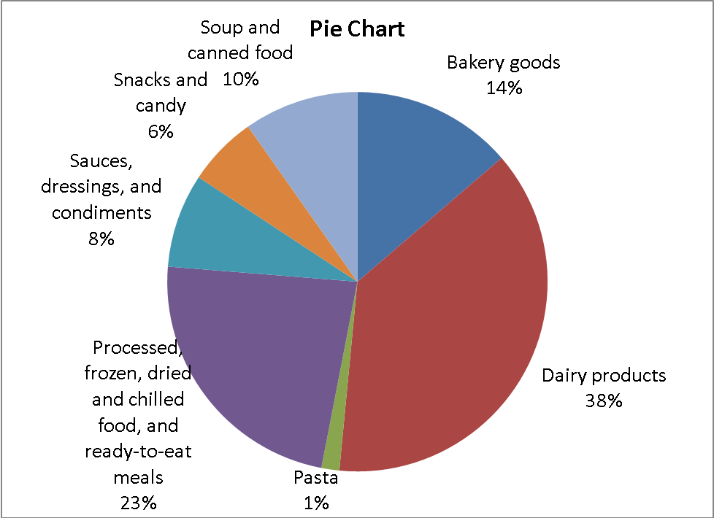
2.83 (b)
cont.
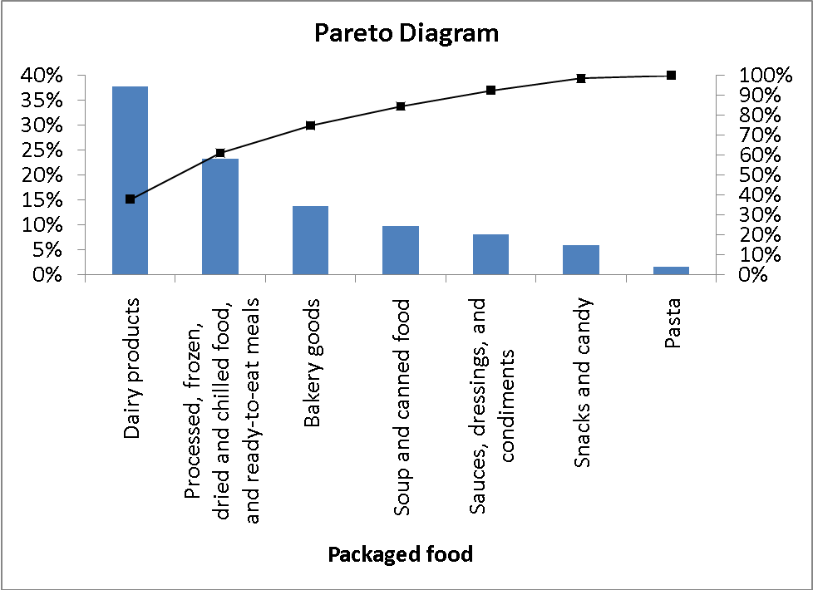
Japan Packaged Food Consumed:
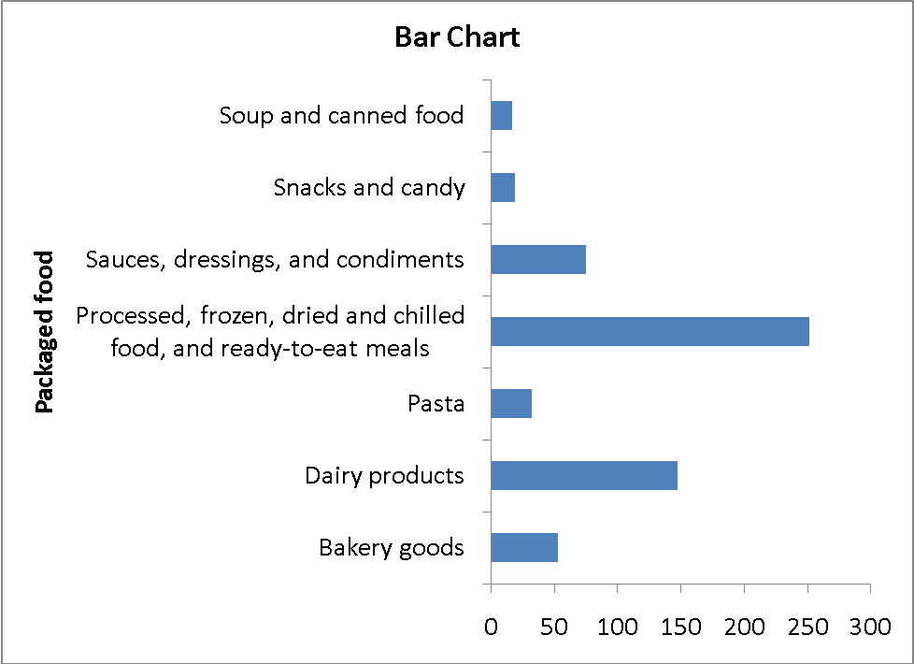
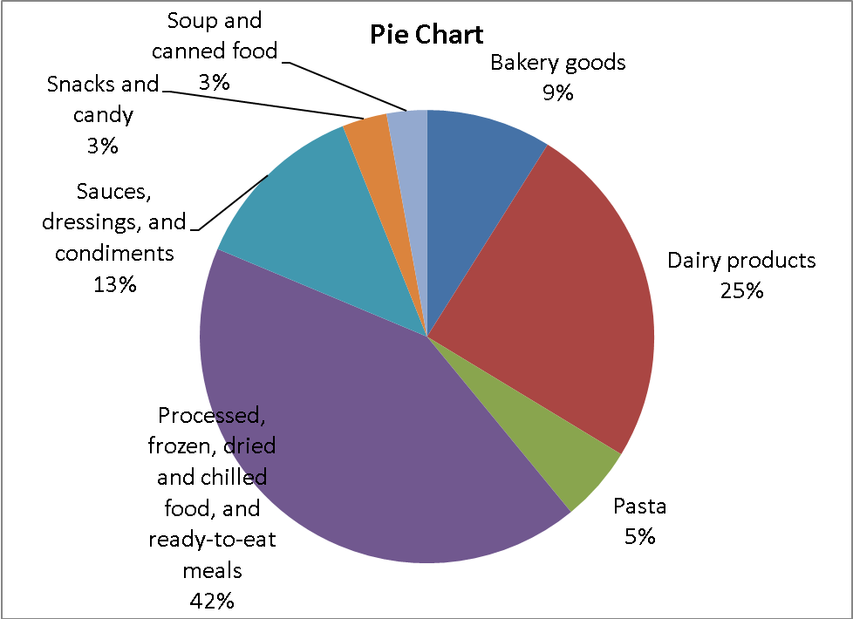
2.83 (b)
cont.
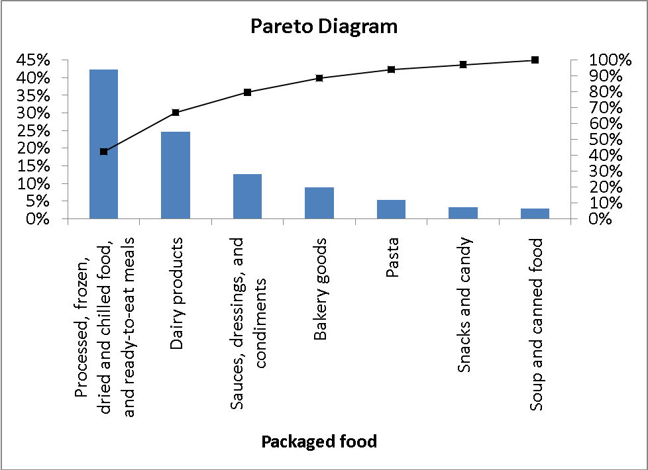
Russian Packaged Food Consumed:
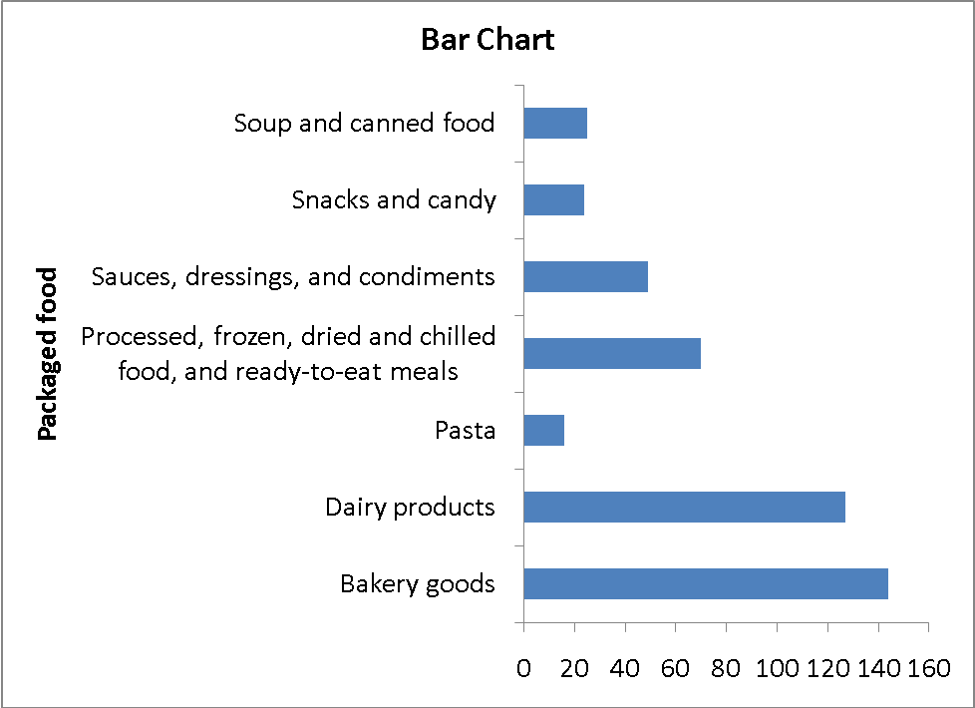
2.83 (b)
cont.

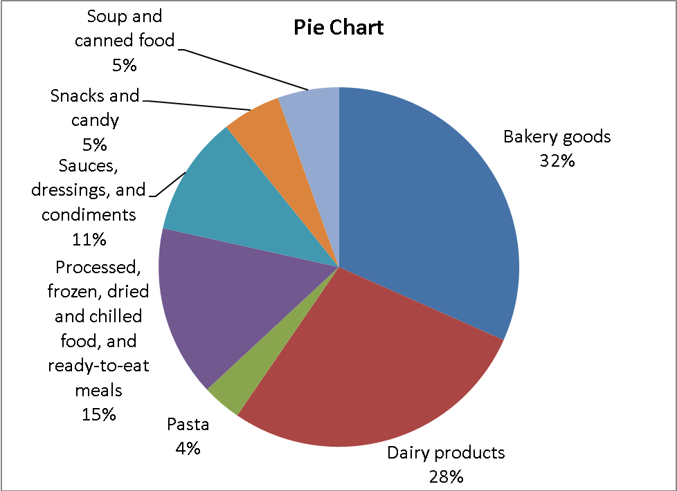
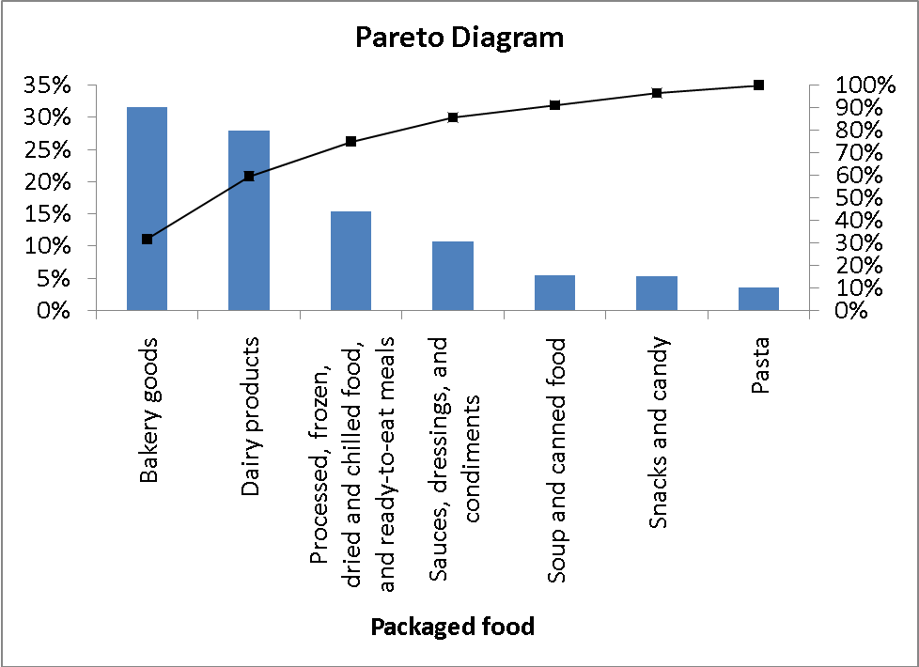

(c) The fresh food consumption pattern between Japanese and Russians are quite similar with vegetables taking up the largest share followed by meats and seafood while Americans consume about the same amount of meats and seafood, and vegetables. Among the three countries, vegetables, and meats and seafood constitute more than 60% of the fresh food consumption.
For Americans, dairy products, and processed, frozen, dried and chilled food and ready-to-eat meals make up slightly more than 60% of the packaged food consumption. For Japanese, processed, frozen, dried and chilled food, and ready-to-eat meals, and dairy products constitute more than 60% of their packaged food consumption. For the Russians, bakery goods and dairy products take up 60% of the share of their package food consumption.
2.84 (a)
23575R15 accounts for over 80% of the warranty claims.
(b)
2.84 (b)
cont.
91.82% of the warranty claims are from the ATX model.
(c)
Tread separation accounts for 73.23% of the warranty claims among the ATX model..

2.84 (d)
cont.
The number of claims is fairly evenly distributed among the three incidents; other/unknown incidents account for almost 40% of the claims, tread separation accounts for about 35% of the claims, and blowout accounts for about 25% of the claims.

2.85 (a)

Range | Frequency | Percentage
0 but less than 25 | 17 | 34%
25 but less than 50 | 19 | 38%
50 but less than 75 | 5 | 10%
75 but less than 100 | 2 | 4%
100 but less than 125 | 3 | 6%
125 but less than 150 | 2 | 4%
150 but less than 175 | 2 | 4%

2.85 (b)
cont.

2.85 (c)
cont.

Range | Cumulative %
0 but less than 25 | 34%
25 but less than 50 | 72%
50 but less than 75 | 82%
75 but less than 100 | 86%
100 but less than 125 | 92%
125 but less than 150 | 96%
150 but less than 175 | 100%

(d) You should tell the president of the company that over half of the complaints are resolved within a month, but point out that some complaints take as long as three or four months to settle.

2.86 (a)
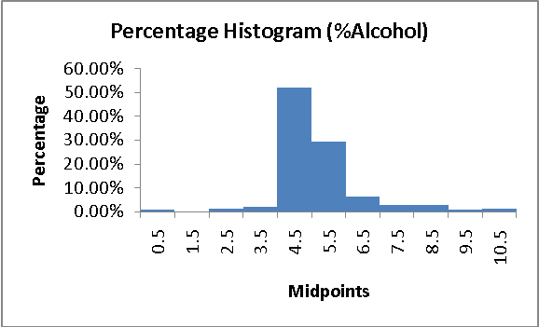
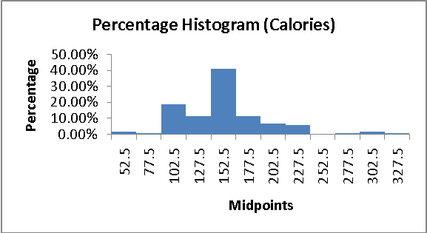
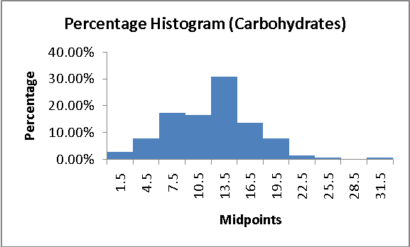
2.86 (b)
cont.
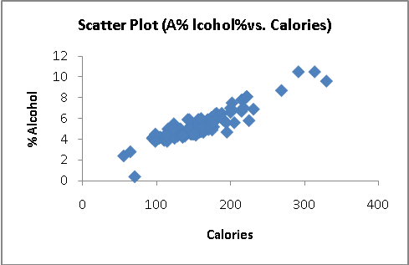

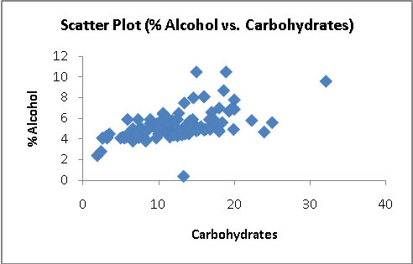
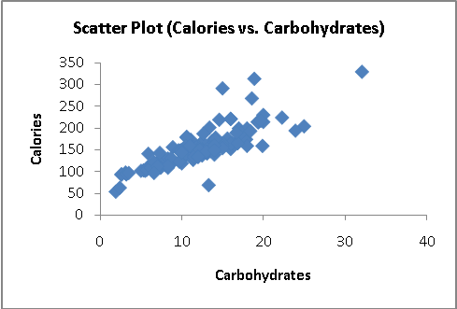
(c) The alcohol % is concentrated between 4 and 6, with more between 4 and 5. The calories are concentrated between 140 and 160. The carbohydrates are concentrated between 12 and 15. There are outliers in the percentage of alcohol in both tails. The outlier in the lower tail is due to the non-alcoholic beer O'Doul's with only a 0.4% alcohol content. There are a few beers with alcohol content as high as around 10.5%. There are a few beers with calories content as high as around 302.5 and carbohydrates as high as 31.5.
There is a strong positive relationship between percentage alcohol and calories, and calories and carbohydrates and a moderately positive relationship between percentage alcohol and carbohydrates.

2.87 (a) Ordered array:
0.070 0.170 0.300 0.360 0.370 0.425 0.440 0.450 0.550 0.570
0.600 0.600 0.620 0.640 0.680 0.695 0.790 0.800 0.840 0.870
0.910 0.980 0.995 1.030 1.150 1.180 1.230 1.250 1.339 1.360
1.410 1.530 1.600 1.600 1.700 1.780 2.000 2.000 2.000 2.000
2.000 2.025 2.240 2.510 2.520 2.600 2.700 2.750 3.000 3.460
(b)
(c) There is a 3.39% difference in the state cigarette tax between the lowest and highest. The distribution of the cigarette tax is somewhat right-skewed with a few states having a cigarette tax as high as around 2.8% to 3.6%. Majority of the states though have cigarette tax concentrated around 0.8%.

2.88 (a) Money market:
 |  |  | Stem-and-Leaf Display
 |  |  | Stem unit: | 0.1
Statistics |  |  | 2 | 0
Sample Size | 25 |  | 3
Mean | 0.9948 |  | 4 | 0
Median | 1 |  | 5 | 0
Std. Deviation | 0.322892 |  | 6 | 5 5
Minimum | 0.2 |  | 7 | 5
Maximum | 1.4 |  | 8 | 5
 |  |  | 9 | 0 5 5 5
 |  |  | 10 | 0 0
 |  |  | 11 | 0 1
 |  |  | 12 | 0 1 5 6 9
 |  |  | 13 | 0 0 5 5
 |  |  | 14 | 0

2.88 (a) 5-year CD
cont.
 |  |  | Stem-and-Leaf Display
 |  |  | Stem unit: | 0.1
Statistics |  |  | 19 | 0
Sample Size | 25 |  | 20
Mean | 2.814 |  | 21
Median | 2.85 |  | 22
Std. Deviation | 0.315053 |  | 23 | 0
Minimum | 1.9 |  | 24 | 0
Maximum | 3.39 |  | 25 | 0 3 8
 |  |  | 26
 |  |  | 27 | 5 5
 |  |  | 28 | 0 0 5 5 5 6
 |  |  | 29 | 0 5 5
 |  |  | 30 | 0 0 0 0 9
 |  |  | 31 | 0
 |  |  | 32 | 5
 |  |  | 33 | 9

(b)
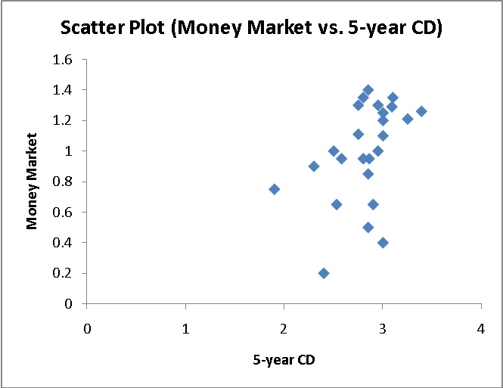

(c) The money market yield is concentrated between 0.95 and 1.35. The five-year CD is concentrated between 2.8 and 3.1. In general, the five-year CD has the higher yield.
There appears to be a positive relationship between the yield of the money market and the five-year CD.

2.89 (a),(c)
bin | Frequency | Percentage | Cumulative % | Midpts
0 but less than 6 | 58 | 29.44% | 29.44% | 3
6 but less than 12 | 82 | 41.62% | 71.07% | 9
12 but less than 18 | 41 | 20.81% | 91.88% | 15
18 but less than 24 | 12 | 6.09% | 97.97% | 21
24 but less than 30 | 1 | 0.51% | 98.48% | 27
30 but less than 36 | 2 | 1.02% | 99.49% | 33
36 but less than 42 | 0 | 0.00% | 99.49% | 39
42 but less than 48 | 0 | 0.00% | 99.49% | 45
48 but less than 54 | 0 | 0.00% | 99.49% | 51
54 but less than 60 | 0 | 0.00% | 99.49% | 57
60 but less than 66 | 0 | 0.00% | 99.49% | 63
66 but less than 72 | 0 | 0.00% | 99.49% | 69
72 but less than 78 | 0 | 0.00% | 99.49% | 75
78 but less than 84 | 0 | 0.00% | 99.49% | 81
84 but less than 90 | 1 | 0.51% | 100.00% | 87
(b)
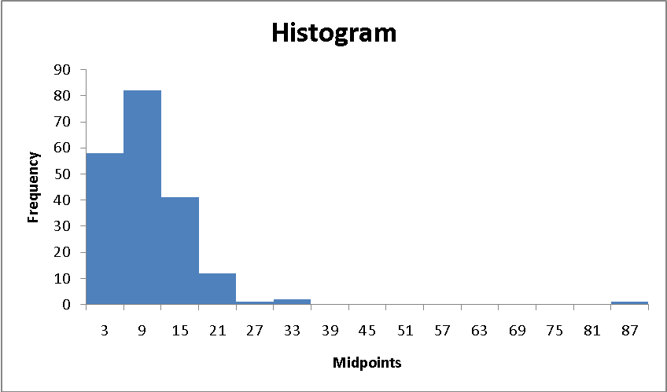
2.89 (b)
cont.
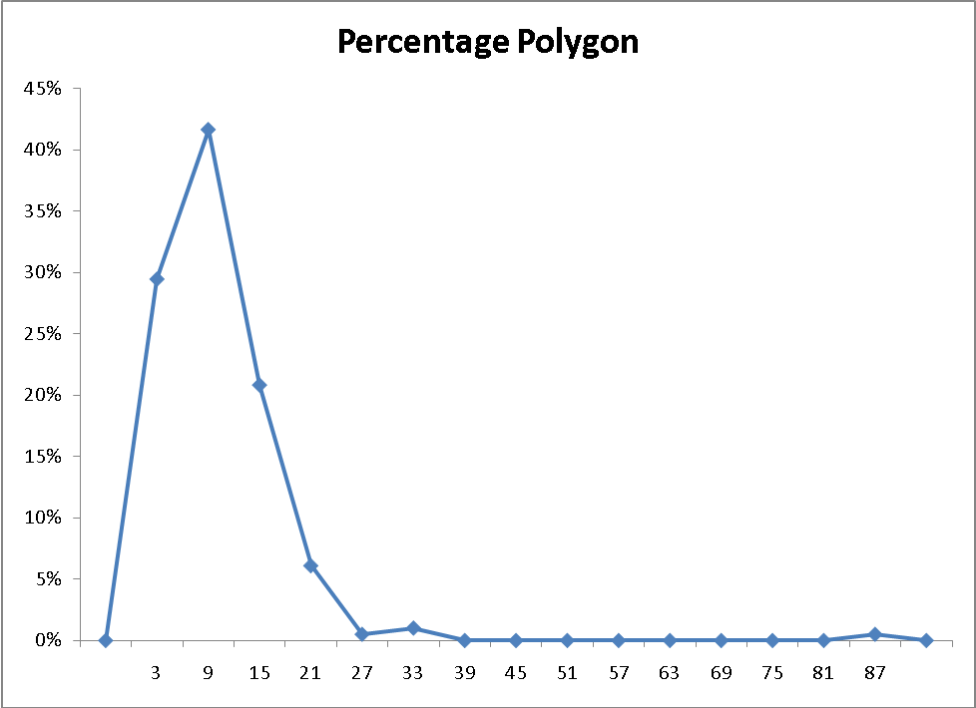
(c)
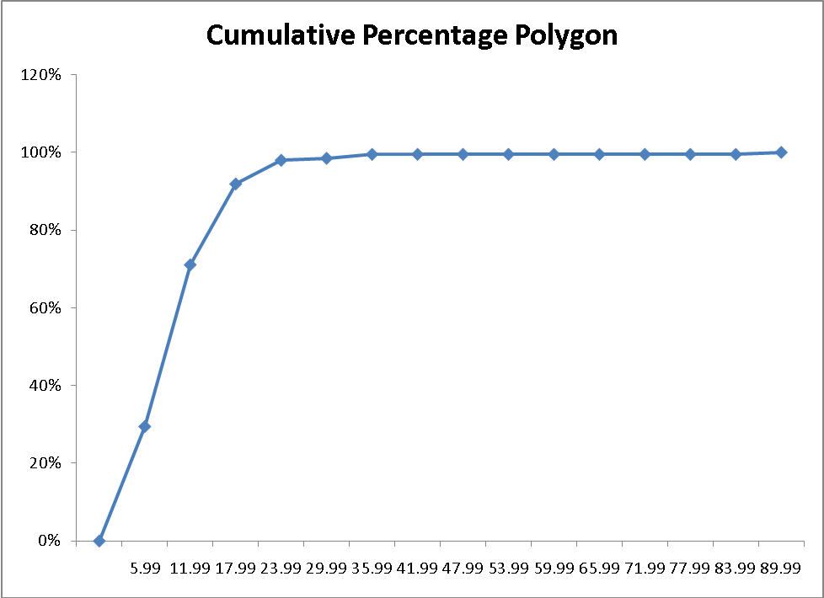
(d) CEO compensation in 2009 is extremely right skewed. More than 90% of the CEOs have compensation lower than $18,000,000. On the other end, 0.51% of the CEOs have compensation higher than $84,000,000.
2.89 (e)
cont.
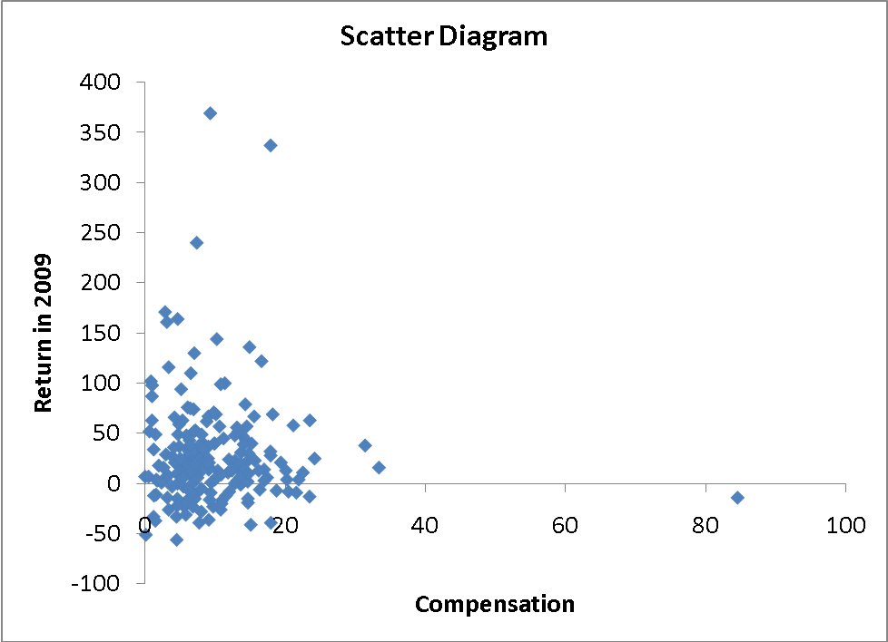
(f) There is not any obvious relationship between the total compensation and investment return in 2009.

2.90 (a)
Frequencies (Boston)
Weight (Boston) | Frequency | Percentage
3015 but less than 3050 | 2 | 0.54%
3050 but less than 3085 | 44 | 11.96%
3085 but less than 3120 | 122 | 33.15%
3120 but less than 3155 | 131 | 35.60%
3155 but less than 3190 | 58 | 15.76%
3190 but less than 3225 | 7 | 1.90%
3225 but less than 3260 | 3 | 0.82%
3260 but less than 3295 | 1 | 0.27%
(b)
Frequencies (Vermont)
Weight (Vermont) | Frequency | Percentage
3550 but less than 3600 | 4 | 1.21%
3600 but less than 3650 | 31 | 9.39%
3650 but less than 3700 | 115 | 34.85%
3700 but less than 3750 | 131 | 39.70%
3750 but less than 3800 | 36 | 10.91%
3800 but less than 3850 | 12 | 3.64%
3850 but less than 3900 | 1 | 0.30%

2.90 (c)
cont.
(d) 0.54% of the “Boston” shingles pallets are underweight while 0.27% are overweight.
1.21% of the “Vermont” shingles pallets are underweight while 3.94% are overweight.

2.91 (a),(c) Two-star:
bin | Frequency | Percentage | Cumulative % | Midpts
20 but less than 30 | 3 | 6.38% | 6.38% | 25
30 but less than 40 | 6 | 12.77% | 19.15% | 35
40 but less than 50 | 3 | 6.38% | 25.53% | 45
50 but less than 60 | 8 | 17.02% | 42.55% | 55
60 but less than 70 | 15 | 31.91% | 74.47% | 65
70 but less than 80 | 5 | 10.64% | 85.11% | 75
80 but less than 90 | 4 | 8.51% | 93.62% | 85
90 but less than 100 | 1 | 2.13% | 95.74% | 95
100 but less than 110 | 0 | 0.00% | 95.74% | 105
110 but less than 120 | 1 | 2.13% | 97.87% | 115
120 but less than 130 | 0 | 0.00% | 97.87% | 125
130 but less than 140 | 1 | 2.13% | 100.00% | 135
Three-star:
bin | Frequency | Percentage | Cumulative % | Midpts
30 but less than 40 | 2 | 4.26% | 4.26% | 35
40 but less than 50 | 4 | 8.51% | 12.77% | 45
50 but less than 60 | 4 | 8.51% | 21.28% | 55
60 but less than 70 | 7 | 14.89% | 36.17% | 65
70 but less than 80 | 5 | 10.64% | 46.81% | 75
80 but less than 90 | 11 | 23.40% | 70.21% | 85
90 but less than 100 | 5 | 10.64% | 80.85% | 95
100 but less than 110 | 5 | 10.64% | 91.49% | 105
110 but less than 120 | 2 | 4.26% | 95.74% | 115
120 but less than 130 | 1 | 2.13% | 97.87% | 125
130 but less than 140 | 0 | 0.00% | 97.87% | 135
140 but less than 150 | 1 | 2.13% | 100.00% | 145

2.91 (a),(c) Four-star:
cont.
bin | Frequency | Percentage | Cumulative % | Midpts
60 but less than 70 | 3 | 6.38% | 6.38% | 65
70 but less than 80 | 4 | 8.51% | 14.89% | 75
80 but less than 90 | 5 | 10.64% | 25.53% | 85
90 but less than 100 | 9 | 19.15% | 44.68% | 95
100 but less than 110 | 6 | 12.77% | 57.45% | 105
110 but less than 120 | 7 | 14.89% | 72.34% | 115
120 but less than 130 | 1 | 2.13% | 74.47% | 125
130 but less than 140 | 1 | 2.13% | 76.60% | 135
140 but less than 150 | 5 | 10.64% | 87.23% | 145
150 but less than 160 | 2 | 4.26% | 91.49% | 155
160 but less than 170 | 2 | 4.26% | 95.74% | 165
170 but less than 180 | 1 | 2.13% | 97.87% | 175
180 but less than 190 | 0 | 0.00% | 97.87% | 185
190 but less than 200 | 0 | 0.00% | 97.87% | 195
200 but less than 210 | 1 | 2.13% | 100.00% | 205

(b) Two-star:
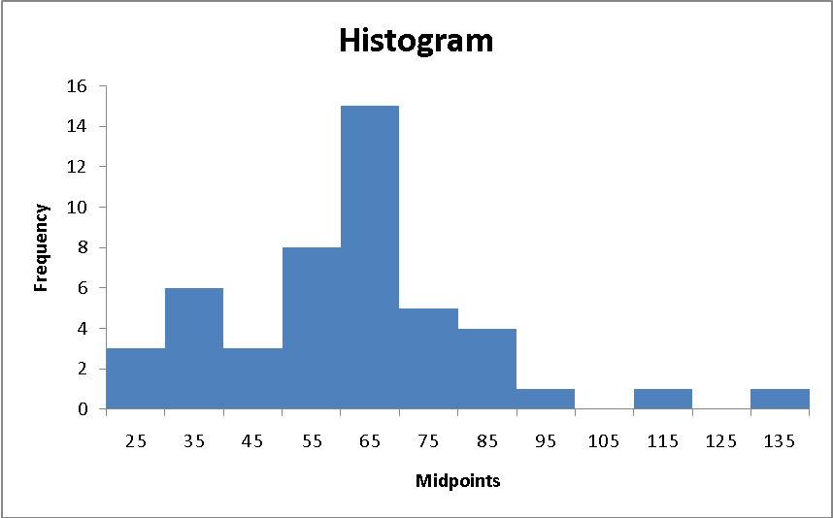
2.91 (b)
cont.
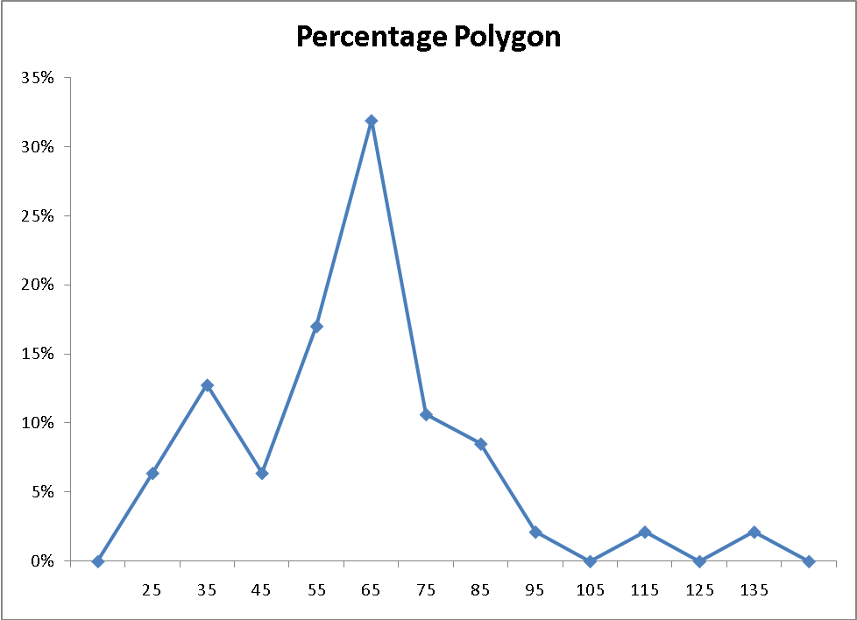

Three-star:
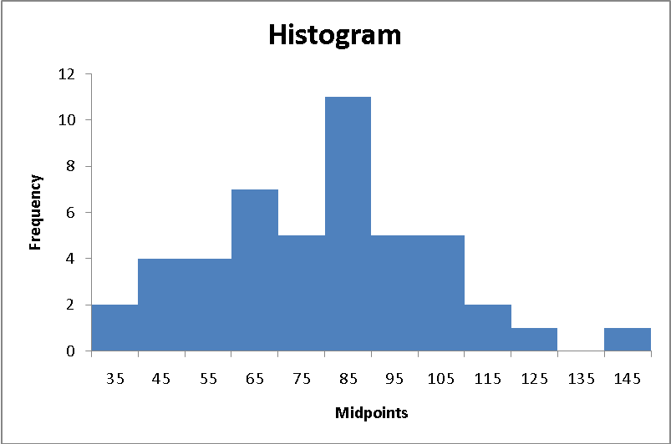
2.91 (b)
cont.

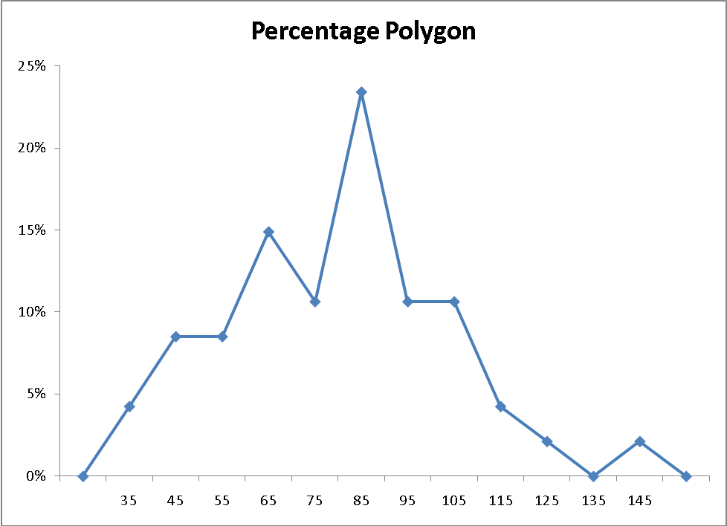

Four-star:
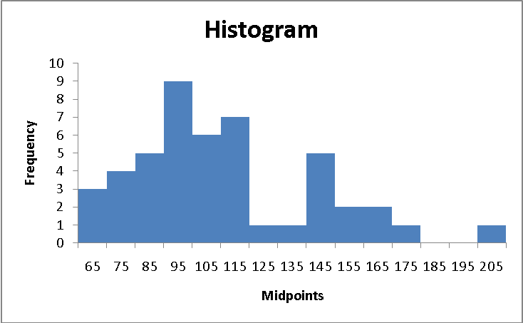
2.91 (b)
cont.

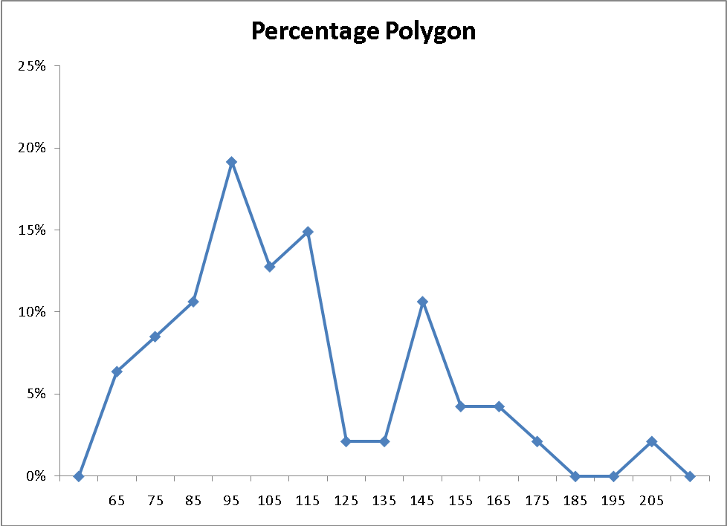

(c) Two-star:
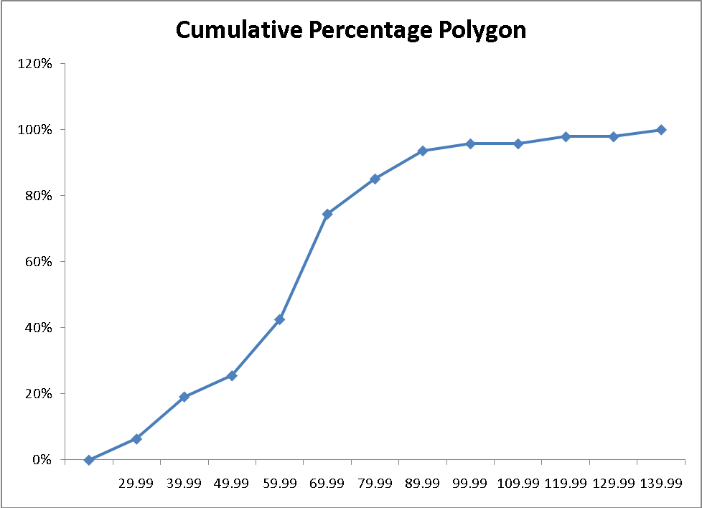
2.91 (c)
cont.
Three-star:
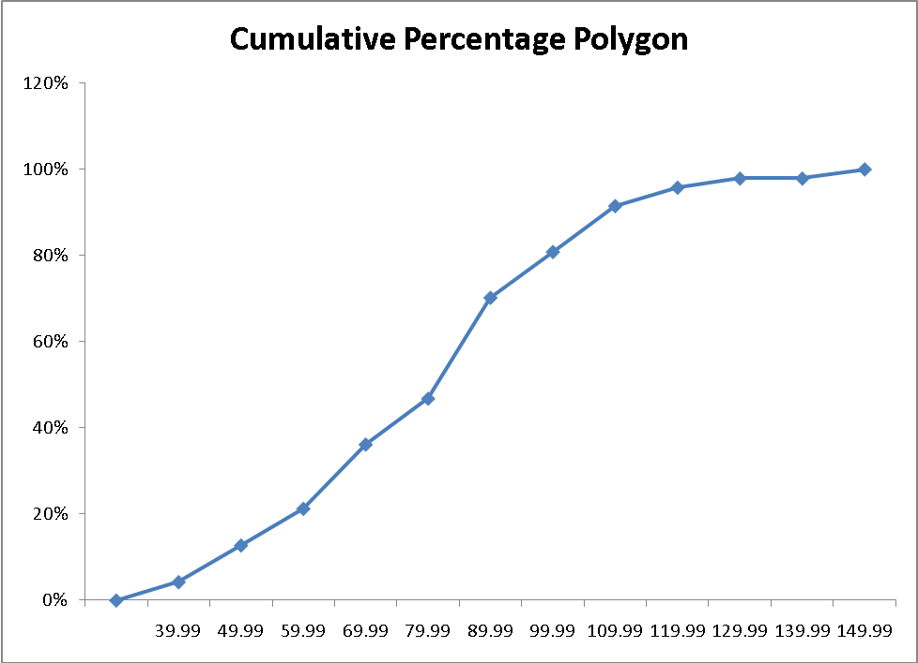
Four-star:
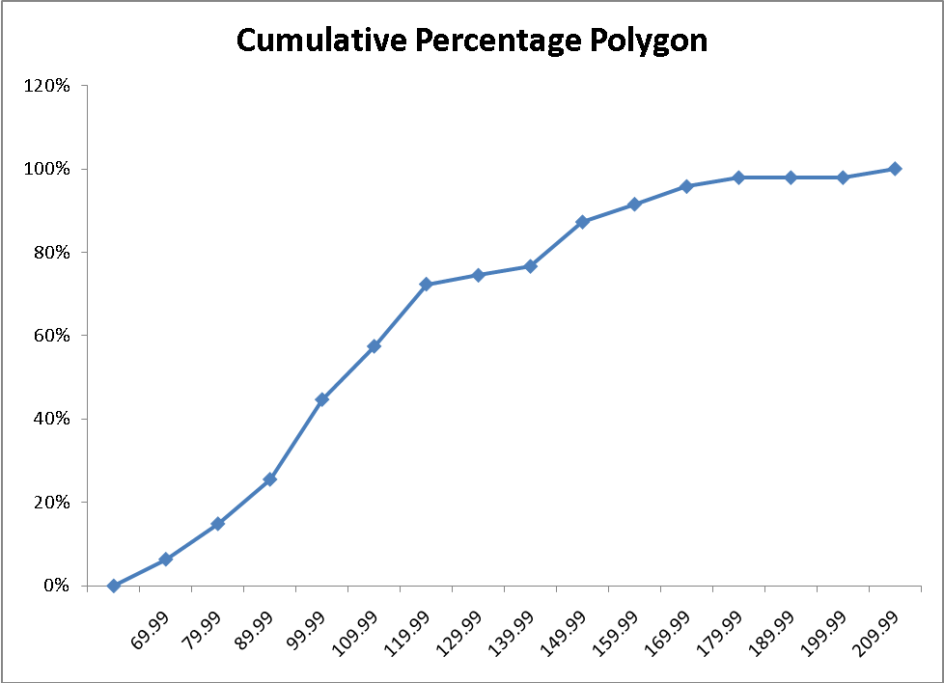
(d) The price of two-star, three-star and four-star hotels are all right-skewed. The median price of two-star , three-star and four-star hotels is around 62, 82, and 102 English pounds, respectively.
2.91 (e)
cont.
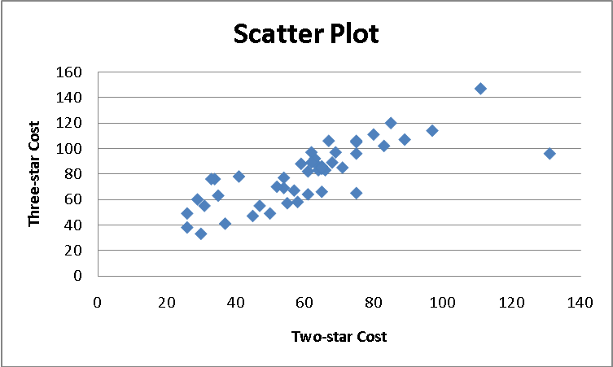
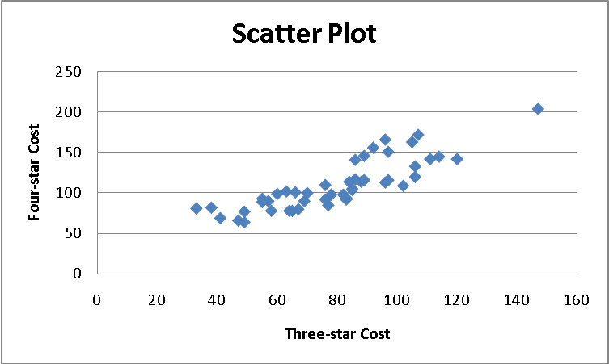
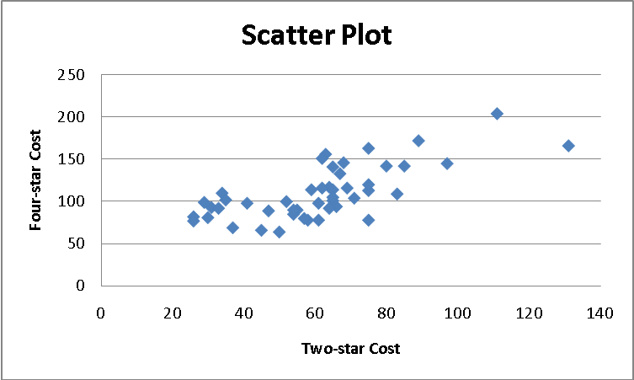
(f) The relationship of the price between two-star and three-star, three-star and four-star, and two-star and four-star hotels are all positve.

2.92 (a)
Calories | Frequency | Percentage | Percentage Less Than
50 up to 100 | 3 | 12% | 12%
100 up to 150 | 3 | 12 | 24
150 up to 200 | 9 | 36 | 60
200 up to 250 | 6 | 24 | 84
250 up to 300 | 3 | 12 | 96
300 up to 350 | 0 | 0 | 96
350 up to 400 | 1 | 4 | 100
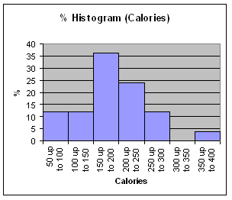
(b)
Cholesterol | Frequency | Percentage | Percentage Less Than
0 up to 50 | 2 | 8 | 8%
50 up to 100 | 17 | 68 | 76
100 up to 150 | 4 | 16 | 92
150 up to 200 | 1 | 4 | 96
200 up to 250 | 0 | 0 | 96
250 up to 300 | 0 | 0 | 96
300 up to 350 | 0 | 0 | 96
350 up to 400 | 0 | 0 | 96
400 up to 450 | 0 | 0 | 96
450 up to 500 | 1 | 4 | 100

2.92 (b)
cont.
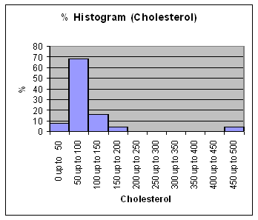
(c) The sampled fresh red meats, poultry, and fish vary from 98 to 397 calories per serving, with the highest concentration between 150 to 200 calories. One protein source, spareribs, with 397 calories, is more than 100 calories above the next highest caloric food. The protein content of the sampled foods varies from 16 to 33 grams, with 68% of the data values falling between 24 and 32 grams. Spareribs and fried liver are both very different from other foods sampled—the former on calories and the latter on cholesterol content.

2.93 (a)
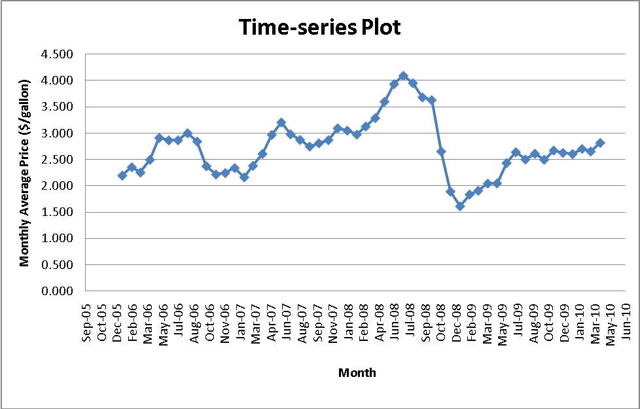
(b) The average price of gasoline in the United States is higher in the summer in general and seems to peak in June.

2.94 (a)
(b) There is a downward trend in the amount filled.
(c) The amount filled in the next bottle will most likely be below 1.894 liter.
(d) The scatter plot of the amount of soft drink filled against time reveals the trend of the data, whereas a histogram only provides information on the distribution of the data.

2.95 (a)
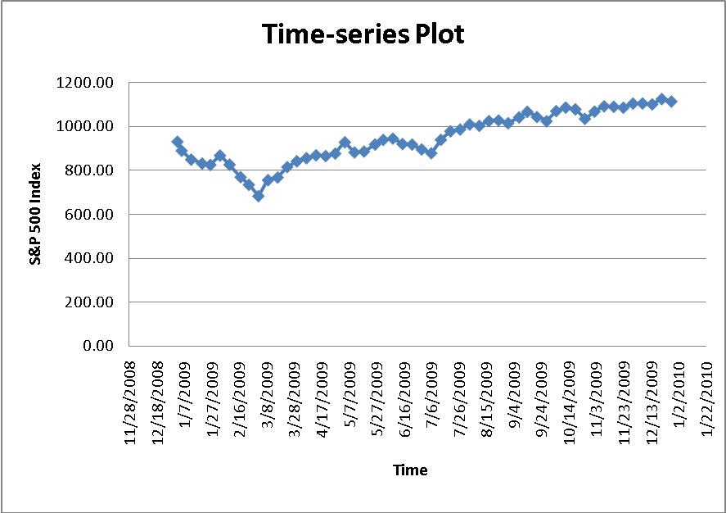
2.95 (a)
cont.
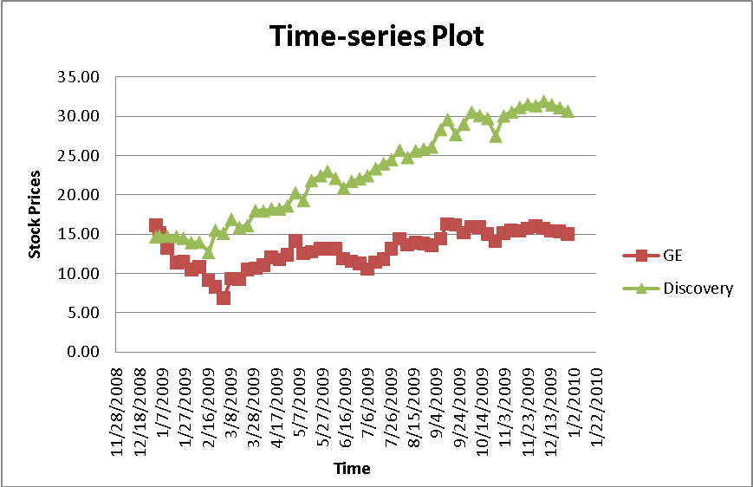
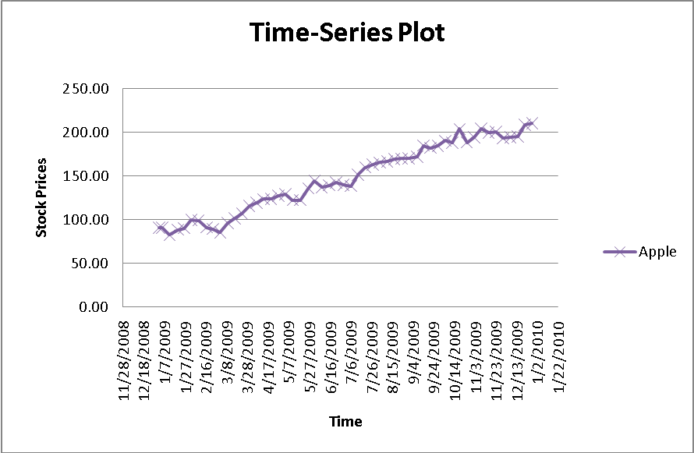
(b) Even though there appeared to be cyclical pattern in the S&P index, there was a general upward trend with a big drop that took place for the week of 3/2/2009. The stock price of Apple fluctuated between $120 and $210 with a general upward trend. The stock price of GE trended downward from about $15 during the week of 1/2/2009 to about $6 during the week of 3/2/2009 but turned around and trended upward back to about $15 during the week of 12/28/2009. Discovery’s stock price trended upward from about $15 to about $30.

2.100 (a) Expense Ratio
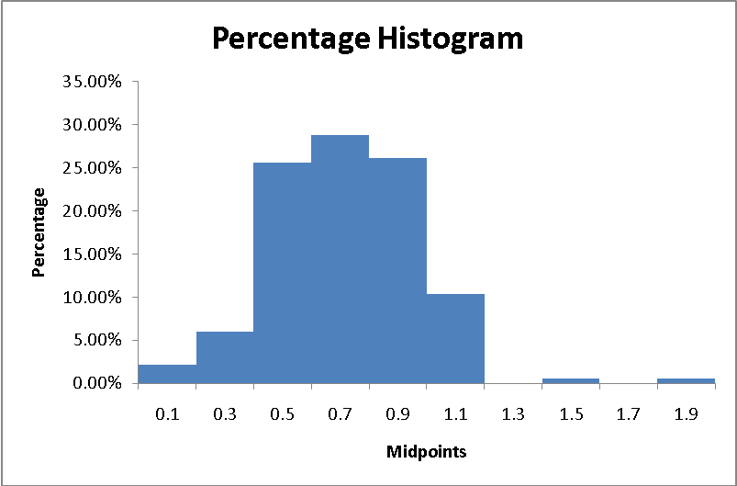
(b)
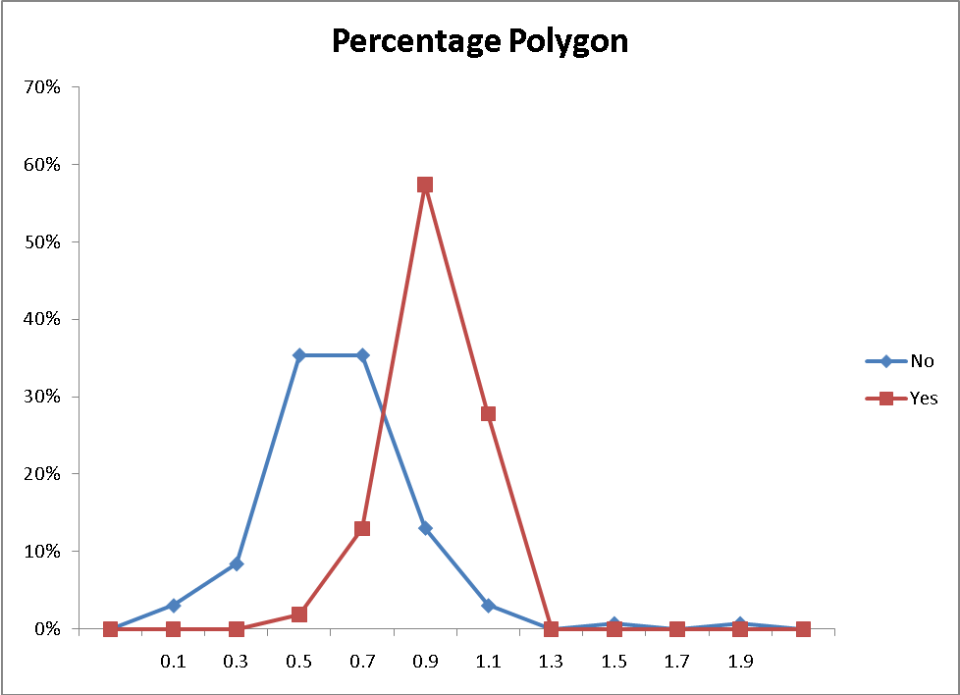
(c) The expense ratio of all bond funds is scattered around 0.75. Bond funds with fees have expense ratios scattered around 0.9 while bond funds without fees have expense ratios scattered around 0.6.

2.101 (a) Three-year Annualized Return
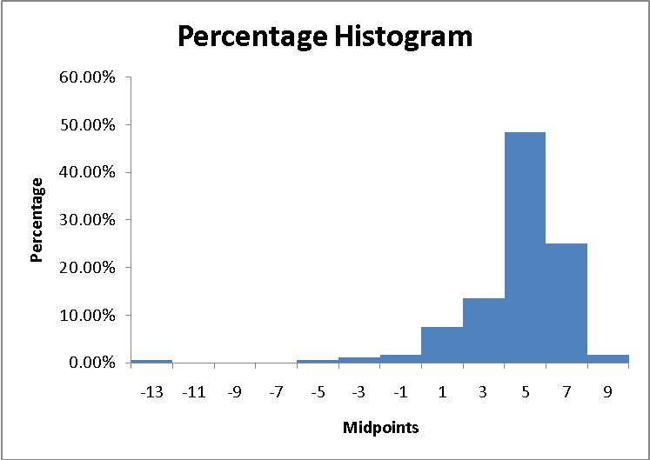
(b)
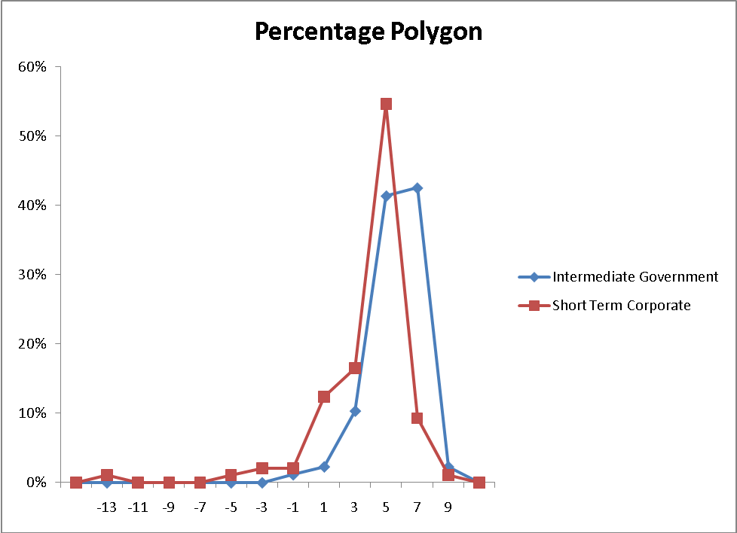
(c) The three-year annualized return of all the bond funds is left-skewed with majority of them (about 87%) scattered between 2% and 8%. About 3.8% of the bond funds have a negative three-year annualized return while about 1.6% of them have a return higher than 8%. In general, the intermediate government funds have higher three-year annualized returns than short term corporate funds. Both types of bond funds have three-year annualized returns skewed to the left.

2.102 (a) Five-year Annualized Return

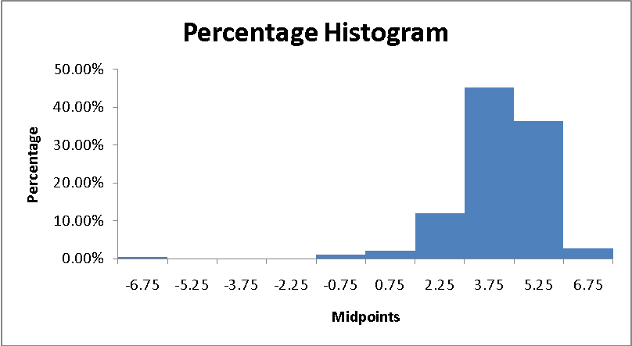
(b)
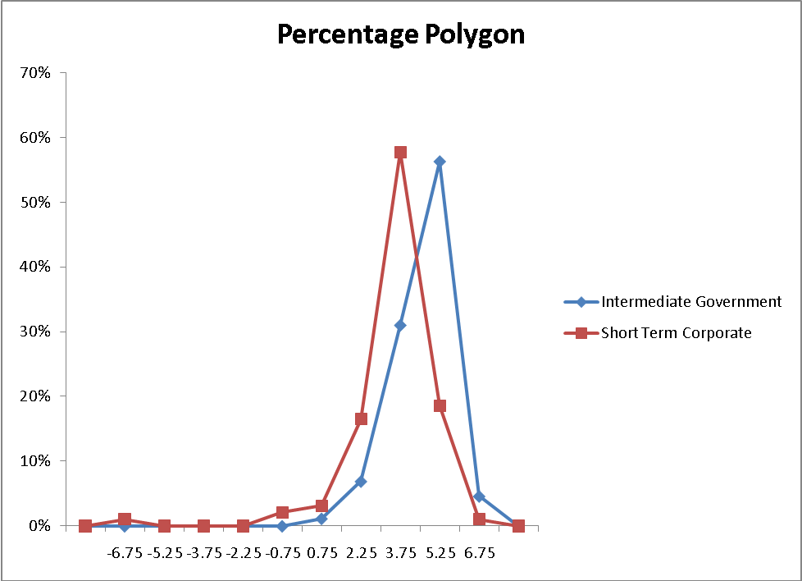
(c) The five-year annualized return of all the bond funds is left-skewed with majority of them (about 93%) scattered between 1.5% and 6%. About 1.6% of the bond funds have a negative five-year annualized return while about 2.7% of them have a return higher than 6%. In general, the intermediate government funds have higher five-year annualized returns than short term corporate funds. Both types of mutual funds have five-year annualized returns skewed to the left.

2.103
Gender:
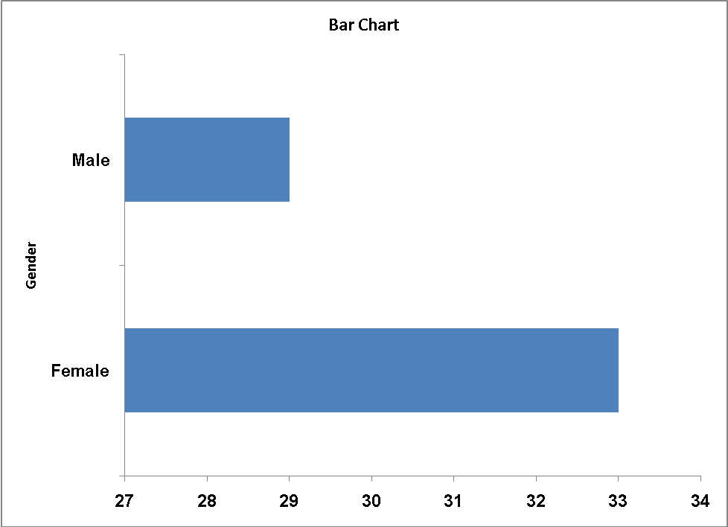

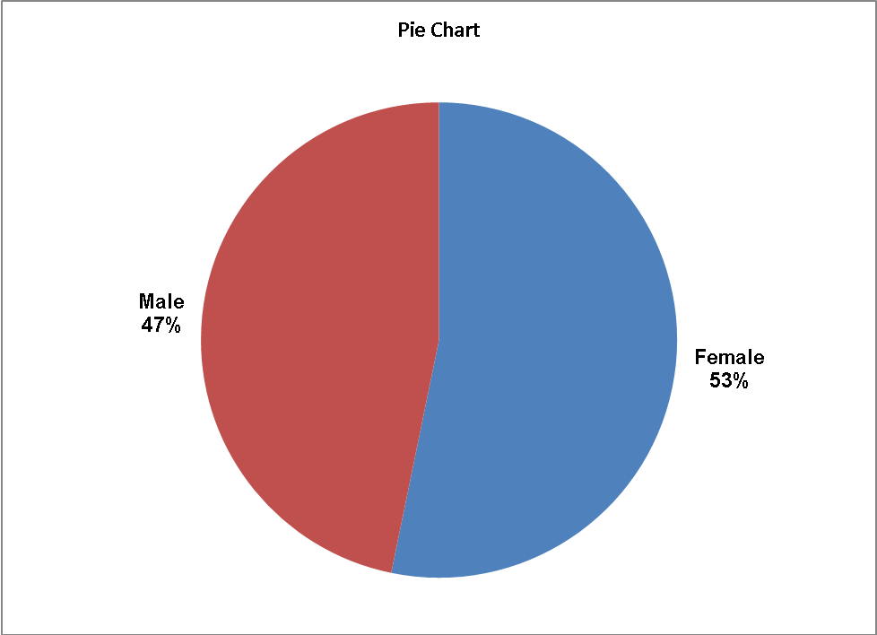
There are more females than males in the survey.
2.103 Class:
cont.

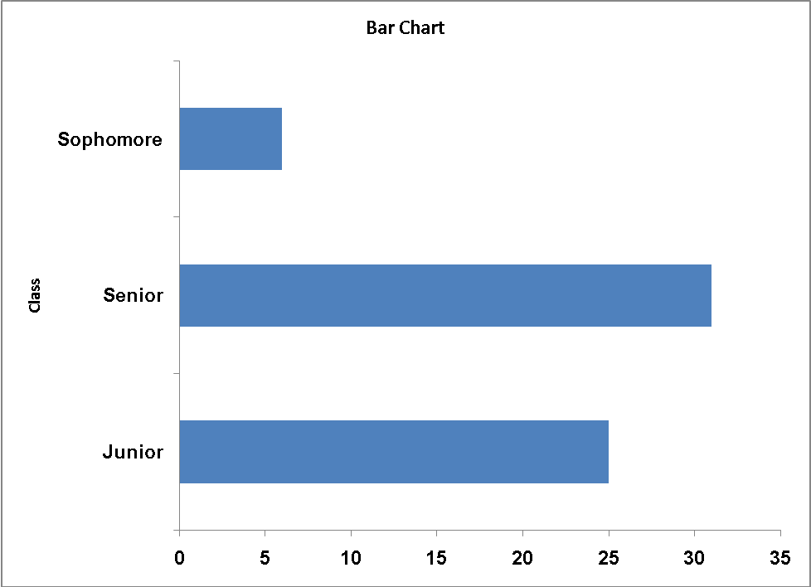
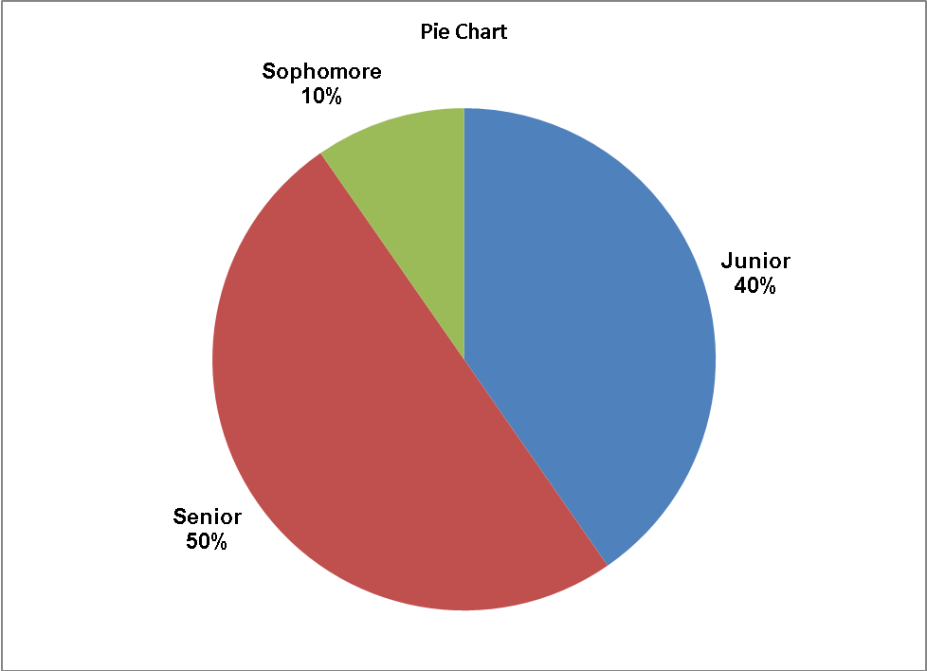
2.103
cont.

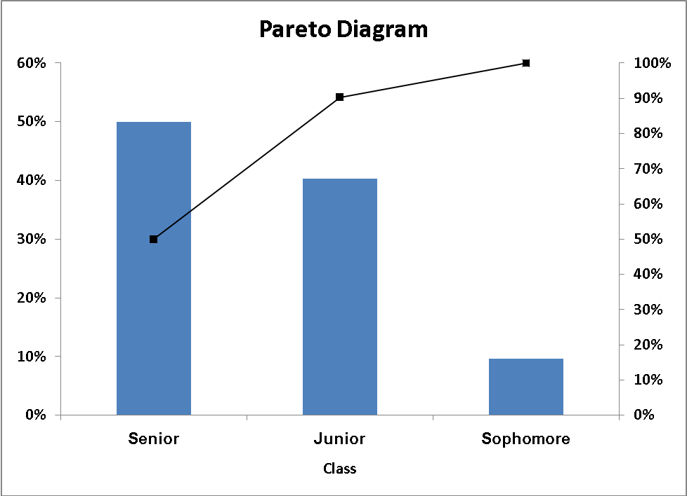
There are more senior and junior students than sophomore.
Major:
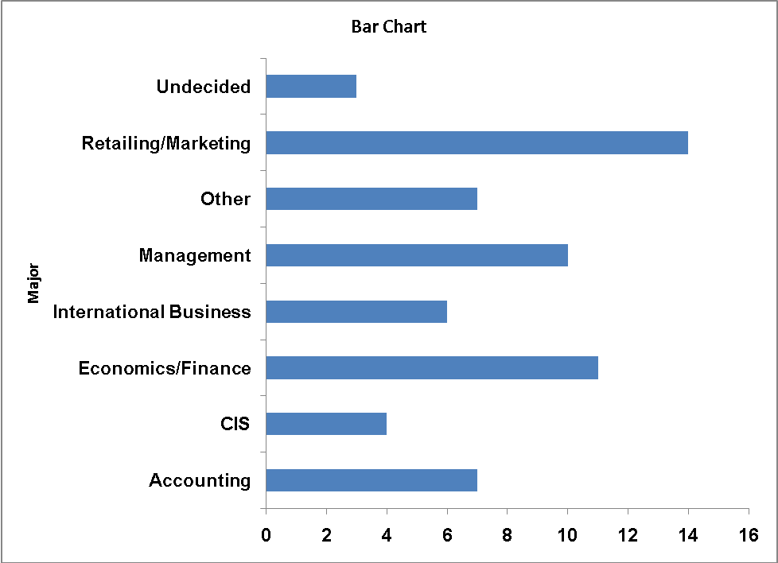
2.103
cont.

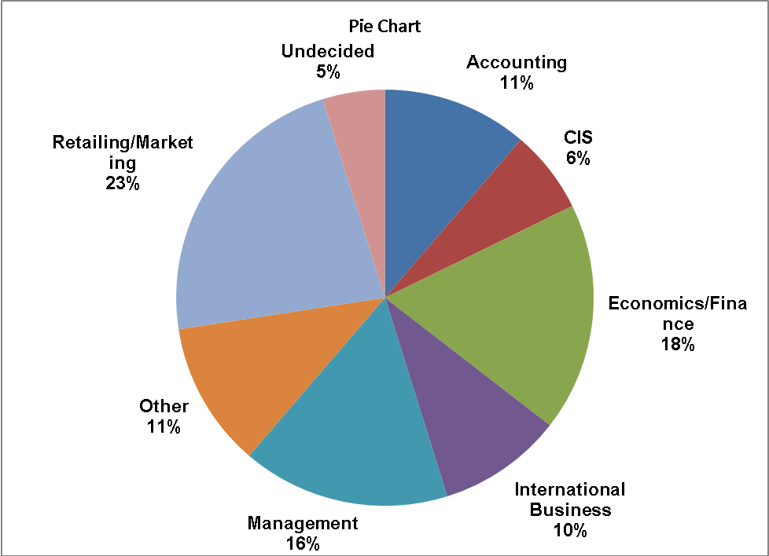
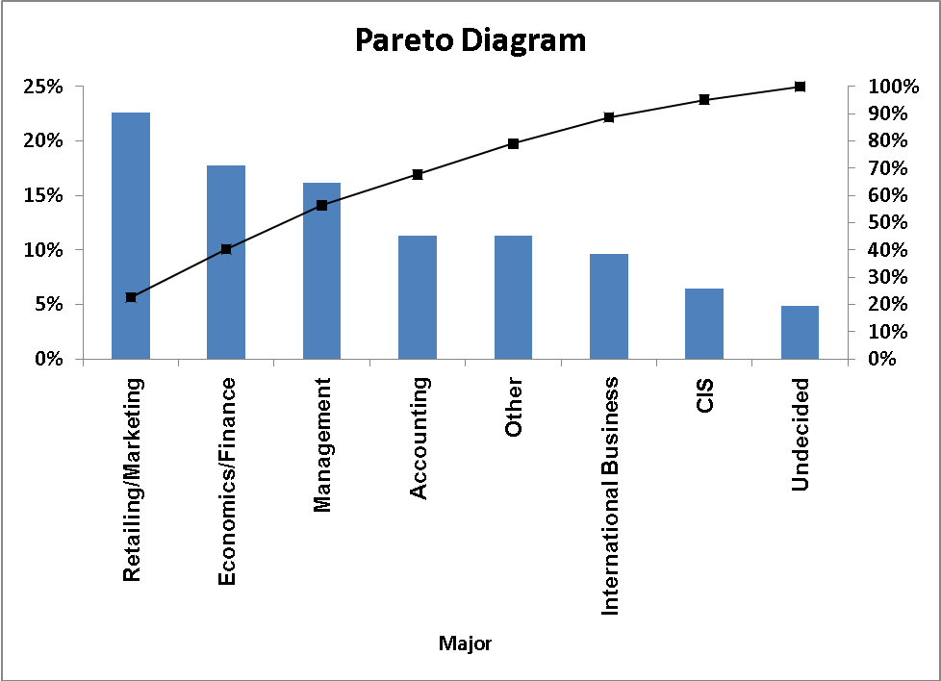
Retailing/marketing, economics/finance and management constituted the
“vital few” while the rest of the majors make up the “trivial many”.
2.103
cont. Grad Intention:
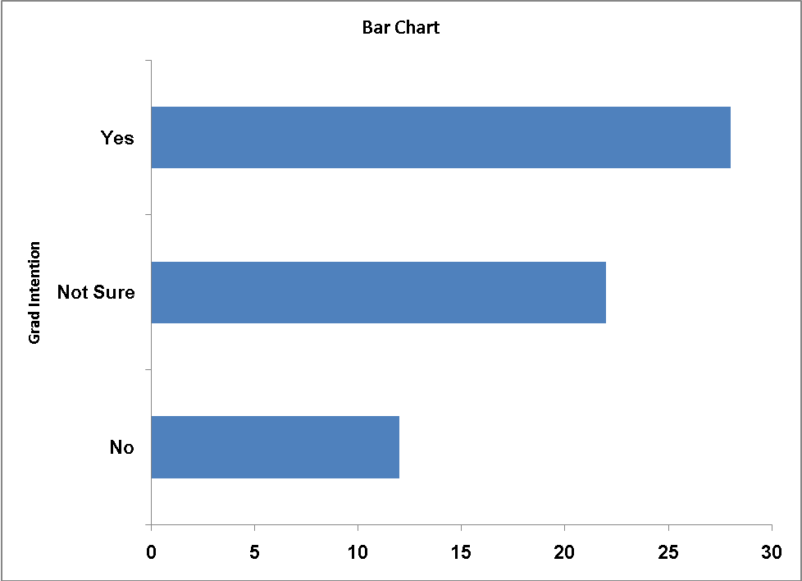
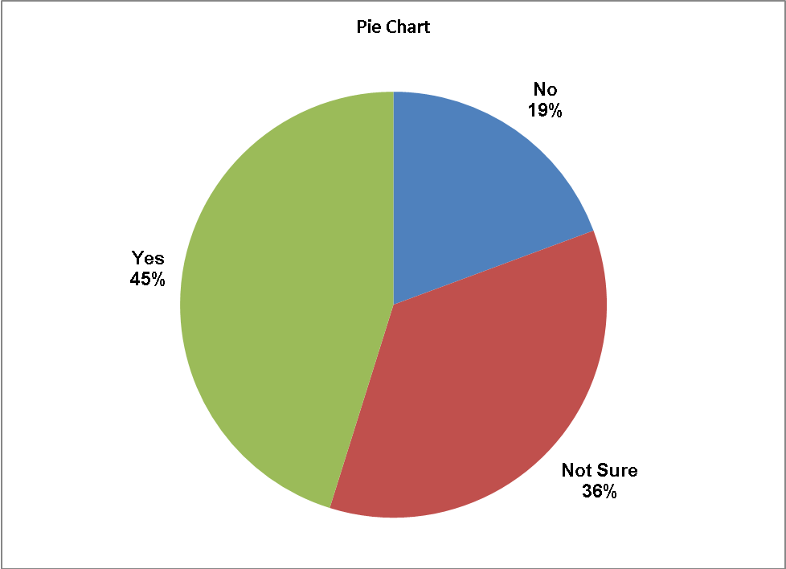
2.103
cont.

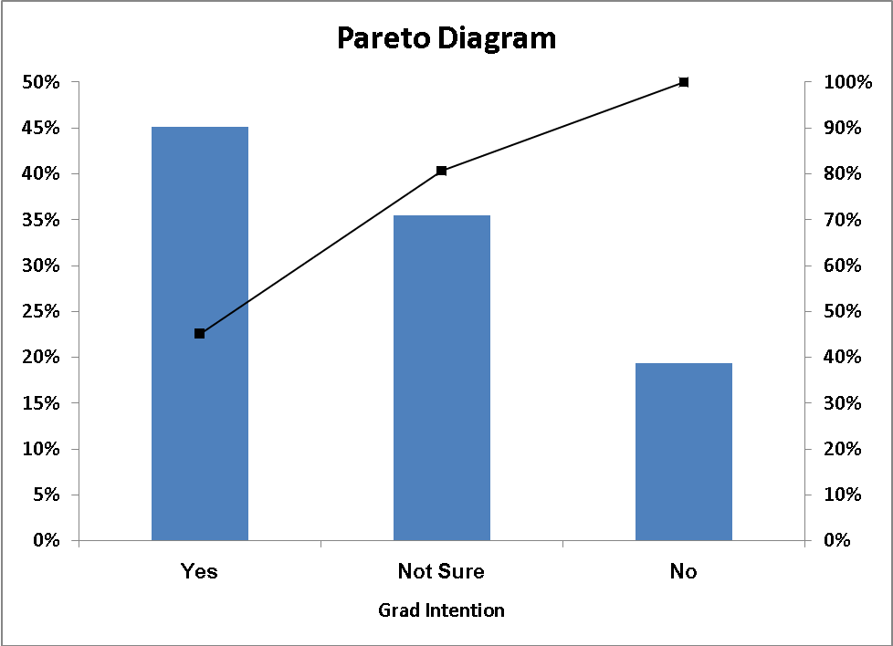
There are more students with a grad intention than either of the other categories.
Employment:
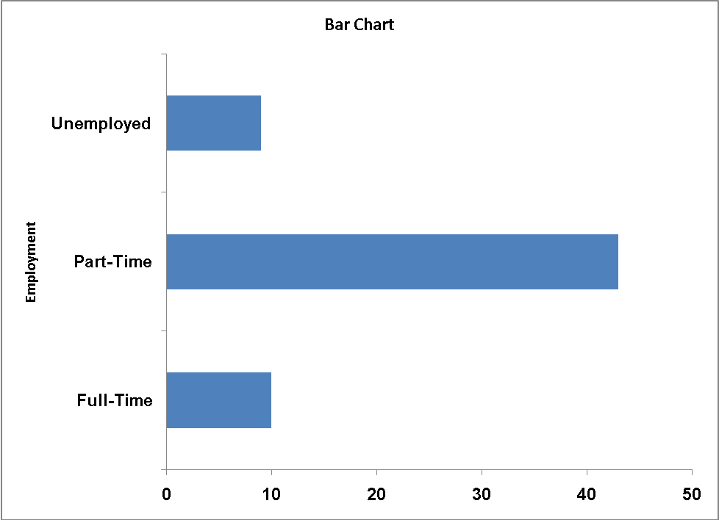
2.103
cont.

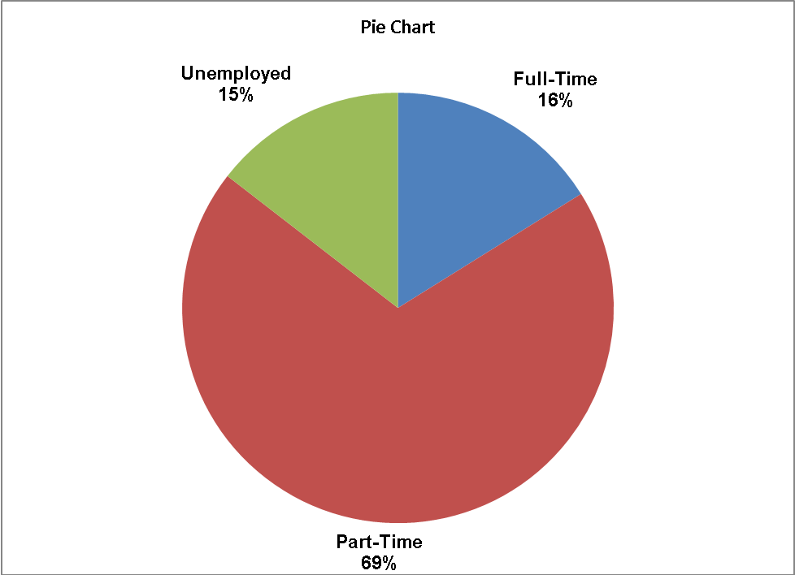

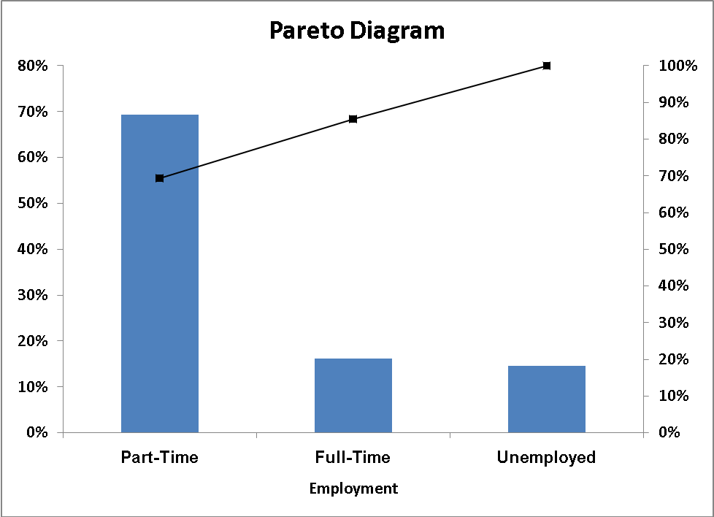
Most of the students have part-time employment.
2.103
cont. Computer:
2.103
cont.
Nearly 90% of the students use laptops.

Age:
Majority of the students surveyed are between 20 and 22 year old.

Social Networking:
Majority of the students are registered at between 1 and 2 social networking sites.
2.103
cont.
Satisfaction:
Majority of the satisfaction ratings fall between 3.0 and 5.0.

Text Messages:
Majority of the students sent less than 400 messages in a typical week.

2.103 Spending:
cont.
Majority of the students spend between $200 and $700 for textbooks and supplies.

GPA:
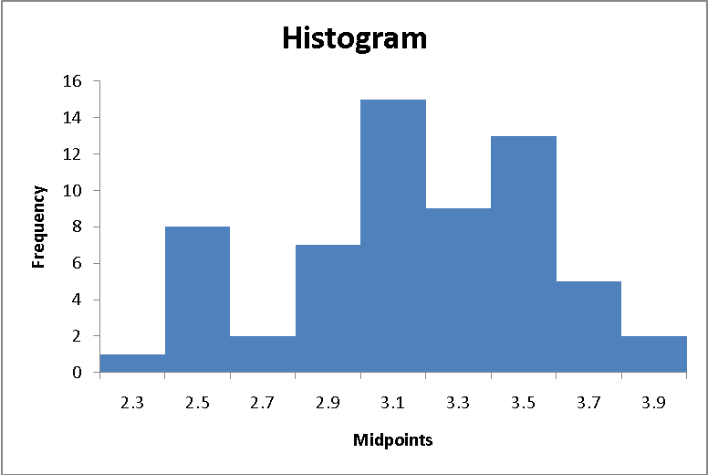
2.103
cont.
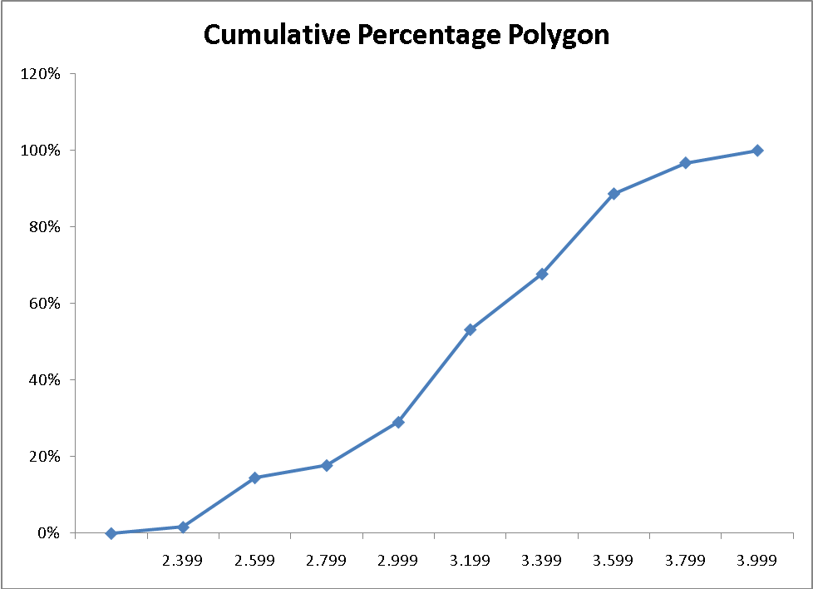
GPA is slightly left-skewed.

Expected Salary:
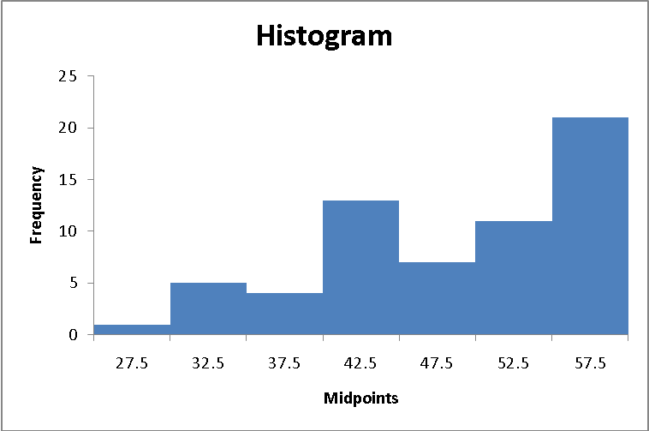
2.103
cont.
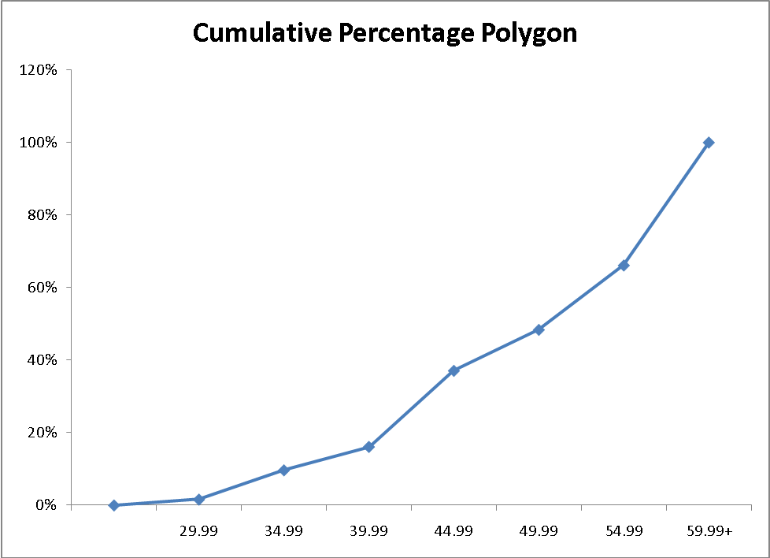
Expected salary is left-skewed.

Wealth:
2.103
cont.
Wealth is right-skewed.
2.105
Gender:
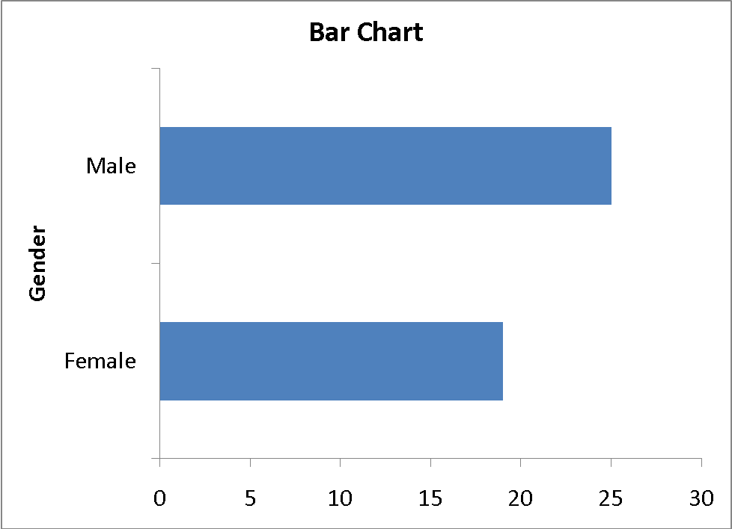
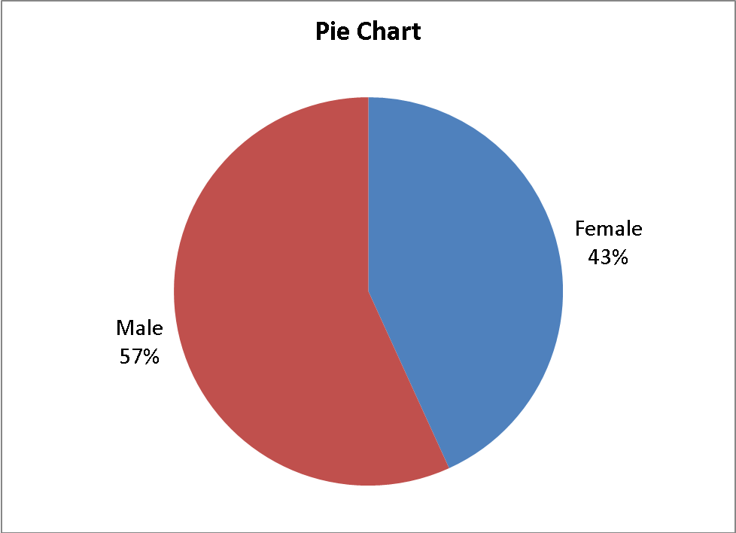
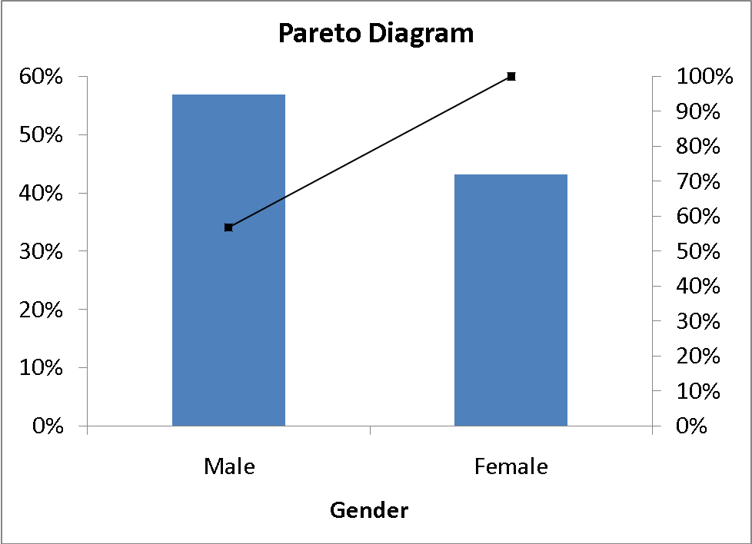
There are more males than females in the survey.

2.105
cont.
Graduate Major:
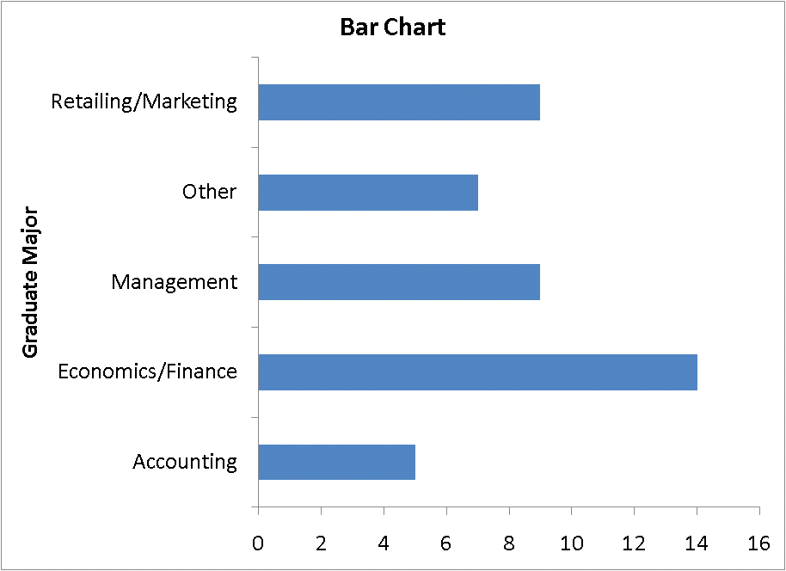
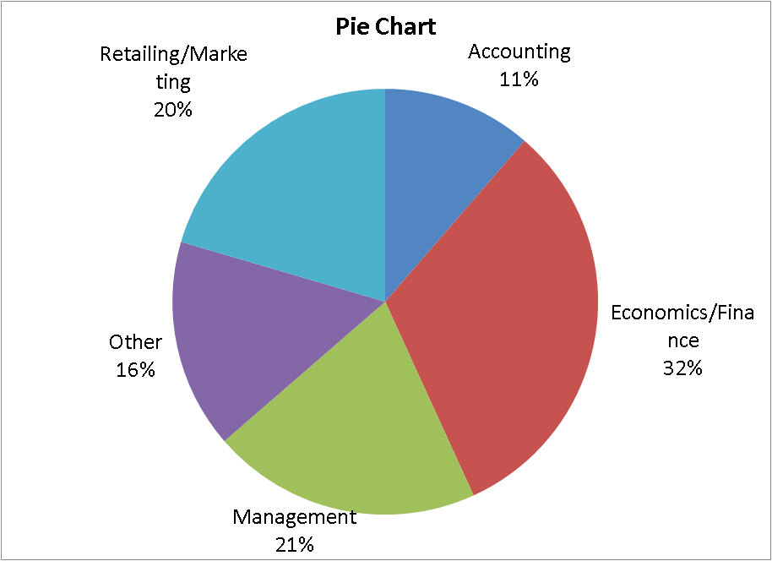
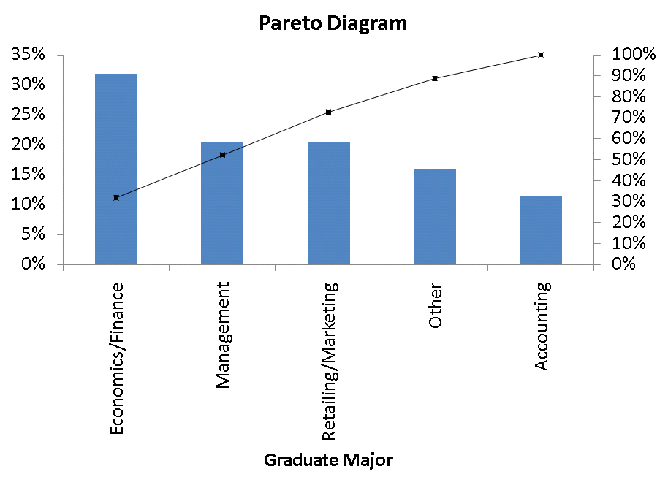

The “vital few” of economics/finance, management, and marketing/retailing account for more than 70% of the graduate majors.

2. 105
cont. Undergraduate Major:
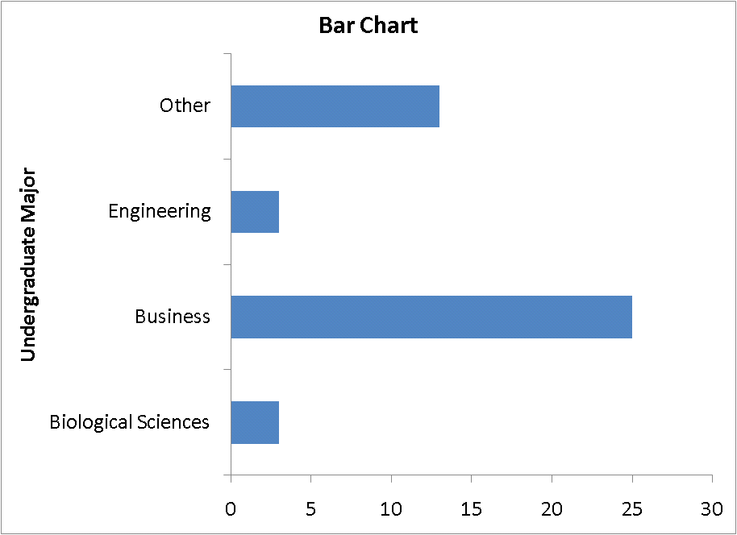
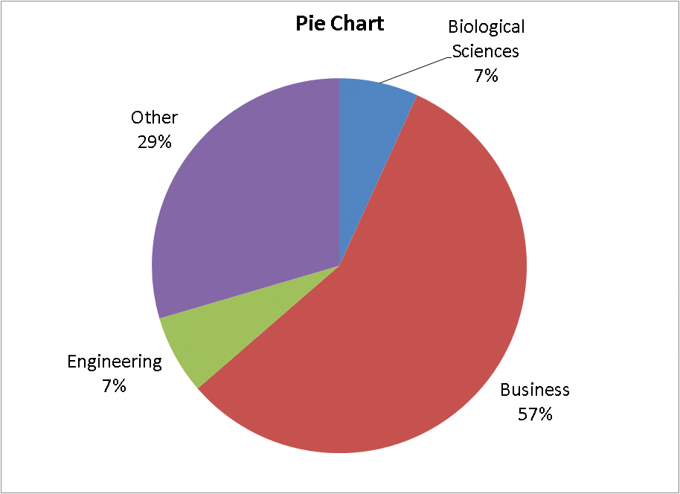
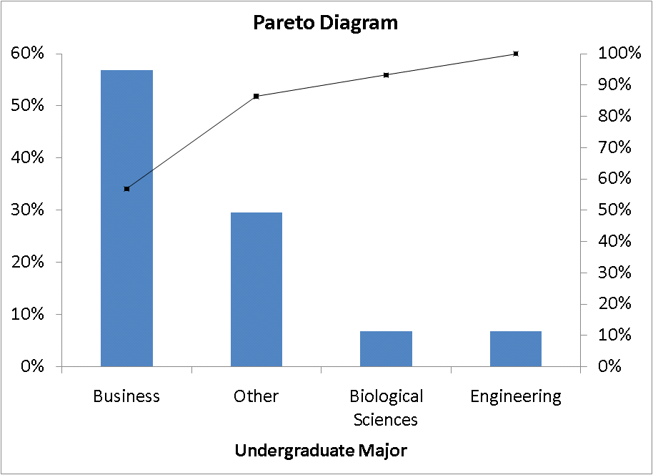
The “vital few” of business administration and other account for more than 80% of the undergraduate majors.
2.105
cont. Employment Status:
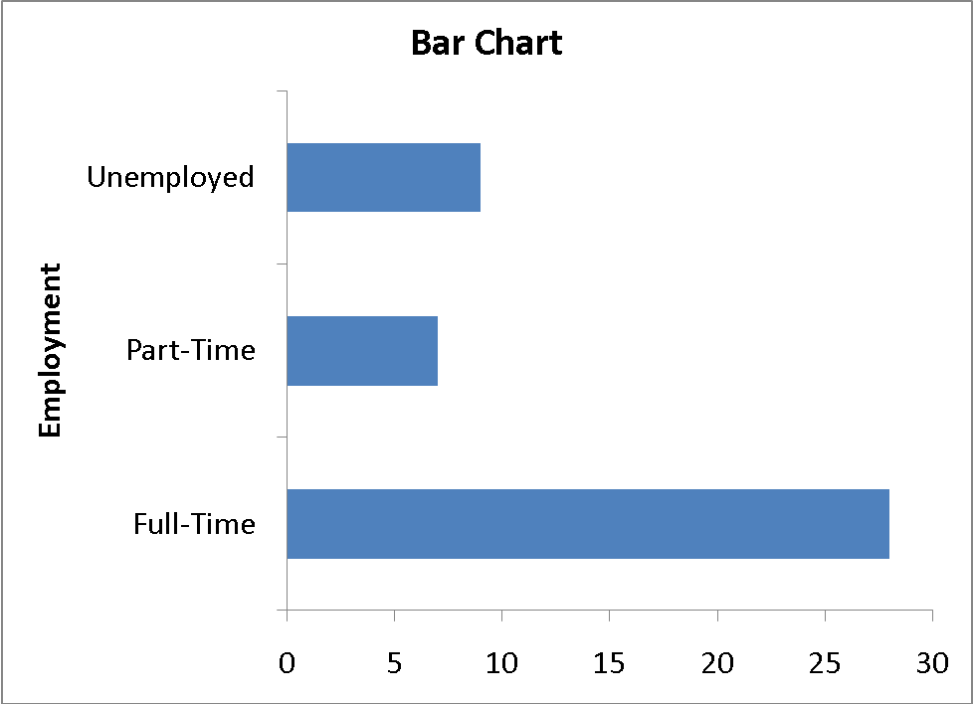
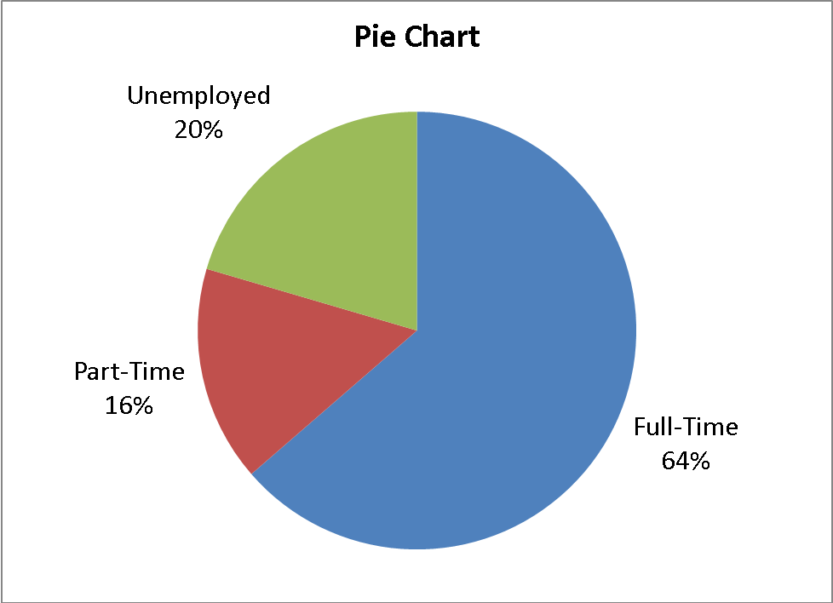
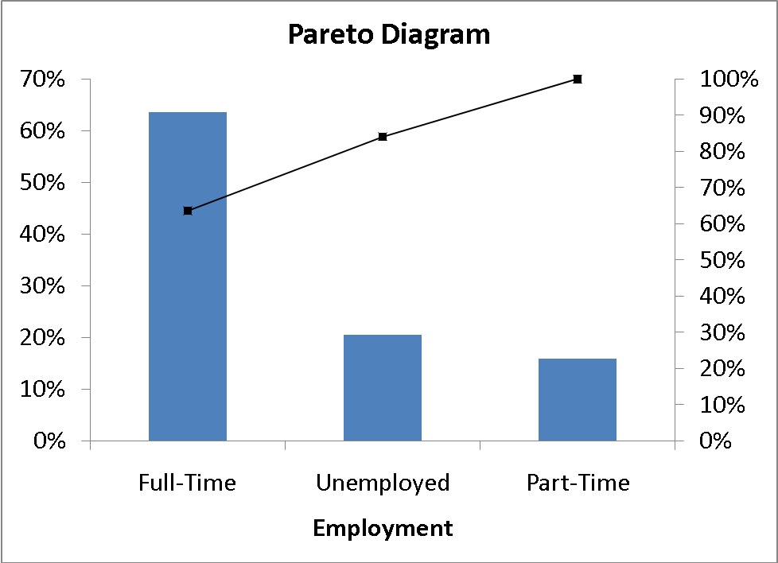

“Full-time” employment status accounts for more than 60% of the students.

2.105
cont.
. Computers:
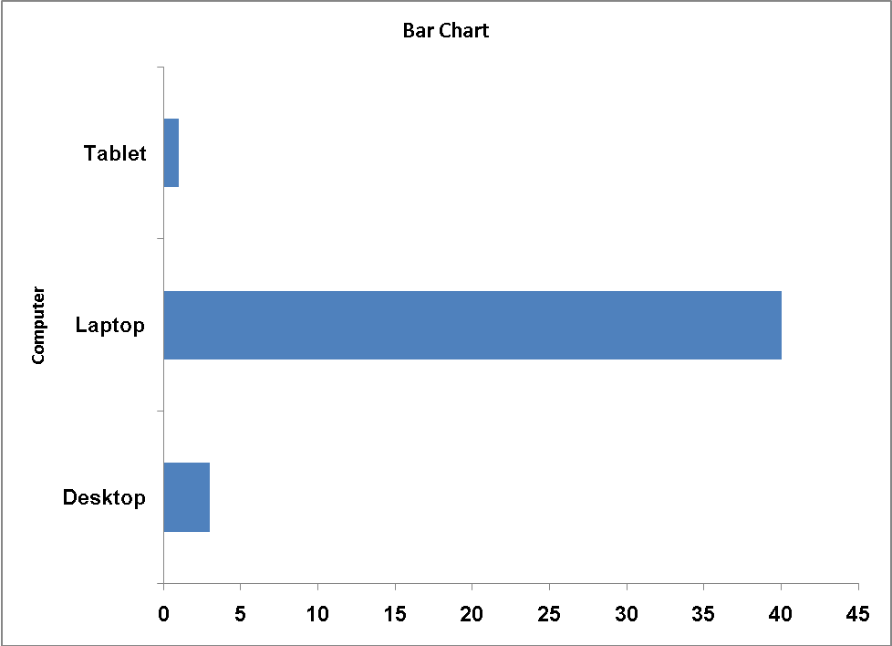
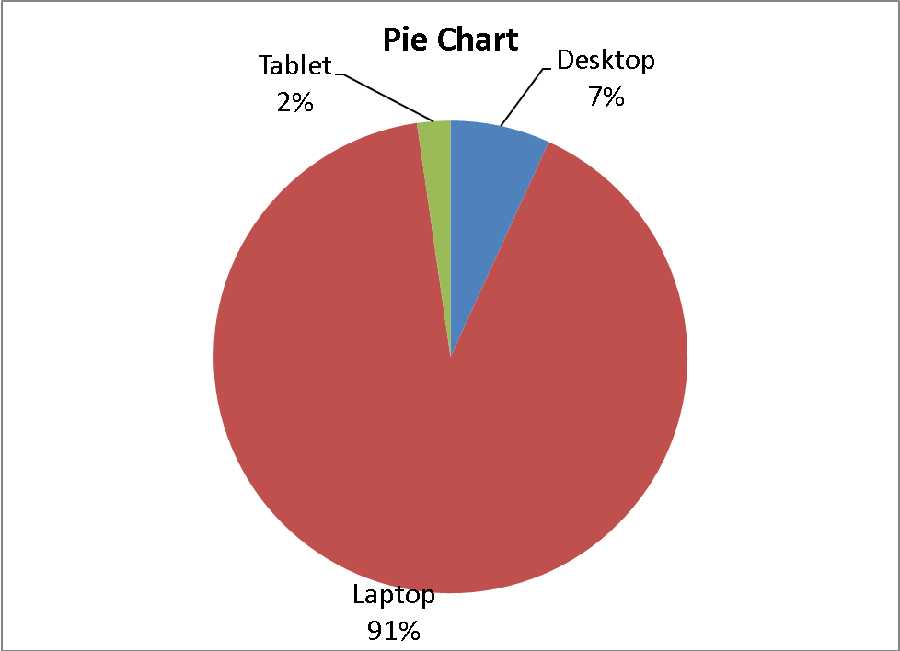
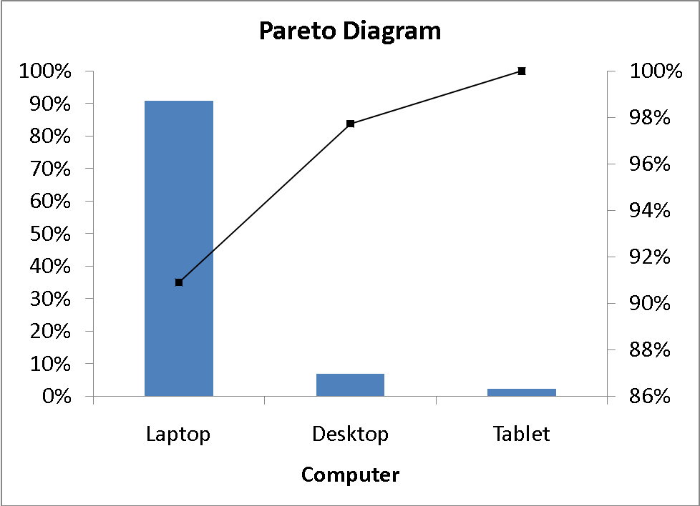
More than 90% of the students use laptop computer for their studies.
2.105
cont.
Age:
Majority of the students are between 22 and 27 years of age and the distribution of age is right-skewed.

2.105
cont.
Full-time Jobs:
Majority of the students have held between 1 and 2 jobs in the past 10 years.
Spending:
Majority of the students spend between $100 and $500 on textbooks and supplies.
2.105
cont.
Advisory Rating:
Majority of the advisory service ratings is between 4 and 5.
Text Message:
Majority of the students sent less than 300 text message in a typical week.
2.105
cont.
Graduate GPA:
Majority of the students have a graduate GPA of 3.0.
Undergraduate GPA:
The distribution of undergraduate GPA is quite symmetrical around 3.35.

2.105
cont.
Expected Salary:
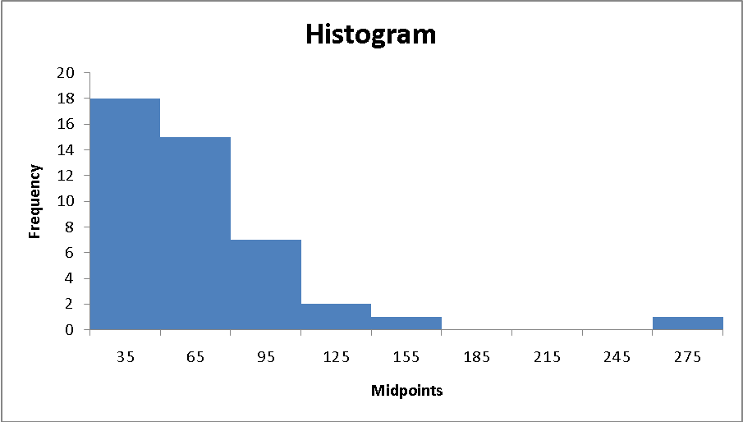
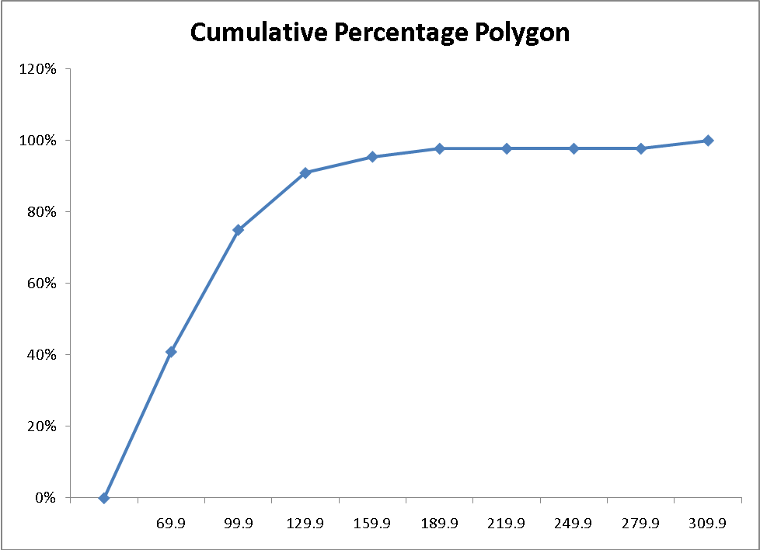
Expected salary is right-skewed.
2.105
cont. Wealth:
Wealth is right-skewed.

