Chapter 2

Presenting data in tables and charts

After studying this chapter you should be able to:
1. describe the distribution of a single categorical variable using tables and charts
2. describe the distribution of a single numerical variable using tables and graphs
3. describe the relationship between two categorical variables using contingency tables
4. describe the relationship between two numerical variables using scatter diagrams and time-series plots
5. correctly present data in graphs

2.1 (a) Category Frequency Percentage
A 13 26%
B 28 56%
C 9 18%

(b) Bar chart

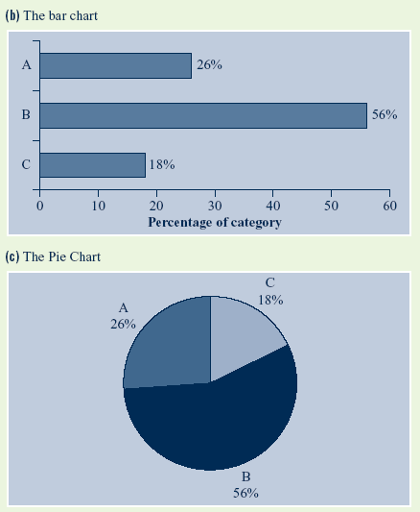

(c) Pie chart

2.2 (a) Bar chart
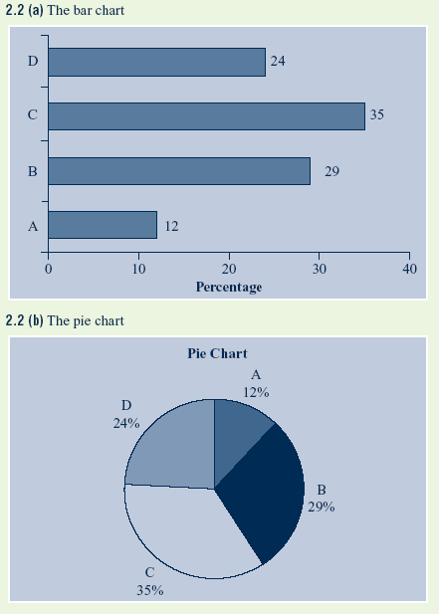

(b) Pie chart

2.3 (a) ABC has approximately 15% to 18% of viewers (actual number is 16.5%).
(b) Channel 7 has approximately 25% of viewers (actual number is 25.5%).
(c) Channel 9 has approximately 25% of viewers (actual number is 24.5%).
(d) Channel 10 has approximately 27% to 30% of viewers (actual number is 28.5%).
(e) SBS has approximately 1% of viewers (actual number is 0.5%).
It is important that, whatever number is calculated, all percentages add to 100%.

2.4 (a) Bar chart

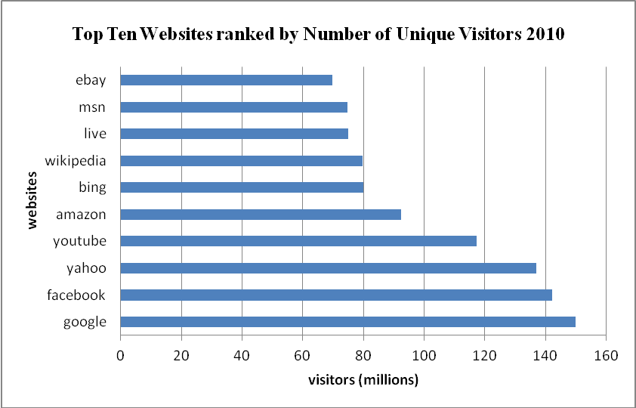

Pie chart
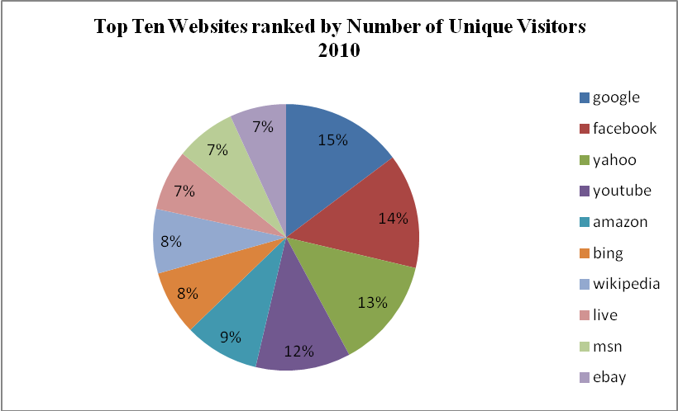

(b) Both graphical techniques highlight the relative market sizes effectively and the selection of one over the other is dependent upon the purpose of preparing the chart.
(c) It is obvious that Google Australia is the dominant player in the search engine market, followed by Facebook, Yahoo! and YouTube, while the others enjoy a similar market share.

2.5 (a) Pie chart
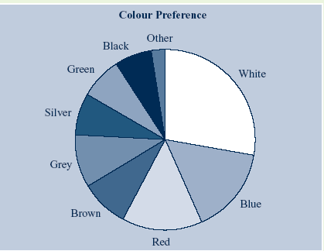

Bar chart
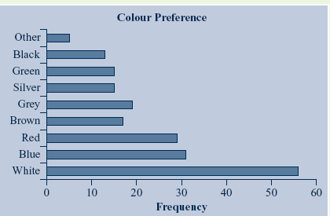

(b) Over 25% of the customers prefer white and (as can be seen from the pie chart) in excess of 50% of the customers prefer the three top colours of white, red and blue. If Pat is not a niche supplier of cars, he should have mainly the top three preferred colours.

2.6 (a) Bar chart

Pie chart

(b) A pie chart or a bar chart could be used; however, a pie chart gives percentages so may be preferable.
(c) From the pie chart, approximately 36% of population is not in the labour force, so the participation rate is approximately 64%.

2.7 Pie chart
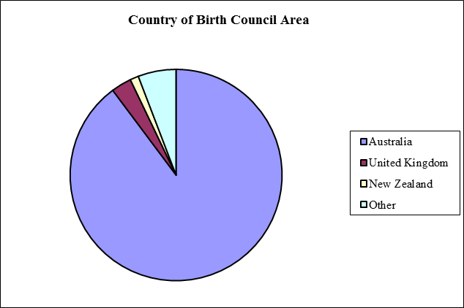

Bar chart
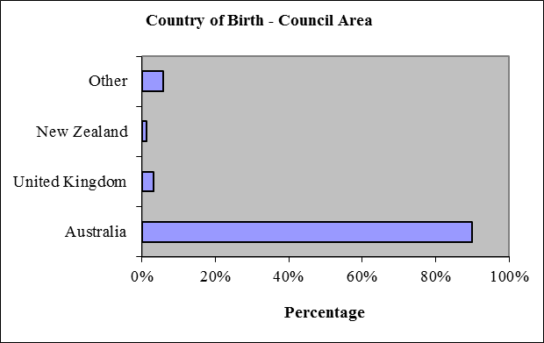

2.8 Ordered array: 63 64 68 71 75 88 94

2.9 Stem-and-leaf display of finance exam scores – stem unit 10, leaf unit 1
5 3 4
6 9
7 4
8 0
9 3 8
n = 7

2.10 Ordered array of information systems exam scores: 50 74 74 76 81 89 92

2.11 (a) Ordered array
Expense claims rounded to nearest $10
$110.00 | $120.00 | $140.00 | $180.00 | $190.00 | $200.00 | $200.00
$210.00 | $230.00 | $290.00 | $290.00 | $290.00 | $290.00 | $290.00
$290.00 | $300.00 | $310.00 | $310.00 | $320.00 | $340.00 | $340.00
$340.00 | $350.00 | $380.00 | $390.00 | $390.00 | $410.00 | $410.00
$450.00 | $450.00 | $460.00 | $500.00 | $510.00 | $550.00 | $560.00

(b) The stem-and-leaf display provides more information, as it shows the distribution of the data as well as the order.
(c) The most common expense claim is $290, which occurs 6 times. Most expense claims are in the range $200 to $390.
(d) The expense claims are concentrated in the $200 and $300 stems, near the centre of distribution.

2.12 (a) Ordered array
15 | 20 | 20 | 35 | 35 | 35 | 35 | 35 | 38 | 38 | 40 | 40 | 40 | 40 | 40 | 45 | 45 | 45 | 45 | 45 | 45 | 50

(b) Stem-and-leaf display of bounced cheque fee

stem unit: 10 | leaf unit 1
1 | 5
2 | 0 | 0
3 | 5 | 5 | 5 | 5 | 5 | 8 | 8
4 | 0 | 0 | 0 | 0 | 0 | 5 | 5 | 5 | 5 | 5 | 5
5 | 0

(c) The stem-and-leaf display provides more information, as it shows the distribution of the data as well as the order.
(d) The bounced cheque fees are concentrated between $35 and $45.

2.13 (a) Ordered array
0.30 | 0.50 | 0.50 | 0.50 | 0.50 | 0.50 | 0.65 | 0.65 | 0.65 | 0.65 | 0.70 | 0.70 | 1.00
1.00 | 1.25 | 1.30 | 1.50 | 1.50 | 1.60 | 1.65 | 2.00 | 2.00 | 2.00 | 2.00 | 2.00 | 2.50

(b) Stem-and-leaf display of ATM fee
stem unit $1 | leaf unit 10 cents
0 | 3 | 5 | 5 | 5 | 5 | 5 | 7 | 7 | 7 | 7 | 7 | 7
1 | 0 | 0 | 3 | 3 | 5 | 5 | 6 | 7
2 | 0 | 0 | 0 | 0 | 0 | 5

(c) The stem-and-leaf display provides more information, as it shows the distribution of the data as well as the order.
(d) The ATM fees are concentrated between 30 and 70 cents.

2.14 (a) Ordered arrays

Full cream milk
135 | 155 | 155 | 160 | 160 | 160 | 160 | 163 | 163 | 165 | 170 | 185 | 188

Low- or reduced-fat milk
110 | 113 | 115 | 118 | 120 | 125 | 128 | 133 | 133 | 140

No-fat or skim milk
85 | 88 | 88 | 90 | 90 | 90 | 90 | 98 | 98 | 108 | 115 | 133

(b) Stem-and-leaf displays
(c) The stem-and-leaf display provides more information, as it shows the distribution of the data as well as the order.
(d) Low-fat and no-fat milk have less calories than full cream milk but there is some overlap.

2.15 (a) The class boundaries of the 9 classes can be ‘10 to less than 20’, ‘20 to less than 30’, ‘30 to less than 40’, ‘40 to less than 50’, ‘50 to less than 60’, ‘60 to less than 70’, ‘70 to less than 80’, ‘80 to less than 90’ and ‘90 to less than 100’.
(b) The class-interval width is .
(c) The nine class mid-points are: 15, 25, 35, 45, 55, 65, 75, 85 and 95.

2.16 (a) 60% of customers spent less than $100.
(b) 160 (0.8 x 200) customers spent at least $60.
(c) The top 10% of customers spent between $140 and $200.
(d) The bottom 10% of customers spent less than $40.

2.17 (a) Frequency distribution and percentage distribution
Electricity costs | Frequency | Percentage | Cumulative percentage
$80 to < $100 | 4 | 8 | 8
$100 to < $120 | 7 | 14 | 22
$120 to < $140 | 9 | 18 | 40
$140 to < $160 | 13 | 26 | 66
$160 to < $180 | 9 | 18 | 84
$180 to < $200 | 5 | 10 | 94
$200 to < $220 | 3 | 6 | 100

(b) Histogram and percentage polygon
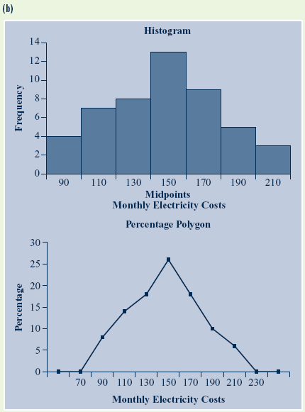

(c) Cumulative percentage polygon

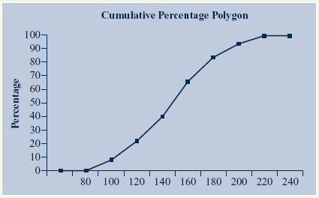

(d) Monthly electricity costs are concentrated between $140 and $160 a month, with more than 25% falling in that interval.

2.18 (a) Frequency, percentage and cumulative distributions
(b) Frequency histograms

(c) Percentage polygons
(d) Cumulative percentage polygons
(e) We can conclude that on this day petrol prices varied approximately from 146 cents per litre to 162 cents per litre and diesel prices from 158 to 170 cents per litre. We can also conclude that petrol prices were generally lower than diesel prices.

2.19 (a) Frequency distribution and percentage distribution

Manufacturer A
Life in hours | Frequency | Percentage % | Cumulative %
5500 to < 6000 | 2 | 5 | 5.00%
6000 to < 6500 | 6 | 15 | 20.00%
6500 to < 7000 | 7 | 17.5 | 37.50%
7000 to < 7500 | 6 | 15 | 52.50%
7500 to < 8000 | 7 | 17.5 | 70.00%
8000 to < 8500 | 7 | 17.5 | 87.50%
8500 to< 9000 | 5 | 12.5 | 100.00%
9000 to < 9500 | 0 | 0 | 100.00%
9500 to < 10000 | 0 | 0 | 100.00%
Total | 40 | 100

Manufacturer B
Life in hours | Frequency | Percentage | Cumulative %
5500 to < 6000 | 0 | 0 | 0.00%
6000 to < 6500 | 0 | 0 | 0.00%
6500 to < 7000 | 3 | 7.5 | 7.50%
7000 to < 7500 | 6 | 15 | 22.50%
7500 to < 8000 | 11 | 27.5 | 50.00%
8000 to < 8500 | 2 | 5 | 55.00%
8500 to< 9000 | 7 | 17.5 | 72.50%
9000 to < 9500 | 7 | 17.5 | 90.00%
9500 to < 10000 | 4 | 10 | 100.00%
Total | 40 | 100

(b) Histogram and percentage polygon

(c) Ogive

(d) Manufacturer B produces bulbs with longer lives than manufacturer A’s bulbs. The cumulative percentage for manufacturer B shows 50% of its bulbs lasted 8000 hours or less contrasted with 70% of manufacturer A’s bulbs. None of manufacturer A’s bulbs lasted more than 9000 hours, but 27.5% of manufacturer B’s bulbs did. At the same time, 20% of manufacturer A’s bulbs lasted less than 6500 hours, while all of manufacturer B’s bulbs lasted at least 6500 hours.

2.20 (a) Table frequencies for all student responses
Student major categories
Gender | A | I | M | Totals
Male  Female  Totals | 14  6  20 | 9  6  15 | 2  3  5 | 25  15  40

(b) Table percentages based on overall student responses
Student major categories
Gender | A | I | M | Totals
Male  Female  Totals | 35.0%  15.0%  50.0% | 22.5%  15.0%  37.5% | 5.0%  7.5%  12.5% | 62.5%  37.5%  100.0%

Table percentages based on row percentages
Student major categories
Gender | A | I | M | Totals
Male  Female  Totals | 56.0%  40.0%  50.0% | 36.0%  40.0%  37.5% | 8.0%  20.0%  12.5% | 100.0%  100.0%  100.0%

Table percentages based on column percentages
Student major categories
Gender | A | I | M | Totals
Male  Female  Totals | 70.0%  30.0%  100.0% | 60.0%  40.0%  100.0% | 40.0%  60.0%  100.0% | 62.5%  37.5%  100.0%

(c) Side-by-side bar chart

2.21 Side-by-side bar chart

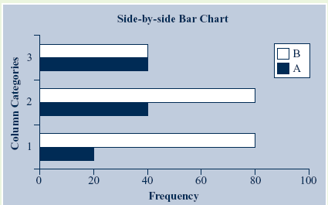

2.22 (a) Cross-classification tables
Table based on column percentages
 | Study mode
Employment Status | Studying Full-time | Studying Part-time | All Students
Employed part-time | 15.3 | 64.9 | 44.1
Employed full-time | 43.2 | 21.0 | 30.3
Not employed | 41.5 | 14.1 | 25.6
All students | 100.0 | 100.0 | 100.0

Table based on row percentages
 | Study mode
Employment Status | Studying Full-time | Studying Part-time | All Students
Employed part-time | 14.5 | 85.5 | 100.0
Employed full-time | 59.7 | 40.3 | 100.0
Not employed | 68.0 | 32.0 | 100.0
All students | 41.9 | 58.1 | 100.0

(b) Side-by-side bar charts
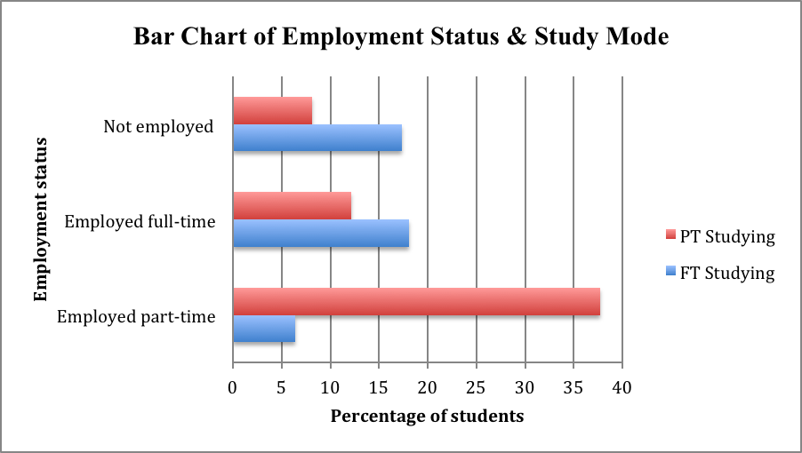

(c) The majority of the full-time students are employed full-time while the majority of part-time students are employed part-time.

2.23 (a) Side-by-side bar chart

(b) In all age groups there are more male fatalities than female. While female fatalities in all age groups are less than 350, most male fatalities are in the 10 to 50 age group and peak at 1225 in the 20 to 30 age group.

2.24 (a) Cross-classification table

(b) Side-by-side bar chart

(c) There is no discernible difference in the education level pattern for males and females. Both genders are more likely to have completed years 10 or 12 than any other level of education.

2.25 (a) Side-by-side bar chart

(b) Sales were similar in November 2012 and 2013 except for Toyota, which significantly increased sales in November 2013. Toyota has the largest market share for both periods.
2.26 (a) Scatter diagram

(b) Yes, there appears to be a positive linear relationship between X and Y since both X and Y change in the same direction.

2.27 (a) Time-series plot

(b) Annual sales appear to be increasing before 2006 but start to decline after 2010.

2.28 (a) Scatter diagram
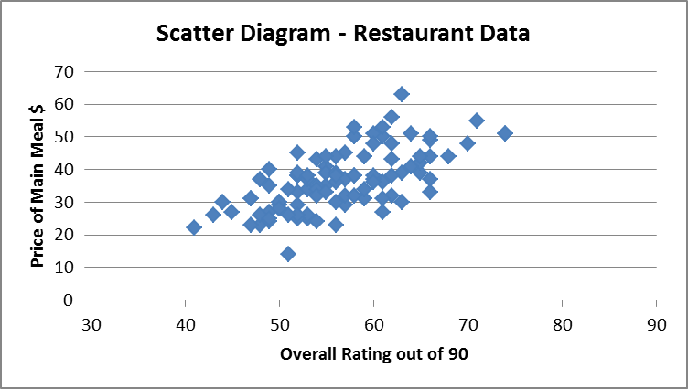

(b) There appears to be a weak linear relationship between overall rating and price. This relationship is positive, with restaurants with a higher overall rating generally having higher prices.

2.29 (a) Scatter diagrams
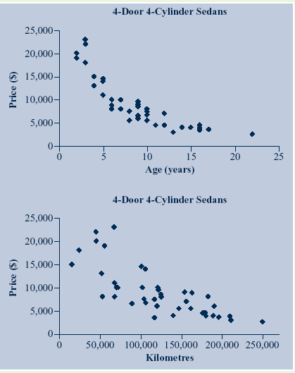

(b) As expected, in general the older a car is or the more kilometres travelled, the cheaper the car is. There is a strong negative exponential relationship between age and price, while there is a weak, possibly linear, relationship between kilometres travelled and price.

2.30 (a) Scatter diagram

(b) There is a weak positive linear relationship between petrol and diesel prices; where petrol prices are high, diesel prices tend to be high. Diesel prices are generally higher than petrol prices.

2.31 (a) Time-series plot

(b) The (seasonally adjusted) unemployment rate decreased from a maximum of 7.1% in October 2001 to a minimum of 4.1% in August 2008. The unemployment rate increased in the second half of 2008 and remained above 5% during 2009 and 2010.

2.32 (a) Time-series plots

(b) The Australian and New Zealand inflation rates are similar for 2007 to 2009, reaching a high of 5.0% and 5.1% respectively for the year ending September 2008, and a low of 1.3% and 1.7% respectively for the year ending September 2009. From 2010, the inflation rates for the two countries have differed, with the New Zealand rate more varied than the Australian rate.

2.33 to 2.36 Answers will vary.

2.37

2.38 Graph (a) probably represents the data best as the vertical scale starts at zero. However, as petrol prices usually differ by only a few cents, graph (b) may be useful in some applications if you wish to show variability of the prices. In this case, you would need to clearly indicate that the vertical axis does not start at zero. Graph (c) shows a very flat graph, as the vertical scale extends to 300; this is misleading, as it does not represent the variation in prices.

2.39 Answers will vary.

2.40 (a) Doughnut chart, cone chart and pyramid chart
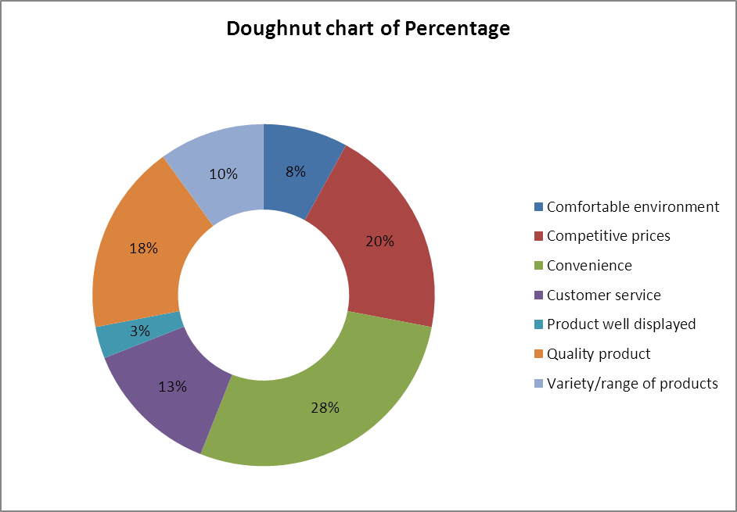

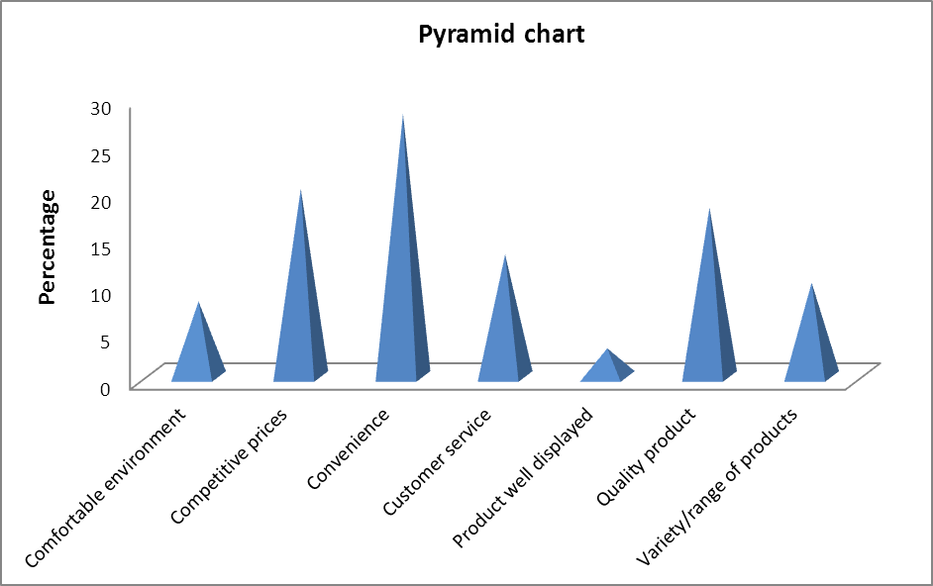
(b) The bar chart and the pie chart should be preferred over the doughnut chart, the cone chart and the pyramid chart, since the bar chart and pie chart are simpler and easier to interpret.

2.41 A histogram uses bars to represent each class while a polygon uses a single point. The histogram should be used for only one group, while several polygons can be plotted on a single graph.

2.42 A summary table allows one to determine the frequency or percentage of occurrences in each category.

2.43 A bar chart is useful for comparing categories. A pie chart is useful when examining the portion of the whole that is in each category.

2.44 The bar chart is plotted with the categories on the vertical axis and the frequencies or percentages on the horizontal axis. In addition, there is a separation between categories. The histogram is plotted with the class grouping on the horizontal axis and the frequencies or percentages on the vertical axis. This allows one to more easily determine the distribution of the data. There are no gaps between the classes in the histogram.

2.45 A time-series plot is a type of scatter diagram with the time on the x axis.

2.46 Percentage breakdowns according to the total percentage, the raw percentage and/or the column percentage allow the interpretation of data in a two-way contingency table from several different perspectives.

2.47 (a)

(b) Over 50% of Australian Internet users polled used the internet for searching, social networking and email, while more than 40% also used a user-generated or upload site such as YouTube in the previous week.
2.48 (a)

(b) Internet usage by time spent is evenly spread between social networking, Internet searches and email and communications. This compares with the data from problem 2.47, which shows that the majority of Australian Internet users polled had visited search, social networking and email sites during the previous week.

2.49 (a)
Contingency table of year and crash type as percentage of year total
The following are some of the appropriate side-by-side bar charts. Pie charts may be appropriate if reviewing one specific year or type of fatality.

(b) From the above graphs we can conclude that for all years between 40% and 50% of road fatalities are single-vehicle crashes, while approximately 13% are pedestrian. We can also conclude that the number and percentage of fatalities in single-vehicle crashes is decreasing, but it is increasing in multiple-vehicle crashes.

2.50 (a) Bar chart

Pie chart

(b) The majority (62%) of drink driving offences are committed by residents of the local council area, either resident in the seaside town (15%) or elsewhere within the council area (47%).
(c) The headline is correct, as only 38% of drink-driving offences are committed by residents from outside the council area.

2.51 (a)

(b) There are differences between Brisbane and non-Brisbane households in the reasons for installing a rainwater tank. Brisbane households installed a rainwater tank mainly to save water, but also to save on water costs, to obtain a rebate and because of water restrictions. While non-Brisbane households also installed a rainwater tank for these reasons, additionally they were concerned about water quality, with the main reason being they were not connected to mains water.
2.52 (a)

(b) There appears to be a strong linear relationship between fat content and calories, with milks with higher fat content having more calories than those with low fat content. There may be a weak negative relationship between fat and sugar content, with a high level of fat tending to have lower sugar content and vice-versa. There is no relationship between sugar content and calories.

2.53 (a) Other graphs and tables may also be appropriate.
The distribution of both diesel and unleaded petrol prices are mound shaped. We can conclude that on this day in December 2013, petrol prices in Queensland varied from 145 to 175 cents per litre, while diesel prices varied from 155 to 180 cents per litre. Diesel prices concentrated between 160 and 170 cents per litre are generally more expensive than petrol prices that are concentrated between 150 and 165 cents per litre.
(b)
There is a strong positive linear relationship between Queensland petrol and diesel prices. When petrol prices are high, diesel prices tend to be high. Diesel prices are generally higher than petrol prices.
(c)
There is a weak positive linear relationship between petrol and diesel prices When petrol prices are high, diesel prices tend to be high. Diesel prices are generally higher than petrol prices.
(d)
The distribution of unleaded petrol prices is the same in New South Wales and Queensland. That is, there seems to be no significant difference in price between the two states.
(e)
Diesel prices are more varied in Queensland but have a similar distribution to those in New South Wales.
(f) The answer to this part could vary.

2.54 (a) Stem-and-leaf display

Property prices range from $320,000 to $840,000. Asking prices are concentrated between $300,000 and $600,000. Only two asking prices are above $800,000.

(b) Frequency percentage and cumulative distributions

(c) Frequency histogram, percentage polygon and ogive

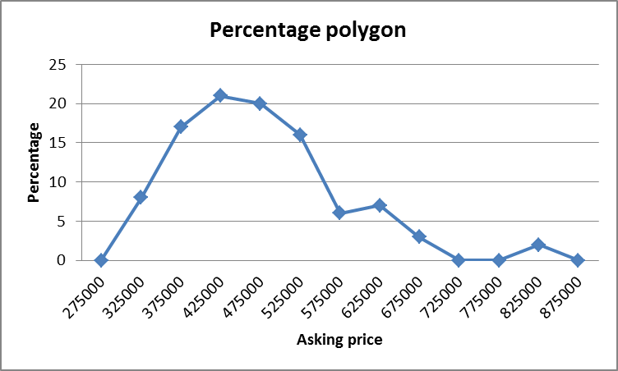

(d) Can conclude that:
- Property prices in the region range from approximately $300,00 to $850,000.
- The asking prices are concentrated between $400,000 and $500,000.
- Only two prices are above $700,000.
- 66% of asking prices are below $500,000.
- 74% of prices are between $350,000 and $550,000.

(e) Scatter diagram
There is a strong positive linear relationship between selling price and asking price.

(f) Cross-tabulation based on totals

(g) Side-by-side charts
(h) Units tend to have a maximum of three bedrooms while the number of bedrooms in a house varies from one to eight.

2.55

From approximately 1995 until October 2009, New Zealand interest rates have been higher than Australian rates, and were slightly less before 1995. Both rates follow a similar pattern with some variation. Since 1990, interest rates in both countries have decreased from a high of 17% or 15% respectively, to lows of approximately 6%.

2.56 This graph distorts the data in Problem 2.55.

This graph emphasises the increase in Australian interest rates by not starting the vertical axis at zero. Furthermore, starting the horizontal axis at February 2009 when rates began to rise is misleading as the graph does not show the larger variations and higher rates of earlier and later years, in particular the high rates in the early 1990s and the fall in interest rates in the second half of 2008 and since November 2011.
2.57 (a) A pie chart of grade distribution. Please note that a frequency or percentage bar chart would also be appropriate.
16% of students failed this statistics unit while 84% passed. Further 20% obtained either a credit or above.
(b) A histogram of total marks. Please note that a percentage histogram, polygon or ogive would also be appropriate.
The majority of students obtained a pass mark of 50%; the most common mark is 50 to 60. A few students obtained a total mark of 10 to 50 and hence failed the unit.
(c) A scatter diagram of semester marks and final marks
There is a positive liner relationship between a student’s semester mark and their exam mark. In general, students with high semester marks obtain higher exam marks.

