Answers to End of Chapter Reviews and Exercises

for Assembly Language for x86 Processors, 7th Edition

by Kip R. Irvine

Chapters 1 and chapter 2 sample

*Revision date: 1/18/2014*

Chapter 1

1.7.1 Short Answer Questions

1. Most significant bit (the highest numbered bit).

2. (a) 53 (b) 150 (c) 204

3. (a) 110001010 (b) 110010110 (c) 100100001

4. 00000110

5. (a) 8 (b) 32 (c) 64 (d) 128

6. (a) 12 (b) 16 (c) 16

7. (a) 35DA (b) CEA3 (c) FEDB

8. (a) 0000 0001 0010 0110 1111 1001 1101 0100

(b) 0110 1010 1100 1101 1111 1010 1001 0101

(c) 1111 0110 1001 1011 1101 1100 0010 1010

9. (a) 58 (b) 447 (c) 16534

10. (a) 98 (b) 1203 (c) 671

11. (a) FFE8 (b) FEB5

12. (a) FFEB (b) FFD3

13. (a) 27641 (b) −16093

14. (a) 19666 (b) −32208

15. (a) −75 (b) +42 (c) −16

16. (a) −128 (b) −52 (c) −73

17.(a) 11111011 (b) 11010110 (c) 11110000

18. (a) 10111000 (b) 10011110 (c) 11100110

19. (a) AB2 (b) 1106

20. (a) B82 (b) 1316

21. 42h and 66d

22. 47h and 71d

23. 229− 1, or 6.8056473384187692692674921486353 X 1038

24. 286− 1, or 77371252455336267181195263

25. Truth table:

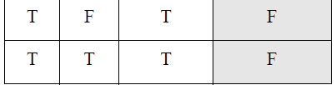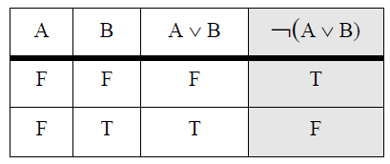

26. Truth table: (last column is the same as #25)

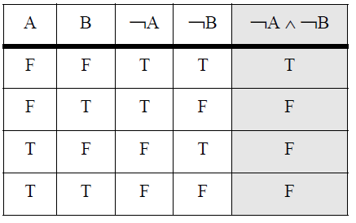

27. It requires 24 (16) rows.

28. 2 bits, producing the following values: 00, 01, 10, 11

1.7.2Algorithm Workbench

1. Code example (C++)

int toInt32(string s) {

int num = 0;

for(int i = 0; s[i] >= '0' && s[i] <= '1'; i++) {

num = num * 2 + s[i]-'0';

}

return num;

}

2. Code example (C++)

int hexStrToInt32(string s) {

int num = 0;

for(int i = 0; ; i++) {

if( s[i] >= '0' && s[i] <= '9' )

num = num * 16 + s[i]-'0';

else if( s[i] >= 'A' && s[i] <= 'F' )

num = num * 16 + (s[i]-'A'+10);

else

break;

}

return num;

}

3. Code example (C++)

string intToBinStr( int n ) {

vector<int> stack;

do {

int quotient = n / 2;

int remainder = n % 2;

stack.push_back(remainder);

n = quotient;

} while( n > 0 );

string s;

while( stack.size() > 0 ) {

s += (stack.back() + '0');

stack.pop_back();

}

return s;

}

4. Code example (C++)

string intToHexStr( int n ) {

vector<int> stack;

do {

int quotient = n / 16;

int remainder = n % 16;

stack.push_back(remainder);

n = quotient;

} while( n > 0 );

string s;

while( stack.size() > 0 ) {

int d = stack.back();

if( d >= 0 && d <= 9 )

s += (stack.back() + '0');

else // probably a hex digit

s += (stack.back() - 10 + 'A');

stack.pop_back();

}

return s;

}

5. Code example (C++)

string addDigitStrings( string s1, string s2, int base ) {

string sumStr;

int carry = 0;

for(int i = s1.size() - 1; i >= 0; i--) {

int dval = (s1[i] - '0') + (s2[i] - '0') + carry;

carry = 0;

if( dval > (base - 1) ) {

carry = 1;

dval = dval % base;

}

sumStr.insert(sumStr.begin(), (dval + '0'));

}

if( carry == 1 )

sumStr.insert( sumStr.begin(), 1 + '0');

return sumStr;

}

Chapter 2

2.8.1Short Answer Questions

1. EBP

2. Choose 4 from: Carry, Zero, Sign, Direction, Aux Carry, Overflow, Parity.

3. Carry flag

4. Overflow flag

5. True

6. Sign flag

7. Floating-point unit

8. 80 bits

9. True

10. False

11. True

12. False

13. True

14. False

14. False

15. False

16. True

17. False

18. True

19. False

20. False

21. True

22. True

23. False

24. False

25. Hardware, BIOS, and OS

26. It gives them more precise control of hardware, and execution is faster.