Chapter 2

THE HUMAN BODY:
READING THE MAP

LEARNING OBJECTIVES
➯ List and describe the various body positions
➯ Define the body planes and associated directional terms
➯ Locate and describe the body cavities and their respective organs
➯ List and describe the anatomical division of the abdominal region
➯ Identify and locate the various body regions

MULTIMEDIA FOUND ON THE POWERPOINT
LECTURE OUTLINE
Videos
1. Body Positions
2. MRIs
3. Radiologic Technology Professional Profile
4. Surgical Technology Professional Profile
5. Ultrasound
Interactive Labeling Activities
1. Body Cavities
2. Body Positioning

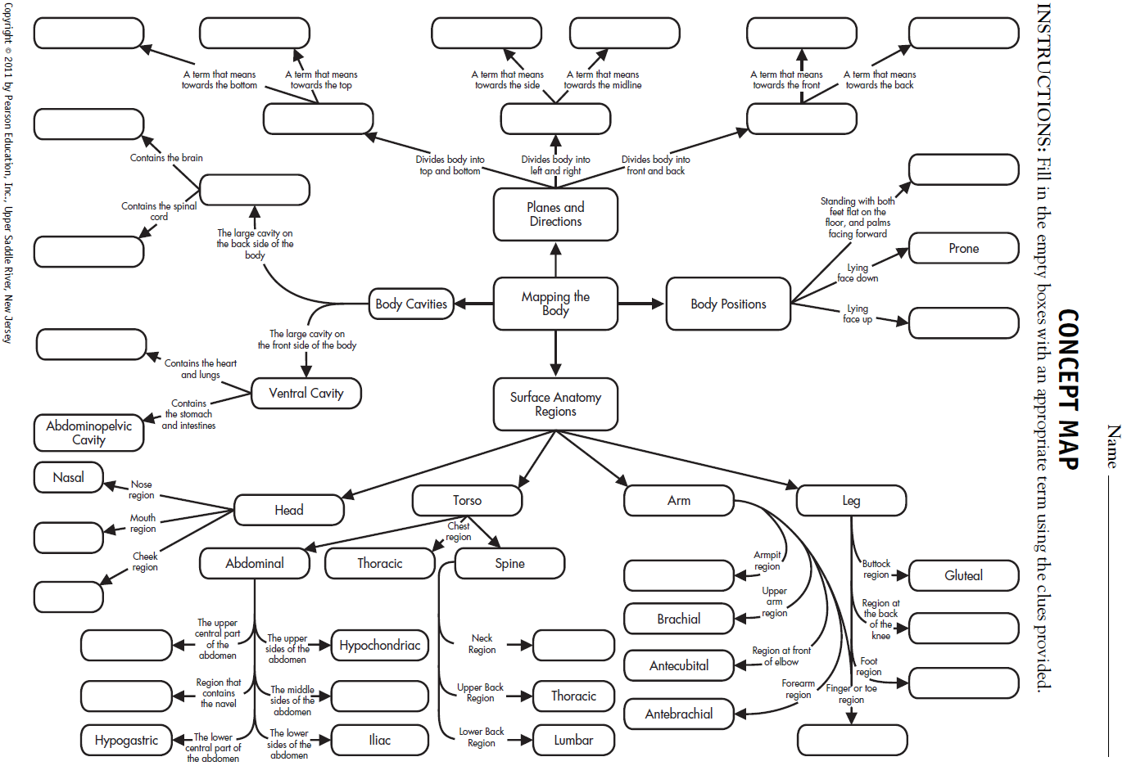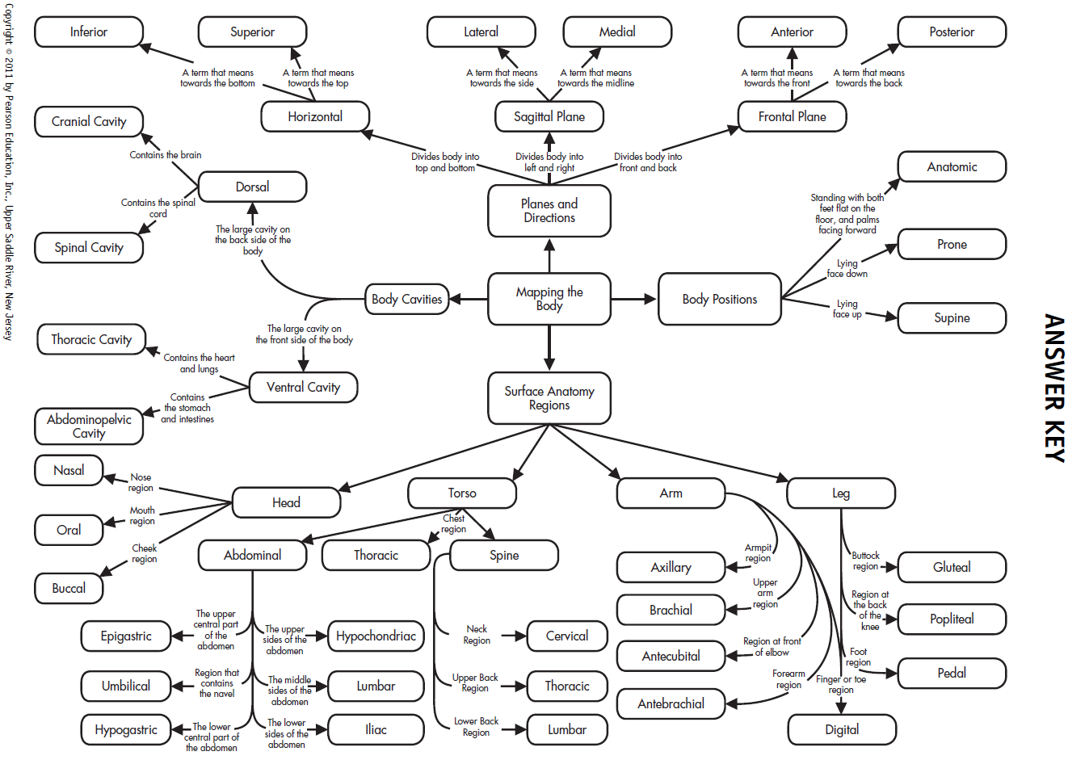
LECTURE OUTLINE
I. Mapping the Human Body
A. Body positions
1. To standardize the orientation for the study of anatomy, the
anatomical position was developed: stand erect, face forward,
feet apart, arms at side, palms forward
2. Supine: faceup
3. Prone: facedown
4. Trendelenburg: head lower than feet
5. Fowler’s: sitting at 45 degrees
II. Directional Terms and Planes of Section
A. Directional terms
1. Depends on comparison to other body parts
2. The point of reference is always from the patient’s point of
view and is not dependent on which way the patient is facing
you
3. Terms usually come in pairs
a. Superior (cranial or cephalic): above, toward the head
b. Inferior (caudal): below, toward the tail
c. Medial: toward the midline
d. Lateral: toward the side (away from the midline)
e. Anterior (ventral): toward the front, belly
f. Posterior (dorsal): back, toward the back
g. Proximal: near the origin
h. Distal: far from the origin
i. Internal: inside the body
j. External: near the outside of the body
k. Superficial: near the surface
l. Deep: far from the surface
m. Central: near center of body
n. Peripheral: near edges of body
B. Body planes
1. Transverse or horizontal plane: divides body into superior and
inferior parts
2. Sagittal plane: divides body into right and left pieces
3. Median or midsagittal plane: divides body into right and left
halves
4. Frontal or coronal plane: divides body into anterior and posterior
parts
III. Body Cavities
A. House and protect organs
1. Anterior cavity
a. Divided by the diaphragm
b. Thoracic cavity
i. The thoracic cavity is superior to the diaphragm
ii. Contains heart, lungs, blood vessels
c. Abdominopelvic cavity: inferior to diaphragm.
i. Abdominal cavity
a. Superior to imaginary line at pelvis
b. Contains abdominal organs: stomach, intestines,
liver, gallbladder, pancreas, and spleen
ii. Pelvic cavity
a. Inferior to imaginary line at pelvis
b. Contains pelvic organs such as the urinary bladder,
reproductive system, rectum, and anus
2. Dorsal cavity
a. Cranial cavity houses the brain
b. Spinal cavity houses the spinal cord
3. Many smaller cavities throughout the body
IV. Body Regions
A. The abdominal region divided into nine quadrants
1. Epigastric is superior to the umbilical region.
2. The right and left hypochondriac is lateral to epigastric.
3. Umbilical region is located in the center, over the umbilicus.
4. Right and left lumbar regions are located on either side of the
umbilical region.
5. The hypogastric region lies inferior to the umbilical area.
6. The left and right iliac regions are located on either side of the
hypogastric region.
B. It is simpler to divide the abdominal region into four quadrants
with the center line of the inferior/superior and left/right division
being the umbilicus; quadrants are generally abbreviated.
1. Right lower quadrant (RLQ): appendix
2. Right upper quadrant (RUQ): liver, gallbladder
3. Left lower quadrant (LLQ): rectum
4. Left upper quadrant (LUQ): spleen
C. Additional body regions: every body part has a technical name

CLASSROOM ACTIVITIES
1. Have students demonstrate various body positions by moving their
extremities into the various positions.
2. Play “Go to the Head of the Class.” Have all students start in the back
of the classroom. Every time they answer a question correctly, they can
move one seat forward until eventually they reach the head of the
class. Rewards can be extra credit points, food, or privileges.
3. Play “Pin the tail on the anatomy.” Have students look for the body
part based only on the technical name, or have blindfolded students
directed to the point on the “body” by other students using only
directional terms.
TEACHING STRATEGIES
1. Give students the names of organs, and ask them to identify in what
body cavity the organs would be located.
2. The game “Operation” can be a wonderful teaching tool for body
cavities, organs, and anatomical divisions. Play a game where students
must answer questions related to the chapter to win a chance to remove
one of the “organs” in the game board. Questions should include things
like, “What is that organ called in real life?” or “What is the name for
the body cavity where that organ is located?” If they successfully
remove the organ without making the buzzer go off, they get to draw a
card that awards them “money.” At the end of the game, they can use
the money they’ve earned to buy rewards like extra credit points.

FACTOIDS
1. Species with a vertebral column are classified as vertebrates and
include fish, amphibians, reptiles, birds, and mammals. The various
planes apply to veterinary medicine as well, and add the term “rostral”
to refer to the direction toward the nose. Dorsal and ventral describe
the sides closest to the sky and closest to the ground in animals. The
terms anterior and posterior are not necessarily the same as ventral and
dorsal in four-legged animals or invertebrates like lobsters.
2. A sagittal plane divides the body into right and left, but does not have
to run down the center of the body—it can divide the body at any
point. If the plane does run down the center of the body, dividing the
body in half, it is a midsagittal plane.
3. Ipsilateral means on the same side, whereas contralateral means on the
opposite side.

ETHICAL DILEMMAS
1. Imagine that the doctor told you to surgically prepare the left
hypochondriac region of the abdomen for surgery, and you didn’t know
where that region was located. Ask students how they would go about
finding out where that area was located. Ask them to discuss the ethics
of “guessing” the location and potential consequences.
2. What obligation do you have to your patient to understand the
information provided in this chapter? What consequences could occur
if you fail to meet your obligation?
ANSWERS TO TEST YOUR KNOWLEDGE

Test Your Knowledge 2–1 Answers, p. 26
1. Person should be standing face forward, palms out as in Figure 2-1.
2. Best body position for following circumstances
a. Getting a back massage: prone
b. Eating in a hospital bed: Fowler’s
c. Watching television in bed: Fowler’s
d. Watching the stars at night: supine
3. Give the opposite directional term
a. Superior: inferior
b. Posterior: anterior
c. Caudal: cephalic (cranial)
d. Ventral: dorsal
e. Distal: proximal
f. External: internal
g. Superficial: deep
h. Peripheral: central
i. Medial: lateral
4. superficial
5. proximal; distal
6. superior
7. peripheral or pedal
8. central cyanosis

Test Your Knowledge 2–2 Answers, p. 29
1. transverse or horizontal
2. anterior (ventral); posterior (dorsal)
3. midsagittal
4. Identify the major body cavity in which the following organs are located.
a. Heart: thoracic or pericardial
b. Spinal cord: spinal, dorsal, or vertebral
c. Stomach: abdominal
d. Lungs: thoracic or pleural
e. Reproductive organs: pelvic
f. Brain: cranial
5. nervous

Test Your Knowledge 2–3 Answers, p. 35
1. oral
2. axillary
3. umbilical
4. lumbar
5. patellar
6. spleen or liver
ANSWERS TO CASE STUDY, P. 36
a. right knee
b. center of the chest (breastbone area)
c. left arm
d. no stomach pain
e. in front of elbow
f. feet

ANSWERS TO REVIEW QUESTIONS, P. 37

Multiple Choice
1. a, 2. d, 3. d, 4. d, 5. a, 6. d

Fill in the Blank
1. anatomical
2. supine
3. inferior; superior
4. brain
5. peripheral or acrocyanosis
6. midsagittal

Short Answers
1. The organs found in the abdominal cavity are the liver, stomach,
pancreas, spleen, gallbladder, small intestine, and part of the large
intestine.
2. In the prone position a person is lying facedown. In the supine
position a person is lying faceup. In Fowler’s position, a person is
sitting up at a 45 to 60 degree angle.
3. There are three superior regions in the abdominal cavity. The medial
superior region is the epigastric (above the stomach) region. The
lateral superior regions are the hypochondriac (under the ribs) regions.
Inferior to those three regions are two lateral regions, the lumbar
regions, and a medial region, the umbilical region. The three most
inferior regions are two lateral regions, the iliac regions and one
medial region, the hypogastric (under the stomach) region.

Name__________________________________

CHAPTER 2 – WORKSHEET

Multiple Choice
1) In this position, a patient is lying on their back, faceup.
A) Prone
B) Supine
C) Trendelenburg
D) Fowler’s
2) In this position, a patient is lying on their stomach, facedown.
A) Anatomical
B) Trendelenburg
C) Prone
D) Supine
3) In this position, a patient is lying with the head of the bed lower than the feet.
A) Trendelenburg
B) Prone
C) Fowler’s
D) Anatomical
4) A patient is standing erect, with face forward, feet parallel, arms hanging to the side, and palms facing
forward. What position is this patient in?
A) Supine
B) Anatomical
C) Fowler’s
D) Prone
5) A patient has a slightly blue discoloration to the fingers and toes. This is an example of _____ cyanosis.
A) central
B) peripheral
C) lateral
D) sagittal

Fill in the Blank
6) _____ The plane divides the body into left and right portions.
7) The _____ plane divides the body into anterior and posterior parts.
8) Another name for the midsagittal plane is the _____ plane.
9) The _____ plane divides the body into superior and inferior parts.
10) The cranial and spinal cavities are both part of the larger _____ cavity.
11) The thoracic and abdominal cavities are part of the larger _____ cavity.

Worksheet – p. 1 of 2

Matching
Please match the following terms with the correct definition.

12) _____ Sternal A. Foot region
13) _____ Pedal B. Neck region
14) _____ Pubic C. Cheek region
15) _____ Axillary D. Breastbone region
16) _____ Cervical E. Finger region
17) _____ Epigastric F. Chest region
18) _____ Thoracic G. Nose region
19) _____ Gluteal H. Genital region
20) _____ Lumbar I. Buttock region
21) _____ Oral J. Superior central portion of the abdomen
22) _____ Buccal K. Front of the elbow
23) _____ Antecubital L. Low back region
24) _____ Digital M. Mouth region
25) _____ Nasal N. Armpit region

Short Answer/Essay
26. List three organs that might be found in the abdominal cavity.
_________________________________________________________
_________________________________________________________
_________________________________________________________
27. Give one example of an organ found in the thoracic cavity.
_________________________________________________________
_________________________________________________________
_________________________________________________________

Worksheet – p. 2 of 2

ANSWER KEY

Chapter 2—Worksheet
1) B
2) C
3) A
4) B
5) B
6) sagittal
7) frontal/coronal
8) median
9) horizontal/transverse
10) dorsal
11) ventral
12) D
13) A
14) H
15) N
16) B
17) J
18) F
19) I
20) L
21) M
22) C
23) K
24) E
25) G
26) Answers will vary, but may
include stomach, intestines,
liver, kidneys, bladder, etc.
27) Answers will vary, but may
include heart, lungs, esophagus,
etc.

Name
LABELING ACTIVITY #1

INSTRUCTIONS: Please label the cavities in the following diagram.

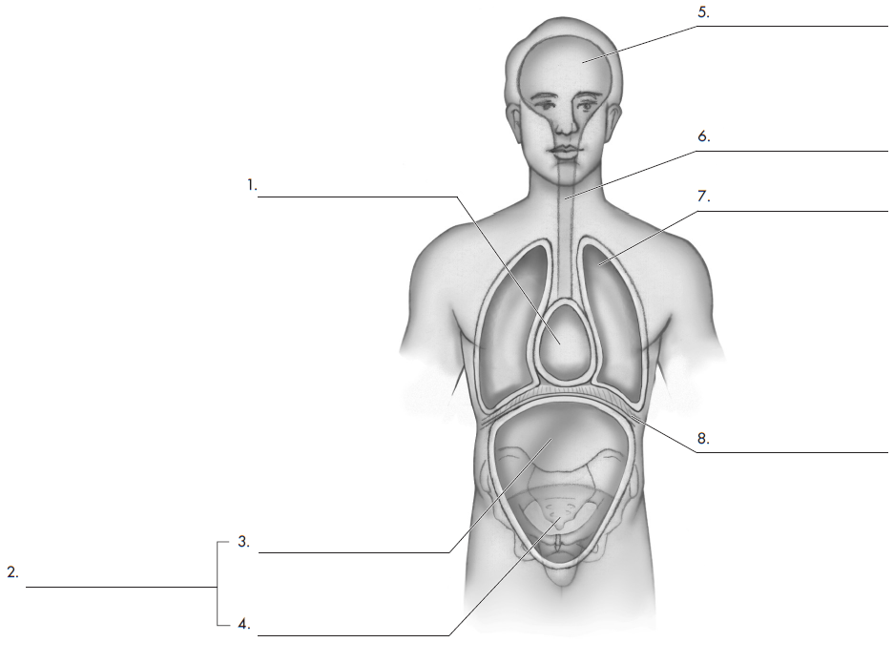
LABELING ACTIVITY #1 ANSWER KEY

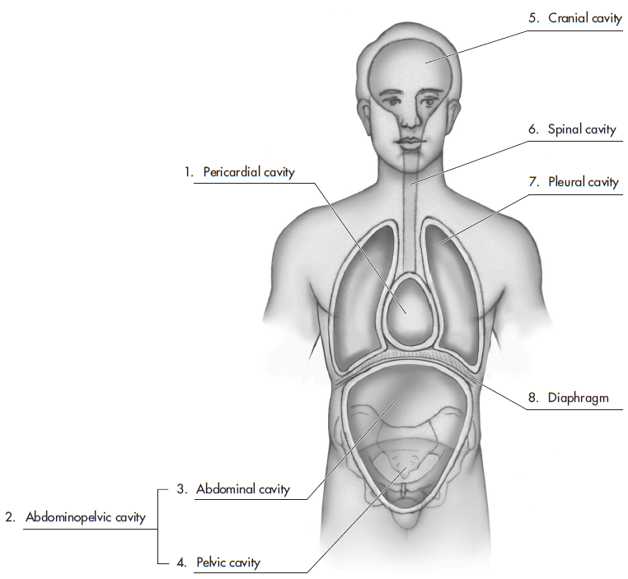
Name
LABELING ACTIVITY #2
.
INSTRUCTIONS: Please label the following regions.

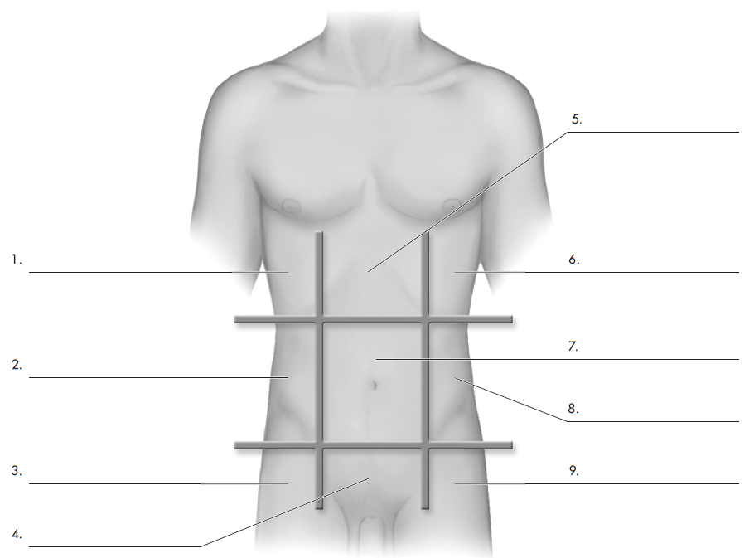
LABELING ACTIVITY #2 ANSWER KEY

