**Instructor’s Solution Manual to Chapter Exercises in**

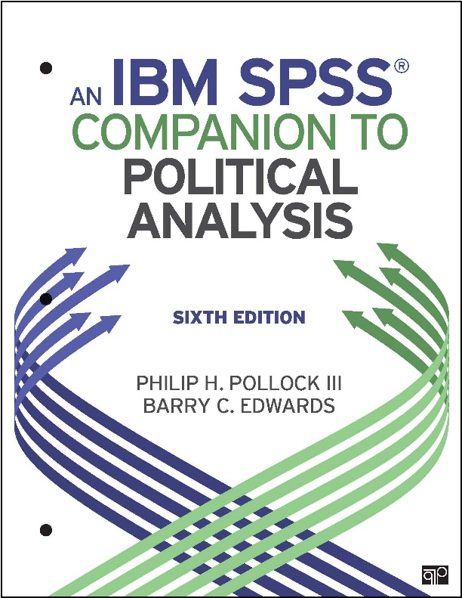

***An IBM SPSS Companion to Political Analysis, Sixth Edition***

**By Philip H. Pollock II and Barry C. Edwards**

|  |  |
| --- | --- |
| **Solutions to Exercises in** | **Page** |
| Getting Started (No exercises) | 2 |
| Chapter 1: Introduction to SPSS | 3 |
| Chapter 2: Descriptive Statistics | 6 |
| Chapter 3: Transforming Variables | 20 |
| Chapter 4: Making Comparisons | 24 |
| Chapter 5: Making Controlled Comparisons | 37 |
| Chapter 6: Making Inferences about Sample Means | 48 |
| Chapter 7: Chi-Square and Measures of Association | 51 |
| Chapter 8: Correlation and Linear Regression | 57 |
| Chapter 9: Dummy Variables and Interaction Effects | 66 |
| Chapter 10: Logistic Regression | 74 |
| Chapter 11: Doing Your Own Political Analysis | 83 |

**Version 1.3, Last Updated May 8, 2019**

**Getting Started**

There are no exercises at end of the Getting Starting section.

**Chapter 1: Introduction to SPSS**

**1.**

A. 26 $170,000 or over

B. 0 Never

**2.**

Display names

Alphabetical

**3.**

A. General Happiness

B. 1

**4.**

A.

|  |  |  |  |  |  |
| --- | --- | --- | --- | --- | --- |
| **General Happiness** | | | | | |
|  | | Frequency | Percentage | Valid percentage | Cumulative percentage |
| Valid | VERY HAPPY | 869 | 30.3 | 30.4 | 30.4 |
| PRETTY HAPPY | 1579 | 55.1 | 55.2 | 85.6 |
| NOT TOO HAPPY | 411 | 14.3 | 14.4 | 100.0 |
| Total | 2859 | 99.7 | 100.0 |  |
| Missing | System | 8 | .3 |  |  |
| Total | | 2867 | 100.0 |  |  |

B. Word-formatted table looks something like this:

|  |  |  |  |
| --- | --- | --- | --- |
| **General Happiness** | **Frequency** | **Percentage** | **Cumulative** |
| Very Happy | 869 | 30.4 | 30.4 |
| Pretty Happy | 1579 | 55.2 | 85.6 |
| Not Too Happy | 411 | 14.4 | 100.0 |
| Total | 2859 | 100.0 |  |

|  |
| --- |
| Syntax for solution |
| **\* with GSS dataset**  **FREQUENCIES VARIABLES=happy**  **/ORDER=ANALYSIS.** |

**5.**

|  |  |
| --- | --- |
| SPSS file type | File name extension |
| Dataset | .sav |
| Output | .spv |
| Syntax | .sps |

**6.**

A. hs_yrs_ss

B. vep16_turnout

C. attend_pct

D. volunteer_percent

**7.**

|  |  |
| --- | --- |
| NES variable “marital” | |
| Numeric code | Value label |
| 1 | Married, spouse present |
| 2 | Married, spouse absent (volunteered) |
| 3 | Widowed |
| 4 | Divorced |
| 5 | Separated |
| 6 | Never married |

**8.**

Here are the variable descriptions in the Appendix. Students were asked to describe these variables in “their own words” so their wording should vary without changing the essential meaning.

A. Total fertility rate: Number children born per woman (CIA)

B. Percentage of population aged 15–49 with HIV. From World Economic Forum

C. Number infants dying before age one per 1,000 live births. From World Bank’s World Development Indicators

D. Public expenditure on health as a percentage of GDP (UN)

E. Age-standardized death rates from non-communicable diseases per 100,000 people (UN)

**Chapter 2: Descriptive Statistics**

A.

|  |  |  |  |
| --- | --- | --- | --- |
| science_quiz score | Frequency* | Percentage | Cumulative percentage |
| 0 | 2 | .4 | .4 |
| 1 | 9 | 2.0 | 2.4 |
| 2 | 13 | 2.9 | 5.3 |
| 3 | 38 | 8.2 | 13.4 |
| 4 | 54 | 11.6 | 25.1 |
| 5 | 66 | 14.2 | 39.2 |
| 6 | 80 | 17.1 | 56.3 |
| 7 | 78 | 16.8 | 73.1 |
| 8 | 60 | 12.9 | 86.0 |
| 9 | 45 | 9.6 | 95.6 |
| 10 | 21 | 4.4 | 100.0 |
| Total | 465 | 100.0 |

B. The science_quiz variable has a mean equal to 6.03, a median equal to 6, and a skewness equal to –0.23.

C.

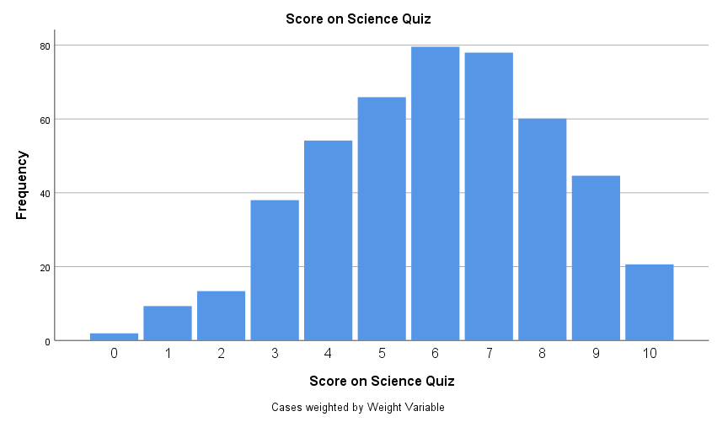

D. Either answer is correct. The mean (6.03) and median (6) are almost the same so either measure of central tendency will work.

E. The median is a good measure of central tendency in this case between the observations are negatively skewed. The mean is attractive because the science quiz is an interval level variable.

F. About 60% of people got passing grades on science_quiz.

About 15% got an A on the science quiz.

|  |
| --- |
| Syntax for solution |
| **\* with GSS dataset**  **FREQUENCIES VARIABLES=science_quiz**  **/STATISTICS=MEAN MEDIAN SKEWNESS SESKEW**  **/BARCHART FREQ**  **/ORDER=ANALYSIS.** |

**2.**

A.

|  |  |
| --- | --- |
| Statistics for women13 variable | |
| Mean | 21.10 |
| Median | 20.8 |
| Skewness | 0.48 |

B. No. 17.8% women in the legislature is below average for a democracy. According to the summary statistics, the world mean is 21.10% and world median is 20.8%.

C. To reach the top 10% of countries in the world, women would need to constitute about 40% of the US House of Representatives.

D.

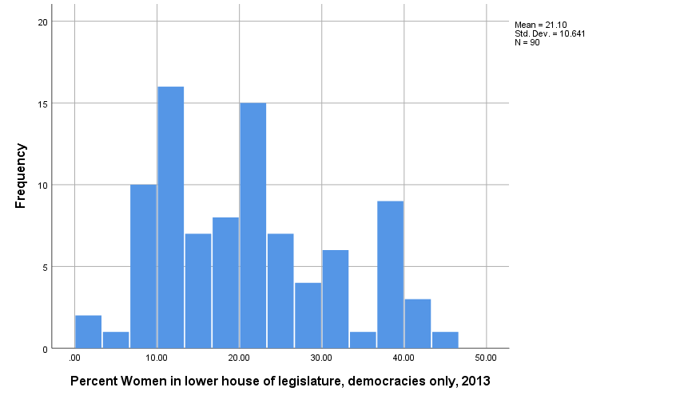

E. The five countries with the *lowest* *percentages* of women legislators are

1. Papua New Guinea
2. Comoros
3. Sri Lanka
4. Nigeria
5. Japan

The five countries with the *highest percentages* of women legislators are

1. Sweden
2. Senegal
3. Finland
4. Nicaragua
5. Iceland

|  |
| --- |
| Syntax for solution |
| **\* with world dataset**  **FREQUENCIES VARIABLES=women13**  **/FORMAT=NOTABLE**  **/STATISTICS=MEAN MEDIAN SKEWNESS SESKEW**  **/HISTOGRAM**  **/ORDER=ANALYSIS.**  **SUMMARIZE**  **/TABLES=country BY women13**  **/FORMAT=VALIDLIST NOCASENUM TOTAL**  **/TITLE='Case Summaries'**  **/MISSING=VARIABLE**  **/CELLS=COUNT.** |

A.

If Pundit 1 is correct, femrole will have a negative skew.

If Pundit 2 is correct, femrole will have a positive skew.

If Pundit 1 is correct, femrole’s mean will be lower than its median.

If Pundit 2 is correct, femrole’s mean will be higher than its median.

B.

|  |  |
| --- | --- |
| Statistics for femrole variable | |
| Mean | 5.87 |
| Median | 6 |
| Mode | 6 |
| Skewness | –0.29 |

C. The choice of bar color is arbitrary.

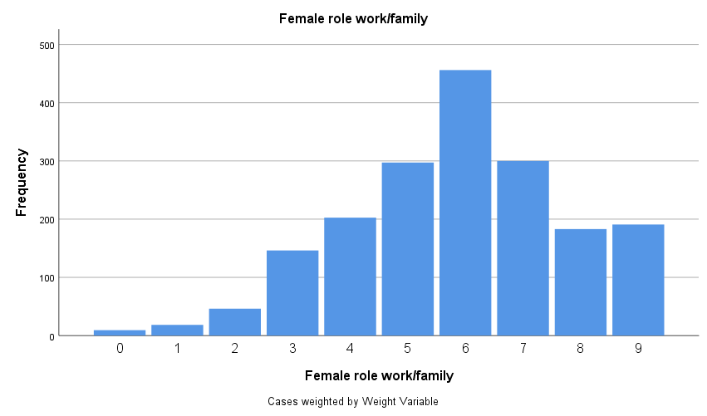

D. Pundit 1’s assessment is more accurate. The distribution of femrole values is negatively skewed and the median is higher than the mean. The bar graph shows values tailing off on the left side. (Wording may vary.)

|  |
| --- |
| Syntax for solution |
| **\* with GSS dataset**  **FREQUENCIES VARIABLES=femrole**  **/FORMAT=NOTABLE**  **/STATISTICS=MEAN MEDIAN SKEWNESS SESKEW**  **/BARCHART FREQ**  **/ORDER=ANALYSIS.** |

A. Maximum dispersion when percentage of observations in each category the same. Figure should something like this:

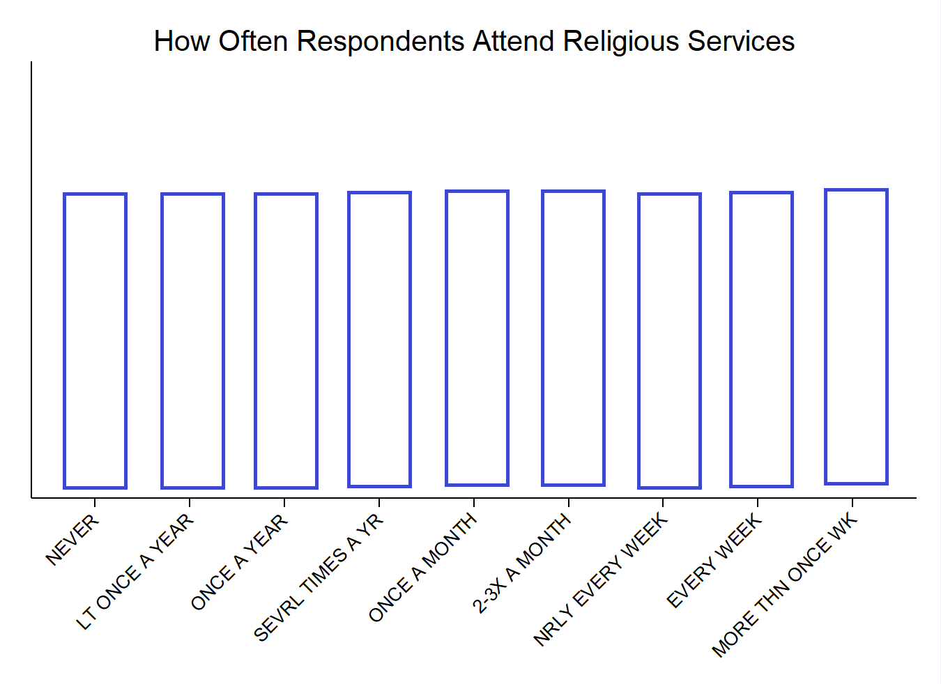

B. No dispersion when all observations in the same category. (It doesn’t matter which category so long as observations all in the same one.)

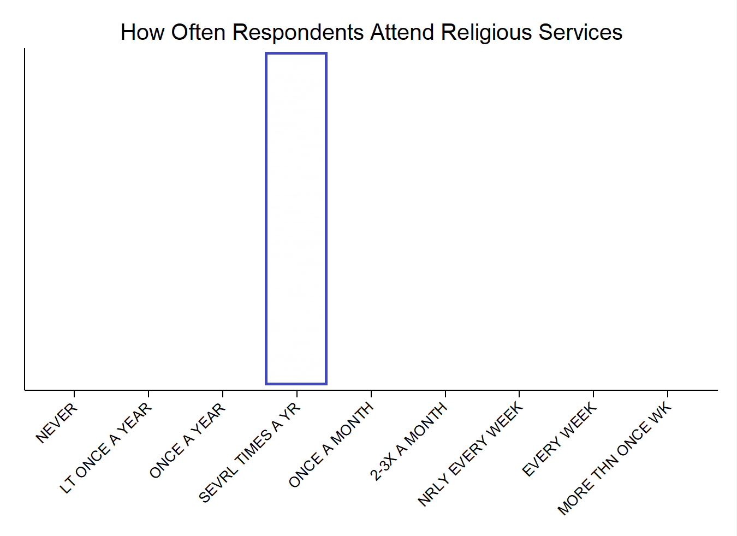

C.

|  |  |  |  |
| --- | --- | --- | --- |
| Attend value | Frequency* | Percentage | Cumulative percentage |
| Never | 711 | 25.0 | 25.0 |
| <Once/yr | 168 | 5.9 | 30.8 |
| Once/yr | 378 | 13.3 | 44.1 |
| Sev times/yr | 316 | 11.1 | 55.2 |
| Once/mo | 198 | 7.0 | 62.2 |
| 2–3 times/mo | 249 | 8.7 | 70.9 |
| Nrly evry wk | 127 | 4.4 | 75.4 |
| Every wk | 498 | 17.5 | 92.8 |
| >Once/wk | 204 | 7.2 | 100.0 |
| Total | 2849 | 100.00% |

* Weighted frequencies

D.

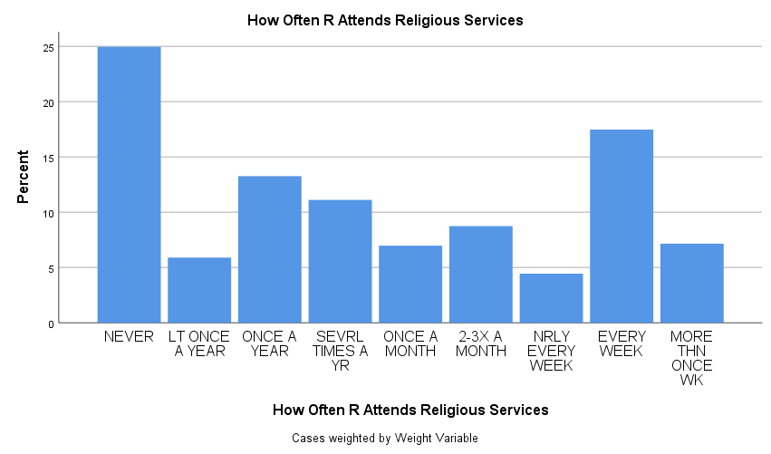

E.

The mode of attend is Never.

The median of attend is Sev times/yr.

F. High dispersion. Although there are not the same number of respondents in each category, there observations are spread out among the categories. (Instructions do not call for explanation.)

|  |
| --- |
| Syntax for solution |
| **\* with GSS dataset**  **FREQUENCIES VARIABLES=attend**  **/FORMAT=NOTABLE**  **/STATISTICS=MEDIAN MODE**  **/BARCHART PERCENT**  **/ORDER=ANALYSIS.** |

**5.**

A.

|  |  |
| --- | --- |
| Send back children brought to US illegally? | Percentage |
| 1. Should send back – favor a great deal | 7.7% |
| 2. Should send back – favor a moderate amount | 8.5% |
| 3. Should send back – favor a little | 2.7% |
| 4. Should allow to stay – favor a little | 9.9% |
| 5. Should allow to stay – favor a moderate amount | 33.9% |
| 6. Should allow to stay – favor a great | 37.3% |
| Total | 100.0% |

|  |  |
| --- | --- |
| Should marijuana be legal? | Percentage |
| Favor | 45.3% |
| Neither favor nor oppose | 25.8% |
| Oppose | 28.9% |
| Total | 100.0% |

|  |  |
| --- | --- |
| Presidential approval scale | Percentage |
| Approve Strongly | 36.0% |
| Approve | 17.2% |
| Disapprove | 9.7% |
| Disapprove Strongly | 37.1% |
| Total | 100.0% |

B. Sending back children brought to US illegally. 71.2% of people moderately or strongly favor letting children brought to US illegally stay in the country. (Wording may vary.)

C. Legalization of marijuana. Opinions are spread out among the values favor, neutral, oppose with no response constituting a majority. (Wording may vary.)

D. Presidential approval. Most respondents either strongly approve the job the president is doing or strongly disapprove the job he is doing. (Note: this NES wave was conducted in 2016 so this question is about Barack Obama, not Donald Trump.) (Wording may vary.)

E.

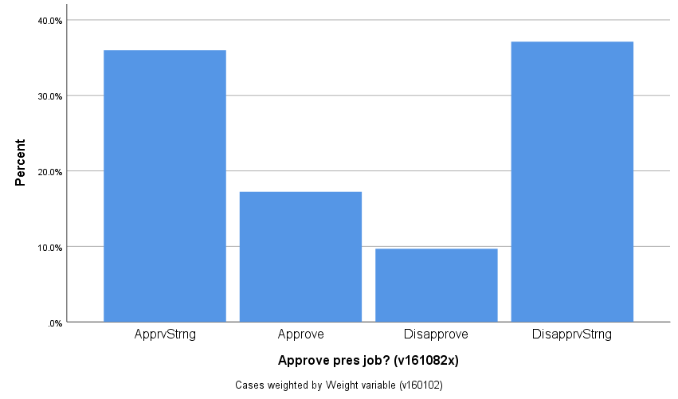

|  |
| --- |
| Syntax for solution |
| **\* with GSS dataset**  **FREQUENCIES VARIABLES=immig_chldrn grass pres_job**  **/ORDER=ANALYSIS.**  **GRAPH**  **/BAR(SIMPLE)=PCT BY pres_job.** |

**6.**

A.

|  |  |  |
| --- | --- | --- |
|  | U.S. Congress | My House incumbent |
| Approve Strongly | 7.2% | 25.4% |
| Approve | 18.0% | 44.9% |
| Disapprove | 20.2% | 18.4% |
| Disapprove Strongly | 54.6% | 11.3% |
| Total | 100.0% | 100.0% |

B. Incorrect. The distribution of opinions about House incumbents is not similar to the distribution of opinions about the whole Congress. The majority of people strongly disapprove of Congress as a whole, but the majority either approve or strongly approve of their House incumbent. (Wording may vary.)

|  |
| --- |
| Syntax for solution |
| **\* with NES dataset**  **FREQUENCIES VARIABLES=cong_approve cong_incumb_approve**  **/ORDER=ANALYSIS.** |

**7.**

A. If the conventional wisdom is correct, the distribution of defense-related expenditures will have a positive skew. If the conventional wisdom is correct, the mean of defense-related expenditures will be higher than its median.

B.

|  |  |
| --- | --- |
| Statistics for defexpen variable | |
| Mean | 1093.74 |
| Median | 931.5 |
| Skewness | 2.29 |

C. The median is more representative of how much a typical state receives. Defense expenditures per state are skewed because a few states receive a lot of expenditures.

D.

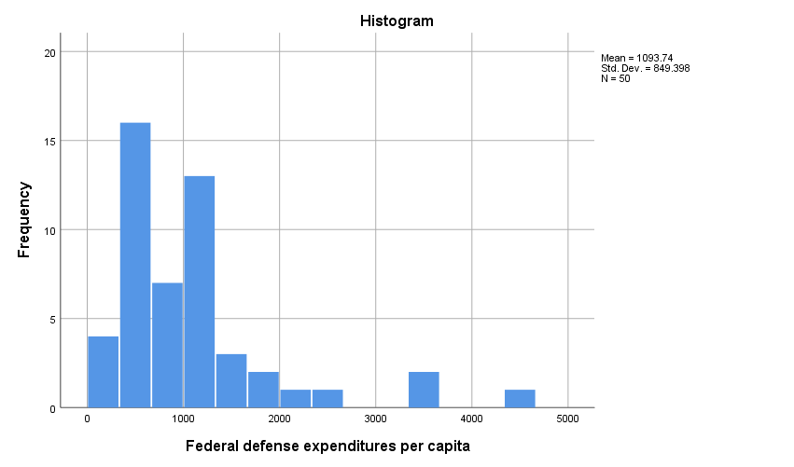

E. The conventional wisdom is accurate

F. The state with the lowest per capita defense spending is West Virginia, with $282 per capita. The state with the highest per capita defense spending is Virginia, with $4,425 per capita.

|  |
| --- |
| Syntax for solution |
| **\* with States dataset**  FREQUENCIES VARIABLES=defexpen  /FORMAT=NOTABLE  /STATISTICS=MEAN MEDIAN SKEWNESS SESKEW  /HISTOGRAM  /ORDER=ANALYSIS.  SUMMARIZE  /TABLES=state BY defexpen  /FORMAT=VALIDLIST NOCASENUM TOTAL  /TITLE='Case Summaries'  /MISSING=VARIABLE  /CELLS=COUNT. |

**8.**

A.

|  |  |  |
| --- | --- | --- |
|  | blackpct_2016 | hispanicpct_2016 |
| Mean | 10.52 | 11.54 |
| Median | 7.3 | 9.05 |
| Skewness | 1.16 | 1.86 |

B. Demographer 1. In this case, the typical state’s percentage black and percentage Hispanic are better described by the median values because the values have a positive skew. (Wording may vary.)

C. Five states with the *lowest percentages* of Hispanics:

1. West Virginia
2. Maine
3. Vermont
4. Mississippi
5. Kentucky

Five states with the *highest percentages* of Hispanics:

1. New Mexico
2. Texas
3. California
4. Arizona
5. Nevada

|  |
| --- |
| Syntax for solution |
| **\* with States dataset**  **FREQUENCIES VARIABLES=blackpct_2016 hispanicpct_2016**  **/FORMAT=NOTABLE**  **/STATISTICS=MEAN MEDIAN SKEWNESS SESKEW**  **/ORDER=ANALYSIS.**  **SUMMARIZE**  **/TABLES=state BY hispanicpct_2016**  **/FORMAT=VALIDLIST NOCASENUM TOTAL**  **/TITLE='Case Summaries'**  **/MISSING=VARIABLE**  **/CELLS=COUNT.** |