Chapter 2
SYSTEMS TECHNIQUES AND DOCUMENTATION

TEACHING TIPS

I normally introduce flowcharting symbols with simple examples on the board. I first introduce a very simple manual flowchart involving only three symbols. An example would be the preparation of a sales order. This would show a customer order coming into the process and a completed sales order coming out. Then I mention how computer symbols could be added.

From experience, I have discovered that the single most important thing for students to learn in analytical flowcharting is the sandwich rule. About 90% of all mistakes seem to involve a violation of this rule. The second largest problem involves separating various functions (e.g., sales, credit, shipping, and so on) into columns.

I've discovered students all seem to do about the same when I place complicated flowcharting problems on exams. For this reason, I now ask mostly short answer questions about flowcharting on exams.

I've found it important to emphasize the distinction between the types of documentation tools used by systems developers and auditors.

With logical data flow diagrams (DFD), it's interesting to discuss how developers go from an existing system to a new system. They begin with an existing analytical flow chart, turn it into a DFD, modify the DFD, and then generate a new analytical flowchart.

It’s worth taking some time to discuss the BPMN, as this is used in Chapters 7-9 to document the basic transaction cycles.

USERS OF SYSTEMS TECHNIQUES

Systems techniques are tools used in the analysis, design, and documentation of system and subsystem relationships. They are used by accountants who do systems work, either internally for their company or externally as consultants or auditors.
Most auditing engagements are divided into two basic components: the interim audit, which involves internal control evaluation, and the financial statement audit, which involves substantive testing. Substantive testing is the direct verification of financial statement figures, placing such reliance on internal control as the results of the interim audit warrant.
Internal Control Evaluation. Analytic flowcharts, document flowcharts, and forms distribution charts may be used by auditors to analyze the distribution of documents in a system. Several other system techniques, such as questionnaires and matrix methods, might also be used in the evaluation of internal controls.
Compliance Testing. Auditors undertake compliance testing to confirm the existence, assess the effectiveness, and check the continuity of operation of internal controls on which reliance is to be placed.
Working Papers. Working papers are the records kept by an auditor of the procedures and tests applied, the information obtained, and conclusions drawn during an audit engagement. Auditors use systems techniques to document and analyze the content of working papers. Internal control questionnaires, analytic flowcharts, and system flowcharts appear frequently in working papers because they are commonly used by auditors in the evaluation of internal controls. Data flow diagrams, HIPO charts, program flowcharts, branching and decision tables, and matrix methods might appear in working papers if they are part of the documentation of a system that is being reviewed.

Use of Systems Techniques in Systems Development
A systems development project generally consists of three phases: systems analysis, systems design, and systems implementation.
Systems Analysis. Logical data flow diagrams and analytic flowcharts are helpful in giving an overall picture with regard to transaction processing within the organization.
Systems Design. Systems design formulates a blueprint for a completed system.
Systems Implementation. Systems implementation involves the actual carrying out of the design plan.

Use of Systems Techniques by Sarbanes-Oxley Act Compliance Participants
System documentation is the underpinning support of the internal control and process documentation requirements that have been set by the Sarbanes-Oxley Act (SOX).

SYSTEMS TECHNIQUES

Flowcharts are probably the most common systems technique. A flowchart is a symbolic diagram that shows the data flow and sequence of operations in a system.

Flowcharting Symbols. The basic symbols include the input/output symbol, the process symbol, the flowline symbol, and the annotation, comment symbol. The flowline symbol is used to link other symbols.
Specialized input/output symbols may represent the I/O function and, in addition, denote the medium on which the information is recorded, or the manner of handling the information, or both. If no special symbol exists, the basic I/O symbol is used.
Specialized process symbols represent the processing function and, in addition, identify the specific type of operation to be performed on the information. If no specialized symbol exists, the basic process symbol is used.
The additional symbols are used to clarify a flowchart or to make the flowcharting of a complete process more convenient.

Symbol Use in Flowcharting
Normal direction of flow is from left to right and top to bottom.

IPO and HIPO Charts
IPO and HIPO charts are used primarily by systems development personnel. A HIPO chart contains two segments: the hierarchy chart that factors the processing task into various modules or subtasks and an IPO chart to describe the input-process-output requirements of each module. The hierarchy chart describes the overall system and provides a "table of contents" to the detailed IPO charts, usually through a numbering scheme.

Systems and Program Flowcharts
Systems flowcharts are associated with the analysis phase of a systems project and program flowcharts with the design phase. A program flowchart is the design step between overall system design and coding the system for computer processing.
A systems flowchart identifies the overall or broad flow of operations in a system.
A program flowchart (also called a block flowchart) is more detailed concerning individual processing functions than a systems flowchart. Each of the processing functions depicted in a systems flowchart is further detailed in a program flowchart, similar to the successive layering of IPO charts in HIPO.

Logical Data Flow Diagrams
Logical data flow diagrams or data flow diagrams (both abbreviated as DFD) are used by systems analysts to document the logical design of a system to satisfy the user's request.
There are four DFD symbols. The terminator is used to indicate a source or a destination of data. The process indicates a process that transforms data. The data store is used to indicate a store of data. The data flow is used to indicate a flow of data. Although these terms and symbols are representative, many variations exist.
Structured Analysis. DFD typically shown in layers of increasing detail, with the DFD in each layer being linked to each other.

Analytic, Document, and Forms Distribution Flowcharts
Analytic flowcharts, document flowcharts, and forms distribution charts may be used to analyze the distribution of documents in a system.
An analytic flowchart identifies all significant processing in an application, emphasizing processing tasks that apply controls.
A document flowchart is similar in format to an analytic flowchart but contains less detail about the processing functions.
A forms distribution chart illustrates the distribution of multiple-copy forms within an organization.

Analytic Flowcharting Illustration
Planning the Flowchart. Flow is from top to bottom and left to right.
Symbol Selection. For manual system, only several symbols are needed; symbols for documents, files, and processes are the most commonly used symbols.
System Analysis. One must first understand the system to be flowcharted.
Drawing the Flowchart
Sandwich Rule. Every process symbol should have its inputs and outputs clearly specified.
Use of Connector Symbol. This symbol is used to terminate the flowchart and then continue it on another page or in a different column.
Entity-Column Relations. Columns in the flowchart typically represent individuals or departments. This is something that beginners often have difficulty with.

Unified Modeling Language (UML)
UML is a technology that assists in the specification, visualization, and documentation of models developed to structure and design software systems. UML uses a variety of graphical techniques to model different aspects and views of software development projects at various levels of abstraction. In addition to techniques used to model the specifics of software development, UML includes techniques that are the functional equivalent of data flow diagrams, document flowcharting, and analytical flowcharting. UML version 2.0 defines thirteen types of diagrams, divided into three categories: structure diagrams, behavior diagrams, and interaction diagrams. When used to model business processes, the graphical techniques used in UML to prepare activity diagrams can result in diagrams that are very similar to analytic flowcharts.

Business Process Diagrams
The Business Process Diagram (BPD) is a graphical representation of a business process. It focuses on the sequence of activities that constitute a business process, and also on the related business logic that guides that sequence of activities. Business Process Modeling and Notation (BPMN) is a widely accepted standard for modeling business processes using BPDs. Similar to UML, BPMN is a computer industry specification standard developed and supported by the OMG, a nonprofit computer industry consortium. BPMN is similar to UML but differs in that BPMN is a process-oriented approach to modeling whereas UML is an object-oriented approach. Where BPMN has a focus on business processes, UML has a focus on software design.

Narrative Techniques
Interviews are useful for familiarizing the analyst with decision makers and their problems. Depth interviews allow the systems analyst to establish a personal working relationship with the manager. Open-ended questionnaires are a fact-gathering technique where persons provide written answers to general, rather than specific, questions. Narrative techniques also include document reviews.

Resource Utilization Analysis
Flowcharts do not show the resources required to operate the system. Such resources must be considered both by the auditor and systems persons.

Work Measurement
Work measurement includes the variety of techniques used to model, measure, or estimate clerical or other activities in a production framework. In an accounting framework, work measurement is similar to the concept employed in standard cost systems.

Work Distribution Analysis
Work distribution analysis studies the assignment of specific tasks to employees. A task list is typically used to record each separate item of work performed by an individual and the average number of hours spent on each task per week.

Decision Analysis Techniques
Branching and Decision Tables are used primarily by systems development personnel. Often the decision logic required in a computer program is sufficiently complex to mitigate the usefulness of the standard decision flowcharting symbol. In such cases, a branching table may be used to depict a decision function. A decision table is a tabular representation of a decision-making process. It is similar to a branching table but more complex in that it incorporates multiple decision criteria. Decision tables are constructed on an IF-THEN premise and appear as a two-dimensional matrix in general form.

Matrix Methods. Matrix methods are used by both auditors and systems personnel to present large volumes of data. The "work" or "spread" sheets used in accounting systems to spread or distribute account balances through different sub-classifications or to facilitate the closing process are common examples of matrix techniques.

Software for Systems Techniques
A variety of software tools can be used to create flowcharts and other graphical systems techniques.
Microsoft Office® Applications. Microsoft Visio® is a Microsoft Office® application that is targeted at the creation of flowcharts and other graphical diagrams. Microsoft PowerPoint® is a general presentation tool that contains specific drawing features that may be used to create flowcharts and other graphical diagrams. These same drawing tools are also available in both Microsoft Word® and Microsoft Excel®, allowing either of these general software applications to be used to prepare graphical diagrams and flowcharts.
Computer-Aided Software Engineering (CASE). Computer-aided software engineering (CASE) is the process of using computer software technology that supports an automated engineering discipline for software development and maintenance.
UML Modeling Tools. A variety of software tools to draw UML charts are available from vendors. Professional UML software is similar to CASE in its objectives and its potential benefits in that it integrates UML charts with other aspects of systems development, such as database design and code generation.

REVIEW QUESTIONS

1. A flowchart is a symbolic diagram that shows the data flow and sequence of operations in a system.

2. The basic symbols include the input/output symbol, the process symbol, the flowline symbol, and the annotation, comment symbol. See Figure 2.1 for the symbols.

3. Flowchart symbols represent the physical aspect of a system.

4. An IPO chart provides very little detail concerning a processing function, but is a useful technique for analyzing overall information requirements. Additional processing detail is provided by HIPO charts. A HIPO consists of a series of charts that represent systems at increasing levels of detail, where the level of detail depends on the needs of users.

5. An analytic flowchart is similar to a systems flowchart in level of detail and technique, but is organized by columns.

6. A logical data flow diagram can be used to document the logical aspect of a system.

7. Auditors use analytic flowcharts in the evaluation of internal controls.

8. Organization of the chart by columns is common to analytic, document, and forms distribution charts.

9. There are four symbols. The terminator is used to indicate a source or a destination of data. The process indicates a process that transforms data. The data store is used to indicate a store of data. The data flow is used to indicate a flow of data. See Table 2.1 for the symbols.

10. No, flowcharting is not useful in analyzing the resources required to implement a system.

11. Work measurement is useful in evaluating the technical feasibility or technical requirements of a system design.

12. A work distribution analysis requires detailed information about functions and responsibilities. A task list is used to record each separate item of work performed by an individual and the average number of hours spent on each task per week. Each employee (or department, and so on) is represented by a column; the work assignments are spread across the table to employees. The method of assignment should be rational; that is, employee qualifications, internal control, scheduling, timing of events, and so forth should be considered.

ANSWERS TO DISCUSSION QUESTIONS AND PROBLEMS

13. - 18. Multiple-Choice (CPA) Varies
13. B
14. C
15. D
16. D
17. C
18. C

19. Systems Design - 30 minutes Hard
This problem provides an opportunity for the student to appreciate the data processing requirements of transactional data. Many students will not appreciate the amount of effort necessary to manually develop the 21 desired subtotals. There are a variety of solutions, including going through the initial batch 21 times for 21 subtotals. The data processing steps required (and overall efficiency) depend on the approach taken. Experience has shown that many student-generated solutions are not effective: examined in detail they fail to generate the 21 subtotals.

A suggested solution is as follows:
(1) Sort the batch of invoices into 2 piles: invoices showing only product 1 sales and those invoices with product 2 and/or 3 sales.
(2) Sort the pile of invoices containing only product 1 sales by customer. Calculate daily sales totals for each customer. Calculate the grand total. Post (transcribe) these subtotals to the worksheet.
(3) Sort the pile of invoices with product lines 2 and/or 3 sales by customer. Either go through each customer pile twice, calculating each required subtotal; go through each pile once, accumulating two subtotals concurrently (this is not possible using a single calculator or with a single adding machine as two totals are being accumulated); or re-sort each pile into 3 piles: product 2 only, product 3 only, and mixed. Calculate subtotals for each customer and transcribe to the worksheets. (Note: the mixed invoices have to be examined when calculating both line 2 and line 3 subtotals.)
20. Analytic Flowchart; Data Flow Diagram - 45 minutes Medium
a. analytic flowchart
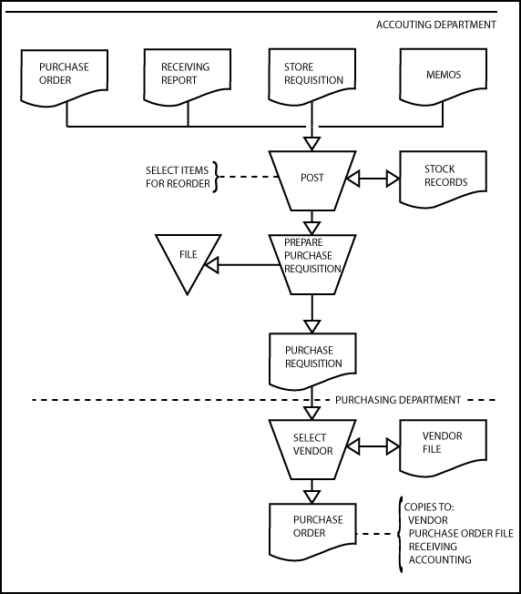
b. data flow diagram
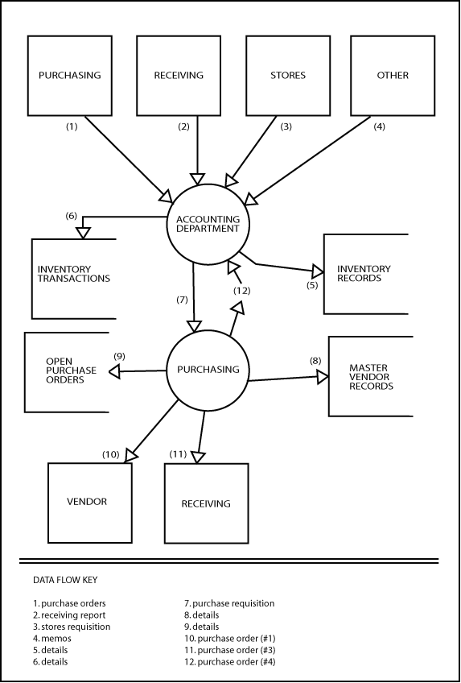
21. Use of Systems Techniques - 10 minutes Easy
It is not uncommon to have to deal with difficult clients. If things are really difficult, you can simply withdraw from the engagement. But if you are billing her by the hour, then you can politely remind her that she can save herself a lot of money by facilitating your work in a way that will permit you to finish at the earliest possible date. There is also the option of bypassing Marjorie Renwald and working directly with her two employees. As far as systems techniques go, the usual ones will be needed: narratives, questionnaires, flowcharts, and internal control summaries.

22. Data Flow Diagram - 10 minutes Easy
1. No source is indicated for the user ID.
2. There are two unlabeled flowlines in the diagram.
3. A direct access storage device symbol, which represents a physical storage medium, is used to represent the valid ID data in the diagram.

23. Flowchart Symbols; Technique - 30 minutes Medium
(a) CPA Examination, Unofficial Answer
1. Time cards.
2. Prepare batch-control slips.
3. Batch-control slips (the numbers 1 and 2 should be added to indicate first and second copy).
4. Time cards.
5. Input.
6. Batch-control slip (the number 1 should be added to indicate first copy).
7. Time cards.
8. By batch.
9. Payroll transaction file.
10. Sort by employee number within batch.
11. Master employee file.
12. Edit and compare batch total hours and number of employees.
13. Batch listing and exception report.
14. Payroll transaction file.
15. Exceptions noted: a. Unbalanced batch b. Invalid employee number
16. Resolve differences.

(b) Advantages of a flowchart:
1. It insures a more comprehensive survey since incomplete information is more evident when it is being recorded on flowcharts.
2. It is readily tailored to specific client system.
3. It enables the system to be more quickly understood by the audit staff since the information is presented in a concise, graphic manner which is easy to comprehend and visualize.
4. It creates more interest on the part of the audit staff because they can better appreciate the functioning of the system and hence the reasons for tests.
5. It produces more valuable and realistic recommendations to clients on internal controls and system efficiency because of increased awareness of accounting systems, relationships, and document flows.
6. It emphasizes those areas of the internal control system (and related accounts) which require more or less attention and therefore assists in better use of audit time.
7. It increases client goodwill because new audit staff members usually require less time for system orientation, and interference with the client's staff is kept to a minimum.
24. Analytic Flowchart - 30 minutes Medium
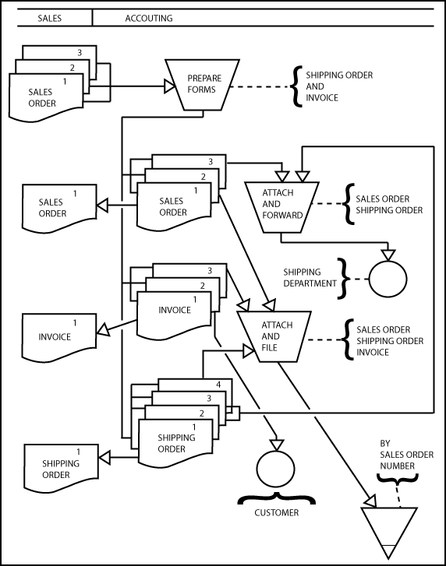
25. Analytic Flowchart - 30 minutes Medium
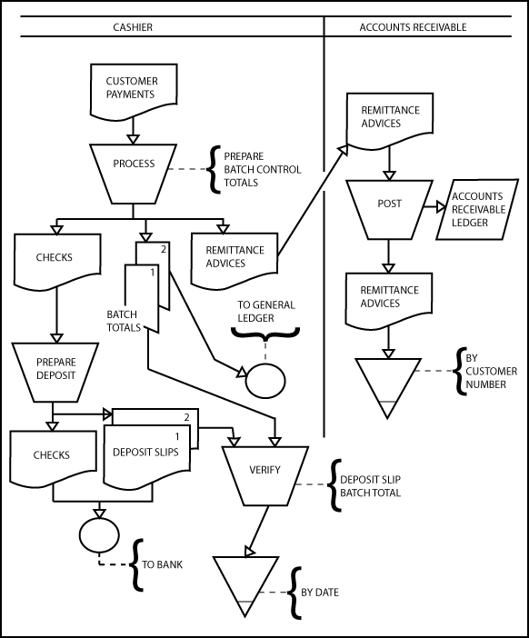
26. Analytic Flowchart - 30 minutes Medium
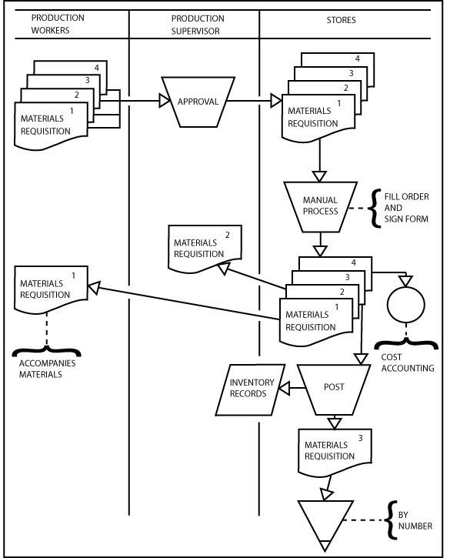
27. Analytic Flowchart - 1 Hour Hard
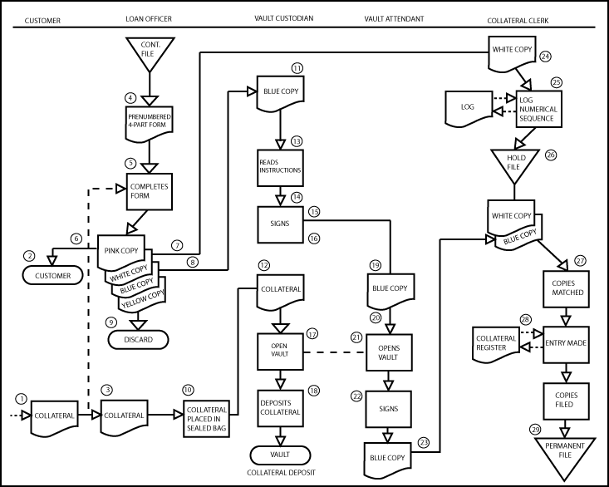
28. Analytic Flowchart Symbols - 15 minutes Medium
CPA Examination, Unofficial Answer

Flowchart Symbol Internal Control Procedure
Letter or Internal Document
c. Approve customer credit and terms.
d. Release merchandise to shipping department.
e. File by sales order number.
f. File pending receipt of merchandise.
g. Prepare bill of lading.
h. Copy of bill of lading to customer.
i. Ship merchandise to customer.
j. File by sales order number.
k. Customer purchase order and sales order.
l. File pending notice of shipment.
m. Prepare three-part sales invoice.
n. Copy of invoice to customer.
o. Post to (or enter in) sales journal.
p. Account for numerical sequence.
q. Post to customer accounts.
r. File (by payment due date).

29. Analytic Flowchart Symbols - 15 minutes Medium
CPA Examination, Unofficial Answer
A. Prepare purchase order
B. To Vendor
C. Prepare receiving report
D. From Purchasing
E. From Receiving
F. Purchase order No. 5
G. Receiving report No. 1
H. Prepare and approve voucher
I. Unpaid voucher file, filed by due date
J. Treasurer
K. Sign checks and cancel voucher package documents
L. Canceled voucher package

30. Decision Table - 30 minutes Medium
a. Limited Entry
1 2 3 4
Approved credit N Y Y Y
Order < 25 units Y N N
Order is 26-50 units Y N
Reject order 1
Approve order 1 1 1
5% discount 2
10% discount 2
b. Extended Entry
1 2 3 4
Approved credit N Y Y Y
Quantity ordered 0-25 26-55 >56
% discount 0 5 10
Accept order x x x
Reject order x

31. Decision Table - 30 minutes Medium
a. Limited Entry
1 2 3
Is purchase less than $50 Y N N
Is purchase between $50 and $100 Y N
Is purchase over $100 Y
Approve with no action x
Give authorization number x x
Place hold on account x

b. Extended Entry
1 2 3
Is purchase less than $50 between $50 and $100 above $100
Approve with no action x
Give authorization number x x
Place hold on account x

32. Work Measurement - 15 minutes Medium
Standard Time/check = (480 + 20 + 20) minutes / 570 checks = .912 minutes/check

Rest/delay/check = (20 + 20) minutes / 570 checks = .070 minutes/check

Rest/delay percentage = .070/.912 = 7.68%

While the above calculations are straightforward, the instructor might wish to expand on some complexities related to the above type of calculations in actual practice, such as ensuring valid and accurate sample sizes, ensuring realistic test conditions, ensuring accurate count of rest and delay times, and the usefulness of such averages in general.
33. Analytic Flowchart - 1 Hour Medium
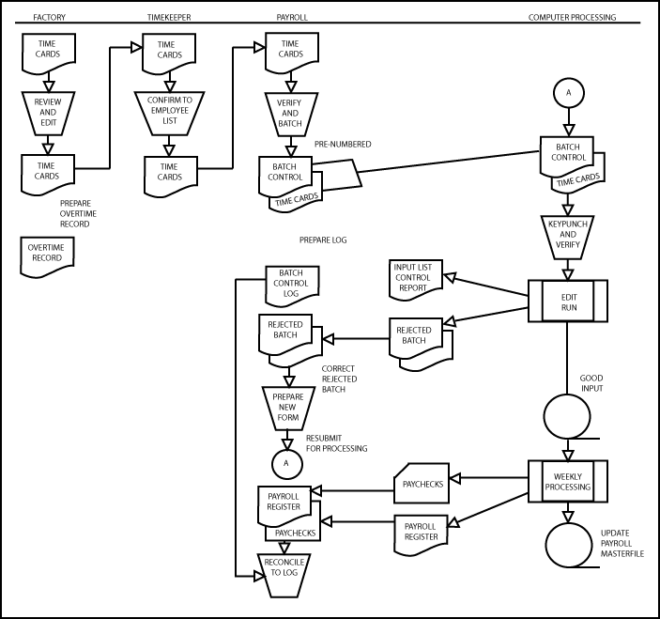
34. Program Flowchart - 30 minutes Medium
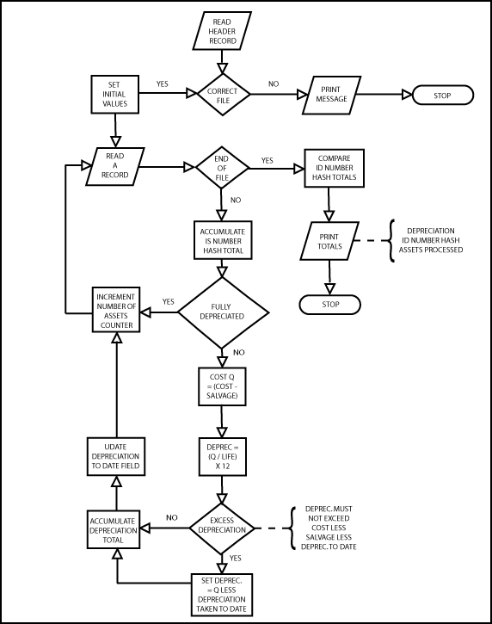
35. Program Flowchart - 30 minutes Medium

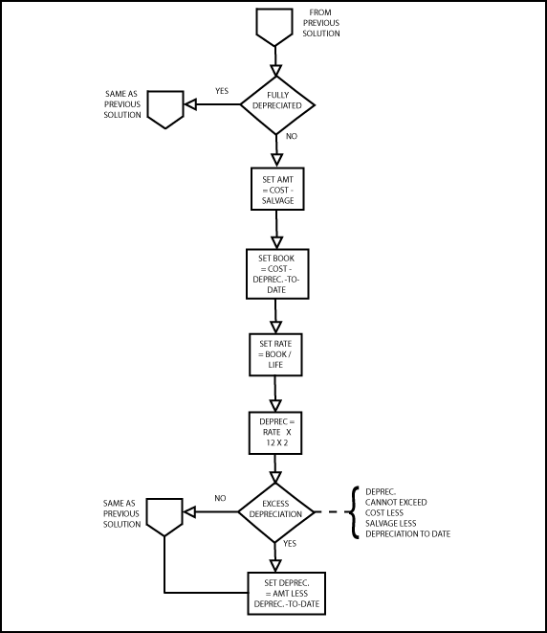

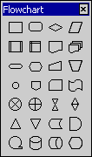
36. Identify Flowchart Symbols -25 minutes Easy

Top Left to Right Symbol Name

Process
Alternate Process
Decision
Data

Predefined Process
Internal Storage
Document
Multi-document

Terminator
Preparation
Manual Input
Manual Operation

Connector
Off-page Connector
Card
Punched Tape

Summing Junction
Or
Collate
Sort

Extract
Merge
Stored Data
Delay

Sequential Access Storage
Magnetic Disk
Direct Access Storage
Display

37. Prepare Flowcharts Using Microsoft Office Flowchart Symbols - Varies
The solutions to the problem are the flowcharts in the textbook that the student is expected to reproduce using Microsoft Office flowchart symbols. These are Figure 2.17, Figure 2.18, and Figure 4.7. Figure 2.17 has 6 symbols and would not take very long to reproduce. The other two figures would take much more time as Figure 2.18 has 29 symbols in three columns and Figure 4.7 has 18 symbols in three columns.

38. A. event B. activity C. gateway
D. sequence E. message flow F. association
G. pool H. lane I. data object

39. Errors in the use of symbols in the BPD figure.
- ‘authorize order’ symbol should be activity symbol (oval) not an event symbol (circle)
- message flow symbol (dashed line) should replace sequence flow symbol (solid line) between ‘authorize order’ and ‘prepare order’
- ‘customer database’ should be data object symbol, not event (diamond) symbol
- association symbol (dotted line) should replace solid line between ‘prepare order’ and ‘customer database’
- sequence flow line between ‘prepare order’ and ‘ship order’ should have arrowhead going into ‘ship order’
- association symbol (dotted line) should replace solid line between ‘ship order’ and ‘shipping notice’
- message flow symbol (dashed line) should replace sequence flow symbol (solid line) between ‘ship order’ and ‘customer’ pool

40. Figure 8.8 in the textbook is the solution (i.e., correctly-prepared version of problem figure). The three data objects should be connected with dotted association lines to an activity symbol (oval) that encloses ‘process completed transaction.’ Message flow symbols (dashed lines) should connect to the ‘accounts receivable’ and ‘general ledger’ pools.

41. Business process diagram for Salt Company

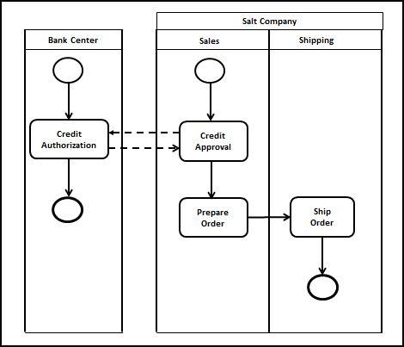

WEB RESEARCH ASSIGNMENTS

42. Both SmartDraw and Visual-Paradigm support BPMN. Visual Paradigm, however, is part of a fairly strong suite of visual development tools, whereas SmartDraw is a generic drawing program.

43. The UML standard incorporates 13 different types of diagrams. One of those types, the Activity Diagram, is very similar to the BPMN diagram. BPMN has the specific advantage of being able to convert directly into program code using a Business Process Execution Language (BPEL). Otherwise, UML provides a much more comprehensive way to document information systems.

44. In recent CPA exams, the candidate has been called on to interpret analytic flow charts in dealing with case-type questions.

(Blank Page)

